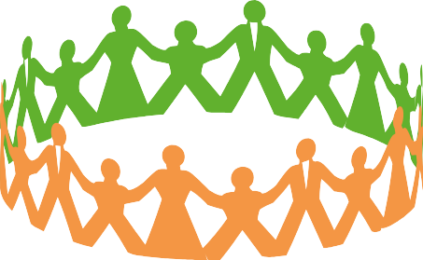

**Build networks & relationships**

* **Invest** time to know your stakeholders
* **Be friendly**, polite and approachable
* **Communicate** clearly and honestly
* **Recognise** their concerns
* **Be aware** of different dynamics of influence

within groups

* **Keep** your commitments

**How to start the dialogue in**

**your agency**

What are the benefits and

challenges for your agency in engaging with citizens and communities?

How does your organisation’s internal culture foster participation and good engagement?

What steps can your agency take to improve its engagement with citizens and communities?

**Aim of the guide**

**Better** and more

**consistent** community **engagement** across government

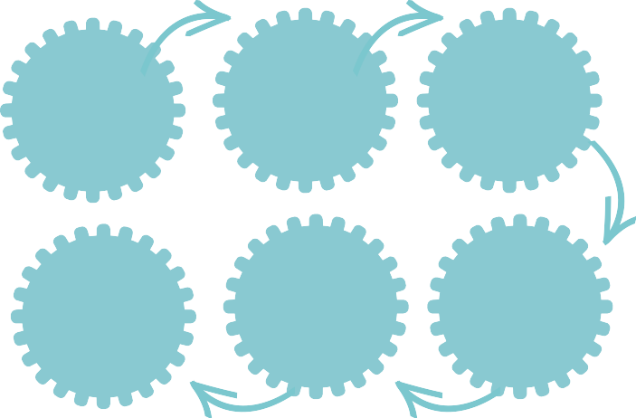

**Identify key steps in**

**engagement process**

Objectives

Deliverables

Milestones

Project team

Costs

Timeframes



**Kia Tūtahi Relationship Accord**



**Who is the guide for?**

All government agencies that interact with communities

**Recognise different engagement**

**levels & what is appropriate**

inform consult empower partner