## Feedback from stakeholders

During public consultation, the Minister of Internal Affairs has been travelling around the country talking to people about the Discussion Document and the proposed options for change. At each meeting he has heard a compelling message from stakeholders about being sure that any of the options for change:

* ensure our fire services meet our local community needs and risks;
* have strong community engagement with local decision-making;
* make the necessary cultural changes so that firefighters can work together and that the feeling of fire services being driven from the top down is avoided;
* have strong links to emergency services and reliable delivery of those services; and
* have strong and careful transition planning so that we do not lose skilled and capable firefighters, retain strong links to the community, and ensure the funding is set right.

This paper seeks to respond to the consistent feedback that we have heard in the conversations with stakeholders and to share this conversation with all stakeholders, including those that have not been able to come to the meetings held so far. Sharing this community feedback is intended to help add to the richness of possible submissions on the fire services review.

This document is a supplement to the Discussion Document, so please incorporate your feedback on this paper into your submission on the Discussion Document, particularly [questions five and six](http://www.dia.govt.nz/vwluResources/FSR-Submission-Form/$file/FSR-Submission-Form.pdf) (page 43).

The Minister has heard your message about community engagement and agrees with the importance of it for our fire services. He would like to hear from submitters about how to best engage and include the voice of the community in a meaningful way under each of the proposed options:

* option 1: enhanced status quo;
* option 2: coordinated service delivery;
* option 3: new national fire services organisation.

Under option 1 the organisational structures stay largely the same. Although we do not yet know the organisational structure for options 2 and 3, we do know that skilled and capable firefighters for vegetation, structure, and non-fire functions will be required. In particular, we need to retain leadership for our forces and communities as provided in roles such as the Principal Rural Fire Officers and Chief Fire Officers.

There are many different ways the options could be put together. You might prefer some parts of the options over others, or want to combine parts of one option with another. The review wants to hear from you, not just about your preferred option, but also about how you think any of the options could be improved. There are no fixed views at this time.

### Community engagement

During the Minister’s conversations around the country with stakeholders we’ve been hearing that many of you would like more details to better reflect on and tell us your ideas about how to give the community a meaningful voice in their fire services.

Meaningful community engagement can range from letting you know about your local fire service right through to owning the fire service and delivering it yourself. The table below shows examples of different approaches to community engagement. Sometimes the best way to get engagement is to use a mixture of the following approaches. These examples are offered to help with this important discussion and do not represent the specific views of any individual or organisation.

Table : Different community engagement approaches

| Approach | Advantages | Disadvantages |
| --- | --- | --- |
| **A. Engaging by sharing information** | Can have high engagement and sense of community ownership through fundraising and volunteering. Also includes activities like:   * promoting fire safety in schools, businesses, etc; * attending community events | Can be a lot of work for individual brigades  If the engagement does not occur correctly the community may not be properly consulted or participate well in decisions on planning, assessing community needs and priorities, and best local responses |
| **B. Community consultation ­** | Members of the public are transparently consulted on meaningful decisions  Can give a broader representation of views than relying on community leaders | Takes time  Lots of different consultation processes, which can overload the public and communities  Many people choose not to participate in the process  Requires a feedback loop to the public so that submitters feel listened to and don’t feel like the decision has been made already |
| **C. Community participation**  **­** | Community leaders have greater input into the decisions  Usually relies on groups of people coming together to discuss and prioritise  Usually used for planning processes | Can sometimes need formal agreements to make sure things happen  There are sometimes lots of these groups around, which can be a lot of work for some members of the community |
| **D. Partnership working ­** | The community makes the decisions, but a different agency responsible for delivering what the community has decided  Needs some legislation so that it is clear who is responsible for what | It can be difficult for communities to work within the constraints of the delivery agency’s budget  Can be a lot of work for the community decision-making body if too many issues are raised  Can be challenging to get national and local working together well |
| **E. Community owned, led, and delivered** | Community owns the fire services, leads them and delivers all the services  Coordination and support could be provided nationally with local Service Level Agreements being used to agree what services the community delivers | Can mean that it is difficult to understand the national picture  Can mean it is difficult for brigades to work together on big incidents  Can lessen the financial benefits gained from combined purchasing  There can be more administration if each community looks after its own services without national support in place  Can mean there is inconsistent delivery of the 4Rs/ fire services resourcing  Greater challenges in ensuring that health and safety obligations are met |

#### Each option has different types of community engagement

|  |  |
| --- | --- |
| Option | Main type of engagement |
| Option 1 | Brigade – Approach A (informed engagement) and sometimes Approach C (community participation) if the brigade is well integrated into the local community  Rural Fire Authorities – Approach E (community ownership) |
| Option 2 | Brigade – Approach A (informed engagement) and Approach B (community consultation), and better supported brigades will mean more of Approach C (community participation) will happen  New Rural Fire Authorities – Approach E but with more of Approach D happening around national activities |
| Option 3 | There is no detail in the discussion document on how community engagement would occur  Stakeholders have expressed interest in the detail on how option 3 could have more community engagement in it |

To help provide stakeholders with how community engagement might work under option 3, we prepared the diagram over the page. This diagram is designed to add to the detail in the discussion document for option 3 (page 26 refers), which is not currently provided. We have this detail already in the discussion document for option 2 (pages 15 and 56 refers). This diagram uses Approach C (community participation) and Approach 4 (Partnership working). Approach E (community owned, led, and delivered) cannot work with a national service.

You may find this diagram helpful for your submission, or you may prefer to tell us in your own way how we should ensure that there is community input into key decisions and that the community has a meaningful voice.

### Community engagement in option 3 might look something like this:

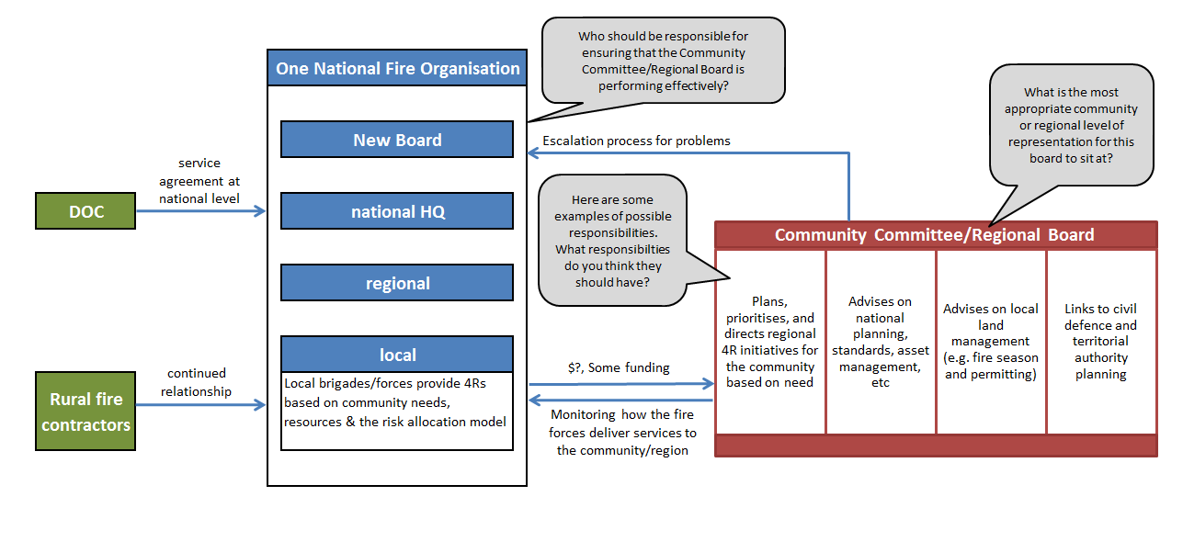

### To make community engagement successful in any of the options we would need to:

* ensure firefighters and the new RFAs or any stakeholder Committees are appropriately supported;
* ensure the planning cycles for the RFAs or any stakeholder Committees are aligned to the fire service so there would be one plan for all firefighters (with the community committee developing and approving the community part of the single plan);
* ensure our skilled and capable leaders stay to successfully work with regional community stakeholders and leaders; and
* build capability in reporting and monitoring so the community can see whether its needs are being met.

### If you think a community committee would provide better engagement under option 3, what would the membership of this committee look like?

The community committee could be similar in nature to the Enlarged Rural Fire Districts Board. For example, it could comprise the community of interest in the local region:

* forest owners, significant landowners, local DOC representative (if required);
* territorial authorities (or representative);
* national fire services organisation representative; and
* senior, but local, members of emergency services.

We’re interested in hearing from the community about what might be a practical, purposeful, and effective number of community committees. Your view on how many committees there should be might depend on what you consider as your community. For example there could be between 10-18 community committees across the country depending on the local variation of regional community needs and risks.

**We encourage you to make your submission before 10 July 2015 and help to shape the fire services of the future.**