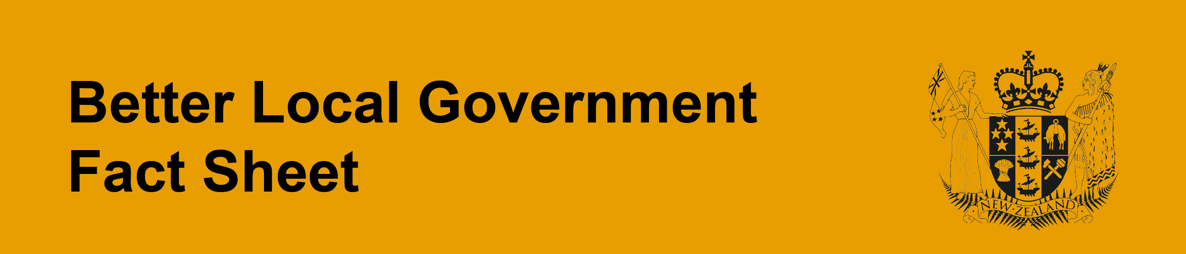

Changes affecting the annual plan (sections 95, 95A and 95B)

Legislative context
Councils are required to prepare and adopt an annual plan each year. In the first year of the long-term plan, that plan also serves as the annual plan (in terms of the financial statement and funding impact statement).
Annual plans contain a council’s proposed budget and funding impact statement for that financial year. (Detailed content requirements are set out in Part 2 of Schedule 10.)

What’s changed?

Consultation on proposed annual plans
The information basis and process for consultation on the proposed annual plan have changed. In some circumstances, consultation may now not be necessary (see below).
Councils are required to use a specific consultation document to consult on the proposed content of an annual plan. This means consultation will be based on a single document, which will not include a draft plan or any other information that is unnecessary for the purposes of the consultation document. The purpose and content of the consultation document, plus presentation requirements, are described in section 95A of the Act.
The focus of the consultation document is quite narrow. It is to identify and explain significant or material differences between the proposed content of the annual plan and the content of the long-term plan for the financial year to which the annual plan relates, and to inform discussions between councils and communities about these matters.
Councils have discretion about what the consultation document contains, based on what they consider will achieve the statutory purpose of the document (in section 95(1)). However, particular matters must be described in the consultation document – as provided in section 95A(2). These matters relate to:
- significant or material variations/departures from the financial statements or funding impact statement in the long-term plan (for that year);
- significant new spending proposals, and the associated costs; and
- substantial delays to, or cancellation of, significant projects, and associated implications.
The consultation document must be presented in a concise and simple manner, and explain matters in a way that can be understood by interested and affected people. A draft of the annual plan must not be contained within, or attached to, the consultation document. The document must state where information it relies on may be obtained.
In addition, the special consultative procedure is no longer required when adopting the annual plan. Rather, councils must consult in a manner that gives effect to the requirements of section 82 before adopting an annual plan, and must prepare and adopt a consultation document that complies with section 95A.
However, under new section 95(2A), the requirement to consult (and adopt a consultation document) does not apply if the proposed annual plan does not include significant or material differences from the content of the long-term plan for the financial year to which the proposed annual plan relates.

Changes to the content of annual plans
There are new information requirements for unitary authorities for districts that include one or more local board areas. The annual plan must include certain information about local board activities and funding allocations, and the local board agreement (new clause 21A of Schedule 10).
In relation to consultation on local board agreements, note that:
- Under section 48OA, unitary authorities with local boards must undertake appropriate consultation on the proposed content of each local board agreement to be included in the annual plan. (This does not have to be done through a consultation document, or not done solely through the consultation document.)
- Under section 22 of the Local Government (Auckland Council) Act 2009, the consultation document is to contain content relating to each local board agreement to be included in the annual plan. (In keeping with the general purpose and content requirements for the consultation document, full drafts of these agreements should not be included.)
Annual plans must also include information about the projected number of rating units within the district or region – as per new clause 15A of Schedule 10.
A further change affecting the content of the annual plan is that, wherever practicable, it is not to duplicate information that is already in the long-term plan for that year. It must contain references to the relevant content of the long-term plan instead, so this can be easily located if needed.
These changes will apply first to the 2016-17 annual plans.

Why? (What’s the intent of this change?)
The overall objective is to improve consultation on, and general understanding of, the proposed annual plan by reducing the length and complexity of public consultation documents. This is to be achieved by having just one document, which is concise, focused, easy to understand, and does not repeat information that has already been covered in the long-term plan.
It is not intended that every variation or departure from the long-term plan would be identified or explained in the annual plan consultation document. Only ‘significant or material’ differences are to be included. These words were chosen deliberately – “significance” is an important concept in the Local Government Act 2002 (and linked to the significance and engagement policy, for example); ‘material’ is a standard concept in accounting. A definition of ‘material’ is included in the Act and would apply in this context.
As well as improving the effectiveness of the consultation documents, the aim is to make the consultation process more efficient and flexible, by minimising ‘re-consultation’ on matters that have already been addressed and decided as part of the long-term plan, and removing the need to use the special consultative procedure.
These changes are also intended to encourage a greater emphasis on longer-term, strategic decision making during consideration of the long-term plan, instead of situations where decisions are being deferred to, or reconsidered as part of, the annual plan.
A further aim is to enable and encourage councils to remove unnecessary material from the annual plan, particularly where this duplicates the long-term plan. This could help to reduce the length of the plan, as well as the resource needed to prepare and publish it.

What does this mean in practice?
The consultation document for an annual plan is likely to be short. The long-term plan should have set the strategic direction for the next three years in detail and important decisions will have been made in that context.
In some circumstances there will be no need for consultation on the proposed plan. If there are no significant or material differences between the proposed annual plan and the content of the long-term plan for the financial year to which the annual plan relates, there would be nothing to put in a consultation document.
Where consultation does occur, councils will have flexibility in terms of process and duration. Because the special consultative procedure is no longer required, the approach to consultation can be proportionate to what is in the consultation document. (For example, a month-long consultation period and hearings may not be necessary.)
Basing consultation on a document that is focused on significant differences from the long-term plan, and does not include a draft annual plan, means previous decisions are not up for debate again. Councils would not need to consider public views on matters that have already been decided and are not proposed to change.

Combined or concurrent consultation on long-term plan and annual plan (section 95B)
If a council carries out consultation in relation to a long-term plan amendment at the same time as, or combined with, consultation on an annual plan, certain provisions apply – as set out in section 95B. The effect is that:
- there must be one consultation document (combining the requirements under any of sections 93D, 93E, and 95A); and
- the special consultative procedure must be used in relation to both matters.
Councils will need to determine whether the matters to be consulted on require a long-term plan amendment or are just a variation or departure from that plan (for the year to which the annual plan relates).
Few variations to the long-term plan require a formal amendment to that plan – these are largely matters to which section 97 relates, such as decisions to transfer the ownership or control of a strategic asset, or alter significantly the intended level of service for a significant activity. (Note that section 96 provides that, subject to section 80, councils may make decisions that are inconsistent with the contents of any long-term or annual plan, except as provided in section 97. It also provides that a resolution to adopt a long-term or annual plan does not constitute a decision to act on any matter included in it.)

