



Community-led Development
Year 2 Evaluation Report

December 2013

Table of Contents
Key Learnings 3
Introduction 5
Year 1 evaluation 5
Purpose of Year 2 evaluation 7
Methodology 7
Findings 8
The Department’s implementation of CLD 8
Impact of training and development programme 9
Feedback from the communities on the Department’s support 9
Progress to date in the five communities 10
Mt Roskill 10
Waitangirua/Cannons Creek 12
Whirinaki 14
Implementing the community plan 14
Projects underway 15
CLD impact 17
Mangakino 17
Implementing the community plan 18
Projects underway 19
CLD impact 20
North East Valley 22
Implementing the community plan 22
Projects underway 23
CLD impact 23
Conclusion 25
The Department’s implementation of CLD 25
Slow progress 25
Emerging community outcomes 25
Appendices 27
Appendix 1: Definition of community-led development 27
Appendix 2: Definition of action research 28
Appendix 3: Evaluation focus group discussion guide 29

Key Learnings

At Year 2 of the evaluation, it is clear that outcomes are starting to emerge in three of the five communities. Whirinaki, Mangakino and North East Valley have realised projects which have community buy-in, and members of the community are enjoying the benefits. At this stage of the community-led development (CLD) pilot, outcomes can be characterised in two ways:
- tangible community outcomes: for example, projects that have delivered real or symbolic “bricks and mortar” facilities for communities to enjoy; be they community rooms (North East Valley), road signage with the aim of attracting tourists to the community (Mangakino), or the awa (river) restoration to prevent future surface flooding (Whirinaki);
- intangible community outcomes: where working together as a community, a greater sense of community has emerged contributing to increased community resilience through collective goal-setting and community action.
Two communities – Mt Roskill and Waitangirua/Cannons Creek – have found it more difficult to meet timeframes and deliver a community plan. Being large suburban communities, consultation with the wider community has proved to be harder.
All of the above examples are also a timely reminder that funding is not necessarily the main driver. Obviously, funding plays an important role for community plans being realised, but the other side of the funding dollar is that money can “get in the way.” Concerns about being accountable and fiscally prudent may unduly stop communities from pursuing perhaps otherwise viable initiatives.
At Year 2 of the evaluation, it is still too premature to report on the overall outcomes envisioned by the CLD approach, or how it compares with other funding interventions. However, at the conclusion of the second year of implementation five key findings, or learnings, are becoming apparent.
These key learnings are:
- The size of the community
It has become evident following the first two years of implementation that the overall size of a community directly affects the pace in which CLD is implemented. In larger communities the implementation of CLD has proven to be difficult and needed much longer to embed. Current examples would be the Mt Roskill and Waitangirua/Cannons Creek communities. As the pilot is nearing its third year, comprehensive community plans have not yet been completed and no projects are underway in either community.
- Continuing learning and development
Following the recommendations of the Year 1 evaluation, a learning and development programme was put in place for Department of Internal Affairs’ staff involved in the CLD pilot. A series of workshops, hui and training sessions were held featuring international experts in the field of community development. The Department’s staff delivering the CLD pilot have been able to further their understanding and appreciation of CLD principles and processes. Developing their knowledge base and confidence in CLD principles and processes has enabled Department staff to better deliver, inform and support the communities involved. It is recommended that this learning and development programme continues throughout the duration of the pilot.
- Flexible funding cycles
During both the Year 1 and Year 2 CLD evaluation focus groups, community members stated that one of the biggest difficulties they face in relation to the CLD pilot is adhering to the Government’s budget cycles for the subsequent funding of activities identified during the community planning process. As the underpinning philosophy of CLD is one of empowerment and self-determination, the application for, and disbursement of, funding should match this. It is recommended that the Department continues to provide a more flexible funding mechanism through using transfers between years, as initiated by the Department during 2012/13.
- The Department providing human resources assistance
Four of the communities involved in the CLD pilot have employed dedicated community workers to ensure that the initiatives are being implemented and that projects are being properly managed. However, the communities have faced difficulties in relation to the recruitment and retention of community workers, possibly due to a lack of access to specialist human resource knowledge and policies. The communities have requested that the Department provide further support in this regard.
- CLD is hard work
Even in the communities that have successfully developed community plans and have a range of projects underway – Whirinaki, Mangakino and North East Valley – the realisation is that CLD is hard work. Ongoing consultation and continuously forging a community consensus comes at a cost as community relationships get tested in the process. Community members involved in CLD are first and foremost volunteers who wish to contribute positively to the community they live in. It is hard work not to lose the momentum, to keep community projects going and to put in the hours.

Introduction
In March 2011 Cabinet approved a transfer of $1.5 million from the Community Organisation Grants Scheme to the Community Development Scheme. The transfer was to enable more significant long-term investment in a community-led development (CLD) pilot. Further funding of $0.400 million was later transferred to the pilot from within the Community and Voluntary Sector vote. The pilot began on 1 July 2011 and is intended to continue until June 2015. It is being implemented in the following five communities across New Zealand:
- Whirinaki, South Hokianga;
- Mt Roskill, Auckland;
- Mangakino, South Waikato;
- Waitangirua/Cannons Creek, Porirua; and
- North East Valley, Dunedin.
The philosophy underpinning CLD is one of community empowerment, and this is illustrated by broad community engagement to identify shared issues and concerns to generate local solutions. The approach focuses on communities as a whole, rather than on specific programmes or activities. CLD shifts the focus away from small grants for individual projects and/or organisations towards an approach where communities have access to flexible funding for activities and projects that contribute to community wellbeing.

Year 1 evaluation
In December 2012 the Department of Internal Affairs (the Department) reported to the Minister for the Community and Voluntary Sector the results of the evaluation of the implementation of the CLD pilot. The evaluation found that the Department had, despite some challenges, successfully commenced the CLD pilot and ensured that the majority of milestones set by the Department were met. In addition, the Department gained valuable lessons on the importance of information sharing across regional teams, providing professional development for staff and providing support for regional teams implementing new initiatives.
The Year 1 evaluation noted some learning areas that could make the implementation of CLD more effective and efficient. These included:
- following agreed processes for the implementation of CLD in all communities;
- providing more formal staff training and development activities to address skill gaps;
- providing clear communication about the nature of CLD, and the roles and responsibilities of both staff and community members; and
- establishing consistent expectations about milestones, deliverables, guidance and templates with staff and community members.
In response to the evaluation report, the Department has addressed the learning areas identified in the evaluation as follows:
- The Department has developed a more targeted learning and development programme for staff working on CLD. The learning and development programme was introduced in early 2013 and takes into account the specific skills and knowledge required to introduce, implement and support the CLD approach.
- The Department has developed a complete set of guidelines, templates and documented processes for all steps in the implementation phase.
- The first year of implementation has shown that, while it is important to have a consistent overall framework for CLD, there is a need for flexibility to accommodate individual communities. For example, Mt Roskill is a large community and needs a longer time to fully consult with residents to develop a community plan. In North East Valley, the Department agreed to pilot the approach with an existing group to lead the community development. The Department will continue to monitor the success of the approach in each community and build the results of the monitoring into ongoing development plans.
- The Department had little time to develop a robust process for selecting communities to participate in the initiative. At the time, the Department acknowledged that, if the programme was to be continued, any new communities would be selected through a more open process following a First Principles review of Crown funding conducted in 2013. If there is a decision to add further communities to the pilot, or extend the programme, the Department will develop an appropriate selection process.
- A number of people in the five communities felt constrained by the timing of milestones imposed by the Department. These milestones were mainly set to ensure funding was distributed within the financial year. The Department has explored options for increasing communities’ ability to access funding when it is required to meet costs stemming from their plans, rather than be tied to government’s annual budget cycle. A possible option considered was a multi-year appropriation to address the tension between the communities’ need to work at their own pace and the Department’s need to be accountable for funding allocated each year. However, the CLD pilot does not meet Treasury requirements for a multi-year appropriation. The Department has since been seeking approval for transfers between years as a mechanism to address this. Moreover, CLD communities have been advised that they are able to apply for funding at any time throughout the financial year.

Purpose of Year 2 evaluation
Last year’s evaluation report predominantly reviewed the Department’s implementation of the CLD pilot among five communities. While the focus remains on the Department’s implementation, this year’s evaluation includes questions about what projects communities are undertaking to meet community outcomes they have defined in their community plans. The Year 2 evaluation focuses on two main aspects:
1. How did the Department perform in the implementation of CLD? Specifically, what have been the results of the learning and development plan initiated by the Department following the recommendations of the Year 1 evaluation?
2. How are the participating communities implementing their community plans and what projects are currently underway as part of the CLD pilot?
The Year 2 evaluation covers the period from 1 September 2012 to 1 September 2013.

Methodology
The evaluation of CLD is based on an action research approach. This means that at each stage of planning, acting, observing and reflecting information is collected. This information covers what is working, what could work better, what is being learnt and what changes are being made to actions as a result of this learning. The chart below presents the stages of the action research approach with the relevant data collection instruments.
Source: New South Wales Department of Education and Training
In the Year 2 evaluation, the action research evaluation approach also acts as a monitoring tool which allows for timely interventions as the CLD pilot is being implemented. By closely monitoring progress of the pilot in the participating communities, suggestions for improvement can be more readily implemented across the five communities. As the Year 2 evaluation will also focus on the projects communities are implementing to realise community outcomes, case study methodology is part of the monitoring toolbox to complement the action research approach.
Findings
Following the publication of the Year 1 evaluation report in December 2012, the Department developed a learning and development plan for staff who are working with the CLD pilot communities. This section will report against the learning and development plan, and other new initiatives directed at the community leadership groups. The key issue here is to ascertain whether the Department’s efforts have brought about a better understanding of the principles of CLD for both staff and the participating communities.

The Department’s implementation of CLD
Following the Year 1 evaluation, it was apparent that further training and development was needed for Department staff that support the CLD initiatives. Whilst staff are skilled community advisors, the CLD approach requires a different way of thinking and a different way of working. A comprehensive learning and development programme was developed to help staff to better understand CLD concepts and to equip them with new tools and approaches to complement their existing advisory skills and knowledge. The Department’s Community Operations group, with input from the Department’s Learning and Development team, provided a high level analysis of skills and knowledge required for the delivery of CLD.
Department staff involved with the CLD pilot subsequently participated in a range of learning and development opportunities through a series of workshops, hui and training sessions. Training and development opportunities were also provided to managers to assist them to support and coach community advisors more effectively, to identify and manage risks, and to address capability gaps in teams.
In addition to supporting the Department's staff directly involved in the CLD pilot, these learning and development opportunities have been extended to all the Department's community advisors to better equip them to apply CLD principles and practices to their work as well.
CLD workshops
As part of its learning and development programme, the Department organised a series of workshops throughout 2013 featuring CLD experts from the United States, Canada, Australia and New Zealand. These events and workshops have proven effective for the development of staff delivering the CLD pilot, as they have increased their knowledge of CLD principles and practices while providing them with examples of CLD work from other parts of the world.
One of these events was a one-day workshop for community advisors in April 2013 held in Wellington. The workshop was conducted by Jim Diers, an international expert on community development. Mr Diers has been working in the field of community development in the United States since the late 1970s. He was Seattle’s first appointed Director of Neighbourhoods, a role in which he served for 14 years and helped the department become a national model for planning and development led by communities. This workshop focused on the underlying principles of community development, illustrated with examples from his experiences from across the world.
Mr Diers toured New Zealand throughout April 2013 and conducted workshops and discussions in Auckland, the Waikato and Taranaki, as well as in Porirua, Masterton, Christchurch and Dunedin. His tour of New Zealand provided some members of the community leadership groups and community advisors with the opportunity to increase their knowledge of CLD processes.
A second workshop was held for community advisors in September 2013. The workshop was conducted by Liz Weaver, Vice President of Tamarack, a Canadian charity established to assist developing communities to help people collaborate and to co-generate knowledge that solves complex community challenges. Ms Weaver spoke about her experiences with Tamarack and the importance of collective impact in community development.
As the CLD pilot familiarised some communities with social enterprise opportunities, a series of workshops presented by the Hikurangi Foundation on the principles of social enterprise were held in July 2013.
National community advisor workshops
Throughout 2013, community advisors and managers involved in the five CLD pilot communities have been meeting for one-day workshops in Wellington. During these workshops, the community advisors working within the five CLD communities have held reflective conversations regarding each community’s progress to date and each advisor’s role within that. The meetings have enabled community advisors to discuss their roles and experience of CLD implementation, with the aim of improving CLD processes in the communities with which they work.

Impact of training and development programme
Compared with Year 1, feedback obtained during this year’s focus group discussions with communities clearly points to better communication of CLD practice and principles by community advisors. Community advisors were seen as instrumental in supporting the leadership groups with a “whole of community” approach, thus preventing capture by a single issue or individual approach. The importance of ongoing consultation with the wider community was recognised by leadership groups as an immediate result from the proactive guidance received from community advisors. The exchange experiences between each community advisor and their respective communities provided all advisors with a broader context when dealing with specific issues their community was seeking to address.
National leadership hui
The Department organised a national leadership hui for the leadership groups of the five pilot communities in Auckland in February 2013. The Department viewed the hui as a means of providing the participating CLD communities with the opportunity to learn from each other’s experiences of the initiative. The leadership groups from Whirinaki, Mt Roskill, Mangakino, Waitangirua/Cannons Creek and North East Valley attended the hui, as well as Department staff involved in the CLD pilot.
The main aim of the hui was to provide learning and development opportunities, in particular for the leadership groups to broaden their understanding of CLD principles and practice. To that effect, guest speakers presented on the principles of CLD from a range of vantage points such as sustainable CLD, mobilising communities at the grass roots level, and creating good neighbourhoods. The community leadership groups also had two workshops in which they discussed and compared the CLD initiatives in their region with each other.
The participating CLD leadership groups have all commented on the importance of the hui, as it provided them with the opportunity to learn from other communities’ experiences with CLD and further their knowledge of CLD principles and processes. Currently, Department staff are in the process of planning a second national leadership hui for 2014.

Feedback from the communities on the Department’s support
In September 2013, Department staff involved in the evaluation conducted focus groups with three communities – Whirinaki, Mangakino and North East Valley – that currently have CLD projects underway. One question posed to the focus group participants related to the provision of services by the Department. Participants gave positive responses, especially about the work undertaken and service provided by the community advisors. The focus group participants across the three communities stated that the assistance and support provided by their respective community advisors has been fundamental in helping them not only implement the initiative, but also in better understanding the principles of the CLD approach.
This can be seen as a positive outcome of the Department’s learning and development programme, as the communities are beginning to look to the community advisors as sources of knowledge on CLD principles and processes. As the community advisors are exposed more to learning and development opportunities, they in turn can provide their learnings to assist, support and inform the communities more effectively.

Progress to date in the five communities
As of September 2013, the CLD pilot has been running for just over two years. At this point in time, it can be concluded that the five participating communities are all at quite different stages of the pilot’s trajectory. Two communities, Mt Roskill and Waitangirua/Cannons Creek, have recorded slow progress. Both communities have yet to produce a community plan and, consequently, no community-wide projects have been undertaken. While Mt Roskill and Waitangirua/Cannons Creek are communities in different geographical locations and have a different social and ethnic composition, both cover a relatively large suburban area and have relatively large populations. A key finding from the Year 2 evaluation is that geography and population size matter and, combined with diverse ethnic populations, this has meant that both Mt Roskill and Waitangirua/Cannons Creek have needed considerably more time to produce a community plan.
For the purposes of this report, Mt Roskill and Waitangirua/Cannons Creek will be discussed first. This section will describe the issues faced in both communities and explain some of the reasons for the delay in producing a community plan. The report then discusses the remaining three communities – Whirinaki, Mangakino and North East Valley – where community plans are being implemented and projects are underway. It will also discuss the impact the CLD pilot has had on these three communities.

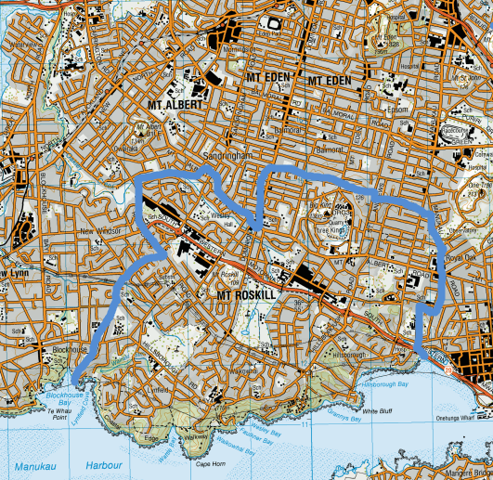
Mt Roskill
Mt Roskill covers a large geographical area in Auckland. It has a wide range of ethnic and age groups, and has approximately 60,000 residents. Mt Roskill’s geography and population size are most likely the reasons that it has taken longer to develop a comprehensive community plan. The first phase of the initiative was to complete groundwork for the plan by carrying out a comprehensive consultation process.
The aim of the Mt Roskill CLD initiative is to build a prosperous, safe, unique and strongly connected community. The Mt Roskill leadership group renamed itself Roskill Together, reflecting its aim of bringing together residents from this large and diverse community. The size of Mt Roskill means the leadership group’s first action was to develop a comprehensive community plan. The first part of this work, a community engagement plan, has been completed. Roskill Together is exploring a local neighbourhood approach to building community engagement. It plans to initiate small local events and projects that will gradually raise the profile of the initiative across the suburb and provide input into the community plan.
So far Roskill Together has:
- started producing a local newsletter with stories about Mt Roskill and information about the CLD initiative;
- talked to residents about CLD at the Roskill South Molly Green family day;
- set up a “wishing tree” that was taken around the suburb to collect residents’ dreams and aspirations; and
- planned a random household survey to gain information for the comprehensive community plan.
By the end of 2013, the leadership group will produce a community plan and implement other activities to build the CLD approach in the community. The group is currently prioritising projects for the coming year based on suggestions generated by the consultation processes to date.
The Roskill Together leadership group recently co-opted new members to replace members who have resigned. This has raised questions within the group about who should be brought in, and also whether they should target residents or local organisations as a way of promoting CLD. Staff from the Department are supporting the leadership group with this issue and providing advice on CLD principles, particularly in relation to the focus on residents rather than groups.
Funding was approved for the Mt Roskill leadership group to develop and implement their community plan. The leadership group’s first progress report, provided in December 2012, showed that a component of this funding was being used to employ a project coordinator and for the activities needed to engage with the community to develop the comprehensive community plan.
In July 2013, the Department’s evaluation staff visited Mt Roskill and attended the leadership group meeting. Representatives from the Indian, Chinese and Ethiopian communities were present at the meeting. The main item on the meeting’s agenda was the Mt Roskill random household survey that was intended to be in the field later in July. The survey aimed to get a clear view of what Mt Roskill residents would like to see happening in the context of CLD. Volunteers to administer the survey were hard to find, and the leadership group agreed to pay part-timers to conduct the survey.
The meeting also decided on the logo for Roskill Together, entries for which were solicited through a competition. After time having lapsed with no tangible project underway, the Chair reflected on the time needed for the leadership group to get to know each other. Once the results of the random household survey are in, the leadership group will start on the community plan.
Currently, no projects have been initiated as a result of the CLD pilot in Mt Roskill. The leadership group are in the process of finalising a draft community plan, which they say will be finished by November 2013. The leadership group have indicated that the final community plan will be finished and submitted to the Department by March 2014.
The Mt Roskill leadership group considers that there are several factors that have inhibited them from completing a community plan. The main reason that no community plan has yet been completed is the geography and population size. With some 16,000 ethnically diverse households and nearly 60,000 inhabitants, Mt Roskill is by far the largest of the five CLD communities. Due to the size of the community, leadership group members are attempting to get the most comprehensive community consultation possible, and this is proving to be an exercise taking time.
The leadership group is planning a detailed community consultation exercise on the draft community plan over the upcoming 2013/14 summer months which is intended to provide all Mt Roskill residents the opportunity to participate in shaping the final community plan. The leadership group are also planning a number of street led activities during this time to further engage the community.

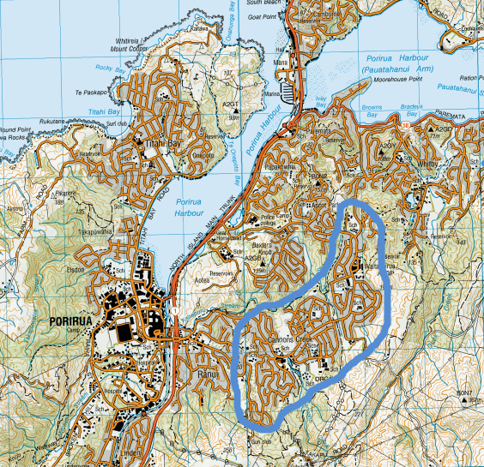
Waitangirua/Cannons Creek
Waitangirua/Cannons Creek (Waican) is located in eastern Porirua. Approximately 12,000 people live in the community and 40 per cent of the population are Pacific peoples and 30 per cent are Māori.
The Department’s staff have been working with the Waican community to determine the future direction of CLD. For several reasons, the community and the Department decided that the way CLD was functioning in Waican was not aligning with fundamental CLD principles.
The key issues identified were that:
- the initiative was not following a CLD approach;
- the leadership group was not functioning effectively; and
- projects being implemented were not necessarily prioritised or supported by the community. The only projects operating at the time the leadership group reported to the Department in December 2012 appeared to be led by individuals who had a specific interest in pursuing them.
Members of the Waican leadership group believed they had received conflicting information regarding their roles and the general principles of CLD from Department staff during the set-up and implementation of the initiative. Due to a lack of clear understanding of the fundamental principles of CLD, the Waican leadership group had been utilising a mix of individual organisation grant methods and service contracting for funding distribution. This meant that rather than utilising a CLD approach where whole-of-community support and buy-in is needed before initiatives and projects can be funded, the Waican leadership group were granting funds to singular community organisations for projects the community had not been properly consulted on.
The Department decided that all projects were to be put on hold and all people and organisations who had lodged a funding request contacted. The leadership group agreed to the Department’s request that an external facilitator be brought in to help them decide on the future direction for the CLD initiative in Waican.
The Department selected a candidate from a list of facilitators suggested by the leadership group to assist them to agree on a future approach. The facilitator was seen as an appropriate fit, as she is a Pacific person, has experience in facilitating community groups and has personal connections in Waitangirua and Cannons Creek. The facilitator was contracted to run up to four workshops depending on the leadership group’s progress in agreeing on how it will proceed in the future. These workshops were run in May 2013.
The facilitator reported back to the Department in June 2013. Her report described that many of the concerns held by the Department were shared by the members of the Waican leadership group and wider community. The workshops resulted in the participants deciding that they needed to first define what CLD is, revisit the Waican community vision and review the structure and purpose of the leadership group. The facilitator reported that there were robust conversations from the workshop participants which resulted in them seeing the need to change, and make clear decisions about what they want for the future of Waitangirua and Cannons Creek.
Workshop participants said that a reason for the lack of progress of CLD in Waican was due to a lack of clear information and guidance from the Department in the early stages of the initiative. Participants said they need better support in the future and asked that Department staff work alongside them during this transitional phase. The Department agreed to support the initiative throughout this phase.
Following the May 2013 workshops, all but three members of the Waican leadership group resigned their positions. The three remaining members decided to continue in their roles (with the assistance of Department staff) until the end of their terms in August 2013. Currently, the Department’s staff are helping to resolve the initial leadership group’s outstanding financial commitments. These have included payments for activities relating to the community language project, arts and sports activities, and resolving proposals which were submitted by community groups prior to the facilitated workshops. The Department’s staff have also contacted the fundholder, Porirua College, to initiate the termination of the grant agreement.
The community’s initial outcomes were to have defined safe areas in the community, enhanced student educational achievement and strengthened cultural identities. To achieve this, the leadership group planned and implemented projects including:
- a healthy lifestyles programme;
- a community sports programme;
- a community language project; and
- a project to develop community arts and crafts.
Now that the Waitangirua/Cannons Creek community is reviewing future direction of CLD, the community will have to identify whether or not the initial outcomes are still the most relevant and desired for them.
The Waican initiative is shifting its focus to individual streets and eventual neighbourhood-wide engagement. Members of the Waican community and local Department staff are planning new rounds of community engagement exercises to try and redefine what outcomes they want. This aims to strengthen greater neighbour connections and collaboration. Department staff have also been exploring a number of options regarding the future of CLD in Waican with key community stakeholders. Feedback received from these stakeholders supports the view that a more successful approach in the Waitangirua and Cannons Creek communities would be a smaller scale neighbourhood initiative, rather than a large scale approach which has been underway to date.

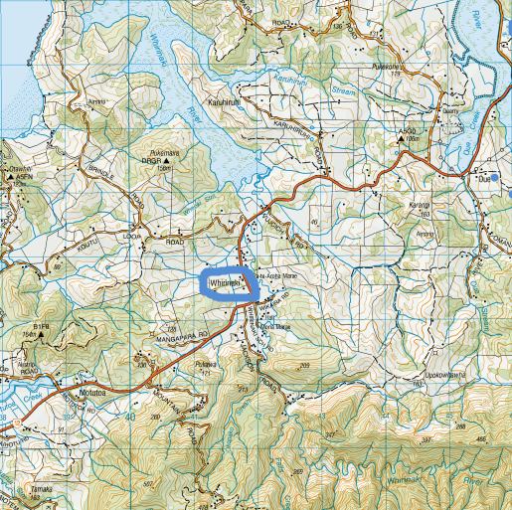
Whirinaki
Whirinaki is a small rural community in the South Hokianga, Northland. Approximately 400 people live in the community and around 90 per cent of the population is Māori.
The community’s vision is for the people of Whirinaki to have healthy lifestyles and to maintain the local culture for all generations.
To achieve this, Whirinaki Toiora is implementing the following projects:
- the Awa (river) Restoration project to improve the community’s water supply;
- the Te Reo o te Hikutu project to increase use of the local hapū dialect;
- the Mokopuna and Rangatahi Project to support the development of leadership within Whirinaki’s youth by providing learning opportunities within and outside of the community;
- the Native Ngahere (forest) and Bird Sanctuary project to establish a nursery for plants to protect waterways and land productivity; and
- the Whirinaki Water Plan Expansion project to maintain the community’s water supply.

Implementing the community plan
The first progress report the fundholder (Nga Manga Puriri Charitable Trust) and Whirinaki Toiora provided to the Department showed that the Awa Restoration and Te Reo o te Hikutu projects were underway and on track. Some initial work has gone in to the Native Ngahere and Bird Sanctuary project and the Whirinaki Water Plan Expansion project.
However, the leadership group has decided the project ideas need further development in the next stage of the community plan.
As a result of the community’s activities so far:
- the local river is no longer full of silt, gravel and debris and has clean, clear, drinkable water and eels and other life have started to return;
- surface flooding has diminished;
- four local men have been employed on projects for six months;
- seventy people have participated in the Te Reo o te Hikutu classes and activities to revitalise the local dialect; and
- there is a “newfound pride in the community and throughout Hokianga”.
In May 2013, Department staff met with the Whirinaki Toiora leadership group to discuss concerns with their current operating structure. Due to difficulties associated with the amount of work and responsibilities required by CLD, the leadership group were beginning to have trouble maintaining community engagement. In order to ensure further engagement of the community, the leadership group reviewed their roles and responsibilities.
The leadership group decided to hire a full-time employee who would be managed by Nga Manga Puriri but work on behalf of Whirinaki Toiora. As the leadership group’s contract with their project coordinator ended in June 2013, the Department’s local staff suggested that the group advertise for a full-time CLD employee. The proposed changes to the roles and responsibilities of the leadership group would ideally help them focus more on community engagement rather than project management.
In July 2013, the Department’s evaluation staff visited the Whirinaki community. Prior to attending the Toiora leadership group meeting, staff visited community project sites. The Department evaluation staff were able to see where work had occurred on the awa during the first phase of the project and then where work would be occurring during the second phase of the restoration. From the roadside bridge, the awa had been noticeably cleared of vegetation and debris which was allowing it to flow freely.

Projects underway
The overall aim of the Whirinaki Toiora initiative is for the people of Whirinaki to have healthy lifestyles and to maintain the local culture for all generations. To begin achieving these desired outcomes, Whirinaki has predominantly focused on two projects; the Awa Restoration and Te Reo o te Hikutu projects. These projects have been identified by the community as being essential to the preservation and development of Whirinaki.
Community members stated that the Awa Restoration project is vital to the environmental outcomes of the area as it is “protecting the waterways and natural ecosystems to ensure sufficient, healthy, fresh water for today and for the future”.
During the first phase of the Awa Restoration project, the community have:
- removed trees and vegetation adjacent to and within the awa;
- trimmed the awa embankment to improve its flow;
- removed gravel and other silt from the river bed and embankments; and
- fenced off the area to reduce livestock from entering the water.
This has proved to be a time and labour-intensive project with dedicated workers hired from the community. Currently, the community is beginning to organise the planting and maintenance of native bush along the completed portions of the awa embankments to ensure the sustainability of the restoration.
The Whirinaki community is also involved in Te Reo o te Hikutu project, providing Māori language and culture classes specific to the local Hikutu hapū dialect. The project has enabled local whānau to develop appropriate local marae protocol and Te Reo skills specific to the Hikutu hapū. The community anticipates that this project will improve community participation, by increasing understanding of the Māori language and increasing its use in formal settings.
The community is focused on investing in the education and development of youth leadership, including positive life choices. To begin achieving this the community has implemented a Mokopuna and Rangatahi project which is providing learning opportunities through a series of holiday programmes, cultural celebrations such as Te Hikutu Kapa Haka Centennial, promoting involvement in community projects such as the Awa Restoration and various educational trips outside of the community. The Toiora leadership group have actively sought input and feedback from the community’s youth for this project. They believe this is encouraging the rangatahi to develop their leadership skills by supporting active participation in the community’s development.
Another environmentally based project for Whirinaki is the Native Ngahere and Bird Sanctuary project. With this project, the community is seeking to protect and enhance the biodiversity of the Whirinaki Catchment Area Forest through the protection of the unique habitat by managing pest plants and wildlife. This project has been put on hold until the completion of the second phase of the Awa Restoration project.
The community has also begun working on a Water Plant Expansion project, which will seek to obtain land easements for the water pipeline across private property. This would provide water to all households in the community and would complete the water supply pipelines to and within the community. This would also enable repairs and maintenance to be carried out as needed. This project will be further developed in the next phase of the initiative.
A focus for the Whirinaki Toiora leadership group is to ensure that all projects are sustainable. The community has noted that they want to ensure the long-term success of their projects with or without government funding. The leadership group believes that in order for this to happen it needs to have the full support of the community. During the September 2013 CLD evaluation focus group, a leadership group member commented:
“In order for the projects to be successful, the community needs to work together, as one. If we can do that in this second phase of the Awa restoration, Te Reo, Mokopuna and Rangatahi projects, there will be sustainability”.
For the next phase of the initiative, the leadership group is considering a range of options and initiatives that will generate capital to allow the CLD initiative to be sustainable in the longer term.

CLD impact
There have been noticeable positive environmental outcomes as a result of the Awa Restoration project, as the water is now clean and flowing smoothly. River life, such as eels, is now seen in the awa where they have not been present for many years. The Awa Restoration project has also contributed to a healthier living environment in Whirinaki as it has diminished surface flooding in the community that occurred on a yearly basis prior to the start of the awa clean-up.
As a result of the Awa Restoration project, the Whirinaki Toiora leadership group as well as the Department’s local staff have noticed the emergence of a more engaged community. The community has begun organising itself to complete the planting and manage the ongoing maintenance of the restoration project.
As a result of the Te Reo o te Hikutu project, a larger portion of community members now feel comfortable reciting their mihi with greater confidence and understanding. Seventy students attended Te Reo o te Hikutu classes, with an average of 30 students per class at the start. People attending the classes have ranged in age, with rangatahi to kaumātua being in attendance.
The Te Reo o te Hikutu project is not only developing community members’ abilities to use the Hikutu dialect in marae protocols, it is also helping to preserve cultural practices for future generations.
During the September 2013 CLD evaluation focus group, Toiora leadership group members discussed the impact to date and what they envisage for the future of the initiative. Leadership group members stated that although the community has faced difficulties during the two years of the CLD pilot, they are now connecting on a new level and are focused on the future. One focus group participant stated:
“There is hope for the future; there is a new sense of coming together. We have learned a lot along the way and we will get there”.

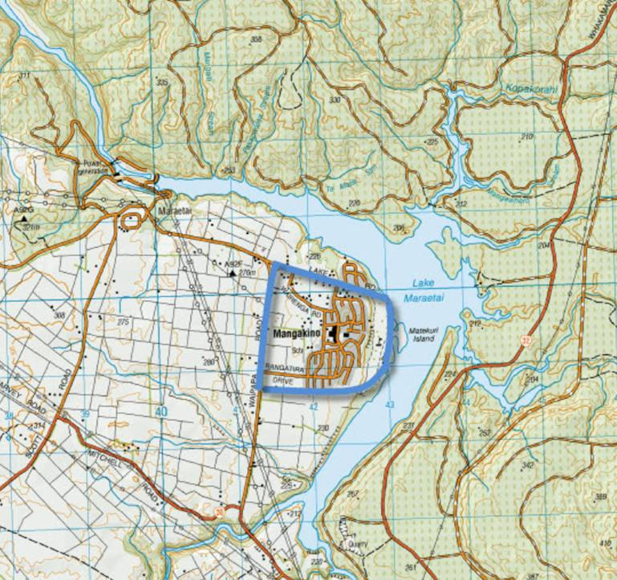
Mangakino
Mangakino is a rural town located on Lake Maraetai in the South Waikato. The usual resident population is approximately 750 and around 60 per cent of the population is Māori.
Mangakino is focused on creating a community of choice which is vibrant, enterprising, caring and connected.
In order to accomplish this, the community is implementing the following initiatives:
- Build Social Capital – Connect, Strengthen and Network Mangakino;
- Pouakani Marae Development;
- Improve Access and Social Connections – Purchase a Community Van;
- Promote Mangakino – Destination Signage and Tourism Radio; and
- Promote, Connect and Involve Mangakino – Providing Community and Visitor Information.

Implementing the community plan
The leadership group has undertaken to reach out to as many residents as possible and is concerned about ways it can connect with residents who have not yet been involved. They have acknowledged the need for Mangakino to have adequate support and human resource to both administer and further develop processes and systems to support CLD in their community. To enable this, the leadership group have been encouraging CLD processes which help build community capacity, connectedness and cohesion. For example, the leadership group have been offering neighbourhood development support focused on engaging neighbourhoods to plan local activities and projects that build community connection and develop local leadership.
Currently the projects are well in hand and the leadership group is working towards completing their next phase of planning. The stage two plan draws from what local people have said are their dreams for Mangakino. The leadership group is particularly focused on how they will actively involve local residents and groups in leading the changes and development that affect them, and to measure the progress they are making towards achieving their outcomes.
In 2013 the Mangakino leadership group decided to hold their meetings monthly rather than fortnightly. Leadership group members said that the length of the fortnightly meetings, coupled with the overall time needed for CLD was beginning to negatively impact on their enthusiasm and motivation for the initiative. With help from local Department staff and their contracted CLD specialist, the leadership group has restructured the general format, reporting methods and frequency of their meetings. This has helped make the meetings more concise and focused. In May 2013 Department evaluation staff were invited to attend the leadership group’s monthly meeting. During the meeting staff were able to see some of the positive impacts that the restructure was having for the group.
In September 2013, Department evaluation staff held a focus group discussion with members of the Mangakino CLD leadership group, community members and other relevant stakeholders. During the focus group, leadership group members discussed how important it has been for them to properly consult with as many community members as possible. Leadership group members acknowledged the difficulties they faced in understanding what CLD actually is, and how vital comprehensive community consultation is to the process. The leadership group members feel that during the two years of the initiative they have been able to increase their knowledge and understanding of CLD principles and processes. As a result they believe they will be able to better consult and engage the community in the future. One leadership group member stated:
“I think we really haven’t touched all of our community residents because like others have said, it’s been a bit hard for us – it was hard for us, to understand where we were and what community leadership, or community-led development, was all about. So, two years down the track I think we’ve got a grasp of it and with the understanding that I have now it’s easier to communicate with our whānau and other groups and organisations”.

Projects underway
Mangakino’s desired outcomes for the CLD initiative are: strengthened social connection; re-establishment of tūrangawaewae; improved access to services; and promotion of the community.
To achieve this, the leadership group has undertaken initiatives that include:
- a project to finish whakairo (carvings) at Pouakani Marae to allow the re-opening of the marae;
- a project to develop tourism radio and local signage to promote Mangakino as a tourist destination and increase visitor numbers;
- a project to improve access and social connection for residents by providing and running a community van service;
- a project to provide community and visitor information to create greater awareness and involvement in services, activities and events in the Mangakino area; and
- building community capability, connection and leadership.
Following the initial rounds of community consultation, the Mangakino community listed re-opening Pouakani Marae as one of its primary goals. CLD funds were budgeted to ensure that necessary works could be completed and the marae re-opened. The community envisioned that the marae complex would be completed in time for its 40th anniversary. CLD funding provided the financial support necessary to complete the whakairo, so that the marae complex could be completed in time for the anniversary.
On 17 November 2012 Pouakani Marae was re-opened, marking nearly five years of work on behalf of the community to rebuild the marae complex after it was destroyed by arson in 2007.
In March 2013 Mangakino residents celebrated Easter and Neighbours Day with community events as a way to continue their ongoing engagement with the CLD initiative. Activities included a raft race on Lake Maraetai, family games and activities, shared meals, pancakes in the park, raffles, an Easter egg hunt and a combined outdoor Easter Church service on the lakefront.
The events were well attended, with over 350 people participating. Feedback to the leadership group was overwhelmingly positive, and summed up by one resident who said:
“It’s so great to have a way to get to talk to each other more so we don’t feel like strangers on the same street”.
The community has decided these will be annual events and is already planning similar activities to continue to build on residents’ sense of belonging and connection to their community.
Residents told the CLD leadership group that they wanted more local activities that would connect neighbours and families, and create opportunities for residents to lead neighbourhood events. As a result individual streets, such as Huamai Street, have planned and held events on their own, with the leadership group and community coordinators offering support.

During the September 2013 CLD evaluation focus group, a resident from Huamai Street said:
“I take my hat off to the leadership group for helping us get started on Huamai Street, they were really wonderful. We are all really grateful for that”.
The Department has worked closely with the leadership group, supporting them to identify the opportunities presented by events such as these to engage with, and bring the community together. The community coordinators, employed by the CLD leadership group, have then supported residents to organise these events.
The community is currently trialling a transportation initiative where they are offering a van for hire at low-cost for non-personal purposes. This initiative has helped foster a relationship between the local school and the leadership group, as the school has offered their under-utilised van for a six-month trial period. This is an indication of collaboration between community groups and asset sharing occurring in the community.
Towards the end of 2013, the leadership group will be further developing the next phase of the community plan. The plan will incorporate the on-going activities currently underway and new initiatives that aim to better include learning and training opportunities to help build social capital and enterprise in the community. In order to develop the next phase of the community plan, the leadership group will be conducting a new round of community consultation and planning. During the September 2013 evaluation focus group, a member of the leadership group commented on the importance of the newest level of consultation and engagement when she said:
“It’s key for our members to be in touch and be out on the ground and actually know how our community works to be able to progress community-led development. So, I think that’s the focus of where we are right now. It’s not about us. It’s about identifying those leaders and for them to come to us with an idea or proposal and them do the work and we help them take that next step”.

CLD impact
During the two year duration of the CLD initiative, significant achievements have occurred in Mangakino as a result of this programme. There have been several community events where the community have been encouraged to plan and organise projects and events themselves, with support from the Mangakino leadership group. These events are enabling community members to share their aspirations and dreams for Mangakino in an environment where they can feel supported and their ideas valued. This is helping to develop new leaders in Mangakino. Huamai Street is a good example of how these community events have encouraged community members to engage, collaborate and share assets to successfully implement and run events and projects together. With the support of the local Council they have utilised a small reserve on their street for their events, and have successfully secured funding to provide play equipment on this site.
The community identified the development of Pouakani Marae as one of its primary CLD projects for the first phase of the initiative. The community hoped that by re-opening the marae they could re-establish tūrangawaewae for the Māori community and begin to foster social cohesion through kotahitanga (unity) and manaakitanga (hospitality).
The Pouakani Marae re-opening ceremony was well attended, with over 700 people in attendance, many of whom were local residents.

One observer commented on the impact and importance of re-opening the marae:
“A lasting image for me was seeing children wrapped in blankets, while older folk supported by their families made their way along the dark streets to the front of the Marae. I recall at an initial CLD Public Meeting one of the Kaumātua shared that he wanted to create the same sense of ‘being one’ as a community that he felt on the morning after the Marae burnt down. I felt that same feeling was re-captured that cool morning last November. It seemed the entire town stood, stared, hugged and cried together”.
Community members have noted that re-opening the marae has had positive outcomes for not only the Māori community, but Mangakino as a whole as it has helped the marae begin to develop leaders throughout the community. During the September 2013 CLD evaluation focus group, a community member stated:
“Re-opening the marae has had some huge outcomes for not only the Māori community, but the whole community as it has helped the marae restructure and develop leaders, not only within but across the community”.
A broader culture of collaboration and leading with others is opening up possibilities to deliver on shared local visions. The Mangakino Area School has worked closely with Pouakani Marae kaumātua and whānau. Over 250 adults and children participated in an open day at the marae in September 2013. Participants acknowledged the value of local education groups working together with the marae, and it is hoped the event will generate more like it in the future. One parent said:
“It was neat how we were welcomed into the wharekai with waiata, let’s do it more often”.
The event signals a further strengthening of connections between the marae, Mangakino Area School, and the wider community.
Along with the development of leaders, greater community connection and participation and re-opening the marae, Mangakino has recorded a dramatic rise in tourist numbers in part due to the destination signage and tourism radio projects. Baseline data for the five-month period of November 2011 to March 2012 showed that 184 campervans entered the community. Following the installation of the tourism radio project there was a 220% increase in campervans entering Mangakino from November 2012 to March 2013. This could be positively impacting on local businesses by increasing the numbers of potential customers coming to town.
In September 2013, the Youth in Emergency Services (YES) programmes was launched in six communities, including Mangakino. The aim of the programme is to open doors for young people to volunteer or follow a career path in the emergency services, and to build connections between young people and their communities.
The Department and the local Ministry of Youth Development staff will be working with Emergency Service groups, employers, education providers, community members and the CLD leadership group, to identify opportunities to connect the YES programme with the community plan themes of earning and learning.

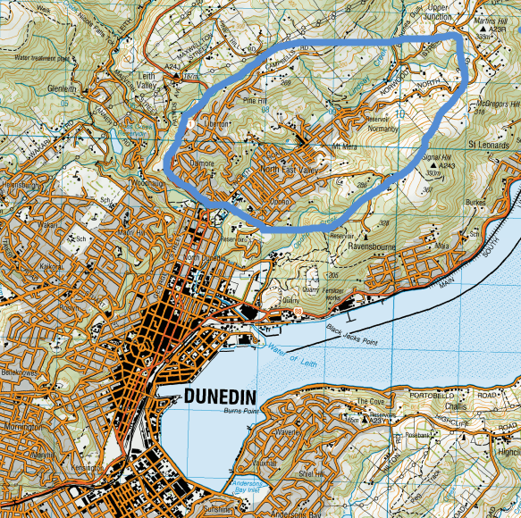
North East Valley
North East Valley is a suburb in Dunedin with a diverse range of ethnic and social groups. Approximately 4,500 people live in the community which has a high proportion of low-income households.
The North East Valley (NEV) project focused on three main outcomes developed during the first year of the CLD initiative which they considered would contribute to the overall outcome of increasing community connection and participation.
Projects covering the three outcome areas are:
- the renovation of buildings;
- purchase of two community vans; and
- set up of an office/community rooms and employment of dedicated community workers.

Implementing the community plan
The NEV leadership group, also known as the Executive, is continuing to run a range of events to get more people involved in the community. The Executive is continuing to consider different ways to involve people from a more diverse range of backgrounds.
The Executive noted that the community is learning that results can come from their ideas, resulting in a sense of empowerment. The Executive believes that empowering the members of the community leads to a greater sense of hope, which is leading to further change because residents believe that their voice matters and that their community matters. One member of the Executive commented on this by stating:
“The community feels that it is worth having ideas now; they are not just pipe-dreams”.
The Executive has compiled an extensive collection of the community’s ideas which have been collated thematically. For the next phase of the CLD initiative, the leadership group is focused on creating a new level of community engagement. They have found that it has been easy for the community to generate new ideas for community projects, so the leadership group is now looking to take these ideas a step further. The Executive view the NEV project as a movement rather than an institution, and they encourage bottom-up, inclusive and organic processes. In staying true to this approach, the leadership group are trying to enlist “community-thinkers” to begin to envision exactly what they believe these ideas will look like.
A current focus for the community is to increase economic development in NEV by creating a more visually appealing business centre. The community has been trying for a number of years to get local business owners, and owners of vacant properties along the main thoroughfare, North Road, to improve their overall appearance to increase the economic potential of the area. The community is now utilising CLD funding to begin repainting structures and place artwork in vacant shop fronts. The community believe that this beautification of the NEV business centre will lead to better economic opportunities. Social enterprise initiatives are some of the opportunities the Executive is thinking about.
The Executive is currently working through employment issues in relation to the coordinator’s role. These issues are proving to be a valuable set of learnings for the leadership group, as they look to employ further community workers in the future.

Projects underway
Activities the Executive has undertaken to achieve its outcomes include:
- purchasing two community vans, used for a range of activities including transporting children to and from sporting and educational activities;
- renovating a building as a hub for residents’ community activities; and
- developing community gardens in the Valley.
As the community projects grow in size and momentum they are beginning to interact and overlap with other community groups. According to the Executive, this is leading to new membership and a “cross-pollination of community projects,” fostering active cooperation between different projects.
In May 2013, Department evaluation staff visited NEV’s community rooms and toured the Valley to see some of the projects underway. Specifically, staff visited different community orchard sites coordinated by Transition Valley 473 Community Orchards at the Pine Hill School grounds and Chingford Park. Department staff spoke to the Principal of Pine Hill School who mentioned that the school used the community vans to take students to Dunedin’s swimming pool. The vans are also being used to take residents without transport to the supermarket for weekly shopping, and a host of other community activities.
At the community rooms, a prefab on the NEV Normal School grounds funded from the CLD budget, members of the Executive outlined some of the projects that are planned for 2013/14. A visit to the near-by community garden was made. The community garden was developed after draining a former school sports ground and has attracted many volunteers who have created vegetable beds for the wider community to share. The community garden received a TrustPower Community award in 2013.
In September 2013, the Department’s evaluation staff held a focus group discussion with members of the NEV Executive and relevant community stakeholders. The focus group wanted to hear about the ways the NEV Executive and community are implementing their most recent community plan, and to discuss any learnings and impacts that have arisen as a result of CLD projects. Focus group participants discussed how much the members of the NEV community like bringing forward new ideas for possible community projects. One participant commented on how much community members appreciate the projects occurring in NEV as a result of CLD:
“People in the Valley are just happy to see that positive things are occurring here”.

CLD impact
During the two years of the CLD initiative in NEV, greater interest and involvement has been noticed at events and activities held within the community. An example of this was the Matariki Hangi held in 22 June 2013. Over 270 people attended the event. Executive members and stakeholders have also received informal feedback from fellow NEV residents that having community projects and events makes it easier to become and feel like active members of the community.
There has been recognition of the work happening in the Valley within the wider Dunedin area. The Dunedin City Council (DCC) has now appointed a liaison person to support the NEV project by working directly with the Executive. This shows that the DCC views the Executive as the “voice” of the NEV community, giving further credibility to the NEV project. DCC staff and management have also taken a tour of the area to view current projects underway, and to assess how they can work closer with the project. During the September 2013 evaluation focus group, the importance of the collaborative work between the DCC and the Executive was discussed. One member of the Executive commented on the importance of collaboration with other Dunedin organisations (such as DCC) when they stated:
“With having stronger initiatives and wanting to do more things that result in bigger change for the community, we have to be able to ask people and organisations for support. For example, our relationship with Dunedin City Council has really grown. That support, and having a liaison person from the council who knows the Valley we can go to directly is vital. Dunedin is amazing like that. There are so many resources here, and I think we are really beginning to tap into that for the betterment of the community”.
The Executive and local Department staff have also noticed that community connection and participation has been fostered through the newly completed community rooms, and the purchasing and utilisation of two community vans. The community rooms provide members of various community groups with space to hold meetings and events at low cost. The community vans provide transportation opportunities for members of the community who would otherwise have none. The vans have literally become a vehicle for community interaction where new connections can occur amongst residents.
The NEV Executive feels that over the past two years of the CLD initiative, they have grown together as a group. Working together has helped the group grow and feel more comfortable being the “voice” of the community. Having a centralised “voice” of the community is helping to progress relationships and networks within NEV as well as the wider Dunedin community. During the September 2013 evaluation focus group session one member of the Executive stated:
“We, the Executive, are all different; we work in different ways and have different backgrounds and do not always agree homogenously, but isn’t that representative of a community?”
While the community is now focused on seeing their dreams become reality, members of the Executive are focused on action.

Conclusion
While it is still too early to assess the outcomes of the CLD pilot as a whole, positive community outcomes are beginning to emerge as a result of the CLD approach and the support, advice and funding provided by the Department.

The Department’s implementation of CLD
Following the Year 1 evaluation (which was focused on the Department’s role within the implementation of the CLD pilot), a more extensive learning and development plan was developed to support staff involved in the pilot. Throughout Year 2 of the CLD pilot, Department staff have been offered opportunities to further their knowledge of CLD principles and practice, through a range of workshops with national and international experts and in-house opportunities provided by the Department. This has enabled the community advisors involved in the CLD pilot to better support and advise the five CLD communities. These learning and development opportunities have been extended to all community advisors, not just those involved in the pilot, resulting in a much wider understanding of the CLD approach throughout the Department’s Community Operations group.
Evidence for improved communication about CLD principles and practice by community advisors emerged during this year’s focus group discussions with communities. The communities noted their appreciation of the community advisors’ role in supporting and providing advice, as they have progressed through Year 2 of the CLD pilot. One example was that community leadership groups now have a greater appreciation for the importance of ongoing and timely consultation with the wider community. They believe this was a direct result of the support and proactive guidance provided by the community advisors. This can be seen as a direct result of the Department’s implementation of the learning and development programme.
As the CLD pilot progresses and the Department’s learning and development programme progresses, the ability of the Department’s staff to deliver the CLD approach will continue to develop.

Slow progress
Following two years of implementation, it has become evident that little progress with completing community plans was made in the Mt Roskill and Waitangirua/Cannons Creek communities. The primary factor is the size of the community. This has directly impacted on the pace in which CLD has been implemented. In these two larger communities, the development of community plans has proven to be difficult and more time has been needed to consult with the wider community. As a result, no projects are currently underway in either Mt Roskill or Waitangirua/Cannons Creek.

Emerging community outcomes
Community outcomes are being realised in the three communities that have implemented a community plan and have projects underway (Whirinaki, Mangakino, North East Valley). The emerging community outcomes can be characterised as tangible and intangible.
The tangible community outcomes relate to the actual physical change residents can see occurring to their communities as a result of CLD funding. Examples include:
- the Awa Restoration project in Whirinaki has created a healthier physical living environment for the communities’ residents as surface flooding has ceased;
- the work done to re-open Pouakani Marae is enabling the wider community of Mangakino to utilise the marae in new ways and is inspiring collaboration between community groups; and
- the construction of community rooms in North East Valley that are a community hub and meeting place for local residents and groups.
These tangible outcomes are direct impacts of the CLD approach and funding.
The tangible outcomes have in turn enabled intangible outcomes to occur in Whirinaki, Mangakino and North East Valley. The intangible outcomes as a result of the CLD approach may be harder to define, as they are not something that may be readily seen. Intangible outcomes relate more to the actual development of residents, rather than the development of the physical environment of a community. In fact, some CLD community residents have said they feel that the changes which could be categorised as intangible outcomes are actually more important to the sustainability of any development in their communities, as they can occur with or without funding.
The emerging intangible community outcomes show that across these three communities there is:
- a greater sense of community;
- a greater cohesion within community; and
- more collaboration among residents and groups.
This can be credited to the CLD principle of a “whole of community” approach. This approach has required the residents in the communities to work collaboratively to define the issues they hope to address and what the subsequent community outcomes would be as a result. The collective goal-setting embarked on by the communities has led to a greater sense of resilience as further engagement among communities’ members occurs. New leaders are also emerging as residents feel that they can have a positive impact upon their surroundings and that their ideas, or “dreams,” for their communities can be realised. As the CLD pilot continues and is allowed more time to mature in each community, both tangible and intangible outcomes will become increasingly evident.

Appendices

Appendix 1: Definition of community-led development
Community-led development is typified by broad community engagement to identify shared issues and concerns, and to generate local solutions. The underpinning philosophy is one of community empowerment, and self determination.
This approach focuses on communities as a whole, rather than on specific programmes or activity, with funding directed at a “whole of community” level, crossing sector and programme boundaries, so that priorities can be addressed in a comprehensive way. It recognises the connections between the wellbeing of communities (social, economic, cultural, environmental), and that of individuals, families, hapū and iwi – rather than responding to present issues or priorities in a piecemeal way.
Communities are encouraged to work in collaboration and partnership, share resources, skills and expertise, and grow their own capability to meet current and future challenges. A community-led development model is consistent with the Department’s current work, which may be best described as a community-driven and “bottom up” approach focusing on a community's strengths. The model will mean a change to business practices. The Department will build on its core expertise by strengthening its role as community development enablers in local communities, consolidating its funding base to make larger more deliberate investment in communities, and taking a strategic longer-term partnership approach to working with communities.
It is envisaged that the model will include provisions for the following key elements:
- a broad-based community visioning and planning process to identify and prioritise community needs and aspirations;
- a three to four year funding focus – recognising that community development takes time and that it can be resource intensive;
- funding for activities identified through the planning process (such as development of infrastructure, provision of and improved access to health, employment and youth development services, environmental projects); and
- identification of a suitable existing organisation within the community that can act as a fund-holder, the employer of a community worker with strong links to the community, and to potentially house a “steering group/community governance group” or similar structure to oversee the development and implementation plan.
The model will ultimately provide for a localised cluster of initiatives within the community that aim to respond to needs, identified through the community visioning and planning process.

Appendix 2: Definition of action research
The Department of Internal Affairs’ approach to action research is that action research is a cyclic process of planning, acting, observing and reflecting, as illustrated in the diagram below. Learning happens in the reflection stage and can be applied to future planning, acting and observing.
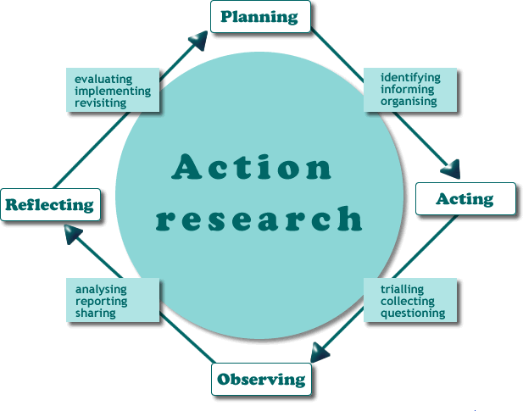
Action Research cycle
Source: New South Wales Department of Education and Training
At each point in the process there is a focus on:
- participation – having community members actively involved;
- information gathering – seeking out information on what is working / what is not working;
- empowerment – ensuring that the community is directing the process; and
- social change – ensuring that initiatives and actions are aimed at achieving the community’s aspirations.
When undertaken by a whole team, action research is intended to:
- help build a learning community in and around a community;
- be used in areas, or for issues, that are complex and open-ended;
- result in deep-level understanding of change – not a “quick fix”; and
- have teams that work in ways that mirror what the research says works.
By working through an action research cycle, the community increases its knowledge of itself; of what works locally (and what does not work); and of what the next steps will be. Using action research helps communities make informed choices and stay in control of their own development.

Appendix 3: Evaluation focus group discussion guide


Focus Group Discussion Guide – September 2013
This focus group discussion, in which you have agreed to participate, will treat everything that is being said as confidential. Also, in subsequent reports you, as participant, will not be identified of what you have said. We are interested only in what is being said, not who is saying it. For reporting purposes, the discussion will be audio-taped. After transcription, the audio-tapes will be deleted. Does anybody have any questions about this? Are there any objections to this procedure? If not, shall we start the discussion.
Questions:
- What has been your involvement to date with the community-led development initiative?
- In what ways is your community plan being implemented?
- What projects are underway initiated by the community-led development initiative?
  - How are these projects related to the outcomes listed in your community plan?
  - How would you gauge community engagement with current community-led development projects?
- What investment / funding of community projects has been made to date?
- Do you believe the funding has provided good value for money?
- What learnings have occurred as a result of the community-led development initiative?
- Have these learnings impacted your planning for future CLD projects? If so, in what ways?
- How well did the Department define for you what “community-led development” is?
- What resources, processes or skills did they use to support and increase knowledge of community-led development?
- What are your views on the facilitation and support provided by the Department?
- What could the Department have done better to support Community-led Development?
  - What other resources, processes or skills could have been used to support Community-led Development
- Do you have any other observations about the CLD initiative in your community?

Department of Internal Affairs, Implementation of the Community-led Development. Evaluation Report, December 2012 – available at www.dia.govt.nz.
In the CLD pilot, Mt Roskill is defined as being within the electoral boundaries of the Puketāpapa Local Board.
It is important to note that over half of Mangakino’s ratepayers are non-residents.
Excerpt from the Cabinet Paper “Reprioritising COGS Funding to Support Community-led Development” SOC(11)6. Pages 5-6

