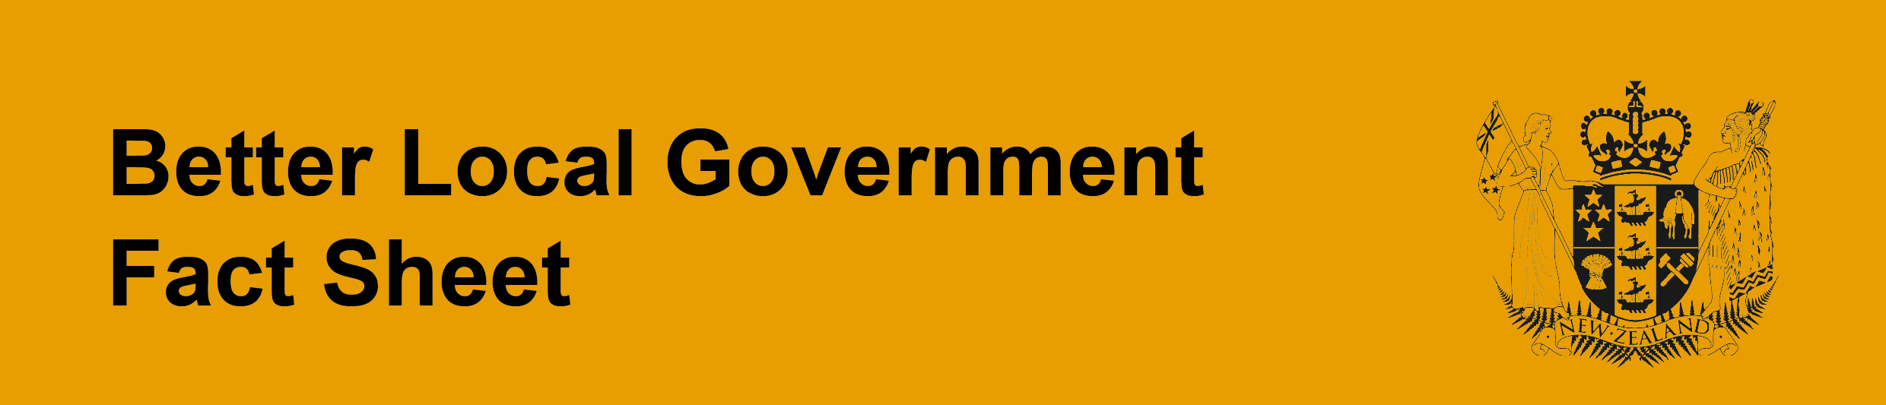
Changes to the way councils are governed
Introduction
In March 2012 the Minister for Local Government announced a reform programme for local government. The programme is part of the Government’s broader economic growth programme, and is designed to improve the efficiency and effectiveness of local government. Called “Better Local Government”, the programme consists of two phases. The first of these phases has resulted in changes to the Local Government Act 2002.
This fact sheet explains the changes relating to how councils are governed.
What’s new?
Menu of assistance and intervention options
There is now a “menu” of ways the Minister can step in to help councils deal with crises – or avoid them altogether (see fact sheet: Ministerial powers to help councils). The Minister will publish, in the NZ Gazette, a list of matters to be considered when deciding whether assistance or intervention is required. Councils can also ask for help.
The menu of options only applies to local authorities - if there is an issue with a council-controlled organisation it will be up to the relevant council to manage that.
Mayoral powers
Mayors now have powers similar to those of the Auckland Mayor (see fact sheet: New powers for mayors). These are tempered by powers of full councils to disestablish a committee established by a mayor, or remove any chairs the mayor has appointed from that position. The new powers are not available to regional council chairs as they are not directly elected by voters.
Other governance arrangements
Councils can set policies on staff numbers and their pay; must review those at least once every three years; and must include information on the number of staff employed by salary bands, in their annual report. These changes will make it easier for councillors and ratepayers to assess their council’s financial health and will promote better financial decision-making.

