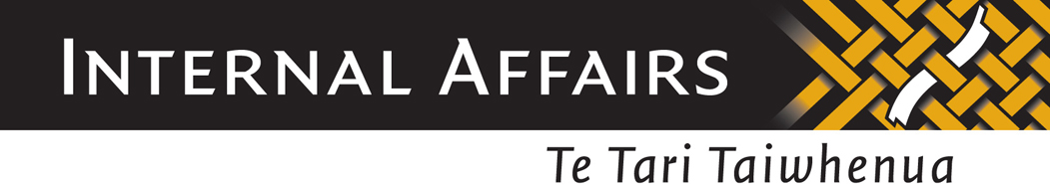

DEBT COLLECTION

The overall risk assessment rating for Debt Collection is LOW.

The activities listed in the table below will help you recognise the risk that money launderers could use your business.

The table does not cover every way a money launderer may work. It reflects ways that money launderers have acted in the past. We encourage you to think about other situations that may apply to your specific business.
Transactions or activities listed in the table may not necessarily signal money laundering if they are consistent with a customer’s legitimate business.
Based on knowledge of your own business you should decide what risk particular customers or transactions pose and how you can recognise that risk.

 | HIGHER RISK CHARACTERISITCS | LOWER RISK CHARACTERISITCS
Nature and Complexity of the Business | Payments received in the form of cash; | Repayments made by direct debit;
 | Cross-border transactions;
Types of Customers dealt with | Customers who act in collusion with debtors, or issue fictitious invoices; | Customers based in New Zealand;
 | Individuals linked to organised crime;
Methods by which services are delivered to customers | Third-party involvement in carrying out the transaction; | Whole transaction carried out by one service provider;

