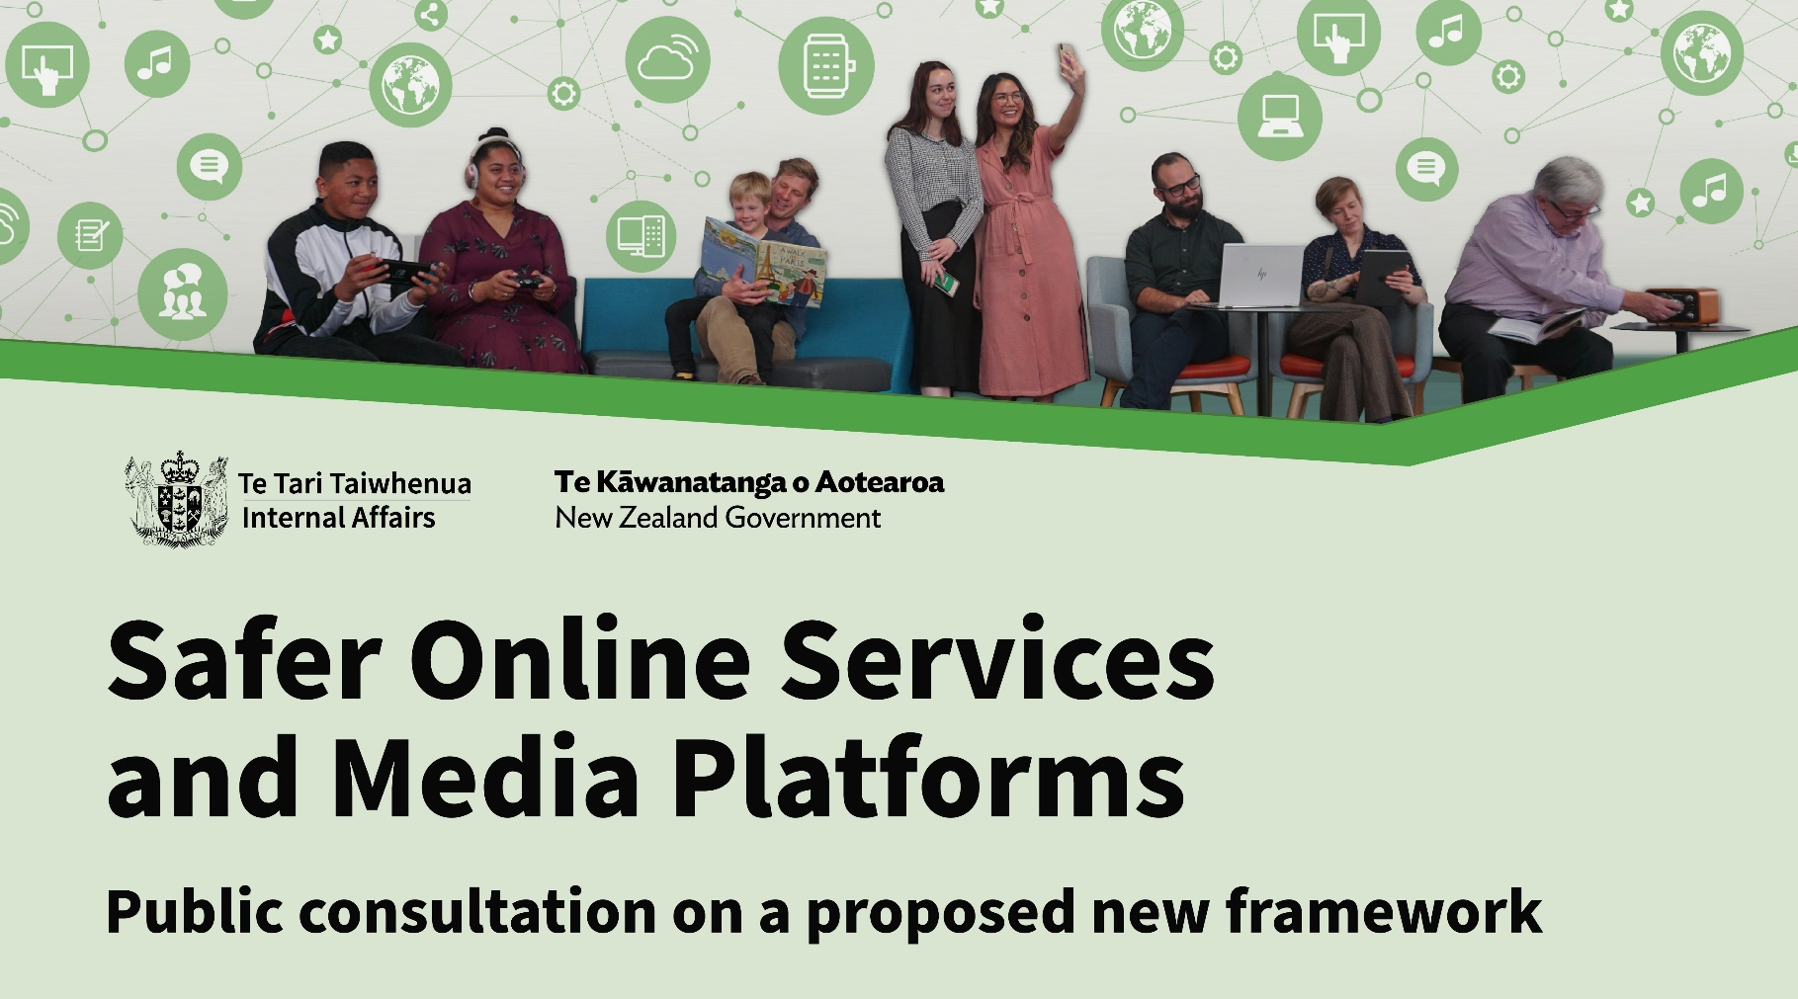

|  |
| --- |
| The questions in this form follow the structure of the discussion document.  You do not have to answer all the questions, even though we are interested in your opinion on all the topics we discuss.  The closing date for submission is **31 July 2023 NZDT** |
| All submissions will be kept by the Department of Internal Affairs. The Department may publish the submissions it receives and provide a summary of them on its website [www.dia.govt.nz](http://www.dia.govt.nz/). This would include your name or the name of your organisation, but not your contact details.  Submissions may be subject to requests under the Official Information Act 1982. Personal details can be withheld under this Act, including names and addresses. If you or your group do not want any information contained in your submission to be released, you need to make this clear in the submission and explain why. For example, you might want some information to remain confidential because it is commercially sensitive or personal. The Department will take your request into account.  The Privacy Act 2020 governs how the Department collects, holds, uses, and discloses personal information about submitters and their applications. Submitters have the right to access and correct their personal information. |

|  |
| --- |
| **Definitions in the proposals** |
| **1. What do you think about the way we have defined unsafe and harmful content?**  Click or tap here to enter your feedback. |
| **2. Does the way we have defined unsafe and harmful content accurately reflect your concerns and/or experiences relating to harmful content?** Click or tap here to enter your feedback. |
| **About our proposed new framework to regulate platforms** |
| **3. Have we got the right breakdown of roles and responsibilities between legislation, the regulator and industry?**  Click or tap here to enter your feedback. |
| **4. Do you agree that Government should set high-level safety objectives and minimum expectations that industry must meet through codes of practice?**  Click or tap here to enter your feedback. |
| **5. Do you agree with how we have defined ‘platforms’? Do you think our definition is too narrow, or too broad? If so, why?**  Click or tap here to enter your feedback. |
| **6. We are trying to focus on platforms with the greatest reach and potential to cause harm. Have we got the criteria for ‘Regulated Platforms’ right?**  Click or tap here to enter your feedback. |
| **7. Do you think we have covered all core requirements needed for codes of practice?**  Click or tap here to enter your feedback. |
| **8. What types of codes and industry groupings do you think should be grouped together?**  Click or tap here to enter your feedback. |
| **9. Do you think some types of platforms should be looked at more closely, depending on the type of content they have?**  Click or tap here to enter your feedback. |
| **10. Do you think the proposed code development process would be flexible enough to respond to different types of content and harm in the future? Is there something we’re not thinking about?**  Click or tap here to enter your feedback. |
| **11. What do you think about the different approaches we could take, including the supportive and prescriptive alternatives?**  Click or tap here to enter your feedback. |
| **12. Do you think that the proposed model of enforcing codes of practice would work?**  Click or tap here to enter your feedback. |
| **13. Do you think the regulator would have sufficient powers to effectively oversee the framework? Why/why not?**  Click or tap here to enter your feedback. |
| **14. Do you agree that the regulator’s enforcement powers should be limited to civil liability actions? (For example, issuing formal warnings and seeking civil penalties for non-compliance)**  Click or tap here to enter your feedback. |
| **15. How do you think the system should respond to persistent non-compliance?**  Click or tap here to enter your feedback. |
| **16. What are your views on transferring the current approach of determining illegal material into the new framework?**  Click or tap here to enter your feedback. |
| **About the regulator** |
| **17. Should the regulator have powers to undertake criminal prosecutions?**  Click or tap here to enter your feedback. |
| **18. Is the regulator the appropriate body to exercise take-down powers?**  Click or tap here to enter your feedback. |
| **19. Should takedown powers be extended to content that is illegal under other New Zealand laws? If so, how wide should this power be?**  Click or tap here to enter your feedback. |
| **20. If takedown powers are available for content that is illegal under other New Zealand laws, should an interim takedown be available in advance of a conviction, like an injunction?**  Click or tap here to enter your feedback. |

|  |
| --- |
| **Summary of potential roles and responsibilities under the proposed framework** |
| **21. What do you think about the proposed roles that different players would have in the new framework?**  Click or tap here to enter your feedback. |
| **22. Have we identified all key actors with responsibilities within the framework? Are there any additional entities that should be included?**  Click or tap here to enter your feedback. |
| **What would the proposed model achieve?** |
| **23. What do you think about how we’re proposing to provide for Te Tiriti o Waitangi through this mahi? Can you think of a more effective way of doing so?**  Click or tap here to enter your feedback. |
| **24. Do you think that our proposals will sufficiently address harms experienced by Māori?**  Click or tap here to enter your feedback. |
| **25. What do you think about how rights and press freedoms are upheld under the proposed framework?**  Click or tap here to enter your feedback. |
| **26. Do you think that our proposals sufficiently ensure a flexible approach? Can you think of other ways to balance certainty, consistency, and flexibility in the framework?**  Click or tap here to enter your feedback. |
| **Are there any other points you would like to raise?** |
| Click or tap here to enter your feedback. |

|  |
| --- |
| Thank you for providing your feedback.  Your feedback will help us understand whether our proposals meet the needs and expectations of New Zealanders.    **Submissions close on 31 July 2023 NZDT.**    If you have any questions, please contact [sosmp_consultation@dia.govt.nz](mailto:sosmp_consultation@dia.govt.nz) |