Visits and Ceremonial Office Flag Protocol
Where flags are required to be flown during a visit, for example, during a press conference or an official call by a Head of State or Head of Government, the protocol is to place the flag of the visiting country on the right shoulder of the New Zealand host (i.e. visitor on the left and New Zealand on the right when viewing the front of the stage).
During the event, the visiting guest of honour should be positioned in front of their country flag and the New Zealand host in front of the New Zealand flag.
See below diagrams:

Press Conference
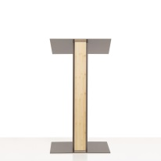

Front of Stage
Visitor
New Zealand

Bilateral Discussions
Window
Visitors
New
Zealand

Official Photo
Official Photographer
Visitor
New Zealand

Cross Over Flags (can be used for State Dinner/Lunch, formal photos, bilateral discussions)

Visitor
New Zealand
Official Photographer

