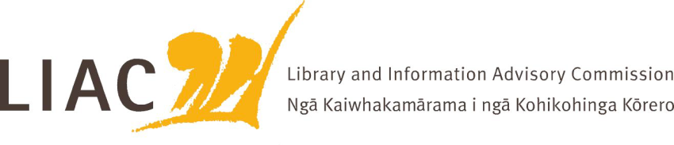
Summary of meeting – 30 June 2023
The June meeting was held face to face in Wellington. Apologies received from Mark Boddington.
- LIAC activities and work programme
- Future workplan to be updated to include consideration of future role of libraries and implications for future library education needs
- LIAC session at 2023 LIANZA Conference confirmed, to seek sector insights about issues of greatest concern
- Support for Information Studies Programme at Victoria University of Wellington and the strategic importance of this programme
- Response from Hon Duncan Webb indicates that future timing of Copyright Review not yet confirmed
- LIAC to prepare post-election briefing papers for the incoming Minister
- Future LIAC meetings will be a mix of face to face and remote to minimise carbon footprint through travel

- Te Pouhuaki National Librarian update
- Ongoing concerns regarding funding of Te Puna and APNK, options to be considered. LIAC will address strategic importance of APNK with the Minister
- Construction of enabling structure from new Archives building is underway, efforts being made to minimise impacts on staff and customers of the Molesworth Street building
- Proposed changes to Public Lending Right regulations are delayed at Cabinet stage
- Co-operation Agreement to be signed with the National Library of Australia
- Te Ara Tahi business case is further addressing how best to achieve the vision. Current focus on people and partnerships, public engagement, and digital services and delivery, including analysis of future physical and digital storage needs. Question of location of storage of digital taonga
- NZLPP wrap up. Final grants allocated. Importance of capturing programme achievements, learnings and opportunities as basis for future planning and advocacy
- Literacy and learning strategy presentation – Commissioners welcomed the greater emphasis on those children who are underserved, especially Māori, and are keen to see consideration of a broader range of future service delivery options

- Mātauranga Māori
- Update on the Mātauranga Māori pillar within Te Ara Tahi and its focus on building capacity, capability and engagement
- Consideration of LIAC’s position statement on Mātauranga Māori and how to take it forward
- Further conversations to be held to consider this

- Safer Online Services and Media Platforms review
- Briefing about the Digital Content Regulation Review report, background and recommendations
- Commissioners welcomed the report and directions. LIAC will prepare a brief submission touching on the role of libraries, the importance of including diverse voices in the development of Codes of Practice, oversight of the regulator role and importance of regular evaluation and review.

