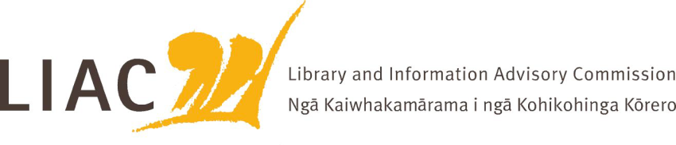
Summary of meeting – 6 October 2023
The October meeting was held remotely.
All Commissioners were present.

- Te Pouhuaki National Librarian update
- Te Ara Tahi update – ongoing management of impacts of Tāhuhu building construction to minimise customer and staff impacts; funding of joint visitor experience between Archives and NLNZ including He Tohu is of concern; programme alignment with NALI objectives
- Fiscal constraints required of wider public service
- Removal and Disposal Policy is close to completion following extensive consultation
- Report of attendance at IFLA World Library and Information Congress and the Conference of Directors of National Libraries, both in Rotterdam, and visit to British Library. Key themes included use of AI in libraries, legal deposit and storage

- Mātauranga Māori
- Komiti Māori chair Evelyn Tobin joined Commissioners to share her work on the original LIAC Mātauranga Māori position statement, its context and importance, and thoughts on how to strengthen it for the future.
- Whaea Evelyn reminded Commissioners that the National Library Act of 2003 was the first instance where Te Reo Māori terms were enacted in legislation – kaitiaki, Mātauranga Māori, taonga. It is important to continue to honour this milestone.
- The title Te Pouhuaki which is gifted to the role of National Librarian was explained as meaning opening the doors, as an open invitation, the person responsible for ensuring the doors to Te Puna Mātauranga are open.
- The meaning of Ngā Kaiwhakamārama I ngā Kohikohinga Kōrero will be further explored

- Te Pūkenga libraries
- Representatives from the 13 libraries that have been included in Te Pūkenga provided an update on progress to date in the amalgamation process which is underway, along with a summary of opportunities and challenges
- The librarians have taken significant steps building on their history of collaboration to find ways to support staff and students across the polytechnics and ITO’s, to extend the range of resources available to them, and make their voice heard in the wider organisation
- The lack of a common student enrolment system and a common library management system are significant barriers which need urgent attention
- The positioning of libraries within the wider organisational structure is not yet clear

- Digital Public Service
- Staff from the Digital Public Service branch (DIA) attended to provide updates on their work in relation to digital equity and cloud-based management of data relating to taonga. The role of the branch is to support the work of the Government Chief Digital Officer
- DPS provides extensive research and support relating to digital equity. LIAC noted the opportunities for DPS and APNK to work more closely together.
- DPS will shortly release guidelines relating to cloud based storage of data relating to Māori and taonga. These are based on extensive consultation with iwi. There will be a programme of training about the guidelines. LIAC suggested that libraries as publishers and repositories of such data should be included in this training.

- Future of library education
- LIAC is concerned about the sustainability of professional education for libraries and other areas of the GLAMMI sector in Aotearoa, given funding constraints faced by the tertiary education sector, the challenge of reflecting rapidly changing roles and learning needs, and the importance of delivering knowledge unique to Aotearoa in these fields.

- Commissioner activities
- LIAC will conduct a workshop on Tuesday 31 October at the LIANZA Conference in Christchurch. The workshop will seek insights about topics of interest, concerns and opportunities to help inform LIAC’s work.

