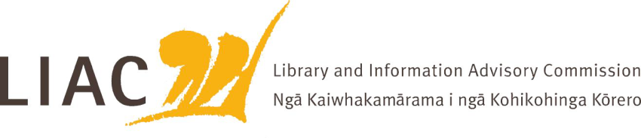
Summary of meeting – 17 September 2025
The September meeting was held online. All Commissioners were in attendance. Laurinda Thomas resigned as a Commissioner before this meeting due to her appointment as Director Archives at DIA.

- Te Pouhuaki National Librarian update
- LIAC met with the 2 remaining newly appointed Directors for Archives Library New Zealand to learn about their backgrounds, roles and priorities in the new structure.
- Updates were provided on the move to the new building and reopening of temporary reading rooms; implementation of the new structure; budget responses.
- A range of activities to celebrate the 60th anniversary of the National Library are planned.
- Membership of the Strategic Advisory Forum is being broadened. LIAC’s representation is to be considered.
- Opportunities for ALNZ in relation to public records, data, digitisation, access and AI to be explored

- Mātauranga Māori Position Statement
- The revision of the LIAC Position statement on Mātauranga Māori was adopted.
- The new position statement will be published on the LIAC webpage.

- Pay equity
- Commissioners were updated on the approach to pay equity across the library sector and impacts of recent changes to pay equity legislation, including claims for library assistants and librarians which were close to resolution.
- A small number of agencies have been able to proceed to apply pay equity, however most have halted their claims and are considering how to proceed. Coordinated effort, Information sharing and transparency have been affected. There is a risk of embedding further pay inequity and skewing recruitment.

- Te Puna building works and customer research
- Commissioners were updated on remaining building works to be undertaken to the National Library building Te Puna to achieve the overall campus vision of shared resources and connected spaces alongside Te Rua, including extended customer reading rooms.
- Final design work is underway, with construction expected for the period July 2026 – April 2028 pending final approval.
- Careful planning and communication will be required to minimise customer, staff and service disruption. representatives provided an update on their organisation, key focus areas and challenges.
- Customer research has been undertaken to inform redesign of these services and spaces, however it can also be applied to wider service design approaches for both physical and online spaces.

- Commissioners’ activities
- No correspondence has yet been received from the Minister in response to LIAC advice. Commissioners have not yet met with the Minister.

- Next meeting
- Next meeting is scheduled for 11 December.
- Topics for the next meeting in Wellington include: Communities of Readers research; Tour of Te Rua; Pacific Virtual Museum

