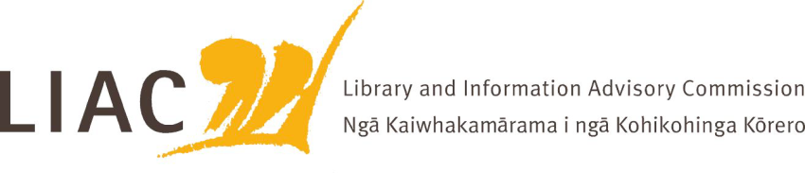

Summary of meeting – 14 May 2026
The May meeting was held online. All three current Commissioners were in attendance.

- Te Pouhuaki National Librarian update
- Te Kahu opened very successfully on 25 March, led by Minister van Velden and with several international guests from national libraries and archives present.
- A panel discussion Disruption, trends and transformation; libraries and archives leading change, and featuring these international guests, was held that evening, attracting a very large Wellington and online audience. https://natlib.govt.nz/events/panel-talk-disruption-trends-and-transformation-libraries-and-archives-march-25-2026
- An update was provided on ongoing building upgrade works. Contracts for remaining building work for reading room development as part of the campus are in progress.

- ALNZ business model and strategy development
- Commissioners had the opportunity to comment on initial work on an ALNZ digital strategy and review of support for schools.
- Work on a property strategy is progressing

- Deputy Secretary Partnerships and Commissions Te Aukaha update
- Hoani Lambert attended the meeting to provide an update from the Partnerships and Commissions Te Aukaha Branch of DIA.
- Hoani summarised recent key achievements, including conclusion of Te Ara Tahi programme, Anzac Stories, and Ministerial visits to ALNZ.
- Hoani provided a summary of wider issues, including budget targets, possible machinery of government review changes, AI impacts and opportunities, and digital opportunities.

- Public Lending Right Regulations amendment
- Commissioners were updated on current consultation with key stakeholders to amend some aspects of PLR regulations this year.
- While this may address some issues, LIAC emphasised the importance of a full review and substantive change of the Act and Regulations to address 21st century opportunities relating to digital copies and streamlined administration which would benefit both authors and National Library.

- Copyright review
- Update on copyright review received. Importance of focus on areas such as orphan copies and public good rights remains.
- ALNZ staff also provided a comprehensive and excellent overview of complexities and opportunities arising from the intersection of AI with copyright practice, and implications for future legislative considerations.

- Commissioners’ activities
- There are currently 3 Commissioners – Spencer Lilley, Michelle Blake and Allison Dobbie (Chair). Recruitment for LIAC vacancies continues.
- The draft scope of work was agreed. This work will now be paused until there is a full complement of new Commissioners to test thinking. There are 4 key themes: National Library long term direction; Strong and literate communities; Information futures; Sector awareness and sustainability
- No correspondence has yet been received from the Minister in response to LIAC advice. Commissioners have not yet met with the Minister.
- Two LIAC meetings remain in this parliamentary term.

- Next meeting
- Next meeting is scheduled for 22 October, most likely as a face to face meeting
- Topics for future meetings include: ALNZ strategic objectives and operating model implementation; Digital Pasifik; reading ambassador; tour of newly reopened Wellington central library; APNK update, sector updates; briefing to incoming Minister

