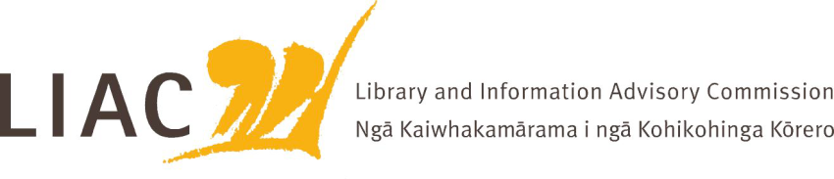
Summary of meeting – 8 December 2023
The December meeting was held remotely.
All Commissioners were present.

- Te Pouhuaki National Librarian update
- Te Ara Tahi update – ongoing management of impacts of Tāhuhu building construction to minimise customer and staff impacts;
- Exploration of closer working relationships between NLNZ and Archives is underway
- Fiscal constraints required of wider public service
- Visit of Leslie Weir, Canadian National Archivist/National Librarian to Aotearoa
- Report of attendance at NSLA meeting in Adelaide, including marking the 50th anniversary of this collaboration between national and state libraries in Australia and New Zealand.

- NZ Legal Information Institute
- Representatives from NZ Law Librarians Association and NZLII updated LIAC on the role, functioning and use of NZLII in New Zealand and internationally and raised concerns about risks. These include funding, technological and sustainability risks.
- In New Zealand NZLII indexes legal decisions, the Gazette and a wide range of other legal documents not otherwise easily accessible. The service is carried out by 1 part time specialist and is supported by the University of Otago Law Faculty. Most funding is by grants and donations. The service is heavily used including by government departments and law firms. The technology platform is shared with other countries and is in need of upgrade.
- NZLLA is keen to establish a more sustainable future for this unique and critical service, by identifying and working with interested stakeholders to discuss future options. LIAC’s help is sought to bring key stakeholders together.
- The need for an all of government information strategy was also noted – whose role is it to ensure that NZ legal material is available to all citizens?

- General Collection and Removal Policy
- Update provided on feedback from consultation on the National Library’s draft General Collection and Removal Policy, and changes to be made as a result
- Overall strong support for the draft policy. Key feedback themes included the importance of transparency, for example through a forward planning agenda

- Te Ara Tahi Digital Futures
- Staff attended to provide an update on the Digital Futures strand of Te Ara Tahi
- Key aspects of this work include update of technology platforms, storage requirements, digitisation, applying Mātauranga Māori standards, and developing a digital strategy.
- This will inform development of an investment case
- Key challenges include the need for and cost of digital storage and the lack of any NLNZ digitisation budget from July 2024. There is a direct link to the wider Property and physical storage strategy.

- LIANZA Conference session
- Good attendance at the LIAC session at the LIANZA Conference in Christchurch.
- Feedback from participants collated and will inform LIAC’s 2024 Scope of work.

