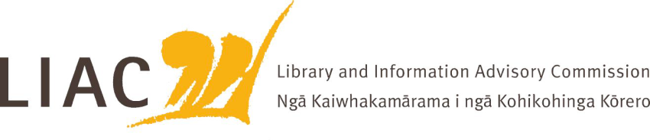

Summary of meeting – 12 February 2026
The February meeting was online. All current Commissioners were in attendance.

- Te Pouhuaki National Librarian update
- Update provided on Public Lending Right payments for 2025: small number of payments not made due to an administrative error, work underway to rectify this asap. This reinforces the need for updated regulations and systems to improve efficiency
- Te Ara Tahi programme is transitioning to operational, with governance transferring to the Directorate
- Business case for remaining building works to optimise Te Kahu campus is progressing
- Te Kahu opening 25 March.

- ALNZ 2030 operating model and strategic objectives
- A draft of the new ALNZ operating model and strategic objectives was shared for feedback. This includes near and longer term objectives. The new structure has now been in place for 8 months, teams have settled and are looking for clear strategic direction and priority

- Government Chief Digital Officer
- Paul James attended the meeting to talk about his role as GCDO and key priorities including data, coherency, education, digital identity and AI.
- In particular the role of ALNZ and libraries in relation to digital equity, education, data and AI was noted
- The importance of collaborative effort and leadership in achieving digital objectives was highlighted, with reference to NLNZ as a good example of this approach.
- Importance of close relationships between Digital Office and ALNZ staff

- Public Libraries NZ
- Mandy Henk has recently been appointed Executive Director PLNZ
- She provided an update of PLNZ activities and priorities, including their new strategic direction and review of the annual survey methodology
- Use of public libraries is growing, however budgets are shrinking. Other challenges include proposed local government reform including rates capping, and threats to freedom of expression
- Discussion included the importance of collaborative effort across the library sector, which in New Zealand is too small to sustain duplicate effort

- Copyright review
- Update on progress to date. Deadline for legislative reform is May 2028, concern that there is much to do including consultation phases
- Recent overseas developments relating to orphan works and AI and copyright will be helpful
- Importance of collaborative effort across the sector

- Commissioners’ activities
- Commissioners farewelled and thanked Vanisa Dhiru for her service as a Commissioner over the past 6 years, and for her contribution in support of a number of NLNZ initiatives including NZLPP and He Tohu planning.
- Commissioners discussed whether LIAC should write an annual report. This is a legislative requirement for the Archives Council and Turnbull Library Kaitiaki.
- Recruitment for LIAC vacancies continues.
- No correspondence has yet been received from the Minister in response to LIAC advice. Commissioners have not yet met with the Minister.

- Next meeting
- Next meeting is scheduled for 14 May, most likely as a face-to-face meeting
- Topics for future meetings include AI and copyright; ALNZ strategic objectives and operating model implementation; Digital Pasifik; reading ambassador; services to schools review update; tour of newly reopened Wellington central library; workplan refresh

