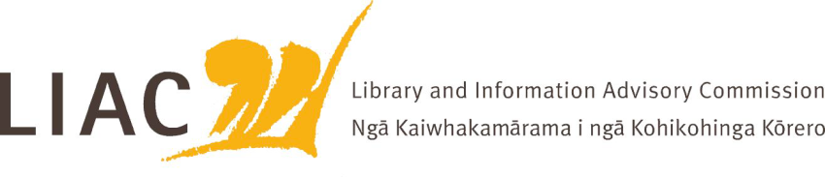

Summary of meeting – 11 December 2025
The December meeting was held in Wellington. All current Commissioners were in attendance.

- Te Pouhuaki National Librarian update
- Updates provided on work underway in relation to:
  - copyright legislation review
  - digitisation strategy and digital collecting
  - Digital Pasifik
  - remaining building works across the Archives National Library campus
  - NSLA meeting.
- Archives digitisation has recommenced followed budget confirmation, with excellent throughput.
- The Communities of Readers research is held over to a future meeting.
- Commissioners toured the digitisation facilities in the new Archives building Te Rua.

- Ka Ao, Ka Awatea te Kāpehu Whetū update
- Commissioners were briefed on the implementation of the Mātauranga Māori strategy across Archives National Library. This programme Ka Ao, Ka Awatea te Kāpehu Whetū is being introduced gradually to all kaimahi.

- LIAC scope of work
- 4 key themes identified as a priority:
  - National library direction
  - Literacy and digital inclusion
  - Information futures
  - Sector awareness
- Further refinement will be undertaken gradually with input to be sought from incoming Commissioners

- Commissioners’ activities
- Commissioners farewelled and thanked Dr Warren Williams for his service as a Commissioner, his 3 year term will end shortly.
- Recruitment for LIAC vacancies is underway.
- The Chair reported her attendance at a School Libraries stakeholder hui in November where NZCER research into the current state and impacts of school libraries in New Zealand was reported, best practice examples shared and next steps considered.
- No correspondence has yet been received from the Minister in response to LIAC advice. Commissioners have not yet met with the Minister.

- Next meeting
- Next meeting is scheduled for 12 February, as a virtual meeting
- Topics for the next meeting include: role of Government Chief Digital Officer; PLNZ; Copyright.

