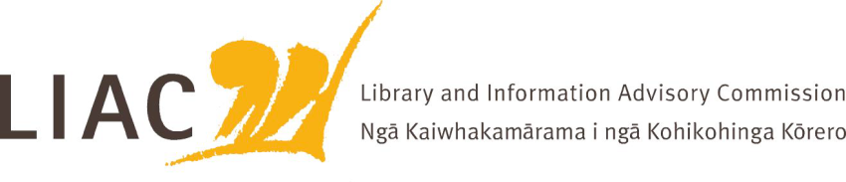
Summary of meeting – 16 November 2022
The November meeting was held face to face in Wellington. Apologies received from Vanisa Dhiru.
- LIAC activities and work programme
- Appointment of new Commissioner is at Cabinet approval stage
- Proposal for meeting processes tabled
- Review of Scope of work and development of forward agenda scheduled for next meeting

- Te Pouhuaki National Librarian update
- Reading Ambassador role to be made permanent
- Public Lending Right – full survey undertaken, payment processing underway
- Te Ara Tahi update, business case still in development

- NZLPP
- Whiria te Tangata update – sustainability champion programme phase 1 underway
- Learning Management System purchased to support NZLPP, concern re ongoing sustainability and access

- Future for Local Government
- Panel report released late October, seeks feedback on recommendations and questions
- LIAC will submit a response

- Council for New Zealand University Librarians CONZUL
- Strategic priorities recently updated. Three key focus areas: Kotahitanga, Sustainable access, Open scholarship, all underpinned by He Tāngata Rawe
- CONZUL have recently analysed current state of open access in Aotearoa. NZ lags behind other nations in making publicly funded research openly available. Most is restricted.
- CONZUL working closely with Australian libraries and with Universities NZ. Goal is to adopt a common Open Access Policy.
- NLNZ to consider developing an OA policy
- Should all publically funded research be mandated through legislation as open access
- MBIE is key as the main funder of scientific and health research

- Copyright issues in New Zealand
- Presentation from sector experts
- Concern regarding copyright term extensions negotiated in recent trade agreements with UK and EU, when and how these will be implemented. Many potentialy negative impacts
- These term extensions make the need for full review of the Copyright Act more critical
- Review of Copyright Act lead by MBIE appears to be stalled
- Lack of public copyright voice in NZ is a major concern. Whose role is this? How is it funded? Where is the public good legal expertise?
- Importance of protecting public domain rights
- LIAC to seek update on review timeframes and involvement from MBIE

