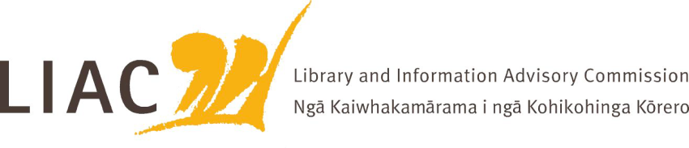
Summary of meeting – 21 March 2023
The March 2023 meeting was held face to face in Wellington. A mihi whakatau was held to welcome new Commissioner Dr Warren Williams. Apologies received from Paula Eskett
- LIAC activities and work programme
- Hon. Barbara Edmonds is now the Minister for Internal Affairs and Minister for National Library
- Welcome to Dr Warren Williams. Vanisa Dhiru reappointed for a further three-years. Full complement of Commissioners now in place. Website biographies to be updated
- Acknowledgement of the recent death of Mary Ronnie, National Librarian 1976-1981, the first woman in the world to hold such a role.
- Letter re copyright review to be sent to Hon Dr Duncan Webb, Minister for Commerce and Consumer Affairs asking that LIAC and the library and information sector are kept informed about and involved in this review.
- Future for Local Government submission completed by LIAC, copy to be added to LIAC website
- LIAC scope of work updated to reflect activities to date; forward agenda planning exercise undertaken to identify priorities for 2023. Work towards a refresh of the LIAC Mātauranga Māori position statement will be a priority
- LIAC to submit proposal to speak at 2023 LIANZA Conference in Christchurch in October

- Te Pouhuaki National Librarian update
- Support of school libraries damaged during Cyclone Gabrielle and other recent weather events
- Refresh of Komitē Māori membership and role underway. Meeting with LIAC planned for future.
- Options for future of NZLPP Learning Management System and content still being considered
- Te Ara Tahi update. Mātauranga Māori policy work is progressing well, possible update for LIAC at next meeting. Construction of connecting structure between Tōhuhu the new Archives building and the National Library Molesworth Street building will commence shortly. Testing undertaken to assess impacts, steps to minimise impacts on staff, customers and collections, including He Tohu, in place
- Briefings provided to new Minister are available online

- National Library Collections and Disposal Policy
  - Draft Collections and Disposal policy shared with LIAC. Part of an overall framework of collection policies
  - Advisory group in place. Engagement with wider sector to commence in April
  - LIAC welcomed the policy and saw it as a sound basis for wider consultation
  - Clear communication of the purpose and management of the National Library’s different collections is essential

