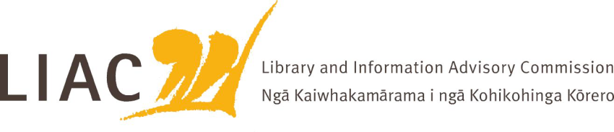
Summary of Meeting – 24 June 2022
The June meeting was held via zoom. Te Paea Paringatai on leave, all other Commissioners attended.
Key topics and discussion points
- LIAC activities and work programme
  - content plan for LIAC website agreed.
  - scope of work approved, to be added to LIAC website

- Te Pouhuaki National Librarian update
  - Covid response and impact
  - Public lending right
  - Removal and disposal policy
  - Collection management approach across national collecting agencies
  - Data sovereignty; digital collection and storage; future of interloan; involvement of young people in envisioning the future library.

- Tāhuhu update
  - Progress on new Archives building
  - Co-design with iwi, criticality of ongoing role of manawhenua
  - Role of linking bridge between Te Puna Matauranga and the new building
  - Te Iho Whakarei the integrated visitor experience will flow through both buildings including He Tohu
  - Co-design process is exemplary and should be widely shared

- Te Ara Tahi update
  - Budget bids 2022 will be reworked
  - Storage capacity both digital and physical is not sustainable and needs to be addressed
  - Te Ara Tahi programme begins 1 July, includes 4 pillars – Matauranga Māori, Tāhuhu, Digital Foundations, Working collaboratively. New manager and governance structure in place
  - IKS branch renamed Te Haumi

- NZ Libraries Partnership Programme
  - Programme close 30 June 2022
  - Transition and sustainability activities continue as Whiria te Tangata with wider sector governance
  - Evaluation reports in process
  - Success of NZLPP in its overall reach, effectiveness and delivery is notable

- Library and information sector workforce planning project
  - NZLPP sustainability project
  - Skills and capability required by sector for the future, a model for libraries to apply
  - Pilot project underway
  - Uses include training and lifelong development, recruitment, remuneration
  - How to get whole sector aware and involved in rollout. Engagement of key partners

- Misinformation
  - Briefing by Tohatoha on their activities to counter misinformation, including A Bit Sus pilot programme through school libraries
  - Librarians are shown to be trusted providers of information
  - Other agencies working in this area in Aotearoa, importance of a local approach based on a Matauranga Māori perspective

