New Zealand Casino Gaming Machine Appendix to the Australia New Zealand Gaming Machine National Standard 2015

Consultation version 2.0

Table of Contents
Explanatory note 4
DIA-1 Application of Appendix 5
DIA-1.1 Title 5
DIA-1.2 Compliance with Minimum Standard required for approval 5
DIA-1.3 Appendix to be read with other documents 5
DIA-1.4 References to the National Standard 5
DIA-1.5 Hierarchy 5
DIA-1.6 Testing 5
DIA-1.7 Applications for new and innovative technology 6
DIA-2 Definitions 7
DIA-2.1 Definitions used in this Appendix 7
DIA-3 Security and Integrity 8
DIA-3.1 Locks and keys 8
DIA-3.2 Logic area 8
DIA-3.3 Banknote acceptance specifications 8
DIA-3.4 Casino vouchers 8
DIA-3.5 Switchers and jumpers 8
DIA-3.6 Power supply 8
DIA-4 Auditability 10
DIA-4.1 Identification of gaming machines 10
DIA-5 Player Information Displays 11
DIA-5.1 Elective information display 11
DIA-5.2 Game information (elective information display) 11
DIA-5.3 Player information (elective and interruptive information displays) 12
DIA-5.4 Optional additional information for elective display 13
DIA-5.5 Interruptive display requirements 13
DIA-5.6 Prohibited messages 14
DIA-5.7 Cessation of information display 14
DIA-5.8 Display of Jackpot information 14
DIA-5.9 Examples of information displays 15
DIA-6 Gaming Machine Tournaments 17
DIA-6.1 Tournament Mode Activation 17
DIA-6.2 Tournament Mode Message 17
DIA-6.3 Implications on Cash Input 17
DIA-6.4 Implications on Cash Out 17
DIA-6.5 Implications on Cashless Gaming 17
DIA-6.6 Tournament Metering 17
DIA-6.7 Effect on player’s ability to have an equal chance of winning 18
DIA-6.8 Tournaments on linked jackpots 18
DIA-7 Multi-terminal and Multi-player Gaming Machines 19
DIA-7.1 Multi-terminal and Multi-player Gaming Machines 19
DIA-7.2 MTGM Conformance to the National Standard 19
DIA-7.3 Game Play Information 19
DIA-7.4 Game Screen Meters 19
DIA-7.5 Metering 19
DIA-7.6 Initiation of Game Play 20
DIA-7.7 Void Game 20
DIA-7.8 Communication Error Detection 20
DIA-7.9 Artwork 20
DIA-7.10 Interruptive Information Display 21

Explanatory note
The Secretary for Internal Affairs (Secretary) may prescribe minimum standards for gambling equipment under section 372 of the Gambling Act 2003.
The Australia New Zealand Gaming Machine National Standard 2015 forms part of the minimum standard set by the Secretary in respect of casino gaming machine equipment and games.
This document also forms part of that minimum standard, and prescribes those requirements that are different to, or in addition to, the requirements in the Australia New Zealand Gaming Machine National Standard 2015 in respect of gaming machines approved for operation in casino venues.
In addition to this document and the Australia New Zealand Gaming Machine National Standard 2015, other requirements prescribed by the Secretary form part of the minimum standard for casino gambling equipment (for example the Minimum Technical Requirements for Casino Electronic Monitoring System). All requirements prescribed by the Secretary are notified in the Gazette and are available on the Department of Internal Affairs’ website www.dia.govt.nz.

DIA-1 Application of Appendix
Refer NS 1 (Introduction)

DIA-1.1 Title
This document is the New Zealand Casino Gaming Machine Appendix to the Australia New Zealand Gaming Machine National Standard 2015.

DIA-1.2 Compliance with Minimum Standard required for approval
Gaming machines and games may only be approved by the Secretary if they comply with the Minimum Standard.

DIA-1.3 Appendix to be read with other documents
- The Appendix must be read with the National Standard and other relevant parts of the Minimum Standard.
- Part DIA-5 of this Appendix (relating to player information displays) must be read with regulations 7 and 8 of the Gambling (Harm Minimisation and Prevention) Regulations 2004.

DIA-1.4 References to the National Standard
In this Appendix, references to the National Standard are denoted by NS followed by the relevant clause number.

DIA-1.5 Hierarchy
- This Appendix applies despite anything to the contrary in the National Standard.
- The Secretary may take a different interpretation of the National Standard to the working party and is not bound by any interpretation of the working party.
Note: It is recommended that gaming machine manufacturers and testers also approach the Secretary regarding any issues regarding interpretation of the Minimum Standard. See also NS 1.16.

DIA-1.6 Testing
Refer NS 1.17 to NS 1.19
- Where, in the opinion of the gaming machine tester, there is non-compliance with the requirements of the Minimum Standard, the gaming machine tester must seek direction from the Secretary.
- Non-compliance with the Minimum Standard must be reported to the Secretary.

DIA-1.7 Applications for new and innovative technology
Refer NS 1.18 and see also NS 3.2
- Any matters of design, manufacture, and performance of casino gambling equipment that are not specifically addressed in the Minimum Standard will be considered by the Secretary as part of the approval process. For the avoidance of doubt, this applies to (but is not limited to) situations involving new technology or features, or in situations where innovative use is being made of existing features, or where the existing Minimum Standard is silent on whether a particular feature is permitted.
- In considering an application under subclause (1), the Secretary may take into account matters of harm minimisation and prevention, and may decline an application due to matters of harm minimisation and prevention.
- The Secretary may amend the Minimum Standard as a result of an application involving features not addressed in the Minimum Standard.
Note: Manufacturers and vendors of gaming equipment are encouraged to contact the Department of Internal Affairs in the course of developing new or innovative technology and features, in order to ensure compliance with the Minimum Standard and in order that any necessary amendments to the Minimum Standard may be made in advance of the equipment being submitted.

DIA-2 Definitions

DIA-2.1 Definitions used in this Appendix
Refer NS 2 (Definitions)
In this document:
Appendix means this document
Minimum Standard means the National Standard, the Appendix, and any other applicable minimum requirements for casino gambling equipment prescribed by the Secretary under section 372 of the Gambling Act 2003
National Standard means the Australia New Zealand Gaming Machine National Standard 2015
Secretary means the Secretary for Internal Affairs.

DIA-3 Security and Integrity

DIA-3.1 Locks and keys
Refer NS 6.2 and 6.3
Locks and keys that secure access to the interior of a cabinet must be of a different combination to other keys and locks for other areas of the equipment unless otherwise approved by the Secretary.

DIA-3.2 Logic area
Refer NS 6.10 and 6.11
- A 6mm hole must be used for affixing physical seals on the logic area door.
- If a logic cabinet is capable of being removed from a gaming machine cabinet in its entirety and replaced with another complete unit, the logic area must be fitted with a device or devices that will detect removal, regardless of whether the mains power is switched on or off.

DIA-3.3 Banknote acceptance specifications
Refer NS 6.15
- Banknote acceptor devices may only validate and accept legal tender banknotes of $5, $10, and $20 in value, or casino vouchers approved by the Secretary.
- A banknote acceptor device must reject and must not validate any banknotes of more than $20 in value.

DIA-3.4 Casino vouchers
Refer NS 6.15
- Any casino tickets, vouchers, or tokens for use with banknote acceptors must be approved by the Secretary.
- Casino vouchers may include numeric and textual images and printing, bar codes, or other approved encoding to indicate the value of each voucher.
- Casino vouchers may be pre-printed forms issued by the casino via manual methods.

DIA-3.5 Switchers and jumpers
Refer NS 6.27
If a jumper or DIP-switch device has a normal mode, the normal operation of the device must be clearly marked on or immediately adjacent to the device.

DIA-3.6 Power supply
Refer NS 6.28
- Where a gaming machine cabinet contains more than one power switch, each switch must clearly identify the unit to which it supplies power.
- Communications interfaces must be independently powered from other devices within the gaming machine to ensure continued monitoring during machine maintenance activities.

DIA-4 Auditability

DIA-4.1 Identification of gaming machines
Refer NS 7.3
- The gaming machine model number required by NS 7.3(c) must also include the approval number issued by the Secretary at the time of approval.
- The numbers are to be displayed in the following format:
“Gaming Machine Model Number” – NZ “Approval Number”

DIA-5 Player Information Displays

DIA-5.1 Elective information display
- Game information and player information must be displayed at the election of the player.
- If a game is in progress at the time of the election by the player, the information may be displayed after the game in progress (including free games or features) is completed.
- The game information and player information must be displayed for at least 30 seconds or until the player exits from the information display, whichever is earlier.

DIA-5.2 Game information (elective information display)
- Game information means the following information generated on displayed on the screen of a gaming machine for each game played on that machine:
  - the odds of winning the game (including the 5 top and bottom winning combinations); and
  - the average winnings paid out to players of the game over a particular period of time or a particular number of plays; and
  - the maximum and minimum player spend rate for the game.
- The game information shown on a gaming machine’s elective information display must be calculated and displayed as set out in this clause.
- All values indicated in the game information screen must be based on theoretical calculated values for individual wins on a single gaming machine as opposed to any values derived from game simulations or actual play history.
- The odds of winning any single combination must be displayed as the theoretical average number of games for any win.
- For the effect of win capping and/or prize truncation the use of simulation is permitted. As a minimum any simulation implementation must also agree to within plus or minus 0.1% of the theoretical game calculation as calculated mathematically without including win capping and/or truncation.
- The top five winning combinations must be displayed with the highest prize winning combination on the top (descending order of winning prize values).
- The bottom five winning combinations must be displayed with the lowest prize winning combination on the top (ascending order of winning prize values).
- If more than one prize is of the same value, the combinations may be displayed either by chance, hierarchy or alphabetical order. For example if five “Tens” and five “Queens” pay the same amount the “Queen” combination may be selected first. Similarly if five “Apples” and five “Oranges” pay the same amount the “Apples” may be displayed first.
- The minimum bet/line or bet/reel or bet/bucket values must be used for calculating the top five and bottom five winning combinations.
- Combinations (especially scatter) that trigger any feature, regardless of the payout from the feature, must not be included in the list of highest (except when the trigger win itself, excluding any additional feature wins, will be one of the top five winning combinations) and lowest winning combinations. However, prize combinations including scatters that do not trigger any feature must be taken into account when selecting the five lowest and highest prize combinations to be displayed.
- Scatter combinations that will trigger features only when they appear on some specific reel positions and do not trigger a feature while they appear in all other combinations must be included in the calculation of the bottom prize combinations. For example if two “Apples” on reel one and two trigger the feature, while two “Apples” in any other positions pay an amount which will be one among the five lowest winning combinations, then the two “Apple” combination must be included in listing the bottom five winning combinations. Note that when calculating the chance of winning, the two “Apple” combinations that trigger the feature must be excluded.
- The average winnings paid out to a player of the game must be expressed as the approved RTP.
- In games that have different RTPs for different bet value combinations, the lowest RTP must be used to display the average winnings.
- Bonus feature games having one RTP in one mode of operation and a different RTP in another mode of operation, and where the difference of RTP between these two modes is typically more than plus or minus 0.25%, must display both these RTPs.
- The RTP must be displayed with a minimum accuracy of two decimal places.
- The maximum player spend rate must reflect the maximum potential bet, if players play the maximum allowed number of lines, betting the maximum amount per line.
- The minimum player spend rate must reflect the minimum potential bet, if players play the minimum allowed number of lines betting the minimum amount per line.

DIA-5.3 Player information (elective and interruptive information displays)
- Player information means the following information generated and displayed on the screen of a gaming machine:
  - the duration of the player’s session of play; and
  - the amount, expressed in dollars and cents, that the player has spent during the player’s session of play; and
  - the player’s net wins or net losses during the player’s session of play.
- The player information shown on a gaming machine’s elective or interruptive information display must be displayed as set out in this clause.
- The credits played, being the amount (expressed in dollars and cents) wagered by the player on the gaming machine during a session, must be displayed.
- The player’s session net wins or losses, being the difference (expressed in dollars and cents) between credits won and credits played, must be displayed.
- The current duration of the player’s session of play must be displayed in hours and minutes.
- The duration of a player’s session of play is the continuous time that has elapsed from the start of the first game played and includes all additional games played by a player until:
  - a player does not play a game and a period of 60 seconds has elapsed since the end of the last completed game; or
  - no further play is possible without additional credits being purchased by the player and a subsequent period of 30 seconds has elapsed since the last completed game; or
  - a player has exited the game by pressing the collect button.
- The activation of the reserve mode, elective display mode, accessing game information screen(s), the display and/or transfer of a jackpot win downloaded direct to the gaming machine, or any other period during which game play is temporarily suspended is deemed to be a part of the duration of a player’s session of play.
- If a non-standard interruption of game play such as a fault, error or power down of a gaming machine occurs, the duration of the player session of play may be inclusive of any time elapsed during the interruption.

DIA-5.4 Optional additional information for elective display
The following information may be displayed on an elective information display on a gaming machine:
  - cash in, being the amount (expressed in dollars and cents) the player has available for play is the total of credits available
  - at the start of a session of play, whether input by the player or not, and any amount the player has put in during a session; and
  - credits played, being the amount (expressed in dollars and cents) wagered by the player on the gaming machine during a session; and
  - credits won, being the amount (expressed in dollars and cents) won by the player on the gaming machine during a session; and
  - cash out, being the amount (expressed in dollars and cents) collected from the gaming machine by the player during a session; and
  - credits available, being the amount (expressed in dollars and cents) that is currently available for the player to wager on the gaming machine; and
  - the time the player began the session.

DIA-5.5 Interruptive display requirements
      - Player information, as outlined in DIA-5.3, must be displayed during a player’s session of play at random intervals.
      - The random intervals must be triggered during a set period of time not less than 5 minutes from the start of the player’s session of play or the cessation of the last interruptive display. The set period may be between 0 and 30 minutes, but the actual display of the information must not exceed 30 minutes after the start of the session of play or the cessation of the last interruptive display of player information.
      - If a game is in progress at the time of the randomly selected interval, the player information need not be displayed until immediately after the game in progress (including free games or features) is completed provided that any period before the player information is displayed does not exceed 30 minutes from the start of the player’s session of play or the cessation of the last interruptive display.
      - If game play has been temporarily suspended as referred to in DIA-5.3(7) and 30 minutes has elapsed since the start of the session of play or the cessation of the last interruptive display of player information, the player information need not be displayed until game play is resumed.
      - When a player information message is displayed in accordance with this clause the display must include a feature that asks the player whether or not he or she wishes to continue with his or her session of play.
      - If the player does not wish to continue with his or her session of play, the gaming machine must include a feature that automatically pays out any winnings or credits to the player, after first completing any game in progress at the time of interruption.
      - In the case of a jackpot win or other event that requires a manual payment, the automatic payout may consist of a screen message indicating that the player should contact a staff member for a manual payment.
      - Player information on an interruptive display must be displayed until:
        - a player chooses to continue game play, providing a minimum period of 15 seconds has elapsed; or
        - a player has chosen not to continue play; or
        - a period of 30 seconds has elapsed and the player has not chosen to either continue or exit game play.

DIA-5.6 Prohibited messages
Any direct or indirect messages intended to encourage the player to continue playing must not be included on an elective or interruptive player information display.

DIA-5.7 Cessation of information display
At the cessation of any player information display, the gaming machine will revert to the display state immediately preceding the information display.

DIA-5.8 Display of Jackpot information
- Jackpot information must be displayed as either part of the game information displayed on the gaming machine, or as a notice affixed to each machine.
- A stand-alone gaming machine jackpot must always display the required information as part of ‘game and player information’.
- If it is practicable to include jackpot contributions in game information, the following information must be displayed:
  - a statement that the game is part of a jackpot arrangement; and
  - the total return to player of the game, being the sum of the return to players contributed by the game and the return to players contributed by the jackpot arrangement; and
  - the return to players of the game contributed by the jackpot arrangement.
- If it is not practicable to include jackpot contributions in game information, the following information must be displayed as a notice affixed to the gaming machine:
  - a statement that the game is part of a jackpot arrangement; and
  - the return to players of the game contributed by the jackpot arrangement.
- Where a jackpot prize is won by a gaming machine as part of a linked jackpot arrangement and downloaded to the gaming machine, this amount must be included in the player information on the display.
- Where a jackpot prize is won by a gaming machine as part of a linked jackpot arrangement and not downloaded to the gaming machine, a message must be included on the player information display that any jackpot wins are not reflected in the totals.

DIA-5.9 Examples of information displays
The following examples are provided for informative purposes only, and are not meant to represent actual screen displays required.
i) Game Information:
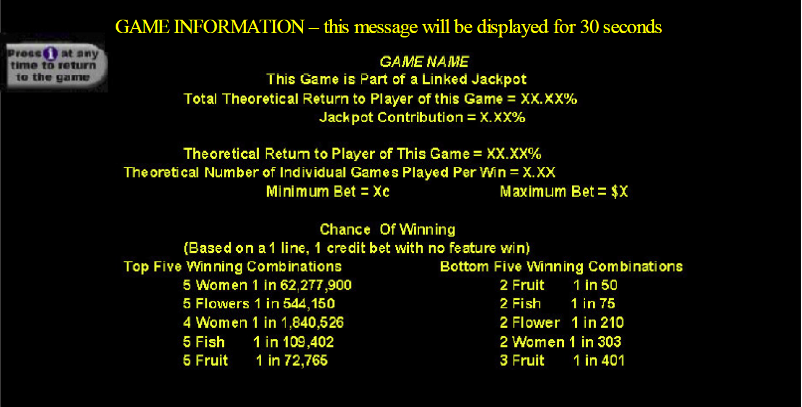
ii) Player information:
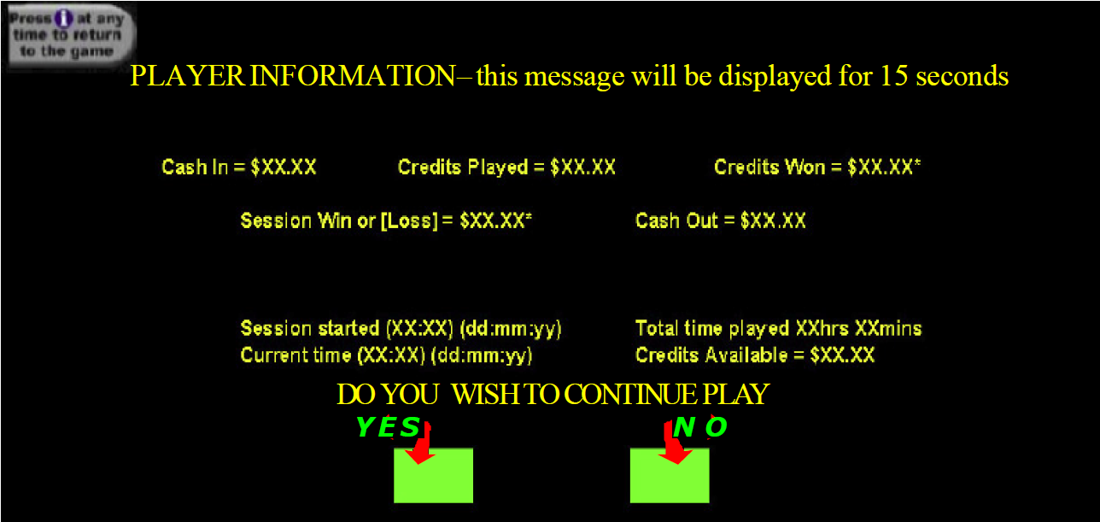

DIA-6 Gaming Machine Tournaments

DIA-6.1 Tournament Mode Activation
    - Specialised software that permits tournament games and requires swapping of chips to implement must not be used.
    - Software that allows tournament mode must provide a secure means to enable switching between tournament mode and normal game play.

DIA-6.2 Tournament Mode Message
When a gaming machine is in tournament mode, a message indicating that the machine is in tournament mode must be clearly displayed on the machine.

DIA-6.3 Implications on Cash Input
- All coin and note acceptors must be disabled when a gaming machine is placed in tournament mode and the main door is closed.
- “Tournament Credits” must only be added via a facility in machine audit mode.

DIA-6.4 Implications on Cash Out
The cash out button or its equivalent (e.g. “Cash Mode” option) must not be operable while a gaming machine is in tournament mode.

DIA-6.5 Implications on Cashless Gaming
Cards or other devices used for cashless gaming must not be able to be used to facilitate the transfer of credits to or from a gaming machine in tournament mode.

DIA-6.6 Tournament Metering
- When a gaming machine is placed in tournament mode, the “Credit” meter must be labelled “Tournament Credits”. The meter’s function must not alter from normal game play.
- When a gaming machine is placed in tournament mode, there must be a “Tournament Win” meter. This meter must be a cumulative meter displayed to the player during tournament mode.
- The “Tournament Win” meter must be reset to zero by entry to tournament mode or by other approved means (e.g. audit mode).
- The number of credits won on a tournament game must be added to the Tournament Win meter.
- When a gaming machine is in tournament mode, no metering information may be sent to the electronic monitoring system.
- The current value of meters prior to entering tournament mode must be preserving upon entering tournament mode, and must be restored upon exiting tournament mode.
- A gaming machine must not enter tournament mode while credits exist on the machine.
- Where credits are obtained while in tournament mode, those credits must be automatically cancelled upon exiting tournament mode and must not be accredited to the meters.
- Progressive meters must not be affected in any way while a gaming machine is in tournament mode.

DIA-6.7 Effect on player’s ability to have an equal chance of winning
- Gaming machines used in gaming machine tournaments must have similar design criteria (e.g. hit rates, maximum bet limits, gamble features and feature games).
- Despite subclause (1), the Secretary may consider exceptions if satisfied that the objective of player fairness will not be compromised.

DIA-6.8 Tournaments on linked jackpots
- Linked progressive or stand-alone progressive gaming machines must not be used in a tournament unless the Secretary is satisfied that prize values are clearly assigned and displayed for all prize winning combinations.
- If linked progressive or stand-alone progressive gaming machines are used in a tournament in accordance with subclause (1):
  - combinations that would normally trigger the jackpots must have prize values associated with them.
  - game lock-up and progressive controllers must be disabled.

DIA-7 Multi-terminal and Multi-player Gaming Machines

DIA-7.1 Multi-terminal and Multi-player Gaming Machines
- A multi-terminal or multi-player gaming machine (MTGM) is a gaming machine that:
(a) is designed and constructed such that the game can be played by more than one player at any one time; and
(b) comprises more than one terminal or player station and any associated game control and ancillary units.

DIA-7.2 MTGM Conformance to the National Standard
(1) A MTGM must conform to all applicable requirements of the National Standard and this document unless exempted, modified, or added to by the requirements of this section.
(2) Any individual terminal or player station, game control and ancillary unit must additionally be considered as a stand-alone gaming machine and conform to all applicable requirements as in (1) above.

DIA-7.3 Game Play Information
(1) Game cycle can be automatic for MTGMs and does not require an idle mode.

DIA-7.4 Game Screen Meters
Ref NS 4.1
(1) For MTGMs, the initial game credit value and all bets made must equate to whole dollars. The display:
(a) must, if credits are displayed, conform to NS 6.39; or
(b) providing it is not ambiguous to the player (that is, artwork and game screen meters are all in dollars and cents as appropriate), display only dollars and cents.
(2) Notwithstanding (1) above, if it is permissible within the rules of the game for a bet to be made which is a ratio of the initial bet (e.g. a blackjack insurance bet), that bet may be made in an amount other than whole dollars.

DIA-7.5 Metering
(1) Each terminal or player station must provide and retain its own set of meters.
(2) The MTGM must additionally provide a set of central meters that records the sum of the following meters from each terminal or player station: Turnover, Total Wins, Cash Box, Cancelled Credits, Money In, Money Out, Cash In, Cash Out.

DIA-7.6 Initiation of Game Play
(1) If MTGM players are given a certain period of time in which to make bets after which the game automatically starts then:
(a) it must be possible for the player to cancel or amend all bets made during this period; and
(b) the time remaining to make or cancel bets must be clearly displayed in seconds.

DIA-7.7 Void Game
(1) At the time of an event requiring a lockup or deactivation of one or more of the player terminals, non-affected player terminals may continue with the game under play and any subsequent game play.
(2) Any player terminal subject to the lock-up or deactivation must:
(a) void the game; and
(b) clearly display on the player’s screen the message ‘Game voided and all bets refunded’; and
(c) on resumption of game play, update player’s credit meters with the total value of all bets made on the game voided.

DIA-7.8 Communication Error Detection
(1) Communication between interconnected units comprising a MTGM must:
(a) be only by metallic or fibre optic cable; and
(b) have communication protocols utilising communication techniques that have proper error detection and/or recovery mechanisms that are designed to prevent unauthorised access or tampering.
(2) Where any terminal or player unit is located such that it is remote from the game control unit and other terminals or player stations that are physically connected so as to be a single physical secure unit (such remote terminals commonly known as satellite terminals), then all physical cable connecting the satellite terminal must be secure from unauthorised access.

DIA-7.9 Artwork
Ref NS 5
(1) The artwork on a MGTM must either state the maximum bet, the number of credits that can be bet per bet option, or it must be possible to deduce this information from the game rules.
(2) Information as to minimum bet (if not easily deduced via bet options) must be readily available to the player.
(3) The game instructions must provide a clear description under which a game is to be declared void.

DIA-7.10 Interruptive Information Display
See DIA-5.5
(1) Interruptive information displays on MTGMs must not interrupt game play such that the time to wager, confirm bets, or make additional game play choices is reduced in any way.

