Division 10 – Money Wheel
Section 1 Application
Section 2 Table Layout and Equipment
Section 3 Wagers
Section 4 Spin of the Wheel and Table Operation
Section 5 Irregularities
Appendix 1 Money Wheel Arrangement
Appendix 2 Money Wheel Table Layout (Option 1)
Appendix 3 Money Wheel Table Layout (Option 2)
Appendix 4 Money Wheel Table Layout (Option 3)

1.0 Application
1.1 The rules contained in this division, together with the general rules contained in division 1, shall apply to the game of money wheel.
1.2 The Casino Operator may operate this game under any name it considers appropriate.

2.0 Table Layout and Equipment
2.1 Money wheel shall be played at a table having on 1 side places for the players and on the opposite side a place for the Dealer or Dealers, with a circular wheel. Each money wheel table shall have a drop box attached to it.
2.2 The wheel referred to in rule 2.1 shall:
- be not less than 1.5 metres in diameter;
- have its rim divided by means of spokes or pegs into 52 equally spaced sections marked in accordance with rule 2.3;
- rotate freely and evenly; and
- have its weight distributed equally throughout.
2.3 The sections around the rim of the wheel shall be marked as follows:
- 24 sections exhibiting a particular symbol (referred to as “Symbol A”);
- 12 sections exhibiting a second symbol (“Symbol B”);
- 8 sections exhibiting a third symbol (“Symbol C”);
- 4 sections exhibiting a fourth symbol (“Symbol D”);
- 2 sections exhibiting a fifth symbol (“Symbol E”);
- 1 section exhibiting a sixth symbol (“Symbol F”); and
- 1 section exhibiting a seventh symbol (“Symbol G”),
and shall be arranged around the rim, together with the corresponding odds, as specified in rule 3.8, applying to a wager on the symbol, as shown in Appendix 1. The symbols to be used on the wheel shall differ from each other and shall be approved by the Secretary.
2.4 The money wheel and associated equipment shall operate, when activated, as a random number generator, in that their use shall result in the selection of a game symbol or the production of a game outcome which is:
- statistically independent;
- uniformly distributed over its range; and
unpredictable.
2.5 The table shall be covered with a layout cloth which shall be marked:
- in a manner substantially similar to that shown in Appendix 2, Appendix 3 or Appendix 4, showing the relevant payout odds in use as specified in rule 3.8;
- with areas for the placement of wagers on the symbols marked on the wheel and the odds applicable to each such symbol.
Each symbol shall be imprinted in a clearly defined area of the layout cloth.
2.6 The following equipment shall also be used in the game:
- an indicator which stops the wheel and indicates the winning section;
- where Non-Value Chips are in use at the table, a display rack, which shall be used to indicate the colours and values of the Non-Value Chips;
- where Non-Value Chips are in use at the table, marker buttons of different colours, sufficient to indicate the value of the subsets of Non-Value Chips in use;
- at the option of the casino operator, a change block, which shall be used for the acceptance and exchange of Chips; and
a bell.
2.7 The table may be fitted with electronic equipment which is programmed to detect that the wheel has completed the required number of revolutions and/or illuminate the winning symbol on the layout.

3.0 Wagers
3.1 A player at the game may place a wager on any of the symbols referred to in rule 2.3, which shall:
- win if that symbol is spun; and
- lose if any other symbol is spun.
3.2 All wagers shall be made by placing either Value Chips, with the smaller denomination Chips on top, or Non-Value Chips in the appropriate wager area of the money wheel layout. A wager must be placed completely within the wagering segment marked on the layout.
3.3 Orally declared wagers shall be accepted only when accompanied by Chips and if the Dealer has enough time to place the wager on the layout before “No more bets” is called.
3.4 Each player shall be responsible for the correct placement of his/her wager on the layout whether or not he/she is assisted by the Dealer. Each player shall be responsible for ensuring that any instructions he/she gives to the Dealer regarding the placement of his/her wager are correctly carried out.
3.5 Except as permitted by these rules, once the Dealer has called “No more bets” no player shall:
- make any wager; or
- handle, alter or withdraw any wager until all winning wagers in that wagering area have been paid by the Dealer.
3.6 No player shall handle, alter or withdraw a losing wager.
3.7 Each wager shall be settled in accordance with its position on the layout when the result of the spin is established, provided however that the Casino Operator may modify the application of this rule if it is apparent in the circumstances that the strict application of the rule would be unfair to the player.
3.8 Winning wagers made pursuant to rule 3.1 shall be paid in accordance with one of the following payout options, which must be specified on the money wheel and on the table layout:
Option One
Wagers On Odds
Symbol A 1 to 1
Symbol B 3 to 1
Symbol C 5 to 1
Symbol D 11 to 1
Symbol E 23 to 1
Symbol F 47 to 1
Symbol G 47 to 1
Option Two
Wagers On Odds
Symbol A 1 to 1
Symbol B 3 to 1
Symbol C 5 to 1
Symbol D 10 to 1
Symbol E 20 to 1
Symbol F 47 to 1
Symbol G 47 to 1
Option Three
Wagers On Odds
Symbol A 1 to 1
Symbol B 3 to 1
Symbol C 5 to 1
Symbol D 10 to 1
Symbol E 20 to 1
Symbol F 45 to 1
Symbol G 45 to 1

4.0 Spin of the Wheel and Table Operation
4.1 The direction of each spin of the wheel may be alternated.
4.2 At least 3 revolutions of the wheel shall be completed for the spin to be valid.
4.3 Either before the wheel is spun or while the wheel is still rotating, the Dealer shall call “No more bets”, at the same time ringing the bell.
4.4 When the indicator comes to rest in a section of the wheel, the Dealer shall:
- announce the winning symbol of the section;
- collect all losing wagers; and then
- pay all winning wagers.
4.5 No person shall at any time interfere with the wheel or the rotation of the wheel, except as provided in these rules.
4.6 Nothing in these rules shall prevent the Casino Operator or its representative from inviting, at their sole discretion, a person to spin the wheel in place of the Dealer from time to time.

5.0 Irregularities
5.1 If, during the spin of the wheel:
- there is a physical interference of any kind with the spin of the wheel; or
- the wheel for any reason becomes unbalanced; or
- there is any kind of a mechanical malfunction of the wheel or its supporting structure,
the Dealer or Game Supervisor shall announce a “No spin”. The spin shall be Void whether or not the indicator comes to rest in any of the sections of the wheel.
5.2 If the indicator comes to rest on a spoke or peg between 2 sections, the Dealer or Game Supervisor shall announce a “No spin”.
5.3 If the wheel does not complete 3 revolutions the Dealer or Game Supervisor shall announce a “No spin”.
5.4 A spin that is Void pursuant to rules 5.1 to 5.3 shall be Void whether or not a “No spin” is announced.
5.5 If the electronic equipment fails to illuminate the winning areas, or fails to illuminate the winning areas correctly, all wagers shall be taken and paid according to the results shown when the wheel comes to rest in its compartment.
5.6 In the event of malfunction of the electronic equipment, such equipment shall be turned off and the game shall continue.
Appendix 1: Money Wheel Arrangement

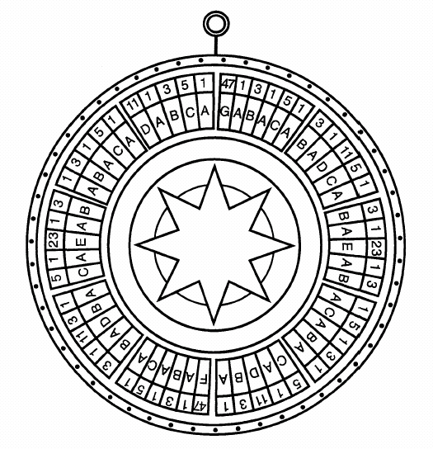

Payout odds above are shown as an indication only. The money wheel design must include the odds specified in either payout Option One, Option Two or Option Three as specified in rule 3.8.
Appendix 2: Money Wheel Table Layout (Option 1)
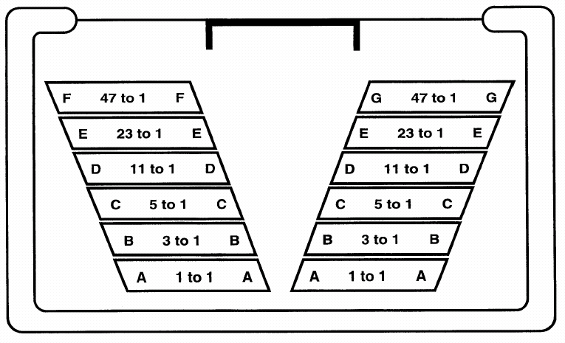
Letters refer to symbols on the Money Wheel
Payout odds above are shown as an indication only. The table layout must include the odds specified in either payout Option One, Option Two or Option Three as specified in rule 3.8.
Appendix 3: Money Wheel Table Layout (Option 2)

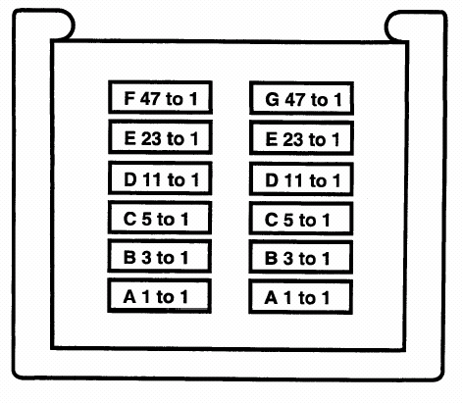
Letters refer to symbols on the Money Wheel
Payout odds above are shown as an indication only. The table layout must include the odds specified in either payout Option One, Option Two or Option Three as specified in rule 3.8.
Appendix 4: Money Wheel Table Layout (Option 3)
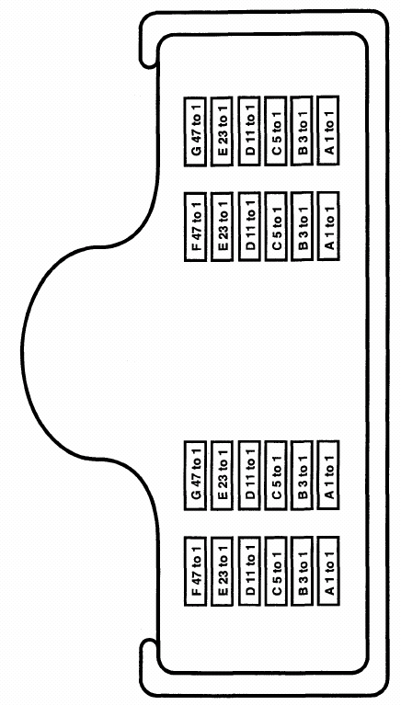
Letters refer to symbols on the Money Wheel
Payout odds above are shown as an indication only. The table layout must include the odds specified in either payout Option One, Option Two or Option Three as specified in rule 3.8.

