He mata whāriki, he matawhānui

Draft report
October 2022

He mata whāriki is a term used to describe a harakeke bush that can be used for making special mats for people to sit on. This variety of harakeke is long and durable.
He matawhānui is a term for a broad vision that is inclusive of the diversity of views. Mata denotes the eyes, being watchful and prophetic, and whānui is an inclusive term for everyone, a broad view. It also relates to the star Vega, so has a celestial connotation of looking distantly.
Together, he mata whāriki, he matawhānui is a metaphor for a welcoming place for people to gather and set a broad vision.

This document may be cited as: Review into the Future for Local Government (2022) He mata whāriki, he matawhānui: Draft report, Wellington: New Zealand.
This work is licensed under the Creative Commons Attribution 4.0 International licence. You are free to share, adapt, and build upon the material. You must give appropriate credit, provide a link to the licence and indicate if changes were made.
ISBN: 978-1-99-118522-8

Local government has a critical role to play in Aotearoa New Zealand’s governance, building strong, healthy and prosperous communities, now and into the future.

Foreword
Everyone the Panel spoke to as part of our review wants to live in, and be part of, a great community. They are passionate about, and hopeful for, their community, yet they are aware of the challenges facing us including climate change, social and economic inequity, and financial pressures.

Local government has a critical role to play in Aotearoa New Zealand’s governance, building strong, healthy, and prosperous communities, now and into the future.
Significant change is needed
Fundamentally different and new ways of thinking and working are imperative. This Review provides a significant ‘once-in-a-generation’ opportunity for us all to reimagine our future and think about how local government should evolve over the next 30 years and beyond.
We need strong leadership and partnerships that embrace the principles, rights and obligations embedded within Te Tiriti o Waitangi. We need to rebuild trust and confidence in local democracy where people can meaningfully contribute to decision-making. We need councils championing and activating wellbeing, drawing on their resources, influence, and proximity to communities. We need local and central government thinking and acting differently about opportunities and possibilities – they must be willing to innovate, value and trust others, and to use their collective resources and strengths for the benefit of communities. This is the wero (challenge) our draft report lays down.
This report traverses a broad and sometimes complex range of issues. It is not a ‘draft’ of our final report. Rather, it’s a provocation that also asks questions and hopefully prompts further vigorous debate, that will help us shape our final report which is due to be completed in mid-2023.
I have been greatly impressed by the openness and commitment of people who have engaged with our review. Over the last eighteen months we’ve talked to more than a thousand people face-to-face or online from across Aotearoa New Zealand. We’ve also received over 5,000 online responses and submissions to our review so far. Thank you for all your contributions, and I am looking forward to discussions continuing.
Feedback and submissions on our draft report is open until 28 February 2023.
We’d love to hear from you.
Ngā mihi nui
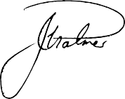
Jim Palmer
Chair, Future for Local Government Review Panel
Contents
Executive summary 9
1 Thriving local government is vital for Aotearoa New Zealand 32
1.1 Decision-making at place is needed for people to thrive 37
1.2 Why local government, and why now? 38
1.3 Increasing focus on wellbeing and local democracy 40
1.4 Five key shifts for the future of local government 42
1.5 How do we get there? 44
2 Revitalising citizen-led democracy 46
2.1 Key findings 48
2.2 Overview 49
2.3 What elements are needed for a strong participatory local democracy? 51
2.4 Where we are now 53
2.5 Why does citizen-led democracy matter? 55
2.6 Deliberative and participatory practices 56
2.7 Enablers of deliberative and participatory tools 63
3 A Tiriti-based partnership between Māori and local government 74
3.1 Key findings 75
3.2 The Panel’s journey 76
3.3 Overview 78
3.4 Section 1: Te Tiriti and local governance 81
3.5 Section 2: A new legislative framework for Te Tiriti in local governance 104
3.6 Section 3: Mainstreaming and consolidating specific arrangements for partnership and co-governance 111
3.7 Section 4: Capability and capacity 115
4 Allocating roles and functions in a way that enhances local wellbeing 120
4.1 Key findings 121
4.2 Overview 122
4.3 The current state of role and function allocation 123
4.4 A new approach for allocating roles and functions 127
4.5 Framework for the future of roles and functions 129
4.6 What could it look like if this approach is applied in practice? 132
4.7 What would an allocation process look like? 134
5 Local government as champion and activator of wellbeing 136
5.1 Key findings 137
5.2 Overview 138
5.3 Local government as a champion of wellbeing 139
5.4 Three key ways councils can champion wellbeing in their communities 142
5.5 How councils can give effect to these roles 149
5.6 What is needed to support this transition 154
6 A stronger relationship between central and local government 157
6.1 Key findings 158
6.2 Overview 159
6.3 Current state of the central and local government relationship 161
6.4 Establishing a shared investment approach to achieving local outcomes 167
6.5 Developing a new approach for co-investment 172
6.6 What might this look like in practice? 175
6.7 Towards a model for Aotearoa New Zealand 185
7 Replenishing and building on representative democracy 188
7.1 Key findings 189
7.2 Overview 190
7.3 Where are we now? 191
7.4 Better representation and electoral processes 195
7.5 Better remuneration and support for elected members 201
7.6 A more strategic local electoral term 204
7.7 New models for council governance – ensuring capability and Tiriti partnership 206
7.8 Ensuring a team approach 210
7.9 Transparency, capability, and continuous improvement 214
7.10 A health check and continuous improvement mechanism for local democracy 216
8 Building an equitable, sustainable funding and financing system 219
8.1 Key findings 220
8.2 Overview 221
8.3 The current state of local government funding and financing 222
8.4 Towards a new equitable funding system 227
8.5 Introduce new funding tools for local government 232
8.6 Retain and simplify rates as a key funding stream, supported by streamlined planning requirements 234
8.7 Climate change funding 236
8.8 Financing local government 237
8.9 Productivity Commission report 239
9 Designing the local government system to enable the change we need 241
9.1 Key findings 242
9.2 Overview 243
9.3 The current form and shape of local government 244
9.4 Our current structure is not sufficient for the future 246
9.5 Principles to support future system design 248
9.6 Example approaches that put the design principles into practice 251
9.7 Enabling flexibility and agility 258
9.8 Increasing collaboration and shared services 258
10 System stewardship and support 267
10.1 Key findings 268
10.2 Overview 269
10.3 What do we mean by system stewardship? 269
10.4 The current system of stewardship for local government 271
10.5 Challenges of current stewardship arrangements 273
10.6 Achieving effective system stewardship 274
11 The pathway forward 278
Our engagement journey 282
Glossary 285
References 295
How to have your say 305

Executive summary

Today’s communities face a host of challenges – climate change, pandemics, biodiversity loss, and growing social and economic inequity.
We are at a time of change, a moment in history where we need to shift to new ways of working, to living our lives more sustainably, to transition to a greener economy, to utilise new technologies and to fully acknowledge our social and Te Tiriti responsibilities.
Through the Panel’s research and engagement, it is clear that significant change is required to many aspects of the local government system to maximise the wellbeing and resilience of communities now and into the future and strengthen local democratic decision-making. Facing these challenges, combined with the pace of change, is causing many of our communities to lose trust in democratic institutions and to disengage. As the layer of government closest to community, local government holds the key to rebuilding trust and confidence in civil society. The challenge is that the current system does not support local government to take full advantage of the important role it holds.

Fit for the future local government
While the ‘unfunded mandate’ of additional responsibilities continues to grow, compounding funding pressures, the potential impact of proposed reforms is creating further uncertainty for the role of local government in communities.

Engagement in local government is declining, with low levels of voter turnout. There is limited representation and an undervaluing of hapū/iwi and Māori as a critical partner, in the absence of a fit-for-purpose legislative framework inclusive of Te Tiriti o Waitangi in local governance.
The wellbeing challenges facing Aotearoa New Zealand are too big for central government to address alone – local government has an important role to play. We need to see shifts in mindsets and approaches with greater collaboration and innovation so that communities and local and central government have the tools, funding, and resilience to face the challenges ahead.
A future system of local governance will need agility and capacity to evolve and respond to an ever-changing environment, drawing on the capabilities of local authorities, central government, hapū/iwi and Māori, business, communities and citizens as needed, and adapting as new challenges and issues arise, from social cohesion to new patterns of work, migration, and travel.
Local government has a fundamental role in responding to these increasingly complex issues and raising the wellbeing of communities. Renewal and change are required to ensure that the sector is ready and able to play this critical role.

The pathway ahead
The Panel, in its lead up to this draft report, has signalled five key shifts that are needed to make this change: strengthened local democracy; authentic relationships with hapū/iwi and Māori; a focus on wellbeing; genuine partnership between central and local government; and more equitable funding. In addition, system design and stewardship will also need reconsideration.

When thinking about these shifts, the Panel has had to grapple with many complex and challenging issues. Exploration of these issues has been aided greatly by the knowledge, expertise, and experience shared by the many contributors to our review so far. Because our thinking is still evolving, this report is not a ‘draft’ of our final report. Rather, it reflects our thinking to date, and acts as a provocation, posing questions that, with further input from others, will help the Panel shape our final report.
While some of the Panel’s recommendations can be implemented without a major reform agenda, we do not think that one piece of the puzzle can be executed in isolation and expect it to achieve all the change we need to see. For example, when considering the roles and responsibilities of local government, the reform agenda will need to take account of many things, such as how central and local government intend to partner with each other, funding implications, organisation form and associated strengths and resources of partners, and importantly, the local and regional context.
Delivering on the recommendations contained in our final report will require a well-considered and well-supported reform and implementation plan that is resourced appropriately, so that action is taken in a logical, sustainable, and agreed manner.
Revitalising citizen-led democracy
Local government is responsible for facilitating democracy – ensuring that it reflects our increasing diversity, embodies Tiriti-based partnerships, and seeks out innovative ways of ensuring the voices of the whole community are heard and reflected in local decisions. Internationally, citizens’ participation in local government decision-making has evolved considerably and practices should be improved and updated.

We see the opportunity for local government to utilise innovative participatory and deliberative practices to advance meaningful opportunities for community-led decision-making. While all of the mechanisms and initiatives are important, building capability and capacity is vital for councils to facilitate citizen-led democracy. Both central and local government need to invest in building the skills and experience to make this a ‘business as usual’ way of working.
Being well informed and connected to decisions that impact us, our whānau, and our whole community can help sustain and grow resilience and trust. However, the local government sector, the community, and Māori have expressed some frustration at the challenges that prevent everyone from having the ability to participate authentically in local decision-making. We believe councils need to be the ‘enablers’ of local democracy, not the ‘holders’ of it.
There are opportunities to review statutory provisions for enhancing the use of deliberative mechanisms, and to review, align, and improve the requirements for engaging with Māori across all local government legislation. In addition, we see the need for local government, in conjunction with hapū/iwi, to incorporate expressions of tikanga in council protocols.
There is a need to consider ways in which we might, through the amplification of digital tools and civics education, increase community understanding about the role of local government that leads to greater civic participation.

Recommendations
- That local government adopts greater use of deliberative and participatory democracy in local decision-making.
- That local government, supported by central government, reviews the legislative provisions relating to engagement, consultation, and decision-making to ensure they provide a comprehensive, meaningful, and flexible platform for revitalising community participation and engagement.
- That central government leads a comprehensive review of requirements for engaging with Māori across local government-related legislation, considering opportunities to streamline or align those requirements.
- That councils develop and invest in their internal systems for managing and promoting good quality engagement with Māori.
- That central government provides a statutory obligation for councils to give due consideration to an agreed, local expression of tikanga whakahaere in their standing orders and engagement practices, and for chief executives to be required to promote the incorporation of tikanga in organisational systems.
Question
- What might we do more of to increase community understanding about the role of local government, and therefore lead to greater civic participation?
Tiriti-based partnership between Māori and local government
In the Panel’s Interim Report, Ārewa ake te Kaupapa, we asked ourselves and others the question ‘How might a system of local governance embody an authentic partnership under Te Tiriti o Waitangi, creating conditions for shared prosperity and wellbeing?’ We have explored this question broadly and deeply, meeting with hapū/iwi, Māori organisations, and rōpū to listen and to learn.

One of the first responses to this was ‘how can there be a partnership where there is no authentic relationship to build on?’ We have heard, and agree, that the current local government–Māori relationship falls short of expectations and importantly, its potential.
We have heard from both local government and Māori an acknowledgment of the need for change. Change to the way the system mandates, supports, drives, and ensures opportunities for the relationship to be successful. Change in the actions and behaviours of all those involved to be mana-enhancing and reflect a sharing of values and priorities of place and people.
This report considers the current state of the overall local government–Māori relationship, summarises what we heard about the issues and opportunities, and makes proposals for change. It proposes a framework as the basis for the future relationship and an architecture for change that is woven throughout this report that:
- creates a new legislative framework for Te Tiriti in local governance
- establishes a strategic role for Māori alongside local and central government in identifying and addressing the priority outcomes that will drive community wellbeing
- establishes and embeds specific mechanisms for partnership and co-governance
- improves Māori participation in local government processes
- improves Māori representation in council governance
- builds local government and Māori capability and capacity to strengthen and maintain a Tiriti-based relationship.
Together, we consider that the framework and architecture for change provides a path towards a stronger Tiriti-based partnership, one that results in mutually beneficial outcomes for each other and importantly, for local communities.
Recommendations
- That central government leads an inclusive process to develop a new legislative framework for Tiriti-related provisions in the Local Government Act that drives a genuine partnership in the exercise of kāwanatanga and rangatiratanga in a local context and explicitly recognises te ao Māori values and conceptions of wellbeing.
- That councils develop with hapū/iwi and significant Māori organisations within a local authority area, a partnership framework that complements existing co-governance arrangements by ensuring all groups in a council area are involved in local governance in a meaningful way.
- That central government introduces a statutory requirement for local government chief executives to develop and maintain the capacity and capability of council staff to grow understanding and knowledge of Te Tiriti, the whakapapa of local government, and te ao Māori values.
- That central government explores a stronger statutory requirement on councils to foster Māori capacity to participate in local government.
- That local government leads the development of coordinated organisational and workforce development plans to enhance the capability of local government to partner and engage with Māori.
- That central government provides a transitional fund to subsidise the cost of building both Māori and council capability and capacity for a Tiriti-based partnership in local governance.

Allocating roles and functions in a way that enhances wellbeing
Compared to other OECD countries, the scope of responsibilities for local government in Aotearoa New Zealand is relatively small, as is its proportion of government expenditure.

We know that many councils are struggling to effectively deliver their current roles, functions, and obligations due to limited capacity and capability, financial pressures, and conflicting responsibilities.
While some roles and functions have been added in recent times, major reforms underway will see the removal of some significant roles and functions through greater centralisation and regionalisation. As councils grapple with that uncertainty, there is also a lack of clarity about their roles in the more complex problems we face. Climate change is a key example. Local government has an essential role to play in supporting local mitigation and adaptation efforts and promoting environmental wellbeing and sustainability.
We consider there is a much deeper role for councils to expand beyond the current infrastructure focus to facilitate and deliver wellbeing.
Any discussion about roles and functions at a local level must also consider the role of hapū/iwi entities, building on the many examples of mana whenua entities adding significant value.
It is time to take a fresh look at how roles and functions are allocated and how the strengths of different actors can be realised. We don’t think it’s about binary allocation (local or central), but rather how the design, accountability, influence, and delivery could sit across many actors.
Recognising local government’s role in wellbeing, we have proposed a framework that could be used when allocating roles and functions – one that is underpinned by the subsidiarity principle and te ao Māori values.
At the heart of the framework is the notion that local comes first, with local government showing leadership in shaping the conditions for communities to thrive, being an important connector, harnessing its role as anchor institution, and creating space for hapū/iwi to pursue self-determination.
The framework also reflects our acceptance that there are justifications for departing from the local-first approach, including effectiveness of scale, access to skills, risks and liability, consistency, and equality.
Using the framework, we consider that local and central government, in a Tiriti-consistent manner, should review the future allocations of roles and functions.
Recommendations
- That central and local government note that the allocation of the roles and functions is not a binary decision between being delivered centrally or locally.
- That local and central government, in a Tiriti-consistent manner, review the future allocations of roles and functions by applying the proposed approach, which includes three core principles:
- the concept of subsidiarity
- local government’s capacity to influence the conditions for wellbeing is recognised and supported
- te ao Māori values underpin decision-making.
Questions
- What process would need to be created to support and agree on the allocation of roles and functions across central government, local government, and communities?
- What conditions will need to be in place to ensure the flexibility of the approach proposed does not create confusion or unnecessary uncertainty?
- What additional principles, if any, need to be considered?

Local government as champion and activator of wellbeing
Local government has a crucial role in championing and activating local wellbeing due to its assets, influence, and proximity to communities. Local government has a systems leadership role within the wider interconnected system that includes social networks, workplaces, community institutions, community spaces, and conditions that interact to affect and foster the local wellbeing of people, place, and the environment.

Hapū/iwi and Māori organisations are fundamental to the Kaupapa of wellbeing. Councils must develop sustainable partnerships with hapū/iwi and Māori organisations. This will require councils to take a more holistic, tikanga-based approach that considers intergenerational outcomes when solving complex problems.
The Panel has identified three ways councils can enhance and champion wellbeing: as an anchor institution, as a place-maker, and as a systems networker and convenor.
We have seen a number of examples where councils are already putting wellbeing at the core of their purpose and shifting the way they work in and with their communities. However, this is not consistent or implemented sustainably across all councils. It will require a significant shift in councils’ mindset, investment, capability, and relationships with central government. Competing demands and budget constraints make it challenging to fully realise this enhanced role without the other changes in the report. Having said that, there are a range of ways councils can take action now.
Recommendations
- That local government, in partnership with central government, explores funding and resources that enable and encourage councils to:
  - lead, facilitate, and support innovation and experimentation in achieving greater social, economic, cultural, and environmental wellbeing outcomes
  - build relational, partnering, innovation, and co-design capability and capacity across their whole organisation
  - embed social/progressive procurement and supplier diversity as standard practice in local government with nationally supported organisational infrastructure and capability and capacity building
  - review their levers and assets from an equity and wellbeing perspective and identify opportunities for strategic and transformational initiatives
  - take on the anchor institution role, initially through demonstration initiatives with targeted resources and peer support
  - share the learning and emerging practice from innovation and experimentation of their enhanced wellbeing role.
Questions
- What feedback do you have on the roles councils can play to enhance intergenerational wellbeing?
- What changes would support councils to utilise their existing assets, enablers, and levers to generate more local wellbeing?

A stronger relationship between central and local government
The Panel has heard clearly that the current relationship ranges from strained to broken, with a lack of trust in both directions being a common theme. Communities are not benefiting from a cohesive, mutually reinforcing relationship that harnesses the strengths of both local and central government.

Both central and local government need to reset the relationship. Tackling the wellbeing challenges of the 21st Century requires partnering at place with a strong focus on agreed outcomes and priorities.
While the people relationships will always trump systems and models, we are concerned that there is system fragility and reliance on individuals. We believe that the optimal combination is strong leadership and relational practice, backed up by a strong system that creates a more sustainable and predictable environment for everyone. This will require a mindset shift from both central and local government, acknowledging the value and strength that each brings.
A key element of any future model must be an approach and a process for identifying shared priority outcomes and commitment to co-invest for community outcomes. Within this process there is an explicit role for Māori alongside local and central government in identifying and addressing the priority outcomes that will drive community wellbeing. Understanding the nature and extent of funding and spending is critical to determine where there are opportunities to reprioritise and ensure resources are applied to best effect.
Our report outlines examples of collective/interdependent models that provide for co-investment, underpinned by a focus on building and maintaining productive relationships.
Questions
As we work towards our final report, we want to consider the merits of the different examples. We are interested in your views as to how to rewire the system of central and local government relationships through developing an aligned and cohesive approach to co-investment in local outcomes.
- To create a collaborative relationship between central and local government that builds on current strengths and resources, what are:
  - the conditions for success and the barriers that are preventing strong relationships?
  - the factors in place now that support genuine partnership?
  - the elements needed to build and support a new system?
  - the best options to get there?
  - potential pathways to move in that direction and where to start?
  - the opportunities to trial and innovate now?
- How can central and local government explore options that empower and enable a role for hapū/iwi in local governance in partnership with local and central government? These options should recognise the contribution of hapū/iwi rangatiratanga, kaitiakitanga, and other roles.

Replenishing and building on representative democracy
Local government needs to ensure that diverse voices are heard. The most effective way to do this is to make sure that every effort is made to reflect diversity around the council table.

Key to this is ensuring that diversity is reflected and that members of council have the necessary skills, experience, and support to lead with confidence, help develop solutions to complex intergenerational problems, and facilitate inclusive and effective participatory democracy.
However, there are still significant barriers to more diverse representation on councils. Participation in local government has continued to decline over the past three decades and a significant proportion of people, due to a number of factors, do not see the value of standing for a position or even voting in local body elections, which limits engagement and confidence in local government decision-making.
Māori wards and constituencies (whilst a positive way of providing representation for Māori as citizens) were not designed to provide for Tiriti-based representation of mana whenua or significant Kaupapa-based groups at the council table. People in councils need to build their capability and understanding of Te Tiriti o Waitangi and te ao Māori.
To promote innovative, strategic, and future-focused leadership, support and capacity building for elected members is recommended. With this in mind, the Panel is also exploring the merits of models for democracy that enable both capability-based and mana whenua appointments to supplement elected members. The Panel is interested in your feedback on this concept.
The Panel has received and considered a lot of ideas about how to strengthen representation and electoral processes. Accordingly, our draft report promotes a number of changes. This includes looking at more proactive support for representation reviews, centralised administration of local electoral processes, stronger direction on the choice of electoral system, the voting age, and the electoral term.
The Panel has considered conditions that could promote success, such as remuneration and workplace support for elected members, as well as mechanisms to promote a healthy relationship between council and staff, transparency and continuous improvement in democratic processes.

Recommendations
- That the Electoral Commission be responsible for overseeing the administration of local body elections.
- That central government undertakes a review of the legislation to:
  - adopt Single Transferrable Vote as the voting method for council elections
  - lower the eligible voting age in local body elections to the age of 16
  - provide for a 4-year local electoral term
  - amend the employment provisions of chief executives to match those in the wider public sector, and include mechanisms to assist in managing the employment relationship.
- That central and local government, in conjunction with the Remuneration Authority, review the criteria for setting elected member remuneration to recognise the increasing complexity of the role and enable a more diverse range of people to consider standing for election.
- That local government develops a mandatory professional development and support programme for elected members; and local and central government develop a shared executive professional development and secondment programme to achieve greater integration across the two sectors.
- That central and local government:
  - support and enable councils to undertake regular health checks of their democratic performance
  - develop guidance and mechanisms to support councils resolving complaints under their code of conduct and explore a specific option for local government to refer complaints to an independent investigation process, conducted and led by a national organisation
  - subject to the findings of current relevant ombudsman’s investigations, assess whether the provisions of the Local Government Official Information and Meetings Act 1987, and how it is being applied, support high standards of openness and transparency.
- That central government retain the Māori wards and constituencies mechanism (subject to amendment in current policy processes), but consider additional options that provide for a Tiriti-based partnership at the council table.
Questions
- How can local government enhance its capability to undertake representation reviews and, in particular, should the Local Government Commission play a more proactive role in leading or advising councils about representation reviews?
- To support a differentiated liberal citizenship, what are the essential key steps, parameters, and considerations that would enable both Tiriti- and capability-based appointments to be made to supplement elected members?

Equitable funding and finance
Local government has been under significant funding pressure for several years, with many suggesting to the Panel that the system is ‘broken’ and that we have reached ‘peak rates’.

Concerns about growing community expectations, unfunded mandates being passed down from central government, along with meeting the impacts of growth, tourism, and significant infrastructure failures have placed huge rate pressures on councils.
Successive funding reviews have highlighted the problems and proffered solutions; however, few have been enacted.
To move from the currently constrained funding system, there needs to be a meaningful change in the way local and central government address issues of sustainable funding, and that also enables councils to establish new funding mechanisms.
While the Panel considers that rates are still the best means of funding council activities, they need better support from central government. The continuing impact of unfunded mandates, the significant future challenges of climate change, environmental restoration, and matters of social and economic inequity are all going to be felt locally, but need central government funding support.
As mentioned earlier, the Panel believes central and local government must partner more effectively and co-invest in community outcomes and priorities. It will require central government to commit funding to those priorities and work with local government in the application of that funding.
The Panel also considers that central government needs to assess the impacts of proposed regulatory changes on local government and then provide funding for them. Only then will the issue of unfunded mandates be addressed. We also think central government needs to start paying rates and other charges on its property, as well as creating a significant intergenerational climate change fund.
Local government will also benefit from long-term planning and rate-setting processes being more flexible and from having greater ability to establish new funding tools, such as congestion charging and bed taxes.

Recommendations
- That central government expands its regulatory impact statement assessments to include the impacts on local government; and that it undertakes an assessment of regulation currently in force that is likely to have significant future funding impacts for local government and makes funding provision to reflect the national public-good benefits that accrue from those regulations.
- That central and local government agree on arrangements and mechanisms for them to co-invest to meet community wellbeing priorities, and that central government makes funding provisions accordingly.
- That central government develops an intergenerational fund for climate change, with the application of the fund requiring appropriate regional and local decision-making input.
- That central government reviews relevant legislation to:
  - enable councils to introduce new funding mechanisms
  - retain rating as the principal mechanism for funding local government, while redesigning long-term planning and rating provisions to allow a more simplified and streamlined process.
- That central government agencies pay local government rates and charges on all properties.
Question
- What is the most appropriate basis and process for allocating central government funding to meet community priorities?

System design
The success and sustainability of local government requires a system design that can support the needs of our communities and foster wellbeing both now and in the future.

The issues that councils face are increasingly challenging and complex, and the current structures and systems need to be strengthened and enhanced to ensure that they are fit for the future.
A successful future system and structure for local government will enable communities to have their voices heard and their needs met locally, while leveraging strong regional connections and resources.
The Panel has developed a set of design principles against which future structures should be evaluated. Our draft report contains examples of structures that could give effect to the principles. As we develop our final report we are very interested in your feedback on the principles and structural examples.
Following our review, local and central government will need to work together to determine the best structural options to give effect to the design principles and that also take account of the best way various roles and functions are delivered.
No matter what the future system design looks like, there needs to be greater collaboration across local government and increased use of shared services. The Panel considers that there are significant opportunities to deliver better value and ensure resources are applied to best effect, especially having shared information systems and support services in place. The Panel also believes there is great potential for central and local government to work more closely together to create a more joined-up public sector.
Recommendations
- That central and local government explore and agree to a new Tiriti-consistent structural and system design that will give effect to the design principles.
- That local government, supported by central government, invests in a programme that identifies and implements the opportunities for greater shared services collaboration.
- That local government establishes a Local Government Digital Partnership to develop a digital transformation roadmap for local government.
Questions
- What other design principles, if any, need to be considered?
- What feedback have you got on the structural examples presented in the report?

System stewardship and support
The sum of all the changes proposed in this draft report requires us to consider what is needed at a system stewardship level to embed, drive, and support the system of local government to successfully navigate and adapt to change over the next 30 years.

System stewardship can be defined as holding the responsibility for the long-term quality, sustainability, and outcomes of the wider system of local government. It’s about guiding and supporting local government to be the very best it can be. It includes a focus on the relational (people) aspects of a system, as well as the processes and enabling conditions needed to ensure all actors are aligned towards the system outcomes.
Local government stewardship is currently provided by people and organisations in central and local government. At a central government level, this primarily includes the Minister of Local Government, the Department of Internal Affairs (along with the Secretary of Local Government), and the Local Government Commission. At a local government level, membership organisations Local Government New Zealand and Taituarā have important roles.
While there are strengths in the current approach, we consider there are gaps and limitations, and that significant change is needed to support the shifts proposed in this report. In particular, we consider that a specified stewardship function is required that can support the system holistically in the long term, including driving the capabilities, processes, actions, and legislation that will lift performance across local government and maximise its strengths and resources and collective impact.
As such, we recommend that central and local government consider which entities are best placed to play system stewardship roles in a revised system of local government that proactively promotes and cares for the health of the local government system, including:
- oversight and monitoring of relevant legislation administered by agencies
- care for the system’s long-term capability and people
- maintenance and enhancement of institutional knowledge and information
- supporting partnerships, co-design, and innovation.
We also seek feedback on how we embed Te Tiriti in local government system stewardship.

Recommendation
- That central and local government considers the best model of stewardship and which entities are best placed to play system stewardship roles in a revised system of local government.
Questions
- How can system stewardship be reimagined so that it is led across local government, hapū/iwi, and central government?
- How do we embed Te Tiriti in local government system stewardship?
- How should the roles and responsibilities of ‘stewardship’ organisations (including the Secretary of Local Government (Department of Internal Affairs), the Local Government Commission, LGNZ, and Taituarā) evolve and change?

Thriving local government is vital for Aotearoa New Zealand

We live our lives in place. People, whānau, and communities are rooted in – and shaped by – the places they call home.
As a Panel, we imagine a future where local government enables solutions to locally specific challenges, connects communities with the resources they need, and makes sure people and the environment can thrive in a rapidly changing world.
Today, many of our places are under threat. As we write this, numerous coastal communities are considering their options for how to adapt and build resilience in the face of increasingly damaging climate impacts. Westport, situated as it is on a floodplain at the mouth of the Buller River, is ground zero for these impacts. Last July, devastating flooding caused major damage to over a quarter of the local housing, and nearly half of Westport’s population was evacuated – or rescued – during the worst of the floods. But even as the rain was falling, the community sprang into action. People came together to lay sandbags and dig out debris, while others offered hot meals, accommodation, and equipment to those who needed it. Resources and emergency services were directed to the area by central government, and on the ground, regional and district councils helped coordinate the response from a broad range of communities, agencies and other organisations.
Clearly, communities are strong, resourceful, and resilient. Still, Westport faced another major flood event only six months later, causing further damage, and a year on from the July floods over 400 homes were yet to be repaired. At a time when ‘one in a hundred years’ storms are happening every year and climate change means we will be facing more and more extreme weather events, we cannot rely only on emergency protocols and the resourcefulness of people under extreme pressure.
Communities need the support of a strong and adaptive system of local governance. This means having government systems that are well resourced to effectively allocate services, give effect to Te Tiriti o Waitangi, and set up to plan ahead, innovate, and coordinate with others to respond to a changing world. But at the moment, these systems, and the culture and mindsets needed to support them, are lacking.
Climate change is only one of the intersecting issues communities face, from the need to reduce inequity, challenging economic and business conditions, to adapting to changing demographics, technologies, and models of employment. Many of these challenges will likely get more pronounced, and others are still beyond the horizon. To support communities through these changes and enable local wellbeing and democracy, councils and communities cannot afford to be stuck in reactive mode. Instead, strength and capability need to be built now, enabling the transformation of local government to support communities now and for generations to come.
Ensuring community wellbeing at place is a job for everyone. Local government, as the level of government closest to communities, is a vital piece of the puzzle. Of course, local government cannot do this alone. Hapū/iwi also have a key role in local governance, along with business and communities and in collaboration with central government. But without major and immediate changes, our councils, and the local government system more broadly, will be ill-equipped to face the challenges ahead.
Introducing place
To us, place is more than just the physical town, city, or region where you live. It is made up of:
The natural world, te taiao, where we are grounded
Te taiao is our interconnected and interrelated natural world, home to our native biodiversity and the plants and animals that define our local area. It also includes the whenua and awa that provide resources for the people who live there. Maintaining ecological balance is essential to the health and wellbeing of communities and te taiao itself.
People and community
Our relationship to place is also defined by the people who live near us. Aotearoa New Zealand’s communities are diverse, varied, and vibrant, and many are in the process of demographic transition. People define the culture of a place, from the longstanding cultural practices of hapū/iwi that inform how land was shaped and what local stories are told, to the arts and cultural expression of our diverse communities.
Infrastructure
The built environment, businesses and local services, and recreational spaces are an essential part of how we imagine a place. This hard and soft infrastructure all contributes to the smooth functioning of communities. From Tāmaki Makaurau Auckland’s high-rise city centre to Oamaru’s historical whitestone district, our local infrastructure – be those pipes, parks, or buildings – is foundational.
In this report, when we talk about communities and the challenges they face, we are talking about people’s experiences ‘at place’. Place is where we experience life, and where the impacts of large-scale changes and issues are felt. For instance, climate change is a global issue, but we experience it at place when we face multiple ‘one in a hundred year’ storms over a winter that cause damage to our homes and landslides that block our route into town. Place is ‘where the rubber hits the road’, where global issues hit home.
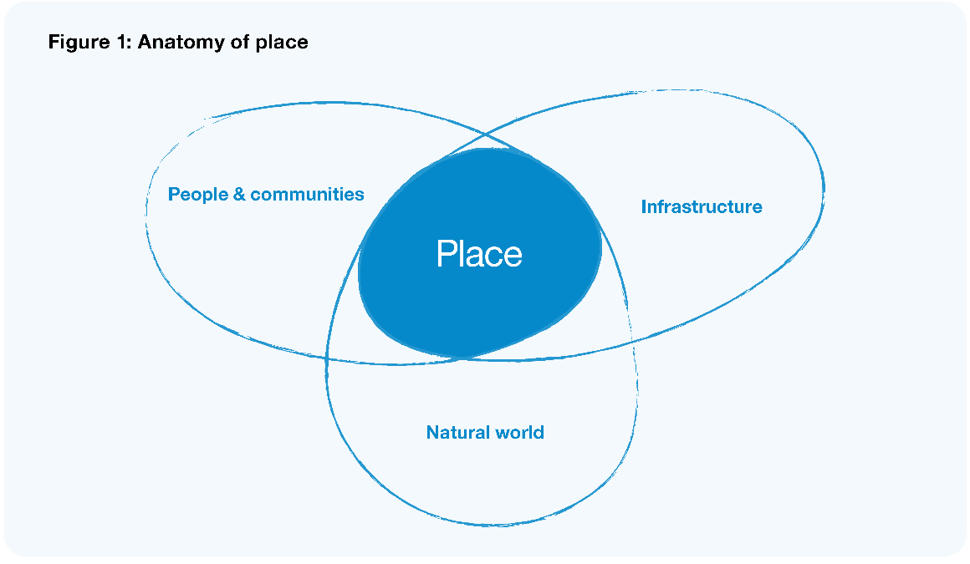

Decision-making at place is needed for people to thrive
Dealing with local challenges and enabling people to thrive at place requires good governance that takes into account the complexities of a place-based context and is in touch with the ways broader policies affect local communities.
Many people and organisations play a role in local decision-making and ensuring that people, culture, the environment, and the economy are supported, resourced, and enabled to flourish. In this report we talk about the roles of, and relationships between, a number of key players with important roles in decision-making at place.
- Local government is a central player in local governance. Councils’ existing assets and levers, and their proximity to communities, mean they are well-placed to lead wellbeing and democracy at place. When we talk about local government, we mean the local authorities established by statute. In this report, we often just refer to ‘councils’, a term many people are more familiar with.
- Hapū/iwi have long governed at a local level in Aotearoa New Zealand and maintain a vital role in local governance and stewardship. Through Te Tiriti o Waitangi they maintain rangatiratanga and rights to manage their own affairs. More broadly, Māori also have the right to be actively involved as citizens and have a role in kāwanatanga.
- Communities have a vital role in making decisions at a local level. They do this by participating in local democratic processes, running local businesses, clubs and organisations that bring people together to increase wellbeing and contributing to local governance at place through civil society entities.
- Central government provides essential resources and services to people in place, and also sets the regulatory framework that guides how local communities and local government operates and is financed. Central government has a role as enabler and partner for local entities across a range of issues.
Local government and local governance
Our terms of reference ask us to consider the future of local governance in Aotearoa New Zealand. Local government, in the context of this review, refers to the local authority structures established by statute.
Local governance refers more broadly to the system by which communities are governed – in essence, who makes decisions, how they are made, and who the decision-makers are accountable to. In any place or community, local governance can involve many decision-makers including central government, local authorities, hapū/iwi and Māori organisations, business and community organisations, and others.
Of course, place does not exist in a vacuum. Each town, city, or region is deeply intertwined with others, linked via infrastructure, shared resources, interpersonal connections, and te taiao (the natural world). These connections create a network of interdependence, where wellbeing and resilience in one place is only possible through collaboration and co-investment with others. So, in looking at local governance we also need to look at connections between us and understand how collaboration across regions and between different levels of government can help tackle issues that affect everyone but converge and impact us at place.

Why local government, and why now?
Local government is the form of government most closely intertwined with people’s day-to-day lives and is with them ‘at the coalface’ in good times and in bad. It has an important contribution to make, allowing different communities to make their own choices and relating and shaping government decisions for the needs of people at place (Lyons 2007). As such, local government is essential to supporting the future of communities and has the potential to help enable democracy and wellbeing.
At the moment, local government makes a tangible positive impact in communities, from the delivery of core services to the many examples around the country of councils taking innovative approaches that help their communities flourish. But as we noted in our Interim Report, Ārewa ake te Kaupapa, councils are currently under significant pressure. This pressure comes in a range of forms, from the ‘unfunded mandate’ of additional responsibilities being delegated from central government without additional resources, to not having a fit-for-purpose legislative framework for Te Tiriti o Waitangi in local governance. In addition, low levels of voter turnout and participation in council processes means there is a risk that decisions are only representative of part of the population.
As such, our current system of local government has great potential to deliver more value for its communities.
“It’s not about the future of the Council but about the future of great communities.”
– Elected member at Council Roadshow
“We the youth of Aotearoa will inherit the next 30 years. It will be our mess to clean up or our place to thrive.”
– Rangatahi at Spotswood College
It is up to all of us, now, to change that. The big challenges coming our way, from climate to a loss of social cohesion and challenging economic conditions, are not going to be solved through a centralised approach from Wellington alone. These complex and often global issues are felt locally by communities at place, and will also need to be solved at place, supported by broader policies and actions that take community needs and interests into account.
There are already many ‘green shoots’ – pockets of encouraging action, where local government is working in an innovative way and collaborates to realise better community outcomes. But we need to do more than celebrate the green shoots that manage to push through the cracks in the concrete. It is time for a broad-based transformation of local government, towards an adaptive, resilient system that enables a field full of green shoots to grow and flourish together.
The change we need now is not just for the communities of today, it is for future generations, who will be facing increasing complexity and large-scale changes. We need to make sure that the right foundations are in place for them to flourish, recognising that what works today might not be what works in 20 years’ time.
We heard loud and clear from the many people we engaged with – from local government, hapū/iwi, and Māori, businesses, communities and central government – that renewal and change is required to ensure that councils are ready and able to fully support local democracy and wellbeing.

Increasing focus on wellbeing and local democracy
The Local Government Act 2002 (LGA) sets out a two-fold purpose of local government:
  - to enable democratic local decision-making and action by, and on behalf of, communities
  - to promote the social, economic, environmental, and cultural well-being of communities in the present and for the future.
As a Panel, we fully support this purpose for local government. While councils already deliver wellbeing outcomes and enable democratic decision-making, there is potential for them to use all the levers at their disposal to achieve much more. We envision a future where wellbeing is put at the centre of everything councils do, which will mean changing the way many things are done and working in innovative and collaborative ways. Ensuring that councils have what they need to reach this potential is at the heart of this report.
Through our research and engagement, it became clear that significant changes would be required to many aspects of the local government system to maximise the wellbeing and resilience of communities now and into the future and strengthen local democratic decision-making.
What is local wellbeing?
Wellbeing looks different for different whānau and communities, depending on their unique needs, values, preferences, endowments, and capabilities. Local wellbeing covers a wide spectrum of interconnected social, cultural, economic, and environmental outcomes. In our Interim Report, Ārewa ake te Kaupapa, we noted that wellbeing includes:
‘Everything that makes a good life, not only for individuals, but also for their whānau and families, their neighbourhoods and communities, and for future generations. This includes, among other things, living in a clean and healthy environment, having basic needs met, being physically safe and secure, experiencing connection with others and a sense of belonging, being able to participate and contribute, being able to express yourself and your identity, experiencing yourself as valued and valuable, and having opportunities to prosper and live to your full potential.’
We also noted that all elements of wellbeing are interconnected – influencing one will have impacts on others, and influencing the wellbeing of one person will have impacts on their relatives and those they are connected to.
Māori and Pacific approaches to wellbeing
There are rich and diverse understandings of wellbeing in Aotearoa New Zealand. In particular, we know that the way Māori view wellbeing is different from how other New Zealanders view wellbeing (TPK and Treasury 2019). Māori approaches to wellbeing are informed by te ao Māori (the Māori world view) and lived experiences. Treasury’s He Ara Waiora framework helps us to understand waiora, which is often translated as a Māori perspective on wellbeing and is grounded in wai (water) as the source of all life. He Ara Waiora draws on te ao Māori foundations for wellbeing grounded in kaitiakitanga (guardianship or stewardship of our resources), manaakitanga (care for others), ōhanga (prosperity) and whanaungatanga (the connections between us) (O’Connell et al 2018). Māori approaches to wellbeing tell us that the wellbeing of te taiao, our natural world and environment, is inextricably linked to intergenerational wellbeing.
There are also diverse approaches to and frameworks for understanding Pacific wellbeing, reflecting the diversity of Pacific peoples in Aotearoa New Zealand (see for example, Ola Manuia: Pacific Health and Wellbeing Action Plan 2020–2025 and Pacific Aotearoa Lalanga Fou).

Five key shifts for the future of local government
We identified five key shifts that need to be made to the way that local governance operates. The shifts are interconnected, and are all needed in order to have a robust, adaptive and inclusive local governance system that supports local communities now and into the future.
These shifts are outlined below at a high level, and are reflected throughout the rest of the report. Making these shifts a reality will require coordinated activity and effort at strategic and structural levels as well as on the ground by people in local government, central government, sector organisations and communities. These shifts do not operate in isolation: they are deeply intertwined, and to take action in one area without addressing the others is unlikely to lead to the change we need to see.
Figure 2: The five key shifts
1 | Strengthened local democracy | From low public trust and participation in local governance  To citizens participating in local decision- making; councils being trusted and reflecting community diversity
2 | Authentic relationship with hapū/iwi and Māori | From variable relationships between councils and hapū/iwi/Māori  To strong, authentic relationships between councils and hapū/iwi/Māori that enable self- determination and shared authority
3 | Stronger focus on wellbeing | From councils often narrowly focused on delivering services and infrastructure  To councils focusing on holistic strategies to improve the wellbeing of their communities
4 | Genuine partnership between local and central government | From low trust between local and central government  To genuine partnership to co-invest in and deliver wellbeing outcomes for communities
5 | More equitable funding | From an over-burdened and constrained funding system  To an equitably funded system that enables communities to thrive

What will the shifts require?
Strengthened local democracy includes building trust and belief in local government by revitalising deliberative democracy processes to ensure everyone has the information, time, and access they need to participate in council decision-making processes. It also means improving representative democracy processes to ensure that councils have the requisite governance capabilities and support in place, reflect the diversity of communities, and Māori are enabled to participate fully as both elected members and partners in governance. It will also include exploring, adapting and trialling new forms of participatory and deliberative democracy and learning from other countries and organisations.
Authentic relationship with hapū/iwi and Māori means shifting towards a future where Māori are an integral part of local governance, and the relationship becomes a genuine, Tiriti-based partnership – enabling the meaningful exercise of rangatiratanga and a more culturally specific exercise of kāwanatanga by councils. This will likely require a new legislative framework for Te Tiriti in local governance, building specific arrangements for partnership and co-governance, and increasing local government and Māori capability and capacity to build and maintain a meaningful Tiriti-based relationship.
Stronger focus on wellbeing points towards a broad shift in mindset, from a local government system that has traditionally focused on delivering infrastructure and services in the most cost-effective way, to a holistic approach that centres community wellbeing. This approach will coordinate activity in ways that mobilise existing resources and support innovation, experimentation, and learning. As part of this shift, we see the need for local government to strengthen its role as an anchor institution, place-maker, and systems networker and convenor, and to coordinate with other councils and organisations to achieve value and outcomes that would not be possible individually.
Genuine partnership between local and central government requires a fundamental reset of the relationship where each party truly values the other and recognises the respective strengths and contributions they can make to community wellbeing. It will require a significant shift in ways of working together to improve outcomes on the ground. A key part of this shift is transitioning to an approach that enables central and local government to effectively co-invest for community outcomes. This likely includes developing a mechanism for aligning priorities, ensuring equitable funding, and a commitment to working together in new ways.
More equitable funding involves ensuring councils have a range of funding and financing tools at their disposal, in order to carry out their roles effectively and support wellbeing at place. This will likely mean a review of the current rating system, the development of new funding mechanisms, and the end of unfunded mandates being passed to local government. It will also involve co-investment with central government to respond more effectively to community priorities and needs.

How do we get there?
In this report you will find chapters focused on actions and approaches to specifically achieve particular shifts. However, these actions need to be supported by a strong local government system, and that will also mean looking at wider issues that stretch over a number of the shifts. This includes looking at how roles and functions are allocated, the future form of local government, boosting capability across the system, and ensuring the local government system as a whole is well supported.
In order to face challenges head on and ensure people, communities and the planet thrive, there will need to be a major shift in the culture of local government, and new mindsets and behaviours to go along with it. A new, refreshed system of local government will need to be innovative and open to experimentation, with a commitment to serving communities and building strong but adaptive systems. This will be a big change. As we carry out these shifts, we will also have to hold two things in mind at once: the need for flexibility and agility and the need for structure.
A future system of local governance will need to evolve and be agile, drawing on the capabilities of local authorities, central government, and others as needed. It will need to have the capacity to adapt and respond as new challenges and issues arise.
We will also need to create a system that is sufficiently dynamic to withstand the unknown pressures of the future and provides a clear platform for action and collaboration. This will involve ensuring the structure, legislation, and processes that underpin our system of local government are strong and fit-for-purpose. We should be looking to build a system and culture of ‘adaptive resilience’ that embraces complexity and enables everyone in the system to respond to expected and unexpected changes and challenges.

A multifaceted framework for change
Many of the suggestions described in this report can be activated to some degree, without needing a mandate or legislative reform. But significant coordinated changes will also be needed across the system of local and central government, to different extents and across a range of timeframes. This will require a joined-up approach, with commitment across the system and sufficient resourcing and capacity made available.
Some of the changes needed will be systemic and structural, including updating some of the underlying legislation and frameworks that define local government. This might look like embedding Te Tiriti more explicitly within local government systems, considering changes to the roles and functions carried out by local councils, and the form of the local government system itself. Legislative change, including to the Local Government Act 2002, would be needed to enable some of these actions.
However, structural changes alone will not be sufficient. The heart of local government and local governance is people, and people are key to the shifts and transformation we need. We will need to work together to improve relationships across local and central government, hapū/iwi, business and communities. There is a need to understand the entrenched mindsets that limit our ability to collaborate across and within organisations, providing people with new mechanisms and spaces for working together and aligning priorities, and being conscious of the existing dynamics (but not being constrained by them).
Throughout, we will need to make sure that people in local government and beyond are supported through this transition and are given the resources and support they need to get there. There will need to be concerted capacity and capability building, sufficient resourcing, and upskilling, including a national commitment to increasing capacity for hapū/iwi and communities to participate meaningfully.
We hope readers will be inspired to imagine what change is possible, and how local government could uplift and support communities through the challenging and exciting times ahead.

Revitalising citizen-led democracy

Citizen participation in local democracy is declining, and communities have lost connection and trust with the current democratic process.

Key findings
Local government needs to become more an ‘enabler’ of democratic decision-making, not the ‘holder’ of it.
The use of deliberative and participatory democracy practices can lead to greater citizen empowerment and enhanced participation in decision-making. This is critical, especially when tackling major challenges such as intergenerational equity, long-term planning, and social cohesion.
Nothing in the Local Government Act 2002 (LGA) prevents the use of deliberative or participatory mechanisms or the adoption of more empowering frameworks; decisions to take more participatory approaches built on community relationships sit with each council.
There are a range of actions that local government needs to take, including increasing its capability and its understanding and use of deliberative and participatory democracy practices.

Overview
We see citizens’ participation in local government decision-making, not just as a tool that contributes towards growing local democracy, but also as a vital part of the very essence of democracy itself. Local government holds the key to strengthening civil society.
We discuss in this chapter that increasing community participation in local government leads to a greater sense of empowerment, higher trust between councils and communities, stronger connections within communities, and better designed and delivered services. It’s important to all of us to feel connected to decisions that impact us, our whānau and our whole community in their everyday lives, and also future generations.
Earlier on in the report we described what we meant by local governance. This chapter focuses on how revitalising community participation in decision-making in local government contributes to a healthier, more innovative local democracy.
In particular, we ask the following questions:
- How can we reach trusted, local decisions where people in the community see that their perspectives have been considered and so agree the decision is generally fair?
- How do we ensure participation is not a competition to be the most vocal and extreme, but an exercise that asks all participants to consider the positions of others in an effort to inform councils what trade-offs they can live with?
When local democracy is bolstered by strong civic participation in this way, we envision a future where:
- communities have high trust in democratic processes, allowing a high trust relationship to be developed between community and council. This relationship enables long-term solutions to complex problems to be explored and addressed
- councils trust citizens in communities by asking for ideas and backing community-led solutions
- people are aware of and value the role of local government in their community. They feel able to confidently connect and interact with council through accessible and meaningful processes
- people engage with and influence democratic processes in a variety of ways. This ensures that participants are well informed to make effective decisions and support equitable access to members of the community
- a Tiriti-based framework for local governance ensures that Māori as citizens and mana whenua have a culturally distinct role identified in democratic processes
- democratic processes are fair and meaningful. The democratic system is able to adapt and evolve as the needs of communities and ways of communicating change
- local authorities are empowered to trial innovative democratic approaches.
The Panel sees an opportunity to promote participatory democracy in local government, but there is a need for it to be better understood and utilised by citizens and councils.
The Panel has been inspired by, and draws inspiration from, the pockets of innovation both locally and internationally, that demonstrate how local government can be a more robust, responsive and innovative partner with citizens and communities.
Key terms
Democracy: The definition of ‘democracy’ can be thought of as ‘power to the people’ and refers to a way of governing by public will. This means that the public are given power to rule the state, either directly or through elected representatives. Most commonly, we see this through elections, where the public vote for people to represent their interests. However, a fundamental and vital part of democracy is also the right to participate directly, not via an elected member. This is another, equally vital way power is given to the people.
Participatory democracy: refers to the direct involvement of citizens in political decision-making, beyond choosing representatives through elections.
Representative democracy: includes people elected to represent citizens.
Participatory democratic methods: involve self-selected groups and are focused on public opinion orientated decision-making for example, participatory budgeting
Deliberative democratic methods: involve demographically representative groups selected by public lottery that weigh evidence, deliberate to find common ground, and develop an informed public judgement on a key issue which can then be directly adopted by council for example, citizens’ assemblies.

What elements are needed for a strong participatory local democracy?
Within the parameters of this review, we consider how participation practices and approaches can be applied within the local democracy sphere. The diagram of participatory democracy below identifies the many strands at play needed to support a functioning, thriving, evolving democracy. Each concept doesn’t sit in isolation but converges and interlinks, acknowledging that all four concepts together enable strong participatory local democracy.
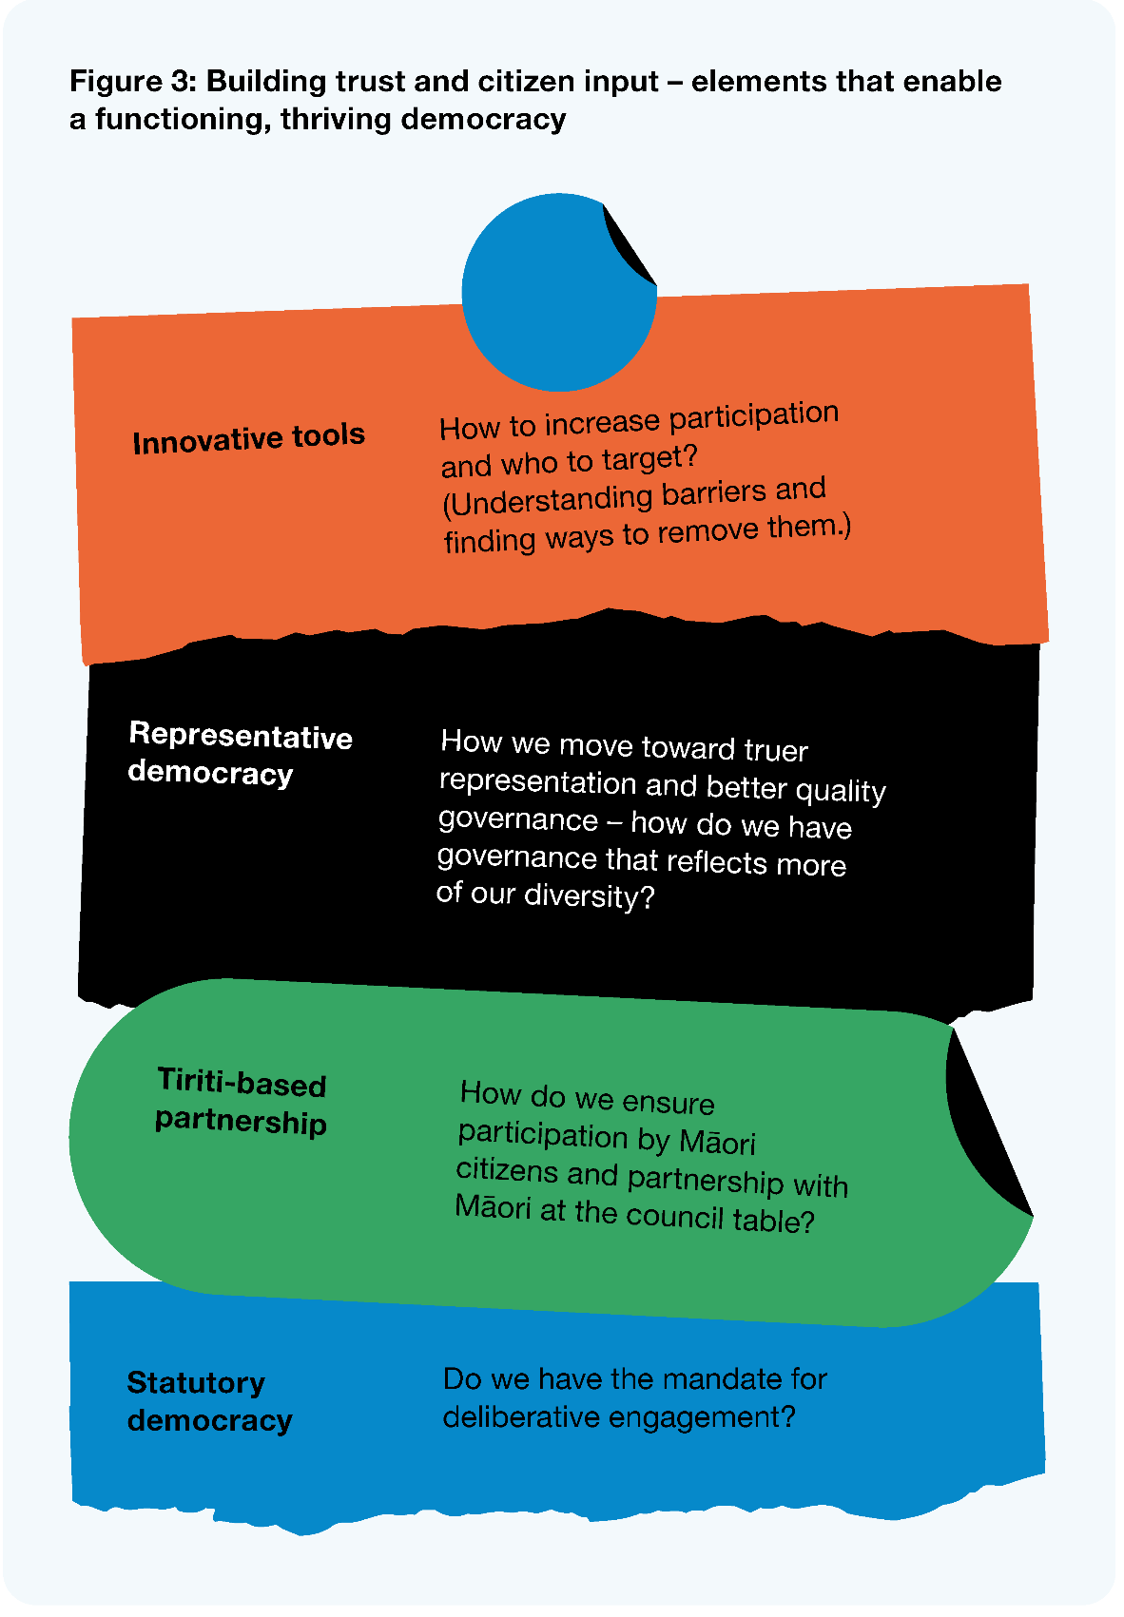
Representative democracy includes, but is not limited to, people elected to represent citizens. Ensuring that people of every socio-economic demographic and culture can participate equally in elections and in a way that makes them feel comfortable is a key part of a fully representative democracy. We discuss how strengthening local governance can help advance and diversify representation in local government in Chapter 7.
Embedding of Tiriti-based partnerships are fundamental to recognising Māori voices, as citizens and as mana whenua, through engagement and participation with local government. This weaves closely with Chapter 3.
Democratic innovation recognises that a strong democracy never reaches an end state. When society changes and new technologies appear, so do new challenges – and we need to develop ways that respond to them. We see this as a move towards utilising more deliberative methods like citizens’ assemblies.
Statutory democracy refers to legislation that enables and mandates local government to engage with participants. This includes consideration of the LGA, which provides the mandate to promote deep community involvement in decision-making.

Where we are now
Internationally, Aotearoa New Zealand ranks well on measures of political participation, electoral processes, and civil liberties (EIU 2020). However, these rankings don’t tell us how much trust and confidence citizens have in local government, or the degree to which councils engage with citizens. This section we will discuss how factors leading to low civic participation drive our current state, emphasising the significant change needed to achieve our vision of a thriving local democracy.
A Local Government New Zealand (LGNZ) survey found that respondents’ ratings of overall performance, leadership, and communication and interaction sat at 28% (LGNZ 2017b). The survey also indicated that 77% of respondents recognised that the collective effort of local government is important for the prosperity and wellbeing of Aotearoa New Zealand. So while there is an understanding about the role of local government in communities, many citizens do not have trust or confidence in their local government. A change is needed in the system, especially to the processes and mechanisms that strengthen community participation, to address this gap and build trust between councils and communities.
We are mindful to ensure, in using new innovative practices, that socio-economic inequity is not a barrier to participation.

What we heard
In our extensive engagement the Panel heard several themes emerge.
- At times, councils do not conduct engagement in a way, at a place, or in a format that works for diverse groups. People often feel intimidated by formal council proceedings, are not able to participate at a time that a council meeting is scheduled due to meeting times, or the cost and time associated with attending.
- Councils are often reaching the same people and have struggled to engage meaningfully with Māori, Pacific peoples, youth, and lower socio-economic whānau.
- There seems to be an over-reliance on ‘top-down’ statutory processes where communities are ‘sold’ a preferred answer, and not enough ‘bottom-up’ engagements where open questions are posed much earlier in the decision-making process.
- Many people do not think their engagement will influence decision-making. Currently councils respond inconsistently to community feedback.
“Stop listening to those voices who are the loudest (usually the most privileged) and work with all people in communities – this means thinking outside the box to engage with those we don’t usually hear from.”
– Survey respondent
- When councils reach these communities, engagement is often not sufficiently well-designed to meet the real needs of local communities. There’s inconsistency in councils’ ability to process and weigh feedback appropriately.
- There needs to be a significant investment in capability and capacity throughout councils to improve participation and engagement.
- There is uncertainty among elected members about how to balance representative decision-making with citizens’ participation. Some councils and boards feel like participatory processes are replacing their role as decision-makers on behalf of their communities. Many elected members have not had the opportunity to experience and learn from truly participatory processes with citizens. This may mean that the current uncertainty simply derives from lack of knowledge, or tried and tested examples for elected members to learn from.

Why does citizen-led democracy matter?
Deliberative democracy increases participation in decision-making, enabling more effective decision-making on tough topics and increasing levels of trust in local government.
We’re not alone in trying to tackle issues of low levels of participation and lack of confidence in our local government. Around the world, countries are grappling with the upsurge of disinformation that contributes towards the rise of populism, polarisation, and pessimism. The Organisation for Economic Co-operation and Development (OECD) report, Innovative Citizen Participation and New Democratic Institutions: Catching the Deliberative Wave (2020), identifies five drivers that have contributed to our current disengaged, disenfranchised age:
- economic: the rise of inequalities, especially wealth inequalities, has led to significant dissatisfaction
- social: people feel left behind by rising inequalities
- political: people see confidence in political systems declining, and want a stronger say in decision-making
- technological: there’s major digital transformation which authorities can’t keep up with, and there is also widening digital inequality
- environmental: living in the Anthropocene age, where human activity has major consequences to the natural order and people are looking towards a new approach.
There is a global movement to utilise tools to increase civic participation and drive informed, active participation in the democratic process. Catching the Deliberative Wave describes this movement, backed up by almost 300 examples collated over 30 years. With this work, the OECD aims to collate, share, and evaluate the practical tools being used to connect communities – an antidote to the lack of trust and confidence in political structures.
These mechanisms are being applied in many different countries across local, regional, and national levels. Evidence shows that such tools are helping authorities tackle complex, difficult issues, such as climate change, that many have struggled with or avoided addressing (Willis 2020).
The evidence also shows how countries are beginning to embed citizen-led democracy into the wider architecture of local democracy – complementing representative democratic processes. This brings greater legitimacy to the state of democracy, which we defined earlier as ‘power to the people’.
The use of these tools has been shown to enhance participation and engagement with citizens through informed and empowered communities, reducing democratic apathy and increasing the trust between authorities and communities.
Deliberative and participatory practices are vital in getting communities on board with changes needed to tackle major challenges, such as climate change and its drivers. Even without the disinformation campaigns driving the trust deficit between local government and communities, making changes to address significant challenges is hard. Local government needs citizens to be engaged, and citizens need a process to feedback as their communities become the frontline in tackling climate emergencies, especially when the impact of climate change is inequitably distributed.
Tools which enable communities to participate in political decisions and policies that impact them have been successful because they:
- enable better policy outcomes, as they are considered public judgement, not opinion
- provide greater legitimacy to decision-making around challenging issues
- enhance public trust by giving citizens an effective role in decision-making
- signal that local government recognises and trusts citizens as politically informed and empowered to influence political issues
- make governance much more inclusive and representative of a whole community
- strengthen the integrity of decision-making and reduce corruption by making the process transparent
- grow community resilience to disinformation and break-down in social cohesion.

Deliberative and participatory practices
In this section, we explain how participatory and deliberative practices, when combined with representative democracy, can strengthen the health of our local democracy.

Participatory practices
Participatory practices are commonly seen as the ‘essence’ of democracy because they enable participation from all citizens who wish to and are able to engage (Willis 2020). Citizens have the freedom to participate if they so wish to. Participatory tools are usually a self-selected process, which makes recruitment straightforward and open to all. Some of the barriers we discussed above (such as location and intimidation by formal processes), can be reduced by moving to a more community-focused space and changing the language and tone. However, participatory tools can still run the risk of profiling those who have the resources, time, education, and confidence to participate.
Examples of participatory democratic practices currently in use
At a national level – referendums. Referendums allow citizens to express a view. There are two types of referendums, those led by parliamentarians and those led by citizens.
At a local level – town hall meetings and annual and long-term planning consultations. This is a space in which councils and their community can come together to hear opinions on topics they are interested in. It’s an open environment, meaning anyone who is interested may attend.
On the other hand, deliberative democratic tools seek a representative sample of the population, usually to respond to a particular question. Participants are randomly selected, which removes the risk of selection bias or influence by interest groups. Compared with participatory democratic tools, fewer people are engaged in the process (it’s impossible to involve a whole population or community in a long-term process) and it requires much more time and resources (as they ‘deliberate’).
The way that deliberative models are organised, facilitated, and executed vary, and can depend on factors such as the institution that initiates, the mandate given, and the level of government. Deliberative processes can either be for one-off issues or established as a permanent aspect alongside elected representatives.
There is evidence to show that deliberative tools provide the place and space for a group to form a collective, informed consensus around complex subject matters. Bringing a diverse range of thoughts to the table, facilitating discussions, navigating beliefs and behaviours, and evaluating each other’s decisions leads to better, more informed decisions. Furthermore, these processes enhance citizens’ level of knowledge and increase levels of public trust – the public see everyday people engaging in complex issues (OECD 2020).
An example of a deliberative democratic tool is a citizens’ assembly.
There are different models of citizens’ assemblies, but in general, they comprise a random, demographically representative sampled group who are asked to ‘deliberate’ on particular issues. The aim is to engage members in serious, informed discussions and make collective/agreed recommendations on the particular issue. Citizens are selected via sortition (at random). Their recommendations are made publicly available and are presented to the governing authority. The authority is required to respond to these recommendations (OECD 2020).
Figure 4: Citizens’ assembly model
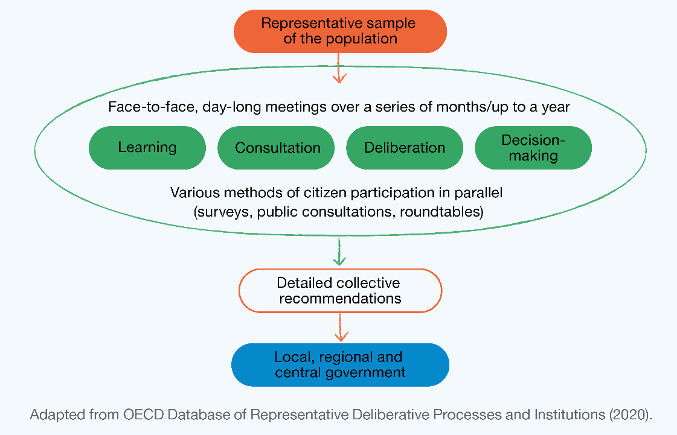

Citizens’ initiative review is another deliberative democratic model that seeks a representative group of citizens to evaluate a proposed ballot measure, with the intent of helping fellow citizens make ‘better informed choices’. This information would then be issued to all voters with their ballot papers. The aim of this model is to address misinformation and disinformation around referenda in particular. In turn, this helps build trust and confidence in the referenda process, where information about each side has been developed by everyday citizens, not campaign strategists.
Figure 5: Citizens’ Initiative Review model
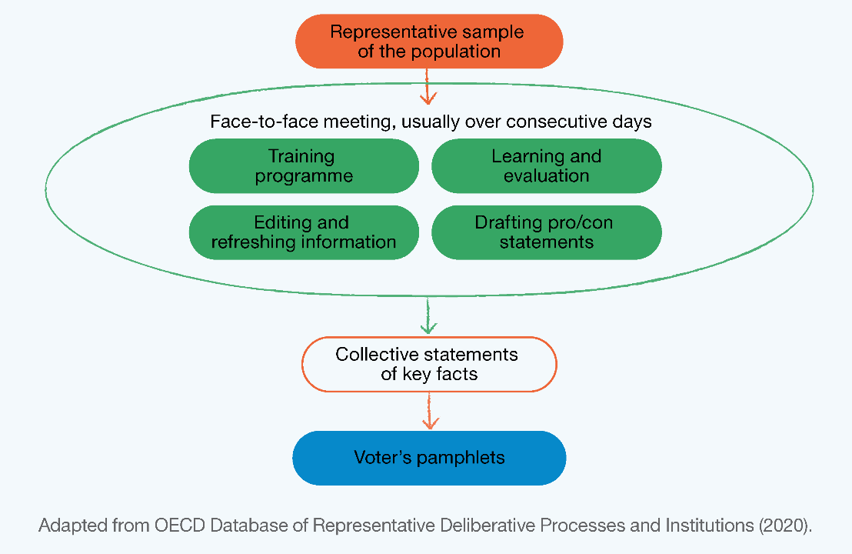
Many of the issues councils grapple with have technical aspects to them, such as resource management or financial expertise. This can appear to make it difficult to involve community in decision-making, particularly in matters involving complex engineering and infrastructure analysis.
However, research across the field has shown that a well-facilitated group of citizens can make better decisions than a group of experts, as they are coming to the topic with an open mind, and that inclusive processes that enable greater cognitive diversity lead to smarter, more legitimate decision-making (Hartz-Karp and Carson 2013). These approaches also build community trust in local government processes. Therefore, we suggest it is well worth taking the time to improve people’s understanding of complex issues and facilitating community input and decision-making.
As we discuss through our report, the complex, intergenerational nature of the challenges we are facing today requires new solutions, and there is a lot we can learn from existing practices in our own communities. Across the motu, Māori and Pacific peoples communities have been utilising their own collective decision-making processes, such as embedding wānanga and talanoa as ways to reach consensus on decisions that have intergenerational impact.

Developing and supporting innovation
We’ve heard that many councils are already finding innovative ways to increase citizen participation and engagement in local government. However, these pockets of innovation emphasise the absence of coordinated support, investment, and sharing of best practices.
We can learn from Australia’s newDemocracy Foundation how partnership and collaboration can enable innovation. The newDemocracy Foundation is a research organisation focused on ensuring citizens trust government decision-making. While not a government-endorsed centre of excellence, we see the great value and contribution they have made in advancing participatory and deliberative practices through exploring and testing process design, methods of operational oversight and advice on best practice.
To advance best practice, we see an opportunity for a funding pool open to local government as a way to provide practical centres of innovation that other authorities can learn and share from. The Innovation in Democracy Programme (IiDP) in the UK provided funding to three local councils to engage their communities in key policy decisions through citizens’ assemblies. A number of resources were published to support other local authorities to develop their own deliberative and participatory practices.
As discussed earlier, the OECD is leading the way in sharing best practices and exploring innovative ways that governments can effectively engage with citizens as part of their wider work on enhancing open government (OECD 2020). It has developed comprehensive materials under a Deliberative Democracy Toolbox that focuses on research across deliberative, collaborative, and participatory decision-making from across the world.
The Deliberative Democracy Toolbox includes a set of principles that can help councils develop their engagement and participation mechanisms. The principles are outlined in the graphic below.
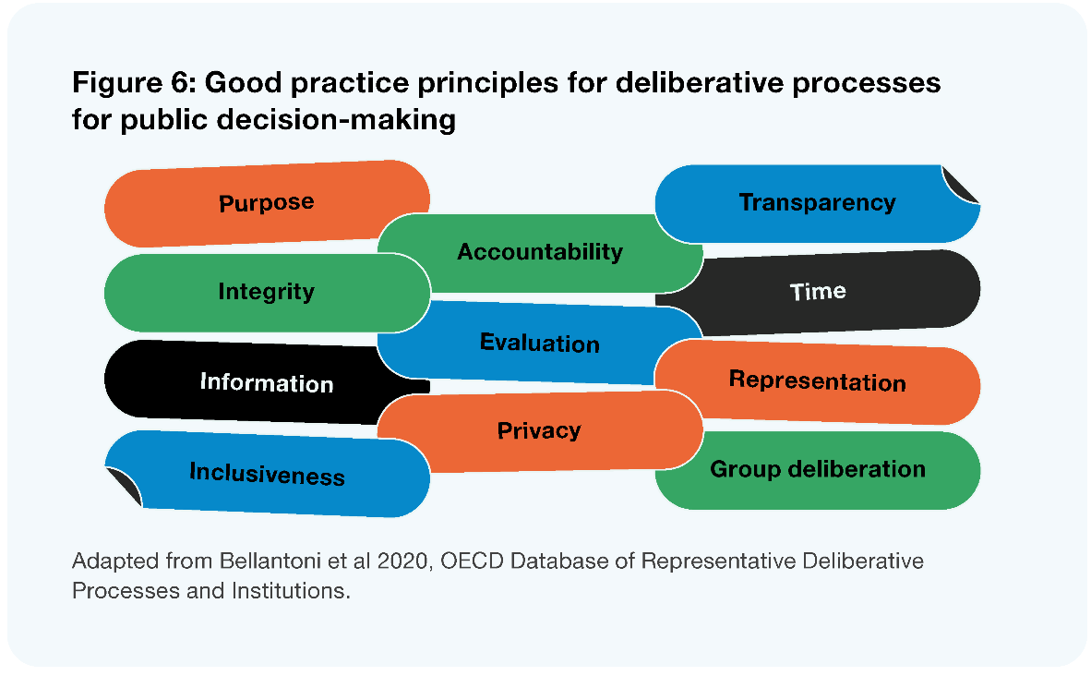
Image description: Figure 6: Good practice principles for deliberative processes for public decision-making are: purpose, integrity, information, inclusiveness, accountability, evaluation, privacy, transparency, time, representation, and group deliberation. Adapted from Bellantoni et al 2020, OECD Database of Representative Deliberative Processes and Institutions.
The principles continue to be refined as more deliberative practices occur, and are intentionally concise, acting as a starting point for public decision-makers. As a guideline, it opens up local government to tailor the principles to their local community. We have heard of organisations working with Māori to incorporate and embed te ao Māori values such as manaakitanga into the design and facilitation of participatory practices.

Watercare: citizens’ assembly project
As well as international examples, there are also initiatives in Aotearoa New Zealand that are enabling greater citizen participation in local decision-making. The citizens’ assembly on the future of water in Auckland – a collaboration between Koi Tū: The Centre for Informed Futures, The University of Auckland (funded by an MBIE Smart Ideas Endeavour Grant) and Watercare, the council-controlled organisation of the Auckland Council – has been set up to provide citizen recommendations on additional sources of water for Tāmaki Makaurau Auckland to be developed over the next 20 years. The objective of this project is to test deliberative democratic processes developed overseas and adapt them to Aotearoa New Zealand to tackle long-term, complex issues that many authorities struggle to resolve.
The approach involves ‘packaging big problems into local solutions’, whereby large, intersectional challenges are discussed at place – you can’t talk about the water supply without raising climate issues such as rainfall patterns and the inequities that come with it (Willis 2020). The core question of the project is how to create a process that upholds treaty obligations, tikanga and rights of the mana whenua while also reflecting the growing multiculturalism of our citizenry through the design, facilitation, and delivery of the workshops.
Watercare appointed 40 citizens to participate. They were reached through a stratified random sampling process which involved 12,000 invites. The assembly was held across four weekends in August and September 2022 and two online evening meetings, and was tasked with discussing options and putting forward a set of recommendations (Watercare 2021). The assembly was supported by strong technical and cultural guidance to assist decision-making.

Decision-making powers for citizens
For citizen-led decision-making to have weight, local government needs to be transparent from the beginning of the process about how the decisions will be handled. There is an accountability within that transparency (VSG 2017).
Evidence from the OECD shows that participatory and deliberative tools don’t undermine the role of representative members but act as a reinforcement (OECD 2020). This ‘bottom-up’ participation supplements the roots of democracy and can enable voting to be a more genuine instrument in building a healthy democracy. Such tools are not a substitute for electoral politics, but can be utilised by elected members to test the public appetite for particular policies and action (Willis 2020).
Elected members can use deliberative democracy practices to complement their position by improving the overall democratic process. It further reinforces the role of elected members to be facilitators of democratic decision-making, rather than solely representative decision-makers.

Enablers of deliberative and participatory tools
Local government has a role in facilitating citizen-led democracy, one that reflects our increasing diversity, embodies Tiriti-based partnerships, and seeks out innovative ways of ensuring the voices of the whole community are heard and reflected in decision-making. In order to do this, we need to consider what other means council can employ to utilise best practices.
In this section we discuss how the kinds of deliberative and participatory tools described above can be framed by the legislative mandate, supported by digital tools, enhanced by civics education, and assisted by capable councils.
In particular (and as described in Chapter 3), there is a need to shift towards more practices and processes that draw from the strength of tikanga and indigenous deliberative processes. If implemented appropriately, we see these tools as enabling the facilitation of a revitalised participatory democracy. As discussed more broadly later in this section, it is important that tikanga is reflected in local government processes.

The general legislative mandate
As per Figure 3 above, one question we have asked ourselves is whether the Local Government Act provides a sufficient statutory mandate for empowering community participation to enable deliberative and participatory practices to occur. Legislative requirements are only one part of the puzzle, however, insufficient legislative direction can mean the system is not set up for success. Beyond the general purpose and principles in part two of the Act, the statutory mandate for community participation and engagement is largely provided in Part 6 of the Local Government Act (planning, decision-making, and accountability). Key areas of this mandate are described below.
- The significance and engagement policy – councils must adopt a policy setting out their general approach to determining the significance of different proposals and decisions (including in relation to strategic assets), and how and when communities can expect to be engaged on those decisions. In many ways, the significance and engagement policy is meant to represent the ‘nexus’ between representative and participatory democracy.
- The decision-making requirements – these provisions effectively try to embed best practice features of decision-making such as the identification of options, evaluation and cost-benefit analysis, and consideration of community preferences. They apply in proportion to the significance of the decision or proposal, and in a way that takes into account resource constraints and the circumstances of particular decisions. These sections also include the requirement for councils to provide opportunities for Māori to contribute to decision-making processes.
- General consultation provisions – these provisions set out principles and information requirements for consultation, including the ideas of providing persons affected by decisions with an opportunity to present their views in a manner and format appropriate to their needs, and that the local authority should receive such views with an open mind.
- The special consultative procedure – this procedure effectively aims to provide a deeper, more prescribed consultative process that must be used for a number of the most significant local authority decision-making processes.

Fitness for purpose of these provisions
The community participation provisions in the LGA are built around councils consulting or engaging on proposals that have already been developed, rather than pointed towards processes of deeper engagement and collaboration with communities based on strong reciprocal relationships. While nothing in the LGA prevents the use of deliberative or participatory mechanisms or the adoption of more empowering frameworks, decisions to take more participatory approaches built on community relationships sit with each council rather than being a requirement.
Concepts of public participation have evolved significantly since the enactment of the LGA in 2002. Many councils’ significance and engagement policies incorporate more recent thinking. For instance, many explicitly reference the International Association for Public Participation (IAP2) Spectrum of Public Participation – the widely accepted framework for thinking about the spectrum of engagement from ‘informing’ through to ‘empowering’ – and aim to apply it in a local context.
However, there is a question as to whether the very idea of a ‘policy’ on significance and engagement generates a sense of pre-determined and transactional engagement that can undermine the community’s sense of how relevant they are to council business. The process itself drives local government to prepare proposals without any prior meaningful engagement, leading to communities feeling like the output has already been determined. The LGA provisions make no specific reference to the need for council to invest in underlying relationships prior to the point at which they require input from citizens. We have heard that the policy can act as a tool for limiting exposure, rather than prompting open-minded decisions about where and when deeper, bespoke, or more tailored engagement would make a critical difference to community empowerment and building trust in council.
Most importantly, we wonder whether the focus on consultation and the absence of any provision for deliberative mechanisms in the LGA mean that they may not provide the best possible platform for revitalising community participation in local governance. In particular, we wonder if the special consultative procedure (as a tool for facilitating engagement on some of the most important decision-making processes) is still fit for purpose given the emergence of more innovative, deliberative mechanisms. We are also conscious that these provisions make no reference to tikanga, or the tailoring of engagement practice for Māori – these issues are discussed below.
International comparison: the Victorian Local Government Act 2020
One of the most recent comparable examples of a legislative platform for better community participation in local government sits in the Victorian Local Government Act 2020. In many ways, this statute was catching up to the more generally empowered model of local governance (such as that outlined in Aotearoa New Zealand’s LGA) from a more prescriptive 1989 statute. As such, core aspects are very similar to the LGA – including the requirement for a community engagement policy that is proportional to the complexity and significance of decision.
One key difference is that the community engagement policy required under this statute must:
- give effect to a set of specified community engagement principles
- include deliberative engagement practices (definable by regulation), which must be capable of being applied to four of the key decision-making processes in the Victorian system. Those areas are community vision, community plan, financial plan, and asset plan.
We understand that legislators purposely chose not to prescribe specific deliberative mechanisms in these requirements so that councils could implement them in a way that was responsive to particular communities and situations. While it is too early to assess the long-term impact of such requirements on outcomes, initial reviews by some commentators suggest it may also have been helpful for the legislation to provide principles or non-negotiable features of deliberative practices or to refer explicitly to OECD guidelines on these issues (Carson 2022).
As noted above, legislative change alone cannot revitalise community participation, and we have heard of examples in which councils go beyond the baseline of consultation to meaningfully engage with their citizens, even without a legislative requirement. This chapter goes on to discuss other tools and initiatives for this purpose, not least of which is the promotion of a step change in the capability and capacity of councils to engage with their community. However, legislation is a key part of the puzzle, and can help create the underlying conditions for increased participation. On balance, we think there is a case for reviewing current provisions with an eye to addressing some of the disincentives and questions we raise above.
The Panel recommends a review of the legislative provisions relating to engagement, consultation and decision-making to ensure they provide a comprehensive, meaningful, and flexible platform for revitalising community participation and engagement. This would include:
- providing a more comprehensive and contemporary set of ‘community engagement principles’ to inform council approaches to community participation, including a general direction to include the use of more deliberative decision-making and participatory mechanisms
- requiring a comprehensive review of requirements for engaging with Māori across local government-related legislation, considering opportunities to streamline or align those requirements.

Greater use of digital interfaces for engagement
We have heard that many people struggle to get a simple, current overview of what’s going on in council. We think there is opportunity for councils to grow their online presence and invest in digital tools and technology to not just enable greater engagement but revitalise our participatory practices.
In 2017, the Department of Internal Affairs undertook research into how digital technology can support participation in government (DIA 2018). They found a significant percentage of respondents (41%) would like government to explore using new and improved digital channels to engage with communities.
Digital technology is widely recognised as an enabler of participation that has the potential to support and enhance public participation in government (DIA 2022). Technology can help overcome barriers to people participating in local government proposals such as time, distance, and accessibility of complex information. Many New Zealanders do not have the time to read long, complex documents and respond to them (DIA 2018). We see the potential for participative tools, such as testing the community’s appetite for policies.
However, it is important to note online platforms are not accessible to everyone. New Zealanders most at risk of digital exclusion include disabled people, Māori, Pacific people, people in social housing, seniors, unemployed people, and remote communities (DIA 2022). These communities are already deeply underrepresented in democratic participation. We would like to see digital interfaces complemented by non-digital ways for people to engage and online content which is accessible for people with disabilities.
We recognise that a lot of thinking is required for digital tools to shift from an information sharing role to a participatory function. Online polling, referenda, and submission portals have the potential to revolutionise public input on policy proposals by making community voices feel heard and valued, as well as making policy information more accessible and easier to understand (DIA 2022).
Councils can use online platforms that are popular with rangatahi, such as social media and online polling, to engage with young people more effectively. Using rangatahi-friendly spaces online can help raise awareness among New Zealand youth of what their local councils do, why local democracy is important and why their vote is important to shape the futures they want to inherit (Tokona te Raki 2022).
Many councils already use digital platforms to keep people up to date on what is happening in their community. The functionality of these platforms varies, ranging from social media and email to online submissions portals and polling. They go across the informed, engaged, and participatory spectrum – but with inconsistent levels of quality, and they are often costly.
An approach to enable citizen-led digital democracy is demonstrated in the example below.
Digital democracy in Taiwan
Audrey Tang, Digital Minister for Taiwan, has been leading revolutionary approaches to civic participation through online platforms. Their position is that the internet is neither good nor bad for democracy – merely an equivalent of local town halls, which can be managed well or badly. Taiwan’s government recognises this too, seeing the internet as public infrastructure to be utilised. Tang’s work within their role as Digital Minister has involved developing a Digital Nation Plan. The Plan includes implementing a ‘digital government’ which enables citizens to interact with government bureaucracies through a single website, designed to be as easy and as accessible as possible. Additionally, another website has been developed that encourages citizens to inquire and discuss legislation and policy issues as they are drafted and implemented. We can learn from Taiwan’s approach to digital democracy as we look to the future of local government and the role digital interfaces will take in the next 30 years.
There is potential for councils to collaborate across regions to share technical expertise and standardise digital communication and engagement processes across local government, including information and communications technology systems.

Improving Māori participation in local government processes
The Panel acknowledges that most councils already have memoranda with mana whenua, and most also have complementary engagement arrangements with Māori in place via committees and consultation protocols. However, we have often heard there can be a lack of coordination within a council as to the engagement undertaken with hapū/iwi across different departments, resulting in a ‘five different phone calls in one day’ phenomenon.
We have also heard that hapū/iwi are experiencing consultation burnout from a range of statutory consultation processes that place significant obligations, duties, and responsibilities to be consulted or participate in decision-making processes.
The panel considers that there is potential to streamline, align, or improve statutory provisions, and recommend that central and local government leads a comprehensive review of such provisions to ensure their fitness for purpose as part of any subsequent legislative change programme. We also think there is value in investing in internal systems including digital tools for managing and promoting good quality engagement with Māori, particularly in light of future participatory and deliberative democracy processes.

Reflecting tikanga in local government processes
In our review, people have repeatedly asserted the potential for tikanga to strengthen the relationship between Māori and local government and facilitate better local outcomes. This aligns strongly with advice we received about the potential for differentiated liberal citizenship and the importance of Māori being able to make culturally distinct contributions to local government. We also think it aligns with a growing awareness and acceptance of the importance of tikanga in public governance and society in general.
We agree that greater use of tikanga in council meetings, interactions between local authority staff, and in local government engagement with Māori would have a profound impact on the overall relationship. We are not expecting all staff and participants in council processes to become experts in tikanga Māori, or to suddenly transform their individual capabilities, and we are aware that tikanga varies across the motu and across hapū/iwi within local areas. However, we think a way can be found to achieve a significant incorporation of tikanga over time.
As a starting point, we recommend a statutory obligation for councils to give due consideration (via an appropriate weighting) to an agreed expression of tikanga for that particular area in their standing orders and engagement practices, and for chief executives to be required to promote the incorporation of tikanga in organisational systems. This expression of tikanga would need to be agreed and provided to the local authority by mana whenua in the area, and provision made for it to be reviewed and revised as needed.
Tikanga becomes a meaningful influence on everyday interactions within and involving local authorities, but that does not mean it becomes the only way decisions are made in meetings, or that it displaces other valid cultural means of relating to each other. We recognise that practices will evolve and depend on the state of relationships in each circumstance. It may be the case that core aspects of council meetings (such as quora and final decision-making processes) are specifically preserved, but we think a meaningful reflection of tikanga would facilitate a step-change in Māori participation.
The Panel recommends that local government, in conjunction with hapū/iwi, incorporates appropriate expressions of tikanga in council protocols and engagement practices.

Civics education
We heard in our engagement that young New Zealanders are passionate about a range of complex issues, but they do not always see or know the value of local government in addressing those issues or understand how it works. We suggest that enhanced civics education could help bridge this gap and enable young people to engage more effectively with local democratic processes.
“[We need] a solid curriculum in secondary schools about civics. If people enter adulthood understanding our governance system as a whole (alongside critical thinking and problem solving) we should gain greater voter engagement, younger people entering governance roles, young people “seeing me” in their representatives… and generally a better understanding of living in society.”
– Survey respondent
There are varied levels of understanding across Aotearoa New Zealand youth (and adults) of what local government is, why it is important and how it works. Many rangatahi do not see themselves represented in the local government system, and because they do not fully understand the system, they cannot determine whether it is relevant to them (Tokona te Raki 2022). A 2019 survey run by Seed Waikato found two in five respondents aged between 15 and 34 did not know how to cast a vote in the 2019 local body elections, and 8 out of 10 felt disconnected from their council (Akoorie 2021).
It is vital to engage New Zealanders in local democracy from a young age. Teaching school students about local government could help grow a generation of future leaders who see the value of, and feel connected to, their local councils (Bohny 2019). The value of ensuring rangatahi are represented and engaged in our local democracy is discussed further in the voting age section of Chapter 7.
Civic education programmes teach citizens about democratic institutions, values, voting and procedures (UNU-WIDER 2014). While the international evidence that civics education leads to higher voter turnout is limited (Siegel-Stechler 2019), we do know that civics education programmes can empower people to be active, well-informed citizens who are aware of and have an interest in local politics (Wong 2018; Illinois Civics Hub; Andolina et al 2003). This can prompt civic participation by encouraging young people to translate knowledge about local government into action – from volunteering and voting in elections to lobbying or running for local council.
In 2020, the Ministry of Education published a Civics and Citizenship Education Teaching and Learning Guide (MOE 2020) as part of their School Leavers’ Toolkit. This guide is optional for secondary schools to teach, and we see the potential for civics education to be embedded more deeply within curriculum.
Going beyond just curriculum change, we think more direct interface between councils and schools (in which councils engage and collaborate directly with schools) is needed to create opportunities for young people to have a say on key issues in their local area. For example, a council upgrading a community library could hold a youth citizens assembly with local students to hear their ideas on how the upgraded library could best benefit the community.
For students, having the opportunity to participate in collective decision-making and see local democracy in action could help grow their understanding of both how local government works, and the value of their local council. This transitions the role of local government not just as an educator, but towards the anchor/facilitator role (discussed in Chapter 5), recognising the value and input of young people’s voices in the policies and political decisions that impact them and their future.
However, education doesn’t stop with schooling – there are opportunities to educate, engage and enable active citizens across the whole age demographic. We think there is a need to consider ways in which both local government and central government can uplift civic education through a variety of processes.
The panel invites submissions on what we might do more of to increase community understanding about the role of local government, and therefore lead to greater civic participation.

Capability and Capacity
While all of the mechanisms and initiatives above are important, it’s also important to transform the capacity of councils to undertake meaningful, innovative engagement with citizens and communities or conduct more deliberative and participatory practices. While we know there are many talented engagement managers and staff in local authorities, we are of the view that this capability is:
- spread too thin across the system
- unsustainably focused in ‘engagement’ teams, instead of being ‘mainstreamed’ across all council staff with an external focus
- often not supported by the budgets necessary to conduct a broad and deep programme of meaningful participatory processes.
In addition, we think much of the current constraint on the use of more deliberative practices is simply a lack of know-how around how to implement them or confidence to adapt them for particular contexts. We think a comprehensive set of guidance and tools tailored for the Aotearoa New Zealand context would be a significant help in this sense.
The know-how and confidence to implement and adapt deliberative practices are just one type of capability and capacity that we think needs significant investment in a new system.
Recommendations
- That local government adopts greater use of deliberative and participatory democracy in local decision-making.
- That local government, supported by central government, reviews the legislative provisions relating to engagement, consultation, and decision-making to ensure they provide a comprehensive, meaningful, and flexible platform for revitalising community participation and engagement.
- That central government leads a comprehensive review of requirements for engaging with Māori across local government-related legislation, considering opportunities to streamline or align those requirements.
- That councils develop and invest in their internal systems for managing and promoting good quality engagement with Māori.
- That central government provides a statutory obligation for councils to give due consideration to an agreed, local expression of tikanga whakahaere in their standing orders and engagement practices, and for chief executives to be required to promote the incorporation of tikanga in organisational systems.
Question
- What might we do more of to increase community understanding about the role of local government, and therefore lead to greater civic participation?

A Tiriti-based partnership between Māori and local government
Whilst there is much goodwill and many positive examples of change within the sector, the local government– Māori relationship is inconsistent across Aotearoa New Zealand and often falls short of a Tiriti-based partnership.

Key findings
The system needs to ensure a more meaningful expression of rangatiratanga and a more culturally specific exercise of kāwanatanga by councils – with te ao Māori values reflected at all levels of the system.
In some instances, this means Māori having a lead role in decision-making, or the design or delivery of local government functions or services. In others, such decisions will still need to be exercised collaboratively, or by local government via good quality engagement with Māori, but in all instances Māori citizens should be able to make culturally specific contributions to local governance.
There needs to be a greater level of direction and accountability within local government–Māori relationships, while leaving enough flexibility to respond to local context and acknowledge that specific relationships are at different stages in their journey.
To respond to these challenges, this chapter and associated parts of the report propose fundamental change to the Te Tiriti o Waitangi provisions of the Local Government Act 2002 (LGA); a strategic role for Māori in identifying and addressing priority outcomes that will lift community wellbeing; and strengthened specific mechanisms for partnership and engagement (including the incorporation of tikanga Māori).
It also proposes improvements to Māori representation at the council table, and a concerted investment in the capability and capacity of both local government and Māori to build and maintain a Tiriti-based partnership in local governance.

The Panel’s journey
As we have embarked on the journey over the past 18 months, the panel has realised that notwithstanding our collective experience, we have had opportunities to listen to, learn (and unlearn), and understand more deeply Te Tiriti o Waitangi and the whakapapa of local government–Māori relationships.
We have gained much during our kōrero and conversations that have identified substantial opportunities for the local government–Māori relationship to flourish. We believe that in order to realise these opportunities, we need step-change that is relational at its heart and is properly resourced and embedded at a systems level. We see the benefits of this not only for the governors and leaders, but critically for the wellbeing of the communities, people, and places they serve.
The knowledge, experiences, leadership, and commitment to meaningful change that has been expressed in the kōrero we have had with hapū/iwi, Māori rōpū, organisations, statutory bodies, special interest groups, academics, and thought leaders has had a significant impact on the Panel. We believe indigenous Māori values, knowledge, and ways of doing things can benefit the local government and wider local governance system in positive ways that are inclusive of Māori, enabling of Māori, and enhance our sense of connection and belonging.
The enduring positivity we heard from Māori for the future, where being a good ancestor means necessary, intergenerational decisions are made by leaders and communities. A future that values and protects Papatūānuku and celebrates our diversity and cultures, where we are all proud of and feel safe in places and spaces where we live and work. A future where decisions instil hope of our tamariki and mokopuna, our most vulnerable, and for the rangatahi who will one day be leaders.
We want to acknowledge the tensions that exist between hapū/iwi, local and central government. This has existed, as you would expect, since the colonisation of Aotearoa New Zealand began pre-1840. This is reflected in the historical and ongoing challenges of sharing of authority at place, the resulting social and economic inequity of the present, and uncertainty about how it will evolve into the future.
We have considered how a future system can embody Te Tiriti o Waitangi. We acknowledge that whilst much of the debate and legal precedence flows from the creation and signing of Te Tiriti, hapū/iwi governed their own affairs for hundreds of years and many relationships between the Crown and hapū/iwi existed before Te Tiriti. These early relationships and experiences continue to hold significance for individual hapū/iwi across the motu. Examples of this include the first interaction between Captain Cook and Ngāti Oneone on the shores of Tūranganui a Kiwa, and the signing of He Whakaputanga for the Northern tribes of Te Tai Tokerau.
We also want and need to acknowledge that there are some really hopeful ways in which local government–Māori relationships are evolving. They are growing in their shared understanding of Te Tiriti, and shared value that is seen and experienced in working more effectively together. This change has been hard fought, and there was a nervousness in our conversations that any change proposed by the Panel seeks to improve that which has been fought for, not backtrack.
Throughout this chapter, and connecting through others, we have tried to reflect and consider the many complex ways in which the local government–Māori relationship currently functions, the drivers that underpin this, the diversity of how these are enacted at place, and explore the conditions in which a relational approach can thrive.
The Panel acknowledges that building and maintaining relationships with Māori requires courageous conversations and acknowledging our shared history. We believe that building trust and working together will place local government in a strong position to face future challenges.
We have observed sophisticated, bespoke, and complex arrangements across the motu. At the same time, we also acknowledge there are some gaps and rudimentary practices. We have outlined our thinking in a package of changes to the system that embraces te ao Māori values and tikanga and the complexity of social and institutional arrangements and supports place-based conversations on roles in local governance.
We hope for a future where Te Tiriti is understood and valued as unique to Aotearoa New Zealand. A future where embracing te ao Māori, te reo, and tikanga is appreciated for the value it brings to people and to place in something that is truly uniquely Aotearoa New Zealand.
Te Tiriti o Waitangi
The Treaty of Waitangi
In this report, we use the term ‘Te Tiriti’ to refer to Te Tiriti o Waitangi/The Treaty of Waitangi. We use ‘Te Tiriti’ to refer to the combined effect of the English and Māori texts, and how we think that impacts on the relationship between Māori and local government. We discussed the Articles of Te Tiriti and the Treaty principles in our Interim Report, Ārewa ake te Kaupapa, and in most cases have not repeated this information here. We suggest interested readers refer to that report for further information; it can be downloaded from the Local Government Review website.

Overview
As we consider what the future of local government, democracy, and governance look like in Aotearoa, we must acknowledge the journey of the local government–Māori relationship that has taken us to this point in time. Equally, we must consider the broader social shift we are seeing across government to operate in a way that is consistent with Te Tiriti. This is important in both upholding Te Tiriti, but critically, in working towards more equitable outcomes for Māori.
Of all the questions we have explored during this review, none is as interwoven throughout our findings as the relationship between local government and Māori. In order to have thriving communities in Aotearoa New Zealand, we consider it vital that Māori are an integral part of local governance, and the relationship becomes a genuine, Tiriti-based partnership – enabling the meaningful exercise of rangatiratanga and a more culturally specific exercise of kāwanatanga by councils.
This will only occur when there is a greater focus on equity, a greater sharing of decision-making authority, when Māori are more involved in the design and delivery of local services, and when local governance embraces and incorporates te ao Māori perspectives.
Across the country there are a variety of relationships between Māori and local government, both at a council level and at an overarching system level. The differences in these relationships reflect different levels of acknowledgment and understanding of Te Tiriti, and capability and capacity of both Māori and local government to engage in a meaningful way. Like any relationship, the potential to achieve mutually beneficial outcomes is significant if it is driven and supported by leaders.
However, the current legislative framework underpinning the relationship does not provide a platform for Tiriti-based partnership. The legislative provisions do not contemplate a genuine sharing of authority with Māori, and specific agreements designed to enhance relationships have been developed on an ad hoc basis, often covering a limited range of local government functions, geographical areas, and hapū/iwi. We also think it is time to get serious about addressing the perennial questions around capability and capacity.
This chapter outlines the current state of the local government–Māori relationship at a high level, summarises what we heard about the challenges and opportunities in relationships at place, and makes proposals for change. This includes a framework we think can guide work towards a Tiriti-based partnership, and an architecture for change that outlines six interconnected areas where we think work is needed:
- creating a new legislative framework for Te Tiriti in local governance
- establishing a strategic role for Māori in local governance
- mainstreaming and consolidating specific mechanisms for partnership and co-governance
- improving Māori participation in local government processes
- improving Māori representation in council governance
- building local government and Māori capability and capacity to strengthen and maintain a Tiriti-based relationship.
Together, we consider that the framework and architecture for change provide a path towards a state of Tiriti-based partnership, one that results in mutually beneficial outcomes for each other and importantly, for local communities.
Māori, hapū/iwi, taura here, mātā waka
In the course of our review we have given much thought to the role in local governance for:
- hapū/iwi groups exercising mana whenua
- other Māori organisations, such as pan-tribal entities, urban Māori authorities or Marae, Māori service providers, and other Kaupapa-based groups
- Māori as citizens and whānau, including communities such as taura here and mātāwaka.
We respect the fact that the collective, political authority component of rangatiratanga is predominantly held and exercised by hapū/iwi. Rangatiratanga is derived from the whenua, through hereditary interests, often whakapapa based and/or through recognised active leadership. For this reason, we expect hapū/iwi to play a lead role in the strategic co-governance or decision-making processes we discuss in these sections.
At the same time, we expect there will be instances where other Māori organisations can add essential value to the local governance process, particularly in the design and delivery of local services.
In addition, we think cultural identity for the purpose of local governance is a very personal, self-determinative concept. Where someone identifies as Māori but lives outside their rohe or chooses not to affiliate with a hapū/iwi, we think they are still entitled to make culturally distinctive contributions to local governance, and for the system to specifically consider their interests.
Given these points, our use of terms throughout the report aims to reflect the particular context. For the above reasons, we have most often used the term ‘Māori’, and we think general obligations in local government legislation should continue to be framed in those terms. However, where we discuss specific partnership or co-governance mechanisms, we certainly envisage those mechanisms including specific representatives of hapū/iwi, mātāwaka, or other Māori organisations. Rather than prescribe what this would look like, we think decisions about how that ‘representation’ occurs should be made by Māori in an inclusive, tikanga-based process that reflects the local context. We think the design of such processes would be an important question for a specific reform programme.

Section 1: Te Tiriti and local governance

Existing drivers and arrangements that facilitate the relationship
The relationship between councils and Māori in the exercise of local governance is expressed in a number of different ways and is not consistent across Aotearoa New Zealand. There is a diverse range of practices, agreements, and other arrangements in place across the system to facilitate the relationship, underpinned by a range of legislative requirements across a number of statues.
Currently, there is not a clear framework for Te Tiriti in local governance. Specific arrangements between local government and hapū/iwi have been developed in a patchwork fashion across the country, with the aim of achieving a measure of co-governance or enabling input to decision-making. These arrangements have been developed voluntarily where there was a high level of local political will or strong relationships at place, or through specific Treaty settlement processes.
This section outlines the legislative drivers of the Māori-local government relationship and the kinds of arrangements that have been developed as a result.

The current legislative drivers
While legislation cannot define or provide for a relationship, it can set (or fail to set) a framework to ensure the relationship strives for partnership. The legislative baseline for the Māori-local government relationship is spread across a number of statutes, including, but not limited to:
- core requirements in the Local Government Act 2002 (LGA) for councils to maintain and improve opportunities for Māori to contribute to decision-making processes, and to consider ways it may foster the development of Māori capacity to contribute to decision-making processes (see section 4, referring to provisions in Parts 2 and 6 of the Act)
- a range of more specific obligations under local government-related statutes that aim to provide for a Māori perspective or role in decision-making processes. For example:
  - the Resource Management Act 1991 (RMA) requires all persons exercising functions and powers under it, in relation to managing the use, development, and protection of natural and physical resources, shall take into account the principles of the Treaty of Waitangi (section 8) and all persons exercising functions and powers under it, in relation to managing the use, development, and protection of natural and physical resources, shall recognise and provide for the following matters of national importance, including but not limited to: the relationship of Māori and their culture and traditions with their ancestral lands, water, sites, waahi tapu, and other taonga; and the protection of protected customary rights (section 6)
  - the RMA also includes mechanisms for the transfer of powers from councils to public authorities including iwi authorities (section 33), and the development of joint management agreements (section 36B), Mana Whakahono ā Rohe agreements (section 58L). The RMA provides that Iwi Management Plans (developed by iwi) must be taken into account in regional policy statements and regional and district plans (sections 61, 66 and 74)
  - the Reserves Act 1977 (in conjunction with section 4 of the Conservation Act 1987) requires councils to give effect to the principles of Te Tiriti when acting as an administering body for reserve land
  - the Heritage New Zealand Pouhere Taonga Act 2014 requires councils to have regard to recommendations from the Māori Heritage Council about wāhi tapu.
  - Local Electoral (Rating) Act 2002 in relation to rating of Māori land
  - Marine and Coastal Area (Takutai Moana) Act 2011 in relation to customary rights.
- Treaty settlement legislation includes a number of specific co-governance models which are primarily orientated towards resource management functions
- the Local Electoral Act 2001 enables councils to create Māori wards/constituencies, thereby allowing for Māori representation at the level of the ‘full council’.

What arrangements have these requirements led to on the ground?
There is a diverse range of practices, agreements, and other arrangements in place across the local government system to facilitate the relationship between councils and Māori. Broadly speaking, they can be thought of in two categories: organisational practices and informal agreements developed by councils (sometimes together with hapū/iwi) to outline ways of working together or support a shared understanding; and more formal institutional agreements which provide for Māori participation in decision-making.
In terms of organisational practices and informal agreements:
- many councils have some kind of engagement or relationship agreement with hapū/iwi that sets out high level principles or processes for how council and hapū/iwi will interact, and which outlines shared priorities
- most councils have some tools and practices aimed at improving their capacity or capability to engage with Māori and ensure a te ao Māori perspective is heard in the development and/or delivery of their work. These tools and practices include internal training for staff and elected members, or the appointment of specialist iwi/Māori liaison officers and advisors
- many councils have developed specific initiatives to support iwi/Māori capacity and capability to participate in local government decision-making and processes. These include funding for iwi/Māori to participate in key functions such as planning or specific projects or having secondment arrangements with local hapū/iwi.
A large portion of councils (over 50% in 2017) (LGNZ 2017a) also have more formal or institutional arrangements. These arrangements, often referred to as ‘co-governance’ or ‘co-management’, provide a deeper level of Māori participation in local governance functions and take a variety of forms. At a high level they can be broken into three categories.
- Voluntary arrangements that allow for iwi/Māori membership on committees of council or a specific advisory role in the local authority structure. These can include the appointment of iwi/Māori to existing committees of council (often with voting rights and remuneration), the establishment of specific ‘standing’ Māori advisory or functional committees, and hapū/iwi attendance at full council meetings.
- Formal agreements for sharing or involving hapū/iwi and Māori in specific statutory functions. These are mostly developed under the specific legislative mechanisms outlined earlier or through Treaty settlements. They include joint management agreements between councils and hapū/iwi about how they will share decision-making on RMA plan changes and/or consents in particular areas, Mana Whakahono ā Rohe agreements under the RMA that take a similar approach, the Independent Māori Statutory Board, arrangements for co-governing land administered under the Reserves Act, and the transfer of a council function to an iwi authority (under section 33 of the RMA).
- Wider co-governance models established via settlement legislation. The majority of these models tend to either:
- include representatives of the relevant post-settlement governance entity(s) with an interest in a particular resource/tupuna (such as a river or lake) on a joint committee of council. This entity develops a strategy or objectives for the resource that is ‘weighted’ into RMA plans and decision-making (and sometimes decision-making under other regulatory frameworks like the LGA or Conservation legislation)
- include representatives of hapū/iwi in a specific geographical area on a committee of council that drafts RMA plans for approval by council
- use settlement legislation to create or enshrine more bespoke versions of some of the mechanisms discussed in A and B above.
A small number of more bespoke settlements for very significant resources have formalised co-governance across a wider range of jurisdictions in order to promote more integrated management of competing interests and give more specific recognition to iwi values.
In addition to the types of arrangements outlined above, 35 councils have established at least one Māori ward for the 2022 local government elections and others are considering establishing them for future elections. Recent amendments have removed provisions for council decisions to establish Māori wards to be overturned by an elector-demanded poll. This change will lead to an increase in the number of councillors elected from Māori wards from nine in the 2019 elections to 67 in 2022.
Case study
Te Pā Auroa nā Te Awa Tupua – The framework for the Whanganui River
Settlement legislation for the Whanganui River contains multiple components that provide not just a role for iwi in decision-making, but wider recognition of the awa itself and the unique values that represent it. The framework includes:
- recognition of Te Awa Tupua as a legal person, and recognition of ‘Tupua te Kawa’ – the fundamental values for the River – which must be ‘recognised and provided for’ or ‘had regard to’ under a range of statutory frameworks
- Te Pou Tupua, a statutory body with members appointed equally by the iwi and the Crown to speak for the River and exercise its rights, powers, and duties
- Te Kopuka – a collaborative strategy body that includes members from the iwi, local authorities, and representatives of conservation, energy, environmental, tourism, recreational, and primary industry interests
- the development of Te Heke Ngahuru ki Te Awa Tupua, a strategy for the health and well-being of the River, which must also be had regard to under a range of statutory frameworks and specific instruments such as RMA plans
- the vesting of previously Crown-owned parts of the riverbed and other lands in Te Awa Tupua
- Te Korotete o Te Awa Tupua: a fund to support the health and wellbeing of the River.
In our discussions with Whanganui District Council, they spoke to how they have embraced the values framework and are looking for new opportunities to work with and leverage off their evolving partnership.

The current state of the relationship
Understanding the legislative framework and current arrangements for co-governance that have been developed around it is only part of the story. During our engagement for this review, we spoke to a broad range of people about the current state of the relationship between Māori and local government, and importantly, what it would take to shift that relationship to a state of genuine partnership. We were fortunate to speak with representatives from 55 iwi and 20 hapū, pan-iwi and hapū groupings. We also spoke to people from Māori organisations, advisory groups, and central and local government. Further information about our engagement for this review can be found in the engagement summary on our website.
We want to acknowledge that during these conversations, council staff and elected members often referenced a genuine and increasing desire to understand te ao Māori perspectives in local governance and to partner with hapū/iwi, and Māori organisations. It is clear that there is much goodwill in some of the individual arrangements that have been established, and that progress is being made towards a more mature and mutually beneficial relationship.
Those who we spoke to from hapū/iwi were frank with us about the profound gap they see between the current state and a Tiriti-based partnership with councils. They shared their views on the historical context of each rohe and takiwā shaping and influencing relationships with local government. In Te Tai Tokerau, Ngāpuhi confirmed the importance of He Whakaputanga (Declaration of Independence 1835). On the East Coast, Rongowhakaata signalled the importance of the first interactions with Captain Cook and Tupaia. Ngāti Whātua o Ōrākei emphasised the significance of the ‘tuku whenua’ to Governor Hobson, that led to the establishment of the Auckland settlement. Ngāi Tahu referred us to their pioneering Treaty Settlement in 1998.
A number of clear themes came through in these discussions. In particular, participants thought that a more consistent and meaningful expression of rangatiratanga is needed in local governance, and that there is room for Māori perspectives to be more meaningfully incorporated into the local exercise of kāwanatanga. We have outlined these further below, along with a discussion of the underlying drivers of these current challenges.

A more consistent and meaningful expression of rangatiratanga is needed
Almost all participants expressed the view that the current system simply does not allow for a meaningful expression of rangatiratanga in local governance. We repeatedly heard concerns that existing arrangements for involving Māori in decision-making:
- are patchy, having been created for some hapū/iwi or areas but not others
- do not involve Māori in the full range of local government functions of relevance to them. For example, ensuring Māori influencing the design of community services like parks, reserves, or libraries, or in decisions about the relative mix and volume of local services overall is just as relevant to the exercise of rangatiratanga as natural resource management
- often do not provide a meaningful role in actual decision-making. For example, processes or parameters for decisions can feel pre-determined to Māori, or the information and analysis that informs decisions has not been shared early enough or in a way that allows Māori participants to form or express a view.
More fundamentally, we heard that if the system is to provide for a meaningful expression of rangatiratanga, it is important that relationships move beyond the paradigm of Māori ‘contributing’ to decision-making processes, and actively consider opportunities for Māori to design and/or deliver some local functions or services themselves.

The exercise of kāwanatanga by local government needs to embrace te ao Māori perspectives
During our engagement, we were also struck by how often participants made the point that the change needed is also about a more explicit or active consideration of te ao Māori values in the exercise of local ‘kāwanatanga’. Sometimes, this was a frustration that the common ground between Māori values (like manaakitanga and whanaungatanga) and western ideas of good governance was simply not recognised. At other times, it was about the potential for a wider set of values to lead to very different decisions (including, for example, ‘putting Papatūānuku at the heart of everything we do’).
In addition, participants felt that Māori interacting with councils were too often expected to work solely within ‘western’ work practices, with little acknowledgement of tikanga beyond the use of karakia in meetings. They felt interactions need to become much more grounded in a permanent, evolving relationship, rather than being stand-alone transactions when council wishes to engage.

Key drivers underlying the current state
When asked what drove the problems or ‘symptoms’ in the current state of the local government–Māori relationship, participants made two key points. First, that the current legislative framework is not sufficient to support a Tiriti-based partnership, and second, that capacity and capability remains a profound constraint on the relationship.

Substance and clarity of the legislative framework
Many participants expressed the view that ultimately, some parts of the local government sector still feel their obligations to Māori are inherently limited by councils’ status as ‘creatures of statute’ (rather than executive bodies of the Crown). In this context, they felt that the legislative framework does not do enough to ensure local governance is ‘Tiriti-consistent’, and could:
- apply Treaty principles more directly to local government
- place much stronger, specific obligations on councils that allow for the expression of rangatiratanga in local governance.
Participants made it clear that for Māori, limits to the relationship based solely on councils’ status as creatures of statute holds little validity when councils exercise a significant portion of the kāwanatanga the Crown claims under Te Tiriti, and should therefore be subject to the Article 2 guarantee of rangatiratanga.
We agree that these issues are fundamental to achieving partnership and delivering better local outcomes for Māori, and we discuss them further below.

Capacity and capability
Almost all Māori and local government people we spoke with felt the relationship was still fundamentally constrained by the capacity and capability of both parties to understand each other’s perspective and engage constructively in local governance. While the economic base of hapū/iwi has improved with the course of historical settlements, many groups are still consolidating assets and building tribal infrastructure, and the historical settlement model was not designed to fund participation in contemporary public governance. The reality is that many hapū/iwi groups cannot meet the range of advisory/engagement requests received from local government, and/or find it hard to retain people with the capability to represent them in complex policy or regulatory issues.
At the same time, participants observed that councils themselves seemed constrained in their capacity to truly partner with Māori, and that initiatives to lift cultural and Te Tiriti capability were often not broad or sustained enough to ‘mainstream’ change in councils. This was a similar theme that came across in our engagement with councils. Many people we spoke to felt unsure about exactly how they should go about meeting the expectations of Māori, and how they could develop or acquire the capability to do so in the context of councils’ resources.

Representation/membership on council
In addition to the broad challenges discussed above, we have been very aware of ongoing debate within councils and also in the public sphere about the Tiriti consistency of mechanisms for Māori representation on council. While the face of local government has become steadily more diverse (LGNZ 2020a) and the uptake of Māori wards has surged for the 2022 elections, the number of council seats that can be derived from Māori wards under the Local Electoral Act is ultimately limited by:
- the size of the Māori electoral population as a proportion of the total electoral population in a council area
- the total number of seats on council. Although many councils could increase the number of seats from the status quo, it is ultimately capped under the Act at 14 members for regional councils and 30 for territorial local authorities. Many councils are well below the maximum number.
These parameters reflect western constitutional principles of equal representation and proportional democracy, but in some areas, they (and the relative size of the Māori population) make it very unlikely that even a single Māori ward could be established.
We also acknowledge the argument that even where councils have Māori wards, they do not necessarily provide for a Tiriti-based approach to Māori representation on Council – they do not provide a mechanism for direct representation of mana whenua.
In particular, we note the view expressed during the debate on the Local Electoral (Māori Wards and Constituencies) Amendment Act 2021 that:
“It is absolutely archaic to believe that Te Tiriti is proportionate….This amendment is a good first step today towards embodying Te Tiriti o Waitangi at a local level and returning the balance of power to mana whenua. However, it does not guarantee Māori representation or necessarily restore any mana whenua rights. So, it must be seen as a first step only in returning power to tangata whenua to their rohe or crossing that bridge. It should be mandatory on councils – or, at least, mandatory to have mana whenua reps.”
– Debbie Ngarewa Packer, MP,
in New Zealand Parliament

Other initiatives underway that will have an impact
There are a range of operational and regulatory initiatives underway that may significantly change or impact the role of Māori in local governance and the local government–Māori relationship. At the time of writing, many of these changes – especially those relating to legislative reform – are still under consideration. We outline them here to illustrate the wider context and highlight the impact they may have on some of the challenges above.
Local government bodies like Local Government New Zealand (LGNZ) and Taituarā – Local Government Professionals Aotearoa have significantly lifted their efforts to provide leadership about the local government–Māori relationship in recent years.
Te Maruata is a sub-committee of LGNZ’s National Council. Its role is to promote increased representation of Māori as elected members of local government, enhance Māori participation in local government processes, provide support for councils in building strong relationships with hapū/iwi and Māori groups, and provide Māori input on development of future policies or legislation relating to local government. Te Maruata has grown significantly since it was established and is a strongly positive influence on the system.
In July 2022, LGNZ announced a new programme called Te Āhuru Mōwai (A Safe Haven) as part of a sector wide Māori strategy LGNZ is currently developing. Te Āhuru Mōwai is a tuakana-teina programme to support a culturally safe and confident space for elected members to support and learn from each other through whanaungatanga and wānanga.

Three Waters and resource management reforms
The Government has initiated resource management and Three Waters reforms, which if enacted as currently scoped will include mechanisms for Māori participation. At a high level:
- the Three Waters reforms, as currently scoped, would provide a significant governance role for mana whenua in the strategic oversight of water service entities, recognition of Te Mana o te Wai in decision-making, and opportunities for mana whenua to engage with the entities
- the resource management reforms, as currently scoped, would:
  - incorporate ‘Te Oranga o Te Taiao’ into the core purpose of the Natural and Built Environments Act (NBA) and the Spatial Planning Act (SPA). The NBA and SPA will each have an identical Treaty clause that will require all persons exercising powers and undertaking functions and duties to give effect to the principles of Te Tiriti o Waitangi and require all persons exercising powers and functions under this Act to give effect to the principles of the Treaty of Waitangi
  - provide for the mana and mauri of the key elements of the environment and the recognition and provision of the relationships of hapū/iwi with the exercise of their kawa, tikanga, and mātauranga in relation to their ancestral lands, water, sites, wāhi tapu, wāhi tupuna, and other taonga, and indigenous biodiversity, to be environmental outcomes that must be provided for
  - require all persons to recognise and provide for the authority and responsibility of each hapū/iwi to protect and sustain the health and wellbeing of te taiao in accordance with the kawa, tikanga (including kaitiakitanga), and mātauranga of each hapū/iwi in their area of interest
  - provide for Māori appointed members or members appointed by Māori on regional planning committees and provide a central government contribution for Māori participation for national functions and only in the transition period.

Local electoral reform and associated local initiatives
In addition, the Minister of Local Government is advancing a second phase of changes to the Māori wards system via the Local Government Electoral Legislation Bill introduced to Parliament on 26 July 2022. These changes are designed to better integrate decisions about Māori representation with the wider representation review process under the Local Electoral Act. As introduced, they require councils to consider whether Māori wards should be constituted as a first step in the review process (occurring every six years), to engage with Māori on this question, and to have regard to their views.
The Minister of Justice’s Māori Electoral Option Bill will also make it easier for eligible voters to exercise different preferences for the Māori and general electoral rolls at national and local levels, with potentially positive impacts on the number of Māori wards over time.
Both these bills are important, and we support their purpose, but it is important to note they are not addressing the concerns raised about the limits of proportionality and the lack of a mechanism for direct mana whenua representation.
Nevertheless, two local initiatives have recently explored alternatives to Māori ‘representation’ as currently provided for in the Local Electoral Act. The Rotorua District Council (Representation Arrangements) Bill seeks to change the application of the Act in that district to allow the appointment of three members from a Māori ward, three from a general ward, and four from the district as a whole.
However, this Bill has been paused following the Attorney General’s report under the New Zealand Bill of Rights Act 1990. This report found the proposals would breach section 19 of the Act (freedom from discrimination) and were not demonstrably justifiable because the number of council members for the Māori ward would be disproportionately higher than the number of members for the general ward in comparison to their respective populations.
In comparison, the Canterbury Regional Council (Ngāi Tahu Representation) Act now provides authority for that Council to include two appointed members (in addition to the 14 elected under the Local Electoral Act), with those appointments made by Te Rūnanga o Ngāi Tahu. This proposal was not found to be in breach of the Bill of Rights Act, and was enacted by Parliament in August. We discuss this Bill and these issues further in Chapter 7.

Towards a Tiriti-based partnership
Given what we heard about the challenges in the current relationship, the following sections explore what kind of framework would describe a desired future state (a Tiriti-based partnership) and how we might get there. In particular, we have been aware of the ongoing debate about the place of Te Tiriti in the constitution of Aotearoa New Zealand, the comparative nature of and relationship between ‘sovereignty’ and tino rangatiratanga, and the appropriate scope and parameters of co-governance in the context of Aotearoa’s commitment to the United Nations Declaration on the Rights of Indigenous Peoples.
Our report does not attempt to resolve these issues, which should be addressed through an ongoing conversation at a national level. Instead, we discuss some of these concepts in order to explain how they have influenced our thinking, and because achieving a consensus about the role of Te Tiriti in local governance requires that we talk about them in an open and constructive way.

‘Spheres of influence’
We have benefited greatly from ideas articulated in Stage One of the Waitangi Tribunal’s Paparahi o Te Raki (Northland) Inquiry and developed further in He Whakaaro Here Whakaumu Mō Aotearoa – the report of Matike Mai Aotearoa (IWGCT 2016). A key starting point of these reports is that, prior to 1840, hapū/iwi were vibrant and functional constitutional entities, with clear institutions of self-governance and the capacity and authority to make binding decisions for the well-being of their people (IWGCT 2016). In other words, hapū/iwi were the ‘local authorities’ for their communities, and we think this should be borne in mind when thinking about the role of Māori in local governance today.
Most importantly, however, these reports have developed the idea that the combined effect of Articles One and Two of Te Tiriti leads to:
  - two distinct ‘spheres of influence’ (kāwanatanga and rangatiratanga spheres)
  - a relational sphere where Māori and the Crown share governance on issues of mutual concern.
While we make no comment on the status of these spheres in relation to sovereignty, we think it helps to focus on the more practical idea that they are simply two different and overlapping forms of public authority – the rangatiratanga sphere representing Māori governance over people and places, and the kāwanatanga sphere representing Crown governance, as in the figure below. The space where these two spheres overlap is the joint or ‘relational’ sphere. By showing the model in both current and future states, the figure reflects the idea that, to date, assumptions by the Crown have meant that the kāwanatanga sphere is considerably larger than either the joint/relational or rangatiratanga spheres.
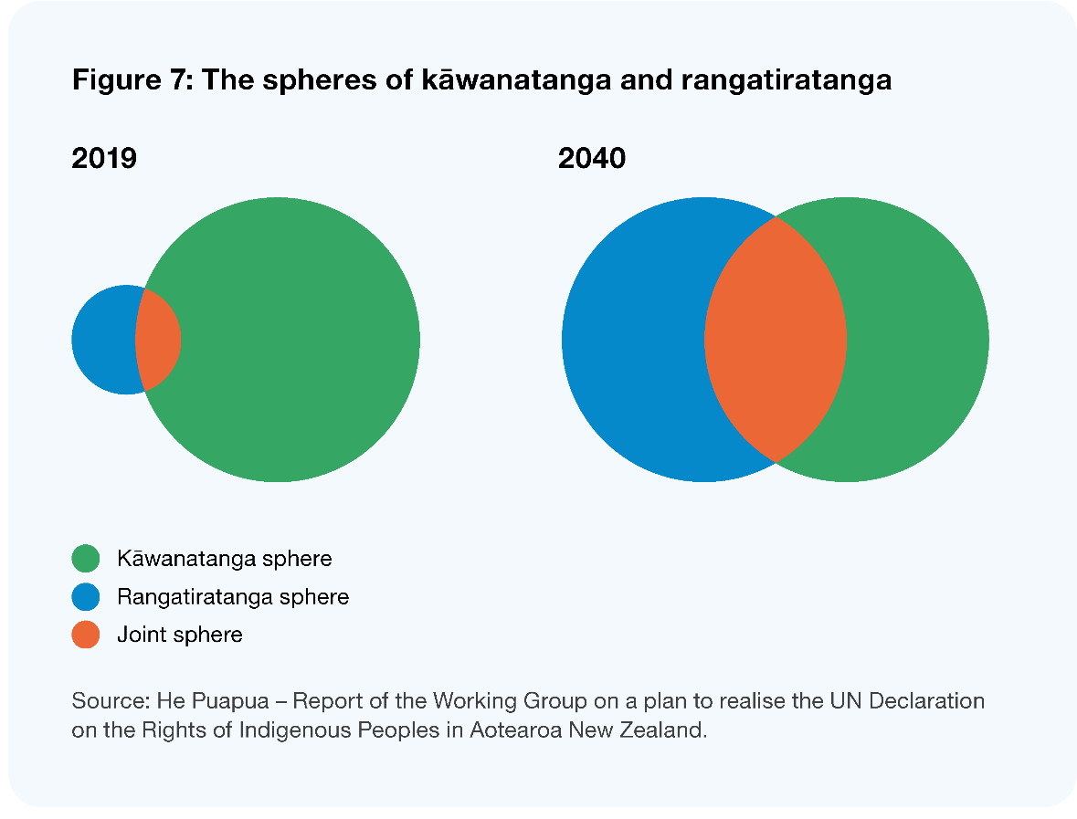
The benefit of this model is that it allows us to consider where different functions of public authority sit in relation to the spheres, taking into account the nature and strength of both the Māori and the wider public interest in those functions. Where those interests overlap, it challenges us to think about how and the extent to which authority needs to be shared (discussed in more detail below). To our mind, this model is not trying to re-define or limit the concept of rangatiratanga itself – that can only be defined and evolved within Māori communities – it simply acknowledges that the practical exercise of both kāwanatanga and rangatiratanga may in many situations constrain and inform each other.
What do we mean by rangatiratanga and kāwanatanga?
Conceptions of rangatiratanga are far from uniform, reflecting the varied histories and customs of different hapū/iwi, but at a high level, we have understood rangatiratanga as a concept of political, social, and cultural authority – closely linked to self-determination – through which Māori exercise control or influence over their own institutions, communities, property, and overall wellbeing (including the public goods and services they receive for their benefit).
We understand it to function at both a collective level (in terms of hapū/iwi), and at a whānau/individual level – as in the relationship between a parent and a child or in the choice individuals exercise about how they lead their lives. In this sense, rangatiratanga is fundamentally contextual in meaning – it evolves over time in Māori communities and its application or exercise takes different forms in different situations.
Most importantly, as with any concept related to self-determination, we understand the exercise of rangatiratanga to be critical to achieving better and equitable outcomes for Māori, and to maximising overall wellbeing for communities.
Kāwanatanga, the ethic of governorship, is historically derived from the term ‘Kawana’ or Governor, who in 1840 was the Crown representative in Aotearoa New Zealand that signed Te Tiriti o Waitangi. In contemporary times, Kāwanatanga refers to the Governor and authority delegated to and vested in Parliament, the judiciary, and the executive of government. Local government is often referred to by Māori as an agent of Kāwanatanga as it carries out roles and functions enshrined in legislation that give practical exercise of Te Tiriti o Waitangi at place.
Some people may still ask how this is relevant to local government when it is not part of ‘the Crown’. With respect, we think this confuses the issue in question. We think local government’s autonomy as a creature of statute is an important feature of the system, but we do not think that status means it cannot and should not be expected to act in a way that is Tiriti-consistent. In other words, nothing about local government’s current constitutional or legal status prevents us from imagining (and providing for) a more substantive relationship that ensures local government is doing its part to fulfil the promise of te Tiriti. As noted by the Waitangi Tribunal in the Wai 262 report:
“It is now well settled that the Crown does not absolve itself of Treaty obligations by using its powers to subdivide kāwanatanga functions between central and local government. …Thus, while local authorities are not the Crown, as its statutory delegates they must be given clear Treaty duties and be made accountable for the performance of them.”
– Wai 262
Or as has been noted in a separate analysis:
“te Tiriti is not about labels but is primarily about roles and obligations. The functions of kāwanatanga were, and are, important. If any Pākehā body which is exercising kāwanatanga affects Māori, then Tiriti obligations operate. It should not matter whether the body is central government, local government, or private…Local government does not need to be artificially conceptualised as the Crown in order to possess Tiriti responsibilities.”
– Potaka (1999)
Whilst we do not think local government has the same Tiriti obligations as the Crown, we think it is very clearly exercising functions of kāwanatanga, and its mandate must therefore provide for a much more meaningful exercise of rangatiratanga than it currently does. Even were this not the case, our engagement in this inquiry tells us there are already some significant, place-based relationships between councils and hapū/iwi, marae, and other Māori organisations. In other words, we think the Treaty is already an influence on the sharing of local authority.
For all of these reasons, we think the relational sphere model is just as relevant to the desired future state of the relationship between Māori and local government as it is for the relationship between Māori and the Crown.

Article Three and ‘differentiated liberal citizenship’
We think it is now well established that Article Three of Te Tiriti obliges the Crown to strive for equitable outcomes for Māori. At the same time, we have benefited greatly from expert advice about the concept of differentiated liberal citizenship (O’Sullivan 2022). This concept emphasises that culture influences how people set political priorities and form views on what local government should do, and that Māori citizens are therefore entitled to make culturally distinctive contributions to council decisions or activities.
The idea of differentiated liberal citizenship relies on the concept of participatory parity, which envisages that resources to support democratic processes must be distributed in a way that ensures participants’ independence and ‘voice’, and that “institutionalised patterns of cultural value express equal respect for all participants and ensure equal opportunity for achieving social parity” (Fraser and Honneth 2003). In other words:
“Participatory parity’s test is whether, after being on the losing side in a democratic contest, one can still say that the decision-making process was fair – that one was not on the losing side because the process was culturally foreign and, therefore, inconsistent with opportunities for the fair and reasonable expression of one’s ideas, that neither culture nor indigeneity were democratic disabilities and that colonialism was not a factor.”
– O’Sullivan (2022)
We think this is closely related to the idea put to us during the iwi kōrero about the need for te ao Māori perspectives to meaningfully influence ‘local kāwanatanga’. As we see it, this right of differentiated (but equal) citizenship is confirmed in Article Three and is a key part of the future state for local governance. It complements the idea of a more meaningful expression of rangatiratanga, because it helps us think about how Māori political authority should exist inside of, as well as outside of or in conjunction with local government. Indeed, the greater the provision for culturally differentiated participation in the kāwanatanga sphere, the less need there may be for separate or shared decision-making mechanisms in the relational and rangatiratanga spheres, or vice versa.
We discuss this idea further below, but for now, we simply note that implementing the concept of differentiated liberal citizenship means we see te ao Māori values, tikanga, and mātauranga Māori as essential components of a future system of local governance.

International models
In the course of our review we have also considered a range of international models for the recognition of indigenous rights or the sharing of public authority with indigenous peoples. In particular, we have noted that:
  - models for recognising indigenous rights vary greatly with the constitutional and political institutions in different places, historical interactions between indigenous and general populations, and the extent to which indigenous populations can and choose to live ‘separately’ within a state
  - successful recognition of indigenous authority seems to depend as much on embedding indigenous values in decision-making as it does on changing decision-making processes/re-allocating decision rights
  - some such values are about different conceptions of wellbeing or relationships to the environment, but many are about how decisions are made (for example a preference for consensus decision-making over ‘hard’ democratic mechanisms like voting).
In addition, the experience of these jurisdictions suggests that the challenges destabilising many countries and governments – racism, geographic and intergenerational poverty, social and economic inequity – will only become more acute in Aotearoa New Zealand if we fail to realise a Tiriti-based partnership in local governance. Most importantly, they suggest to us that formal models and structures will only take us so far, and that the evolution of culture and societal behaviour will have a profound influence on whether partnership is achieved.

Conceptual framework for the future state
Taking the ideas outlined above, and what we heard through our engagement, we have developed a framework for what we think a Tiriti-based partnership between local government and Māori could look like. We think this framework represents a Tiriti-consistent exercise of ‘local authority’. Further in this chapter, we use this framework as a basis for an architecture for change that sets out areas of action needed to realise this partnership.
The framework, which draws on both the Articles and principles of Te Tiriti, contemplates:
- the meaningful expression of rangatiratanga in local areas, for example by enabling roles and functions to be exercised by, or shared with, hapū/iwi
- equitable participation by Māori in decision-making and engagement processes
- te ao Māori values, mātauranga and tikanga to be embedded in the work of councils and their interactions with Māori.
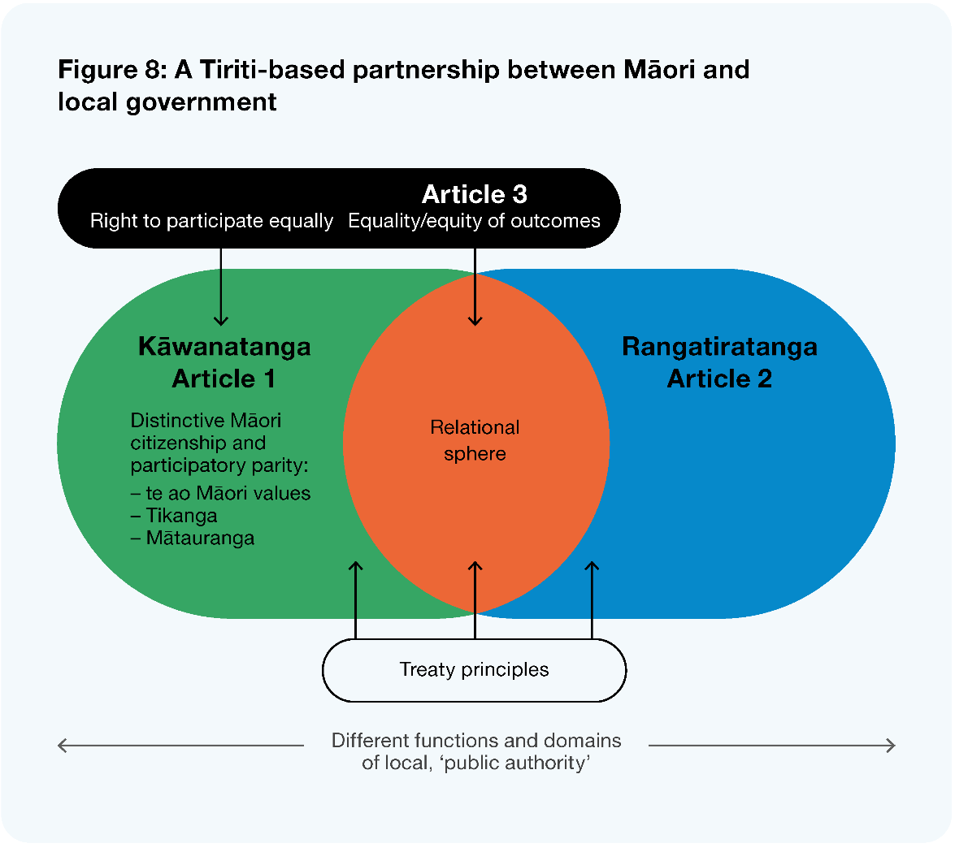
Image description: Figure 8: A Tiriti-based partnership between Māori and local government. This figure shows how the rights from Article 3 feed into other aspects. The right to participate equally feeds into Kāwanatanga in Article 1, with distinctive Māori citizenship and participatory parity with te ao Māori values, tikanga, and mātauranga. Equality/equity of outcomes feeds into the relational sphere between Article 1 (Kāwantanga) and Article 2 (Rangatiratanga). Treaty principles feed into all three spheres, and different functions and domains of local, public authority cut across all three.
As noted, this framework considers different functions of local authority along a continuum, where at one end they may be carried out solely or predominantly by councils, and on the other by hapū/iwi. Most importantly, however, it imagines that a lot more functions in between these points would be thought of as part of a larger ‘relational sphere’, and be exercised with higher levels of collaboration, co-design, or co-governance. The extent to which (and how) decision-making should be shared depends on the nature and strength of the interests involved. Tiriti principles are incorporated as a flexible framework for guiding the allocation, and local capacity and capability are important considerations.
Under this framework, in situations where Māori have a strong interest in a local function, and there is no fundamental reason why it must be exercised by council on behalf of the whole community, they may take a lead role in the design or delivery of that function. A good example of this may be environmental monitoring, where community interests can be established in core service requirements, and the exercise of such a function is fundamental to kaitiakitanga. Similarly, where the active protection of Māori interests or more equitable outcomes may be achieved by the use of Kaupapa Māori-based service models (say, in community libraries), there may be a role for Māori in the design and delivery of those services.
Conversely, where functions have little cultural specificity (such as roading) they may stay predominantly or wholly in the kāwanatanga sphere. In these cases, all decisions and local services would still be informed by te ao Māori values, tikanga, and mātauranga Māori, and the culturally unique perspective of Māori as citizens.
An example of a function that could sit in the ‘relational sphere’ includes the making of decisions in the Long-Term Plan about the overall mix and volume of local services. This is a function that the whole community will always have a strong interest in, and which is likely to require substantive collaboration between council and Māori.
What is co-governance?
At its heart, we think co-governance in a local government context is about decision-making partnerships between local government and Māori, built on trust and confidence, used to develop a vision and objectives for a Kaupapa to work together. It is about sharing information at the outset and bringing together different perspectives and knowledge systems in a conversation based on mutual recognition.
It does not mean that final decisions can or should always be made ‘jointly’ – certainty and efficiency may still mean that final decisions fall one way or another, but it does mean that a high degree of dialogue may be required before a decision can be made, or that decision-makers must strive for a consensual approach before resorting to ‘hard’ democratic mechanisms like voting.
We do not think co-governance undermines the fundamentals of democratic decision-making – we think it augments and enriches the local governance system with an indigenous way of deliberating.

An architecture for change
In order to think about the changes we need to make to achieve a Tiriti-based partnership between Māori and local government, we compared the future-state framework with what we heard about the status quo during our research and engagement.
We have identified six interconnected areas where we think change is needed.
- A new legislative framework for Te Tiriti in local governance: Revising the Treaty provisions of the LGA could clarify the role of Te Tiriti in local governance and enable a Tiriti-based partnership. There are a number of design considerations for such a framework, which could explicitly recognise te ao Māori values and conceptions of wellbeing, provide principles for involving Māori in the exercise of decision-making authority and service design, and make specific provision for equity in local outcomes, cultural specificity of local services, and the incorporation of mātauranga Māori.
- Establishing a strategic role for Māori in local governance: We think it essential that Māori have a role in identifying the priority outcomes that would maximise community wellbeing, and in any co-investment processes that occur between ‘central and local’ to help determine how such outcomes will be achieved.
- Mainstreaming and consolidating specific mechanisms for partnership and co-governance: Along with a new legislative framework, there is also the opportunity to mainstream and consolidate specific mechanisms for local co-governance of particular functions or decision-making processes, taking into account existing models and the proposals in other current reforms.
- Improving Māori participation in local government processes: We discuss how Māori participation in day-to-day council processes may be improved, including through incorporation of tikanga and better alignment of council engagement.
- Improving ‘Māori representation’ in council governance: We suggest that the existing mechanisms for providing Māori representation at council level are not sufficient, and propose the potential to provide more direct representation for mana whenua and significant Kaupapa-based groups.
- Building local government and Māori capability and capacity to build and maintain a Tiriti-based relationship: No relationship can flourish if the parties do not actively nurture it. We consider how to achieve a step-change in the capacity and capability of councils and Māori to develop and maintain a Tiriti-based partnership.
The areas for action fall into three themes – setting the system conditions; fostering the relationship at a number of levels; and supporting the change happening in practice. Together, these form an architecture for change – a set of actions for systemic, specific change. The six areas and how they fit together are summarised in the diagram below.
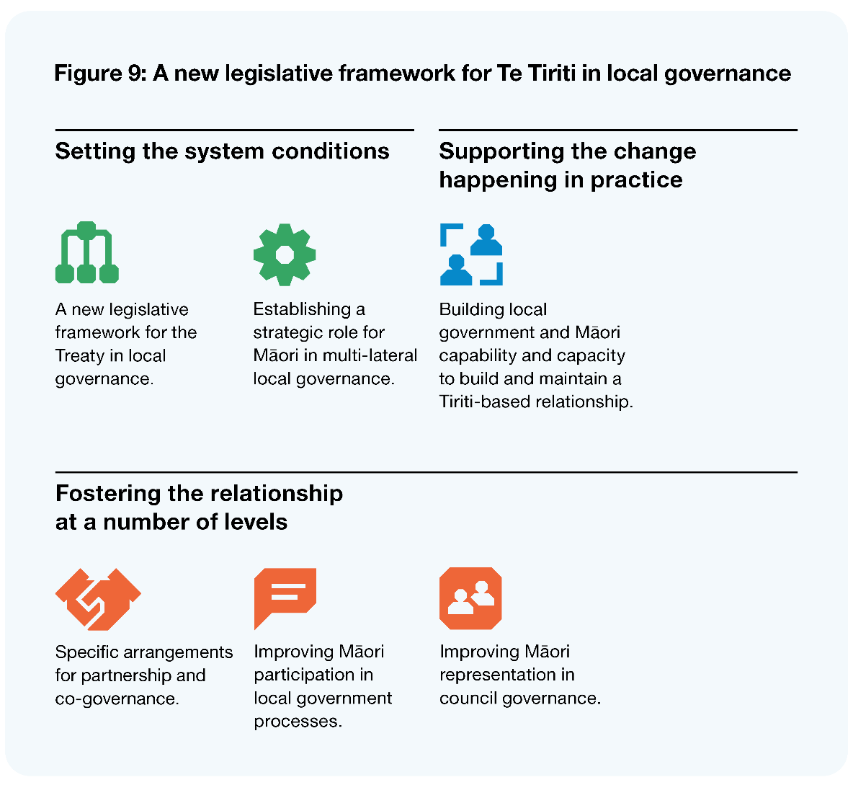
Image description: Figure 9: A new legislative framework for Te Tiriti in local governance. This figure shows that the framework should set the system conditions with a new legislative framework for the Treaty in local governance and establish a strategic role for Māori in multi-lateral local governance. It should support the change happening in practice by building local government and Māori capability and capacity to build and maintain a Tiriti-based relationship. It should foster the relationship at a number of levels through specific arrangements for partnership and co-governance, improving Māori participation in local government processes and improving Māori representation in council governance.
A new legislative framework, specific arrangements for partnership and co-governance, and capability and capacity are discussed in the last part of this chapter. The remaining aspects of this architecture are discussed in other chapters that provide relevant context for the changes proposed. In particular:
- a strategic role for Māori in local governance is discussed in Chapter 6
- improving Māori participation in local government processes is discussed in Chapter 2
- improving Māori representation in council governance is discussed in Chapter 7.
In addition to these sections, we note that the discussion of system stewardship in Chapter 10 also asks how we might embed Te Tiriti in the stewardship functions for the local government system.

Section 2: A new legislative framework for Te Tiriti in local governance

Context
As noted in Section 1 above, legislative provision for Te Tiriti or Māori rights and interests in local governance is spread across core requirements in the LGA and a range of more specific obligations under local government-related statutes. We discuss the latter in Chapter 2, but for now, we focus on the core ‘Tiriti provisions’ of the LGA. These flow from section four of the Act, which states:
“In order to recognise and respect the Crown’s responsibility to take appropriate account of the principles of Te Tiriti of Waitangi and to maintain and improve opportunities for Māori to contribute to local government decision-making processes, Parts 2 & 6 provide principles and requirements for local authorities that are intended to facilitate participation by Māori in local authority decision-making processes.”
– Local Government Act
The ‘principles and requirements’ referred to include requirements for local authorities to:
- provide, establish, and maintain processes to provide opportunities for Māori to contribute to decision-making processes
- consider ways to foster the development of Māori capacity to contribute to the decision-making processes of the local authority
- provide relevant information to Māori for the above purposes and ensure it has in place processes for consulting with Māori
- (where a significant local authority decision relates to land or a body of water), take into account the relationship of Māori and their culture and traditions with their ancestral land, water, sites, wāhi tapu, valued flora and fauna, and other taonga.

Descriptive (specific) and ‘general operative’ Tiriti clauses
Section 4 of the LGA was one of the earliest examples of a ‘descriptive/specific’ Tiriti clause in legislation. This kind of clause references the Crown’s Tiriti responsibilities in a generalised way, with specific provisions setting out how those responsibilities are given effect to by the specific decision-makers and actors under a statute. They attempt to show what Parliament determined is required to comply with Te Tiriti in the particular context. Recent guidance from Te Arawhiti assesses that:
“The descriptive approach (and the analysis that goes into designing specific mechanisms to address Tiriti obligations) provides greater certainty for decision-makers than an operative clause, but it can be less flexible in application. It may struggle to anticipate all situations where more specific provision is needed to ensure a meaningful expression of te Tiriti.”
– Te Arawhiti (2022)
In contrast, general operative clauses require decision-makers under the relevant Act to consider, place a particular weight on, or act in accordance with Treaty principles. While they can be applied to certain decisions or decision-makers, they have often been applied to the exercise of all functions or powers under the Act. In this respect, the Te Arawhiti guidance notes that:
“By their nature, operative Tiriti clauses pass responsibility for determining what te Tiriti means to statutory decision-makers and ultimately the courts. This may be appropriate, especially if the legislative regime delegates significant discretion to decision-makers and lists other relevant considerations. But such clauses should reflect a very deliberate and clear policy outcome….and they must fit within the design of the legislative framework. There should be a clear understanding of what their practical effect will be and how those charged with implementing the Act will implement it.” (emphasis ours)
– Te Arawhiti (2022)
The Te Arawhiti guidance also makes the point that there is no prescribed formula or model for recognising Te Tiriti in legislation, and that such decisions should be a matter for discussion and analysis in the particular context.
We are aware that the exposure draft of the Natural and Built Environments Bill includes a general operative clause, but we note the Bill also includes several specific mechanisms to provide for Māori appointed members on regional planning committees. We are also aware that in developing the Pae Ora (Healthy Futures) Act 2022 as a framework for the new health system, Cabinet decided not to rely on a general clause, but to combine strong specific mechanisms (such as the Māori Health Authority), with a set of system principles that they felt reflected the general obligations necessary to give effect to Tiriti principles in a health context (DPMC 2021).

A new framework for Te Tiriti in local governance
Fundamentally, we accept the view that the core requirements in the LGA fall well short of a Tiriti-based partnership. At the same time, we think there is a real willingness in local government to deepen the relationship and deliver better outcomes for Māori if only the framework provided greater clarity. As such, a key recommendation of this review is that the Tiriti-related provisions of the LGA be thoroughly revised to provide a framework for the Treaty in local governance that drives genuine partnership and better local outcomes for Māori.
The core requirements in the current LGA provide little guidance as to the impact of Treaty principles on the role of Māori in local governance, failing to reflect the breadth or depth of obligations we think are needed to provide for a meaningful expression of rangatiratanga. Nor do they reflect the guarantee of equity and differentiated liberal citizenship that we think flows from Article Three. Finally, they are deficient in acknowledging te ao Māori values, conceptions of wellbeing, or principles of governance, or the incorporation of mātauranga Māori in local service design. This lack of direction and clarity is a key reason for the current patchwork and ad hoc approach to co-governance arrangements discussed above.
In short, we think these provisions have become an anachronism, and fail to provide clarity about the role of Te Tiriti in local governance.
We think it should be left to a legislative reform programme to devise a specific version of revised Tiriti-related provisions, and that this should be the subject of detailed discussion between Māori, local government, and central government agencies. Nevertheless, below we make a number of observations and suggestions about the significant choices of structure and content inherent in a revised framework.

General approach and structure
We support the use of specific provisions to provide the clarity all parties seek about the nature of a Tiriti-based partnership. Generally speaking, we think the lack of substance in the current provisions is more of a problem than the form of the Treaty clause itself. And yet, we can see an argument that the significant discretion provided by the LGA means a more general clause should be considered. We also do not object to the idea of councils being subject to greater judicial scrutiny about how they have provided for Treaty principles – we think such scrutiny could be a valuable addition to the accountability framework for local government.
However, the breadth of functions performed by councils and their role as a facilitator of democratic decision-making present some unique challenges for a general clause. First, we think it would take the courts a long time to establish a set of decisions that provide some certainty to the sector about how it achieves consistency with Treaty principles in different situations. In other words, it would be very difficult to meet the ‘practical effect’ criterion referred to in the Te Arawhiti guidance. In addition, that process would mean funding an increased number of litigation processes, generating significant cost for ratepayers in the short to medium term.
More specifically, we are concerned that a general clause with a legal weighting of ‘give effect to’ may not be the most appropriate way to actually give effect to Treaty principles in local governance. Such weightings can create a platform for individuals to challenge particular decisions on their merits (as opposed to on a procedural basis) – meaning the court may effectively substitute its own decision for that of the statutory decision-maker. This scenario may be appropriate in contexts like resource management, where choices are made about specific rights to natural resources, and where there is already a comprehensive judicial fabric that contemplates such choices.
In a broader local governance context, by contrast, democratically made decisions about the mix, entitlement to, and design of local services are constantly weighing complex fiscal and social value trade-offs in the interests of the collective good. In this situation, we think the court is unlikely to be the most appropriate institution for making such decisions, and merits-based challenges on the basis of specific litigants’ interests may only undermine the certainty and integrity of the system.
We understand that general clauses have been valued by Māori as a way to advance their relationship with a Crown that has not always been responsive to Treaty principles. But with respect, we think it may be more important to base reform on a positive vision of the future than a current trust deficit. If our future system sees local government and Māori making tough choices about local service provision in partnership, as proposed in this report, then we think a general clause with such a weighting is unlikely to be helpful or necessary.

A possible way forward
Ultimately, the solution may lie in a more contemporary hybrid of these approaches. It may be that a combination of a general clause (with a strong weighting less than ‘give effect to’) and more specific obligations about how to involve Māori in decision-making are sufficient. Still, we remain concerned about the ability of very specific obligations to provide for Tiriti consistency in all situations and the ability of a general clause to provide certainty.
On balance, in lieu of a general clause, we think it may be more useful to enact an integrated set of local governance principles that describe more specifically (but still flexibly) what is required of councils to give effect to Treaty principles in the context of local governance. We discuss the potential content of such principles below.
Like under a general clause, councils could be judicially reviewed as to how well they have turned their mind to and provided for such principles – though we would not propose a legal weighting that creates a platform for merits-based challenges. These principles would be just one part of the package of specific mechanisms discussed elsewhere in this report (such as the strategic role for Māori in identifying wellbeing priorities in Chapter 6, and the specific mechanisms for partnership discussed below) which would form the overall framework for Te Tiriti in local governance. We think it important that this choice of approach is tackled early and informed by detailed engagement with Māori and councils.

Potential content for Tiriti-based local governance principles

Explicit recognition of te ao Māori values and conceptions of wellbeing
As noted earlier, we think the absence of explicit recognition for te ao Māori values and concepts of wellbeing is a significant deficiency in the LGA, and a constraint on the idea of differentiated liberal citizenship for Māori. A revised legislative framework for Te Tiriti could explore principles-based obligations that ensure councils consider or provide for such values when making decisions, or designing and delivering local services.
These obligations may reflect broad elements in the Māori conception of wellbeing (see Treasury 2021) or high-level values that bear more on the nature of governance – such as Kotahitanga, Whanaungatanga, Manaakitanga, and Tiakitanga. We make no specific recommendations about what should be incorporated. Rather, we recommend these be determined via a comprehensive engagement process with Māori.

Principles for involving Māori in decision-making and service design
Fundamental to a more meaningful expression of rangatiratanga in local governance is pushing past what has been described to us as the ‘contribution paradigm’ in the iwi kōrero. The current principle of providing opportunities for Māori to contribute to decision-making processes does not, we think, set an aspirational standard that equates to partnership.
Rather, we think the Act could include a key principle (or principles) that ensure local government provides opportunities for Māori to:
- engage in decision-making processes and exercise decision-making authority
- be meaningfully involved in the design and/or delivery of local services.
As noted, this does not mean that all decisions in which Māori have an interest must be made jointly, or that Māori should deliver all services in which they have an interest. Rather, this would aim to facilitate a step change in the relationship by providing a strong (but still flexible) expectation that, in many instances, the need to involve Māori will go well beyond consultation. This involvement may include more substantive engagement, collaboration, shared decision-making, or in some cases, design and delivery of a function by Māori. As discussed in part 3.4.5 above, the question of where a decision-making process or function sits on this spectrum would depend on the strength and nature of both the Māori and the wider public interest and the specific decision or service. These factors could be explored in the principles or left deliberately flexible.
As noted above, councils would be open to judicial scrutiny about how they have weighed the considerations above and come to a view about the way to involve Māori in a particular decision-making process. We think this concept is already reflected in contemporary approaches to Te Tiriti and in Te Arawhiti’s engagement framework with Māori (Te Arawhiti 2018), and we note that there is a recent precedent for this idea in legislation.
Where such consideration leads to delivery of a function by Māori, it would be important that the hapū/iwi or Māori entity receives the funding collected for it and is clearly accountable to the community (through the council) for its performance. We would welcome any general or specific feedback on this idea, and how such accountability might work.

Equity, cultural specificity, and mātauranga Māori
Including principles explicitly referencing te ao Māori values and the need to involve Māori in decision-making and service design is likely to significantly improve the cultural specificity of local services, and therefore improve equity in local outcomes through greater provision for a ‘Māori voice’, but these ideas could also be separately referenced in the new set of principles for local governance.
By cultural specificity, we mean that services are designed or provided in a way or in a format that is accessible or effective for Māori in the context of their cultural values, as for Te Paataka Koorero o Takaanini (the Takaanini Community Hub), where an existing building was re-developed into a multi-purpose community hub and library that reflects the rich history of local mana whenua.
In addition, we see significant value in this framework acknowledging the importance of mātauranga Māori in decision-making and service design.

Section 3: Mainstreaming and consolidating specific arrangements for partnership and co-governance
Section 2 above discussed the principles-based considerations that might be included in a revised framework for Te Tiriti in local governance. We think strong, general obligations like those will drive significant change in the local government–Māori relationship. But it is also an option to require councils to enter into specific relationship mechanisms or co-governance/partnership arrangements for particular functions. This section considers the potential for improving or consolidating these arrangements, taking into account the existing landscape and other proposals in this report.

The impact of existing and proposed arrangements
As discussed in Section 1 of this chapter, the lack of a clear framework for Te Tiriti in local governance has meant that specific arrangements aimed at achieving a measure of co-governance or substantive input to decision-making have been developed in a patch-work fashion. These arrangements have been developed voluntarily where there was a high level of local political will, or in specific Treaty settlements. They are discussed in more depth in Section 1, but at a high level they include:
  - voluntary arrangements that allow for iwi/Māori membership on committees of council or a specific advisory role in the local authority structure
  - formal agreements for sharing or involving hapū/iwi in specific statutory functions (mostly developed under specific legislative mechanisms)
  - wider co-governance models established via settlement legislation.
We firmly support the idea that existing arrangements negotiated with Māori and enshrined in legislation should be respected and maintained. However, it is important to note that these arrangements are ad hoc and non-comprehensive in the sense that:
- most are heavily orientated towards resource management decision-making, and do not cover the wider role and suite of functions of local government
- they have been developed for some hapū/iwi groups and not others (or for some resources or geographical areas of resource management and not others)
- most of the arrangements appointing Māori to council committees remain in place at the ‘grace and favour’ of the council of the day, and some do not necessarily provide full voting rights or remuneration for Māori participants
- different arrangements often represent different levels of political commitment (in terms of the willingness of local or central government to share authority with Māori).
At the same time, a number of proposed reforms and other drivers are adding to the variety or likely uptake of such arrangements. These include but are by no means limited to:
- Regional Planning Committees and Spatial Planning Committees proposed under RMA reform, intended to provide input for Māori into the planning documents of a region under the NBA and SPA and more strategic decision-making across the planning and infrastructure nexus
- the retention of the Mana Whakahono ā Rohe provisions are being retained and enhanced, which will preserve and enhance the ability of any iwi authority or group representing hapū to seek a more structured arrangement for sharing particular resource management functions in their rohe
- Three Waters reform, which will provide hapū/iwi with significant input to the oversight of water service entities
- recent court decisions and policy reviews related to conservation, which set a powerful platform for co-governance between local government and Māori in that context.
Nevertheless, the above outline of existing and proposed arrangements remains incomplete in terms of the specific relationships between many hapū/iwi, Māori organisations, and councils. We think there is a need to consider how we can ‘raise all boats’, making sure all groups are included in the way they want to be, and ensuring we are sharing local authority at the right times and places. However, we are very reluctant to address this by recommending further prescribed mechanisms for co-governance in the context of a combined reform agenda that is already making huge demands on both council and Māori capacity. We also think the question of ‘what else is needed’ here will really depend on local conditions, circumstances, and pre-existing arrangements.

Integrated partnership frameworks
Given the breadth of local conditions and circumstances, we think it may be more useful to require comprehensive, integrated ‘partnership frameworks’ that act as a platform for ‘rounding out’ or filling gaps in existing arrangements between councils and Māori in particular areas. We see these as formal but flexible agreements that could set out or acknowledge/take into account:
  - the collective and individual relationships between council, hapū/iwi, and significant Māori organisations (it would need to be clear that the mana of individual hapū/iwi relationships are not subsumed within the framework)
  - common and/or separate values and principles on which relationships will be based
  - Māori appointments to council committees
  - existing, formal mechanisms for co-governance of particular resources or functions
  - other mechanisms for involving Māori in key decision-making processes for policy, planning, and service design or specific arrangements for operational involvement in particular functions or services
  - specific agreements about how the parties will address capability constraints over time.
There are a small number of emerging agreements we see as pointing the way towards this kind of holistic framework for enhancing wellbeing through relationship, governance, and participation mechanisms. These include the Greater Wellington Regional Council memorandum of partnership with tangata whenua (GWRC 2013), the Manatu Whakaaetanga between Te Arawa and the Rotorua Lakes Council (RLC 2015), and the way the Mana Whakahono ā Rohe agreement between Ngāti Tūrangitukua and the Taupō District Council (Ngāti Tūrangitukua and Taupō District Council, nd) makes LGA-related commitments in long-term and annual planning processes. In almost all cases, Māori and local government would not be ‘starting from scratch’ – much material from existing agreements could likely be incorporated.
Fundamentally, we see these framework agreements as a fresh opportunity for the parties to think comprehensively about the council– Māori relationships in their areas and consider:
- where particular hapū/iwi or Māori organisations may have been left behind (or can now participate more actively because they have lifted their capability and capacity)
- where a deepening may be needed in the involvement of Māori in specific functions (particularly in light of the new Tiriti framework proposed in Section 2 of this chapter.
We think they could help clarify that councils often don’t need to be in active interactions with all hapū/iwi at all times, but that all such groups who desire it have a basis for their relationship with council. They would provide a single source of information for staff trying to understand when and how their work is affected by council’s obligations to Māori and help realise efficiencies in areas where multiple iwi have interests in a function or service.

Some specific features
Generally speaking, we recommend that the requirement for partnership frameworks is left relatively flexible, to allow councils and Māori to arrive at the most suitable set of arrangements for local circumstances and the specific aspirations or priorities of local hapū/iwi. However, once agreed, we think the framework should bind future councils, except to the extent that all parties agree to vary it in future. In addition, we think it important to make sure that some specific features of a partnership approach are provided for.
Specifically, where Māori seek appointment to council committees, we think there should be an obligation on council to facilitate a conversation with all hapū/iwi and significant Māori organisations in the area about how this can best be achieved. Where the number of groups in the area is much greater than the number of seats that can be efficiently provided on a committee without it becoming unwieldy, we think it would be reasonable to expect Māori to provide tikanga- or whakapapa-based solutions as to how all groups’ interests can be represented by appointees. Once agreed by Māori, those arrangements should be put in place with full voting rights and remuneration where desired.
Lastly, and subject to committee arrangements, we think provision should be made in the framework requirements for councils to explore more collaborative approaches with Māori to the long-term planning process. As the planning process that drives most of the choices about the mix and volume of local services, we think it essential that Māori are involved early in this process and receive information that allows them to form and express a view on key choices before the plan is referred to the full council. We have not proposed a particular arrangement for this, as it may also be provided for by appointments to council committees.

Section 4: Capability and capacity

A fundamental driver of partnership
As discussed earlier in this chapter, while many councils are investing in capability and capacity building, we have repeatedly heard that the relationship is fundamentally constrained by a lack of capacity and capability on both sides. We feel strongly that legislative change and formal models for co-governance can only provide the framing for partnership – no relationship can flourish if the parties do not have the time or the ability to nurture it, and to fulfil their obligations to each other in the fullest sense. This is not a new issue, but we cannot emphasise enough how important we think it is.
We believe in the long term, an empowered, stable system of local government and iwi/Māori partners may be able to invest in and maintain their own capability and capacity for this purpose. However, we think this point lies some time into the future, and it is time to acknowledge that:
- treaty settlements were never intended to put Māori in a position to fully exercise their role as a contemporary Treaty partner in local governance
- small councils with low rating bases are not able to fund an immediate increase in their own capability or support for Māori, or are trapped in a ‘negative investment cycle’ – they cannot convince communities to invest in it without demonstrating the outcomes it will have, but they cannot achieve those outcomes without capability
- without a clear signal of future investment, supply of such capability will remain weak.
While some capability will be ‘built by doing’ in a new system, if we cannot increase both capability and capacity in the next 5 to 10 years, we think many proposals in this report will fail or be at risk of change in political direction. We will simply not be setting the parties up for success and will not secure confidence in a new system.
We acknowledge that the resource management reforms are considering the capacity and capability of Māori and local government to support a Tiriti-based partnership in the resource management context.
Nevertheless, we think the above points and the broader nature of the relationship across all local government-related functions) suggest the need for a package of initiatives that combines local government leadership and accountability for long-term capability with further transitional support from central government. These ideas are discussed further below.

More specific legislative direction for councils
We think the LGA is now significantly out of date in not including any specific requirements for the cultural or Treaty-related capability of local authorities. Examples of statutes that include such requirements for governing bodies are becoming increasingly common, and we think there should be a clear obligation on local authority chief executives to:
  - develop and maintain the capacity and capability of council staff to understand Te Tiriti and te ao Māori
  - embed such perspectives in corporate policies and organisational systems.
We have also considered the sufficiency of council efforts to foster the development of Māori capacity and are aware of a small but increasing number of innovative and substantial initiatives aimed at this.
- Funding agreements reached between Greater Wellington Regional Council and mana whenua – these agreements allow the iwi to choose how they wish to allocate funds to build their capacity, based on a work programme agreed and aligned with Council.
- The independent iwi environment unit set up by Taranaki Regional Council and mana whenua – this unit is paid for by Council but staffed by iwi appointees capable of providing a Māori perspective on resource management planning and other environmental issues.
At other times, we are aware that funding for Māori participation has been set aside for specific projects or decision-making processes (such as the develop of the long-term plan).
Generally speaking, the current obligation on councils to ‘consider’ ways to foster the development of Māori capacity is not strong, and we do not think it has led to substantive action across the sector. At the same time, specific, fixed legislative requirements are often not the best way to promote this kind of investment – the nature of the investment needs to be tailored to the context, and we expect the need for direct financial capacity support to diminish over time as hapū/iwi consolidate their economic base.
Nevertheless, we see significant value in central government exploring stronger procedural requirements for councils in relation to fostering Māori capacity. It may be that these changes require something like ‘best endeavours’, or that the requirement to consider this is tagged specifically to the annual planning process to ensure a robust conversation about options at the right time.

Sector-led workforce development and support
Although we suggest exploring stronger requirements for councils, we are conscious that legislative requirements are a blunt incentive, and there are already pockets of significant cultural capability in councils and many good relationships with Māori in specific situations.
For these reasons, we think there is much to be gained from a new, comprehensive, and sector-led organisational and workforce development programme.
We think Te Arawhiti’s Māori Crown Relations Capability Framework (Te Arawhiti nd) for the public service provides an excellent steer as to the individual competencies and organisational features that lift overall capability in public agencies, and we think these are largely transferrable to a local government context. We would expect organisational initiatives to focus on:
- refreshed approaches to recruitment and procurement processes (to remove/mitigate unconscious bias and increase the likelihood of Māori becoming council staff or tendering for council contracts)
- how to make workplace environments comfortable and supportive for Māori staff and demonstrate a commitment to te ao Māori through an agency’s physical environment
- specific initiatives aimed at increasing the awareness senior leaders have of te ao Māori, obligations to Māori, and their personal relationships with Māori organisations
- targeted investments in building the organisation’s understanding of Māori outcomes in the local authority area, and exemplar models of culturally specific service design.
We would expect workforce initiatives to include:
- increased access to resources and courses; training and development for Te Reo Māori and tikanga Māori; Te Tiriti education; and understanding of equity, unconscious bias, and institutional racism
- building recognition of the above skills into performance management systems
- sector-wide talent mapping and peer-to-peer support initiatives that connect leading practitioners across councils
- a suite of tools/guidance incorporating the latest in best practice engagement with Māori.
We would expect this programme to be led and supported by sector agencies, and for support to be prioritised towards councils coming off a ‘low base’.
We see value in councils proactively seeking opportunities to have shared experiences with hapū/iwi, to build relationships, grow shared understandings of the local histories, whakapapa and taonga.

A transitional fund to support a new system
As we argued at the start of this chapter, we cannot ignore the fact that there is a significant short- to medium-term affordability problem for many councils in funding both the type of initiatives discussed above, and the capacity of iwi/Māori to participate. We acknowledge that investment has been tagged to the resource management reforms, and this will contribute to closing this gap, however the capability we are talking about is broader than the resource management context.
We think a more concerted effort is needed by central government to ensure its Treaty obligations to Māori in relation to local governance are met.
On balance, we recommend central government provide a transitional fund to subsidise the cost of building this capability and capacity at the local level. We recommend that:
- grants be subject to clear evidence of co-investment by those councils
- requirements imposed to ensure that a share of each funding grant is allocated specifically for Māori capacity.

Recommendations
- That central government leads an inclusive process to develop a new legislative framework for Tiriti-related provisions in the Local Government Act that drives a genuine partnership in the exercise of kāwanatanga and rangatiratanga in a local context and explicitly recognises te ao Māori values and conceptions of wellbeing.
- That councils develop with hapū/iwi and significant Māori organisations within a local authority area, a partnership framework that complements existing co-governance arrangements by ensuring all groups in a council area are involved in local governance in a meaningful way.
- That central government introduces a statutory requirement for local government chief executives to develop and maintain the capacity and capability of council staff to grow understanding and knowledge of Te Tiriti, the whakapapa of local government, and te ao Māori values.
- That central government explores a stronger statutory requirement on councils to foster Māori capacity to participate in local government.
- That local government leads the development of coordinated organisational and workforce development plans to enhance the capability of local government to partner and engage with Māori.
- That central government provides a transitional fund to subsidise the cost of building both Māori and council capability and capacity for a Tiriti-based partnership in local governance.

Allocating roles and functions in a way that enhances local wellbeing

Changing context and expectations, reform pressures, and the need to adapt now and position well for the future means it is timely to review who is best placed deliver roles and functions.

Key findings
The nature and mix of roles and functions should be allocated in a way that delivers maximum value to communities and benefits the country as a whole.
It is not about a binary allocation – local or central – but rather how the design, accountability, influence and delivery could sit across many actors, with subsidiarity being a key principle.

Overview
The roles and functions that councils undertake – what councils ‘do’ – is in a state of flux, being pushed and pulled in a number of directions. The major reform programmes, including the Three Waters and resource management reforms currently underway, stand to remove and change some traditional local government roles and functions. The role of councils in tackling major challenges such as climate change is becoming increasingly unclear. Councils are also delegated responsibilities by central government, often when the benefits at a local level are unclear and in many cases with limited consideration as to how councils will fund the activity.
While this flux can cause unease and uncertainty for councils, we believe there is an exciting opportunity for local government to be renewed and strengthened to face the challenges of the future. This renewal includes taking a fresh, comprehensive look at what councils do. However, this allocation of roles and functions is not simple and is made more complex by the state of flux we are in and the interdependencies with other aspects of the local government system discussed in this report. There is also the ongoing tension around centralisation and decentralisation that needs to be discussed and resolved.
Fundamentally, we consider at the core of a future for local government is a stronger focus on wellbeing. In Chapter 5 we discuss how councils can transform their contribution to wellbeing by utilising their existing relationships, assets, and levers to unlock wellbeing in communities. To support that, we propose a new approach to the allocation of roles and functions: one that puts ‘local’ first.
In this chapter, we propose an approach we think could help guide the allocation of roles and functions between different actors, including central and local government, hapū/iwi entities, and community organisations. The approach is centred on recognising local government as a key enabler of community wellbeing, starting with a local-first approach (the subsidiarity principle) and being guided by te ao Māori values.
We do not have all the answers about how roles and functions should be allocated. Rather than providing details about where specific roles and functions may need to shift or change, we want to present a new approach to how the allocation can be considered and potential opportunities that can be further explored. However, we do see a much deeper role for local actors in the design, commissioning, and alignment of a range services and activities, including embedding local knowledge of populations and place into the targeting, design, or delivery of central services in response to wellbeing challenges.
We believe that local government and central government, in a Tiriti-consistent manner, need to review the future allocations of roles and functions by applying the proposed approach. We want your feedback on the processes that would need to be created to support and agree the allocation of roles and functions across central government, local government, hapū/iwi, and community.

The current state of role and function allocation

Local government carries out a range of roles and functions
Local, unitary, and regional councils carry out a wide range of roles and functions. Some of these are statutory obligations set out in a range of regulatory instruments, while others are discretionary, and carried out with the aim to realise the purpose of the Local Government Act 2002. Statutory roles and functions include transport management, building consenting, and animal control. Discretionary roles and functions are broad and vary between councils but can include things like economic development and commercial activities. Overall, there is a strong focus across local government, and particularly by territorial authorities, on infrastructure provision.
What we mean by roles and functions
A function is a broad area of responsibility, and this could include things like roading provision, system stewardship, or environmental management. Roles are the different actions or jobs that contribute to a broader function. For example, in the function of roading provision, councils have the role of building and maintaining local roads, and Waka Kotahi does the same for state highways.
The scope of, and available funding for, local government responsibilities in Aotearoa New Zealand is smaller compared to other OECD countries. Internationally, education, social protection, general public service provision and health are the primary areas of subnational spending (OECD/UCLG 2019). The relatively small scale of responsibility is also reflected in our local government expenditure as a percentage of GDP, which was just 4% in 2022 (Stats NZ). Aotearoa New Zealand is one of just six OECD countries with subnational government expenditure accounting for less than 5% of GDP (OECD/UCLG 2019).

The current landscape of roles and functions across local government
While there is the opportunity for local actors to further facilitate and deliver wellbeing in their communities, many local authorities are struggling to effectively deliver their current roles and functions. This is for a range of reasons, including limited capacity and capability in some areas, financial pressures, increasing obligations, and conflicting responsibilities.
Over the last decade, the number of roles and responsibilities placed on local government by central government has increased, in many cases with limited consideration as to how councils will fund the activity. For example, the National Policy Statement for Urban Development, issued by the Minister for the Environment, requires councils to complete Housing and Business Development Capacity Assessments and develop Future Development Strategies. Often, when new responsibilities are added, Ministers and central government agencies make the assumption that councils can recover the costs of these types of requirements from rates. However limited consideration is usually given about the ability and/or willingness of communities to pay for these activities. This is particularly an issue where local government bears the costs to achieve national objectives.
While some roles and functions have been added to councils, there are examples where they have moved, or are in the process of being moved, to a more centralised delivery model, including some which directly impact local wellbeing. The major reform programmes across government, including Three Waters and resource management reforms currently underway, are pushing and pulling the roles and functions that local government undertakes, with a tendency towards the centralisation/regionalisation of functions away from the local level.
In some cases, there is a lack of clarity about councils’ roles in some of the more complex problems we face. A key example is climate change. While Aotearoa New Zealand’s national response to climate change is led by central government, local government has a critical role in undertaking and supporting local mitigation and adaptation efforts at place and in promoting local environmental wellbeing, including by supporting communities to live more sustainably. Councils are currently required to consider the effects of a changing climate on communities and incorporate climate change into existing frameworks, plans, projects, and standard decision-making procedures. Climate mitigation and adaptation efforts will need to be an ongoing part of a number of councils’ functions such as flood management, building regulations and transport.
The diagram below outlines a similar complexity in the waste management area – demonstrating how the roles cut across all layers of government.
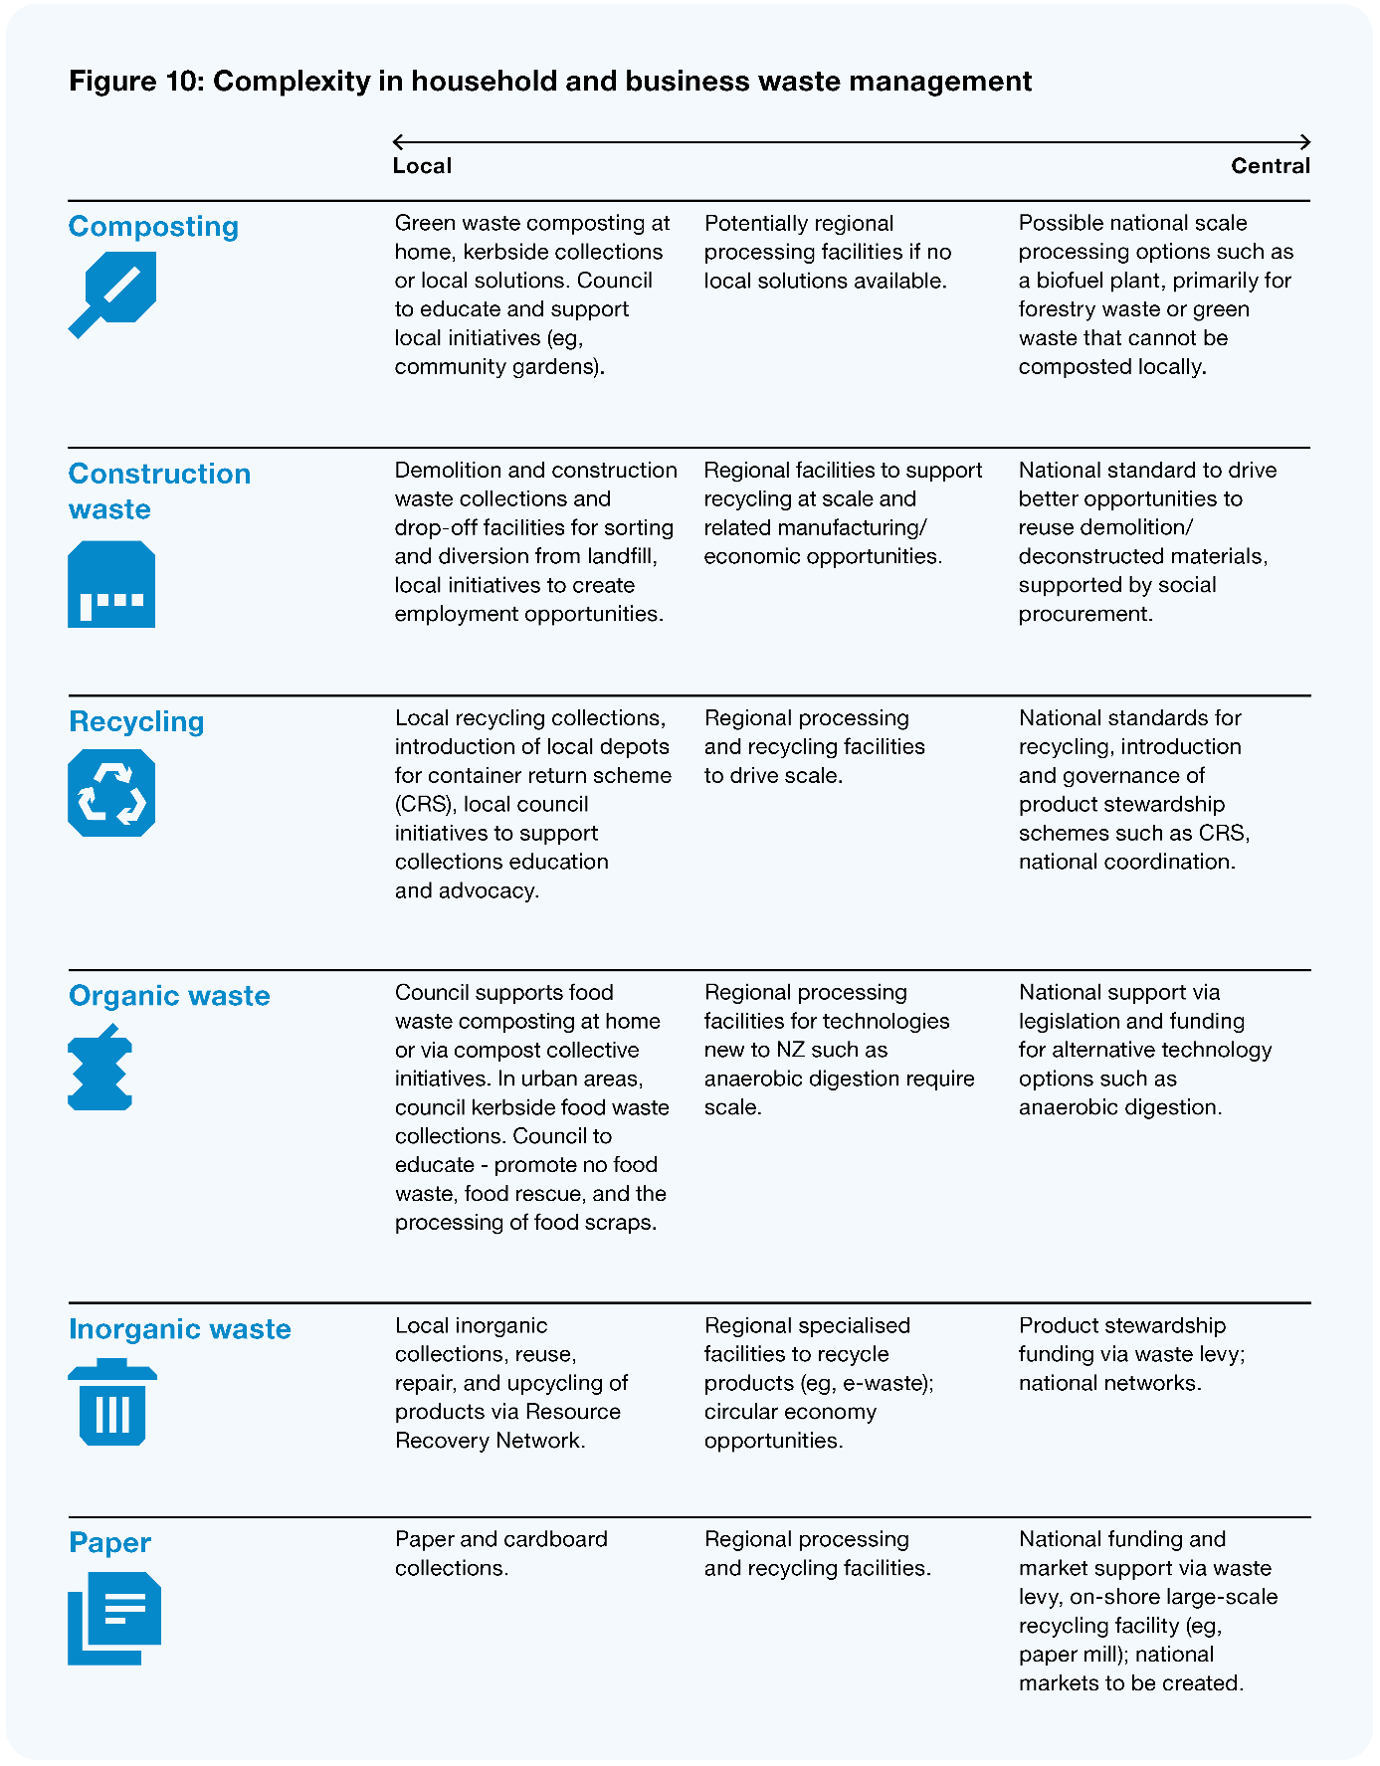
Image description: Figure 10: Complexity in household and business waste management. This figure lists different aspects of waste management and describes the functions carried out at each level of government associated with them. For composting, the local role is green waste composting at home, kerbside collections or local solutions. Council to educate and support local initiatives (eg, community gardens). At the regional level, potentially processing facilities if no local solutions are available. At the central level, possible national scale processing options such as a biofuel plan, primarily for forestry waste or green waste that cannot be composted locally. For construction waste, at the local level, demolition and construction waste collections and drop-off facilities for sorting and diversion from landfill, local initiatives to create employment opportunities. At the regional level, facilities to support recycling at scale and related manufacturing/economic opportunities. At the national level, a standard to drive better opportunities to reuse demolition/deconstructed materials, supported by social procurement. For recycling, at the local level, collections, introduction of local depots for container return scheme (CRS), local council initiatives to support collections education and advocacy. At the regional level, processing and recycling facilities to drive scale. At the national level, standards for recycling, introduction and governance of product stewardship schemes such as CRS and national coordination. For organic waste, at the local level council supports food waste composting at home or via compost collective initiatives. In urban areas, council kerbside food waste collections. Council to educate – promote no food waste, food rescue, and the processing of food scraps. At the regional level, processing facilities for technologies new to NZ such as anaerobic digestion require scale. At the national level, support via legislation and funding for alternative technology options such as anaerobic digestion. For inorganic waste, at the local level, inorganic collections, reuse, repair, and upcycling of products via Resource Recovery Network. At the regional level, specialised facilities to recycle products (eg, e-waste); circular economy opportunities. At the national level, product stewardship funding via waste levy, and national networks. For paper, at the local level paper and cardboard collections. At the regional level, processing and recycling facilities. At the national level, funding and market support via waste levy, on-shore large-scale recycling facility (eg, paper mill); national markets to be created.
The discussion about who has responsibility for carrying out roles and functions at a local level has also often centred on local government entities like councils. Aotearoa New Zealand is yet to really consider the potential for hapū/iwi entities to deliver or play a significant role in the exercise of functions, either for themselves, or in some cases for the wider community. We discussed this point more fully in Chapter 3, so here we simply note that there are already examples of mana whenua entities adding significant value to functions that to date have been undertaken predominantly by central or local government, such as vaccination drives and environmental monitoring.

A new approach for allocating roles and functions
In order to maximise local wellbeing, we think it is time to take a fresh look at how roles and functions that affect local communities and their wellbeing are allocated. This means looking at the roles different actors (like central government, local government, Māori, and communities) have in the design and delivery of, and overall responsibility for, a range of functions. As a Panel, we do not think that the allocation of roles and functions needs to be ‘binary’ between being delivered either centrally or locally. Rather, the design, accountability, and influence of these roles and functions could sit across a number of actors as appropriate.
In this chapter, we introduce a proposed approach we think could be used when allocating roles and functions. First, we introduce three principles that are core to this framework.
- The allocation of roles and functions should recognise that local government has significant ability to influence and create conditions for wellbeing in their communities.
- The starting point for allocating roles and functions should be at the level of government closest to the affected communities – reflecting the principle called subsidiarity.
- The process for allocating of roles and functions should be underpinned by te ao Māori values.
A. How can the allocation of roles and functions recognise local government’s ability to influence and create conditions for local wellbeing?
As further discussed in Chapter 5, the Panel considers local government is well placed to maximise wellbeing in its communities. There are a range of ways that local actors can be involved in the discharge of roles and functions. This can include having full responsibility for the planning and delivery of a role or function, through to being involved in the design and decision-making process and influencing in other ways. In order to maximise local wellbeing, it is vital that the allocation of roles and functions enables:
- a much better sense of the specific outcomes that will maximise wellbeing for a given community over a period of time
- shared accountability for these outcomes across local actors and central government
- fundamentally more collaborative conversations and negotiations about the exercise of particular roles and functions across local and central government, including local actors having a direct influence for community outcomes on central government expenditure, and local strengths, challenges, and opportunities are recognised.
B. Putting local first: how can the concept of subsidiarity be applied to Aotearoa?
We consider the allocation of roles and functions needs to acknowledge the unique role of councils in their ability to influence and champion wellbeing due to their proximity to communities and people; their connection to history, people, and whenua; their role in the infrastructure of place; and their partnerships with central government.
To reflect this, we think that the concept of subsidiarity is a useful way to frame and guide decisions about the allocation of local government functions and roles in Aotearoa New Zealand. Put simply, subsidiarity means that problems should be solved at the lowest possible level.
In an Aotearoa New Zealand context, we think applying the subsidiarity principle would mean that roles and functions should be led and managed at the most appropriate local level so that communities are empowered to shape their outcomes and take a leadership role in doing so.
While local would be a starting point, in some cases it might be appropriate for the ownership to sit more centrally to realise economies of scale, enable equity of outcomes, or mitigate risks that cannot be appropriately managed at a local level. Even when a role or function is delivered more regionally or centrally, consideration should be given to other ways local actors can influence its design, accountability, or delivery to ensure local needs are appropriately met.
Subsidiarity has some limits when viewed in isolation from other concepts
We recognise that the concept of subsidiary comes with many connotations and varying definitions. For example, it is often thought about through the polarising lens of generalised and politicised concepts like centralism and localism and the idea that services can or should be delivered either only locally or centrally. Both central and local actors are often guilty of using these narrow concepts to justify their positions of how roles and functions should be allocated. Through this report, we want to directly challenge this idea that there is a binary choice to be made.
C. How can te ao Māori values underpin decision-making?
In Chapter 3 we outlined the need to provide for a Tiriti-based partnership at all levels of the system. This includes the potential for Māori to play a more significant role in the design or delivery of local roles and functions. This could be either for themselves, or in some cases for the wider community.
In addition, we think the choice of whether something is locally or centrally allocated should not rest solely on westernised concepts of public policy, or western interpretations of concepts like equity and efficiency. For this reason, the framework below aims to incorporate some of the high-level values and concepts from te ao Māori that we think may be most relevant to these choices.

Framework for the future of roles and functions
The diagram below outlines our proposed framework to guide the allocation of roles and functions, building on the three key principles outlined above. The framework includes key actions for making decisions, as well as concepts to guide the process of making decisions.
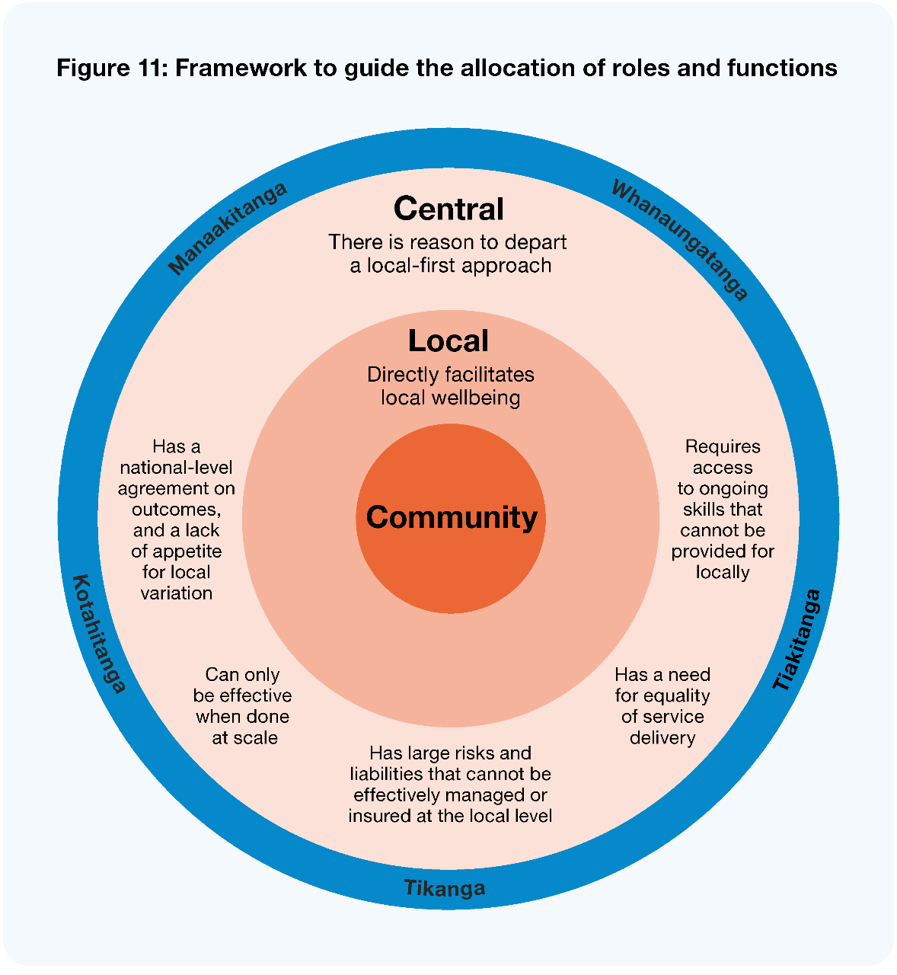
Image description: Figure 11: Framework to guide the allocation of roles and functions. This image shows several concentric circles. At the middle is community. The next smallest circle is local, which directly facilitates wellbeing. The next circle is central, where there is a reason to depart from a local-first approach. These reasons include a national-level agreement on outcomes and a lack of appetite for local variation, something that can only be effective when done at scale, something that has large risks and liabilities that cannot be effectively managed or insured at the local level, has a need for equality of service delivery, or requires access to ongoing skills that cannot be provided for locally. The circle is surrounded by the principles of manaakitanga, whanaungatanga, tiakitanga, tikanga, and kotahitanga.

Starting local
At the heart of the approach is the notion that local comes first. When allocating a role or function, consideration should always be given to what local actors can add to a role and/or function. More specifically, how can local government facilitate local wellbeing, including through:
- having a lead role in shaping the conditions for wellbeing of communities to thrive
- being a critical connector between iwi/Māori, community, and central government
- creating space for hapū/iwi to pursue self-determination.
Departing from the local-first approach is then only justified if there are other factors present, such as the need for specialist skills that cannot be obtained locally.

Departing from local-first approach
In some cases, it may not be feasible or ideal for local councils to lead work on a particular role or function. The approach outlines five justifications for departure, when roles and functions:
- can be done at scale in the interests of community
- require access to ongoing skills that cannot be provided for locally
- have large risks and liabilities that cannot be effectively managed or insured at the local level
- have national-level agreement on outcomes and/or a lack of appetite for local variation
- have a need for equality and consistency of service delivery.
In some areas, while it will make sense for ownership of some roles or functions to sit centrally, in some situations there will still be aspects where local actors can support and influence delivery and outcomes.

Process guided by te ao Māori values
Underpinning the whole approach are a set of te ao Māori concepts that incorporate key values and the practice of tikanga.
- Manaakitanga – care, respect, and generosity.
- Whanaungatanga – forming and maintaining relationships and strengthening connections between communities.
- Kotahitanga – togetherness and identifying as one. It can mean alignment, connectedness, and coordination.
- Tiakitanga – guardianship, stewardship, and protection.
- Tikanga – decisions in accordance with the right values and processes, including in partnership with the Treaty partner.
These values reflect the He Ara Waiora framework (Treasury 2021) that is built on te ao Māori knowledge and perspectives of wellbeing. They should be considered in any allocation decisions alongside the other two aspects of the approach.
For example, a western perspective might suggest that a particular role should be undertaken at a regional level, given scale or efficiency considerations. However, when considering te ao Māori values such as manaakitanga and whanaungatanga, there may be a strong case for the function (or parts of the function) to be held locally.

What could it look like if this approach is applied in practice?
We do not propose to have all the answers at this point in time, including where specific roles and functions may need to shift or change. Given the wider change proposed in this report, like the potential for a fundamentally different central and local government relationship and changes the way local priorities are agreed and invested in, we cannot jump right into allocation decisions.
That said, we do consider that local government and central government, in a Tiriti-consistent manner, should review the future allocations of roles and functions using the proposed approach. In this section we outline what this framework might mean in practice and some initial opportunities for further exploration.

Overall, the change we expect is more nuanced than just transferring roles from one actor to another
As discussed above, the approach allows for nuance in how roles and functions are allocated across local, regional, and central sectors, in order to build on their relative strengths. For example, while scale factors (such as efficiency, equity, capability) will often mean primary ownership of a function should stay with central government, there is a lot of scope for local actors to be more involved in the design, commissioning or targeting of services or a regulatory function. We have not heard from local government that they suddenly want to be funding and delivering social services; however, this more nuanced sense of subsidiarity tells us there is still a unique local value-add throughout the delivery of wider roles and functions that needs to be harnessed.

There are some areas where we think direct change is needed in the allocation of roles and functions
We consider that there are opportunities to explore some specific changes to the allocation of roles and functions that affect local wellbeing, including in housing and urban development, public health, economic development, waste management, and building consenting. We outline some of these opportunities below.
There are some areas where we think aspects of local government or local actors can, and should, play a greater role in the exercise of particular functions, some of which currently sit centrally.
- Local government and hapū/iwi’s role across the housing continuum and within urban development. This includes continuing to use current levers to effectively support and enable urban development and growth and using local knowledge and relationships with communities to support the delivery of housing across the continuum – including public housing. We also consider that local government’s role in the delivery of council housing should be further explored, along with the opportunities for hapū/iwi to deliver housing outcomes.
- Local government’s potential to better drive economic development. This includes how local government and their economic development agencies can play a greater role in working with and supporting local and regional businesses to maintain and grow an inclusive local economy. In a similar vein, they can also play are larger role working with and supporting people who are not in employment, education, or training. While initiatives such as the Majors’ Taskforce for Jobs have for many years helped local people into jobs, more can be done.
It is also clear that some functions could benefit from being coordinated, commissioned or delivered at scale, even if still fundamentally local in character. There may be some areas where the greater use of shared services could be embedded due to economies of scale benefits. Libraries are an example where there are economies of scale benefits in greater centralisation, such as improving access to resources, stock and systems. Many libraries already collaborate in this manner and are an excellent example of how economies of scale support retention of important community services, especially in smaller towns and settlements. Shared services are discussed further in Chapter 9.
We also see opportunities for the regional layer to play a greater role in some areas. As we are seeing with the resource management and Three Waters reform programmes, there are potential scale and efficiency arguments to be made for other aspects of roles and functions that relate to climate change mitigation and adaptation, transport, waste management, and building consenting. However, as with the nature of the framework, this is not a binary decision, and does not mean that local councils would no longer play a role (such as continued local delivery of components of the service), rather these are areas for potential greater collaboration that harnesses the strengths of both local agility and scale efficiencies.
Finally, and on the other side, there also some functions which we think should be specifically reviewed to assess the balance of central and local responsibility. Currently, local government is responsible for a wide range of roles and functions that when assessed against the framework allocation criteria opens questions about whether they are best done at a local level, or if there are efficiency gains in them being delivered more centrally. Many of these are regulatory responsibilities imposed on local government by central government across a range of pieces of legislation such as animal control, sale of alcohol, and building regulations. These roles and functions can be resource-intensive, with little need for variation across the country. Again, this is not to say local government should not have a role, rather there is a need to better understand how local government can input into a range of local regulations, and only take on the service delivery functions when considered against the allocation framework.

What would an allocation process look like?
While we have some ideas about opportunities to investigate further, as outlined above, we are not proposing answers about how these roles and functions should be allocated across local and central actors, and the process that would need to be undertaken in order for decisions to be made.
Rather, between now and the final report we are seeking feedback on what type of process would need to be created to support and agree the allocation of roles and functions across central government, local government, Māori, and potentially community organisations. Part of this will be considering how te ao Māori values can help guide such a process.

Recommendations
- That central and local government note that the allocation of the roles and functions is not a binary decision between being delivered centrally or locally.
- That local and central government, in a Tiriti-consistent manner, review the future allocations of roles and functions by applying the proposed approach, which includes three core principles:
- the concept of subsidiarity
- local government’s capacity to influence the conditions for wellbeing is recognised and supported
- te ao Māori values underpin decision-making.
Questions
- What process would need to be created to support and agree on the allocation of roles and functions across central government, local government, and communities?
- What conditions will need to be in place to ensure the flexibility of the approach proposed does not create confusion or unnecessary uncertainty?
- What additional principles, if any, need to be considered?

Local government as champion and activator of wellbeing
Local government has significant capacity to champion and activate wellbeing due to its proximity to community and its local assets and influence.

Key findings
Putting wellbeing at the core of council’s purpose and all its roles and functions using existing relationships, infrastructure, assets, and levers will unlock greater wellbeing outcomes for communities.
Councils have an opportunity to strengthen and expand their role as an anchor institution, systems networker and convenor, and place-maker, to enable more social, economic, environmental, and cultural wellbeing.
Councils are already taking on a greater wellbeing role. However, this is inconsistent across local government. A significant shift in councils’ mindsets, investment capability and relationships with central government, hapū/iwi, business, and communities will unleash community value and local wellbeing.

Overview
Local government has a key role to help create and foster the conditions for communities to thrive. Communities already have many of the strengths, skills, and capabilities they need to advance and contribute to their own wellbeing (Hagen et al 2021). We heard clearly in our engagement that is vital to draw on these strengths and enable community-driven approaches to wellbeing.

“We need to tip the system upside down and place the people on top.”
– Survey respondent
“Empower and support local communities to be masters of their own destiny.”
– Survey respondent
Local government has significant capacity, and the legislative mandate, to support these community aspirations and champion and activate local wellbeing. For example, it has assets, influence in place, and proximity to communities. To fully realise the opportunities, we consider councils can enhance and expand their roles as:
- an anchor institution
- a systems networker and convenor
- a place-maker.
In this chapter, we describe these three roles and highlight a number of examples where councils are already taking on a greater wellbeing role and shifting the way they are working in and with their communities. Implementing these roles sustainably across local government will require a significant shift in councils’ mindset, investment, capability, and relationships with central government. However, there are also a range of ways that councils can take action now.
While it is clear that councils can play a much stronger role to unlock wellbeing, they have competing demands and limited resources. While some of the actions and approaches needed to realise these roles will be possible within current budgets and operating models, they will not be able to be fully realised without the other changes in this report.
The frameworks and concepts in this chapter are informed by work we commissioned from The Southern Initiative. This work drew together learning and insights from local and international experiences about the potential of local government in activating a wellbeing ecology at place.

Local government as a champion of wellbeing
Local government has significant capacity to champion and activate local wellbeing, due to its legislative mandate, assets, influence in place, and proximity to communities. Councils have a range of existing levers, assets, and enablers available to them. These range from economic levers like investment, infrastructure, urban planning, and procurement, to tangible enablers like services, community spaces, and facilities, and intangible enablers like relationships and capability building. Throughout this chapter we discuss how councils can use these levers and enablers more intentionally to enhance local wellbeing.

An ecology of wellbeing
The ‘ecology of wellbeing’ model presents an effective systems view. Figure 12 below shows the various stakeholders and layers of influence across whānau, community, government, and wider society within the ecology of wellbeing.
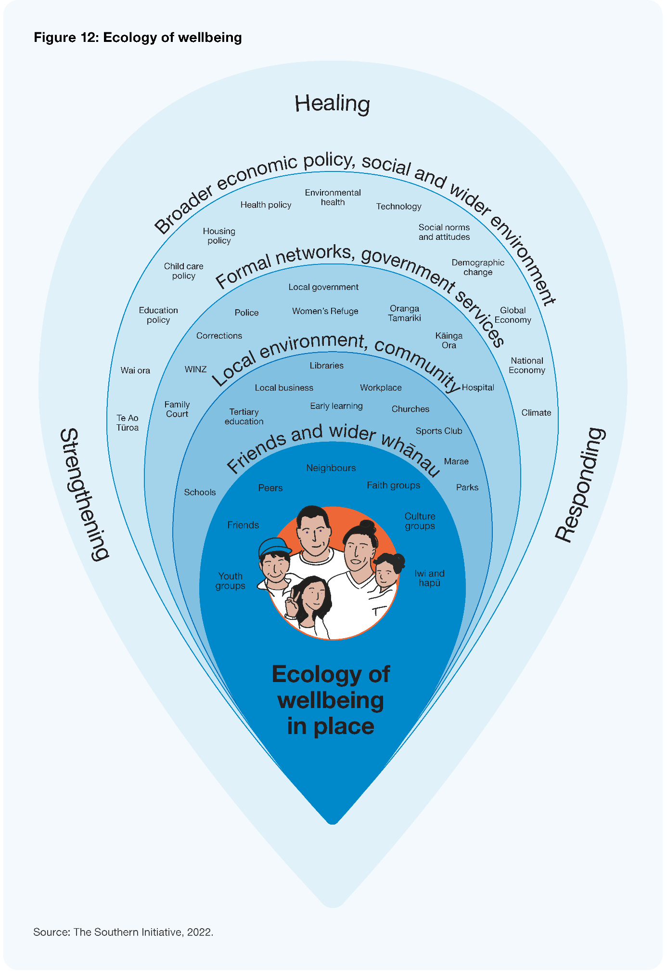
Image description: This graphic shows several concentric teardrop shapes to demonstrate the way wellbeing grows layer by layer. The smallest and closest layer is friends and wider whanau, including youth groups, friends, peers, neighbours, faith groups, culture groups, and iwi and hapū. The next layer is local environment and community, including libraries, local businesses, workplaces, early learning, tertiary, churches, sports clubs, marae, parks, and schools. The next layer is formal networks and government services, including local government, Police, Oranga Tamariki, Women’s Refuge, Kāinga Ora, Corrections, Hospital, WINZ, and Family Court. The final layer is Broader economic policy, social and wider environment, which includes environmental health, health policy, technology, social norms and attitudes, demographic change, global economy, national economy, climate, housing policy, childcare policy, educational policy, wai ora, and te ao tūora.
This ecological, or systems, view helps us move beyond traditional services and programmes to understand wellbeing as part of an interconnected system that includes social networks, workplaces, community institutions, and community spaces. It also includes the conditions that interact to affect and foster the local wellbeing of people, place, and the environment.
The ecology approach recognises the powerful role of communities, neighbours, whānau, and hapū/iwi, who already have many of the skills, strengths, relationships, and capabilities they need to flourish and drive their own wellbeing.
Councils can help create and foster the conditions for communities and neighbourhoods to thrive by connecting the strengths and aspirations of community and business leaders, hapū/iwi, and citizens with the resources they need, and creating opportunities for innovation and locally grounded solutions to emerge. However, the systems resources, capability, leadership, and commitment need to be in place for this approach to become the norm.
Hapū/iwi and Māori organisations are fundamental to the Kaupapa of wellbeing. Throughout our engagement with hapū/iwi and Māori, we have heard a fundamental desire to see Māori involved in the design and delivery of community wellbeing initiatives. The Covid-19 response highlighted the essential role of hapū/iwi in the delivery of services to their communities and the need for ‘by Māori for Māori’ approaches. Councils can develop sustainable partnerships with hapū/iwi and Māori organisations and work together to develop local solutions that recognise the needs, challenges, strengths, and aspirations of people at place. This will require councils to take a more holistic, tikanga-based approach that considers intergenerational outcomes when solving complex problems. Councils need to be willing to learn by doing and unlearn existing business as usual practices and behaviours that exacerbate inequities for Māori (TSI 2022).

Taking a transformational approach
At the moment, the delivery of council services has a tendency to be transactional, with a focus on traditional infrastructure services with siloed priorities and cost savings pressures. While projects are often initiated for a particular result, the coincidental benefits are not always measured or reported on and therefore not valued.
To maximise the potential to enhance wellbeing, there is a huge opportunity to move to a transformational approach which looks beyond individual outcomes and efficiency measures to seek multiple wellbeing outcomes that mutually reinforce each other and multiply impact.
Figure 13: The transformational approach
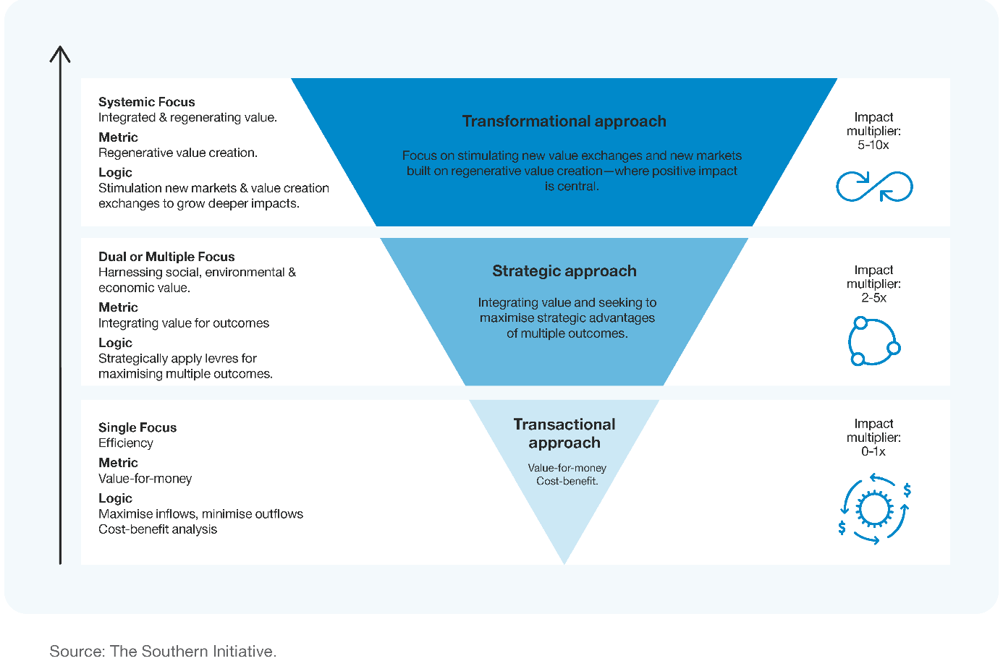
Image description: This image shows an inverted pyramid divided into three sections. The smallest section shows the transactional approach, which has an impact multiplier between 0 and 1. It has a single focus on efficiency, a value-for-money metric and a logic of maximising inflows, minimising outflows and a cost-benefit analysis. The medium section of the pyramid shows the strategic approach, which has an impact multiplier between 2 and 5. It has a dual or multiple focus on harnessing social, environmental and economic value. It uses integrating value for outcomes as a metric. It uses a logic of strategically applying levers for maximising multiple outcomes. The largest section of the pyramid is the transformational approach, which has an impact multiplier between 5 and 10. It has a systemic focus on integrated and regenerating value and a metric of regenerative value creation. It uses a logic of stimulating new markets and value creation exchanges to grow deeper impacts.
There are many ways a transformational approach can be applied. For example, councils can take a transformational approach in the design and management of community facilities like a library. A transactional approach sees libraries as operational spaces that lend books. A transformative approach sees libraries as anchor institutions and multi-use community hubs that can strengthen community identity and create opportunities for civic and economic participation.
This approach will need councils to work differently and embrace new roles to champion and activate wellbeing.

Three key ways councils can champion wellbeing in their communities
Drawing on the learnings and practice from The Southern Initiative, the Panel has identified three key ways that councils can champion wellbeing. The three roles discussed in this chapter overlap and are mutually reinforcing. These roles are shown in Figure 14 below.
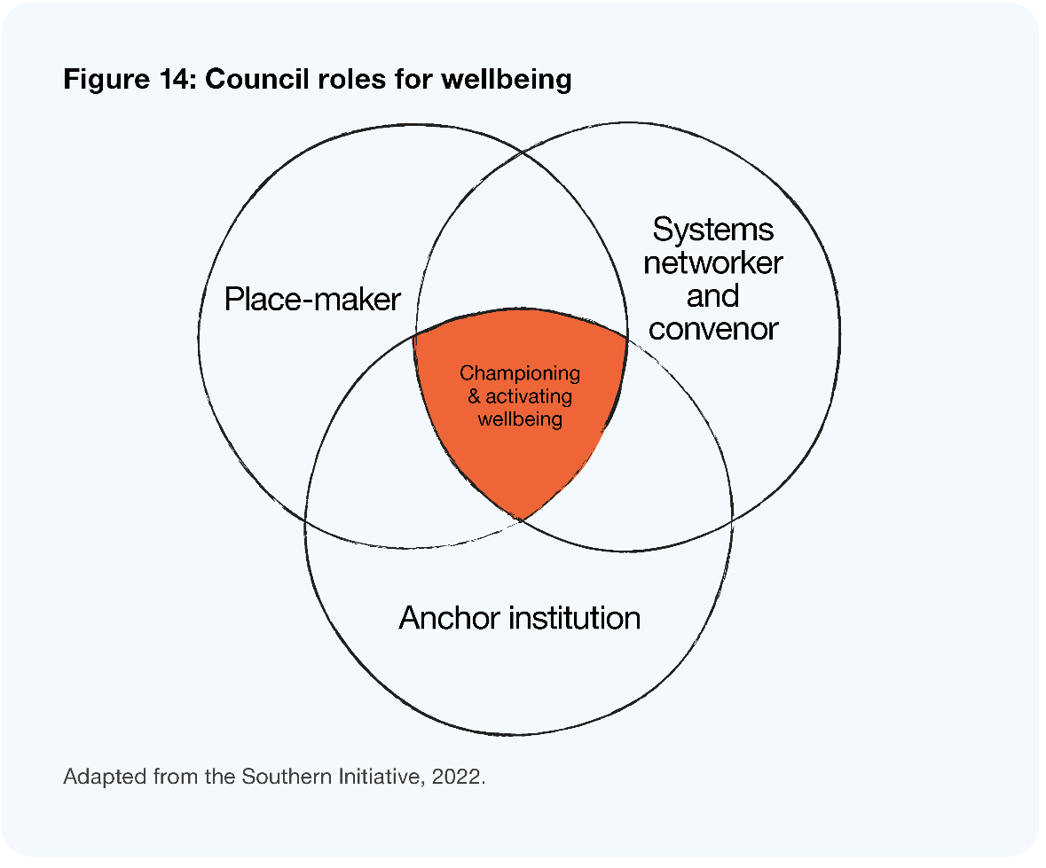

Councils as anchor institutions
Anchor institutions are entities like councils, hospitals, universities, faith groups, or other organisations based in a town, city, or defined region, with a long-term and enduring commitment and connection to the place. Anchor institutions play a vital role in local communities and economies. Anchor institutions can work together to improve local wellbeing by changing how they deliver their core business, partnering with one another for collective impact (Boorman et al 2022), and planning long-term initiatives that survive beyond short-term political cycles or narrow funding horizons.
Councils are in a unique position as anchor institutions responsible for public value creation at place. Figure 15 below outlines the range of anchor activities that councils can undertake.
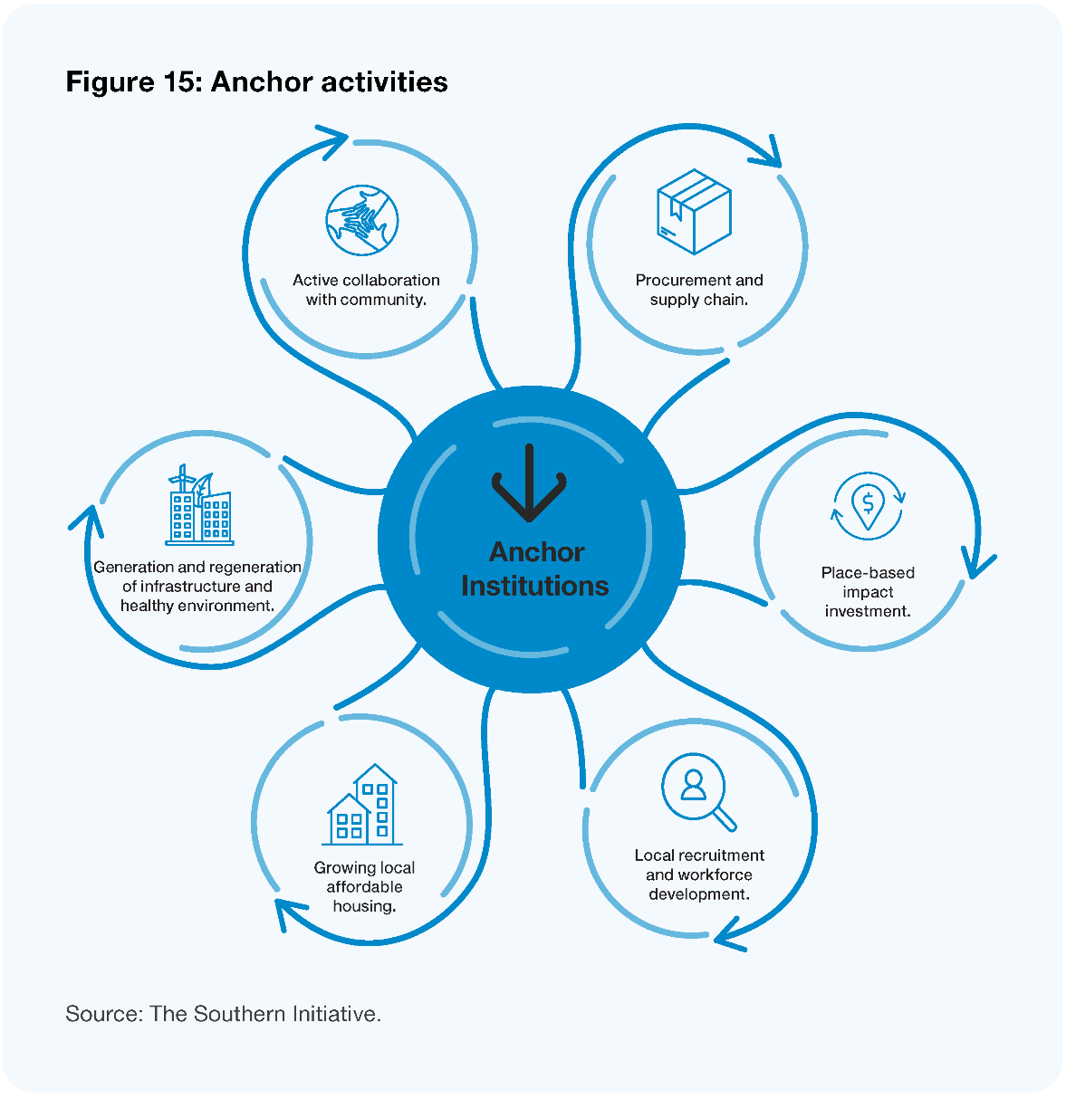
Local government has an immediate opportunity to take a more active and intentional role as an anchor institution and deliver its core business activities, from procurement and hiring to investment and infrastructure, in ways that are informed by equity and Te Tiriti, and leverage local strengths to address local challenges.
‘Social procurement’ is one example of how councils can take an active anchor institution role. Social procurement is when organisations use their purchasing power to generate social or public value beyond the value of a good or service being procured. It is typically achieved by including social, economic, or environmental outcomes in the assessment or contracting stages of the procurement process, or by deliberately choosing to purchase from organisations that are likely to deliver those outcomes through the way they conduct their business. Social procurement is one way that councils can contribute to community wealth-building (Fensham 2020) by developing local supply chains of diverse businesses that are “likely to support local employment and retain wealth locally” (CLES).
Case study
Amotai – Supplier Diversity Aotearoa
Amotai is an intermediary organisation nested in Auckland Council that works with central and local government, corporate, and iwi organisations to unlock procurement opportunities for Māori and Pasifika businesses. Eighteen councils have already registered with Amotai as buyers. Amotai has a national database of 1,200 Māori- and Pasifika-owned businesses and supports supplier diversity by connecting buyers like councils with these businesses. They also provide buyers with advice and online training in supplier diversity.
Local businesses can also pursue anchor strategies to improve local wellbeing and build wealth in communities (Taylor et al 2022). Creating opportunities for work experience and skills development by actively involving community members in the maintenance, management, and development of local parks and reserves is another way councils can support local workforce development.
In addition to initiatives based around council-held infrastructure, we think there is an important role for local government in supporting or investing in community-owned infrastructure and facilities. For example, Auckland Council’s Cultural Initiatives Fund provides grants for marae development.
Te Aka Mauri – Rotorua Library and Children’s Health Hub
A current example of innovative management community infrastructure is Te Aka Mauri – Rotorua Library and Children’s Health Hub. Rotorua Lakes Council collaborated with the Lakes District Health Board (DHB) to upgrade the under-utilised local library. The library hosts the Children’s Health Hub and provides a range of DHB services such as ‘B4 school’ checks for children, mental health services, and maternal support. Te Aka Mauri is not just a library or health hub, it is a collaborative approach to the community’s holistic health and wellbeing. Since opening in 2018, the library has become a popular community space and the DHB’s previously low attendance rates have risen dramatically.

Councils as place-makers
Councils can influence cultural, environmental, social, and economic wellbeing outcomes through place-making. Place-making is widely understood as “the process of strengthening the connection between people and the places they share,” in order to maximise shared value and strengthen community identity (Dyet 2021). According to Placemaking Aotearoa, place-making includes uplifting the mana, strength, and mauri (spirit) of communities. It puts Papatūānuku, people, and place at the centre of ‘business as usual’ local government functions like the design of new community spaces, the maintenance of parks and reserves, and local arts and cultural events.
Part of place-making is ensuring community spaces reflect the community’s cultural diversity so all whānau have a sense of belonging. It also includes fostering a thriving arts and culture scene that makes the community an exciting place to live, and ensuring the local environment is cared for and protected.
As place-makers, councils can support more connected communities through culturally informed urban design of community spaces. Place-making “provides mana whenua, mataawaka, tauiwi, and manuhiri the opportunity to connect and deepen their ‘sense of place’” (TSI 2022). For example, councils can ensure indigenous knowledge is valued and the stories of local mana whenua are told through the design of community spaces and neighbourhoods. Community spaces can also be designed to reflect ethnic diversity and provide space for local migrants and refugee families to participate in and connect with their community.
Place-making can have significant environmental benefits. By encouraging people to take ownership of and care for their local parks, rivers, and beaches, place-making activities can help encourage environmentalism and climate action in the community (Kent 2011). This creates a sense of kaitiakitanga (guardianship and protection of the environment) that can be passed down to rangatahi and future generations.
Thriving local arts and culture is vital for making communities vibrant, exciting places to live. Creative place-making (Kyrre 2020) can include filling empty spaces with arts and culture through urban design and fostering local creative entrepreneurship through the innovative use of community and council-held infrastructure. For example, an underutilised community hall could become a space where small local businesses can set up pop-up craft stalls and musicians can perform.
Gap Filler Christchurch
Gap Filler is a creative placemaking and urban regeneration social enterprise in Christchurch that works with the public and private sectors on government-funded and commercial projects. They design and deliver experimental civic installations, temporary projects, events, and amenities in the city. For example, they created a DIY ‘Dance-O-Mat’ installation using an old laundromat washing machine with music speakers and a dance floor. Their ‘Super Street Arcade’ installation is a free outdoor arcade game system programmed by local developers and high school students.

Council as systems networker and convenor
Local government has a crucial role to play as a systems networker and convenor, connecting and bringing people together from across organisations, sectors, and cultures (Oppenheimer 2021). As a convenor, councils play a place-based leadership role and facilitate innovative solutions that respond to local needs and support intergenerational wellbeing at place.
At its heart, the systems networker and convenor role is about building or stimulating an ecology of wellbeing, enabling learning across boundaries and silos, and weaving together “activities, spaces, relationships, capabilities and opportunities in ways that are more responsive to people’s needs and aspirations than traditional service models” (Boorman et al 2022).
Councils are well placed to cultivate and invest in social and cultural infrastructure (Treasury 2018) to help grow civic innovation within communities and enable people to lead their own responses to complex and emerging issues.
Working with central government is a key part of this role. Councils can utilise their local knowledge and data to identify local challenges with a systems lens rather than a siloed agency view. As a systems change and learning partner, councils can work with central government policy and operational teams to support both bottom-up and top-down policy development processes. This includes co-designing interventions that are led by whānau and communities and are informed by their lived experiences and on-the-ground testing.
The systems networker and convenor role also includes supporting innovation and momentum that is already emerging in communities. This can involve connecting or convening like-minded community leaders, hapū/iwi, and local businesses, sharing resources and expertise, or providing small grants to help get community innovation off the ground.
Sometimes being a convenor is simply about providing space, such as under-utilised council-owned land or facilities, for community members and groups to use for activities that will drive wellbeing. For example, old bowling clubs and unused netball courts can be invaluable recourses for community groups to operate out of and provide initiatives such as community gardens and food hubs, sports programmes, or after-school homework clubs.
Porirua’s WELLfed
Porirua’s WELLfed is an adult education programme for healthy food that was co-designed with the local community in 2016. In 2018, the programme began operating out of a previously unused bowling club owned by Porirua City Council. Community members can attend free weekly interactive cooking classes and learn how to plan, shop, safely prepare, and cook low-cost healthy meals. Since 2016, over 780 people have learnt new cooking skills and over 6,800 free meals have been made. WELLfed has partnered with a local community garden and uses the harvest in their classes.

Kaipara Moana Remediation Programme
Another example is the $300 million Kaipara Moana Remediation Programme. The programme is a collaboration with the Ministry for the Environment and is co-governed by Northland Regional Council, Auckland Council, and local iwi Te Runanga o Ngāti Whātua, Ngā Maunga Whakahii o Kaipara and Te Uri o Hau. A formal agreement was signed between the Ministry, councils and moana iwi in 2020 and a co-governance committee was set up with iwi and council representatives. The Kaipara Moana is facing significant environmental degradation. The ‘Foundation Planting’ campaign is scaling up planting near waterways using local volunteers. Their Landowner Grants Scheme supports landowners to undertake sediment reduction projects in the Kaipara Moana catchment that improve water quality and reduce sediment running into the waterways and the Moana.

How councils can give effect to these roles

Councils innovating and learning by doing
A significant change in approach and mindset will be needed, and councils will need to take on a culture of and appetite for innovation and learning by doing to truly champion wellbeing.
The transition from traditional ways of doing things towards a more innovative approach cannot be underestimated. It will require a shift in how local government works more than what local government does. This shift is about focusing on what serves communities and citizens, not bureaucratic processes. We envision a more entrepreneurial local government that experiments, takes calculated risks, and learns fast.
Working more innovatively means councils will experiment more and learn by doing, rather than a traditional arms-length planning approach to implementation. This will require a shift in mindset towards a ‘journey’ approach, a culture of learning, a willingness to innovate and challenge the status quo, and partnering with communities in the spirit of participatory democracy.
It is difficult to quantify, measure and evaluate long-term, intergenerational community outcomes. This will require a shift from traditional outcomes-based evaluation to culturally grounded evaluation, planning, and strategy processes that value mātauranga Māori, embrace complex issues, and allow for innovation.

Leveraging councils’ levers and enablers to unlock wellbeing
Local government has a range of levers, mechanisms, and enablers available to it. These levers are used to drive change, influence, and mobilise activity. They range from economic levers like investment and infrastructure, to tangible enablers like services and policy and intangible enablers like relationships and capability building.
A selection of councils’ existing levers and enablers are shown in Figure 16 below, in order to illustrate the potential already within local government.
Figure 16: Local government’s levers and enablers
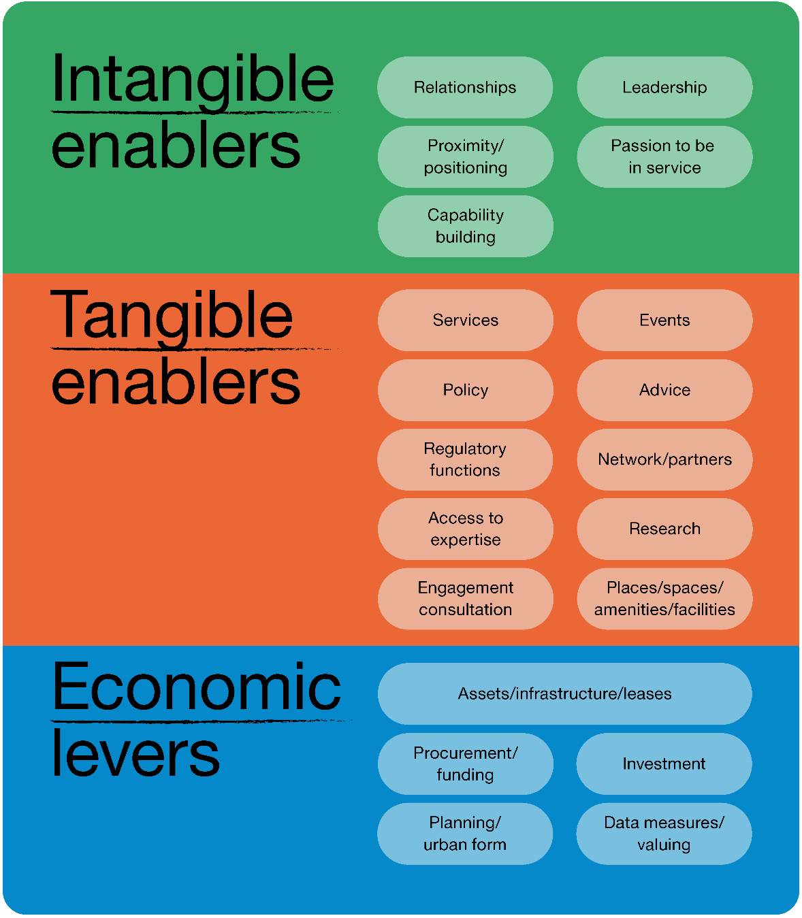
Adapted from the Southern Initiative, 2022.
Image description: Intangible enablers include: relationships, leadership, proximity/positioning, passion to be in service, and capability building. Tangible enablers include: services, events, policy, advice, regulatory functions, network/partners, access to expertise, research, engagement consultation, and places/spaces/amenities/facilities. Economic levers include: assets/infrastructure/leases, procurement/funding, investment, planning/urban form, and data measures/valuing.
As noted by The Southern Initiative, “there is opportunity for local government to unlock the untapped resources and assets already in the system and in communities by using these levers more intentionally towards equity and wellbeing” (TSI 2022).
As discussed earlier, this requires a shift in understanding and accounting for value away from a perspective that prioritises short-term, transactional and efficiency savings, towards a transformational approach that values long-term benefits and wellbeing outcomes, and uses levers more effectively to influence multiple positive outcomes.
For example, the Puhinui Stream Regeneration Project facilitated by Auckland Council’s development agency Eke Panuku shows what is possible when councils take a transformational approach to initiatives that maximise multiple long-term wellbeing outcomes.
Puhinui Stream Regeneration
Auckland Council’s Eke Panuku Development is taking an innovative approach to restore the mauri of Te Puhinui, an urban stream in Manukau, South Auckland. The regeneration project is a collaboration with local mana whenua, the Department of Conservation, and local businesses and community organisations. Te Puhinui stream is currently polluted and disconnected from the local community. By focusing on more than just restoring the stream, the regeneration also aims to revitalise the community and bring numerous long-term benefits including:
- attracting economic investment and creating job opportunities for rangatahi
- providing green spaces for whānau to play
- growing recreation and health outcomes
- restoring Manukau’s cultural and ecological heritage.
Puhinui Stream Regeneration is also an example of place-making in action. A key goal of the project is to reconnect the local community with nature, instil a sense of kaitiakitanga, and involve mana whenua and the community in the waterway’s regeneration and design.
Figure 17: Puhinui Regeneration Project
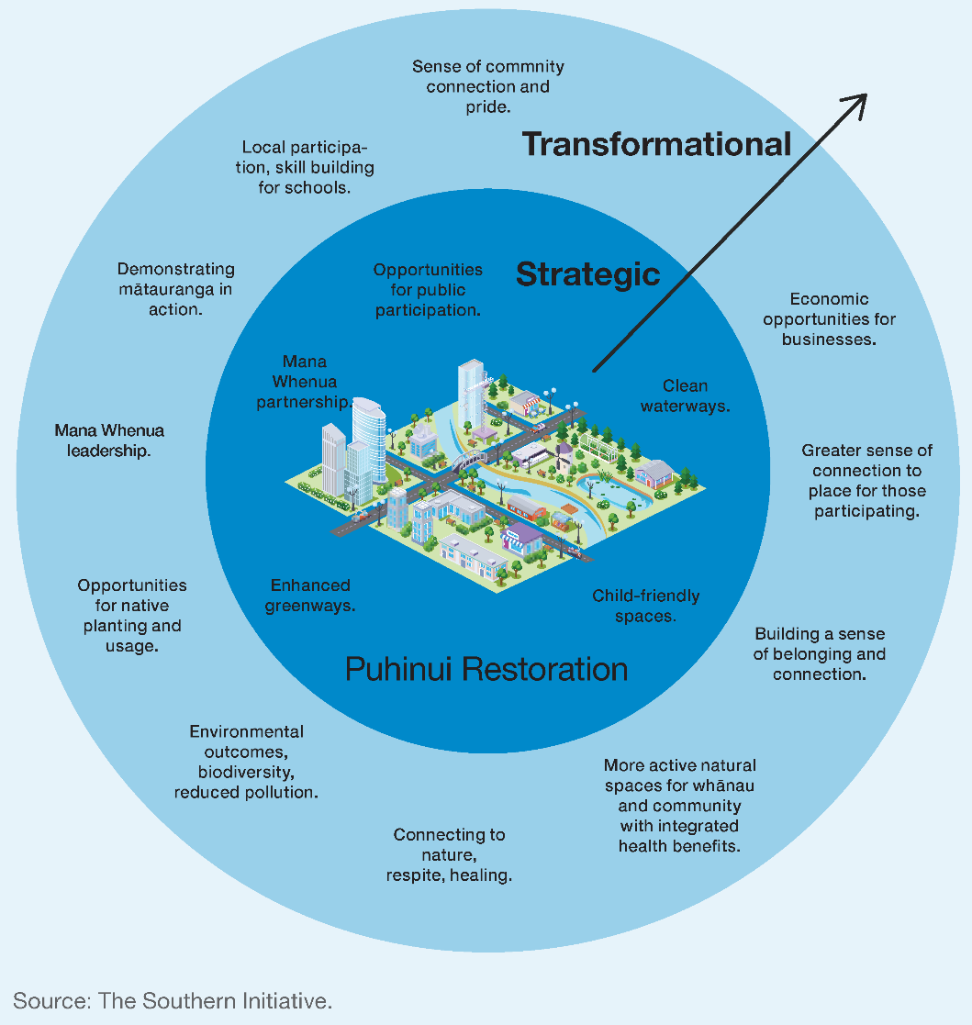
Image description: Puhinui Restoration strategic outcomes: clean waterways, child-friendly spaces, enhanced greenways, mana whenua partnership and opportunities for public participation. The transformational outcomes included: sense of community connection and pride; local participation, skill building for schools; demonstrating mātauranga in action; mana whenua leadership; opportunities for native planting and usage; environmental outcomes, biodiversity, reduced pollution; connecting to nature, respite, healing; more active natural spaces for whanau and community with integrated health benefits; building a sense of belonging and connection; greater sense of connection to place for those participating; and economic opportunities for businesses.

Councils taking a more relational approach
The three roles outlined in this chapter require all parts of councils to take a fundamentally more relational approach to engage with communities in a more empowering way. Many councils are already practising a relational approach and shifting the way they work in and with their communities. However, there is opportunity for this to be further maximised and implemented across all parts of local government with a fundamental shift in mindset, practice, and behaviour.
There is no one way of how councils should do this. The relational approach is much more a practice than a set of functions or pre-programmed activities. Learning by doing is a key part of this role. Common features of a relational approach (Hancock 2018) are:
- brokering relationships with citizens, stakeholders and ‘unusual suspects’ from across the public and private sectors to find common ground and create shared ownership of new solutions
- building relationships based on trust and transparency, generating whakawhanaungatanga (a sense of belonging) and reciprocity
- valuing learning together and exploring and iterating new ideas and initiatives
- leading change by challenging the status quo, removing roadblocks, and mobilising resources and legitimacy to make change happen
- sharing resources, knowledge, expertise, and relationships to empower community-led aspirations
- creating a strategic network of relationships with community-builders, connectors, change-makers, and innovators such as social enterprises, entrepreneurs, and key actors across the wider council and central government
- having a ‘heart for community’ and believing in the power of communities
- providing small levels of funding as an essential catalyst for connecting people at an event, building transitional capability, or proving the concept of new initiatives/innovations.

Mission-oriented innovation
For large-scale challenges that cross multiple domains, the systems networker and convenor role starts to overlap with as the emerging field of ‘mission-oriented innovation’ (IIPP 2022). This approach involves councils:
- engaging deeply with a community to build motivation for change and obtain a sense of different parties’ needs, aspirations, and concerns about a complex issue
- developing a ‘mission roadmap’ that includes specific ‘mission projects’ – detailing the actions, changes, innovations, or investments that will be needed to achieve a distant target. This idea is critical to establishing a basis for collaboration between discrete actors and to provide stability for the mission across political cycles or narrow investment horizons
- mainstreaming and distributing ownership for key aspects of the mission – this phase tends to be about a genuine sharing of authority and responsibility for specific aspects of the roadmap and creating shared accountability
- tasking specific projects and holding relevant parties to account.
Greater Manchester carbon neutral mission
The Greater Manchester Combined Authority in the United Kingdom is taking a mission-oriented innovation approach to achieve their mission of becoming carbon neutral by 2038. They have undertaken public engagement with citizens and local businesses, and are using a distributed governance model to ensure distributed ownership of the mission and enable other stakeholders to drive the mission forward. Key stakeholders from the public sector, local authorities, private sector, and academia are represented on ‘challenge groups’ which are responsible for different priority areas and mobilising local action.

What is needed to support this transition
The three roles outlined in this chapter will require councils to use their existing levers and enablers more intentionally, innovate and learn by doing. We think there is a clear need and opportunity for local and central government to explore funding and resources that enable and encourage councils to innovate, experiment, and share learnings. This could include learning platforms, funding, targeted knowledge resources and practice guidance, and mentoring from experienced local government sector practitioners.
Taking a relational approach to engage with communities in a more empowering way is time- and resource-intensive up front. While many councils are already practising a relational approach in place, we think more support is needed to build councils’ capability and capacity across their whole organisation.
Social procurement is one area where councils will need targeted resourcing and support to build their technical know-how and capability as anchor institutions. Further support is also needed to foster the social procurement marketplace, for example through the verification of enterprises that meet social procurement objectives, joining up suppliers to buyers, addressing gaps in the availability of suppliers in some areas, and building capability to operationalise this approach. Currently, Amotai and the Ākina Foundation are doing work in this area, but are not funded at a level that can generate the pace and scale of change that is needed. We recommend that local government, in partnership with central government, explore opportunities to embed social/progressive procurement and supplier diversity as standard practice in local government, with nationally supported organisational infrastructure and capability and capacity building.
As a systems networker and convenor, councils are well placed to provide local intelligence about what is happening in their communities. We see opportunity for more collaboration and co-investment between local and central government to support community- and whānau-led development.
Recommendations
- That local government, in partnership with central government, explores funding and resources that enable and encourage councils to:
  - lead, facilitate, and support innovation and experimentation in achieving greater social, economic, cultural, and environmental wellbeing outcomes
  - build relational, partnering, innovation, and co-design capability and capacity across their whole organisation
  - embed social/progressive procurement and supplier diversity as standard practice in local government with nationally supported organisational infrastructure and capability and capacity building
  - review their levers and assets from an equity and wellbeing perspective and identify opportunities for strategic and transformational initiatives
  - take on the anchor institution role, initially through demonstration initiatives with targeted resources and peer support
  - share the learning and emerging practice from innovation and experimentation of their enhanced wellbeing role.
Questions
- What feedback do you have on the roles councils can play to enhance intergenerational wellbeing?
- What changes would support councils to utilise their existing assets, enablers, and levers to generate more local wellbeing?

A stronger relationship between central and local government

The central–local government relationship is strained with a lack of trust and confidence in both directions.

Key findings
Communities need and deserve collaborative and cohesive effort from both central and local government that utilises their collective strengths and resources.
A reset is required to create a relationship between central and local government that enables a unified approach to tackling deep-seated, complex intergenerational issues. It will require a mindset shift from both central and local government.
There is no consistent approach to collaboration, with systems being fragile and reliant on individuals. Stronger, more systemic collaboration mechanisms are required for better alignment, partnering, and co-investment for the benefit of communities.

Overview
Central and government entities and actors have distinct yet intertwined roles and responsibilities in regard to lifting wellbeing outcomes for communities. In order to support community wellbeing now and into the future, effective collaboration between local and central government is essential. The Panel acknowledges that complex national issues that are felt most acutely at place will require a more structured and sophisticated approach than issues that are more obviously local in nature and should be governed and managed at a local level.
All the challenges of wellbeing come together in communities – ‘at place’ is where the impact of system-level interventions and decisions become visible. So, while central government will always be an influential actor for most public goods and services or regulatory functions across all levels for reasons of scale, equity, capability, and consistency, local government has an equally vital role in shifting the dial on wellbeing challenges. An approach that enables central and local government to co-invest for community outcomes and address issues locally has the potential to prevent harmful effects of social and economic challenges and improve local wellbeing.
However, the relationship between central and local government needs work. Currently, the relationship is strained in a number of ways, with many longstanding areas of tension and discomfort. There are a variety of reasons for these tensions, both structural and interpersonal. But the result is that local and central government can struggle to overcome silos and move beyond deep-seated assumptions to work together effectively.
In this chapter, we propose a shift towards genuine partnership between central and local government to deliver wellbeing outcomes in communities. We see that there is a strategic opportunity to adopt a unified and mutually reinforcing approach between local government and central government to tackle deep-seated, complex intergenerational issues.
We propose a number of ways of moving towards a stronger relationship. This includes mindset shifts to help reframe the relationship, attributes for effective collaboration, and a series of principles that can guide better ways of building interdependence and co-investment in a multi-faceted way.
We also look at a number of local and international examples to help us imagine what a more effective approach to collaboration and co-investment at place could look like. This includes emergent thinking on a local model for collective investment.
As indicated in Chapter 3, our kōrero with hapū/iwi and Māori organisations also made clear there is an opportunity for Māori to play a more strategic role in local governance, being involved at the outset in determining the priority outcomes that drive wellbeing and what should be done to achieve these. While this chapter focuses on the specific nature of the relationship between central and local government, any interventions to collaboratively achieve community outcomes must be designed with, and provide for decision-making by, iwi/Māori.

The relationship between central and local government
When we talk about a relationship between central and local government, we are talking about the interactions between people in councils, government agencies and the Government, in order to improve outcomes at a national and local level. The relationship is situated within a wider system that includes legislative provisions that affect how people in agencies and councils can work together, financial systems, and organisational structures.
There are a range of circumstances where central and local government officials work together, from emergency management to public health prevention and preparedness.
The relationship itself is ‘many to many’ – that is, 20-plus government agencies and 78 councils all have a role in activities that affect outcomes in local communities, and officials and elected members from both local and central government work together in various arrangements and make decisions in a range of circumstances.

Current state of the central and local government relationship
It is vital that central and local government can work together effectively in order to achieve community outcomes and help address a range of challenges, now and into the future.
A key theme in our Interim Report, Ārewa ake te Kaupapa, and further highlighted in subsequent engagement, is that the relationship between central and local government needs work. The Panel considers there must be a shift in the relationship from one which is limited by relational and structural challenges to one where people have trust and confidence in each other to be reliable partners who can deliver equitable local wellbeing outcomes.
Like any relationship, the relationship between central and local government plays out at an interpersonal level – between people. People from different levels of government, different agencies, or different organisations come together to achieve specific outcomes and get things done. These interpersonal relationships are affected by power dynamics, behaviours, mindsets, and individual connections and alliances.
While the relationship manifests on an interpersonal level, it is affected and shaped at a structural level – that is, the systems within which people work. Things like policies, legislation, organisational culture, and resource flows provide the grounding for the relationship to play out. These structural elements can be a barrier to working together effectively, or they can help foster a positive and effective relationship.

The outcomes of a strengthened relationship
We think a relationship between central and local government that maximises community, and by extension national, wellbeing is one where:
- there is mutual trust, respect, and confidence between central and local government actors
- a joint approach is taken to tackling problems that are too big for either party alone, making use of the relative strengths of local and central government (including their relationships, resources, skills, and tools)
- central government recognises, values and enables the roles and local knowledge of local government and iwi/Māori, and enables innovation to generate local solutions to local challenges
- there is clear alignment of outcomes and accountability requirements between central and local government and a mature process of engagement and resolution of issues
- the executive and administrative arms of central government are aligned and committed to enabling community outcomes with local government.
Currently, the relationship between central and local government is strained in a number of ways, leading to dysfunction across the system and making it difficult to align efforts and collaborate for the benefit of communities. Below, we set out a summary of the current state of the relationship, the structural issues underlying the current state, and how people in local and central government experience the relationship in their current roles.

Current state of the relationship: interpersonal layer
Within the relationship between central and local government, there are hundreds of individual relationships: between groups of agencies and councils who work together for a particular reason, or between individuals in local and central government who communicate on an ongoing basis around a certain issue. The dynamics and mindsets that shape these individual relationships can be deeply entrenched, and people on both sides of the central government–local government divide can feel frustrated, challenged, or underappreciated.
To hear first-hand about the current tensions and explore the impacts on people throughout the sector, we commissioned Thinkplace to explore how people working in local and/or central government perceive the current state of the relationship, with a focus on the interpersonal experience. Of the people interviewed, more of them were in local government roles, but about half also had extensive experience in central government. The perspectives gathered and summarised in this work were provided in submissions and engagement with the Panel (Thinkplace 2021).
When participants were asked to describe the interactions between local and central government, a clear picture begins to emerge. Negative interactions were described using terms like ‘tension,’ ‘frustrated,’ ‘agendas,’ ‘patronising,’ ‘hierarchical,’ ‘contradictory,’ and ‘adversarial.’ Positive interactions were described with terms like ‘collaborative,’ ‘certainty,’ ‘respect,’ ‘cross-party support,’ ‘motivated,’ ‘consistent,’ and ‘passionate.’
Some of the key themes that emerged from discussions about tensions from a local government perspective when it comes to the relationship include:
- frustration that only local government is being asked to reform, when they perceive that the whole system (including central government) needs to change. “We need a future of our communities, not the future of local government,” said one participant
- that people in local government roles feel they are viewed as ‘second tier’ to their central government counterparts, even when they have decades of experience and very senior positions
- that local government has unrealistic expectations placed on it, and is required to execute a huge range of things “on the smell of an oily rag” where central government agencies get to specialise
- the sense of a disconnect between local government’s perspective from working on the ground with communities, and what is perceived as central government’s more removed, theoretical approach. “Local government thinks, ‘What’s good for our city?’ whereas central government thinks, ‘What’s good for NZ as a whole?’” said one participant
- that central government and local government see themselves as having different ‘masters’ – with local government working for the community ratepayers and central government working for the Minister – leading to challenges finding shared drivers
- frustration that central government has the power to stop a local initiative in its tracks even if it is the product of careful planning and relationship building, and is likely to have positive social, environmental, or economic outcomes.
However, there are bright spots and some positives along with the tensions. Some participants felt that the relationship has been improving, with one person noting that central government is getting better at listening and not having all the answers. Another described improvement overall but said, “the highs are getting higher, and the lows are getting lower.” People clearly felt that better alignment and collaboration could help improve both the relationship and outcomes – one participant described the relationship at its best when central government teams come into the region and work side by side with them to tackle problems, “standing in the middle of the field with us.”
Some of the key themes that emerged from discussions about tensions from a central government perspective when it comes to the relationship include:
- in many cases, local government does not influence central government from a position of strength, and the political environment in local government is less predictable than that of central government
- people in central government agencies respect local government officials, but are not confident in their political authorising environment and worry about a lack of depth and fragmentation in local government
- ministerial boundaries in central government can narrow the focus and drive towards exerting pressure within the scope of a single portfolio
- the public management and political system also encourages agencies to stick to what they’re familiar with. As a result, the perception of central government is that the trade-offs are not worth the transaction costs and risks.
There are some common issues to both local and central government. There are also challenges in the lack of knowledge and mutual understanding between central and local government. Central government can be seen as overly policy-focused but with no understanding of delivery, resulting in views of ‘all talk, no action and out of touch with local priorities’. Equally, local government can be seen as overly focused on local and missing the need to consider national priorities, or lacking the capability to deliver large or complex projects that could make significant changes in local as well as national wellbeing.
As noted in Chapter 3 (Section 2), the lack of clarity about the role of Te Tiriti in local governance has been a fundamental constraint on the relationship between both these parties and Māori at the local level.

Current state of the relationship: structural layer
As noted above, the relationship between central and local government is also shaped by the structural conditions – including legislation, policy, funding streams, and organisations. These structural elements can never define a relationship on their own, but getting the right structures and legislation in place is necessary in order to facilitate a better relationship that can deliver positive outcomes for communities.
Two core tensions currently affect the central and local government relationship:
- the different legislative and financial incentives between central and local government
- organisational structures for local and central government that impede the ability to collaborate and direct resources to achieve joint outcomes.
For local government, the existing legislative framework means that:
- the costs of environmental, economic, and social development (including urban growth) fall on councils with limited or no additional revenue
- the prescribed decision-making process and legislative framework tend to only allow councils to consider local average costs and benefits. This comes at the expense of potential cross-boundary benefits.
For central government, the existing legislative framework means that:
- the benefits of economic and social investment flow to central government through increased tax take or reduced welfare liability
- decisions are made on average national costs and benefits, generally ignoring distributional differences and concentrated local effects.
Both central and local government operate different authorising and decision-making environments. Decisions at central government are made via the cabinet process under collective responsibility prior to decisions being made public. By contrast, decisions are made at local government level as part of a public accountability process with recommendations made public in advance of decision-making. These differences in the authorising environment inhibit transparent, joined-up decision-making and the ability to partner and agree on how to deliver community-based outcomes.
These core differences limit the ability of central and local government to be reliable partners, have integrity in the relationship, act with a duty of care in providing for the interests of each other and mutually deliver the outcomes sought by the community, whether national or local.

The current structure results in a relationship that is ad hoc, misaligned, and low trust
The current system of governance is premised on strict jurisdictional lines that dictate the confines of our levels of government. Each level of government is supported by its own revenue-generating mechanisms and processes, in theory designed to support only the functions and responsibilities of their respective level of government. This system of independent, disjointed systems and processes can lead to conflict and competition between levels of government.
In addition, the current system of governance sometimes creates scenarios where gains in one level of government are the result of expenditures in another, and these expenditures and benefits are not seen as fairly distributed. For example, when local government invests in addressing local unemployment, costs are incurred locally while the benefits accrue to central government for the national welfare system. Similarly, early work conducted by the Department of Internal Affairs’ Future Systems team to understand Aotearoa New Zealand’s infrastructure funding and financing constraints highlights the extent to which economic growth and development generate uneven outcomes. Often, dividends accrue to central government, as growth equates to higher revenue-generation potential, while creating challenges for local government, because it drives a need to accelerate infrastructure investment to support growth, which some local authorities struggle to support. In such a system, it can be difficult to identify areas of common value, which disincentivises levels of government from working together to achieve common goals.

Some changes are happening already
While the current structures supporting the local–central government relationship are a limiting factor for working together for community outcomes, there have been some recent changes which in some circumstances are reducing barriers. These changes are not across the whole system, however, so many of the challenges outlined above will persist.
Recent amendments to the Public Finance Act 1989 (Public Finance Amendment Act 2020) allow for joint ventures (for example Tāmaki Redevelopment) and the use of sectoral clusters (eg, Budget 2020 Justice cluster across NZ Police, Corrections, Ministry of Justice) seeking to promote broader, multi-domain focus on complex outcomes, but these do not provide for or ensure local government involvement across the board.
There is emergent thinking on improvement to public sector management through the provision of new, collective funding models for initiatives that target complex problems, including ‘social entrepreneurialism’ at the local level. This could include having a separate investment track for collective initiatives (Warren 2022).
The Public Service Commission has established the Regional Public Service Leadership programme which has appointed public service leads and is developing regional profiles and priorities to bring a more collective approach to system issues. This is a start, but as currently scoped this is about central government reaching out to local government with central government’s view of regional outcomes rather than a two-way dialogue. This approach also does not incorporate the community voice at the territorial level.
In addition, there are existing or emerging structures for collaboration in specific domains/locations – in particular, transport, housing and social services – that could point to principles that build interdependence and add value to all parties.
Regional Public Sector Commissioners
As part of reforms to the public sector in 2020, the need for a more collective approach to system issues was identified. As a result, provision was made for the establishment of interdepartmental ventures and joint operational agreements that support joined-up, agile service delivery and joint resource management, including assets and staff, and interdepartmental executive boards that support joined-up planning, budgeting and/or policy alignment on complex, cross-cutting issues.
Included within these changes were provisions to enable agencies to work differently in the regions. Supporting this reform (but established in 2019) are regional leaders to provide system stewardship. Regional public sector commissioners (RPSCs) have a mandate for convening cross-agency decision-making fora. Included in this work is communicating public service focus areas through regional profiles and priorities for the whole public service. There is an intention to engage more with leaders within local government, iwi, business, and community groups.
In the next section, we look beyond the current state of the local–central government relationship. We sketch out some key components of a strengthened relationship and describe aspects we think are needed – including a shared investment approach and a commitment to collaboration at place – to achieve improved outcomes for communities.

Establishing a shared investment approach to achieving local outcomes

Co-investment for community outcomes
The Panel believes that a key element of a reset relationship between central and local government must be a commitment to co-invest for community outcomes. By co-investment, we mean an approach where central and local government align efforts to plan, fund, and execute initiatives and projects to maximise wellbeing outcomes at place. Successful co-investment is informed by place-based expertise and knowledge, and creates avenues for funding and strategy from central government to be deployed more effectively through input and leadership from local government and impacted communities.
Our research and engagement with communities confirmed that the mix of outcomes and supporting initiatives that will maximise community wellbeing will vary from place to place, and depend on the values, preferences, and endowments of different communities. Therefore, any approach to co-investment by central and local government needs to support and accommodate local needs and aspirations.
As noted above, while local and central government are key actors in a co-investment approach, mana whenua also have a central role to play in local governance and therefore must also be included in these approaches, starting with the design phase.

There are already examples of co-investment, but this is not the norm
There are already examples of where local and central government co-invest in community outcomes. The table below outlines some examples and the outcomes they are seeking to achieve.
Figure 18: Examples of co-investment activities
Type of shift | Example  Outcome | Specific initiative
Better alignment between local and central interventions | Addressing housing shortages and homelessness | Hastings place-based housing partnership  Central government agencies partnered with Hastings District Council, iwi, and providers in a place-based initiative to provide a mix of public housing, affordable housing, papakāinga, and additional transitional housing.  Porirua housing regeneration  A strategic and integrated regeneration programme between central government, local government, and iwi to deliver affordable housing, improved community infrastructure, and resilience.
Centrally funded initiatives that are locally led, where central government has partnered with local government. | Addressing income inequality and supporting wealth building | UPTEMPO Whole-of-family approach to workforce progression for Pasifika peoples  The Southern Initiative (Auckland Council) and central government agencies collaborated and utilised private sector, trade unions, and Pasifika organisations and relationships to create an initiative that thinks beyond individualised employment support services and aims to understand and address wider family barriers to quality employment and wider economic opportunities ‘in context’ where current labour market policies and interventions are not generating enough impact.

A new approach to co-investment is needed
In order to support a reset relationship between central and local government actors that allow them to better align, partner, and co-invest for the benefit of communities, there need to be processes and collaboration mechanisms in place to support and incentivise this way of working.
As a starting point, it is important that central and local government actors have a better understanding of what outcomes will drive wellbeing gains for a particular community and make more deliberate, responsive choices about the mix of interventions needed to reach these outcomes.
In this context, we consider community wellbeing can be maximised with a clear and effective way for central and local actors to:
- agree in conjunction with community the specific outcomes and priorities that would lift aggregate/distributional wellbeing in a specific place
- constructively challenge each other about how to change or align investment in public goods and services, the exercise of regulatory functions, or other public interventions in order to achieve these goals.
In order for this to be successful, there also must be:
- the ability for these discussions to meaningfully influence central and local government investment (the co-investment conversation)
- agreed measurement of progress to inform direction of activity and provide accountability to the community and create transparency about all parties actions.
We note that including not only central and local government, but also Māori and the community in the design and implementation of any collaboration process will be vital to achieve community outcomes.
We consider that a process for collaboration as outlined above will facilitate a significant shift from a system focused too rigidly on a binary view of local or central government, to a truly collaborative system of local governance that can adapt to future challenges and enable communities to thrive.
We also see this as critical to ensuring the relevance of, and confidence in, local government. We think it provides Ministers and local government leaders with an important tool for connecting, and for addressing tensions between centralisation and localism. We are also conscious that some communities simply cannot afford the same level of publicly funded interventions as others, so we see this process as critical to our consideration of more equitable funding.

Attributes of effective collaboration
The shift towards effective collaboration for co-investment will require work at an interpersonal level as well as a structural level. The interpersonal aspects of an improved relationship will involve mindset shifts and developing new processes for working together.
In considering the range of arrangements for interaction between central and local government we have also examined attributes for collaboration (adapted from Beca 2021). Key attributes include:
- a shared, agreed strategy between collaborating partners
- a governance approach with shared accountability
- collaborative people working together, supported by effective leadership
- investment in capability and culture to create a shared culture that reflects the partner organisation cultures
- business processes that support collaboration and interdependence
- decision-making that is transparent and works for all partners.

Steps toward a mindset shift
We identified earlier the outcomes of a strengthened relationship. We believe there needs to be a deliberate and active approach from both central and local government officials and politicians to reset and strengthen the relationship. The challenges facing communities are deep-seated, complex, and intergenerational and can only be tackled with a cohesive approach. Central government needs to understand the value that local government can bring to help solve some of its challenges and local government needs to be focused and organised to be able to maximise the value of a more effective partnership.
Another significant step in improving the interpersonal level of the central–local government relationship in order to effectively collaborate is recognising and addressing the need to build a productive culture, set of behaviours, mindsets and attitudes for both central and local government to reinforce the wider system changes this report recommends. This will require everyone to take a different approach to the working relationship between central and local government; the role of iwi in a new operating model; and the emphasis on roles and responsibilities within a mature relationship. Without this shift, opportunities will continue to be missed and the ability to tackle big changes is diminished. Steps in making this change include:
- actively doing things together that can build trust through identifying and initiating joint projects or activities
- changes to organisational policies and practices to enable working across levels
- moving from just enabling to proactively seeking the sharing of resources, which might be joint projects, secondments or transfer of resources and delegations to the people (including community groups) with close connection to the outcomes being sought
- developing a unified investment in leadership and skill development across central and local government.
The above is not an exhaustive list, and change will take time and sustained effort. We have already seen good examples of positive and productive relationships, but they are not widespread, are largely reliant on individuals, and not reinforced by system conditions and settings. We seek both strong leadership and a system that rewards and reinforces collective approaches and effort. Communities both need and deserve central and local government working in harmony for the benefit of the people they serve.

Developing a new approach for co-investment
In considering how we move from the current ad hoc and misaligned model of central and local government relationships to one where all levels of government are encouraged to share gains and co-invest to address challenges, we are thinking about strategies to move towards more interdependent governance.
An interdependent governance system is one in which gains in one level of government are at least directly proportional to gains in another. This proportionality should also mean that losses or risks in one level of government are at least directly proportional to losses and risks in another. An interdependent system is likely to encourage all levels of government to become invested in the wellbeing and success of the others, and provide incentives for information-sharing and support to invest in areas of common interest.
Work by the Panel to investigate interdependence in the context of potential reforms to the local government system is still at a conceptual stage. However, thought has been given to how the principle of interdependence could be incorporated into a number of areas, including a wellbeing framework for local and central government, changes to policy development, relationships, behaviours, and revenue-generation systems. We consider that incorporating interdependence principles could improve social, cultural, economic, and environment wellbeing.

Principles for an interdependent system
We have developed a set of principles that we think can guide work towards a system of interdependence that facilitates effective co-investment for community wellbeing. These are outlined in the table below.
These principles have been developed from a range of inputs, including learnings from previous co-investment activities.
Principles | Explanation
Balance structure and direction with flexibility for local conditions and existing landscape | While a statutory structure is needed to bring the parties together, this needs to be flexible and responsive to local conditions, wrapping around existing collaborative models for specific outcomes/locations – for example Spatial Planning fora / Te Hiku Forum – by minimising ‘prescribed’ governance.  The system also needs to encourage the parties to ‘follow the opportunities’ (which will depend on local preferences and capability).
Balance efficiency with granularity in priority-setting | There would be little clarity and limited capability if we had 78 local authorities and 20-plus central government conversations at different times and places. A regional format is essential, but this must retain space in the conversation for territorial level priorities and investment shifts and be willing to have pan-regional conversations.
Government-enabled but community-owned | Central and local leaders must be visibly committed to and facilitate these conversations, but citizens must drive the priority-setting – a deliberative or much more participatory approach will be essential.
Māori embedded at the governance level | Hapū/iwi and significant Māori organisations would need to be represented at the heart of an interdependent system with equal status to central and local government representatives, and be supported to participate. A Māori-led, tikanga-based process for appointments will be necessary to achieve an efficient number of representatives at a regional scale.
Clear expectations about the relevance of national objectives and decision-making processes | Parties must strive for consensus but accept they won’t always agree – local actors cannot expect central government to support investments that are fundamentally inconsistent with national objectives or equity, but central government must come prepared to consider real change in service design. Where there are differences, local actors can still pursue separate initiatives aimed at those priorities.
Investment in capability and culture building | There must be initial and ongoing investment by all parties in the capability and culture needed to support the model and make the most of contributions by all parties. The system needs people with relational skills and who are able to act as innovative policy entrepreneurs, to both bridge the gaps across and within organisations and also derive new public value from better use of central and local government investment.
Investment shifts must be immediately actionable within an interdependence model, relevant agencies, or given a ‘fair go’ in central government budget processes. | Investment shifts must generate visible change in local communities. While changes in the exercise of regulatory functions will need to sit with ‘owning’ authorities, – we think any interdependence model in the new system should have commissioning rights and a dedicated budget to implement service-related shifts that can be safely/equitably actioned immediately.  Where change cannot be addressed within such a budget, or where central government representatives think there are opportunity costs/risks for national objectives, such proposals should be given meaningful consideration through a separate track in the central government budget. Shifts that involve both central and local government levers can incorporate a funding-matching conversation with local actors.
Shared and intelligent accountability | In addition to traditional accountability mechanisms that ‘publicise’ the agreed priorities and investments, consideration should be given to more innovative in-cycle evaluations and an independent locus of accountability (see the Well-being Commissioner in the Welsh model below). Fundamentally, central and local actors must stick up for each other in tough public conversations about trade-offs or the pace of change.

What might this look like in practice?
We have looked to both local and international examples to help us imagine what an interdependence approach could look like. Broadly, these can be thought of in two categories:
- place-based initiatives that are developed for a specific geographic area
- broader approaches that set requirements at a national level while enabling local specificity.
We also outline emergent thinking on collaborative/interdependent models.

Place-based initiatives (PBI)
Place based initiatives are projects that concentrate investments and activities in a specific location to achieve measurable community results and are generally structured as projects or programmes including between central and local government.
Place-based initiatives can be an effective approach for the provision of some services and can also help achieve economies of scale in service delivery and address externalities associated with service provision. For this reason, we think that looking at a range of PBI examples can help us to imagine possibilities for a reset relationship. However, PBIs do not provide an ongoing structure or foundation for the coordination of service delivery. Voluntary cooperation can work to some extent in situations where objectives are shared by policymakers in local and central government. However, this approach will not work well when objectives differ between parties or there are wider structural incentives for key participants to minimise or remove themselves from involvement, such as different accountability reporting lines. Implementation of PBIs requires an action plan and adequate resources that might need a more formal arena for collaboration (Slack 2007).

Social Sector Trials
In 2011, the Social Sector Trials (the Trials) were set up to test a new approach to improving service delivery by reorganising funding and decision-making processes across the social sector and shifting control to local levels. The trials were a partnership between the Ministries of Social Development, Justice, and Education, and the New Zealand Police and were governed by a Joint Venture Board. The Trials were initially established as a two-year programme in six communities, but these were subsequently extended to 30 June 2014.
The initial Trials in six communities focused on a specific set of outcomes for 12- to 18-year-olds. The outcomes were to: reduce truancy; reduce offending by young people; reduce alcohol and drug abuse by young people; and increase participation of young people in education, training, or employment.
Evaluation of the trials found that initiatives did harness community knowledge and led to collaboration on particular outcomes, cohorts, and locations. However, the focus on a narrow set of outcomes limits a holistic approach and does not give space for communities to lead the prioritisation of outcomes across the wellbeing domains.
In addition, not all the initiatives included local government and the short-term nature of the pilots (1–2 political cycles) was not sufficient to comprehensively prove the concept/build critical mass of support.

The Southern Initiative
A part of Auckland Council, The Southern Initiative and Western Initiative (TSI) is a place-based innovation unit that works across local and central government to drive social and economic innovation and transformation. It is based in south and west Auckland. Supported by Auckland Council, the team’s work also attracts philanthropic and central government funding around specific initiatives and Kaupapa.
In addition to partnering with existing government agencies and providers, TSI is focused on finding and demonstrating radical solutions to pressing social and economic challenges with a particular focus on Māori and Pacific innovation and leadership. It operates like an integrated economic and social development agency, and aims to catalyse change by demonstrating and incubating different approaches to achieve equity and wellbeing.

South Auckland Social Wellbeing Board
The South Auckland Social Wellbeing Board (the Wellbeing Board) is a government agency-led PBI with 13 government agency members, one local government member and an independent non-government chair. It is focused on identifying learnings that can improve the system and getting services to families and whānau who have not engaged previously.
The Wellbeing Board uses a ‘test and learn’ approach to innovate and disrupt the system. This is done through running prototypes of potential approaches for positively impacting the South Auckland community. Prototyping enables the Wellbeing Board to be fluid and responsive to the needs of their communities and partners. The Wellbeing Board has an in-house evidence and insights team that captures learnings and enables them to make a case for change for collective action and to inform local and national decision-making.

Urban Growth Partnerships
Urban Growth Partnerships are partnerships between the Crown, local government, and iwi to advance the government’s Urban Growth Agenda (UGA).
Under the UGA, central government partners with councils and iwi to ensure that government investment in infrastructure is aligned to help deliver connected, thriving, and sustainable urban communities. Urban growth partnerships formalise these relationships between the Crown, local government, iwi, and local communities to deliver the UGA objectives.
Current partnerships are focused on regions that are experiencing significant growth pressures and where councils want to work with the central government to help address the challenges and opportunities from that growth. Urban Growth Partnerships include spatial planning and take a long-term and integrated approach to land use and infrastructure planning. A number of partnerships are underway including the Auckland Housing and Urban Growth Joint Programme, Greater Christchurch, Future Proof – the Hamilton to Auckland Corridor, Queenstown Lakes Spatial Plan, SmartGrowth in Tauranga-Western Bay of Plenty, and the Wellington Regional Leadership Committee for the Wellington-Horowhenua Region.
In August 2020, Cabinet endorsed the strategic priorities for joint spatial plans for the Hamilton-Waikato and Tauranga-Western Bay of Plenty metropolitan areas and the Queenstown Lakes area (MHUD nd).

International example: City Deals
City deals are bespoke packages of funding and decision-making powers negotiated between central government and local authorities and other local bodies. City deals are designed to bring about long-term strategic approaches to improving local and regional economies, aiming to harness additional investment, create new jobs, and accelerate inclusive economic growth. Deals to date have been tailored to locations reflecting different strengths and weaknesses and consist of a programme of interventions to support change.
City deals have been specifically implemented in the United Kingdom and Australia. The Metro Vancouver Regional Growth Strategy can be considered a Canadian equivalent of a city deal. Relatively well-known examples of city deals are Greater Manchester City Deal and Edinburgh City Deal.

National frameworks that allow for local specificity

Welsh well-being model
The 2015 Well-being of Future Generations (Wales) Act established a legally binding common purpose for national government, local government, local health boards, and other specified public bodies. The Act sets out actions that public bodies must:
- set and publish objectives (‘well-being objectives’) that are designed to maximise its contribution to achieving each of the well-being goals
- take all reasonable steps (in exercising its functions) to meet those objectives. This means that each public body listed in the Act must work to improve the economic, social, environmental, and cultural well-being of Wales.
These objectives will show how each public body will work to achieve the vision for Wales set out in the well-being goals. Public bodies must then take action to make sure they meet the objectives they set. The Act ‘formalises’ the shared outcomes and investment process that establishes 19 regional Public Service Boards (PSBs) which are clusters of key public bodies in a local context, with central and local government in a core layer, and wider community players in a second tier. The Act requires PSBs to identify a comprehensive set of well-being objectives (local outcome priorities) and develop local well-being plans which include the steps and actions for alignment and investment in services or wider public intervention that they will take to achieve these priorities.
The Act also establishes an independent Well-being Commissioner to audit performance, advocate for improvements to meet the objectives, increase public understanding and accountability, and facilitate innovation and knowledge transfer across public bodies.
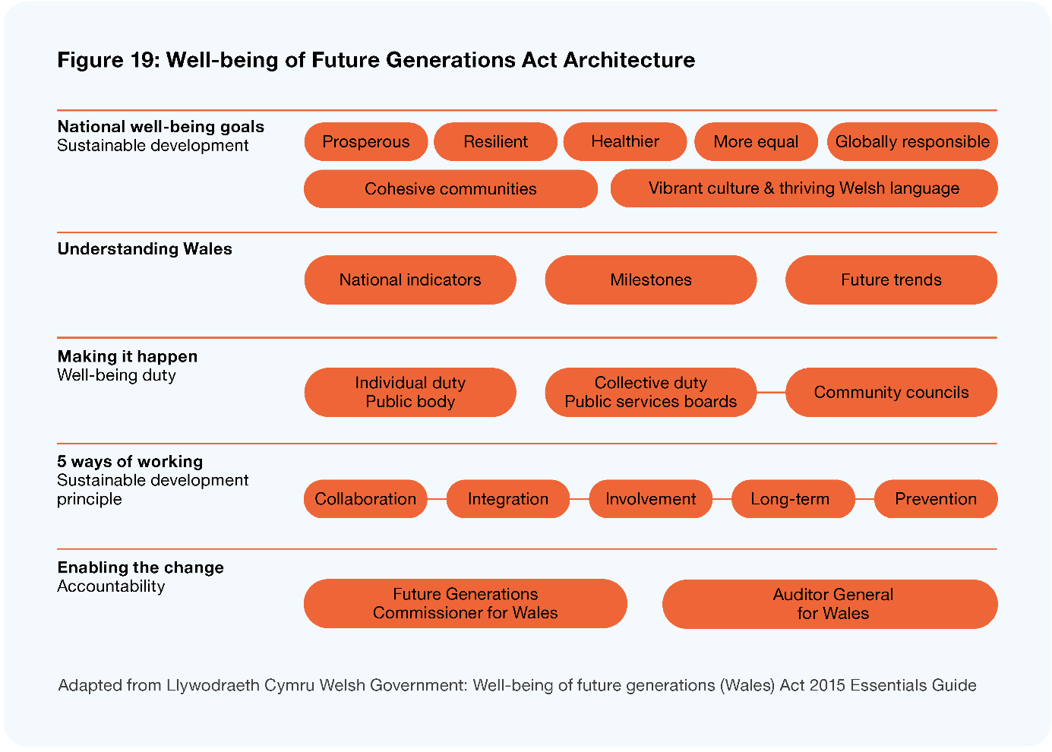
Image description: Figure 19: Well-being of Future Generations Act Architecture. Level 1: National well-being goals (sustainable development): prosperous, resilient, healthier, more equal, globally responsible, cohesive communities, vibrant culture and thriving Welsh language. Level 2: Understanding Wales: National indicators, milestones, future trends. Level 3: Making it happen (well-being duty): individual duty public body, collective duty public services boards, community councils. Level 4: 5 ways of working (sustainable development principle): collaboration, integration, involvement, long term, prevention. Level 5: Enabling the change (accountability): Future Generations Commissioner for Wales, Auditor General for Wales.

Early indications from the Welsh Model
A Welsh Parliamentary review in March 2021 (WPPAC 2021) found tangible progress and much good will, but:
- there was not enough investment by participating organisations in the capability and culture change needed to support the model and make the most of contributions by the community sector
- the lack of dedicated (additional) funding for the administration of PSBs has limited effectiveness
- separate and misaligned organisational funding cycles/approaches and lack of dedicated resources for actions has constrained well-being plans
- the Commissioner role was not sufficiently resourced to facilitate the model
- the Public Service Boards need to be aligned and consolidated with other collective impact bodies in the system.
Overall there was a strong sense in the review that the model is worth pursuing, but there are some pointed lessons about the need to fully fund and support the model, that there is a clear authorising environment for investment shifts, and a need for patience and commitment in realising the returns.

Emergent – collective/interdependent model
Recent Public Finance Act amendments (Public Finance Amendment Act 2020) allow for joint ventures (for example the Tāmaki Redevelopment) and the use of sectoral clusters (eg, Budget 2020 Justice cluster across the New Zealand Police, Department of Corrections, and the Ministry of Justice). These seek to promote broader, multi-domain focus on complex outcomes, but these do not provide for or ensure local government involvement across the board.
There is emergent thinking on improvement to public sector management through the provision of new, collective funding models for initiatives that target complex problems, including ‘social entrepreneurialism’ at the local level. This could include having a separate investment track for collective initiatives (Warren 2022).
Building on the emergent thinking from Warren (2022) and research from Beca on collaborative models (Beca 2021), outlined below is an example of how a collective investment model could provide a connective layer between central and local government.
Elements with this model would be three connected phases of:
- the setting of wellbeing priorities
- a co-investment conversation
- accountability and evolution.
Like existing operating models, these phases would not be linear, but would involve each phase feeding into, responding to or intertwined with others. For example, the phase of co-investment may identify opportunities to deliver a different range or more wellbeing priorities than originally considered.
This collective investment model builds on the evolution of previous operating models that were based on a transactional and ‘complete contracts’ theory that formed the basis of the 1980s central and local government reforms, to include new thinking and evidence on co-investment, public sector management, and partnerships which is partly informed by work on incomplete contracts models as outlined by Oliver Hart (Hart 2016) and vested (relational) contracts by Kate Vitasek (Vitasek et al 2020).

Phase 1 – Statutory Authority and public statement of community wellbeing priorities
The collective investment model enabled by a collective/interdependent authority would:
- be supported by dedicated staff and an administrative budget (drawn from central government and local government participants)
- hold a dedicated investment fund apportioned equitably on the basis of population, deprivation, and performance
- have commissioning rights for actioning some investment shifts.
The authority would encompass facilitation every three years of:
- wellbeing assessment and measurement
- community owned processes for setting regional and territorial wellbeing priorities using deliberative and participatory democracy processes.
This facilitation work would result in a public statement of community wellbeing priorities (target outcomes) by the authority in conjunction with all the parties involved.
Within this system there needs to be a built-in ‘innovation laboratory’ providing a dedicated space to look at, evaluate, and incubate alternatives to existing public service innovations.

Phase 2 – Annual co-investment statement
The collective model includes an annual co-investment conversation for participants to discuss and decide:
- changes to make to service volumes or design, regulatory functions, or the alignment of central/local action to lift the target outcome
- when/how to shift away from traditional service models and utilize social sector and community innovations
- how to reconcile national and local priorities or objectives within choices
- who is best placed to do what
- how fast to move in the coming year.
This conversation would produce a public statement of investment shifts and actions between central and local government and hapū/iwi to deliver on the public statement of community wellbeing priorities.
To be meaningful and result in genuine changes and delivery on the wellbeing target outcomes, the co-investment conversation will need to include and action:
- fiscally neutral ‘alignment’ or regulatory shifts that can be actioned by relevant organisations
- service shifts and innovations that are funded and commissioned directly through the collective/interdependent authority
- the identification and prioritisation of shifts that have significant opportunity, costs, or risks for national objectives to feed into a formal track for local wellbeing priorities in the central and/or local government budget process.

Phase 3 – Accountability and evolution
Within this system there continues to be a need for a trusted relationship between central government, local government, and citizens. This is about all actors within the system demonstrating competence, reliability, and honesty in a way that allows citizens to judge the trustworthiness of the actors in using public money and resources or exercising regulatory functions. To ensure there is integrity in the exercise of power in a way that is true to the values, purposes, and duties for which that power is entrusted, the following actions will be required:
- agreed shifts and actions will feed into central and local government annual plans, local government long-term plans and where relevant iwi, and community work programmes
- a 3-yearly monitoring cycle will be established which informs the co-investment conversation. This monitoring will utilise a range of innovative evaluation methods, including learning ethos/practice-based considerations to test progress, provide a basis for all actors to be jointly and severally accountable, to the community and Ministers. Audit, advocacy, and facilitation functions will assist in maintaining the system, enabling the system to evolve, and support fairness within the system.
An outline of this model and how the components connect, interact with, and reinforce each other is shown in Figure 20 below.
Figure 20: A collective/interdependent model
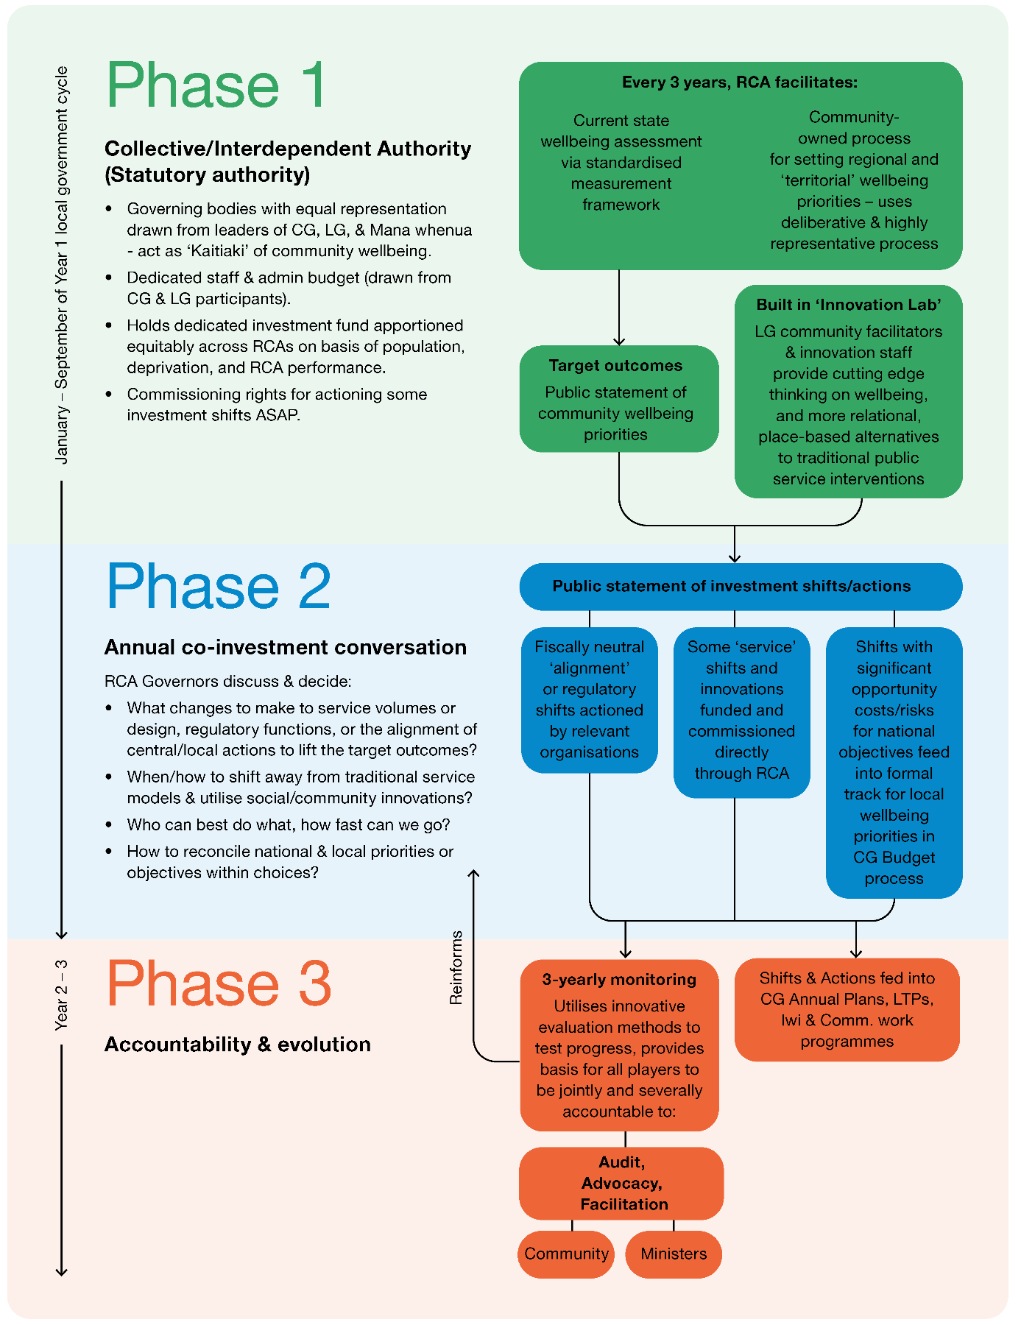
Image description: Phase 1 takes place between January and September of Year 1 of the local governance cycle. Collective/interdependent authority (statutory authority): governing bodies with equal representation drawn from leaders of central government (CG), local government (LG) and mana whenua to act as kaitiaki of community wellbeing; dedicated staff and admin budget (drawn from CG and LG participants); holds dedicated investment fund apportioned equitably across RCAs on basis of population, deprivation, and RCA performance; commissioning rights for actioning some investment shifts ASAP. Every 3 years, RCA facilitates current state wellbeing assessment via standardised measurement framework and community-owned process for setting regional and territorial wellbeing priorities – uses deliberative and highly representative processes. This feeds into target outcomes (public statement of community wellbeing priorities) and built in Innovation Lab (LG community facilitators and innovation staff provide cutting edge thinking on wellbeing, and more relational, place-based alternatives to traditional public service interventions). Phase 2 is an Annual co-investment conversation. RCA governors discuss and decide what changes to make to service volumes ore design, regulatory functions, or the alignment of central/local actions to life the target outcomes, when/how to shift away from traditional service models and use social/community innovations, who can best do what, how fast can we go, and how to reconcile national and local priorities or objectives within choices. They provide a public statement of investment shifts/actions. These are fiscally neutral alignment or regulatory shifts actioned by relevant organisations. Some service shifts and innovations funded and commissioned directly through RCA. Shifts with significant opportunity costs/risks for national objectives feed into formal track for local wellbeing priorities in CG budget process. These feed into Phase 3, which is accountability and evolution and takes place during year 2 and 3 of the local election cycle. It involves 3-yearly monitoring which uses innovated evaluation methods to test progress, provides basis for all players to be jointly and severally accountable to audit, advocacy and facilitation by community and ministers. It also involves shifts and actions fed into CG annual plans, LTPs, Iwi and community work programmes.

Towards a model for Aotearoa New Zealand
Whilst we have outlined a range of examples above we feel that there is a need for a new approach to central and local government working together that provides for co-investment, underpinned by a focus on building and maintaining productive relationships. The examples above provide us with vital insights about what works well in co-investment approaches. However, each of the models provided have aspects that mean that they might not work as a systemic approach.
In our final report, we want to present models that provide effective ways for co-investment and how this could work in our particular context. To help inform this, we are interested in views on how to rewire the system of central and local government relationships and develop a shared vision and co-investment in local outcomes. Below we outline some key aspects we think need to be present in a new approach. We then have provided a set of questions we would like your feedback on.

Some things we think need to be present in a new model
As a Panel, we have been thinking about how an interdependence model could work using the principles and attributes as a guide. We are considering several key aspects.
- Any new approach needs to be an enabling model, not a prescriptive one. While we know a co-investment approach will need to enable parties to agree outcomes and financial approaches, it will need to provide sufficient flex to change and adapt to local circumstances and events that will happen across time.
- The need for a stronger statutory process that enables co-investment towards agreed regional outcomes. While structural responses are only part of the solution, and there are changes needed to capability and mindsets, we think a model, enabled by statute, is an important aspect to provide stability and mandate. We also think that convening at a regional level will enable local perspectives and circumstances to be considered while enabling decisions across both local and central government.
- Any new approach should support place-based decision-making and innovation. Bottom-up, local approaches will need to be incorporated in order to achieve desired outcomes and design locally appropriate solutions, even when infrastructure is regional.
- Governance of the co-investment approach should be an equal partnership between local government, central government, and Māori. We note there would need to be a Māori-led, tikanga-based process for determining Māori representatives. In general, we would expect hapū/iwi to have a lead role in these entities, but there may also be regions where urban Māori authorities or Kaupapa-based groups play a significant role in the Māori community and consideration should be given to their views being represented.
- There needs to be proper investment in the approach. We have learned from PBIs and the Welsh model that a ‘half in’ approach will not work, and appropriate funding needs to be provided both to initiatives and also to support different actors working together.
- It will be important to balance the need for structural change with the need for acting quickly and innovation to address challenges and opportunities in communities now while building an embedded sustainable approach for the future.
Any interdependent model needs to be seen as part of a package of bigger shifts that this report is recommending – a stronger local government that must be valued as a key player in working with central government to help tackle the wellbeing challenges that communities face.
For the final report, we want to consider different options with a series of workshops with people from across both central and local government together with iwi representation to test the proposed models.
The Panel wants to consider the merits of the different options to create an interdependent relationship between central and local government, that will ensure their strengths and resources are best applied to the challenges of present and future communities.
Whether it is planning for sustainable growth, housing and social and economic sector pressures or environmental challenges, communities need and deserve collaborative and cohesive effort especially from both central and local government.

Questions
As we work towards our final report, we want to consider the merits of the different examples. We are interested in your views as to how to rewire the system of central and local government relationships through developing an aligned and cohesive approach to co-investment in local outcomes.
- To create a collaborative relationship between central and local government that builds on current strengths and resources, what are:
  - the conditions for success and the barriers that are preventing strong relationships?
  - the factors in place now that support genuine partnership?
  - the elements needed to build and support a new system?
  - the best options to get there?
  - potential pathways to move in that direction and where to start?
  - the opportunities to trial and innovate now?
- How can central and local government explore options that empower and enable a role for hapū/iwi in local governance in partnership with local and central government? These options should recognise the contribution of hapū/iwi rangatiratanga, kaitiakitanga, and other roles.

Replenishing and building on representative democracy

Local voter turnout has declined over the past three decades and a significant proportion of people are not engaged in local body elections.

Key findings
Councils remain predominantly made up of older European/Pākehā elected members. There needs to be more diverse representation and increased governance capability at the council table.
While Māori wards and constituencies are a positive feature, they were not designed to provide for Tiriti-based representation of mana whenua or significant Kaupapa-based groups.
Councils need to increase their capability in, and understanding of, Te Tiriti o Waitangi and te ao Māori.
Elected members’ conditions, remuneration, training and support need to improve to attract a wider pool of potential candidates and increase the quality of governance.
Aspects of the current electoral and representation review provisions and processes need revision.

Overview
To respond more effectively to the challenges facing Aotearoa New Zealand and maximise wellbeing for communities as a whole, we need to ensure that local leadership allows diverse voices to be heard. We also need to ensure that members of councils have the necessary skills, expertise and experience to help facilitate solutions to these complex, intergenerational problems. We need trustworthy leadership that is brave enough to lead new and innovative forms of democracy. And as per our discussion in Chapter 3, we think a Tiriti-based partnership needs to function at all levels of the system.
When local democracy and election processes are working well, we imagine a future where:
- representation and electoral processes are robust; fair and meaningful; and able to evolve with community needs and preferences
- everyone understands and can access local electoral processes
- council governance (the membership of councils) is more representative, with a diverse and talented range of elected members who represent a breadth of cultures, demographics, expertise, and community knowledge
- council governance is trusted, supported, and valued, with a full range of the capabilities needed to make quality, intergenerationally minded decisions
- council decisions reflect a strategic perspective, thinking beyond short-term political cycles
- Māori representation at the council table is not limited to Māori as citizens, but extends to direct representation for mana whenua or significant Kaupapa-based groups
- representative democracy is supported by a positive, constructive relationship between council governance, management, and staff.
At the moment, although we see many individual examples of these ideas or initiatives, we think there are a number of barriers in the existing mechanisms, conditions, and parameters for democratic representation that stop us from achieving this overall vision.
In particular, we have made recommendations aimed at improving the quality and consistency of local electoral processes and electoral systems. We have also recommended a reduction in the voting age and a more strategic electoral term. We have also considered how well the level of remuneration and support for elected members promotes a capable, representative council membership.
We acknowledge limitations in the Māori wards mechanism, and the potential for new models of council governance to ensure Tiriti-based representation at the council table and a more comprehensive set of governance capabilities.
Finally, we explore options for ensuring a team approach across council governance, executive team, and staff and for ensuring transparency, capability, and continuous improvement in local democratic processes.

Where are we now?
This section provides a more detailed discussion of the challenges with the current state of representative democracy, as context for what we recommend in the rest of this chapter.

Low voter turnout
While voter turnout should not be seen as a comprehensive indicator of the relationship between councils and communities, in relative or directional terms it can be a useful indicator of the health of democratic processes. Actual percentages of eligible voters have declined from a national average of 57% in 1989 to 42% in 2019. Although results over the three most recent elections have stabilised, the turnout numbers still indicate a significant proportion of citizens are not engaged in local body elections. Comparatively, central government election voter turnout was 82.5% in 2020. Poor turnout at local elections has been variously attributed to:
- a lack of awareness around elections, candidates, and policies
- disengagement from politics and council
- a general apathy towards voting (Asquith et al 2021).
Differences in voter turnout are strongly pronounced when broken down across ethnicity, age, and socio-economic status. It has also been highlighted that these demographics and characteristics compound each other – for example, young Māori living in lower socio-economic neighbourhoods were less likely to vote (Asquith et al 2021). We also note that relationships between councils and their communities decline with larger populations, as the distance between people and their representatives increases. In essence, smaller communities who have a closer connection to their candidates are more likely to vote (LGNZ 2019a).
The Panel also observed that the current process of postal voting is contributing to low voter turnout. As technology evolves, the opportunity for electronic voting needs exploration.
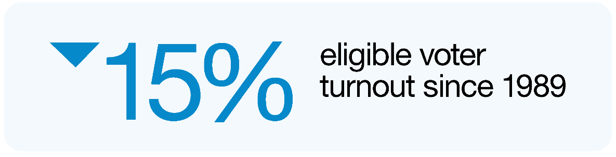

Limited diversity of membership
Having a body of diverse elected representatives is likely to improve the quality of council decision-making for the whole community, by ensuring decisions take into account the needs and preferences of people with different genders, ethnicities, socio-economic and cultural backgrounds, physical abilities and ages. This diversity also strengthens the legitimacy of local government, by ensuring people can see themselves reflected in the governing body.
While the ethnic diversity of elected members is increasing (particularly with the upcoming elections seeing 35 councils adopting Māori wards for the first time), the table below highlights that the current diversity of candidates is not yet reflective of our community (LGNZ 2020b).
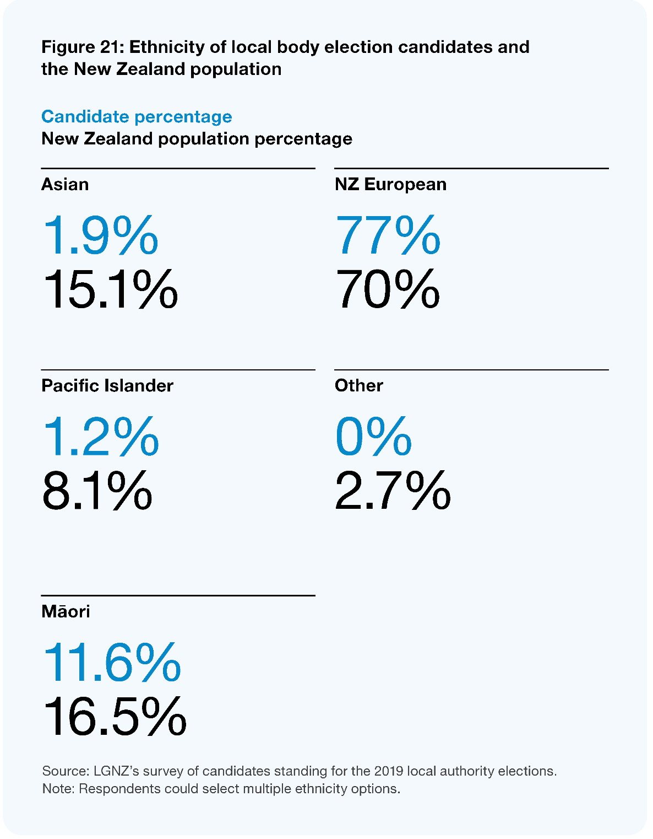
Image description: Figure 21: Ethnicity of local body election candidates and the New Zealand population. Asian: 1.9% of candidates, 15.1% of population; NZ European: 77% of candidates, 70% of population; Pacific Islander: 1.2% of candidates, 8.1% of population; Other: 0% of candidates, 2.7% of population; Māori: 11.6% of candidates, 16.5% of population. Source: LGNZ’s survey of candidates standing for the 2019 local authority elections. Note: Respondents could select multiple ethnicity options.
Councils remain predominantly made up of older European/Pākehā members (LGNZ 2020a). Of all council members elected in 2019, 13.5% identify as Māori, while Pasifika, Asian and other ethnic minorities are significantly underrepresented. While the 2019 election saw the highest proportion of women ever elected to local government in Aotearoa New Zealand (40.5%), less than 30% of mayors are women. The average age of elected members is 56–60, and only 13.9% of members are under 40.
As demonstrated by the quotes below, the need to increase diversity in council membership was reflected in our engagement with communities:
“We need a system of election that is more engaging so that elected members are truly representative.”
– Survey respondent
“There are a lot of people who are not represented around the council table. Those who do not own their own homes, those who are low income, people with disabilities, people from ethnic minorities, Māori. Those under 18.”
– Survey respondent
“Youth need better representation and more of a voice in local government.”
– Survey respondent

Constraints on good quality decision-making and capability
We also heard that:
- the 3-year local electoral term does not allow for progress on complex issues and encourages short-term political cycles that cancel each other out
- elections do not always deliver a council with the full range of governance capabilities needed to respond to complex, intergenerational issues
- there is significant variation in how the employment relationship between the council and the chief executive is managed, and in the quality of relationships between elected members and staff.

The need for a Tiriti-based partnership at the council table
As highlighted in Chapter 3, we think the point is now well made that Māori wards and constituencies were not designed to provide for Tiriti-based representation of mana whenua or significant Kaupapa-based groups at the council table. We were repeatedly told that people in council governance need to build their capability and understanding of Te Tiriti o Waitangi and te ao Māori.
“Governance needs to be upskilled in language and te ao Māori, [and] better understand the Māori communities it serves.”
– Survey respondent

Towards a more robust representative democracy
To achieve more diverse representation, a range of actions and interventions will be needed. The following sections provide more detailed analysis and recommendations in the following areas:
- better representation and electoral processes
- better remuneration and support for elected members
- a more strategic local electoral term
- new models for council governance – ensuring capability and Tiriti partnership
- ensuring a team approach
- transparency, capability and continuous improvement.

Better representation and electoral processes
We think general drivers of low voter turnout (such as apathy and disengagement) and the lack of diversity in representation will be addressed to an extent by the wider set of changes proposed across this report. However, we think there are some specific features of representation and electoral processes that should be reconsidered. This includes looking at current provisions for representation reviews, the future of Māori wards and constituencies, the administration of local electoral processes, local discretion as to the choice of electoral system, and the voting age.

Representation reviews
Under the Local Electoral Act 2001 (LEA), local authorities are required to review their representation arrangements at least once every six years in order to achieve fair and effective representation. As part of these reviews, councils are required to consider things like the total number of councillors, how they are elected (whether from wards or at large or a mix of both) the boundaries of wards, and whether community boards are needed.
Any person interested in proposals made as a result of such a review can lodge a submission with the local authority, and if still dissatisfied with proposals after they have been heard, can lodge an appeal. The Local Government Commission has a direct role in appeals and objections against final representation review proposals, and in cases where proposals do not comply with statutory fair representation requirements.
We consider that the Local Government Commission’s deliberations on appeals from representation reviews for 2022 suggest some variation in the quality or legal compliance of reviews conducted by councils. Not all councils have invested to ensure sufficient capability and capacity to undertake reviews to the requisite standard, and there is little incentive to do so.
Yet we are not convinced there is a systemic problem with the process for setting representation arrangements. We think such arrangements should still be locally driven, and that other proposals in this report aimed at promoting more representative councils may mitigate the risks above. For this reason, we make no specific recommendation related to representation reviews for now, but seek feedback from all parties on whether further support for councils in carrying out such reviews is required. In particular, we seek feedback as to whether the Local Government Commission should play a more proactive role in leading or advising councils about representation reviews, so that fewer discussions reach the point of requiring an appeal and determination process.

The future for Māori wards and constituencies
As noted above, we acknowledge that Māori wards and constituencies are not sufficient to provide for a Tiriti-based partnership at the council table, and below discuss how we think they should be complemented by mechanisms that promote new models for council governance.
However, within the framework we set out in Chapter 3, we think Māori wards should remain a key feature of the system, as they ensure Māori citizens in the vast majority of local authority areas have an opportunity for culturally specific, proportionate representation. On balance, we do not support the idea raised in the past around some form of ‘compulsory’ Māori ward mechanism, or suggestions to base the electoral formula on the total Māori population instead of the Māori electoral population – we think Māori elected representation should remain a fundamentally local and self-determinative choice within the wider representation review process.
Beyond these points, however, we have not focused on the more technical aspects of the Māori wards system (such as its integration with wider representation choices) in this draft. Many of these issues will be discussed during the passage of the Local Government Electoral Legislation Bill, and we would like to consider the views of submitters before making any comment on these issues.
Where relative populations mean that at least one Māori ward is not possible and raising the number of elected members is not practical, we think partnership can still be achieved through the mechanisms we have recommended in part 7.7 below, and in other parts of the architecture for change we discuss in Chapter 3.

Centralised administration of local electoral processes
At the moment, local authorities are responsible for administering local elections. Councils must appoint an electoral officer and undertake elections in accordance with the LEA. While a few councils undertake this function themselves, most engage an independent contractor to be the electoral officer and run the election process. For the 2019 local elections, the Electoral Commission provided a supporting role by:
- encouraging people to update their enrolment details
- promoting community engagement
- providing electoral roll data to electoral officers
- checking special vote declarations to confirm voting eligibility.
In terms of encouraging voter turnout, the Local Government Act 2002 (LGA) makes local authority chief executives responsible for ‘facilitating and fostering representative and substantial elector participation’. Chief executives must discharge specific responsibilities relating to the elections, such as preparing a pre-election report as outlined in the LEA.
While localised delivery can mean electoral processes are better tailored to local circumstances, it can lead to inconsistency in the interpretation and application of electoral law across the country. It can also lead to different standards of voter support and promotion activities due to differing council budgets. Because elections are held only every three years, and require a specialised skillset, we are concerned that it is often not possible for councils to acquire the ‘surge’ capability needed to engage with these issues, resulting in lower quality elections. A recent inquiry into the 2019 local elections by the Justice Select Committee considered that ‘one of the main reasons for voter turnout decreasing since 1989 is the poor coordination and resourcing of local election campaigns’ (House of Representatives 2021).
We are also concerned that the obligations on council chief executives create an inherent conflict of interest in terms of their relationship with incumbent members, and that there is often little incentive for incumbent members to support efforts to increase voter turnout and participation.
The Justice Committee’s inquiry process sought submissions on the potential to ‘centralise’ the running of local elections through the Electoral Commission. Most submitters supported the idea as a way to improve consistency in the interpretation and application of local electoral law. We also note that in Australia, local body elections are largely administered by state electoral commissions.
Overall, we recommend that the administration of local elections should be conducted by the Electoral Commission, including design and oversight, standard setting, promotional activity, specific initiatives to promote diversity of candidates, determination of the election method, and the conduct of the election process. Although we are mindful of concerns previously expressed about the ability of a central entity like the Electoral Commission to attract and maintain relevant staff in the regions, we think this problem would be overcome with a clear mandate.

Online voting
The issue of online voting was raised frequently with the Panel as a way to address the declining voter turnout and as a possible method of encouraging younger voters to engage. Postal voting is seen as increasingly outdated and in some areas access to post boxes is challenging as they are being systematically removed.
Online voting is seen by many as more convenient and accessible way to cast a ballot. A poll by Auckland Council following the 2016 elections asked people for their preferred method of voting. 74% said online with stronger support from 18- to 24-year-olds, non-voters and non-ratepayers (Todd 2017). In 2016 and again in 2019 a group of councils proposed trialling online voting for the local body elections. These trials did not proceed as the government cited concerns around access, security, and lack of ability to guarantee electoral integrity as reasons not to continue.
The Panel acknowledges these challenges will need to be resolved before online voting can confidently be rolled out, but it supports the ongoing work to resolve the barriers to effective online voting.
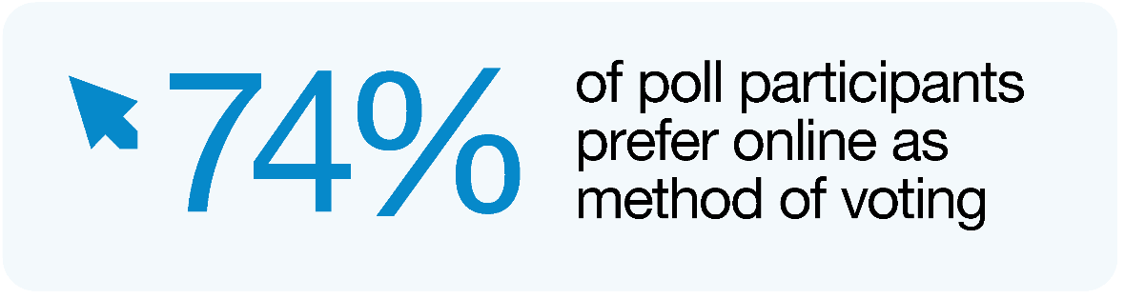

Stronger direction on the choice of electoral system
As with other features of local elections, the choice of electoral system currently sits with councils. The most commonly used method is ‘First Past the Post’ (FPP). This ‘winner takes all’ system is poorly equipped to represent a population’s diversity. The generally preferred alternative system of ‘Single Transferrable Vote’ (STV) can improve representativeness by transferring votes and avoiding ‘wasted ballots’, although this improvement often depends on having a greater number of candidates to choose from, and the presence of multi-member wards. Overall, we believe that STV promotes greater diversity, with early research demonstrating that STV leads to improvements in the representation of women (Vowles and Hayward 2021).
However, in 2022, just 15 of 78 local authorities used STV. Although this is an increase from 11 in 2019, only one council had polled their voters on the potential use of STV in the 2022 elections (STV). We are also conscious that local discretion on this matter can lead to a conflict of interest where elected members perceive they have an increased chance to win under a particular system.
As with electoral processes more generally, we think the infrequency of elections and the specialised knowledge required may be limiting councils’ ability to consider the merits of different voting systems. In addition to the recommendation above for the Electoral Commission to administer local elections, we recommend legislative change to make STV the nation-wide voting method in local body elections.

Voting age
A significant point raised with us in our engagement relates to voting age. The voting age for both local and central elections is 18. Overseas, the voting age has been lowered from 18 to 16 for local body elections in Austria (2007), Scotland (2015), and Wales (2021). Scotland also lowered the age to 16 for the 2014 Scottish Independence Referendum. These international examples have shown that lowering voting age can instil voting habits and make youth feel empowered to affect change through the democratic process (Huebner 2021; Zeglovitz and Zandonella 2011). There is now a growing movement to lower the age to 16 in Aotearoa New Zealand, including through the ‘Make it 16’ campaign. We understand that the question of voting age for Parliamentary elections is within the scope of the Independent Electoral Law Review recently commissioned by central government.
The Panel strongly supports lowering the eligible voting age for local body elections to 16 and encourages the Independent Electoral Law Review to consider this change for Parliamentary elections.
While we understand there are different views on this issue, we see fundamental value in ensuring our youth are represented in local democracy. Rangatahi are our future leaders and will inherit the decisions made by councils. They are passionate about complex issues like climate change, poverty, housing, and education, and bring to the table intergenerational perspectives that go beyond the 3-year election cycle. For example, the Schools 4 Climate Change protests highlight that rangatahi want to be a part of change. They want to have their views recognised and have a say on the big issues that will impact their future (Tokona te Raki 2022). The majority of participants (55%) from the ‘Get vocal in your local’ survey we commissioned think the voting age should be lowered to 16 years of age.
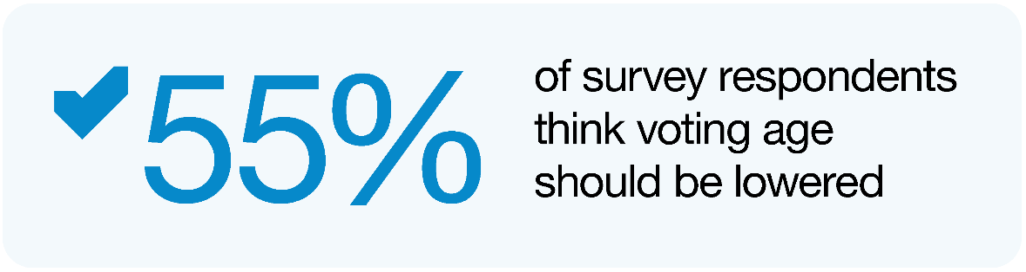
Arguments against lowering the voting age include the potential for parental coercion, and that 16- and 17-year-olds can already participate in our democracy through other mechanisms such as protesting, lobbying, petitioning, and presenting to Parliamentary select committees.
However, we consider that lowering the voting age for local body elections to 16 could empower young New Zealanders to take ownership of their future, advocate for their communities and have a say in who makes decisions on the issues that matter to them. In particular, we have heard how important it is to ensure rangatahi Māori are involved and engaged in local democracy. This would be strengthened by civics education discussed in Chapter 2, and along with an increased digital presence of local government, also discussed in Chapter 2, could help attract more young people to vote and work in local government.
If New Zealanders are learning about local government in schools from a young age and can vote in local elections from the age of 16, the Panel thinks this will help grow a generation of future leaders who feel connected to and represented by their local council.

Better remuneration and support for elected members
As with any complex and challenging role, the way we remunerate and support elected members is critical to ensuring a representative and capable council. This section discusses the sufficiency of current remuneration and the potential for more investment in training and development for councillors and mayors.

Remuneration
Local government remuneration is determined by the Remuneration Authority in accordance with the requirements of the Remuneration Authority Act 1977 and the LGA. This framework requires the Authority to have regard to the need to achieve and maintain fair relativity with remuneration received elsewhere, to be fair to individuals, groups, taxpayers, and ratepayers, and to recruit and retain competent persons. It also requires them to take into account things like the requirements of a position, the conditions of the service enjoyed by comparable people or groups, and any prevailing adverse economic conditions.
These considerations shape the policies of the Remuneration Authority, which in turn drives the remuneration for elected members. While a total pool approach is taken for each council, remuneration for councillors, mayors and chairs is essentially driven by three factors:
  - the size of the governance role of each council, which includes measures relating to the size of the council. This includes consideration of ‘people issues’, including population size, where an area sits on the socio-economic deprivation index, the number passengers taking public transport; total assets and total operating expenditure of the council; and geographical characteristics
  - the average time required by an elected member on a council of a particular size
  - a general comparison with parliamentary salaries.
The table below gives an indicative sense of how base salary and superannuation compares between MPs and local councillors.
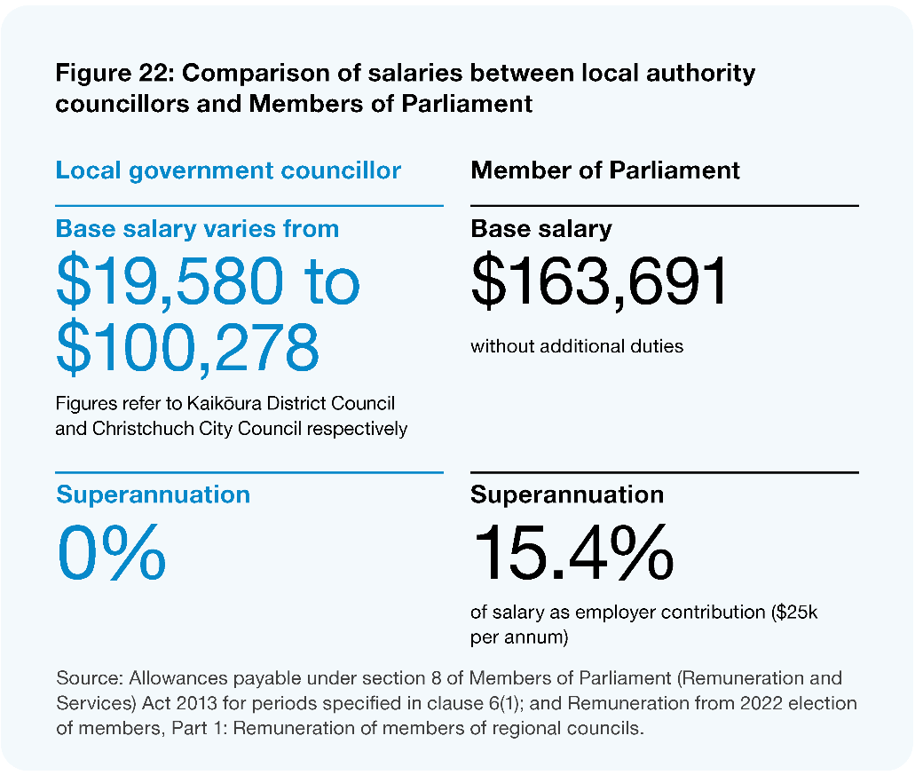
Image description: Figure 22: Comparison of salaries between local authority councillors and Members of Parliament. Local government councillor base salary varies from $19,580 to $100,278 (figures refer to Kaikoura District Council and Christchurch City Council respectively). They do not receive superannuation. For a Member of Parliament, base salary is $163,691 and they receive a superannuation of 15.4% of salary as employer contribution ($25k per annum). Source: Allowances payable under section 8 of Members of Parliament (Remuneration and Services) Act 2013 for periods specified in clause 6(1); and Remuneration from 2022 election of members, Part 1: Remuneration of members of regional councils.
While we acknowledge the importance of relativity and the effort made by the Authority to achieve fairness in a system with highly varied roles, we are convinced that the absolute level of local remuneration is simply not attracting a representative and sufficiently capable set of elected members in many communities. We think there is a ‘fixed cost’ (in terms of time and effort) to being an effective elected member, which, below a certain point, does not decrease with population. We also think facilitating community consensus on issues such as climate change or inequality is just as complex and time consuming at a local level as it is at central level. We also think that the relativity with Parliamentary remuneration fails to recognise less tangible aspects of the local elected member role (which often plays out in less formal contexts or overlaps directly with daily life in the community).
At current levels of remuneration, in many cases (particularly for younger people, parents, or those in lower socio-economic conditions), people simply cannot ‘afford’ to stand for council. This is reflected in the profile of elected members, which despite some improvement is still skewed towards older, potentially more financially independent people.
While other actions proposed in this report will help to improve ‘representativeness’ and the capability of members, we do not think we will achieve community confidence in elected members without a fundamental reconsideration of the absolute level of remuneration, and we recommend this occur as soon as possible.

Wider support and development for elected members
At the same time, we acknowledge that obtaining a more representative and capable range of elected members does not just rely on core remuneration. We have heard and observed that many elected members feel unsupported in their roles, which not only limits their ability and confidence to do their job well, but makes it less attractive to new candidates.
In the survey informing LGNZ’s elected member profile for 2019–2022, members strongly identified a desire for more training and skill development opportunities, particularly in relation to the ability to engage with communities, local organisations, and iwi/Māori (LGNZ 2020a). We agree there is a case for significant change in the way that elected members are offered training and development, in order to increase their capability (and therefore confidence) in making effective decisions, and to strengthen councils’ role as a facilitator for communities.
We acknowledge that LGNZ has put in place a new system to support Māori members elected in 2022, and we recognise that many councils run training or information days for potential members. LGNZ also offers induction programmes for elected members. However, we think a more comprehensive programme for all members should be a priority (see, for example, Vic Councils’ Becoming a councillor). We propose a formal professional development programme that requires members to undertake a specified level of accredited development during each 3-year term. It could include a range of relevant modules, including:
- civic education, engagement, role of democracy and representation – including localised information
- understanding and empowering diversity and a range of cultural frames
- governance training – how to lead, collaborate and steward effectively with others
- subject specific education and training (for example financial literacy, wellbeing frameworks, or the specific regulatory roles of local government)
- Te Tiriti – history, frameworks, and applications.
In addition to training and development, we have received feedback that in some places, progressive employment practices such as providing EAP counselling services and support for childcare or family-friendly practices are not comprehensively available. Lack of available childcare is often a barrier to younger candidates putting themselves forward for election. We have also heard that the increasingly stressful nature of being an elected public figure brings with it threats of violence, threats to family and cyber bullying. Often elected members are told that ‘it goes with the territory’ and do not have access to support systems that council staff or those elsewhere in the workforce do. This is an increasingly cited reason for people not standing again.

A more strategic local electoral term
At present, councils are elected to represent their communities for a 3-year term. There is ongoing international debate on what constitutes the optimal term length for politicians and governments (Gersbach et al 2021), and we have looked to comparable jurisdictions overseas to guide us on this issue. While terms vary from as little as one (some Hamlets in Canada) or two years (Western Australia), to as many as five years (Wales), the most common term length for local members by far is four years (Scotland, England, most of Canada and other Australian states). In Aotearoa New Zealand, a number of councils have supported extending the electoral term for local elected members (Neal 2020). In 2020, LGNZ member councils Annual General Meeting voted in support of a 4-year term.
We heard that the current term limits members’ ability to look beyond the three-year election cycle and advocate for long-term solutions to complex, systemic challenges, such as climate change and intergenerational poverty:
“Currently the 1st year is doing previous council stuff, slowly get an understanding. 2nd year is planning for things you’d like to achieve, 3rd year starting to implement and 99% of the time you don’t get to see those finalised and then you’re up for re-election.”
– Elected member during Council Roadshow
As with voter age, we understand that term length (for central government) is being considered by the Independent Electoral Law Review.
We think that a longer term could:
- promote more innovative, strategic or intergenerationally minded decision-making, dissuading elected members from focusing on politically led or short-term solutions
- improve capability and the quality of governance by giving new members more time to learn about their role and responsibilities
- lengthen horizons for decisions on infrastructure or large capital investments, which often require political consistency and multiple years of development
- encourage the use of richer, sustained, or more deliberative mechanisms for participatory democracy, such as citizens’ assemblies
- generate cost and time savings (from less frequent elections) that could be reprioritised to substantive governance issues
- mitigate ‘voter fatigue’ or apathy, thus improving turnout in local elections.
On the other hand, it can be argued that short terms help to hold local governors accountable and give the public regular opportunities to vote out incompetent politicians (Gersbach et al 2021). Another potential disadvantage of a longer term is that it might deter potential candidates who are unwilling to commit to office for longer. Conversely, it may increase appeal to other candidates who hold longer-term aspirations.
On balance, with the complex, intergenerational issues now pressing on council agendas, we consider there is a strong case for a longer term, and we recommend it be extended to four years.

New models for council governance – ensuring capability and Tiriti partnership
Many of the proposals above are aimed at ensuring more representative and better-quality council governance through changes to electoral processes and parameters or the support provided to elected members. While we think those proposals will make a significant difference, we also think it is time to acknowledge that local elections do not always provide councils with the comprehensive mix of governance capabilities needed to respond to the increasingly complex and intergenerational issues they are dealing with. And as noted earlier, we acknowledge that Māori wards were not designed to provide for a Tiriti-based partnership around the council table.
As such, we have considered the potential for new models of council governance that respond to these two imperatives in the sections below.

A Tiriti-based partnership at the council table
We accept that, in a situation where Māori are a minority, representative mechanisms based solely on the Western ideal of proportional democracy cannot provide a level of influence consistent with a Tiriti-based partnership. We also acknowledge that the collective, political authority aspect of rangatiratanga is predominantly held and exercised by hapū/iwi, and that Māori wards were not designed to ensure representation of mana whenua or Kaupapa-based groups.
And yet, we also think that a Tiriti-based partnership is about much more than final decisions made at the council table. In a future state for local government that reflects a genuine sharing of authority, there are vast opportunities to collaborate, co-design, and (we would argue), ‘co-govern’ outside of those points at which the full council signs off on something. In many ‘co-governance’ initiatives, what is being shared is the responsibility to prepare or influence draft instruments or proposals that are still subject to final approval by council. These models are successful not because they focus on who has the ‘final say’, but because of the ripple effect across partner organisations that happen through the exchange of information, different perspectives and ideas, the building of capability, and the forming of relationships.
For this reason, we have asked ourselves, ‘how important is it to provide for a more direct hapū/iwi voice on council if the wider range of changes recommended in this report are adopted?’. We think those other changes would go a long way towards ensuring partnership. The revised legislative framework for Te Tiriti and integrated partnership frameworks discussed in Chapter 3 would put hapū/iwi at ‘decision-making tables’ in many instances. We also think greater incorporation of tikanga in council processes would mitigate the negative impact of majority politics by encouraging councils to strive for consensus. In other words, we think the question of a more direct voice at the council table is only one part of the puzzle.
However, on balance, we think it is time to question the strict application of Western representative principles and explore hybrid governance models that provide for a Tiriti-based partnership. We are led to this conclusion by the fact that decisions by councils often have a very direct and immediate impact on the lives of hapū/iwi, and whānau, and that, ultimately, the setting of rates by a council is a fundamental aspect of local, public authority. More simply, we think the Tiriti-based partnership will be significantly enhanced if hapū/iwi are represented at the council table.
Yet in the very broad context of local governance, we do not think a Tiriti-consistent partnership requires a 50:50 split of Māori appointees and elected representatives. The idea of constant joint decision-making is not likely to be practical or necessary all the time, and we think a richer sense of partnership will be achieved less by counting votes and more by the exchange of ideas and perspectives, and genuine relationships between appointed and elected members.

Building on recent innovation
We think the approach and balance of the changes set out in the Canterbury Regional Council (Ngāi Tahu Representation) Act 2022 are instructive in terms of thinking about mana whenua representation in council governance. At the same time, we do not think the way forward is as simple as rolling out an existing, context-specific model. Changes of this nature need to be tailored to local circumstances, including relative populations, the presence of Māori wards, and the practical size of particular councils. The solution in each instance is not likely to be the product of a mathematical formula, but of collaboration and a reasoned, culturally aware judgment. Such change may also need to be phased in over time, taking into account any changes to local government structures as described in Chapter 9.
In addition, we do not think the Crown will fulfil its Tiriti obligations to Māori if it leaves such change to local Bill processes that often turn on popular or majority support. Rather, we consider some standing mechanism would need to be available in legislation for hapū/iwi and councils to advance such arrangements, subject to some form of independent advice as to the balance to be struck between electoral representation and Tiriti partnership.
Finally, while we have referred to hapū/iwi in this analysis, and we think they have the primary interest in this proposal, we acknowledge there may be communities where wider Māori entities, such as urban Māori authorities or Kaupapa-based rōpū have an important role in the Māori community and would need to be included in the conversation about Māori appointees. As with our discussion in Chapter 2, we think those appointees would need to be determined via an inclusive, Māori-led, and tikanga-based process.

Maximising the capability of councils
In addition to the above rationale for exploring hybrid governance models from a Tiriti perspective, we are conscious of arguments about the potential to augment elected membership with appointees who bring particular governance capabilities that would strengthen the overall council.
There is a role for ministerial intervention and the placement of commissioners where there is a significant problem impairing good local government or public health and safety. However, we do not think a sense of improvement in situations where such a point has been reached is evidence of a compelling alternative model for council governance. Councils are not boards of directors, and this report is underpinned by a fundamental belief in the wisdom of communities, their ability to govern their own lives and determine their futures.
Nevertheless, we do agree that many of the issues councils are dealing with have become increasingly complex (for example, inequality), or subject to a challenging balance of local and national interests (for example, freshwater management or climate change), and we accept that local elections do not always provide a comprehensive mix of the capabilities needed to respond to such issues. We also think changes proposed in this report will place greater emphasis on the need for some specific governance capabilities, like the ability to facilitate more deliberative and participatory engagement.
While it is the role of the council executive and staff to provide impartial advice and help elected members understand complex issues, we think some level of skill around the table in particular domains of governance can often make the difference between good decisions and bad. We also acknowledge that local government is often competing for a scarce pool of quality potential governors. In short, we think there is a wider, capability-based argument for allowing appointed members on council with full voting rights.

Options, parameters, and considerations for hybrid governance models
We think there are three broad options to address Tiriti-partnership and capability issues in council governance.
- No significant change to the status quo (which would still allow appointments to council committees with voting rights, and appointments to council without voting rights).
- Develop a specific mechanism to provide for hapū/iwi (or significant Māori organisational) appointees to council.
- Develop a comprehensive mechanism allowing for a number of appointments on both a Tiriti and a capability basis.
For Options B and C, a key step in adding appointed members would be for appointment proposals to be referred to, and subject to the approval of, an independent statutory body. This entity would assess proposals against statutory criteria or principles that would aim to balance Tiriti and capability needs with local electoral representation. It would take into account local circumstances and populations, the presence of Māori wards, and current council size, although it would not have a role in reviewing the specific appointees put forward by hapū/iwi or Māori organisations within the proposal.
This independent body could also recommend complementary or alternative initiatives where it sees fit (such as appointments to committees) and have a role in resolving disputes between the parties where proposals cannot be agreed. In the case of Option C, we have envisaged the following key parameters or considerations.
- The total number of appointed members should be capped at an additional, fixed percentage (50%) of elected members, so appointed members would make up no more than one-third of total members. For example, a council with 10 elected members could have a maximum of 15 members, up to five of which could be appointed.
- Proposals would need to occur and be resolved as soon as possible following local elections in order to allow for a capability assessment, provide certainty for the community, and allow the council to get on with business.
- Hapū/iwi or Māori organisational appointments should be considered as a first step in this process, with an expression of interest from Māori, meaning councils have to co-design a proposal with them for submission to the independent body.
- We would expect Māori organisations to pursue consensus about how they will collectively or separately make appointments to such seats.
- Appointees would be subject to the same core eligibility criteria as elected members, and receive the same remuneration available to other members, with appointments not reducing the remuneration available to each member under Remuneration Authority policy.
- The statutory criteria and role of the independent body would need to ensure that capability-based appointments are based on genuine skill gaps in elected membership, and are not:
  - being put forward to advance political interests (by strengthening membership around a particular viewpoint)
  - creeping into demographically driven appointments. While we thoroughly support diversity at the council table, we do not think this is the most effective way to achieve it.
- Appointments would be made for a specified term, although councils could remove appointees (following due process) where circumstances/needs change. An exception would be for Māori organisational appointees, where joint agreement would be needed for removal.

Where to from here?
On balance, we have an in-principle preference for Option C. While appointments on a capability basis may become less important over time as the system matures, we think the ability to add appointed members will provide councils with an important tool in a more dynamic, Tiriti-consistent, and wellbeing-focused system. We also think a comprehensive assessment of both Tiriti and capability needs under Option C provides maximum flexibility and is likely to produce a better-quality governance arrangement by ensuring the parties take into account the capabilities brought to the table by Māori appointees. However, we seek specific feedback on how such an approach might be implemented.

Ensuring a team approach
Successful councils require elected members that work well together and are in tune with their communities. The role of mayor or chair is vital in a well-functioning council. The mayor or chair and elected members must also work constructively with their chief executive, executive team, and council staff. The quality of the leadership and the way elected members and staff work together for the benefit of their community is a prerequisite for a high-performing council. Below, we consider the roles of mayors and chairs, the potential for more constructive employment relationships between councils and the chief executive, and issues around the codes of conduct for elected members.

Critical role of the mayor or chair
The mayor plays a crucial role in the leadership of their community and council. In times of crisis and natural disaster it is the mayor that the community, the media, and at times the nation look to for support, direction, and advocacy. The mayor is often also the advocate to central government for the council’s position on issues affecting their community. The Panel is aware of many great examples where this has been demonstrated in recent decades, especially at times of adversity. Those with sound understanding of the strategic context, and who can communicate with clarity and empathy appear most successful. In contrast, chairs of regional councils are often less visible and not well known in their communities. We would welcome any specific feedback about how a stronger regional voice may be enabled or promoted within the system.
The leadership role mayors or chairs play within a council is also crucial. The LGA gives certain powers and functions to a mayor, such as appointing a deputy and committee chairs and leading the planning and budget process, although such decisions still need council approval. From feedback the Panel has received (and its experience), the mayor’s ability to appoint the deputy mayor (and chairs of committees), lead the district, and at times have councillors who disagree with them, should be seen as a healthy part of our democracy. Mayors navigate uncertainty and complexity and lead without the benefit of party politics. Those who develop inclusive leadership styles are often able to implement policy and deliver on their vision through collaboration and cooperation with their elected members and with their chief executive. It is critical to grow and support the development of these team-building and leadership capabilities in our mayors.

Ensuring constructive employment relationships with the chief executive
As reflected in LGNZ CouncilMARK™ reviews, high-performing councils have an excellent relationship with their chief executive, with trust and confidence fundamental to that relationship. Yet Taituarā has advised the Panel that 38 current council chief executives have held their role for two years or less. This has continued a trend in the last decade of high turnover rates. While some turnover is healthy, the collective loss of knowledge to the sector, and the disruption and uncertainty created through constant change does not help position the sector for success. The reasons for such high turnover rates appear to include:
- the demanding and challenging nature of the role
- a breakdown in the employment relationship between councils and their chief executive or appointees not meeting the expectations of councils
- unexpected changes following the advertising of an incumbent’s role.
Under the LGA, the council employs the chief executive with the role advertised as a fixed-term contract with a maximum term of five years. While a two-year extension is permitted, the role must be readvertised at the end of the initial term with the incumbent eligible to apply. The requirement to readvertise is unique within the public sector and, we think, unhelpful. Failing to be reappointed when the incumbent has publicly signalled an intention to reapply has seen careers end abruptly or in harsh circumstances. We are informed that ‘surprises’ arise because of poor process, a lack of transparency and honesty (especially in the lead up to the advertising process), and/or tensions created through the subsequent recruitment process. We consider the requirement to advertise the role at the end of each fixed term should be dispensed with, and that employment provisions should reflect those of other public sector chief executives.
While appointing the chief executive is one of the most important decisions a council makes, we observe that many councils do not invest sufficiently in managing the relationship thereafter, and many chief executives are left to their own devices, with not a lot of structured sector guidance and support in managing their employment. Councils have an obligation to act as a good employer and need mechanisms in place to ensure there is integrity in the relationship, performance is fairly assessed, and there is a safe and healthy environment. We are aware of widely varying efforts in this respect and that many approaches do not meet best, or even good, practice.
Given the inherent power imbalance in the relationship, the Panel believes there needs to be specific obligations on councils to support the employment relationship. One feature evident in many strong and successful relationships is where an independent facilitator is involved in:
- developing a fair performance framework, assessing performance objectively and helping to work through any issues that may arise
- assessing remuneration fairly
- ensuring professional development plans are in place.

Relationship between elected members and staff
Part of building trust and confidence is the way elected members, executive teams and staff work together, with all parties needing to understand and respect each others’ different roles. Where relationships are strong, information is shared freely, there is respect for staff (especially in public forums), a ‘no surprises’ approach is taken and there is a willingness to experiment and instil a learning culture. When the relationship is failing, we hear staff asserting that elected members are over-reaching or getting too involved in operational details, and elected members feeling like they are locked out of the organisation or unable to access staff or information. A healthy governance-management relationship requires constant evaluation with any issues addressed promptly, openly, and constructively.
It is our expectation that councils regularly and constructively assess the health of the relationship between elected members, the executive and staff and increase their investment in learning and professional development.

Code of conduct
Local government codes of conduct are a governance tool aimed at encouraging good conduct and behaviour by elected members. Currently, local authorities are responsible for creating and enforcing their own code of conduct that sets out how elected members are expected to behave towards the public, each other and staff. However, the Local Government Commission’s 2021 report to the Minister of Local Government on this issue (LGC 2021) notes that the visibility of elected member conduct issues within local government, and the difficulties in dealing with them had increased.
While noting that codes are part of a wider context and suite of governance tools that need to be considered holistically, the Commission expressed concern about:
- the need to bolster wider understanding of what constitutes good governance behaviour and the governance skills that allow mayors and chairs to build and lead effective teams
- wide variation in how councils approach the more complex areas of codes like materiality, complaints processes, penalties, staff interactions, and social media
- wide variation in practices for informing newly elected members of the code and re-adopting codes each triennium.
The Commission’s recommendations included proposals for:
- a sector-specific education framework for members and council staff, starting at pre-candidacy and continuing through ongoing professional development
- a standardised code, referenced in legislation in such a way that provides more guidance on complex issues but retains scope for councils to agree on their own shared values and principles
- requirements for codes to form part of the statutory briefing at the inaugural council meeting, and for councils to re-adopt codes near the beginning of a triennium, with an assurance assessment of individual codes provided by the Commission
- standardised processes for making, triaging, and investigating code of conduct complaints.
We support the Commission’s recommendations and think that these should be explored further. We see particular links with our recommendations above in relation to a comprehensive professional development framework for elected members.
Although the Commission’s report contemplates the potential for the use of independent parties in investigating complaints, we would go a step further. We have repeatedly heard that peer-based judgment of individual members (even if removed to a regionalised pool) is divisive, time-consuming, and highly draining for other members. While we are not suggesting it will always be the best approach, and we think councils should have a choice, there should be a specific option for local government to refer complaints to an independent investigation process that is conducted and led by a national organisation, such as the Commission.

Transparency, capability, and continuous improvement
The following sections raise questions about the balance of provisions and practice under the Local Government Official Information and Meetings Act 1987 (LGOIMA), the potential for greater central and local government collaboration in building the capability of wellbeing-focused councils, and the potential for a regular health check of local democratic processes.

Ensuring LGOIMA is fit for purpose
The LGOIMA is an important safety net when addressing the trust deficit between councils and communities. LGOIMA creates a public right of access to information held by local government and sets standards of openness for council meetings. Given the imbalance of power between themselves and communities, and as the information holder, local authorities have both a legal and a moral responsibility to act with openness and transparency.
However, we have heard of varied experiences and opinions about how well balanced the provisions of LGOIMA are in instances where good governance requires a period of time for councils to deliberate on decisions or maintain information in confidence. One particular example raised with us is the use of ‘workshops’ and informal meetings, and we acknowledge that the Ombudsman has launched an investigation into this practice. We are also aware of concerns expressed about trends in the volume and nature of LGOIMA requests over time and the financial and resourcing effects this may be having on local authorities (LGNZ 2019b).
Subject to the findings of the Ombudsman’s investigation, we recommend that central government consider whether the provisions of LGOIMA and the way it is being applied achieves its purpose.

Capability investment in wellbeing-focused councils
The breadth, complexity and changing nature of local governance already means councils require ongoing investment in the capability and professional development of executive teams and staff. Gaining and sustaining the required competencies to lead complex organisations requires constant effort, and wellbeing-focused councils will require different competencies and skills. However, due to financial pressures, high workloads, and the frequent lack of a learning culture, there is often under-investment in capability-building. For councils to remain relevant, be seen as good places to work, and to maximise their impact on community wellbeing, we believe a step change is required in learning and professional development.
Actions needed will include providing clarity around the council’s purpose, values, and acceptable behaviours; building an inclusive culture that supports learning and experimentation, reflecting national and international practice; maintaining strong relational collaborative teams; and instilling a public service and customer-centric ethos. Investment in te ao Māori, mātauranga Māori and tikanga will also be essential.
The Panel observes that within central government, there is a range of coordinated and supported professional development programmes for staff. While Taituarā supports the local government sector with professional development and training, the Panel sees great potential for sharing and extending central government’s professional development programmes and expertise with the local government sector. In a similar vein, former central government executives who have taken positions within the local government sector have commented that if they had more exposure to, and understanding of, the local government sector earlier in their career, they would have been better-rounded central government executives. To this end, and with the desire of seeing a more joined-up public sector, the Panel believes there is considerable scope in developing both a cross-sector executive secondment programme and a shared professional development offering.

A health check and continuous improvement mechanism for local democracy
As discussed previously in Chapter 2 and this one, there’s a need for profound improvement in the mechanisms and processes that enable participatory and representative democracy – to give communities confidence that their opinions are meaningful to council, and that council is relevant to their daily lives. These changes do not just need to happen, they need to be demonstrably seen as happening, and the sector must strive for continuous improvement to meet the evolving needs and preferences of communities for participation or representation.
One idea we have heard put forward in various forms is a regular and independent ‘health check’ for the democratic performance of local authorities. Such a mechanism could take a variety of forms and use a variety of methodologies, from an audit-based approach to one largely based on self-assessment by councils.
There are various precedents and existing initiatives to consider, either as models or in order to avoid duplication of scope (such as LGNZ’s CouncilMARK, and the Performance Improvement Framework previously employed by central government). But on balance, we think such exercises could provide a deeper assessment of:
- current community trust and confidence
- the effectiveness of a council’s representation arrangements in delivering diversity
- the level of transparency in local government decision-making
- how effectively councils are making use of participative and deliberative methods and in combination with other decision-making tools
- the functionality of elected members, including behaviour and performance management, the level of support provided to elected members, and the effectiveness of the training and professional development programme.
We think it important that the methodology used allows for an honest but constructive and collaborative dialogue with individual councils (including a component of self-assessment and improvement) rather than a strict audit-based approach. Care would be needed to ensure we avoid a pass/fail mentality, and that the process generates reflection and action for improvement.
Recommendations
- That the Electoral Commission be responsible for overseeing the administration of local body elections.
- That central government undertakes a review of the legislation to:
  - adopt Single Transferrable Vote as the voting method for council elections
  - lower the eligible voting age in local body elections to the age of 16
  - provide for a 4-year local electoral term
  - amend the employment provisions of chief executives to match those in the wider public sector, and include mechanisms to assist in managing the employment relationship.
- That central and local government, in conjunction with the Remuneration Authority, review the criteria for setting elected member remuneration to recognise the increasing complexity of the role and enable a more diverse range of people to consider standing for election.
- That local government develops a mandatory professional development and support programme for elected members; and local and central government develop a shared executive professional development and secondment programme to achieve greater integration across the two sectors.
- That central and local government:
  - support and enable councils to undertake regular health checks of their democratic performance
  - develop guidance and mechanisms to support councils resolving complaints under their code of conduct and explore a specific option for local government to refer complaints to an independent investigation process, conducted and led by a national organisation
  - subject to the findings of current relevant ombudsman’s investigations, assess whether the provisions of the Local Government Official Information and Meetings Act 1987, and how it is being applied, support high standards of openness and transparency.
- That central government retain the Māori wards and constituencies mechanism (subject to amendment in current policy processes), but consider additional options that provide for a Tiriti-based partnership at the council table.
Questions
- How can local government enhance its capability to undertake representation reviews and, in particular, should the Local Government Commission play a more proactive role in leading or advising councils about representation reviews?
- To support a differentiated liberal citizenship, what are the essential key steps, parameters, and considerations that would enable both Tiriti- and capability-based appointments to be made to supplement elected members?

Building an equitable, sustainable funding and financing system

The current funding arrangements for local government are unsustainable.

Key findings
The absence of a sustainable and equitable co-investment model is undermining the potential for central and local government and iwi to partner for better community outcomes.
Decisions on regulatory interventions are being made without sufficient regard for the impacts on local government, resulting in significant unfunded mandates.
Rating as the primary funding mechanism is appropriate, but the rates setting and planning processes need to be simplified.
Councils are unreasonably constrained in their ability to introduce appropriate funding mechanisms.
Councils will have a significant and growing role in driving mitigation and adaptation responses to climate change, but an intergenerational national funding mechanism is needed.

Overview
Despite numerous reviews into local government funding, very few of the resulting recommendations have been implemented. Local government is sceptical about central government’s willingness to address the systemic issues that exist. If any real change is to occur, then there must be a genuine commitment to explore and resolve the issues raised.
Enabling strong, sustainable communities is the responsibility of multiple actors. Local government, central government and other parties like hapū/iwi, businesses, and not-for-profit organisations all have a vital role. The Panel sees a successful future funding system as one where community outcomes and priorities are equitably funded by central government, local government and other parties, reflecting respective national and local outcomes, objectives and priorities.
The future funding system will need to ensure that all local authorities have the capacity and capability to sustainably deliver the roles and functions needed by their communities. The system should also create an environment that supports and encourages innovation and effective collaboration among all contributors to maximise the value from joined-up co-investment.
The Panel has identified several opportunities to strengthen the future funding system.
- There should be co-investment in public goods: A new commissioning model should be established where central government and local government, in partnership with iwi, commit to sustainably and equitably co-funding an agreed set of outcomes and objectives.
- The passing of unfunded mandates to local government should end: The current regulatory impact assessment process should include a local government impact assessment. Where regulatory interventions are likely to have significant future funding impacts for local government, central government should make funding provision to reflect the national public-good benefits that accrue from those regulations.
- New funding mechanisms should be established: Local authorities should have authority to establish new funding mechanisms (following due process) to broaden the revenue generating mechanisms available.
- Rating should be retained and simplified: Rating should be retained as the primary funding mechanism for local government funding to maintain and reinforce the autonomy and independence of local government, but the processes for setting rates need simplification, as do the processes for developing, consulting, and auditing long-term and annual plans.
- There needs to be an intergenerational fund to tackle climate change: A new climate change adaptation and mitigation funding mechanism should be established by central government. Decision-making about the application of those funds should be joined-up and take local and placed-based priorities into account.
These changes in funding, along with additional changes to the way that financing (borrowing) happens are necessary to achieve the key shift of local government as an enabler and co-ordinator of community wellbeing. This chapter provides background information on the contributors to community wellbeing and the particular role of local government as a facilitator and funder of wellbeing. It then describes the pressures on the current funding system and outlines a new funding system with principles for new funding tools, mechanisms for co-investment with central government, and changes to ensure meaningful accountability.

The current state of local government funding and financing
Central and local government are the key sources of funding for initiatives that foster local wellbeing outcomes through mechanisms like taxes and rating. Funding also comes from philanthropy, churches, volunteer groups, local businesses, iwi, community trusts, and gaming trusts.
Central government is a major funder of community wellbeing through grants, subsidies, and contractual services as well as through direct provision of core services in health, education, infrastructure, policing, justice, community services, and social services.
Local government has a particular interest and direct role in providing a wide range of services to the community that support wellbeing. These range from regulatory services like enforcement of the Building Act 2004, through to the provision of local roads, water, and community facilities. Local government is also a funder of community groups through the provision of operational funding grants and contestable funds that enhance communities. This includes funding for groups like surf lifesaving clubs, historical societies, women’s refuges, and environmental restoration groups. It also includes funding for community events, arts and culture, and economic development.
Despite the range of support and goodwill from all parties towards building community wellbeing, the current system of funding community outcomes is disjointed. In order to advance wellbeing in their communities, local authorities must deal with many government agencies, each with their own structures and objectives. Little effort is made to ensure the resources and funding at the disposal of central and local government are applied to local priorities to best effect.
The Panel considers there is considerable scope to enhance the delivery of community outcomes through more connected and effective relationships between the community, local government, and central government. At the heart of this more connected, coordinated, effective and efficient system is a revised planning and co-investment model for funding community outcomes.
Funding, financing, and revenue
Funding is a broad term which refers to the ways that local authorities ensure they collect sufficient money to be able to pay for ongoing costs of delivering services to the community. Financing refers to the means by which local authorities are able to access capital (usually by borrowing money) to enable them to manage their cashflows and build large capital projects.

Funding mechanisms available for local government
The main funding streams available for local government activities include:
- rates (property taxes) charged to property owners, including general rates and targeted rates for specific services which can include water metering charges
- central government grants, particularly grants from Waka Kotahi to contribute towards the cost of developing, maintaining and upgrading transport assets
- fees and charges for services like building and resource consents, liquor and other licensing, dog registrations, and use of community facilities
- development and financial contributions, which are paid to a council by developers to help pay for new growth-related infrastructure like water and wastewater supplies
- returns on investment income.
Other than returns on investment income, the requirements for collecting these revenue streams are set out in legislation.
Of the revenue streams available to councils, rates make up about 60% of the total local government income (Stats NZ). Not all countries rely on rates so heavily to pay for local government activities. Of the local government systems across OECD countries, Aotearoa New Zealand is one of the most reliant on property taxes (rates) as the primary tax revenue source. The Productivity Commission has found that the types of local taxes used varies across high-income countries (Crawford and Shafiee 2019). A variety of other taxes are levied by local governments across the OECD, including personal income, corporate and sales taxes. However, in countries where these additional local taxes are collected, councils tend to deliver a wider range of services like education, police, and social services that in Aotearoa New Zealand are typically funded from, and delivered by, central government.
The current funding approach for local government in Aotearoa New Zealand means there is little scope to easily accommodate ever-increasing and changing community expectations. These expectations include not only the preferences and priorities of local communities, but also the expectations of society as a whole, which get reflected through legislation passed by Parliament or other regulatory tools.
Over the past two decades in particular, local government has been under increasing pressure to fund these additional expectations. The expectations, especially those set through legislation and regulation, such as addressing growth and improving water and infrastructure quality, are often accompanied by very high funding demands that burden councils’ finances. The capital costs for addressing growth and improving water and infrastructure quality by local government to the expected levels is likely to exceed NZ$50 billion, spanning multiple generations (Sense Partners 2021).
Making local government responsible for the implementation of such legislation and regulation without any accompanying national funding is referred to as ‘the unfunded mandate’. It is this unfunded mandate that has placed great pressure on councils, requiring them to increase rates at levels consistently higher than the Consumer Price Index. This pressure is at the nub of the funding dilemma for local government and engagement on the review has sparked comments that the current model is ‘broken’ and unsustainable, and that councils have reached ‘peak rates’.
Over the past 70 years, local government’s share of overall tax revenue has stayed at around 2% of GDP, despite it having a growing number of roles and responsibilities. In contrast, as reflected in Figure 23 below, the central government share of GDP has increased to reflect the changing expectations from the public about which services and support are provided.
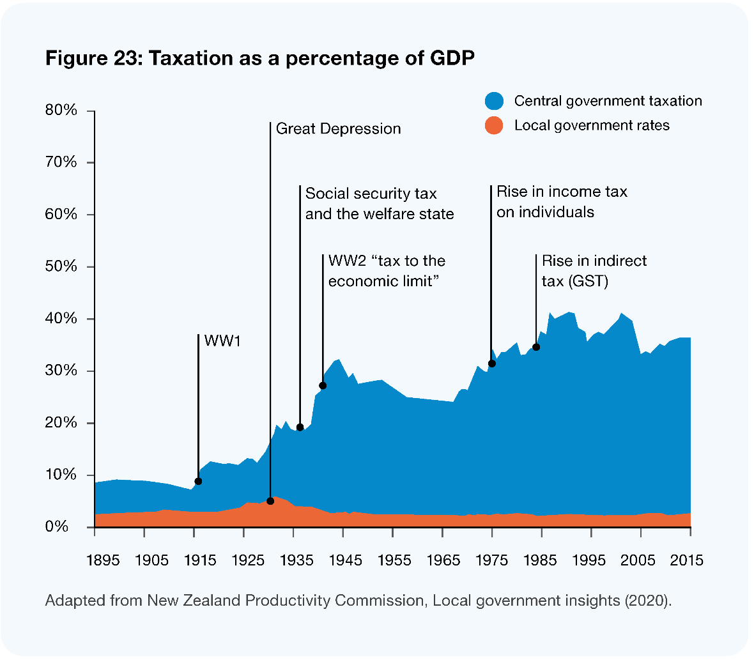

The current funding system is not sufficient for the future
Current and future conditions have put pressure on the funding system. The Productivity Commission’s 2019 report on local government funding and financing identified a range of drivers that will have an impact on the local government funding system (NZPC 2019) including:
- population growth and decline in particular areas, for example due to people moving for employment and decreasing rural population
- central government delegating additional responsibilities to local government without also allocating financial resources to cover their costs – the unfunded mandate
- some local authorities, like the Queenstown Lakes District Council, that experience much higher tourism levels than others, putting pressure on their local infrastructure network
- effects of climate change and other environmental issues on the natural environment, property, and infrastructure
- impacts of growth which generates revenue for the Crown through GST, business, or income taxes, but comes as a cost for local government for new infrastructure and services
- local authorities experiencing fluctuating income streams from assets such as ports and airports
- specific challenges, especially for small councils, arising from natural disasters such as flooding and severe earthquakes.
The Productivity Commission also notes that increasing operating and capital costs intensify the funding pressures caused by the drivers above. Operating expenditure grew at a compound annual rate of 1.2% per person from 2007 to 2017 and (pre-Covid) projections to 2028 estimate the need for an average of 5% growth in rates revenue across all councils as a result of projected increases in operating expenditure (NZPC 2019). These increases do not account for the extent of the impacts of recent inflationary pressures.

Public concerns with the rating system challenge the legitimacy of the current funding model
While the current rating system is generally favoured by economists, it is often criticised by the ratepaying public, and increasingly, local councils. Concerns from the public are broad and strongly felt and have the potential to challenge the legitimacy of the current funding model. The public have a range of concerns, including the significant year-on-year percentage rate increases; the large percentage of disposable income that rates consume, especially for those on fixed incomes (notwithstanding the rate instalment plans offered); and the fact that rate liability does not take into account the ability to pay rates, potentially leaving property owners cash-poor. Further, many argue that council policy decisions about how rates should be allocated to ratepayers (in accordance with the prevailing beneficiary principle model) lack rigour, especially about who benefits from activities undertaken, with some classes of ratepayers paying more than their fair share. An example is large farms that have high capital values paying a high rate, or businesses paying high ‘business’ differentials which do not reflect the services actually received.
While the beneficiary principle – the idea that people who benefit from a local government’s activities should pay for it – sounds attractive to many people, there are practical challenges that limit how effective this approach can be. There are two key reasons for this.
- People and groups have differing ideas about public versus private benefit. There are potential disputes about when the benefit of local government investment lies in the domain of public good rather than private benefit. For example, when recovering the costs of operating swimming pools, councils need to make decisions about the portion of costs that should be recovered from entry fees versus those covered by rates.
- Councils are required to measure and identify who the beneficiaries of public goods are over specified time horizons. For example, they must consider which group or groups will benefit directly from an action, and those who will experience indirect or flow-on benefits. This is complicated and can be hard to be precise about.
As well as practical challenges of implementing the beneficiary principle, there are also affordability issues with this approach. Some communities and their councils cannot afford to pay for particular investments they require. This is especially the case if a community or council is geographically isolated, has a small rating base, or the area faces deprivation. If the beneficiary principle is applied strictly, the rate increases are both unaffordable for individual ratepayers and politically unpalatable. Within the current funding system, areas with significant deprivation or that lack large ratepayer bases need a larger ratepayer-base to support them, and in a number of cases specific central government funding support is required.

Towards a new equitable funding system
A more equitable funding system that supports communities to thrive will require an approach that retains existing rating tools, provides new tools for local government funding, stops the use of unfunded mandates, and enables coordination and co-investment with central government.
Overall, the local government funding system needs to be able to scale strategically, change with demand, be cost effective to collect, and provide public trust in the methodology for assessment.

What does it mean to have an equitable funding system?
Concepts of equitable funding include:
- vertical equity (is there the right balance between national and local funding to support community outcomes)
- horizontal equity (to achieve similar outcomes across the country, some regions or areas require more support than others).
Vertical equity has been raised as an issue by nearly all councils in that the current dependence on rates to fund community outcomes is too great, and that central government needs to make a greater contribution to the funding of community outcomes. As shown in Figure 23 above, the proportion of central government taxation as a percentage of GDP has dramatically changed over the past century, whilst local government’s share has remained largely static.
In terms of horizontal equity, processes and criteria for allocating national funding to regions or areas need to recognise regional variations. While allocations are often based on the population of each region or area, funding criteria should also recognise that additional funding may be needed in some areas depending on geographic and demographic factors and deprivation levels. This would ensure there is greater funding applied to regions that struggle to otherwise pay their fair share. Transport funding adopts a Financial Assistance Rate (FAR) that takes such regional variations into account and is a model that is generally considered one of the better means of doing this.

Local government funding system principles
To ensure there is transparency and robust consideration of any new revenue sources or approaches, the Panel proposes five principles to guide the development of revenue system design.
These principles are particularly important when considering new funding tools, and particularly those like visitor levies, where the authority for setting them has been the sole preserve of central government in Aotearoa New Zealand (though they are commonly used for local government internationally) (Olivershaw 2022).
The principles are that the local government revenue system should be:
- workable: any funding stream should be feasible to implement, easy for the public to understand, and raise revenue while incurring reasonable compliance and administrative costs. Whether a proposal meets this requirement may be different according to the operational requirements of the tax and the context in which it is to be implemented, which will often vary from area to area
- fair: recognising how the population, or segments of it, will view the proposal
- sustainable: funded activities can be undertaken with certainty, and the system is not constantly changing
- incentivised: the system does not provide incentives for people to act in a way contrary to community welfare. Taxes produce incentives for people to act one way or another. They may incentivise behaviours in the public good like minimising pollution, or behaviours that have potential harm, like shifting business activities to avoid paying a local tax
- nationally consistent: revenue tools should not encroach on the central government tax base or impact a wider national policy goal such as income redistribution. Any approach should maintain consistency with national taxation policies and principles and overall government policy.

Areas where change is needed
Below, we outline five key areas of change to the way revenue is determined and collected that we think are needed to enable an equitable, sustainable local government funding system:
- ceasing unfunded mandates
- introducing ongoing central and local government co-investment in local outcomes
- introducing new funding streams for local government
- retaining and simplifying rates as a key funding stream, supported by streamlined planning processes
- establishing an intergenerational climate change fund.

Ending unfunded mandates
As noted earlier in this chapter, a significant pressure on councils’ funding systems is the impact of unfunded mandates.
While the funding impacts of many of the national regulations have been, or are starting to be, felt by local government with costs being passed onto ratepayers, in some cases the funding effects will take many years to be fully felt. The Panel believes there should be an assessment of the regulations that are likely to have significant ongoing funding impacts for local government, and that provision be made for funding the national public-good benefits that accrue from those regulations.
The Panel noted in its Interim Report, Ārewa ake te Kaupapa, that central government regularly imposes costs or obligations on communities without adequate consideration of the impacts. One of the Report’s early recommendations, that we reinforce here, is that central government agencies should expand the current regulatory impact statement to include a local government impact statement as part of the process. As we have previously noted, these statements could:
- increase transparency about the impacts of new regulatory requirements, and about cumulative impacts
- build trust and mutual understanding between central and local decision-makers
- create the potential for dialogue about how local government might contribute to solutions and about innovative approaches that could achieve desired outcomes without imposing unfunded cost burdens on local government.

Co-investing with central government
The Panel believes that where partnering produces enhanced outcomes, and where central government, local government and iwi can advance the wellbeing of communities, there should be an agreed set of outcomes and objectives that all parties are committed to sustainably co-fund with appropriate accountability in place.
There are opportunities for the enhancement of community wellbeing if central government funding contributed to the achievement of community outcomes, particularly those that extend beyond traditional areas of local government activity. While there is already significant funding available for local outcomes across the system, it is fragmented, there is little transparency of central government spend locally, and access to central government funds is difficult with duplicative processes. The Panel considers that to improve the outcomes sought at place there needs to be an interdependent partnership model. For it to be effective there needs to be access to a significant pool of money from central government where the decisions about how it is spent are made locally.
There have been examples in the past where central government has sought to make funding available to advance community outcomes, including health (wastewater and water) subsidies in the 1960s and 1970s, housing support in the 1980s, and water infrastructure funding in the mid-2000s.
In recent years the main mechanism for making central government funding available for community outcomes was the Provincial Growth Fund (PGF). As this aimed to provide an economic boost to the provinces, major cities were ineligible for this funding. It was a contestable fund to invest $1 billion per annum over three years in projects that were intended to raise the productivity potential of regional Aotearoa New Zealand.
The PGF was in place for a defined period and therefore is not a sustainable source of funding for communities. Organisations that received funding believed it has made a significant difference to their communities. An often-cited example of the success of this approach was the PGF investment in the development of the Ōpōtiki Harbour. It was seen as a catalyst for a number of other economic investments in the district, which has had multiple benefits providing for ongoing workforce development, increased home ownership, reduced overcrowding, reduction in criminal offending, the revitalisation of iwi, population growth, and an increased rating base.
The use of contestable funding as the mechanism for increasing vertical equity in community outcomes is not always appreciated by funding applicants. There is significant cost associated with developing business cases, there are often short timeframes for making applications, and applicants have no certainty of whether they will receive funding. In some cases, these factors increase scepticism from potential applicants and therefore affects their commitment to the process. The Panel considers it would be best if each region or area had certainty about the funding to be allocated for their area and for it then to determine how best to apply the funds based on the regional needs and priorities.
During our engagement, we heard consistently that it would be a very encouraging signal if the amount of funding made available by the PGF was available to all regions (including cities) on an ongoing basis. The Panel notes that councils have raised the apparent inconsistency of charging GST on rates in that it is seen as ‘a tax on a tax’. GST collected on rates is in the order of NZ$1 billion (per annum) (Stats NZ) and this could, in a similar way to the PGF, form the basis of an initial fund.

Establishing fiscal equalisation
Moving towards an interdependence model means we need to consider a fiscal model that achieves a more even distribution of both the costs and benefits. This is referred to as fiscal equalisation. In this context, local efforts to incentivise sustainable economic growth would yield revenue for a different level of government on the basis that this revenue for central government. Fiscal equalisation would see this revenue at least partially being redistributed locally.
Developing a fiscal equalisation model would require first establishing a national approach where all levels of government engage and agree on the minimum standards of living and service delivery quality that will apply across the nation. Parties (including local and central government, and hapū/iwi) would collectively determine the wellbeing indicators that will apply locally and, by extension, nationally. These indicators will then be pursued through the array of services provided locally.
A model would be established in which the highest level of government redistributes funds under its direct control through equalisation payments, to support the agreed-upon standards, service delivery bottom lines, and issues of equity. The funding model needs to recognise local context and conditions, including demographics, geography and deprivation, and the model could be similar to the Funding Assistance Rates policy applied by Waka Kotahi for investments from the National Land Transport Fund.
The Panel appreciates that ongoing, sustainable co-investment arrangements are going to take some time to evolve, but that developing a central and local governance partnering arrangement with a meaningful central government investment would be seen as a very positive and encouraging signal.
For the co-investment approach to be successful, a number of features need to present, including:
- a surety of funding and a long-term commitment to the funding approach
- matters relating to horizontal equity need to be taken into account when allocating the funding
- decisions about how to apply the funding should be made by representatives of central government, local government, and iwi at a regional level
- appropriate accountability surrounding the use of funds.

Central government paying rates and charges
Central government agencies pay limited or no rates and charges on their properties. Successive reviews have recommended this change, but central government has not implemented these recommendations. The Panel strongly recommends as a signal of good faith that the central-local government relationship is changing, rates and charges should be paid on central government properties.

Introduce new funding tools for local government
Increasing the diversity of local government revenue sources is key to providing the flexibility and resilience local authorities need to deliver for their communities.
The Local Government Act 2002 (LGA) has a number of features that the Panel supports being retained, including the ability to set fees and charges for services provided and the use of development contributions to contribute towards the cost of infrastructure needed to support growth.

Potential revenue streams
The Panel considered potential revenue streams councils could use to support equitable, sustainable wellbeing outcomes for communities. An outline of the options and a brief analysis can be found on our website.
The Panel considers that legislative and policy changes should be made to make additional funding tools broadly available to local government, including:
- road congestion (or similar) charges. Congestion charges are a corrective charge that internalises the external costs of congestion to individual road users. The charge is set to account for external costs of travel, such as congestion and crashes, and to achieve a more socially efficient level of demand (Nunns et al 2019). Where a road is near capacity, these charges provide incentives for road users to consider the extra cost they impose on others because each extra vehicle slightly worsens congestion for everyone. This also provides signals for investment to improve transport networks. In time, in order to meet emission reductions targets, the Panel envisages the potential to use a range of mechanisms to encourage modal shift and dis-incentivise the use of private vehicles
- bed taxes and visitor levies that are charged to visitors to fund infrastructure which has to be built to specifications beyond the needs of locals in order to accommodate peak demand (driven by tourism numbers)
- value capture using targeted rates, which would allow local authorities to capture some of the increase in property values resulting from infrastructure investments. The Panel is aware that crafting value capture provisions that are fair and equitable is challenging
- revenue bonds, which are a class of local government bonds issued to fund public projects which then repay investors from the income created by that project
- volumetric charging, which provides for recovery of costs and management of water demand by businesses and households.
The proposed funding tools suggested above are consistent with Productivity Commission recommendations, according to our initial assessments.
While the Panel does not oppose local government investigating the feasibility of local sales taxes, we note that there will be challenges in developing a workable approach to implementing this revenue stream. It would be advisable for local government to inform and coordinate with central government in any development of this option.
The Panel does not recommend local income taxes. There are significant administrative issues of workability and encroachment on the central government revenue base and national policy goals associated with this potential revenue stream.

Retain and simplify rates as a key funding stream, supported by streamlined planning requirements
Local government rating provides a high level of revenue autonomy for local government. While there is stress on the funding system for local government and changes are needed, rating still has a significant place in the local government revenue tool kit and should be retained as the primary funding mechanism for local government. However, the processes for implementation need simplification, as do the processes for developing, consulting on, and auditing long-term plans, annual plans and other supporting policies and documents.
Setting of rates is a very prescriptive approach. Currently, it requires a great deal of specific rating knowledge to be able to set and recover rates in accordance with the legal provisions. Presently, many councils undertake a detailed legislative review to ensure the process complies with all the various legislative requirements. Further, if procedural errors are inadvertently made during the rate-setting process, it sometimes requires validating legislation to be passed through Parliament to correct the errors. Having mechanisms that make the process easier to apply with the ability for councils to correct any procedural matters without recourse to validating legislation would be advantageous.

The protection and development of Māori land
Māori land is administered and developed under the Te Ture Whenua Māori Act 1993 and Treaty settlement rights and interests are recognised in bespoke legislation.
The design of the rating system does not always respond effectively to issues and circumstances associated with Māori land. These circumstances include: the historical context of land takings by the Crown; where land has been locked up in planning restrictions or has cultural, built, or heritage encumbrances; and property that was abandoned that has been transferred in Treaty settlements and other mechanisms. There are also issues of land that potentially has large numbers of beneficial owners, is held in perpetual trust, is landlocked where the property is inaccessible via public thoroughfare road access, has limited alternative uses, is wāhi tapu, or is impacted by Treaty settlements.
The rating system needs to provide tools for council to adjust for issues relating to Māori land. As these matters often have unique circumstances associated with them, councils, landowners, land trusts, and post-settlement governance entities need to work together to determine and agree what is fair and reasonable in setting and collecting rates. These changes will require revision of the Local Government (Rating) Act 2002.

Redesigned long-term planning processes
In addition to a complex rates-setting process, councils have extensive and prescriptive legislative compliance requirements associated with developing and adopting long-term plans (LTPs). In order to ensure that council resources are used most effectively, compliance costs are minimised, and meaningless consultation avoided, the Panel considers it important that this process is redesigned. Current LTP requirements can be exhausting and virtually all councils have told us that the process and content requirements, along with the need for an audit, has added huge cost without adding commensurate value. The Productivity Commission also identified the need for long-term planning and performance reporting to be streamlined and readable to a wider range of people.
The Panel believes there is potential to involve the community a great deal more in the developmental stages of the LTP. For example, councils could carry out early engagement on community outcomes and priorities and be open to communities’ and citizens’ ideas and innovations in council planning processes. There is also an opportunity to use methods such as participatory budgeting processes to more genuinely involve a wider cross-section of the community in the process, rather than just relying on the Special Consultative Procedure that is currently specified in the LGA.
The performance framework embedded in the Local Government Act which is reflected in the requirements contained within the LTP should also be reviewed, as currently the accountability framework has tended to focus evaluation on outputs rather than outcomes. Along with the need for non-financial performance to be audited, it has tended to focus the performance evaluation on what can be measured, rather than what is important. While the Panel is supportive of the audit of Annual Reports, including in non-financial performance information, councils should be encouraged to explore best-practice models and be empowered to determine what they consider is the best way of demonstrating their contribution towards progressing community outcomes.
Further, with a change in the emphasis of the LTP the Panel considers that the scope of an audit could be significantly reduced, or potentially dispensed with. Any such review should also consider how other performance frameworks complement the council framework. The Panel also suggests that relevant accountability information is easily accessible to citizens and meaningfully transparent and readable to the public beyond technical experts.
The current provisions that enable a simplified annual planning and budgeting process to be applied by councils is supported by the Panel, although judgment needs to be applied when considering how to engage the community on any major changes in direction.

Climate change funding
The climate change challenge facing Aotearoa New Zealand and the rest of the world is huge, and councils have a significant role in mitigating and adapting to climate impacts in their areas. The future climate challenge for local government is likely to be greater than the challenge it has faced over the past 30 years to address the infrastructure deficit. To ensure we are well placed to meet the challenge there needs to be a joined-up and sustained approach. Local government has a key part to play along with many others.
Investment is required in climate change mitigation, including implementing emission reduction strategies, as well as for adaptation, especially in flood-prone regions.
Without a comprehensive and sizeable fund to enable the country to respond to these challenges, we will be constantly caught responding to the next crisis.
Current funding streams to manage the impacts of climate events are already being challenged, and the insurance industry is signalling that property owners in at-risk areas may not be able to secure insurance cover in the medium to long term. This places many communities at risk and requires a long-term approach to addressing these issues.
While some modelling has been done, the reality is that the sums involved to mitigate and respond to climate effects are likely to be significant. We consider that there is a need for a large national fund that is available to fund the actions that need to be taken. This fund, in combination with the resources of local government and private property owners, will need to bear the brunt of the climate adaptation and mitigation cost that will be faced. The Productivity Commission has also recommended that a fund is needed and this is consistent with others’ calls for change. While the Panel sees merit in such an approach, the exploration of the best model is beyond the scope of this Review.
However, the Panel strongly believes that there must be enduring political support for whatever model is finally agreed upon. We believe this is one of the biggest and most important funding decisions and needs to be advanced as a priority.
Once a fund is established, there needs to a joined-up consideration of how best to apply it. As part of a robust national framework for the application of the fund, there need to be mechanisms that ensure matters that have regional and local impacts are decided in conjunction with the affected communities and local government authorities. Councils and local communities have first-hand detailed information about the risks and issues, and they are also able to help shape responses that meet the needs and concerns of affected communities.
For decisions that need to be made in the best long-term interests of communities, there needs to be a mature and balanced consideration of the issues and interests, and for those actions not to be unduly swayed by a heightened risk of litigation. The Panel therefore considers that councils and other bodies that have been charged with property valuation responsibilities or are required to include risk-related information on Land Information Memorandums, are protected from claims that may follow those actions or decisions, provided they have acted in good faith.

Financing local government
In addition to the revenue streams listed above, councils rely on financing (usually through borrowing) to pay for large investments like infrastructure. An increasing number of councils have signalled that they are reaching their prudent borrowing limits. Typically, this has been caused by the need to borrow heavily to meet new infrastructure and growth challenges, the impacts of meeting increased standards for water, stormwater, and wastewater, as well as growing community expectations for improved community facilities.
Some councils risk their credit ratings being downgraded if they borrow additional money. Should that occur, it not only raises questions about their financial prudence by the public and financiers, it will see them paying higher interest rates. A lower credit rating may also limit a council’s ability to finance their share of the costs needed to recover from major natural disasters, as well as respond to emerging climate change challenges.
Currently, finance (capital) is relatively freely available across the globe. However, given many of the geopolitical challenges, that may not always be the case. The Local Government Funding Agency (LGFA), which most councils rely on to secure part, or all, of their financing, is a vehicle which helps ensure capital is available to councils on very competitive terms and conditions. Having vehicles like the LGFA in place to help secure capital is a very positive feature of the current local government system. Not only does this provide the sector with a strong source of finance, it has also saved councils a great deal of money by being able to secure loans on very good terms and conditions.
In order to deliver on community wellbeing outcomes, local government needs to work with other people to support place-based investment and should always be exploring ways to deliver and fund services for its citizens, or on their behalf. Examples of approaches to enable financing (lending) for local community outcomes include:
- a ratepayer financing scheme, which has been conceived by LGNZ in consultation with a financial advisor. This type of scheme enables homeowners to take out low-cost loans to pay for improvements to their homes, like insulation and efficient home heating, which also positively impact occupants’ wellbeing. These schemes are one example where the local government sector can leverage its resources and financial strength to help citizens, especially those who may not otherwise have access to affordable financing arrangements
- community and philanthropic organisations are exploring means of co-investing in public goods and community priorities. The philanthropic sector has reportedly substantial funding available (approximately NZ$5 billion a year), making a significant contribution to our society and local communities. While donors are usually over-subscribed, they are increasingly looking for strategic and impactful giving opportunities. Place-based giving is on the rise and generous philanthropy, although concentrated, is transformational in its nature. Additionally, responsible investment, and as a subset of that, impact investment, is rapidly increasing in Aotearoa New Zealand, as it is in many other countries. Impact investment delivers intentional and measured financial returns alongside intentional and measured social and/or environmental returns. While mechanisms like these are used to some degree, we see the potential for this to form a greater part of how local government partners with others to facilitate and support community outcomes
- revenue bonds are used, particularly in the United States of America, to raise debt for a specific project. These are often development projects, and with appropriate security, the debt and servicing costs are repaid by the beneficiaries of the project. Revenue bonds could unlock funding for new projects that have the ability to pay their own way, rather than wait on prioritisation against other activities.
Having these types of financing options available to the sector is beneficial and should continue to be explored further.

Productivity Commission report
The Panel has made an initial assessment of the recommendations from the 2019 Productivity Commission report on Local Government Funding and Financing. The Panel recommendations set out in this chapter are broadly consistent with the Productivity Commission recommendations. There are two areas where some of the Commission’s recommendations have been surpassed, arising from reforms to the Resource Management Act and Three Waters. An assessment is provided on our website.
Recommendations
- That central government expands its regulatory impact statement assessments to include the impacts on local government; and that it undertakes an assessment of regulation currently in force that is likely to have significant future funding impacts for local government and makes funding provision to reflect the national public-good benefits that accrue from those regulations.
- That central and local government agree on arrangements and mechanisms for them to co-invest to meet community wellbeing priorities, and that central government makes funding provisions accordingly.
- That central government develops an intergenerational fund for climate change, with the application of the fund requiring appropriate regional and local decision-making input.
- That central government reviews relevant legislation to:
  - enable councils to introduce new funding mechanisms
  - retain rating as the principal mechanism for funding local government, while redesigning long-term planning and rating provisions to allow a more simplified and streamlined process.
- That central government agencies pay local government rates and charges on all properties.
Question
- What is the most appropriate basis and process for allocating central government funding to meet community priorities?

Designing the local government system to enable the change we need

The current structure of local government won’t be sufficient to meet future challenges.

Key findings
There is a need to keep the ‘local’ in local government, enabling communities to have their voices heard and their needs met locally.
To ensure better value spend, minimise duplication, and get the best use of people and resources, more effective collaboration, innovation, and shared services are required. This should also extend to how central and local government can work together to have a more joined-up public sector.

Overview
The success and sustainability of local government in Aotearoa New Zealand requires a system design that can support the needs of communities and foster wellbeing both now and in the future. The Panel sees a successful future system and structure for local government as one that enables communities to have their voices heard and their needs met locally, while leveraging strong regional connections and resources.
To make this vision a reality, change is needed to the structure of local government to meet future challenges. We need a system where local government entities are:
- sustainable, capable, anchor institutions
- agile, innovative, and able to help communities to thrive and prosper
- resilient and have enough capacity to make meaningful contributions to future challenges like climate change, and be able to respond to major natural hazards
- responsive to increasing expectations from citizens to have a greater say in decisions that directly impact them and future generations
- able to retain the ‘local’ and ensure flexibility and agility
- aligned and work as one across the local government sector, enabling effective application of resources and generation of value for communities.
We have heard loud and clear that we need to keep the ‘local’ in local government, while realising the benefits of sharing resources and working differently. In this chapter, we do not have a firm view on what the specific future structure should look like. However, we outline five design principles that we think should guide the future structure for local government to support the wider changes outlined in this report. We recommend that these are used as the basis for the future structure of local government. These principles are important, so we are seeking your feedback.
Based on these design principles, we have also outlined three examples of what a future structure for local government could look like. These are not intended as recommendations – instead, they provide an explanation of what a new structure might look like and consider the benefits and trade-offs inherent in each.
Structural changes and new design principles are necessary to not only ensure local government is flexible, sustainable, and allows communities to thrive, but also to provide a strong foundation from which the other changes laid out in this report can be made.
We also consider that no matter what the future system design looks like in terms of form, there fundamentally needs to be greater collaboration across local government and increased use of shared services.

The current form and shape of local government
There are 78 local authorities which are responsible for democratic local decision-making and community wellbeing. There are three main types of councils:
- 11 regional authorities (regional councils) that are primarily focused on the physical and natural environments within their boundaries
- 61 territorial local authorities (including district and city councils) that have broad functions relating to local wellbeing, infrastructure, and service provision
- 6 unitary authorities (unitary councils) that are responsible for both regional council and territorial authority functions.
There are also 110 community boards which represent the interests of particular communities and advocate on their behalf. Community boards have been established for a range of reasons, and vary in size, functions, delegations, and geographical coverage. In Tāmaki Makaurau Auckland, there are also 21 local boards, several of which serve populations that exceed 100,000.
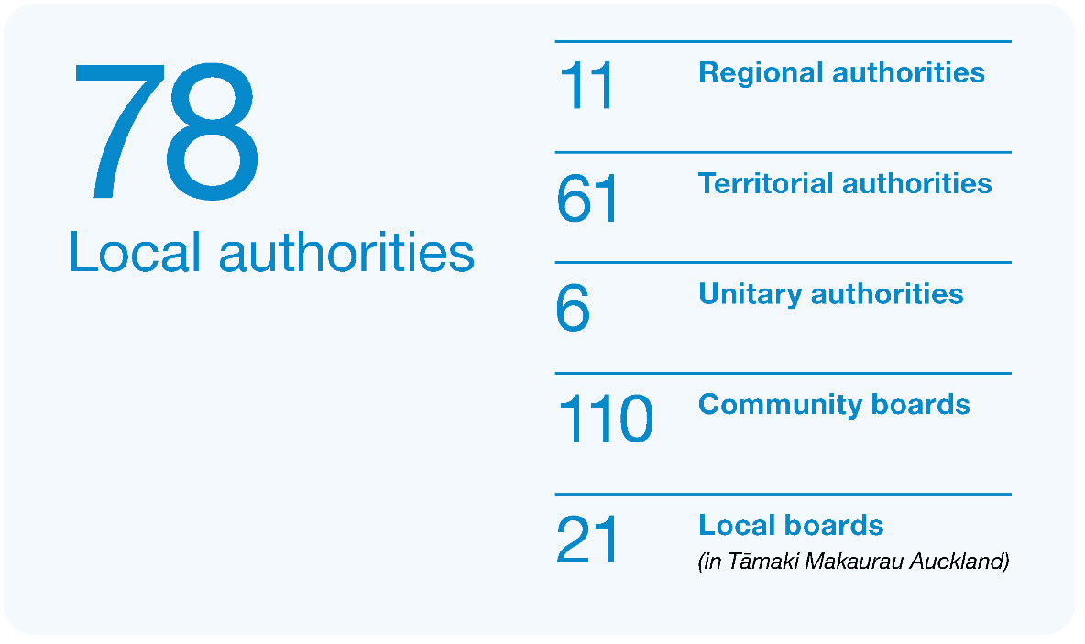

How does Aotearoa New Zealand compare internationally?
Structures of local government can be considered both in terms of the tiers of government (for example, central, regional, and territorial) and population coverage (for example, the size of the population a local council serves).
Within the OECD, there is substantial variation in how countries structure the tiers of local government. Three common ways of distributing local government across tiers internationally are:
- three tiers which can include metro/regional councils, local councils, and a form of hyper-local entities
- two tiers which can have local councils, usually accountable to regional councils
- one tier with a single unitary council.
Across OECD member countries, 23% of countries have a three-tiered system, 46% of countries have a two-tiered system and 31% have one tier of local government (OECD/UCLG 2019).
While we have regional and local councils, and a combination in unitary councils, it is not a typical two-tiered system because regional and local councils have different functional responsibilities at regional and local levels, and one is not subordinate to the other, as is common in two-tier structures (OECD/UCLG 2016). As such, it has often been described as a single-tier system with two complementary roles.
There is also significant variation in the populations that local governments serve. Some OECD countries have a large number of small local governments, where on average one local council serves 2,000 people. Others have over 200,000 people per municipal body. The OECD average was one local government entity per 39,000 people (NZIC 2022).
On average, unitary and territorial authorities serve a population of 75,000 people. However, the most common population per council is smaller, sitting between 10,000 and 50,000 people (48% of councils). Only 13% of councils are very small, with fewer than 10,000 people; and only 10% of councils are large, with populations over 100,000 people (NZIC 2022).
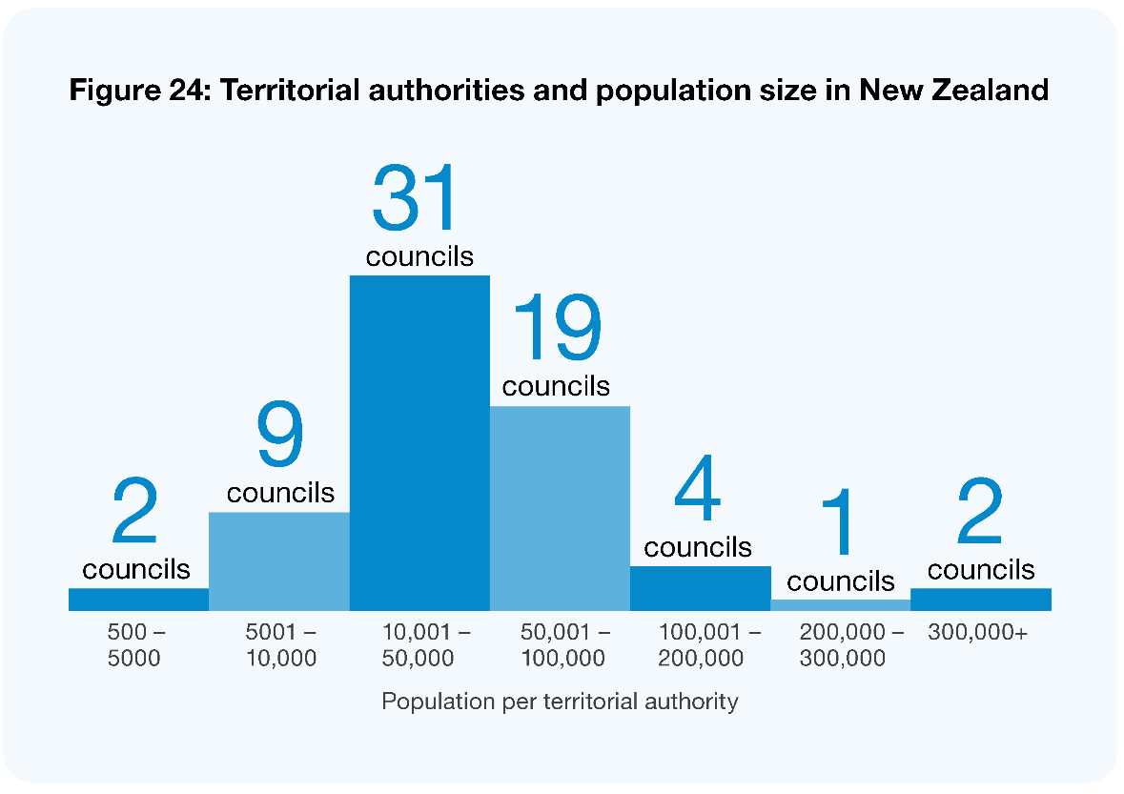
Image description: This graph shows that 2 councils have a population between 500 and 5,000; 9 councils have a population between 5,001 and 10,000; 31 councils have a population between 10,001 and 50,000; 19 councils have a population between 50,001 and 100,000; 4 councils have a population between 100,001 and 200,000; 1 council has a population between 200,000 and 300,000; and two councils have a population over 300,000.

Our current structure is not sufficient for the future
To support the future of local decision-making and enable the changes proposed in this report, we need councils that are:
- sustainable, capable, and agile institutions that are innovative and help enable communities to thrive and prosper
- aligned and work as one across the whole system, enabling effective application of resources and generation of value for communities.
At the moment, the structure of local government will not support the changes we need. There are current capacity and capability challenges which will be exacerbated as the current Resource Management and Three Waters reforms continue. The increased complexity of the business carried out by councils compared to 1989 (when the last significant structural reform occurred), and the size and scale of the challenges facing the country require different ways of working to be able to meet those challenges effectively. We want to retain and improve local decision-making, but also make the most of innovations, amplify efforts and enable resource sharing.
What we mean by local government structure
When we talk about structure in this report, we are talking about the governance and organisational arrangements that make up local government. For example, we are talking about what type of councils and other local government entities like local boards or council-controlled organisations there are, what responsibilities they have (including what roles and functions they carry out) and how members are elected or appointed.

Challenges with the current structure
We noted in our Interim Report, Ārewa ake te Kaupapa, that in the face of rising community expectations and increased regulatory requirements, local government has been under constant pressure. We have continued to hear through our engagement with stakeholders that local government is facing a range of issues, including:
- capability and capacity constraints, in particular for smaller councils, which struggle to secure the needed resources to deliver on the ever-increasing complex needs of communities now and into the future
- limited ability to respond to adverse events, such as earthquakes and floods
- funding constraints within communities, meaning needed strategic investments are deferred or not undertaken
- limited collaboration between councils resulting in high operating costs, with relatively high fixed and overhead costs
- pressures from cost increases, paired with the need for major investment to adapt and respond to climate change and respond to increasing environmental standards as well as complex social issues is resulting in financing challenges and large forecast rates increases
- local government leadership that is undervalued in building collaborative partnerships to solve complex issues.
These issues stem from a range of causes, including a complex operating environment, a disconnect in the relationship between local and central government, wide and varying practices across councils, and a lack of scale to deliver some services. In addition, central government has added significant additional responsibilities and expectations on local government over the last two decades without providing clear direction on how to carry out these functions or funding support. This has increased the complex web of legislative and regulatory requirements and complicated the operating environment. The additional responsibilities that have been added range from meeting new national freshwater management standards, which will cost billions of dollars, to achieving more sustainable, liveable cities that require massive investments to cater for growth and reshaping the current urban form.
While councils are currently struggling to meet and fund their legislative requirements and community expectations, there are also major reforms looking to change the formation of aspects of the local government system to address some of these issues. The Three Waters and Resource Management reforms will likely impact a significant proportion of what local authorities do and how they do it.
This report proposes many changes to address challenges facing, and grasp opportunities available to, local government. The proposed changes are significant. To ensure they are successful, they will need to be supported by a strong, adaptable local government system that can support the changes and embed them for the long term. We think this will require a new approach to how local government entities are structured. The current make-up of local entities will not be sufficient to support the change needed to tackle future challenges.

Principles to support future system design
The future system design of local government will need to strike a balance between centralism and localism, and:
- harness local government’s proximity to communities that gives it a unique ability to understand and act on opportunities and challenges in place
- have the ability to deal with complex, long-running challenges and to better withstand external shocks
- harness the benefits of combining resources and expertise to add more value and deliver better quality services to communities.
As a Panel, we are interested in hearing feedback during the engagement process on our draft report about the features that need to be present in a new system. We will consider the feedback we receive before deciding whether we will propose a new structure for local government or leave that to some future reform process to determine. However, we are clear that any new structure will need to have a number of features in order to support the wider changes outlined in the rest of this report.
We have developed five principles that we think should guide the design of a new local government structure – that is the entities, governance arrangements, and delegation of roles and functions. These principles set out at a high level what a new structure should enable. If local government cannot enable these outcomes, we do not consider that it will appropriately support local wellbeing and decision-making now and into the future. These five principles are interconnected and are all needed to enable communities to thrive – they will not work if adopted in isolation.

Core design principles for a new system

1 | Local  There is local place-based decision-making and leadership, and local influence on decisions made about the area at a regional and national level | The local knowledge of communities, hapū/iwi is valued and reflected in governance decisions made at a local level. This knowledge also influences and informs decisions made at a regional and national level that affect local outcomes, like strategic directions and investment approaches.
2 | Subsidiarity  Local government entities support and enable roles and functions to be allocated adopting the principle of subsidiarity | The system ensures local government entities have access to the financial resources and range of skill sets they need to effectively and sustainably carry out the roles they are allocated in line with the principle of subsidiarity. Subsidiarity means that as a starting point, local government roles and functions should be allocated to the lowest level of government possible. This idea is outlined in more detail in Chapter 4.
3 | Resourced  Local government entities have the people, skillsets and can generate the funding and have the resources needed to effectively deliver services | Local government entities have access to the skillsets they need to carry out their functions and address challenges. This includes challenges already on the radar like adapting to and mitigating climate impacts in their area and those that are yet to emerge. Entities will also need financial resources and resilience to manage risk, invest in and achieve community outcomes.
4 | Partnership  Local government entities have flexibility to partner with each other and with other parties to share decision-making and delivery of services, in order to advance community outcomes effectively and efficiently | Local government entities will have flexibility in the way they use resources to deliver and influence local services. They will be able to easily work together and with others where appropriate. Different types of shared governance that reflect local contexts will be available such as co-governance, subsidiaries, and collaborative partnerships.
5 | Economies of scope  Local government entities make use of economies of scope and combine resources and expertise where appropriate to ensure services and functions are delivered to a high standard | The system enables local government entities to work together and with other organisations to be more productive. This will enable them to carry out their roles and functions in a way that delivers best value while being supported by competent and capable people, processes, and systems.

Any future system design needs to be Tiriti-consistent
In addition to these principles, Tiriti consistency is a fundamental parameter for any future system design. As discussed in Chapter 3, Tiriti-based framework means that any structure of local government needs to ensure the local authorities can provide opportunities for Māori to:
- engage in decision-making processes
- exercise decision-making authority
- be meaningfully involved in the design and/or delivery of local services.

Example approaches that put the design principles into practice
The principles outlined above provide a road map for how to design a future local government system that ensures flexibility and agility, prioritises sustainability and gives effect to the wider changes proposed in this report.
In order to demonstrate how the design principles could be given effect to, and what they might look like when put into practice, we have developed three examples of potential new structures. Each of these examples has some form of local and regional function, but the roles they play and governance structures vary significantly for each.
At this stage, these are not recommendations for a new structure. Instead, they aim to highlight how these principles could be applied in practice.
Example one
One council for the region supported by local or community boards
In this example, there is one single council for the region that is responsible for delivering all the local government functions.
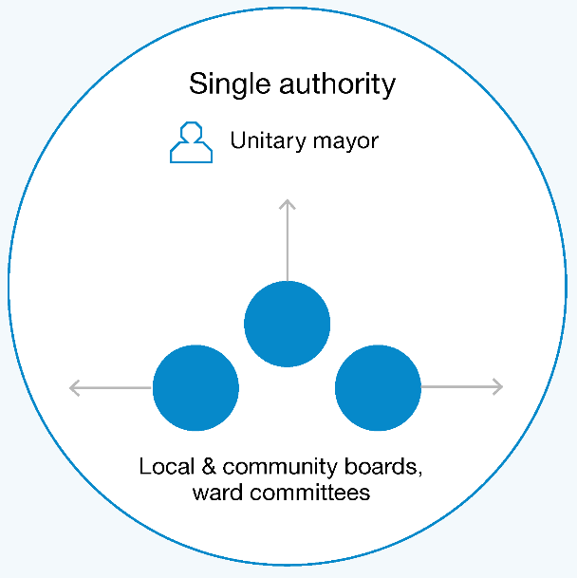 | This unitary council is accompanied by localised subsidiary entities like local boards, community boards, and ward committees, to which some roles and functions can be delegated. This model significantly simplifies the local government system with a ‘one-stop-shop’ approach that eliminates complexity and confusion across levels of government.  Of the three examples, this one would be most structurally similar to the unitary model adopted by six councils, including Auckland Council.
Functions
The unitary council would carry out or administer all roles and functions for the region, delegating specific aspects to localised entities as appropriate. This would include all current regional council and territorial authority roles and functions.
Local or community boards or ward committees would still serve a vital function under this model. They would have roles and functions delegated to them, be able to collaborate with each other, and have the unitary authority advocate for local views.
Governance
Communities would elect councillors from wards and a mayor at large who would represent the entire region. The single authority could include both Māori representatives elected under the Māori wards mechanism and any Tiriti- or capability-based appointees as discussed under the hybrid governance model discussed in Chapter 7.
Local communities would also elect members of localised entities like local boards, community boards, and/or possibly some ward committee members.
Considerations and trade-offs
The simplified structure of this example reduces complexity and confusion across levels of government and enables resources to be applied effectively for the benefit of communities. It creates a strong, unified local government for an area. There is also a loss of visible localised leadership, and this model has the potential to ‘blanket’ diverse communities if there is not substantive recognition of the role that subsidiary bodies should play, particularly in rural and provincial areas. Under this example, the Tiriti-based Māori appointees would be expected to represent a greater number of hapū/iwi groups. Additionally, the model will likely only be viable in regions with a minimum population between 70,000 and 100,000 people and would typically require aggregating around that critical mass.
There will be some regions where it may make sense to have a unitary council based on communities of interest and boundaries, however they may struggle due to low population size and a limited resource base. For these regions, the unitary council would need to collaborate extensively with others to ensure it has sufficient capability and capacity to operate effectively.

Example two
Local and regional councils with separate governance
In this example, there are local and regional councils that each have separate governance.
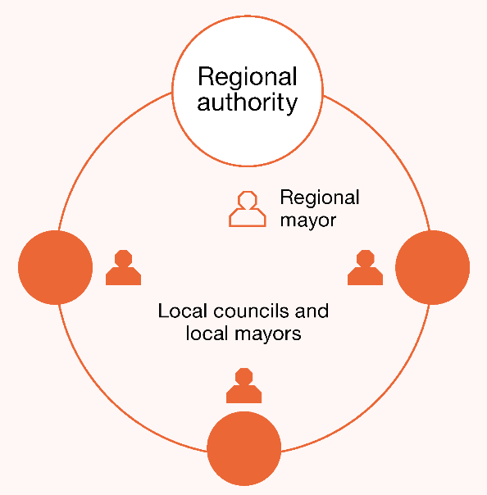 | Local councils provide local functions and services like community facilities and place-making. They also partner with local hapū/iwi, agencies, and community groups to facilitate and advocate for community wellbeing outcomes. Regional councils carry out roles that are mandated to be delivered regionally, albeit councils can transfer functions between regional and local tiers. Local communities elect councillors and a mayor to their local and the regional council. In some circumstances it may be appropriate to also have local or community boards.
Roles and functions
Local councils would be responsible for the provision of local functions. They would also partner with local hapū/iwi, agencies, and community groups to facilitate and advocate for community wellbeing outcomes.
Regional councils would carry out specifically mandated functions that are best considered to be delivered regionally. As with example one, the regional council would be responsible for current regional council functions, potentially along with greater roles in transport services, civil defence, building and consenting, and regional economic development. While independent, the regional council could also be responsible for providing ‘backbone’ support to the local authorities, as agreed.
Governance
Communities would elect councillors from wards and a mayor at large for both the local and regional councils. As with example one, the local and regional authorities would include both Māori representatives elected under the Māori wards mechanism and any Tiriti- or capability-based appointees, as discussed under the hybrid governance model discussed in Chapter 7.
Considerations and trade-offs
This example ensures that place-making can be retained in small towns and communities, while ensuring there are resources to carry out roles through their delivery at a regional level. The clear separation means it is more of a two-tier system with the regional councils potentially being seen as a more dominant form of government. The separation of governance between councils enables more direct accountability to communities; however, there may be some disconnect and tension between the two.

Example three
Local and regional councils with separate governance
In this example, there are local and combined councils that share some representation at the governance level.
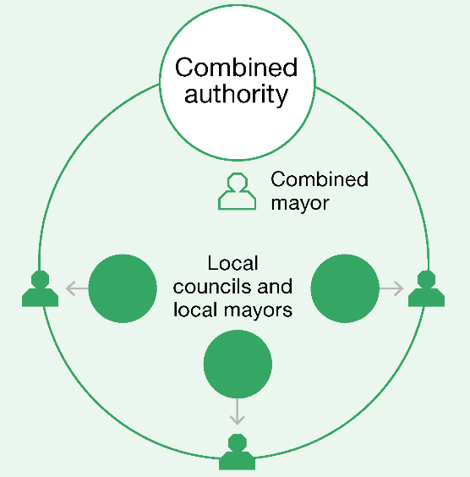 | Local councils provide place-based leadership for their local area and carry out functions that lift the wellbeing of their communities. A combined council carries out functions that affect the whole region or require specialist capability, and provides appropriate economies of scale. It also provides ‘backbone’ support for the local councils by providing shared services. Communities elect councillors and a mayor to their local council. The combined council is formed by representatives from each local council and a combined mayor, elected at the same time as local mayors and councillors. In some circumstances it may be appropriate to also have local or community boards.
Roles and functions
Local councils would focus on activities that achieve wellbeing outcomes for their communities, provide leadership on local issues, and facilitate collaboration and innovation to address opportunities and challenges in their area. This could include place-making, provision of community facilities and services, and leading place-based roles like transitioning from education to employment and social cohesion initiatives.
The combined council could carry out a range of roles and functions. Some would be legislatively specified, including the current regional council functions, potentially along with greater roles in transport services, civil defence, building and consenting and regional economic development. The local councils would be strongly encouraged to delegate other roles and responsibilities to the combined council when they agree it makes sense for these to be coordinated regionally. These functions could include providing shared support services, such as information and communication technology (ICT) and corporate services and would be funded from a levy on local councils. The combined council would work with central government and hapū/iwi, business, and community to determine regional outcomes and priorities and make co-investment decisions, with input from the local councils.
Governance
Local communities would elect councillors and a mayor to their local council. As with the two previous examples, Māori representatives can be elected under the Māori wards mechanism, as well as any Tiriti- and capability-based appointees as proposed under the hybrid governance model discussed in Chapter 7.
A representative from each local council (potentially the mayor) would be on the combined council, along with a combined mayor. The mayor would be the only member elected to the combined council as part of the local election process. This model is similar to the Greater Manchester Combined Authority.
While the detailed provisions would need to be carefully considered and developed, we anticipate under this example that:
- public accountability (for example, through voting) would be via the local councils
- the combined council would prepare its own strategic and annual plans, accompanied by an audited annual report
- major regional decisions, such as the adoption of strategic and annual plans and levy decisions, require super majority support
- levies would be charged to local councils (based on population and other factors, such as deprivation) to recover the combined council’s cost of operating (after deducting grants and other income streams).
Considerations and trade-offs
This model aims to retain the best of ‘local’ and ‘regional’, enabling decision-making close to local communities while facilitating region-wide delivery of some services that benefit from the combining of resources. It brings the local and regional tiers of local governance closer together by having shared representatives and more aligned decision-making. However, the model does present challenges with ensuring that combined councils are accountable to local communities, as their members (other than the mayor) will not be directly elected by the region.

Local and community boards
110 | Community boards  Community boards were created by the local government boards in 1989. Some 110 community boards now operate in both urban and rural areas within local authorities throughout Aotearoa New Zealand. They carry out functions and exercise those powers delegated to them by their councils (LGNZ nd).
21 | Local boards  Local boards provide governance at the local level within Auckland Council. They enable democratic decision-making by and on behalf of community within the local board area.  There are 21 local boards with between five and nine members elected to each board (149 local board members in total).  Local boards are charged with decision-making on local issues activities and services, and provide input into regional strategies, policies, plans and decisions (Auckland Council nd).

Enabling flexibility and agility
A future system for local government needs to be able to support the full spectrum of communities. There are wide variations in the size and composition of communities from our largest city, Auckland, with a population of over 1.7 million, to the Chatham Islands, which has a council that represents about 600 people. The three example models will impact communities in different ways, and these impacts will need to be considered in decisions about future structure. Each of these examples will require consideration of communities of interests and different boundaries, including the rohe boundaries of hapū/iwi.
As we stated in our Interim Report, Ārewa ake te Kaupapa, any new local government system should be flexible and agile enough to meet the needs of diverse communities and circumstances. A one-size-fits-all approach to roles, functions, and governance arrangements is unlikely to meet the needs of all communities. We have continued to hear about the importance of flexibility and agility from stakeholders over the last few months and have considered the best way this can be embedded into a future system. While enabling flexibility can potentially be done in many ways, different approaches come with different trade-offs. For example, some approaches may enable significant flexibility but may add significant complexity.
We consider that flexibility could be embedded in governance or delivery arrangements (or a mix of both). This could be done in a number of ways. For example, flexibility in delivery could mean different entities and communities have the ability to undertake different roles and functions than their counterparts. Flexibility in governance could mean different entities have different structures and governance arrangements depending on local circumstances, with different models implemented in different areas. These issues will need consideration as part of any future reform programme.
We welcome any feedback on the best way to enable flexibility in a future structure, and whether it is feasible or desirable to accommodate more than one organisational form within Aotearoa New Zealand’s system of local government.

Increasing collaboration and shared services
No matter what the future system design looks like in terms of form, we consider that there fundamentally needs to be greater collaboration across local government and increased use of shared services.

There are a range of arrangements already in place across local government
The local government sector has expressed a desire to collaborate rather than compete, with a spectrum of current arrangements and mechanisms already in place, some of which are effective and some of which are not. Many councils already come together for different reasons, usually through holding fora to discuss cross-cutting priorities or sharing services across councils.

Cross-cutting regional priorities
Arrangements such as mayoral fora allow councils to discuss regional priorities, overlapping regional issues and ways to share best practice in these areas. These fora are made up of local mayors and the regional council chair, and aim to improve joint planning, economic development, and local government efficiency generally. Through the fora, mayors and chairs usually agree on priority workstreams. For example, the Wellington Mayoral Forum is currently focusing on reviewing the funding of Wellington’s regional amenities.
For specific issues like urban growth and development, some councils have also established programmes like Urban Growth Partnerships with iwi and central government to coordinate and prioritise growth in an area. Currently there are six urban growth partnerships.

Sharing of services
In some areas, councils also look to share services like procurement, information management, or call centre support when it makes sense to do so. In some areas this is done through a Local Authority Shared Services (LASS) entity which provides mechanisms to develop and procure services across an area. For example, as part of a LASS in the Waikato there is the Waikato Building Consent Group, a collaborative cluster of eight councils which aims to foster cooperation and consistency in building control functions, processes, and documentation.
In other areas, shared service delivery entities are used to provide specific services to their shareholding councils. For example, Transwaste Canterbury provides waste services to the local councils and private sector. There are also a number of regional economic development and tourism agencies that provide services on behalf of councils to their local communities.
The Local Government Funding Agency is an institution that councils can join to secure finance (borrowing) at very competitive rates. Civic Financial Services is another entity that provides collective mutual insurance to member councils for natural disasters and professional indemnity, as well as offering KiwiSaver services to council employees.

However, there are challenges in embedding the sharing of services
Even though there are a number of arrangements in place for councils to share services and learnings (as described above), this is not the case across the board or embedded at a system level. This results in missed opportunities to innovate, change behaviour, and create scale to invest in new systems and capability. This can mean it is difficult for the community to see and realise the benefits of new ideas and approaches that have been actively explored and tested and are ready for adoption.
For example, even with the collaborative efforts mentioned above, there has been minimal attention on investing in common systems and capability across the sector, including digital and data architectures and resulting services and systems. While central government agencies face similar issues, local government does not have either the executive or the political centre to provide a strong authorising environment for systemic change.
However, these are symptoms of a wider context and drivers in which local government operates, impacting the ability of the sector to effectively collaborate and deliver best value for their communities. For example, due to current operating environments, public accountability, and perception, councils face a number of challenges.
- Councils can find it challenging to prioritise projects that enhance organisation systems and capability over more public-facing investments. This leads to them lacking the capability to maintain existing levels of service and an inability to scale up activity efficiently for new services.
- Efforts are largely driven by a ‘coalition of the willing’ with limited incentives to advance opportunities that do not align. While a coalition of the willing is useful, this can result in missing the advantages of network (scaling) effects due to the absence of key participants.
- There are concerns that proposals that see functions or services being transferred elsewhere can result in a loss, or perceived loss, of local service delivery or autonomy.
- Councils do not have the mandate or resources to invest in initiatives for the greater good, therefore initiatives can flounder for lack of financial support.
- There is a perception that a move to common systems will require a whole new investment, and for those councils that have made recent ICT improvements, that could mean that they do not achieve the expected return.
- Councils also have different investment cycles which are difficult to align for significant investments such as technology and communication changes. This can create inefficiencies and duplication of resources.

There are opportunities that can be harnessed now
The Panel has identified an opportunity for common systems and greater standardisation across local government, in both back office corporate functions and business customer facing systems, including:
- digital, data, and information services
- communication and engagement processes, systems, and expertise
- finance and corporate services support
- human resource practices including policy development, recruitment, and training
- customer support functions, including after-hours support facilities and property management
- emergency management.
As mentioned above we acknowledge that there is currently no sector-wide systems architecture, channel strategy or customer strategy to align investment. While these investments take time, we do see opportunities for immediate change, with overlaps and synergies with the approach central government is taking, especially regarding digital, collaboration, and co-investment.

Joined-up investment in ICT is a particularly significant opportunity
One of the biggest opportunities to address is joining up ICT investment, with benefits including:
- reduced cost of information and data (including its collection, storage, and use)
- more effective and efficient customer service offerings
- more secure systems that are less vulnerable to breaches
- improved monitoring of environmental impacts based on integrated data systems.
There are currently 78 bespoke ICT arrangements across local government – no two councils have the same business process or systems. Lack of shared vision, challenges bringing councils together to create scale that makes investment more affordable, and the capital required for improving systems all prevent closer collaboration across councils in ICT.
Some councils use shared applications such as Regional Software Holdings Limited. Many councils are also part of group purchasing or consortium arrangements in providing library services: 43 councils are part of the Kōtui Consortium for library service products and 55 councils provide library Internet services to their communities using a common platform and hardware solution, Aotearoa Peoples’ Network Kaharoa. Both rely on the Department of Internal Affairs (DIA) acting through the National Library to coordinate procurement and support. Some councils use the same systems for resource consenting applications, such as GIS-enabled ePlans. However, there is no consistency across the country. For example, only a handful of local authorities in Aotearoa New Zealand offer fully dynamic web-based resource consent application forms.
In our Interim Report, Ārewa ake te Kaupapa, the Panel highlighted the potential for work to start thinking about a stocktake of existing systems and preparation of a roadmap for transition with an appropriate business case. The case for investing in ICT at scale (club funding) is strong for local government. We have since commissioned CoDigital, digital consultancy firm, to advance the thinking further. The Panel shared an approach for ICT co-investment with Taituarā, Digital Government Leadership Group, the Resource Management Reforms Group at the Ministry for the Environment, and the Three Waters Team at DIA. There is potential to meet multiple ICT objectives for local government by working together across these parties. However, time is of the essence, and this work would need a champion or champions in order to progress meaningfully. We note that this work started in 2018 with the launch of the Digital Local Government Partnership (Curran 2018).
Joining up services across councils is one consideration as part of the wider digital transformation journey for local government. Other aspects will include understanding the ‘why’ of becoming a digital council, the possibilities, barriers, and required mindset shifts.
The CoDigital report provides a problem definition and some potential options for addressing these challenges, such as creating centres of excellence. We see this as a good starting point for the sector. Below is an extract of CoDigital’s findings. The full report can be found on the Future for Local Government Review’s website.
Key findings from the CoDigital review
The timing is great
People/citizens are more ready now than ever before for digital channels of engagement with local government. The experience of the Covid-19 pandemic has brought a sea change for people transacting and connecting in a digital way, including influencing the ways people prefer to work.
There are overlaps and synergies with the approach central government agencies are taking to deliver more joined-up, digital services. Collaboration and co-investment between central and local government should be encouraged. For the average citizen, there is no distinction between central and local government.
Build on what local government already does well
Libraries are a stellar example of how councils have used their collaborative power to build foundational community resources. Libraries have been leading the way not only in common business systems, but also in enabling access, inclusion, and community capability in digital systems – they are a key resource that local government provides and can leverage for wider impact.
Shared systems are needed to drive lasting change
A major obstacle to digital transformation across councils is the lack of scale within each individual council. For example, very few councils process more than 1,000 resource consents a year. As a single council, the business justification to invest in more integrated and efficient infrastructure is not present. In order to incentivise modernisation to improve citizens’ experiences in transacting with councils, shared systems are needed by councils.
What direction should action take?
Creating a more supportive leadership culture
Appoint digitally aware leaders with a vision to change and the energy to actively support those in their councils who can lead change.
Digital capability and know-how
Increase digital service delivery capabilities and consider public-private partnerships to enhance staff skillsets.
Data and digital investment and integration
Identify clear alignment opportunities and start there, potentially through a centre for digital excellence for councils.
Key alignments and opportunities
Leverage current needs
Use the digital changes from Resource Management reforms to build joined-up systems in some areas across central and local government.
Cultural inclusion is a must
Digital technology can help revitalise cultural identity and wellbeing by improving accessibility and the protection of mātauranga for those who want it.
Data collection and use
Integrated, co-designed systems will enhance the use of shared data, such as that needed for the Resource Management reforms.
Share and build on the Digital Strategy for Aotearoa
Focus on the pillars of Mahi Tika (Trust), Mahi Tahi (Inclusion), and Mahi Ake (Growth).

There needs to be support for this change
For the local government sector to make the changes proposed, it needs the space, resources, expertise, and mindsets to start the process, with a clear programme and roadmap that recognises the steps and processes that needed to be taken.
We think that local government sector leaders (both elected members and executives) need to be strong advocates for change, and the sector needs to invest in this. However, it also needs strong support from central government. The Panel considers that in the current environment, local government, supported by central government, needs to invest in a programme that identifies and implements the opportunities for greater shared services collaboration.
There are also risks of not moving fast enough, including security risks in aging assurance infrastructure; information loss through non-transferrable data formats; and growing expectation gap between citizen expectations and local government delivery.
However, we are conscious that one of the biggest challenges for the sector to commence a major change programme is the size of the investment and the willingness of the sector to participate. As mentioned above, that is often why collaboration efforts are led by those who are passionate, with the gains often being incremental and small compared to the overall sector potential.
It is going to take some years and a lot of sustained energy to deliver the level of change required. While the Panel acknowledges that some changes will be dependent on the shape of wider sector reform signalled in this report, work considering how a joined-up digital partnership for local government can be advanced should start now.

Fundamental shift towards a unified public service
As well as the sharing of services, there is also a need to shift the way in which skills and learnings can be shared – not only across local government, but between local and central government. Fundamentally, there needs to be a more deliberate shift towards a joined-up public service across central and local government. This builds on the system stewardship discussion in Chapter 10.
This means an integrated system where staff exchanges, training and development, recruitment, sharing and providing tikanga and cultural advice is common practice. For example, there are opportunities to broker mobility through secondments, potentially through the Leadership Development Centre.

Recommendations
- That central and local government explore and agree to a new Tiriti-consistent structural and system design that will give effect to the design principles.
- That local government, supported by central government, invests in a programme that identifies and implements the opportunities for greater shared services collaboration.
- That local government establishes a Local Government Digital Partnership to develop a digital transformation roadmap for local government.
Questions
- What other design principles, if any, need to be considered?
- What feedback have you got on the structural examples presented in the report?

System stewardship and support

Effective system stewardship is needed to embed, drive, and support the system of local government to be successful and to navigate and adapt to change over the next 30 years.

Key findings
Currently system stewardship is delivered through a range of ways across central and local government including the Minister of Local Government, the Secretary for Local Government, and entities such as the Local Government Commission, LGNZ and Taituarā. The investment made in the system is small relative to the overall size of local government.
There needs to be an approach to identifying opportunities and facilitating action for system-wide improvement. The architecture, relationships and enabling conditions need review, so that all actors are aligned towards the system outcomes that maximise its strengths, resources, and collective effort.

Overview
The shifts across the local government system being proposed in this report are significant. To ensure the local government sector can make the changes necessary and support communities over the long term to address challenges and achieve wellbeing outcomes, there needs to be strong stewardship of the local government system.
Local government stewardship – that is, the responsibility for the long-term quality, sustainability, and outcomes of the system – is currently provided by people and organisations in central and local government. At a central government level, this primarily includes the Minister of Local Government (the Minister), the Department of Internal Affairs (DIA) (along with the Secretary of Local Government) and the Local Government Commission (LGC). At a local government level, membership organisations Local Government New Zealand (LGNZ) and Taituarā have important roles. We consider both local and central actors need to be involved in stewardship in the long term.
While there are strengths to the current approach, we consider there are gaps and limitations, and that significant change is needed to support the shifts proposed in this report. In particular, we consider that a specified stewardship function is required that can support the system holistically in the long term.
This chapter sets out the current state of local government stewardship, the limitations of this approach, what a stewardship function would include, and questions for consideration. We want to hear from you about who is well placed to carry out the roles within this function and what is needed for it to succeed. Between the draft and final reports, there is an opportunity to develop potential options for strengthening the stewardship and support system for local government.

What do we mean by system stewardship?
When we talk about system stewardship for local government, we are talking about guiding and supporting councils and the wider local government system to be the very best they can be. Effective stewardship focuses on the relational (people) aspects of a system, processes, and enabling conditions needed to ensure all actors are aligned towards the system outcomes.
Effective local government stewardship allows the system to continually develop and adjust to an ever-changing world. It is about acting upon the understanding that leadership is a temporary role which is outlasted by the lifespan of an organisation. Leaders are performing the act of stewardship whenever they are actively preparing for the system and councils’ future vitality.
A local government system stewardship function actively promotes and cares for local government, including:
- oversight and monitoring of relevant legislation administered by agencies
- care for the system’s long-term capability and people
- maintenance and enhancement of institutional knowledge and information
- supporting partnerships, co-design, and innovation.
Both local and central government actors have roles in the stewardship of the local government system. For local government, there is need for stewardship at all levels:
- at a council governance level, leaders need to ensure their organisations and people have the capability to work effectively for current and future generations and that councils receive free, frank, expert advice
- at a general council level, all actors work towards the broader goals, which can mean putting aside individual interests for the greater good, or perhaps taking on accountabilities outside the normal scope of their role
- at system level, there needs to be effort put into driving the capabilities, processes, and actions that will lift performance across local government and maximise its strengths, resources, and collective impact.
Central government entities also have a role to ensure that there is appropriate legislation and regulatory powers, along with sufficient checks and balances, in place. These roles are undertaken by Parliament, the Minister, and other independent agencies, such as the LGC, the Auditor-General and the Ombudsman.
System stewardship for local government should also include taking a view across the whole sector – working with central government agencies to deliver; identifying where things need to change; and what needs to happen to achieve a step change in the quality of local government services and the outcomes local government seeks to achieve for citizens and communities.

The current system of stewardship for local government
There are layers of stewardship with distinct roles that enable and support the current system of local government. Central government actors and organisations with stewardship roles include the Minister, the DIA, and LGC. Local government organisations with stewardship responsibilities include bodies like LGNZ and Taituarā. As mentioned above, system stewardship is not, and cannot be, just the responsibility of central government.

Central government’s role
Within central government, the Minister has key stewardship roles, which includes having oversight or responsibility for:
- setting and maintaining the constitutional and statutory framework for local government
- promoting a constructive, meaningful relationship between local and central government
- monitoring and reviewing the system
- considering or exercising intervention powers where necessary.
The Minister is supported by DIA, whose chief executive also holds the role of Secretary for Local Government and is the regulatory steward of the local government system. As an agency, DIA therefore has the closest central government relationship with local government and is responsible for administering the Local Government Act 2002 (LGA) and providing policy advice to the Minister.
In addition, there are many other agencies which have roles that intersect with, and have influence on local government through:
- being directly responsible for the administration of legislation that impacts the roles and functions undertaken by local government (such as the Ministry for the Environment, which is responsible for the legislation that provides for planning roles and functions under the Resource Management Act 1991)
- having oversight of systems that rely on councils to be well-functioning (such as the Ministry of Housing and Urban Development, which is focused on the enablement of urban development).
The LGC is an independent statutory body empowered by the LGA that also plays a stewardship role at the central level. The LGC currently comprises three members – appointed by the Minister and supporting staff. Its purpose is to promote good local government in Aotearoa New Zealand. To do this, it has functions, such as leading:
- appeals and objections against final local authority representation review proposals
- initiatives and requests for an investigation relating to reorganisations
- responses to requests for district councils to become city councils.
In part, the LGC carries out its role by providing information about local government and promoting good practice relating to a local authority or to local government generally. There are also other specific functions and activities the LGC may undertake at its own discretion or as directed by the Minister on matters relating to a local authority or local government.

Local government’s role

Local Government New Zealand and Taituarā
In addition to councils themselves, there are two main local government centralised entities that have a role in system stewardship at the system level: LGNZ and Taituarā – both funded primarily through membership fees.
LGNZ is an organisation that provides support and advocacy for councils and is primarily focused on elected members. LGNZ’s services include:
- mechanisms to maintain a relationship with central government on behalf of local government, such as through the Central Government Local Government Forum
- fora for different local government sectors (regional, metros, rural, provincial councils, and zones) to come together to discuss matters of common interest and advance issues on their behalf
- national advocacy for councils and coordinating insights and influence on government policy
- training and development for elected members, including conferences.
Taituarā is an organisation for local government professionals (staff) with the purpose of promoting and supporting professional management in local government. Their services include:
- training and development for staff, as well as conferences and fora to explore and discuss new ideas
- best practice guidance on the conduct of local government business, such as long-term planning, funding and financing, rating, and local elections
- advice and coordination relating to workplace practices, including recruitment and retention.
LGNZ and Taituarā also play a strong sector leadership role in facilitating processes to support a ‘sector voice’ that responds to central government policies and any changes that impact local government. Taituarā tends to focus on practical implementation issues associated with policy; LGNZ focuses on the policy merits of proposals.
LGNZ in particular also has a number of subcommittees which have specific roles in advocating for and representing different voices of the sector. These include:
- Te Maruatā which among other roles, provides for Māori input on development of future policies or legislation relating to local government
- the Young Elected Members Committee that provides advice to the LGNZ National Council on any relevant matters
- the Community Boards Executive Committee which represents all the community boards in Aotearoa New Zealand as an advisory committee.
The support LGNZ and Taituarā provide continues to evolve as the challenges and operating environment of local government changes. For example, LGNZ has recently announced that it is putting in place a support system for Māori elected members, particularly those who will be elected to new Māori Wards in the 2022 local body elections.

Challenges of current stewardship arrangements

Current central government stewardship arrangements do not bring coherence to the system
As outlined above and in Chapter 6, there are many central government agencies who have a direct impact on local government but who are not coordinated effectively. Fundamentally, the nature and organisation of central government means there is a complex and overlapping web of responsibilities and interests in local government, with multiple agencies and ministers placing demands on local government, often without an awareness of the collective impact or supported by resource to reflect increased responsibilities. While DIA has a role in steering greater coordination across agencies, there are limitations in both mandate and resource.
This complexity presents challenges for local government. When actions are not aligned across central government agencies, the friction and impact of this affects local government most adversely. This can have negative consequences for local government coordination, expectations, and the associated funding implications.
The current statutory LGA intervention model does not provide a spectrum of options for the Minister to address an issue with council performance. The system would benefit from intervention options short of appointing commissioners that can address any performance issues while preserving the intent of local democracy.

Local government entities face some stewardship challenges
Local government entities such as LGNZ and Taituarā have facilitated and supported many of the significant improvements to practice over the last two decades. They have also been a critical repository of knowledge and a ‘bridge’ into the system for central government. However, they face inherent challenges as system leaders (being a membership-based organisation) in retaining membership and funding.
Entities like these are an essential part of a successful system. The Panel considers that there is significant need for strong sector leadership through any subsequent change programme, with LGNZ and Taituarā well placed to play a greater role. However, consideration needs to be given to whether their current structure and institutional arrangements are sufficient for the future given the changes signalled in this report.

Achieving effective system stewardship
The Panel has considered what is needed to ensure there is effective long-term stewardship of the local government sector, taking the current challenges into consideration.

A nationally coordinated stewardship function is needed
At the system level, we consider there needs to be a nationally coordinated stewardship function that builds on current roles undertaken across central and local government. Part of a steward’s role needs to focus on coordination and policy coherence across the central government agencies that have relationships with local government, as well as between the tiers of local government. Another part of this function will be supporting the visibility of central government activity that impacts local government, including changes to legislation and key developments in public service provision. This includes allowing for understanding all the ways in which central government activity is impacting the system of local government, prioritising strategic issues across the landscape, and ensuring timely advice is provided to effect change.
To carry out these roles, stewards must have the status and authority to convene multiple central government agencies to resolve strategic policy or cross-cutting issues in the relationship between central and local government. This includes significant questions about securing the role of local government in the design or commissioning of centrally held or funded services at place.
There is also a role for central government working in collaboration with the local government sector to proactively monitor and review the system to ensure it is fit for purpose. The steward should have the ability to act on or ensure solutions to identified problems and opportunities in the system design. This is also about all parties working together to ensure that the system has accurate information.
Stewardship should drive greater knowledge and practice of local governance, and cultural build (better attitudes and behaviour towards local government) within central government agencies.
A key part of the stewardship function is about setting standards for integrity and conduct, the service values for local government, and oversight of their application. These standards apply to all local government elected and appointed representatives and staff, including controlled organisations. Stewards set (and sometimes vary) these standards in light of the legal, commercial, or operational context.

Roles within the stewardship function
To achieve this, there needs to be a strong system stewardship function that cares for the health of the system and undertakes the areas of action described above.
Within their current resources and mandates, we do not consider the existing sector roles and organisations (such as the Secretary of Local Government and DIA, the LGC, Taituarā and LGNZ) can maintain the status, authority, or capability to achieve the above functions. In particular, while there is currently regulatory stewardship, we are concerned about the lack of system stewardship in relation to local government across central government, and the limited inclusion of local government and hapū/iwi in this function.
We consider that central government, with local government and hapū/iwi need to determine the best way to develop local government models of system stewardship to ensure all actors are working towards the same outcomes for communities. This includes considering which actor/s are best placed to play local government system steward roles. These roles proactively promote and care for the health of the local government system.
As above, we do not consider this function can be completely led by central government, and consideration needs to be given to the role of local government and hapū/iwi, as well as consideration of whether greater independence is needed from central government in this role (such as through further removed central government entities such as the LGC). We also note that consideration needs to be given to how the local government system is considered at the policy and funding level within central government, as well as the role of a more independent and non-political steward.

Embedding Te Tiriti in local government system stewardship
In Chapter 3 we outlined the need to truly provide for a Tiriti-based partnership at all levels of the system. This includes considering and providing for the role and influence of Māori at the system stewardship level.
While central and local government actors are already taking steps to strengthen local government’s relationships with hapū/iwi and Māori (for example Te Maruata as mentioned above) we do see a greater opportunity for Māori at the system level and consider that this could potentially be formalised through an independent advisory role. We see this opportunity being critical to:
- ensuring there is a Māori perspective represented in system stewardship
- providing advice and support during the system wide uplift of capability, capacity and system changes recommended in this report across the sector
- supporting Te Maruata members and Māori wards to navigate the change
- tracking the change and effectiveness of change proposed across the sector. This would better inform a national picture, enable more efficient sharing of learnings, and promote progress more generally.
We seek your feedback on how to embed Te Tiriti in local government system stewardship.
Recommendation
- That central and local government considers the best model of stewardship and which entities are best placed to play system stewardship roles in a revised system of local government.
Questions
- How can system stewardship be reimagined so that it is led across local government, hapū/iwi, and central government?
- How do we embed Te Tiriti in local government system stewardship?
- How should the roles and responsibilities of ‘stewardship’ organisations (including the Secretary of Local Government (Department of Internal Affairs), the Local Government Commission, LGNZ, and Taituarā) evolve and change?

The pathway forward

This chapter briefly discusses a pathway forward for the changes proposed in this report, including the process for reform and providing clarity on the purpose of local government. At the end of this chapter, we also outline some of the areas that while important, have not been discussed as part of this report and will be covered in the final report.
Cultural shifts across the system
The changes proposed in this report will not be successful unless there is a significant shift in culture across all actors, including during any transition to an improved future state of local government. We consider that there are a number of mindsets, behaviours, and practices that enable local government to activate the new roles described. These include:
- developing leadership, cultures, and behaviours that put Papatūānuku, people and community at the heart of councils’ work
- central government valuing and seeking local government as a wellbeing partner
- building and investing in the capability of leaders who are comfortable working in relationship-based ways to engage and deliver that span central and local government, hapū/iwi, and the broader community
- giving effect to the importance of embedding te ao Māori and the place of Te Tiriti in building an authentic partnership and ensuring this is enacted in daily practice
- acknowledging the power of people in place and valuing civic participation, civic innovation, and wellbeing
- developing an equity and wellbeing mindset, taking a system-wide approach that recognises both the complexity of issues and the unique local context
- ensuring that a culture of learning, innovation and entrepreneurial practice is actively shared and communicated between both the central and local government sectors
- identifying and executing new ways to create community/public value by re-framing, maximising, and connecting assets, resources, relationships, and opportunities.
Without these behavioural and cultural shifts, in the future and in the transition towards the future, the changes proposed in this report are not likely to reach their full potential.
Changing system design
The proposals in this report, if accepted, will need to be complemented by a strong process for change and system reform. As part of this, consideration will need to be given to who would lead such a change programme. This process will not just be a legislative programme, rather it will be a significant system change.
The Panel’s view is that any structural change should align with the Resource Management and Three Waters reforms (if they proceed as signalled). Structural change alone, excluding the other changes proposed across this report, would be a major reform programme.
The Panel would be interested in feedback on what factors need to be considered for a wider reform programme to be successful, but also specifically what factors need to be considered to implement structural change.
Embedding local government’s purpose
We acknowledge that local government cannot embed a wellbeing approach as outlined through the report if the purpose as set out in the Local Government Act 2002 (LGA) is subject to regular change and inconsistently given effect. The constant flux of amendments has accumulated in uncertainty that persists for many councils about how to deliver on this purpose – in particular, local government’s role in wellbeing.
We have heard from stakeholders that there needs to be greater certainty and stability around the purpose of local government, either through cross party support or constitutional change. Many people have suggested the need to clarify local government’s constitutional role to provide it with more protection, such as by:
- entrenching the constitutional status as part of the LGA
- referring to local government in a written constitution or in an amendment to the Constitution Act 1986
- establishing a Parliamentary Commissioner of Local Government – a non-political office to give effect to Parliament’s interest in New Zealand having an effective system of local government
- establishing cross-party support for the purpose of local government.
These changes are often suggested in response to the unstable operating environment created by frequent legislative change (including to the purpose); accountability gaps between those who set the policy (central government) and those who bear the effects and costs (local government); and overlapping responsibilities between central and local government.
However, we think it is important to consider whether the issue is the strength of the legislation, or rather the relationships (both formal and informal) between central and local government and lack of mutual respect and understanding.
“A more productive interaction and mutual understanding [between central and local government] cannot be mandated. Rather, it is the product of a collection of experiences built up over time by leaders within both spheres of government. These positive experiences filter through organisations, influencing the behaviour of staff and changing organisational cultures.”
– New Zealand Productivity Commission (2013)
Further, as a package of recommendations, the changes proposed in this report already present significant constitutional change. Specifically, they change the relationships between central and local government and local government and citizens.
Therefore, we need to consider that the broader changes proposed in this report, particularly in Chapter 6, will go some way to address many of these concerns.
Other areas of consideration
Given the broad scope of the review, the Panel encountered many topics during the draft report process, both through research and stakeholder engagement. Not all of these were able to be discussed in this report, such as wellbeing outcome measurements across central and local government and cost implications of reform programmes. That said, we are open to receiving your feedback on any issues that we have not covered, such as future disrupters and trends.

Our engagement journey
During the Review, the Panel has engaged with and heard from local and central government; hapū/iwi and Māori organisations and rōpū; young people; diverse communities; the business sector; and others.
The Panel has met people face-to-face and online and received feedback through surveys, our online tools, social media, email, and submissions. This diagram is a snapshot of some of that work. A more detailed description of our engagement is available on our website.
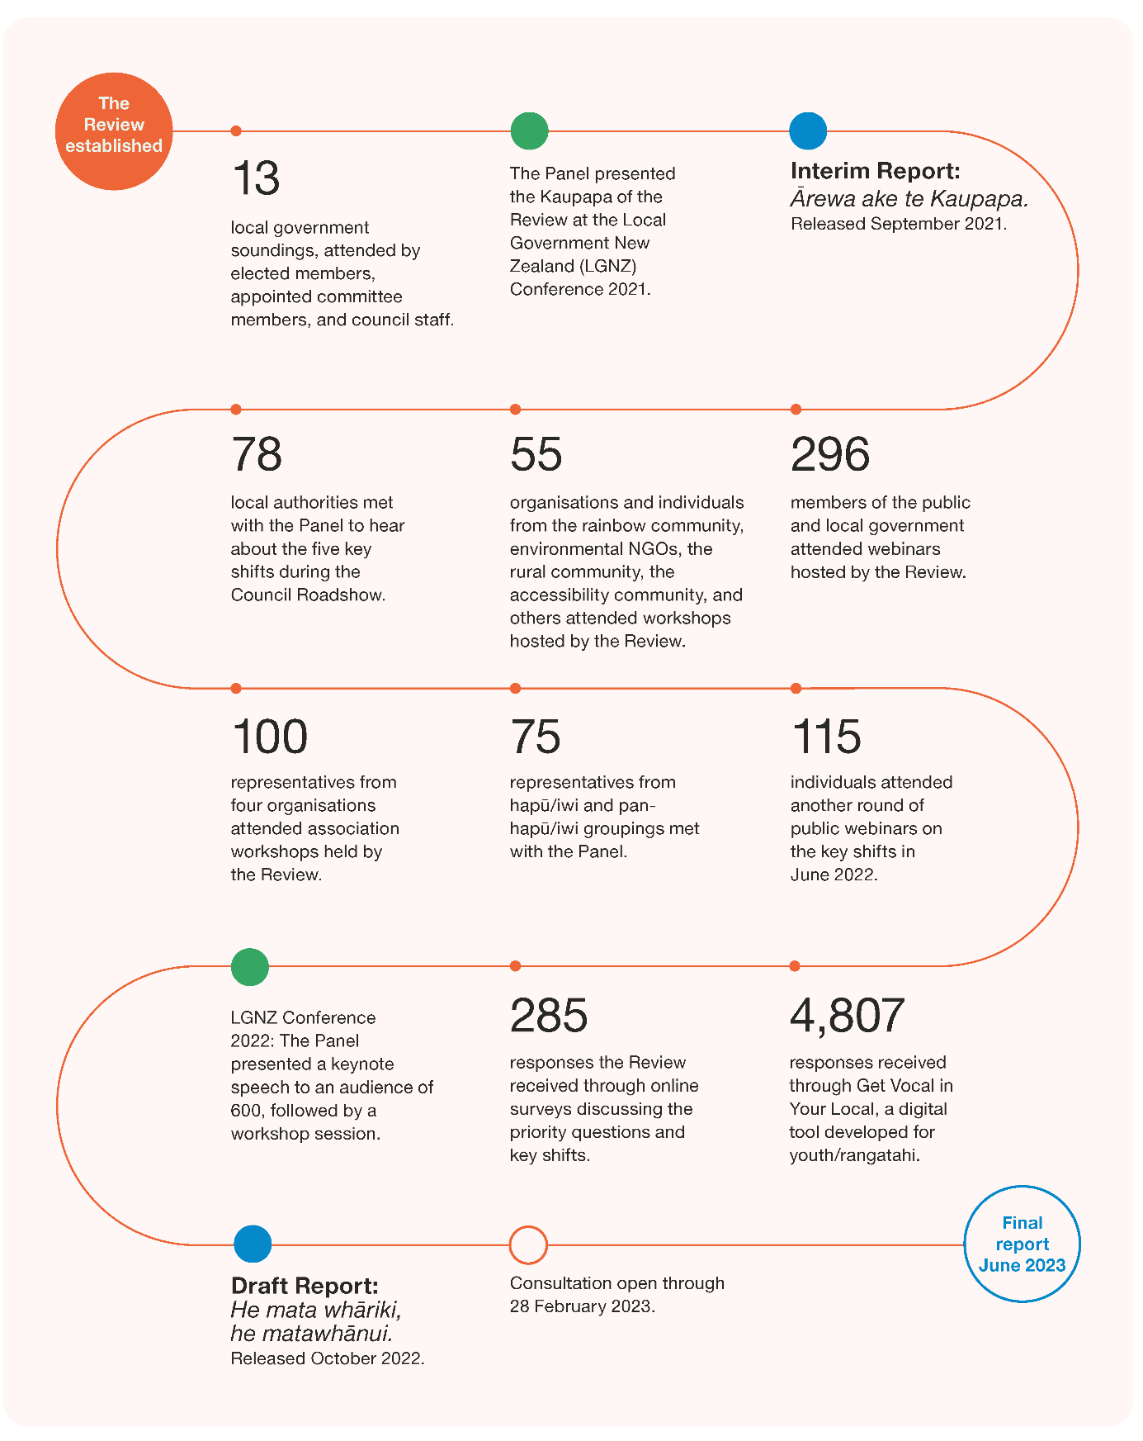
Image description: The timeline begins with the Review being established, followed by: 13 local government soundings, attended by elected members, appointed committee members, and council staff; The Panel presented the Kaupapa of the Review at the Local Government New Zealand (LGNZ) Conference 2021; Interim Report: Ārewa ake te Kaupapa released September 2021; 296 members of the public and local government attended webinars hosted by the Review; 55 organisations and individuals from the rainbow community, environmental NGOs, the rural community, the accessibility community, and others attended workshops hosted by the Review; 78 local authorities met with the Panel to hear about the five key shifts during the Council Roadshow; 100 representatives from four organisations attended association workshops held by the Review; 75 representatives from hapū/iwi and pan-hapū/iwi groupings met with the Panel; 115 individuals attended another round of public webinars on the key shifts in June 2022; 4,807 responses received through Get Vocal in Your Local, a digital tool developed for youth/rangatahi; 285 responses the Review received through online surveys discussing the priority questions and key shifts; LGNZ conference 2022: The Panel presented a keynote speech to an audience of 600, followed by a workshop session; Draft report: He Mata whāriki, he matawhānui, released October 2022; Consultation open through 28 February 2023; Final report in June 2023.

Reference groups
The Review’s terms of reference provide for the establishment of reference groups. Two of these were established during the Review’s engagement phase: a Business Reference Group and Māori Thought Leaders Rōpū.
These groups have made a great contribution to our thinking and will continue to provide the Review with advice until the release of the final report.
Business Reference Group
The Business Reference Group is made up of business leaders from across Aotearoa New Zealand, representing different industry sectors and perspectives. They are: Susan Huria, Dr Emma Saunders, David Kennedy, Leeann Watson and Kirk Hope.
Māori Thought Leaders Rōpū
The Māori Thought Leaders Rōpū has been established to offer the Review a range of perspectives on how te ao Māori and Te Tiriti o Waitangi might shape the future of local governance. They are: Sharon Shea, Glenn Wilcox, Carol Berghan and Elisapeta Heta.

Glossary
We recognise that Te Reo Māori is a taonga that requires protection and nurturing. We acknowledge that terms expressed in this report are highly contextual. The terminology defined in this glossary is relative to the content of this report and are included to support understanding, not be exhaustive in their definition. These translations are subject to constant and necessary debate, and not one that the panel has the authority or intent to remediate within this report.
Term | Description
Allocation (of roles and functions) | Who does what in the system of local government. In other words, what local government should deliver and be responsible for.
Anchor institutions | Entities like councils, hospitals, universities, faith groups or other organisations based in a town, city, or defined region with a long-term and enduring commitment and connection to the place. Anchor institutions play a vital role in local communities and economies.
Co-governance | In a local government context, co-governance is about decision-making partnerships between local government and Māori, built on trust and confidence, used to develop a vision and objectives for a Kaupapa to work together. It is about sharing information at the outset and bringing together different perspectives and knowledge systems in a conversation based on mutual recognition.  It does not mean that final decisions can or should always be made ‘jointly’ – certainty and efficiency may still mean that final decisions fall one way or another, but it does mean that a high degree of dialogue may be required before a decision can be made, or that decision-makers must strive for a consensual approach before resorting to ‘hard’ democratic mechanisms like voting.
Co-investment | An approach where central and local government align efforts to plan, fund, and execute initiatives.
Cross-boundary benefits | Benefits that accrue in one jurisdiction from activities funded and carried out in a neighbouring jurisdiction.
Deliberative democratic methods | These involve demographically representative groups selected by public lottery that weigh evidence, deliberate to find common ground, and develop an informed public judgement on a key issue which can then be directly adopted by council.
Democracy | This can be thought of as ‘power to the people’ and refers to a way of governing by public will. This means that the public are given power to rule the state, either directly or through elected representatives. Most commonly, we see this through elections, where the public vote for people to represent their interests. However, a fundamental and vital part of democracy is also the right to participate directly, not via an elected member. This is another, equally vital way power is given to the people.
Digital interfaces | Broadly understood as any computer software (including a website or applications) accessed by users.
Differentiated liberal citizenship | This concept emphasises that culture influences how people set political priorities and form views on what local government should do, and that Māori citizens are therefore entitled to make culturally distinctive contributions to council decisions or activities.
Economies of scale | When services are delivered in larger quantities, resulting in lower overhead costs (as costs are shared more widely).
Economies of scope | These can occur when services that draw on specialist skills and resources can also be used for other services, reducing cost and sharing expertise.
Electoral systems | The way in which communities are able to elect their representative. New Zealand uses two systems in local elections (see single transferrable vote and first past the post).
First past the post | Citizens have one vote, and the candidate who receives the most votes is the winner.
Fiscal equalisation | Both a mechanism and an objective. The mechanism is the process through which revenues collected by central government are distributed to local government to provide a level of fiscal autonomy for the local government. The objective is that of simultaneously allowing for different bundles of public goods and services to be selected according to local preferences whilst enabling comparable levels of public goods and services to be delivered across local government. The Waka Kotahi funding assistance rate (FAR) policy is an example of fiscal equalisation. Petrol taxes and Road User Charges are collected into the National Land Transport Fund (NLTF) and then part of the NLTF via the FAR methodology is allocated on a percentage basis to local authorities to deliver transport services and activity. The FAR system enables central and local government to achieve optimal national land transport outcomes within their combined financial resources; an integrated and appropriately consistent land transport system throughout the country; and appropriate sharing of costs and recognition of both national and local benefits from investment in the land transport system.
Function | A broad area of responsibility. This could include things like roading provisions, system stewardship, or environmental monitoring.
He Whakaputanga | He Whakaputanga o te Rangatiratanga o Nu Tireni is the Declaration of the Independence of New Zealand, signed in 1835.
Horizontal equity | The ability to achieve similar outcomes across the country, noting some regions or areas require more support than others. The equal (like) treatment of equals.
Kaitiakitanga | The exercise of Tiakitanga by the tangata whenua of an area in accordance with tikanga Māori. Commonly this is related to natural and physical resources and includes the ethic of stewardship.
Kāwanatanga | The ethic of governorship, historically derived from the term ‘Kawana’ or Governor, who in 1840 was the Crown representative in Aotearoa New Zealand who signed Te Tiriti o Waitangi. In contemporary times, Kāwanatanga refers to the Governor and authority delegated to and vested in Parliament, the judiciary, and the executive of government. Local government is often referred to by Māori as an agent of Kāwanatanga as it carries out roles and functions enshrined in legislation that give practical exercise of Te Tiriti o Waitangi at place.
Local governance | The system by which communities are governed – in essence, who makes decisions, how they are made, and who the decision-makers are accountable to. In any place or community, local governance can involve many decision-makers including central government, local authorities, hapū/iwi and Māori organisations, business and community organisations, and others.
Local government | The local authority structures established by statute.
Local government system stewardship | A function that promotes and cares for local government. This includes:  - oversight and monitoring of relevant legislation administered by agencies  - care for the systems’ long-term capability and people  - maintenance and enhancement of institutional knowledge and information  - support for partnerships, co-design, and innovation.
Local wellbeing | This covers a wide spectrum of interconnected social, cultural, economic, and environmental outcomes. It includes everything that makes a good life, not only for individuals, but also for their whānau and families, their neighbourhoods and communities, and for future generations. This includes living in a clean and healthy environment, having basic needs met, being physically safe and secure, experiencing connection with others and a sense of belonging, being able to participate and contribute, being able to express yourself and your identity, experiencing yourself as valued and valuable, and having opportunities to prosper and live to your full potential. Local wellbeing includes diverse Māori and Pacific approaches to wellbeing.
Long-Term Plan (LTP) | A 10-year plan which sets out the activities a council does and how these activities fit together. They cover what activities will be completed over the LTP’s 10-year period, why the council chose those activities, and the costs of those activities to the community.
Mātauranga Māori | This refers to the Māori way of being and engaging to examine, analyse, critique and understand the world. Mātauranga uses kawa, tikanga, values, concepts, philosophies and whakapapa, traversing contemporary and customary systems of knowledge to build understanding.
Mātāwaka | In the context of local government, this refers to Māori living in a particular rohe who are inclusive of all waka and iwi but are not mana whenua or affiliated to mana whenua.
Papatūānuku | In the creation story, Papatūānuku is the earth mother which all living things originate from.
Participatory democratic methods | These involve self-selected groups and are focused on public opinion-oriented decision-making.
Participatory democracy | The way citizens participate directly or indirectly in policies and political decisions that impact them.
Place-making | Widely understood as the process of strengthening the connection between people and the places they share, in order to maximise shared value and strengthen community identity.
Pre-Election Report | A report released by chief executives before each local body election. It outlines information to promote public discussion about the issues facing the relevant local authority.
Quora | The minimum number of people required to hold a meeting or make a decision in meetings. Normally, this is the majority of people in that group.
Rangatiratanga | A concept of political, social, and cultural authority – closely linked to self-determination – through which Māori exercise control or influence over their own institutions, communities, property, and overall wellbeing (including the public goods and services they receive for their benefit). Rangatiratanga is derived from the whenua, through hereditary interests, often whakapapa-based and/or through recognised active leadership. In terms of political authority, rangatiratanga is predominantly held and exercised by iwi and hapū.
Rates | A form of tax on property. Rate means a general rate, a targeted rate, or a uniform annual general charge that is set under the Local Government (Rating) Act 2002.
Regulatory impact assessment/statement | When there’s a proposal to create or change a policy, legislation or regulation, the government agency responsible often has to provide Cabinet with a Regulatory Impact Assessment/statement (RIA). RIAs summarise the problem that needs to be addressed; options for addressing the problem; the costs and benefits of each option; who has been consulted and their views; and proposals for implementation and review.
Remuneration | The total compensation received by a person. This includes salary, fees, superannuation, reimbursements, allowances, and benefits.
Representative democracy | This includes people elected to represent citizens.
Rohe | Can refer to an iwi boundary, traditional or customary district, geographical area, or region.
Role | The different actions or jobs that contribute to a broader function.
Single transferable vote | Citizens rank candidates in their order of preference, which transfers votes and avoids wasted ballots.
Social procurement | Happens when organisations use their purchasing power to generate social or public value beyond the value of a good or service being procured.
Sortition | A sampling technique that selects a group of people that is demographically representative of the wider population or group. It is also known as civic lottery.
Subsidiarity | A principle which means that roles and functions should be led and managed at the most appropriate local level, so that communities are empowered to shape their outcomes and take a leadership role in doing so.
System design and structure | The governance and organisational arrangements that make up local government. This includes the types of councils and other local government entities like local boards or council-controlled organisations, what responsibilities they have (including what roles and functions they carry out) and how members are elected or appointed.
Systems networkers and convenors | These connect and bring people together from across organisations, sectors and cultures, enable learning across boundaries and silos, and facilitate innovative solutions that respond to local needs.
Takiwā | Can mean a locality, district, area, region, or territory. Sometimes there are several takiwā within a rohe.
Tiakitanga | Tiakitanga is the value of guardianship, stewardship and protection.
Taura here | Meaning ‘ropes that bind’, this refers to Māori individuals or groups who join together to fulfil a common purpose to retain their identity and links back to their tribal homelands, and live outside their iwi territories.
Te Tiriti o Waitangi | In this report, we use the term ‘Te Tiriti’ to refer to Te Tiriti o Waitangi/The Treaty of Waitangi. We use ‘Te Tiriti’ to refer to the combined effect of the English and Māori texts, and how we think that impacts on the relationship between Māori and local government.
Tikanga | Refers to the Māori ways of doing things, including protocols, practices, and behaviours that make up the system of values which have been developed and embedded over time. In the context of local government decisions in accordance with the right values and processes, including in partnership with the Treaty partner.
Tikanga whakahaere | The specific exercise of rituals and practices such as karakia, whakawatea, whakatau, etc.
Tuakana-Teina | This refers to the relationship between an older (tuakana) and younger (teina) siblings and is commonly used to identify reciprocal learning between two people. The roles can switch depending on the context or situation, but refers to a learner and a teacher/mentor.
Unfunded mandate | These occur when a function or role is delegated from central to local government without associated funding.
Vertical equity | The balance between national and local funding to support community outcomes. This can be through treating groups or individuals differently based on having different needs.
Voter turnout | The proportion of all enrolled electors (both residents and ratepayers) who cast a vote.
Wāhi tapu / waahi tapu | Wāhi refers to a location or place, and tapu is commonly understood as sacred, holy or forbidden. Tapu can isolate or restrict the activities of individuals, practices and natural resources. Wāhi tapu can refer to a specific place or area that holds sacred significance.

References
Akoorie N (26 May 2021) ‘Civics and citizenship education being left to chance, expert says’, Stuff, https://www.stuff.co.nz/national/education/125243469/civics-and-citizenship-education-being-left-to-chance-expert-says, accessed 21 September 2022.
Andolina M, Jenkins K, Zukin C and Keeter S (2003) ‘Habits from Home, Lessons from School: Influences on Youth Civic Engagement’, Political Science and Politics, http://dx.doi.org/10.1017/S104909650300221X, accessed 23 September 2022.
Asquith A, Webster K and Cardow A (2021) ‘Voting in New Zealand Local Government Elections: The Need to Encourage Greater Voter Turnout’, Commonwealth Journal of Local Governance, https://doi.org/10.5130/cjlg.vi24.7541, accessed 21 September 2022.
Auckland Council (nd) He Kōrero mō ngā poari ā-rohe About local boards, https://www.aucklandcouncil.govt.nz/about-auckland-council/how-auckland-council-works/local-boards/Pages/about-local-boards.aspx, accessed 3 October 2022.
Beca Limited (2021) Collaborative Models Report, report prepared for Review into the Future for Local Government, https://www.futureforlocalgovernment.govt.nz/assets/Uploads/Collaborative-Models-Report.pdf, accessed 21 September 2022.
Bellantoni A, Chwalisz C and Cesnulaityte I, Good Practice Principles for Deliberative Processes for Public Decision Making, OECD, https://www.oecd.org/gov/open-government/good-practice-principles-for-deliberative-processes-for-public-decision-making.pdf, accessed 21 September 2022.
Bohny S (4 September 2019) ‘More representation, education keys to boosting young voter turnout’, Stuff, https://www.stuff.co.nz/national/politics/local-body-elections/115352890/more-representation-education-keys-to-boosting-young-voter-turnout, accessed 21 September 2022.
Boorman C, Burkett I and McNeill J (2022) Anchor Approaches: Activity domains for system-level transformation, Local Government Information Unit, https://lgiu.org/briefing/anchor-approaches-activity-domains-for-system-level-transformation/, accessed 19 September 2022.
Carson L (2022) What can be learned from the implementation of the Victorian Local Government Act 2020?, newDemocracy, https://www.futureforlocalgovernment.govt.nz/assets/Uploads/RD-Note-Learnings-from-Victoria.pdf, accessed 21 September 2022.
CLES (Centre for Local Economic Strategies) Progressive procurement of goods and services https://cles.org.uk/what-is-community-wealth-building/the-principles-of-community-wealth-building/progressive-procurement-of-goods-and-services/, accessed 19 September 2022.
Crawford R and Shafiee H (2019) Scope and funding of local government: an international comparison, New Zealand Productivity Commission, https://www.productivity.govt.nz/assets/Documents/scope-and-funding-of-local-government/a383912a56/Scope-and-funding-of-local-government-an-international-comparison.pdf, accessed 20 September 2022.
Curran C (15 August 2018) Speech to the Digital Local Government Partnership launch, text available at https://www.beehive.govt.nz/speech/speech-digital-local-government-partnership-launch, accessed 29 September 2022.
DIA (Department of Internal Affairs) (2018) How digital can support participation in government, https://www.digital.govt.nz/assets/Standards-guidance/Engagement/How-digital-can-support-participation-in-government.pdf, accessed 21 September 2022.
DIA (2022) Draft Long-term Insights Briefing: Consultation document, https://www.dia.govt.nz/diawebsite.nsf/Files/Long-term-insights-briefing/$file/DRAFT-Long-term-Insights-Briefing-Department-of-Internal-Affairs-v2.pdf, accessed 21 September 2022.
DPMC (Department of Prime Minister and Cabinet) (2021) Proactive Release: Health and Disability Review Reform, https://dpmc.govt.nz/sites/default/files/2021-12/cabinet-material-health-disability-reform-nov21-updated.pdf, accessed 22 September 2022.
Dyet G (2021) ‘Keeping “placemaking” in focus through reform’, NZ Local Government Magazine, https://localgovernmentmag.co.nz/placemaking-3/, accessed 20 September 2022.
EIU (Economist Intelligence Unit) (2020) Democracy Index 2020, https://onesite.eiu.com/campaigns/democracy-index-2020/, accessed 21 September 2022.
Fensham P (2020) The right time for community wealth building reform in Australia, SGS Economics & Planning, https://www.treasury.govt.nz/sites/default/files/2017-12/hls-ag-socinfr-jan13.pdf, accessed 19 September 2022.
Fraser N and Honneth A (2003) Redistribution or Recognition? A Political-Philosophical Exchange, Verso.
Gersbach H, Jackson MO and Tejada O (2021) Optimal Term-Length and the Structure of Democracy, https://dx.doi.org/10.2139/ssrn.3615407, accessed 23 September 2022.
GWRC (Greater Wellington Regional Council) (2013) Memorandum of Partnership between Tangata Whenua ki Te Upoko o te Ika a Maui and Wellington Regional Council Te Pane Matua Taiao. https://www.gw.govt.nz/assets/Documents/2021/08/Memorandum-of-Partnership-2013.pdf, accessed 28 September 2022.
Hagen P, Tangaere A, Beaton S, Hadrup A, Taniwha-Paoo R and Te Whiu D (2021) Designing for equity and intergenerational wellbeing: Te Tokotoru, The Auckland Co-design Lab, The Southern Initiative, https://www.aucklandco-lab.nz/reports-summary/te-tokotoru, accessed 20 September 2022.
Hancock F (2018) A relational approach to community and social innovation: Practices that make a difference, Auckland Council https://knowledgeauckland.org.nz/media/1412/relational-approach-community-social-innovation-tsi-march-2019.pdf, accessed 19 September 2022.
Hart O (2016) Incomplete Contracts and Control, Nobel Prize Lecture, https://www.nobelprize.org/uploads/2018/06/hart-lecture.pdf, accessed 21 September 2022.
Hartz-Karp J and Carson L (2013) ‘Putting citizens in charge: Comparing the Australian Citizens’ Parliament and the Australia 2020 Summit’, The Australian Citizens’ Parliament and the future of deliberative democracy, Pennsylvania State Press.
House of Representatives (2021) Inquiry into the 2019 Local Elections and Liquor Licensing Trust Elections, and Recent Energy Trust Elections, https://www.parliament.nz/resource/en-NZ/SCR_112173/ac056d5bfbb02d80f3171b435891330c1ff92bb7, accessed 21 September 2022.
Huebner C (2021) ‘How Young People in Scotland Experience the Right to Vote at 16: Evidence on “Votes-at-16” in Scotland from Qualitative Work with Young People’, Parliamentary Affairs, https://doi.org/10.1093/pa/gsab017, accessed 21 September 2022.
IAP2 (International Association for Public Participation) IAP2 Spectrum of Public Participation, https://cdn.ymaws.com/www.iap2.org/resource/resmgr/pillars/Spectrum_8.5x11_Print.pdf, accessed 21 September 2022.
IIPP (Institute for Innovation and Public Purpose) (2022) Mission-oriented innovation in action: 2021 casebook, University College London, https://www.ucl.ac.uk/bartlett/public-purpose/sites/bartlett_public_purpose/files/final_moin_casebook_2021_edited_2022_updated_final.pdf, accessed 19 September 2022.
Illinois Civics Hub, Why Civics? https://www.illinoiscivics.org/about/why-civics/, accessed 23 September 2022.
IWGCT (The Independence Working Group on Constitutional Transformation) (2016) The Report of Matike Mai Aotearoa, https://nwo.org.nz/wp-content/uploads/2018/06/MatikeMaiAotearoa25Jan16.pdf, accessed 22 September 2022.
Kent E (2011) ‘Placemaking as a New Environmentalism: Reinvigorating the Environmental Movement in the 21st Century’, Project for Public Spaces, https://www.pps.org/article/placemaking-as-a-new-environmentalism, accessed 19 September 2022.
Kyrre O (2020) ‘Creative Placemaking: Using Arts & Culture for Urban Revitalization’, The Urban Condition, https://medium.com/the-urban-condition/creative-placemaking-using-arts-culture-for-urban-revitalization-623099d01220, accessed 19 September 2022.
LGC (Local Government Commission) (2021) Local Government Codes of Conduct: Report to the Minister of Local Government, Local Government Commission, https://www.lgc.govt.nz/assets/Uploads/LGC-report-to-MoLG-Local-government-codes-of-conduct-Sept-2021.pdf, accessed 21 September 2022.
LGNZ (Local Government New Zealand) (nd) Community boards, https://www.lgnz.co.nz/local-government-in-nz/community-boards/, accessed 3 October 2022.
LGNZ (2017a) Council-Māori Participation Arrangements: Information for councils and Māori when considering their arrangements to engage and work with each other, https://www.lgnz.co.nz/assets/Uploads/2dac054577/44335-LGNZ-Council-Maori-Participation-June-2017.pdf, accessed 22 September 2022.
LGNZ (2017b) New Zealand Local Government Survey 2017, https://www.lgnz.co.nz/assets/Uploads/d3464622d1/44474-LGNZ-Reputation-Report-2017-FINAL.pdf, accessed 21 September 2022.
LGNZ (2019a) Local elections 2019: Quick facts, https://www.lgnz.co.nz/assets/Elections-Fact-sheet-19.pdf, accessed 21 September 2022.
LGNZ (2019b) Local government debates remits at AGM, https://www.lgnz.co.nz/news-and-media/2019-media-releases/local-government-debates-remits-at-agm/, accessed 29 September 2022.
LGNZ (2020a) Elected members’ profile 2019-2022, https://www.lgnz.co.nz/assets/Elected-member-profile-2019-2022.pdf, accessed 21 September 2022.
LGNZ (2020b) Candidates and their views: LGNZ’s survey of candidates standing for the 2019 local authority elections, https://www.lgnz.co.nz/assets/Uploads/Candidates-Survey-Report-2019.pdf, accessed 21 September 2022.
Lyons M (2007) Place-shaping: a shared ambition for the future of local government, final report, Lyons Inquiry into Local Government.
MHUD (Ministry of Housing and Urban Development) Urban Growth Agenda, https://www.hud.govt.nz/our-work/urban-growth-agenda/, accessed 28 September 2022.
MOE (Ministry of Education) (2020) Civics and Citizenship Education: Teaching and Learning Guide, report prepared by Cognition Education for the New Zealand Ministry of Education, https://sltk-resources.tki.org.nz/assets/Uploads/Teaching-and-Learning-Guide.pdf, accessed 21 September 2022.
Neal T (13 August 2020) ‘Young councillor says four-year local government term would help oust “useless” councillors’, RNZ, https://www.rnz.co.nz/news/national/423490/young-councillor-says-four-year-local-government-term-would-help-oust-useless-councillors, accessed 21 September 2022.
Newton K (2018) ‘White noise’, RNZ, https://shorthand.radionz.co.nz/white-noise/index.html#article, accessed 5 October 2022.
Ngāti Tūrangitukua and Taupō District Council, Mana Whakahono ā Rohe, https://www.taupodc.govt.nz/repository/libraries/id:25026fn3317q9slqygym/hierarchy/Council/Committees%20and%20meetings/Mana%20Wahakahono%20A%20Rohe.pdf, accessed 28 September 2022.
NZIC (New Zealand Infrastructure Commission) (2022) Does Size Matter? The impact of local government structure on cost efficiency, https://www.tewaihanga.govt.nz/assets/Uploads/July-2022-Research-Insights-Final-1.pdf, accessed 20 September 2022.
NZPC (New Zealand Productivity Commission) (2013) Towards better local regulation, https://www.productivity.govt.nz/assets/Documents/f32eda4453/Final-report-Towards-better-local-regulation.pdf, accessed 12 October 2022.
NZPC (2019) Local government funding and financing: Final report, https://www.oecd.org/regional/regional-policy/Subnational-Governments-Around-the-World-%20Part-I.pdf, accessed 20 September 2022.
Nunns P, Whitaker E and Donovan S (2019) Social and distributional impacts of time and space-based road pricing, report prepared for the NZ Transport Agency by MRCagney Pty Ltd, https://www.nzta.govt.nz/assets/resources/research/reports/654/654-Social-and-distributional-impacts-of-time-and-space-based-road-pricing.pdf, accessed 20 September 2022.
O’Connell E, Greenaway T, Moeke T and McMeeking S (2018), He Ara Wairoa/A Pathway Towards Wellbeing (DP18/11), The Treasury, https://www.treasury.govt.nz/publications/dp/dp-18-11-html, accessed 19 September 2022.
OECD (2020) Innovative Citizen Participation and New Democratic Institutions: Catching the Deliberative Wave, OECD Publishing, https://doi.org/10.1787/339306da-en.
OECD/UCLG (2016), Subnational Governments around the world: Structure and finance, https://www.oecd.org/regional/regional-policy/Subnational-Governments-Around-the-World-%20Part-I.pdf, accessed 20 September 2022.
OECD/UCLG (2019), 2019 Report of the World Observatory on Subnational Government Finance and Investment – Key Findings, https://www.sng-wofi.org/publications/2019_SNG-WOFI_REPORT_Key_Findings.pdf, accessed 20 September 2022.
Olivershaw Limited (2022) The Future for Local Government – Study into the Principles of a High Quality Tax and Revenue System – Key Issues, report to the Review into the Future for Local Government, https://www.futureforlocalgovernment.govt.nz/assets/Uploads/Oliver-Shaw-paper-March-22.pdf, accessed 20 September 2022.
Oppenheimer J (2021) Systems convening: leadership for the 21st century, Centre for Public Impact website, https://www.centreforpublicimpact.org/insights/systems-convening-leadership-for-the-21st-century, accessed 19 September 2022.
O’Sullivan D (2022) Rangatiratanga, Citizenship, and a Crown that is ‘Māori too’: Boldness and the Future of Local Government, report prepared for the Review into the Future for Local Government, https://www.futureforlocalgovernment.govt.nz/assets/Uploads/Rangatiratanga-Citizenship-and-a-Crown-that-is-Maori-too-Final.pdf, accessed 22 September 2022.
Potaka T (1999) ‘A Treaty Agendum for Local Government’, Victoria University of Wellington Law Review. https://www.austlii.edu.au/nz/journals/VUWLawRw/1999/13.html, accessed 28 September 2022.
RLC (Rotorua Lakes Council) (2015) Manatu Whakaaetanga Partnership Agreement, https://www.gw.govt.nz/assets/Documents/2021/08/Memorandum-of-Partnership-2013.pdf, accessed 28 September 2022.
Sense Partners (2021) New Zealand’s infrastructure challenge: Quantifying the gap and path to close it, https://www.tewaihanga.govt.nz/assets/Uploads/Infrastructure-Challenge-Report.pdf, accessed 4 October 2022.
Siegel-Stechler K (2019) ‘Is civics enough? High school civics education and young adult voter turnout’, ScienceDirect, https://www.sciencedirect.com/science/article/abs/pii/S0885985X18301293, accessed 21 September 2022.
Slack E (2007) Managing the Coordination of Service Delivery in Metropolitan Cities: The Role of Metropolitan Governance, World Bank, https://openknowledge.worldbank.org/handle/10986/7264, accessed 21 September 2022.
Stats NZ, Infoshare, https://www.stats.govt.nz/tools/stats-infoshare, accessed 20 September 2022.
STV (Single Transferrable Vote) STV legislation, background and further information, https://www.stv.govt.nz/legislation.shtml, accessed 23 September 2022.
Taylor L, Werts S, Ramanadhan S, Heberlein C, Singer S and Aveling E (2022) ‘Can Businesses Be Anchor Institutions?’ Stanford Social Innovation Review. https://ssir.org/articles/entry/can_businesses_be_anchor_institutions, accessed 19 September 2022.
Te Arawhiti (2018) Crown engagement with Māori, https://www.tearawhiti.govt.nz/assets/Maori-Crown-Relations-Roopu/451100e49c/Engagement-Framework-1-Oct-18.pdf, accessed 22 September 2022.
Te Arawhiti (2022) Providing for the Treaty of Waitangi in Legislation and Supporting Policy Design: Questions for policy-makers, https://www.tearawhiti.govt.nz/assets/Tools-and-Resources/Providing-for-the-Treaty-of-Waitangi-in-legislation.pdf, accessed 22 September 2022.
Te Arawhiti (nd) Public Sector Capability, https://www.tearawhiti.govt.nz/tools-and-resources/public-sector-maori-crown-relations-capability/, accessed 29 September 2022.
ThinkPlace (2021) An exploration into the local government-central government relationship, report prepared for Review into the Future for Local Government, https://www.futureforlocalgovernment.govt.nz/assets/Uploads/LGCG-Relationship-insights-report_FINAL.pdf, accessed 21 September 2022.
Todd J (2017) ‘Awareness of and attitudes towards voting in the 2016 Auckland Council elections’, Auckland Council, https://www.knowledgeauckland.org.nz/media/1144/tr2017-013-awareness-attitudes-voting-in-2016-auckland.pdf, accessed 29 September 2022.
Tokona te Raki (2022) He Ao Anō Apōpō: A rangatahi perspective of the future for local government, report prepared for The Review into the Future for Local Government.
TPK (Te Puni Kōkiri) and The Treasury (2019) An Indigenous Approach to the Living Standards Framework (DP 19/01), https://www.treasury.govt.nz/publications/dp/dp-19-01-html, accessed 20 September 2022.
Treasury (2018) Living Standards: A Short Guide to ‘Social Infrastructure’ https://www.treasury.govt.nz/sites/default/files/2017-12/hls-ag-socinfr-jan13.pdf, accessed 19 September 2022.
Treasury (2021) He Ara Waiora, https://www.treasury.govt.nz/information-and-services/nz-economy/higher-living-standards/he-ara-waiora, accessed 28 September 2022.
TSI (The Southern Initiative) (2022) Unlocking the potential of local government: Activating a wellbeing ecology, in place, https://futureforlocalgovernment.govt.nz/reports/.
UNU-WIDER (2014) ‘The Impact of Civic Education Programmes on Political Participation’, https://www.wider.unu.edu/publication/impact-civic-education-programmes-political-participation, accessed 21 September 2022.
Vic Councils, Becoming a councillor, https://www.viccouncils.asn.au/stand-for-council/becoming-a-councillor, accessed 21 September 2022.
Vitasek K, Winn JK and Nickel TE (2020) ‘The Vested Way: A Model of Formal Relational Contracts’, University of the Pacific Law Review, https://scholarlycommons.pacific.edu/uoplawreview/vol52/iss1/22/, accessed 21 September 2022.
Vowles J and Hayward J (2021) ‘Ballot structure, district magnitude and descriptive representation: the case of New Zealand local council elections’, Australian Journal of Political Science.
VSG (Victoria State Government) (2017) Victorian Government Response to the Geelong Citizen’s Jury, https://www.newdemocracy.com.au/wp-content/uploads/2016/07/Geelong_Govt_Response.pdf, accessed 21 September 2022.
Waitangi Tribunal, Wai 1040: Te Paparahi o Te Raki (Northland) inquiry https://waitangitribunal.govt.nz/inquiries/district-inquiries/te-paparahi-o-te-raki-northland/, accessed 28 September 2022.
Warren K (2022) ‘A New Model of Collaboration’, Policy Quarterly, https://doi.org/10.26686/pq.v18i1.7498, accessed 21 September 2022.
Watercare (2021) Statement of Intent 2021 to 2024, Watercare, https://wslpwstoreprd.blob.core.windows.net/kentico-media-libraries-prod/watercarepublicweb/media/watercare-media-library/reports-and-publications/watercare_statement_of_intent_2021_2024.pdf, accessed 21 September 2022.
Willis R (2020) Too Hot to Handle? The Democratic Challenge of Climate Change, Bristol University Press.
Wong A (6 October 2018) ‘Civics Education Helps Create Young Voters and Activists’, The Atlantic, https://www.theatlantic.com/education/archive/2018/10/civics-education-helps-form-young-voters-and-activists/572299/, accessed 23 September 2022.
WPPAC (Welsh Parliament Public Accounts Committee) (2021) Delivering for Future Generations: The story so far, https://senedd.wales/media/sjrp5vm0/cr-ld14223-e.pdf, accessed 21 September 2022.
Zeglovits E and Zandonella M (2011) ‘Political interest of adolescents before and after lowering the voting age: the case of Austria’, Journal of Youth Studies, https://doi.org/10.1080/13676261.2013.793785, accessed 21 September 2022.

How to have your say

Submissions
This report is the culmination of more than a year of engagement, research and thinking about how to build a local government system to serve communities now and into the future. With your feedback, we will be able to robustly test our thinking and improve our proposals.
You can share your thoughts on our recommendations and the future for local government by participating in our consultation.
Submissions close 28 February 2023.
To hear more about the draft report, please check the Review into the Future for Local Government website for details of upcoming engagement opportunities and sign up for our newsletter.

Stay connected with the Review by joining the conversation on social media.
@futureforlocalgovernment
@futureforlg
facebook.com/TeArotake
linkedin.com/company/te-arotake

We can see this through Auckland Council’s plan 2050, in which analysis from RNZ showed three quarters of submissions were from Pākehā or European descent, two thirds from high income areas and 70% were aged 35 or older. 7% of submissions were from Pacific peoples, while they represent 15% of the population. In this scenario the importance of place-based participation was jeopardised by over-representation of submissions from outside the area being discussed (Newton 2018).
Watercare did not perform the random selection – although the invitations were sent using both NZ post database and Watercare database, Watercare did not know the identity of people who accepted invitations and did not select the final 40. Koi Tū undertook the sortition with the assistance of newDemocracy Foundation.
These refer to sortition, deliberation/learning and empowered remit – these are all integral to the deliberative process which we will discuss shortly.
We note that the question of Māori ‘electoral representation’ or ‘membership’ on councils (governing bodies) is often conflated with or discussed interchangeably with mechanisms for Māori participation in the wider decision- making processes or activities of local authorities, particularly where mechanisms for this involve members on particular structures (such as council committees) being appointed to ‘represent’ an Iwi, hapū or wider Māori perspective. We acknowledge that both are relevant to the overall relationship, and that their impact on outcomes for Māori can overlap, but for the purposes of our report we have talked about them separately, because they often present different issues and challenges, as we will discuss later in this report.
See external appointees to Hamilton City Council committees.
See Te Upoko Taiao, a committee comprising an equal membership of elected and mana whenua representatives that oversaw the preparation of the regional policy statement and regional plan for the Greater Wellington Region or the Māori Standing Committee of the South Wairarapa District Council.
See the agreement between Ngati Porou and Gisborne District Council over the Waiapu River Catchment.
See the recent agreement between Ngāti Tūrangitukua and Taupo District Council, which also voluntary discusses arrangements for sharing decision-making in relation to Reserves and wider LGA related processes.
See the joint administration of Mauao Historic Reserve in Tauranga or the co-governance of Te Motu o Poutoa by Rangitāne o Manawatu and Palmerston North City Council.
One example of this exists between Waikato Regional Council and the Tuwharetoa Māori Trust Board.
See the Rangitaiki River Forum.
See the Hawkes Bay Regional Planning Committee.
See the Tūpuna Maunga Authority in Tāmaki Makaurau and the enshrining of Iwi representatives on Committees of Council under sections 97-101 of the Taranaki Iwi Claims Settlement Act.
See the Te Awa Tupua (Whanganui River Claims Settlement) Act 2017.
Numbers vary with population and electoral enrolment choices, but in February 2021, when considering amendments to the Act, the Māori Affairs Committee was advised that, at current council size, 12 councils would not qualify for a Māori ward councillor position. In some cases, the increase to the size of council needed to allow for a single Māori ward were significant.
This clause would require that all persons exercising powers or performing functions and duties under the Act must give effect to the principles of Te Tiriti o Waitangi.
As above, we note that a similar approach was taken recently in the Pae Ora (Healthy Futures) Act 2022.
See section 7(1)(c) of the Pae Ora (Healthy Futures) Act 2022.
See Ngai Tai ki Tamaki Tribal Trust v Minister of Conservation [2018] NZSC 122.
See s 14(2) of the Public Service Act or 16(1)(d)(ii) of the Pae Ora Healthy Futures Act
We note that Auckland Council and the Chatham Islands are treated as outliers and determined through a separate process.
Central government uses a model called ‘functional leads’ which makes a senior public servant responsible for setting direction and guiding progress in key, cross-cutting areas. One such functional lead is the Government Chief Digital Officer, who is responsible for setting digital policy and standards, improving investments, system assurance and other critical stewarding of the digital public sector.

