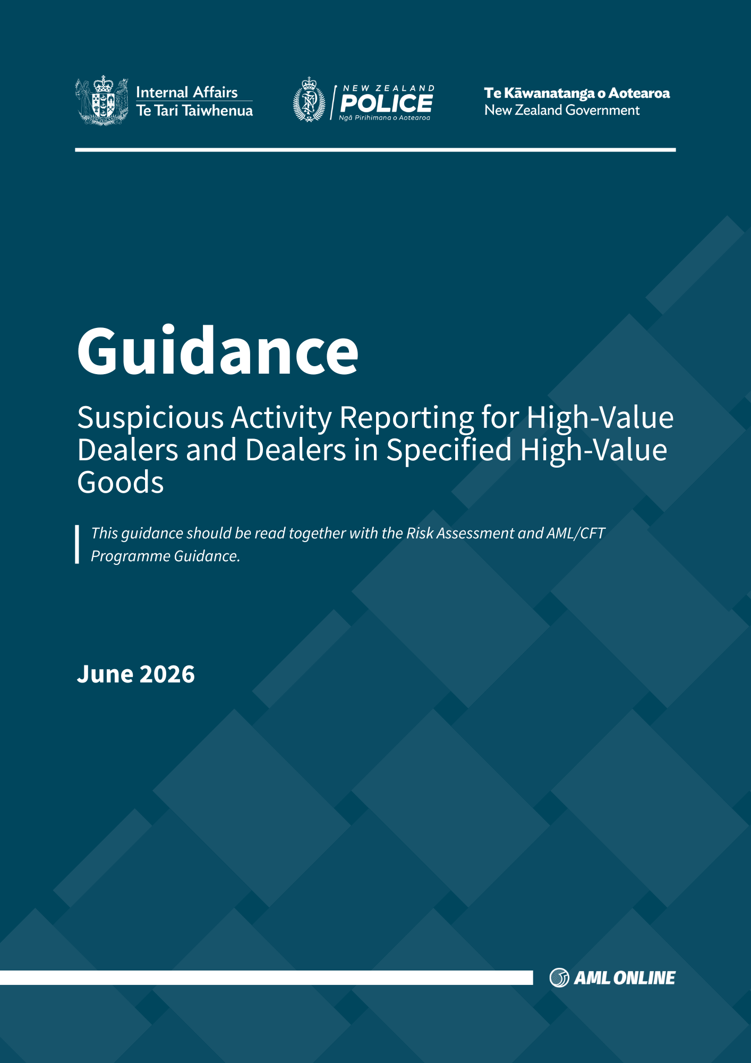

Introduction
- This guidance has been produced by the Department of Internal Affairs (the Department) and the New Zealand Financial Intelligence Unit (FIU) to support high-value dealers and persons in trade in high-value goods to which the cash transaction prohibition applies, to comply with their requirements under the Anti-Money Laundering and Countering Financing of Terrorism (AML/CFT) Act 2009 (the Act).
- While this guidance has been produced to assist high-value dealers and persons in trade in high-value goods to which the cash transaction prohibition applies, you should ensure you understand your obligations under the Act. This guidance does not constitute legal advice.
Prohibited cash transactions for specified goods
- Section 67A of the Act prohibits any person who is in trade from buying or selling certain specified goods, by way of a cash transaction or a series of related cash transactions, if the total value of that transaction or those transactions is equal to or above the NZD$10,000 threshold.
- The specified high-value goods are:
  - jewellery,
  - watches,
  - gold, silver, or other precious metals,
  - diamonds, sapphires, or other precious stones,
  - motor vehicles, and
  - ships.
- Prior to 11 May 2023, as high-value dealers these persons were required to undertake customer due diligence and report prescribed transactions when carrying out cash transactions, or a series of related cash transactions, for customers of NZD$10,000 or more. However, with the prohibition preventing such transactions, these persons in trade in specified goods no longer meet the definition of a high-value dealer under the Act and do not have to comply with these requirements.
- Note: The prohibition applies whether a transaction exceeding NZD$10,000 is carried out in a single transaction, or several transactions that appear to be related or linked (related transaction conditions). For more information on related transaction conditions see paragraphs 12 to 13 below.
1 / 6
High-value dealers in other goods
- You are still considered a high-value dealer under the Act if you, carry out cash transactions of NZD$10,000 or more, in the ordinary course of business, if you are dealing in any of the following items:
  - paintings,
  - prints,
  - protected foreign objects,
  - protected New Zealand objects,
  - sculptures,
  - photographs,
  - carvings in any medium, and
  - other artistic or cultural artefacts.
- The definition of high-value dealer includes any person who carries out the above activity as a registered auctioneer. Auctioneers who deal with both specified goods subject to the cash prohibition and the other goods above, should ensure that they have policies, procedures and controls in place to comply with the prohibition.
- As a high-value dealer, when you sell or purchase the goods outlined above in paragraph 7, in cash, to the value of NZD$10,000 or more, you must comply with your obligations under the Act. These include, conducting standard customer due diligence, prohibitions if unable to conduct standard customer due diligence, record keeping, and prescribed transaction reporting.
- Note: The requirements of the Act apply whether a transaction exceeding NZD$10,000 is carried out in a single transaction, or several transactions that appear to be related or linked (related transaction conditions). For more information on related transaction conditions see paragraphs 12 to 13 below. In practice, this means a high-value dealer must take steps to identify related transactions, so that customer due diligence requirements can be applied when triggered.
2 / 6
- Details around the distinctions between dealers in specified goods and high-value dealers have been documented in a flowchart, which is captured in Appendix 1.
Related Transaction Conditions
- The related transactions conditions are important. They are an “anti-avoidance” provision to mitigate the risk of a person, or more than one person, structuring transactions to bypass the NZD$10,000 threshold, and to evade the application of the Act.
- To detect related transactions, you should take a risk-based approach to implement appropriate procedures, policies and controls. You must take adequate steps to identify whether transactions appear to be related or linked. It will not be sufficient to say that transactions did not appear to you to be related if you have made no, or inadequate, attempts to identify related transactions.
Suspicious activity reporting
- The Statutes Amendment Act 2025 amended section 40 of the Act to allow a high-value dealer to report a suspicious activity report (SAR) to the Commissioner.
- The AML/CFT (Supervisor, Levy and other Matters) Act 2026 amended the definition of a suspicious activity to include an activity that occurs in the ordinary course of carrying out the business of a person who is in trade in respect of 1 or more of the articles specified in section 67A of the Act (specified goods).
- This means that any person in trade may report a SAR to the Commissioner that occurs in the ordinary course of carrying out their business.
- This means high-value dealers in specified goods and other goods may submit a suspicious activity report to the FIU.
- If a high-value dealer has reasonable grounds to suspect that a transaction or activity by a customer who seeks to conduct, or conducts, a sale or purchase, is related to criminal activity, a SAR may be filed. To enable you to submit a SAR, it is recommended that high-value dealers register with goAML. A copy of the report for filed SARs must be kept.
3 / 6
Money laundering and terrorism financing risks associated with high-value goods
- High-value goods can be vulnerable to money laundering by virtue of their nature, and potential to hold or represent significant value. Thus, they can serve as a substitute for value, that can be used to transfer or conceal criminal proceeds, while evading or obscuring detection. For instance, criminals may use illicit funds to purchase high-value artistic or cultural objects which they then store in private residencies or storage facilities as a means to store value. Some types of high-value goods are small in size, meaning they can be easily hidden and transported, thus can be utilised to facilitate the cross-border movement of illicit proceeds.
- In some cases, the acquisition of these objects serves not only to launder criminal proceeds but also to offer personal enjoyment or confer social status.
- Cultural objects originating from areas where terrorist groups or terrorist activities are operating can be vulnerable to terrorist financing, including via proceeds from the smuggling of illegally excavated or looted items.
- Dealers in high-value goods can be vulnerable to misuse for the following reasons:
  - Use of cash in transactions: purchasing high-value goods may be a way to legitimise illicit cash, converting it to an asset that retains value and can be sold later.
  - Misuse of intermediaries, legal persons or arrangements: the use of intermediaries to conceal the beneficiary of the transaction, disguising their identity(ies) and further obscuring the source of funds.
  - Use of under or over-pricing: to conceal value or legitimise illicit proceeds. High-value goods can be unique, making their value subjective and potentially volatile.
  - Collusion between buyers and sellers: for instance, a launderer may list a good for auction that is purchased by an accomplice using illicit cash. The launderer then receives a transfer from the auctioneer to their account for the sale, successfully placing the illicit funds in the financial system.
- High-value dealers should therefore be alert to red flag indicators, including those provided in Appendix 2.

4 / 6

Provenance
- An underlying principle in dealing with arts, antiquities, or taonga is provenance.
- Provenance refers to an item/object’s source, or origin, as well as its record of ownership. It establishes the context of the item/object, for both its time of manufacture and production, as well as its discovery. These are important elements for identifying possible illicit activity and in many cases may be an effective tool in the identification and reporting of suspicious activity.
- Provenance should be conducted on high-value art, antiquities, and taonga. Regions experiencing armed conflict and political instability are especially vulnerable to illicit trade, and special attention should be made for arts and antiquities originating from those areas.
Further information
- For further information on crime types that pose a money laundering, terrorist financing or proliferation financing threat and sectoral vulnerabilities, including high-value dealers, it is recommended to refer to the National Risk Assessment.
- If you require further information on the application of the Act, please contact Department of Internal Affairs Te Tari Taiwhenua, AML/CFT Group on amlcft@dia.govt.nz.
- If you require further information regarding the suspicious activity reporting process using the FIU’s goAML system, please refer to the FIU website, access goAML, or contact the FIU on goaml@police.govt.nz.
- The Financial Action Taskforce (FATF) provides useful information on ML/TF risks, likewise the Asia Pacific Group on Money Laundering (APG) provides information relevant for this region, including yearly typology reports and up-to-date news on methods and trends. Dealers in other goods, including arts, antiquities and taonga may find the FATF Report on Money Laundering and Terrorist Financing in the Art and Antiquities Market to be of particular relevance.
- Red flags and indicators can be found in Appendix 2.
Disclaimer
Note: This guidance has been produced by the Department of Internal Affairs under s132(2)(c) of the AML/CFT Act, for high-value dealers and persons in trade to which the cash transaction prohibition applies. This guidance does not set out all obligations under the AML/CFT Act, its associated regulations and codes of practice. This guidance does not constitute legal advice.
5 / 6
Version History
Version | Date | Author | Description of Changes
1.0 | June 2026 | Department of Internal Affairs and the New Zealand Financial Intelligence Unit | Initial version

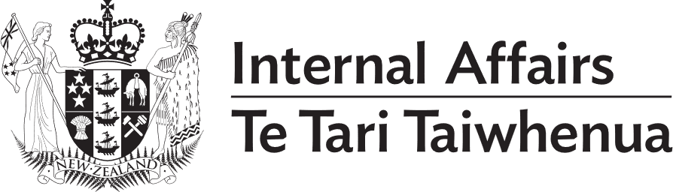
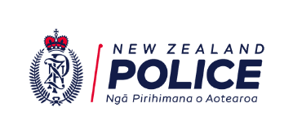
6 / 6
Appendix 1
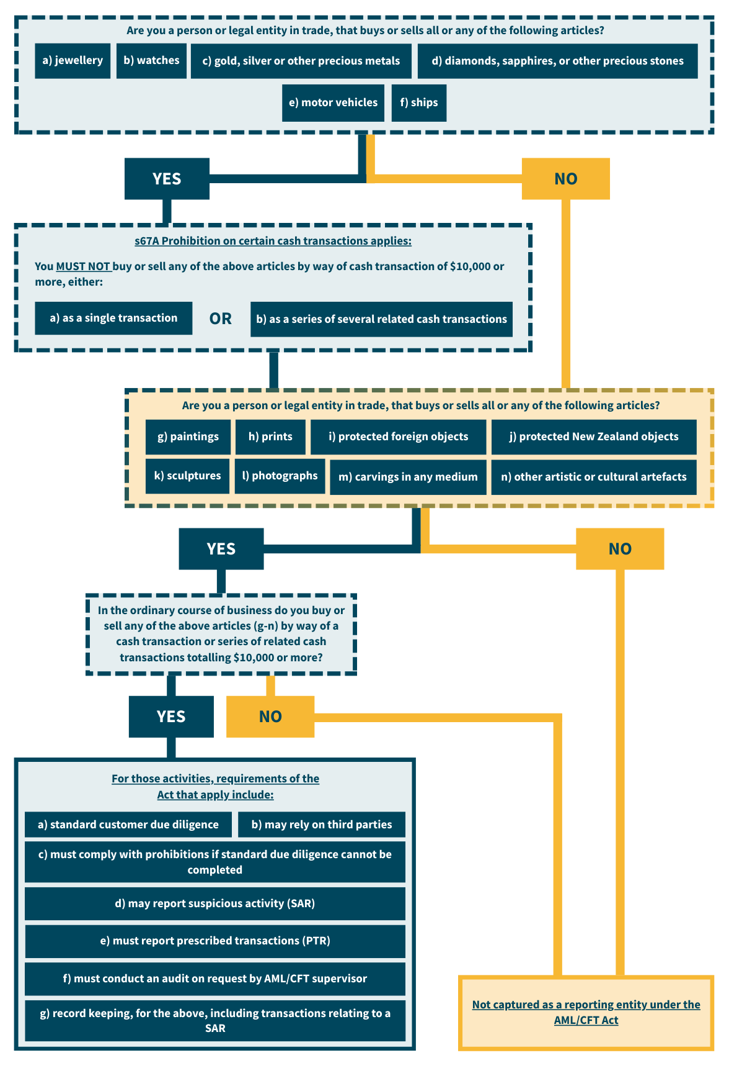
How is my High-Value Goods Business Captured by the AML/CFT Act?

Red Flag Indicators for High-Value Dealers in Other Goods
Appendix 2
Red flag indicators for high-value dealers in other goods include:
Use of shell companies, trusts, or third-party intermediaries to purchase, hold, or sell cultural objects, including art dealers, brokers, advisers, or interior designers.
Cash transactions, in particular, using large volumes of cash.
Use of large-denomination banknotes.
Unusually high profit margins on the sale of an item of art, antiquity, or other cultural objects.
Sales or purchases of items involving sellers who are not concerned with recouping their initial investment.
Sales, or purchases, of art vastly or routinely exceeding the expected sales value of the work.
Sales, or purchases, of art involving purchasers who do not appear to be concerned with paying a substantially higher price than the notional value of the work.
Sales, or purchases, of art where a client is not familiar with, or interested in, the provenance, history, style, genre, or artist of an object.
Unwillingness of a customer to provide identification information to receive an art-collateralised loan, or early repayment, or use of cash to pay such a loan.
Imported, or exported, items not declared to the relevant customs administration(s).
Purchase, or termination, of insurance policies to protect the market value or provide cash payments for the loss, theft, or destruction of privately held or donated high-value art in circumstances where other information has suggested the art has a low value
Presence of natural, or legal, persons known to be involved in, or suspected of, trafficking in cultural objects.
Use of social media or financial intermediaries to advertise cultural objects that have been looted.
Unique archaeological pieces allegedly related to existing collections, but previously unstudied.
Newly ‘discovered’ art attributed to a prominent artist.
Purchases of items by third party intermediaries on behalf of an ultimate seller or purchaser.
Transactions involving market participants without expertise in concluding high-value purchases, or sales.
Transactions involving politically exposed persons (PEPs), or their family members, or close associates.
Use of financial services to acquire, sell, or ship artworks or cultural property in and out of specialist storage facilities.
Sale of objects/items originating from regions with current or historically recent armed conflict (post-1900).

Refer to the definition of a high-value dealer in section 5 of the Act. Refer also to 67A of the Act.
Refer to Regulation 5AC of the AML/CFT (Definitions) Regulations 2011.
As defined in section 6(1) of the Motor Vehicle Sales Act 2003.
As defined in section 2(1) of the Maritime Transport Act 1994.
Refer to section 6(4(d) of the Anti-Money Laundering and Countering Financing of Terrorism Act 2009
As defined in section 2(1) of the Protected Objects Act 1975.
As defined in section 2(1) of the Protected Objects Act 1975.
As defined in section 4(1) of the Auctioneers Act 2013. Refer also to section 5 (high-value dealer) (b) of the Act.
Refer to section 6(4)(d) of the Act
Refer to sections 14, 15 and 16 of the Act.
Refer to section 37 of the Act.
Refer to section 50 of the Act.
Refer to sections 48A and 48B of the Act.
Statutes Amendment Act 2025 | New Zealand Legislation
Refer to section 40(5) of the Act.
Anti-Money Laundering and Countering Financing of Terrorism (Supervisor, Levy, and Other Matters) Amendment Act 2026 | New Zealand Legislation
Refer to section 40A(2) of the Act.
Refer to section 2 (taonga tūturu) of the Protected Objects Act 1975.

