Service Delivery and Operations
Customer Experience Survey
2016/17

Analytics and Reporting
Service Delivery and Operations

Acknowledgements

The Department of Internal Affairs acknowledges Mark Johnson and his team at Research New Zealand for their analysis of the data.

Authors: Kelly Risdon and Claire Harkess – Analytics and Reporting, Operations

Introduction

This report provides a summary of key findings from the 2016/17 Service Delivery and Operations Customer Experience Survey.

Service Delivery and Operations (SDO) provides a variety of services to the public including passports, community advisory and funding services, birth, death, marriage, civil union, and name change, authentications, citizenship, charities registration, and identity verification services.

In this survey we seek to understand how the public rates our service, how they interact with SDO and what we can do to improve our service.

The 2016/17 survey is the fifth year this survey has run to monitor public satisfaction over time, and to monitor responses to changes in our service delivery.

Key Findings

- Overall, SDO customer satisfaction with the services the Department of Internal Affairs deliver remains high.

- Overall SDO customers reported that it was easy to do business with SDO.

- Improvements or additions to online services remain a key customer need.

- Customers continue to have high expectations of the service they will receive and rated the service received as better than expected.

- Interactions with SDO staff remain highly rated.

- Customers continue to have high trust and confidence in the Department.

Overall Satisfaction

Most customers (89 per cent) were satisfied or very satisfied with the overall quality of SDO service delivery. Results in 2016/17 were basically the same as in 2015/16, reflecting the maintenance of a high level of service.

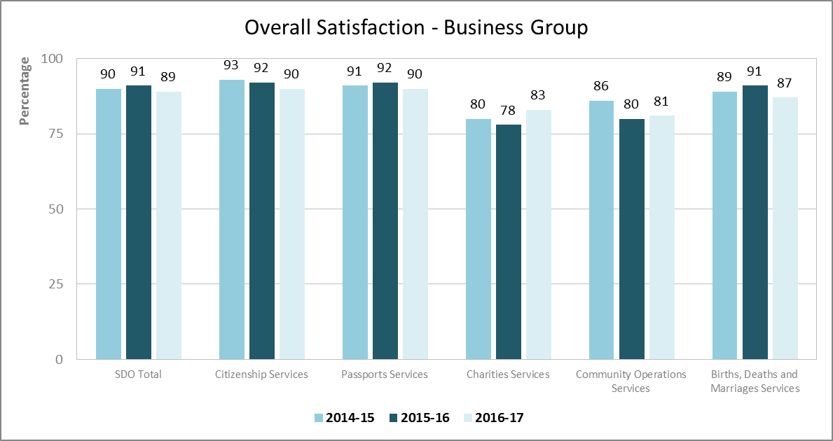
Source: Service Delivery and Operations Customer Experience Survey 2016/17

Overall satisfaction with Charities Services is slightly higher than the previous year, with 83 per cent of customers satisfied or very satisfied with that service. This result likely reflects a greater understanding of the new reporting standards introduced on the 31st March 2016, and improvements made to make it easier to complete the requirements.

Examples of positive feedback provided by customers:

It made me proud to be a New Zealander. It was fast, professional, friendly, responsive and helpful. Honestly I was so impressed.

Excellent service from all the staff of Internal Affairs. Thank you for making things easy when applying for citizenship, passports, etc.

The Case Officer I was assigned was professional, helpful and prompt with his responses. This was much appreciated and helped ensure a smooth process.

The process is very easy to understand. It also helps when you can save your work, and return to it later.

I went online, confirmed eligibility and photo quality, applied, paid, and got it. Easy as.

Service Expectations and Experience

Over half of SDO customers had high expectations of the quality of service they would receive and felt that the resulting service received was better than expected.

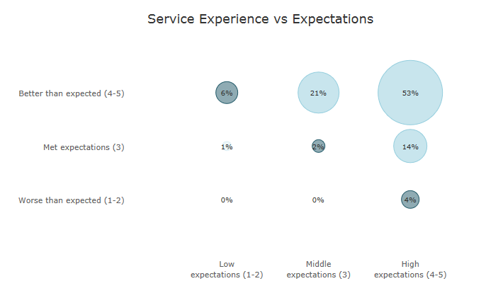
Source: Service Delivery and Operations Customer Experience Survey 2016/17

Key Service Measures

SDO customers rated the key service measures highly. In particular “Staff were competent”, “Staff did what they said they would do”, and “I was treated fairly” were all rated highly by more than 90 per cent of customers. These three measures relate directly to the service received from SDO staff.

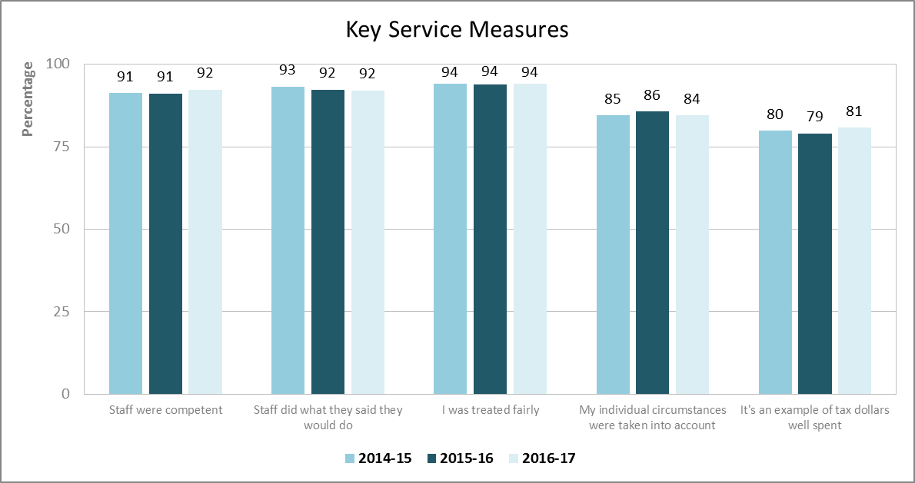
Note: Only customers who had had direct contact with an SDO representative were asked whether Staff were competent, Staff did what they said they would do, or I was treated fairly.
Source: Service Delivery and Operations Customer Experience Survey 2016/17

Trust and Confidence

SDO customers continue to report high trust and confidence in the Department of Internal Affairs.
Slightly lower results for Charities Services reflect the regulatory nature of the business.

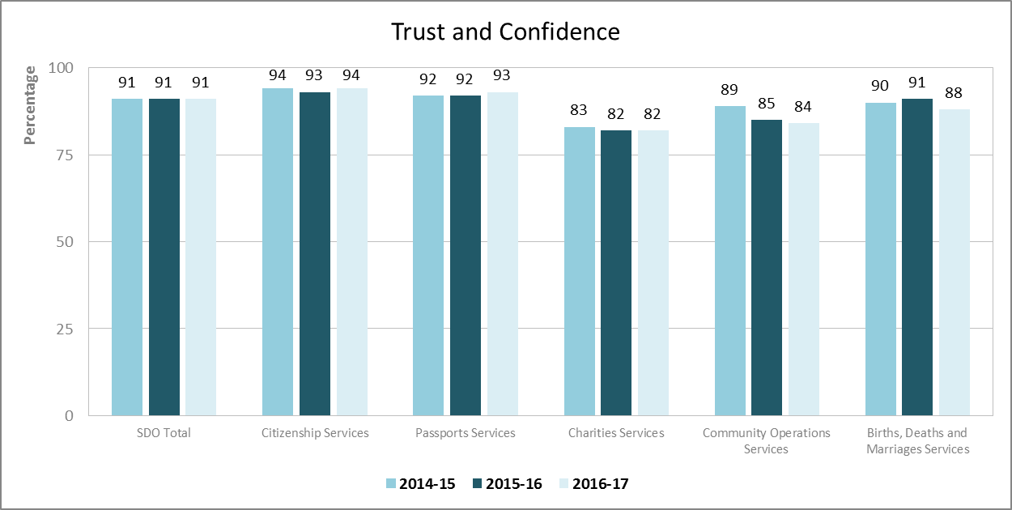
Source: Service Delivery and Operations Customer Experience Survey 2016/17

Ease of getting service

Overall just under 80 per cent of SDO customers reported that it was easy to get their service with SDO.

International research shows that ease of getting service is a key driver of the customer experience. Assessing how easy we make it for our customers is crucial to assessing how we are performing, and for determining actionable next steps to improve the customer experience.

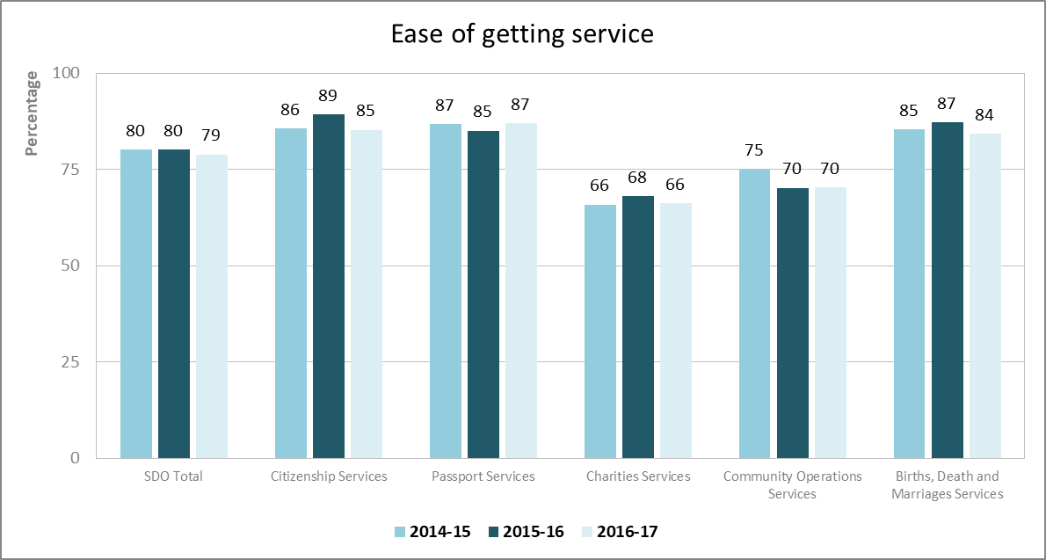
Source: Service Delivery and Operations Customer Experience Survey 2016/17

Service Improvements

Half of SDO customers felt that SDO could make improvements to our service. Among those who made suggestions, the biggest group was once again those who suggested improving our website and online service.

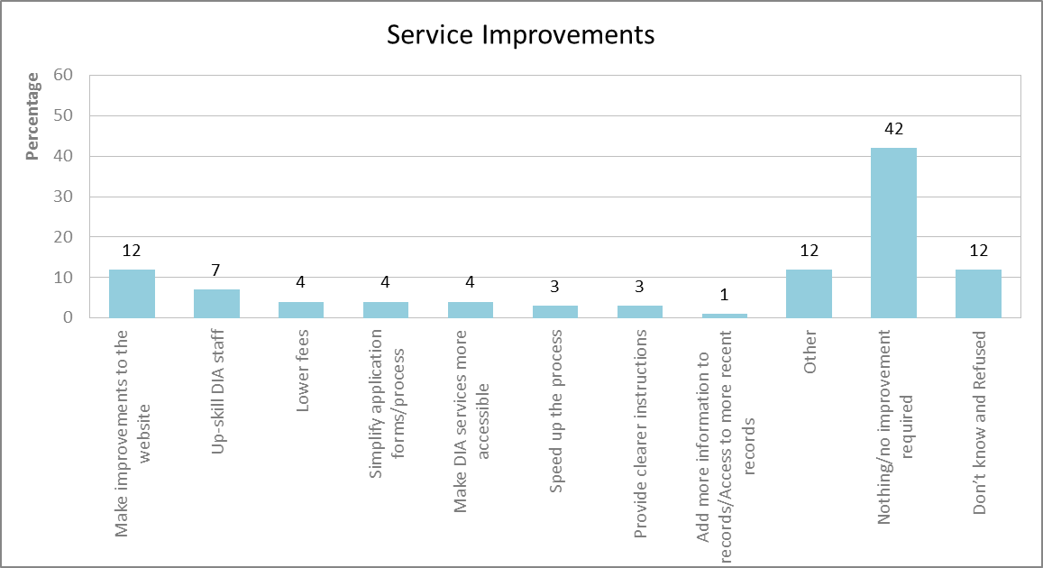
Source: Service Delivery and Operations Customer Experience Survey 2016/17

Examples of the types of comments received from customers regarding improvement are:

If there is anything like a mobile app to make it easier, rather than going on the computer or laptop

To be prepared to service applications by mail for people who do not have access to a PC or who are not competent at using a computer

Simplify the process and perhaps email death certificates once produced rather than waiting on the postal service

Online tracking of where your application is in the process. Especially for urgent requests. Then there would be fewer calls placed to DIA I believe

Allow people to ask questions via chat online. That way, we can get access to expert advice pertinent to our specific requirements, but would not have to wait on the phone to talk to someone

Make website a bit more user friendly, current format needs improving

If there was to be any improvement it would be for us to receive an automated prompt that "in the next four months your passport will expire", but I guess given the number of people that could be too much

Ease of application. Maybe a step-by-step guide to applying for a grant. Just going to one place online to submit. RealMe is a bit confusing

Provide regular updates via email on the progress of the application

Next Steps

SDO is working to transform our system of service delivery. Findings from this research will continue to help us understand our customers’ needs and enable us to see the effect of service changes on our customers. A programme of continuous improvement is being undertaken based on customer and staff experience.

Improving our web and digital services is a strong focus for SDO. Analysis from the survey, particularly of customer comments, will help direct this.

The Community Operations website redevelopment was completed in September 2017 and feedback continues to be monitored.

The SDO Customer Experience Survey is being run again in 2017/18 with results expected to be published late January 2019.

Methodology

The 2016/17 survey was run continuously during 2016/17. Recent customers were asked to participate via a telephone or online survey. 2,500 customers completed the survey. The margin of error is between +/-3.9% and +/-4.8% for each business group.

Most changes between years are not statistically significant, therefore we cannot say for certain that there has been any change
This is a statistically significant change
All changes between years are not statistically significant, therefore we cannot say for certain that there has been any change.
Source: CEB Customer Contact Council Member Survey 2010.

