Service Delivery and Operations
Customer Experience Survey
2015/16

Branch Development and Support
Service Delivery and Operations

Acknowledgements

The Department of Internal Affairs acknowledges Mark Johnson and his team at Research New Zealand for their analysis of the data.

Authors: Thida Seng and Claire Harkess - Branch Development and Support

Introduction

This report provides a summary of key findings from the 2015/16 Service Delivery and Operations Customer Experience Survey.

Service Delivery and Operations (SDO) provides a variety of services to the public including passports, community advisory and funding services, birth, death, marriage, civil union, and name change, authentications, citizenship, charities registration, and identity verification services.

In this survey we seek to understand how the public rates our service, how they interact with SDO and what we can do to improve our service.

The 2015/16 survey is the fourth in a series of annual surveys to monitor public satisfaction over time, and to monitor responses to changes in our service delivery.

Key Findings

- Overall, Service Delivery and Operations customer satisfaction with the services the Department of Internal Affairs deliver remains high.

- Overall SDO customers reported that it was easy to do business with Service Delivery and Operations.

- Improvements or additions to online services remain a key customer need.

- Customers continue to have high expectations of the service they expect to receive and rated the service they actually received as better than expected.

- Interactions with SDO staff remain highly rated.

- Customers continue to have high trust and confidence in the Department

Overall Satisfaction

Most customers (91 per cent) were satisfied or very satisfied with the overall quality of SDO service delivery. Results in 2015/16 were basically the same as in 2014/15, reflecting the maintenance of a high level of service.

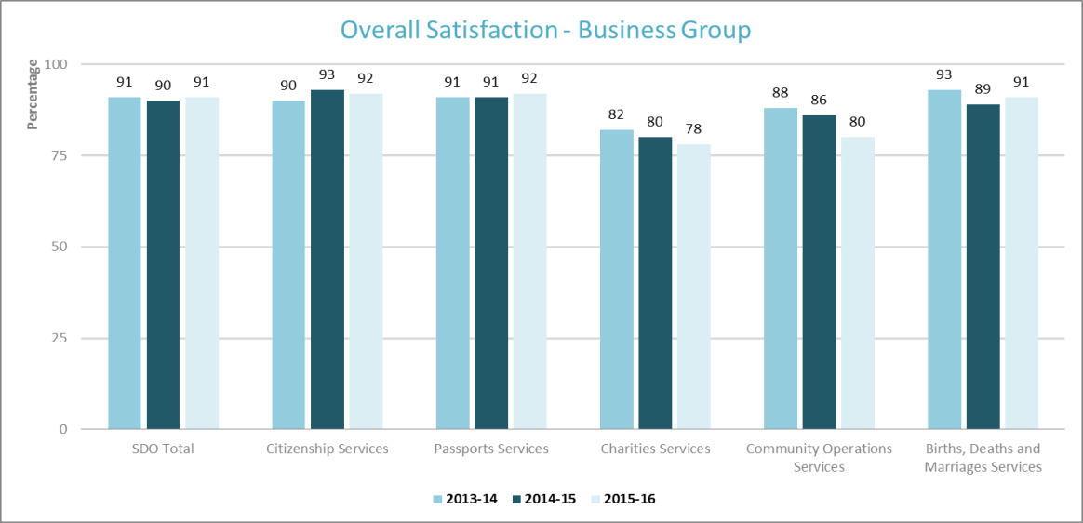
Source: Service Delivery and Operations Customer Experience Survey 2015/16

Overall satisfaction with Community Operations is slightly lower than the previous year, with 80% of customers satisfied or very satisfied with that service. This result may reflect the initial implementation of the new grant management system from October 2014. Prior to implementation customers had a choice to apply on line or through a paper application process. After implementation, applications could only be made online. Although the new system has received positive feedback, we were aware that some customers would need the assistance of staff to make an online application until they were used to the new system. Staff work actively to assist these customers. Continuous improvements are being made to the system, based on customer and staff experience, and the application systems thinking methodology. The timing of the survey does not capture these later experiences.

Examples of positive feedback provided by customers:

The online service is excellent. I have been using it for over eight years now, but [in] the recent two years the system has really been streamlined and we receive death certificates the following day

I actually got my passport within 24 hours which actually amazed me and I didn't have to go hunting for a lot of paperwork, birth certificate and marriage license

The services are brilliant very easy to follow and use, and when we rang we didn't get a computer we got a real human to talk to which was great

Fantastic, easy new online system to apply for COGS and backed up with quick response to emails
Your staff were amazingly helpful and knowledgeable about the process and were a pleasure to deal with either by phone or email

Service Expectations and Experience

Over half of SDO customers had high expectations of the quality of service they would receive and felt that the resulting service received was better than expected.

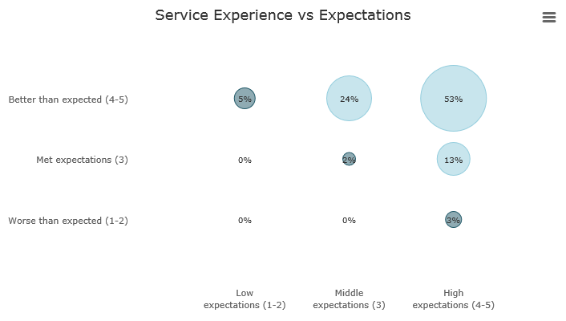
Source: Service Delivery and Operations Customer Experience Survey 2015/16

Key Service Measures

SDO customers rated the key service measures highly. In particular “Staff were competent”, “Staff did what they said they would do”, and “I was treated fairly” were all rated highly by more than 90 per cent of respondent. These three measures relate directly to service received from SDO staff.

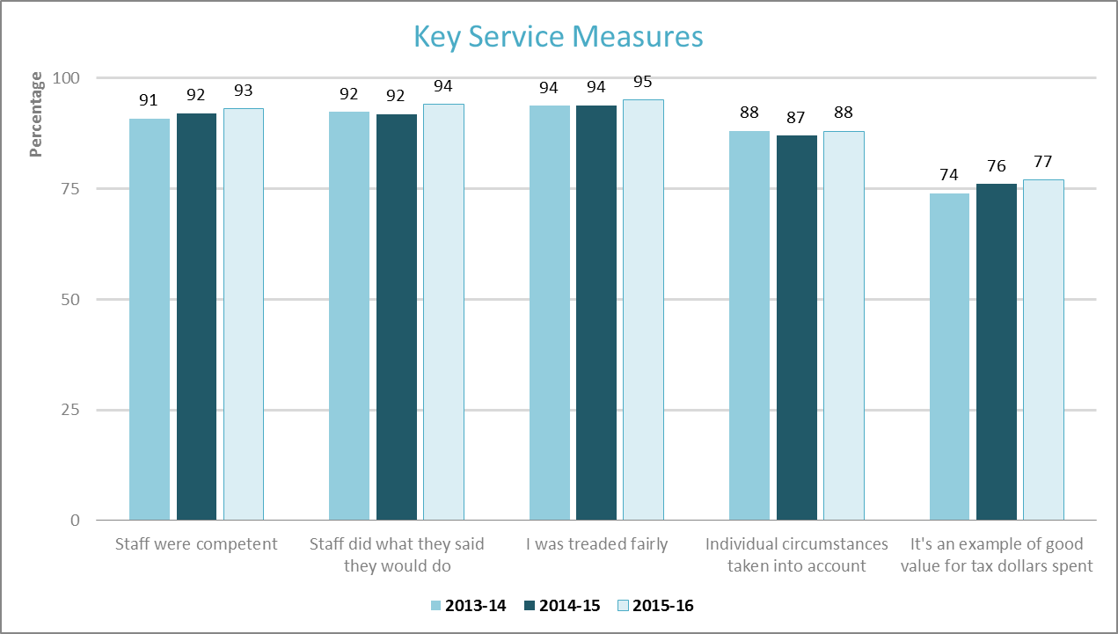
Note: Only customers who had had direct contact with an SDO representative were asked whether Staff were competent, Staff did what they said they would do, or I was treated fairly.
Source: Service Delivery and Operations Customer Experience Survey 2015/16

Trust and Confidence

SDO customers continue to report high trust and confidence in the Department of Internal Affairs.
Slightly lower results for Charities Services reflect the regulatory nature of the business.

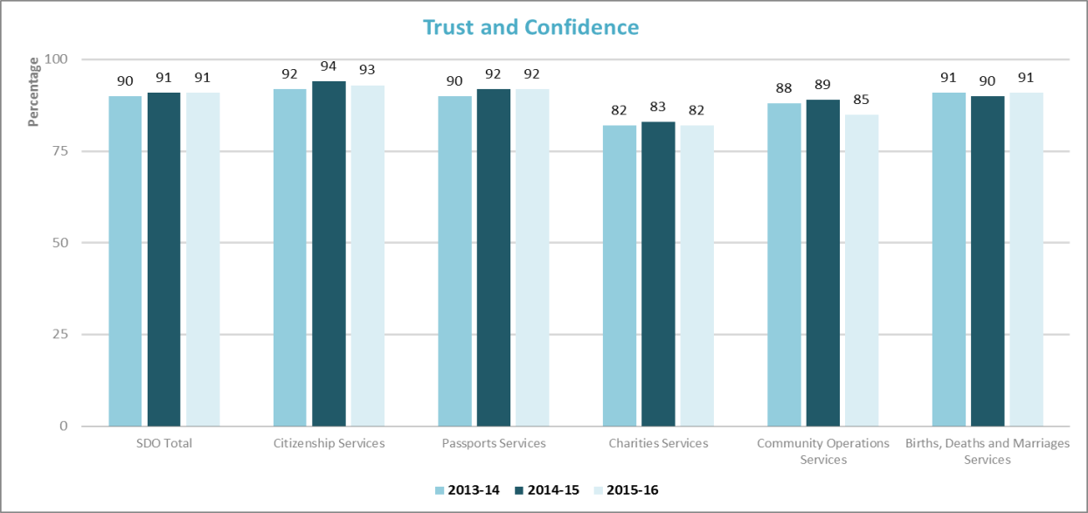
Source: Service Delivery and Operations Customer Experience Survey 2015/16

Ease of getting service

Overall 80 per cent of SDO customers reported that it was easy to get their service with Service Delivery and Operations.

International research shows that ease of getting service is a key driver of the customer experience. Assessing how easy we make it for our customers is crucial to assessing how we are performing, and for determining actionable next steps to improve the customer experience.

Source: Service Delivery and Operations Customer Experience Survey 2014/15

The Community Operations result is slightly lower than 2014/15 again likely reflecting the initial implementation on the new grant management system.

Service Improvements

Half of SDO customers felt that SDO could make improvements to our service. Among those who made suggestions, the biggest group was once again those who suggested improving our website and online service.

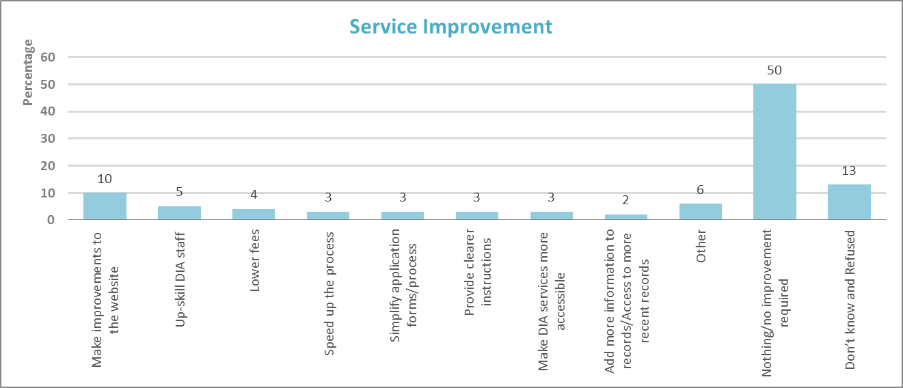
Source: Service Delivery and Operations Customer Experience Survey 2015/16

Examples of the types of comments received from customers regarding improvement are:

Clarify the process to be taken – it wasn’t clear in some cases what form to use

Have a simple printable booklet with a set of clear guidelines. Have a template that could be downloaded, completed and then uploaded once again once completed

Make sure users can reach a person via phone/helpline, when they are having problems with the online system

Focus on online applications where everything can be done online

I think as we applied for passports it would have been great to tick a box on the citizenship form and get passports at the same time. Basically we were filling in a similar form and had to get a new photo for the passport so it was a bit of an inconvenience

Provide an online facility to track the progress of applications

Look at the process of the website from an applicant's point of view. Staff were great but even IT skilled people couldn't understand the process

Improve the search function and make more information visible in the results

Next Steps

SDO is working to transform our system of service delivery. Findings from this research will help us understand our customers’ needs and enable us to see the effect of service changes on our customers. At the same time a programme of continuous improvement is being undertaken based on customer and staff experience.

Improving our web and digital services is a strong focus for SDO. Analysis from the survey, particularly of customer comments, will help direct this.

The SDO Customer Experience Survey is being run again in 2016/17 with results expected to be published late January 2018.

Methodology

The 2015/16 survey was run continuously during 2015/16. Recent customers were asked to participate via a telephone or online survey. 2,700 customers completed the survey. The margin of error is between +/-3.8% and +/-4.8% for each business group.

Most changes between years are not statistically significant, therefore we cannot say for certain that there has been any change
This is a statistically significant change
All changes between years are not statistically significant, therefore we cannot say for certain that there has been any change.
Source: CEB Customer Contact Council Member Survey 2010.
We began asking customers about ease of doing business in early 2014. So 2015/16 is second full year for which we have results on ease of doing business.

