Review of Community – Government Engagement Practices
  - September 25, 2015

Level 4  120 Featherston Street  PO Box 25333  Wellington  New Zealand |  | Peter Glensor: 027 241 5152  Dave Henderson: 027 484 8165 |  | info@huie.org.nz  www.huie.org.nz

Table of Contents
- Executive Summary 2
- Introduction 4
- Demography 5
- Results 7
- Q3. Have you experienced examples of good practice engagement between government agencies and communities or community organisations? 7
- Q4. If yes, please give a brief description: 8
- Q5. What worked well in your example(s)? 13
- Q6. What parts of your experience of engagement with government agencies were most challenging? 20
- Q7. Are you involved in any initiative(s) underway aimed at improving engagement and or building relationships between government agencies and communities or community organisations? 30
- Q8. If yes, please give details: 31
- Q9. Are you aware of the Kia Tūtahi Principles? 32
- Q10. If yes, can you give an example of how the Kia Tūtahi principles have been evident in the initiative(s): 33
- Case Studies 34
- Discussion 43
- Implications of the Survey for Kia Tutahi and the Sector-Government Relationship 48
- Appendix – The Survey Questions 50

Executive Summary

A total of 25,446 contacts were drawn from the charities register and from Hui E!’s mailing list and contacted by Hui E!. They were asked to participate in a survey exploring community and government engagement practices. Of those contacted, 991 responded (a response rate of 3.9%). 672 respondents gave the name of their organisation, and 585 respondents gave their contact address allowing opportunities for follow-up.
Items on the survey explored the following topics:
- Experiences of good practice engagement between government agencies and communities/community organisations
- What worked well in these examples
- Challenges faced
- Initiatives aimed at improving engagement and/or building relationships
- Awareness of Kia Tūtahi principles, and whether there is any evidence of them being honoured in initiatives underway

Key Findings

- 60% of respondents have experienced examples of good practice engagement between government agencies & communities/community organisations

- The Department of Internal Affairs (DIA), The Ministry of Social Development (MSD), specific City and District Councils, The Ministry of Health (MoH) and The Department of Conservation (DoC) are all directly mentioned multiple times in examples given of good practice engagement between central government agencies and communities/community organisations (listed in order of highest frequency of references to lowest)

- Auckland, Canterbury, Wellington, Hawkes Bay and Bay of Plenty are all directly mentioned multiple times in examples given of good practice engagement between government agencies and communities/community organisations (listed in order of highest frequency of references to lowest). Although this survey is focused on engagement between community organisations and central government, many respondents have cited city and regional councils. These references have been included as it is still useful data to acknowledge.

- Informative seminars and workshops, regular meetings and updates, forums and discussions and hui are all specified as initiatives that encourage and enable good practice engagement between government agencies and communities/community organisations

- Key themes discussed around what worked well in the examples given are; collaboration and partnership, communication, supportive advice, information and practical help, clinics, workshops and seminars, respect and appreciation of expertise, funding, speed of responses and clarity
- Key barriers to good practice engagement discussed are; over bureaucracy and inflexibility, lack of collaboration, discussion or meaningful engagement, technical frustrations, not knowing who the right person to contact is, funding instability and the competitive contracting model, lack of understanding, lack of continuity and consistency, slow responses, issues with following up and transferring into action, lack of respect, mistrust and unreasonable timeframes
- A further point raised within discussions around barriers to good practice engagement was that difficulties often arise when trying to get government agents and departments to really understand the major role that volunteers play in NGOs and the challenges they consequently face
- A final concern voiced within discussions around barriers to good practice engagement was that experiences are often person-dependent (one agent may be particularly understanding and helpful while another may not)

- The majority of respondents (68%) are not involved in any initiative(s) underway aimed at improving engagement and or building relationships between government agencies and communities or community organisations.
- Of those respondents that are involved in initiatives, many discuss their own schemes underway, and only a small proportion (45 respondents out of 216, 21%) talk about specific initiatives led by both the government and communities/community organisations. Family Violence initiatives are mentioned the most, followed by Children’s Teams, Strengthening Families and Social Sector Trials, Community Development Projects and Whanau Ora

- Almost all respondents (87%) are not aware of the Kia Tūtahi Principles

- Of the respondents that said they are aware of the Kia Tūtahi Principles, over 1/3 (38%) said that they could not give an example of how they have been evident in initiatives. Furthermore only a minority of respondents made reference to clear examples of how the Kia Tūtahi principles have been evident in the initiative(s) (19 out of 95, 20%). Of those clear examples, the majority (46% of the examples) were in reference to the principle that ‘we have a collective responsibility to hear and respond to the voices of all’.

Note: The complete survey form is included in this document as an appendix

Introduction

Background & Purpose
The Department of Internal Affairs (DIA) is currently reviewing the Kia Tūtahi Relationship Accord (the Accord). The Accord was signed by various community representatives and the Government in 2011. A reference group comprising government and non-government representatives was formed for one year in 2012 to provide advice on giving effect to the Accord. In addition, DIA and five other government agencies were tasked with promoting the principles of the Accord through various initiatives, and several seminars were also held in 2013 and 2014.
The Accord is a commitment by communities and government to engage more effectively to achieve social, economic, environmental and cultural outcomes. It sets out high level principles and expectations for how communities and government should interact. These include: building trust and mutual respect; acting in good faith; having a collective responsibility to hear and respond to the voices of all New Zealanders; and respecting and recognising the Treaty of Waitangi as the founding document of New Zealand. The Accord complements existing materials such as the Auditor General and Treasury’s guidelines for contracting, and promotes good engagement practices across the community and government sector.
The review of the Accord is also part of New Zealand's Open Government Partnership (OGP) Action Plan 2014-2016. The OGP is an international forum where countries work together to ensure that member governments are more open, accountable and responsive to citizens.
In partnership with Hui E!, the DIA sought the input of Non-Government-Organisations (NGOs) on how communities are engaging with government.
The focus of the review is on government engagement practices and relationships with communities and community organisations. The aim of this research was to gather examples of initiatives that demonstrate what is working well and what can be improved from government agencies, communities and community organisations.

Methodology
The information reported here was obtained using an online survey questionnaire through ‘SurveyMonkey’, using both quantitative and qualitative questions. The sample was gathered by obtaining the list of registered charities in New Zealand, and email invitations were sent out to everyone on the list. A risk of using an online list as a sample group is that it may not be entirely up to date, and this is partially so in our survey as 2.48% of the emails sent out bounced. However, it is a small enough number of bounces for a good sized group of people still to have been contacted. In addition to the charities register, email invitations were also sent out to all of Hui E!’s personal mailing list.
During August Hui E! telephoned key respondents to the questionnaire to obtain further discussions around examples of good practice engagement.

Demography
As the survey was completed by individuals representing their charity/NGO/community organisation, the personal demographics of the respondents are unknown. Furthermore, not everybody gave information regarding the name of their organisation. However, of those that answered, the sectors from which the organisations are from are as follows (percentages = percentage of total respondents that answered):
- Education / training / research: 103 respondents (15.3%)
- Social Services: 83 respondents (12.4%)
- Community Development: 69 respondents (10.3%)
- Arts / culture / heritage: 67 respondents (10%)
- Other: 52 respondents (7.7%)
- Health: 45 respondents (6.7%)
- Religious activities: 40 respondents (6%)
- Environment / conservation: 33 respondents (4.9%)
- People with disabilities: 26 respondents (3.9%)
- Sport / recreation: 23 respondents (3.4%)
- Fund-raising: 11 respondents (1.6%)
- Accommodation / housing: 9 respondents (1.3%)
- Emergency / disaster relief: 7 respondents (1%)
- Marae (on reservation land): 7 respondents (1%)
- International activities: 4 respondents (0.6%)
- Care / protection of animals: 3 respondents (0.4%)
- Promotion of volunteering: 3 respondents (0.4%)
- Economic development: 2 respondents (0.3%)
‘Education / Training / Research’, ‘Social Services’ and ‘Community Development’ are the three most prominent sectors (that stated the name of their organisation) that participated in the survey.

Results

Q3. Have you experienced examples of good practice engagement between government agencies and communities or community organisations?

60% of respondents have experienced examples of good practice engagement between government agencies & communities/community organisations.
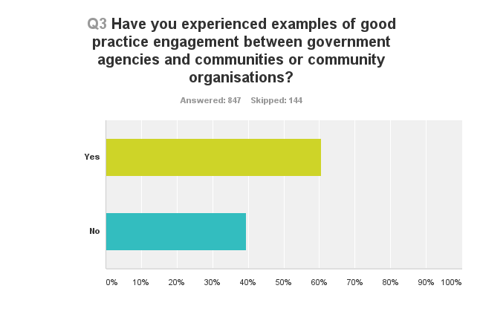

Q4. If yes, please give a brief description:

Departments/Agencies
Within responses about examples of experiences of good practice engagement, some departments or agencies are mentioned multiple times. The most frequently mentioned departments or agencies are:
- Department of Internal Affairs (DIA) - Total = 92 references
Specific reference within department/agency | Number of references made
DIA | 42
Charity Services | 22
Community Organisation Grants Scheme (COGs) | 16
Lottery Grants Board | 11
Authentication Unit | 1

“The DIA partnership with our Project has worked very well. The DIA rep who works with us has done a superb job of supporting us and guiding us over various hurdles.”
- Ministry of Social Development (MSD) - Total = 58 references
Specific reference within department/agency | Number of references made
MSD | 28
Work & Income (WINZ) | 16
Child, Youth and Family (CYF) | 10
Think Differently Fund Team | 1
Sexual Violence Task Force | 1
S.K.I.P Team | 1
Social Housing Unit | 1

“MSD capability building engagement was good”
- Specific city/district councils - Total = 38 references (largely all different councils)
“The Council proposed many items in the LTP consultation process and provided many public meetings, on-line information and documents were available throughout the district”
- Ministry of Health (MoH) - Total = 35 references
Specific reference within department/agency | Number of refrences made
District Health Boards (DHB) | 18
MoH | 14
Child Development Services | 1
Child and Adolescent Mental Health Service | 1
‘Health Agencies’ | 1

“Ministry of Health recently made a concerted effort to ensure good representation of NGOs at workshops on the review of the NZ Health Strategy”
- Department of Conservation (DoC) – 22 references
“We have a strong working relationship with DOC”

Geographical Areas
Many places around the country are directly mentioned, however only some areas are specified on multiple occasions. Included in this section are the top 5 most frequently cited areas. Although this survey is focused on engagement between community organisations and central government, many respondents have cited city and regional councils. These references have been included as it is still useful data to acknowledge. Whether the respondent has referred to local or central government is specified within the tables.
- Auckland – Total = 15 references

Specific reference within area | Central gov. references | Local gov. references
Auckland | 2 | 5
Waitemata | 4 | 0
Tamaki | 1 | 0
Mt Roskill | 1 | 0
Mangere | 1 | 0
Otara | 1 | 0

“good relationship with Auckland council”

“WDHB (Waitemata) stakeholders reference group for Health of Older People”

- Canterbury – Total = 14 references

Specific reference within area | Central gov. references | Local gov. references
Canterbury | 2 | 3
Selwyn | 0 | 2
Christchurch | 3 | 1
Riccarton and Wigram | 0 | 1
Linwood | 1 | 1

“CERA Director of Strategy and other CERA staff regularly meet with [our organisation] to exchange information about and discuss the recovery.”

“Dialogue between COGs' office in Christchurch and myself as a committee member is excellent”

- Wellington – Total = 11 references

Specific reference within area | Central gov. references | Local gov. references
Wellington | 3 | 3
Hutt | 0 | 3
Porirua | 1 | 1

“Think Differently Fund team at MSD Wellington”

“Wellington meeting to set local priorities for Community Organisations Grant Scheme”

- Hawkes Bay – Total 7 references

Specific reference within area | Central gov. references | Local gov. references
Hawkes Bay | 1 | 1
Napier | 2 | 1
Hastings | 1 | 1

“DIA Napier have kept me in touch”

- Bay of Plenty – Total 6 references

Specific reference within area | Central gov. references | Local gov. references
Bay of Plenty | 2 | 1
Rotorua | 1 | 2

“Appointment of Maori Advisor to Bay of Plenty Area Health Board”

Types of Initiatives

Types of initiatives that are mentioned multiple times are:
- Seminars and workshops (specifically, the free seminars run by Charity Services that explained new reporting standards arise in discussion the most) – Total = 52 references

“Charities Services seminars on new reporting standards were well-run and informative.”

- Regular meetings and updates (including a preference for multi-agency meetings) – Total = 26 references

“our local MAST (Multi Agency strategic Team) meeting in Kaipatiki”

- Forums and discussions – 26 references

“Waikato DHB's Community Health Forum which brings together many community groups and reps as well as individual community members to discuss health issues.”

- Hui – 10 references

“Quarterly Expose Community Services collective hui”

Negatives
24 respondents (4.8%) gave negative comments in this section, discussing a variety of issues.
“It all depends on how proactive you are as an industry association. There is not a lot of initiative from the government sector. Again it is very departmentalised and many issues cover several departments”
“I think that we are toooo far north for Government to know that we exist!”
“Recently the communication has been one way. Our feedback and reports with respect to Client's presenting issues are summarily ignored or dismissed unless they align with the Minister's and the Ministry's opinion”

Q5. What worked well in your example(s)?

Discussions around what works well (in the examples of experiences of good practice engagement) largely centred around eight key themes:
• Collaboration and partnership – relationships with people where there is a feeling that the government agencies have a genuine interest in, and understanding of the community organisations
• Communication - face to face and personal (regular meetings etc.)
• Supportive advice, information and practical help
• Clinics, workshops and seminars
• Respect and appreciation of expertise
• Good funding
• Speed of responses and action
• Clarity of expectations and information

Collaboration and Partnership
127 respondents discussed the importance of collaboration and partnership. They highlighted the value of building strong relationships with people within government agencies, and feeling that they have a genuine interest in, and understanding of the community organisations and communities they serve.
In regards to collaboration and partnership, the Ministry of Social Development was referenced 7 times (MSD referenced 4 times, WINZ referenced twice, Strengthening Families referenced once). The Department of Internal Affairs was referenced 6 times (DIA twice, Lotteries twice and COGs and Charities Services both once). District Health Boards and specific councils were both directly referenced 3 times. The Ministry of Education was directly referenced once.
“Where the government representatives entered the relationship with the intention of understanding and supporting the organisation, its purpose and work rather than simply seeking a contact compliance relationship”
“The people we have engaged with are interested in what we do and provide great assistance with the issues we face”
“Shared vision and commitment. Partnership working in practice. Real commitment on behalf of MSD colleagues”
“All parties demonstrating a willingness to work together cooperatively to achieve mutually beneficial outcomes”
“Having an understanding of where we come from, especially as our committee roles are voluntary and we have work and family to balance as well”
“We are treated in a partnership way rather than as a contractor”
“A genuine commitment to a relationship/partnership; Expertise and resources brought to the table enabling cocreation”

Communication
120 respondents suggested that communication is key to ensuring good practice engagement. A preference for face to face, and personal contact was expressed. Regular meetings were suggested as a good initiative to encourage good practice engagement.
In regards to communication, the Ministry of Social Development was directly referenced 3 times (MSD once, CYF once and Strengthening Families once). The Department of Internal Affairs was directly referenced twice. The Office of Ethnic Affairs and Housing New Zealand were both directly referenced once.
“Face to face discussions and activities”
“Commitment to monthly meetings from MSD and HNZ allowed information sharing around changing processes”
“Personal communication with staff”
“The face to face contact”
“Open communication, willing to engage”
“Communication was great and they are able to visit us for meetings and see exactly what we are trying to achieve”
“Communication. Being fully informed about procedures and changes. An easily accessed phone help desk”

Supportive Advice, Information and Practical Help
67 respondents discussed the value of helpful information and practical assistance. Hands on support and access to useful material and advice were discussed as particularly beneficial.
In terms of helpful information and practical assistance, the Department of Internal Affairs was directly referenced 5 times. The Department of Conservation was directly referenced 3 times. The Ministry of Social Development was directly referenced twice (MSD once, CYF once). WW100 team, the Police, Inland Revenue Department (IRD), Housing New Zealand and specific councils were all directly referenced once.
“Useful and relevant material. Questions and answers sessions”
“Training and advise from DOC equals good work getting done by the community”
“Great Advisory Officer who supported us and encouraged us to "think outside the box"”
“Having someone available who could advise of the best approach”
“The helpfulness of the staff I spoke to. All questions were answered promptly and any explanation was clearly given.”

Clinics, Workshops and Seminars
22 respondents suggested that the use of clinics, workshops and seminars in their examples worked well.
In regards to clinics, workshops and seminars the Department of Internal Affairs was directly referenced twice (DIA once, Charities Services once). The Ministry of Social Development was directly referenced once.
“The 1-1 clinics helped immensely to ensure a clear understanding of processes”
“Face to face workshops”
“Multiple short workshops around the country with optional time slots”
“Multiple opportunities to attend workshops, rather than just once -targeted information aimed at smaller segments rather than just broad-brush approach”
“they did the training in our region”

Respect and Appreciation
17 respondents suggested that relationships built on trust and appreciation of expertise are crucial to good practice engagement. Respondents discussed the value of feeling as if they are genuinely heard and respected, not merely included in a tokenistic way.
In reference to respect and appreciation the Department of Conservation and the Ministry of Social Development were both directly referenced once.
“Engagement based on values of mutual respect, and a realisation by government that NGOs were more than service providers, but partners in endeavours to advance social justice”
“a DOC staff member attends our monthly board meetings and keeps us well informed on development on the island. It also enables the Trust to raise any challenges we are having. There is a good partnership and mutual respect involved in working to improve the island as an asset for the NZ public”
“I am happy as long as everyone is treated equally and with respect no matter their origin and culture. Treat everyone as New Zealanders.”
“The fact that, as a budget adviser with a recognised service, I always felt respected and listened to by staff I approached either in person or on the phone”
“talking to us as human beings as opposed to treating us as a contract service provider. to be treated with respect and offering support and guidance to ensure compliance and continuation of contract agreement”
“We are respectfully listened to as "experts" in our local area by MSD”

Funding
14 respondents highlighted the importance of funding. This may seem like an obvious point, however it reiterates the importance of substantially resourcing and funding community organisations.
In regards to funding, the Ministry of Education and ‘Strengthening Families’ were both directly referenced once.
“The fact that funding is made available and community engagement is a core focus”
“Having a funded co-ordinator”
“Ability to access funds for community projects”
“good funding”

Speed of Responses
11 respondents suggested that prompt responses and efficient action are vital to good practice engagement.
“Communicated well and in a timely manner”
“Quick response to questions”
“Being able to deal with issues immediately and coming to an agreed set of actions to resolve issues”
“Prompt response, return phone call or email”

Clarity
10 respondents discussed the importance of clarity, of both expectations and information presented.
“Clear expectations for both parties in the Agreement”
“clarity and consistency of message”
“A basic understanding of what was the goal. An understanding of expectations of all parties early in the process and a commitment by all to the goals and expectations”
“Gave clear summaries of issues that they wanted feedback and direction on”

Negatives/No Contact
In this section, 23 respondents also highlighted negative experiences, or the fact that they had actually had no contact with government agencies.
“No example of engagement”
“You asked if I had experienced "best practice" My answer was n. however there were aspects of the contacts I have had which were OK, but overall the experience was that the interest of govt in community point of view, much less an individuals, was cursory at best.”
“Very little”

Sector Representation
A few challenges arise when attempting to categorise clearly what sectors respondents are from within this question. As there was no specific question within the survey addressing what sector respondents belong to, the sectors have been determined by correlating the names of organisations to the charities services register and using the sectors charities have allocated themselves here. 319 respondents (out of the total 991 answering the survey) skipped the question asking for the name of their organization, and therefore 32% of respondents sectors could not be determined. Furthermore, an additional proportion of respondents gave incomprehensible answers in this section, or belonged to individual businesses or the government itself as Hui E!’s personal mailing list was used in addition to the charities register. Despite this, it is useful to see an approximate spread of the sectors respondents are from answering within this question.

There is a similar layout across the sectors as found in the sector representation of the total survey.

Q6. What parts of your experience of engagement with government agencies were most challenging?

Responses on the topic of challenging experiences of engagement with government agencies centered around twelve key themes:
• Over bureaucracy and inflexibility – government agencies not listening or trying to gain a real understanding of the community
• Lack of collaboration, discussion or meaningful engagement
• Technical frustrations (form filling & online services)
• Not knowing who the right person to contact is, and a lack of ownership from government agencies
• Funding instability and the competitive contracting model
• Lack of understanding – gap between government and policy-makers and communities and community organisations
• Lack of continuity (people keep changing, positions keep changing)/consistency
• Slow responses
• Issues with following up and transferring into action
• Lack of respect
• Mistrust
• Unreasonable timeframes

Over Bureaucracy, Rigid Requirements and Inflexibility
63 respondents suggested that over bureaucracy of processes and a rigid, inflexible approach to engagement was a key challenge faced.
In regards to over bureaucracy and inflexibility the Department of Internal Affairs is directly referenced 6 times (Charities Services 4 times and Lotteries and RealMe once). Department of Conservation is directly referenced 3 times. IRD, WINZ and Councils are all directly referenced twice. The External Reporting Board, the New Zealand Transport Agency, the Ministry of Business, Innovation and Employment (MBIE) (specifically Immigration New Zealand) and the Ministry of Education are all directly referenced once.
“Very often young bureaucrats who have a set idea and don't want to listen or make it clear that they are not listening”
“The insistence on process over relationships”
“GOVT. processes too slow. Too much red tape. Took a lengthy time to know what the govt. department really wanted from us and what we were to give in return”
“The detailed application forms to be filled in, followed by a Board interview going over exactly the same questions”
“Funding applications became complex and the degree of accountability become high for instance reporting on KPI's that were required for simple activities”

Lack of Collaboration, Discussion or Meaningful Engagement
59 respondents discussed the problem of one-sided interactions with government agencies, where no negotiation or meaningful engagement takes place.
In reference to lack of collaboration, discussion or meaningful engagement Child, Youth and Family are referenced directly by respondents twice. Department of Conservation, Councils, Ministry of Education and Civil Aviation Authority are all directly referenced once.
“At a local level getting CYF to engage with community agenices in a collaborative or inclusive way has been futile.”
“Accessing the appropriate level of engagement to discuss policies and procedures”
“Having the Government agencies committed to attending SF Local Management Group meetings - we need them at the table so we can share and get support to assist our families”
“Presently the conversations are more one way and less receptive of our opinions on whats happening on the ground in our community”
“The narrow definition of advocacy adopted that prevents deep discussion of topics community organisations know best/ poor understanding of consultation and the advantages of having open and widespread consultation”

Technical Frustrations
52 respondents voiced their frustrations over technical problems and form-filling involved with government processes.
In regards to technical frustrations the Department of Internal Affairs is directly referenced 15 times (DIA 5 times, Charities Services and RealMe both 4 times, Lotteries and COGs both once). IRD is directly referenced once.
“Not being able to complete a form/questionanire because of a lack of mac compatibility on the government website”
“Accessing and using the website and realme”
“Websites that look pretty but fail to provide user friendly information because they are too in house.”
“After DIA (Lotteries) shifted to new system SLANZ was not able to communicate effectively.”

Not Knowing Who the Right Person to Contact is
43 respondents suggested that a key barrier to good practice engagement is not being informed of who the right point of contact is for different issues. They also suggested that lack of ownership from the government is frustrating.
In regards to confusion around points of contact and ownership, Ministry of Social Development is directly referenced 3 times (WINZ twice, MSD once). Housing NZ and IRD are both directly referenced once.
“to get the right person to help with a particular department & not getting passed around for someone to answer an enquiry”
“Their unapproachability. Not knowing who to engage with.”
“Sometimes speaking to an answerphone is annoying- I would prefer to speak to a person. Being passed through different departments after being put on hold on a phone call”
“Often getting the right person who cares”
“When staff did not own the matter we were trying to resolve and did not channel our query to an appropriate person.”

Funding Instability and the Competitive Contracting Model
41 respondents highlighted the difficulties of a competitive contracting model, and the problems faced with uncertainties around funding.
In regards to funding instability and the competitive contracting model, Department of Conservation is directly referenced twice. Lotteries, Tertiary Education Commission (TEC), DHB, MSD and Councils are all directly referenced once.
“The fact that there is increased accountability and increased responsibility and no increase in funding and the number of contracts awarded gets cut every year - eg TEC. We are now set in competition with other providers instead of working cooperatively so less is achieved but it allows further cuts to be made.”
“Governments tendency is to flog us harder to achieve more and then dump payment for outcomes on us - inadequate and unrealistic funding for a sector already under challenge just adds more stress. Governments current attitude is abusive and truly discouraging. We already work for wages well below the private sector and then have to reach higher and higher targets – unrealistic”
“The challenge is always sustainable funding. Although developing a really strong relationship with Funders is beneficial they are not decision makers when it comes to any new funds or an increase in current contracts. They are limited in what they are able to achieve for the NGO sector. The real challenge is achieving the fair funding between the DHB's and the NGO Community sectors providing the same services, employing staff with the same skill set and not being funded equally”
“The uncertainty of the funding from one year to the next”

Lack of Understanding
35 respondents discussed the feeling that government agencies often have a lack of understanding of the work that community organisations do on the ground. They suggested that there is a gap between government policy makers and agencies and the community sector.
In terms of lack of understanding, the Ministry of Education is directly referenced twice (MoE cited once, TEC once). The Department of Internal Affairs is also directly referenced twice (DIA and Lotteries both once). Councils are directly referenced once.
“Living and working in a community at ground level I have found that there is a huge gap between Govt policy makers and the communities. I believe the policy makers often seem as though they come from another planet.”
“Their lack of understanding of the community sector”
“Some sectors do not engage well. Lack of knowledge by government organisations about the work the nongovernment sector do”
“when there was a lack of understanding of the challenges for some areas of the sectors and the intent to put one model to fit all eg rural communities do not fit the city interventions or strategies.”

Lack of Continuity and Consistency
32 respondents highlighted the challenges faced when staff members are constantly changing, and directions and approaches are inconsistent.
In reference to lack of continuity or consistency the Department of Conservation is directly referenced 3 times. Child, Youth and Family is directly referenced twice. The DIA and WINZ are both directly referenced once.
“The uncertainty regarding continuity of staff at DOC. Continuous restructuring and fund-cutting means the process of actually doing things is terribly slow. People who 'know' are suddenly no longer employed”
“Turnover of staff in government agencies - having to re-invent the wheel at times - time consuming and costly to us”
“Changes in staff at Work and income makes relationship development a challenge”
“Often the problem is that engagement is made between individuals and the individuals in government keep changing”

Slow Responses
31 respondents suggested that waiting for responses and action is a key barrier to good practice engagement.
In terms of slow responses, Health is directly mentioned 3 times (DHBs twice, MoH once). IRD is directly referenced twice. MSD is directly referenced once.
“Slowness in response with govt processes”
“Timeliness of most interactions, very drawn out”
“The speed at which they react”
“Communication and long response times”

Issues with Following Up and Transferring into Action
15 respondents suggested that problems occurred when government agents did not follow up or transfer words into action. A key issue raised was securing long-term commitment. No specific government departments were mentioned in regards to this theme.
“Translating engaged and mutually respectful dialogue into engaged and mutually respectful action is always challenging.”
“Our total lack of success in getting anything more than kind words from anyone in local or central government”
“Government groups not undertaking what they said they would”

Lack of respect
15 respondents suggested that they felt they were not appreciated, or respected and that this was a key barrier to good practice engagement. Respondents felt that their expertise and value was not recognized.
In regards to lack of respect, Child, Youth and Family and Housing NZ are both directly referenced once.
“Being taken for granted by Cyfs, seen us as not professional and expecting us to be there at the "drop of a hat" when they want their work done. doing their work for them!”
“Government agencies do not treat us with respect even though we are delivering their social responsibilities”
“We are a small group of volunteers and govt agencies don’t seem to take us seriously”

Mistrust
15 respondents suggested that government processes are not always transparent and that they have feelings of mistrust and skepticism towards the government.
In terms of mistrust, the Ministry of Justice (MoJ), Councils, the Ministry of Health (specifically Pharmac) and the MBIE (specifically Immigration New Zealand) are all directly referenced once.
“Not always transparent. Refusal to be specific. Advising one thing and then responding contrary to that advice.”
“gaining trust, being told one thing and another happening”
“… they operate with hidden agendas, (reducing NGOs), set us in competition with each other, change the rules (changing contract dates), under-fund the services they want us to provide and pay our contracts late. Based on the evidence of their behaviour over last few years we would be unwise to trust the government”

Unreasonable Timeframes
14 respondents discussed the problem of unreasonable timeframes set by the government. They suggested that often schedules and contract requirements are led by the government’s agenda with little consideration of the challenges community organisations may face in trying to meet these timeframes.
In terms of unreasonable timeframes, the New Zealand Transport Agency is directly referenced once.
“Time frames which work for government agencies do not necessarily work for our projects and delivery.”
“Timeframes for the formal consultation too short for us as an organisation to consult with our members who we represent and get a submission in.”

In total, in this section (discussing challenges faced) the Department of Internal Affairs was referenced directly 25 times. The Ministry of Social Development was referenced a total of 15 times. The Department of Conservation, and specific councils were both referenced a total of 9 times. The Ministry of Health and IRD were both directly referenced a total of 6 times. The Ministry of Education was directly referenced 3 times.
Specific reference of department/agency
DIA  Charities Services  DIA  RealMe  Lotteries  COGs | 25  9  7  5  3  1
MSD  WINZ  MSD  CYF | 15  7  4  4
DoC | 9
Councils | 9
MoH  DHBs  MoH  Pharmac | 6  3  2  1
IRD | 6
MoE  MoE  TEC | 3  2  1

Understanding the Role and Position of Volunteers
13 respondents discussed the feeling that the government did not consider, or really understand the fact that many community organisations are largely made up of volunteers. Volunteers do not necessarily all have particularly technical skill-sets or large amounts of time and some requirements and processes set out by government agencies do not seem to be receptive of this.
“voluntary groups are often made up of older, possibly retired people. They are not IT specialists, yet the application processes are all going ON LINE, and require all documents to be in electronic form for up loading! Older people can read and write and fill in forms and post letters easily, but this technology is becoming a barrier and I suggest it will mean fewer volunteers in future. Surely the goal should be that the funders meet the needs of their clients, not the other way around where clients have to meet the needs of the funding processes”
“Council attitude, their total disregard that they are working with volunteers, but expecting a senior management response”
“These will still be beyond the skill set of a lot of the volunteers. Accounting practices for small organisations need to be kept simple.”

Person-dependent
One topic that came up multiple times within people’s responses throughout the survey was that experiences are dependent on individual people. 10 respondents in this section suggested that experiences of government agencies, and whether they are positive or negative, depends on who the interaction is with. This suggests an inconsistency of service, and perhaps difficulties in building long-lasting relationships.
“Sometimes the messages/expectations/advice between each successive visit is different and dependent on current theories, attitudes or perspectives of the different visiting officers”
“When personalities get in the way and people in govt/local body agencies are more interested in protecting their mana than promoting healthy and transparent engagement”

Sector Representation
Again, despite the challenges that arise when attempting to categorise clearly what sectors respondents are from within this question (discussed in sector representation – Question 5), it is useful to see an approximate spread of what sectors respondents are from answering within this question.

The layout across the sectors is similar to both question 5 and the sector representation of the total survey.

Q7. Are you involved in any initiative(s) underway aimed at improving engagement and or building relationships between government agencies and communities or community organisations?

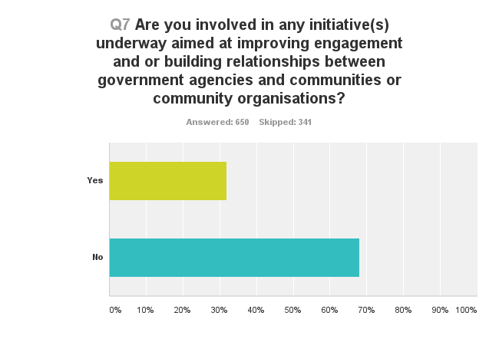
The majority of respondents (68%) are not involved in any initiatives underway aimed at improving engagement and or building relationships between government agencies and communities or community organisations.

Q8. If yes, please give details:

(As a follow-up to Q.7) A lot of respondents discuss their own initiatives underway, and only a small proportion (45 respondents out of 215, 21%) talk about specific initiatives led by both the government and communities/community organisations.
- Family Violence initiatives are mentioned the most – total = 6 references

“Family Violence Interagency Response Group, District Health Board Family Violence Inter-agency Initiative, Te Rito Family Violence prevention network”

- followed by Children’s Teams – total = 4 references

“Childrens Action Team We had a High Trust Contract now Integrate Outcomes and it is working well”

- Strengthening Families – total = 3 references

“Involved with Strengthening Families locally (Dunedin)”

- and Social Sector Trials, Community Development Projects and Whanau Ora – all total – total = 2 references

“Working on how to continue a Whanau Ora navigation project”

The lack of strong responses to this question perhaps reflects ambiguity in the question; whether the initiatives are to originate from government or from the organisation.

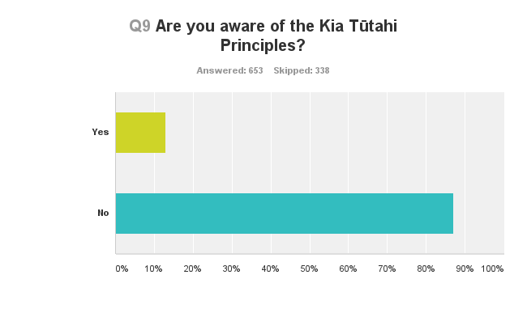
Q9. Are you aware of the Kia Tūtahi Principles?

Almost all respondents (87%) are not aware of the Kia Tūtahi Principles.

Q10. If yes, can you give an example of how the Kia Tūtahi principles have been evident in the initiative(s):

Of the respondents that said they are aware of the Kia Tūtahi Principles, over 1/3 (38%) said that they could not give an example of how they have been evident in initiatives. Furthermore only a minority of respondents made reference to clear examples of how the Kia Tūtahi principles have been evident in the initiative(s) (19 out of 95, 20%). Of those clear examples, the majority (46% of the examples) were in reference to the principle that ‘we have a collective responsibility to hear and respond to the voices of all’.
Examples given:
We will respect Te Tiriti o Waitangi
“We work in a bi-cultural setting like Te Tiriti informs us and honor the document to the best of our abilities our worker work alongside each other to compliment one another and in our strengths.”
We have a collective responsibility to hear and respond to the voices of all
“Good attempts to engage and hear partners - free workshops, feedback asked for.”
We will act in good faith
“The project involves collaboration between community agencies and government in order to achieve best outcomes to address a key social issue.”
Our work together will be built on trust and mutual respect
“We found the dialogue and relationship respectful and helpful”

Case Studies

A small number of respondents were contacted for a further discussion of their answers. As such a large proportion of respondents are not aware of the Kia Tūtahi principles, Hui E! felt that it would be more useful to direct the topic of the follow-up interviews towards examples of good practice engagement between government agencies and communities/community organisations.
Respondents were selected if they had written fairly detailed accounts, or had raised some interesting points around examples of good practice engagement. 6 telephone interviews were conducted, lasting between approximately 10 and 30 minutes.

Interviewee 1 (Sector = Education / Training / Research)

What works well
- Prompt and direct answers appreciated
- Face-to-face contact as a preference
- Verbal and personal contact (experienced working with MSD & TEC)
- “Mutual benefit through mutual collaboration rather than demanding or expecting”
- MSD staff-member is “very possibility focused and helpful”, he finds a way to get outcomes for the community through policies that are currently prevalent
- Visits are really appreciated. “It’s absolutely tremendous that we’ve got them to come here and have a look, just wonderful. I mean they’ve all got the policy outcomes they’ve got to implement, but the fact that they’ve come to see has been a real breath of fresh air”
- To ensure good practice, listening and feedback is vital, specifically “both ways listening”
Example given of initiative highlighting good practice engagement:
MoH’s ‘Raise Hope’ - local strategic plan for improving mental health and addiction outcomes. (link to information http://www.southerndhb.govt.nz/pages/raisehope/)
- Through ‘Raise Hope’, the community is involved. All are listened to and empowered to contribute. Feedback is taken note of and someone from the community is on the board.
- Working together as a group is key – having everyone around a table to make sure outcomes are best for the learners/schools (discussed in the context of work with TEC & MoE)
Areas for improvement
- Some confusion occurs when government agents dealing with the community organisations are not always the same. Issues with “different interpretations of the different agents”
- An issue raised specifically with WINZ is that, although it is not the staff’s fault, the “system can be pretty inflexible and seemingly unreasonable”
- A barrier encountered (specifically in the Department of Corrections) is that probation are very constrained by the requirements of their role. “…frustrating when what you see happening is a letdown of an individual & further destruction of that individuals capacity, because they’re not being adequately assisted”
- Corrections need to be less organised around their computers and more out there with their “probationees”… “If you’re not in touch with the person on the ground how are you going to know what the risk is”
- A challenge encountered with CYF is that policy seems to suggest services have to “fix people” in a certain amount of time “We have generational issues, you can’t fix people in a few weeks”. Instead, you need to build long-term relationships & trust. “What we have is a whole bunch of people out there with a toolkit that fixes problems rather than a bunch of coaches who are out there enabling people to find the solutions to their problems”
- Would like to be more engaged with MBIE, but find it a little bit intimidating – not fluent in where to find things
- The main challenge to good practice engagement is differing philosophies. “Overarching issue is that government don’t seem to have the sort of humanitarian approach that I would like to see”
- The middle band of government is process driven, and consequently makes life at the bottom more difficult
- A final key issue is trust (which is earned). It is best when staff from government agencies actually come and see what is going on “I would like to see more of that”

Interviewee 2 (Sector = Community Development)

What works well
- The Ministry of Pacific Island Affairs (MPIA) Southern Regional Team have given strong support of community activities. They are present at all the different events and have an email network set up which they use to send information out to all the organisations.
- Visibility of government agencies and information-sharing are both very important
- The most important point is that “they really believe in what they’re doing and you can see that in how they talk to people, how they hold themselves, but also just how generous and gracious they are with all of the politics that go on” (in reference to MPIA)
Example given of inititative highlighting good practice engagement:
Ministry of Youth Development (MYD) ‘Youth Advisory Group’ (YAG) – gives young people the opportunity to provide advice and input to both governmental and non-governmental organisations from a youth perspective (link to information http://www.myd.govt.nz/young-people/national-youth-advisory-group.html)
- Key point is that MYD actually resource the YAG, it’s not just tokenistic
- MYD are a strong leader in youth development. “All these things they try to teach to others, they really demonstrate themselves”. Irrespective of age, they have not lost touch with what the role means
- Youth engagement has got better with Canterbury Earthquake Recovery Authority (CERA)
- Communication and transparency are crucial
- Processes seem very clear with the DIA and Charities Services, and there are people to talk to
- MPIA’s help with a presentation/workshops around cultural competency and cultural intelligence “really did help enlighten a number of people’s quite outdated views of Pacific people in NZ”
- MPIA supports and helps advocate internally the community organisation’s own initiative ‘iSPEAK’ so that ministers respond to young people
- Key necessity is that all voices are heard and that everyone is there the whole way through
- Key theme is that they are there, they care about their jobs and they resource what they are doing. “These two ministries probably have the lowest budges. But the amount they give of time and energy is far more than that” (in reference to MPIA and MYD)
- “Government pulling services in one place for people to access, that’s very helpful. It really does make sense in my mind”
Areas for improvement
- Do not seem to see the DIA out as much as other agencies, but appreciate that they are more online (and very accessible)
- Would like to be able to work more proactively earlier on, rather than being an “ambulance”. “We have to be reactive, much rather education”
- Would be great to be further resourced
- Would like something similar to the “I am Auckland” report regionally nationwide. (link to information http://www.aucklandcouncil.govt.nz/EN/planspoliciesprojects/plansstrategies/Councilstrategies/Documents/iamaucklandstrategicactionplan2014.pdf)
- Need the government to create an audit to measure whether youth engagement is tokenistic or not

Interviewee 3 (Sector = Other)

What works well
- MoJ’s fortnightly teleconferences
- Teleconferencing is a forum that enables a collective view of what is happening nationwide. It is effective for identifying whether issues are systemic, wide-ranging or unique, and allows you to see whether other organisations have developed any solutions
- Teleconferencing provides an opportunity to share good practice and ensures everyone is getting the same information at the same time, “common understanding”
- Key to ensuring good practice engagement is that an opportunity is provided, and there is a willingness from everyone to participate and contribute
- Openness, transparency, respect and trust are all vital to enabling good practice engagement
- Everything depends on the quality of the relationships built between government agents and community organisations
Areas for improvement
- A challenge with teleconferences is that they are quite limited. You are restricted by a) scheduling and b) often stilted conversation
- Fact that there are very few opportunities for organisations to meet in person is frustrating (used to have a national conference, but it is no longer financially feasible)
- Teleconferences are therefore an example of good practice, but within the constraints that you are working to
- There is a general sense that everyone is struggling around trying to have government agencies deal with providers in a transparent way

Interviewee 4 (Sector = Social Services)

What works well
- What works well “comes back to the person really – the right person for the right job”
- “That’s the main driver for me – leadership, whoever’s running it is passionate about what they do”
- DIA agent has been very supportive “she sticks with the people ‘til the end, she’s just always there. She’s supported them wholeheartedly in trying to take a few steps forward”
Areas for improvement
- Main challenge faced concerns presence of government agencies at meetings
- Not enough government agencies come to the meetings. This lack of attendance stunts learning – the only way you learn is through meeting with others and finding out about what they do/what’s available “You can go in and have a look at their website, but it’s the actual talking across the table with one another that seems to be the best interaction”
- CYF have been present probably more than anyone else, but have noticed that once government agencies pass the case on to someone in the community they tend to close it down on their side. “I don’t think that’s right, they still need to make sure there’s progress going forward” – they need to part of the whole picture
- Key challenge is getting government agencies to understand how important it is to attend and engage. “They tend to all work in their own little area, I understand it’s because of time restraints. But if we work like ‘Strengthening Families’, where all the agencies come together and we all sit around the table… then that family doesn’t have to put up with all these agencies turning up at their door at different times” (link to information http://www.strengtheningfamilies.govt.nz/about-strengthening-families/index.html)
- “We’re all accountable – you’re letting the client down and the other agencies if you’re not doing what you’ve been asked to do”
- Accountability goes two ways – government has to be accountable too
- “We’re trying to get a result. The only way you’ll get a result is getting everybody round the table”

Interviewee 5 (Sector = Social Services)

What works well
- MSD are taking engagement seriously
- Should not be driven by a contract, but by what is best practice for agencies
- “There’s a real commitment, particularly from the MoJ, to support providers to ensure they’re doing it properly”
Example given of initiative highlighting good practice engagement:
MSD’s ‘Community Investment Strategy’ - gives communities and providers clarity about the priorities for funding for the next three years and explains how the Ministry will manage this investment (link to information https://www.msd.govt.nz/about-msd-and-our-work/work-programmes/community-investment-strategy/index.html)
- Relationships are developing at different levels. Can see with MSD’s ‘Community Investment Advisors’ – recently really putting energy and emphasis into engagement, and actually trying to make it work
- Developing a relationship is crucial. Being able to be honest about things that aren’t working well. “Often there is a power imbalance… between those that are your contract holders and you delivering a contract”. In the past you were less likely to voice concerns, but now there is more openness/willingness to do so
- The government has a greater commitment to and value of these organisations, “there’s a greater awareness of some government agencies to take notice of what is actually happening on the ground to inform some of the policy as well”
- There has always been good engagement with MSD and now there has been a big improvement with engagement with MoJ
- “We’re constantly learning and improving and we’re talking, which is good. Not so much top down, but more of a relationship and a partnership”
Areas for improvement
- One challenge, specifically with Corrections, is that it is quite structured, there is no room for movement. The organisation has a good relationship with district officers, but there is no opportunity to discuss how the family violence programmes are delivered
- The contracting model is very competitive… “It’s become quite competitive and that’s not particularly healthy, because it doesn’t provide good outcomes for the people you’re supposed to be working for”
- There is a feeling that the government is trying to reduce the number of organisations that they are contracting with… “but we still need to be addressing what the community needs are”
- There is also a feeling that government agencies have an idea that because community organisations are NGOs, they are not professional. “But that is completely wrong”

Interviewee 6 (Sector = Education / Training / Research)

Example given of initiative highlighting good practice engagement:
MSD’s ‘Social Sector Trials’ - a social change model focused on improving outcomes by testing an alternative approach to social service delivery in communities (link to information https://www.msd.govt.nz/about-msd-and-our-work/work-programmes/initiatives/social-sector-trials/)

What works well
- The fact that they take part in the trials, and have the right people at the table is crucial
- WINZ have been there right from the start (but not always health or education)
- “We seem to achieve a lot more when they’re all there – because it impacts on all our agencies”
- Key to ensuring good practice engagement is communication and being physically present (understand that that takes time and that there is not necessarily an outcome from it, which is what the government wants, but it is important that they are there)
- It would have been good if everyone was on board from the start, but only in the last 18 months has everyone shown an interest. Perhaps it was not pressed on departments to be a part at the beginning, but now we are seeing a change
- Have noticed an improvement recently, maybe driven from the top telling people to get out there and be a part of it. Better for government agencies too, putting a face to people and communicating
Areas for improvement
- A key challenge is isolation. Organisation is geographically isolated a long way away from any major centres/services. In these kind of circumstance it is even more important to see the people you are contracted with, and to know that there is a lifeline

Key points gathered from all six interviews:
Initiatives and approaches that encourage and enable good practice engagement are:
- Face-to-face meetings and discussion
- Mutual collaboration rather than one-sided demands
- Possibility focused approach
- Physical visits made by government to community organisations (visibility throughout)
- Everyone working together around the table
- Communication - both ways listening
- Long-term relationships built on trust
- Information sharing (ensuring common understanding)
- Passionate and committed staff (good leadership)
- Transparency (openness of processes)
- Resourced well (both financial & time/energy)
- Opportunities provided to share good practice (willingness to participate/contribute)
- Respect – valuing community organisations input and expertise
- Both government and community organisations are accountable
- Ability to be honest, so learning can take place (power imbalance addressed)

Challenges and barriers to good practice engagement are:
- Too computer-based, out of touch with organisations on the ground and needs of those serving
- Focus on fixing problems, rather than empowering to find solutions (need to be preventative, rather than reactive)
- Conflicting philosophies (of government departments and individual agents within them vs community organisations)
- Limited opportunities to meet in person
- Lack of presence/attendance at meetings and throughout projects
- Rigid and structured approaches/policies – no opportunity to discuss
- Competitiveness of contracting model
- Geographical isolation of some community organisations (far from other services and government departments)

The conclusions gathered from the case studies confirm and reiterate the key themes voiced in the survey.

Discussion
Demography
The sectors most represented in this survey are ‘Education / Training / Research’, ‘Social Services’ and ‘Community Development’. The sectors least represented in this survey are ‘Economic Development’, ‘Promotion of Volunteering’ and ‘Care / Protection of Animals’. This demographic layout reflects the spread of sectors represented in the New Zealand Charities Register.
Good practice engagement
60% of respondents have experienced examples of good practice engagement, which is a majority, however not an overwhelming majority. It would be only speculation to discuss why 40% did not give an example of good practice engagement. Possibly a future survey could refine this question to get more clarity.
Government agencies
The Department of Internal Affairs (and its sub departments) is referenced directly the most in examples given of good practice engagement, followed by the Ministry of Social Development, local Councils, the Ministry of Health and the Department of Conservation. The Ministry of Education, however, is not a department that is mentioned particularly frequently even though the sector in which it belongs (‘Education / training / research’) is the most represented sector in this survey. The survey itself, however, can throw no light on why this ministry is not mentioned as frequently as others.
Geographical locations
Auckland, Canterbury, Wellington, Hawkes Bay and Bay of Plenty are the areas mentioned most frequently in examples of good practice engagement. This could be expected, as they are 5 of the most populous areas within New Zealand. Although this survey is focused on engagement between community organisations and central government, many respondents have cited city and regional councils. These references have been included as it is still useful data to acknowledge. Details of whether the citations are about central or local government is included within the results section in question 4. Just over half of the total citations to geographical locations are in reference to central government.
Types of initatives
The types of initiatives suggested as being the most helpful in encouraging and enabling good practice engagement are seminars and workshops, regular meetings and updates, forums and discussions and hui. These initiatives, therefore, should be utilised as much as possible.
Negative responses
Within the question exploring examples of good practice engagement, 24 respondents reported only negative responses. Negative responses in this section perhaps reflects a feeling of dissatisfaction from the sector strong enough to encourage responses outside of the suggested field. The percentage of respondents giving negative responses in this question, however, was 5% which is only just statistically significant.
What works well
In this section the five most frequently touched upon themes (within the question exploring what works well in examples of good practice engagement) will be discussed. Collaboration and partnership was the most referenced theme within examples of what works well. The MSD and the DIA were the most frequently referenced departments when respondents were talking about collaboration and partnership, which could suggest their commitment to meaningful engagement with the NGO sector and partnership working.
Communication was the next most referenced theme within this section, and highlights the importance of clear communication and a commitment from the government to regular meetings with the community sector in order to keep all parties ‘in the loop’ and a part of the process. The MSD was the most frequently referenced department within this theme, suggesting that the NGO sector may have experienced good levels of communication with this department.
Supportive advice, information and practical help was another key theme discussed. The DIA was directly referenced the most within this theme, perhaps signifying that the department is a good source of support.
Clinics, workshops and seminars are discussed frequently in examples of good practice engagement, and the DIA is again referenced the most within this theme. This could be a reflection of the success of the Charities Services accounting standards seminars.
Respect and appreciation of expertise is another key theme suggested by respondents. The DoC and the MSD are both directly referenced once with regards to respect and appreciation.
Again, within this question (exploring what works well in examples of good practice engagement) 23 respondents gave only negative responses. The percentage of respondents giving negative responses in this section is just under 5%, and therefore not statistically significant. However, it is important to acknowledge that respondents have repeatedly voiced frustrations within all the survey questions.
Word cloud created on www.wordle.com showing word frequency in respondent’s answers in Question 5

Challenges faced
In this section, the five most frequently touched upon themes within the question exploring challenges faced/barriers to good practice engagement will be discussed. Over bureaucracy, rigid requirements and inflexibility was the most discussed theme within this question. This perhaps suggests the need for government agencies and departments to be less fixed in their interactions with the NGO sector, and approach issues more openly. The DIA is referenced the most within this theme, which could suggest that the department is bound to policies and procedures more inflexibly than others.
Lack of collaboration, discussion or meaningful engagement was the next most referenced theme within this question. This clear mirroring of the most referenced theme within explorations of what works well solidifies the importance of meaningful collaboration between government agencies and the NGO sector. CYF is directly referenced twice within this theme, perhaps suggesting the need for clearer collaborative approaches from these departments.
The next most frequently discussed theme within this section is technical frustrations. Many of the respondents voiced frustrations with procedures going online (reflecting issues facing the demographic of a large part of the NGO sector – older volunteers). Again, the DIA was cited by far the most in this section with 15 direct references. This perhaps reflects that the DIA requires the most amount of form-filling and use of technical applications within its services.
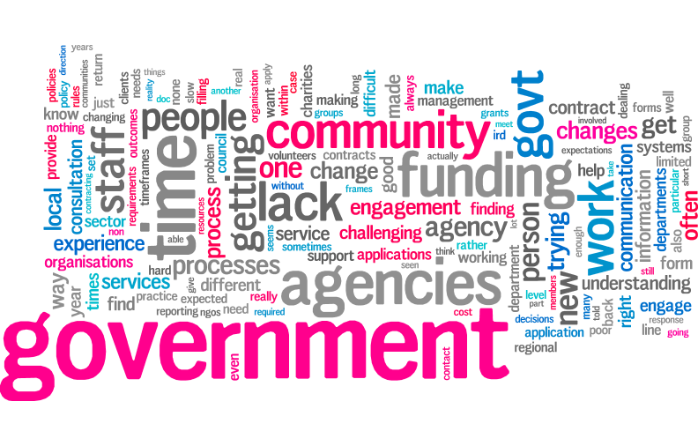
Not knowing who the right person to contact is, and lack of accountability is the next most referenced theme within this question. This, in theory, should be an easy issue to amend, and highlights the importance of clear information and communication. MSD is directly cited the most in this section (three times), suggesting the need for work in the area of ownership of issues and clarity of points of contact within this department.
Word cloud created on www.wordle.com showing word frequency in respondent’s answers in Question 6
Challenges faced with funding instability and the competitive contacting model was another frequently referenced theme within this section. This highlights a key concern amongst the sector at the moment with the current commercial and competitive short-term contracting paradigm. The DoC is directly referenced twice within this theme.
Initiatives underway aimed at improving engagement/building relationships
68% of respondents are not involved in any initiatives underway aimed at improving engagement and or building relationships between government agencies and communities or community organisations. This highlights the need for more work in this area, specifically in the areas raised within the challenges section of this survey.
Of those respondents that did discuss clear, government-led initiatives that they were involved in Family Violence initiatives were cited the most, followed by Children’s Teams and Strengthening Families. These initiatives could, therefore, be used as models of good practice engagement and lessons could be drawn from them. Further research into what specifically works well within these initiatives would be useful.
Kia Tūtahi
87% of respondents are not aware of the Kia Tūtahi Principles. This highlights that the current accord is not successfully engaging the NGO sector, and that perhaps something more meaningful needs to be developed drawing from the examples of what works well discussed within this survey.
Case studies
Finally, the telephone interviews conducted reiterate the key themes discussed within the survey around what works well in examples of good practice engagement, and what the common challenges faced are. The interviews highlight further case studies of good practice engagement between government agencies and the NGO sector that could instruct development and learning around improvement in this field. MoH’s ‘Raise Hope’ programme, MYD’s Youth Advisory Group, MoJ’s application of teleconferencing, MSD’s Strengthening Families initiative, Community Investment Strategy and Social Sector trials all potentially provide rich sources of information and ideas around collaboration and partnership working.

Implications of the Survey for Kia Tutahi and the Sector-Government Relationship

This survey was undertaken by Hui E! Community Aotearoa under a contract with the Department of Internal Affairs. In Hui E!'s view the survey responses demonstrate the current lack of any effective whole-of-government or whole-of sector programme that has as its focus improving the sector-government relationship, or promoting better ways of working together.
While it is very positive that 60% of respondents report they have experienced examples of good practice, there is no whole-of government or even whole-of-department pattern. The highest numbers of positive initiatives identified by respondents are based in specific high-priority programmes such as Family Violence prevention, Children’s Teams, Strengthening Families and Social Sector Trials. Interestingly these are also the programmes where there is a shared commitment between government and the sector to achieving change.
The other notable areas where good practice and especially communication are highlighted are programmes where by design there is deliberate effort to engage in ways that are shown to be successful - for example Community Development Projects, Whanau Ora, and education for registered charities about the requirements of the new Accounting Standards.
Apart from these commonalities, good practice seems to depend very much on the personal qualities of individuals working within government agencies. This is the most likely explanation for the widely scattered examples of good practice (geographically and across government agencies) and it is borne out by the specific reports of good practice ending when a particular individual moves on from their role.
Alongside this good practice, many of the same government agencies that are responsible for the programmes where good practice is occurring are also identified in the examples of negative experiences. There are examples where the same government agencies' work with community sector organisations demonstrates poor practice. Again, the role of individual workers in a government agency may be as significant as any deliberate policy or strategy set by the agency.
Re Kia Tūtahi, it is notable that 87% of respondents are not aware of the Kia Tūtahi Principles, and of the respondents that said they are aware, 38% said that they could not give an example of how they have been evident in initiatives under way.
This low level of awareness of Kia Tūtahi, combined with the scattered nature of examples of good practice and their overlap with examples of poor practice, means the reported examples of good practice cannot be attributed to Kia Tūtahi.
In Hui E!'s view Kia Tūtahi cannot be regarded as a recipe for successful engagement and relationship-building. It's principles are inarguable, but they are very high-level and too remote to make a difference in day-to-day, on the ground, ways of working that the survey respondents report as being successful. The reports of what works and what does not work are at a different level, closer to the reality of delivering responses to community needs. In Hui E!'s view also, greater promotion and awareness of Kia Tūtahi will not address this crucial issue.
The greatest value of this survey is perhaps in its clear identification of the most useful strategies and practices that government agencies should adopt if they are serious about improving engagement and developing collaborative relationships with community sector organisations.
The respondents' comments about practices they have experienced that undermine productive working relationships (and in some cases cause harm to the organisation) also make it clear that an investment in improving relationships and engagement would have the potential to add significant value to the work of both parties to the relationship.
Thus in Hui E!'s view a deliberate effort to improve relationships and engagement will, given the degree to which services prioritised in government's Better Public Services set of goals are actually delivered through community sector organisations, significantly benefit progress on the goals. Where good practice is missing, there is significant opportunity cost to the taxpayer and to New Zealand as a whole.

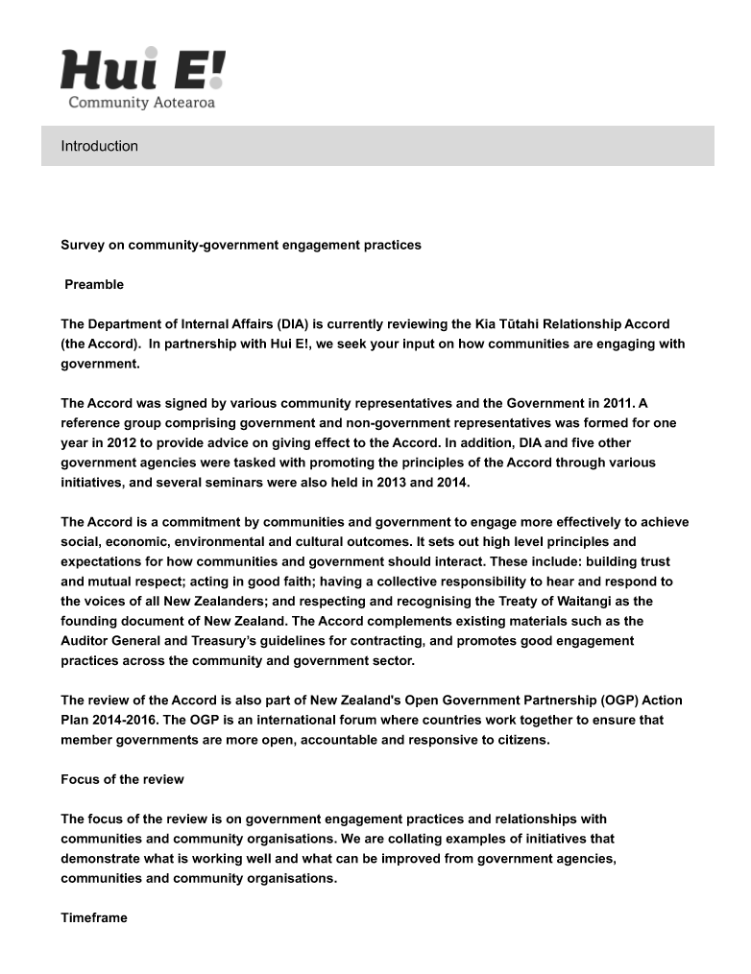
Appendix – The Survey Questions
