Community Digital Hubs

Note from LIAC to the Minister of Internal Affairs, August 2013

In May we met with representatives of the Association of Public Library Managers (APLM), Library and Information Association of New Zealand Aotearoa (LIANZA), and National Library’s Services to Schools, to discuss Community Digital Hubs (CDH). We heard about exciting early work from Riccarton, Upper Hutt, and elsewhere, and about the challenges and opportunities they provide.

This paper makes recommendations and provides a summary of the key learnings. It ends with a list of sources consulted.

Recommendations

- The Minister should build future CDH work on existing best practices, identifiable by requesting case studies from APLM, LIANZA, and the School Library Association of New Zealand (SLANZA).
- The Minister should commission research into the economic value of investment in public libraries, to provide an evidential basis when partnering with local government bodies to deliver CDHs.
- The Minister should use the Public Library Strategic Framework developed by APLM as a basis for engaging public libraries and local government in the discussion of CDH.
- Agreements to provide CDH should mandate that they be “free of charge”, to ensure equity of access.
- Agreements to provide CDH should preserve the professional independence of librarians. (That is, they act for citizens not for government and should not be required to act against citizens’ interests)
- Agreements to provide CDH should include provision for adult literacy support where needed by communities.
- The Minister should incorporate the CDH concept into the Government’s strategies to achieve Result 10, as a tool, proven in a number of leading-edge countries, to encourage community involvement in the knowledge economy.
- The Minister and his colleagues should use the National Library’s Aotearoa People’s Network Kaharoa (APNK) project as a platform for establishing CDHs across New Zealand.
- The Minister and his colleagues should use the National Library as a central point of contact between central government and CDHs, providing service needed to deliver front-line support to citizens.
- The Minister should support his colleagues in implementing the recommendations of the Education and Science Select Committee around making it easier for schools to offer community services from their space, as school libraries are the only libraries in some rural towns.
- The Minister should be aware that libraries will need additional resources (hardware, Internet connectivity, and staff) to deliver these services.
- The Minister should notify his colleagues of reports from Christchurch of early problems with MSD directing citizens to public libraries for help writing CVs to access government services, without understanding the depth of need in their patrons (and the preparation required for libraries to meet those needs).

Discussion

Community Hubs is an established concept around the world, referring to public space shared by several community service groups. The word “Digital” means the public space offers Internet access, computers to access the Internet, and staff to support these.

Existing CDHs address needs in:

- Internet connectivity. “I have an iPad but no Internet access, please help.”
- Computer hardware. “I have no computer at home, please help.”
- Literacy. “I can’t read enough to use the Web, please help.”
- Digital Literacy. “I don’t know how to sign up or use this online service, please help.”
- Task-Specific Support. “I don’t know which category of benefit I should be applying for, please help.”

There is a recognised gap in Internet access in New Zealand:

- The 2006 census found that 100,000 families with school-age children did not have computers in their homes. (source: Commerce Select Committee Inquiry into 21st Century Learning)
- An increasing percentage of low-income families no longer have a fixed landline, having switched to prepaid mobile phones to reduce costs. We heard that families that are struggling to pay for a fixed line will not be able to afford broadband access, which will further exacerbate the digital divide. (source: Commerce Select Committee Inquiry into 21st Century Learning)
- 25 percent of people will not have fibre to the home, and there will be over 40 percent of rural dwellers still without connectivity other than a dial-up line. (source: APLM NZ Public Libraries Strategic Framework)

That gap is both rural/urban and rich/poor. The challenge for CDH as equity provision for central government services is the variability of provision of existing services:

Local authorities serving populations of 25,000 or under spend on average 50 percent less per head of population on library services than those serving 100,000 or more. This disparity in funding has meant a significant inequity in the services available to those living in rural and provincial New Zealand.
—NZ Public Libraries Strategic Framework
To bridge those gaps, most New Zealand public libraries already offer Internet access, either directly supplied or through the National Library’s APNK program (which currently services 145 libraries from 43 local authorities).

The APNK has had a very significant impact on public libraries in rural and provincial towns, bringing in new customers and helping to ensure that those that do not have access in their homes are not disadvantaged by the move to online information and services.
—Public Libraries Strategic Framework

There is no legislative mandate for local authorities to provide public library services, nor for any of the services to be free. The Local Government (Public Libraries) Amendment Bill was defeated last November, which would have ensured Internet use remained free of charge in public libraries. For CDHs to work, some obligation will need to be imposed on local governments and legislation will need to be revised.

Public libraries are currently 80–97 percent funded from the public purse through rates (local body property taxes).
—NZ Public Libraries Strategic Framework

Central government subsidies as part of APNK have made it easier for public libraries to get connected and offer Internet access, but such services still come at a cost to the local authorities who often mandate access charges for patrons to use the computers. This can present the paradoxical sight of middle-class patrons using their iPads for free in the library while poor patrons pay to use the library’s computers.

This significantly impedes the libraries’ equity function, in the words of LIANZA President Laurinda Thomas:

Even very small charges create very big barriers to use.

Public libraries are the nation’s democratic backstop for access to information. That is, citizens without the skills or means to purchase, find, or engage with information already turn to their public library for help. In addition, librarians and library services help citizens and businesses to access and use the information they need to succeed economically.

The Government’s objective of increasing digital delivery of services to citizens, and of providing greater integrated online access to business information and services, align well with these roles of libraries as seen by the APLM.

The reframed roles of Public Libraries for the foreseeable future include:

  - Collecting, curating and providing access to knowledge, ideas and works of the imagination
  - Fostering the joy of reading and supporting the development of literacy in all its forms
  - Enabling independent lifelong learning, research and innovation
  - Providing community based services for all in places that are at the heart of their community
  - Collecting, creating and making available local content and history.
—NZ Public Libraries Strategic Framework

The public library is a public space. For some people, the main service the library offers is to be a warm dry safe space where people smile at you. For others it’s a place to Skype with family back home. As the role of libraries has grown, physical space and librarian skills have had to adapt to meet the sometimes-conflicting needs of different users (in many libraries, Skype calls are made beside studying students, which is not ideal for either).

Librarians already assist people with computer skills, job applications, and access to some government services. These transactions aren’t always quick and easy. Some patrons have mental health issues, some lack basic literacy skills, some face severe language barriers, some are so outside traditional systems that they aren’t contactable except in the library. Librarians’ core expertise is in cataloguing and finding information, and they have found themselves stretched to provide mental health, literacy, and technical training without support.

Foot traffic [up 20%] is non-traditional library users, making us look at every aspect of our service. Our clientele has changed: the new clients have far greater personal needs. They are coming in to use the Internet but many need assistance, not just skills—getting people who have disabilities, mental health issues, ESOL, or almost no literacy skills.
—Debbie Duncan, Upper Hutt City Library

That said, some rural libraries are already serving as proxies for government agencies.

In rural and provincial towns in particular, a trend is emerging whereby the library becomes the stand-in venue for government agencies that have shifted their services online or to call centres and no longer offer a physical presence in the area. For example, the library becomes the New Zealand Post Shop or provides interview space for government agencies at specific times. Some government agencies are directing those without personal access to the Internet to use the public library’s facilities. Librarians often need to support these people, who may not be familiar with computers.
—NZ Public Libraries Strategic Framework

A librarian’s professional competence is in information literacy: finding, assessing, and distilling information for use. CDH patrons need IT (“how do I get my phone online?”), mental health, adult literacy, and other non-information support. CDH will need librarians for information literacy services, but we anticipate a broad range of people present and employed to deliver the broader range of services.

These needs are met by people time. Sometimes it can be provided by communities or intergenerational connection. The computer mentors at Upper Hutt City Library are volunteers, all vetted and trained. We take a similar approach to the Citizen Advice Bureau: the mentors can be booked, 2 hours at a time. MSD contracted training on job searching to be delivered through the library.
—Debbie Duncan, Upper Hutt City Library

It’s no coincidence that the first word in CDH is Community. These work best when the Community has decided what services it wants, and central government investment can be a catalyst to help realize the community’s ambitions. The Computers in Homes installations for Tuhoe led their community to organise the creation of an iwi-wide wifi network (funded through the government’s Broadband Challenge program).

Provide support for the community to grow itself.
—Hāromi Williams, Commissioner

In our discussion, we focused on the equity of access provisions, as a way of facilitating the Result 10 goal. However, we noted that digital literacy and information curation services are useful to New Zealand SMEs and that CDHs have a role to play in upskilling NZ businesses for economic growth.

In Europe, particularly in Denmark, Finland and the Netherlands, the focus is on both improved digital offerings and on the changing use of library buildings, in order to embrace all media, not just the print and physical items. The library as place – a community hub, a business hub, a space for innovation and creativity – is becoming more important even as libraries become more digital and virtual. The level of investment in new central library buildings, in Europe as elsewhere in the world, is particularly notable. In the Netherlands, for example, a project in Delft is providing young start-ups willing to pay a modest fee the chance to use the facilities at the library – meeting spaces, wifi and technology labs. The library is changing from being a place where people came to get ideas and information to an experiential place where people meet with others to create, share and learn about new ideas in a social context.
—NZ Public Libraries Strategic Framework

Participants repeatedly commended the APNK program as a successful intervention to assist libraries in providing Internet access and support where those things would otherwise have been unavailable. APNK a National Library project, is delivered as a package to help a library to offer Internet support to the community (hardware, Internet access, training) including financial support. Councils fund approximately 30% of the costs, primarily ongoing Internet access.

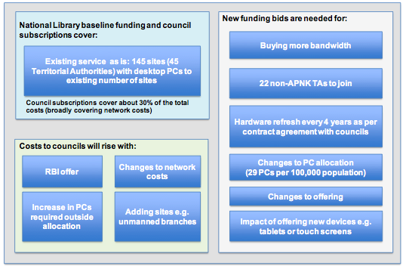

In 2010, the Department of Internal Affairs commissioned an external impact evaluation of APNK, which noted “some significant benefits for hard-to-reach audiences, and in particular Māori and younger age groups”.

In particular, Māori were:

  - More likely to have arranged to meet others at the library;
  - More likely to have enrolled in formal educational and training opportunities;
  - More likely to have completed or updated their CVs, and searched or applied for jobs and employment;
  - Twice as likely to have updated their electoral roll information online;
  - More likely to feel part of the online environment, and able to access information they couldn’t access before.
—APNK: An Impact Evaluation, Simpson Edwards (Jan 2011)

A 2012 external strategic review of APNK recommended that the National Library re-engage with the longer-term benefits of APNK, moving the focus from connectivity to the services available through the connection. One specific recommendation was to “Support the connected community hub concept”. The report noted that “the government’s priority to move more services online is a great chance to leverage the existing service to deliver other benefits.” (Strategic Review of Aotearoa People’s Network Kaharoa at The National Library, Starfish Consulting (October 2012)).

That review, and our discussion, highlighted the vulnerability of funding for APNK:

The current APNK model relies on libraries opting into the service and paying a portion of the costs. More importantly however, in terms of the end-user (library customer) experience, the current model relies on public libraries to provide space in suitable buildings, furniture for the users and equipment, and, critically, library staff to support APNK users. [...] The economic environment is harsh. National Library has had base funding cut and councils are under financial pressure too so neither are well positioned to provide additional resources without a fundamental shift in funding approach.
—Strategic Review of Aotearoa People’s Network Kaharoa at The National Library, Starfish Consulting (October 2012)

The review and our discussion noted that CDHs are responsible for most of a local authority’s Internet charges. Although the rural broadband infrastructure (RBI) is laid to the boundary of library properties, it has been up to the local authority to take up the offer of connection. APNK does help partner libraries to connect to RBI.

For example in most libraries the library internet traffic is 75% - 90% of the council's total internet bill.
—Strategic Review of Aotearoa People’s Network Kaharoa at The National Library, Starfish Consulting (October 2012)

We use 90% of the council’s Internet data plan.
—Debbie Duncan, Upper Hutt City Library

APNK’s role in connecting partner libraries to RBI fibre is to organise the changeover, liaise with service providers, and administer additional associated charges.
—APNK Website

The group felt that the relationship between central and local government would have to be ongoing and sustainable. As the Minister knows, simply redirecting frontline customers to public libraries will neither meet their needs nor build a sustainable relationship with the local authorities which provide those library services. Already, reports from Christchurch are that MSD staff are directing customers to public libraries for help preparing CVs, but those customers often have complex literacy needs and little to no computer skills, and the public libraries sometimes offer computer access in time blocks unsuitable to meeting such needs.

Funding public libraries is an investment, and while other countries have done research into the payback from such investments there’s been no similar work done here in New Zealand. Without support from independent research, it will be difficult to make arguments for central or local government to invest further in the provision of community services. We recommend that the Minister commission such research to support the development of sustainable partnerships with local authorities.

APNK is the best example of a collaborative large-scale project between central and local government to deliver services in public libraries. We heard that while the Internet service has been well-resource and supported, another service (Kete, software for collecting and sharing community stories and photographs) was not so well supported. Lack of such support threatens the ability of local libraries to get full value from the initial investment.

Exemplars

There aren’t consistent terms for the CDH concept, and we didn’t find contemporary research into the ideas in New Zealand or overseas. For this reason, we recommend that the Minister engage with the New Zealand library bodies (APLM and LIANZA) to prepare such a list of existing work, from which local authorities and central government can learn what works and what doesn’t.

That said, a list of interesting projects follows.

Palmerston North Youth Space represents the culmination of four years of collaborative hard work on the part of Palmerston North Youth Council, the City Council, the City Library and numerous community and funding organisations. [...] The work of this multi-purpose facility is aligned to the council and library strategic direction and delivers outcomes for young people. “We’re very fortunate to have a training kitchen, three meeting rooms, a purpose-built events area, a gaming room and the youth library collection. We also have free wi-fi and a small number of computers so we can host and run a range of classes and events. We hold homework clubs and taster sessions for young people to try out different things. We work with youth service providers to try to offer as many positive engagement opportunities as we can.”

In October 2011 the Carterton District Library re-opened for business in the new Carterton Events Centre building. This was the culmination of 10 years’ work with the community looking at how different services could best be delivered in a local authority of 7,100 residents. The advent of the centre was the community’s desire to see a single place from which a wide range of services (including the library) could be offered. The concept promoted the new building as the ‘hub of the community’.
—NZ Public Libraries Strategic Framework

We heard from the former school librarian at Riccarton High School in Christchurch, which merged its school library with the local public library. Their mixed use facility saw the public and classes using the space at the same time, building closer relationships between the school and the community. It has been a partnership which took careful planning and buy-in from all stakeholders, not something imposed from without that magically worked (see Annex B for a description of the key success factors). The group noted that some areas may have school libraries but not public libraries.

The Education and Science Select Committee, during their inquiry into 21st Century Learning, heard how schools face legal barriers offering community services. In part because of this, the community wifi and upskilling in East Tamaki is being done through the Manaiakalani Trust, even though it began at Point England School.

The Upper Hutt City Library provides Internet access through APNK and computers to access the Internet. Citizens already use the facilities to access government services. Library is a public space for the delivery of community services.

Conclusion

Community Digital Hubs is a concept whose time has come for New Zealand. It is a way to accomplish the Government’s goals in partnership with local authorities, though the nature of the relationship will require some collaboration. The Government can learn from existing examples from New Zealand and the world, and a project to build upon (APNK). It is a partnership that libraries welcome.

Sources

“The Future of the Profession”, Australian Library and Information Association. http://www.aliafutures.wikispaces.com/home

“National Digital Economic Strategy”, Australian Government. http://www.nbn.gov.au/nbn-benefits/national-digital-economy-strategy/

“Inquiry into 21st century learning environments and digital literacy. Report of the Education and Science Committee”, New Zealand Government. http://www.parliament.nz/NR/rdonlyres/FD34151C-744B-4B49-86F2- 6FE5850123AE/256992/DBSCH_SCR_5695_Inquiryinto21stcenturylearningenvir.pdf

“Library Services in the Digital Age”, Pew Internet and American Life Project.
http://libraries.pewinternet.org/2013/01/22/library-services/

“Te Kauroa - Future Directions 2013-2023”, Auckland City Libraries.
http://www.aucklandlibraries.govt.nz/EN/About/plansandpolicies/futuredirections/Pages/futuredirections.aspx

“Public Libraries of New Zealand - A Strategic Framework 2012 - 2017”, Association of Public Library Managers.
http://www.publiclibrariesofnewzealand.org.nz/strategicframework

Annexure A

The success of the Upper Riccarton model came down to a shared and sustained understanding from both parties of the vision for the project, a mutual understanding of the success necessary for all stakeholders and underpinning it all the continuing strategic relationship building and nurturing that started over two years before the library opened.

The support of literacy, information literacy and digital literacy that both parties; Riccarton High School and Christchurch City Libraries have for their individual communities, facilitates a shared and joint vision, success for the School & Community Library, and much potential for the future.

It's essential to have that shared vision and outcomes as without them many Joint-Use / shared facilities and relationships breakdown and fail.

The Learning Outcomes of the Upper Riccarton Joint Use Library partnership as of 2011 were identified for an international joint use library conference as;

One of the key strengths of the joint use library is the commitment to the partnership and its success shown by all stakeholders. Like the special child in the family, which everyone wants to see succeed, Upper Riccarton School and Community Library has had, and continues to have staff and management structures in both organisations who are passionate about making it work to benefit both communities.
* the dynamics of any library are dependent on multiple factors, but achieving buy in from all stakeholders and users of the library from the outset is essential. If this is not the reality, then it needs to be addressed with robust discussion and honest communication before things proceed any further. These dialogues should not cease once the library is open and running. The partnership needs to keep being worked at, with both organisations providing opportunities for ongoing collaboration. Create your own relevance based on your joint use library scenario.
* be very clear from the outset what each organisation's goals and vision are for the joint use library.
Keep aware of any changes to these, and understand revised stakeholder expectations. Provide regular opportunities for staff from both organisations to 'walk in each other's shoes' and then allow time for reflection together.

Two reports about the project which add depth to the joint-use/shared community digital hub concept, are available at the web-sites below:

http://www.lianza.org.nz/sites/lianza.org.nz/files/whatsyoursismine_peskett_1.pdf

http://www.thefreelibrary.com/Strong+foundations+on+shaky+ground%3A+the+Upper+Riccarton+School%2FPublic...-a0277344043

Information from Paula Eskett, Programme Advisor, School Library Futures Christchurch, National Library of New Zealand by email on 31/07/2013

Annexure B

Abandoned Walmart is Now America’s Largest Library
Article by Steph, filed under Public & Institutional in the Architecture category.
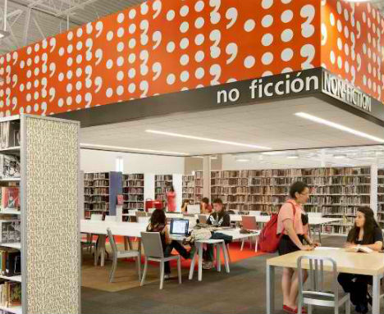
There are thousands of abandoned big box stores sitting empty all over America, including hundreds of former Walmart stores. With each store taking up enough space for 2.5 football fields, Walmart’s use of more than 698 million square feet of land in the U.S. is one of its biggest environmental impacts. But at least one of those buildings has been transformed into something arguably much more useful: the nation’s largest library.

Article available at http://weburbanist.com/2012/09/04/abandoned-walmart-is-now-americas-largest-library/
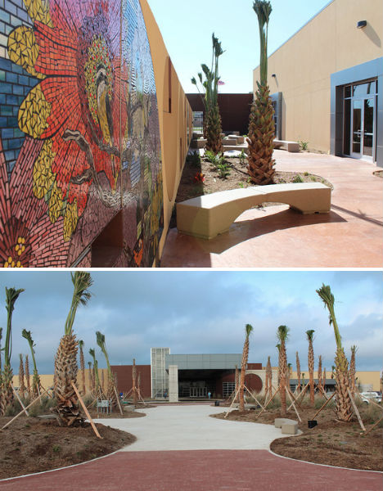
Meyer, Scherer & Rockcastle transformed an abandoned Walmart in McAllen, Texas, into a 124,500-square-foot public library, the largest single-floor public library in the United States.

Article available at http://weburbanist.com/2012/09/04/abandoned-walmart-is-now-americas-largest-library/
The design won the International Interior Design Association’s 2012 Library Interior Design Competition. MSR stripped out the old ceiling and walls of the building, gave the perimeter walls and bare warehouse ceiling a coat of white paint, and set to work adding glass-enclosed spaces, bright architectural details and row after row of books.

Article available at http://weburbanist.com/2012/09/04/abandoned-walmart-is-now-americas-largest-library/
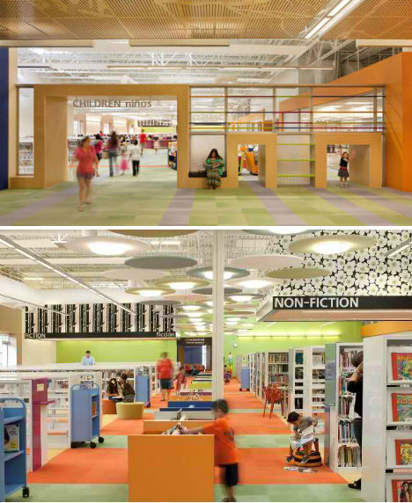
The library even has an acoustically separated lounge for teens as well as 6 teen computer labs, 16 public meeting spaces, 14 public study rooms, 64 computer labs, 10 children’s computer labs and 2 genealogy computer labs. Other new features include self check-out units, an auditorium, an art gallery, a used bookstore and a cafe.

Article available at http://weburbanist.com/2012/09/04/abandoned-walmart-is-now-americas-largest-library/
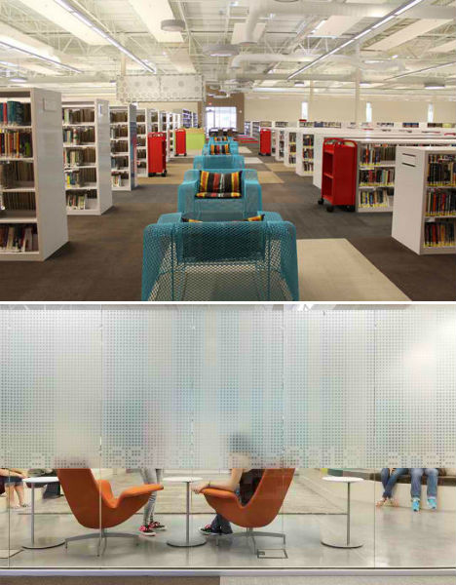
While you can still see hints of what the library once was in its sprawling shape and industrial ceilings, it seems like an entirely new space. According to PSFK, the library saw new user registration rise by 23% within the first month following the new library’s opening.

Article available at http://weburbanist.com/2012/09/04/abandoned-walmart-is-now-americas-largest-library/

