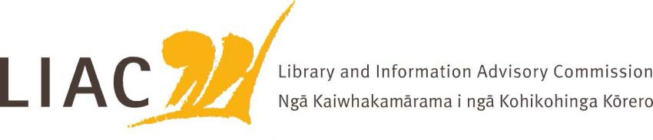

Meeting Papers Monday 2 November 2015

Te Pae Tapuwae Room Level 3
National Library of New Zealand Molesworth Street
Wellington

09.00 am

Monday 02 November 2015 at 09.00 am Department of Internal Affairs
Te Pae Tapuwae Room, Level 3, National Library of New Zealand, Molesworth Street, Wellington

AGENDA

Members: Sharon Dell (Chair), Bill Macnaught (Ex-Officio), Carolyn Robertson, Helen Tait, Judith Johnston, David Reeves

Apologies: Carolyn Robertson

Attendees: Department of Internal Affairs
Wendy Balfour, Advisor/Secretariat Support, Branch Development and Support, Information and Knowledge Services (IKS) Branch
Peter Murray, Deputy Chief Executive, IKS Branch
Lewis Brown; Manager Planning and Development, National Library of New Zealand, IKS Branch
Winston Roberts, Senior Advisor, Professional Support, National Library, IKS Branch
Hinerangi Himiona, Principal Advisor, Māori, Service and System Transformation Branch
Paul Diamond, Curator Maori, Alexander Turnbull Library, National Library of New Zealand, IKS Branch
Kris Wehipeihana, President, Library and Information Association of New Zealand (LIANZA)
Joanna Matthews, Executive Director, Library and Information Association of New Zealand (LIANZA)

Item No | Subject | Time | Lead | Paper
1. | Welcome and introduction to new members | 09.00 | Chair
2. | Apologies for Absence | 09.03 | Chair
3. | Discussion on role and function of LIAC | 09.05 | Chair
4. | Approval of Minutes of Previous Meeting held on Thursday, 4 August 2015 [Page 5] | 09.15 | Chair | ✓
5. | Matters Arising from Previous Meeting not covered elsewhere on the agenda [Page 17] | 09.17 | Chair | ✓
6. | Review Letter of Agreement between the Department and LIAC [Page 31] | 09.25 | Chair | ✓

- Update from the National Librarian, National Library of New Zealand, Department of Internal Affairs on issues of interest to the Commission
09.35 Bill ✓
Macnaug ht

Break for Morning Tea 10.15
- Positioning the National Library for the future 10.30 Bill Macnaught

- Update from the Deputy Chief Executive, Information and Knowledge Services Branch, Department of Internal Affairs on issues of interest to the Commission
11.15 Peter Murray

- LIANZA - The Future of Libraries Summit report Report from the President and Executive Director of LIANZA [Page 37]
12.00 Kris ✓
Wehipei hana/ Joanna Matthews

Break for Lunch 12.30

- LIAC Planning 2016 [Page 73]
  - Review of work programme
  - Stakeholder list
  - Commissioner – gaps in expertise

13.00 Chair ✓

- Update on Archives Exhibition Project [Page 81] 13.45 Hinerangi
Himiona

- Update on Wai 262
The Trans-Pacific Partnership Agreement (TPPA) ‘Next Steps’
13.55 Paul Diamond/ Lewis Brown

- General Discussion/Outcomes for Reporting to the Minister 14.15 Chair

- Date of Next Meeting – late February, early March -tbc Venue: TPT Room, Level 3, National Library
14.40

Commissioners depart for meeting with the Minister of Internal Affairs, Hon Peter Dunne
14.45

- Meeting with Minister of Internal Affairs, Hon Peter Dunne
– Venue: Level 11L Bowen House, Parliament Buildings
15.00

- Close of meeting 15.30
Tour of National Library 15.45-
17.00

