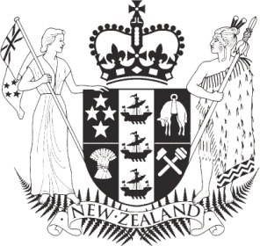

MEDIA ADVISORY 4 December 2013

Inquiry presents first stage report to Ministers
The Government Inquiry into the Whey Protein Concentrate Contamination Incident presented its report on the first stage of the Inquiry to the Minister for Primary Industries and the Minister for Food Safety yesterday afternoon. The first stage reports on New Zealand's regulatory and best practice requirements for dairy food safety.
The public release of the report is for the government, and it would not be appropriate for the Inquiry to make any public comment.
Information about the Inquiry can be found at http://www.dia.govt.nz/Government-Inquiry-into-Whey-Protein-Concentrate-Contamination-Incident
Media contact:
Iona Wassilieff
Senior Communications Advisor
The Department of Internal Affairs, Te Tari Taiwhenua
Phone 04 495 7299; mobile 021 245 9268
Email iona.wassilieff@dia.govt.nz

