

Makowhero District Council Long-Term Plan

Makowhero District Council
2015-2045 Infrastructure Strategy

30 June 2015
FICTIONAL EXAMPLE –
FOR DEMONSTRATION PURPOSES ONLY

Contents
Geographic Context 4
Purpose 5
What is infrastructure? 5
Assumptions and capital expenditure drivers 5
When should infrastructure be replaced? 6
When should the council invest in improving the existing service? 8
Environment expectations 8
Climate change 8
Earthquake resilience 9
How much needs to be invested to provide for a growing community? 9
Future Population 9
Other Assumptions 10
Inflation 10
Replacement of the Victoria and Albert Bridge 10
Most likely scenario 11
Most likely scenario – major projects timeline 12
What will it cost? 13
Cost of most likely scenario 13
Cost implications of significant capital expenditure decisions 13

IMPORTANT:
This document is for the sole purpose of providing an illustration of the intended content and level of detail to be included in infrastructure strategies introduced by the Local Government Act 2002 Amendment Act (No 3) 2014 (the Amendment Act).
It is extremely difficult to provide a hypothetical example of an infrastructure strategy that reflects the “real life” situations councils will encounter. An effective infrastructure strategy will place the infrastructure issues a council faces within a wider context of the overall objectives the council has for its District and the significance of infrastructure issues to the achievement of those objectives. This will require the council to exercise its judgement in identifying and presenting issues within the infrastructure strategy.
Although the Department of Internal Affairs has made all reasonable efforts to provide information that reflects the intent of the Amendment Act, no guarantee is provided that reliance on the model portrayed will ensure legal compliance with the Amendment Act.
Makowhero District Council and all information relating to it is fictional and is the intellectual property of the Crown. Any resemblance to a particular New Zealand local authority, past or present, is coincidental and unintentional.

Geographic Context
[It would not normally be necessary to provide such a detailed geographic context in an infrastructure strategy, as the council can reasonably assume that readers will have a basic understanding of the district’s geography. However, some aspects of district geography and demography, both present and expected in the future, may need to be explained to provide context for the infrastructure issues and decisions the council confronts.]
Makowhero District Council is a unitary authority, having the functions, responsibilities and powers of both a territorial authority and a regional council.
Makowhero District comprises some 1,339 km² of land of which 81% is the fertile flood plains positioned between the 1,860 metre high volcano Mt. Tumblehome and low-lying coastline of the Makowhero Bight. To the west it borders Upper Creek District (whose main city Wellesley has a population of 122,000 and is 35km from Alberton).
The main settlement of the Makowhero District, Alberton, is located on the plains on the western banks of the Kikorangi River, nearly 2.5 kilometres upstream of the river mouth. The river is crossed by the Victoria and Albert Bridge (part of State Highway 109) which carries the trunk water services to and from the reservoirs and treatment plants (on the eastern bank).
The Kikorangi River is a historic path for lahars. High rainfall in and around Mt. Tumblehome (2,680mm per year) means the Kikorangi River is prone to overtopping its banks and flooding the coastal plains around Alberton.
Figure 1: Makawhero Urban Areas 2015
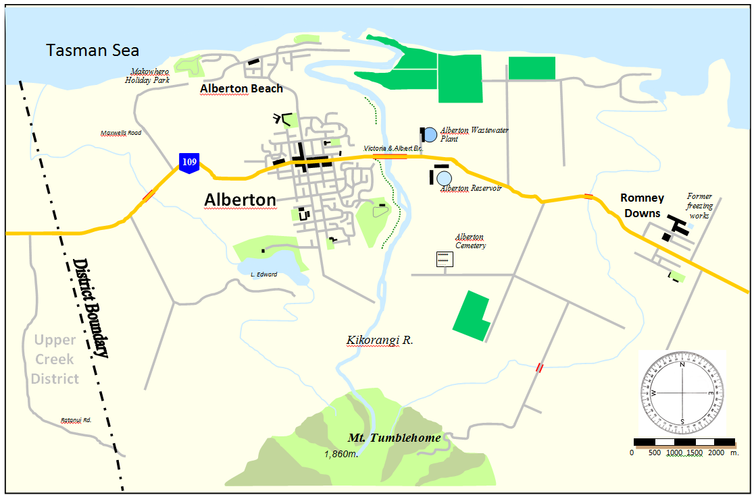

Purpose
Infrastructure accounts for half of the council’s operating expenditure and 70% of the council’s capital expenditure. This expenditure provides the foundations on which the Makowhero community is built – it is essential to health, safety, and transport and has a significant impact on the physical environment. While infrastructure services may not be as exciting as others, infrastructure enables businesses and communities to flourish. Poor infrastructure will inhibit the economic performance of Makawhero. Getting infrastructure spending right is a pre-requisite to determining how much the council can spend on services that enhance the quality of life and attract people to live in Makawhero.
This infrastructure strategy outlines:
- the key infrastructural service issues the Makawhero community must address over the next 30 years:
- the main options for dealing with those issues;
- the cost and service delivery implications for residents and businesses of those options; and
- the Council’s current preferred scenario for infrastructure provision.
The strategy will help the Council and the community make informed decisions in the next three and ten years, that position the Council to deal with the major decisions and investments that will occur in the next 10 to 30 years.

What is infrastructure?
The strategy covers:
- roads;
- water supplies;
- sewage treatment and disposal;
- stormwater; and
- flood protection.
As the Council also confronts issues about major community buildings, these have been included under the heading of community infrastructure.

Assumptions and capital expenditure drivers
The key decisions the council has to make are about how much capital expenditure it should make on infrastructure.
Capital investment decisions are driven off three considerations:
- when should existing infrastructure be replaced;
- when should the council invest in improving the existing service; and
- how much needs to be invested to provide infrastructure for a growing community.
In preparing this plan, the council has had to make assumptions related to these matters.

When should infrastructure be replaced?
The expected asset lives of council’s assets are set out in detail in the statement of accounting policies, at page 187 of the long-term plan. Council has physically inspected about one-third of the reticulation network and confirmed that its condition is consistent with the accounting lives being used in these forecasts. It will continue a physical inspection programme, focussed particularly on those parts of the reticulation network that are most critical because they service large numbers of properties, essential services, and businesses
The graphs below show the expected replacement profiles for the Council’s water, sewer and stormwater reticulation. The performance of reticulation typically deteriorates gradually over time. Therefore, it is not critical that any particular pipe is replaced in the specific year shown. Council will smooth the planned replacement programmes to achieve a balance between optimal timing of replacement, keeping funding demands on ratepayers even, and ensuring that work that affects street surfaces is integrated with the Council’s street resealing programme.
In making these projections, council has assumed that the current state of engineering technology remains unchanged. There continue to be developments that both lower the cost of replacing pipes, for example by using trenchless construction technologies, and allow pipes to be treated in ways that extend their lives for several decades, for example by inserting new linings in existing pipes.

Water reticulation
Figure 1: Projected annual water reticulation replacement
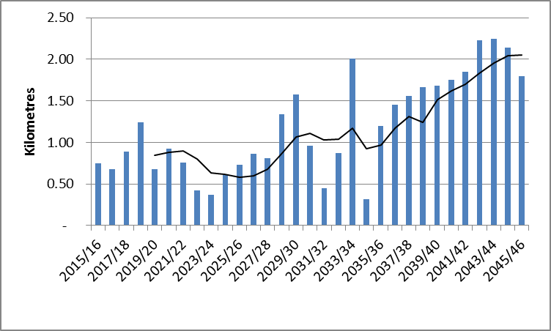
Annual pipe replacement
5 year moving average
Figure 1 shows that the Council will gradually need to increase its water reticulation renewal programme. While in the coming decade renewals amount to between 0.5 and 1 kilometre a year, this steadily increases to 2 kilometres a year towards the end of the 30 year period.

Sewerage reticulation
Figure 2: Projected annual sewer reticulation replacement
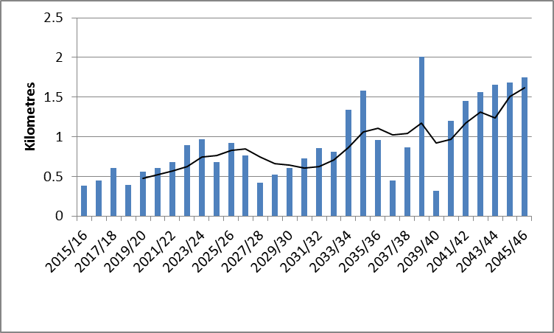
Annual pipe replacement
5 year moving average
As with water reticulation, Figure 2 shows a gradually increasing sewer reticulation replacement programme will be needed over coming years.

Stormwater reticulation
Figure 3: Projected annual stormwater replacement programme
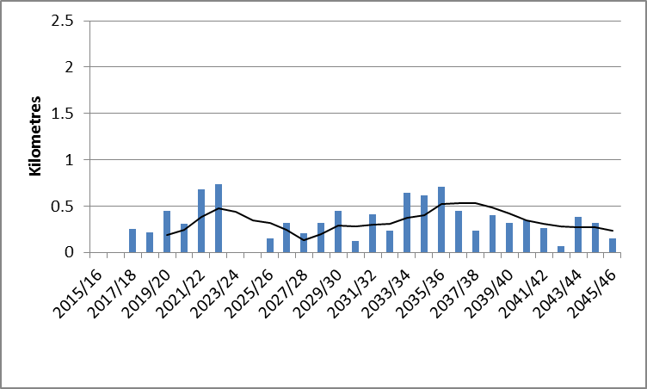
Annual pipe replacement
5 year moving average
Typically storm water pipes have a longer life than water and sewer pipes. Therefore, over the life of this strategy, there is a relatively constant storm water renewals programme. However, to date the council has invested very little in storm water reticulation replacement, so the Council does need to commence a modest storm water replacement programme.

Roading
The wear and tear from heavy traffic requires that council periodically rebuilds sections of road. Council expects that there will be significant harvesting of pine forests occurring from about 2030. This will result in significant additional heavy traffic on rural roads at that time, which in turn will require a programme of road reconstruction after the peak harvesting load has passed.

When should the council invest in improving the existing service?
There are three reasons why the council would improve existing infrastructure services. These are responding to:
- rising environmental expectations;
- climate change; and
- earthquake resilience.

Environment expectations
The main area in which this is likely to affect the council is in the discharge of waste water from council’s two treatment plants at Alberton and Romney Downs. The Council will have to decide how it complies with the National Policy Statement on Freshwater Management under the Resource Management Act. In turn, that will determine whether existing discharges can continue when council’s resource consents for the wastewater plants are due to be renewed (in 2022 for the Alberton treatment plant and in 2030 for the Romney Downs plant).
Council also considers that land use in the catchment of the Kikorangi River is likely to shift from forestry towards farming during the coming 30 years. This may also require the council to improve the quality of its wastewater discharges to offset reductions in water quality from that land use shift.

Climate change
The Ministry for the Environment suggests that councils plan for a sea level rise of between 0.5m and 0.8m for periods up until 2090. Sea level rise may generate additional flooding around the mouth of the Kikorangi River, unless steps are taken to manage that risk.
Climate change is likely to also result in more extreme storm and drought events. This requires council to consider the level of flood protection for Alberton and the capacity of the town’s storm water drainage system. More frequent droughts may affect the security of water supply to Alberton. Currently the council relies on adequate water flows from the Kikorangi River and has no stored water for a prolonged drought.

Earthquake resilience
The Alberton Town Hall barely meets 33 per cent of current earthquake standards and upgrading, while possible, is expensive. Parts of Alberton are built on old flood plains that could be subject to liquefaction in a major earthquake. Part of the councils reticulation renewals programme will involve using different construction methods and materials to provide greater earthquake resilience in pipelines. Council does not consider this risk is so great that it should bring forward its renewals programme. Instead it will address resilience at the time pipes are replaced.

How much needs to be invested to provide for a growing community?

Future Population
Growth in the Makowhero District has typically followed the Statistics New Zealand medium growth population projection. Under the Statistics New Zealand medium growth population projections the Makowhero District’s population is expected to grow steadily from 19,535 in 2015 to 24,380 in 2045.
Household size is projected to decrease from 2.8 persons per household to 2.2. Retirees and life-stylers from Wellesley are the primary source of population growth for Makowhero. As the total population increases, and household size decreases (from 2.8 persons per household to 2.2), the number of households in Makowhero District is expected to increase from 6,977 in 2015 to 11,082 in 2045.
In terms of demand for infrastructure, the main determinant of demand for reticulation is the growth in the number of households. The demand for reticulation is driven by water consumption which is influenced by population numbers, consumption drivers (such as change in appliance use and conservation) and change in business use. Business use is not a significant factor in Makowhero and unless new businesses establish in the District, demand will be driven by the residential population.
While some growth will occur in Alberton, most growth will occur at Alberton Beach. Romney Downs is expected to decline in population, and no significant change is expected in the rural population.
Figure 4: Projected changes in urban households – 2015 to 2045
Alberton
Alberton Beach
Romney Downs
2015 households
2045 households

Other Assumptions

Inflation
The financial forecasts for the first 10 years of this strategy are adjusted for projected inflation based on the BERL local government cost index, which is detailed more fully at page 143 of the long-term plan.
The financial forecasts for years 11 to 30 have been inflated to year 10 costs – no further inflation allowance has been added.

Replacement of the Victoria and Albert Bridge
The Victoria and Albert Bridge is managed by the New Zealand Transport Agency on behalf of the Government. The bridge carries major sewer and water pipes from the treatment plants to the east of the Kikorangi River to Alberton. The Bridge’s design and location also influences the design of flood protection works on the banks of the Kikorangi River for which the Council is responsible.
The Council has had discussions with the NZTA and has based its planning on the Bridge being replaced between 2022 and 2026.

Most likely scenario
The following timeline shows the most likely scenario for the Council’s infrastructure investment. A feature of this scenario is that while infrastructure investment in the decade covered by this plan is relatively modest, significant investment is required in the next decade driven by three influences:
- the need to increase expenditure to replace aging reticulation;
- the need to increase standards of sewage treatment as resource consents expire; and
- the need to expand the capacity of existing infrastructure to meet the needs of a growing population.
The total projected capital expenditure over the next 30 years is $160 million. Operating expenditure over the same period is $312 million.

Most likely scenario – major projects timeline
 | 2015
Alberton Beach water main replacement | 2015
Civic Precinct development | 2016
 | 2017
Alberton Beach sewer pump station | 2018
 | 2019
 | 2020
 | 2021
 | 2022
 | 2023
Kikorangi River south-east stopbank upgrade | 2023
Alberton waste water treatment plant – tertiary treatment upgrade | 2024
 | 2025
 | 2030
Romney Downs waste water treatment replacement  Rural road rehabilitation programme commences | 2030
Second Alberton water treatment plant constructed  Second road access to Alberton Beach constructed | 2035
 | 2040
Alberton Beach stopbank extensions  Ratanui Road upgrade | 2040
 | 2045

What will it cost?

Cost of most likely scenario
The following graph shows the annual capital and operating costs of the most likely scenario. Details of the first 10 years expenses for each infrastructure activity are shown in the funding impact statements for those services. The graph shows each of the first ten years and annual average expenditure for the next twenty years in five year blocks.

Figure 4: Annual operating and capital expenditure required for the infrastructure strategy
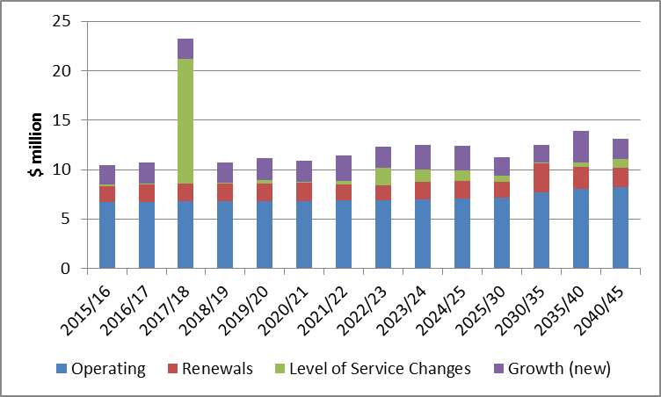
Five year average

Cost implications of significant capital expenditure decisions
There are a number of significant capital expenditure decisions that could affect those costs. These are summarised in Table 1.
Table 1: Summary of capital expenditure options
Project | Probable Year of Construction | Lower Cost Option | Most Likely Scenario | Higher Cost Option
 |  | $m | $m | $m
Alberton Beach water main replacement | 2016 |  | 0.30
Civic Precinct development | 2018 | 5.00 | 12.50
Alberton Beach sewer pump station | 2019 |  | 0.45 | 1.20
Alberton waste water treatment plant - tertiary treatment | 2024 |  | 2.70 | 7.70
Kikorangi River south-east stop bank upgrade | 2024 |  | 1.00 | 3.50
Romney Downs waste water treatment replacement | 2030 |  | 2.00 | 3.00
Rural Road rehabilitation programme | 2033 - 41 |  | 6.30
Second Alberton water treatment plant | 2035 | 3.60 | 5.00 | not costed
Second road access to Alberton Beach | 2036 | 1.70 | 2.60
Ratanui Rd upgrade | 2040 |  | 15.00
Alberton Beach stop bank extensions | 2040 |  | 3.60

Alberton Beach water main replacement
This project replaces the trunk water main connecting Alberton Beach to the two water supply. It increases the capacity of the main to accommodate future population growth at the Beach and uses more flexible construction so that the main will be more resilient to earthquakes. The cost is estimated at $400,000. Council is committed to carry out the project in 2016 and therefore no alternatives are presented.

Civic Precinct Redevelopment
This project replaces the existing town hall and visitor information centre with new facilities that would better meet the community’s needs. It also improves the existing council offices.
The most likely scenario is to build a new civic precinct incorporating a community and convention centre, the visitor information centre, and council meeting facilities. This will also allow reconfiguration of the existing council offices. The project is timed for 2018. It has a capital cost of $12.5 million, but results in annual operating cost savings of $100,000.
The principal alternative is to refurbish the existing Town Hall at a cost of $4 million, which would bring it up to 50% of earthquake standard, and to build a small extension to the council offices at a cost of $1 million. This option would not provide a multi-purpose facility suitable for conventions and would not provide a solution to declining use of the visitor information centre.

Alberton Beach sewer pump station
The Alberton Beach sewer pump station is scheduled to be replaced in 2019.
The most likely scenario proposes a new pump station costing $450,000. This scenario involves providing two hours of wastewater storage at the pump station site so that small interruptions to the power supply can be accommodated without overflows of untreated sewage into the Kikorangi River.
The principal alternative is to provide more storage at the pump station site to further reduce the risk of overflows. This could be supplemented with a permanent on site generator so that some pumping capability is available if power supply is interrupted for long periods. An option with 12 hours of wastewater storage and a permanent generator with sufficient capacity to operate one of the three pumps in the pumping station would cost $1.2 million with additional annual operating costs of $50,000. The additional operating costs are to provide periodic running and maintenance of the generator.

Alberton waste water treatment plant upgrade
The resource consent for this plant is due to be renewed in 2024. To operate a compliant plant, the council will need to decide what type of upgrade it intends to proceed with when it lodges an application for a new resource consent in 2021. Council considers it highly improbable that the status quo could continue.
The most likely scenario proposes upgrading the plant to provide tertiary treatment of wastewater at a capital cost of $2.7 million, and additional annual operating costs of $200,000.
The principal alternative is that, in addition to tertiary treatment, land based disposal is also required. This would require purchase of suitable land, which might be some distance from the existing treatment plant. It is probable in this scenario that treated wastewater would have to be pumped to the disposal site. Council has not carried out any detailed costing of this option. It considers that, depending on the distance of the disposal site from the treatment plant, the cost of land based disposal might add approximately $5 million to the capital cost and a further $250,000 to the annual operating costs of the plant.

Kikorangi River stopbanks
The LTP provides for new stopbanks to be constructed on the Kikorangi River south of the Victoria and Albert Bridge to provide increased protection to the water and waste water treatment plants. The work is intended to be timed to coincide with the replacement of the Victoria and Albert Bridge. The bridge is on a state highway, so the exact timing will be determined by the New Zealand Transport Agency which is responsible for all state highway works. Currently council expects this to happen in 2024, so design decisions will be needed in about 2022.
The most likely scenario proposes upgrading the stop banks to protect the treatment plants from a 100 year flood, that is a flood which is estimated to have a 1% chance of occurring in any given year. The estimated cost of this work is $1 million.
Principal alternatives are to do nothing or to or to design the work to a higher standard, say a 200 year flood.
The do nothing option provides flood protection to only a 66 year flood. Council considers this level of protection is too low, given the economic and environmental impact of disrupted water and sewage treatment on the community and the costs to the council of restoring the treatment plants after flooding.
Providing protection to a 200 year flood standard would be significantly more expensive. The new stopbank would have to extend further south and be higher. Council considers providing protection from a 200 year flood would cost approximately $3.5 million.

Romney Downs waste water treatment plant replacement
The Romney Downs Waste water treatment plant needs a new resource consent in 2030. It is highly improbable that the resource consent would be renewed on existing terms.
The most likely scenario proposes upgrading the existing plant for $2 million with an additional annual operating cost of $50,000. Given the smallness of the Romney Downs community, this may not be cost effective.
Principal alternatives are to close the treatment plant and pump the wastewater from Romney Downs to the main treatment plant, or to return the community to on-site sewage disposal.
The cost of a pipeline and pump station to the main treatment plant is estimated to be in the order of $3 million. Annual operating costs of this option are also expected to be in the order of $50,000. The main reason for considering this option would be if the most likely scenario was also unable to obtain a resource consent.
The cost of returning to on-site disposal would be a lot lower than public treatment options, but whether it would be feasible without creating adverse public health or environmental outcomes is highly uncertain.

Rural road rehabilitation programme
Sealed and unsealed rural roads are nearing the end of their useful lives. This is expected to be accelerated by heavy traffic from forestry harvesting.
The most likely scenario proposes $6.3 million of capital expenditure between 2033 and 2041 to rebuild and resurface priority roads.
There are few alternatives to this scenario. Deferring or reducing this work will result in deteriorating road surfaces which will ultimately be even more expensive to rehabilitate and will require increased maintenance in the interim. The poorer quality surfaces will increase running costs for the motorists using the road and increase the risk of accidents.

Second Alberton water treatment plant
The Council expects that by about 2035 further water treatment and storage capacity will be needed for Alberton. Final timing will be determined by population growth in the community.
The most likely scenario is to build an additional plant using artesian water to the west of the Kikorangi River. This has an approximate capital cost of $5 million and additional annual operating costs of $440,000.
There are two principal alternatives to building a new plant. The first is to reduce demand for water by introducing meters. Introducing meters would extend the life of the existing plant for another two or three decades before reliability of supply became an issue, but would be controversial with some members of the community. Today, the cost of metering Alberton would be approximately $3.6 million. Council expects that changes in technology may lower the cost of metering in the future, and that use of smart meters could mean that reading and billing costs would be outweighed by other operational savings.
The second alternative is to find an artesian source that can be pumped to the existing plant for treatment and distribution. This has not been costed as no surveys have been done of artesian water availability to the east of the Kikorangi River. As the decision is approximately 20 years away, it would not be an efficient use of ratepayers’ money to carry out major investigations at this time

Second Alberton Beach Road Access
The Council expects that by 2036, traffic volumes on Beach Road will have grown to the point where an improved road access to Alberton Beach will be required.
The most likely scenario is to link Maxwells Road through to Alberton Beach, creating alternative access from State Highway 109 to the west of Alberton. This has a capital cost of $2.6 million. Additional annual operating costs would amount to about $50,000. This scenario also provides a more resilient network, by providing a choice of routes to Alberton Beach and ensuring access is available if one route is closed for any reason.
The principal alternative would be to widen key intersections on Alberton Beach Road. This would involve some land purchase from existing property owners. Typically such land purchases are difficult to achieve voluntarily. A desk top costing exercise suggests this option might cost $1.7 million to achieve, excluding the costs of obtaining resource consents and the costs of negotiating land acquisition.

Ratanui Rd Upgrade.
The most likely scenario is to upgrade Ratanui Rd to provide an alternative route should State Highway 109 be closed, especially at Victoria and Albert Bridge. The project will not be done in the foreseeable future and is shown in the strategy to occur in about 2040. High level “desktop” costings suggest the project would cost in the order of $15 million, which would be shared with the Upper Creek District Council and the NZTA. The viability of the project will depend on traffic growth making the project cost-beneficial in its own right. The Council considers that by 2040 tourist attractions on and around Mount Tumblehome and extra traffic generated by the conversion of forestry land to dairying are likely to generate sufficient traffic to justify the investment.
The alternative to upgrading the road is to do nothing.

Alberton Beach Stop Bank extensions
The Council considers that extensions to stop banks at the mouth of the Kikorangi River will be desirable to protect low-lying areas of Alberton and Alberton Beach from flooding in storm surges. The probable timing is about 2040, but will be determined by the rate of growth at Alberton and Alberton Beach; whether predicted sea level rise occurs and whether high intensity storms do, in fact, become more frequent.
The most likely scenario is to build new stop banks on both sides of the Kikorangi River at a cost of $3.6 million. Once constructed there would be additional operating costs of about $100,000 per annum to meet the costs of maintaining river channels, especially in dry years when normal river flows do not adequately “flush” river channels.

The low growth projection would see the population decline slightly to 19,300 while the high growth growing to 28,150 by 2045.
Long-term plans are required to include a section on assumptions that apply to the whole plan. DIA expects that assumptions specific to the infrastructure strategy will be specified in the strategy. Relevant assumptions that apply to the whole plan, such as inflation assumptions, may be best identified by cross-reference.

