Disclaimer
This publication represents the collective view of the Local Government Infrastructure Efficiency Expert Advisory Group. It is not government policy. Any view or opinion expressed does not necessarily represent the individual views of any of the Group members. While every effort has been made to ensure the information in this publication is correct, the Group does not accept any responsibility for or liability for error of fact, omission, interpretation or opinion that may be present, nor for the consequence of any decisions based on this information or any reliance placed on it.

ISBN 978-0-478-35571-0 (Online)

Department of Internal Affairs, PO Box 805, Wellington
Email: info@dia.govt.nz

22 March 2013

Table of contents
1. Foreword 1
2. Executive summary 3
3. Recommendations 9
4. Introduction 18
5. Local Government Infrastructure - Financial Parameters 22
6. What is driving change? 33
7. Formal framework within which local government delivers infrastructure 49
8. Business practice issues 85
9. Institutional issues 113
10. Size and scale 124
Appendices 141
Glossary 154

Foreword
- Local Government infrastructure provides a basic platform that is essential to support the modern living standards to which New Zealanders aspire. Its planning and delivery is by far the biggest role of councils - governed by a complex network of law and regulation and subject to political and community pressures. When local government infrastructure operates efficiently, it is largely unnoticed by the general public. Failure, however, can cause havoc and provoke outrage.
- This is the context within which elected councillors, together with the managers and technical staff of councils, make decisions every day on various aspects of infrastructure - and the context that formed the backdrop for our report.
- The Government commissioned our group to provide advice on how this infrastructure could be delivered in the most cost-effective manner to support a growing economy. Given the breadth of local government infrastructure, our brief was wide-ranging and we have made recommendations on actions that can be taken by central government and various of its agencies, by local government as a sector and by individual councils. We have not been able to examine each category of infrastructure specified in the terms of reference, but have focussed more on areas of greatest expenditure and widest delivery across the sector.
- During our work to produce this report, we were struck by the number of times that some constant themes emerged - simplification, integration, collaboration, transparency, innovation, process and accountability.
- Simplification and integration of the statutory framework within which local government infrastructure is planned would be one of the most important commitments the Government could make towards increasing efficiency of delivery. On the other hand, far greater collaboration or consolidation to introduce scale to various areas of delivery could be a game-changer on the part of local government.
- Transparency also ranked very high in our findings – driven initially by our own frustration at not being able to access readily (or, in some cases, at all) data that would enable us to gain a picture of performance and promises on the part of councils. Innovation and process both emerged as areas where there are great examples of good practice but also room for improvement amongst many councils.
- Finally, the issue of accountability was significant. Local government exists to serve communities. The people who make up those communities have right to know “what, when, how” and at what cost their councils are planning to deliver or have already delivered. They also have a right to engage with their councils to discuss questions of “why” and “why not”. But to have those discussions in an informed way, people require full information and assessments of costs, benefits, risks and options.
- We hope that this report can assist all parties in addressing some of the challenges that are present. We wish to thank all who worked with us on producing the report and those with whom we consulted in the course of our work, a number of whom were very generous in sharing their time and knowledge.


  Fran Wilde (Chair) |  | 

Elizabeth Anderson | Alan Bickers |   Philip Cory-Wright


Josephine Grierson | Stephen Selwood | Jeremy Sole

Executive summary
- The Local Government Infrastructure Efficiency Expert Advisory Group (EAG) was established by the Minister of Local Government in late 2012. The EAG’s terms of reference required us to provide advice focussed on how to deliver in the most cost-effective manner good quality local government infrastructure to support a growing economy. We were required to consider opportunities and barriers in terms of infrastructure costs, relevant legislation, and decision-making processes.
- In response to the terms of reference, we have made various recommendations. These range from improving the coordination of the policy environment at the more generic level, to improving the ways in which councils manage the delivery of infrastructure. There are specific recommendations about funding, monitoring and governance mechanisms.
- A combined full set of recommendations is presented as Chapter 3, but the individual recommendations are also appended, where relevant, to the end of each section in the report. This is not a suite of recommendations in the sense that the individual parts add up to an integrated whole. Instead, individual recommendations can stand alone or be implemented with others; the combination is for others (including central and local government) to decide.
- Discussion and recommendations in the report are grouped under the headings of:
- What is driving change?
- The formal framework within which local government delivers infrastructure
- Business practice issues
- Institutional Issues
- Size and scale

Background data about council infrastructure
- As part of the background to providing our advice, we examined relevant and readily available data. Various factors and themes emerged from that data, which informed our thinking throughout the rest of its work. A major theme is significant future council spending. Expenditure on infrastructure over the period 2013-2022 is projected to be $111.1 billion ($30 billion in capital expenditure and $81.1 billion in operational expenditure), a large proportion of which will be in Auckland. Spending varies according to the type of authority, with rural areas having service provision requirements and challenges that are quite distinct from those facing metropolitan councils. The data highlights the importance of delivering good quality and cost effective infrastructure, as the local government sector is the second largest owner of assets in New Zealand, after central government. In 2011, councils are estimated to have owned fixed assets valued at $94 billion (up from $70 billion in 2006, compared to $141.5 billion owned by central government).

Drivers of change
- As a wider context for our deliberations, we considered a range of matters that may be influencing or driving change in the current and future provision of council infrastructure. Population growth, decline and structural change are considered to be key drivers. A graphic example of future structural change is provided by the maps in Figure 11. Larger urban centres will generally need to cope with growth. Sparsely populated rural areas will have to cope with aging, flat or, in many cases, declining populations. These are coming realities (not future “scenarios”) and each has its own implications for infrastructure.
- Economic trends are also key, including the response of councils to the recessionary environment since 2007/2008, including increases in levels of council debt and deferment of pre-programmed expenditure. Aging infrastructure may be an issue, so knowledge about its condition becomes critical. Better and more consistent asset management is key to managing this risk, while resilience in the face of natural disasters and climate change is also relevant. Rising community expectations, especially in relation to water standards, levels of service and environmental outcomes can drive infrastructure investment. Trends in technology offer some solutions, enabling councils to re-visit how they deliver and manage services. All of these trends and drivers are overlain by the issue of affordability, which is particularly significant in light of lower economic growth and demographic trends.

Relevant legislation
- We examined the formal legislative framework within which infrastructure is planned, funded, built and managed. The complex nature of the framework creates problems of implementation and interpretation for central government, councils and the general public. The main pieces of legislation are the Local Government Act 2002 (LGA), the Resource Management Act 1991 (RMA) and the Land Transport Management Act 2003 (LTMA) which we consider need greater integration. However, there is also what we refer to as the “water framework” – a complex mesh of laws, regulations, standards and practices that govern the management of water supply, wastewater and stormwater drainage.
- In general, rationalisation and better alignment of legislative and regulatory frameworks would substantially improve infrastructure delivery, especially if duplication of effort and conflicting timeframes are addressed. A clear whole-of-government approach is required to recognise and deal with the issues. Specific recommendations are made about ways to improve individual aspects of the frameworks. The most significant is that spatial planning (similar to the Auckland model) should be mandated for use elsewhere in New Zealand. We consider that this one action would have the greatest beneficial impact; the formation of the Auckland Council has lifted the bar in terms of infrastructure planning and delivery.
- Recently proposed legislative reforms of the RMA and of freshwater management were taken into account. We welcome some aspects of the proposed reforms, but we have concerns about others. In particular, the proposed RMA reforms, by not mandating true spatial planning, are seen as having little benefit for council infrastructure. The freshwater reforms are seen as useful, although the need to avoid adding to existing complexity in the water framework is highlighted.
- We gave particular attention to the complex provisions of the water framework (water supply, wastewater disposal and stormwater drainage). Many infrastructure upgrades are driven by environmental requirements and the national Drinking Water Standards. This has been expensive, especially for councils with smaller populations. We have not recommended major change to the Drinking Water Standards, but suggest that clarification of the way the standards are implemented is needed. This could be accompanied by training for elected members and relevant staff so any trade-offs proposed in this area in long term plans (LTPs) can be clearly spelled out to communities. A reconsideration of the eligibility criteria for financial assistance on water supply and wastewater upgrades would be useful.
- Councils need to have better conversations with their communities about the planning, funding and delivery of infrastructure. Council LTPs provide one vehicle for those discussions, but the questions are so important and fundamental to the role of councils and their financial health, that greater effort needs to be made.

Business practices
- The EAG also looked at the business practices utilised by councils in relation to infrastructure, in particular decision-making around asset investment, development and management. We considered this to be an important area of inquiry, as business practices have a direct relationship to efficiency and cost effectiveness. There is much good practice among councils already but some legislative change is recommended, as well as training.
- Professional asset management is important, set within a ‘line of sight’ framework that links strategy, levels of service and operations. Good processes in setting levels of service is essential; balancing what is affordable against what is desired by the community. We noted that, as monopoly providers, councils might run the risk of either “gold plating” infrastructure (therefore overcharging the community), or under investing in response to local sentiment about rates increases. In this respect, professional asset management practice is a necessary foundation for good quality and cost-effective infrastructure. Asset managers need sound information that enables optimal decision-making about capital expenditure and its timing. Levels of service and demand forecasting are relevant to the good management of any infrastructure.
- We noted the complexity and risks inherent in funding, financing and charging for infrastructure. Reliance on rates for funding infrastructure does not necessarily lead to optimal outcomes, as these assets are by nature long life and rely on long term stable planning and funding. There is a wide range of options which councils need to comprehensively and carefully consider, including such tools as development contributions, appropriate debt management and public private partnerships. Compelling reasons were identified to introduce more direct charging for provision of council infrastructure services. These include demand management, accountability and increased flexibility in funding and procurement. Recommendations are made about the use of volumetric charging for water and the examination of pricing mechanisms for roads.
- Business case development and procurement are areas in need of improvement. We considered that councils should use Treasury’s Better Business Case framework for large projects and a simplified framework for smaller projects. Realising the benefits of a sound business case requires effective procurement and we noted several potential issues in the procurement process. Councils can struggle to gain clarity about what they want delivered, to chose the best procurement method, and to understand and mitigate risk. Sector-wide approaches to the development and benchmarking of best practice are recommended to help councils avoid these problems.

Institutional issues
- Greater transparency, reporting and benchmarking of performance should be introduced for council infrastructure activities. Accountability and decision making need to be supported by understandable and consistent disclosure and benchmarking regimes, linked to the long term plan system. Performance data and measures for financial and non-financial elements (such as levels of service) need to be clear, understandable and standardised so they are comparable between different councils. Without it, communities (and councils) cannot accurately judge if they are doing a good job. The role and resourcing of the Office of the Auditor-General (OAG) should be enhanced so that it can provide more focus in this area. Engagement with the community on these issues needs to occur at the right level and both the process and the final decisions should be guided by the principle of subsidiarity.
- The need to share expertise and knowledge across the local government sector was a common theme throughout our discussions. The theme also has direct relevance to the capacity and capability of councils to deliver infrastructure. The Local Government Funding Agency is a successful example of councils sharing specialist expertise. In a similar vein, we recommend that the Local Government Association of New Zealand (LGNZ) work with its member councils to establish a Local Government Centre of Excellence for Infrastructure. Its purpose would be to assist councils in accessing expertise, training and benchmarking of best practice in all areas of infrastructure delivery and management.

Size and scale
- A recurring theme is around the difficulties and cost for small councils in maintaining infrastructure expertise. Apart from better business practices, consolidation is suggested as a way of addressing the issue.
- Shared services are one approach to consolidation and we observed numerous examples of good outcomes being achieved in this way. However, frequently they appear to be bespoke and reliant on personal relationships and goodwill. Legislative change is recommended to remove some barriers to council collaboration. We also recommend more shared services with central government agencies, iwi, community and charitable organisations to capture benefits such as economies of scale. This is especially relevant to social infrastructure such as recreational and sports facilities.
- Greater use of infrastructure delivery at a regional scale will facilitate substantial benefits where the assets being managed are also at that scale. For significant capital expenditure, scale can provide the specialist skills needed to manage scope, procurement, timing, financing and operational issues. We recognise that biggest is not always the best and there is a need to assess optimal size in terms of both contracts and management/governance units. However, in a number of areas the evidence pointed to larger scale delivery entities having greater ability than smaller ones to deliver affordable infrastructure to all communities.
- In some cases, regional scale delivery may be best facilitated by full council mergers. Central government needs to form a clear view about the appropriate scale and scope of local government units to optimise infrastructure delivery. We recommend that the 400,000 population threshold for use of the two-tier unitary model should be reduced to 100,000.
- Error: Reference source not found below provides an overview of the spectrum of change underpinning our recommendations.
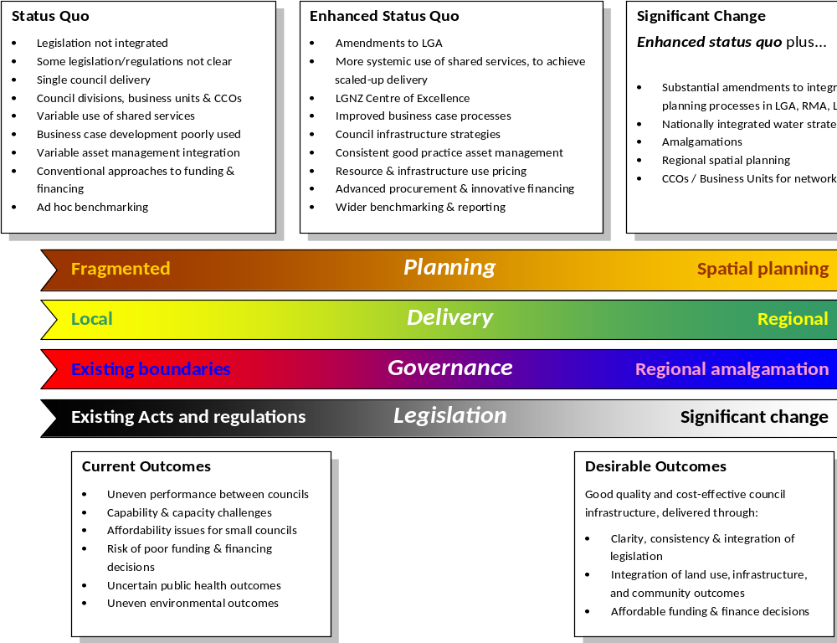
Figure 1: The spectrum of change

Recommendations
This section provides an overview of the recommendations contained in this report. While it can be read alone, for clarity it should be read in conjunction with the remainder of the report. These are grouped by theme and do not follow the sequence in the report.

Amendments to simplify and integrate the policy and legislative framework
Recommendation 26
The Ministers of Local Government, Environment and Transport should coordinate a whole-of-government approach to clarifying and integrating the planning framework - LGA, RMA, LTMA and other planning mechanisms.
Local Government Act
Recommendation 30
The Local Government Act 2002 should be amended to make explicit the potential for levels of service to either decrease or remain unchanged, as well as increase.
Recommendation 32
If the statement of service provision is retained in the Local Government Act, it should be amended to explicitly link levels of service to the wider strategic objectives of councils. Such objectives would include community outcomes specified in the LTP and any relevant objectives in a Regional Policy Statement, Regional Plan, District Plan or Regional Land Transport Strategy; or any other spatial plan or infrastructure strategic plan that may be introduced in time.
Recommendation 56
The Local Government Act 2002 should be amended so that it cannot be used to obstruct or prevent collaboration between councils or with other partners.
Recommendation 31
The Government should implement recommendation 17 of the Local Government Efficiency Taskforce which would see long term plans primarily focus on strategic issues. As part of that re-focus, long term plans should not be required to include detailed information about levels of service.
Recommendation 7
The water and sanitary services assessments carried out under section 125 of the Local Government Act should be reviewed to ensure that they perform a clear and useful function in council infrastructure planning and provision, and the Act should be amended, if necessary, to provide for this.
Land Transport Management Act
Recommendation 9
The Land Transport Management Act should retain the requirement for a separate National Land Transport Strategy that would be subject to a normal consultation process during its development and that would ensure a long term national view on transport strategy to which Regional Land Transport Strategies could give effect.
Recommendation 10
Amendments to the Land Transport Management Act should provide policy clarity around strategy and planning, not just administrative compliance.
Recommendation 41
The Land Transport Management Act should be amended to allow pricing on existing roads where there is a business case that enables effective network optimisation.
Water Framework
Recommendation 12
The Government should appoint a Minister with specific responsibility for management of all water related issues, including:
- achieving a greater degree of integration and clarity within the various elements that comprise the statutory and regulatory frameworks for water supply, wastewater and stormwater
- ensuring that any national strategies specific to water management appropriately address the cost of infrastructure for local government.
Recommendation 16
The Government should expedite the development of the National Objectives Framework for freshwater and should involve local government in the development of the details
Recommendation 13
The Government should review national goals for drinking water and wastewater, to ensure that there is an appropriate balancing of community costs, health risks and environmental outcomes.
Recommendation 14
In its final decisions on the proposed freshwater reforms, including the National Objectives Framework, the Government should avoid adding to the existing confusion of the water framework.
Recommendation 15
The Drinking Water Standards should be amended to clarify that they are subservient to the “all practicable steps” duty of the Health Act (Health Act, Part 2A).
Recommendation 17
Councils should actively consider and actively promote the use and development of alternative engineering solutions for drinking water, wastewater and stormwater management issues.
Planning
Recommendation 8
In its final decisions on the proposed RMA reforms, the Government should:
- mandate a planning process that is regionally based as being more effective in dealing with large scale and network infrastructure
- incorporate the Project Consent Process recommended by the Technical Advisory Group on Infrastructure.
Recommendation 27
The concept of spatial planning as applied to the Auckland Council should be mandatory as a strategic planning mechanism for use at a regional level in other parts of New Zealand.
Recommendation 21
Changes in legislation to provide for spatial planning should include processes to ensure strategic alignment between central and local government in the development of the plan and in their subsequent and on-going review.
Recommendation 28
Until spatial planning is mandated, all councils (excluding Auckland Council) should produce an infrastructure strategy that links asset management with LTP community outcomes and identifies strategies for regional network optimisation where appropriate.
Recommendation 20
Spatial plans should provide full disclosure of benefits, costs and risks associated with the plan, including how it will be funded, and the plan development process needs to take account of the Government’s role as a major funder of transport infrastructure.
Recommendation 22
Process and content audits similar to those specified in the Auckland Plan should be used by other councils as part of a wider strategic approach to the planning and delivery of infrastructure.
Recommendation 2
Councils should ensure their long term plans reflect projected numerical and age-related structural population changes and explicitly provide for these changes in their infrastructure and financial planning.
Recommendation 19
Auckland Council’s request for simplification of its planning regime should be implemented. Specifically, it should have a statutory exemption from providing a separate Regional Transport Strategy and the Regional Policy Statement, both of which should be integrated into the Auckland spatial planning framework.
Other statutes, regulations and standards
Recommendation 11
The Ministry of Business, Innovation and Employment should review the application of the Building Act to local authority infrastructure. Specific areas requiring attention include:
- whether council infrastructure should be subject to the current building consent regime, if its safety and performance would be better assessed by a Chartered Professional Engineer; and
- whether council infrastructure should simply be required to meet the Building Code provided it is designed by a Chartered Professional Engineer, with construction appropriately supervised and recorded.
Recommendation 23
The review of Standards NZ (SNZ) should specify how the outputs of SNZ integrate with other parts of the formal framework that regulates local government infrastructure.
Recommendation 24
The development and revision of standards relating to public infrastructure should be supported by a mix of industry and central government funding, and central government should also consider funding of SNZ’s core capability.
Recommendation 25
Standards for infrastructure should focus on performance criteria (outcomes) rather than determining methods of delivery.
Recommendation 29
In conjunction with any consultation or referendum on a four year Parliamentary term the Government should specifically include consideration of the same for local government.

Training, good practice and sharing of expertise
Recommendation 18
The Ministry of Health and Local Government New Zealand should work together to provide training to increase councillor, relevant council staff and drinking water assessors’ understanding of the water framework, in particular the tradeoffs between health and cost effectiveness.
Recommendation 3
Local Government New Zealand should lead councils in sharing and accessing expert advice on complex technical issues.
Recommendation 43
Local Government New Zealand should explore access to and sharing of expert advice on funding, financing and risk management.
Recommendation 34
Local Government New Zealand should ensure there is appropriate training available for elected members and council managers in the process of setting levels of service.
Recommendation 45
Councils should ensure that elected members and relevant staff receive training that helps them understand the concepts and practice of asset management.
Recommendation 49
Local Government New Zealand should work with appropriate technical and professional organisations to ensure there is training available for councillors and staff on improved procurement practices and that councils are aware of the full range of procurement options.
Recommendation 55
Local Government New Zealand should establish a Local Government Centre of Excellence for Infrastructure.

Improved conversation with communities
Recommendation 5
Councils should actively stimulate informed public discussion on the financial implications, timing and community impact of strategies designed to promote infrastructure resilience in high risk locations (for example, managed retreat).
Recommendation 6
Councils should be actively engaged in local lifelines groups and, if necessary, promote the formation of such groups where they are absent, with a view to developing risk management strategies and response plans coordinated across infrastructure providers.
Recommendation 50
During consultation on the long term plan, councils should provide transparent information about the potential costs and benefits of enhancing service levels to meet rising community expectations including whole of life costs, information on alternatives and their relative costs and benefits.
Recommendation 51
Councils should use a range of consultation methods including rigorously designed tools for testing public opinion.

Improving business practices
Recommendation 4
Councils should be actively deploying technology to improve asset management and service delivery.

Recommendation 33
Councils should carefully examine the appropriateness and affordability of proposed levels of service for each type of asset in the context of changes in the population profile for the council and the council’s overall long term budget.
Recommendation 44
Councils should implement and support professional asset management practices that:
- link day to day engineering with strategy, policy and governance
- determine loss of service potential, instead of using depreciation as the basis for predicting asset failure
- incorporate a balance between asset testing, statistical analysis and standardised methods to determine the need for asset replacements.
Recommendation 46
Councils should utilise the Better Business Case framework for large scale infrastructure projects.
Recommendation 47
LGNZ should work with the NIU to develop an appropriate business case approach for smaller projects, based in the principles in the BBC.
Recommendation 48
Councils should use current information for forecasting of demand and should also verify the reliability of those forecasts.
Recommendation 57
Councils should, wherever possible, operate infrastructure at the point where economies of scope and scale are maximised and are fundable while being aware of diseconomies of scale.

Funding and pricing mechanisms
Recommendation 35
Development contributions should be retained as an economically efficient funding mechanism.
Recommendation 36
Any changes to the formal mechanism of development contributions should be aimed at addressing issues of transparency, the reasonableness of assumptions underpinning the policies and the provision of reasonable appeal rights.
Recommendation 37
Where benefits exceed costs of implementation and compliance, volumetric charging for water should be implemented and variable charging for wastewater should also be implemented.
Recommendation 38
The introduction of water metering should be accompanied by robust educational campaigns to highlight the benefit of water conservation and how to achieve it.
Recommendation 39
The introduction of water metering should include provision to assist those with medical needs resulting in additional water demand.
Recommendation 40
The Government should urgently undertake further work on pricing for transport to optimise use of the network.
Recommendation 42
Councils should consider the option of PPPs for large infrastructure projects with a significant whole-of-life cost where value for money outcomes through risk transfer and private sector innovation can be anticipated.

Better information and greater transparency
Recommendation 1
To achieve nationally-consistent reporting of council infrastructure data, all long term plans and annual reports should include required data sets covering asset classes and specific activities. This data should be available in standard digital format as well as printed formats. DIA should work with LGNZ to determine the classifications and digital formatting required and the LGA should be amended, if necessary, to provide for this.
Recommendation 52
Building on current initiatives, the Government should work with Local Government New Zealand to develop appropriate standardised financial and non-financial performance measures for council infrastructure delivery.
Recommendation 53
Councils should be required in LTPs to formally identify levels of service for specific infrastructure types, then to report delivery against their agreed levels of service, using standardised financial and non-financial performance measures for different assets.
Recommendation 54
Monitoring of the reporting referred to in Recommendation 53 should remain with the OAG, which may need additional expert resource to be able to undertake this task comprehensively and in such a way that it can provide detailed feedback to councils and the public.

Increased coordination and removal of barriers to shared services
Recommendation 58
Councils should actively explore shared services arrangements with other councils, central government agencies, iwi or the private sector to capture possible benefits of partnerships and economies of scale. In particular, this applies to community infrastructure and networks such as libraries, recreational facilities and sports facilities, as well as small scale utilities.

Greater use of regional provision to deliver regional solutions
Recommendation 59
Councils should consider moving delivery of potable water and wastewater to regional level, with the management and implementation of such delivery at arm’s length from political decisions, through either a jointly-owned or regional council owned CCO or a business unit run on economically efficient lines.
Recommendation 60
Councils should consider moving delivery of land transport infrastructure to a regional level, through either a jointly-owned or regional council owned CCO or a business unit run on economically efficient lines.
Recommendation 61
The Government should form a clear view of appropriate scale and scope for local government units in relation to the delivery of infrastructure.
Recommendation 62
The Local Government Act 2002 should be amended so that all regions with populations above approximately 100,000 can choose to adopt a two-tier unitary council model, similar to that now available for populations above 400,000.
Recommendation 63
All councils should consider amalgamation into unitary authorities with minimum populations of approximately 100,000.

Introduction

Purpose of the Local Government Infrastructure Efficiency Expert Advisory Group
- The EAG was appointed to provide independent advice to the Minister of Local Government (the Minister) on how good quality local government infrastructure to support a growing economy can be delivered in the most cost-effective manner.
- The EAG was specifically asked to focus on:
- what opportunities, methods or means exist to reduce the current and future overall costs of purchasing, providing and maintaining local government infrastructure while still ensuring that infrastructure is capable of supporting a growing economy
- what barriers (including legislative, regulatory, institutional, political or community) currently stop local government from exploring and implementing the opportunities, methods and means identified above
- how barriers to opportunities, methods, or means to reduce the overall costs of purchasing, providing and maintaining local government infrastructure may be avoided, reduced, or overcome
- how local government can improve its consideration of the benefits and cost implications of decisions they take in relation to infrastructure when selecting projects, setting standards or determining levels of service.

Scope of Work
- The Terms of Reference for this review (listed in Appendix A) defined the term local government infrastructure as “land, buildings, structures and facilities that a council either owns or has an interest in (as the operator or as a partner) including:
- pipes, pumping stations, treatment plants, and other physical assets required for water supply, drainage or sewerage systems and networks;
- structures for transport on land by cycleway, rail, roads, bridges, walkways or other means;
- land or structures required to avoid or mitigate natural hazards (such as flooding);
- land, structures or facilities for loading and unloading of passengers or freight that is transported by sea or air; and
- land, and any assets on that land, to provide public amenities (for example, reserves, halls, libraries, public toilets, cemeteries, crematoria, and sports venues).”
- During our review we looked at much of this infrastructure, but we were unable to assess all of it in detail. We particularly focussed on infrastructure that typically has a large capital and/or operational cost and thus is likely to have a significant impact on affordability for any community. We have also endeavoured to look at principles that might apply across all infrastructure, though in some cases we do differentiate between different types.

Interpretation of "Cost Effective"
- We took “cost effective” to mean value for money rather than least cost, therefore both benefits and cost implications over the whole life of any particular asset must be considered.
- We concluded that “cost effectiveness” is essentially “economic efficiency”, which “requires an optimal allocation of productive resources and incentives for efficient use over time” “Economic efficiency” has three dimensions: “allocative efficiency”, “dynamic efficiency” and “productive efficiency”.
- “Allocative efficiency” occurs in perfectly competitive markets, where all outputs are sold at marginal cost (i.e. the cost of producing the last unit of output) and every unit of resource is employed in the use or uses in which the market values it most highly. This enables society to optimise the use of scarce resources. We consider the current regulatory trend is to stress “allocative efficiency” and favour “cost reflective” pricing methodologies by, for example, incentivising prices that minimise wasting resources and environmental damage and encouraging pricing methodologies that are “transparent”, (i.e. easily auditable) and cost effective to implement.
- “Dynamic efficiency” focuses on continuous innovation and improvements to increase efficiency. Dynamic efficiency is often hard to quantify and analyse but we consider it should not be overlooked as a policy objective.
- “Productive efficiency” is maximised when each firm or organisation in an industry or sector carries out its activities at the minimum cost of inputs.
- We acknowledge that in some instances there are legitimate trade-offs between public policy objectives and economic efficiency. Drinking water standards are a good example of these tensions. The policy objective of a high standard of drinking water for all New Zealanders may be in conflict with allocative efficiency because some communities may not be able to afford the true cost of raising drinking water standards. In recognition of this, the Government has provided financial assistance to smaller communities facing these affordability issues as discussed in the section on Costs of Compliance in Chapter 7. This financial assistance is a cross subsidy from taxpayers to local communities so it obscures locational price signals. In this case, the loss of economic efficiency is considered less important than the objective of having safe drinking water for all. The discussion on average pricing in Chapter 10 is another example of this tension.
- While recognising the trade-offs, we have sought to recommend measures that will enhance all aspects of economic efficiency. For example, we consider that:
- The recommendations on volumetric pricing of water and waste water, development contributions and the potential for road pricing will encourage “allocative efficiency” because they aim to give price signals to consumers about the cost of their consumption of goods and services in a particular location so that they can make informed and efficient choices.
- Sizing infrastructure and administrative units at a level to maximise economies of scope and scale as discussed in Chapter 10 encourages “productive efficiency”. Improving business practice as discussed in Chapter 8 will also encourage “productive efficiency”.
- Transparency and accountability discussed in Chapter 9 and examining new technologies in Recommendation 4 encourage “dynamic efficiency”.

Approach
- The EAG was established in September 2012 and began work in October 2012. The membership of the Group is listed in Appendix B. The Terms of Reference for the review required us to support with evidence our identification and assessment of issues and the options we propose. In the time available and with the resource available, we have not able to commission any primary research, so the findings in this report are based on the research and work of a number of other organisations and individuals. There is also anecdote and comment which we have been unable to test.
- Our early focus was on information gathering and consultation and much time was spent discussing infrastructure issues – in person or by telephone conference – with key individuals across New Zealand. These people represented different councils, together with a wide range of other organisations that have dealings with councils in relation to infrastructure delivery. We are most grateful for the time they gave us and for sharing their wisdom and information. They are listed in Appendix C.
- In addition, as part of our review, the Department of Internal Affairs (DIA) developed two surveys (“the surveys”). One was distributed to all 78 chief executives of New Zealand’s territorial authorities and regional councils and the second to 30 members of organisations associated with New Zealand’s infrastructure. Of the 78 local government chief executive surveys distributed, 35 were completed or partially completed. From the other parties, 29 surveys were completed or partially completed.
- From our many conversations with individuals across New Zealand, the wide-ranging experience and knowledge of EAG members, research and consideration of various case studies in New Zealand and overseas, and responses to the survey, we were able to gain a broad understanding of the current situation of local government infrastructure in New Zealand and the likely needs over the next few decades. In doing so, we have been able to consider and discuss various options to maximise New Zealand’s ability to meet its future needs for good quality infrastructure in a manner that is cost-effective. This report is the result of our enquiries, discussions and considerations.

Local Government Infrastructure - Financial Parameters

Councils as major owners of infrastructure

Overview of asset ownership
- Over many decades councils have purchased, built or otherwise acquired a substantial infrastructure asset base. The sector is now the second largest owner of infrastructure assets in New Zealand, after central government. In 2011 it was estimated that New Zealand councils owned $120 billion of assets, $94 billion of which are fixed assets, up from $70 billion in 2006. In comparison, central government owns $141.5 billion of fixed assets.
- Of the $94 billion of fixed assets owned by local government, $79 billion is infrastructure and $12 billion is land and buildings (much of which may be classified as community infrastructure, such as halls, reserves, sport centres and libraries). The remaining $3 billion refers to non-infrastructure assets, such as equipment and machinery, vehicles, computer hardware and software and library books.
- The scale of the value of infrastructure assets is matched by, and a reflection of, the variety of infrastructure owned, operated and maintained by councils. The range of this infrastructure includes roads, bridges, tunnels, street furniture, public transport facilities and vehicles, water and wastewater treatment plants, water, sewage and stormwater pipes and drains and related infrastructure, flood control, ports and airports, and community infrastructure.
- Broadly speaking, territorial authorities own and operate urban potable water supply infrastructure, urban wastewater networks, stormwater networks and drains, roads and accessways, local parks and reserves, libraries, sports fields and recreational facilities. Regional councils tend to own or operate flood control works, irrigation works, regional parks and public transport. Ports and airports are generally owned or partly owned by regional councils, but as with some of the other infrastructure mentioned above, this is not always the case. Infrastructure types owned by individual councils are often influenced by the geography, economy and demography of an individual area.
- Local government infrastructure often links with, or complements, the substantial infrastructure assets owned and operated by central government, such as the state highway network, the rail network and energy assets. The private sector provides networks of national importance, for example in the telecommunications and energy sectors. Private developers are significant builders of the infrastructure required for new property developments. This infrastructure is often later transferred into local government ownership and operational responsibility.
- Both regional councils and territorial authorities may part own or hold shares in a variety of infrastructure assets alongside central government, other councils and private shareholders. In some instances, councils own some elements of the infrastructure required to provide a particular service, but not others. For example, a council may own a recreational hall, but lease the land on which it sits.

Council Controlled Organisations
- Councils may also own, operate and provide infrastructure through Council Controlled Organisations (CCOs), which are allowed for under Section 6 and Part 5 of the LGA. There are more than 200 CCOs in existence, including Council Controlled Trading Organisations (CCTOs), which are CCOs that have the explicit objective of making a profit.
- A CCO may be registered as a company, with 50% or greater council ownership, or registered as another legal entity where a council or councils control more than 50% of voting rights. Legal separation from the council(s) is required by the enabling statute.
- The assets for which a CCO is responsible can be formally owned by it or leased from the council. Financial separation is reinforced by prohibitions on lending on favourable terms or lending guarantees from the council(s) to the CCO.
Data Sources
- This chapter provides a detailed description of the nature of local government infrastructure ownership. All figures we cite are noted in real terms and have been drawn from councils’ LTPs 2012-2022 by DIA. Data presented has been adjusted for inflation and converted to the real dollar value using the BERL Local Government Cost Index figures (2011 update). Adjustments were made using 2012 as the base year. The same adjustors were applied to all councils, but it is recognised that some councils may have used different index figures, or other variations, in the preparation of their own inflation adjusted figures.
- Unless otherwise stated, the Operating Expenditure (OPEX) and Capital Expenditure (CAPEX) data used comes primarily from the funding impact statements in the LTPs, which was used because it can be separated into the five infrastructure activities councils are now required to report: roading (except public transport), sewerage, water supply, stormwater and flood protection. OPEX totals from the funding impact statements may differ slightly from those collected from the statement of financial performance.

Unavailability of consistent data
- The 2010 Transparency, Accountability and Financial Management Reforms of Local Government (TAFM) made it mandatory for councils to report against the five main infrastructure types listed above. There is no requirement for councils to report separately on other types of infrastructure, which may include, for example, libraries, sports fields, crematoria and community halls.
- We endeavoured to obtain data breaking down the 10 year LTPs, but this has not proved possible. At our request, DIA sampled how a number of councils report infrastructure outside the five main activities and found widespread inconsistency. For instance, some councils report expenditure on libraries as a stand-alone figure, while others combine library expenditure with other items under a more generic “community infrastructure” label. Consequently, in the tables used below, all infrastructure expenditure outside of the five for which there is mandatory reporting is aggregated as “other”. The one exception is the public transport expenditure of Auckland Council and regional councils. It should be noted that the “other” category also includes expenditure on activities other than infrastructure.
- This information void places considerable limitations on the use of aggregated data, making it impossible to make valid comparisons between individual councils or groups of councils, or to analyse in any meaningful way trends in some types of infrastructure expenditure. This is of serious concern and we have concluded that there should be a mandatory requirement for councils to report on infrastructure provision in a consistent way in their LTPs and annual reports, using required data sets covering specific asset classes and activities.

Infrastructure as a component of council expenditure
- Statistics New Zealand figures show that local government total annual OPEX has increased steadily from $5.2 billion in 2006 to $7.8 billion in 2011. As shown in Figure 2, OPEX is expected to increase steadily to $8.4 billion in 2022.
- CAPEX is also a significant component of total local government expenditure, although it is a more static figure than that for OPEX. It is anticipated councils will spend $30 billion between 2013 and 2022, at a steady average of $3 billion a year. Typically, CAPEX expenditure is higher in the first three years of the LTP, decreasing in the out years. This reflects greater certainty about the staging of big projects. For this reason, we note that longer term CAPEX projections are generally less reliable than those for OPEX.
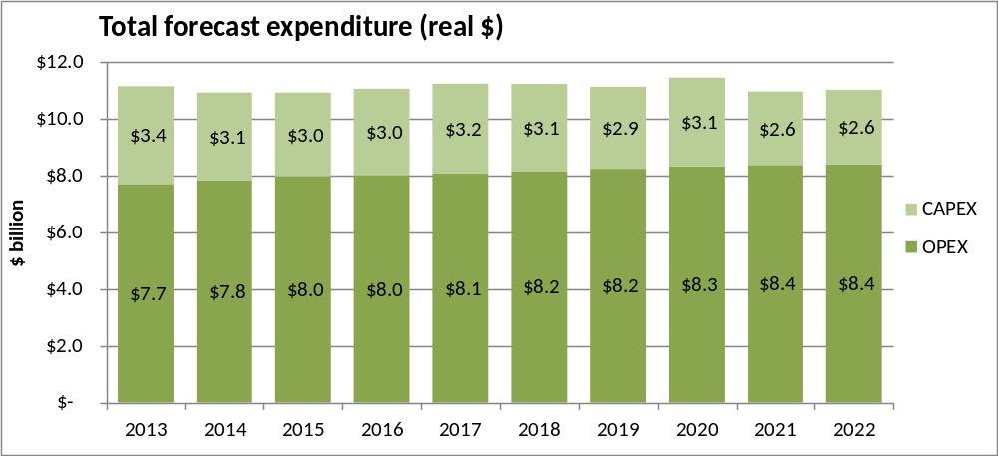
- Nominal dollars for Figure 2 are provided in Appendix D. The data used in Figures 2 to 6 came from LTPs and analysis of those plans by DIA, the BERL Local Government Cost Index, the OAG and material from Statistics New Zealand.
Figure 2: Projected Local Authority Total Operating and Capital Expenditure, 2013-2022
- Of the $30 billion worth of local government capital expenditure forecast for the period 2013-2022, just under 54% ($16.12 billion) will be associated with the Auckland Council.
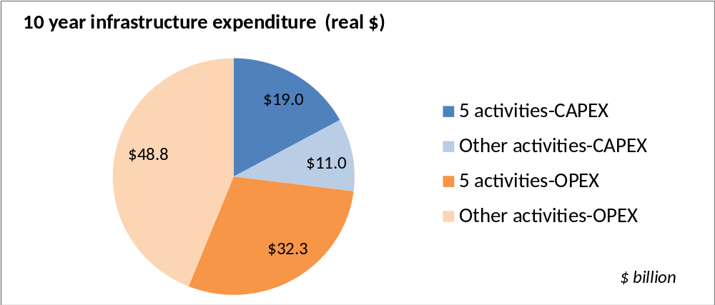
- Figure 3 shows that 46% of the projected CAPEX and OPEX spending by councils between 2013 and 2022 will be used on the five main reporting categories of infrastructure.
Figure 3: Projected Local Government CAPEX and OPEX, 2013-2022
- Figures 4 and 5 break out those five infrastructure categories, on which $51.3 billion will be spent - most of it ($32.3 billion) on OPEX, not CAPEX. Nominal dollars for Figure 4 are shown in Appendix D.
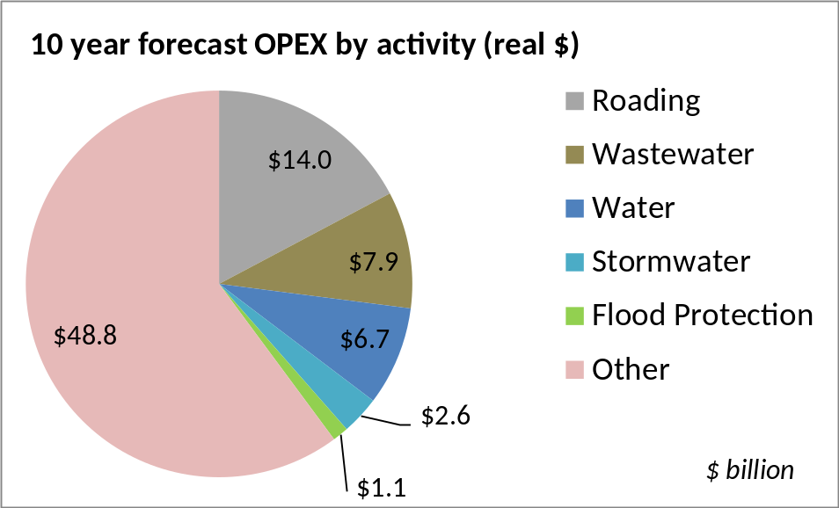
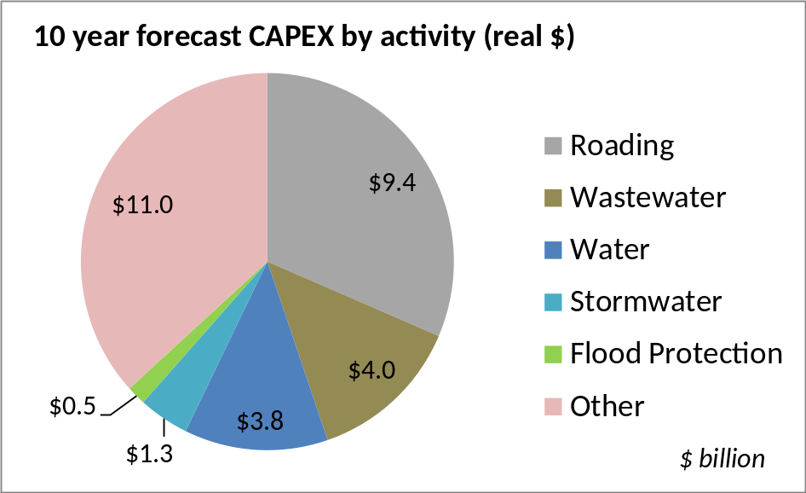
Figure 5: Total projected OPEX spend by infrastructure type
Figure 4: Total projected CAPEX spend by infrastructure type

Forecast infrastructure expenditure
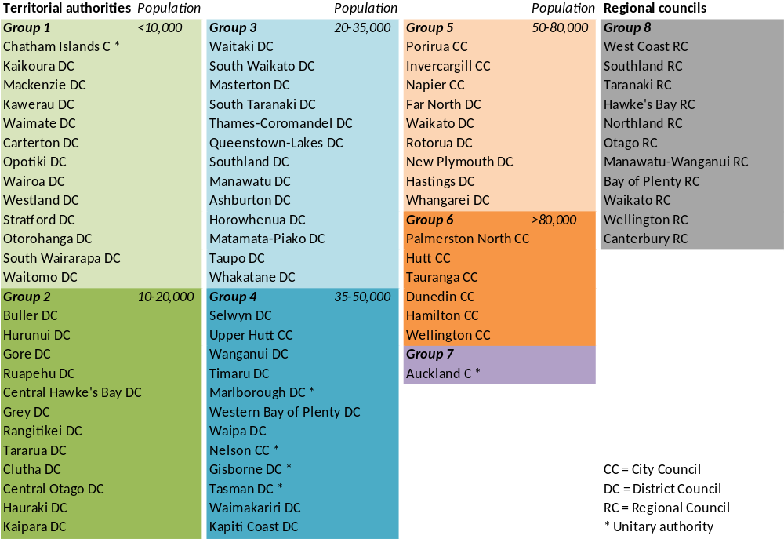
- The OAG has divided New Zealand’s territorial and unitary authorities into the seven groupings listed below (excluding Christchurch City). These are grouped by population, with the first group being territorial authorities with populations of less than 10,000 and each group thereafter increasing in population. Group 7 is Auckland only. This grouping was done to ensure optimal comparability. For the purposes of our report, we have used these seven groupings and added an eighth (Regional Councils).
Figure 6: Groups of local authorities used in following graphs in this chapter

Figure 7: Projected capital expenditure by infrastructure type
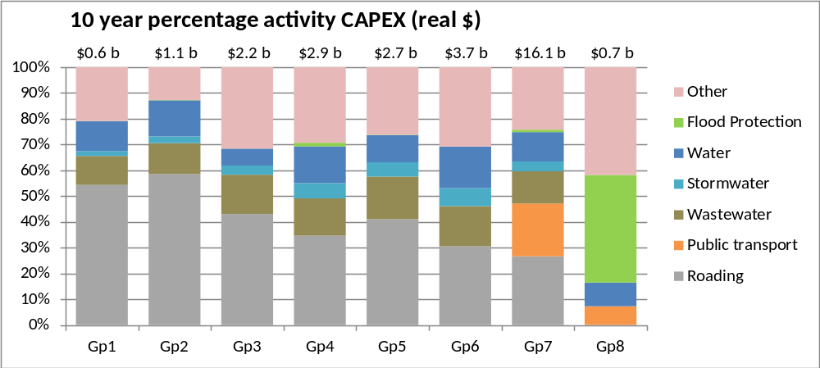
NB: Public Transport is listed as a separate unit for Auckland and regional councils only, due to the significant expenditure expected. The figures above do not include ports and airports

Figure 8: Projected operational expenditure by infrastructure type
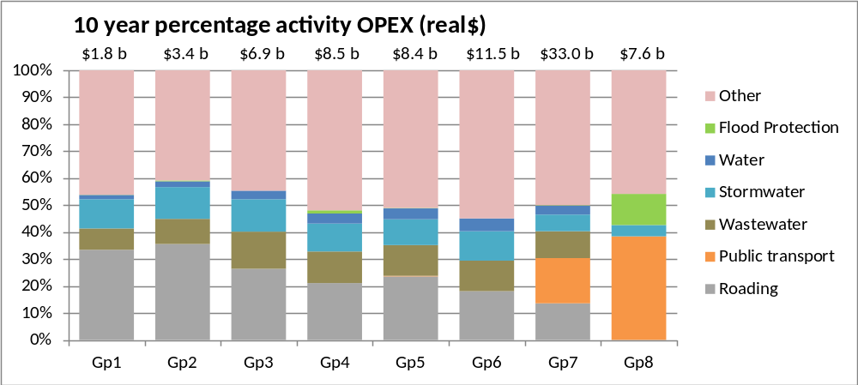
NB: Public Transport is listed as a separate unit for Auckland and regional councils only, due to the significant expenditure expected. The figures above do not include ports and airports

- Figure 7 shows that Groups 1 – 6, that is territorial and unitary authorities (except Auckland) spend around 70-80% of their infrastructure CAPEX on the five reported infrastructure types. It should be noted, however, that while percentage spend across the infrastructure types may sometimes appear similar (such as for wastewater), the actual dollar sums can vary considerably between the groups. The proportion of total forecast CAPEX to be spent on roading ranges from an average of 27% in Auckland to 59% in Group 2. Proportions for wastewater are largely the same across Groups 1-7, with regional councils (Group 8) taking the greatest share of responsibility for flood protection. The unitary councils in Group 4 also deliver flood protection.
- Auckland’s CAPEX projections include significant expenditure on public transport (20% over 10 years). Elsewhere, regional councils (and the four smaller unitary authorities) will largely take on the responsibility for public transport, which is denoted in Figure 7 as “other” - i.e. part of a broader item of expenditure that includes community infrastructure – for example, libraries, playing fields, cemeteries and crematoria, sports venues and public toilets.
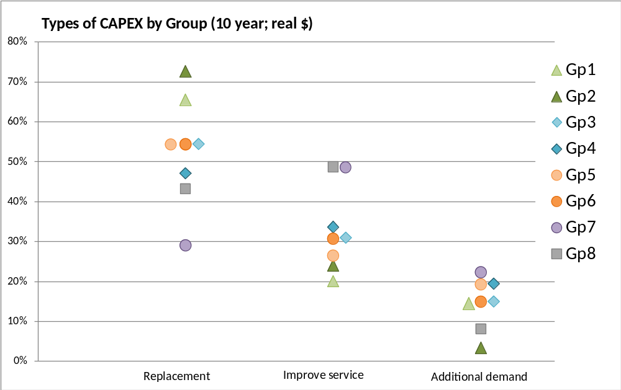
- The available information regarding local government spending on infrastructure is detailed and complex – but, as noted above, incomplete. Although the picture is clear at an aggregate level, there are challenges when attempting to make comparisons between individual local authorities. We have commented above on the lack of comparative data that results from inconsistencies in reporting outside of the five main types of infrastructure. Disregarding that, and even when focusing just on those five main types, there are other variances between councils themselves. For example, at any given time individual councils will be at different stages in the lifecycles of their infrastructure, so the quality of one network may not be comparable to another. There may also be substantial differences in the economic make up of different communities (and their ability to pay for infrastructure), which makes it difficult to make valid comparisons about the true meaning of actual and proposed spending. These circumstances need to be borne in mind when considering the expenditure of individual councils.
Figure 9: CAPEX expenditure on replacements, service improvements and growth driven demand
- Figure 9 refers to CAPEX spending on replacement, improving service and filling additional demand. It shows that the biggest category of spending is on replacement and the smallest on meeting additional demand.
- The terminology used in Figure 9 to describe these categories arises from a specific LGA requirement and is the terminology we use throughout this report. However, the LGA terminology differs somewhat from terms commonly used in asset management. For instance, in asset management, “replacement” can mean either replacement to a similar capacity, or to an upgraded capacity or alternative level of service. It thus potentially covers all three of the LGA categories. The asset management term “renewal” is restricted to replacement with an asset of similar capability. We are unaware of whether councils take a consistent approach in reconciling their asset management terminology with the categories of reporting required by the Act.

Forecast expenditure on roading
- For the period 2013-2022, the proportion of roading CAPEX that is forecast to be spent on renewals appears to be significantly greater in councils with smaller populations. This is because many sparsely-populated districts have roading networks spanning large land areas relative to their population. With a small funding base, the priority for forecast expenditure in these areas will often be on the maintenance of existing assets. Operational pressures in Auckland are evident in the fact that most forecast roading expenditure is for service level improvements.
- For all groupings, the proportion of annual expenditure on roading is set to increase at a steady rate over time. Given the nature of the assets and general focus on renewals, this trend is unsurprising.
- All groups show variable levels of CAPEX on improved levels of service. This pattern is likely to be a result of the impact of large roading projects and is particularly evident in cities. Renewal expenditure across all groups is also expected to increase steadily over time, partly due to the impact of inflation.

Forecast expenditure on sewerage infrastructure
- Medium sized districts predict 26% of their sewerage CAPEX will go to meeting increased demand. High predicted growth in Auckland means meeting demand will absorb 40% of the city’s CAPEX on sewerage - the largest of any council.
- In the least populated areas, 41% of sewerage CAPEX is expected to be absorbed in achieving compliance with environmental standards.
- LTPs show a focus on the completion of major sewerage projects in the least to medium populated areas. Over 47% of total rural sector sewerage CAPEX will be incurred in the first three years of the LTP because of this focus.

Forecast spending on water supply infrastructure
- Council LTPs show that, over the next 10 years, cities will have an overall increase in demand-related CAPEX for water, with a major peak in 2019 and 2020. This is entirely due to projected population growth. The trend for the small to medium sized districts is similar to that for sewerage, with large project spending earlier in the LTP, and again in the latter years.
- The drive to comply with environmental standards in small to medium sized districts is also evident in CAPEX on water. Over 43% of total water CAPEX in the least populated areas will be incurred between 2013 and 2015. The main driver for this expenditure is compliance with the Drinking Water Standards, which will be discussed later.

Conclusion
- Despite differences in approach, scope and focus, local government throughout the country is generally faced by the same key infrastructure pressures, with the majority of CAPEX going on the provision of roading, drinking water, waste water and stormwater, and the broad category of "other" activity. This other activity includes the big ticket items such as public transport. Spending does, however, vary according to the type of authority, with rural areas having service provision requirements and challenges that are quite distinct from those facing metropolitan areas.
- As a result of the TAFM reforms of 2010, we have been able to compile detailed information on the five main infrastructure types (roading, wastewater, drinking water, stormwater and flood protection). These account for approximately 80% of territorial authority infrastructure spending, so our recommendations to achieve future efficiencies tend to focus on these areas.
- Information available for ‘other’ infrastructure expenditure is not sufficiently reliable for detailed assessment by us.

To achieve nationally-consistent reporting of council infrastructure data, all long term plans and annual reports should include required data sets covering asset classes and specific activities. This data should be available in standard digital format as well as printed formats. DIA should work with LGNZ to determine the classifications and digital formatting required and the LGA should be amended, if necessary, to provide for this.

What is driving change?
- This section provides a high level overview of some key drivers of change in local government delivery of infrastructure. Some of these trends are similar or identical to trends that are apparent in most other developed countries – for example, changes in demographics. This chapter does not address the statutory or regulatory framework, which is addressed in the next chapter. Change in the delivery of infrastructure includes the expansion of existing networks, the upgrade of old facilities and the provision of completely new facilities. It may also include the downgrading or closing of infrastructure in some circumstances.
- Local authorities recognise that a broad range of factors influences their long term planning. In 2009, the top five categories of assumption factored into LTPs were inflation (100%), population growth (98%), interest rates (95%), funding sources (95%) and external factors (92%). External factors were the effects of migration patterns, currency fluctuations and the effects of business growth. In comparing LTPs 2006-2016 and 2009-2019, it emerges that the new matter covered in assumptions about external factors in 2009-2019 was the economic recession.
- We also note that there are other trends in New Zealand that are impacting on local government delivery in general. For example, settlement of claims made under the Treaty of Waitangi is providing iwi throughout the country with economic tools that position them as potential partners for local government, a trend on which we comment in Chapter 9. Another example is the increasingly multi-ethnic nature of populations in some of the bigger urban areas, particularly Auckland. Whilst these trends are important, in the context of infrastructure delivery they are not primary drivers of change or creators of barriers or challenges, as are some of the “mega trends” that we discuss below.
- It was commonly stated by respondents to our survey that significant issues are aging infrastructure, affordability against rising standards and customer expectations, as well as changing demographics affecting the ability of the community to pay. The convergence of these issues creates a nexus where the components are inextricably linked. These issues must also be seen in the context of increasing regulatory requirements and public expectations round environmental and health outcomes, both of which are driving the push for higher levels of service in a number of local government delivery areas. Together they create huge challenges for councils.

Population
- Population change is a key driver of demand for infrastructure. Change includes numerical growth and decline, as well as changes to population structure such as the number of persons in each age group. As the major location of continued population growth, the Auckland metropolitan area will face on-going challenges in infrastructure provision. Conversely, many smaller and rural communities will experience population decline and structural change, which may make the maintenance (much less the upgrade or renewal) of existing infrastructure less affordable as rating bases also decline.
- Recent work by Professor Natalie Jackson shows the impact of demographic trends on local authority areas in recent years and the projected future impact. As with many other developed countries, an aging baby-boomer population and low reproductive rates are the main factors creating changes to our population structure. In many local authority areas, there is also an out-migration of young adults and these areas are likely to see absolute population decline.
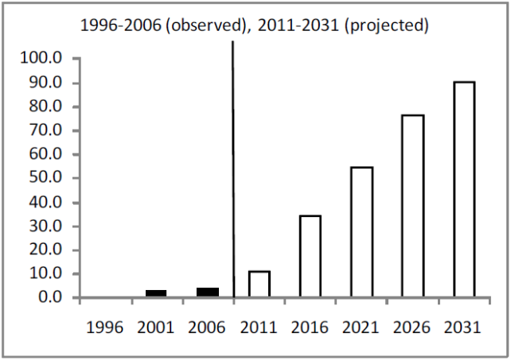
- As each successively larger cohort of baby boomers passes into the older age group across the regions and age structures continue to hollow out from the loss of young adults, the projected proportion of areas with more elderly than children takes a massive jump. By 2016, more than 30% of territorial authorities are anticipated to have more elderly than children, by 2021 above 50% and by 2031 fully 90% (see Figure 10). The OAG confirms predictions of decline over the next 10 years in its two smallest categories of council – comprising 23 out of 65 territorial authorities, all of them rural and each with populations under 20,000. Figure 11 shows where the changes in the ratio of elderly to children will occur.
Figure 10: Percentage of territorial authorities with more elderly than children
Source: Jackson, Natalie, The demographic forces shaping New Zealand’s future. What population ageing [really] means
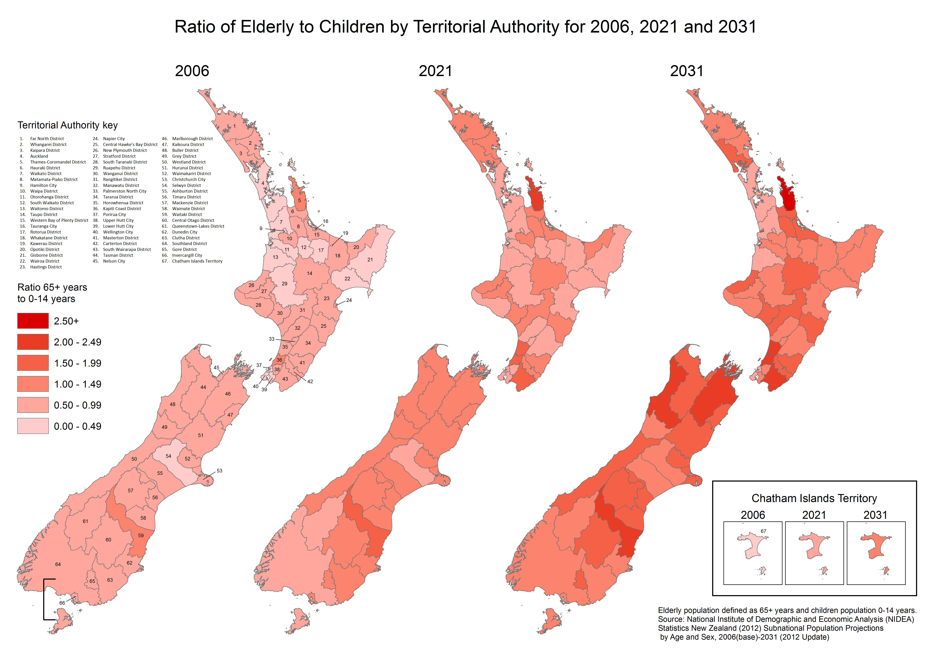
Figure 11
- Ageing will, according to the OECD, demand change in urban design and development, the provision and design of housing, land use, transportation, and the urban environment. It will influence forms of governance and citizen participation. “It will influence the lifestyle of all citizens and the trajectory of urban development.” (OECD 2003)
- Some of the implications arising from these population changes include:
- More elderly people will be on fixed incomes and therefore be less able to afford rises in charges related to maintaining or building infrastructure.
- Numerical population decline in many locations will mean that there are fewer ratepayers to support the cost of infrastructure.
- As younger people move to metropolitan locations, attracted by markets that compete for their comparatively scarce labour, the population structure of rural and provincial areas will change - they will have significantly higher proportions of elderly. This effect may be exacerbated in some locations that could attract older populations for lifestyle reasons. As a result of this, the demand for different types of community infrastructure will change. For instance, there may be less demand for some types of sporting facilities in locations with declining numbers of young people. Conversely, there may be increasing demand for council housing for the elderly (in local authorities that provide such a service) and demand for other types of council social or recreational infrastructure.
- The OAG notes there are emerging differences between local authorities based on population size, reflecting their response to the influences and pressures they face, and considers they should not “be caught by surprise” by numerical population changes.
- Since 2010, the LGA has required the financial statement in a council’s LTP to include a statement of various factors, including “the expected changes in population and the use of land in the district or region, and the capital and operating costs of providing for those changes.” Local authorities may well understand predicted numerical changes, but it is unclear whether all decision-makers fully appreciate the social and economic changes that both numeric and structural change will bring. Survey responses as part of our review suggest that some do, with changing demographics listed as one of the main factors underpinning future infrastructure issues, especially with regard to its effects on the ability of the community to pay for upgrades and renewal.
- We consider that councils need to have a very good understanding of both numerical and structural population change, and its effects on the affordability of infrastructure, as a prerequisite for sound forward planning.
- Although it may be a generalisation, we consider the situation paints an emerging picture of “two New Zealands.” One is urban, more wealthy and younger, and able to afford high standards of environmental health and public facilities. The other is rural, poorer and older, facing population decline and a future of living with lower standards and lesser service. Of course this does not apply across the board, much less within each council area. Nevertheless, it is a broad reflection of the demographic reality that is fast emerging and which we consider to be so profound that it needs to be a basic premise of local government decision making in all aspects of infrastructure delivery.

Councils should ensure their long term plans reflect projected numerical and age-related structural population changes and explicitly provide for these changes in their infrastructure and financial planning.

Technology
- There is a trend towards increasing sophistication in the physical delivery and management of infrastructure. The technology involved can have a high-tech engineering focus, such as in water purification or sewage treatment. It can also be e-focussed, such as through the use of GPS, remote monitoring or ultra-fast broadband. New technologies (at whatever scale) can offer increased levels of service and potential cost savings. Poorly considered and applied uses of technology can also be a cost to the community.
- In addition to the breadth of technology available to infrastructure operators, widely-available technologies are changing public expectations about the way infrastructure can be delivered. Smart phones, smart meters and e-books are examples of technology that provide new options for customers to access services or information about their own accounts and/or usage. The scale of use of such technology could well have major impacts on the type of delivery expected by users and on the way it is delivered. It also offers opportunities to drive down the transaction costs of volumetric charging, which is discussed later in Chapter 8.
- Councils are facing an ever-increasing and potentially confusing choice of technology and delivery options. Responses to this “new reality” require sound and informed decision making or there is a risk of unnecessary expenditure in an area that is characterised not only by long term decisions and investment, but also by wide-scale delivery. There are good examples of councils round the country looking for innovative technology solutions. This trend will continue and is to be applauded. However, we would not expect many councils to have in-house resources to be able to advise on complex technological issues and consider that this is an area where LGNZ is in a strong position to assist councils to share knowledge and expertise (including central government and other external parties). We comment on this further in Chapter 8.
Libraries in the Digital Age
Libraries are a prime example of community infrastructure that is undergoing a significant review of purpose. The digitalisation of information is moving at rapid speed and the idea of the library as we know it is being forced to change too. Some have argued that libraries will soon be obsolete, but libraries around the world have seen the changing technology as an opportunity to evolve, moving from depositories of largely paper-based resources to hubs of digital data and access.
All the while, the central role of the library as a community-based resource remains. New Zealand’s libraries have no doubt as to the pivotal role they can continue to offer communities. The issue, however, is how best to transition into a changed world. To do so effectively will mean giving New Zealand’s libraries the tools and resources to meet fully the needs and expectations of communities increasingly literate in – and demanding of – digital data. This will likely involve increased CAPEX up front but in the long term should be aimed at creating efficiencies and savings and higher levels of service. We note that the National Library is in the process of negotiating purchase of digital books and this could be an area where local and central government work together.

Local Government New Zealand should lead councils in sharing and accessing expert advice on complex technical issues.
Councils should be actively deploying technology to improve asset management and service delivery.

Community expectations
- In a democracy, community considerations and expectations play a large role in shaping what both central and local government deliver. This includes decision making on infrastructure.
- Customer (community) expectations for infrastructure generally revolve around the level of provision (how much and where) and the levels of service (how well it works). There is a tendency for expectations about levels of service, public health and environmental outcomes to rise over time.
- These expectations have also been translated into national and local regulation. Initially, change was often driven by the expectations of individual communities. However, over time, regulation increasingly came from the national level, as New Zealand grew from a collection of isolated communities into a more politically and physically interconnected nation. That trend continues today. However, in a time of instant global communication, community expectations are now also driven by international trends in public opinion and knowledge of what is available. In our survey, respondents noted the link between those expectations, the costs of meeting them and affordability in terms of the changing ability of communities to pay, which we discuss later.
Cess-pits, night soil and sewers
The open backyard and public cess-pits of early New Zealand settlement were replaced by council-provided night soil services, collecting buckets of household waste for burial elsewhere. Night soil collection preceded and existed alongside reticulated sewerage for many years.
For instance, in Palmerston North, official night soil collection began in 1879 and the first sewers were installed in 1890. The sewers discharged direct and untreated to the Manawatu River (immediate letters of complaint were received from the Mayors of Foxton and Horowhenua). Despite the night soil collection and the early sewers, problems were still experienced with Palmerston North’s cesspits as late as 1899.
Night soil collection continued in Palmerston North’s un-sewered streets and was still buried until 1919 when the council began discharging it to the sewer. The council sought to eliminate night soil collection in 1920, but the proposed sewer expansion project was deemed too expensive and had to be modified. Even so, there was a ratepayer revolt against paying the sewer project loans and the expansion was severely disrupted. Night soil collection finally ended after WWII as sewerage expansion progressed.
Elsewhere in New Zealand, in some settlements without sewers, the night-soil system hung on for decades, with Kāinga in North Canterbury reputed to be the last place that had a night cart - till 1986. Even in Auckland, a few isolated houses still used buckets until 1969. Rising social expectations about health and environmental quality gradually saw the system phased out, with communities investing in other alternatives.
- In 21st century New Zealand, most people expect that they will have a continuous supply of potable drinking water and that their roads will be pot-hole free. There are expectations around new infrastructure (such as in a new subdivision), but also around upgrades to existing facilities. For instance, a community may want an existing playing field to be upgraded over time to offer a high quality all-weather playing surface and be floodlit at night to allow extended use.
- However, if faced with the prospect of rising rate levels, some communities may be prepared to forego increased levels of service. Those trade-offs are often difficult for councils to decide because the community expectations and preparedness to pay may not be uniform.
- Although community demand often incrementally pushes up levels of delivery, conversely, resistance to change in “the way things are done” may also come into play when confronted with what is perceived as a more radical change in provision. For example, could the use of digital technology ultimately lower the cost of libraries and also enable a higher service level in, for example, rural areas, where accessing your books on-line might mean more books available at less cost? The change would initially be radical but the long term benefit of releasing money for other services or to hold rates could be worthwhile.
- A 2012 PWC/GHD study on the water industry found that community resistance to change is one of the factors inhibiting many water operators from implementing changes to governance arrangements and funding mechanisms. Consequently, slow progress is being made in considering alternative funding tools to alleviate affordability issues.
- Community influence on decision making was also considered recently by the Local Government Efficiency Taskforce. In its report of November 2012 the Taskforce noted that “there are issues with changing parochial and entrenched council views or attitudes arising from perceived geographical or cultural exceptionalism.”
- We consider that this perceived geographical and cultural exceptionalism is a strongly prevailing ethos in New Zealand - not just in local government. It is quite understandable that local communities value their character and cherish the right to make decisions about their own neighbourhoods. This is a hallmark of our democracy and needs to be defended. However, when resources are constrained, councils need to make an extra effort to bring alternative options to the attention of communities. There might also be a useful discussion around what constitutes “local” when it comes to the provision of larger regional facilities or network infrastructure. In particular, the concept of subsidiarity is relevant – conversations around issues affecting a wider group of people within a region may differ from place to place and decisions need to be made for the wider good.
- Regardless of circumstances and the nature of the discussion, informed decisions about levels of service communities require full information. We discuss this further in Chapter 8.

Aging infrastructure
- Aging infrastructure was mentioned in the survey responses, with respondents noting, for example, that "one of the greatest issues facing local government is the age of our assets and the cost of renewal or upgrading these assets,” and that “the cost of renewal will be significant.”
- It has been difficult to generalise on this issue. The Assistant Auditor-General (Local Government) commented in a discussion with us that there is a need to look at where local authorities are in their asset cycles. “For 20 years they have been renewing systems. Although not totally structured information, aging assets may not be a problem – certainly it may not be the most significant issue in local government”.
- We also raised this issue with the Local Government Funding Agency (LGFA) because we considered this would be a core issue for the LGFA as a lender. The response was as follows: “The LGFA has now admitted 37 councils as approved borrowers and declined none. The LGFA has been impressed with the credit quality of councils in New Zealand with the vast majority having very sound credit standing. An area for further investigation identified however, is the condition of essential infrastructure such as water pipes and other infrastructure. Unlike other utilities such as electricity and gas networks, there does not appear to be information available and presented in a consistent format to enable firm views to be taken on the state the council infrastructure. This is not to say there is a problem in their condition. However, the LGFA considers it would be very helpful for councils and the wider public to have sound engineer-reviewed asset condition information on council infrastructure assets presented in a consistent form - and, ideally, to have this validated by an expert external party. This would provide confidence to the ratepayers and lenders to councils that their assets, whilst in many cases quite old, are in "fit-for-purpose" condition and that sufficient money is being spent on them to maintain them. It would also provide council infrastructure managers with the information tools to make smart decisions around the inevitable trade-offs between deferring CAPEX and incurring higher maintenance or spending more on CAPEX now to save on maintenance later".
- As noted in Chapter 5, during our work we found that data on utility infrastructure such as roads and water was more readily available than data on community infrastructure such as libraries, recreational and sports facilities. While smaller scale in terms of dollars, the need to understand where community assets sit in a lifecycle sense is critical (refer to comment on community facilities in asset management discussion in Chapter 8).
- It appears that despite a lack of agreement among some observers as to whether or not New Zealand’s infrastructure can now generally be described as aging, there is no doubt that the issue of aging infrastructure is seen as a significant one by local government managers. From the comments and limited assessments we were able to access, we conclude much has been done in the last couple of decades, which could be why aging infrastructure was one of the issues raised by council respondents to our survey – it is top of mind and the renewal process has been costly for councils for some time now.
Rangitikei District Council
Rangitikei District is typical of other rural areas affected by urban drift, an aging and decreasing population and a change in farming technologies. Historically the council kept rates low so as to limit the impact on its small, less affluent communities, but eventually the aging infrastructure had to be replaced.
In 2012, the Council consulted on its 2012-22 LTP, asking the community for its views on upgrading its water and wastewater treatment plants and the level of maintenance of its road network. As a result, of the $136 million budgeted for capital projects between 2012 and 2022, $127 million will be spent on network assets ($76 million on roading and $51 million on drinking water wastewater and stormwater). $13 million this will be spent in the first two years of the LTP to achieve compliance with the New Zealand Drinking Water Standards and with resource consents for wastewater discharge. The Council will increase its borrowings from $5.8 million in 2011-2012 to nearly $32 million in the ten year plan, giving an average rates increase of 3.94% over that time, but with larger ones in 2012-13 (6.34%) and 2013-14 (6.66%).
The Council has adopted a district-wide approach to charging for water, wastewater and stormwater under what is termed “public good.” Charges will apply to all properties and be uniform in 2012-13, but in 2012-14 will be partly uniform and partly value-based. However, unconnected rural properties are not charged the consumption charge urban properties must pay. This lower charge reflects the lower level of service to rural properties.
- Although there may not be a risk of widespread catastrophic failure of infrastructure, nonetheless, knowledge of asset condition is not consistent across the sector. Not having knowledge of asset condition is dangerous for individual councils and could prove exceptionally costly. We comment further and have recommendations on these issues in Chapter 8 in the section dealing with asset management plans.

Resilience
- Resilience is a significant theme for all infrastructure operators. The term is often used to cover planning and upgrades required to be able to mitigate or respond to threats to service levels arising from one-off events such as storm surge, flood, drought or earthquake, or long term trends such as rising sea levels or climate change (the latter is seen as the trigger for more frequent and in some cases larger one-off events).
- In 2009 the Ministry for the Environment published a document advising local government on dealing with the impacts of climate change and rising sea levels. In the conclusion, they noted that “coastal hazard risks are increasing and more of New Zealand’s urban development and infrastructure is being located in coastal areas…Planning is more effective and less costly over the long term than reacting to events when they occur”.
- It appears that concern about resilience has increasingly influenced council thinking in relation to asset management planning. The OAG has documented this shift in thinking and noted such examples as infrastructure planning allowing for more frequent flood events or an increased need for water storage because of more frequent drought conditions. We consider that this is a permanent shift in thinking that will continue to be a major factor in infrastructure planning, funding and delivery and in land use decisions.
- Clearly this is not just a local government responsibility. All infrastructure operators by now will be highly sensitised to the logistical and financial ramifications of the impacts of climate change. As noted above, for councils (and for the central government roading agency, NZTA, which is a funding partner for local government) a growing concern will be coastal roads that are being affected by a combination of sea level rise and storm surge. Roads are often the corridors for water infrastructure and, of course, for the buildings that this infrastructure services.
- We are not in a position to recommend how the response to this could be approached more efficiently or effectively. It falls into the category now frequently described as “wicked” problems. Local communities need to be provided with full knowledge of the science and the data, together with an understanding of the financial implications and timing of strategies such as managed retreat.
- The high degree of interdependence of infrastructure recovery following a major natural event such as an earthquake (for example the importance of road access) means that councils are in a good position to be key drivers of work to increase resilience.
- In most parts of New Zealand, significant reports have been produced by what are generally referred to as “lifelines” groups, comprising private and public sector infrastructure providers In conjunction with regional hazard information, these reports have provided impetus for councils and other lifeline utilities to address resilience issues both collectively and at an individual organisational level. The benefit of such pre-event analysis and planning was demonstrable following the Christchurch earthquakes. A Christchurch lifelines report in 1997 prompted widespread activity amongst infrastructure operators, including Orion, the council-owned electricity network. In the aftermath of the Christchurch earthquake, the benefit of the work undertaken on the Orion network was evident in the reasonably short restoration times to most areas.
- The work of regional lifelines groups should be strongly supported by all councils. The focus of lifelines activities should be the collective identification and mitigation of critical areas (“hot spots”) of regionally significant networks. The outcomes from this work feed into and support the resilience activities of individual local authority network operators.
- Dave Brunsdon, Chair of the New Zealand Lifelines Committee, noted in a discussion with us the importance of lifelines work being driven from a regional perspective, at least initially to ensure that the right “big picture” of vulnerabilities is established. He suggested that once this is done, the appropriate context and framework is set for resilience planning and work in local urban areas. The example he used was the dramatic difference between Christchurch and Wellington in terms of post-earthquake access, which then flows through to different influences on the resilience strategies of territorial authorities.
- It is important to reinforce that resilience-driven upgrading of infrastructure to cope with either long term trends or one-off events clearly has huge cost implications for the infrastructure providers and for their customers. Apart from having full transparency on these issues, local government is also in a strong position to lead a community discussion regarding priorities and timing of such upgrades.

Councils should actively stimulate informed public discussion on the financial implications, timing and community impact of strategies designed to promote infrastructure resilience in high risk locations (for example, managed retreat).
Councils should be actively engaged in local lifelines groups and, if necessary, promote the formation of such groups where they are absent, with a view to developing risk management strategies and response plans coordinated across infrastructure providers.

Economic trends and affordability
- As noted by the National Infrastructure Plan, the nature of economic growth is a key factor in infrastructure provision. Unsurprisingly, the current global recession, beginning in 2007-2008, has affected the overall affordability of infrastructure. This needs to be seen in particular in the context of the push for more or upgraded infrastructure immediately prior to the onset of the global financial crisis when “times were good”.
Hamilton City Council
The Hamilton City Council used the development of its 2012-22 LTP to confront the changes to levels of service needed in response to its financial challenges. Having used debt to fund infrastructure, facilities and services to support anticipated growth, the Council ended up running at a loss and with unsustainable debt levels when growth slowed.
The Council decided on the high level goals of holding debt at current levels and returning quickly to an operating surplus. A goal of $15m of operating savings a year was set. The chief executive committed to finding $6m of that from internal Council efficiencies without affecting levels of service.
The remaining savings sought were divided across each group of services. The Council conducted consultation and a series of meetings during the second half of 2011. Each meeting worked through the options for changing levels of service to find the required savings. Stakeholders and members of the public participated in open sessions with councillors before the councillors had their own sessions. This approach allowed the impacts of the cuts on specific services to be discussed by those with the greatest interest in them, with a clear understanding of the overall imperative for savings.
The approach allowed councillors to work through options systematically and, once the full picture was available, make adjustments to where the impacts fell. These adjustments were relatively minor. The proposals included in the draft long term plan that came out for consultation in March 2012 were part of a coherent plan that had been tested and understood by significant stakeholders. The final plan gives a clear indication of the impacts on levels of service in the “Living within our means” chapter, which clearly lists “What’s going up” and “What we’re cutting”.
- However, even in times of economic prosperity, there is always public debate around the concept of affordability. The call to hold down rates increases is frequent and enduring, although, in contrast, most councils also experience public demand for increased service levels in a diverse range of areas.
- Affordability is a difficult concept to define for any particular council. Relevant factors include current levels of indebtedness, the stage of the council in its investment cycle, rates levels and community appetite to service greater debt for any particular reason. Within the boundaries of virtually any council there are disparities in wealth between different sections of the community and it is observable that calls to hold rates are not confined to the poorer or least advantaged sections of any community.
- Unfunded mandates are also a cost that affects affordability for communities. The Productivity Commission discussed this issue in relation to the regulatory responsibility of councils. The Commission noted "unfunded mandates occur when central government imposes additional responsibilities and costs onto local government without the funding necessary for their provision, or the ability to fully recoup the cost of carrying out these responsibilities." A result can be inequitable cost bearing, inefficient financing and under-resourcing of regulatory functions. The Commission also noted that unfunded mandates highlight the need for central government to make sure that the total benefits outweigh the total costs of regulation. The Commission noted a strong belief among councils that central government does not understand or adequately consider the financial implications of new regulations assigned to local authorities. Councils responding to our survey had the same comments regarding increasing environmental standards for water infrastructure, which is discussed in Chapter 7.
- Regardless of shades of public opinion, affordability becomes a particularly significant issue not only with the current prospect of a long period with lower economic growth than previously, but when observed through the lens of demographic trends. A third long term factor is the consensus on the probability of oil price rises over time. Despite fluctuations in the near future, this long term trend will impact on the cost of all local government infrastructure, particularly roading.
- These external trends need to be looked at alongside projections for capital expenditure in LTPs. The “big three” areas of infrastructure for most councils (excluding Auckland) are roading, sewerage and water, accounting for around three quarters of capital expenditure projections in the next ten years. Not surprisingly, councils with high projected population growth are planning to spend a higher proportion of their capital on projects related to increased demand, particularly sewerage infrastructure. However, around the country there are smaller councils with low or no projected growth that nonetheless have planned for increased infrastructure spend. Sewerage infrastructure is significant across the board, driven by the need to conform to higher environmental standards. In the case of holiday destinations, there may also be a perceived need to cater for much more than the usually resident population. Kaipara District Council has become the “poster child” for these councils but there are others that are also facing big challenges.
- Roading is a good example of the effect that economic growth places on infrastructure. Local and regional roads, at 83,000 km, make up 88% of the country’s road length. Of this total, 20% are urban and the remainder rural, with the majority of rural roads being unsealed.
- Local roads account for between 1.3-1.8 times the value of major exports carried on state highways. Despite this, the current land transport funding system accords them low priority. As a result there is a growing pressure for local roads to be increasingly funded at the local level, which raises affordability issues.
- The OAG has pointed out a correlation between the size of councils and incomes of individual residents. Average incomes of the two smallest rural groups were 7% lower than those of the three middle-sized groups and 21% lower than the large metropolitan councils. This trend appears to persist despite the higher cost of living in cities and may be due to a number of factors, though the report does not list any possible reasons. Furthermore, the report noted that “on average the person in smaller councils pays higher rates, so an even higher proportion of their personal income is needed to pay rates.” It might be the case that small, rural councils generally lack the substantial base of commercial ratepayers enjoyed by metropolitan areas.
- Thus it appears that the issue of affordability may be especially pertinent for smaller councils and for those already facing higher levels of debt and static or declining populations. Of course this is not always the case. For example, there are some small councils in a strong financial position. On the other hand, the current discussion on the proposed Auckland central rail loop is an example of the largest council in the country contemplating an extremely large and expensive infrastructure project. Generally, however, it would appear that smaller populations are disadvantaged because of the cost of large infrastructure projects – not only by having fewer ratepayers to share the cost, but by having a lower income base amongst that rate paying population. Changes in demographics noted earlier are likely to exacerbate this in the future. Some smaller councils that are facing a radically shrinking population in the next few decades will have difficult decisions to make if they face immediate needs to upgrade infrastructure.
Southland District Council
Southland District Council faced a significant increase in demand for investment in renewals of roads. The Council decided that with the prolonged economic downturn and volatility, together with uncertainty about future road funding, it needed to adopt a more strategic approach to roading investment. This approach needed to meet community needs rather than preserving existing roading levels of service and standards. The Council found it needed a better way to classify its local roads to be economically "fit for purpose”. To do this the Council developed an economic network plan (ENP).
In developing the ENP the Council first determined the absolute essentials to meet prospective economic capacity needs and ensure a secure and safe network.
To do this the Council identified the economic benefits of each section of road. This measure captures the productivity of land gaining access from a road in relation to the five export sectors considered significant in Southland District. This is based on the notion that a road that transports export product is a fundamental contributor to the wealth of New Zealand. Any disruption to this network would mean that the export return may not be realised. Social and safety factors were also included.
The ENP identified opportunities to rationalize investment to a more affordable level across the District’s 5,000km local roading network. The Council has used the results to consult with its community giving them affordable investment options and a clear and transparent rationale for trade-offs across the network.
- Two main approaches to managing the recessionary environment have been identified by the OAG - to increase levels of debt and to defer pre-programmed capital and operational expenditure.
- To quote the OAG: “The recessionary environment accentuated the need for local communities to consider affordability. It also forced local authorities to evaluate whether the trend of increasing levels of service was viable for the long term. To maintain levels of service to meet the community’s expectations in the future … a number of local authorities sought to mitigate this and balance their books by increasing debt.”
- The OAG also noted that in other cases, some local authorities are agreeing with the community to reduce some levels of service.
- As well as using debt or reducing service levels, realising economies of scale can also assist with affordability for some parts of the community, often the most financially challenged. This issue is further discussed in Chapter 9.

Formal framework within which local government delivers infrastructure
- Local government, and the infrastructure for which it is responsible, operates within what we refer to in this report as a “formal framework”. The framework includes Acts of Parliament, regulations made under those Acts and a raft of standards, practices and guidelines. The framework requires, encourages or allows councils to do certain things that govern the provision of infrastructure. This multiplicity of instruments, some mandatory, some optional, have developed over a long period of time and cover a wide range of issues that govern how councils make decisions and operate.
- The various instruments have mostly been developed independently, focusing on individual aspects of the local government system. The complex nature of the formal framework creates problems of implementation and interpretation for central government, councils and the general public. We consider this is a barrier to more cost-effective provision of good quality infrastructure by councils, and greater clarity and integration of the formal framework is key to addressing these issues.
- Below, we provide a brief summary of some of the main components of the formal framework, that relate to infrastructure. The summary covers:
- Acts and their subordinate regulations including
  - Local Government Act
  - Resource Management Act
  - Local Government (Auckland Council) Act
  - Land Transport Management Act
  - Building Act
  - The water framework (including reference to the Health Act)
- Standards, codes, practices and guidelines
  - Formal standards.
  - Other codes, standards, practices and guidelines.
- Towards the end of this chapter we discuss issues related to the formal framework, and draw conclusions about what changes might be needed to overcome regulatory barriers to more cost-effective provision of good quality infrastructure.

Acts and regulations

The Local Government Act
- The Local Government Act 2002 (LGA) is the main legislation relevant to all councils. It specifies the purpose of local government and provides the fundamental framework within which councils operate. The Act requires the use of some tools, such as an LTP and an annual plan. Together, these are important means by which each council specifies the infrastructure it will be providing, the quality of that infrastructure and how the council will pay for that infrastructure. The Act sets out the structure of entities (regional councils, unitary councils and territorial authorities) and assigns some responsibilities or powers to them.
- The LGA does not require councils to provide infrastructure such as roads, water, sewerage, stormwater or community infrastructure. However, it does require that councils “have particular regard” to the contribution those “core services” make to their communities. The LGA gives councils powers to organise the administrative delivery of the services it chooses to provide and also gives a council power to fund its infrastructure delivery through various mechanisms. The LGA does not require a council to deliver specific services, but a council is obliged to retain existing water supply services unless it follows a statutory process. The council can seek to close down small water services (serving fewer than 200 people), subject to a statutory process.
- The LGA’s purpose is specifically relevant to infrastructure, as its wording includes being able “to meet the current and future needs of communities for good-quality local infrastructure … in a way that is most cost-effective for households and businesses. In this Act, good-quality, in relation to local infrastructure … means infrastructure, … that [is]:
- efficient
- effective
- appropriate to present and anticipated future circumstances”.
- The LGA’s requirement that local government deliver good quality infrastructure in an efficient and effective way is reflected in our terms of reference. We also note that the Act’s definition of good quality echoes references to efficiency and effectiveness found in other legislation, such as the RMA provisions related to the consideration of alternatives, benefits and costs.
- There are a number of other sections in the LGA that relate to specific aspects of council infrastructure – for example section 125 that requires an assessment of water and other sanitary services. We refer to and discuss the most significant ones later in the report. There are others, but they are not necessarily material to a high level discussion.

Resource Management Act
- The Resource Management Act 1991 (RMA) is the main statute covering the local government environmental regulatory regime. Its focus is on controlling adverse effects on the environment, within a hierarchical framework established by the development of a three-tier system of policies and plans (national, regional and territorial). The hierarchy demands consistency. That is, each instrument down the governance chain must give effect to all of the ones above it. At the top of the hierarchy sit National Policy Statements (NPS) and National Environmental Standards (NES), prepared by central government. Below that sit Regional Policy Statements prepared by Regional Councils. The third tier comprises Regional Plans, prepared by Regional Councils, and District Plans prepared by territorial authorities. Unitary authorities (which combine regional and territorial functions) prepare a District Plan that combines regional and district planning. Auckland Council is a unitary authority, but its planning regime is somewhat different, as we note later in our report.
- Unlike the LGA, the RMA does specify different environmental regulation roles for regional councils and territorial authorities. Regional councils generally deal with the natural environment, including effects on the “commons” - environmental resources such as water and air. Territorial authorities deal with land use (such as the built environment) and its associated effects.
- The RMA is the main legislative instrument for directing how councils treat infrastructure as a land use and how it interacts with the natural environment. Regional councils are required to achieve the strategic integration of infrastructure with land use, but this must be through regional policy rather than regional land use planning, because regional councils do not have a power to make land use plans. Territorial authority land use plans are the mechanism through which the integration of infrastructure with land use can occur. The Act gives no specific direction for them to do so, but the hierarchy of policy and plans means that territorial authority plans must give effect to any regional policy direction on infrastructure.
- Regulation of individual infrastructure projects is via the statutory RMA approvals system, within the framework created by policies and plans. A project may require consent from both a territorial authority (for land use) and a regional council (for taking water or for discharging contaminants to water, land or air). If an infrastructure network crosses an administrative boundary, there may be the need for consent from more than one territorial authority or regional council.
- The RMA includes enabling provisions specific to network infrastructure. The system allows a requiring authority (which includes all councils) to designate land within which an infrastructure project will be built. Although having some similarities to resource consent, the “owner” of a designation has greater powers with regard to its approval and the subsequent control of the land use. Although designations cover land use, resource consent (such as for discharges from a designated network) is still required from a regional council.

Land Transport Management Act
- The Land Transport Management Act 2003 (LTMA) sets out the planning and funding framework that channels around $3 billion of central government funding annually into roading, public transport and traffic safety. The Act requires regions to prioritise roading projects and develop transport plans. The LTMA planning framework is established under a hierarchy of a Government Policy Statement (GPS), National Land Transport Strategy (NLTS), Regional Land Transport Strategies (RLTS), and Regional Land Transport Programmes (RLTP). In addition, the Act establishes the basis for national contributions to funding of local roading projects.
- The New Zealand Transport Agency (NZTA) is the operational arm of the LTMA. It is responsible for allocating monies from the National Land Transport Fund, co-funding local road and public transport activities and managing the State Highway network. It decides on the allocation of funding to local authorities and approves their procurement procedures.

Building Act
- The Building Act 2004 provides for the regulation of building work by building consent authorities (BCA), the establishment of a licensing regime for building practitioners, and the setting of performance standards for buildings. The Act exempts network utilities (such as water supply, sewerage and drainage) from the definition of “building” and therefore the need for consent.
- However, buildings connected to a utility network (such water or sewage treatment works) would require consent. Buildings for community infrastructure, such as libraries, museums, and recreational facilities and structures within reserves will require consent, as will structures such as retained roading embankments or bridges.
- The Act lists many exemptions to the need for building consent, mostly relating to works of a minor scale, none of which have any real significance for council infrastructure.

The Water Framework
- New Zealand’s water management regime covers not only drinking water, but also wastewater and stormwater drainage. The LGA, Health Act 1956, RMA and Building Act are all components of the regime. The management regime includes mandatory requirements, voluntary codes of practice and community-derived self-regulation.
- The delivery of drinking water infrastructure by councils to specific standards is controlled under a framework created mainly by the Health (Drinking Water) Amendment Act 2007, which amended the Health Act. The Act creates duties for councils by including a requirement to report on drinking water quality within their districts. The Act also creates an obligation on water suppliers and water carriers (including councils) to monitor drinking water and take all practicable steps to comply with standards.
- The New Zealand Drinking Water Standards 2008, which are derived from WHO guidelines, prescribe the maximum allowable concentrations of potentially harmful contaminants that may be present in drinking water. The standards are exactly the same for all supplies, regardless of size or type, because they relate to health effects on people. However, the monitoring and compliance criteria become more detailed or stringent as population increases. This approach provides different levels of certainty that the standards are being met and is intended to help balance costs against public health risks. As the standards note: “From a public health perspective, the more people served the more certainty that is needed”. There is also a degree of flexibility in the standards, as water suppliers may apply to have alternative treatment processes approved, other than those set out in the standard.
- There is further flexibility for the smallest categories of water supply, in that the standards prescribe suitable treatments depending on whether the water catchment is protected, partially protected or fully protected. However, the greatest flexibility for small water supplies lies in Public Health Risk Management Plans (PHRMP) where communities can identify risks to their supplies, consider affordability and practicality and may prioritise addressing risks.
- There is a phased timetable for compliance with the drinking water provisions of the Act. From the specified dates, a water supplier must comply with the duties to:
- Take all practicable steps to
  - ensure there is an adequate supply of drinking water
  - comply with the drinking water standards
- Take all reasonable steps to
  - protect raw sources of drinking water from contamination
  - provide wholesome drinking water
- Prepare and implement a PHRMP.
- Supplies serving 10,000 or more population must already be compliant. Those serving 5,000 to 10,000 have until July this year (2013). Smaller supplies are progressively phased in over 2014 to 2016.
- Part of the compliance regime is the use of a drinking water assessor (DWA), supported by “designated officers”. There are currently 33 appointed DWAs, whose employers are the district health boards. The DWAs have a statutory responsibility to assess the performance of drinking water suppliers to determine if they are complying with the Act and the standards, and whether or not public health risk management plans are being implemented. The DWAs and designated officers have extensive powers of inspection and recording. Non compliance with the standards can lead to a compliance order issued by the Medical Officer of Health. The water supplier may seek a review of decisions made the DWA.
- The grading provisions, administered by public health unit staff in district health boards, have been effectively replaced by the statutory PHRMP process. Previously, the grading provisions were regarded as the principal driver of improvements in water quality. However, since 2007, grading is undertaken only when requested by a water supplier and is completely voluntary. The grading system is currently under review.
- Another relevant provision is the National Environmental Standard for Sources of Human Drinking Water, produced under the RMA. This requires regional councils to consider the impact of possible contamination on sources of supply. In addition, the National Policy Statement for freshwater management provides a guide to councils on achieving national objectives for fresh water management through regional policy statements and plans.
- The LGA requires councils to assess water, wastewater and stormwater in their districts. It also obliges councils to maintain existing water services for its communities, although it does not oblige the establishment of new services. There are provisions governing the closure or transfer to community ownership of small water schemes and requirements for any contracts entered into for the operation of water services.
- The LGA enables but does not require the provision of wastewater systems. Under the Health Act, the Minister of Health can require a local authority to provide, alter or extend sewerage works. The Act also provides the basis for Parliament to provide grants or subsidies for sewerage works.

Utilities Access Act
- The Utilities Access Act 2010 provides for either a co-regulatory environment or central government responsibility for developing and administering a suitable Code of Practice. The Utilities Access Code was subsequently established as a regulation in 2012. The aim of the Code is to improve co-operation and integration between utility operators (including local authority water utilities) and transport corridor managers. The Act and the Code resulted in the sharing of costs when work on a road required the relocation of utility infrastructure – previously the cost was fully borne by the utility provider.

Auckland Council Act
- The Local Government (Auckland Council) Act 2009 created the Auckland Council, which commenced operations in 2010. The Auckland Council took over the functions of the Auckland Regional Council and the region's seven city and district councils. The Act also established transport and water organisations as part of the governance framework.
- The key difference between the Auckland provisions and those applying to the rest of the country is around spatial planning, which is specifically mandated by the Act. Planning for the provision of infrastructure, including its location, sequencing and timing, is a central part of the spatial plan (referred to as the “Auckland Plan”). Although this is a plan developed by the Auckland Council, the Council is required to work with central government and the private sector and to maintain their ongoing support for the plan.
- The Auckland Plan does not limit infrastructure to the typical council networks of water, sewerage, stormwater and roads. Instead, it is expanded to include “cultural and social infrastructure”, and, importantly, “services managed by network utility operators” other than the Council, which, in the spirit of the plan, the Council refers to as “partners”.

Standards, Codes, Practices and Guidelines

Formal Standards
- In addition to legislation and regulation, which can set out compulsory actions, there are also standards. For the purposes of this report, we consider formal standards to be those created by national and international standards bodies through formal prescriptive and collaborative processes. Standards can define materials, methods, processes, practices, or outcomes. They can then be used to set requirements, provide better practice, and deliver guidance. Standards are generally silent on the use of specific technology, recognising that numerous technologies are available and the most appropriate for any given situation will depend on a range of factors, leaving the door open for local choice and innovation. Compliance with standards may or may not be compulsory, depending on the ability of one party to compel another to use them.
- The national body for standards is Standards NZ (SNZ) which is a Crown Entity and operates under its own statute. The work of SNZ covers a wide range of local government activities. This includes, for example, on-site “end of pipe” infrastructure of individual properties; a standard for land development and subdivision infrastructure with criteria for design and construction of roads, stormwater, wastewater and water supply as part of subdivision development; a Model General Bylaws series covering various matters including water supply, wastewater drainage and solid waste; and a standard for managing flood risk, designed to guide decision making on flood risk rather than being a technical, prescriptive or performance-based approach. SNZ has also published a guide that describes service delivery mechanisms (e.g. public private partnerships (PPPs) or council controlled organisations) and when they would typically be used (see Appendix E). There is a formal standard for conditions of contract for building and engineering construction which is currently under review.

Other Codes, Practices and Guidelines
- Separate from formally developed standards, are customs, products, or systems that become significant due to public acceptance, market forces, co-regulatory or self-regulatory processes, or professional organisations and affiliations. These can be thought of as de facto standards.
- Instances of significant practices or de facto standards can be seen in conditions imposed on resource consents, where they set threshold levels of environmental performance related to infrastructure. These are sometimes developed in one local authority jurisdiction and later adopted or adapted in others. An example (although not directly related to infrastructure) is the Auckland Regional Council erosion and sediment control guidelines, initially developed in the 1990s. A requirement to comply with the guidelines (or similar local versions) later became a common resource consent condition in many other parts of the country.
- A set of guidelines of particular significance for local authority infrastructure is the International Infrastructure Management Manual, published by the New Zealand Asset Management Support Group (NAMS). Asset management is not mandated by legislation and neither are these guidelines, but they have become a widely accepted form of good practice.

Discussion about the framework elements
- The following discussion of the formal framework largely follows the headings and order of the framework elements outlined above. The one exception is the addition of a discussion about integrated planning. We consider that this important to highlight on its own account, as it pulls together a theme that cuts across several of the statutes that referred to earlier.

Local Government Act
- The LGA is the main legislative instrument for directing how local authorities should plan for and provide infrastructure. There are significant issues related to the Act’s structure and content which result in such planning and provision being inefficient.
- Under the LGA, LTPs are supposed to provide for “integrated decision making and co-ordination of the resources of the council”. However, the Act does not specify what that means and we consider that there is a lack of integrated decision making around infrastructure. We are unaware of any source of good practice information for councils to help them in this respect, although there have been a number of examples of initiatives aimed at wider integration (including with other councils and the private sector), some of which we describe in Chapter 10. We note, however, that such examples of collaboration or consolidation still need to be delivered within a statutory framework that lacks integration.
- A principle of the LGA is sustainable development but, again, that term is not defined in the LGA. The most often quoted definition was coined by the Bruntland Commission in 1987, being “development that meets the needs of the present without compromising the ability of future generations to meet their own needs.” With respect to both network and community infrastructure, we suspect that local government has logically interpreted it to mean building in capacity for projected future growth. We consider that this is an outcome that would reasonably occur regardless of the specific requirement to consider sustainable development. As noted by the OAG, “even leaving aside the environmental reasons for considering it, the lifespan of many assets requires that sustainability has to be considered. Asset management should determine the most cost effective solution that balances the needs of present and future customers.”
- The LGA requires territorial authorities to provide an “assessment” of water and other sanitary services from “time to time”, but this is not required for other forms of infrastructure. These assessments cover the services provided by both the council and private providers. The 2010 amendments to the LGA removed the legislative specification of the content of and process for these assessments, allowing councils to determine this themselves. This has led councils to develop varying approaches to the timing and content of the assessment, and different views about the purpose of the assessments.
- It is not mandatory for the assessment of those services to be linked to the community outcomes of the LTP, although that would seem a logical connection given the requirement for integrated decision making. Adding to the complexity, we also note that the LGA 1974 gives DIA residual regulatory powers in relation to roads, sewerage and stormwater.
- As well as water-related infrastructure, councils are also responsible for roads and community infrastructure (for example libraries, recreation/sports facilities). We see no lesser need for an assessment requirement regarding those forms of infrastructure. The concept of assessing current and future needs is a central tenet of professional asset management, but the use of that discipline is not referred to by the LGA. This is not to suggest that councils do not undertake assessments where required. For instance, most councils have a well planned roading asset management programme. We simply observe that because of the LGA’s inconsistency, assessments of all forms of council infrastructure are not actively encouraged. We discuss asset management and the necessity for sound knowledge on condition of assets in Chapter 8.
- We note a further inconsistency, in that the requirement for water and sanitary services assessment applies only to territorial authorities. In contrast, regional councils are exempt from the requirement. Greater Wellington is the only council with solely regional responsibilities that delivers bulk water and its operations are controlled by separate legislation, which includes no requirement to provide an assessment similar to that required of territorial authorities under the LGA. If other regional councils were to enter the water supply business, there would likewise be no assessment requirement of them.
- Our overall impression of the LGA is that it has good intentions, in terms of integrated planning, but it does not provide the right kind of direction to ensure that this is achieved for infrastructure. The intended purpose of section 125 assessments appears to have become unclear. There are inconsistent views on what the assessments cover and guidance for councils is lacking. The role of such assessments should be reviewed to ensure that they perform a useful role in council infrastructure provision, and legislation amended if necessary. As we note elsewhere, we consider that integrated infrastructure planning through the LGA is only part of the picture; the concept of integration needs to extend further.

The water and sanitary services assessments carried out under section 125 of the Local Government Act should be reviewed to ensure that they perform a clear and useful function in council infrastructure planning and provision, and the Act should be amended, if necessary, to provide for this.

Resource Management Act
- The RMA is often criticised as a barrier in that it introduces uncertainty and timing issues into the development process. We agree this needs to be remedied. Over recent years the Government has spasmodically moved to address such issues through reforms of the Act. A discussion paper about the latest proposed reforms was released in February 2013.
- The proposed reforms translate the recommendations of two Technical Advisory Groups, which both considered infrastructure, into a provision that would establish “the efficient provision of infrastructure” as a principle of the Act. That principle would be a matter that decision makers must recognise and provide for in making plans and in making decisions on designations and resource consent applications. We consider that this is a good outcome but, in our opinion, the main issue rests in forward planning, not case by case RMA approvals (consents and designations). The Technical Advisory Group on Infrastructure (TAG) also noted this issue when it called for “regional instruments” as an important part of better RMA planning for infrastructure.
- The TAG described these regional instruments by saying “we consider that local authorities should also develop plans and policies to guide regionally important infrastructure development, including reflecting infrastructure in: regional policy statements, spatial plans and [LTPs]. These documents would similarly, provide the strategic planning and statutory context for the development and consideration of specific infrastructure projects.”
- The EAG concurs with the TAG’s observations, if not its recommendations, which stopped short of proposing legislative change to require comprehensive spatial plans or strategic infrastructure plans. We are also disappointed that the discussion paper on the latest RMA reform package does not recognise and act on the issue.
- The reforms discussion paper does propose a high level requirement that all policy statement and plan makers “promote collaboration between local authorities on common resource management issues”. Again, we welcome this outcome and see it having benefit in an RMA planning sense. However, we consider that there is a gulf between infrastructure collaboration being promoted in RMA plans and specific responses such as shared services, via the LGA.
- Directive mechanisms outlined in the discussion paper would allow central government to require individual changes to district or regional plans to address issues it considered significant. We can see this having some benefit for large scale infrastructure (assuming it was regarded as a significant issue). However, we do have some concern that the Ministerial power to require plan changes could be applied inconsistently over time and location. For infrastructure of regional or national significance, we consider there is more to be gained through adopting the Project Consent Process recommended by the Technical Advisory Group on Infrastructure. This would apply to major infrastructure projects and would streamline the various statutory approvals for major projects into an integrated process. The TAG recommended it as a new category of consent to be obtained through a new consenting path that exists as an additional alternative to, rather than substitute for, other methods under the RMA.
- A single plan template for each district, as proposed by the discussion paper, would combine regional and district planning provisions into one document – with a standardised approach. We note that this is an outcome of the Confidence and Supply Agreement between the National and ACT parties. Theoretically, a single standardised plan could be a good outcome for infrastructure, as it addresses some of our concerns about integration (at least within the context of RMA plans) and it could make it easier for regional councils to successfully direct the strategic integration of infrastructure with land use. However, we question the utility of confining this approach to district plans, some of which will cover quite small geographical areas. A regionally-based plan would be more effective in dealing with network infrastructure.
- The reform discussion paper also provides a variation on the single plan template, which would enable single resource management plans to cover a region and more than one district. We support this approach as being more appropriate for the planning of infrastructure. However, we note that the preparation of combined planning documents is already enabled by section 80 of the RMA and that there has been no rush on the part of local authorities to use those provisions, although some have done so. A streamlined process is proposed to encourage single plan development, including some changes to the role of the Environment Court. We welcome this in particular, because the use of appeals has been one of the major reasons why plan development takes so long – a situation recognised by the Government in providing a statutory limit to appeals in the case of Environment Canterbury. Nevertheless, although there may be some uptake of the regional option around the country, we doubt that the streamlining is enough of a carrot to override the local parochialism and “geographical exceptionalism” that has held back joint planning in the past. As a result, we fear that the planning and delivery of local government infrastructure will still be unnecessarily suboptimal in terms of timing, efficiency and effectiveness.
- We also commend the proposal in the discussion paper that there should be an “obligation to plan positively for future needs”, although the document provides no real details about what this might mean.
- Part of the rationale given for the current reform package is that planning rules set by one council can be quite different to the one next door. We agree that this is an issue, but have not been able to find any documented evidence as to its scale. The Productivity Commission noted, “it is hard to assess whether the costs faced are significant and greater than the benefits of local variation in regulatory approach that may be driven by local preferences and conditions.” Local preferences and conditions will always be important and depending on the issue, may be justifiable. However, overall we agree with the Ministry for the Environment discussion paper that there is “inefficient duplication of effort in developing plans, and unnecessary variation and complexity in planning documentation creating problems for engagement, understanding and compliance”. A regional approach would be a significant part of the solution to these issues. We address this matter when dealing with cross boundary issues in Chapter 9.
- We note that the recently proposed freshwater reforms, released just as this report was being finalised, also have implications for the RMA. In particular, the proposed collaborative planning process as an alternative when preparing, changing or reviewing freshwater policy statements and plans. We agree that the collaborative approach, as exemplified by the Land and Water Forum, has much to recommend it.

In its final decisions on the proposed RMA reforms, the Government should:
- mandate a planning process that is regionally based as being more effective in dealing with large scale and network infrastructure
- incorporate the Project Consent Process recommended by the Technical Advisory Group on Infrastructure.

Land Transport Management
- The strategy, planning and delivery for public roads and transport occur within a much more prescribed and complex framework than applies to other classes of local government capital investments. This is because local government receives around 50% of its funding from the National Land Transport Program (NLTP) – in effect from various road user charges collected by central government.
- There are currently amendments before Parliament and the Select Committee reported to the House on the amendments on 5 March 2013. The amendments are in recognition that there are “too many strategies and plans, with misalignments between them”
- We welcome the streamlining of the LTMA and the integration of provisions relevant to transport planning in Auckland. The PPP and tolling changes also correct a number of the issues with the current LTMA – e.g. the exclusive focus on concessions and the decision making criteria for a toll road. There are however some areas which we consider have the potential to impact on the cost effective planning and delivery of transport infrastructure. Firstly there is a potential timing mis-match between the LGA and the LTMA. In a perfect storm councils will have to amend their LTPs to reflect the available funding through the National Land Transport Programme (NLTP). Information on the potential funds may not be available until either very late in the LTP process or even after the LTP is approved. While not quantified, feedback from councils indicates that in a similar situation in 2009/2010 the costs were not insignificant. The scale of these costs needs to be better understood.
- Another issue is the merging of the existing GPS and NLTS provisions. We consider that there should be an appropriate long term focus on strategy, and that strategy should be formulated in a transparent manner. We agree the existing NLTS provisions could have been improved, but they at least acknowledged the need for strategy, which is key to planning and investment decisions made at a regional and local level, and the importance of transparency. Without the NLTS provisions, we see a reduced potential for delivering good quality and cost effective roading infrastructure and consider that it should be retained.
- The amendment bill also has an emphasis on process, but makes little reference to strategy and planning at the regional level. While acknowledging the particular interest that central government has in land transport funding and therefore why it may want to be more prescriptive on these matters, the balance presented in the current Bill is inconsistent with the thinking presented earlier in this report on integrated planning and also later on linking the strategic, planning and operational components of infrastructure.
- Later in this report we comment on the broader issue of land transport charging and revenue issues more specific to Auckland.

The Land Transport Management Act should retain the requirement for a separate National Land Transport Strategy that would be subject to a normal consultation process during its development and that would ensure a long term national view on transport strategy to which Regional Land Transport Strategies could give effect.
Amendments to the Land Transport Management Act should provide policy clarity around strategy and planning, not just administrative compliance.

Building Act
- As noted earlier, some significant elements of infrastructure projects require building consent from a local authority in its capacity as a building consent authority (BCA) under the Building Act.
- The works in major infrastructure projects can be very different from the building construction with which most BCA inspectors are familiar. On significant projects, it is common for the BCA to engage consultants to provide the specialist engineering advice that is required. The role of a consultant is to either review the design for compliance with the NZ Building Code or rely on “producer statements” or professional peer reviews commissioned by the applicant (the infrastructure agency). It is therefore arguable that, in relation to many large or complex council infrastructure projects (e.g. road bridges or reservoirs), a building consent process adds little if any value.
- These were also issues noted in a report prepared for NZTA in relation to building consents for the Agency’s bridge structures. The Department of Building and Housing - now Ministry of Business, Innovation and Employment (MBIE) had earlier provided advice to the government that it would be premature to remove the requirement for building consent until NZTA had appropriate standards, controls and procurement practices in place to assure the safety and quality of road infrastructure works. The Department of Building and Housing had suggested a risk-based approach similar to that for commercial buildings. In contrast, NZTA’s report concluded that a preferred option was to operate its own approval system, although it would be expensive to set up and require a major commitment from the Agency. Operating costs were expected to be similar to the existing BCA system.
- The issues surrounding the appropriateness of the current BCA system for council infrastructure are real, but the role of regulation in providing minimum safety and structural performance should not be underestimated. However, both of the options identified by the NZTA report may be overly complex for most council infrastructure. We consider that if the MBIE could develop an alternative, it would be of benefit to councils. We suggest a simple framework as the basis, including:
- design and construction complying with the New Zealand Building Code and being undertaken and/or approved by a Chartered Professional Engineer
- construction being observed and/or approved by a Chartered Professional Engineer (not necessarily the designer) and provision of a record of work.
- The outcomes of such a review would also logically apply to private and central government infrastructure providers and the gains for councils, in terms of efficiency and effectiveness, may be relatively minor. However, we consider that the overall public and private gains for New Zealand would be worthwhile.

The Ministry of Business, Innovation and Employment should review the application of the Building Act to local authority infrastructure. Specific areas requiring attention include:
- whether council infrastructure should be subject to the current building consent regime, if its safety and performance would be better assessed by a Chartered Professional Engineer; and
- whether council infrastructure should simply be required to meet the Building Code provided it is designed by a Chartered Professional Engineer, with construction appropriately supervised and recorded.

The Water Framework
- The term “three waters” is commonly used for water supply, wastewater and stormwater, but because of the closer relationship between drinking water supply and wastewater the reality is closer to “two plus one”.
- Water supply and wastewater are effectively part of the same water management system; most water used by consumers is discharged via the sewerage system. Stormwater drainage networks are physically unconnected to those for water and wastewater, but ultimately connected as part of the wider environment. In terms of management, stormwater has a closer connection to land development and roading networks. Other than responding to the need for growth, maintenance, renewal and replacement, there are different major investment drivers for each of these networks. Health standards are driving most capital expenditure in water supply, environmental standards are driving wastewater spending, and climate change resilience is driving stormwater investment.
Tararua District Council
Tararua District Council’s approach is an example of the steady progress that most councils are making in improving water supplies. The Council recognises that legislation requires all practicable steps towards meeting the Drinking Water Standard by having a Public Health Risk Management Plan approved and underway.
The Council initially investigated an external supplier's proposed approach for water supply upgrades that used only microfiltration. Given the desirability of gaining central government drinking water subsidies, the Council discussed its options with the Ministry of Health, Mid-Central Health and Horizons Regional Council. The Council ultimately decided that the unproven proposed approach was not affordable and should not proceed. Instead, the Council went back to its in-house technical expertise to develop affordable options. The solutions chosen, mainly using conventional UV treatment methods, are now part of an upgrade programme for the eight council water schemes that serve the District’s small towns.
The Council’s approach to upgrades has been informed by the assumption of static or slowly-growing demand, given likely population trends. Water metering is being implemented. Along with a five-year leak detection programme and possible public education programmes, demand will be contained and costly further upgrades avoided.
- The complexity and diversity of responsibilities for the water framework makes oversight and planning of this essential infrastructure difficult. In particular, we found the complexity surrounding drinking water so great that it would be a challenge for most people to fully understand unless they are an expert.
- Despite legislative pressure, progress in upgrading water and wastewater facilities has been slow in some areas. The latest annual review of Drinking-Water Quality shows compliance with drinking water standards to be well below acceptable levels for small, minor and medium sized networks (see footnote Error: Reference source not found). We suspect that many communities also have parallel compliance issues related to wastewater discharges.

Drinking water and public health
- The EAG identified a number issues related to drinking water. Chief among these is an apparent disconnect between the Health Act and the Drinking Water Standards. Another is the role of the drinking water assessors, whose primary focus is on health risk – whereas the Act calls for a balance between health and affordability. The final major issue is where the costs and benefits fall as a result of the standards on individual communities, wider regions or the nation.
- Because of their complexity, the drinking water compliance requirements are often misunderstood. On the one hand, the Act requires “all practicable steps” to meet the standards, with one way being via a public health risk management plan (PHRMP). The Act defines “all practicable steps” to mean actions which are “reasonably practicable to take in the circumstances”, having particular regard to availability (of the step) and affordability, while also having regard to health risks. On the other hand, the Drinking Water Standards state that they are “the water quality standards to which all drinking-water supplies must comply”. The Ministry of Health measures our national annual progress against the Drinking Water Standards, rather than assessments of “reasonably practicable”.
- At face value this situation is somewhat contradictory. To comply with the Act, a drinking water supplier must comply with the timeframes and is subject to the related duties set out in the Act (which we noted earlier). The effect of this is that a water supplier need only take reasonably practicable steps to comply with the standards. It is therefore possible to be in compliance with the Act, but not comply with the standards. Clarity issues are compounded by the voluntary grading system which can duplicate some of the effort put into the compulsory PHRMPs.
- We find the relationship between the Act and the standards unclear and suspect that many members of the public, and possibly some councils, would feel the same. We consider that education about the Act and clarification of the standards’ role would help lessen the uncertainty. We commend the Ministry of Health’s decision to review the grading system and suggest that any revision should aim for simplicity, minimisation of costs to councils and improved clarity.
Green Engineering for Water
In the management of water supply, wastewater and stormwater drainage there has been an emerging public expectation of “green living” or “soft engineering” approaches. In some respects, this is the antithesis of network connected infrastructure. Examples include roof rainwater collection; separation and re-use of greywater (sullage) for other purposes; on-site sewage and stormwater disposal; and provision for stormwater ponding (as opposed to piping).
The degree to which councils facilitate this type of development varies significantly across New Zealand. Although there are, among other issues, public health and community cost aspects to consider, green living and soft engineering have a higher profile in some other countries. For example, Australia, due to water scarcity, has a proactive stance (and strict standards) related to minimising potable water use, and maximising greywater/stormwater use.
Infrastructure systems (and consequent impacts on natural environments) could benefit from the wider adoption of such practices. The recently proposed freshwater reforms signal the future development of good management practice toolkits related to stormwater management.
- The drinking water assessor (DWA) regime potentially adds to the lack of clarity. DWAs administer the Act’s drinking water provisions and are well trained in the scientific and operational aspects of their job, which has focussed most on achieving compliance with the standards. In response to the “practicable” aspects of complying with the Act, the Ministry of Health recently required DWAs to take affordability into account. The Minister of Health recently advised DWAs to accept a council’s LTP process as indicating affordability in that community. A judgement about affordability is central to compliance with the Act (being defined as part of “practicable”). While we welcome the Minister’s advice to DWAs, we query if their scientific and operational skills also qualify them to make decisions about affordability.
- The Ministry is very willing to help others understand the regime, but we consider that a more concerted effort is required to achieve that outcome. Incorporating the water framework into training for elected members and relevant staff could help encourage the strategic thinking required for this important aspect of infrastructure provision.
- Recent freshwater reform proposals would establish a National Objectives Framework that sets minimum acceptable environmental states for the different values of a water body. As an example, a water body’s value for drinking would be recognised by setting attributes to be managed such as clarity and bacteriological levels. The Framework would also allow a region to choose a “band” (A, B or C) to achieve, with respect to each attribute. It is important that the proposed National Objectives Framework does not add to the confusion of the water framework.

Discharges, health and the environment
- Some smaller communities have wastewater facilities that are inadequate in terms of public or environmental health. A Ministry of Health review identified 139 communities that would qualify for subsidy assistance to upgrade their facilities. Some councils also face difficulty in achieving compliance with wastewater and stormwater resource consent conditions. For example, a report by Environment Southland shows that of the 26 sewage discharge resource consents held by Invercargill City, Southland District and Gore District councils, only six were classed as fully compliant and six were found to be significantly non-compliant. Although some aspects of the non-compliance are not serious, it is indicative of ongoing management issues that councils will always face. We are anecdotally aware that the situation exemplified by Southland is not uncommon in the rest of New Zealand.
- There are no national standards for what contaminants are to be discharged via either wastewater or stormwater. However, the RMA does contain standards which set a limited range of maximum and minimum parameters for the effects of discharges. These parameters apply within particular classes of water, after reasonable mixing of any contaminant. The RMA also provides specific flexibility to allow rules that are more stringent or specific than these parameters, and even allows regional councils to create new classes of water management. Regional plans, which are used to manage environmental discharges, therefore often contain rules that build off and add to the provisions of the Act, including controls on what is in the discharge.
- The National Objectives Framework will help address these concerns and should be proceeded with as quickly as possible, with the involvement local government.
- Sometimes these rules are based on documents such as the ANZECC guidelines, but there is no overall consistency of approach throughout New Zealand. Although starting from a consistent base (RMA Schedule 3), the RMA allows standards for discharges to be litigated through the development of each relevant regional or unitary plan, and often re-litigated through the resource consent process. This process, especially where applicants appeal via the Environment Court, can represent significant time and monetary costs to infrastructure development and management.

Costs of compliance
- Legislation and related standards are sometimes criticised as being centrally set without considering the potential compliance costs for local communities, or adequate provision for local solutions. For instance, criticism of this nature has been levelled at the Health Act and Drinking Water Standards. We think the specific criticism related to drinking water is unjustified because the compliance and monitoring criteria are less onerous for smaller communities, the very smallest communities also have less onerous treatment requirements, and the smallest supplies have been given an extended timeframe to comply.
- Affordability can be mitigated by efficiency in delivering network infrastructure and we make recommendations about that elsewhere in our report. Notwithstanding that, money spent to achieve legislative compliance is an opportunity cost that might otherwise be prioritised for spending elsewhere. The real questions are whether the monetary/health costs of meeting/not meeting standards are justified by the outcomes. In the areas of public and environmental health (whether for drinking water or discharges), these are scientific and risk questions that we are not qualified to answer.
- Central government has recognised the monetary cost implications of meeting the drinking water quality standards and responded in 2006 by approving a 10 year, $133m subsidy programme scheme for drinking water improvements in communities of up to 5,000 people. Approximately $30m ($10m per annum) remains available before the last funding round in 2015. The subsidy was put on hold in 2009 then reinstated in 2010 with an increased qualifying community deprivation level for subsidies, thereby reducing the number of communities likely to qualify. Based on the current criteria it is not clear if all the available funding will be used. Despite that, we consider subsidies will remain necessary so long as cost of upgrades exceeds the ability of smaller communities to pay. Given the disproportionate nature of costs for small communities, we consider that in these cases, the benefits of full compliance are mostly in terms of national reputation (i.e. our tourism industry) and health system savings.
Clutha’s water upgrade
Clutha District Council recently told the Productivity Commission that the Council had spent $3.5m on water supply plant upgrades and has a further $2.5m of work programmed. The Council noted
“This was an absolute requirement on Council, despite the fact that independent analysis showed a negative cost-benefit ratio for small-medium schemes such as ours. If Council had been able to make its own choices there could have been much better uses of $6m (e.g., road safety, where a similar investment would save many lives instead of simply reducing the incidence of stomach upsets). It is also quite possible that ratepayers themselves would have had other priorities for that money, whether through rates or retaining it themselves”.
- Similarly, communities that qualify for the wastewater subsidy qualify not only because of unsatisfactory facilities, but also because they have a high deprivation index. Despite the subsidy being available, it is known that some communities struggle to upgrade, let alone maintain, sewerage systems. The OAG has noted that spending on wastewater facilities is projected to rise significantly, from around 10% of all council capital expenditure currently to around 20% in 2022. The previous 2002 New Zealand Waste Strategy, which was updated and replaced in 2010, called for all substandard wastewater treatment plants to be closed or upgraded by 2020. The current New Zealand Waste Strategy does not address wastewater.
- The current situation for both drinking water and wastewater indicates an ongoing affordability issue for smaller communities if they are to move along the path towards compliance with standards or better environmental outcomes. However, we do note that the example of a benefit cost analysis of compliance with the drinking water standards. Undertaken in 2010, this analysis indicated an overall positive benefit for larger and some medium sized schemes. Evidence of this nature has relevance to our later findings about scale in Chapter 10.
- Better understanding of compliance requirements could address some community and council concerns about the costs of infrastructure upgrades. We consider that a lack of understanding may, in some instances, be driving investment that could otherwise be delayed or scaled back.

Summary
- Our consideration of what we call the water framework has identified a range of issues which in shorthand can be summarised as complexity, gaps, health and affordability. The EAG considers there is no one simple solution and for that reason, our recommendations reflect a mix of approaches. Any solutions need to balance public and environmental health questions, the effects on individual communities and financial implications.
- We consider that:
- There needs to be a clear financial context for decisions around compliance with standards. For example clarifying the notion of affordability contained in the Public Health Act for drinking water.
- To help achieve compliance with national standards, central government needs to properly consider the subsidy available to communities where there is a negative benefit/cost of upgrading their facilities to comply with the standards. Any longer term operating costs also need to be considered.
- On the part of councils, business case decisions need to be improved to ensure that appropriately scaled and targeted solutions are delivered. Better asset management can also help achieve efficiencies and therefore contain costs.
- Against that background we consider that complexity and gaps in the framework can be addressed via some combination of legislative reform, council education, and council cooperation.

The Government should appoint a Minister with specific responsibility for management of all water related issues, including:
- achieving a greater degree of integration and clarity within the various elements that comprise the statutory and regulatory frameworks for water supply, wastewater and stormwater
- ensuring that any national strategies specific to water management appropriately address the cost of infrastructure for local government.
The Government should review national goals for drinking water and wastewater, to ensure that there is an appropriate balancing of community costs, health risks and environmental outcomes.
In its final decisions on the proposed freshwater reforms, including the National Objectives Framework, the Government should avoid adding to the existing confusion of the water framework.
The Drinking Water Standards should be amended to clarify that they are subservient to the “all practicable steps” duty of the Health Act (Health Act, Part 2A).
The Government should expedite the development of the National Objectives Framework for freshwater and should involve local government in the development of the details.
Councils should actively consider and actively promote the use and development of alternative engineering solutions for drinking water, wastewater and stormwater management issues.
The Ministry of Health and Local Government New Zealand should work together to provide training to increase councillor, relevant council staff and drinking water assessors’ understanding of the water framework, in particular the tradeoffs between health and cost effectiveness.

Auckland Council
- The advent of the new Auckland Council and its development of the Auckland Plan demonstrates the benefits of close integration of the various plans and the benefit of having them developed on the same table.
- We note that in mandating the Auckland Council to develop this plan, the central government did not amend other parts of the planning framework. The Auckland Council has therefore not only had to develop the Auckland Plan but also ensure that it is integrated with its LTP, Regional Policy Statement (RPS) and Regional Land Transport Strategy (RLTS), all of which sit under other statutes. Understandably this has caused some difficulties and Auckland Council has requested simplification of this planning framework. Specifically, they have suggested that the RLTS and the RPS be removed in the case of Auckland. The Council holds that the RLTS should be integrated within the Spatial Plan and the RPS within the Unitary Plan (which includes both regional and local land use planning provisions). We consider this to be a sensible approach.
- The spatial planning undertaken in Auckland makes a clear link between land use planning and the provision of infrastructure. Each, to an extent, drives the other. The important point is that this is done in a rational and integrated context, with the purpose of giving effect to a long term vision for how the community will develop. Figure 12 below, showing the Auckland Council planning framework (taken from the Auckland Plan), shows the Mayor's Vision sitting over the Auckland Plan and other aspects of the framework. We note that the legislation requires the Mayor of Auckland to articulate and promote a vision for Auckland. However, there is no specific legislative link between that requirement and the required approach and contents of the Auckland Plan. In effect, we think this means the vision can be aspirational, rather than being tightly tied to currently available funding or reliant on total agreement with parties outside the Auckland Council.

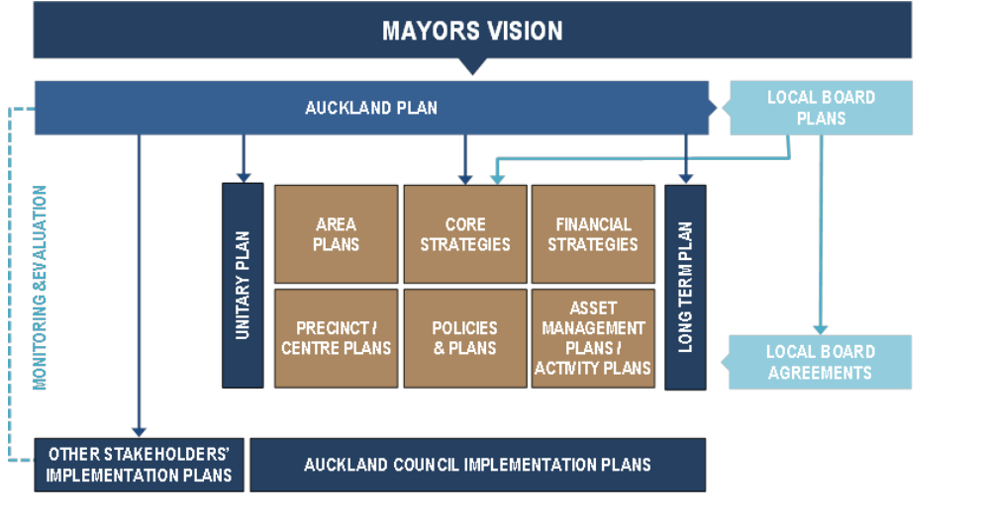
- The working relationship between Auckland Council, central government and other parties, including private sector investors, is central to the success of the Auckland Plan. As noted by the Infrastructure TAG “the preparation of well-informed spatial plans to which all are committed would be helpful to the timing and provision of infrastructure. On the other hand, a spatial plan that lacks central government input, content and approval could well turn out to be worse than the status quo”.
Figure 12: Auckland Council planning framework
- While considerable positive commitment went into achieving alignment between central government and the Auckland Council in the development of the Auckland Plan, full agreement has yet to be reached. There is broad agreement that Auckland needs to achieve greater urban density and a mode shift to public transport to accommodate expected population growth. However, despite this high level agreement, there are significant differences between the Council and central government over the degree and pace of intensification and the prioritisation, timing and funding of key infrastructure projects integral to the plan.
- Through investment in key public infrastructure such as schools, hospitals and tertiary institutions, as well as the provision of public services including state housing, justice and social welfare, government agencies can significantly shape urban form. Failure to achieve alignment in location and timing of that investment could significantly affect the efficacy of the Auckland Plan.
- Transport infrastructure investment has an even greater significance. The proposed Central Rail Link, together with road projects such as the Auckland Manukau Eastern Transport Initiative and the additional Waitemata Harbour Crossing, are by far the largest and most capital intensive projects that New Zealand will be undertaking for many decades. These and other projects that are integral to the plan require capital investment of more than $45 billion over thirty years. It is critical that all such investment is not only optimised but fully integrated with land use. Broad alignment between successive central governments and Auckland councils (over time) will be imperative to deliver value for money.
- Funding is also central to effective delivery of the Auckland Plan. The Plan states that new funding mechanisms will be required for $10 to $15 billion of transport projects. However, there is little likelihood that this gap will be bridged without a significant shift in central government policy (potentially including enabling pricing on existing roads). Once again, the need for alignment between central government and councils is the key to effective implementation of plans.
- It is also a fundamental building block of private sector investor confidence. Without confidence that there is general alignment between central and local government, private investment will be much more difficult to attract. This is especially true of international investors who may not have the same understanding of local circumstances and, consequently, may be much more cautious about political risk when making investment decisions.
- We consider there is an important lesson to be learned from the Auckland experience if spatial planning is to be adopted across the rest of the country – that a spatial plan without funding and strategic alignment between central and local government cannot be effectively implemented. As central government is a major investor in infrastructure and the most significant transport funder, it ultimately has to approve relevant spending. We consider that this would create difficulties for any council in the case of disagreement. We observe that this is the regime applying to all regional land transport plans, where NZTA (not councils) makes the final decision on allocation and timing of funding of major road projects.
- We acknowledge that not all issues associated with the funding of a plan with a long time frame may be able to be resolved at the beginning. Nevertheless, we consider that all parties to the plan should be informed by full disclosure of the benefits and costs associated the strategic direction and the funding mechanisms that are assumed to enable its implementation. Where differences exist between central and local government, it is preferable that these are resolved in the development of the plan or, if this is not possible, that a process is set out in the plan to enable differences to be reconciled as early as practicable.
- Crucially, the Auckland Plan recognises that integrated infrastructure planning requires on-going review of its plans and programmes to ensure alignment with the strategic vision. As noted by the Plan “Alignment has to be actively pursued internally and with the partners, and will only be possible if a process is in place to regularly assess the degree of alignment, declare variations, and put actions in place to resolve them”. To do this the Plan establishes the use of a process audit and a content audit. We consider that these are important concepts to be adopted by other councils, regardless of the planning instruments used, if integrated planning is to be successful. We also consider that central government commitment to such process and content audits will be key to the success of long term spatial planning by regions.

Auckland Council’s request for simplification of its planning regime should be implemented. Specifically, it should have a statutory exemption from providing a separate Regional Transport Strategy and the Regional Policy Statement, both of which should be integrated into the Auckland spatial planning framework.
Spatial plans should provide full disclosure of benefits, costs and risks associated with the plan, including how it will be funded, and the plan development process needs to take account of the Government’s role as a major funder of transport infrastructure.
Changes in legislation to provide for spatial planning should include processes to ensure strategic alignment between central and local government in the development of the plan and in their subsequent and on-going review.
Process and content audits similar to those specified in the Auckland Plan should be used by other councils as part of a wider strategic approach to the planning and delivery of infrastructure.

Formal Standards
- Standards NZ has suggested to us that individual councils and DIA currently give low levels of consideration, coordination and support of formal standards as instruments for local government. There is currently no dedicated annual work programme to develop and maintain formal standards that promote consistency, efficiency and better cost management across local government (including model bylaws, handbooks, and guidance materials). Despite the views expressed to us, we are aware that formal standards are often referenced in RMA plans and engineering codes of practice and are considered to be of real value. We suspect that the issue is consistency and completeness of use across councils, rather than a lack of use. The operation of Standards NZ has been subject to several proposed reviews, the latest of which, by the Ministry of Business, Innovation and Employment, is still in progress. We consider it would be especially useful for the review to look at questions of clarity and integration - that is, how Standards NZ material relates to the other parts of the formal framework that regulates local government infrastructure. We also consider that it is imperative that SNZ remains (and is seen to remain) truly independent and is not subsumed into a government department. This is necessary to maintain credibility for a wide range of stakeholders from the public and private sectors. In order to have this independence and to provide stability to SNZ, it might also be necessary for the Government to consider some basic corporate funding.
- The development of new standards is substantially funded by sponsorship of stakeholders through a collaborative process. Although this is a useful model in many ways, we consider that it presents two potential matters of concern. The first is that standards are developed where the stakeholder groups perceive a need and are prepared to fund development. This can result in a failure to develop or revise a standard to meet a need that is in the public interest but where there is no funding. Secondly there is the potential for the development of the standard to reflect the views of the stakeholders who are funding the work. To avoid these possible risks, we consider that identification of the need for and development of standards related to public infrastructure should be supported by a mix of industry and central government funding.
- We note that SNZ is only one of a number of sources from which formally prepared standards can emanate. International standards also influence some aspects of local infrastructure. As an example, drinking water standards produced by the World Health Organisation and used by Codex Alimentarius in some cases may drive demands by processors for councils to upgrade water supplies. Another example is international climate change issues and agreements, leading to outcomes such as standards on gas emissions from landfills.
- A central question in this area is around the appropriateness of national or local standard setting. The corollary of this question is “who pays to meet the standard?”, especially as both national and international standards and practices have the potential to impose significant costs on local infrastructure.
- One argument is that if standards are set nationally then central government should pay, leading to the need for subsidy schemes. An alternative view is that such schemes distort pricing and do not address the underlying problem of non-viable service delivery entities (small councils). We address this issue in Chapter 10.
- Finally, we consider it desirable that all standards relevant to infrastructure that is delivered at a local level should determine the performance criteria to be delivered, but not the method by which a particular service is to be achieved – that is, standards should be outcome based.

Informal codes, standards, guidelines and practices
- There is a plethora of informal codes, standards and guidelines in existence, some of which influence the provision of local infrastructure. These instruments are produced by a range of public and private organisations including professional bodies, consultants and international interests.
- Sometimes the identification of need and the development of a response is well focussed and coordinated. At other times their development may have been significantly influenced by commercial considerations, personal beliefs, or politics. We consider it is not practicable or reasonable to try and influence or coordinate this effort. However, we do think that where feasible, central and local government interests should work together to reduce duplication and conflicts in messaging. Two areas in particular that we consider require attention are guidance around procurement and service delivery models. These issues, and related recommendations, are addressed in Chapter 8.

The review of Standards NZ (SNZ) should specify how the outputs of SNZ integrate with other parts of the formal framework that regulates local government infrastructure.
The development and revision of standards relating to public infrastructure should be supported by a mix of industry and central government funding, and central government should also consider funding of SNZ’s core capability.
Standards for infrastructure should focus on performance criteria (outcomes) rather than determining methods of delivery.

Integrated planning
- All of the issues raised in this chapter of the report lead us to conclude that comprehensively integrated decision making is currently a missed opportunity in the local government system.
- As noted in Building Competitive Cities, “the lack of alignment and connection between the three statutes has created a complex regulatory environment, with little integration between strategies, regulation, expenditure and decision-making. For example, plans under the different Acts all have their own timeframes, processes and consultation requirements, resulting in duplication and lack of clarity, and demanding considerable time and resources from all parties involved. The lack of alignment is a disincentive for infrastructure providers and the private sector to engage effectively with the planning system. It also makes it difficult to provide sufficient certainty about what will happen, as each process may have a different outcome. It does not promote or encourage integrated decision-making to provide the right infrastructure in the right place at the right time”.
- Infrastructure needs are driven by land use, with new residential or industrial areas, for example, having different requirements. That implies the need for an understanding of present and future spatial relationships and patterns of demand, which in turn will spring from future demographic and social changes. Also, infrastructure can be provided only when there is adequate funding, which requires an understanding of present and future costs and how they can be met. Furthermore, local government infrastructure does not stand alone but is planned and delivered alongside infrastructure delivered by other parties, and which should also be planned to support future population and social trends. Therefore, land use planning, financial planning and infrastructure planning need to be integrated within an overall strategic framework.
- We note that the Local Government Efficiency Taskforce called for amending the purpose of LTPs to make them a strategic document, and also called for asset management plans to be mandatory. We agree with the principles lying behind the Taskforce’s recommendations. However, we consider that further thought needs to be given to their implementation. The optimal solution would be a new planning regime that provides in a single document an overarching vision and strategic intentions, rather than simply shoehorning these into the LTP.
- In looking at this issue, we sought appropriate examples from international jurisdictions. One example aimed at achieving integrated planning was legislation in New South Wales, Australia. However, the Australian system of local government, the relationship between the State Government and local authorities, and the nature of the planning system are all different from our own conditions. The New South Wales legislation is also highly directive.
- While New Zealand should certainly look at other jurisdictions for any practices that could be adopted or lessons learned, we cannot just copy a whole model from elsewhere. In developing an overall schema for planning of this nature, it is important to focus on local and central government structure, political culture and the decision-making framework within New Zealand.
- The Auckland Plan, which is mandated under legislation to integrate both private sector and public sector infrastructure delivery, can be contrasted with the example of Wellington In 2007, the regional and territorial councils in the Wellington region agreed on the Wellington Regional Strategy (WRS), which they described as being a “… collaborative effort of the private sector, central and local government, and organisations seeking to foster economic development. It will be a rallying point for matters requiring a region-wide approach”. However, despite identifying infrastructure as one of its six key focus areas, the WRS does not include provision for the joint planning and delivery of infrastructure, much less integration with private sector delivery, which is a key element of the Auckland Plan.
- An example of a voluntarily integrated planning model that includes the joint planning of infrastructure is SmartGrowth in the Western Bay of Plenty. SmartGrowth is a collaboration between three local authorities – Tauranga City, Western Bay of Plenty District and Bay of Plenty Regional Council – and tangata whenua, working in partnership with businesses, central government, education groups, industry and the community. Its instigators note that one of its cornerstones is the integration of land use with infrastructure and funding requirements.
- Dunedin City Council has recently adopted a spatial plan. This is a comprehensive document that sets out to lead the city’s future in an integrated way, including with regard to the role of infrastructure. Its development required a commitment on the part of the council and other parties to try an innovative approach to planning. That said, the spatial plan is a non-statutory document. As noted in the plan itself “the Spatial Plan is a high level, non-regulatory strategy. The individual policies and actions of the Spatial Plan will need to be implemented through the DCC’s existing and future strategies and plans, and can be subject to change and refinement through the processes used to develop those documents”.
- Our concern is that in not being a statutory document, the Dunedin spatial plan is not politically and administratively cemented in place as the lead instrument. As the plan notes, it “can be subject to change and refinement through the processes used to develop” other documents, such as the district plan. We recognise that a spatial plan does, indeed, need to change in response to emerging circumstances, but through not being the statutory lead document the risk is that, over time, the cart may lead the horse.
- Our observation regarding voluntary examples is that success cannot be guaranteed because of the high degree of collaboration required of multiple parties, all of which have complete independence in terms of the development of their own planning documents.
- Nearly two years ago the then Minister for the Environment noted that “the requirement to produce a spatial plan does not exist outside of Auckland, but the general empowering provisions of the LGA enable other regions and districts to develop spatial plans in a voluntary capacity. My intention is that eventually all of New Zealand should be able to benefit from a simplified and more integrated planning system”. We agree with the former Minister’s resolve that the system should be simplified and more integrated, but doubt that the benefits to be derived from spatial planning will evolve on a voluntary basis as provided for under the current proposed reforms. We consider that a specific commitment to examining the use of spatial / strategic planning elsewhere in New Zealand should continue to be pursued, irrespective of the comments we made earlier on the paper outlining the next stage of reforms.
- The wider adoption of spatial planning along the lines of the Auckland model would require a regional view in other parts of the country to achieve a scale that is efficient and effective. Aside from the plethora of planning instruments, it would also be difficult under current structural and legal arrangements to deliver spatial planning in the same way as the Auckland Council does. In particular, the critical spatial plan element of land use planning cannot be delivered by regional councils because they do not have that power under the RMA. Spatial planning that integrates land use would therefore need to be delivered through district plans put together by territorial authorities. As noted above, this voluntary delivery would require an intense degree of collaboration, even with the Government’s proposed incentives.
- Three years ago, the Regional Sector Group of Local Government New Zealand set up a Spatial Planning Working Group (SPWG) to address spatial planning issues. Since Auckland Council published the Auckland Plan there has been an even closer interest in the possibility of spatial planning in local government. The SPWG noted that spatial planning, in various forms, has occurred in councils other than Auckland. However, the SPWG consider that those documents did not meet a complete definition of spatial planning in that, importantly, they are not “co-produced” with parties other than the council. The plans also avoid social and cultural planning and there is variability in the alignment with third party programmes.
- The SPWG consider that to be successful, spatial planning must involve all tiers of government and be at a sufficiently large scale. They suggested that regional councils were well placed to lead the delivery of spatial planning, given the evidential sophistication required (and the potentially significant costs involved) and the need for a broad perspective of issues.
- We acknowledge that localised integration can be achieved through the use of structure plans, which are incorporated as part of a district plan. Hamilton City is an example of where structure planning has been used to set out development futures for defined areas of land, integrating detailed infrastructure planning via the LTP with land use planning in the district plan. While no doubt successful, structure plans usually cover only part of a district. And individual structure plans, taken together, do not necessarily represent an overall integrated strategy for an entire district, much less a wider region.
- Spatial planning on a regional scale thus remains our preference as a model for truly integrated planning. We consider that it would support the optimal delivery of good quality and cost-effective infrastructure in the context of future demographic trends, social needs, resilience, service delivery and land use planning.
- If spatial planning were to be mandated on a regional basis, there would still need to be some consideration of what would be the best determinant of an efficient spatial planning “unit”. In particular, we think that there could be an issue of scale for some of the smaller or less populated regions, including the current unitary authorities (except Auckland). In our view, although regional council boundaries should be used in the first instance, those boundaries may ultimately need to be reviewed if the optimal potential of spatial planning is to be achieved.
- We are not certain that the efforts by various Ministries to integrate and simplify may be sufficiently integrated between themselves. If there is to be comprehensive integration of the LGA, RMA and LTMA, then that specific aim should be translated into a single whole-of-government approach to the issue. Despite an apparent recognition of the issue, is not clear to us that such an approach is being pursued.
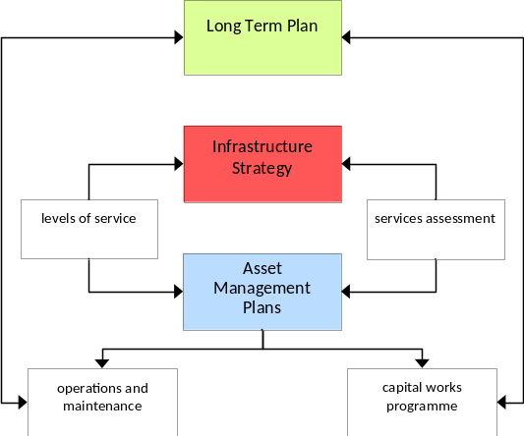
- Meanwhile, in the absence of spatial planning, we consider there is another tool for achieving the more efficient provision of infrastructure. That is, to introduce a requirement for a specific infrastructure strategy for each council. An infrastructure strategy would be an overarching document that leads and builds off individual asset management plans for different classes of infrastructure. Figure 13 below illustrates how such a strategy would relate to the LTP community outcomes, assessment of need / levels of service, individual asset management plans and implementation. This diagram necessarily ignores the multiplicity of links to other aspects of legislation, including the RMA and LTMA. It simply sets out to show the possible place of an infrastructure strategy in relation to asset management planning and the LTP. We consider that such an infrastructure strategy could be developed by a council effectively and reasonably rapidly and would be utilised as a major input into any future spatial plan.
Figure 13: Role of infrastructure strategy

- Finally, we note that the time horizon available to any particular council to make strategy and planning decisions is short, given the mandatory planning and consultation requirements within which local government also has to work. The lack of integration between the various planning statutes magnifies this issue. The New Zealand three-year electoral cycle is not consistent with the long term horizons required for local infrastructure planning, funding and delivery. Particularly in smaller communities, where it is not uncommon for local elected representatives to have personal linkages with a large proportion of the population, the council triennium may well incentivise short term thinking. Clearly this is not always the case, but when a candidate is reliant on a small number of votes for an electoral majority, political risk makes difficult decisions even more difficult.
- We consider that the possibility of a significant switch in policy focus following an election as a result of a majority of new incumbents being elected is more likely in local than in central government. This is not because governments do not change. It is because, despite some major policy differences between political parties on the national level, the sheer size of the whole of central government with its multitude of different departments and agencies gives it a high degree of continuity in policy direction that is not available to individual units of local government. This is particularly the case for small councils with small management teams. Even though the management team may remain the same, it is quicker and easier for newly elected members to effect a change in policy direction. We note recent comments by the Prime Minister on the advantages of a four year electoral cycle and we consider this would also be of advantage to local government.

The Ministers of Local Government, Environment and Transport should coordinate a whole-of-government approach to clarifying and integrating the planning framework - LGA, RMA, LTMA and other planning mechanisms.
The concept of spatial planning as applied to the Auckland Council should be mandatory as a strategic planning mechanism for use at a regional level in other parts of New Zealand.
Until spatial planning is mandated, all councils (excluding Auckland Council) should produce an infrastructure strategy that links asset management with LTP community outcomes and identifies strategies for regional network optimisation where appropriate.
In conjunction with any consultation or referendum on a four year Parliamentary term the Government should specifically include consideration of the same for local government.

Business practice issues
- The following chapter discusses a number of issues which are relevant to business practices in all councils. Variations in governance and management expertise, as well as specific local circumstances, are amongst matters which mean that success in dealing with these issues can vary. Some of the issues discussed in this chapter are pertinent to the institutional issues we discuss later, especially transparency and accountability.
- This section does not purport to represent best practice across all aspects of an infrastructure business or local government; rather it makes a set of observations and recommendations that we believe will improve cost effective delivery of infrastructure.
- We have divided this chapter into sections that include levels of service; funding, financing and charging; asset management; and the business cases processes of strategic, economic, financial, commercial and management assessment. Within the context of business case commercial assessment, we have specifically commented on procurement, as required by our terms of reference.
- Overall we consider that there is a disconnect between strategic and implementation elements. One way this can be viewed is through the lens of the Audit New Zealand 2010 report which observed that “Most councils had not documented their service delivery arrangements, contracts, or the rationale for their way of working. Most, similarly, did not have documented maintenance plans linked to standards and performance criteria for their contractors to meet. Where this detail did exist, it was often in contracts, not in plans, which, in our view, is the wrong way around”.

Levels of service
- According to the International Infrastructure Management Manual, levels of service statements “… describe the outputs an organisation intends to deliver to its customers. The statements commonly cover attributes such as quality, reliability, responsiveness, sustainability, timeliness, accessibility and cost. Performance measures (customer and technical) are used to define specific targets in relation to levels of service. Customer performance measures define the service the customer receives. Technical performance measures quantify how the organisation provides the service.”
- Levels of service are a starting point that informs the other business practice issues referred to in this chapter. Audit New Zealand noted that there is “considerable confusion” about what the concept of levels of service actually means, how it is assessed, and how it links to higher objectives and community outcomes. In addition, some levels of service are influenced by external factors such as regulation and national standards. For water, levels of services are largely dictated by the drinking water standard, conditions on consents to discharge from wastewater treatment plants, along with fire fighting and appliance requirements for requisite levels of pressure.
- Levels of service are a critical factor in the cost of infrastructure. The OAG notes that, nationally, 40% of projected capital expenditure ($14.7 billion) over the period 2012 – 2022 is to improve service levels, with just over half of that amount being spent in Auckland. In comparison, only 19% was to provide for growth. That leaves approximately $7 billion being spent in the rest of New Zealand to improve levels of service over that period, with a significant proportion of that being spent on water, wastewater and stormwater. The figures suggest that wastewater projects will be the biggest proportion of those costs.
- Higher levels of service generally mean higher monetary costs for a community, either in the form of rates or direct customer charges. This was discussed in Chapter 6 in relation to community expectations and affordability. In addition, we note that levels of service are the most flexible aspect of providing for infrastructure. Other aspects, such as catering for population growth and the need for physical replacements, are inflexible. We therefore consider that local government should first focus its analysis on levels of service when seeking to achieve efficiencies in infrastructure provision.
- As noted by the OAG, small and rural authorities, in particular, are looking for ways to spread the costs affecting small communities by moving away from targeted rates to district-wide funding of projects. The OAG noted that this approach was seen most often where infrastructure systems needed to meet higher performance levels required by legislation, such as in drinking water supply and wastewater disposal schemes.
- Within the concept of levels of service, it is important to distinguish between two aspects: customer levels of service and technical levels of service (see the Glossary for further explanation). Ultimate outcomes, in terms of levels of service, need to be the result of a well-managed conversation with the community. Under the LGA, the community discussion around levels of service takes place within the context set by the LTP and the annual plan. The LGA requires an LTP to address budgeting for improvements in levels of service. There is no similar reference in the LGA to simply maintaining or even reducing levels of service in particular circumstances, which we consider sends the wrong messages – given that such changes can be a necessary part of good asset management.
- The LTP’s statement of service provision must refer to performance measures, targets and any intended changes to levels of service or costs and the reasons for these. Engaging with the community on these issues can be politically challenging, as they deal with people’s expectations around such matters as quality, quantity, availability, timing and cost. The Local Government Efficiency Taskforce has recommended that long term plans be simplified to primarily focus on strategic questions. As the Taskforce noted, “the current purpose of the long-term plan is a confusing mixture of both strategic and operational obligations”. We consider that this confusion sometimes extends to debate around technically detailed levels of service, which are best addressed at a higher strategic level. Engaging in consultation to increase or decrease levels of service, (whether technical or customer-focussed) is not consistent with the objective of maintaining flexibility and pragmatism in maintenance responses.
- We consider that councils need to establish clear “line of sight” links between higher level strategic objectives, levels of service and actions at the operational level, in order to achieve integrated decision making theoretically required within the LTP. The process of consulting with the public within the wider strategic context can provide a good level of clarity that can help make it easier to consider and accept other options when circumstances change.
- The need for elected members, council managers and the community to rationally understand levels of service and respond to changing circumstances is a theme picked up by Audit New Zealand. As noted, “unless the desired levels of service are defined, clear, and understood by asset managers and users alike, there cannot be effective asset management”. As an example, some reporting in LTPs deals with assets as groups of activities, making it difficult for the public to understand where true costs lie. We discussed this earlier in Chapter 7.
- In some cases levels of service and infrastructure standards are unnecessarily high. In addition to complying with national standards, this can be the result of ratepayer pressure for improved standards (e.g. sealing of roads or footpaths in areas of low use) but may also result from asset managers wanting to improve network quality when it is not financially viable.
- Risk needs to be an underlying consideration in relation to technical levels of service. As an example, should there be an immediate response (with associated cost implications) to a minor leak from a water main or can it be left until later when repairs can be scheduled at a cheaper rate? The question is one of the appropriateness of the response versus risk and consequences. If it was a sewer leak, the environmental risk and consequences would likely suggest that a repair response should be more rapid.
- Given that levels of service are such an important starting point in infrastructure decisions we consider that it is vital that elected members as well as their technical advisors have a good understanding of the issues.

The Local Government Act 2002 should be amended to make explicit the potential for levels of service to either decrease or remain unchanged, as well as increase.
The Government should implement recommendation 17 of the Local Government Efficiency Taskforce which would see long term plans primarily focus on strategic issues. As part of that re-focus, long term plans should not be required to include detailed information about levels of service.
If the statement of service provision is retained in the Local Government Act, it should be amended to explicitly link levels of service to the wider strategic objectives of councils. Such objectives would include community outcomes specified in the LTP and any relevant objectives in a Regional Policy Statement, Regional Plan, District Plan or Regional Land Transport Strategy; or any other spatial plan or infrastructure strategic plan that may be introduced in time.
Councils should carefully examine the appropriateness and affordability of proposed levels of service for each type of asset in the context of changes in the population profile for the council and the council’s overall long term budget.
Local Government New Zealand should ensure there is appropriate training available for elected members and council managers in the process of setting levels of service.

Funding, financing and charging
- Funding, financing and charging for infrastructure is a highly technical and complex subject. Different approaches to funding, financing and charging can positively or negatively affect value in infrastructure delivery.
- Funding for new investment can be managed in two ways. Either existing revenues can be increased and new revenue streams introduced, and/or, available funds can be used to pay for a new asset over time through debt financing.
- Financing methods such as bonds and public private partnerships (PPPs) are often confused as a means of funding, when in fact they are debt financing mechanisms.

Figure 14: Funding options available to councils
Funding Option | Description / Example
Property rates | - Targeted or general rates  - Targeted, uniform or annual charges
Fees and user charges | Volumetric pricing for water or wastewater, entry fees and library charges
Subsidies | Government subsidy for drinking water upgrades in small communities and NZTA contribution to local roading construction and maintenance
Road tolls | Tolls on new bridges, tunnels, or motorways
Development levies | Development contributions (LGA) and financial contributions (RMA)
Investment and asset sales | Sale of a physical asset (e.g., a hall), a council business (e.g., an electricity distribution company), or an investment that returns dividends
Other options (not currently available to local government)
Fuel taxes | Regional or local
Road pricing | Congestion charging and network charging

Figure 15: Financing options available to councils
Financing Option | Description / Example
Borrowing | Traditional bank debt, Local Government Funding Agency, private investors
Public private partnerships | Project financial risk taken on by the private partner. For example, a sewage treatment plant financed and constructed by a private developer, then leased to the council
Other options (not currently available to local government)
Tax increment financing | Project financing, equivalent to the value of assumed future tax / property rate gains caused by the future existence of the project

Direct charging
- There are good reasons to introduce new tools that enable smarter, more targeted charging or provide a way of generating a realistic revenue stream to support new investment. Moving the costs of consumption to the consumers who use a good or service leads them to be more efficient in their use of it. In turn, if they adjust their consumption the suppliers of that service can adjust their capital expenditure plans to take account of changes in demand. Generally there are no legislative barriers around existing mechanisms, including the introduction of volumetric charges for water, although road pricing on existing roads is specifically prohibited by the Land Transport Management Act 2003.
- In some instances the call for more funding mechanisms is about wanting more money for new investment without substantive evaluation of the relative costs and benefits of the proposed investment. This approach is flawed as there is a limit to affordability in a community and, indeed in New Zealand as a whole, and a new way of funding does not change that.
- Councils need to take account of the fact that user pays funding can have significant social equity issues especially when consumers have no alternative to reduce or avoid using the service. Nevertheless, where the demand management and investment benefits exceed the costs of implementation and compliance, direct user charging can offer the dual benefit of providing funding to support investment and helping to manage excessive demand.

Development contributions
- Councils frequently require the payment of development contributions from land developers or builders when a resource and/or building consent is granted. There are two statutory provisions which enable this – the RMA which authorises “financial contributions” and the LGA which authorises “development contributions”.
- Where a council has used this power under the RMA, a developer may appeal the provisions of the proposed plan to the Environment Court, as well as appealing the calculation of the specific contribution imposed as a condition. This right of appeal by developers became a concern to some councils, who then adopted the more recent provisions of the Local Government Act 2002, which did not contain similar rights of appeal. This approach has been criticised by developers, because they are unable to challenge the reasonableness of the council’s policy or contributions sought.
- Development contributions may be required for provision of reserves, network infrastructure or community infrastructure under the policy adopted by the local authority. The policy must contain an explanation and the justification for the contribution, together with the significant assumptions.
- Development contributions are a source of significant funding for councils that are providing new infrastructure. The use of financial or development contributions is based on the principle of “exacerbator pays”, which means that existing ratepayers are not required to pay for the costs of providing or expanding infrastructure that is required as a direct result of development.
- The development contributions regime is currently under review. Its use through the policies of individual councils has been criticised for a number of reasons including:
- inconsistency and lack of transparency in the methodology used to justify and calculate the contributions
- inequity and unreasonableness in basic assumptions used
- inability to appeal to an independent authority
- the quantum of the contributions sought and the purposes for which they are sought
- the requirement for developers to pay the contribution when consent is granted, and before any revenue can be derived from their development
- the inability, in some cases, to have payments refunded if the development is abandoned.
- A properly conceived process will mean developers pay contributions only for the share of capacity that their development consumes, not for existing shortfalls in service levels or under-provision of assets. Development contributions internalise the costs of development to those who benefit from it, so are economically efficient and equitable as they give clear locational price signals. When transparently implemented, they do not create cross subsidies from either existing ratepayers to new users, or vice versa.
- We consider that, if properly used, development contributions are an equitable system for both developers and existing ratepayers.

Development contributions should be retained as an economically efficient funding mechanism.
Any changes to the formal mechanism of development contributions should be aimed at addressing issues of transparency, the reasonableness of assumptions underpinning the policies and the provision of reasonable appeal rights.

Metering & Volumetric charging for water and wastewater
- Volumetric charging is a way of charging for use and of managing demand. In the vast majority of cases, councils in New Zealand fund water delivery to residential ratepayers through rates and development levies, not through any charges relating to actual use.
- As a demand management tool, volumetric charging can lead to better use of existing resources by sending users transparent price signals about the cost of what they consume, which in turn gives them an incentive to be efficient in their consumption. This in turn leads to a drop in demand which allows investment in new infrastructure such as pipes or treatment plants to be delayed. The cost of paying for them can likewise be slowed and consequently rate rises or other forms of funding can be delayed.
- The same benefits of volumetric charging apply to wastewater discharge. However, there is no practicable means of direct volumetric measurement of wastewater. Experience has shown that approximately 75-80% of the water delivered to a property is discharged through the sewerage system. The remainder is discharged in many ways including swimming pools, gardening, and consumption of drinks and food. Where water supply is volumetrically measured through water meters, the above factor can be used as a surrogate for wastewater discharge but it needs to be adjusted for atypical users (for example, large swimming pools or industries, such as manufacturing drinks, where water is consumed in the process and not discharged). Councils can address dangerous or “over strength” industrial discharges in trade waste bylaws.
- Metering and volumetric charging for domestic water supply is currently provide to all main reticulated supplies in Whangarei District, Auckland Council, Tauranga City, Carterton District, Nelson City and Tasman District. We understand that some other councils have adopted metering in specific locations.
- Cost/benefit analyses of water metering and volumetric charging indicate that there is a high rate of return in areas where large capital expenditure is being considered on the treatment facilities to keep up with demand. The cost of water meter installation and monitoring has sometimes historically exceeded the cost of augmenting the supply. However, with the cost of meters continuing to decline and collaboration between providers (for example, shared metering), it is possible that the whole-of-life cost of metering may increasingly be less than the whole-of-life cost of augmented supply and treatment facilities. There are also savings to be made on leak detection. For example, in March 2013 Kapiti Coast District Council commented that more than 340 water leaks (amounting to a daily loss of 1.8 million litres) had been detected on private property since the Council had introduced water meters and stepped up its water reduction strategy.
- The cost savings are not only in CAPEX. A study of the Tauranga decision to introduce water metering in 2001 found benefits with a net present value of $53.3 million in 2009 dollars. The benefits were split evenly between capital and operating costs, as the deferral also resulted in savings such as reduced electricity consumption which applied to both water and wastewater.
- Despite identifiable benefits in volumetric charging, water metering is a contentious issue. The 2009 - 2019 draft LTP from Waikato District Council reported that the most common responses offered by members of the public who opposed water metering included: that metering was a money-making exercise for the council; that other water management tools should take priority, such as water tanks and education programmes; and that it was inequitable for low income households who would struggle to pay for water.
Carterton District Council
Carterton District Council was able to reduce annual water usage by a third when it introduced water meters, an active leak detection programme and charging for excess water. Inspectors visit properties where meter readings indicate higher than normal use and, to discourage wasteful use, customers are charged $1.50 per cubic meter for water above an annual 300 cubic meter allocation.
Water New Zealand, "The Case for Demand Management in Council Water Supplies (May 2009)", p.4.
- Community concerns need to be actively addressed by councils to encourage communities to support the introduction of volumetric charging.
- In particular, we consider that the provision of assistance to those with medical conditions that create additional water demands should be specifically addressed in any proposal to introduce metering.
- There is also a degree of concern that charging for water on a user-pays basis is the first step towards privatisation. This is unfounded. Legislation currently prevents this and given the monopolistic aspects of water provision it is unlikely a move to privatisation would find public or political support.
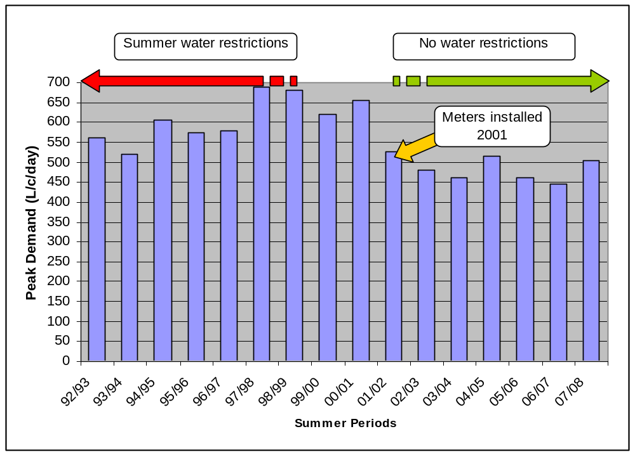
- The EAG considers that while volumetric charging for water is not appropriate in all circumstances (such as small water supplies or where the costs of metering exceed savings resulting from deferral of new investment) it should be adopted as the standard approach to pricing for water services across most council water supplies in New Zealand. We suggest variable charging is adopted for wastewater to allow for residential consumption and trade waste.
Figure 16: Tauranga – reduction in demand following introduction of water metering
- For water metering to succeed in financial terms, its introduction needs to be supported by complementary measures such as promotional and educational programmes to highlight how it works and the benefits of water conservation, as well as options such as water efficient appliances. It also needs to be applied universally, for example by metering all units within an apartment block so that the person paying the bill is incentivised to reduce consumption.

Where benefits exceed costs of implementation and compliance, volumetric charging for water should be implemented and variable charging for wastewater should also be implemented.
The introduction of water metering should be accompanied by robust educational campaigns to highlight the benefit of water conservation and how to achieve it.
The introduction of water metering should include provision to assist those with medical needs resulting in additional water demand.

Tolls and road pricing
- The current system of Fuel Excise Duty (FED) and Road User Charges (RUC) is a low cost means of collecting revenue from road users. It is, however, a very blunt means and has limitations in terms of being able to address location specific issues such as congestion and large scale demand for investment. These mechanisms do little to incentivise efficient use of all modes of transport. In an urban context, increasing fuel excise provides no incentive to travel off peak and achieves little in discouraging use of key transport corridors during peak periods. Consequently, public transport options are not always fully utilised while roads remain jammed during peak periods and comparatively empty off peak. The resulting uneconomic use of the transport network and underutilisation of alternative transport modes reduces economic performance and inevitably drives the need for earlier investment in additional road capacity to service growth.
- We note that in addition to the above misaligned incentives, improving fuel efficiency and heavy vehicle productivity, together with the impact of better roading standards, are likely to continue reducing the amount of revenue per kilometre driven. This means that without on-going increases in fuel excise there will be less revenue into the land transport fund in the future, even though demand for road space continues to rise, especially in Auckland.
- To ensure that a more efficient and effective solution is found, the base road charging system and any additional charging mechanisms need to be considered together.
- The most recent comprehensive review of New Zealand’s road charging regime was undertake in the 1990s, culminating in the release of the discussion document Better Transport Better Roads. This study recognised that the way roads are charged for needs to be linked to governance and accountability arrangements. Due to the highly contentious nature of the proposed changes, it was not implemented.
- A review of the RUC regime during 2009 and 2010 demonstrated the complexity involved in more accurately charging for the actual impact that a vehicle has on the road network. This review resulted in the simplification of RUC charges, and thus more cross subsidisation between different vehicle classes. This underscores the need to balance charging accuracy with administrative efficiency, including for those having to comply.
- While obviously presenting a challenge, ensuring that the base charging regime continues to be efficient and effective is important. The likelihood of being able to do things differently in the road charging space will increase as knowledge about the road asset and technology improves. Given developments around the world and that almost 15 years have passed since Better Transport Better Roads, the EAG considers it is again time to consider having a more comprehensive look at the current road charging system. Such a review also needs to consider the role that rates play in making efficient investment decisions.
- It is unlikely that a base charging system alone will be able to support cost-effective transport investment in all circumstances. That said, neither will local government rates. This is in part because there is no clear link between usage and payment and, as a result, there is limited ability to manage demand for investment and improving levels of service. Many councils are currently seriously concerned that the Roads of National Significance (RoNS) programme is consuming too large a share of the national transport fund, causing pressure on budgets for local roads, maintenance and renewals. This concern has increased since the release of the Financial Assistance Rate review discussion document, which under some options could see some councils financial contribution cut significantly.
- Fundamentally, the call for further investment is likely to outstrip a community’s and possibly New Zealand’s ability to pay.
- The Ministry of Transport's Auckland Road Pricing Evaluation Study 2006 and Auckland Road Pricing Study 2008 examined road pricing as a means of reducing congestion and raising revenue for investment in land transport. The study examined several alternative schemes which were developed to provide enough information to help decide if any work on road pricing should be progressed.
- The 2008 study states that: “This Report does not aim to make recommendations. Nevertheless, in summary, it is clear that the Congestion Scheme, in parallel with other initiatives, would be a strong contributor to the achievement of national and regional transport objectives. It would reduce congestion, encourage the growth of public transport and active modes (walking and cycling) and generate improved environmental outcomes throughout the region. The scheme would yield significant net revenues, providing additional funding for road and PT network upgrades in Auckland. The analysis has also shown that in the absence of pricing it will be difficult to continue improving transport outcomes beyond 2016 (i.e. despite significant investment, congestion levels stay about the same), and to achieve the NZTS outcomes sought, particularly the environmental and energy-use outcomes.”
- In effect, the study found that a congestion charging scheme would produce a more efficient result than just the current FED and RUC regime. However throughout both reports there was an acknowledgement that implementation was not a simple matter.
- Since these two studies, work has also been undertaken by a number of interests, both in Auckland and Wellington. They all point to the benefits, indeed necessity, of better network charging through the use of more targeted charging mechanisms. Common to them all is a belief that charging of only new roads, while currently allowed through the tolling provisions in the LTMA, is insufficient to ensure greater efficiency in transport investment.
- We consider that there is sufficient analysis to support the use of more targeted charging in areas of severe congestion and, while difficult to do and likely to be unwelcome by some, it is a key step to ensuring more cost-effective transport investment, irrespective of ownership. Additional funding from road pricing schemes such as tolling (where appropriate) would enable existing national transport funds to be redeployed to other priority projects with positive cost/benefit ratios that may not otherwise be funded.
- While Auckland presents the most current challenge, Wellington is also likely to benefit from a more considered package of additional charging mechanisms.

The Government should urgently undertake further work on pricing for transport to optimise use of the network.
The Land Transport Management Act should be amended to allow pricing on existing roads where there is a business case that enables effective network optimisation.

Financing
- The OAG review demonstrates that while the overall situation is sound there are opportunities to improve financial management of infrastructure investment by councils, particularly amongst smaller councils who may not have the resources to support specialist technical expertise in risk management and finance. Councils need to ensure they consider the cost of capital appropriately. Robust business case development will help to improve decisions on capital investment. Moreover, there are advantages in deploying more sophisticated funding and financing tools such as PPPs, for example, where appropriate.

Debt
- Debt is an important tool in managing council finances. Common forms of debt finance include traditional bank debt, bond issues such as infrastructure bonds, and PPPs. It is also possible to combine revenue and debt financing such as PPPs with user charges and through value capture mechanisms (including tax increment financing), targeted rates or betterment levies. Prudent levels of debt are an important tool in a council’s funding functions.
- Debt can be used as a mechanism to mitigate two key issues: intergenerational equity and affordability. Large infrastructure projects are costly and usually have long asset lives. It would not be equitable or, often, affordable, for the current generation of rate payers or users to fund the whole of an infrastructure project which has a lifetime that may span generations. They should pay for their share of the asset’s life and future generations should pay for theirs. In order to do this, the term of the debt should be aligned with the asset’s predicted life as far as possible. The loan is repaid by rates and/or user charges on an annual basis. In its 2012 report on council LTPs, the OAG concluded that all local authorities had prepared LTPs that are financially prudent. Levels of debt are forecast to nearly double during the 10-year period of the LTPs, reaching $18.4 billion in 2021/22, but five of the 77 councils (excluding Christchurch City) are forecasting no debt during the 10 years with a further three councils (territorial authorities) planning to have no debt from about 2016. Of the $18.6 billion, Auckland will reach $12.5 billion, or 68% of total council debt in 2022. Councils in larger metropolitan areas plan to increase debt to fund large infrastructure projects but within reasonable financial limits and expectations of income.
- However, the OAG noted that some rural councils are planning large increases in debt levels. These councils were said to face greater risks in the accuracy of their forecasting, growth patterns and ability to deal with the unexpected as their capacity to respond to shocks reduces.
- The OAG also noted a number of mostly smaller councils are planning for little or no debt during the 10-year period. Low debt and low rates increases may also indicate underinvestment by councils in infrastructure and a transfer of investment in infrastructure to future generations. Where these councils are carrying out large capital projects, this raises questions about the appropriateness of their financial strategies and intergenerational equity.

Public Private Partnerships
- Over the last four years the Government has actively encouraged central agencies to use PPPs. As a result there has been considerable effort put into marshalling expertise and developing understanding about their use and delivery. In its 2011 report Managing the Implications of PPPs, the OAG notes that while their use is maturing, a sound platform for an ongoing programme still needs to be built. This platform was seen to not be in place due to: limited understanding of PPPs within wider stakeholder interests and communities; only partial guidance for local government; fragmented skills, knowledge and information flows; limited diversity in New Zealand’s capital markets and funding base; and lack of some domestic private sector expertise and skills. The report noted that “If more PPPs are entered into, careful attention is needed to ensure that innovation continues to be encouraged and the challenges and opportunities that these partnerships present are fully understood, managed and accounted for. For the public sector, this means broadening oversight and control of the PPP program to ensure that the public’s interest is effectively represented, supervised and, ultimately satisfied.”
- The report also noted “There has been a lot written internationally about public private partnerships (PPPs). Much of this has focused on the upfront structural and contractual arrangements involved, which are central to organising the process and the parties. There have also been many appraisals of PPP projects but their findings are highly specific to particular countries, remarkably polarised, and, taken as a whole, inconclusive.”
- That said, PPPs provide a clear option for councils to consider as part of the range of financing options available to them, particularly for projects with a significant whole-of-life cost. We support their use as long as the decision is based on a sound understanding of the risks and benefits that can be derived, and that councils have access to sufficient and appropriate skills and knowledge. We do not see any legislative barriers to their application.
- Overall, the EAG considers that strengthened access to specialist knowledge about funding, financing and risk management is needed in many councils. As some of the skills are extremely limited, there are likely to be few places from which they can be sourced in a cost effective manner. We consider it would be appropriate for LGNZ to give consideration to how the advice on the more limited of these skills could be sourced, including possibly through the Local Government Funding Agency and central government's various pools of expertise. We further discuss the concept of a central pool of expertise in Chapter 9. In relation to PPPs, we note that any PPP needs to be considered in light of the overall government programme being developed across New Zealand and that there are some strong synergies and benefits to be had by working with central government agencies to ensure that the scarce PPP resources and knowledge are shared and that the market is able to effectively respond.

Councils should consider the option of PPPs for large infrastructure projects with a significant whole-of-life cost where value for money outcomes through risk transfer and private sector innovation can be anticipated.
Local Government New Zealand should explore access to and sharing of expert advice on funding, financing and risk management.

Asset management
- Asset management practice has undergone significant development over the last 20 years. As a discipline it is not required by legislation but is recognised as good practice within local government. We strongly support the use of good asset management. Without it, communities will struggle to achieve good quality and cost-effective infrastructure.
- Audit New Zealand notes that asset management in local government is a multi-skilled role, requiring such capabilities as leadership, planning, project management, the use of performance data and sound financial decision making. We agree that it is not common that all these skills reside within a single individual and suggest that it requires political judgement as well. This presents a challenge in linking asset management practice (day-to-day) engineering with the strategy, policy and performance of the local authority. Without an understanding of each other’s responsibilities, skills and perspective, neither elected members nor senior managers nor asset engineers are well equipped to deliver infrastructure that meets the best interests of the community.
- Audit New Zealand has continued to develop an overview of asset management practice as it has developed and matured. The audit of the 2012 – 2022 LTPs included the observation that local government is well ahead of other sectors. However, while some councils had shown significant improvements, others had gone backwards. In comparison to the previous LTP audits, Audit New Zealand also noted that asset management work is occurring earlier in the LTP audits and peer review is occurring. The separation of capital cost (renewals, growth and levels of service) was seen to be good and assumptions were better understood.
- While improvements continue to be made, Audit New Zealand also noted that there were still a number of areas for improvement. These include:
- governance and senior management awareness and support for asset management
- credibility of Asset Managers within councils
- excessive use of consultants, which may be aggravating losses of institutional knowledge – retention of at least some key staff may be advisable
- inappropriate response to affordability issues
- a degree of disconnect between asset management and LTP processes and conclusions
- “right debate” issues not always occurring
- Our overall conclusions are consistent with those above. We also question whether the evolution of asset management practice is outpacing councils’ ability to apply it.
- Figure 16 below is Audit New Zealand’s asset management pyramid and is based on their observations and impressions as a result of their audit role. It reflects their view of the various levels of practice in asset management starting with asset knowledge (not just asset information) up to improvement planning. One of the things it appears to indicate is that if the foundation level is weak (asset knowledge) then the performance at each subsequent level will suffer. This emphasises the need to get the basics right.
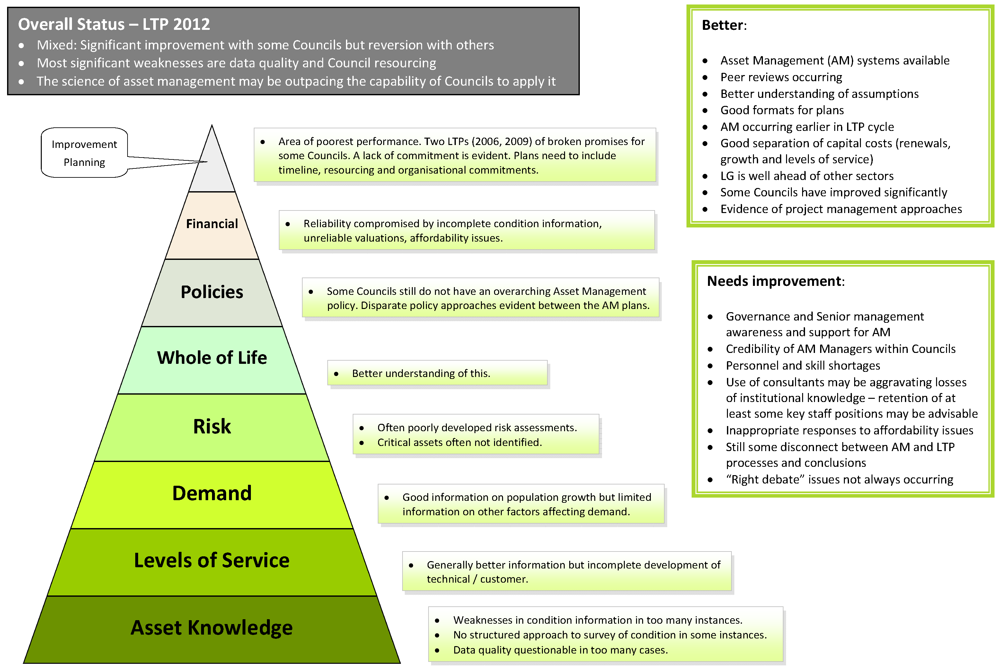
Figure 17: Audit New Zealand asset management pyramid
- Having good asset knowledge is critical. We note that decisions to replace assets are in some instances still driven by the use of standardised asset lives and financial depreciation. We consider that standardised approaches such as this are not ideal. Assessments of asset condition should reflect their physical reality rather than assumed economic lives, although this need not involve physical assessments of all assets. Some statistically based approaches can accurately predict useful life, based on an element of physical asset testing.
- Asset management relies on Asset Management Plans (AMPs). An AMP is a tactical document that assists the local authority to make decisions about achieving strategic goals for the asset. A basic asset management plan may use simple risk assessment to identify the cash-flow required by council to maintain the asset’s desired level of service.
- In the early stage of asset life, loss of service potential may be insignificant and maintenance practices may ensure that there is minimal adverse effect on the level of service. A reasonably confident prediction of asset failure should be the basis for renewal or replacement or the “do nothing” option. In our opinion, asset managers need to determine the “loss of service potential” of assets rather that adopting depreciation as a surrogate for this.
- Figure 17 below provides some interesting insights. Built from the International Infrastructure Management Manual (IIMM), it is an assessment of how well the AMP meets the level or quality of practice decided by a group of councils. This in turn is guided by the IIMM. The figure is of a representative group of six councils with populations between 7,000 and 25,000.
- The “existing status” line is influenced by how well the AMP pulls together and summarises existing thinking and its underlying analysis - and/or the absence of any such thinking or analysis. Irrespective, the assessment provides an opportunity to not only consider how well the AMP provides an effective link between strategy and delivery, but also helps to identify possible areas where gaps in analysis or thinking might exist.
- In summary it shows that there are still improvements to be made to AMPs. Other diagrams that show the assessment by asset class indicate that most work is needed around community facilities.
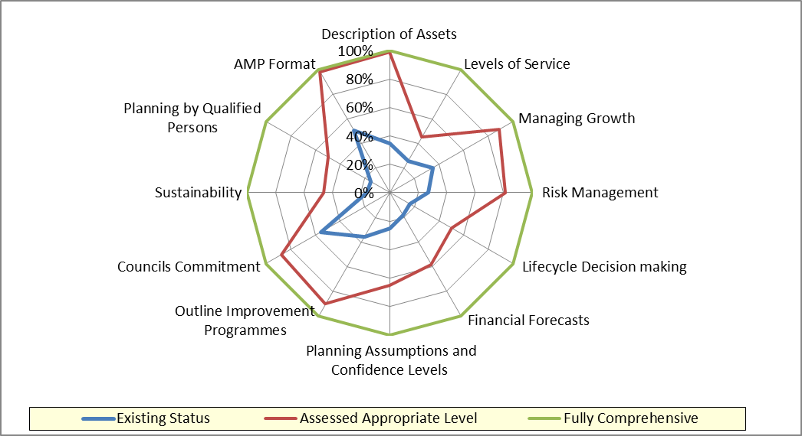
- We consider that the quality of decision making needs to be improved at all levels. Elected members should understand asset management concepts, so they can set rational strategy and policy, and govern business case decisions. Senior managers need to communicate well with elected members about options, risks, consequences and financial implications.
Figure 18: Assessment of level or quality of practice in Asset Management Plans of a representative group of six councils
- Examples of risk-based asset management include: extending the intervals between maintenance reseals for roads; not replacing some water mains with the same diameter because of network resilience; allowing for service levels to deteriorate when there is low service demand. Such actions can result in reducing costs but with little or no community impact.
- Our conclusion is that asset management should be operated as both a technical and a governance discipline.

Councils should implement and support professional asset management practices that:
- link day to day engineering with strategy, policy and governance
- determine loss of service potential, instead of using depreciation as the basis for predicting asset failure
- incorporate a balance between asset testing, statistical analysis and standardised methods to determine the need for asset replacements.
Councils should ensure that elected members and relevant staff receive training that helps them understand the concepts and practice of asset management.

Business case development
- Preparing a business case is a fundamental aspect of any infrastructure project and should occur regardless of the size of the project. This applies across the board, not just in local government. We have not been able to obtain data indicating the extent to which councils develop business cases for infrastructure, nor the quality of the work when they do so. Our experience and the discussions we have had with other parties indicate that the situation is varied. Indeed, in some cases we suspect that councils may regard a “business case” as simply a document that is produced in order to obtain approval to proceed, whereas its real purpose is to inform decision makers with a robust and objective assessment of the problem and its implications, which will then lead on to a range of solutions.
- The central government Better Business Case (BBC) framework was devised to improve the quality of analysis and decision making around state sector capital projects and it applies to projects over $25m. At the heart of the framework are five key questions (described as “case areas”) that are not discrete, and that must be embedded into the business case development process to provide an organising structure for analysis – and to help with communication to stakeholders. The five areas are:
- Strategic - is there a compelling case for change?
- Economic - what is the preferred option and will it deliver value?
- Commercial – how will the preferred option be bought? Is it commercially viable?
- Financial – how will the preferred option be funded and it is affordable?
- Management – how will the preferred option be managed and delivered?
- Each project will have its process design based on levels of risk, complexity, scope and value. Figure 19 below shows an overall process for a complex, high risk and high cost project.
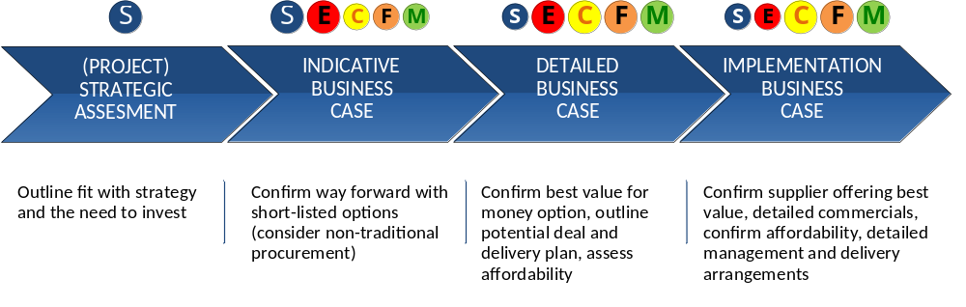
- We consider that the BBC framework is totally compatible with large scale infrastructure development in the local government sector.
Figure 19: Overall process under the BBC Framework for a complex, high risk and high cost project
- There is debate around the applicability of the BBC framework to smaller projects. We note that SportNZ, for example, has developed its own business case process and has offered peer review services to local government as part of strategy and facilities projects. We are advised that while there has been small uptake, those who have accessed this service have found it useful.
- We consider that the discipline of developing a robust business case should apply equally to all infrastructure projects, regardless of size, but we do acknowledge that the BBC may be out of scale for the smaller end. For smaller projects, there needs to be a pragmatic and easily-used framework that ensures that councils ask the right questions at every stage, but is not so complex that people will not use it. What is important is the approach, and we consider that the essential approach of the BBC framework could well be adapted to apply to smaller projects.
- We do not need to rehearse all elements of business case development and application. However, there are some aspects that we consider to be worth highlighting, apart from the real need to actually have a robust business case, which is axiomatic. The first of these is the question of problem definition - that is, what is fundamentally driving the need to change? We suspect that in local government - and in central government - this step is sometimes omitted. An elected person or manager might have in mind a “solution”. However, without problem definition or an understanding of the required result it may have unintended outcomes.
- The National Infrastructure Unit stressed to us that problem definition was critical and that being open-minded was a necessary aspect. We agree. Both elected and management levels in local government should be aware of the hazards in this respect. Of course this may also apply to private sector development but in the private sector there is not the risk of having to deal with election promises made without any detailed knowledge of the situation.
- We do note that for some major projects (particularly in the transport area where there may be co-funding between central and local government) there could be agreement on problem definition but a lack of agreement on the solution. There is no easy way to fix this, but we consider that the possibility of it arising can be minimised with close collaboration between the parties involved from a very early stage.
- Full problem definition assumes full engagement of the governance level of council and good quality information. For infrastructure, the latter leads on to questions of forecasting (population growth, consumption patterns), asset knowledge and technology. We address these elsewhere. There are also questions of the type of solution available – sometimes described as “hard v. soft”. Soft solutions can be more cost effective but they may not be the ones favoured by those with a traditional engineering focus. Decision makers also need to consider questions of risk and reward (e.g. compliance or security of supply v. cost), flexibility and feedback.
- We also consider that poor demand forecasting impacts on making cost effective decisions. In an OAG report related to drinking water, looking at a sample of eight councils, it was found that five of the eight used demand forecasting that was a minimum in terms of industry standards. As the OAG noted “this is problematic for local authorities needing to build new infrastructure or facing restrictions on their access to water. They could spend money on infrastructure that is not the right size for their needs, and could put more pressure on water sources than they need to”. We support the OAG recommendations that councils should use up to date information for forecasting, and verify the reliability of those forecasts, to reduce the risk of over or under investing in water supply infrastructure. Given the strong functional link between water supply and wastewater outflows, we consider that the same observations and recommendations should be made for sewerage networks.

Councils should utilise the Better Business Case framework for large scale infrastructure projects.
LGNZ should work with the NIU to develop an appropriate business case approach for smaller projects, based in the principles in the BBC.
Councils should use current information for forecasting of demand and should also verify the reliability of those forecasts.

Delivery capability and procurement
- The management assessment in the BBC framework is about ensuring that the right resources are available to ensure that the work is done properly and providing a frank answer about internal capability. It is also about ensuring the right organisational structures are in place. For instance, should the delivery of a particular type of infrastructure be through an in-house business unit, or should it be through another means, such as a CCO? Or, for a particular project, should delivery be through the standard practices of the business unit / CCO, or does it require something else such as a project alliance, or a public private partnership? These various approaches to service delivery have related implications of organisational scale and management expertise, some of which are discussed in Chapter 10.
- Although council processes may well be adequate for the ongoing maintenance of infrastructure, complex programmes or multi-million dollar capital projects may present a challenge. The staff skill sets needed for these different levels of management are quite different and people with specialist skills are in demand. Anecdote suggests that this is a particular issue in smaller councils, although in some disciplines the challenges seem as great for many of the larger councils. We also note the finding of Audit New Zealand that most councils do not document why their management and delivery is structured in the way it is. Audit New Zealand found that councils’ definition of management processes and service delivery arrangements were consistently weak. The report noted “most councils had not documented their service delivery arrangements, contracts, or the rationale for their way of working”.
- The ability of a Council to fully realise the benefits articulated in the business case and design rely to a significant extent on the procurement process used and the effects of previous procurement decisions on the supplier industry.
- The procured asset is unlikely to produce optimum outcomes if a smart buyer capability is missing and, specifically, if those who have responsibility for delivering the project lack understanding of the nature of the engineering risks in the project, or the principles for efficiently allocating those risks to the appropriate parties and the perverse outcomes that flow from inappropriate decisions.
- An effective supplier procurement system requires alignment and consistency within council over multiple levels of policy, finance, planning, and procurement processes. When these aspects are not aligned there is uncertainty and often distrust, which translates to additional cost either directly or through delays.
- Sometimes annual plans specify funded infrastructure capital works and maintenance activities that the local authority does not have the capacity to bring to the market. This creates an environment of uncertainty that compromises the ability of local suppliers to plan and invest in growing their capability.
- There are also a number of other issues in procurement processes with the potential to reduce value and add cost. The examples discussed below are not particular to local government and there could be further value gained by central and local government sharing knowledge and leanings.
- Scoping the works or services to be procured. It would seem that many councils struggle with providing sufficient clarity about what they want delivered. This uncertainty leads to higher prices and arguments over outcomes. As a result of lack of clarity around scope, some contractors tend to price higher for some councils than for others for similar work. Inadequate scoping also makes it difficult to consider non-conforming bids, which are often discarded without proper consideration.
- Choice of procurement method to use. Choosing the right method of procurement requires careful consideration and an understanding of the purpose and effects of a particular method.
  - Lowest price, from an appropriately pre-qualified supplier, should be the primary criteria for awarding a contract for routine works. However, at other times it is prudent to consider methods more reflective of project complexity and risk, and supplier capability.
  - More sophisticated forms of contracting, including early contractor involvement (ECI) and alliances have the potential to save significant time, risk and funds when used in conjunction with capital projects and term maintenance contracts.
  - Where complex processes are used for routine works or where simple processes are used for complex works, there will be suboptimal outcomes in terms of cost or quality and potential negative effects on the supplier industry.
  - Smart buying goes beyond procurement of a particular project. It also looks at the impact of procurement methodologies on the overall health and competitiveness of the supplier market, to ensure that future procurement processes are likely to attract sufficient quality bids from competent and capable suppliers.
- Allocation of Risk. Part of commercial thinking around procurement is to understand what the risks are and how to most efficiently manage them. Risks, real or perceived, are inherently in a project’s system and do not go away when allocated inappropriately to parties who are not best placed to manage them. When risk is inappropriately transferred out to suppliers, inadvertently or otherwise, astute suppliers will price it into their bids.
Therefore inappropriately apportioned risk ceases to be a contingent liability on the council and becomes actual project costs; or, if not priced, may cause the supplier to cut corners or collapse prior to project completion.
On the other hand a smart buyer also understands what risks should be passed through to the supplier and the benefits to the project of doing so.
Where a council’s consultant or legal advisor is not provided with guidance as to allocation of risk, these agents often transfer all risk to suppliers, through altering the physical works contract, without regard to the potential perverse outcomes from doing so.
- Following correct procurement procedure. While not widespread, we were aware of the practice of changing process part way. Not only is this illegal, but it adds uncertainty and mistrust, resulting in increased cost and risk. A change in process can be influenced by the prices tendered. Such changes are often the result of lack of thinking up front and as a result of shutting out from the tender the possibility of alternative ways of achieving the desired outcomes.

Local Government New Zealand should work with appropriate technical and professional organisations to ensure there is training available for councillors and staff on improved procurement practices and that councils are aware of the full range of procurement options.

Institutional issues
- In addition to the issues discussed in the previous chapter, which can be addressed by individual councils, the EAG has identified a number of issues that we believe need to be addressed sector-wide, either by central government or by local government. These are issues that are embedded in the way local government in New Zealand operates and are normally beyond the ability of a single council to address effectively. They require a wider response. The key institutional issues relating to infrastructure delivery are discussed in this chapter. They are:
- Transparency, accountability and oversight
- Dealing with cross-boundary issues
- Capability/capacity.
- Size and scale issues are also issues that need to be addressed sector-wide. They are discussed in the next chapter.

Transparency, accountability and oversight
- The Oxford English Dictionary defines transparent as “easy to perceive or detect”. In organisational terms, transparency usually implies openness, communication and, ultimately, accountability. There are a number of practices which can support greater transparency including clearer linkages between revenue collection and expenditure, the publication of robust and clearly argued advice (including options and opportunity costs) as part of the public engagement, the use of suitable performance management and improvement tools, clear and accessible reporting mechanisms and appropriate external oversight.

Transparency of information – consulting, reporting and oversight
- When looking at local government delivery, while there are again some good practices, it is debatable whether overall there is always sufficient transparency for the community to determine if the right infrastructure and associated services are being delivered in a cost effective way.
- An example is the question of community knowledge of alternatives including whole of life costs, especially when a large infrastructure project is being considered. Some councils go to extraordinary lengths to summarise and make available accessible public information on their proposals. But we ask if opportunity costs are regularly explored and exposed to the public in such a way. For example, have other options been explored – perhaps providing a different level of service or working on a cross-boundary basis? On the other hand, while advocating clearer and higher quality information (rather than quantity), we also consider that it would be helpful in the interest of transparency to reduce the degree of prescription around decision making and formal consultation required by local government. Consultation can become very formulaic and there is a widely identified syndrome of “consultation fatigue” on the part of the public.
- The Local Government Efficiency Taskforce noted that the LGA mandates representative rather than participative democracy and commented that “if the provisions of the Act lack clarity and create confusion with councils and the community, there could be implications for the efficiency and effectiveness of decision making and consultation”. This is a pertinent point for the delivery of infrastructure and we support the Taskforce’s recommendation that section 10(a) of the Act should be clarified.
- The Taskforce was asked to comment on the requirements for councils to have a “policy on significance”. The Taskforce recommended retaining the requirement for a policy on significance as it gave councils flexibility to reflect community circumstances, rather than applying set thresholds. We agree with this. We understand the growing interest in local government regarding more meaningful alternatives to the traditional form of consultation. Here the principle of subsidiarity cuts in.
- There are processes for involving communities at neighbourhood level to drive real decisions that will impact on the local place. For small-scale community infrastructure, such approaches are entirely appropriate and the additional benefit of greater mutual understanding from such council-community collaboration can only be positive.
- On the other hand, for decisions around large scale or networked infrastructure, consultation can certainly involve such methodology when looking at local impacts, but (in keeping with the principle of subsidiarity) decisions need to be made for the benefit of the wider community.
- There are on-line programmes available that allow councils to reach a much wider sample of the community than can be achieved through the conventional practice of written submissions followed by hearings. We consider that these should be utilised as much as possible by councils and that there is a role for LGNZ in promoting best practice and innovative tools for community engagement.
- In many cases, there is also room for improvement in the reporting of infrastructure delivery. For example, the historic practice by many councils of bundling water and sewerage charges with rates means that customers often have little idea of the cost of water services or their value. Often they do not have any readily available information on whether or not there are cross subsidies between any council activities.
- For large scale infrastructure, the disclosure regimes applicable to other infrastructure providers such as electricity and gas networks and airports provide useful precedents and support the argument for more formalised reporting and benchmarking. We also consider the information regarding large scale infrastructure should be made available in a form that allows meaningful scrutiny, such as a separate section in the annual report that contains both financial and other measures, as well as commentary about the activities and challenges/successes of the particular piece of infrastructure under consideration and comparisons through time and population data. Such reports should also be available in digital format for on-line access, and the data presented needs to be able to be reformatted by users if required to enable easy comparisons.
- The question of just what should be reported and what measures should be used is not a new issue. A 2007 OAG report noted that more than 65% of local authorities had performance measure shortcomings to varying extents. The intentions for the groups of activities were unclear and there was often no identifiable measure against which achievement could be assessed. In 2012, the LTP audit findings focussed on the need to collaboratively work towards more consistency in information and agreed measures for the sector. The report said: “Any method for assessing extracted financial data is, and will remain, a matter of judgement. However, we consider that there is a need for a consensus within the sector and with policy-makers on what financial data is useful and reasonably reflects the performance and position of the sector and individual local authorities”.
- DIA is currently undertaking a number of work streams on performance measures or frameworks.
- Following the 2010 amendments to the LGA, DIA is developing a set of non-financial mandatory performance measures for drinking water, wastewater, stormwater, flood protection, roads and footpaths for inclusion by councils in their LTP.
- In consultation with LGNZ, early work is underway on regulations under the 2012 amendments to the LGA to set financial prudence benchmarks or parameters. A key part of this work will be to ensure that the benchmarks provide meaningful assessments of financial prudence which can recognise the wide variety and circumstances of local authorities in New Zealand.
- As part of the next phase of the Better Local Government programme there is work underway to explore options for a performance framework for local government. This will draw on the Productivity Commission’s report on local government regulation and look at ways to improve the efficiency and effectiveness of local government through systematic and on-going improvements by local authorities.
- Other central government agencies (such as the NIU) and private sector organisations (such as Water New Zealand) are working on performance indicators or benchmarks for local government. We consider that there needs to be a genuine collaboration between local and central government in order to generate consensus on appropriate financial and non-financial performance measures. If this were achieved, individual councils would then be able to take the agreed measures and decide, in consultation with their communities, what level of service they could or should provide in relation to each one.
- In the case of some measures, it might be possible to decide a minimum of level of service on a national basis, but in many cases it will depend on local circumstances and priorities. Regardless, standardised reporting of outcomes of the same measures on an annual basis would make it easier for the public to benchmark results. Such reporting would also enable consideration of whether the actual level of service agreed in the annual or LTP was appropriate. In this regard, we acknowledge the work currently underway in DIA to establish non-financial performance measures that will encourage councils to report, along standardised lines, on the levels of service provided under the main infrastructure types.
- While important, performance indicators and measures are only part of the jigsaw. Looking at some of the current activity listed above, it is our view that some of the initiatives alone are unlikely to encourage genuine transparency, while also supporting a culture of performance improvement and thus resulting in improved efficiency.
- In terms of external oversight there is already a range of mechanisms. They include the formal oversight of the Controller and Auditor-General, more general oversight and evaluation by other government agencies such as DIA and NZTA (which administers the national transport funding system) and reviews by agencies such as the Productivity Commission. In addition, there are other ad hoc review and advisory groups that central government commissions from time to time. The public can also initiate oversight of local government through appeals to the Ombudsman or judicial review. This list is not comprehensive, but it gives an indication of the breadth of review to which councils are subject. On the one hand, it is expensive and can be time consuming for councils. On the other, the processes available for third parties to be able to gain insights are often cumbersome and confusing – and can be costly.
- There needs to be more clarity about the overall external oversight framework for local government with the aim of reducing duplication, ensuring it is efficient and effective and reducing costs for third parties. We note the current review by the OAG into the problems with Kaipara District Council, which includes a review of the role played by the Council’s auditor. We do draw from this the importance that the various oversight mechanisms must target the right things, be performed effectively and complement one another. It could be argued that this need is now more important than ever, given extended ministerial power of intervention. It is critical that any such intervention be founded on fact and this can be best obtained from independent oversight.
- With regard to water infrastructure, we note that, unlike all other utility industries which have single purpose legislation (the Gas, Electricity and Telecommunication Acts), there is no equivalent statute in New Zealand. This is in contrast to Australia, Britain, the United States and most other western countries where economic regulation of essential services is the norm.
- Water is essential for public wellbeing but it is also a natural monopoly. People require it in many ways for personal and community survival and prosperity. However, in the absence of regulation, a monopoly provider can charge a higher price or, more likely in the case of council water provision, be less efficient in providing the service than a company in a contestable market would be. In New Zealand public ownership is relied on to curb monopolistic inefficiencies. In the case of a CCO, the general policies of the company have to be agreed with the council, but management of the business – and hence information flows – is entrusted to management of the firm.
- Unless there is strong countervailing power in the customer base or a high level of specialized expertise and resources in the owner, the public ownership model entails relatively little direct accountability for the management of a water utility.
- This raises the question of whether natural monopoly segments of council owned businesses could perform better if there were a specialist regulatory body or expert review team who oversaw their activities and/or gave advice. An example of such a regulatory body is the Essential Services Commission in Victoria, Australia, which is an independent economic regulator for water, sewerage, electricity, ports and rail freight.
- The performance of a regulator depends on several attributes, the key ones being:
- the level of independence of the expert regulatory body and its staff from the political process or vested industry interests
- the power to specify uniform accounting rules
- the power to examine the operating records and forecast expenditures of the regulated entity
- professional staff with the expertise and resources necessary to analyse and evaluate information including: accountants, engineers, economists, environmental experts etc
- the choice of an economically efficient cost model on which regulated tariffs or performance standards will be based.
- When the Government agreed that Watercare Services Limited would provide integrated water and wastewater services in Auckland it considered this issue and concluded that “the risks associated with Watercare’s potential abuse of its monopoly position were limited by the CCO governance framework and wider safeguards” and that “the CCO framework and wider safeguards provided by the Office of the Auditor-General and the Commerce Act 1986 would provide an appropriate regulatory framework for Watercare”. There is also a requirement that the Controller and Auditor General from time to time should review the service performance of the Auckland Council and each of its council controlled organisations.
- Following consideration of these issues, we do not see a case for formal economic regulation of council water infrastructure at this time. Nonetheless, there is potential for suboptimal delivery of infrastructure and there is risk to consumers of not having their infrastructure demands met by their sole council supplier (e.g. poor water quality leading to poor health outcomes, degraded environment from waste disposal facilities not operating at satisfactory standards).
- We consider that the Government should establish an appropriate disclosure regime for water, applying to CCOs, CCTOs, council business units and other modes of delivery. The Government should be prepared to consider further measures should the need arise in the future.
- We discussed what might be an appropriate institution to have responsibility for monitoring this reporting, including various candidates such as the Commerce Commission, the National Infrastructure Unit, the DIA or a new specialist body. In the interests of efficiency, we consider that the task should continue to lie with the OAG, which already has a significant oversight role. However, we also conclude that the necessary resourcing – including access to expert technical advice – should be available to the OAG to ensure that this role is performed in the most optimal way.

During consultation on the long term plan, councils should provide transparent information about the potential costs and benefits of enhancing service levels to meet rising community expectations including whole of life costs, information on alternatives and their relative costs and benefits.
Councils should use a range of consultation methods including rigorously designed tools for testing public opinion.
Building on current initiatives, the Government should work with Local Government New Zealand to develop appropriate standardised financial and non-financial performance measures for council infrastructure delivery.
Councils should be required in LTPs to formally identify levels of service for specific infrastructure types, then to report delivery against their agreed levels of service, using standardised financial and non-financial performance measures for different assets.
Monitoring of the reporting referred to in Recommendation 53 should remain with the OAG, which may need additional expert resource to be able to undertake this task comprehensively and in such a way that it can provide detailed feedback to councils and the public.

Dealing with the cross-boundary issues
- Strategic decision making across territorial authority boundaries is a common challenge, as was noted in Chapter 7 in the discussion on spatial planning.
- We note as a good example of dealing with strategic issues the Auckland Council’s Southern Initiative. This includes planning for future infrastructure needs in the area under consideration. It spans part of south Auckland that was previously within three council boundaries and that could never have been aggregated into one area as it is now and been the beneficiary of the type of planning and delivery (including infrastructure) now available to the Auckland Council.
- Throughout the rest of the country there are many examples where infrastructure and the associated community and environmental drivers are not being addressed strategically. The Wellington Region Local Government Review Panel examined the situation of regional infrastructure amongst other issues. It noted the current inability of the region’s nine councils to have a strategic long term view , or to have integrated asset information, rationalisation of infrastructure, or efficiencies through an integrated approach.
- National organisations such as Sport NZ can provide a useful perspective on national and meta-regional trends and issues which can help territorial authorities consider cross boundary issues. The way in which this is developed and communicated from the centre is important to how effective it will be.
- The inability to deal with cross-boundary issues in relation to water also has another less obvious but important cost for infrastructure delivery, when discharges managed by several councils working under different planning regimes ultimately end up in the same catchment. This can relate to wastewater, stormwater or even discharge of silt and sediment from bulk earthworks sites. In small rural and provincial councils, it is easy for “off site” catchment impacts not to be considered holistically. This can create cost in terms of efficiency and effectiveness, with high transaction costs. The situation is frequently adversarial, with too much spent on commissioning contesting engineering or environmental reporting, or even Environment Court processes. There is infrequently a genuine and holistic conversation about how to best design and build infrastructure so as to best manage its outputs.
Southern Initiative
The Southern Initiative is one of two big place-based initiatives of the Auckland Plan. It covers the four local board areas of Māngere-Ōtāhuhu, Ōtara Papatoetoe, Manurewa, and Papakura, which together represent an area with significant economic opportunity but high social need. Of a population of almost 300,000 residents, mostly comprised of Māori, Pacific or Asian heritage, more than 80,000 are under 15 years of age.
While there are many jobs located in the area, many of its local residents are unemployed. The Southern Initiative sets out a plan to deliver a long-term programme of co-ordinated investment and action that will transform the area socially, economically and physically. It will do this by improving educational achievement, economic development, job growth, public transport, housing, and social conditions. Central to the ethos of the Southern Initiative is the idea of 'partnership' or working directly with those who will be impacted by the project. This includes local iwi.
- It would be unfair to single out only smaller rural authorities, however. In the case of storm water management, urban areas such as Auckland (previously) and Wellington struggle with managing at a regional level the multiple inputs into single receiving environments from different local jurisdictions. Different councils may take different approaches to the speed and quantum of investment they put into infrastructure, have different conversations with local communities as to their aspirations and, ultimately, often adopt different planning and investment regimes or even water quality standards. With a single receiving environment such as a harbour, this is not a strategic approach in any respect.

Capacity and capability
- We consider that council capacity and capability are two vital issues in the context of infrastructure planning and delivery. By “capacity” we mean the specific ability of an organisation to deliver, measured in quantity, and by “capability” we mean the ability of an entity deliver, measured in quality.
- The report to the Minister of Local Government on the Kaipara District Council regarding the Mangawhai Heads sewerage treatment plant is relevant to this topic. The Kaipara review team explored various areas of capability and capacity as they relate to infrastructure development and delivery. While it is important to note that Kaipara might well be an outlier and not typical of councils generally, nevertheless there were some comments on capability that are relevant to this report. The Kaipara review team noted that: “Many of the problems faced by the Kaipara District Council are likely to be shared by other small, predominantly rural territorial authorities. Their small scale often makes it unaffordable to employ specialist staff, and where such staff are sought, attracting and retaining them can be hard. This makes the funding and delivery of quality services difficult.”
- The reviewers noted also that outsourcing of core functions creates a high risk of consultant capture, noting: “It is apparent that the Council has lost institutional knowledge and control of intellectual property … and finds itself in a weak position to set policy and undertake planning and asset management.” This is an issue also noted by OAG. The Ministry of Health has also noted this risk in the context of its work on drinking water standards and wastewater.
- The Local Government Efficiency Taskforce noted in its report that “From an overall efficiency viewpoint there would appear to be major opportunities for councils to be more proactive and willing to give up some perceived autonomy in order to reduce overall costs or risks of certain projects or services – particularly where relevant expertise or experience is not readily available with the councils’ own staffing or jurisdiction. Increased willingness to utilise a shared or collaborative approach to managing the risks associated with major projects or new services provision would appear to have a number of financial, management and operational advantages”.
- Because local government competes on an open labour market, the question of continued availability of appropriately skilled people is an issue. While we were not able to get definitive data, it appears that a number of the relevant professional groups are aging and, although there is also a bulge at the new entrant level, there could be shortages in some areas in future. In this case, collaboration would appear to be a useful strategy. There are also a number of examples around the country where secondments have been successfully used including in the development of Selwyn District’s new aquatic centre.
- Even if there is a move to drive delivery of regional infrastructure by taking a regional approach, this is unlikely to be sufficient in itself. With the exception of Auckland, Wellington and Christchurch, most regions in New Zealand are relatively small (<300,000 people). And even in the case of bigger population bases, there is still likely to be some skill deficits in what is nationally a relatively small market. The issue then is how to provide expert and relevant advice for local government in a way that is appropriate and efficient, enabling benchmarking of process and, importantly, access to skills that individual councils do not have.
- The approach we consider would be most appropriate and effective, but also affordable, is the formation of a Local Government Centre of Excellence for Infrastructure. We consider that the most efficient model would be a specialist unit which is focussed on council infrastructure and accountable to councils only. The Local Government Funding Agency (LGFA) is a good example of the benefits of councils pooling their resources and employing expert management. However, the diversity of local government infrastructure and the diversity of skills required in that area mean that an infrastructure agency would be completely different from the LGFA.
- The idea of a Centre of Excellence has some overlaps with the recommendation of the Road Maintenance Task Force which observed the opportunity for a New Zealand-wide “asset management group”. The Task Force also suggested “there are opportunities to improve the way we share best practice and drive business improvement”.
- A combined Centre of Excellence would need to cover all infrastructure types owned or operated by local government. It would need to be truly “owned” by local government itself and would need to provide a range of services, including benchmarking, training and expert advisory services.
- We consider that LGNZ should develop a formal Centre of Excellence for Local Government Infrastructure, which would be owned and operated by LGNZ. We acknowledge that LGNZ is often seen as the group representing elected councillors, but it is actually the peak body for local government and we are aware of moves to rationalise some of the different groups, both formal and informal, within the sector.
- Such a centre would need good relationships with organisations such as ITOs, professional bodies and universities as part of accessing expert advice. The existing New Zealand Asset Management Support (NAMS) would need to be considered as part of this delivery. NAMS is a non-profit industry organisation established to promote asset management through the development of best practice guidelines and training. It acts as a hub through which industry professionals can gain information and training, and stay up to date on the latest developments in asset management. Because there is a company structure associated with NAMS, the process of drawing this proposal together would, we acknowledge, require good will from all parties, but we consider that the outcome would be to the benefit of the sector and, ultimately, to the general public that councils serve.
- Given the cost of setting up a new organisation, consideration should be usefully given to having much of the human skill clustered in what would effectively be a virtual agency, peopled by all councils with some kind of mutually agreed formula covering the cost of the time and expertise of the council staff utilised in particular cases.
- We understand that LGNZ is currently revising its strategy with new focus on providing greater value for members. As part of this strategy it is considering what services it might provide. The Centre of Excellence for Local Government Infrastructure would be part of such a service offering.

Local Government New Zealand should establish a Local Government Centre of Excellence for Infrastructure.

Size and scale
- Another option for addressing capacity and capability and improving overall efficiency is consolidation to create size and scale. This section considers international research on the benefits of consolidation, including recent studies from Australia and New Zealand, and compares the learning from this analysis against the current institutional arrangements in New Zealand. It then looks at opportunities to achieve economies of scale in infrastructure delivery in the New Zealand context through shared services arrangements, regionalisation or full council amalgamation.
- In economic terms, economies of scale occur when the average cost of producing a unit or delivering a service falls as production increases. Economies of scope occur when it is less expensive to produce two or more goods or services together than it is to produce them separately. Economies of density occur when unit costs fall in relation to population density rather than declining as a function of absolute numbers. Conversely, diseconomies occur when the average cost per unit of production rises as output increases, when it becomes more efficient to separate the delivery of different services or when population density raises rather than reduces average costs.
- Empirical research signals broad consensus regarding the existence of scale economies, up to a point, for capital intensive infrastructure provision. Larger councils provide opportunities to lower administrative costs on a per capita basis, increase purchasing power, improve facilities utilisation and leverage financial capability. In addition, larger councils are also likely to exhibit superior technical, managerial and strategic capacity, may be better able to plan and contribute to economic development, can be more effective community advocates and, typically, also interact at a more strategic level with government and business.
- However, without effective implementation and ongoing review, benefits from consolidation may also be offset by increased costs. Greater scale requires a larger and more complex bureaucracy and the centralisation of services can lead to a loss of local knowledge, expertise and reduced community engagement. In addition, not all services provided by local government may benefit from economies of scale, or may benefit only up to a point before diseconomies of scale emerge (i.e. the per capita cost of a service stops declining and begins to increase).
- Distinguishing between evidence of economies and diseconomies is often complicated by findings showing that, unless specifically mandated, efficiency gains from consolidation are more likely to be reflected in enhanced strategic capacity or improved service delivery than in reduced rates. As discussed in Chapter 9 we have also found this difficult in the New Zealand context because there is a lack of consistent data.
- While lessons from overseas are helpful in identifying potential opportunities and risks, such information needs to be considered carefully. More often than not, overseas jurisdictions have significant differences in their cultural, economic, social and political makeup, making comparison with New Zealand somewhat difficult. The most substantive research undertaken in recent years in the Australasian context was a collaborative research project commissioned by the Australian Centre of Excellence for Local Government (ACELG), Local Government Association of South Australia (LGASA) and LGNZ in 2011. The project partners sought to review consolidation in local government, free from any current political or other pressures to recommend any particular approach towards structural reform. While the primary focus was on the Australian and New Zealand contexts, samples from the international literature were also included. They used the term “consolidation” to embrace a wide range of options that may deliver economies of scale or scope, or other benefits in terms of more effective local government. Options investigated included shared service delivery, various models of regional collaboration, boundary adjustment, and voluntary and forced amalgamations of councils. The circumstances of some failed amalgamations were also reviewed.
- The key attributes of each form of consolidation are reproduced in the table below.

Figure 20: Summary attributes of different forms of consolidation

 | Amalgamation | Boundary Change | Shared Services | Regional Collaboration
Efficiency and Economies of Scale | Strong link | Potentially strong link subject to size/disposition of re-shaped councils | Strong link | Weak link
Strategic Capacity | Strong link | As above – benefits will flow to larger “new” council/s | Potential medium-strong link subject to organisation structure and governance | Weak link
Service Improvement and Innovation | Strong link | As above | Strong link (but limited to those services that are effectively shared) | Potential link subject to nature and scope of collaboration
Potential Diminution of Local Democracy | Distinct risk, but can be managed | Some risk depending on nature of “new” councils – can be managed | Risk where shared services are extensive and decision making is ceded to joint authority – may be difficult to manage | Little or no risk
- The research found that boundary changes, shared services and regional collaboration all showed potential benefits, but amalgamation showed strong linkage to efficiency and economies of scale, to strategic capacity and to service improvement and innovation. Potential diminution of local democracy was found to be a “distinct risk, but could be managed”.
- The research demonstrated that, as a general rule, benefits of some sort do accrue when councils adopt mechanisms to collaborate or consolidate with other local authorities. As noted elsewhere, they also caution that council amalgamation will not automatically yield substantial economies of scale. Potential benefits are reduced or lost when the process is flawed due to inadequate planning and consultation or a failure to consider all the options available and precisely what each could achieve. While efficiency gains can be achieved through various forms of consolidation, they are unlikely to produce reductions in local rates and charges due to other expenditure needs.
- What the report also showed was that various forms of consolidation have the capacity to yield economies of scope or enhanced strategic capacity and that this effect may well be strongest in the case of amalgamation into relatively large units. New services and/or innovative approaches to service delivery have been promoted through various forms of consolidation.
- Concerns for any diminution of local democracy were muted, suggesting that councils may be managing this issue well and/or that it is often not a major, ongoing factor in the eyes of the community.
- In respect of water services, we note the recent report prepared by IPENZ, Ingenium and Water New Zealand which concluded:
“It is apparent that economies of scale and to some extent of scope, sufficiency of funding and use of commercial disciplines in decision making are the key factors that determine the efficiency of a water entity. Nevertheless, it is important to recognize the trade-off between accountability and economies of scale. Overall, our assessment suggests there are opportunities for greater water industry efficiency and effectiveness by creating greater economies of scale and to a lesser extent utilising scope. Detailed analysis of the options suggests rationalising smaller entities into larger, single-focus groupings combined with a commercial approach, should be encouraged in many circumstances.”
- Another recent study on water services - a pilot study of nine council water providers in New Zealand - identified a number of related factors that supported or inhibited good performance. Several different governance models were included in the study, ranging from council department, business unit, shared service, CCO asset manager/operator and fully dedicated water utility.
- The study found a clear correlation between an operator’s scale and its results. Larger operators scored better than smaller operators. Increased size enabled improved strategic focus, specialisation of technical staff, purchasing power and economies of scale. Single-purpose entities had a greater degree of strategic focus enabling better overall performance. Governance models that enabled inter-council sharing or integration provided leverage for both scale and strategic focus. These models also provided greater opportunities for funding network infrastructure in smaller townships, which are subject to affordability challenges. However, while shared service arrangements were found to achieve many benefits, the study concluded that they cannot fully replicate the benefits of amalgamated water operators.
- A range of factors which inhibit good performance in the provision of water services were also identified. Some of these issues are discussed elsewhere in this report. Specific issues that related to the smaller operators included:
- affordability of schemes for small towns
- operation of multiple schemes, making compliance difficult, impractical and involving higher compliance costs
- capacity of smaller councils to allocate resources to all compliance requirements.
- Having reviewed international empirical evidence, it is clear that there is no universally recognised optimal population size for local authorities that will maximise economies of both scope and scale over the full range of services. It is very much a “horses for courses” situation. Some services are more efficiently provided locally, others regionally, depending on the particular activity. The EAG therefore concludes that an optimum institutional arrangement is one that achieves economies of scale in the provision of capital intensive infrastructure services (and planning for them), whilst enabling more local decision making on service provision where economies of scale, scope and density do not apply.

The New Zealand Situation
- New Zealand’s local government sector consists of 78 councils including 61 territorial authorities (11 city councils and 50 district councils) 11 regional councils and six unitary councils – which are territorial authorities with regional council responsibilities.
- While the average population per council is approximately 65,000 residents, the range between the largest council and the smallest (the two outliers) extends from 1.4 million residents in Auckland to approximately 650 in the Chatham Islands. The numbers of councils within a range of population bands is set out in Figure 21. Thirteen councils have a population below 10,000 people, a third below 20,000 and just 10% (seven councils including Auckland) have more than 100,000 people.

Figure 21: Numbers of Territorial and Unitary Authorities by Population Bands

Population | Number of Councils | Cumulative Number of Councils | Cumulative  Percentage of Councils
Less than 10,000 | 13 | 13 | 19%
10,000 to 20,000 | 12 | 25 | 37%
20,000 to 30,000 | 7 | 32 | 48%
30,000 to 40,000 | 7 | 39 | 58%
40,000 to 50,000 | 11 | 50 | 75%
50,000 to 60,000 | 4 | 54 | 81%
60,000 to 70,000 | 2 | 56 | 84%
70,000 to 80,000 | 2 | 58 | 88%
80,000 to 90,000 | 2 | 60 | 90%
90,000 to 100,000 | 0 | 60 | 90%
100,000 plus | 7 | 67 | 100%
NB Regional councils are not included in this table
- The comparatively small populations of the majority of councils has a number of implications in terms of their ability to deliver infrastructure services, all of which have already been canvassed in this report. They may include:
- constraints on the ability to fund the level of investment required
- higher fixed costs per rate payer
- reduced purchasing power
- insufficient size to support specialist staff and inability to attract and remunerate the levels of expertise required
- lack of in-house expertise and dependence on contracted services
- inability to justify the purchase of specialised software, systems and equipment to support technical decision making
- lack of capacity to cope with complex change and keep pace with emerging trends.
- For New Zealand as a whole, about two thirds of local government infrastructure investment over the years 2012-22 is planned to be spent in capital intensive goods. Outside Auckland that figure is around 72%. These types of high sunk cost investments typically exhibit economies of scale and density, although, as noted above, beyond a certain point diseconomies may set in. The key question to be addressed, therefore, is what institutional arrangements will support economies of scale for capital intensive infrastructure delivery whilst still allowing local services to be decided at the local level where this is more efficient?
- There are three main options that we consider are feasible for achieving the benefits of scale and scope in delivering local government infrastructure. They are:
- Shared services with other councils or, where relevant, other agencies (central government, iwi or NGO)
- Regional delivery
- Council amalgamation.

Shared Services
- A shared services model involves two or more councils collaborating in the delivery of services using the resources of one or more of the councils. Shared services is the most common option used by local government to achieve scale. Usually the services are delivered across one or more councils with contiguous boundaries and the services concerned may include a wide range of regulatory and non-regulatory activities. For example, three Wairarapa councils – Masterton, Carterton and South Wairarapa – have a combined District Plan. Another example is shared asset management between Rangitikei and Manawatu District Councils through a single business unit within, and staffed by, Manawatu District Council. The shared structure became operational in March 2008 and now provides key infrastructure services for both councils. Feedback from both communities has been positive, with council responsiveness to demand increasing, particularly in Rangitikei District, and Manawatu seeing a decrease in its overheads.
- Councils that come together to deliver shared services do not need not be physical neighbours in all circumstances. There are successful examples of co-operative alliances in New Zealand.
- Shared services are commonly delivered through an agreement between the councils with oversight by a joint committee, but large infrastructure is frequently delivered through a jointly-owned CCO. In the latter case the risk is that the participating councils will fail to agree on overall strategy, to the extent that the CCO business has to differentiate service levels in different areas. This is not an optimal model for achieving efficiencies, regardless of how good the operator may be.
- Councils sometimes deliver services and infrastructure that is similar to that delivered by other agencies or organisations – for example, by schools or sports clubs. We considered community infrastructure, in which we included sports, recreation and community facilities, as well as libraries. It was difficult to get exact data on community infrastructure but it became clear that there are many opportunities for local government to collaborate with other sectors in order to be more cost-effective for both. In the case of the sports club partnerships that Sport New Zealand refer to as “Sportville”, the critical success factors that are considered essential to make collaboration effective are good governance, clarity of purpose, clustering of resources, staged progression and council support.
Kate Valley Landfill Joint Venture
The Transwaste Canterbury joint venture land fill at Kate Valley north of Christchurch is a good example of cooperation between councils and partnership with the private sector.
In September 1998, six of the original ten territorial local authorities resolved to establish a joint venture with a private sector land fill operator Canterbury Waste Management Services (CWMS) to own and operate the regional land fill. Ownership of the joint venture company, Transwaste Canterbury Limited, is split on a 50/50 basis with the six councils owning between them half the shares and CWMS the remaining half.
Development and operation of this regional facility has enabled the replacement of over 50 former local council dumps which were operating well below acceptable environmental standards. An alliance contracting model was used for construction.
The facility utilises private sector waste management expertise including an integrated waste transport system. Council public service outcomes have been achieved by the development of wide-ranging community outreach programmes; major conservation, education, scientific and recreation use of site. The facility operates as a profitable business, and reports the lowest disposal charge for a modern landfill in New Zealand.
- Other good examples of this are the Wellington City Council’s partnerships with secondary schools to build all weather sports fields and the partnership between Tamaki College, the Centres Management Trust and Auckland Council to develop the Tamaki College Community Recreation Centre.
- The risk in this arrangement for local government is that the other partner may at some stage cease to exist because of changes in the population profile of the district or region, or changes in community preferences for sport or recreational activities.
- Councils are increasingly thinking about partnering with iwi and hapū in infrastructure. As Treaty settlements continue, iwi and hapū economic strength grows, and the need for infrastructure investment continues. This will bring opportunities across the country similar to those pioneered by Ngāi Tahu. In infrastructure, iwi and hapū are ideal partners for councils as long term investors. Both parties are firmly anchored in the local or regional area and people and neither will be leaving “the neighbourhood”. Both also have long time horizons and a shared concern for good environmental and social outcomes. Many of the members of the iwi or hapū are also likely to be ratepayers and users who pay for infrastructure.
- While iwi and hapū should not be expected to accept lower returns on investment just because they are investing locally, infrastructure collaboration with councils has the added potential benefit of maintaining and improving the wider relationship between councils and iwi or hapū. Iwi and hapū approaches to economic development will vary and will continue to develop. For example, a “kaupapa driven” (that is values based) business approach could evolve among iwi and hapū. This approach could give stronger emphasis in investment decision making to factors beyond commercial returns, such as the iwi and hapū views on the environmental impacts of particular projects or the effectiveness of a council’s broader approach to engaging with Māori. It has also been suggested that iwi and hapū could pool their resources in a consortium model. The model could allow more effective assessment and promotion of collaborative investment opportunities than might be possible from an individual iwi’s or hapū’s own resources. In some ways, this mirrors the collaborative model of the Local Government Funding Agency.
Ngāi Tahu and
Christchurch City Council
In 2010 the new $120m Christchurch City Council Civic Building Te Hononga was opened. The building was developed and is owned through a 50/50 joint venture between Ngāi Tahu and Civic Building Limited (wholly-owned by the Council). The building is leased back to the Council. The financial results for Ngāi Tahu from this partnership have met expectations.
The award-winning building was closed only briefly for minor repairs after the February 2011 earthquake, and continues to be the base for the Council’s activities in the centre of the city as reconstruction begins.
- We have not identified any legislative barriers to further collaboration between councils and iwi and hapū. Local government and iwi or hapū leadership should continue to explore the potential opportunities for collaboration in their long term planning. While councils continue to work on improving their broader relationships with Māori, Local Government New Zealand should consider whether it could assist in enhancing infrastructure collaboration links through some kind of brokerage role, sharing knowledge of the opportunities across councils and iwi and hapū organisations.
- Finally, shared services might also be delivered in conjunction with a central government agency. In this case there is considerable synergy between the two partners. Rotorua Roads is an example where the NZTA has transferred its road maintenance responsibilities to the Rotorua District Council. Marlborough Roads has been a successful example where the district council contracted with Transit NZ (now NZTA) to deliver local roading services. A more collaborative model is the arrangement between Transit NZ (now NZTA) and the Western Bay of Plenty District Council for roading maintenance which has delivered significant financial benefits to the council. The lower North Island regional councils (Wellington, Hawke’s Bay and Horizons) and the Department of Conservation (DOC) have formed a strategic alliance to collaborate on natural resource and natural hazard management in the lower North Island. The aim is to identify initiatives where DOC and the councils could work together on gaps and opportunities that would benefit from a combined approach. The initial areas include the sharing of science, technical information and capability, biodiversity and biosecurity, regional park management and community engagement.
- The provisions of section 14(1)(e) of the LGA support the concept of shared services but some local authorities argue that, because of the inherent cross subsidisation that can occur, the model is precluded by section 114(1)(g):
“A local authority should ensure prudent stewardship and the efficient and effective use of its resources in the interests of its district or region…”.
- In all these types of shared services, an important aspect for councils to consider is the challenge inherent in melding together different governance models and arrangements to deliver a single, seamless service or piece of infrastructure. Different organisations will have different requirements, so councils entering into shared service arrangements need to be careful to understand the drivers of their partners.
- When the challenges are successfully addressed, shared services provide a significant opportunity to achieve efficiencies in infrastructure. In the end their success will always be dependent on the longevity of the partnership over time and the willingness of the partners to collaborate, agree priorities and jointly fund the necessary investment over time.

The Local Government Act 2002 should be amended so that it cannot be used to obstruct or prevent collaboration between councils or with other partners.
Councils should, wherever possible, operate infrastructure at the point where economies of scope and scale are maximised and are fundable while being aware of diseconomies of scale.
Councils should actively explore shared services arrangements with other councils, central government agencies, iwi or the private sector to capture possible benefits of partnerships and economies of scale. In particular, this applies to community infrastructure and networks such as libraries, recreational facilities and sports facilities, as well as small scale utilities.

Regional delivery
- Delivery at a regional scale is the second option for achieving scale and is more applicable to large scale infrastructure and networks than to local community infrastructure. Water, sewerage infrastructure and roads are obvious examples, as would be large regional venues and projects such as waterfront developments.
- For example, by delivering water regionally and using a network pricing strategy, price equalisation for all consumers can be achieved and capital costs become less unaffordable when spread across the larger population base. The same approach can be applied to local roads or any other network infrastructure.
- We acknowledge that price equalisation over a regional network necessarily entails an element of cross subsidy from some users to others. Cross subsidies are by their nature economically “inefficient” as they distort price signals to individual users: the true cost of supply is not reflected in the price paid. It can also be argued that they constitute a transfer of wealth from one group of consumers to another. These are valid points but have to be counter-balanced by the efficiencies that can be gained through economies of scale or scope in larger networks. As highlighted throughout this report, affordability is an increasing challenge for many small councils in New Zealand. It is a significant challenge for councils facing population decline and structural change but with a backlog of investment required.
- Regionalisation of the management of infrastructure does not necessarily mean “one solution” imposed from above. Nor does it require regional delivery to be provided by regional councils. In many instances there is the opportunity for local solutions managed regionally by one council on behalf of a number of councils, thus achieving the desired economies of size and scale, as well as access to regional expertise.
- Options for regional delivery include collaboration between territorial authorities through a department of an existing council in a region, an arms-length business unit run on economically efficient lines or a CCO. They also include similar delivery mechanisms through a regional council. These are described in Appendix E.
- We consider that for major infrastructure, delivery through a council department is likely to be sub-optimal in comparison with an arms-length business unit or a CCO, where a more commercial culture can apply.
- Arguments in favour of a CCO usually revolve round the separation of operational decisions from political decision making and the ability to introduce a higher degree of commercial know-how. Expertise in risk management, capital financing, procurement and asset management is key to effective infrastructure delivery. The CCO model enables external expertise in those disciplines to be deployed at the governance level through appointment of independent professional directors.
- Arguments in favour of arms-length business units usually focus on the fact that essential services such as roads and water are monopolies and an associated concern that “corporatisation” is often perceived as the first step to privatisation (regardless of the fact that privatisation is not permitted by law). The argument is that that in-house business units are not necessarily less efficient than CCOs, provided there are protocols that protect the arms-length nature of the relationship between management and the governance side of the council(s). In the case of water the need to align council catchment management responsibilities (especially round the water source) with provision of infrastructure fits well with existing regional council responsibilities.
- Both models have advantages and disadvantages which councils would need to examine in the light of the nature of the infrastructure, potential efficiencies, local preferences, the capability and culture of the council (both elected members and senior management) , and synergies or otherwise with other strategic delivery of the council. Whatever the model, it is critical that there is a high degree of transparency around the drivers of decisions and clear reporting mechanisms, as outlined in Chapter 8 of this report.
- We note that, in either case, elected representatives may reserve the right to decide on what they consider to be the important strategic decisions – such as, e.g., the introduction of volumetric charging, and that this is not necessarily related to whether or not there is a CCO in place. Conversely, in some instances elected councillors may choose to set up a CCO precisely for that reason – to make decisions that might be seen as just too hard for elected people.
- There are a number of examples of CCOs running community infrastructure, particularly in the case of large venues, for example, where there are commercial imperatives that the council considered to be better delivered by a CCO than in-house. In some instances these are trusts that have been established to enable independent fund-raising for the venue concerned.
- While the establishment of regional CCOs or business units provides an opportunity to achieve scale efficiencies for capital intensive infrastructure such as water, transport services, roads and major regional facilities, there are risks associated with this model if it is adopted by a group of territorial authorities.
- A key element is that councils must be willing to commit funding from rates into a regional entity and delegate operational responsibility to it in return for a minority governance role on the controlling body - be it a joint committee or a board. As with shared service arrangements, there remains an ongoing risk of differing views about strategy, funding, investment and operational priorities amongst the partners.
- Where services can be directly charged to users, as with volumetric charging for water for example, this may not be an obstacle. But where councils are obliged to commit significant rates funding into an entity and delegate responsibility to that entity, as would be the case with roads, library services, park maintenance, waste management and other core council services, this is likely to be much more problematic.
- One way of overcoming the issue of potential conflict between participating territorial authorities is to create regional scale by moving some responsibilities into regional councils. This would be appropriate for delivery of services such as water and wastewater infrastructure. However, beyond that it becomes more problematic because local roading, for example, is related to land use planning - a function undertaken by territorial authorities. Thus, while regional council delivery of water may be perfectly feasible, going beyond that would mean removing a significant part of the business of territorial authorities and would inevitably raise the question of structural amalgamation.

Amalgamation
- The third model for achieving scale is, then, structural amalgamation of councils. In New Zealand voluntary amalgamation is an historic rarity. Most amalgamations have been achieved by central government fiat. The most recent example - Auckland Council -– appears to be well on track to achieve on-going efficiencies in infrastructure delivery.
- For instance, we are advised by Watercare, the CCO responsible for water and wastewater in Auckland that since integration in November 2010 $104 million of savings had been achieved. This meant the retail price of water was able to be cut by an average of 15%. Without these savings, the cost of drinking water would have been 40% higher in 2012. In 2012/13 Auckland’s water and wastewater charges will be $74 million lower than previously planned by the former councils and local water network operators. As a consequence of savings, customers, especially those in rural areas, have also benefited from new investment in plant. Although we do not have the resources to fully explore these numbers we have no particular reason to doubt that, overall, there have been benefits for the community.
- The same applies to Auckland Transport (AT), which also reports achieving efficiencies following amalgamation, having consolidated approximately 35 term contracts into nine. Savings of around 10% across the AT $2 billion procurement plan are anticipated in the next eight years. Elsewhere in this report we also comment on the benefits of scale for planning, which is a vital element of infrastructure.
- We have considered the benefits of various consolidation options and sub-options in the light of the literature we have read and the experience we have observed in New Zealand and elsewhere. Elsewhere in this report we have discussed planning, capacity/capability, strategic imperatives and a host of other issues that are pertinent to this issue.
- We consider that a well-conceived amalgamation can enable districts to access economies of scope and scale and allow the “sharing” of economies of density amongst disparate populations by way of funding and rating decisions. However, it is important to note that a poorly conceived amalgamation risks increasing, rather than decreasing, the net costs of local government services. For example, putting two or three rural areas together will not create economies of scale or density. It is critical that any proposal for amalgamation is well considered and formulated, and that the communities involved have an understanding of both the benefits and the risks.
- We noted earlier that amalgamations are not normally undertaken on a voluntary basis. However, following the creation of the new Auckland Council and the passing of the LGA amending legislation in December 2012, there is now widespread debate and activity around the concept. At the time of writing this report, applications for amalgamation had been submitted to the Local Government Commission from Northland and Hawke’s Bay, and considerable work was being undertaken in the Wellington region with the probability of application(s) being submitted in the next few months. Councils in other parts of the country are also discussing options for consolidation.
- It is clear that the Government is generally supportive of council amalgamations, but has decided that it will not impose any further structural change, preferring instead to enable change to occur where there is strong community support. While this is both understandable and indeed desirable, the EAG considers that the Government needs to have a clear view of what it would like to achieve and to discuss that view openly and frankly. It would be extremely helpful for communities considering the advantages and disadvantages of amalgamation to have some independent, rational and objective advice on what a good outcome might look like.
Christchurch/Banks Peninsula
On 10 June 1997, Banks Peninsula District submitted a proposal for the merger of the Banks Peninsula District with Christchurch City Council. The Banks Peninsula District Council would be dissolved and local government functions within Banks Peninsula would be performed by the Christchurch City Council. The proposal was agreed in 1999 after a Local Government Commission consideration of the merits of merger and occurred at the time of the 2001 elections. The Commission found, among other things that:
substantial administrative and capital savings of $438,000 in year one, $578,000 in year two and $609,000 in subsequent years could be achieved by amalgamation;
these savings could be reinvested in the Banks Peninsula, particularly “in the provision and maintenance of parks, the improvement of roads and an enhanced programme for the maintenance of housing and property.” A joint working party of elected members of the Banks Peninsula District Council and the Christchurch City Council, estimated that amalgamation would free-up an extra $605,000 per year for reinvestment in Banks Peninsula parks and reserves, $843,000 for roads, $225,000 housing and property in the first two years (and $175,000 in years thereafter). It was determined that a range of smaller annual sums “would be spent on service improvements on solid waste, liquid waste, libraries, leisure and community services, and management information systems.”
these service enhancements could be achieved – thanks to the savings made by a merger – with only a 0.34% increase in rates across the combined district.
- We discussed what might be optimum size for consolidation models in terms of delivering infrastructure effectively and efficiently (particularly large and/or networked infrastructure). We received a Water New Zealand proposal which proposed establishing “water business services”, being 6 to 12 publicly owned companies to deliver water throughout the country. Capital funding would be secured by transfer of assets from existing councils and gearing as necessary. Where economically feasible, customers would be charged directly for water services. Since the need for storm water services is dictated by land use and planning for land use is a council responsibility, Water New Zealand recommended storm water services should remain with councils but suggested that there should be provision in any empowering legislation to allow councils to contract the rationalised water businesses to manage storm water infrastructure. Water New Zealand also proposed the establishment of an independent economic regulator to oversee performance of the water services companies.
- While consolidation of water entities as proposed by Water New Zealand has merit from an efficiency perspective, it begs the question whether water should be treated separately from other council services such as roads, library services, planning, waste management etc. which might also benefit from consolidation. The scale that might work well for water might not be suitable for other council services.
- We concluded there are a number of important factors that should be considered. These include consideration of water catchments, the regional economy, spatial planning, land use, growth and development, transport connectivity, community affinity, cultural values and the existing political context. Taking all of these factors into account we considered that regions broadly based on existing regional boundaries would, on balance, be more appropriate than six or so larger "super regions".
- Using existing regional boundaries, with some adjustment to suit local need, has the potential to achieve efficiencies in scale whilst harnessing recognised "communities of interest" that already exist. In the case of small unitary councils, it may be appropriate to provide joint delivery with neighbouring councils (perhaps through a CCO) to achieve scale or, alternatively, consider amalgamation of an existing unitary authority into a larger region. Overall, the EAG considers that a two tiered organisational structure would satisfy two imperatives: the need to deliver strategic oversight of planning and economies of scale for capital intensive infrastructure; and enabling representation and decision making at local level on local issues.
- We have looked at the “Auckland model”, which is now provided under the LGA 2012 amendment for large metropolitan areas. The model provides for a single, integrated unitary council with two tiers – a Governing Body elected from across the region and Local Boards elected by local communities.
- The Mayor provides vision and leadership. The Governing Body is responsible for the big picture and region-wide strategic decisions including overall strategy, planning, infrastructure, networks and economic development. The Local Boards are responsible for overseeing and advocating for local activities and for drawing up local plans.
- In December 2012 the LGA was amended to enable the Local Government Commission to propose the Auckland model for reorganisation proposals for a unitary authority where the area is predominantly urban and the population is predicted within five years to exceed 400,000. It also clarified that the division of responsibility between the two levels is determined by the Local Government Commission and cannot be unilaterally changed by the Governing Body. If the Local Boards disagree with any proposed change in functions, the matter must be referred back to the Commission. This mechanism is aimed at protecting the ability of the Local Boards to make real decisions on community issues.
- The organisational split in the “Auckland model” largely reflects the theory of economies of scale and also the concept of subsidiarity, allowing decisions to be made at the appropriate level. However, in terms of efficient and effective delivery of quality infrastructure, the introduction of a minimum population threshold of 400,000 does not seem appropriate. We understand that the DIA is currently investigating a dual or two-tiered local governance model for other parts of local government. The aim of this work is to ensure there is available a menu of appropriate arrangements that can meet the needs of different areas. We support this and consider that the population threshold for a two tier model should be reduced to approximately 100,000 to allow more regional communities at least to consider this option. For communities below 100,000 we consider that a unitary model is not appropriate, as it would likely be difficult for them to support the necessary range of territorial and regional responsibilities in a cost effective manner.

Councils should consider moving delivery of potable water and wastewater to regional level, with the management and implementation of such delivery at arm’s length from political decisions, through either a jointly-owned or regional council owned CCO or a business unit run on economically efficient lines.
Councils should consider moving delivery of land transport infrastructure to a regional level, through either a jointly-owned or regional council owned CCO or a business unit run on economically efficient lines.
The Government should form a clear view of appropriate scale and scope for local government units in relation to the delivery of infrastructure.
The Local Government Act 2002 should be amended so that all regions with populations above approximately 100,000 can choose to adopt a two-tier unitary council model, similar to that now available for populations above 400,000.
All councils should consider amalgamation into unitary authorities with minimum populations of approximately 100,000.

Appendices

Appendix A
TERMS OF REFERENCE

Local Government Infrastructure Efficiency Expert Advisory Group

Purpose
The Local Government Infrastructure Efficiency Expert Advisory Group (the EAG) is appointed to provide independent advice to the Minister of Local Government (the Minister) on how good quality local government infrastructure to support a growing economy can be delivered in the most cost-effective manner.
The EAG will also advise on:
- means to reduce the cost of purchasing, providing and maintaining local government infrastructure as set out in these terms of reference, while still ensuring that infrastructure is of sufficient quality to support a growing economy; and
- how local government can improve their consideration of benefits and cost implications of the decisions they take in relation to infrastructure when selecting projects, setting standards or determining levels of service.
Commencement
The EAG will commence on a date set by the Minister.
Context
New Zealand’s councils spend nearly $7.5 billion per year and manage $100 billion of assets. Since 2002 capital expenditure has increased 154% from $1.6 billion to $ 4.0 billion per annum, largely driven by the costs of building, renewing or replacing infrastructure.
In line with Government, business and household efforts to reduce costs and run as efficiently as possible the Government believes that councils should also try and minimise the rates burden and provide high quality infrastructure at the least possible cost.
In March 2012 the Government announced an eight point reform programme to improve the legislative framework for local government in New Zealand. It aims to better clarify the role of councils, improve efficiency, and provide for more responsible fiscal management.
Point seven of the eight point plan states that an expert advisory group is to be established to explore issues and report on ways to better manage the costs of local government infrastructure. Particular mention is made of:
- exploring greater flexibility in the purchase of infrastructure;
- the possible introduction of volumetric charging for wastewater; and
- and the cost implications of standards for infrastructure.
Scope of Work
The EAG will investigate how good quality local government infrastructure to support a growing economy can be delivered in the most cost-effective manner.
For the purpose of the investigations, reference to the term local government infrastructure is to be read as land, buildings, structures and facilities that a council either owns or has an interest in (as the operator or as a partner) including:
- pipes, pumping stations, treatment plants, and other physical assets required for water supply, drainage or sewerage systems and networks;
- structures for transport on land by cycleway, rail, roads, bridges, walkways or other means;
- land or structures required to avoid or mitigate natural hazards (such as flooding);
- land, structures of facilities for loading and unloading of passengers or freight that is transported by sea or air; and
- land, and any assets on that land, to provide public amenities (for example, reserves, halls, libraries, public toilets, cemeteries, crematoria, and sports venues).
The advice of the EAG is to focus on:
- what opportunities, methods or means exist to reduce the current and future overall costs of purchasing, providing and maintaining local government infrastructure while still ensuring that infrastructure is capable of supporting a growing economy;
- what barriers (including legislative, regulatory, institutional, political or community) currently stop local government from exploring and implementing the opportunities, methods and means identified above;
- how barriers to opportunities, methods, or means to reduce the overall costs of purchasing, providing and maintaining local government infrastructure may be avoided, reduced, or overcome; and
- how local government can improve their consideration the benefits and cost implications of decisions they take in relation to infrastructure when selecting projects, setting standards or determining levels of service.
Deliverables
The EAG will provide interim advice in the form of a draft written report to the Minister no later than 14 December 2012. The interim report shall focus of the issues and options that have been identified up to that point.
A copy of the interim report shall be provided to the Department of Internal Affairs no later than 12 December 2012.
The EAG will provide its final advice in the form of written report, with recommendations, to the Minister no later than 15 February 2013.
The written report shall contain:
a. A description of the current situation (the status quo);
b. clear identification of problems, supported by evidence;
c. the range of options identified and considered;
d. an assessment of the main options (including anticipated impacts);
e. a statement as to who (if anyone) was consulted in the preparation of the report; and
f. conclusions and recommendations.
The recommendations in the reports are to address any changes that may be required to the Local Government Act 2002 as the main priority, but may also suggest changes to central and local government practice or identify possible changes in other legislation. This is intended to allow for possible legislative changes to be considered for inclusion in a proposed Local Government Act Amendment bill for 2013.
In developing the recommendations the EAG shall consider the impacts on the broader local government framework, the environment, businesses, human health, and the community (including Māori).
Taskforce members are to be available to provide oral advice to the Minister until the end of March 2013 (unless otherwise agreed with the Minister).
Proceedings
The Minister shall appoint the members of the EAG, including the chairperson.
The EAG shall determine its own proceedings and meet no more than three times in each month until it reports back with its final report.
The EAG may choose to:
- address particular issues through the use of sub-groups; and
- 141utilise teleconferencing, to ensure steady progress
The EAG chair will have overall responsibility for the preparation of the written report with support from the secretariat. The EAG chair may delegate all or part of the preparation of the report to other EAG members by mutual agreement.
Confidentiality and External Advice
The proceedings of the EAG and any material that it produces shall remain confidential at all times. Unless release of information is agreed to by the Minister the EAG will not communicate or release information publicly.
In undertaking its work the EAG is expected to support its identification and assessment of issues and options with evidence and in so doing may invite focussed input from organisations and individuals as it sees fits.
Working Relationships with Government Officials
The Department of Internal Affairs will:
1. provide secretariat support to the EAG, including assistance in the sourcing of evidence;
2. be available to answer questions and provide advice to the EAG, as the EAG works through the processes agreed in these terms of reference;
3. attend meetings of the EAG (except where the chair requests a private session);
4. manage access to officials and information from other departments, councils, and to other governmental and external expertise as required;
5. provide updates to the Minister on the EAG’s progress, as requested by the Minister;
6. provide feedback to the EAG on the draft written report; and
7. provide independent advice to the Minister on the EAG’s draft written report.
The Minister (supported by the Department of Internal Affairs), will be responsible for all public communications and the release of information related to the considerations and advice of the EAG.
In addition to the taskforces and advisory groups listed below, the EAG may also request through the secretariat, that officials from other Government departments brief the EAG about local government infrastructure work or legislation in those departments’ jurisdictions.
Relationships with Other Taskforces and Advisory Groups Working On Infrastructure
In conducting its investigations it is recommended the EAG consider the work and any available reports from:
- the Road Maintenance Taskforce;
- the Local Government Efficiency Taskforce;
- the Minister for the Environment’s Infrastructure Technical Advisory Group;
- the National Infrastructure Advisory Board;
- the National Infrastructure Unit of Treasury;
- any relevant recommendations from the Māori Economic Growth Panel
- the Minister for the Environment’s Urban Technical Advisory Group; and
- the New Zealand Productivity Commission

Appendix B

Members of Local Government Infrastructure Efficiency Expert Advisory Group
Hon Fran Wilde CNZM, QSO, JP (Chair) Chair of the Greater Wellington Regional Council. Fran is also a former Mayor of Wellington and was an MP from 1981 – 1992 and a Cabinet Minister in the 1984 – 1990 Government. Her business experience includes CEO of Trade New Zealand, consultant and chair and/or director of a number of listed, privately held, state owned and council owned companies. Fran has also held governance roles in the community and philanthropic sectors, has acted as a Chief Crown Negotiator for Treaty of Waitangi claims, was a Prime Ministerial appointee to the APEC Business Advisory Council and chaired the Business Capability Partnership.
Elizabeth Anderson Director of Liardet Advisory Limited, a company that provides public and private sector infrastructure advice. Liz has been a Director of Hyder Consulting and a General Manager at the Ministry of Transport. She worked with the Tasmanian State Government’s Department of Infrastructure, Energy and Natural Resources.
Alan Bickers JP Engineering, infrastructure and management consultant based in Tauranga. Alan has worked as a consultant and independent resource consent commissioner for 20 years, after nearly 25 years in local government. He was the former Chief Executive of the Tauranga City Council and former City Engineer at Palmerston North City Council. He previously chaired Transit New Zealand and been a director of Manukau Water Ltd and a number of other council controlled organisations and a member of the Standards Council. Alan is the current chair of the Building Practitioners Board and the Plumbers, Gasfitters and Drainlayers Board.
Philip Cory-Wright Director and owner of Sigglesthorne Consulting Limited. Philip has considerable experience as a corporate finance director for New Zealand investment banks on debt and equity projects. Currently the Director of South Port and independent director of the Local Government Funding Agency, Philip is also a strategic advisor to clients in the energy and infrastructure sectors.
Josephine Grierson is an economist and a former Member of the Commerce Commission who has 20 years’ experience in both corporate and advisory roles in network industries and as an advisor to both large and small local authorities. She is a former director of Metrowater. She has a background in corporate strategy consulting with Bain & Company, investment banking and venture capital where she was responsible for investments in a wide range of industries.
Jeremy Sole Chief Executive of the New Zealand Contractors Federation. Previously a business consultant and due diligence assessor for a range of companies, Jeremy also served on the Minister of Transport’s Road Maintenance Taskforce and is an Elected Companion of the Institute of Professional Engineers New Zealand.
Stephen Selwood Chief Executive of the New Zealand Council for Infrastructure Development. Stephen is a specialist on the infrastructure sector in New Zealand in the areas of infrastructure governance, regulation, funding, delivery and management. He has served on a number of government advisory groups and was a member of the Minister for the Environment’s Infrastructure Technical Advisory Group in 2010. He is a member of the NZ Institute of Directors and has held a number of governance positions within the local government sector and charitable organisations.

Debbie Packer was also appointed to the group but because of unforeseen circumstances was unable to participate.

Appendix C

Parties the EAG talked to in preparing this report
- the Office of the Auditor-General
- Local Government New Zealand
- the National Infrastructure Unit
- the New Zealand Transport Agency
- the Ministry for the Environment
- the Ministry for Business, Innovation and Employment
- Standards New Zealand
- Water New Zealand
- Roading New Zealand
- the Local Government Funding Agency
- the New Zealand Council for Infrastructure Development
- Auckland Council
- Auckland Transport
- Waugh Infrastructure
- Chief Executives and other representatives of a number of individual councils throughout New Zealand.

This list is not exhaustive.

Appendix D

Nominal expenditure (reflecting the data for real expenditure set out in Chapter 5)
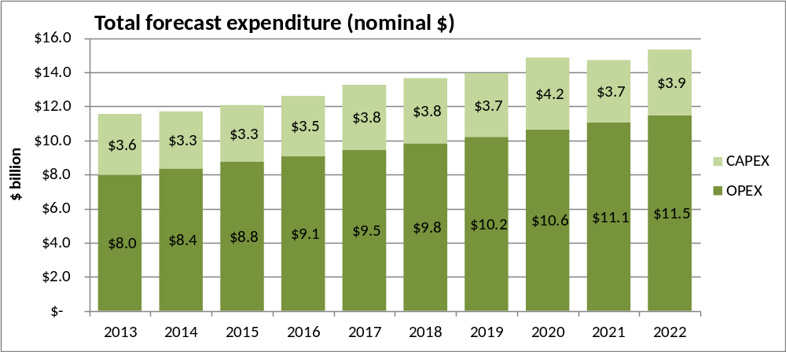
Figure 22: Projected local authority operating and capital expenditure, 2013-2022
(real expenditure at Figure 2: in Chapter 5)
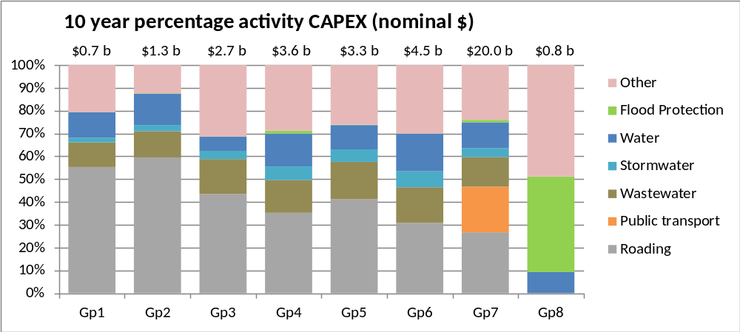
NB: Public Transport is listed as a separate unit for Auckland only, due to the significant expenditure expected between 2013-202
Figure 23: Projected capital expenditure by infrastructure type
(real expenditure at Figure 7 in Chapter 5)

Appendix E

Description of Local Government Service Delivery Mechanisms

In-house Council Department
This option involves the utilisation of the local authority’s own resources for the delivery of the services (i.e. own staff, buildings, plant and equipment, processes and systems). In order to utilise this option, the resources need to be appropriate and adequate for the nature, scope and scale of the services to be delivered (whether operations and maintenance or capital projects). There would need to be adequate technical and professional competencies, quality management systems and accountability.
The option would not normally involve the creation and operation of a dedicated service delivery unit along commercial lines (i.e. a business unit) and may not necessarily involve the formality of internal purchaser/provider arrangements.

In-house Business Unit
Although the term and concept of “business unit” is widely used in the local government sector, there is no statutory definition of the term nor is there any consistent application. In general, a business unit is an accounting and management concept representing “quasi-commercialisation” of the way in which the local authority delivers a service.
The Controller and Auditor-General has provided a description of the main characteristics that apply to business units as follows:
(a) Semi-autonomous management;
(b) Commercial operation; and
(c) Primary objective of recovering costs or making a profit.
Transfund defined the term as “a management entity within a local authority which marshals physical and human resources to provide services and undertake works”. Transfund specifies rules under which a business unit must operate.
A business unit is part of the local authority’s organisation and is not a separate legal entity. It is, therefore, subject to the same statutory provisions and local authority’s policies and its staff are employed by the local authority’s chief executive. The delivery of services by a business unit is usually established through the implementation of a purchaser/provider model within the local authority.
Nevertheless, the concept envisages a business unit as having greater operational freedom than in-house council departments and a more transparent and commercial approach to delivery of services while retaining control within the local authority.

Shared Services with other Local Authorities
This concept involves two or more local authorities collaborating in the delivery of services, using the resources of one or more of the authorities to directly deliver the service. It is not the same as a “joint principals’ contract” where two or more local authorities jointly contract for the delivery of a service.
Shared services have been described as capturing the best of both centralised and decentralised models to create a cost effective platform for delivering services.
The structural models available are varied and may include a joint governance or management group, contracting between local authorities and jointly council controlled organisations.

Shared Services with other Public Sector Agency
Frequently, there is a synergy between the services provided by a local authority and a (Central Government) public sector agency e.g. Department of Conservation, District Health Board, Transit New Zealand. In such cases, it may be possible for either the local authority or the public sector agency to deliver the service to the customers of both.
The Local Government Act 2002 includes the principle that a local authority “should collaborate and co-operate with other local authorities and bodies as it considers appropriate to promote or achieve its priorities and desired outcomes, and make efficient use of resources.”
The reasons for entering into such a shared services arrangement are effectively the same as for the option for shared services with another local authority. There are, however, some important differences between the two models:
(a) The statutory provisions that apply may be significantly different;
(b) The basis for charging/funding may be different
(c) The governance structures are different; and
(d) The accountability structures are different.
For the foregoing reasons this option may require special considerations in its establishment. Such arrangements may also involve joint management arrangements as has been successfully implemented for roading services.

Public-private Partnership (PPP)
Public-private partnerships can be used to describe a spectrum of possible relationships between public and private sector participants for the co-operative delivery of services.
They can include joint ventures, build-own-operate-transfer contracts (BOOT), concessions, franchise arrangements, etc.

Council-controlled Organisations (CCO)
Council-controlled organisations (CCOs) are subject to specific provisions of the Local Government Act generally defined in section 6 of the LGA to include:
(a) Companies in which 50% or more of equity securities are held, or directly or indirectly controlled, by one or more local authorities; or
(b) Companies in which the local authorities have the right to appoint 50% or more of the trustees, directors or managers; or
(c) Organisations in which one or more local authorities directly or indirectly control 50% or more of the votes; or
(d) Organisations in which local authorities may directly or indirectly appoint 50% or more of the trustees, directors or managers. This definition covers a wide range of entities and/or commercial arrangements, including companies, partnerships, trusts, arrangements for sharing of profits, union of interest, co-operation, joint venture or other similar arrangements. It also covers subsidiaries of these.
Council-controlled trading organisations (CCTOs) are classified under section 6 of the Act as being those CCOs that operate a trading undertaking for the purpose of making a profit.

Outsourcing Contracts through Private Sector
Commissioning the delivery of services through an outsourcing contract with the private sector is a standard service delivery mechanism that has been available for many years. Traditionally, this has been applied to the creation of capital assets, such as infrastructure assets, general services, such as cleaning, and supply of consumables e.g. fuel.
The contracting process has gradually developed into a highly sophisticated mechanism applied to a wide variety of services, including maintenance services, professional services, facilities management and regulatory services. Further development has seen community and economic development services included to the point where there is almost no local authority function or service which is not capable of being contracted out.
The important considerations are whether or not it is appropriate to contract out a facility or service in terms of the core functions of the local authority, allocation of risk and other possible disadvantages.
Two main approaches are used in the development of service delivery contracts:
(a) Prescriptive method – which details precisely how the services are to be delivered in terms of method, materials, timing, location, quality specification;
(b) Performance method – which specifies the result to be achieved, leaving the provider some discretion about the method of work.
Both approaches are valid in relation to specific applications.
The following outline some common types of contracts:
- Maintenance contracts,
- Performance specified contracts,
- Capital works contracts,
- Design-construct contracts,
- Design-construct-operate contracts,
- Full delivery.
- Concessions/Franchises
Typically these are long term arrangements between a local authority and a private firm for the management and operation of a particular service, often funded by user charges. Examples are mainly associated with infrastructure services such as water distribution, roads, gas. As many of these services are, in effect, monopolies, it is important to ensure some form of regulation or price control to prevent the private firm abusing its position. Some concession arrangements are associated with build-own-transfer (BOT), build-own-operate–transfer (BOOT) or design-build-finance (DBF) contracts.
There are three main types of franchise arrangements:
(a) A management contract of a specified period, usually no longer than 10 years. The provider’s responsibilities are confined to management of the operation or a defined part of the infrastructure or facility, and its return comes from payments from the local authority, which it, in turn, funds from charges to consumers.
(b) An arrangement known as “affermage”, typically for a term of around 12-15 years, under which the local authority still has responsibility for investment in plant and network, but the provider is normally responsible for equipment renewal.
(c) Concessions, which are normally for a longer term, around 25-30 years. Under this arrangement the provider is responsible for all expenditure, including maintenance and new investment. It receives its revenue from charges imposed directly on consumers, but with the rules for charging defined in the contract between it and the local authority. At the end of the concession term responsibility for the assets reverts to the local authority.

Glossary
Term | Explanation
Asset Management Plan | Long term plans (usually 10-20 years of more for infrastructure assets) that outline the asset activities and programmes for each service area and resources applied to provide a defined level of service in the most cost effective way.
Benefit-Cost Analysis | A decision technique that quantifies the benefits and costs in monetary terms over the life of the decision (often the life of the asset involved), discounting these to current monetary terms (where non-monetary terms are used, this is called “multi-criteria” analysis).
Community Infrastructure | Sections 5, 11A, and 197(2) of the LGA, act together to define community infrastructure as including land, or development assets on land, owned or controlled by the territorial authority, to provide public amenities including libraries, museums, reserves, and recreational facilities.
Condition Assessment | The inspection, assessment, measurement and interpretation of the resultant data, to indicate the condition of a specific component so as to determine the need for some preventive or remedial action.
Council | A territorial authority, regional council or unitary authority.
Council Controlled Organisation (CCO) | An organisation that takes the form of a company in which 50% or more of the voting rights of shareholders are held by one or more councils or where more than 50% of the directors are appointed by the council. CCOs are described in greater detail in Appendix E.
Council Controlled Trading Organisation (CCTO) | A CCO that operates a trading undertaking for the purpose of making a profit.
District plan | A document required to be produced by all territorial authorities, under the Resource Management Act (RMA). The district plan sets out issues facing the district, and objectives, policies and methods (including rules) to manage those issues. Land use and subdivision that would infringe the rules requires resource consent. The district plan must give effect to relevant National Policy Statements and National Environment Standards, the Regional Policy Statement, and any relevant Regional Plans.
Infrastructure | Stationary systems forming a network and serving whole communities, where the system as a whole is intended to be maintained indefinitely at a particular level of service potential by the continuing replacement and refurbishment of its components.  “Network infrastructure” is more narrowly defined in section 197(2) of the LGA 2002 as “provision of roads and other transport, water, wastewater, and stormwater collection and management”.
Levels of service | The outputs an organisation intends to deliver to its customers. A level of service statement commonly covers attributes such as quality, reliability, responsiveness, sustainability, timeliness, accessibility and cost. Performance measures (customer and technical) are used to define specific targets in relation to levels of service. Customer performance measures define the service the customer receives. Technical performance measures quantify how the organisation provides the service.
Long term plan | A document required of all councils by the Local Government Act. The long term plan covers a period of at least 10 financial years, but must be reviewed every three years. Its purpose is to describe the activities of the council and community outcomes; provide integrated decision making, co-ordination of council resources, and a long term focus for the council’s decisions and activities; provide a basis for council accountability; and provide for public participation in the decision making processes about council activities.
Maintenance | All actions necessary for retaining an asset as near as practicable to its original condition, but excluding rehabilitation or renewal. Maintenance does not increase the service potential of the asset or keep it in its original condition, it slows down deterioration and delays when rehabilitation or replacement is necessary.
Multi-Criteria Analysis | A decision technique where criteria are selected to represent the benefits provided from the proposal. Each attribute is scored and weighted for the different options and the results can be used to identify the preferred solution/s.
Public private partnership | PPPs are whole-of-life contracts for the provision of infrastructure where the private party assumes substantial financial, technical and operational risk in the project. A public agency enters into a contract with a private company or consortium to provide finance and arrange design, construction and on-going operation of a facility. The private sector may be granted a concession to charge users directly (as in a toll road for example) and/or may be paid service payments or lump sum payments directly by the public agency based on performance. The contract is typically for 20-30 years, or a substantial part of the life of the facility until the asset is paid for. At the end of the contract, control of the facility is usually returned to the government or a local authority.
Regional council | A regional council as named in Schedule 2 of the Local Government Act. Some of a regional council’s powers and responsibilities are specified by other Acts, notably the RMA and LTMA. Regional councils span the territories of multiple Territorial Authorities.
Regional Land Transport Strategy | A document required of all regional councils by the Land Transport Management Act (LTMA). The RLTS is prepared every six years and covers a period of at least 30 years. It provides guidance on the land transport outcomes sought by the region. The RLTS must contribute to achieving an affordable, integrated, safe, responsive, and sustainable land transport system; assist economic development, safety and personal security, and improved access and mobility. It must also protect and promote public health, and ensure environmental sustainability. The RLTS must be consistent with any relevant National Policy Statement, Regional Policy Statement or Regional Plan.
Regional Plan | A document that may be prepared by a regional council. A regional coastal plan must be prepared; other plans are optional. A regional plan must be reviewed at least every 10 years. A regional plan sets out particular issues facing the region (e.g., freshwater management), and objectives and policies to manage those issues; it may also specify rules. The regional plan must give effect to the intentions of the Regional Policy Statement and any relevant National Policy Statements and National Environment Standards. If rules are specified, activities that infringe those rules require resource consent. Regional resource consents include those for water takes, and permits for discharge to land, water and air.
Regional Policy Statement | A document required of regional councils by the Resource Management Act. The RPS must be reviewed at least every 10 years. The RPS sets out issues facing the region, and objectives and policies to manage those issues to achieve integrated management of natural and physical resources. The intentions of RPS are given effect to by regional plans and district plans. The RPS must give effect to any relevant National Policy Statements and National Environment Standards.
Renewal | Works to replace existing assets or facilities with assets or facilities of equivalent capacity or performance capability.
Replacement | The complete replacement of an asset that has reached the end of it life, so as to provide a similar, or agreed alternative, level of service.
Spatial Plan | A 20–30 year strategy that sets the strategic direction for a community and which serves as the basis for the co-ordination of decision making, infrastructure, services and investment. It is a means of aligning other council plans. A spatial plan provides a visual illustration of the intended future location and mix of residential, rural and business areas, along with the critical infrastructure required to service those areas and any relevant environmental constraints (for example, hazards or areas that need to be protected from development).
Strategic Plan | A plan containing the long term goals and strategies of an organisation / community. Strategic plans have a strong external focus, cover major portions of the organisation / community and identify major targets, actions and resource allocations relating to the long term survival, value and growth of the organisation / community.
Tax increment financing | A new investment or infrastructure project will increase the value of surrounding land and therefore generate additional tax revenue (and / or rates). TIF allocates those anticipated future gains to the repayment of the debt used to finance the project. If TIF is used, it is applied within a defined area, such as for brownfields redevelopment.
Territorial authority | A city council or district council.
Unitary authority | A territorial authority that has the additional duties, responsibilities and powers of a regional council.
WACC | The rate that an organisation is expected to pay on average to all its security holders to finance its assets, or risk them investing elsewhere.

New Zealand Productivity Commission, New Zealand Freight Transport Services Inquiry, April 2012, page xii.
Statistics New Zealand local authority financial statistics.
As defined by Statistics New Zealand.
Nominal figures are shown in Appendix D.
The analysis excludes data from the Christchurch City Council as it was exempt from producing a long term plan in 2012.
Schedule 10, clause 3(1) LGA requires councils to report on the amount budgeted to meet additional demand for an activity, improve the level of service, and replace existing assets.
7 OAG, Matters arising from the 2009 – 2019 long-term council community plans, 2010, Figure 1, paragraphs 6.21 – 6.23.
8 Born 1946 – 1965.
9 Jackson, Natalie, The demographic forces shaping New Zealand’s future. What population ageing [really] means, May 2011, page 20.
10 Jackson, Natalie, The demographic forces shaping New Zealand’s future. What population ageing [really] means, May 2011.
11 OAG, Matters arising from the 2012-22 local authority long term plans, 2012, paragraph 5.99.
12 OECD, Ageing Housing and Urban Development, 2003.
13 OAG, Matters arising from the 2012-22 local authority long-term plans, 2012, paragraphs 1.25 and 5.100.
14 LGA, section 101A(3)(a)(i).
15 PWC GHD, Implementing the National Infrastructure Plan in the Water Industry – A Pilot Study, 2012, page iv.
16 Report of the Local Government Efficiency Taskforce, page 86, paragraph 289.
17 In Towards Better Regulation – Draft Report, New Zealand Productivity Commission, December 2012, the Commission also looked at subsidiarity in the context of regulation, saying: “This principle asserts that decision-making, powers, responsibilities and tasks should be handled by the lowest , or least centralised competent authority (level of government). Therefore there is a presumption against centralisation, unless there is insufficient competence to carry out any particular functions.” Later in the section, discussing the application of the principle to the regulatory function, the Commission notes: “…where the costs and benefits of regulatory activity materialise in other jurisdictions (spillovers), the welfare objective may best be met by allocating regulatory functions to a higher tier of government…There are also situations where a higher tier of government may be able to provide regulatory activities more efficiently and effectively. This is where there are economies of scale and scope in service provision which enable the same regulatory services to be provided at a lower cost”. The EAG considers that this definition of subsidiarity applies equally as well to the provision of local government infrastructure.
18 Meeting between the Assistant Auditor-General and the EAG on 10 December 2012.
19 Email exchange with Chief Executive, LGFA and the Chair of EAG.
20 Preparing for Coastal Change – A guide for local government in New Zealand, MfE, March 2009, page 30.
21 OAG, Matters arising from the 2009 – 2011 long-term council community plans, 2010, paragraphs 6.25 and 6.29.
22 Christchurch Engineering Lifelines Project Centre for Advanced Engineering, Risks and Realities – A Multi-Disciplinary Approach to the Vulnerability of Lifelines to Natural Hazards, 1997.
23 Personal communications by email between Dave Brunsdon and the EAG, February 2013.
24 Towards Better Regulations – Draft Report, Productivity Commission, December 2012, pages 64-68.
25 Auckland infrastructure is mainly in the “other”’ category, as noted in chapter 5 of this report.
26 The figures in the following paragraphs are derived from Transport Futures – economic evidence, BERL, 2012.
27 OAG, Matters arising from the 2012-22 local authority long term plans, 2012, page 84.
28 Such factors may include: some farmers having low reported personal income; retiree populations on fixed incomes; a higher proportion of jobs in the primary sector, small scale retail, and a lower-price service sector.
29 In 2009/10, debt funded 57.4% of asset purchases. This is expected to fall to 27.2% by 2018/19.
30 OAG, Matters arising from the 2009 – 2011 long-term council community plans, 2010, page 6.
31 LGA, section 125.
³² “Other sanitary services” is defined in section 124 as being those services defined in section 25(1) (a), (b) (d), (h) and (i) of the Health Act 1956: drainage works: sewerage works, and works for the disposal of sewage; waterworks; sanitary conveniences for the use of the public; cemeteries; and crematoria.
33 Watercare in Auckland also delivers water, but the Auckland Council has both territorial and regional responsibilities. It therefore seems likely that the LGA assessment requirement applies to Watercare’s operations.
34 Wellington Regional Water Board Act 1972.
35 Report of the Minister for the Environment’s Technical Advisory Group on Infrastructure, August 2010.
36 Confidence and Supply Agreement between National and ACT, December 2011, “ACT and National support simplifying the planning process, and will legislate to ensure that there is only one plan (a “unitary” plan) for each district.”
37 New Zealand Productivity Commission, Towards better Local Government Regulation, Draft report, 2012 page 51.
38 Ministry for the Environment, Freshwater reform, 2013 and beyond, 2013, page 24.
39 Minister of Transport, Cabinet Economic Growth and Infrastructure Committee Paper, Land Transport Management Act 2003 Review: Planning and Funding, May 2011.
40 There is no provision in the Building Act for these, but they are still widely used. They come in the form of four types of statements relating to compliance at design, design review, construction and construction review.
41 Beca for NZTA, Investigation of Options for Consenting Bridge Structures for Compliance with the Building Act, 2012.
⁴² Bridge structures in the report were defined to include bridges, culverts, retaining walls and small highway structures – but excluding tunnels.
43 The Chartered Professional Engineers Act 2002 provides for competence-based registration of Professional Engineers.
44 Except in cases where household stormwater drains are misconnected to sewers, and where sewers are used as ‘emergency’ overflow systems during periods of high water flow. Both of these have been historical, and in some cases ongoing, problems in New Zealand.
45 Nine central government agencies have responsibilities for aspects of water policy, but none are in overall charge. Water New Zealand, Future Face of Urban Water Services in New Zealand - a discussion document, page 9.
46 Ministry of Health, Annual Report on Drinking-water Quality 2010–2011, 2012.
47 Section 69(v)(3) states that a public health risk management plan is not the only way of taking all practicable steps to meet the standards.
48 Section 69H(1), Health Act 1956.
49 The 2010-2011 report noted that 78% of New Zealanders are served by supplies that meet all of the standards, overall compliance having improved by 2% from 2009-2010. In 2010-2011, 97% met bacteriological standards, 97% met chemical standards, and 79% met protozoal standards. Compliance was generally highest in large supplies, and lowest in small supplies. Overall compliance figures mask poor compliance by supplies in the categories of small (15% compliant), minor (28% compliant) and medium (44% compliant), which serve over 293,000 people.
50 Ministry for the Environment, Freshwater reform: 2013 and beyond, 2013.
51 GHD Ltd for Ministry of Health, Report for the Five Year Review of the Sanitary Works Subsidy Scheme, 2006.
52 Environment Southland, Environmental Compliance Monitoring Report 2011-12.
53 The various non-compliance issues included not meeting monitoring / sampling requirements, and exceeding threshold limits for some discharge parameters.
54 Wastewater is the biggest waste by volume in New Zealand. Approximately 1.5 billion litres of domestic wastewater is discharged into the environment daily.
55 RMA, Schedule 3 – Water Quality Classes.
56 The classes in Schedule 3 of the RMA include water managed for the following purposes: aquatic ecosystems, fisheries, fish spawning, gathering or cultivating shellfish, water supply, irrigation, industrial abstraction, natural state, aesthetic, and cultural.
57 RMA, section 69(1).
58 Australian and New Zealand guidelines for fresh and marine water quality, 2000. The guidelines are currently under review by the New Zealand and Australian environment ministries.
59 In its submission to the Health Select Committee in 2006 Local Government New Zealand proposed that the Health (Drinking Water) Amendment Bill needed to be substantially changed to avoid placing significant costs on councils and ultimately ratepayers. We note that the committee setting the standards actually had over thirty members including significant representation from local government and industry.
60 If they choose the Public Health Risk Management Plan / catchment type approach, outlined earlier in the report.
61 GHD Ltd for Ministry of Health, Report for the Five Year Review of the Sanitary Works Subsidy Scheme, 2006.
62 OAG, Matters arising from the 2012-22 local authority long-term plans, 2012, from Figure 10.
63 LECG, Raising the quality of New Zealand networked drinking water, June 2010 page 4.
64 Section 9, Local Government (Auckland Council) Act 2009.
65 Report of the Minister for the Environment’s Infrastructure Technical Advisory Group, 2010, page 53.
66 Personal communication, Standards NZ CEO.
67 A number of factors gave rise to the review, including a trend of regulators to carry out functions traditionally carried out by the Standards Council eg, regulators developing technical documents with regulatory force as an alternative to citing New Zealand Standards in regulations.
Standards New Zealand is not publicly funded. All of its income is earned from the sale of documents, fulfilment of contracts for service, membership fees, royalty income and interest from bank deposits.
Codex Alimentarius is the principle organ of a joint Food and Agriculture Organisation of the United Nations / World Health Organisation effort intended to raise food standards.
Report of the Local Government Efficiency Taskforce, 2012, recommendations 17 and 23.
NSW Local Government Amendment (Planning and Reporting) Act 2009
Combined councils of the Wellington Region, Wellington Regional Strategy - Internationally Competitive Wellington, June 2007.
The SmartGrowth collaborative partnership provides a long-term vision and direction to grow a sub-regional community that values social, environmental, economic and cultural factors. The SmartGrowth Strategy sets the strategic direction agreed by local government and community partners on key issues facing the sub-region and the SmartGrowth partnership then works to implement the action plan.
Bill Wasley, chairman, SmartGrowth.
September 2012.
Minister for the Environment, Cabinet Business Committee Paper: Phase Two of the Resource Management Reforms – urban and infrastructure planning and general issues, May 2011.
We understand that there are already around 177 planning documents in New Zealand, a country of 4.4 million. This can be contrasted with Scotland, a country of 5.3 million, which has 37 planning documents.
LGNZ Regional Sector Group, Report from Spatial Planning Working Group, May 2011.
TV3 News, 6 February 2013.
International Infrastructure Management Manual, 2011.
Audit New Zealand, Asset management for public entities: learning from local government examples, April 2010, pages 18, 22, and 48.
The service level for fire fighting is in SNZ PAS 4509:2003 Code of Practice for Fire Fighting Water Supplies.
OAG, Matters arising from the 2012-22 local authority long-term plans, 2012, page 40.
OAG, Matters arising from the 2012-22 local authority long-term plans, 2012, from Figure 10. Capital expenditure (for water supply, wastewater disposal, and stormwater drainage) rises from around 28% of the local authority spend in 2012, to around 40% of the total in 2022. Over that period, water supply varies between approximately 10% and 14% of capital expenditure, wastewater disposal between 10% and 20%, and stormwater drainage between 3% and 5%. For each of these activities, the expenditure remains relatively flat for the first 8 – 9 years (until around 2019 / 2020), and then rises. The sharpest rise in projected spending is on wastewater treatment and disposal.
OAG, Matters arising from the 2012-22 local authority long-term plans, 2012, paragraphs 2.32 and 2.33.
LGA, Schedule 10, clause 3.
LGA, Schedule 10, clause 4.
LGA, section 93(6)(c).
Tax increment financing (TIF) is different to targeted rates in that a proposed project receives monetary benefit at or near the outset, on the calculated assumption of future land value increases in surrounding property. In effect, it is present financing funded by borrowing against assumed future revenue. TIF (if it was an available mechanism) would be more appropriate as a means of encouraging private investment in infrastructure. In contrast, targeted rates to fund local authority infrastructure can only be collected over time and can therefore only 'drip-feed' the required funding or provide it as a lump sum at the end of a period. Also see further explanation of TIF in the Glossary.
Under Section 48(2) of the Act the Minister, must not recommend that an existing road or part of it be tolled unless he or she is satisfied that the existing road or part is located near, and is physically or operationally integral to, the new road in respect of which the tolling revenue will be applied.
RMA 1991, section 409.
LGA 2002, section 198 (3).
Water leak detection successful, 14 March 2013 on www.kapiticoast.govt.nz.
Smith, N., McDonald, G. & Wilson, D. (2010) Water demand management: An economic framework to value with case study application. Report WA7090/7, Beacon Pathway Ltd.
David Walker, Steve Carne, Bassam Halabi, “Demand management - for the environment and ratepayers,” New Zealand Local Government, August 2009, page 13.
Better Transport Better Roads, consultation proposal document, New Zealand Government, 1999.
Funding assistance rate review: Background document, New Zealand Transport Agency, November 2012.
Auckland Road Pricing Study 2008 - Executive Summary Report, Ministry of Transport, August 2008, p89
Betterment is an approach where the increased value of land, due to either improvements or the grant of development rights, is captured or leveraged.
OAG, Matters arising from the 2012-22 local authority long-term plans, December 2012.
Ibid, page 4.
Ibid, page 3.
Audit New Zealand, Asset management for public entities: Learning from local government examples, 2010.
"The right debate is about providing information that is relevant to the stakeholder, and being transparent. This requires a local authority to assess what the important issues are, what options – including the option adopted in the consultation document – are open to the community, and what all the implications associated with the issues are." OAG, Local government: Results of the 2006/07 audits, page 23.
Figure from Waugh Infrastructure Management Limited.
Conversation with NIU, March 2013.
OAG, Local authorities: Planning to meet the forecast demand for drinking water, 2010.
Audit New Zealand, Asset management for public entities: Learning from local government examples, 2010, page 11.
In its guide on Public sector purchases, grants and gifts: Managing funding arrangements with external parties, June 2008, the OAG says “Every public entity needs to consider the type of procurement that it does, the associated value and risks, and how important procurement is to achieving its goals and business strategy. That consideration should not be isolated from the rest of the public entity’s planning and management.” page 12.
Section 90 LGA requires councils to adopt a “policy on significance”. The policy must set out that council's general approach to determining the significance of proposals and decisions in relation to issues, assets, or other matters; and any thresholds, criteria, or procedures that are to be used by the council in assessing the extent to which issues, proposals, decisions, or other matters are significant. It must also list the assets considered by the local authority to be strategic assets. A council must use the special consultative procedure to adopt and amend the policy.
National Infrastructure Performance Indicators Framework, February 2013.
Auckland Governance Reforms: Water Issues [AGR (09) 18 refers] on www.dia.govt.nz.
Section 104, Local Government (Auckland Council) Act 2009.
Wellington Region Local Government Review Panel, Future Wellington – Proud, Prosperous and Resilient, 2012, pages 8-9.
Road Maintenance Taskforce: Review of Road Management Regime, October 2012, page 9 on www.nzta.govt.nz.
NAMS was established in 1995 with the backing of INGENIUM, LGNZ, SOLGM, the OAG, the NZ Water and Wastes Association and the NZ Recreation Association. The NAMS manuals and guidelines are distributed worldwide, are well recognised and represent the world’s best practice. One of its main publications, the International Infrastructure Management Manual (IIMM) is a collaborative document produced by NAMS and its industry partners in Australia, South Africa, the UK and USA. The IIMM is typically updated every five years.
S. Berg, R. Marques, "Quantitative Studies of Water and Sanitation Utilities: A Literature Survey March 3, 2010
See in particular summaries of different reports in Brian Dollery, Joel Byrnes and Lin Crase, An Analysis of the New Perspective on Amalgamation in Australian Local Government, February 2007; United States Environmental Protection Agency, Restructuring and Consolidation of Small Drinking Water Systems, October 2007, p.iii; PWC and GHD, Implementing the National Infrastructure Plan in the Water Industry, July 2012.
See for example, the literature review featured in McKinlay Douglas Ltd, Local Government Structure and Efficiency, October 2006; Brian Dollery, Joel Byrnes and Lin Crase, An Analysis of the New Perspective on Amalgamation in Australian Local Government, February 2007.
Chris Aulich, Melissa Gibbs, Alex Gooding, Peter McKinlay, Stefanie Pillora and Graham Sansom; Consolidation in Local Government: A Fresh Look; Volume 1 Report, May 2011.
Urban Water Services, IPENZ, Ingenium and Water New Zealand (2013), page 14.
PWC and GHD Implementing the National Infrastructure Plan in the Water Industry, July 2012.
In 2008, Sport New Zealand commissioned a review of the Sportville partnerships from Peter Burley, Director of Sport Guidance. Burley noted that 6 of the 8 Sportville examples he reviewed were what he would consider successful. For those he was able to pinpoint the critical success factors listed above, noting that there was no absolute need for any one approach to the partnership, nor any particular need for partners to formally amalgamate.
Iwi and Māori Economy: An Emerging Giant, Sir Mark Solomon, address to Wellington Regional Chamber of Commerce, 7 August 2009.
Co-investment models: what, how, and when to use them, Hamiora Bowkett, PWC, paper to Māori Co-investment and Economic Development Forum, 19 April 2012.
The clause states: "a local authority should collaborate and co-operate with other local authorities and bodies as it considers appropriate to promote or achieve its priorities and desired outcomes, and make efficient use of resources".
Email from Auckland Transport to EAG February 2013.

