Service Delivery and Operations
Customer Experience Survey
2013-14

Branch Development and Support
Service Delivery and Operations
December 2014

Acknowledgements

The Department of Internal Affairs acknowledges Mark Johnson and his team at Research New Zealand for their analysis of the data.

Author: Claire Harkess, Branch Development and Support
Introduction

This report provides a summary of key findings from the 2013/14 Service Delivery and Operations Customer Experience Survey.

Service Delivery and Operations (SDO) provides a variety of services to the public including passports, community development advice and grants, birth, death and marriage registrations, citizenship, charities registration, and identity verification services.

In this survey we seek to understand how the public rates our service, how they interact with SDO and what we can do to improve our service.

The 2013/14 survey is the second in an annual series of surveys to monitor public satisfaction over time, and responses to changes in our service delivery.

Key Findings

- Overall, satisfaction with the service SDO delivers remains high. However improvements or additions to online services remains a key customer need.

- Customers continue to have high expectations of the service they expect to receive and then rate the service they actually received as better than expected.

- Interactions with SDO staff remain strongly rated.

- Customers continue to have high trust and confidence in the Department of Internal Affairs.

Overall Satisfaction

Most customers (92%) were satisfied or very satisfied with the overall quality of SDO service delivery. Results in 2013/14 are basically the same as 2012/13, reflecting the maintenance of a high level of service.

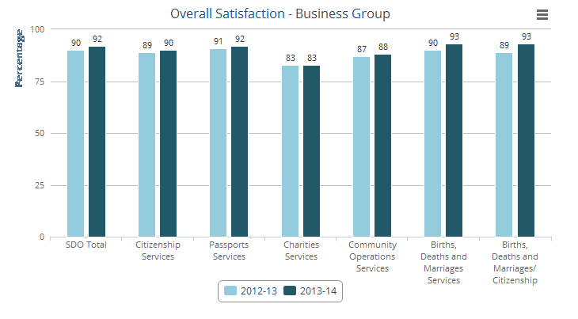
Source: Service Delivery and Operations Customer Experience Survey 2012/13 and 2013/14

Customers provide some very positive feedback:

What they [are] doing now is perfect
I have dealt with them for 8 years, service is consistently good…
I have found the Department of Internal Affairs delivery of service re Charities Services professional and helpful. When completing the Annual Return, any queries are responded to appropriately and succinctly.
It was really fast, it was good service.
I am very satisfied with the service, applied for citizenship and passport for my son, got both of them within two weeks. Keep it up guys, proud to be a Kiwi.
… When I deal with an IA employee I am always reminded that they represent their country no less than a star AB Wing. NZ is a special place because of people like you…

Service Expectations and Experience

Just over half of SDO customers had high expectations of the quality of service they would receive and felt that the resulting service received was better than expected.

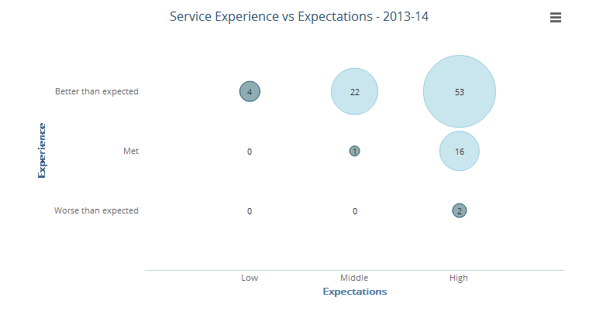
Source: Service Delivery and Operations Customer Experience Survey 2013/14

Key Service Measures

SDO customers rate the key service measures highly. In particular “Staff were competent”, “Staff did what they said they would do”, and “I was treated fairly” were all rated above 90%. These three measures relate directly to service received from SDO representatives.
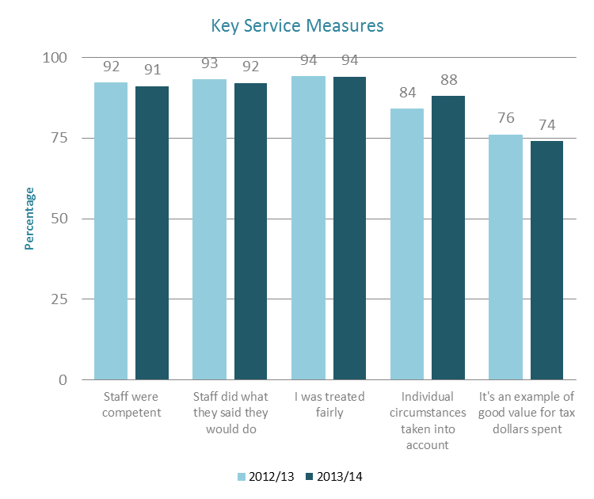
Note: Only SDO customers who had had direct contact with an SDO representative were asked whether Staff were competent, Staff did what they said they would do, or I was treated fairly.
Source: Service Delivery and Operations Customer Experience Survey 2013/14
Service Improvements

Just under half of SDO customers felt that SDO did not need to make any improvements to our service. For those who did make suggestions, the biggest group remains in relation to improving our website and online service.

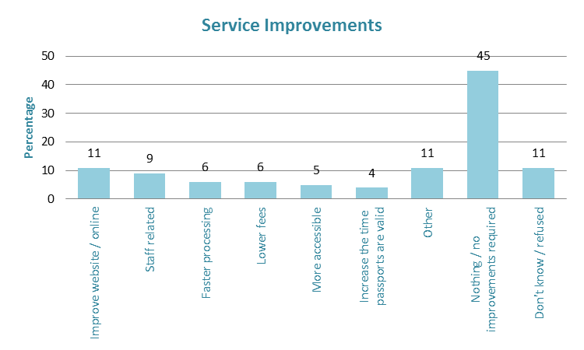
Source: Service Delivery and Operations Customer Experience Survey 2013/14

Examples of the types of comments from customers are:

Making their website easier to use when locating the online Death Certificate request form.
Communication, full explanation (in examples) so that we have an idea of what the question means.
I think we should be able to select. I think we should be able to download the page by number that we require. They just need to streamline that paper-work so you don’t have to print it all out.
Efficiency, know what they are doing, know what requirements are without having to send 3 letters over 3 weeks to get what they needed right.
They need to find another way for ID. I had to send my driver’s license away and they kept it for 2 weeks so I couldn’t drive.
… it would be really good if the online application facilities can be made to be compatible with mainstream browsers like [Internet Explorer]10, Chrome etc.

Trust and Confidence

SDO customers continue to report high trust and confidence in the Department of Internal Affairs.

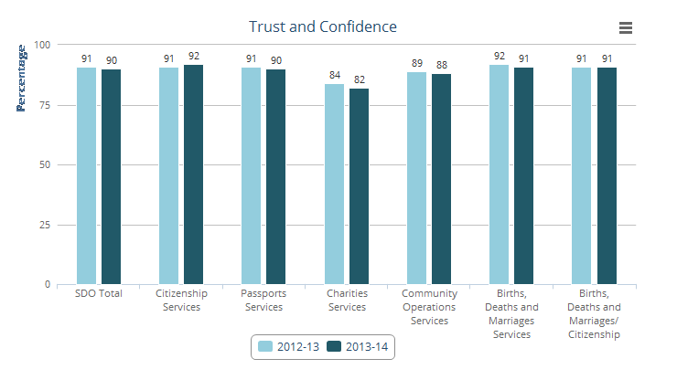
Source: Service Delivery and Operations Customer Experience Survey 2012/13 and 2013/14

Next Steps

SDO is working to transform our system of service delivery. Findings from this research will help us understand our customer’s needs and enable us to see the effect of service changes on our customers.

Improving our web and digital services is a strong focus for SDO. Analysis from the survey, particularly of customer comments, will help direct this.

The SDO Customer Experience Survey is being run again over 2014/15 with results expected to be published late 2015.

Methodology

The 2013/14 survey was run continuously during 2013/14. This is in contrast to the 2012/13 survey which was run at the end of 2012/13. Recent customers were asked to participate via a telephone or online survey. 2,206 customers completed the survey. The margin of error is between +/-4.3% and +/-4.9% for each business group.

All changes between years are not statistically significant, therefore we cannot say for certain that there has been any change.
All changes between years are not statistically significant, therefore we cannot say for certain that there has been any change.

