Service Delivery and Operations
Customer Experience Survey
2017/18

Analytics and Reporting
Service Delivery and Operations

Acknowledgements

The Department of Internal Affairs acknowledges the team at Research New Zealand for their analysis of the data.

Authors: Matt Disney and Claire Harkess – Analytics and Reporting, Operations

Introduction

This report provides a summary of key findings from the 2017/18 Service Delivery and Operations Customer Experience Survey.

Service Delivery and Operations (SDO) provides a variety of services to the public including passports, community advisory and funding services, birth, death, marriage, civil union, and name change, authentications, citizenship, charities registration, and identity verification services.

In this survey we seek to understand how the public rates our service, how they interact with SDO and what we can do to improve our service.

The 2017/18 survey is the sixth year this survey has run to monitor public satisfaction over time, and to monitor responses to changes in our service delivery.

Key Findings

Customer satisfaction with the services that SDO deliver remains high. Customers continue to have high expectations of the service they will receive and comments show us that customer expectations of our services continue to evolve. As such, we have a customer centred transformation underway which will substantially shift the way our services are delivered.

Overall Satisfaction

Most customers (89 percent) were satisfied or very satisfied with the overall quality of SDO service delivery. Results in 2017/18 were basically the same as in 2016/17, reflecting the maintenance of a high level of service.

Source: Service Delivery and Operations Customer Experience Survey 2017/18

Examples of positive feedback provided by customers:

Everything was clearly explained, systems were smooth and people competent, efficient and friendly.

I ALWAYS find the DIA Community Operations Services staff helpful and easy to work with. They may not always be able to answer my queries immediately, but they find out and get back to me.

I had to apply for an urgent passport, the application was easy to fill out and the DIA representative that contacted me was awesome to deal with, they made it all very easy and explained what the steps were.

I was able to make an appointment to have my application lodged and it was a speedy and wonderful experience. My case officer, […], was a pleasure to deal with, explained the process fully and followed through in every instance where required.

They made it very easy, [they were] easy to talk to and very informative, giving me all the info I needed and answering all the questions I had thoroughly and in a professional manner.

Service Expectations and Experience
Over half of SDO customers had high expectations of the quality of service they would receive and felt that the resulting service received was better than expected. This is in line with results from previous years.

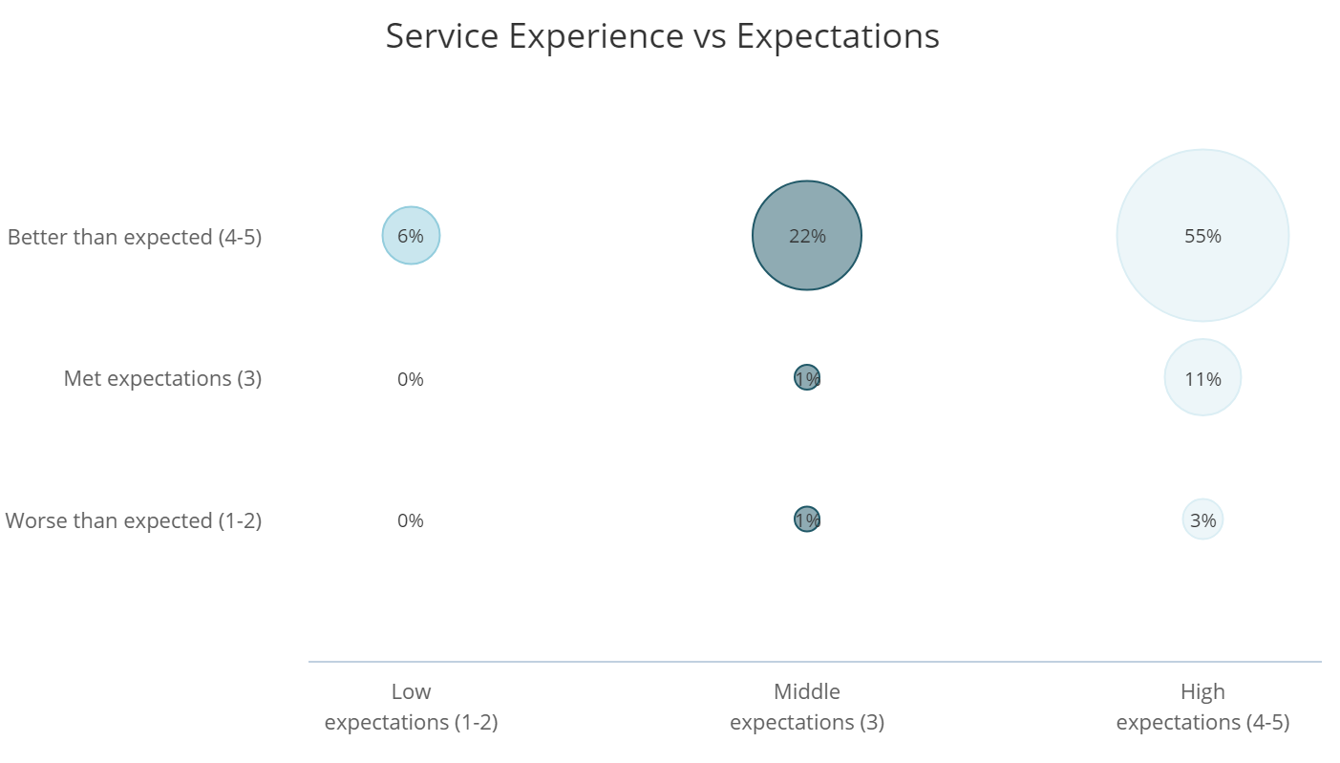
Source: Service Delivery and Operations Customer Experience Survey 2017/18

Key Service Measures

SDO customers rated the key service measures highly. In particular “Staff did what they said they would do” and “I was treated fairly” were all rated highly by more than 90 per cent of customers. These measures relate directly to the service received from SDO staff. The year on year change is not statistically significant, but when comparing results across the last three years there has been a statistically significant decline. The survey does not give customers an opportunity to comment on why they have given a particular rating. Customer expectations continue to evolve and we do need to ensure we are always refining our services to meet or exceed what our customers expect of us.
Source: Service Delivery and Operations Customer Experience Survey 2017/18

Trust and Confidence

SDO customers continue to report high trust and confidence in the Department of Internal Affairs.
The Community Operations business group in particular has had a strong improvement in this measure. This improvement arises from Community Operations’ on-going drive to make the customer the centre of what they do.
Source: Service Delivery and Operations Customer Experience Survey 2017/18

Ease of doing business with DIA

Overall 86 percent of SDO customers reported that it was easy to do business with Service Delivery and Operations. This number has been consistent over the last few years. The slightly lower overall score for Charities Services reflects on the regulatory nature of this part of the business – for the majority of our services our customers choose to come to us; however the opposite is true for most customer interactions with Charities Services – to continue to qualify for charitable status, charities need to comply with requirements, including annual reporting. Customer commentary also suggests that the lower ease score is due to the requirements being relatively complex, especially for smaller charities that rely on volunteers.

Community Operations has also shown a significant increase in this measure. There have been a number of projects and service improvements that are likely to have contributed to this increase along with the increase in the Trust and Confidence measure above.

- Re-development of the Community Matters website that provides clearer information about funds and services available to customers, with ongoing improvements after the initial go-live date based on direct customer feedback.
- Feedback is also received from customers via our contact centre along with feedback from staff. This is collated in an enhancements register which is actively managed to ensure this feedback results in meaningful improvements that our customers ask for.

Source: Service Delivery and Operations Customer Experience Survey 2017/18

International research shows that ease of doing business is a key driver of the customer experience. Assessing how easy we make it for our customers is crucial to assessing how we are performing, and for determining actionable next steps to improve the customer experience.

It is worth noting that even among those customers who had low expectations of how easy it was to business with us, the majority of those customers did report that they found it easy.

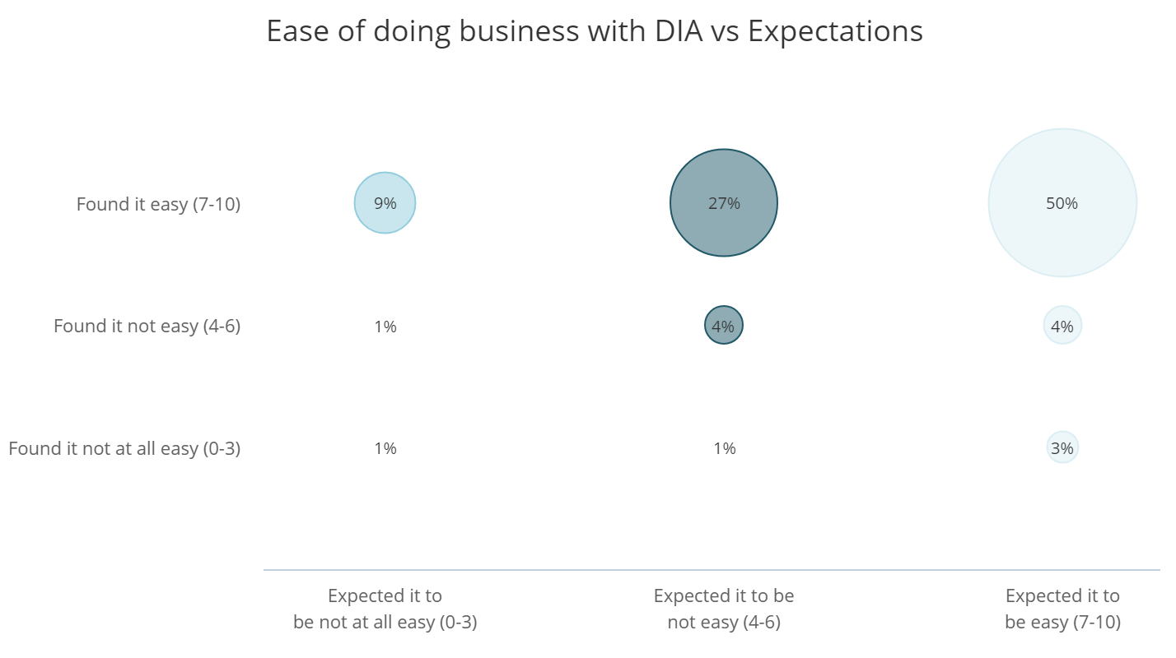
Source: Service Delivery and Operations Customer Experience Survey 2017/18

Service Improvements

Over 40 percent of SDO customers felt that SDO could make improvements to our service. Among those who made suggestions, the largest group was those who suggested we make improvements to our online services. This has been a recurring theme each year the survey has been run, however the percentage of respondents who ask for improvements to the website is significantly higher than previous years which reflects the changing expectations of how customers want to access our services.

Source: Service Delivery and Operations Customer Experience Survey 2017/18

Examples of the types of comments received from customers regarding improvement are:

A chat channel with near instant response.

I think being able to apply online for the first time might make life a bit easier. Also, if there was a way to see what stage the application [was at] online, if you could log in online rather [than] dealing with someone over the phone.

Less waiting time to speak with someone, or offer a call back option as I was ringing while also managing a toddler and a new-born.

Improve user friendly navigation around the website. Provide direct access to online help when on your site.

Keep adding new services online.

Next Steps

SDO is working to transform our system of service delivery. Findings from this research will continue to help us understand our customers’ needs and enable us to see the effect of service changes on our customers. A programme of continuous improvement is being undertaken based on customer and staff experience.

Improving our web and digital services is a strong focus for SDO. Analysis from the survey, particularly of customer comments, will help direct this. Projects that have been implemented since the 2017-18 survey has been completed include:

- Improvements to the BDM online service – adding options to order more non-historical certificates/records online.
- Electronic verifications for marriage licences – adding a process that allows customers to electronically verify their identity and agree with key statements, removing the need for customers to visit a registry office and make a statutory declaration in person.
- Piloting a citizenship by grant online application process. This also includes an eligibility tool so customers can quickly check whether they may be eligible for NZ citizenship.
- Improvements to the online photo checker for online passport service, starting with better technical help so customers can self-diagnose and fix common errors with their photos.

The SDO Customer Experience Survey is being run again in 2018/19 with results expected to be published late January 2020. The survey is being reviewed to ensure it is fit for purpose for the coming years and continues to support our move to being customer centric.

Methodology

The 2017/18 survey was run continuously during 2017/18. Recent customers were asked to participate via a telephone or online survey. 2537 customers completed the survey. The margin of error is between +/-4.0% and +/-4.8% for each business group. The margin of error across the total of SDO is 3.1%.

Most changes between years are not statistically significant; therefore we cannot say for certain that there has been any change.
Results show a small percentage increase from last year, but as it is not statistically significant, we cannot be certain there has been any change.
Most changes between years are not statistically significant; therefore we cannot say for certain that there has been any change.
These are both statistically significant increases.
Source: CEB Customer Contact Council Member Survey 2010.

