Key findings from the 2014 Survey of AML/CFT reporting entities: awareness across sector – Support Document

Contents
Appendix A – Tables
Appendix B – Survey Summary Data – Anonymised.

Appendix A – Tables

Figure 1.1 Respondent Locations Figure 1.2 Respondent Subsectors
Respondent Location
Auckland | 183 | 59.42%
Canterbury | 33 | 10.71%
Wellington | 21 | 6.82%
Overseas | 13 | 4.22%
Waikato | 12 | 3.90%
Northland | 10 | 3.25%
Bay of Plenty | 8 | 2.60%
Hawkes Bay | 7 | 2.27%
Otago | 6 | 1.95%
Taranaki | 5 | 1.62%
Manawatu-Whanganui | 4 | 1.30%
Nelson | 4 | 1.30%
Marlborough | 1 | 0.32%
Tasman | 1 | 0.32%
Respondent Subsector
Non-Bank and Non-Deposit Taking Lender | 117 | 34.72%
Foreign Exchange | 48 | 14.24%
Remittance | 39 | 11.57%
Lending / Finance Company | 28 | 8.31%
Financial Leasing | 21 | 6.23%
Trust and Company Service Provider | 21 | 6.23%
Debt Collection | 11 | 3.26%
Payment provider | 9 | 2.67%
Factor | 8 | 2.37%
Non-Bank Credit Card | 8 | 2.37%
Cash Transport | 6 | 1.78%
Payroll | 5 | 1.48%
Serviced Office / Virtual Office | 5 | 1.48%
Money Transfer | 4 | 1.19%
Consultant / Advisor / Accountant | 4 | 1.19%
Casino | 2 | 0.59%
Tax Pooling | 1 | 0.30%

Figure 2.1 Finding information on Website Figure 2.2 Usefulness of website information

Ease of finding information on the website
1. Extremely easily
2. Reasonably easily
3. Could find some areas more easily than others
4. With difficulty
5. Could not find at all
Overall Individual Respondent Average | 2.53 | + / Average
Cash Transport | 2.80 | 0.27
Casino | 2.00 | -0.53
Debt Collection | 2.50 | -0.03
Factor | 2.86 | 0.33
Financial Leasing | 2.78 | 0.25
Foreign Exchange | 2.31 | -0.22
Non-Bank and Non-Deposit Taking Lender | 2.60 | 0.07
Non-Bank Credit Card | 2.67 | 0.14
Payment provider | 2.25 | -0.28
Payroll | 3.00 | 0.47
Remittance | 2.44 | -0.09
Tax Pooling | 2.00 | -0.53
Trust and Company Service Provider | 2.89 | 0.36
Lending / Finance Company | 2.85 | 0.32
Money Transfer | 2.25 | -0.28
Serviced Office / Virtual Office | 2.80 | 0.27
Consultant / Advisor / Accountant | 2.00 | -0.53
Usefulness of website information
1. Extremely useful
2. Reasonably useful
3. Some areas more useful than others
4. Not very useful
5. No use at all
Overall Individual Respondent Average | 2.49 | + / Average
Cash Transport | 2.60 | 0.11
Casino | 2.00 | -0.49
Debt Collection | 2.50 | 0.01
Factor | 2.57 | 0.08
Financial Leasing | 2.44 | -0.05
Foreign Exchange | 2.29 | -0.20
Non-Bank and Non-Deposit Taking Lender | 2.36 | -0.13
Non-Bank Credit Card | 2.17 | -0.32
Payment provider | 2.38 | -0.11
Payroll | 3.20 | 0.71
Remittance | 2.18 | -0.31
Tax Pooling | 3.00 | 0.51
Trust and Company Service Provider | 2.68 | 0.19
Lending / Finance Company | 2.45 | -0.04
Money Transfer | 2.00 | -0.49
Serviced Office / Virtual Office | 3.00 | 0.51
Consultant / Advisor / Accountant | 2.50 | 0.01

Figure 3.1 Types of Interaction with the Department
 | Types of interaction with the Department
Type | A roadshow presentation | A face-to-face meeting where I was given information | A telephone conversation where I was given information |  | An email or letter where I was provided information | An AML/CFT programme review | An AML/CFT on-site inspection
Overall Individual Respondent Average | 14.84% | 25.52% | 20.18% |  | 34.12% | 9.50% | 4.45%
Cash Transport | 33.33% | 66.67% | 16.67% |  | 33.33% | 0.00% | 0.00%
Casino | 50.00% | 100.00% | 100.00% |  | 50.00% | 50.00% | 0.00%
Debt Collection | 27.27% | 9.09% | 9.09% |  | 27.27% | 0.00% | 0.00%
Factor | 12.50% | 0.00% | 12.50% |  | 25.00% | 0.00% | 12.50%
Financial Leasing | 4.76% | 9.52% | 9.52% |  | 33.33% | 4.76% | 0.00%
Foreign Exchange | 12.50% | 22.92% | 16.67% |  | 45.83% | 12.50% | 8.33%
Non-Bank and Non-Deposit Taking Lender | 11.11% | 21.37% | 17.95% |  | 24.79% | 5.13% | 4.27%
Non-Bank Credit Card | 0.00% | 25.00% | 37.50% |  | 37.50% | 0.00% | 0.00%
Payment provider | 0.00% | 11.11% | 22.22% |  | 44.44% | 11.11% | 0.00%
Payroll | 80.00% | 60.00% | 20.00% |  | 20.00% | 0.00% | 20.00%
Remittance | 20.51% | 53.85% | 28.21% |  | 48.72% | 17.95% | 7.69%
Tax Pooling | 0.00% | 0.00% | 0.00% |  | 0.00% | 0.00% | 0.00%
Trust and Company Service Provider | 38.10% | 47.62% | 33.33% |  | 52.38% | 28.57% | 4.76%
Lending / Finance Company | 10.71% | 10.71% | 14.29% |  | 28.57% | 7.14% | 0.00%
Money Transfer | 0.00% | 0.00% | 25.00% |  | 25.00% | 50.00% | 0.00%
Serviced Office / Virtual Office | 0.00% | 20.00% | 40.00% |  | 40.00% | 0.00% | 0.00%
Consultant / Advisor / Accountant | 0.00% | 0.00% | 25.00% |  | 0.00% | 0.00% | 0.00%

Figure 4.1 Other sources of information
 |  |  |  | Other sources of information
Type | Consultant | Financial Action Task Force | Financial Markets Authority | Industry Body | Legal Professional | Ministry of Justice | NZ Police | Reserve Bank | Other Banks | Similar Businesses | Various online sources
Overall Individual Respondent Average | 38.87% | 16.32% | 20.47% | 9.79% | 29.08% | 11.28% | 24.93% | 10.68% | 1.48% | 0.89% | 1.19%
Cash Transport | 33.33% | 50.00% | 16.67% | 16.67% | 50.00% | 16.67% | 16.67% | 16.67% | 0.00% | 0.00% | 0.00%
Casino | 100.00% | 50.00% | 0.00% | 50.00% | 50.00% | 100.00% | 50.00% | 0.00% | 0.00% | 0.00% | 0.00%
Debt Collection | 27.27% | 9.09% | 18.18% | 0.00% | 0.00% | 0.00% | 18.18% | 9.09% | 0.00% | 0.00% | 9.09%
Factor | 37.50% | 0.00% | 12.50% | 12.50% | 12.50% | 0.00% | 0.00% | 0.00% | 0.00% | 0.00% | 0.00%
Financial Leasing | 52.38% | 0.00% | 4.76% | 9.52% | 33.33% | 4.76% | 14.29% | 0.00% | 0.00% | 0.00% | 0.00%
Foreign Exchange | 54.17% | 25.00% | 20.83% | 2.08% | 20.83% | 12.50% | 27.08% | 12.50% | 2.08% | 0.00% | 2.08%
Non-Bank and Non-Deposit Taking Lender | 35.90% | 12.82% | 22.22% | 14.53% | 32.48% | 11.97% | 29.06% | 12.82% | 1.71% | 2.56% | 0.00%
Non-Bank Credit Card | 12.50% | 25.00% | 25.00% | 0.00% | 50.00% | 0.00% | 25.00% | 12.50% | 12.50% | 0.00% | 0.00%
Payment provider | 44.44% | 22.22% | 22.22% | 0.00% | 44.44% | 11.11% | 11.11% | 33.33% | 0.00% | 0.00% | 0.00%
Payroll | 20.00% | 0.00% | 20.00% | 0.00% | 0.00% | 20.00% | 20.00% | 0.00% | 0.00% | 0.00% | 20.00%
Remittance | 48.72% | 30.77% | 23.08% | 7.69% | 33.33% | 17.95% | 41.03% | 12.82% | 0.00% | 0.00% | 2.56%
Tax Pooling | 0.00% | 0.00% | 100.00% | 0.00% | 100.00% | 100.00% | 0.00% | 0.00% | 0.00% | 0.00% | 0.00%
Trust and Company Service Provider | 42.86% | 28.57% | 23.81% | 19.05% | 47.62% | 4.76% | 28.57% | 14.29% | 0.00% | 0.00% | 0.00%
Lending / Finance Company | 21.43% | 0.00% | 21.43% | 7.14% | 14.29% | 3.57% | 7.14% | 0.00% | 3.57% | 0.00% | 0.00%
Money Transfer | 0.00% | 0.00% | 25.00% | 0.00% | 0.00% | 50.00% | 50.00% | 0.00% | 0.00% | 0.00% | 0.00%
Serviced Office / Virtual Office | 40.00% | 20.00% | 20.00% | 0.00% | 40.00% | 0.00% | 0.00% | 20.00% | 0.00% | 0.00% | 0.00%
Consultant / Advisor / Accountant | 0.00% | 0.00% | 0.00% | 25.00% | 0.00% | 0.00% | 0.00% | 0.00% | 0.00% | 0.00% | 0.00%

Figure 5.1 Subsector Risk Assessments

Business understanding around conducting a risk assessment | Two years ago | When the Act came into effect in July 2013 |  |  | Now
 | B/Line | Self-  Assessment | Movement | Self-  Assessment |  | Movement
Overall Subsector Average (out of 5) | 2.64 | 3.59 | 0.96 | 4.09 |  | 0.50
Debt Collection | 2.60 | 3.10 | 0.50 | 3.30 |  | 0.20
Serviced Office / Virtual Office | 2.20 | 2.80 | 0.60 | 3.60 |  | 0.80
Payroll | 2.00 | 3.20 | 1.20 | 3.60 |  | 0.40
Lending / Finance Company | 2.22 | 3.37 | 1.15 | 3.96 |  | 0.59
Cash Transport | 2.67 | 3.83 | 1.16 | 4.00 |  | 0.17
Consultant / Advisor / Accountant | 3.33 | 3.67 | 0.34 | 4.00 |  | 0.15
Tax Pooling | 2.00 | 4.00 | 2.00 | 4.00 |  | 0.50
Money Transfer | 2.33 | 3.00 | 0.67 | 4.00 |  | 0.33
Financial Leasing | 2.45 | 3.35 | 0.90 | 4.05 |  | 0.70
Payment provider | 2.67 | 3.56 | 0.89 | 4.11 |  | 0.55
Non-Bank Credit Card | 2.00 | 3.63 | 1.63 | 4.13 |  | 0.47
Non-Bank and Non-Deposit Taking Lender | 2.49 | 3.72 | 1.23 | 4.19 |  | 0.00
Foreign Exchange | 3.00 | 3.79 | 0.79 | 4.21 |  | 1.00
Factor | 3.00 | 4.14 | 1.14 | 4.29 |  | 0.42
Trust and Company Service Provider | 2.89 | 4.00 | 1.11 | 4.47 |  | 0.47
Remittance | 2.97 | 2.90 | -0.07 | 4.58 |  | 1.68
Casino | 4.00 | 5.00 | 1.00 | 5.00 |  | 0.00

Figure 5.2 Subsector AML/CFT Programme
Rate business understanding of developing and regularly reviewing the AML/CFT Programme | Two years ago | When the Act came into effect in July 2013 |  | Now
 | B/Line | Self-  Assessment | Movement | Self-  Assessment | Movement
Overall Subsector Average (out of 5) | 2.49 | 3.53 | 1.05 | 3.94 | 0.41
Debt Collection | 2.30 | 2.80 | 0.50 | 3.00 | 0.20
Serviced Office / Virtual Office | 2.00 | 2.80 | 0.80 | 3.20 | 0.40
Lending / Finance Company | 2.15 | 3.04 | 0.89 | 3.59 | 0.55
Factor | 3.00 | 3.71 | 0.71 | 3.71 | 0.00
Payroll | 2.20 | 3.40 | 1.20 | 3.80 | 0.40
Non-Bank Credit Card | 2.00 | 3.38 | 1.38 | 3.88 | 0.50
Payment provider | 2.56 | 3.44 | 0.88 | 3.89 | 0.45
Cash Transport | 2.33 | 3.50 | 1.17 | 4.00 | 0.50
Consultant / Advisor / Accountant | 3.33 | 3.67 | 0.34 | 4.00 | 0.33
Tax Pooling | 2.00 | 4.00 | 2.00 | 4.00 | 0.00
Money Transfer | 2.33 | 3.67 | 1.34 | 4.00 | 0.33
Non-Bank and Non-Deposit Taking Lender | 2.28 | 3.47 | 1.19 | 4.02 | 0.55
Financial Leasing | 2.35 | 3.45 | 1.10 | 4.15 | 0.70
Foreign Exchange | 2.77 | 3.62 | 0.85 | 4.30 | 0.68
Trust and Company Service Provider | 2.84 | 3.89 | 1.05 | 4.37 | 0.48
Casino | 3.00 | 4.50 | 1.50 | 4.50 | 0.00
Remittance | 2.82 | 3.74 | 0.92 | 4.58 | 0.84
Figure 5.3 Subsector Annual Reporting
Rate business understanding of the information needed to provide in Annual Report | Two years ago | When the Act came into effect in July 2013 |  | Now
 | B/Line | Self- Assessment | Movement | Self- Assessment | Movement
Overall Subsector Average (out of 5) | 1.95 | 2.76 | 0.81 | 3.29 | 0.53
Debt Collection | 1.70 | 2.10 | 0.40 | 2.30 | 0.20
Serviced Office / Virtual Office | 1.60 | 1.80 | 0.20 | 2.40 | 0.60
Payroll | 1.00 | 2.40 | 1.40 | 2.60 | 0.20
Lending / Finance Company | 1.74 | 2.41 | 0.67 | 2.81 | 0.40
Cash Transport | 1.83 | 2.67 | 0.84 | 3.33 | 0.66
Factor | 2.29 | 3.00 | 0.71 | 3.43 | 0.43
Non-Bank Credit Card | 1.50 | 2.38 | 0.88 | 3.00 | 0.62
Consultant / Advisor / Accountant | 3.00 | 3.33 | 0.33 | 3.33 | 0.00
Financial Leasing | 1.75 | 2.65 | 0.90 | 3.40 | 0.75
Payment provider | 2.11 | 2.67 | 0.56 | 3.44 | 0.77
Non-Bank and Non-Deposit Taking Lender | 1.73 | 2.63 | 0.90 | 3.26 | 0.63
Tax Pooling | 2.00 | 3.00 | 1.00 | 4.00 | 1.00
Money Transfer | 2.50 | 3.50 | 1.00 | 4.00 | 0.50
Foreign Exchange | 2.32 | 3.04 | 0.72 | 3.70 | 0.66
Trust and Company Service Provider | 1.95 | 2.94 | 0.99 | 3.84 | 0.90
Remittance | 2.13 | 2.97 | 0.84 | 3.66 | 0.69
Casino | 2.00 | 3.50 | 1.50 | 3.50 | 0.00

Figure 5.4 Subsector Suspicious Transaction Reporting
Rate business understanding of requirement to submit Suspicious Transactions Reports | Two years ago | When the Act came into effect in July 2013 |  | Now
 | B/Line | Self- Assessment | Movement | Self- Assessment | Movement
Overall Individual Respondent Average (out of 5) | 2.66 | 3.49 | 0.83 | 3.90 | 0.41
Debt Collection | 2.60 | 3.40 | 0.80 | 3.70 | 0.30
Serviced Office / Virtual Office | 2.00 | 2.60 | 0.60 | 3.20 | 0.60
Payroll | 1.40 | 2.80 | 1.40 | 3.20 | 0.40
Lending / Finance Company | 2.41 | 3.07 | 0.66 | 3.56 | 0.49
Cash Transport | 2.50 | 3.33 | 0.83 | 3.50 | 0.17
Factor | 2.43 | 3.43 | 1.00 | 3.71 | 0.28
Non-Bank Credit Card | 2.25 | 3.75 | 1.50 | 4.25 | 0.50
Consultant / Advisor / Accountant | 3.33 | 3.67 | 0.34 | 4.00 | 0.33
Financial Leasing | 2.05 | 3.05 | 1.00 | 3.75 | 0.70
Payment provider | 2.78 | 3.33 | 0.55 | 4.00 | 0.67
Non-Bank and Non-Deposit Taking Lender | 2.21 | 3.45 | 1.24 | 3.98 | 0.53
Tax Pooling | 3.00 | 4.00 | 1.00 | 4.00 | 0.00
Money Transfer | 3.00 | 3.50 | 0.50 | 4.00 | 0.50
Foreign Exchange | 3.00 | 3.72 | 0.72 | 4.28 | 0.56
Trust and Company Service Provider | 2.84 | 3.89 | 1.05 | 4.26 | 0.37
Remittance | 2.89 | 3.82 | 0.93 | 4.39 | 0.57
Casino | 4.50 | 4.50 | 0.00 | 4.50 | 0.00

Appendix B – Survey Summary Data
Q1: What sector best describes your business's services?
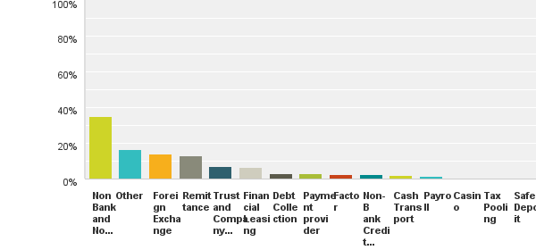
Answered: 308 Skipped: 0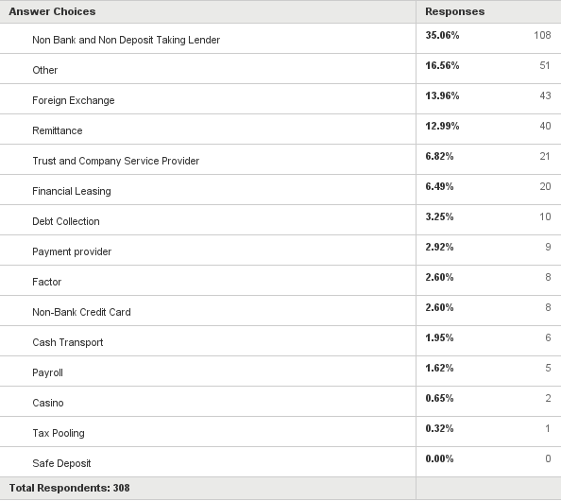
Q2: In which region is your business located?
(If your business is located in multiple regions please provide the region of the head office).

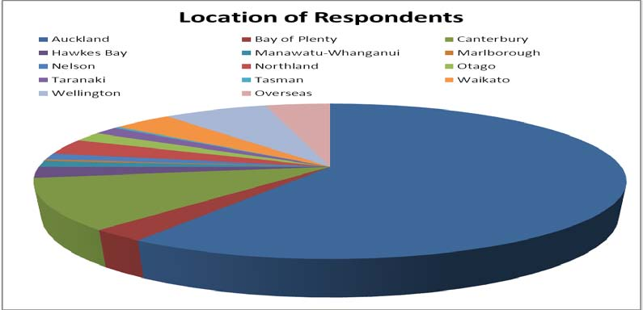Answered: 308 Skipped: 0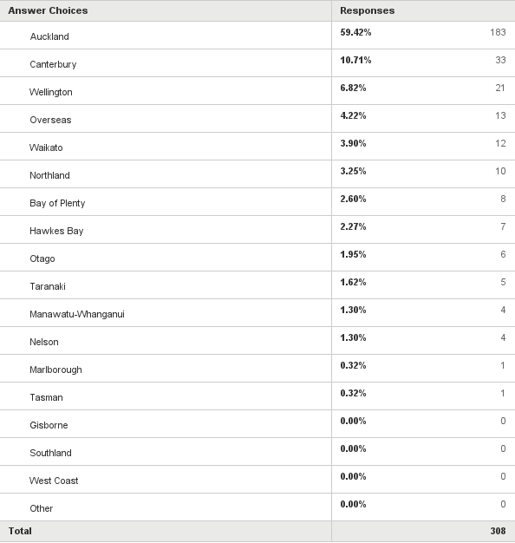
Q3: Is your business a member of a Designated Business Group (DBG)?

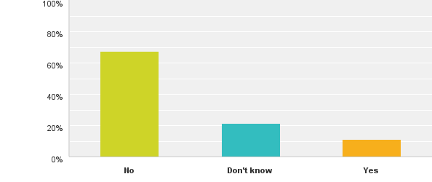
Answered: 308 Skipped: 0

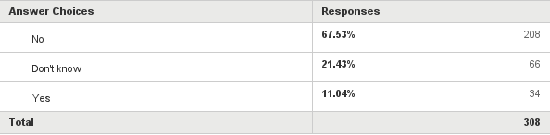

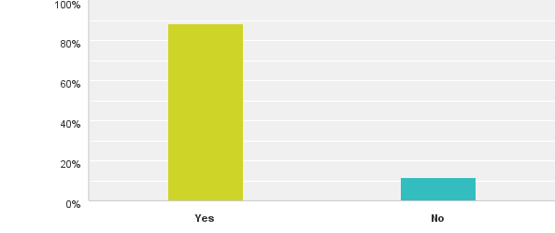
Answered: 304 Skipped: 4
Q4: Have you referred to the Department of Internal Affairs’ website for
information about complying with the AML/CFT Act?

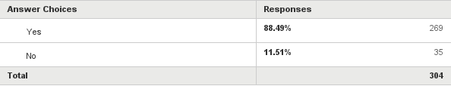

Q5: Please rate how easily you were able to find the information you
were looking for on the Department's website.

1. Extremely easily
2. Reasonably easily
3. Could find some areas more easily than others
4. With difficulty
5. Could not find at all

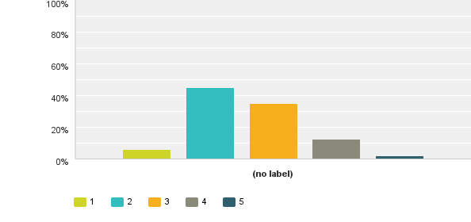

Answered: 267 Skipped: 41

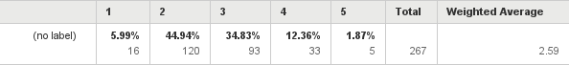

Q6: Please provide any comments on how easy the website was for you to use.
# Responses
- Good
- as our business is quite simple, I can find what I need to do
- Ease was due to simple structure of layout with menu on left side and main section is sections with accompanied links to the main documents such as the legislations
- I found all required information to be found easily especially with the use of hyperlinks
- Department using links to the act and other departments (e.g FIUNRA, ACT etc..).
- The website is very informative and helpful.
- n/a
- Mostly seemed to be information not relating to Serviced Office business.
- Still waiting on finalised information regarding futures/forex dealers. When is this going to be finalised?
- could not gain access to message board or log on to any sites. Could not find any way to speak to someone.
- Easy to find the information I need
- Have a good search button
- I could access the GoAML site through Firefox. When I had an issue with my password, the assistance was expedited. The email notifications allow me to keep up to date in all communications received.
- The whole ACT is complex especially for SMEs -it's a huge overhead
- The links were fairly easy to use but there was too much information some of which was not easy to understand as to how to put the information into practical use.
- The website is structured in a way that is user-friendly.
- Spoke to officers and sent them drafts of my controls, etc
- Quick keys could be better -search
- The AML legislation refers to prescribed forms which I found a little hard to find. However, your staff have been extremely helpful in locating these.
- we are ongoing studying about the website and we always update the information from DIA and NZ Police.
- Didn't appear to be anything aimed at payroll providers
- Please make it more user friendly. Please arrange training program for users to understand what's expected to be fully compliant. It’s new area for us so please need help. Our auditor said that they would like to audit our business so again we do not know what to look for to be fully compliant, unknown, new area for us.
- easy to find what we need
- Easy to use the website
- The font used is good and it is not harsh on the eyes. Colour also great as well. I think it is systematically organised and I like it. Reasonably easy to find things I'm looking for.
- Very difficult to access notices from FIU. Suggest they add a hyperlink to the bottom of the email.
- We have found the website easy to navigate and the guideline documents etc. easy to locate
- Quite simple and easy to browse
- It has improved. Much better visually than before. A little easier to search.
- There are multiple links before you get to source document so relatively time consuming
- The website should be simpler in its grammar
- Confusion is caused through having multiple regulators and then separately reporting to the FIU
- Not so easy to find things as there is the Act plus the additional parts with variations so you have to read lots of material to find out what you want.
- We looked for and found info about getting an exemption.
- Specific areas of the act were not easy to clarification the website e.g Designated Business Groups
- I keep receiving email that there are messages for me (for my business or all businesses ??) but I cannot find them.
- too much information.
- We employed a AMLFCT Act consultant
- If you know what you are looking for, then it's reasonably easy. However to find out whether or not we need to be registered is still an answer I cannot find, so have registered so as not to break any laws.
- I found it difficult to understand information about how to write anti-money laundering policy. I think there should be one template with questions to be used as a guideline when writing this AML policy. Otherwise it becomes challenging, especially with the format. I think there should be a standard format, e.g. A written report.
- The problems with the website use
- Wasn't able to locate any info re annual audit had to phone DIA Auckland. Info slow to be posted to website.
- I thought it was not for business people; a typical bureaucratic product.
- N/A
- A bit hard to find out exactly what is relevant to our business.
- We keep getting these emails when you hit the link who knows what they are trying to tell you not user friendly at all
- The website seems easy enough but compliance to your standards seems very difficult. We were chided for not being 'long enough' in our explanations when we felt we were being succinct. We didn't change much content, increased the font size and made it double spacing and suddenly we were ok!! I think there needs to be a bit more sense around it.
- FAQ Removing of outdated information. Grouping of documents belong to all 3 supervisors separate from DIA. If there is a DIA specific guidance or document, group them separately. Restart the old newsletter to keep REs informed. Share with RE on the common observations found among each sector.
- It was not that easy because this information is all new to us and there were so many items listed. Sometimes we are already reading midway the information only to find out it doesn't really apply to us. So we were hoping that all rules and other requirements will be available under a specific heading like for example us, "Money Transfer / Money Remitters" so that we can just spend time looking at that particular information.
- It is possibly the worst designed website that I have to deal with. Because I only need to login occasionally I find the login process tedious, and very hard to find.
- Straight forward
- Difficult to find answers for my particular situation. Appeared contradictory
- Search functions made it easy to zero in on the information I was seeking
- The information is there easy to be accessed, and we get email for new update information from time to time.
- Would be good to have AML as a link on the home page however I have the AML page set as a favourite. Would be great to have an alert messaging so that when new items appear on a preferred page, an email with link is received.
- From my limited interaction with the website it's been easy to find the information that we require.
- web is easy but law too complicated for small business.
- I personally could not find some documents that were referred to in an email I received.
- It didn't take me long to find what I wanted, and having ability to download forms and guidelines on PDF was very helpful. The guidelines were easy to follow and understand and I think the average person (regardless of culture or ethnicity) would be able to understand the contents in the forms and the guideline documents.
- You need a MBA to understand it... make it easy to understand for the average Jo.
- Content is good and well labelled for ease of searching
- Found it difficult to navigate around the website. Don’t need to go there often at all and that is part of the problem but when I do it’s not very easy to flow around the site.
- I find it easier to search Google for the exact phrases I need to find which then link into the DIA website.
- Reasonably easily to use
- I like the guidelines and other documents - very helpful. I did not know where they were or even existed until someone pointed them out
- normally if I would like to find some AML/CFT related information, I can easily access or google the website link online. I really like the function of search bar. But if the website can contain more case study, that will be great.
- Not overly user friendly

Q7: Please rate the usefulness of the information provided on the Department’s website to assist you in complying with the AML/CFT Act.

1. Extremely useful
2. Reasonably useful
3. Some areas more useful than others
4. Not very useful
5. No use at all

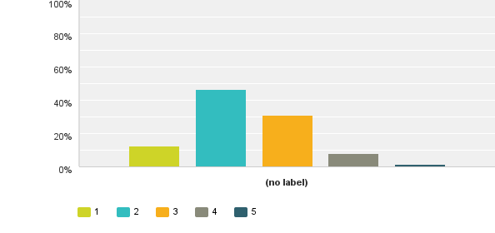
Answered: 267 Skipped: 41
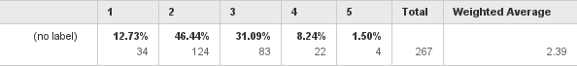

Q8 Please provide any comments on the usefulness of the information on the website.
# Responses
- I am hoping we can establish more information following this survey about DBG
- The website provides useful information that’s useful in assisting in complying
- It will be nice if you can put a AML Programme template.
- Assist with risk assessments and compliance programme, Customer Due Diligence and our manual & procedures
- Easy access, and useful
- Finding specific things can be difficult. Finding the GoAML login page was initially very difficult. All links seemed to talk about it but not actually get to it.
- N/A
- Had to refer to online legislation. I just hope I have got it right.
- the website provide all the information we need to assist us in complying with act
- Easy to find useful info.
11. I find the answers to some of my questions on the website
12.Example of useful information received: Anti-Money Laundering Countering Financing of Terrorism Seminar 2014 Notification to keep date free 10 & 11 July 2014 Te Papa, Wellington Registrations coming soon A Joint venture between ACAMS and the Financial Intelligence Unit
13. It was useful to assist us in understanding what the act was about and compliance requirements
14. Useful
15. Better the Police one which I still contact login to as they haven't supplied me with login details
16. The guidance on identity verification is limited value as it does not articulate how to verify address details. The standard customer due diligence requirements under ss15 & 16 of the AML/CFT Act require address to be collected and verified, yet the guidance is silent on this requirement ?????
17. The website is extremely useful for getting information if you are looking for specific answers to queries. The issues only arises if the business does not perform some of the functions if a procedure mentioned on the website must be included in the manual or if a simple not applicable would be sufficient .e.g if a small business does not have a lot of additional staff how to practically write procedures for training etc
18. Provides us with relevant information. It educates us.
19. DIA is our supervisor, we have to follow all information that DIA provides.
20. Difficulties in finding relevant information for example AML guidelines
21. Couldn't find anything simple for payroll providers
22. Few areas are easy to find, another could spend time looking for information. Do not know what relevant and what's not. Sometime feel what relates to our business and what not. Finally, had to involve Solicitor as Being an Associate Chartered Accountant I could not find all useful information.
23. All the information is there.
24. I've applied some of the information to our business.
25. Quite useful towards preparation of AML Programme
26. The information is limited to guidance notes; not industry specific; limited examples.
27. It seems like whoever writes the info is too scared to commit to their word which makes things vague. This makes things unclear.
28. See previous comment
29. Police dept. letters, Cannot find them.
30. Would be good to have FAQ's and tips and tricks so to speak. Discussion on specific topics e.g.
Customer due diligence relating to FX transactions or Address Verification requirements in relation to different transaction types
31. Sometimes it was not specific when required
32. The information supplied seems to be for large businesses at high risk.
33. I find it somewhat useful but I think it needs to be simplified. It talks a lot about AML but I think the main points should be summarised at the end of the article
34. Generally usefuI.
35. Found info guidelines useful
36. No comment.
37. N/A
38. Relevancy
39. I'm a university graduate, well able to write an essay and understand the complexities of language and I found it difficult to know exactly what you were getting at in some cases. I doubt the people who find English difficult would be able to understand what they had to do.
40. Some information are a little confusing.
41. Far too wordy.
42. Didn't have to use the web-site particularly as most the information was provided by the staff.
43. The requirements are listed clearly and straight forward, so it is very helpful.
44. Useful but some parts require legal background to understand.
45. Some checklists would be handy.
46. Every time I have called to ask questions... You never get to talk with someone and when you do, you get just the basics and not the answer you need. Would be nice if when you call, the person seemed like they want to help... and do help.
47. maybe more hyperlinks would be useful.
48. On the whole I have found it much easier learning from my AML consultants who tend to have information and answers more readily at hand.
49. Had all the info I required
50. Information provided helped for guidelines and report responsibilities
51. The Risk Assessment guidelines would be helpful if there was a more comprehensive list of questions we could ask ourselves about the potential risks and develop a score or rating method. It’s quite subjective
52. some information are useful such as regulation details, guideline, support documents from other organizations.
53. Not very relevant to our business
Q9 Have you had any contact with the Department of Internal Affairs, either directly or indirectly (other than the Department’s website or newsletters), regarding the AML/CFT Act?

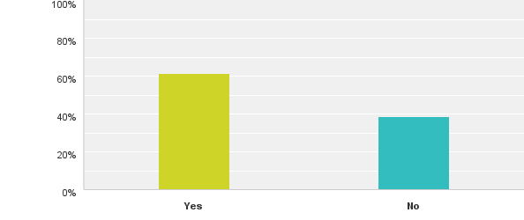

Answered: 301 Skipped:7

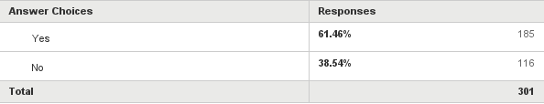

Q10: What type of interaction best describes that interaction?

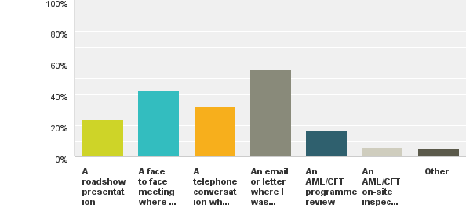
Answered: 184 Skipped: 124

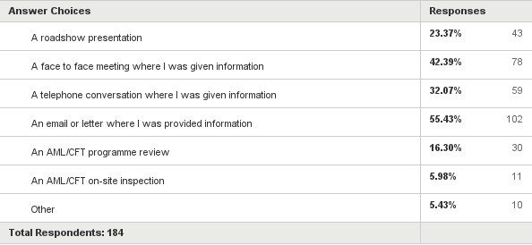

Q11: How would you rate your business’s understanding around conducting a risk assessment to assess the money laundering and terrorist financing risks your business reasonably expects to face.
Please rate as follows
1. No understanding at all
2. Very little understanding of the requirements
3. Some understanding of the requirements
4. A reasonable understanding of the requirements
5. An extremely good understanding of the requirements.

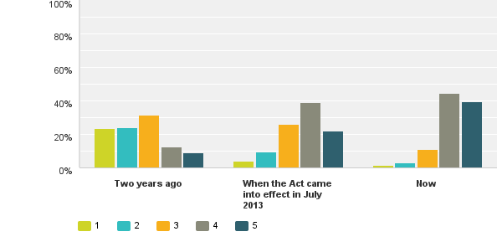
Answered: 294 Skipped: 14

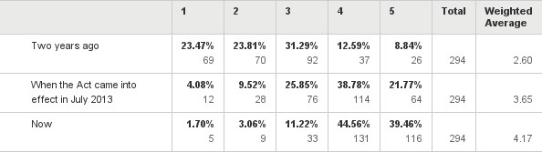

Q12: Do you have any comments about your business’s understanding around conducting a risk assessment to assess the money laundering and terrorist financing risks your business reasonably expects to face?
# Responses
- We don't expect to face any
- with the programme, we have reduced the risk greatly. it is helpful.
- We provide company services, our main risk is one of due diligence on the type of customer, the geographical risks, product risks and service risks.
- Will be relying on a Risk Assessment and Compliance Programme being completed to better understand our requirements under this Act.
- As a Payroll Provider the risk is virtually nil for us. We don't pay anyone overseas, we only pay employees who have a NZ IRD Number and NZ Bank Account so both these entities have already validated the persons and we only receive funds from a company overseas to pay 5 NZ employees.
- We know our client base and the reason why they remit funds to Samoa -systems in place to ensure that AML requirements are met. With the good understanding of our business plus the information found on DoIA websites helped us with conducting our risk assessment to assess the money laundering and terrorist financing risks that our business reasonably expects to face.
- Not sure how to do this.
- AML/CFT legislation was enacted in the jurisdiction of our HQ back in 2010 so we have good experience and systems to comply with AML regulations
- We obtain solicitors advice with respect to shedding light on grey areas.
- Have DIA contact companies advising them who they can contact and ensuring the company has all relevant info as the Act relates to our specific situation.
11. An assessment has been done as best I understand it.
12. The organization may be directly impacted on if it commits violations of, or non-conformance with laws, rules, regulations, prescribed practices, internal policies and procedures, or ethical standards and this corporative behaviour may lead to a reduction in revenues by way of significant fines imposed by the Regulator for non-compliance with the Country Regulatory requirements
13. We have completed a risk assessment with specialist legal assistance.
14. My business could reasonably expect to face no risk of money laundering and absolutely no risk of terrorist financing
15. Minimal exposure as we loan a maximum of $50,000 and we only loan to Maori NZ'ers that are going to conduct business in NZ. We also keep a close relationship with each of our clients.
16. Officers very helpful in checking my documents. As a result there were a lot of things that I needed to do and these have been done. I have approached an independent audit Company to check our procedures before the Department audits
17. We lend money that is privately owned -we don't have any director or investors -it is just personal money, so most of this doesn't seem to affect us or relate to us.
18. My Lending business does not have any clients capable of money laundering. Most are small loans to pay school fees etc paid off over long periods
19. no, but just follow the law.
20. We would presume we are very low risk and don't understand why we are being targeted.
21. Compliance with this act requires a lot of reading, a lot of understanding of what is required for a business that has very low money laundering risk. This comes at a significant cost. Whilst we acknowledge that there is risk there, for our business this legislation and implementation is a sledge hammer to crack a nut.
22. I would like some examples to help me.
23. As a lender to the local community, our business obtains all relevant personal information to conduct a rick assessment, not only for the AML / CFT, but to protect our own business.

24. We have used expert Solicitor in this area to implement looking at our understanding around this area. We will have them doing the Audit during 2014-15 financial year, to have best practice review and assess our understanding across industry.
25. We understand exactly what is required by Act, and follow what is set out accordingly.
26. Given the relatively small size of our business, the capacity to complete the task, and the skill set required to complete the task, we commissioned external consultants in this field to assist us. This was great investment and resulted in a more comprehensive and professional assessment and resultant program.
27. we are always do the KYC as the basic to do the business.
28. Extremely good knowledge about Risks in New Zealand -would be keen to share with regulators
29. The assessment and review of the level of risk that remains challenging
30. get rid of the gobbly gook highly intelligent grammar and write everything in layman's language so it is simple and clearly understood. How can we work towards protecting our country and people when we don't really understand everything? The road show I went to seemed like a banter show for Oxford scholars showing off how clever they were by talking in a way that was too intelligent for me to learn from and I consider myself smart, sharp and clever, run my business too. I am not trying to be critical but merely offer this as feedback so that you may learn and help us all better. Please simply talk and write so it is easy to follow and understand, there is no need to complicate things just to make yourselves look flash and clever.
31. As we also fall under Australian jurisdiction we are very familiar with AML requirements
32. We have invested a lot of time and money in building up our capability to ensure that we understand our requirements.
33. Being part of a franchise group it has been confusing whether or not the franchisor can deal with certain points or franchisees individually
34. the additional screening & information gathering in relation to clients has improved the quality of our lending risk assessment
35. My business got clear picture of how to comply with AML
36. Just the format
37. We had experienced AML regulation via Australian parent, so were reasonably prepared for implementing our AML risk assessment
38. I only lend to close friends and family and am a one person company so believe there is near zero risk for me
39. Waste of time for a small NZ family business
40. In my 40 years in this business, I have never met a terrorist. In my opinion, the system is designed to protect the country where it is not even attacked.
41. As head office in in Australia, we were already familiar with Risk Assessment techniques to meet our Australian AML-CTF obligations.
42. The issues we currently face almost on a daily basis are around the identification of trustees, including professional trust/trustee companies. Majority of professional trustees are either accountants or lawyers who refuse to provide information for us to comply with the guidelines set out. We do not want to be losing business because of this, is there any further guidance on this? Is there any plan to send out information to lawyers/accountants in regards to this?
43. we are a simple business well controlled by another entity above us so compliance and understanding are fine. For the things we do ourselves, we have excellent procedures and so have not found it difficult -our understanding what we have to do to be compliant -difficult. However as I said our business is very very simple.
44. If you could send out a programme sheet in simpler terms than the act of our requirements We would also be very open to an agent of the Dept calling in to discuss our obligations etc so it is clearer in our minds than just reading the Act which is in legal terminology
45. The ongoing question is how do you define "reasonable".
46. Most of our knowledge were still induced from third party independent consultants. DIA was helpful only as a guidance.
47. It would be helpful if the Dept of Internal Affairs had a more robust template system like some of the other Authorities that are looking after businesses. Whilst I understand the need for independent Risk Analysis in order to individually address the issues and write relevant policy/SOPs some better guidelines would streamline the process and make compliance, especially for SME's (who are time and people short) a lot more simple.
48. Feedback from DIA is that we did well with our Risk Assessment document but we are aware that it still needs refining and are working to improve it now with some outside consulting to assist.
49. NO. We are a franchise, and our head office has helped us in this regard
50. We employ a third-party to perform our risk management.
51. It is good to have this assessment, and in some way it is a good protection for our business.
52. Typology reports are very useful to aid practical understanding and provide examples for training.
53. Our business does not have any immediate regulatory requirements in relation to AML/CFT however in-time we will and our proactiveness in getting staff educated is paying off. It's a very important piece of the puzzle, and with a programme and risk assessment already completed we have adequately prepared ourselves for what is to come.
54. Wish this can be simplified
55. This was made easier for us as the parent organisation had been subject to the Austrac regime for some years and we had previously been applying the Austrac regime to our NZ business. The NZ risk assessment was in fact more detailed than that required for Australia and took some time to complete and ensure it met the requirements prescribed by the Act. We are having our first post implementation external independent review of our NZ program and Risk Assessment completed at the moment and expect the result shortly. Early indications are positive.
56. We have a clear understanding of the potential risks that we can expect to face. In the immediate future and having to do further assessments going forward as our business develops
57. We can usually determine who is trying to launder money. e.g. We are a small business and we get asked to recover a $200,000 debt for an overseas creditor and then we get an unsolicited email from the debtor saying he knows we have been asked to collect the debt
58. We are debt collectors and do not believe money laundering or terrorist financing affects what we do.
59. The risk assessment guide could be more comprehensive. From the DIA and other websites I see there are a lot of companies in the same category as us, that is non-deposit taking lenders. Many are small organisations and guidance in this category would help many become better at preventing / recognising money laundering. It would also be good to have a training guideline for employees. Code of practice or similar. I know there are organisations who sell and support these requirements, but DIA could offer more with best practice guidelines. Another thought is to have a scoring or rating template where each risk factor is rated and scored. Total score would then be indicative of the level of risk
60. I can say that without the assistance of a 3rd party AML consultancy firm, I would have found it extremely difficult to get a grasp on exactly what was expected of my firm. I contacted DIA numerous times for guidance on my specific business group (Company formations) but they had none available for me. The 3rd party firm I used was able to explain and package up a risk assessment and compliance program that I could understand.
61. Question 11 is poorly designed. In questions 5 and 7, a rating of 1 is "good" and 5 is "bad". You should use the same basis for all questions otherwise you are likely to get a number of people filling out the survey incorrectly.
62. Comments: In reality the type of lending conducted and repayment of money (which is carried out electronically) the legislation and annual reporting is an over kill for the size of our organisation. Annual reporting and compliance requirements should of been scaled for each sector, size of operations and the type of a business operation/ methodologies -these factors should be considered and should influence the reporting requirements DIA place on small businesses.
63. It would be good to have simple/layman's terms and guides around this. Everything just refers to the act which can take some deciphering and can be subjective
64. that will help us to easily to understand what the potential risk during operating the normal transactions for customers so that we could set up a efficient compliance program to train the staffs to make sure we exactly follow the AML/CFT act.
65. We have complied with the Australian Legislation since inception.
Q13: How would you rate your business’s understanding of developing and regularly reviewing the AML/CFT Programme for your business?
Please rate as follows
1. No understanding at all
2. Very little understanding of the requirements
3. Some understanding of the requirements
4. A reasonable understanding of the requirements
5. An extremely good understanding of the requirements

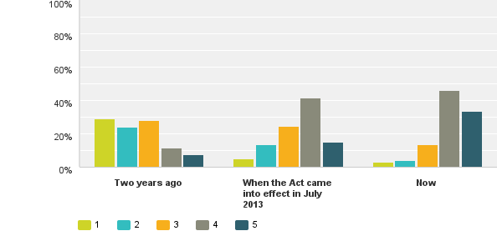
Answered: 292 Skipped: 16

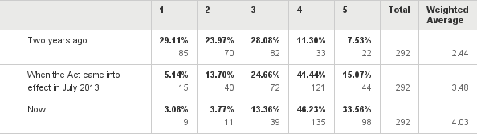

Q14: Do you have any comments about your business’s understanding of developing and regularly reviewing the AML/CFT Programme for your business?
# Responses
1. Have not had any problems
2. We have a AML/CFT Programme -as we have yet to have an independent audit, we are concerned and we certainly look forward to any input to confirm we have complied
3. Once a Risk Assessment and Compliance Programme is completed, we will be better able to review the findings for this business.
4. No
5. NONE
6. Regular review of our risk assessment, Compliance programme, Customer Due Diligence, policies and procedures, staff training
7. My business is really simple to complaint the AML/CFT Programme
8. No
9. Two years ago we had little idea what was required. When the act came into effect, we had a programme, but we were tentative about how to review it regularly. Now we are learning and understanding much more as we go.
10. N/A
11. none
12. No, not at this time
13. No, I do not
14. No I don’t have any questions
15. No
16. No
17. have user expert so hope we have followed correct process.
18. I understand the all the procedure regarding this matter.
19. We understand what has to be done.
20. no
21. Going forward we would again rely on consultants to assist us with the process.
22. Have great understanding of the AML/CFT Programme
23. We actively review procedures
24. write your rules in simple to understand language.
25. See previous response
26. We have an exemption so we will look at this again when our situation changes.
27. comments previously apply.
28. As we are currently being reviewed, I guess this will answer my understanding level.
29. I think there should be a calendar of events such as reviews sent out to every business owner to let them know the key dates when to produce their reports and in what form these reports should be. Will someone come on site or the director will be required just to produce a written report, etc.
30. Will evaluate after first audit
31. Likewise, we had had experience of AML compliance via our Australian parent. We have a better understanding now having engaged external consultants to run a gap analysis on our risk assessment and programme
32. We attend many seminars internationally and they are becoming less and less useful. In my opinion, the authorities should not employ any recent graduates but only people with serious experience.
33. Refer previous comments.
34. We have not completed a review or the annual audit as yet, so understanding the requirements will be better after that
35. we know what the requirements are and how often we need to review them
36. No
37. Thanks to our lawyers we get a very good understanding of the importance of review and all requirements re AML/CFT
38. No
39. No
40. None -straightforward
41. It is complicated, but it is very effective and necessary.
42. Aiming for annual review or more often as required
43. There is no clear guideline that I can see... It would be helpful if you could put together a question and answer sheet (booklet) for basic businesses (small) . I know I need an AML Risk assessment done but where do you get the questions and template for this??
44. No
45. see earlier comments
46. Our business is in a highly competitive market and to set ourselves apart from the others we have taken to do quarterly reviews and annual audits to prepare us for the biannual audit as required by legislation. The reviews have been highly beneficial for the growth of our company in cementing our relationship with not only the DIA but the banks who have taken a strong stance with money remitters. We, like many stood to lose our small family owned business, we never want to be put in that situation again hence our vigorous plan to ensure we are above and beyond of what is expected of us. Our company believes in hindsight this law is just want companies like us need, to set us apart from the 'mickey mouse' operators who unfortunately are still out there operating.
47. I don't believe it applies to our business in any way, shape or form
48. A guide or template we could follow to set up a programme would be useful. The published guideline is satisfactory but could contain more details or appendices with templates
49. Once again the compliance is an over kill for a small electronically based finance company that deals in an homogenous financing
50. We will keep in touch with Internal affairs staff and try to get the latest information or news from email, website or FIU. Meanwhile, combine with the risk assessment review, we are able to adjust the rules that in the compliance programme to suitable for any current law or business changing situation
51. We have regularly had our Australian program independently assessed as required since inception of the Act.

Q15: How would you rate your business’s understanding of the information you need to provide in your Annual Report to the Sector Supervisor? (i.e. DIA)
Please rate as follows
1. No understanding at all
2. Very little understanding of the requirements
3. Some understanding of the requirements
4. A reasonable understanding of the requirements
5. An extremely good understanding of the requirements

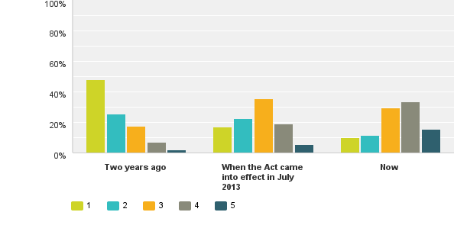
Answered: 291 Skipped: 17

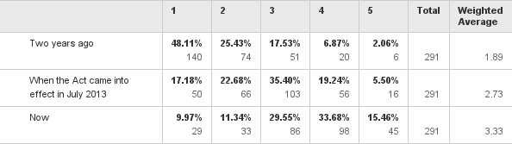

Q16: Do you have any comments about your business’s understanding around the information you need to provide in your Annual Report to the Sector Supervisor? (i.e. DIA)
# Responses
- Once again no problems
- for some very small scale business, please simplify it.
- After spending much energy getting the Programme into operations, we have left little time to prepare for this task.
- Review of certain requirements outlined in the annual assessment, may require input from council to ensure most appropriate response are provided.
- Have a reasonable understanding around information that we need to provide in our annual return, the website provides details of required information and if there is anything that we are not sure of then we will contact the Department of Internal Affairs for assistance in completion of our annual report
- don't know
- We expect to complete the report in conjunction with our review. We will conduct further research and obtain advice on this closer to the time.
- Contents of the annual Report are contained in the legislation and we recently received and email notification regarding the requirement to file the Annual Report and a link to the Annual Report questions.
- This is a fresh challenge for us.
- When I met the auditors form the DIA I got very good understanding of the requirements for the annual report.
- Have yet to complete so until I work through difficult to give a positive response
- none
- Can we have a template please!
- No I do not have any comments about my business' understanding around the information you need to provide in your Annual Report to the Sector Supervisor (i.e. DIA)
- I will have to search online to make sure there have been no changes and we are current. I think this info should be condensed and regular emails sent without having to log on
- We have no idea what this is
- We understand the Regulators will put out guidance on the Annual Report?
- Actually, not clear what is required as we maintain a lot of information, but what is expected to be provided, not sure.
- We have read all documents pertaining to the Act by the authority.
- Yet to go through the exercise -watch this space!
- We have only recently received information relating to the annual report and still await issuance of the guidelines.
- Once we have gone through the process after the first year I think we will develop a better understanding for the next year.
- Lot of duplication
- write the rules simpler
- The annual report cannot be submitted until after 30/6 and further information is still to be provided by DIA
- We have yet to prepare our first Annual Report to the Supervisor but have a reasonable understanding of the requirements. We would expect to develop a more in depth knowledge of the information required following completion of the first report later in the year.
- Yet to be reviewed in depth
- As we have an exemption I don't think we need to do this.
- Controlled by our Corporate Counsel division in Australia
- Not applicable -have an exemption
- AMLFCT consultant helping with the report
- I would like to have a summary of the information I need to provide and by what date
- We will be further up to speed with this point as the annual report date comes closer
- This is an area where we feel exposed in terms of information, as we do not have the same obligations under Australian law. We took some comfort from the DIA's announcement this week that some further guidance will be issued shortly.
- I think we meet all international requirements but I believe that reporting on it is a waste of time. We should have our own responsibility and not depend on government people who have no practical experience.
- Compared to the Australian requirements, the New Zealand annual report seems to go into much deeper detail. It almost seems like the report is not so much a declaration of compliance with the requirements, but more a fact-finding mission for the regulator to figure out who it is regulating.
- No understanding then or now
- this has been news to us. maybe we didn't notice this at first as obviously it was there, but when you are a tiny business without much staff resource, extra compliance is just enormous. I look forward to finding out what the requirements are.
- Please send out what is required via email in simple terms
- Still a bit hazy because we have not received any guidelines. We were hoping DIA can provide a series of seminars to be able to explain what are the key things needed i.e for a business like us; moneytransfer/remitter service.
- There are still some uncertainty on specifics of the annual review that will be introduced after june 2014 this year.
- Waiting for further instructions on how to submit Annual Report.
- It would be good to see an example of what a report might look like. Or even a template
- Our understanding is that the contents/questions to cover in the Annual Report will be very similar to that of a Risk Assessment.
- We have never done this Annual Report before, so not sure what to do.
- Whilst recognising the need for the sector supervisors to have an overview of each sector, in time some consideration of alignment of reporting to entity balance dates would be beneficial for those in the sector to reduce additional work and to enable alignment to audited/management accounts for the financial sections of the report.
- I have no idea what to provide, this is the first I’ve heard of it.
- Some sample documents or templates would be very useful.
- Had forgotten about the annual report requirement.
- From the get go, DIA had been vague with information to help us when we were preparing for the legislation. We knew this was well over our heads and specialised assistance was required. We hired a consulting group who to date we are still enlisting their help in refining our services. Our understanding of what is required of us was from the help of this group and not always from DIA
- I doing what you are asking me to do but do not believe it helps you or me in any way
- A template for what is required in an annual report would be useful, especially by business category. The legislation provides some questions to be answered. If there was a template we could complete it would make it easier for both us and DIA
- Annual reporting over kill for smaller organisations
- No comments or concerns at this stage -still early in the process of reviewing what needs to be supplied and working with my AML consultancy firm over this.
- according to the law, I know the business has to provide the annual report to Internal Affairs. But this is the first year we make the report; we do not have any experience that how we should do it. I hope we can get some further support on the structure or a template we can follow.
- We are aware of when we need to submit it and that's about it
- will know more once we have done one
- We are exempt from providing information

Q17: How would you rate your business’s understanding of the requirement to submit Suspicious Transactions Reports to the Police Financial Intelligence Unit?
Please rate as follows:
1. No understanding at all
2. Very little understanding of the requirements
3. Some understanding of the requirements
4. A reasonable understanding of the requirements
5. An extremely good understanding of the requirements

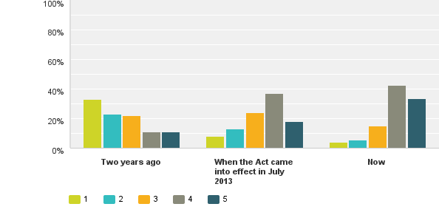
Answered: 291 Skipped: 17
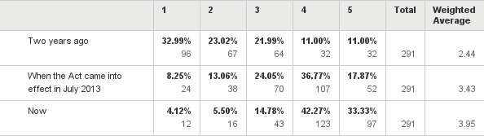

Q18: Do you have any comments about your business’s understanding of the requirement to submit Suspicious Transaction Reports to the Police Financial Intelligence Unit?
# Responses
- So far we have not had any
- We are certainly aware of the process required to file and STR and the reasons we would be required to file an STR
- Again, once a Risk Assessment and Compliance Programme is available, this business will better understand its requirements.
- No
- no
- AML/CFT Risks in the Money Remittance Sector -The Financial Intelligence Unit Risk Assessment 2010 (FIUNRA) identified the use of wire and transfers to transfer the proceeds of crime from one person to another - via money remittance services as the highest risk AML/CFT area for New Zealand. We have a good understanding of submitting a Transactions Reports to the Police Financial Intelligence Unit
- We very understand
- Though we haven't actually had need to submit Suspicious Transactions, we understand the requirement
- N/A 10.none 11.Pursuant to Section 41 (1) of the AML/CFT Act 2009 the prescribed form for STRs and the means by which they are to be submitted to the FIU is goAML Web. From 30 June 2013 goAML Web is the only means by which the FIU will accept suspicious transactions reports. Any reports submitted by other means after that date other than as provided for in Section 41 (2) will returned to the Reporting Entity. This facility is available to all Reporting Entities as defined in Section 5 of the Anti-Money Laundering and Countering Financing of Terrorism Act 2009 and Financial Institutions as defined in Section 3 of the Financial Transactions Reporting Act 1996.
12. no
13. Do you have any comments about your business's understanding around the information you need to provide in your Annual Report to the Sector Supervisor (i.e. DIA) 14.No 15. Not applicable to my business
16. No
17. I had once before and report it to the police.
18. No
19. Have not had any transactions that exceeded the trigger as per our policy therefore have not required to submit any. Given the nature of our business this is fairly low risk (as identified on our risk assessment)
20. Go AML system -at times quite unfriendly
21. Still difficult to assess the level/threshold for forming the STR and the level of reasonable enquiry required to reach the conclusion
22. We have made a STR to the FIU
23. We have not had the need to file any Suspicious Transactions Reports as yet, and given the limited spread of the lending activity we undertake, and the limited nature of our client base, we believe it is quite unlikely we will have to do so in future, but we remain watchful to ensure this remains the case.
24. The process can be lengthy and unforgiving. Won’t let you upload data using a common template. Only allows XML which is out of reach for non-bank/ non-corps as the pricing is extreme
25. Yes that's reasonably clear
26. If the occasional arises to make a suspicious transactions report we will more closely at this aspect
27. Nil
28. We have a reasonable understanding of the types of transactions or behaviour that would trigger a report, however, as we are yet to submit a report, we have some concerns about how easy the FIU website will be to negotiate.
29. I have never had a situation where it was necessary to report. In principle we do not deal with people who deal with "criminal" resources. They do not come to us anyway.
30. The web site and setup to enter data for suspicious transaction is appalling.
31. Because we do not deal in cash, and our products are low risk, we rarely need to submit STRs. So, it's more a matter of gaining experience.
32. no, it's very clear what we have to do.
33. No
34. We have submitted STRs but i think it would also be good if we at least get updates on what has been done about it after sometime.
35. Some further guidance on what constitutes a suspicious transaction would be beneficial.
36. No
37. No
38. GoAml system took us a while to get used to.
39. None
40. general comment not specific to me: entities are doing their bit sending STRs but all they seem to get back from the Police FIU is heavy handed emails criticising the quality of the information. I have not had to complete an STR yet but it seems that if most entities are getting it wrong the process is complicated and onerous and proper training has not taken place
41. Fine with the understanding of the requirements however ease of use of the goAML tool means that the process is very time consuming and can result in rejected STRs.
42. No
43. Know we have to do them. Know the theory behind them. Eg, how to complete them etc but haven't had to do one yet and don't envisage having to do one in the near future based on current business plans.
44. The FIU have been brilliant with assisting us. Their feedback on our rejected reports have been helpful. I have also spoken to them a few times on the phone and via email and they give me the confidence as they come across as patient and understanding.
45. Not applicable to our business operation
46. After working for Lawyers as a Debt Collector for ten years and then working as a self-employed debt collector for the next 16 years, I have never ever had any transaction which was in the slightest way suspicious
47. Herein lies the main issue I have come up against when sorting through material and understanding the requirements for my firm. My firm deals in the establishment of new companies for NZ and Australian residents - it is not involved in the movement or transfer of any funds. When I did have a suspicious transaction to report, I wasn't able to use the goAML system at all because virtually all of the questions related to the source and destination of the funds etc. After making contact with FIU, they gave me the email address of somebody within MBIE who I am to email directly with any suspicious dealings I may come across. I've been left to presume that this is the formal way I should be notifying STR's going forward as I have not heard anything to the contrary.
48. In the last year we have had no suspicious transactions
49. we will check customer ID and try to find out what the true purpose of the money transfer. In the compliance programme appendix, we do summarise some suspicious activities and train the staffs. If we found any individuals or business partnership could not explain these transaction details; we will report to FIU as soon as possible.

Q19: Have you viewed other sources of information to assist in understanding how to comply with the AML/CFT Act’s requirements?

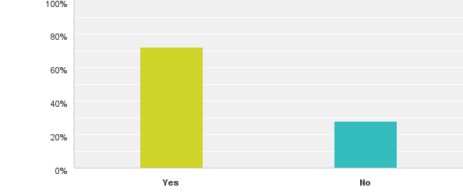
Answered: 291 Skipped: 17

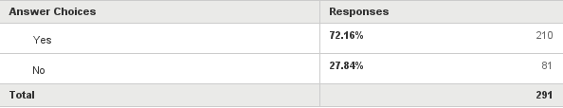

Q20: What other sources of information has your business used to assist in understanding how to comply with the AML/CFT Act’s requirements?

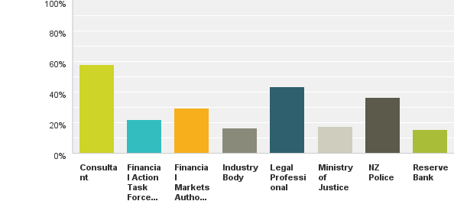
Answered: 207 Skipped: 101

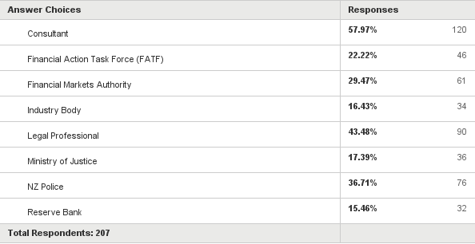

Q21: Please record any other comments in relation to your experience of gaining an understanding of the reporting entity requirements under the AML/CFT Act.

# Responses
- The task has been overwhelming and has heightened our concerns. We have attempted to comply and maintain constant efforts to ensure we keep abreast of changes and requirements.
- None
- NONE
- With the high risk -we have put systems in place to ensure that we have information for all our clients that remit funds through our service -report any suspicious transaction that comes thru our business to report to (FIUNRA) -review and audit our risk assessment, policies and procedures
- It is a very good source of info.
- no comments
- The legislation is not written for trust service providers -it is a one-size-fits-all for financial service providers and we are trying to make our clients and transactions "fit" into the reporting requirements for transactions. Are limited partnerships covered by the legislation?
- It was very very time consuming / months & months of work creating the full programme and risk assessment to ensure it met Audit standards and requirements and for the Bank to accept. Once in place and being processed it’s all good
- I often feel the DIA could have been more hands on, helping smaller companies like mine comply, rather than leaving us to make our judgments entirely, and or spending a lot of money on consultants or lawyers, and ongoing screening and reviews. Compliance is expensive, and counter-productive. The cost must trickle down to the consumer eventually.
- N/A
- I believe my operation is low risk as the requirements were already in place in order to minimize losses.
- I attended most of the seminars that was held by DIA. I read many seminars on the internet. I met a lawyer who is specialized in AML. I looked at most of the websites of DIA, Ministry of Justice and police in regards pf AML/CFT and finally I used a proficient company who are specialized in AML to help me with our AML program and to inform me about any new updating.
- We do not have any further comments at this time
- The AML/CFT requirements are not applicable to my business
- As a direct result of the ANZ’s so called "Anti Money Laundering obligations" we have been refused services that are fundamental to our business... This is the impact of this legislation where faceless individuals can inhibit payment system innovation and businesses simply because in our view they do not have any capacity for discretion in relation to any proposition - we too are subject to AML obligations and other legislation. It is ironic that two organisations, both equally regulated, cannot efficiently exchange transactions. The ANZ bank (as do all other banks) has obligations in terms of the provision of and efficiency of the New Zealand payment system. Under the guise of AML /CFT the ANZ is withdrawing payments services in a way that a cynic could interpret best suppresses innovation or at worst is anti-competitive. We do not believe the intent of this legislation is to suppress legitimate commerce but in our experience that is exactly what is happening … The ANZ Bank “aggregates” transactions the same as our company “aggregates” transactions yet it’s because we aggregate that the ANZ will not provide services – you work it out…..!!!
17. Public awareness is low as no one had a budget for informing the public. Educating the public would have improved our customer acceptance with providing the information required. Customers with Trusts found the questions intrusive.
18. Need regular road shows
19. We feel that the Act has limited flexibility for varying business models. We feel that our business while we are in a high risk area of overseas payments, that our model has a lower risk as we use the bank systems for clients to pay us & for us to do our pay away & we don’t accept or deal in cash. Basically any single payments through us are getting checked by the bank when our client pays us, we do our checking on it, then our bank is checking it on the way out. This is triple checked which is twice more than a retail bank would do. Some scope for flexibility here would be great.
20. The person I spoke to on the phone was very helpful. Maybe someone to speak to directly is better than a generalised answer on the net
21. We are a small business of 2 staff and the requirements to meet the new regulations and reporting requirements places a huge strain on our resources.
22. We get notifications that messages are on your website but have not been able to access them. Very difficult to use.
23. Our exposure is limited to some guests who exchange foreign currency with us which is very small and in most cases less that NZ$300.
24. The compliance cost for this legislation is very high. There has been no recognition nor offers of easier ways to deal with this risk for low risk businesses such as non-deposit taking private lending businesses. We acknowledge that risks exist, however there needs to be very simple and easy processes the DIA could develop for low risk businesses. One sledgehammer does not fit all. What also needs to be acknowledged is the raft of compliance that all in the finance industry has been subjected to over the past 3 years. We understand that government wants to be seen to be doing things for both an international audience as well as domestically – where losses have occurred. In reality despite the huge compliance costs on the industry and the consumers there will not be significant gains.
25. It would be really helpful if the DIA provided practical seminars to reporting entities
26. Hasn’t been pitched at payroll companies. We are dealing with what comes up.
27. Need more training from the actual source, who is requesting us to comply, without adding further cost to be compliant.
28. I understand all the requirements by AML/CFT Act.
29. We understand the measures to take regarding the Act.
30. Far too complicated for small businesses any communications received from you are more of a direct order bordering on threats – does not encourage continued communications from us your levies are excessive – around 3% of our total profit. You need to look at the way you treat small business if you want cooperation from them.
31. It is complex and takes some digestion. I expect to gain knowledge through experience but I think this will only occur after I have compiled several annual reports. I have not needed to lodge a suspicious transaction report but have read feedback and it appears quite complex as well. Again knowledge will grow if required to do so regularly but hopefully the preventative measures we have in place will negate that and so it will be hard to gain knowledge in that area.
32. 1 - Enhanced customer due diligence required for certain transactions requiring suspicious transaction report
2 – Additional information about beneficiaries of trusts
3 – Other identifying information prescribed in relation to wire transfers.
4 – Details to be contained in written suspicious transaction report
5 – Prescribed form for annual report under section 60 of Act
6 – Prescribed form for formal warnings.
33. Quite comprehensive – good understanding
34. Needs to be better dissemination of the law to consumers around the requirements and how that effects them so that particularly staff implementing new processes don’t get aggressive negative responses. Complete change to NZ approach around privacy.
35. Am about to complete our first annual report so expect to be more conversant after that
36. It is my intention to write a user friendly manual to assist business comply so any helpful info would be of use and a contact person to liaise with as I develop this manual so I can ensure it complies with requirements. I have done the same with privacy compliance and market our own Privacy compliance manual to businesses. I am also working on the same for Fair trading Act compliance manual.
37. We have experienced some difficulties in customer due diligence processing, particularly around trusts and identifying trustees and beneficiaries
38. A education road show as was done with the PPSR system was very good and informative whereas the introduction of Financing of Terrorism has been non-existent. My biggest problem are letters from police, in your letter box. If they wish to send me a letter why can they not attach it to the advice they have just sent!!!
39. There is too much reporting for the level of AML risk
40. I believe I am in a low risk category and also a small business. Information tailored to these requirements would be helpful.
41. Industry need to be audited in a quicker pace, so that we can apply to Banks for better banking facilities
42. I think that there should also be qualified help by phone, because when in doubt when reading the AML requirements you should be able to call a professional and get clarifications. My experience shows that it is quite difficult to get hold of someone who has good understanding and can explain things about AML
43. It would have saved time and effort if some of the regulations had been put in place earlier. Possibly nothing to do with Internal Affairs
44. Target the bad boys and stop wasting time
45. I think the compliance cost is too high.
46. The documents released to read must have been written by lawyers. They are not that easy to follow or understand
47. N/A
48. They are very onerous for small businesses. We realise they are necessary and we received very good help from DIA personnel for this, but it doesn’t make it any easier in terms of staff time
49. Please issue an online AML/CFT Training for all REs. Do not rely on the commercial sector to “sort it out”. There are those that do not have the budget or resource to issue training for a large number of people. For example, AUSTRAC has an elearning piece that is specific to their AU environment. I see this as a must for the AML/CFT supervisors.
50. If we could have our requirements listed in simple terms on a spread sheet or similar we could easily follow the requirements. One answer we can’t get is who is appropriate to audit us biannually!
51. Well, at this stage it seems there are so many things to do and it’s a bit overwhelming especially we don’t know what to expect and what is expected of us. Hopefully, as requested a series of seminars will be provided for some guidance of completing an annual report.
52. It has to be said that when dealing with a particular staff member it was a pleasure. He was prompt and thorough with his guidance. Since his departure I am met with silence whenever I try and submit an enquiry to the DIA AML/CFT team.
53. The one comment I have to make is that the emails I get from FIU_NZ@police.govt.nz telling me that “this is a notification to inform you that there is a new message for your agency posted on the goAML message board” are extremely annoying. I have to go through the convoluted OTT login process to get to a message that tells me the system is going down for 1 hour. Duh! Who cares!! Just send me an email saying the system is going down. This is network security gone made.
54. As a small organisation we found the experience very time consuming and although the Internal Affairs staff were friendly we did feel that things could have been better explained. We felt as though we were being used as a “test” for the system of business compliance, which would have been fine if we were told up front. Things that were said that would happen did not happen. An example of this is: We were asked to put our first draft together of our Risk Analysis Programme and send it through for comment prior to 1 July. We did this in good faith as we were told it would be reviewed for comment (to make sure we were on the right path) and then we could make arrangements and finalise. This “very much draft document” was not reviewed but instead was used as our final submission which was clearly not what we intended and did not meet the necessary requirements under the Act. We were asked not to make any subsequent changes. As the document clearly did not meet the requirements (it wasn’t even finished) – the Dept., subsequently requested an Audit of the business giving just a few days’ notice – this was extremely inconvenient timing due to Christmas and other obligations our business had to our clients at this time for payroll and other operations that needed to be completed prior to the vacation. We subsequently were audited at the end of January, but were being audited against our draft documentation written some 7 months previously – procedures had changed during this time as our understanding of the Act had increased dramatically but we had to “learn” this ourselves rather than from a review and correction of the initial draft document. Within this timeframe we had also implemented a Google Site with all the new information on which had also been submitted to Internal Affairs. The audit, which was against a draft document from 7 months ago clearly showed “fails” which is not surprising. We just felt it was giving the two staff members an opportunity to validate their system for review and wasn’t really about what we as an entity had done and were doing. Anyway, to cut a long story short – all employees here are very aware of our obligations under the AML/CFT Act, but we believe this could have been handled better and consideration for small organisations should be taken into account. Thank you for doing the survey.
55. It is a lot of work to put the programmes in place for a small business. Set up costs were costly. Ongoing vigilance takes time and for a small business that does very small value transactions it is an onerous requirement. We have to do all this extra work and incur extra costs for no financial return. Entities are basically acting as pseudo defacto police without the police salary. There is no recognition given or appreciation shown for all the contributions entities are making. The DIA have been awesome with their training and knowledge and pragmatism.
56. Our head office (we are franchised based) has been very helpful, ensuring they have supplied us with the information, and given suggestions on how to comply. Otherwise it might have been a bit complex for a small operator. To register for email alerts on your website is a pain, as it requires chrome. Otherwise all ok.
57. Timing of supplementary guidance has often been once development has been well underway. Welcome guidance on annual report however to allow businesses to build this into reporting: early release is needed.
58. We do understand that AML/CFT, especially CFT is very important for either national security or citizens but make it so hard to even open a bank account is another story! I do believe that making good rules for banks is efficient but ask banks not to open financial company accounts is ridiculous. If we can’t even open accounts, why do we need to AML/CFT Act?
59. We are still unclear how to file our reports i.e. online or hard copy and to whom should these be addressed to? There is no clear link on the DIA website leading to AML/CFT information.
60. A template to help people fill in the risk assessment and another template to show a timeline for what need to happen and when….
61. Our experience in gaining an understanding of the reporting entity under the Act was one of sheer frustration. We under the supervision of the DIA were doing our bit to comply, only to have the banks set out their own compliance requirements, to the point of certain banks (ANZ) taking a DKYC (Don’t Know Your Customer) approach, and, Don’t Care mind set. We know the Act would work for companies like ours that takes compliance seriously but the time and money we had to invest in keeping the “banks” happy left us feeling DIA was unfair in allowing this to happen in the first place. At the moment it feels like the cost of NOT complying is high, but the cost of complying is higher. Things can only get better from here.
62. How effective the act can be????????????
63. The Australian entity has complied with the Austrac requirements since they were introduced, the program is audited every year, every second year by an independent consultant so we are familiar with the general compliance requirements. Consequently we were aware of the substantial work involved in preparing the Risk Assessment and the program. This was all prepared well in advance of the introduction date.
64. As an internet based lender we already had good ID review of our clients, we are now more aware. Our process holds all verification information on our clients which is cross referenced were possible with other entities (like employers) who would also have cross reference (IRD)etc, Veda also is providing ID Plus which gives good independent assessment which is not based on our input.
65. Once pieced together and fully read the Act and the procedures fell into place, ongoing updates are helpful and well written
66. I read information which I believe is relevant to my business but I receive a plethora of information through every day which is of little or no benefit to me or my business. I still do not believe I am involved in anything that would have a bearing on the Anti-Money Laundering and Countering Financing of Terrorism Act.
67. My only comment would be that his has been somewhat frustrating trying to determine what exactly is required of a company formation provider when virtually all of the material surrounding AML & CFT relates to the movement and source of funds, who’s behind the money etc – information that has nothing to do with what my firm does. My consultancy firm has been very useful in helping to design a compliance program that is tailored to specific needs, and without their assistance I would have found the process extremely difficult to navigate.
68. When needed, DIA have been very helpful dealing with queries ….
69. I am happy to help with any other user feedback you may need. We all want to stop money laundering and do our best to prevent it. The more DIA can support us, the better we can be.
70. I hope we could have more chance to join a seminar or training course to obtain more information from the supervisor. I realise most of the meeting will be held in Wellington. Is that possible to allocate some of the chance to Auckland?
71. It is very cumbersome.
72. FAQ could be broader. Links added to websites of others that could help with requirements
73. The drafting of the Act and regulations in relation to trust and company service providers is confusing and has made it more difficult to identify what or who is caught by the Act. A licensing system for Trust and company service providers would give greater certainty within the industry and a clearly enforceable standard across the NZ market.
74. Not enough guidance is available from the supervisors to enable reporting entities to fully comply. A lot of clarification needs to come from the supervisors on the interpretation of the various obligations. Industry specific guidance is required rather than one general one for one sector.

