Key findings from the 2014 Survey of AML/CFT reporting entities: awareness across sector

Contents
Executive Summary 3
Introduction 5
Methodology 6
Respondent Profile 7
Information Services (Department and External) 8
Sector understanding of the AML/CFT Act 9
Risk Assessment 10
AML/CFT Programme 11
Annual Reporting 12
Submitting Suspicious Transaction Reports 13

Executive Summary
Purpose
This report summarises the results of the Department of Internal Affairs’ (the Department) 2014 survey of its reporting entities under the Anti-Money Laundering & Countering the Financing of Terrorism Act 2009 (AML/CFT Act) and explains the methodology behind the survey.
The Act took effect in July 2013 and it was important to gauge the level of awareness across the sector over various responsibilities concerning risk assessments, AML/CFT programmes, annual reporting, and suspicious transactions. The survey looked at the shift in awareness of the Act’s requirements from the reporting period of two years prior to the Act taking effect, to 1 July 2013 and at the time of the survey in April 2014. This enabled us to see how awareness evolved from the initial educational phase up until the time of the survey.
The survey also provided an opportunity to look at our communications to the sector to ensure that we are providing helpful and understandable information services to reporting entities as they learn their requirements.
Key findings to emerge from the survey questions:
Overall the survey demonstrated that respondents had, on the whole, a positive interaction with the Department and had increased their awareness of the AML/CFT requirements. The Department’s website was generally seen as fairly easy to use and helpful, with Department staff approachable and informative.

The majority of respondents as of April 2014 claim to have a ‘reasonable’ understanding of the requirements (by their own assessment) and their understanding has increased markedly over the last two years. Two years ago annual reporting was, and still is, the biggest area of concern while across the sector risk assessments cause the least concern. It was interesting to note that nearly 40 per cent of respondents had hired consultants to help them establish systems and learn more about the Act and requirements.

The survey highlighted the perception that some of the AML/CFT information was too complex and needed to be easier to understand. We have identified ways to communicate information more clearly, particularly on our website, and ways to improve our annual report template which we will implement in 2015.

Respondent Profile
Of the 788 stakeholders invited to participate in the survey, 308 responded – a response rate of 39.09 per cent. Most of the 308 respondents were based in Auckland (59.42 per cent) followed by Canterbury (10.71 per cent) and Wellington (6.82 per cent). The three highest responding business sectors were non-bank and non-deposit taking lenders (34.72 per cent), foreign exchanges (14.24 per cent) and remitters (11.57 per cent). The margin of error of the survey is ±4.36 with a 95 per cent confidence level.

Information Services – Department website
The majority of respondents found information on the Department’s website to be both easy to find and helpful to use with over 87 per cent of respondents having referred to the website.
Information Services – Contact with the Department
Over 60 per cent of respondents had contacted the Department about the Act with most being emailed information.
Awareness of Responsibilities – Risk Assessment
During the reporting period respondents went from a position of having ‘very little’ understanding of conducting risk assessments through to what they describe as a ‘reasonable’ understanding.
Awareness of Responsibilities – AML/CFT Programme
During the reporting period respondents moved from a position of having ‘very little’ understanding of developing and reviewing an AML/CFT Programme through to what they describe as a ‘reasonable’ understanding.
Awareness of Responsibilities – Annual Report
During the reporting period respondents went from having almost ‘no understanding’ of annual report requirements through to what they describe as ‘some’ understanding. This is the area where respondents reported most concern. Most respondents wanted to withhold comment until they had completed the annual report process for the first time.
Awareness of Responsibilities – Suspicious Transaction Reports (STR)
During the reporting period respondents went from a position of having ‘very little’ understanding of submitting suspicious transactions through to what they describe as having ‘some’ understanding.
Key themes to emerge from the free text/comments questions in the survey:

Ease of website – This topic produced a range of responses from ‘very informative and helpful’ to ‘not overly user friendly.’ However, the majority of comments were positive.

Usefulness of information on the website - The majority of comments were positive but with a significant portion requesting a more straightforward and simple approach to providing AML/CFT information.

Conducting a risk assessment – Many respondents considered themselves at a very low risk of money laundering or terrorist financing and saw the obligation to carry out a risk assessment as something of a burden and a disproportionate compliance cost. Requests for a risk assessment template and simple guidelines for carrying out a risk assessment were also present.

Developing and reviewing AML/CFT programme – Responses to this section tended to demonstrate a growing understanding of the AML/CFT environment and the need to comply with the Act and its Regulations. Requests were again present for a template and guidelines to aid in the production of an AML/CFT Programme.

Information required for the annual report – As with the previous question, responses tended to demonstrate a growing understanding of the annual report requirements and the need to comply. However, requests were made for clear and simple guidelines/templates to aid in the production of an AML/CFT annual report.

Submission of STRs – Given the generally self-reported, low-risk nature of the respondents there were limited comments on this topic. However, a common theme was the perceived ‘unfriendly’ nature of the Financial Intelligence Unit’s (FIU) goAML reporting system used to submit STRs.

Any other comments on AML/CFT requirements – Comments indicate that while general AML/CFT awareness has grown, compliance is seen as an ‘onerous’, ‘overwhelming’ and ‘frustrating’ burden. Other comments request further training, seminars and roadshows to assist reporting entities in meeting their obligations.

Introduction
Survey Purpose
The Department is responsible for supervising casinos, non-deposit taking lenders, money changers, money remitters, payroll remitters, debt collectors, factors, financial leasors, safe deposit box vaults, non-bank credit card providers, stored value card providers, cash transporters, payment providers, tax poolers and trust and company service providers to ensure compliance under the AML/CFT Act.
The Department is interested in understanding stakeholder views on their experience in engaging and communicating with the Department as well as determining the level of understanding within the sector around requirements. As this is the first survey of the AML/CFT sector it was designed to create a baseline upon which subsequent surveys can be measured.
A support document accompanies this document which contains Appendix A (tables) and Appendix B (survey data).

Survey constraints
This is the first year that there has been a survey of reporting entities under the Act and as such there are no comparisons from previous years.
Given that respondents had not yet had a chance to apply some of the requirements under the Act (annual report, etc.) many were not willing to answer questions around their understanding, preferring to wait until they had submitted information to gauge how easy the process was.

Methodology
Approach
The survey was sent out electronically using a link to an online survey tool (Survey Monkey). Invitations to participate in the survey were emailed to survey participants and two reminders were sent to optimise the survey response rate.
Survey Sample
The reporting entities surveyed were:
- Cash Transport
- Casino
- Debt Collection
- Factor
- Financial Leasing
- Foreign Exchange
- Non-Bank and Non-Deposit Taking Lender
- Non-Bank Credit Card
- Payment provider
- Payroll
- Remittance
- Safe Deposit
- Tax Pooling
- Trust and Company Service Provider
- Other

Added to the sample (after the selection of ‘Other’) were:
- Consultant / Advisor / Accountant
- Lending / Finance Company
- Money Transfer
- Serviced Office / Virtual Office

Reading the results
The questions all followed a five-point Likert-type scale (see figure 1)
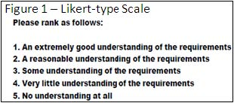
Where applicable within tables and graphs the sub-sector average rating has been supplied alongside individual average ratings. In these cases the ‘number of respondents’ may exceed 308 (survey replies) as many individuals identified with a number of subsector groups.

Respondent Profile
SUBSECTOR REPRESENTATION
QUESTION 1 – TYPE OF BUSINESS
The majority of respondents identified with the Non-Bank and Non-Deposit Taking Lender subsector (34.72 per cent). See Appendix A for table (1.2 – Respondent Subsector)

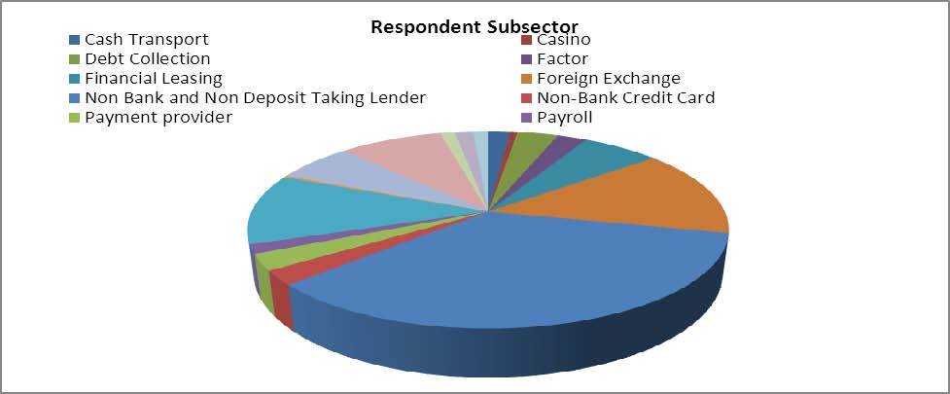

QUESTION 2 – LOCATION OF BUSINESS
The majority of respondents identified their business or head office location as Auckland (59.42 per cent).
See Appendix A for table (1.1 – Respondent Location)

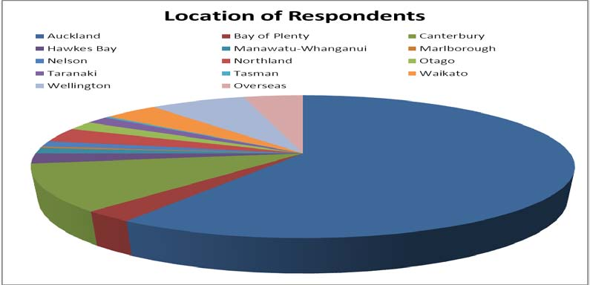
QUESTION 3 – DESIGNATED BUSINESS GROUP (DBG)
The majority of respondents did not belong to a DBG.

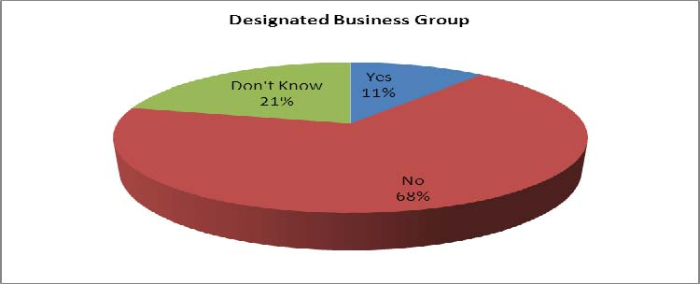

Information Services (Department and External)
In order to gauge the effectiveness of our communications to the sector we asked a number of questions around use of the Department’s Website, as well as other mediums of information gathering respondents had used to find out information about the Act and their requirements.
DEPARTMENT WEBSITE
QUESTION 4 – REFERRAL TO THE DEPARTMENT’S WEBSITE
Respondents were asked whether they had referred to the Department website for information about the Act and/or their requirements. 87.24 per cent of respondents had referred to the website. Respondents were then asked to rate how easily they were able to find information on the website and subsequently how useful the information was.
QUESTION 5 – FINDING INFORMATION ON THE DEPARTMENT’S WEBSITE
The average response was a rating of 2.53 meaning that respondents were inclined to feel that whilst the website was reasonably easy to use, some information could be more easily found than the rest. See Appendix A for table (2.1 – Finding information on Website)

QUESTION 6 – COMMENTS ON EASE OF USE OF THE DEPARTMENT’S WEBSITE
Refer to Appendix B – Survey Summary data

QUESTION 7 – USEFULNESS OF INFORMATION ON THE DEPARTMENT’S WEBSITE
The average response was a rating of 2.49 meaning that respondents were inclined to feel that whilst the information found was reasonably useful, some information was more useful than the rest. See Appendix A for table (2.2 – Usefulness of website information)

QUESTION 8 – COMMENTS ON THE USEFULNESS OF INFORMATION ON THE DEPARTMENT’S WEBSITE
Refer to Appendix B – Survey Summary data

CONTACT WITH THE DEPARTMENT
Respondents were asked how often they had been in contact with Department either directly or indirectly and in what form that interaction had taken place.
Some 60.53 per cent of respondents had been in direct contact with Department, with 30.75 per cent citing an email as the method of interaction, and 22.99 per cent citing face-to-face meetings where they were given information. Only 13.37 per cent mentioned attending a roadshow.
QUESTION 9 – DIRECT OR INDIRECT CONTACT WITH THE DEPARTMENT
Over half of respondents had had contact with the Department regarding the AML/CFT Act.
QUESTION 10 – TYPES OF INTERACTION WITH THE DEPARTMENT
Of the respondents who had interaction with the Department we were keen to understand the type of interaction this included. For Question 10 respondents were given a number of options and the ability to choose one or more. See Appendix A for table (3.1 – Types of Interaction with the Department)

OTHER SOURCES OF INFORMATION
QUESTION 20 – OTHER SOURCES OF INFORMATION
The final question we asked related to any other agency, business, etc. that respondents had contacted or used in order to find more information about the Act. See Appendix A for table (4.1 – Other sources of information)

Sector understanding of the AML/CFT Act
In order to establish how respondents felt about their understanding of the Act and requirements we asked a series of questions and asked respondents to rate their understanding at specific times:
- Two years ago
- When the Act came into effect on 1 July 2013
- Now (April 2014)

This method would enable us to view growth of knowledge as well as creating a baseline for movement. The four areas of understanding we focused on were:
- Conducting a risk assessment to assess the money laundering and terrorist financing risks their business reasonably expects to face
- Developing and regularly reviewing an AML/CFT Programme for their business
- Information needed to be provided in their Annual Report to the Sector Supervisor
- The requirement to submit Suspicious Transactions Reports to the Police Financial Intelligence Unit.

We noted that two years ago annual reporting was, and still is, the biggest area of concern respondents had while across the sector risk assessments cause the least concern.

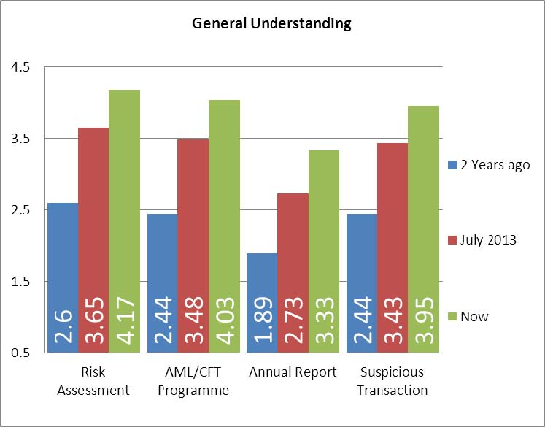

Risk Assessment
Question 11 -How would you rate your business's understanding around conducting a risk assessment to assess the money laundering and terrorist financing risks your business reasonably expects to face?

- No understanding at all
- Very little understanding of the requirements
- Some understanding of the requirements
- A reasonable understanding of the requirements
- An extremely good understanding of the requirements.

The average individual response for understanding 2 years ago was a rating of 2.60. The average individual response for understanding in July 2013 was a rating of 3.65. The average individual response for understanding as of April 2014 was a rating of 4.17.
Across all respondents there was a movement of 1.57 since two years ago.
Across all respondents there was a movement of 0.52 since the Act came into effect.

The survey illustrated that since the Act came into effect in July 2013 respondents have gone from a position of having ‘some’ understanding of conducting risk assessments through to what they describe as a ‘reasonable’ understanding.
The most confident subsector as of April 2014 is Casino Operators (5.00) whilst the least confident is Debt Collectors (3.30). See Appendix A for Table (5.1 – Subsector Risk Assessment)
QUESTION 12 – COMMENTS ON UNDERSTANDING OF RISK ASSESSMENTS
Refer to Appendix B – Survey Summary data

AML/CFT Programme
Question 13 -How would you rate your business's understanding of developing and regularly reviewing the AML/CFT Programme for your business?

- No understanding at all
- Very little understanding of the requirements
- Some understanding of the requirements
- A reasonable understanding of the requirements
- An extremely good understanding of the requirements.

The average individual response for understanding 2 years ago was a rating of 2.44. The average individual response for understanding in July 2013 was a rating of 3.48. The average individual response for understanding as of April 2014 was a rating of 4.03.
Across all respondents there has been a movement of 1.59 since two years ago.
Across all respondents there has been a movement of 0.55 since the Act came into effect.

The survey illustrated that since the Act came into effect in July 2013 respondents have moved from a position of having ‘some’ understanding of developing and reviewing an AML/CFT Programme through to what they describe as a ‘reasonable’ understanding.
The most confident subsector as of April 2014 is Remittance Services (4.58) whilst the least confident is Debt Collectors (3.00). See Appendix A for Table (5.2 – Subsector AML/CFT Programme)

QUESTION 14 – COMMENTS ON UNDERSTANDING OF AML/CFT PROGRAMME
Refer to Appendix B – Survey Summary data

Annual Reporting
Question 15 -How would you rate your business's understanding of the information you need to provide in your Annual Report to the Sector Supervisor (i.e. the Department)?

- No understanding at all
- Very little understanding of the requirements
- Some understanding of the requirements
- A reasonable understanding of the requirements
- An extremely good understanding of the requirements.

The average individual response for understanding 2 years ago was a rating of 1.89. The average individual response for understanding in July 2013 was a rating of 2.73. The average individual response for understanding as of April 2014 was a rating of 3.33.
Across all respondents there has been a movement of 1.44 since two years ago.
Across all respondents there has been a movement of 0.6 since the Act came into effect.

The survey illustrated that since the Act came into effect in July 2013 respondents have gone from a position of having almost no understanding of annual report requirements through to what they describe as some understanding. This is the area where there is the most concern across respondents as well as the area where the majority of respondents declined to comment until they had applied what they knew.
The most confident subsector as of April 2014 is Money Transfer Services (4.00) whilst the least confident is Debt Collectors (2.30). See Appendix A for Table (5.3 – Subsector Annual Reporting)
QUESTION 16 – COMMENTS ON UNDERSTANDING OF ANNUAL REPORT
Refer to Appendix B – Survey Summary data

Submitting Suspicious Transaction Reports
Question 17 -How would you rate your business's understanding of the requirement to submit Suspicious Transactions Reports (STRs) to the Police Financial Intelligence Unit?

- No understanding at all
- Very little understanding of the requirements
- Some understanding of the requirements
- A reasonable understanding of the requirements
- An extremely good understanding of the requirements.

The average individual response for understanding 2 years ago was a rating of 2.44. The average individual response for understanding in July 2013 was a rating of 3.43. The average individual response for understanding as of April 2014 was a rating of 3.95
Across all respondents there has been a movement of 1.51 since two years ago.
Across all respondents there has been a movement of 0.52 since the Act came into effect.

The survey illustrated that since the Act came into effect in July 2013 respondents have gone from a position of having very little understanding of submitting suspicious transactions through to what they describe as having some understanding.
The most confident subsector as of April 2014 is Casino Operators (4.50) whilst the least confident is Debt Collectors (3.20). See Appendix A for Table (5.4 – Subsector Suspicious Transaction Reporting)

QUESTION 18 – COMMENTS ON UNDERSTANDING OF SUBMITTING STRs
Refer to Appendix B – Survey Summary data

