Summary of Three Waters Request for Information Clinic

# Tuesday, 1 December 2020, 8am to 11am

## Overview of the clinic

The purpose of this clinic is to provide an overview of Tables E and G and for councils to ask any specific or general questions they may have.

## Link to the recording

<https://vimeo.com/486541647>

## Questions related to Section E

**Question: Do you enter a zero in Area cells that you aren't using or leave them blank?**

Answer: Please input a zero to show that the line is not used and include a note in the comment field indicating why you have used a zero. Using a zero is preferable over not inputting anything to enable the check function to work.

**Question: For Table E, please confirm that you don't require forecasts past 2021? Or do you just not need the forecasts split?**

Answer: We don’t need the forecasts beyond 2021 for Table E. For 2022 and beyond, please put zeros in the cells, so that the check function works correctly. We recognise this is a significant change, and will include this in the broadcast email sent out this week.

***Follow on question: Do we provide forecasts past 2021 for all of the other schedules?***

Answer: Yes, please provide forecasts past 2021 for all other schedules.

**Question: If the costs are meant to balance to the Funding Impact Statement (FIS) then where do the management costs go (i.e. salaries)? Reporting treatment plants and distribution doesn't include head office costs and FIS do.**

Answer: Those management costs (i.e. salaries and HR, legal, management) would be included in E1.10 ‘General and Support Employment Costs’. In E1.11 please include any ‘General and Support Other Costs’ and allocate these costs across the value chain activities. This line would include, for example, insurance for the three waters assets. If a council has an accounting system that allocates this information across the value chain, please use information from this system. If not, please work with asset managers and operators to make estimates of costs. Use the confidence grades as your friends and ensure it reconciles with the reporting in your statutory accounts.

**Question: Just to confirm, if we roll up to a district level in E1, E2 and E2b, then we shouldn't split it out in E4 onwards to scheme level?**

Answer: That is correct. The exception is the information on large wastewater treatment plants reported in Table E9.

Please follow the same approach throughout the E tables. For example, a council that reports direct costs across four sub-areas in table E1 should provide information for the same four sub-areas in tables E4 and E6.

**Question: For FY 2022 onwards, would you prefer us to use our published 2018-28 LTP number or draft 2021-31 LTP number even if the numbers are still moving/likely to change, but perhaps more realistic than the existing LTP?**

Answer: For the E Tables, please only populate data out to 30 June 2021. For other areas of the workbook requiring forecasts beyond the 30 June 2021, please use your latest numbers even if these are still in draft form.

**Question: A lot of the cells in Table E are dark grey where instruction tells us not to populate - how do we do treat these cells?**

Answer: You do not need to input anything into the grey cells.

**Question: Can you please clarify lines E1.23 and E1.24? You said these don't total anywhere, therefore you mean they are included above but then split apart here for more information?**

Answer: Yes, that is correct. These will also be included in lines E1.1 to E1.11 above. You will notice that lines E1.23 and E1.24 are not included in any of the calculated totals.

**Question: In relation to stormwater, for people that have wetland treatment systems and require some sort of regular maintenance and/or changing out of cesspits and swale drains. Where should those items be included? Is that a treatment cost or is it part of the running costs (maintenance)?**

**Post meeting note:**

Unless the cost is capitalised, it should be included in table E2b in the column ‘stormwater treatment and disposal’. Please ensure that these costs are not reported in ‘stormwater collection’ or in table E2 to avoid double-counting.

**Question: In relation to Table E2, on "sludge treatment and disposal" cells may be better to just have the "disposal costs" entered because there are not many NZ WWTPs where sludge is not treated on the same site i.e. sludge is not transported to a shared regional sludge treatment facility. There are also often non-annual one-off sludge disposal costs when oxidation ponds are de-sludged. How do councils record these non-annual costs?**

Answer:

Councils should provide an estimate of the sludge treatment costs in the ‘sludge treatment and disposal’ and reflect the uncertainty in the confidence grade selected. If this is not possible, sewage and sludge treatment costs could be reported in the sewage treatment and disposal column and sludge disposal costs could be reported in the sludge column. Councils should explain where sludge treatment costs are reported in the commentary cells.

In relation to non-annual one-off sludge disposal costs, if these costs are incurred in the period covered by the RFI, we ask that these are reported in the relevant year. If these are incurred in earlier years, please indicate the level of expenditure and how frequently such costs are incurred. In either scenario, please provide as much information as possible about these costs in order to aid our understanding.

**Statement: In Table E4, can we have an example of the calculation for average pumping head for resources and treatment that we can share.**

**Post meeting note:**

Please see the example provided below.

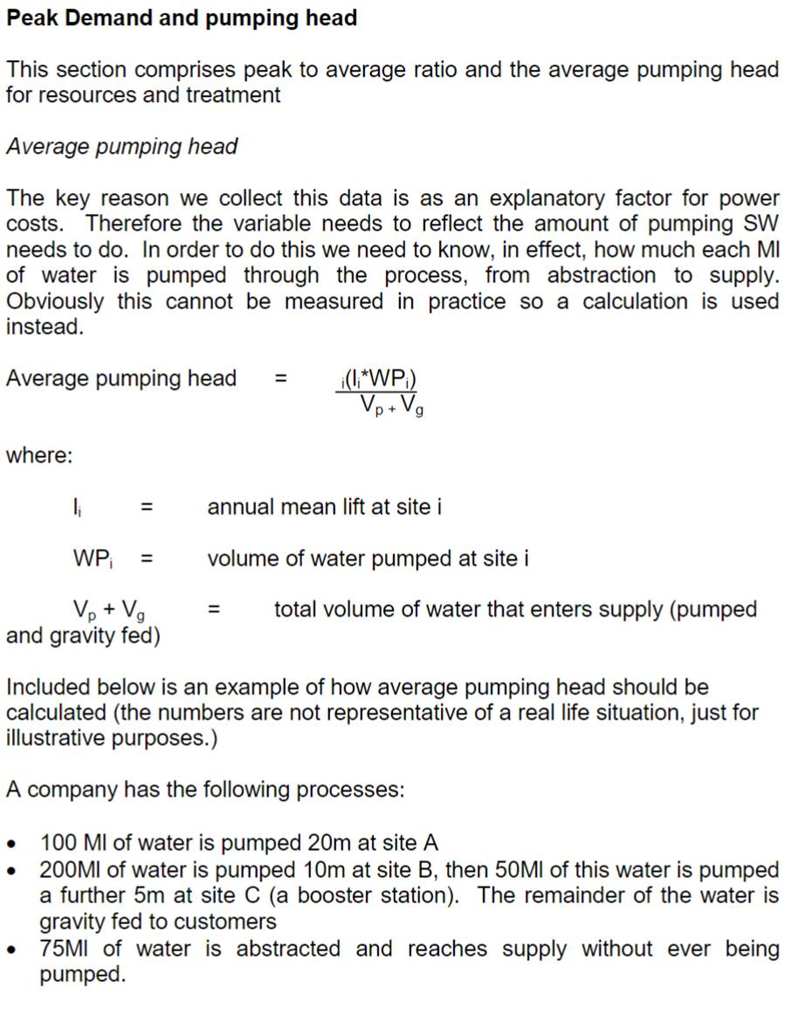

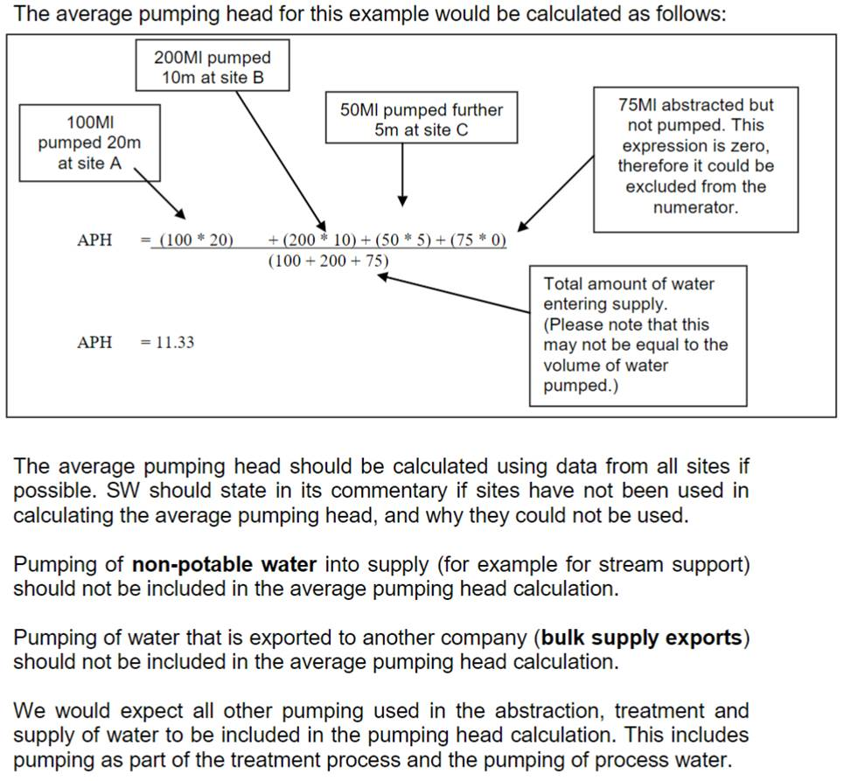

**Question: In relation to E4.0-E4.5, what is the time period you want to derive average demand?**

Answer: Please use the most recent financial year i.e. the financial year ending 30 June 2020.

**Question: Or should plants be sized by their rated treatment capacity rather than what they processed last year?**

**Post meeting note:**

The appropriate size band should be based on each work’s design peak hydraulic capacity, not its distribution input in a particular year.

**Question: Do lines E4.6 and E4.7 only relate to imports and exports to other councils? We supply tankers for household use (is that an export) and have water sourced from a third party (is that an import)?**

Answer: This should include any bulk supply import to, or export from, a third-party (e.g. a council).

If water is sourced from a third-party, then that would be considered as a bulk supply import.

**Post meeting note:**

We would expect the supply of water for household use to be included within distribution input in A2.1. There may, however, be exceptions to this. One example could be that the council provide a temporary water supply by tanker to customers on a private supply (e.g. in the event of a drought). This happened in Scotland in 2018. We would suggest that this is reported as a bulk supply export and reported in line E4.6. Please also include an explanation on the additional supply provided in the commentary cells.

Please report the actual volume received/supplied in the year. If these are exceptional (e.g. due to a drought), please provide the additional water received/supplied in the commentary cells.

**Question: Are the operating costs for E4.20-27 and E4.28-39 expected to reconcile with anything provided earlier?**

The total operating costs for treatment reported in lines E4.27 and E4.39 should reconcile.

There are several lines that should be consistent. These are:

* Line E4.19 should align with the costs reported for resources and treatment in line E1.12 (‘water resources and treatment’ column).
* Line E8.40 should align with the costs reported for wastewater treatment in lines E2.11 (‘wastewater treatment’ column).
* Line E10.11 should align with the costs reported for sludge treatment and disposal in line E2.11 (‘sludge treatment and disposal’ column).

**Question: What about wastewater vaults, which are basically just a storage tank, which get pumped out periodically. Which column would that fit in to?**

**Post meeting note:**

If the wastewater vault is the only form of treatment, then please include these in the ‘primary’ treatment column. Based on our guidance in Scotland, this would include:

“works whose treatment methods are restricted to preliminary and primary treatment (screening, comminution, maceration, grit and detritus removal, pre-aeration and grease removal, storm tanks, plus primary sedimentation, including where assisted by the addition of chemicals e.g. Clariflow)”.

Given that storm tanks are included in this category, it would seem that this is the most appropriate column.

If the wastewater is transported to another works, the asset needs to be included in the ‘J’ tables. The operating costs of the transport should have been reflected in total sewerage operating costs. Likewise, the operating costs associated with treatment should include the treatment of the waste that has been tinkered in.

**Question: When as you mention there is a need for "reconciliation" between different worksheets. Is this done automatically by the workbook logic or is this up to the user to make sure the totals reconcile?**

Answer: It is up to the user to make sure the totals reconcile. This function is not automatically built into the spreadsheet.

There are several lines that should be consistent. These are:

* Line E4.19 should align with the costs reported for resources and treatment in line E1.12 (‘water resources and treatment’ column).
* Line E8.40 should align with the costs reported for wastewater treatment in lines E2.11 (‘wastewater treatment’ column).
* Line E10.11 should align with the costs reported for sludge treatment and disposal in line E2.11 (‘sludge treatment and disposal’ column).

**Question: Please clarify what you mean by workshops, control centres and depots.**

Answer: This question was also asked in the clinic last week. The answer is set out below.

The following definitions were suggested:

* Control centres are used, for example, to receive information on incidents (e.g. real time monitoring of the network) and coordinate the response through the operations teams; and
* Depots are used, for example, as a base for operations crews and vehicles and is used as a central store for equipment.

There was discussion of the difference between depots and workshops. It was considered that it may be useful to consider a workshop as a facility that is similar in definition to a depot, but is located on the same site as one of the operational assets (e.g. a water or wastewater treatment plant).

*Follow on question: Do we include our contractors’ facilities?*

Answer: As a general rule, we suggest that councils report assets that they own. As such, we suggest that councils do not include the contractor’s facilities.

*Follow on question: Do we include the depots of alliance partners?*

Answer: No, the same general rule applies as outlined in the response above.

*Follow on question: Does that also apply to laboratories?*

Answer: If you own and operate a laboratory you would record that in E11. If you do not own it, please include a comment in the comments field that you are sharing it using services provided by other councils or contractors.

*Follow on question: Is the assumption to only include workshops that belong to the Council rather than the O & M contractors correct?*

Answer: That is correct. Please only include workshops that are owned by councils.

**Question: For Table E12 (inflation factors) should we complete columns for 2022 and beyond? Also, what is the meaning/relevance of an inflation assumption for past (2019, 2020) years?**

Answer: Councils do not need to provide inflation assumptions for previous years. Given that forecasts are not required beyond financial year ending 30 June 2021 in the E tables, we suggest inputting a zeros for financial year ending 30 June 2022 and beyond in E12. As such, councils should just include their inflation assumptions for the current financial year (ending 30 June 2021).

## General questions

**Question: What is the basis for reporting supply pipe leakage which, e.g. according to the definition in the Schedules is water loss beyond the point of supply (i.e. within customers’ premises). The DIA mandatory performance measure to report annually the percentage water loss is a measure of the loss from the Council’s reticulation system and, therefore, does not seem to provide the information required to answer this question. What is the basis on which to estimate on-premises water loss. We could use the volumes that have had rates rebates (for measured connections only) based on a burst pipe within the property but other than that continue to seek guidance.**

Answer: A2.29 and A2.30 only cover water losses from the council’s water system and excludes supply pipe leakage. As such, these should be consistent with the DIA mandatory performance measure in this regard.

Information on supply-pipe leakage is requested in order to calculate per capita consumptions in lines A2.4 and A2.8. We ask councils to provide their best estimate based on the information available and select a confidence grade that reflects the underlying level of uncertainty.

**Question: Can we please get a list of tabs which reconcile to each other?**

Answer: There are several lines that should be consistent. These are:

* Line E4.19 should align with the costs reported for resources and treatment in line E1.12 (‘water resources and treatment’ column).
* Line E8.40 should align with the costs reported for wastewater treatment in lines E2.11 (‘wastewater treatment’ column).
* Line E10.11 should align with the costs reported for sludge treatment and disposal in line E2.11 (‘sludge treatment and disposal’ column).

**Question: Just checking the definitions of 'Area of District' and 'Drained area' in E7 and E7b. Is 'Area of District' the total area (serviced and unserviced) of the district and the 'Drained area' is the serviced area (or what we call the rateable areas for each scheme)?**

Answer: ‘Area of District’ is the area of operation, with the caveat that this would also cover the area covered by any planned extensions of the wastewater system. The drained area (E7.6) relates to the stormwater drainage area and is therefore more applicable to the stormwater table in E7b. As such, councils may want to report the same area in E7.5 and A7.6.

In table E7b, we suggest that councils report the area which is connected to a reticulated stormwater system in E7b.5 and report the total area that is drained in E7b.6 (e.g. including and road areas and land).

**Follow on question: Where there are plans to extend the "urban" infrastructure into "rural" areas which would it be defined as? Should it appear in the wastewater district or drainage area?**

Where you have a planned extension, it should appear in the wastewater district, not the drainage area. The wastewater district is the area you are currently serving or any planned extensions of the wastewater system.

## Questions related to Table G

**Question: In regards to G1.3b - does this relate to new connections for water or wastewater, or both?**

Answer: Please capture water, wastewater and stormwater separately.

We also ask councils to differentiate between:

* expanding the connection rate among the population that is not connected to the reticulated three waters systems today; and
* expanding the network to increase capacity to meet new population growth and migration.

**Post meeting note:**

Some councils have explained that they will add additional rows for wastewater properties connected and stormwater properties connected. As such, we suggest that other councils follow this approach.

**Question: Line G1.30 relates to third party grants or contributions - I assume we include the current stimulus funding in this row?**

Answer: Yes, please include the stimulus funding in G1.30 and provide an explanation in the commentary cells.

**Question: In relation to growth/quality/renewal capex. Where there may be a mix of reasons for an investment, do we attempt to "allocate" the investment between them? Or just enter it all into one field based on what we deem the primary reason to be?**

Answer: Please provide an estimate the percentage allocation to each category in tables G2 to G4 (columns 17-19). This could be a broad percentage allocation, rather than the precise estimate.

**Question: I don't understand your definitions on non-infrastructure assets. These all seem like Infrastructure assets to me.**

There may be a difference in terminology. In very broad terms, the UK water industry would consider underground assets or civil structures as infrastructure assets and above-ground assets as non-infrastructure assets. We suggest that councils use the common definition in New Zealand in providing percentage allocations in G2 to G4 (columns 20-22) as it is not material to our analysis.

**Question: Is there an expectation that total annual project cost be reconciled to the total annual investment?**

Yes, that is the expectation. The totals in G2.6 (water), G3.6 (wastewater) and G4.6 (stormwater) should reconcile with the total gross capital expenditure for the three waters reported in G1.29.

**Question: What if Covid-19 has seriously impacted our infrastructure capital expenditure pipeline? Are we expected to do a pre-Covid-19 and post-Covid-19 forecast?**

Please provide the most recent forecasts. We also emphasise that we are looking to capture all investment needs that have been identified, whether or not they are in the LTP or annual plan. Councils are asked to provide their ‘unconstrained’ list of investment needs.

**Statement: In regard to the G Tables and impacts of Covid-19, in terms of any forecasting for 2021, that would be per the annual plans, we wouldn’t be expecting to re-forecast those numbers for 2021. But we would be expecting to change our forecasts for years beyond this.**

Answer: Yes, we agree. For the forecast for 2021, please use current information (i.e. the annual plan). Please use the comments field to note that you have done this.

**Question: In New Zealand terms, unconstrained forecasting would refer to the forecasting in asset management plans. If this is used, then there may not be a reconciliation between forecasting and the individual projects list.**

Answer: It was suggested that this question would be discussed with the council outside of the clinic. We will provide an answer at a future clinic.

## General Q & A

**Question: I have a general question regarding any budgets being provided in the RfI - are these required to be ratified by each Council first before being submitted and should reconcile to the latest version of their individual draft 2021-2031 LTP?**

We recognise that the 2021-2031 LTP is still in draft. They are not required to be ratified by each council because we are asking for your best estimate, based on the information you know at the current time. Any decision to ratify figures with a more senior member of the council team prior to submission is the decision of the council.

**Question: In relation to the B Tables, B1, B1a, B1.2, B1.3, in the schedule it says “For all water supply areas included in this row please list the deployable output, outage allowance and water available for use in the commentary.” Do you really want this information in the comments? Should there not be boxes for this info?**

Answer: It is probably not worth doing this when the headroom is greater than 5%, but for zones with headroom less than or equal to 5%, it would be useful to understand the differences between water available for use and demand for those zones.

## Common questions received by WICS

**In relation to the G Tables, there have been quite a few questions around the future capital programme. Specifically, whether providing this will commit us to anything.**

Answer: There will always be constraints, whether driven by supply chain availability, budget or impact on communities for example. But those constraints do not necessarily mean that these projects are not required. We are looking to get a good understanding of the investment needs, so please provide as much information about the future capital programme possible.

***Follow on question: Further clarification on what is meant by unconstrained projected expenditure… where it has been necessary to cut 2021 LTP projected expenditure (through recent workshops with elected members) in order to limit rates increases or because of deliverability constraints etc we should be reporting the original (unconstrained) recommended costs/projects before the cuts were made?***

The answer to this is generally yes. An internal constraint on an organisation should not be a reason for excluding this information. It is important for us to understand what the future liability is.