

Amendment to the Rules of Casino Table Games – Division 8 Roulette

Pursuant to section 367 of the Gambling Act 2003 the following amendments to Division 8 of the Rules of Casino Table Games (Roulette) were prescribed on 6 December 2011.

These amendments take effect from the day after notification in the New Zealand Gazette.

Division 8 – Roulette

- The list of contents at the beginning of the document is deleted and replaced with the following:

“Section 1 Application
Section 2 Table Layout and Equipment
Section 3 Wagers
Section 4 Rotation of Wheel and Ball
Section 5 Irregularities
Appendix 1 37 number Roulette Table Layout and Illustration of Main Roulette Wagers (Option 1)
Appendix 2 37 number Roulette Table Layout and Illustration of Main Roulette Wagers (Option 2)
Appendix 3 38 number Roulette Table Layout and Illustration of Main Roulette Wagers (Option 1)
Appendix 4 38 number Roulette Table Layout and Illustration of Main Roulette Wagers (Option 2)
Appendix 5 Layout of Optional Additional Wagering Areas (Asian Racetrack)
Appendix 6 Layout of Optional Additional Wagering Areas (Race Track)
Appendix 7 Roulette Wheel Numbers”

- In rule 2.1 the digit “1” is deleted and replaced with the word “one”.

- Rule 2.2 is deleted and replaced with the following:

“The layout cloth of the roulette table:

(a) shall be marked with areas for the placement of wagers in a manner substantially similar to that shown in either Appendix 1, Appendix 2, Appendix 3 or Appendix 4; and

(b) may, at the option of the casino operator, also be marked, in a manner substantially similar to that shown in Appendix 5 (showing either a single zero or double zero), with additional areas (called the “Asian racetrack”) for the placement of wagers; and

(c) may, at the option of the casino operator, also be marked, in a manner substantially similar to that shown in Appendix 6 (showing either a single zero or double zero), with additional areas (called the “racetrack”) for the placement of multiple wagers.”

- Rule 2.3 is deleted and replaced with the following:

“The roulette wheel shall:

(a) have 37 or 38 (at the election of the casino operator) numbered compartments equally spaced around it, where the roulette ball shall come to rest. Where:

- the wheel has 37 compartments, 1 shall be marked 0 and coloured green and the rest shall be marked from 1 to 36 inclusive and coloured alternately red and black; and

- the wheel has 38 compartments, 1 shall be marked 0 and coloured green, 1 shall be marked 00 and coloured green and the rest shall be marked from 1 to 36 inclusive and coloured alternately red and black;

(b) have a number of vertical and horizontal hazards fitted to its surface; and

(c) be level and move freely and evenly.

The numbered compartments shall be arranged around the wheel in the applicable order shown in Appendix 7.”

- Rule 3.1 is amended by inserting the phrase “Where 37 numbered compartments are used,” at the beginning of the first paragraph.

- Rule 3.1(d)(i) is amended by inserting the word “and” after the comma.

- After rule 3.1, the following new rule is added:

“3.1A Where 38 numbered compartments are used, a player at the game may place wagers on the following numbers or combinations of numbers, being 0, 00 and from 1 to 36 inclusive:

(a) 1 specific number or “Straight Up”, which shall:

(i) win if that number is spun, and

(ii) otherwise lose;

(b) 2 specific adjoining numbers or “Split”, which shall:

(i) win if either of those numbers is spun, and

(ii) otherwise lose;

(c) where the layout depicts numbers 00 and 0 marked from left to right, 3 specific numbers (being in a row across the layout or comprising 0, 2 and 3; 0, 00 and 2; or 00, 1 and 2) or "Street", which shall:

- win if any of the numbers wagered on is spun,

(ii) win if 0 and 2 and 3 are wagered on and any of them is spun,

(iii) win if 0 and 00 and 2 are wagered on and any of them is spun,

(iv) win if 00 and 1 and 2 are wagered on and any of them is spun,
and

(v) otherwise lose;

(cA) where the layout depicts numbers 0 and 00 marked from left to right, 3 specific numbers (being in a row across the layout or comprising 00, 2 and 3; 0, 00 and 2; or 0, 1 and 2) or "Street", which shall:

- win if any of the numbers wagered on is spun,

(ii) win if 00 and 2 and 3 are wagered on and any of them is spun,

(iii) win if 0 and 00 and 2 are wagered on and any of them is spun,

(iv) win if 0 and 1 and 2 are wagered on and any of them is spun, and

(v) otherwise lose;

(d) 4 specific numbers forming a square on the layout or “Corner”, which shall:

(i) win if any of those numbers is spun, and

(ii) otherwise lose;

(e) 5 specific numbers compromising 0, 00, 1, 2 and 3 or “Five-Line”, which shall:

(i) win if any of the numbers is spun, and

(ii) otherwise lose;

(f) 6 specific numbers in 2 rows across the layout or “Six-Line”, which shall:

(i) win if any of the numbers in the 2 rows is spun, and

(ii) otherwise lose;

(g) 12 specific numbers in a column on the layout or “Column”, which shall:

(i) win if any of the 12 numbers in the column is spun, and

(ii) otherwise lose;

(h) 12 specific numbers (1 to 12, 13 to 24 or 25 to 36 inclusive) or “Dozen”, which shall:

(i) win if any of those numbers is spun, and

(ii) otherwise lose;

(i) the numbers 1 to 18 inclusive or “Low”, which shall:

(i) win if any of those numbers is spun, and

(ii) otherwise lose;

(j) the numbers 19 to 36 inclusive or “High”, which shall:

(i) win if any of those numbers is spun, and

(ii) otherwise lose;

(k) even numbers or “Even”, which shall:

(i) win if the number spun is an even number, and

(ii) lose if the number spun is an odd number or 0 or 00;

(l) odd numbers or “Odd”, which shall:

(i) win if the number spun is an odd number, and

(ii) lose if the number spun is an even number or 0 or 00;

(m) numbers with red compartments on the wheel or “Red”, which shall:

(i) win if the compartment of the number spun is red, and

(ii) otherwise lose; and

(n) numbers with black compartments on the wheel or “Black”, which shall:

(i) win if the compartment of the number spun is black, and

(ii) otherwise lose.

An illustration of the manner of placement of wagers on the layout pursuant to this rule is contained in Appendices 3 and 4.”

8. Rule 3.2 is amended by deleting the words “Appendix 3” and inserting “Appendix 5” at the end of the last sentence.

9. Rule 3.2A is amended by deleting the words “Appendix 3A” and inserting “Appendix 6” at the end of the last sentence.

10. Rule 3.9 is deleted and replaced with the following:

“Winning wagers made pursuant to rule 3.1, 3.1A, 3.2 or 3.2A shall be paid at the following odds:

Wager Payout Odds

Straight Up 35 to 1
Split 17 to 1
Street 11 to 1
Asian Neighbour 11 to 1
Corner 8 to 1
Five-Line 6 to 1
Six-Line 5 to 1
Column 2 to 1
Dozen 2 to 1
Low 1 to 1
High 1 to 1
Even 1 to 1
Odd 1 to 1
Red 1 to 1
Black 1 to 1”

11. Rule 3.10 is amended by inserting the phrase “On roulette wheels featuring 37 compartments,” at the beginning of the rule.

12. After rule 3.10, the following rule is added:

“3.11 On roulette wheels featuring 38 compartments, when the ball comes to rest in the compartment of the wheel marked:

(a) “0”, all wagers shall lose other than those made straight upon the 0, or in any available combination of the 0 and the numbers 00, 1, 2 and 3;

(b) “00”, all wagers shall lose other than those made straight upon the 00 or in any available combination of the 00 and the numbers 0, 1, 2 and 3.”

13. Rule 5.8 is amended by inserting “if” after the word “even”.

14. The title of Appendix 1 is deleted and replaced with the following:

“Appendix 1

37 Number Roulette Table Layout and Illustration of Main Roulette Wagers (Option 1)”

15. The title of Appendix 2 is deleted and replaced with the following:

“Appendix 2
37 Number Roulette Table Layout and Illustration of Main Roulette Wagers (Option 2)”

16. Appendices 3 and 4 are removed, and the following new appendices 3, 4, 5, 6, and 7 are inserted:
Appendix 3
38 Number Roulette Table Layout and Illustration of Main Roulette Wagers (Option 1)

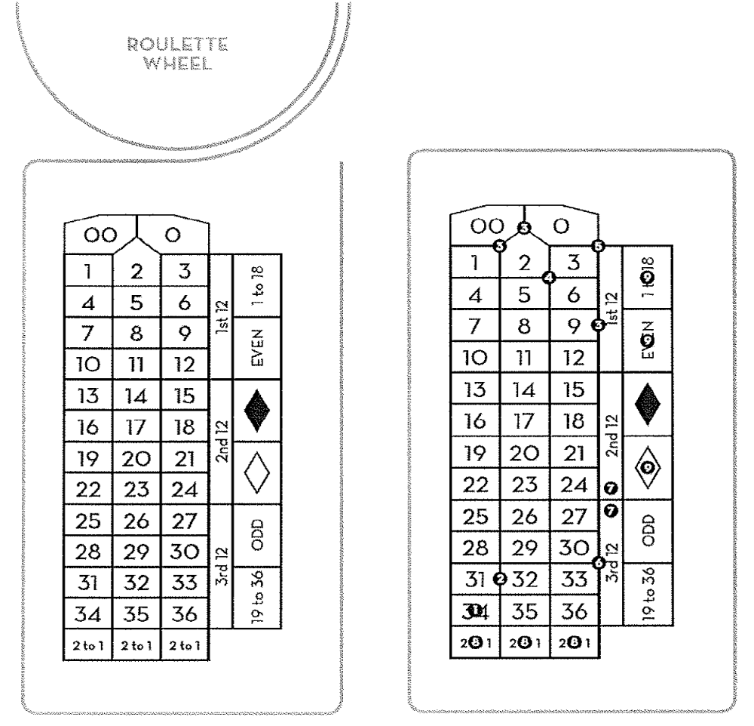
1. Straight Up
2. Split
3. Street
4. Corner
5. Five Line
6. Six Line
7. 1 Dozen
8. 12 Column
9. Even Chance (i.e. High, Odd, Black, Red, Even, Low)

Appendix 4
38 Number Roulette Table Layout and Illustration of Main Roulette Wagers (Option 2)

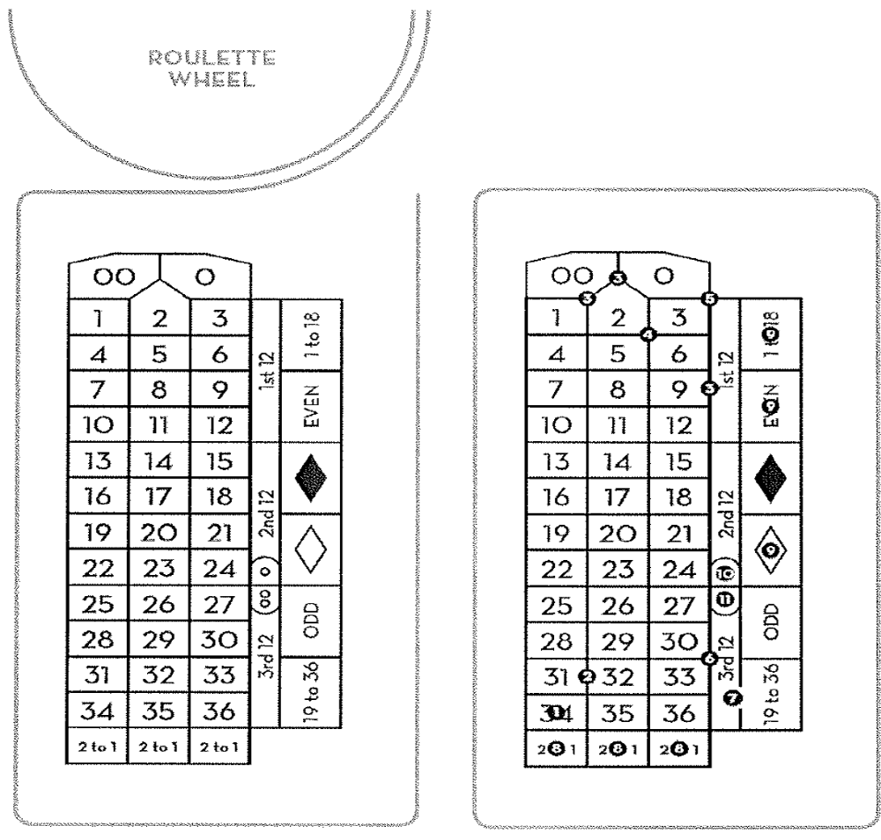

1. Straight Up
2. Split
3. Street
4. Corner
5. Five Line
6. Six Line
7. 1 Dozen
8. 12 Column
9. Even Chance (i.e. High, Odd, Black, Red, Even, Low)
10. Courtesy line between 2nd and 3rd dozen (zero)
11. Courtesy line between 2nd and 3rd dozen (double zero)

Appendix 5
Layout of Optional Additional Wagering Area (Asian Racetrack)

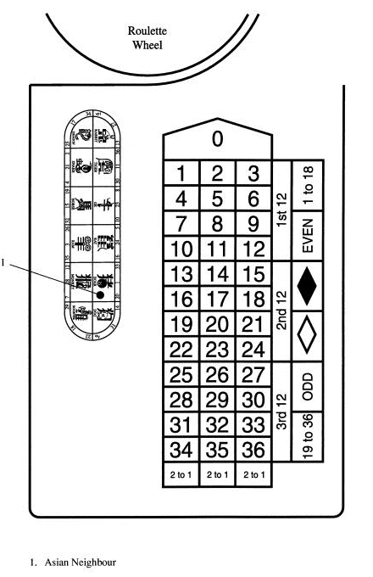

Appendix 6
Layout of Optional Additional Wagering Area (Racetrack)

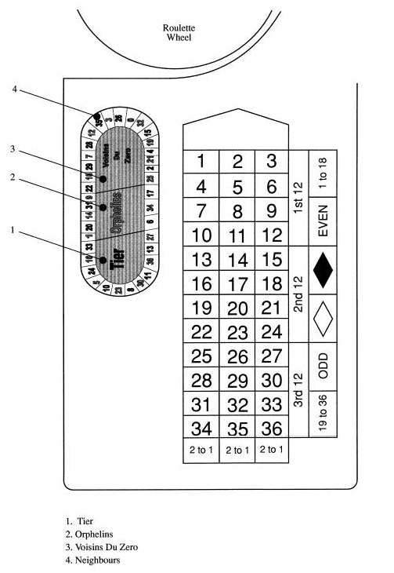

Appendix 4
Roulette Wheel Numbers

Appendix 7
Roulette Wheel Numbers

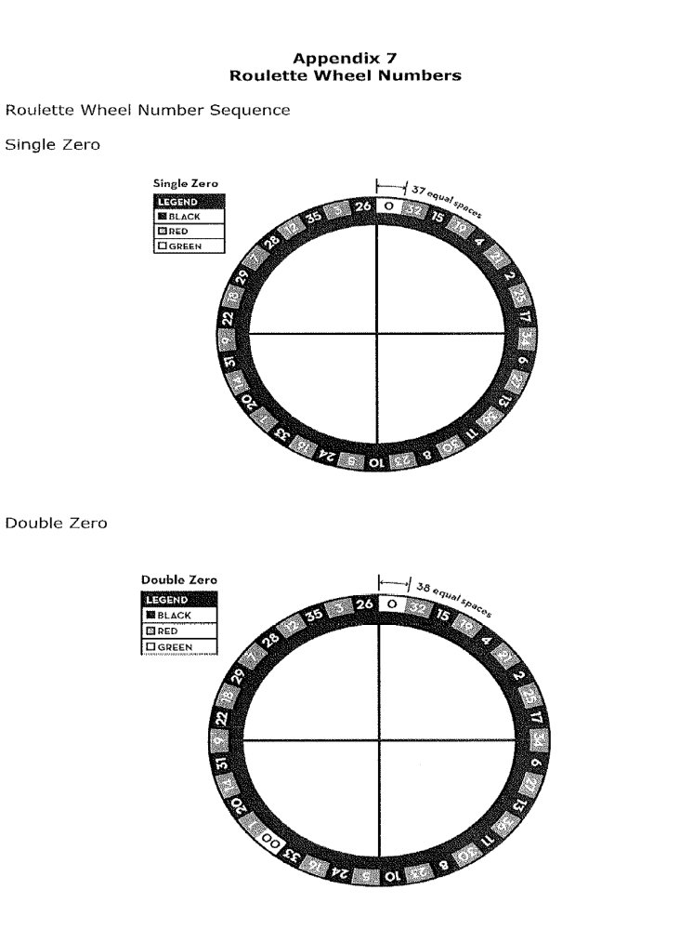

Roulette Wheel Numbers

Double Zero

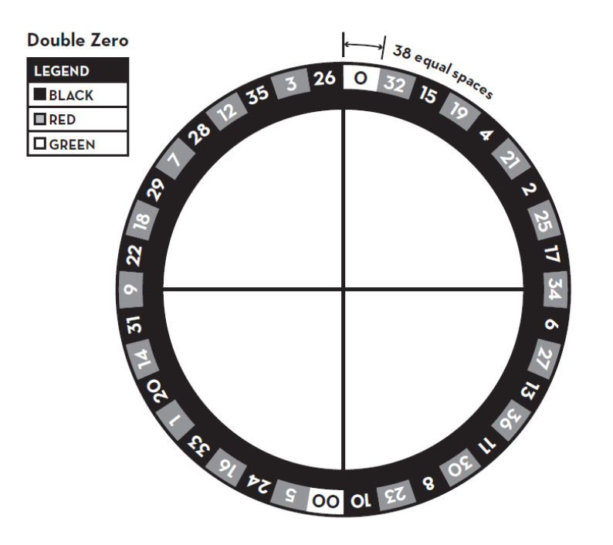

Double Zero



