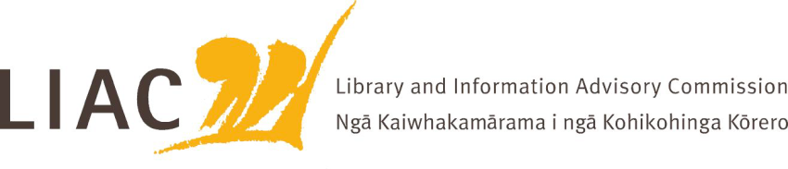
Summary of meeting - 14 September 2022
The September meeting was held face to face in Wellington. All Commissioners attended.
Key topics and discussion points
- LIAC activities and work programme
- Te Paea Paringatai has resigned as a LIAC Commissioner due to her employment at DIA
- Recruitment of a new Commissioner is underway
- LIAC is considering how best to receive and provide advice and progress priority work areas

- Te Pouhuaki National Librarian update
- Covid update
- NLNZ Digitisation programme and resourcing update
- Update from IFLA World Congress and Conference of Directors of National Libraries
- Fire and Emergency NZ levies – proposal that FENZ levies will apply to cultural heritage collections is causing concern across the wider sector. LIAC supports retention of exemption and that exemption be made permanent

- Kaihautu role
- Commissioners met Ruki Tobin who has been appointed to the role of Kaihautu for NLNZ
- This is a significant leadership role, supporting leadership and the wider Mātauranga Māori programme

- Te Ara Tahi
- Update on programme and next steps
- Champions Board will include LIAC Chair

- NZLPP Evaluation report
- Draft of the independent evaluation report of NZLPP received
- Report indicates success of the programme and the immediate benefits of NZLPP funding, as well as some sustainability concerns and bigger questions to be addressed long term
- Communication strategy being developed
- Whiria Te Tāngata ongoing implementation update

- Services to Libraries review (NZLPP)
- Review covers the following national resources - APNK, Te Puna (National Union Catalogue), EPIC and Kōtui
- Sustainability and resourcing concerns
- Important role of these resources in supporting literacy, equity including digital equity and access to information

- Ministerial Review of National Archival and Library Institutions (NALI)
- Presentation from a group of senior now retired librarians
- Concern that NALI goals are not being met and that current arrangements are not sustainable
- Suggest consideration of alternative governance options

- Preserving Local History and Educational Trust Te Pupuri I nga hitori o te rohe Trust
- Briefing from representatives of the Trust
- Purpose is to raise funds to ensure the digitisation and accessibility of small local newspapers not yet available on microfilm or accessible by any other means. Many of these newspapers are fragile and poorly housed
- Importance of local newspapers as a resource supporting local history and local identity
- Initial funding being used to establish pilots in Waikato and Central Otago. Further funding will be sought from local and national sources, especially local fundraising to support digitisation of local newspapers.
- Close partnership with NLNZ to use Papers Past as the vehicle to make these digitised papers available.
- Concern re lack of budget provision for NLNZ’s ongoing digitisation programme

- Reading Ambassador
- Growing evidence of the positive difference the Reading Ambassador initiative offers.
- Concerned that funding for this initiative is not secure.

- School Library Week
- video by Minister Tinetti in support of the important role of school libraries was welcomed
- https://natlib.govt.nz/blog/posts/celebrate-aotearoa-nzs-school-libraries-school-library-week-2022

