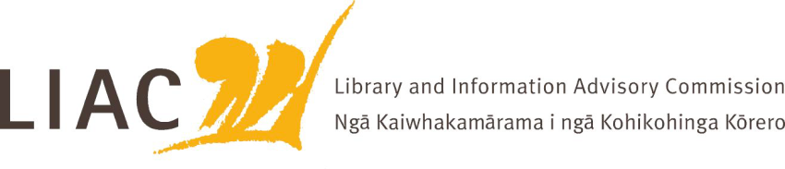
Summary of Meeting – 16 March 2022
The March meeting was held via zoom. Te Paea Paringatai on leave, all other Commissioners attended.
Key topics and discussion points
- LIAC activities and work programme
- Noted that LIAC website is out of date, content to be reviewed
- Review of draft workplan, to be confirmed at next meeting

- Te Pouhuaki National Librarian update
- Kaihautū role has been filled, will be invited to meet with LIAC in future
- Covid response and impacts
- Collections disposal policy under development. NLNZ will seek wider engagement on this
- OPC process still attracting negative comment
- Proposals for extended copyright provisions in recent trade agreements are causing concern, NLNZ and LIANZA have provided feedback

- NLNZ Policy Development
- Policy development is undertaken as part of wider DIA resources and priorities
- NLNZ policies include public lending right, legal deposit, access, collection management and disposal. Most are out of date and in need of refresh
- Minister of Internal Affairs determines priorities

- NZ Libraries Partnership Programme
- Sustainability projects proceeding – Data research and evaluation, Workforce planning, Services to Libraries
- Longer term governance for sustainability and transition projects should build sector capability
- Programme evaluation
- Role of National Library in sector

- Te Ara Tahi and Matauranga Māori programme update
- Revised governance model proposed for Te Ara Tahi programme, following review of scope
- Integrated operating model and comprehensive service design
- Matauranga Māori programme includes WAI262 and whole of government approach. Goal is to bring Matauranga Māori to forefront, embedding Te Ao Māori, working sustainably with Māori and delivering in partnership

- Pacific Virtual Museum
- Digitalpasifik.org
- Funded by DFAT Australia, delivered by NLNZ using its specialist technical expertise
- Co-design process, leveraging knowledge of cultural institutions globally which hold Pacific resources. All content partners are equal. Skill building role
- Goal is to improve access to and awareness of Pacific resources through this digital gateway
- Long term funding and sustainability is an issue

- School libraries current state
- Recent survey carried out by SLANZA indicates the degree to which the sector is struggling, both in staffing and resourcing. 65% of schools do not have a library. There is huge variation and unevenness in provision and standards
- Pressure on school operating grants due to Covid is impacting school libraries
- Lack of evidence about positive impacts of school libraries in NZ and lack of awareness of the role they can play, especially in relation to misinformation, literacy, history curriculum, child and youth wellbeing
- Positive benefits of various NZLPP programmes, including skill building and misinformation responses
- Role of Ministry of Education in setting guidelines and expectations

