Division 12 - Pai Gow
Section 1 Interpretation
Section 2 Application
Section 3 Table Layout and Equipment
Section 4 Ranking of the Tiles
Section 5 The Bank
Section 6 Wagers
Section 7 Control of Boxes
Section 8 Opening of Table for Gambling
Section 9 Shuffle and Cut of the Tiles
Section 10 Delivery and Setting of the Tiles
Section 11 Variations of Play; Settlement of Wagers
Section 12 Irregularities
Appendix 1 Pai Gow Table Layout
Appendix 2 Ranking of Tiles - Pairs, Wongs, Gongs and High Nines
Appendix 3 Ranking of Tiles - Individual
Appendix 4 House Way
Appendix 5 Pai Gow Cuts

1.0 Interpretation
In this division, unless the contrary intention appears:
“Approved Cut”, in relation to a casino, means a cut that is:
- named in Appendix 5, and
- approved by the Secretary, and conducted in a manner approved by the Secretary, in writing for use in the casino;
“Bank” means the hand against which:
- where the hand is held by the house, all of the players, and
- where the hand is held by a player/banker, all of the other players, wager;
“Banker” means the person or persons holding, or who is or are to hold, the bank during a round, and may be or include the house;
“Banker Wager Area” means that part of the layout in front of the dealer which is designated as the area for placing the banker’s wager, where there is a player/banker, as shown in Appendix 1;
“Box” means a numbered area on the pai gow layout designated for the placement of wagers by the players;
“Chung” means a marker that is used to denote the box to which the banker’s tiles will be dealt;
“Co-Banker” means a player/banker who holds or is to hold the bank in equal partnership with the house;
“Cut” means a process for dividing, into 8 groups of 4, a set of 32 pai gow tiles that have been stacked by the dealer, each of which groups is to be delivered to a box on the pai gow layout, and which dictates the order in which the tiles shall be delivered to the boxes;
“Hand” means a group of 4 tiles which is delivered to a box and which, if and when it is set, consists of a high hand (of higher rank or value) and a low hand (of lower rank or value), each of 2 tiles;
“House” means the casino operator;
“House Way” means the set of rules contained in Appendix 4 which, where applicable, dictate how a hand shall be set;
“Laja” means an additional mix of the tiles that may be performed by the dealer under these rules;
“Losing Wager Area” means that part of the layout in front of the dealer which is designated as the area for placing losing wagers, as shown in Appendix 1;
to “Match” means to compare:
- the high hand in a player’s hand with that in the banker’s hand, and
- the low hand in a player’s hand that in the banker’s hand,
for the purpose of determining whether any wager on either of the hands wins, loses or constitutes a push;
“Player/Banker” means a player who holds or is to hold the bank in a round of play, either as the banker or as a co-banker;
“Round” means a period of play beginning with the cut of the tiles and ending when the dealer matches the hands and, if applicable, collects losing wagers, determines pushes and pays out winnings;
to “Set”, in relation to a hand, means to divide the hand into a low hand and a high hand, each consisting of 2 tiles;
to “Shuffle”, in relation to the pai gow tiles, means to randomly and thoroughly mix all of the tiles by hand in a washing or swirling motion, while they are spread face down on the table;
“Tile” means 1 of the set of 32 tiles referred to in subparagraph (a) of rule 3.3; and
“Total” means the total of the dots on the high or uppermost faces of the 3 dice after any given spin of the dice in the dice cup.

2.0 Application
The rules contained in this division, together with the general rules contained in division 1, shall apply to the game of pai gow.

3.0 Table Layout and Equipment
3.1 Pai gow shall be played at a table having on 1 side places for up to 8 seated players and on the opposite side a place for the dealer. Each pai gow table shall have a drop box attached to it.
3.2 The layout cloth covering the table shall:
- have up to 8 numbered boxes; and
- be marked in a manner substantially similar to that shown in Appendix 1, provided that the designated area for unused tiles, and the dealer’s work area, need not be marked on the layout cloth.
3.3 The following equipment shall also be used in the game:
- a set of 32 tiles, in the nature of dominoes, which are identical in size and shape:
  - the faces of which bear the individual markings shown in Appendix 3, and
  - the backs and sides of which are of the same colour and design, and appear identical in all other respects;
- a set of 3 plastic dice, each with faces:
  - of a minimum size of 10 millimetres square, and
  - the respective values of which are marked by the use of dots,
which shall be used to determine which box receives the first set of tiles from the cut;
- a dice cup, being a cup-like device with a non-transparent cover which shall be used to contain and shake the dice;
- where rule 9.6 applies, 2 buttons, one marked “+4” and the other marked “-4”;
- a marker button marked “Off”, which shall be used to denote a box removed from play under rule 12.9; and
- a chung, 1 of whose faces shall be marked either “Co-banker” or otherwise so as to indicate a co-banking situation, and the reverse face of which may be marked “Banker”.

4.0 Ranking of the Tiles
4.1 Pairs of tiles, wongs, gongs and high nines shall rank with regard to each other, from highest to lowest, as set out in Appendix 2.
4.2 When a 2 tile hand ranks lower than Day High Nine (ranking 22), the value of that hand shall be:
- determined by totalling the respective point values of the 2 tiles forming the hand;
- where the total of the point values of the tiles in the hand is a number from 0 to 9 inclusive, that number; and
- where the total of the point values of the tiles is the number 10 or above, the right digit of that number.
For the purposes of this rule, the point value of a tile is the number of dots on its face, except that each of the 2 tiles comprising the pair Gee Jun may be counted as either a 3 or a 6.
4.3 Where the respective point values of each 2 tile hand are the same, then the point value of each such hand is further ranked by the ranking of the highest individual tile in that hand.
4.4 Individual tiles shall rank, from highest to lowest, as set out in Appendix 3.
4.5 A 2 tile hand with the same point value as the bank’s 2 tile hand and the same high ranking tile is called a “copy”.
4.6 The bank, whether held by the house or the player or in conjunction with the house, shall win any “copy” hands.
4.7 A 2 tile hand with the point total of 0 has no ranking, and shall therefore be a “copy” hand if both the player and banker have a 2 tile hand of 0.

5.0 The Bank
5.1 Subject to these rules, the bank may be held during a round by:
- the house; or
- a player/banker covering all of the wagers placed by the other players, with the house taking no part; or
- a player/banker and the house as co-bankers, each covering 50% of the wagers placed by the other players up to the displayed maximum (if any).
5.2 At the start of play, and at the recommencement of play following any period during which the table has been vacant, the house shall be the banker for the first round. After that round the bank shall be offered counter clockwise around the table to each player in turn, starting with box number 1.
5.3 No player may accept the bank as a player/banker unless he/she:
- played in the previous round of play;
- controls a box; and
- has sufficient funds to cover 50% (if accepting the bank as a co-banker) or 100% (otherwise) of the total of the wagers placed by the other players against the bank.
When offered the bank, a player may elect to co-bank with the house pursuant to these rules.
5.4 A player/banker may hold the bank for no more than 2 consecutive rounds before it must be offered to the other players, counter clockwise around the table, beginning with the box to the right of the player/banker.
5.5 The casino operator may at its discretion allow 2 or more players wagering on a box to share the bank.
5.6 If no player entitled to do so elects to accept the bank, the house will be the banker.

6.0 Wagers
6.1 Each player in a round, other than the player/banker (if any), shall make a wager against the bank, which shall:
- win if:
  - the player’s high hand is higher ranking than the banker’s high hand and the player’s low hand is higher ranking than the banker’s low hand, or
  - the banker and the player have the same value hand and the player’s high tile is of a higher ranking than the banker’s high tile;
- lose if:
  - the banker’s high hand is higher ranking than the player’s high hand and the banker’s low hand is higher ranking than the player’s low hand, or
  - the banker’s high hand is higher ranking than the player’s high hand and if both the banker’s and the player’s low hands have a value of 0; or
- constitute a push if only 1 of the player’s high and low hands is higher than the corresponding hand in the banker’s hand.
6.2 In any round the player/banker (if any) shall place a wager, in conjunction with the house where he/she is a co-banker, which shall:
- win if:
  - the banker’s high hand is higher ranking than the player’s high hand and the banker’s low hand is higher ranking than the player’s low hand, or
  - the banker and the player have the same value hand and the banker’s high tile is of equal ranking to the player’s high tile, or
  - the banker’s high hand is higher ranking than the player’s high hand and if both the banker’s and the player’s low hands have a value of 0, or
- lose if the player’s high hand is higher ranking than the banker’s high hand and the player’s low hand is higher ranking than the banker’s low hand; or
- constitute a push if only 1 of the banker’s high and low hands is higher ranking than the corresponding hand in the player’s hand.
6.3 All wagers shall be made by placing chips, with the smaller denomination chips on top, in the appropriate wager area of the pai gow layout.
6.4 Orally declared wagers shall be accepted only when accompanied by chips and if the dealer has enough time to place the wager on the layout before “No more bets” is signalled.
6.5 Subject to rule 11.1(a), the casino operator may permit up to 3 players to wager on any 1 box, except that where there is a player/banker, the player/banker’s wager shall be the only wager allowed on the player/banker’s box.
6.6 The casino operator may direct that the total of all players’ wagers on any 1 box shall not exceed the table maximum, or that the total of the wagers of any particular player or players on any 1 box shall not exceed the permitted maximum. Where the casino operator issues such a direction a sign stating the box maximum and/or player maximum, as the case may be, shall be displayed at the table.
6.7 Subject to these rules, a player may wager on more than 1 box.
6.8 Where a player/banker is holding the bank other than as a co-banker, no maximum wager limit shall apply to either the player/banker or the other players, but the stated table minimum will apply.
6.9 Except as permitted by these rules, once the dealer has signalled “No more bets” and placed the shaken dice cup on the layout, no player shall:
- make any wager; or
- handle, alter or remove any wager until all winning wagers in that box have been paid by the dealer,
and no dealer or other person shall permit a player to do so.
6.10 No player shall handle, alter or withdraw a losing wager.
6.11 Winning wagers made pursuant to rule 6.1 shall be paid at odds of 1 to 1, less a commission of 5% on the amount won, which shall be payable to the house and shall be collected from the player at the time the winnings are paid.
6.12 If it would not be possible to pay a wager against the bank exactly in chips at odds of 1 to 1, less commission, were that wager to win, the wager shall not be accepted.
6.13 If a wager is made and accepted in contravention of rule 6.12, as much of the wager as could be paid exactly in chips, were that portion of the wager to win, shall be regarded as valid and the remainder shall be void.
6.14 The dealer shall collect a commission of 5% on the amount due to a player/banker after:
- payment of winnings due to the other players;
- where the player/banker is a co-banker, payment of the moneys due to the casino operator pursuant to subparagraph (k) of rule 11.3; and
- repayment of the player/banker’s original wager.

7.0 Control of Boxes
7.1 Subject to rules 7.2 and 7.3, where more than 1 player wagers on a box:
- the decisions with regard to the tiles dealt to that box shall be made by:
  - the player who is seated at the box, or
  - at the discretion of the seated player (if any) or if there is no seated player, the player with the highest wager on the box, or
  - if there is no seated player and all wagers on the box are of equal value, the player whose wager is nearest to the dealer;
- the dealer shall, before the beginning of the round, ascertain the player who is to make the decisions with respect to the tiles pursuant to subparagraph (a);
- the dealer shall ensure that the player making the decisions places his/her wager in the part of the box nearest to the dealer’s side of the table.
7.2 A player may not control the tiles on more than 1 box at a table. If, but for this rule, a player would be entitled to control the tiles on more than 1 box, he/she shall indicate before the beginning of the round which 1 of those boxes he/she wishes to control, and the tiles dealt to the other such box or boxes shall be set by the dealer in accordance with the house way.
7.3 Subject to rule 10.4, where 2 or more players share the bank pursuant to rule 5.5 they may jointly decide how the tiles in the hand shall be set.

8.0 Opening of Table for Gambling
After receiving the set of 32 tiles at the table, the dealer shall check them, tile by tile, and then display them face up on the table in order of rank, following which the tiles shall be checked by the game supervisor. The tiles shall remain so displayed until a player takes a place at the table.

9.0 Shuffle and Cut of the Tiles
9.1 Before the beginning of each round the dealer shall shuffle all of the tiles so that they are randomly intermixed and then stack them face down on the table and place the stacks on the layout in front of him/her.
9.2 After the tiles have been stacked and before the style of the cut has been determined:
- where the house is the sole banker, a player; or
- where there is a player/banker, the player/banker,
may request a laja by the dealer, which the dealer shall perform.
9.3 Subject to the provisions of any rule providing for a laja in the event of an irregularity in the conduct of the game, only 1 laja may be performed during a round.
9.3A An approved cut shall be selected:
- where there is a player/banker, by the player/banker if he/she elects to; or
- by the game supervisor; or
- through a random selection method as set out in approved procedures.
The tiles shall be set up by the dealer.
9.4 Before the cut tiles are delivered the dealer shall signal “No more bets” and then shake the dice cup so as to cause all of the dice to tumble. Where there is a player/banker the dealer shall permit him/her to shake the dice cup after the dealer has done so, if the player/banker wishes to.
9.5 [This rule has been deleted (Amendment No. 12).]
9.6 Where the casino operator offers this as an option of play, after the cut has been decided and before the dice have been disclosed the player/banker may decide to adjust the point of delivery of the tiles by nominating a value of +4 or -4. The nominated plus value is added to the total of the dice, and the nominated minus value deducted from it, for the purpose of deciding which box shall receive the first set of 4 tiles from the cut.
9.7 Where a player/banker decides to adjust the point of delivery of the tiles pursuant to rule 9.6, the value nominated by him/her shall be shown on a marker button placed in a central position on the table.
9.8 The dealer shall then place the dice cup in a central position on the table and remove the cover, ensuring that all players have an uninterrupted view of the tiles when they are uncovered. All 3 dice must come to rest with 1 surface flat to the base of the dice cup, otherwise the dice cup shall be shaken again.
9.9 After announcing the total of the dice the dealer shall ascertain which box is to receive the first tiles by counting in a counter clockwise direction, starting with the box designated by the chung, which shall be counted as 1, 9, or 17. The first box to receive tiles shall be that whose number corresponds to the number which is total of the dice, adjusted in accordance with rule 9.6 where applicable.

10.0 Delivery and Setting of the Tiles
10.1 Having determined where to start, pursuant to rule 9.9, the dealer shall deliver 4 tiles to each box in accordance with the style of the cut that has been adopted. The tiles shall be delivered face down in groups of 4 to each of the boxes.
10.2 Where there is no bet on a box, the 4 tiles will be delivered in relation to this empty box.
10.2A Where groups of 4 tiles are to be delivered to adjacent empty boxes, they may be placed collectively in relation to those boxes.
10.2B Where the layout contains fewer than 8 numbered boxes, all tiles not delivered by the dealer in accordance with rules 10.1-10.2A will be placed undisclosed in the designated area for unused tiles.
10.3 When all of the tiles have been delivered to the boxes:
- the dealer shall retrieve the tiles dealt to boxes without wagers and place them undisclosed in the designated area for unused tiles as shown in Appendix 1; and
- the players (other than the player/banker) shall, subject to subparagraph (a) of rule 10.4, set their own tiles and then place them face down in 2 stacks of 2, 1 stack being the low hand and the other the high hand, on the table between the box to which the tiles were dealt and the dealer.
10.4 The dealer:
- may, at the request of a player other than a player/banker, set the player’s hand, in which event the dealer shall do so in accordance with the house way, after all of the other players have set their hands but before the banker’s hand is set;
- shall set a co-banker’s hand in accordance with the house way; and
- shall, at the request of a player/banker other than a co-banker, set the player/banker’s hand in accordance with the house way, and the hand so set shall be confirmed by the player/banker.
10.5 Once a player (other than a player/banker) has returned his/her tiles to the area between the box and the dealer the player’s hand is considered set and shall not be touched again by any player.
10.6 Each player shall be responsible for the correctness of the manner in which his/her hand is set, whether or not the hand was set by the dealer.
10.7 Subject to rule 7.3, only the player controlling a box is permitted to handle and set the tiles dealt to it.
10.8 No player or spectator shall:
- mark, alter or withdraw; or
- except as permitted by these rules, handle,
any tile used in the game, and no dealer or other person shall permit a player or spectator to do so.
10.9 The tiles must remain within the table area and in view of the dealer. Players may not:
- exchange tiles; nor
- except as expressly permitted by these rules:
  - exchange or communicate, or cause to be exchanged or communicated, in any way any information regarding their hand, or
  - communicate in any form during a round until after the chung has been removed from the banker’s tiles.
10.10 Subject to rule 10.14, no tiles shall be exposed until the hands of all of the players (other than the player/banker) have been set, and the banker’s tiles have been exposed and set.
10.11 Upon exposing and matching a player’s hand, the dealer shall determine whether the hand has won (“Jung”), has lost (“Che”), or constitutes a push (“Jowl”) pursuant to section 6. The dealer shall indicate a push by tapping the table near the player’s tiles.
10.12 The players may view, but not handle, any unused tiles after all payouts are completed.
10.13 Where a player is the only person wagering on a box, he/she may concede his/her wager by indicating with a sweeping motion with his/her hand towards the dealer. The dealer shall collect the player’s wager, and then pick up the tiles and place them in the dealer’s work area as shown in Appendix 1 without exposing them. Once a player’s hand has been conceded it cannot be returned to play. The game supervisor may view the tiles of a conceded hand at his/her discretion.
10.14 Notwithstanding the foregoing rules in this division, when the house is the sole banker and there is only 1 player playing, the player may expose his/her tiles face up on the table.
10.15 If any tile is found to be damaged or marked during play the casino operator shall replace either the tile or tiles concerned or the whole set.
10.16 The casino operator may, after any round, direct that the set of tiles in play at the table be replaced by another set, in which event the new tiles shall be checked and displayed in accordance with section 8, and shall remain displayed unless or until a player is seated at the table.
10.17 Before any set of tiles is removed from the table the tiles shall again be checked on the table, tile by tile, and set out in order of rank.

11.0 Variations of Play; Settlement of Wagers
11.1 When the house is the sole banker:
- the chung shall be placed on box number 1 and the house tiles shall be the group of 4 tiles delivered to that box. No wagers shall be accepted on box number 1;
- the house tiles shall be positioned directly in front of the float tray in the dealer’s work area as shown in Appendix 1;
- the dealer shall set the house tiles after all of the players’ hands have been set;
- the dealer shall expose the house tiles and compare the hand with each of the players’ hands in turn to determine whether the hand wins, loses or draws in accordance with rule 6.1;
- all losing wagers shall be picked up and placed in the losing wager area and the corresponding tiles placed in the dealer’s work area as shown in Appendix 1. After all comparisons have been made, and before the winning wagers are paid, the losing wagers shall be placed in the float tray;
- if a hand constitutes a push, the tiles shall be removed and placed in the dealer’s work area and the wager shall remain; and
- after all of the hands at the table have been exposed, the dealer shall pay, in accordance with rule 6.11, all winning wagers, picking up the tiles when payment is made and placing them in the dealer’s work area.
11.2 When a player/banker is banking and the house is not participating in the bank:
- the chung shall be placed on the player/banker’s box and the player/banker’s tiles shall be the group of 4 tiles delivered to that box;
- after all of the other players have made their wagers, the player/banker shall place, in the player/banker’s box, chips of a value equal to or greater than the total of the other players’ wagers. If the player/banker fails to cover the total of the other players’ declared wagers, the game shall be conducted in accordance with either rule 11.1 or rule 11.3;
- the dealer shall take the player/banker’s wager and place it in the banker wager area;
- the player/banker’s hand shall be set, after all of the other hands have been set;
- after the player/banker’s hand has been set, the dealer shall move it to the front of the float tray and then expose the hand;
- the dealer shall then, in turn, expose and match each of the other players’ hands with the player/banker’s hand;
- all losing wagers shall be picked up immediately and placed in the losing wager area, and the corresponding tiles placed in the dealer’s work area;
- if a hand constitutes a push, the tiles shall be removed and placed in the dealer’s work area and the wager shall remain;
- after all of the hands at the table have been exposed, the dealer shall pay, in accordance with rule 6.11, all winning wagers with chips from the losing wager area, counter-clockwise from the player/banker’s box, picking up the tiles when payment is made and placing them in the dealer’s work area. The sum remaining in the losing wager area shall be handed to the player/banker, less commission, in accordance with rule 6.14; and
- if there are insufficient funds in the losing wager area to pay winning wagers, the shortfall shall be taken from the player/banker’s wager.
11.3 When the player/banker and the house are co-bankers:
- the chung shall be placed on the co-banker’s box and the banker’s tiles shall be the group of 4 tiles delivered to that box;
- after all of the other players have made their wagers, the co-banker shall place, in the co-banker’s box, chips of a value equal to or greater than 50% of the total of the other players’ wagers;
- the dealer shall take the co-banker’s wager, together with chips of an equivalent value from the float tray, and place them in the banker wager area;
- the co-banker’s tiles shall then be moved to a position directly in front of the float tray;
- the dealer shall set the banker’s hand in accordance with the house way after all of the other hands have been set, and may permit the co-banker to expose 2 of the 4 tiles in the hand before the hand is set;
- the dealer shall then, in turn, expose and match each of the other players’ hands with the co-banker’s hand;
- all losing wagers shall be picked up immediately and placed in the losing wager area, and the corresponding tiles placed in the dealer’s work area;
- if a hand constitutes a push the tiles shall be removed and placed in the dealer’s work area and the wager shall remain;
- after all of the hands at the table have been exposed, the dealer shall pay, in accordance with rule 6.11, all winning wagers with chips from the losing wager area, starting counter-clockwise from the co-banker’s box, picking up the tiles when payment is made and placing them in the dealer’s work area;
- the total remaining in the losing wager area after settlement of the other players’ wagers shall be divided equally between the co-bankers;
- the house’s share of that sum, and the house’s original wager, shall be returned to the float tray. The co-banker’s original wager shall be handed to him/her. The sum remaining in the losing wager area shall be handed to the co-banker, less commission, in accordance with rule 6.14; and
- if there are insufficient funds in the losing wager area to pay winning wagers, the shortfall shall be taken from the co-banking wager. Any sum left after the settlement of all winning and losing wagers by the other players shall be divided in 2, and the house’s portion placed in the float tray and the co-banker’s portion handed back to him/her.

12.0 Irregularities
12.1 If any tile is exposed during stacking the dealer shall perform a laja.
12.2 If more than 2 tiles are exposed during a laja a re-shuffle will occur.
12.3 If the dealer exposes 2 or more tiles:
- in a player’s hand, the player may declare the hand void, provided he/she does so before viewing the remaining tiles in the hand;
- in the player/banker’s hand, the player/banker may declare the hand void, provided he/she does so before viewing the remaining tiles in the hand. If the player/banker chooses to void his/her hand pursuant to this rule the round shall be declared void and the tiles reshuffled.
12.4 If 1 exposed tile is dealt to any hand this shall not constitute a misdeal. The dealer shall turn the tile over and the game shall continue.
12.5 If any tiles are exposed in the house’s hand the hand shall be played.
12.6 If the player/banker exposes any of his/her own tiles the hand shall be played.
12.7 The game supervisor may direct the dealer to reshuffle the tiles if he/she considers it appropriate to do so due to the exposure of tiles or suspected tile tracking.
12.8 If it is discovered that the house’s hand is not set in accordance with the house way, whether the house is the sole banker or there is a co-banker:
- the hand may be re-set provided the dealer has not exposed the first player’s hand; otherwise
- the hand shall stand.
This rule shall also apply to the hand of a player/banker which has been set by the dealer at the player/banker’s request.
12.9 If:
- all of the boxes are in play;
- the house is banking (either alone or with a co-banker); and
- any of the players is believed to be communicating, in breach of these rules, the values of the tiles held,
the casino operator may, at its discretion, remove a box or player from play.
12.10 If the casino operator decides to remove a box from play under rule 12.9, that box shall be determined by the dealer shaking the dice and, having ascertained the total of the dice, counting counter clockwise from box number 1. The box corresponding to the total of the dice shall be removed from play and a marker button denoting “Off” shall be placed on that box. If, however, the total of the dice indicates that the box of the casino operator should be removed from play the procedure shall be repeated until the result indicates another box.
12.11 The casino operator may decide when a box removed from play pursuant to rule 12.9 may be reintroduced into play, and when a player removed from play may rejoin the game.
12.12 If a player is or players are suspected of viewing another player’s tiles, or collecting information from any of the other players, whether active or inactive, the casino operator may:
- direct the player or players so suspected to set his, her or their hands before the other players handle theirs;
- ban players suspected of collusion from playing at the same table;
- direct the players at the table to speak in English only.
12.13 If the dealer distributes the tiles incorrectly the round shall be declared void and all of the tiles reshuffled, whether or not any of the players has handled any of the tiles.
12.14 If the dealer, in the course of exposing a player’s hand, accidentally knocks down or mixes up the tiles of that player the dealer shall set the disturbed tiles the house way.
12.15 If any of the tiles in a hand become accidentally mixed with any of the tiles in another hand, and a reconstruction is not possible, the hands involved shall be void.
12.16 If a player is not present to set his/her tiles the dealer shall set the tiles in accordance with the house way, and the player shall accept responsibility for any subsequent result.
12.17 In the event that there is a player/banker or co-banker, and the dealer counts the total of the bets incorrectly so that there are insufficient funds to cover all the winning wagers the player/banker shall make up the difference. In the case of a co-banker the difference shall be made up equally by the co-banker and the house.
12.18 Notwithstanding the application of rules 12.1 to 12.17, subsequent to any error occurring, whether or not the error results in a void hand being declared, all hands dealt thereafter shall stand as dealt.

- Pai Gow Table Layout

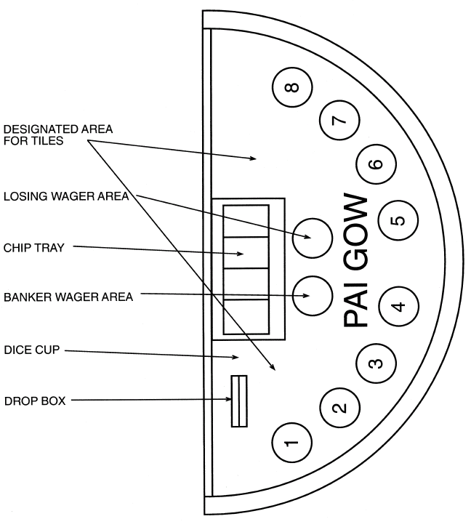

- Ranking of Tiles - Pairs, Wongs, Gongs and High Nines
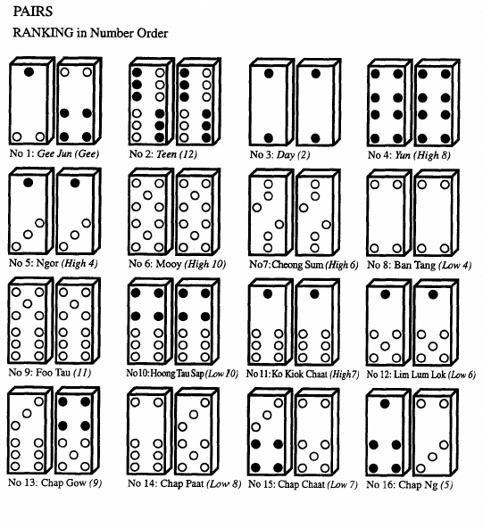

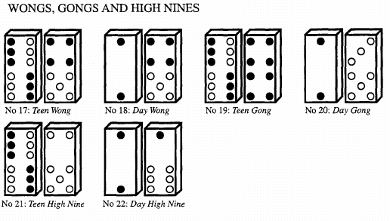

Note: a Wong, Gong or High Nine can be played with any 9, 8 or 7, not only the tiles depicted.

- Ranking of Tiles - Individual

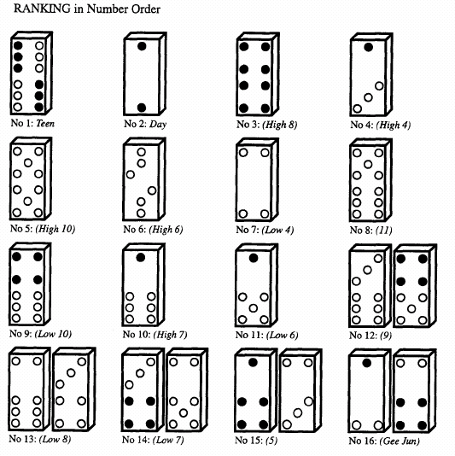

Note: Gee Jun as individual tiles are the lowest ranked. They can both be used as either a 3 or a 6.

- House Way

1. Interpretation
In this appendix, “Harmony 3” refers to the value of a hand consisting of 2 tiles where:
- the hand has a point count of 3; and
- the higher ranking individual tile in the hand has a ranking of High 4.

2. Pairs
2.1 With 2 ranking pairs, play the 2 pairs as 2 hands.
2.2 Never split the following pairs:
Fours
Fives
Sixes
Tens
Elevens.
2.3 Split:
Gee Jun with 6 and 6 (non-pairing)
6 and 5
6 and 4
Teen or Day with 9 and 11
9 and 8
9 and 7
9 and 6
9 and 5
9 and 4
8 and 8 (non-pairing)
8 and 7
8 and 6
8 and 5
8 and 4
7 and 7 (non-pairing)
7 and 6
7 and 5
7 and 4
6 and 6 (non-pairing)
6 and 5
6 and 4
Nines with Teen and Day
Teen/Day and 10
10 and 10 (non-pairing)
Eights with Teen and Day
Teen/Day and 11
Teen/Day and 10
11 and 10
11 and 9
10 and 10 (non-pairing)
Sevens with Teen and Day
Teen/Day and 11
Teen/Day and 10
11 and 10
10 and 10 (non-pairing)

3. Wongs, Gongs and High Nines
3.1 If no pair play is possible, play Wong, Gong or High Nine.
3.2 Play High Nine, Gong or Wong in that order providing Harmony 3 or better is achieved in the low hand.
3.3 Play Wong, Gong or High Nine in that order if Harmony 3 or better is not achieved in the low hand.

4. General Rules
4.1 Maximise the point count of the low hand providing the low hand achieves Harmony 3 or better.
4.2 If it is not possible to set the low hand at Harmony 3 or better, then maximise the point count of the high hand providing a high hand of 8 or better can be achieved.
4.3 If a high hand of 8 or better cannot be achieved, then maximise the point count of the low hand.

5. High Ranking Tiles
5.1 If possible, when the low hand is 7 or less, play the highest ranking tile in the low hand; however if there is a choice, do not play the 2 highest ranking tiles in the same hand.
5.2 If possible, when the low hand is 8 or better, play the highest ranking tile in the high hand; however if there is a choice, do not play the 2 highest ranking tiles in the same hand.
5.3 However, if the house is seeking to maximise the point count of the high hand, strengthen the high hand by adding the highest ranking tile.
5.4 If there is a Teen in 1 hand and a Day in the other, play the Teen in the high hand unless the 2 remaining tiles are:
- 4/5 or
- 10/11,
in which event play the Teen in the low hand.

6. Exceptions to General Play
6.1 Where the four tiles are 6, 7, 11 and any non-pairing tile, maximise the low hand even if Harmony 3 or better is not achieved in the low hand.
6.2 Where a hand can be played as either 8/8 or 7/9 in the low and high hands (respectively), play it as 7/9 unless one of the tiles is Low 10.
- Pai Gow Cuts
Traditional Name | Options | English Name
Yat Dong Dong | (Right or left) | 1 Stack
Cup Say | (Top or Bottom)  (Right or Left) | Tiger
Chee Yee | (Top or Bottom) | Chop the Ears
Dai Pin | (Right or Left) | Big Slice
Jung Quat | (Top or Bottom) | From the Heart
Long Tau/Fong May | (Right or Left) | Dragon Head/Phoenix Tail
Wui Fung Bank |  | Hong Kong Bank
Foot Say |  | 4 Across
Seung Gwai Pak Moon |  | Ghost Closing the Door
Pong Yun | (Right or Left) | Buddha’s Signal
China Bank |  | China Bank
Harbour Bridge |  | Harbour Bridge
Bo Bo Go Sing | (Right or Left) | Boy Walks Up Stairs
Gum Un Que | (Right or Left)  (Front or Back) | Double Bridge
Ghan Dong Ping Say | (Right or Left) | Kangaroo Jump
Chong Wan Sup Lok | (Top or Bottom) | 16 Across
Yat Kai Sum May | (Right or Left) | Chicken 3 Ways
Ghan Dong Cup Say | (Right or Left) | Striped Tiger
Arn Lok Peng Sar | (Right or Left)  (Head or Tail) | Flying Dragon
Girl on the Right and Left |  | Girl on the Right and Left

