Division 11A – Snake Eyes
Section 1 Interpretation
Section 2 Application
Section 3 Table Layout and Equipment
Section 4 Wagers
Section 5 Dice and Table Operation
Section 6 Irregularities
Appendix 1 Snake Eyes Layout (Option 1)
Appendix 2 Snake Eyes Layout (Option 2)
Appendix 3 Snake Eyes Layout (Option 3)

1.0 Interpretation
1.1 In this Division, unless the contrary intention appears:
“Active Dice” means any two of the Dice to be Rolled;
“Dice” means the dice used in the game of Snake Eyes, each complying with section 16 of the General Rules for Casino Table Games, provided that, at any one time, only two of the Dice may be utilised in active play and Rolled and no more than five Dice in total may be present or placed on a table;
“Roll” means a throw of the Active Dice by the Shooter or Dealer (as applicable) pursuant to these rules and “Rolled” has a corresponding meaning;
“Shooter” means the player who Rolls the Active Dice and, where the Active Dice are Rolled by the Dealer pursuant to these rules, includes the Dealer;
“Total” means the total value of the high or uppermost faces of the Active Dice following a Roll and, for the avoidance of doubt, only one face on each of the Active Die shall be considered the high or uppermost face; and
“7 Out” means a Roll by the Shooter where the Total equals 7.
1.2 In these rules, unless the contrary intention appears:
- the singular includes the plural and vice versa;
- a reference to Dealer means the Dealer or Dealers (as applicable) who control the game of Snake Eyes at a table;
- a reference to a rule is a reference to a rule in this Division;
- a reference in a rule to a subparagraph is to a subparagraph of that rule;
- a reference in a division to a rule is to a rule in that division;
- a reference in a division to a section is to a section of that division; and
- a reference in a division to an appendix is to an appendix to that division.

2.0 Application
2.1 The rules contained in this Division and the general rules contained in Division 1 shall apply to the game of Snake Eyes.

3.0 Table Layout and Equipment
3.1 The game of Snake Eyes shall be played on a table with:
- rounded corners;
- high walled sides;
- a drop box attached to it;
- where the Dice comprise more than two dice, a bowl, which shall be used to contain the Dice that are not Active Dice; and
- where Non-Value Chips are in use at the table:
- a display rack, which shall be used to indicate the colours and values of the Non-Value Chips; and
- marker buttons of different colours in such number as is sufficient to indicate the values of the subsets of Non-Value Chips in use.
3.2 The layout cloth of the table shall be marked with areas for the placement of wagers and in a manner substantially similar to that shown in Appendix 1, Appendix 2 or Appendix 3 (as applicable).
3.3 The Dice shall be placed on the table at the start of play.
3.4 The following equipment may also be used in the game of Snake Eyes:
- a stick, which may be used by the Dealer or Game Supervisor to collect and pass the Active Dice;
- a game results display, being an electronic device for recording and displaying the most recent winning results at the table; and/or
- electronic equipment which is:
- capable of capturing and/or entering the outcome of a Roll; and
- programmable to illuminate all areas of the layout representing the winning combination(s).
3.5 The electronic equipment referred to in rules 3.4(b) and 3.4(c) shall be of a type approved by the Secretary, contain components necessary for the performance of their respective functions, and comply with the applicable provisions of Division IV of the Rules of Casino Keno and Gaming Machines, as amended from time to time, approved for use in the casino and set out in the Supplement dated Tuesday, 1 November 1994 to the New Zealand Gazette of Thursday 27 October 1994, or any provisions approved in substitution for those provisions.

4.0 Wagers
4.1 In the game of Snake Eyes, a player may place any or all of the following wagers:
- a “Hardways” wager, being a wager on one of the specified “Hardways” betting areas of the layout (being a hard 4, hard 6, hard 8 or hard 10), which shall:
- win if the relevant Total (being a Total of 4, 6, 8 or 10) is Rolled the “hard way” with each of the Active Dice showing the same value before:
- that Total is Rolled by any other combination of numbers; or
- a Total of 7 is Rolled ; or
- otherwise lose;
- a “Hardway Combo” wager, being a wager on the “Hardway Combo” betting area of the layout, which shall:
- win if a Total of 4, 6, 8 or 10 is Rolled the “hard way” with each of the Dice showing the same value before:
- that Total is Rolled by any other combination of numbers; or
- a Total of 7 is Rolled; or
- otherwise lose;
- a “5” wager, being a wager which shall:
- win if a Total of 5 is Rolled before a Total of 7 is Rolled; or
- lose if a Total of 7 is Rolled before a Total of 5 is Rolled;
- a “6” wager, being a wager which shall:
- win if a Total of 6 is Rolled before a Total of 7 is Rolled; or
- lose if a Total of 7 is Rolled before a Total of 6 is Rolled;
- an “8” wager, being a wager which shall:
- win if a Total of 8 is Rolled before a Total of 7 is Rolled; and
- lose if a Total of 7 is Rolled before a Total of 8 is Rolled;
- a “Field Bet” wager, being a wager on a single Roll which shall:
- win if a Total of 2, 3, 4, 9, 10, 11 or 12 is Rolled immediately following the placement of that wager; or
- otherwise lose;
- an “Any 7” wager, being a wager on a single Roll which shall:
- win if a Total of 7 is Rolled immediately following the placement of that wager; or
- otherwise lose;
- a “C&E Combo” wager, being a wager on a single Roll which shall:
- win if a Total of 2, 3, 11 or 12 is Rolled immediately following the placement of that wager; or
- otherwise lose;

- a “Craps 2” wager, being a wager on a single Roll which shall:
- win if a Total of 2 is Rolled immediately following the placement of that wager; or
- otherwise lose;
- a “Craps 3” wager, being a wager on a single Roll which shall:
- win if a Total of 3 is Rolled immediately following the placement of that wager; or
- otherwise lose;
- a “Craps 12” wager, being a wager on a single Roll which shall:
- win if a Total of 12 is Rolled immediately following the placement of that wager; or
- otherwise lose;
- an “11 in 1 Roll” wager, being a wager on a single Roll which shall:
- win if a Total of 11 is Rolled immediately following the placement of that wager; or
- otherwise lose.
4.2 Whether a wager wins or loses is determined by the Total after, in the case of a wager on a single Roll, that single Roll or, in the case of a wager on multiple Rolls, a relevant Roll. Only one face on each die shall be considered high or uppermost.
4.3 All wagers shall be made by placing either Value Chips or Non-Value Chips on the relevant wager area of the layout. Where one or more Value Chips is placed in the same wager area of the layout by a player, the Chips shall be stacked in ascending order with the highest denomination chip on the bottom and the lowest denomination chip on the top.
4.4 All wagers shall be made by the players at a table before the Active Dice are Rolled, provided that a wager may be made between the time the Active Dice leave the Shooter’s hand and the time the Active Dice come to rest if:
- there is enough time for that wager to be confirmed orally by the Dealer or Game Supervisor at that table;
- that wager is confirmed orally by the Dealer or Game Supervisor at that table; and
- that wager is accompanied by Chips.
4.5 Each player shall be responsible for the correct placement of his/her wager(s) on the layout (whether or not he/she is assisted by the Dealer) and ensuring that any instructions he/she gives to the Dealer regarding the placement of his/her wager(s) are carried out correctly.
4.6 Each wager shall be settled in accordance with its position on the layout when the result of the relevant Roll has been established, except where the Casino Operator determines that a wager has been accidentally moved or misplaced by the Dealer or another player at that table.
4.7 A player may, at any time, remove or reduce any wager placed by him/her before the Active Dice (which will determine the outcome of that wager) come to rest.
4.8 No player shall handle, alter or withdraw any losing wager.
4.9 Winning wagers shall be paid in accordance with the odds specified in the following tables:
Multi Roll Wagers
Hardways wager
4 | 7 to 1; or 6 to 1
6 | 9 to 1; or 8 to 1
8 | 9 to 1; or 8 to 1
10 | 7 to 1; or 6 to 1
Hardway Combo wager | 4 to 1

5, 6 and 8 wagers
5 | 1 to1
6 | 1 to 1
8 | 1 to 1
Single Roll Wagers
Field Bet wager | Option 1 | Option 2 | Option 3
3, 4, 9, 10 or 11 | 1 to 1 | 1 to 1 | 1 to 1
12 | 2 to 1 | 2 to 1 | 1 to 1
2 (Snake Eyes) | 3 to 1 | 2 to 1 | 3 to 1

Any 7 wager | 4 to 1

C & E Combo wager | 4 to 1

Craps 2, 3 and 12 and 11 in 1 wagers
Craps 2 (Snake Eyes) | 34 to 1; or  33 to 1; or  32 to 1; or  31 to 1; or  30 to 1
Craps 3 | 16 to 1; or  15 to 1
Craps 12 | 34 to 1; or  33 to 1; or  32 to 1; or  31 to 1; or  30 to 1
11 in 1 Roll | 16 to 1; or  15 to 1
4.10 The Casino Operator shall display the applicable odds at each table, which, for the avoidance of doubt, may comprise any combination of the odds specified in the tables in rule 4.9.

5.0 Dice and Table Operation
5.1 The Dealer shall be responsible for the control of, and retain, the Dice (except the Active Dice) in the Dice bowl (as referred to in rule 3.4(b)) at the table.
5.2 Upon receipt of the Dice at a table (whether at the start of play or during the course of play), the Dice shall be independently inspected by each of the Dealer and Game Supervisor and then placed in the Dice bowl (as referred to in rule 3.4(b)) or on the layout (as applicable).
5.3 At the start of play:
  - the Dealer shall offer the Dice to the player immediately to his/her left;
  - if that player rejects the Dice, the Dealer shall then offer the Dice to each of the other players in turn, clockwise around the table, until one of the players accepts them; and
  - the first player to accept the Dice shall become the Shooter and be entitled to choose and retain any two of the Dice as the Active Dice. The remaining Dice (if any) shall be returned to the Dice bowl (as referred to in rule 3.4(b)) and placed in front of the Dealer.
5.4 To be eligible to Roll the Active Dice, a player must have a wager placed at the time of that Roll.
5.5 After choosing the Active Dice, the Shooter shall throw them so that they leave his/her hand simultaneously and in a manner calculated to cause them to strike the end of the table farthest from him/her in a random manner. When handling or throwing the dice the Shooter shall use one hand only.
5.6 When the Active Dice come to rest after a Roll, the Dealer or Game Supervisor:
- shall immediately call the Total;
- shall, if electronic equipment is being used in accordance with rules 3.4(b) and 3.4(c), at the same time as announcing the Total enter the result into the electronic equipment by pressing the relevant numbered button or buttons, or switch or switches, on the entry terminal corresponding to the declared Total and pressing the entry button on the terminal;
- shall collect the Active Dice;
- shall place the Active Dice in the centre of the table; and
- as soon as all wagers have been settled in accordance with section 4, may pass the Active Dice to the Shooter for the next Roll.

5.7 The Shooter may at his/her election, after any Roll, either relinquish the Active Dice or remain the Shooter, provided that:
- subject to clause 5.8, the Shooter shall be required to relinquish the Active Dice immediately after Rolling a 7 Out; and
- the Dealer or Game Supervisor may require the Shooter to relinquish the Active Dice if the Shooter unreasonably delays the game, repeatedly makes a void Roll or at any time contravenes these rules.
Where the Shooter loses all of his/her wagers before a 7 Out is Rolled, the Shooter shall be given the opportunity to place a further wager and may at his/her election continue to Roll or relinquish the Active Dice.
5.8 At the Casino Operator’s sole discretion, any Shooter who Rolls a 7 Out on their first Roll may be provided with an opportunity to retain the Active Dice for another Roll. Should the Shooter elect to take another Roll and subsequently Roll another 7 Out, they shall be required to relinquish the Active Dice immediately. For the avoidance of doubt, all wagers will be settled in accordance with these rules irrespective of whether or not the Casino Operator uses their discretion under this clause 5.8.
5.9 When collecting and passing the Active Dice, the Dealer may use either the stick (as referred to in rule 3.4(a)), if any, or his/her hand.
5.10 If the Shooter relinquishes the Active Dice in the course of play:
- the Dealer shall offer the Dice to the player immediately to the Shooter’s left, provided that that player has placed a wager;
- if that player does not accept the Dice, the Dealer shall then offer the Dice to each of the remaining players who have placed a wager in turn clockwise around the table;
- the first player to accept the Dice shall become the new Shooter and be entitled to choose and retain any two of the Dice as the Active Dice. The remaining Dice (if any) shall be returned to the Dice bowl (as referred to in rule 3.4(b)), if any, and placed in front of the Dealer; and
- if no eligible player is available or willing to accept the Dice and undetermined wagers remain on the layout, the Dealer shall Roll the Active Dice until a result has been determined or a 7 Out is Rolled.

6.0 Irregularities
6.1 If any of the Dice leave the table during play:
- an immediate effort shall be made to retrieve the missing Dice;
- any remaining Dice at that table shall be offered to the Shooter for him/her to select replacement Dice – in which case, the Shooter may select replacement Dice or request the original Dice;
- if the missing Dice are found, the Dealer, or Game Supervisor, or Casino Supervisor shall carefully inspect such Dice for damage, alteration or any other irregularity before either returning such Dice to the Shooter (if the Shooter has so requested) or placing such Dice in the Dice bowl (as referred to in rule 3.4(b)), if any;
- if the missing Dice are not found, the remaining Dice at that table shall be removed from the game and replaced with new Dice. To avoid any delay in the game, the Shooter at the time the Dice went missing shall be entitled to continue to play with the remaining Dice until he/she either Rolls a 7 Out or his/her wager wins and he/she declines any further Roll.
6.2 Subject to rules 6.3 and 6.4, if any of the Active Dice lands on an object on the table (i.e. it does not land flat on the table), the face directly opposite the face that is resting on that object shall be considered the uppermost face of that Active Die. If there is a dispute as to which face is the uppermost face, the Game Supervisor may determine at his/her sole discretion which face of the Active Die is the uppermost face or declare the relevant Roll Void.
6.3 Notwithstanding any other rule, if, in respect of any Roll:
- any of the Active Dice leaves the table;
- one of the Active Dice comes to rest on top of the other of the Active Dice on the table;
- any of the Active Dice comes to rest on the bank of Chips on the table;
- any of the Active Dice comes to rest in the Dice bowl (as referred to in rule 3.4(b)), if any, on the table or on any of the rails surrounding the table;
- more than one face of any of the Active Dice comes to rest on an object (including any chip) on the table;
- any of the Active Dice is fraudulent or not approved for use in the game or a fraudulent technique is used;
- any of the Active Dice is Rolled in such a way that it would be possible to call the natural fall of the Dice; or
- someone other than the Shooter rolls the Active Dice,
then the Dealer or Game Supervisor shall announce “No roll”, if possible, before the Active Dice come to rest and that Roll shall be deemed Void. Any such Roll shall be Void whether or not “No roll” is announced.
6.4 Notwithstanding any other rule, if, in respect of any Roll:
- the Active Dice do not leave the Shooter’s hand simultaneously;
- any of the Active Dice fails to strike an end of the table;
- the Dealer or Game Supervisor considers that Roll to be improper for any other reason; or
- any other irregularity has occurred,
then the Dealer or Game Supervisor may at his/her sole discretion deem that Roll to be Void by announcing “No roll”, if possible, before the Active Dice come to rest.
6.5 A call of “No roll” made under rule 6.4 or 6.5 shall, whenever possible, be made before the dice come to rest.

6.6 The:
- Game Supervisor may overrule the Dealer if, in his/her judgement, the Dealer has made an error in calling the outcome of a Roll;
- Casino Supervisor may overrule the Dealer and/or Game Supervisor, if in his/her judgement, the Dealer and/or Game Supervisor have made an error in calling the outcome of a Roll ;
- a senior Casino Supervisor may overrule the Dealer, Game Supervisor and/or Casino Supervisor if in his/her judgement, the Dealer, Game Supervisor and/or Casino Supervisor have made an error in calling the outcome of a Roll; and
- the Casino Operator may overrule the Dealer, Game Supervisor, Casino Supervisor and/or senior Casino Supervisor if, in his/her judgement, the Dealer, Game Supervisor, Casino Supervisor and/or senior Casino Supervisor, have made an error in calling the outcome of a Roll.
6.7 To the extent a matter is not addressed in these rules, the Casino Operator’s decision in relation to that matter is final.
6.8 If, after the entry button has been pressed pursuant to rule 5.6, it is found that the incorrect numbers have been entered into the electronic equipment, the result shall be amended under the supervision of the game supervisor before the wagers on the layout are settled.
6.9 If the electronic equipment fails to illuminate the winning areas, or fails to illuminate the winning areas correctly, all wagers shall be taken and paid according to the result shown on the dice and rule 6.10 shall apply.
6.10 Notwithstanding rule 6.9, in the event of an equipment malfunction, no further games shall be conducted until either the malfunction has been rectified or procedures that do not compromise the integrity of the game have been introduced.
6.11 If a game results display is provided at the table, the Casino Operator shall not be responsible for the display of any incorrect results or other information or for the consequences of any other malfunction of the display.

Appendix 1: Snake Eyes Table Layout (Option 1)
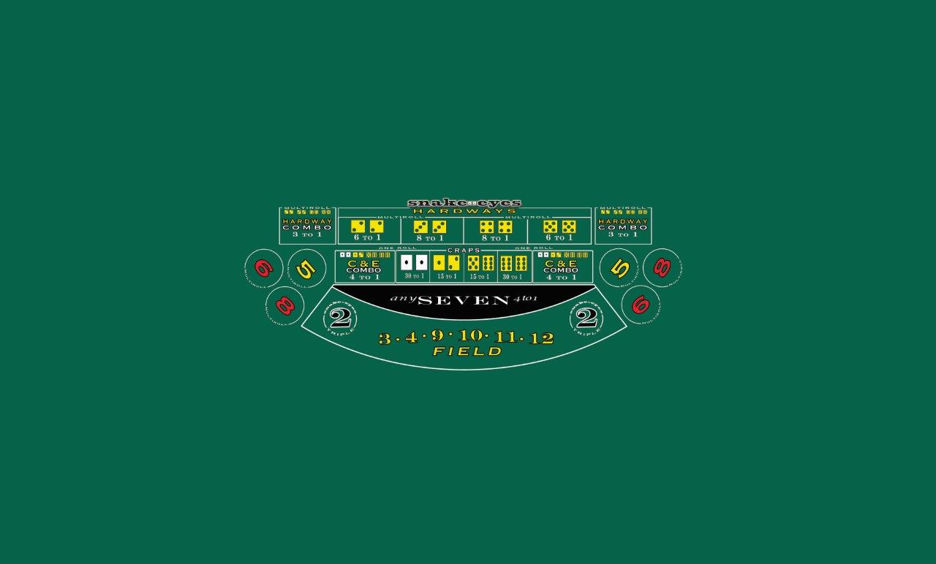

Appendix 2: Snake Eyes Table Layout (Option 2)
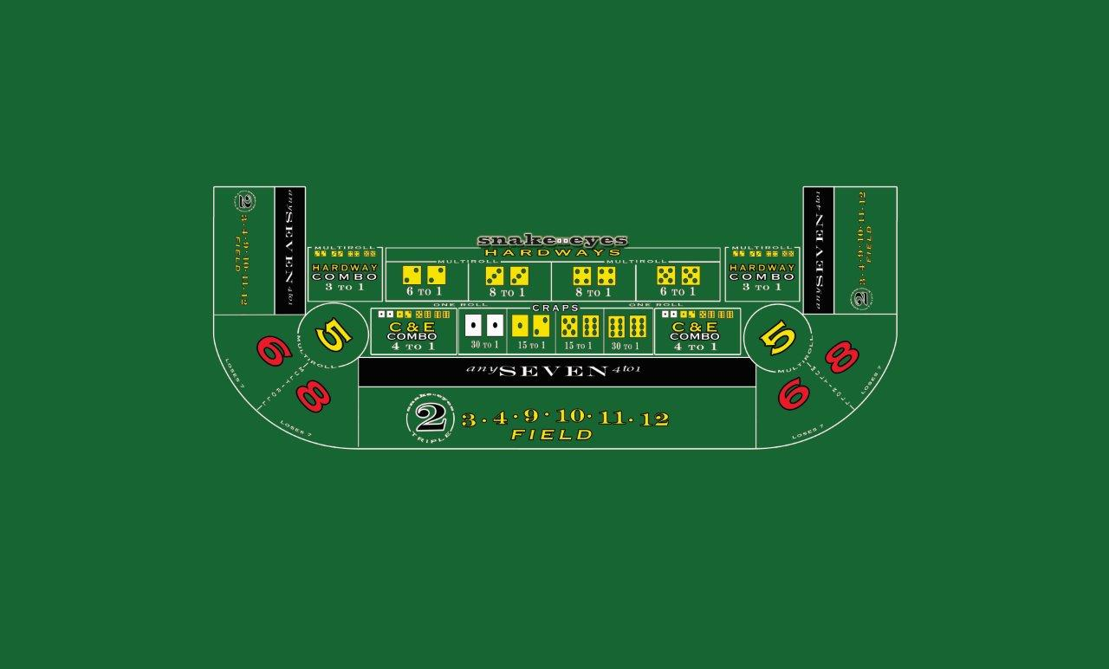

Appendix 3: Snake Eyes Table Layout (Option 3)
