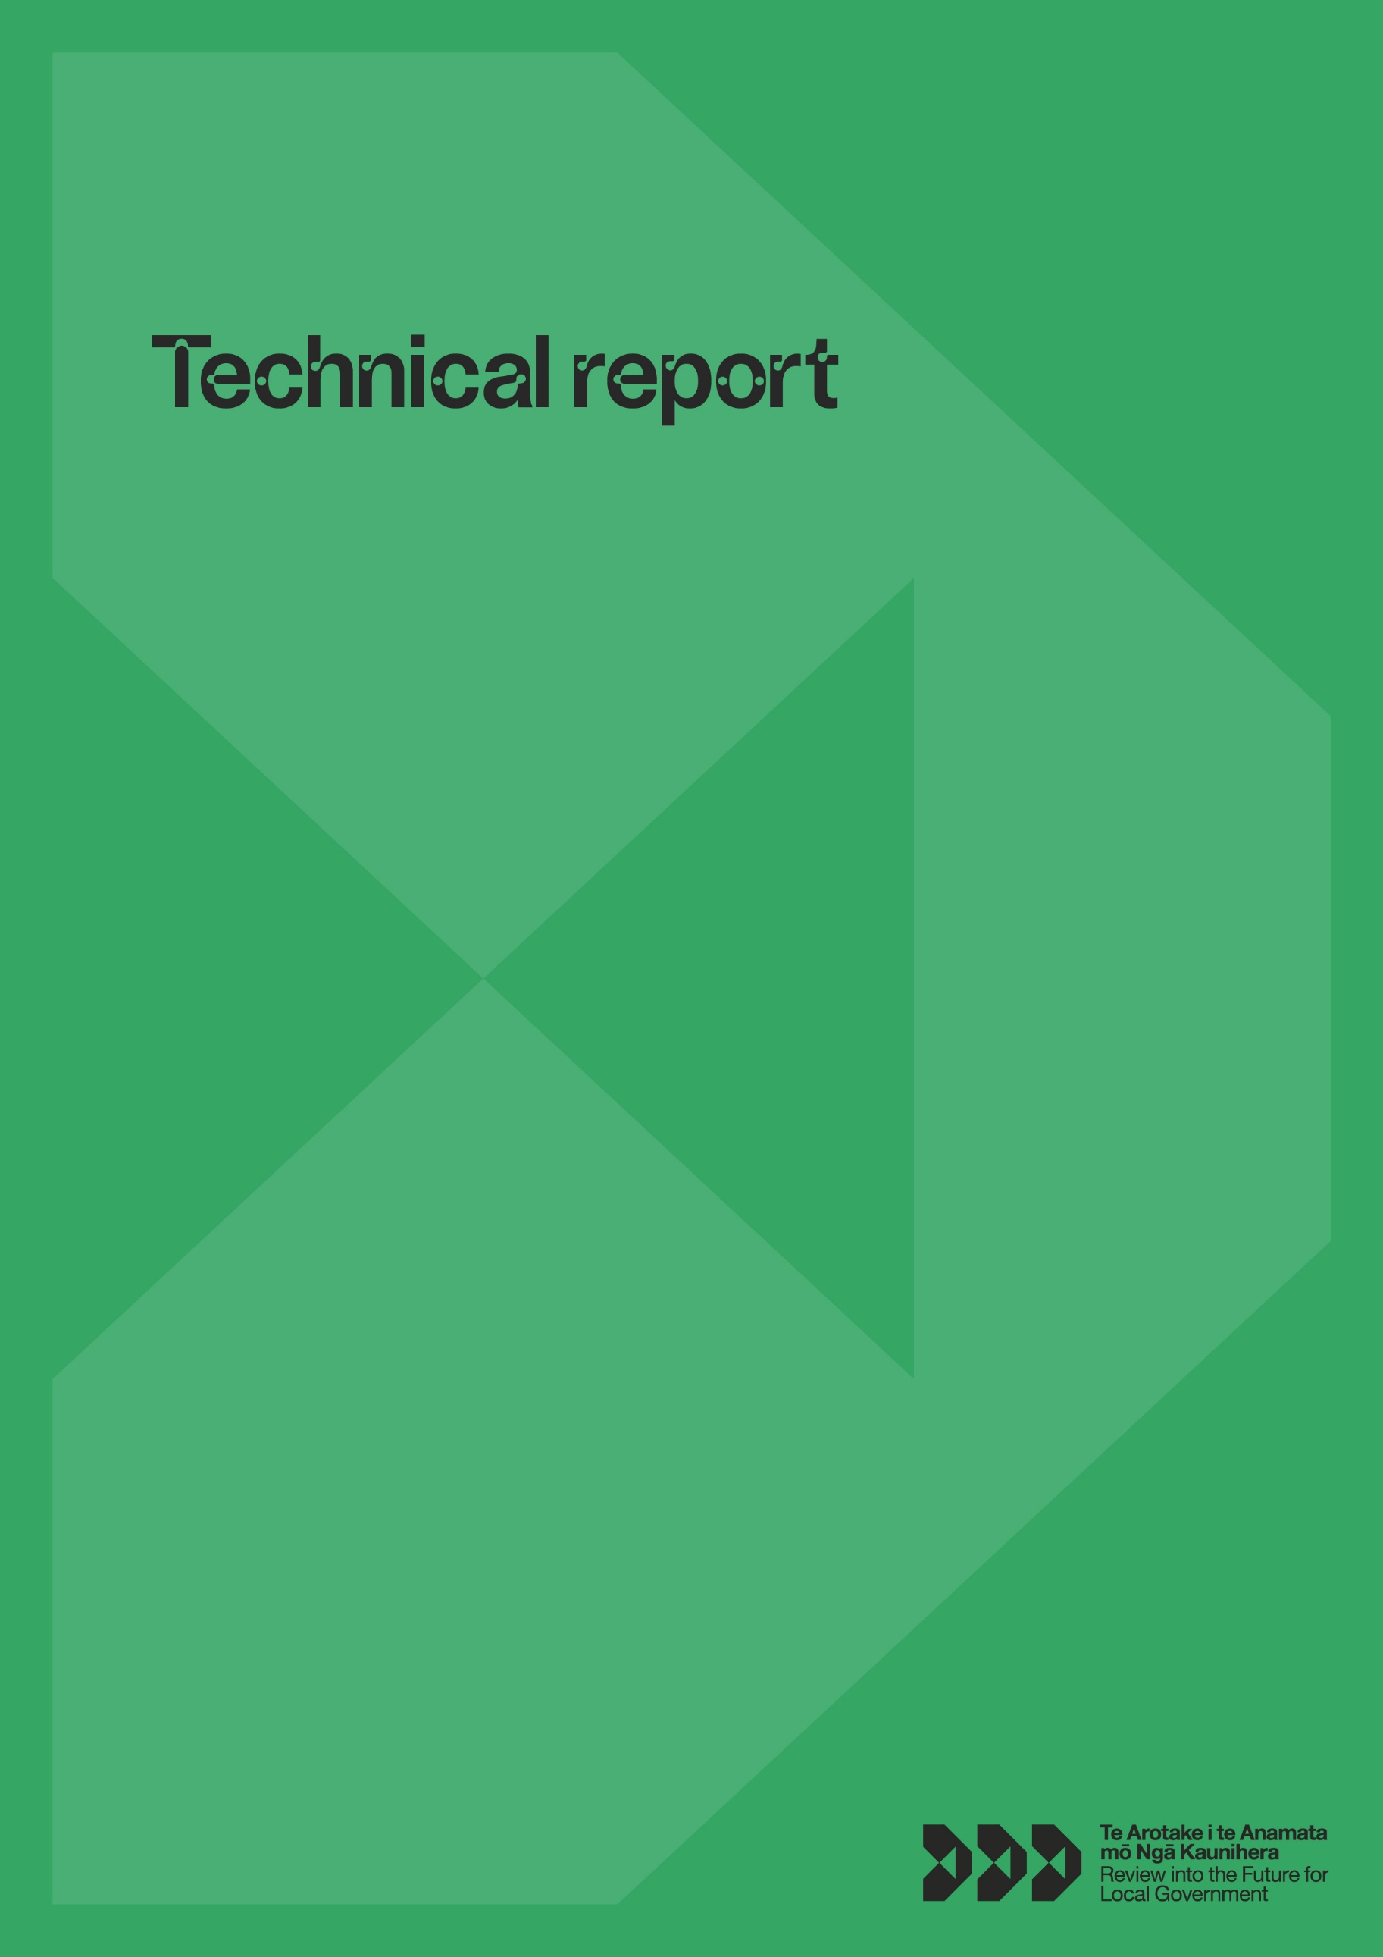

This document may be cited as: Review into the Future for Local Government (2023) Technical Report, Wellington: New Zealand.
This work is licensed under the Creative Commons Attribution 4.0 International licence. You are free to share, adapt, and build upon the material. You must give appropriate credit, provide a link to the licence, and indicate if changes were made.
ISBN: 978-1-99-118529-7 (print)
ISBN: 978-0-473-68212-5 (online)

About this report
This technical report accompanies Te Arotake i te Anamata mō Ngā Kaunihera, the Review into the Future for Local Government’s (the Review) Final Report, He piki tūranga, he piki kōtuku. To find out more about the establishment and purpose of the Review, refer to the methodology section of this report and the Terms of Reference: https://www.dia.govt.nz/Future-for-Local-Government-Review-Terms-of-Reference.
The technical report is a compendium of resources, research and ideas that have informed the Panel’s thinking throughout the Review. The technical report complements the final report by providing further explanation, evidence, and reasoning that has informed the Panel’s conclusions and recommendations. This technical report includes resources referred to by the Panel throughout the development of the interim, draft, and final reports.
The technical report also functions as an historical archive for the Review, helping users to engage with the content of the Review as work continues after its conclusion. The report is not intended to provide instruction on how to incorporate the findings from the Review, but to provide individuals engaging with the issues identified throughout the Review with access to research and ideas that may help to inform their thinking, planning, and problem solving.
To engage with the content meaningfully, readers should refer to the interim, draft and final reports to understand the development of the Review and the context behind the areas the Panel researched and engaged with. You can access the Review’s reports at https://www.futureforlocalgovernment.govt.nz/reports/.

How to use this report
This report outlines resources by the level of impact they had on the Panel’s thinking throughout the Review. Most sections refer to ‘key resources’ (work that substantially informed the Panel’s thinking) and ‘additional resources’ (work that the Panel lightly engaged with).
This report also lists ‘other resources’ – a range of other articles, papers, and resources that may help further explore the research and current thinking in the areas covered by the Review. These resources were circulated during the Review but were not significantly discussed.

Contents
Methodology 6
Terms of Reference established 6
Research 7
Early soundings 7
A broader national conversation 7
Policy analysis and advice 9
Formal consultation and submissions 10
Engagement strategy 11
Key frameworks 12
The Three Horizons Framework 12
Horizon one 12
Horizon two 12
Horizon three 12
Additional Three Horizons Framework resources 13
Rangatiratanga and kāwanatanga 13
Cynefin Framework 14
Polarity thinking 15
Living Standards Framework 16
He Ara Waiora 16
Changes to the system of local government 18
Giving full effect to councils’ wellbeing purpose 18
Local government as place-shaper 18
Local government as anchor institution 19
Local government as systems networker and convenor 20
Mindset and culture shift in councils 20
Aligning central and local government to support community wellbeing 21
Alignment 22
Place-based agreements 22
Collaboration and coordination 23
Taking a fresh look at local government roles and functions 24
A sustainable, equitable local government funding and finance system 25
Equitable and sustainable funding and finance 25
Local government embracing Te Tiriti o Waitangi and te ao Māori 26
Replenishing local democracy 30
Deliberative and participatory democracy 30
Active citizenship 32
The local government electoral system 33
Improved representation around the council table 35
Elected members are valued and grow as governors 35
Reorganising local government 35
Purposeful stewardship to support a healthy local government 36
Current reviews and reforms 39
Climate change 39
Water Services Entities Bill (Three Waters/affordable water reforms) 39
Resource management reforms 40
Social system and infrastructure reforms 40
Electoral system reforms 41
Māori health reforms 41
Other resources 43
Giving full effect to councils’ wellbeing purpose 43
Aligning central and local government to support community wellbeing 45
Taking a fresh look at local government roles and functions 45
A sustainable, equitable local government funding and finance system 45
Replenishing local democracy 46
Reorganising local government 46
Purposeful stewardship to support a healthy local government 46
Climate change 46
Resource Management 46
List of Appendices 47

Methodology
The Panel has taken a flexible, iterative approach, considering in depth a vast range of ideas and approaches throughout the course of the Review. It was important to the Panel that conclusions and recommendations were not made without considering the voices of the local government sector and all key stakeholders, including central government, diverse communities, businesses, hapū and iwi, and rangatahi. Engagement and research throughout the Review has been far-reaching and comprehensive to ensure decisions considered stakeholder opinions from across Aotearoa New Zealand.
The Panel considered a broad range of ideas which have been subjected to robust discussion and research, supported by the Secretariat. A policy lens was applied throughout the course of the Review to ensure that ideas considered by the Panel were well-researched and evidence based.
The Review was conducted with the support of Local Government New Zealand and Taituarā – Local Government Professionals Aotearoa, to ensure the local government sector was involved throughout the Review.

Terms of Reference established
The Terms of Reference asked the Panel to consider the future of local governance in New Zealand. Local government, in the context of this Review, refers to the local authority structures established by statute. Local governance refers more broadly to the system by which communities are governed – in essence, who makes decisions, how they are made, and who the decision-makers are accountable to. In any place or community, local governance can involve many decision-makers, including central government, local authorities, iwi, hapū, and Māori organisations, business and community organisations, and others.
In that context, the Panel considered:
- the functions, roles, and structures of local government
- relationships between local government, central government, hapū/iwi, Māori, businesses, communities, and other organisations that contribute to local wellbeing
- how the local governance system might authentically embody Treaty partnership
- whether current funding arrangements are sustainable, equitable, and maximise wellbeing
- what might need to change so that local government and its leaders most effectively reflect and respond to the communities they serve.
In accordance with the Terms of Reference, the Panel did not inquire into any Government policy decisions, including but not limited to those related to programmes of reform. The impact of reform programmes on local government (such as the Three Waters/affordable water and resource management reforms) are within the scope of the Review.
Similarly, the Panel considered the merits of recent public sector reforms, Climate Change Commission advice, Productivity Commission recommendations, Waitangi Tribunal recommendations, and reports on local government elections and financing.
More information about the establishment of the Review and the Terms of Reference can be found at https://www.dia.govt.nz/Future-for-Local-Government-Review-Terms-of-Reference.

Research
The Terms of Reference established core areas of focus that the Panel needed to consider as a part of the Review. Research was conducted into these core areas of focus early in the Review to inform the direction and focus of engagement and further research.
Conducting this research ensured the Panel had a base and agreed level of knowledge of the current Aotearoa New Zealand local government context. This early research enabled the Panel to define the problems in the current system and to familiarise themselves with current and emerging best practice, including international examples.

Early soundings
The first stage of the Review involved initial scoping and early engagement with some (mainly local government) organisations and iwi to take a future-focused look at the local governance system and identify priority questions and lines of inquiry.
These engagements (soundings) conducted throughout May–August 2021 included a series of workshops held with local government elected members and regional groupings of council staff at which the Panel posed questions and captured the resulting ideas. The Panel also engaged with the Office of the Prime Minister’s Chief Science Advisor Forum. and the Business Reference Group (established by the Review). Engagement with the Business Reference Group focused on gaining insights around the business sector’s relationship with local government, identifying that business is intrinsically a part of communities, and identifying structural issues in the relationship between businesses and local government.
The Interim Report, Ārewa ake te Kaupapa: Raising the Platform (September 2021) reflected the results of this work and signalled the broad lines of inquiry that the Panel took for the next stage of the Review. They landed on five priority questions:
- How should the system of local governance be reshaped so it can adapt to future challenges and enable communities to thrive?
- What are the future functions, roles and essential features of New Zealand’s system of local government?
- How might a system of local governance embody authentic partnership under Te Tiriti o Waitangi, creating conditions for shared prosperity and wellbeing?
- What needs to change so local government and its leaders can best reflect and respond to the communities they serve?
- What should change in local governance funding and financing to ensure viability and sustainability, fairness and equity, and maximum wellbeing?
To learn more about the engagements and findings from this initial stage of the Review you can read a full report at https://www.futureforlocalgovernment.govt.nz/assets/Reports/Soundings-Report.pdf.

A broader national conversation
After the interim report was published a broader national conversation began. The Panel engaged deeply across the motu, including commissioning idea pieces and research from experts and hosting workshops with community groups. The Panel placed emphasis on the discovery of new ideas and research, and considered the broad range of ideas raised by communities across Aotearoa. Throughout this stage the Covid-19 pandemic meant that online alternatives for engagement were used when necessary, such as the online roadshow to meet with 78 councils. The Panel met online with rangatira from hapū and iwi across the country. The online engagement tool, Get Vocal in Your Local, made it possible for young people across the motu to have their say. The Māori Thought Leaders Rōpū was established in December 2021, and met with the Panel throughout 2022.
A summary of the engagement journey up until the delivery of the draft report is shown in the diagram below.
Figure 1: Review into the Future for Local Government Engagement Process
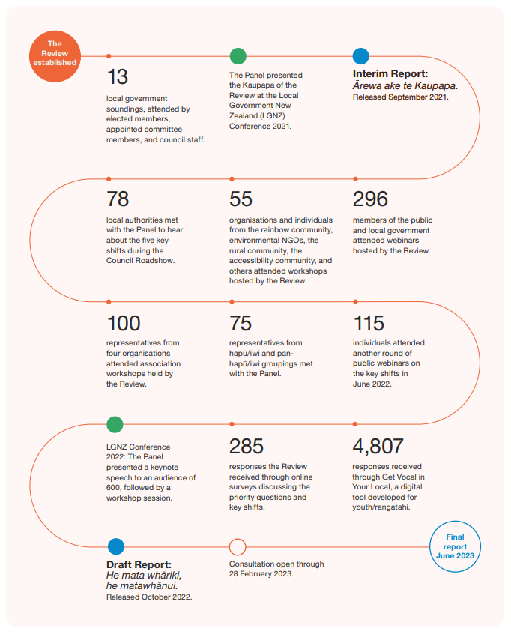
Image description: This figure shows the timeline of the Review into the Future for Local Government Engagement Process. First, the Review was established. 13 local government soundings were attended by elected members, appointed committee members, and council staff. The Panel presented the Kaupapa of the Review at the Local Government New Zealand (LGNZ) Conference 2021. The Interim Report: Ārewa ake te Kaupapa was released September 2021. 78 local authorities met with the Panel to hear about the five key shifts during the Council Roadshow. 55 organisations and individuals from the rainbow community, environmental NGOs, the rural community, the accessibility community, and others attended workshops hosted by the Review. 296 members of the public and local government attended webinars hosted by the Review. 100 representatives from four organisations attended association workshops held by the Review. 75 representatives from hapū/iwi and pan-hapū/iwi groupings met with the Panel. 115 individuals attended another round of public webinars on the key shifts in June 2022. At the LGNZ Conference 2022: The Panel presented a keynote speech to an audience of 600, followed by a workshop session. The Review received 285 responses through online surveys discussing the priority questions and key shifts. 4,807 responses were received through Get Vocal in Your Local, a digital tool developed for youth/rangatahi. The Draft Report: He mata whāriki, he matawhānui was released October 2022. Consultation was open through 28 February 2023. The Final report was released June 2023.
A summary of the engagements leading up to the publication of the draft report is available at https://www.futureforlocalgovernment.govt.nz/reports/.
The draft report was kept deliberately broad to represent the diverse range of ideas being considered and the breadth of research and engagement that occurred throughout this phase. This allowed submitters to have full context about what ideas the Panel was considering and ensured that the Panel did not narrow its focus or exclude ideas that could inform conclusions and recommendations before considering submissions.
The Panel worked to achieve consensus across issues being considered in the Review, only moving forward as a unit with a conclusion or recommendation after reaching full agreement. Consensus was reached by the Panel on policy directions with the support of the Secretariat. Sometimes agreement was achieved through formal papers, while other times consensus was agreed upon through more fluid, iterative and conversational processes.
Building on the interim report’s priority questions, the Panel identified five key shifts as the most pressing issues facing local government. The draft report’s recommendations and conclusions focused on these key areas:
Figure 2: Review into the Future for Local Government key shifts
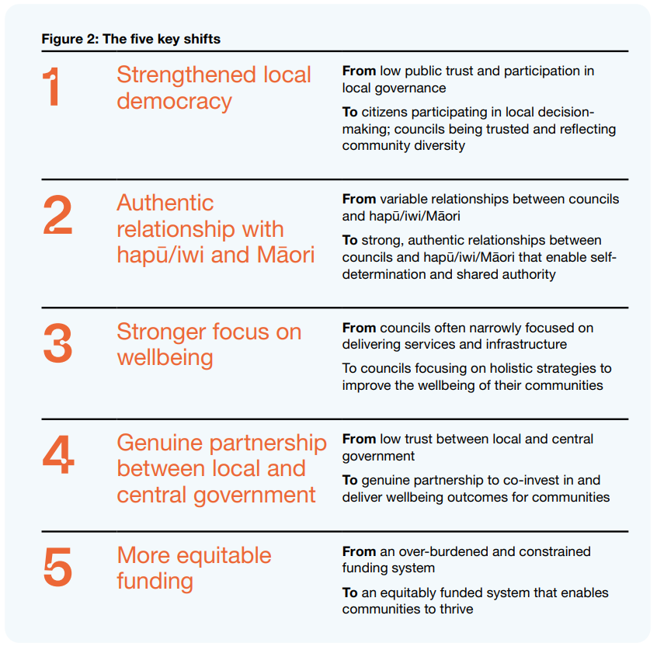
Image description: This figure lists the five key shifts. Shift 1: Strengthened local democracy – From low public trust and participation in local governance, to citizens participating in local decision-making; councils being trusted and reflecting community diversity. Shift 2: Authentic relationship with hapū/iwi and Māori – From variable relationships between councils and hapū/iwi/Māori, to strong, authentic relationships between councils and hapū/iwi/Māori that enable self-determination and shared authority. Shift 3: Stronger focus on wellbeing – from councils often narrowly focused on delivering services and infrastructure, to councils focusing on holistic strategies to improve the wellbeing of their communities. Shift 4: Genuine partnership between local and central government – from low trust between local and central government, to genuine partnership to co-invest in and deliver wellbeing outcomes for communities. Shift 5: More equitable funding – From an over-burdened and constrained funding system, to an equitably funded system that enables communities to thrive.

Policy analysis and advice
Standard and innovative policy tools were used to inform Panel decisions. Innovative tools used by the Review included Get Vocal in Your Local – an online survey tool and accompanying campaign aimed at engaging with rangatahi. For more information about Get Vocal in Your Local, visit https://www.futureforlocalgovernment.govt.nz/reports/.
Throughout the Review, the Panel was provided with policy support by the Secretariat, who ensured a policy and research lens was applied to the Review. The Panel also received several spontaneous papers and written feedback from local government stakeholders, iwi and hapū.
The following diagram from the Department of Prime Minister and Cabinet’s Policy Project explains some of the key policy concepts that were used by the Secretariat team to support the Panel’s decision-making and progress throughout the Review. These skills ensure that high-quality policy decisions are made which consider the current environment, risks, issues, and realities of implementation.
Figure 3: Start Right Guide
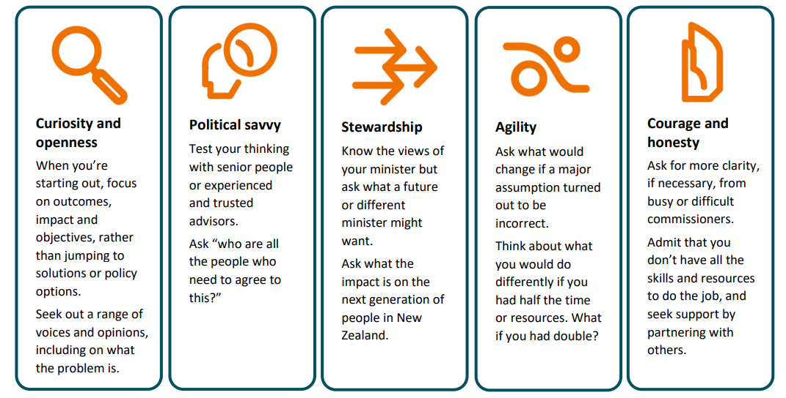
Image description: This figure explains key policy concepts. Curiosity and openness – When you’re starting out, focus on outcomes, impact and objectives, rather than jumping to solutions or policy options. Seek out a range of voices and opinions, including on what the problem is. Political savvy – Test your thinking with senior people or experienced and trusted advisors. Ask “who are all the people who need to agree to this?” Stewardship – Know the views of your minister but ask what a future or different minister might want. Ask what the impact is on the next generation of people in New Zealand. Agility – Ask what would change if a major assumption turned out to be incorrect. Think about what you would do differently if you had half the time or resources. What if you had double? Courage and honesty – Ask for more clarity, if necessary, from busy or difficult commissioners. Admit that you don’t have all the skills and resources to do the job, and seek support by partnering with others.
Source: Department of Prime Minister and Cabinet (2019) Start Right Guide, DPMC Policy Project, https://www.dpmc.govt.nz/sites/default/files/2019-08/start-right-guide-may21.pdf.
The Panel considered who would be affected by changes, the current appetite for change, risks and issues, and the purpose of change. These questions and policy approach ensured the final report delivered clear and actionable advice and recommendations.

Formal consultation and submissions
The final report is designed to be concise and usable, and delivers actionable recommendations. The final report is not a reiteration of the draft report. After delivering the draft report the Panel considered some new ideas and research, and conducted final testing and engagements with key experts.
A formal submissions process was undertaken to engage deeply across the motu on the conclusions and recommendations in the draft report. The Draft Report posed questions and made recommendations across 11 chapters, reflecting the five key shifts identified by the Panel as necessary to reform the future of local government. It also looked at the issues of system design and stewardship.
Submitters were invited to share their views using an online portal. The portal walked users through the draft report and asked for feedback on recommendations and questions, as well as the broader subjects of each chapter. The Panel also received written submissions outside the online portal. These submitters chose to structure their feedback in ways that reflected their views and priorities.
The submissions analysis team reviewed submissions and identified feedback about the draft report’s chapters, questions, and recommendations. This feedback was collated for the Secretariat to review and identify areas where there was clear agreement across submitters, and where feedback was less conclusive. Alongside other evidence, research, and consultation, the Panel considered the submissions received on the draft report to help shape their final report and recommendations.
While we heard from a number of people, the submissions we received cannot be taken to represent the views of all New Zealanders, or even a cross section. Those who engaged with our consultation represent highly engaged individuals and organisations rather than society as a whole. In light of this we have not focused on statistical summaries but instead highlighted the most common themes that emerged from submissions.
In summary, we received a total of 14,093 submissions throughout the submissions process. An online consultation portal was available and was used by 583 submitters, while the public information email address received 13,525 submissions (including 13,443 form submissions). Due to Cyclone Gabrielle, two affected councils chose to submit by having an online conversation with Panel members. We also received one handwritten submission.
Overall, we received 13,946 submissions from individuals, 67 from councils, and 95 from other organisations or representative groups.
A summary of the submissions process and findings is available at https://www.futureforlocalgovernment.govt.nz/reports/. These findings were considered by the Panel before it delivered the Final Report, influencing the Panel’s final conclusions and recommendations.

Engagement strategy
A comprehensive engagement strategy guided engagement with Māori and iwi, the local government sector, central government, communities across Aotearoa, businesses and business sector organisations, and rangatahi. Further detail on the full volume of these engagements prior to the publication of the draft report is available at https://www.futureforlocalgovernment.govt.nz/reports/.
The Panel was clear that the final report would not simply be a reiteration of the draft report, and engagement continued across these sectors and groups after the publication of the draft report. These engagements largely focused on promotion of the Review to ensure that communities, organisations, and individuals were aware of the submissions process and provided with adequate information to engage meaningfully with the Review material.

Key frameworks
This section sets out the main frameworks that the Panel used throughout the Review to conceptualise and tackle large and complex issues facing Aotearoa New Zealand’s local government.

The Three Horizons Framework
The Three Horizons Framework is a foresight tool that can help structure thinking about the future in ways that spark innovation. The framework pulls us out of the ‘here and now’, to see future opportunities and make decisions that will stand the test of time. Three Horizons was described by Bill Sharpe for the International Futures Forum. Since then, the framework has been used in a variety of contexts, including the future of intelligent infrastructures in the United Kingdom, technological foresight in the IT industry, transformative innovation in the Scottish education system, and rural community development.
The Panel has used the Three Horizons Framework as a model to help think and plan for making change over a longer term.
The framework describes three possible futures, called horizons.

Horizon one
- What does now look like? How we do things at the moment.
- This may look at the existing core business.

Horizon two
- Can you imagine a brighter future? What’s changing?
- The way we want things to work in the future – this is the vision. It may be that pockets of this way of working are already happening on the fringes.

Horizon three
- How do we get to a brighter future from where we are now?
- The innovations that help make the shift from horizon one to horizon three.
Figure 4: Three Horizons Framework
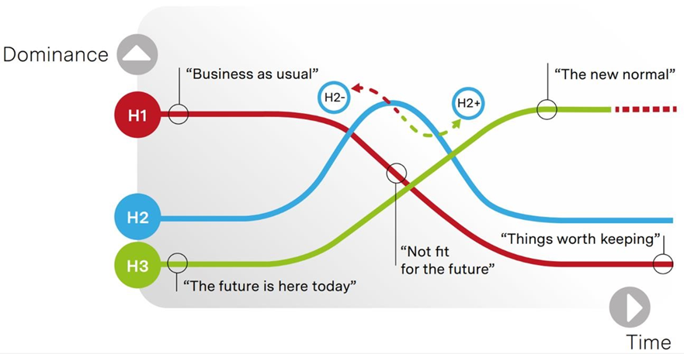
Image description: This figure shows the trajectory of the three horizons. The vertical axis is labelled “dominance”, and the horizontal axis is labelled “time”. Horizon one starts with “business as usual”, and considers what is “not fit for the future” and “things worth keeping”. Horizon two also considers “things worth keeping”. Horizon three starts with “the future is here today”, and finishes with “the new normal”.
Source: Petchey L (2020) Three horizons: A toolkit to help you think and plan for the long-term, Public Health Wales and the office of the Future Generations Commissioner for Wales, https://www.futuregenerations.wales/wp-content/uploads/2020/02/PHW-Three-Horizons_FINAL.pdf.

Additional Three Horizons Framework resources
Doughnut Economics Action Lab (2018) Three Horizons Framework – a quick introduction, https://www.youtube.com/watch?v=_5KfRQJqpPU.
Griffith Centre for Systems Innovation (2021) Creating Intentional Futures: Three Horizons and Challenge Mapping, published in Good Shift, https://medium.com/good-shift/creating-intentional-futures-aaa4cd2571e9.
Baghai M, Chan J (1997) Three Horizons of Growth Companies need to balance present operations against future possibilities to ensure success, Post 2000 Report On The Nation: Management, National Post, Post 2000, https://growthalchemy.com/2016/08/30/three-horizons/.
Petchey L (2020) Three Horizons: A toolkit to help you think and plan for the long-term, Public Health Wales and the office of the Future Generations Commissioner for Wales, https://phw.nhs.wales/news/future-proof-your-planning-with-easy-to-use-tool/three-horizons-toolkit/three-horizons-toolkit/.
Taituarā (2022) Navigating Critical 21st Century Transitions: Supporting the local government sector to lead fundamental change in their communities, Taituarā, https://taituara.org.nz/critical-transitions.

Rangatiratanga and kāwanatanga
The Panel engaged with a model of governance developed in He puapua: Report of the Working Group on a plan to realise the UN Declaration on the Rights of Indigenous Peoples in Aotearoa, New Zealand. “The rangatiratanga sphere reflects Māori governance over people and places. The kāwanatanga sphere represents Crown governance. There is a large ‘joint sphere’, in which Māori and the Crown share governance over issues of mutual concern.
If they choose, Māori must be able to prarticipate in Crown governance. This is reinforced by Article 3 of te Tiriti, which confirms Māori equity and equality. There is much room for improvement in the kāwanatanga sphere, as Māori remain a minority with their rights vulnerable to the majority and face disproportionate socio-economic disparities.
The spheres, as they currently operate, do not reflect te Tiriti.”
The following diagram was used to explore how Te Tiriti in an ideal future state would be reflected in governance.
Figure 5: The spheres of kāwanatanga and rangatiratanga
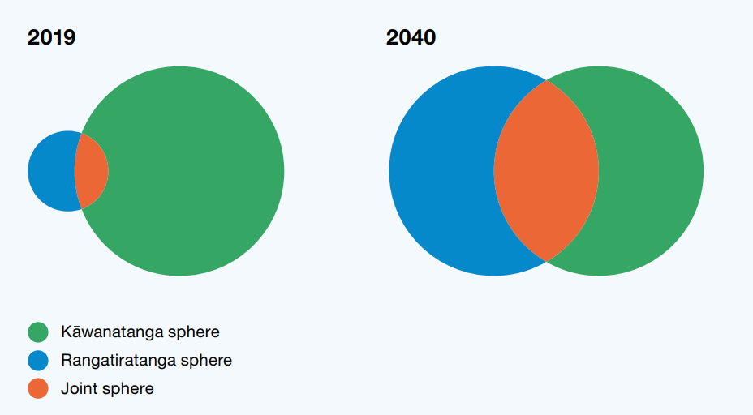
Image description: This figure shows the overlap between the spheres of kāwanatanga and rangatiratanga, and how they evolve over time. In 2019, the kāwanatanga sphere is much larger than the rangatiratanga sphere, and they overlap slightly. In 2040, the kāwanatanga and rangatiratanga spheres are the same size, and they overlap significantly to create a “joint sphere”.
Source: Adapted from Charters et al (2022) He Puapua – Report of the Working Group on a plan to realise the UN Declaration on the Rights of Indigenous Peoples in Aotearoa New Zealand, https://ndhadeliver.natlib.govt.nz/delivery/DeliveryManagerServlet?dps_pid=IE68578740.

Cynefin Framework
The Cynefin Framework was used to explore and discuss roles and functions across central and local government. The Framework demonstrates and helps to pull apart and clarify the complex and intertwined factors in an environment. It helps leaders and problem solvers contextualise issues, understand their challenges and make sense of solutions.
Figure 6: Cynefin Framework
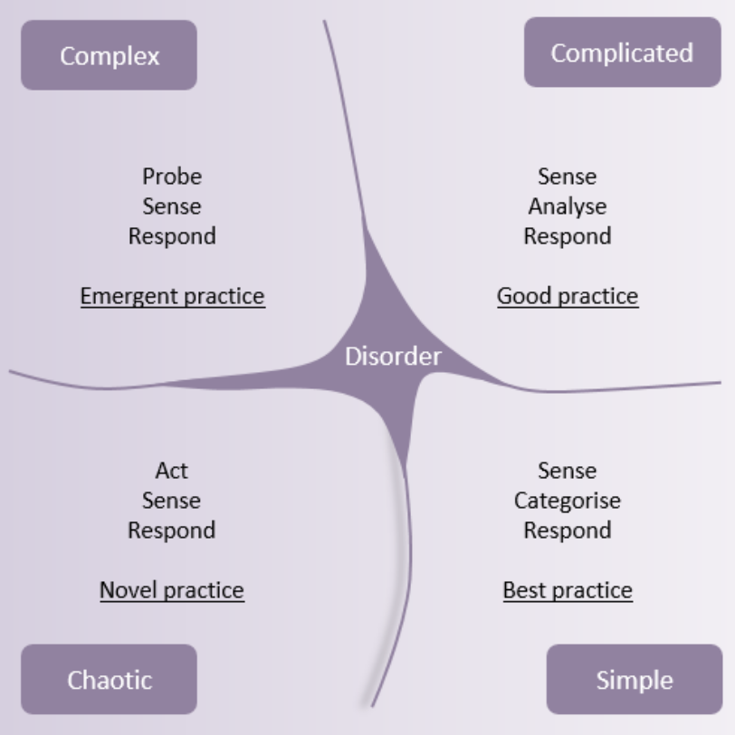
Image description: This figure shows four different types of practice. In the centre of the graphic there is “disorder”. On the top left there is “complex” emergent practice – probe, sense and respond. On the top right there is “complicated” good practice – sense, analyse and respond. On the bottom left there is “chaotic” novel practice – act, sense and respond. On the bottom right there is “simple” best practice – sense, categorise and respond.
Source: Praxis (n.d) Cynefin framework, https://www.praxisframework.org/en/library/cynefin-framework.
The following sources were used to discuss the Cynefin framework and provide further information around how the framework operates and can be used:
Edwards A, Fuller J, Lowther K and Snow T (2023) The models, frameworks and concepts that support our learning partnerships, Centre for Public Impact, https://www.centreforpublicimpact.org/insights/the-models-frameworks-and-concepts-that-support-our-learning-partnerships.
Kurtz C.F and Snowden D.J (2003) The new dynamics of strategy: Sense-making in a complex and complicated world, IBM Systems Journal, 42(3).
The Cynefin Co: Making Sense of Complexity (n.d.) The Cynefin Framework, https://thecynefin.co/about-us/about-cynefin-framework/.

Polarity thinking
The Panel used polarity thinking throughout the Review to navigate complex issues and to make sense where tensions, or polarities, existed. The following sources explain polarity thinking and how it can be used by leaders and problem-solvers to overcome polarities in their work:
Clark L (2018) Navigating Complexity: Managing Polarities, Harvard Business Publishing Corporate Learning, https://www.harvardbusiness.org/navigating-complexity-managing-polarities/.
CoCreative, Deep collaboration: The Values Iceburg, Co Creative, https://www.wearecocreative.com/_files/ugd/6b38a6_a521fe17747146668f8f9e41a08ecc19.pdf.
Johnson B (2020) Polarity Partnerships, LLC. https://www.polaritypartnerships.com/.
Leading Effectively Staff (2020) How to Manage Paradox, Centre for Creative Leadership, https://www.ccl.org/articles/leading-effectively-articles/manage-paradox-for-better-performance/.
Leslie J B, Ping Li P, Zhao S (2015) Managing Paradox: Blending East and West Philosophies to Unlock Its Advantages and Opportunities, Centre for Creative Leadership, https://cclinnovation.org/wp-content/uploads/2020/04/managing-paradox.pdf.

Living Standards Framework
Treasury’s Living Standards Framework (LSF) provides a useful framework for thinking about the contributors to wellbeing. The LSF was designed to centre wellbeing in conversations about policy and decision-making. It prompts thinking about short- and long-term policy impacts across the different dimensions of wellbeing. Local government is a contributor to all aspects of individual and collective wellbeing expressed in the LSF.
Figure 7: Living Standards Framework
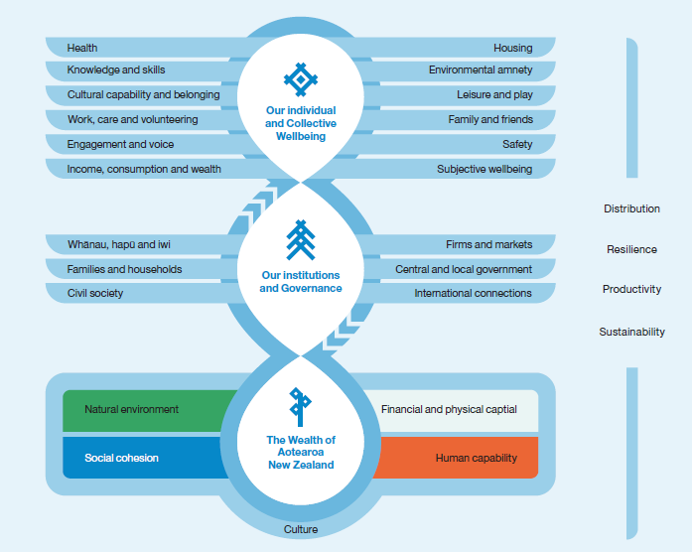
Image description: This figure shows the different types of wellbeing on three levels. The first level is The Wealth of Aotearoa New Zealand. This includes the natural environment, financial and physical capital, social cohesion, and human capability. This is underpinned by culture. The second level is Our Institutions and Governance. This includes whānau, hapū and iwi, families and households, civil society, firms and markets, central and local government, and international connections. The third level is Our Individual and Collective Wellbeing. This includes health, knowledge and skills, cultural capability and belonging, work, care and volunteering, engagement and voice, income, consumption and wealth, housing, environmental amenity, leisure and play, family and friends, safety, and subjective wellbeing. Distribution, resilience, productivity and sustainability sit across all three levels.
Source: Adapted from Treasury (2021) The Living Standards Framework. https://www.treasury.govt.nz/publications/tp/living-standards-framework-2021-html

He Ara Waiora
He Ara Waiora is another framework used by the Treasury which provides a more culturally specific approach to wellbeing based in te ao Māori. It uses the concept of waiora – often translated as a Māori perspective on wellbeing – to build a holistic, intergenerational approach to wellbeing. It articulates both the ends (the important elements in Māori perceptions of wellbeing) and the means (the values or principles that help to achieve the ends).
Figure 8: He Ara Waiora
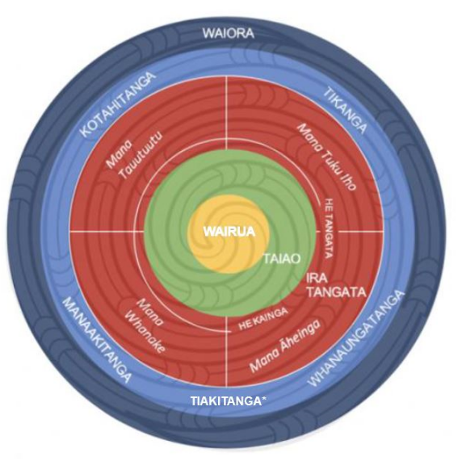
Image description: This figure shows the elements of Waiora in a circular diagram. In the centre of the diagram is Wairua. The next ring is Taiao. The next ring includes Mana Tauutuutu, Mana Whanake, Mana Āheinga, He Kainga, Ira Tangata, He Tangata, and Mana Tuku Iho. The surrounding ring includes Kotahitanga, Tikanga, Whanaungatanga, Tiakitanga and Manaakitanga. The outer ring is Waiora.
Source: Treasury (2021) He Ara Waiora, https://www.treasury.govt.nz/information-and-services/nz-economy/higher-living-standards/he-ara-waiora

Changes to the system of local government
This section outlines resources that informed the Review, organised around the key areas of change identified by the Panel. This includes resources that informed the interim, draft and final reports, as well as the range of engagements and consultation.

Giving full effect to councils’ wellbeing purpose
Putting wellbeing at the core of council’s purpose and all its roles and functions using existing relationships, infrastructure, assets, and levers will unlock greater wellbeing outcomes for communities. Councils are well placed locally to have a pivotal role to strengthen and expand their role as an anchor institution, systems networker and convenor, and place-shaper, to enable more social, economic, environmental, and cultural wellbeing.
Councils are already taking on a greater wellbeing role. However, this is inconsistent across local government. A significant shift in councils’ mindsets, investment capability and relationships with central government, hapū/iwi, businesses, and communities will unleash community value and local wellbeing.
In the final report the Panel concluded the future local government system needs all councils to embrace their role leading intergenerational wellbeing and place-shaping. This is especially vital in the face of climate change and other challenges like persisting inequity and the rising cost of living. Councils play a vital role in supporting the social, environmental, cultural, and economic wellbeing (the four wellbeings) of citizens and communities, now and for the future. Putting wellbeing at the centre of councils’ day-to-day work means using all their existing relationships, infrastructure, assets, and levers to unlock greater outcomes.

Local government as place-shaper
Councils can influence cultural, environmental, social, and economic wellbeing outcomes through place-making.
Place-making is a term used in Aotearoa New Zealand and internationally. It is widely understood as “the process of strengthening the connection between people and the places they share,” to maximise shared value and strengthen community identity.

Key resources
TSI (The Southern Initiative) (2022) Unlocking the potential of local government: Activating a wellbeing ecology, in place, The Auckland Co-Design Lab, https://www.aucklandco-lab.nz/reports-summary/unlocking-the-potential-of-local-government-activating-a-wellbeing-ecology-in-place. Work commissioned by Panel.

Additional resources
Arup, C40 Cities (2021) Green and thriving neighbourhoods, https://www.arup.com/perspectives/publications/research/section/green-and-thriving-neighbourhoods.
Doughnut Economics Action Lab (2023) Cities & Regions: Let's Get Started, https://doughnuteconomics.org/tools/210.
Doughnut Economics Action Lab (2022) Neighbourhood Doughnut Portrait Launch, https://doughnuteconomics.org/stories/213.
Dyet G (2021) ‘Keeping “placemaking” in focus through reform’, NZ Local Government Magazine, https://localgovernmentmag.co.nz/placemaking-3/.
Kyrre O (2020) ‘Creative Placemaking: Using Arts & Culture for Urban Revitalization’, The Urban Condition, https://medium.com/the-urban-condition/creative-placemaking-using-arts-culture-for-urban-revitalization-623099d01220#:~:text=Creative%20placemaking%20is%20deeply%20intertwined%20with%20the%20idea,city.%20This%20is%20especially%20apparent%20in%20developing%20countries.

Local government as anchor institution
Councils can work as anchor institutions to influence local wellbeing by changing how they deliver their core business with activities like social procurement.
Anchor institutions are entities like councils, hospitals, universities, faith groups, or other organisations based in a town, city, or defined region. They play a vital role in the local economy and have a long-term and enduring commitment and connection to the local community.

Additional resources
Boorman C, Burkett I and McNeill J (2022) ‘Anchor Approaches: Activity domains for system-level transformation’, Local Government Information Unit, https://lgiu.org/briefing/anchor-approachesactivity-domains-for-system-level-transformation/.
Citymart Procurement Institute (n.d) https://medium.com/citymartinsights.
CLES (Centre for Local Economic Strategies) (n.d.) Progressive procurement of goods and services, CLES, https://cles.org.uk/what-is-community-wealth-building/the-principles-of-community-wealth-building/progressive-procurement-of-goods-and-services/.
de Blasio B, Salas L (2020) Municipal Policies for Community Wealth Building, https://www.nyc.gov/assets/dca/downloads/pdf/partners/Municipal-Policies-for-Community-Wealth-Building.pdf?mc_cid=8063777561&mc_eid=%5bce8b133d2c.
Cottell J, Tabbush J (2022) Making the Most of Local Authority Assets, https://centreforlondon.org/publication/local-authority-assets/.
DPMC (Department of Prime Minister and Cabinet) (2021) Proactive Release: Health and Disability Review Reform, https://www.dpmc.govt.nz/publications/cabinet-decision-cab-21-sub-0092-health-and-disability-system-review-proposals-reform.
Economic Development Association Scotland, CLES (2023) Implementing Community Wealth Building: A Guide, https://edas.org.uk/wp-content/uploads/2023/01/Implementing-Community-Wealth-Building-A-Guide.pdf.
Fensham P (2020) The right time for community wealth building reform in Australia SGS Economics & Planning, The Treasury, https://www.treasury.govt.nz/sites/default/files/2017-12/hls-ag-socinfr-jan13.pdf.
McGuinness Institute (2021) Discussion Paper 2022/01- Future for Local Government, https://www.mcguinnessinstitute.org/wp-content/uploads/2022/06/20220601-5pm-Future-for-Local-Government-Workshop-paper.pdf.
McNeill J et al (2022) Localisation, sustainability, and resilience in Newcastle, Australia: Harnessing the power of Anchor Collaboratives, https://lgiu.org/briefing/localisation-sustainability-and-resilience-in-newcastle-australia-harnessing-the-power-of-anchor-collaboratives/.
North Ayrshire (2020) North Ayrshire Community Wealth Building Strategy 2020-2025, https://www.north-ayrshire.gov.uk/Documents/nac-cwb-strategy-brochure.pdf.
Taylor L, Werts S, Ramanadhan S, Heberlein C, Singer S and Aveling E (2022) ‘Can Businesses Be Anchor Institutions?’ Stanford Social Innovation Review, https://ssir.org/articles/entry/can_businesses_be_anchor_institutions.

Local government as systems networker and convenor
As a convenor, councils can connect local wellbeing actors and facilitate innovative solutions that respond to local needs and support intergenerational wellbeing at place.
The systems networker and convenor role is about enabling learning across boundaries and silos, and weaving together “activities, spaces, relationships, capabilities and opportunities in ways that are more responsive to people’s needs and aspirations than traditional service models.”

Additional resources
Hagen P, Tangaere A, Beaton S, Hadrup A, Taniwha-Paoo R and Te Whiu D (2021) Designing for equity and intergenerational wellbeing: Te Tokotoru, The Auckland Co-design Lab, The Southern Initiative, https:// www.aucklandco-lab.nz/reports-summary/te-tokotoru.
Healthy Families New Zealand (n.d.) Local Government Impact Report: Creating thriving communities, https://www.healthyfamiliesnz.org/publications.
Oppenheimer J (2021) Systems convening: leadership for the 21st century, Centre for Public Impact website, https://www.centreforpublicimpact.org/insights/systems-convening-leadership-for-the-21st-century.
Treasury (2018) Living Standards: A Short Guide to ‘Social Infrastructure’, The Treasury, https://www.treasury.govt.nz/sites/default/files/2013-01/hls-ag-socinfr-jan13.pdf.

Mindset and culture shift in councils
Councils must shift their approach from transactional to transformational and build their capacity and capability to champion wellbeing by innovating and learning by doing.
The transformational approach looks beyond individual outcomes and efficiency measures to seek multiple wellbeing outcomes that mutually reinforce each other and multiply impact.

Key resources
Whatman R (2023) Mission-Orientated Approaches to Wellbeing- why, and how, to do things differently, https://www.dia.govt.nz/diawebsite.nsf/Files/Future-for-Local-Government/$file/Appendix-1-Whatman-R-2023-Mission-Orientated-Approaches-to-Wellbeing-why-and-how-to-do-things-differently.pdf, paper prepared for the Review into the Future for Local Government. Work commissioned by Panel. (Appendix 1)

Additional resources
Bellinson R (2022) Mobilising Local Action to Address 21st Century Challenges: Considerations for Mission-Oriented Innovation in Cities, https://www.ucl.ac.uk/bartlett/public-purpose/sites/bartlett_public_purpose/files/bellinson_mobilising_local_action_to_address_21st_c_challenges.pdf.
Brown A (2019) The mindset shift emerging from local government, Centre for Public Impact, https://www.centreforpublicimpact.org/insights/mindset-shift-emerging-local-government.
Centre for Public Impact (2021) Human Learning Systems: Public Service for the Real World, https://www.centreforpublicimpact.org/assets/documents/hls-real-world.pdf?__hstc=45853115.acf2492ab421bd7e56d4694f8be28e54.1669632886113.1669632886113.1669632886113.1&__hssc=45853115.1.1669632886113&__hsfp=3234665583.
Cummins C (2022) Locating Authority: A vision for relational local government, Demos, https://demos.co.uk/wp-content/uploads/2022/01/locating-authority.pdf.
Hancock F (2018) A relational approach to community and social innovation: Practices that make a difference, Auckland Council, https://knowledgeauckland.org.nz/publications/a-relational-approach-to-community-and-social-innovation-practices-that-make-a-difference/.
IIPP (Institute for Innovation and Public Purpose) (2022) Mission-oriented innovation in action: 2021 casebook, University College London, https://www.ucl.ac.uk/bartlett/public-purpose/research/mission-oriented-innovation.
Relationships Project (n.d) The Relationship Makers’ Toolbox, https://relationshipsproject.org/toolbox/.
The Lab: The Southern Initiative (2021) Tamariki Wellbeing August 2021, https://www.dia.govt.nz/diawebsite.nsf/Files/Future-for-Local-Government/$file/Appendix-2-The-Lab-The-Southern-Initiative-2021-Tamariki-Wellbeing.pdf. (Appendix 2)
21st Century Public Servant (n.d) https://21stcenturypublicservant.wordpress.com/tag/relational-state/.

Aligning central and local government to support community wellbeing
Communities need and deserve collaborative and cohesive effort from both central and local government that uses their collective strengths and resources. A reset is required to create a relationship between central and local government that enables a unified approach to tackling deep-seated, complex intergenerational issues. It will require a mindset shift from both central and local government.
There is no consistent approach to collaboration, with the current system being fragile and reliant on individual networks and extraordinary leadership. Stronger, more systemic collaboration mechanisms are required for better alignment, partnering, and co-investment for the benefit of communities.
In the final report the Panel concluded that there needs to be a stronger partnership between central and local government, with both working together to address the complex future challenges facing Aotearoa New Zealand. To ensure this happens, the Panel recommends a dedicated Crown department is established to facilitate the relationship and coordinate and align resources.
The new Crown department will help enable the shift to a new way of operating and working together. It will provide space for collaboration and help to break down structural barriers to working together. It will help quantify and communicate the value that civic and social infrastructure create for communities. It will also be an integration point for the many government departments and councils involved in local outcomes.

Alignment
A clear alignment of outcomes exists and there is a clear process of engagement between partners so that issues can be resolved.

Key resources
Berthold T and Cribb J (1999) Working paper no. 1: Roles of Central and Local Government in Joint Problems, Public Service Commission.

Additional resources
AHURI (2020) Understanding international City Deals and other place-based deals, Australian Housing and Urban Research Institute, https://www.ahuri.edu.au/research/brief/understanding-international-city-deals-and-other-place-based-deals.
Bergvall D, Charbit C, Kraan D.J and Merk O (2006) Intergovernmental transfers and decentralised public spending Working Paper no.3, OECD Journal on Budgeting, 5 (4).
Department of the Prime Minister and Cabinet (n.d.) Delivering City Deals, Australian Government, https://www.infrastructure.gov.au/sites/default/files/migrated/cities/city-deals/files/City-Deal-Process-factsheet.pdf.
Economy, Infrastructure and Skills Committee (2017) City Deals and the Regional Economies of Wales, National Assembly for Wales, https://senedd.wales/laid%20documents/cr-ld11264/cr-ld11264-e.pdf.
Greater Manchester Combined Authority (2012) Greater Manchester City Deal, HM Government Gov UK, https://www.gov.uk/government/publications/city-deal-greater-manchester.
HM Government (2011) Unlocking Growth in cities, https://assets.publishing.service.gov.uk/government/uploads/system/uploads/attachment_data/file/7523/CO_Unlocking_20GrowthCities_acc.pdf.
Scottish Government, City Region Deals, https://www.gov.scot/policies/cities-regions/city-region-deals/.
Scottish Government, Regional Growth Deals, https://www.gov.scot/policies/cities-regions/regional-growth-deals/.
Ward M (2023) Research briefing SN07158: City Deals, House of Commons Library, https://researchbriefings.files.parliament.uk/documents/SN07158/SN07158.pdf.

Place-based agreements
Through place-based agreements, councils can influence cultural, environmental, social, and economic wellbeing outcomes.

Key resources
Climate Change Commission (2021) Ināia tonu nei: a low emissions future for Aotearoa, Climate Commission, https://www.climatecommission.govt.nz/public/Inaia-tonu-nei-a-low-emissions-future-for-Aotearoa/Inaia-tonu-nei-a-low-emissions-future-for-Aotearoa.pdf.
Fry J and Wilson P (2023) Working together: Re-focusing public accountability to achieve better lives, a report for the New Zealand Productivity Commission, NZIER report to the New Zealand Productivity Commission, https://www.productivity.govt.nz/assets/Documents/working-together-re-focussing-public-accountability-to-achieve-better-lives/NZIER-accountability-report-final.pdf.

Additional resources
Economic Transformation Lab (2023) Beyond GDP: A proposed new economic framework for Vancouver, Vancouver Economic Commission, https://vancouvereconomic.com/wp-content/uploads/2022/10/Beyond_GDP_Phase_1_Report_V4_WEB.pdf.
Improvement Service (n.d) Place and Wellbeing Outcomes, https://www.improvementservice.org.uk/products-and-services/consultancy-and-support/planning-for-place-programme/place-and-wellbeing-outcomes.

Collaboration and coordination
As a convenor and connector, the new Crown department can connect local and national wellbeing actors and facilitate innovative solutions that respond to local and national needs and support intergenerational wellbeing at place. This is a similar role to what local government does with and for its communities at the local level.
The Panel engaged with the idea of a collaborative model and commissioned a report from Beca to outline what an effective collaborative model looked like. Key attributes of an effective collaborative model are:
- a shared, agreed strategy
- a single point of governance and accountability
- collaborative people led well
- a shared culture that reflects the partner organisation cultures
- following a single bespoke business process that supports collaboration
- a formal organisation structure that is transparent and works for all partners.

Key resources
Beca (2021) Collaborative Models Report, https://www.dia.govt.nz/diawebsite.nsf/Files/Future-for-Local-Government/$file/Appendix-3-Collaborative-Models-Report.pdf, prepared for the Future for Local Government Panel. Work commissioned by Panel. (Appendix 3)
Think Place (2021) An exploration into the local government-central government relationship, https://www.dia.govt.nz/diawebsite.nsf/Files/Future-for-Local-Government/$file/Appendix-4-LGCG-Relationship-insights-report.pdf, report prepared for the Future for Local Government Panel. (Appendix 4)

Additional resources
Future Generations Commissioner for Wales (2018) Wellbeing in Wales: the journey so far, Future Generations Commissioner for Wales, https://www.futuregenerations.wales/wp-content/uploads/2018/11/FGCW-1-year-Report-_English.pdf.
Lyons M (2007) Place-shaping: a shared ambition for the future of local government, Lyons Inquiry into Local Government.
Public Service Commission (2020), Public Service Act 2020: An overview of the changes, https://www.publicservice.govt.nz/assets/DirectoryFile/Factsheet-1-An-overview-of-the-changes.pdf.
Warren K (2022) ‘A New Model of Collaboration’, Policy Quarterly, https://ojs.victoria.ac.nz/pq/article/view/7498.
Welsh Government (2015) Wellbeing of Future Generations (Wales) Act 2015: The essentials, Welsh Government, https://www.gov.wales/well-being-future-generations-act-essentials-html.
What Works Wellbeing (2023) Review refresh: Places, spaces, and social connections, https://whatworkswellbeing.org/resources/review-refresh-places-spaces-and-social-connections/.
WPPAC (Welsh Parliament Public Accounts Committee) (2021) Delivering for Future Generations: The story so far, https://senedd.wales/media/sjrp5vm0/cr-ld14223-e.pdf.

Taking a fresh look at local government roles and functions
Regional councils, territorial local authorities, and unitary authorities carry out a wide range of different roles and functions. While many are the same across councils, some vary from place to place depending on the type of council, community size, and local needs.
The Panel heard from councils that they want to localise the delivery of some roles currently carried out by central government. Many councils believe they have the expertise and local knowledge to deliver these effectively. Further, councils see themselves supporting intergenerational wellbeing as much as providing physical infrastructure, and many are keen to grow their local role as an anchor institution in their communities.
Councils face funding pressures that affect their capacity to carry out their current roles and functions. These are exacerbated when additional roles are added by central government without supporting funding streams. Further, impacts of proposed reforms have also created uncertainty.
In the final report, the Panel suggested that local government’s current roles and functions should be assessed as part of the broader process of structural reorganisation. Over time, councils must work with central government, hapū/iwi, and communities to decide how to deliver roles and functions. Functions relating to big wellbeing challenges facing communities like climate change, public health, economic development, and social housing need more thorough analysis and consideration. Roles across these complex, multi-faceted functions cannot be delivered by just one arm of government.

Key resources
Review into the Future for Local Government Secretariat (2022) Future of local government’s roles and functions, https://www.dia.govt.nz/diawebsite.nsf/Files/Future-for-Local-Government/$file/Appendix-5-Future-of-local-government%E2%80%99s-roles-and-functions.pdf, supporting paper internally prepared for the Future for Local Government Panel. (Appendix 5)
Tasmanian Policy Exchange (2022) Place shaping and the future role of local government in Tasmania: evidence and options, University of Tasmania, https://www.futurelocal.tas.gov.au/wp-content/uploads/2022/06/FoLGR-UTas-Paper-3-Place-shaping-and-the-future-role-of-local-government-in-Tasmania.pdf.
Wilde F and Winder P (2021) Local Government Futures: A Discussion Paper, https://www.dia.govt.nz/diawebsite.nsf/Files/Future-for-Local-Government/$file/Appendix-6-Wilde-F-and-Winder-P-2021-Local-Government-Futures-A-Discussion-Paper.pdf, report prepared for the Future for Local Government Panel. (Appendix 6)

Additional resources
Crampton E (2022) A path to subsidiarity, https://www.dia.govt.nz/diawebsite.nsf/Files/Future-for-Local-Government/$file/Appendix-7-A-path-to-subsidiarity-Eric-Crampton.pdf, Think piece for the prepared for the Future for Local Government Panel. Work commissioned by Panel. (Appendix 7)
Slack E (2007) Managing the Coordination of Service Delivery in Metropolitan Cities: The Role of Metropolitan Governance, World Bank, https://openknowledge.worldbank.org/entities/publication/9ad2fba4-d6ad-5f5d-ac45-0f09240bf4a5.

A sustainable, equitable local government funding and finance system
Local government has been under significant funding pressure for several years. Councils face growing community and government expectations and the impacts of growth, tourism, and significant infrastructure failures. Many people have suggested to the Panel that the system is broken and that we have reached peak rates.
The current funding and financing approach is not sustainable in the context of complex wellbeing challenges and increasing community expectations.
Numerous previous reviews of local government funding have highlighted the problems and recommended changes to the system to ensure that councils can more sustainably fund their activities. However, central government has failed to enact these recommendations and the issues are compounding.
In the final report, the Panel recommended some significant changes to the local government funding and finance system that will coincide with the new system of local government. This time, change must happen. Without it, local communities and future generations will be the ones missing out.

Equitable and sustainable funding and finance
A range of funding tools, including co-investment with central government, exist to invest and innovate in providing community outcomes.

Key resources
Crawford R and Shafiee H (2019) Scope and funding of local government: an international comparison, New Zealand Productivity Commission, https://www.productivity.govt.nz/assets/Documents/scope-and-funding-of-local-government/a383912a56/Scope-and-funding-of-local-government-an-international-comparison.pdf.
Fraser N and Honneth A (2003) Redistribution or Recognition? A Political-Philosophical Exchange, Verso.
New Zealand Infrastructure Commission (2022) Does size matter? The impact of local government structure on cost efficiency, New Zealand Infrastructure Commission / Te Waihanga. Te Waihanga Research Insights series, https://www.tewaihanga.govt.nz/strategy/infrastructure-reports/te-waihanga-research-insights-july-2022/.
New Zealand Infrastructure Commission (2022) Financing & Funding of Infrastructure in New Zealand, New Zealand Infrastructure Commission / Te Waihanga. https://www.tewaihanga.govt.nz/strategy/infrastructure-reports/financing-and-funding-of-infrastructure/.
New Zealand Infrastructure Commission (2022) Rautaki Hanganga o Aotearoa New Zealand Infrastructure Strategy 2022 – 2052, New Zealand Infrastructure Commission / Te Waihanga https://media.umbraco.io/te-waihanga-30-year-strategy/mrtiklkv/rautaki-hanganga-o-aotearoa.pdf.
Olivershaw Limited (2022) The Future for Local Government – Study into the Principles of a High Quality Tax and Revenue System – Key Issues, https://www.dia.govt.nz/diawebsite.nsf/Files/Future-for-Local-Government/$file/Appendix-8-Oliver-Shaw-paper-March-2022.pdf, report prepared for the Future for Local Government Panel. Work commissioned by Panel. (Appendix 8)

Key resources from the Productivity Commission
The Productivity Commission has developed several research pieces examining local government funding and finance. These include topics such as international comparisons, cost drivers, cost recovery, rating tools, land taxes and housing supply, development contributions, accounting, and financial management. These resources are available through the Productivity Commission website at https://www.productivity.govt.nz/inquiries/local-government-funding-and-financing/.
Sources from the Productivity Commission that significantly informed the Panel’s thinking include:
Crawford R and Smith J (2020) Local Government insights, New Zealand Productivity Commission, https://www.productivity.govt.nz/assets/Documents/d0b2849e4d/Local_Government-Insights-Report-2020_midres.pdf.
New Zealand Productivity Commission (2019) Local Government funding and financing, https://www.productivity.govt.nz/inquiries/local-government-funding-and-financing/.
New Zealand Productivity Commission (2013) Towards better local regulation, https://www.productivity.govt.nz/inquiries/towards-better-local-regulation/.
Review into the Future for Local Government Secretariat (2022) Response to Productivity Commission report and recommendations, https://www.dia.govt.nz/diawebsite.nsf/Files/Future-for-Local-Government/$file/Appendix-9-Response-to-Productivity-Commission-report-and-recommendations.pdf, report prepared by the Review into the Future for Local Government Secretariat. (Appendix 9)

Additional resources
Auckland Council, Community and Social Innovation team (2021) Creating shared prosperity through the circular economy: Building Māori and Pasifika economic resilience through a regenerative and circular enterprise movement, Auckland Council, The Southern Initiative, https://knowledgeauckland.org.nz/publications/creating-shared-prosperity-through-the-circular-economy-building-m%C4%81ori-and-pasifika-economic-resilience-through-a-regenerative-and-circular-enterprise-movement/.
Hart O (2016) Incomplete Contracts and Control, Nobel Prize Lecture, https://www.nobelprize.org/uploads/2018/06/hart-lecture.pdf.
Vitasek K, Winn JK and Nickel TE (2020) ‘The Vested Way: A Model of Formal Relational Contracts’, University of the Pacific Law Review, https://scholarlycommons.pacific.edu/uoplawreview/vol52/iss1/22/.

Local government embracing Te Tiriti o Waitangi and te ao Māori
As we consider what the future of local government, democracy, and governance look like in Aotearoa, we must acknowledge the journey of the Māori–local government relationship that has taken us to this point in time. Equally, we must consider the broader social shift we are seeing across government to operate in a way that is consistent with Te Tiriti o Waitangi. This is important in both upholding Te Tiriti, but critically, in working towards more equitable outcomes for Māori.
Of all the questions we have explored during this review, none is as interwoven throughout our findings as the relationship between local government and Māori. In order to have thriving communities in Aotearoa New Zealand, we consider it vital that Māori are an integral part of local governance, and the relationship becomes a genuine, Tiriti-based partnership.
This will only occur when there is a greater focus on equity and a greater sharing of decision-making authority, when Māori are more involved in the design and delivery of local services, and when local governance embraces and incorporates te ao Māori perspectives. Whilst there is much goodwill and many positive examples of change within the sector, the Māori–local government relationship is inconsistent across Aotearoa New Zealand and often falls short of a Tiriti-based partnership. The system needs to ensure a more meaningful expression of rangatiratanga and a more culturally specific exercise of kāwanatanga by councils – with te ao Māori values reflected across all levels of the system.
In some instances, this means Māori having a lead role in decision-making, or the design or delivery of local government functions or services. In other instances, such decisions will still need to be exercised collaboratively, or by local government via good quality engagement with Māori. However, in all instances, Māori citizens should be able to make culturally specific contributions to local governance.
There is much contemporary and historical context that underpins this area, both in thinking and practice. There is also significant social, legal, economic, political, and cultural context that has informed and shaped the Panel’s thinking.
In the final report the Panel concluded that a future local government system needs to honour and give effect to Tiriti-based partnership between local government and Māori at a system-wide and individual council level. Local government must embody a more culturally specific exercise of kāwanatanga, where te ao Māori, mātauranga Māori, and tikanga are woven into its fabric. This will support councils to create a safe place for Māori and deliver enhanced wellbeing outcomes for all communities.
The Panel has recommended that local government needs to be explicitly recognised as a Te Tiriti partner in the Local Government Act 2002, partnership frameworks need to be developed between councils and hapū/iwi and Māori, a review of requirements for local government engaging with Maōri occurs to streamline requirements, and councils are required to prioritise and invest in developing capability and capacity in the areas of Te Tiriti o Waitangi, te ao Māori values, mātauranga Māori, tikanga, and the whakapapa of local government.

Key resources
]
Bargh M, Jones C, Tapsell E and Lucas D (2022) Steps Towards Authentic Te Tiriti o Waitangi Relationships at Local Government Level, The SO7/Adaptive Governance and Policy Team as part of New Zealand’s Biological Heritage National Science Challenge, https://www.dia.govt.nz/diawebsite.nsf/Files/Future-for-Local-Government/$file/Appendix-10-Bargh-et-al-2022-Steps-Towards-Authentic-Te-Tiriti-o-Waitangi-Relationships.pdf, paper prepared for the Review into the Future for Local Government. Work commissioned by Panel. (Appendix 10)
Canterbury Regional Council (Ngāi Tahu Representation) Act 2022. https://www.legislation.govt.nz/act/local/2022/0001/latest/LMS578055.html.
Charters C, Kingdon-Bebb K, Olsen T, Ormsby W, Owen E, Pryor J, Ruru J, Solomon N and Williams G (2019) He Puapua: Report of the Working Group on a plan to realise the un declaration of the rights of indigenous peoples in Aotearoa, Working Group,https://ndhadeliver.natlib.govt.nz/delivery/DeliveryManagerServlet?dps_pid=IE78646805.
Independent Māori Statutory Board (2021) Schedule of Issues of Significance 2021-2025, https://www.imsb.maori.nz/publications/the-issues-of-significance-2021/.
Independent Māori Statutory Board (2016) The Māori Report for Tāmaki Makaurau 2016, https://www.imsb.maori.nz/publications/the-maori-report/.
Matike Mai Independent Working Group on Constitutional Transformation (2016), He Whakaaro Here Whakaumu Mō Aotearoa, Working Group, https://nwo.org.nz/wp-content/uploads/2018/06/MatikeMaiAotearoa25Jan16.pdf.
McClurg T (2022) Local Government and the Treaty of Waitangi, https://www.dia.govt.nz/diawebsite.nsf/Files/Future-for-Local-Government/$file/Appendix-11-McClurg-T-2022-Local-Government-and-the-Treaty-of-Waitangi.pdf, paper prepared for the Future for Local Government Panel. Work commissioned by Panel. (Appendix 11)
Ministerial Advisory Committee on a Māori Perspective for the Department of Social Welfare, Rangihau, John Te Rangi-Aniwaniwa (1986) Puao te ata tu- Day Break, The Committee, https://natlib.govt.nz/records/39371620.
O’Sullivan D (2022) How would local government arrangements need to change to promote tino rangatiratanga/mana Motuhake? https://www.dia.govt.nz/diawebsite.nsf/Files/Future-for-Local-Government/$file/Appendix-12-Address-to-the-Local-Government-Review-Panel-Dominic-OSullivan.pdf, Paper prepared for the Future for Local Government Panel. Work commissioned by Panel. (Appendix 12)
O’Sullivan D (2022) Rangatiratanga, Citizenship and a Crown that is ‘Māori too’: Boldness and the Future of Local Government, https://www.dia.govt.nz/diawebsite.nsf/Files/Future-for-Local-Government/$file/Appendix-13-Rangatiratanga-Citizenship-and-a-Crown-that-is-Maori-too.pdf, paper prepared for the Future for Local Government Panel. Work commissioned by Panel. (Appendix 13)
Review into the Future for Local Government Secretariat (2023) System Stewardship of Local Government-Māori relationship, https://www.dia.govt.nz/diawebsite.nsf/Files/Future-for-Local-Government/$file/Appendix-14-System-Stewardship-of-Local-Government-M%C4%81ori-relationship.pdf, paper prepared for the Future for Local Government Panel. (Appendix 14)
Review into the Future for Local Government Secretariat (2023) Independent Māori Statutory Board Case Study, https://www.dia.govt.nz/diawebsite.nsf/Files/Future-for-Local-Government/$file/Appendix-15-Review-into-the--Future-for-Local-Government-Secretariat-2023-Independent-M%C4%81ori-Statutory-Board-Case-Study.pdf, paper prepared for the Future for Local Government Panel. (Appendix 15)
Royal C (2021) Te Ahukaramū Charles Royal’s four key points to the Panel of the Review into the Future for Local Government, https://www.futureforlocalgovernment.govt.nz/reports/.
Supreme Court of New Zealand (30 September 2021) Media Release: Trans-Tasman Resources Ltd v Taranaki-Whanganui Conservation, [2021] NZSC 127, https://www.courtsofnz.govt.nz/assets/cases/2021/MR-2021-NZSC-127.pdf.
Te Puni Kōkiri and The Treasury (2019) An Indigenous Approach to the Living Standards Framework discussion paper (DP 19/01), https://www.treasury.govt.nz/publications/dp/dp-19-01-html.
Tokona te Raki (2022) He Ao Anō Apōpō: A rangatahi perspective of the future for local government, https://www.dia.govt.nz/diawebsite.nsf/Files/Future-for-Local-Government/$file/Appendix-16-Tokona-te-Raki-2022-He-Ao-Ano-Apopo.pdf, report prepared for The Review into the Future for Local Government. Work commissioned by Panel. (Appendix 16)
Tokona te Raki (2022) Te Korekoreka: A kawa for Māori future-making, https://www.dia.govt.nz/diawebsite.nsf/Files/Future-for-Local-Government/$file/Appendix-17-Tokona-te-Raki-2022-Te-Korekoreka-A-kawa-for-M%C4%81ori-future-making.pdf, report prepared for The Review into the Future for Local Government. Work commissioned by Panel. (Appendix 17)
Tokona te Raki (2022) Te Pō-Future scan 2040, https://www.dia.govt.nz/diawebsite.nsf/Files/Future-for-Local-Government/$file/Appendix-18-Tokona-te-Raki-2022-Te-Po-Future-Scan-2040.pdf, work prepared for The Review into the Future for Local Government. Work commissioned by Panel. (Appendix 18)
Tokona te Raki (2022) Future for Local Government: A summary report, https://www.dia.govt.nz/diawebsite.nsf/Files/Future-for-Local-Government/$file/Appendix-19-Tokona-te-Raki-2022-Future-for-Local-Government-A-summary-report.pdf, report prepared for The Review into the Future for Local Government. Work commissioned by Panel. (Appendix 19)

Additional resources
Duder-Hura M (2023) Rangatahi panel give their perspective on the Treaty, Radio New Zealand, https://www.rnz.co.nz/national/programmes/waitangiday/audio/ 2018876567/rangitahi-panel-give-their-perspective-on-the-treaty.
GWRC (Greater Wellington Regional Council) (2013) Memorandum of Partnership between Tangata Whenua ki Te Upoko o te Ika a Maui and Wellington Regional Council Te Pane Matua Taiao, https://schooltravel.gw.govt.nz/assets/Documents/2021/08/Memorandum-of-Partnership-2013.pdf.
LGNZ (2017a) Council-Māori Participation Arrangements: Information for councils and Māori when considering their arrangements to engage and work with each other, https://lgnz-prod.sites.silverstripe.com/our-work/publications/council-maori-participation-arrangements/.
Moir J (2023) Reframing co-governance: Jackson’s warning to Labour, Newsroom, https://www.newsroom.co.nz/pro/jacksons-co-governance-warning-to-labour.
Ngarewa-Packer D (2023) Why we must believe in Māori, The Northern Advocate, https://www.pressreader.com/new-zealand/the-northern-advocate6030/20230208/281659669197432.
Ngāti Tūrangitukua and Taupō District Council, Mana Whakahono ā Rohe, https://www.taupodc.govt.nz/repository/libraries/id:25026fn3317q9slqygym/hierarchy/Council/Committees%20and%20meetings/Mana%20Wahakahono%20A%20Rohe.pdf.
Potaka T (1999) ‘A Treaty Agendum for Local Government’, Victoria University of Wellington Law Review, https://www.austlii.edu.au/nz/journals/VUWLawRw/1999/13.html.
RLC (Rotorua Lakes Council) (2015) Manatu Whakaaetanga Partnership Agreement, https://www.rotorualakescouncil.nz/repository/libraries/id:2e3idno3317q9sihrv36/hierarchy/our-city/bilingual/tearawapartnership/documents/Te-Arawa-Partnership-Agreement-Final-1.pdf.
Te Arawhiti (2018) Crown engagement with Māori, https://www.tearawhiti.govt.nz/assets/Maori-Crown-Relations-Roopu/451100e49c/Engagement-Framework-1-Oct-18.pdf.
Te Arawhiti (2022) Providing for the Treaty of Waitangi in Legislation and Supporting Policy Design: Questions for policy-makers, https://www.tearawhiti.govt.nz/assets/Tools-and-Resources/Providing-for-the-Treaty-of-Waitangi-in-legislation.pdf.
Te Arawhiti (nd) Public Sector Capability, https://www.tearawhiti.govt.nz/tools-and-resources/public-sector-capability/.
Waitangi Tribunal (2012) Wai 1040: Te Paparahi o Te Raki (Northland) inquiry, https://waitangitribunal.govt.nz/inquiries/district-inquiries/te-paparahi-o-te-raki-northland/.
Waitangi Tribunal (2018) WAI 898 Te Mana Whatu Ahuru, https://forms.justice.govt.nz/search/Documents/WT/wt_DOC_142124627/Te%20Mana%20Whatu%20Ahuru.pdf.
Waitangi Tribunal (2017) WAI 894 Te Urewera Part 1, https://waitangitribunal.govt.nz/news/wai-894-te-urewera-pre-publication-part-i-2/.
Waitangi Tribunal (2008) WAI 1200 He Maunga Rongo, Stage 1, volume 1, https://forms.justice.govt.nz/search/WT/reports/reportSummary.html?reportId=wt_DOC_68568897.
Waitangi Tribunal (2010) WAI 863 The Wairarapa Ki Tararua Report, https://waitangitribunal.govt.nz/news/wairarapa-ki-tararua-report-released-2/.
Waitangi Tribunal (2011) WAI 262 Ko Aotearoa Tēnei, Te Taumata Tuarua volume 1, https://forms.justice.govt.nz/search/Documents/WT/wt_DOC_68356416/KoAotearoaTeneiTT2Vol1W.pdf.
Williams D (2023) David Williams: The Treaty, in English or Māori, is still our best way forward, E-Tangata, https://e-tangata.co.nz/comment-and-analysis/david-williams-the-treaty-in-english-or-maori-is-still-our-best-way-forward/.

Replenishing local democracy
Local government needs to become more of an enabler of democratic decision-making, not the holder of it. The use of deliberative and participatory democracy practices can lead to greater citizen empowerment and enhanced participation in decision-making. This is critical, especially when tackling major challenges such as intergenerational equity, long-term planning, and social cohesion. Nothing in the Local Government Act 2002 prevents the use of deliberative or participatory mechanisms or the adoption of more empowering frameworks; decisions to take more participatory approaches built on community relationships sit with each council. There are a range of actions that local government needs to take, including increasing its capability and its understanding and use of deliberative and participatory democracy practices.
Councils remain predominantly made up of older Pākehā elected members. There needs to be more diverse representation and increased governance capability at the council table. While Māori wards and constituencies are a positive feature, they were not designed to provide for Tiriti-based representation of hapū/iwi or significant Kaupapa-based groups. Councils need to increase their capability in, and understanding of, Te Tiriti o Waitangi and te ao Māori. Elected members’ conditions, remuneration, training, and support need to improve to attract a wider pool of potential candidates and increase the quality of governance. Aspects of the current electoral and representation review provisions and processes need revision.
In the final report, the Panel concluded a system of local government that is fit for the future will ensure robust, representative, and inclusive local democracy. The Panel made a series of recommendations to help build the capability of local government, ensure voting and elections are effective and inclusive, and expand the opportunities for people to have an active say in how their communities are governed.

Deliberative and participatory democracy
Deliberative democratic methods involve demographically representative groups selected by public lottery that weigh evidence, deliberate to find common ground, and develop an informed public judgement on a key issue which can then be directly adopted by council, for example, citizens’ assemblies.
Participatory democracy refers to the direct involvement of citizens in political decision-making, beyond choosing representatives through elections.

Key resources
Reid M (2018) Saving local democracy: An agenda for the new government, A report prepared for The Policy Observatory, Auckland University of Technology, https://thepolicyobservatory.aut.ac.nz/__data/assets/pdf_file/0020/144470/Mike-Reid-Saving-Local-Democracy-February-2018.pdf.
The Koi Tu Watercare Citizens’ assembly project was used to explore the idea of a Citizens’ Assembly. Overall information about the project can be found here: https://www.watercare.co.nz/About-us/Information-Hub/Community-engagement-hub/citizens-assembly-project.

Additional resources
Bellantoni A, Chwalisz C and Cesnulaityte I, Good Practice Principles for Deliberative Processes for Public Decision Making, OECD, https://www.oecd.org/gov/open-government/good-practice-principles-for-deliberative-processes-for-public-decision-making.pdf.
Colchester J, Kaur M, and Kaur M (2023) Governance in an Age of Complexity, A Si Governance Hub Publication, https://www.systemsinnovation.network/posts/governance-in-an-age-of-complexity-position-paper.
EIU (Economist Intelligence Unit) (2020) Democracy Index 2020, https://www.eiu.com/n/campaigns/democracy-index-2020/.
FIDE (Federation for Innovation in Democracy - Europe) (2022) Organising a Democratic Lottery, https://static1.squarespace.com/static/5fe06832bfc2b9122d70c45b/t/63811fa466ef155fd6bf6acf/1669406633663/FIDE+-+Organising+a+Democratic+Lottery.pdf.
G1000 (2022) Brussels launches world's first permanent Citizens’ Assembly on Climate, https://www.g1000.org/en/news/brussels-launches-worlds-first-permanent-citizens-assembly-climate.
Labour Party (2023) A new Britain: Renewing our democracy and rebuilding our economy, 17246_22, reproduced from electronic media, promoted by David Evans on behalf of the Labour Party, both at Labour Central, Kings Manor, Newcastle, NE1 6PA, https://labour.org.uk/page/a-new-britain/.
Lodewijckx I (2020) What’s the difference between deliberation and participation? Citizen lab, https://www.citizenlab.co/blog/civic-engagement/whats-the-difference-between-deliberative-and-participatory-democracy/.
OECD (2020) Innovative Citizen Participation and New Democratic Institutions: Catching the Deliberative Wave, OECD Publishing Paris, https://www.oecd-ilibrary.org/governance/innovative-citizen-participation-and-new-democratic-institutions_339306da-en.
OECD (2022) OECD Guidelines for Citizen Participation Processes, https://www.oecd.org/gov/open-government/oecd-guidelines-for-citizen-participation-processes-f765caf6-en.htm.
RSA (2020) How to run a citizens' assembly, https://www.thersa.org/reports/citizens-assembly-guide.
Watercare (2021) Statement of Intent 2021 to 2024, Watercare, https://wslpwstoreprd.blob.core.windows.net/kentico-media-libraries-prod/watercarepublicweb/media/watercare-media-library/reports-and-publications/watercare_statement_of_intent_2021_2024.pdf.
Wellbeing Economy Alliance (n.d) Porto Alegre, Brazil – Continuous Innovations in Wellbeing Policy Design and Implementation, https://weall.org/resource/porto-alegre-brazil-continuous-innovations-in-wellbeing-policy-design-and-implementation?_ga=2.261457477.978564228.1652237502-1609324918.1652237502.

Active citizenship
It is important that in Aotearoa New Zealand citizens are empowered, independent of formal institutions, to make decisions and take actions for the benefit of their communities.

Key resources
Burkett, Ingrid (2022) Civic Innovation and local government futures, https://www.dia.govt.nz/diawebsite.nsf/Files/Future-for-Local-Government/$file/Appendix-20-Civic-Innovation-+-Local-Government-Futures.pdf, Yunus Centre Griffiths University. (Appendix 20)
Department of Internal Affairs (2022) Me pēhea te whakapai ake i te whai wāhitanga me te tukanga whakatau a te hapori mā te whakamahinga o te hangarau? How can community participation and decision-making be better enabled by technology, DIA Long term Insights Briefing, https://www.dia.govt.nz/long-term-insights-briefing.
James C (2018) The wisdom of crowds v the madness of crowds, presented to Australasian Study of Parliament Group seminar, Wellington, http://www.colinjames.co.nz/wp-content/uploads/2018/09/ASPG-NZ-version-18Sep12.pdf.
Public Service Commission (2022) Te Kirirarautanga: Te Whai Wāhitanga Tūmatanui ki Te Kāwanatanga Anamata: Enabling Active Citizenship: Public Participation in Government into the Future Long Term Insights Briefing, https://www.publicservice.govt.nz/publications/our-long-term-insights-briefing/.

Additional resources
Akoorie N (26 May 2021) ‘Civics and citizenship education being left to chance, expert says’, Stuff, https://www.stuff.co.nz/national/education/125243469/civics-and-citizenship-education-being-left-to-chance-expert-says.
Alexander J, Conrad A (2022) Citizen future: Why we need a new story of self and society, BBC, https://www.bbc.com/future/article/20220803-citizen-future-why-we-need-a-new-story-of-self-and-society.
Andolina M, Jenkins K, Zukin C and Keeter S (2003) ‘Habits from Home, Lessons from School: Influences on Youth Civic Engagement’, Political Science and Politics, https://www.cambridge.org/core/journals/ps-political-science-and-politics/article/abs/habits-from-home-lessons-from-school-influences-on-youth-civic-engagement/9D4381CA80444AE6384B0B057D34AA0B.
Basford M, Colom A (2022) Shaped by People — making active citizenship a shared strategic priority in Kirklees, Democratic Society, https://medium.com/@demsoc/shaped-by-people-making-active-citizenship-a-shared-strategic-priority-in-kirklees-a7f6b54011b.
Bohny S (4 September 2019) ‘More representation, education keys to boosting young voter turnout’, Stuff, https://www.stuff.co.nz/national/politics/local-body-elections/115352890/more-representation-education-keys-to-boosting-young-voter-turnout.
Community Taranaki (2021) How Communities Awaken — Some Conversations for Active Citizens, https://www.taranaki.gen.nz/hca.
Curran C (15 August 2018) Speech to the Digital Local Government Partnership launch, text available at https://www.beehive.govt.nz/speech/speech-digital-local-government-partnership-launch.
DIA (2018) How digital can support participation in government, https://www.digital.govt.nz/dmsdocument/175~how-digital-can-support-participation-in-government/html.
DIA (2022) Draft Long-term Insights Briefing: Consultation document, https://www.dia.govt.nz/diawebsite.nsf/Files/Long-term-insightsbriefing/$file/DRAFT-Long-term-Insights-Briefing-Department-ofInternal-Affairs-v2.pdf.
Hartz-Karp J and Carson L (2013) ‘Putting citizens in charge: Comparing the Australian Citizens’ Parliament and the Australia 2020 Summit’, The Australian Citizens’ Parliament and the future of deliberative democracy.
IAP2 (International Association for Public Participation) IAP2 Spectrum of Public Participation, https://iap2.org.au/wp-content/uploads/2020/01/2018_IAP2_Spectrum.pdf#:~:text=IAP2%20Spectrum%20of%20Public%20Participation%20IAP2%E2%80%99s%20Spectrum%20of,found%20in%20public%20participation%20plans%20around%20the%20world.
Illinois Civics Hub, Why Civics?, https://www.illinoiscivics.org/about/%20why-civics/.
MOE (Ministry of Education) (2020) Civics and Citizenship Education: Teaching and Learning Guide, report prepared by Cognition Education for the New Zealand Ministry of Education, https://sltk-resources.tki.org.nz/assets/Uploads/Teaching-and-Learning-Guide.pdf.
Siegel-Stechler K (2019) ‘Is civics enough? High school civics education and young adult voter turnout’, ScienceDirect, https://www.sciencedirect.com/science/article/abs/pii/S0885985X18301293.

The local government electoral system
A range of changes have been explored to improve participation through the electoral system. These include the Single Transferable Vote method, lowering the voting age to 16, having the Electoral Commission run elections, and introducing 4-year terms for elected members. These ideas have been explored through international examples and key expert research.

Additional resources
Asquith A, Webster K and Cardow A (2021) ‘Voting in New Zealand Local Government Elections: The Need to Encourage Greater Voter Turnout’, Commonwealth Journal of Local Governance, https://epress.lib.uts.edu.au/journals/index.php/cjlg/article/view/7541.
Boston J, Bagnall D, Barry A (2019) Foresight, insight and oversight: Enhancing long-term governance through better parliamentary scrutiny, Victoria University of Wellington, https://www.victoria.ac.nz/__data/assets/pdf_file/0011/1753571/Foresight-insight-and-oversight.pdf.
Gersbach H, Jackson MO and Tejada O (2021) Optimal Term-Length and the Structure of Democracy, https://papers.ssrn.com/sol3/papers.cfm?abstract_id=3615407.
Huebner C (2021) ‘How Young People in Scotland Experience the Right to Vote at 16: Evidence on “Votes-at-16” in Scotland from Qualitative Work with Young People’, Parliamentary Affairs, https://academic.oup.com/pa/article/74/3/563/6320902.
Kirklees Democracy Commission (2017) Growing a stronger local democracy from the ground up: Kirklees Democracy Commission Full report, https://www.democracycommission.org.uk/wp-content/uploads/2017/06/Kirklees-Democracy-Commission-full-report-June-2017-WEB.pdf.
LGNZ (2019a) Local elections 2019: Quick facts, https://www.lgnz.org.nz/assets/Elections-Fact-sheet-19.pdf.
LGNZ (2019b) Local government debates remits at AGM, https://www.lgnz.co.nz/news-and-media/2019-media-releases/local-government-debates-remits-at-agm/.
LGNZ (2020a) Elected members’ profile 2019-2022, https://www.lgnz.org.nz/assets/Uploads/Analysis-of-the-2020-elected-members-survey.pdf.
LGNZ (2020b) Candidates and their views: LGNZ’s survey of candidates standing for the 2019 local authority elections, https://www.lgnz.co.nz/assets/Uploads/Candidates-Survey-Report-2019.pdf.
LGNZ (2017b) New Zealand Local Government Survey 2017, https://www.lgnz.co.nz/our-work/publications/new-zealand-local-government-survey-2017/.
McGuinness Institute (2014) A Youth Statement on Regional Goals: An output of the LocalNZ workshop, https://www.mcguinnessinstitute.org/talentnz/a-youth-statement-on-regional-goals-available-online/.
Neal T (13 August 2020) ‘Young councillor says four-year local government term would help oust “useless” councillors’, RNZ, https://www.rnz.co.nz/news/national/423490/young-councillor-says-four-year-local-government-term-would-help-oust-useless-councillors.
New Citizenship Project, Kirklees Council (n.d) New Citizenship Project (NCP) and Kirklees Council: Blog, Local Government Association, https://www.local.gov.uk/new-citizenship-project-ncp-and-kirklees-council-blog.
Newham Democracy and Civic Participation Commission (n.d) Newham Democracy and Civic Participation Commission Final Report, https://www.newham.gov.uk/downloads/file/1444/democracy-commission-report.
STV (Single Transferrable Vote) STV legislation, background and further information, https://www.stv.govt.nz/legislation.shtml.
Todd J (2017) ‘Awareness of and attitudes towards voting in the 2016 Auckland Council elections’, Auckland Council, https://www.knowledgeauckland.org.nz/publications/awareness-of-and-attitudes-towards-voting-in-the-2016-auckland-council-elections/.
UNU-WIDER (2014) ‘The Impact of Civic Education Programmes on Political Participation’, https://www.wider.unu.edu/publication/impact-civic-education-programmes-political-participation.
United Nations General Assembly (1948) Universal Declaration of Human Rights (217 [III] A), https://www.un.org/en/about-us/universal-declaration-of-human-rights.
Vowles J and Hayward J (2021) ‘Ballot structure, district magnitude and descriptive representation: the case of New Zealand local council elections’, Australian Journal of Political Science.
Wong A (6 October 2018) ‘Civics Education Helps Create Young Voters and Activists’, The Atlantic, https://www.theatlantic.com/education/archive/2018/10/civics-education-helps-form-young-voters-and-activists/572299/.
Zeglovits E and Zandonella M (2011) ‘Political interest of adolescents before and after lowering the voting age: the case of Austria’, Journal of Youth Studies, https://psycnet.apa.org/record/2013-38679-010.

Improved representation around the council table
Councils need to reflect their diverse communities.

Additional resources
liDP (2019) Innovation in Democracy Programme (LiDP), UK, Department for Culture, Media and Sport, and Department for Levelling Up, Housing and Communities, https://www.gov.uk/government/publications/innovation-in-democracy-programme-launch.
Newton K (2018) ‘White noise’, Radio New Zealand, https://shorthand.radionz.co.nz/white-noise/index.html.
VSG (Victoria State Government) (2017) Victorian Government Response to the Geelong Citizen’s Jury, newDemocracy Foundation, https://www.newdemocracy.com.au/2016/07/10/local-government-victoria-democracy-in-geelong/.

Elected members are valued and grow as governors
Professional development and remuneration changes have been explored as ways to ensure elected members are valued and supported to progress and perform as governors and leaders.

Key resources
Carson L (2022) What can be learned from the implementation of the Victorian Local Government Act 2020?, newDemocracy Foundation, https://www.newdemocracy.com.au/wp-content/uploads/2022/06/RD-Note-Learnings-from-Victoria.pdf.
LGC (Local Government Commission) (2021) Local Government Codes of Conduct: Report to the Minister of Local Government, Local Government Commission, https://www.lgc.govt.nz/assets/Uploads/LGC-report-to-MoLG-Local-government-codes-of-conduct-Sept-2021.pdf.

Additional resources
Local Government Association (2023) Local Leadership Framework for Councillors, https://www.local.gov.uk/publications/local-leadership-framework-councillors.
Thorold R, Painter A (2021) Governing for the future: Lessons in democracy and governance from Covid-19, RSA, https://www.thersa.org/reports/governing-for-the-future-lessons-in-democracy-and-governance-from-covid-19.

Reorganising local government
Local government entities need to be sustainable, capable, and innovative, and help enable communities thrive and prosper. A new local government structure needs to be fit for the future and best meet evolving local needs and aspirations.
The Panel recognises there are some benefits in consolidating the current units of local government, such as economies of scope, and scaling of expertise and resources. However, the Panel also supports the importance of proximity to the locally specific wellbeing needs of communities – keeping the local in local government.
In the final report, the Panel recommended a reorganisation of local government, to ensure we have resilient institutions that can work at place for communities. This reorganisation includes the types of council structure, the roles and functions they will carry out, and their governance arrangements.

Key resources
Auckland Council (nd) He Kōrero mō ngā poari ā-rohe About local boards, https://www.aucklandcouncil.govt.nz/about-auckland-council/how-auckland-council-works/local-boards/Pages/about-local-boards.aspx.
Doherty J (2022) Digital Futures: Democratising Digital & Data, Future State Operating Model Design Concept v3.0, prepared for Review for the Future of Local Government, https://www.futureforlocalgovernment.govt.nz/reports/.
New Zealand Infrastructure Commission (2022) Does size matter? The impact of local government structure on cost efficiency, New Zealand Infrastructure Commission / Te Waihanga. Te Waihanga Research Insights series, https://www.tewaihanga.govt.nz/assets/Uploads/July-2022-Research-Insights-Final-1.pdf.
OECD/UCLG (2019) 2019 Report of the World Observatory on Subnational Government Finance and Investment – Key Findings, https://www.sng-wofi.org/reports/Key_Findings_2019.pdf.
OECD/UCLG (2016) Subnational Governments around the world: Structure and finance, https://search.oecd.org/regional/regional-policy/Subnational-Governments-Around-the-World-%20Part-I.pdf.
Reid M (2022) Structures and roles for enabling local authorities to maximise their contributions to community wellbeing and adapt to meet future challenges, https://www.dia.govt.nz/diawebsite.nsf/Files/Future-for-Local-Government/$file/Appendix-21-Mike-Reid-LG-roles-and-functions.pdf, Background paper prepared for the Future for Local Government Panel. Work commissioned by Panel. (Appendix 21)

Additional resources
Acemoglu D, Egorov G and Sonin K (2020) Institutional Change and Institutional Persistence, National Bureau of Economic Research, https://www.nber.org/papers/w27852.
Auckland Council (2023) The Auckland Plan 2050, https://www.nber.org/papers/w27852.
Daniell K.A and Kay, A (Eds.) (2017) Front Matter. In Multi-level Governance: Conceptual challenges and case studies from Australia (pp. i–iv). ANU Press, http://www.jstor.org/stable/j.ctt1zgwjv0.1.
Department of Internal Affairs (2021) Royal Commission on Auckland Governance website, https://www.dia.govt.nz/Decommissioned-websites---Royal-Commission-on-Auckland-Governance.
LGNZ (Local Government New Zealand) (nd) Community boards, https://www.lgnz.co.nz/local-government-in-nz/community-boards/.
Lloyd J, Randle A, Casey A (2020) Introducing New Operating Models for Local Government, Nesta, https://www.nesta.org.uk/report/introducing-new-operating-models-local-government/.
Slack, E (2019) Metropolitan Governance: Principles and Practice, Institutions for Development Sector Fiscal Management Division, Inter-American Development Bank, https://publications.iadb.org/en/metropolitan-governance-principles-and-practice.

Purposeful stewardship to support a healthy local government
Effective system stewardship is needed to support the system of local government to be successful and navigate change over the next 30 years.
Currently, there are multiple layers of stewardship with distinct roles that enable and support the local government sector. A range of organisations and actors are involved, including the Department of Internal Affairs, the Local Government Commission, Local Government New Zealand, and Taituarā. They all play a different role, and the Panel acknowledges the contribution all these organisations make.
However, this current set of stewardship arrangements was established over time to address immediate issues, and each organisation brings its own lens. There is no clear high-level picture of what is good for the local government system as a whole, but rather a complex, overlapping and often disjointed web of responsibilities.
In the final report, the Panel concluded that purposeful stewardship is needed to support the health and performance of the local government system. The Panel recommended creating a new independent local government stewardship institution to strengthen the health and fitness of the system. The proposed stewardship institution will be dedicated to nurturing and advocating for the local government system and the outcomes it delivers for communities.

Key resources
Brogan A et al (2021) Human Learning Systems: Public Service for the Real World, Centre for Public Impact, https://www.centreforpublicimpact.org/assets/documents/hls-real-world.pdf.
Crawford R and Smith J (2020) Local Government Insights, New Zealand Productivity Commission, https://www.productivity.govt.nz/assets/Documents/d0b2849e4d/Local_Government-Insights-Report-2020_midres.pdf.
Reid M (2022) System stewardship and support- some additional thoughts, https://www.dia.govt.nz/diawebsite.nsf/Files/Future-for-Local-Government/$file/Appendix-22-Reid-M-2022-System-stewardship-and-support-some-additional-thoughts.pdf, Paper prepared for the Future for Local Government Panel. Work commissioned by Panel. (Appendix 22)

Additional resources
Bardsley A, Clyne D and Gluckman P (2022) Koi Tu Reimagining Tamaki Makaurau Auckland, Koi Tū: The Centre for Informed Futures, Univeristy of Auckland, https://informedfutures.org/auckland/.
Controller and Auditor-General (2019) Public-accountability: A matter of trust and confidence, Office of the Auditor General New Zealand, https://oag.parliament.nz/2019/public-accountability/docs/public-accountability.epub/view.
Crampton E (2023) Careful Sailing, https://www.dia.govt.nz/diawebsite.nsf/Files/Future-for-Local-Government/$file/Appendix-23-Crampton-E-2023-Careful-Sailing.pdf, Think piece for the Future for Local Government Panel. Work commissioned by Panel. (Appendix 23)
Genua D et al (2022) Failing forward in local government: how-to guide, Centre for Public Impact, https://www.centreforpublicimpact.org/case-study/naca-fail-forward?utm_source=website&utm_medium=popup&utm_campaign=naca_ff.
Local Government New Zealand (2022) Scenarios for the future, https://www.dia.govt.nz/diawebsite.nsf/Files/Future-for-Local-Government/$file/Appendix-24-Local-Government-New-Zealand-2022-Scenarios-for-the-future.pdf, paper prepared for the Future for Local Government Panel. Work commissioned by Panel. (Appendix 24)
Murikumthara D (2021) System Stewardship: Three themes from our final Reimagining Government webinar of 2021, Centre for Public Impact, https://medium.com/centre-for-public-impact/system-stewardship-three-themes-from-our-final-reimagining-government-webinar-of-2021-cf8d549002fb.

Current reviews and reforms
A range of other reforms and current issues have had considerable government policy work occurring throughout the Review. Although direct advice on these reforms and issues was outside the scope of the Review, the Panel did consider as part of Aotearoa New Zealand’s current context and known issues, the potential impact of these reforms and key issues on local government.
These pressing matters and reforms included: climate change, Three Waters/affordable water reform, resource management reform, infrastructure programmes and reform, social equity, and electoral system reform. The Panel considered various pieces of research in the context of local government.

Climate change

Key resources
KPMG (2022) Climate Change, https://www.dia.govt.nz/diawebsite.nsf/Files/Future-for-Local-Government/$file/Appendix-25-KPMG-Report-climate-change-2022.pdf, Report prepared for the Future for Local Government Panel. Work commissioned by Panel. (Appendix 25)
Willis R (2020) Too Hot to Handle? The Democratic Challenge of Climate Change, Bristol University Press.

Additional resources
Climate Change Commission (2021) Ināia tonu nei: a low emissions future for Aotearoa, Climate Change Commission, https://www.climatecommission.govt.nz/our-work/advice-to-government-topic/inaia-tonu-nei-a-low-emissions-future-for-aotearoa/.
IPCC (Intergovernmental Panel on Climate Change) (2022) Climate Change 2022: Impacts, Adaptation and Vulnerability, Contribution of Working Group II to the Sixth Assessment Report of the Intergovernmental Panel on Climate Change. https://www.ipcc.ch/report/ar6/wg2/.
Kent E (2011) ‘Placemaking as a New Environmentalism: Reinvigorating the Environmental Movement in the 21st Century’, Project for Public Spaces, https://www.pps.org/article/placemaking-as-a-new-environmentalism.

Water Services Entities Bill (Three Waters/affordable water reforms)

Additional resources
Delahunty C (2023) The Pākehā allegy to sharing, E-Tangata, https://e-tangata.co.nz/comment-and-analysis/the-pakeha-allergy-to-sharing/.
Department of Internal Affairs (17 November 2022) Proactive release of Cabinet material related to progressing the three waters service delivery reforms, https://www.dia.govt.nz/diawebsite.nsf/Files/Three-waters-reform-programme-2022/$file/Cabinet-paper-and-Minute-Water-Services-Legislation-Bill-Approval-for-introduction-17-November-2022.pdf.
Hawkesby K (2023) Water NZ: Commentary on Three Waters has focused too much on co-governance, Newstalk ZB, https://www.newstalkzb.co.nz/on-air/early-edition/audio/gillian-blythe-water-new-zealand-ceo-says-commentary-on-three-waters-has-focused-too-much-on-co-governance/.
Mandow N (2023) Māori and Crown paddle double-hulled waka on the Waikato, Newsroom, https://www.newsroom.co.nz/pro/maori-and-crown-paddle-double-hulled-waka-on-the-waikato.
Ministry for Environment (2 April 2020) Our freshwater 2020, https://environment.govt.nz/publications/our-freshwater-2020/.
National Party (2022) Local Water Done Well, National Party Policy document, https://www.national.org.nz/local_water_done_well.

Resource management reforms

Key resources
Local Government New Zealand (2023) Natural and Built Environment Bill and Spatial Planning Bill, LGNZ Submission, https://www.lgnz.co.nz/assets/Submissions/LGNZ-submission-on-the-NBE-Bill-and-SP-Bill.pdf.
Markham S (2022) Impact of reforms on Local Government, https://www.dia.govt.nz/diawebsite.nsf/Files/Future-for-Local-Government/$file/Appendix-26-Markham-S-2022-Impact-of-reforms-on-Local-Government.pdf, scoping Paper for the Future for Local Government Panel. Work commissioned by Panel. (Appendix 26)
Ministry for the Environment (26 January 2023) Natural and Built Environment Bill and Spatial Planning Bill: Approval for Introduction, Cabinet paper CAB-22-MIN-0458.
Ministry for the Environment (15 November 2022) Resource management system reform, https://environment.govt.nz/what-government-is-doing/areas-of-work/rma/resource-management-system-reform/.
Resource Management Review Panel (2020) New Directions for Resource Management in New Zealand: Report of the Resource Management Review Panel June 2020, https://environment.govt.nz/assets/Publications/Files/rm-panel-review-report-web.pdf.

Additional resources
Conway M, Mitchell S and Wakefield M (16 March 2023) RMA reform: Natural and Built Environment Bill & Spatial Planning Bill, https://www.dia.govt.nz/diawebsite.nsf/Files/Future-for-Local-Government/$file/Appendix-27-Conway-M-Mitchell-S-and-Wakefield-M-2023-RMA-reform.pdf, Simpson Grierson. (Appendix 27)

Social system and infrastructure reforms

Key resources
Ministry of Social Development (2022) Social Sector Commissioning 2022–2028 Action Plan, https://msd.govt.nz/documents/about-msd-and-our-work/publications-resources/planning-strategy/social-sector-commissioning/ssc-action-plan-2022.pdf.
New Zealand Infrastructure Commission (2022) Rautaki Hanganga o Aotearoa New Zealand Infrastructure Strategy 2022 – 2052, New Zealand Infrastructure Commission / Te Waihanga https://media.umbraco.io/te-waihanga-30-year-strategy/mrtiklkv/rautaki-hanganga-o-aotearoa.pdf.
New Zealand Productivity Commission (2022) A fair chance for all: Breaking the cycle of persistent disadvantage, Interim report from the New Zealand Productivity Commission, https://www.productivity.govt.nz/assets/InquiryDocs/EISM-Interim/Productivity-Commission-A-fair-chance-for-all-Interim-Report.pdf.
Nunns P, Whitaker E and Donovan S (2019) Social and distributional impacts of time and space-based road pricing, report prepared for the NZ Transport Agency by MRCagney Pty Ltd, https://www.nzta.govt.nz/assets/resources/research/reports/654/654-Social-and-distributional-impacts-of-time-and-space-based-road-pricing.pdf.
Review into the Future for Local Government Secretariat (2022) Productivity Commission Interim Report- Summary, https://www.dia.govt.nz/diawebsite.nsf/Files/Future-for-Local-Government/$file/Appendix-28-Productivity-Commission-Interim-Report-summary-paper-Nov-2022.pdf, report prepared by the Review into the Future for Local Government Secretariat. (Appendix 28)

Electoral system reforms

Key resources
House of Representatives (2021) Inquiry into the 2019 Local Elections and Liquor Licensing Trust Elections, and Recent Energy Trust Elections, https://selectcommittees.parliament.nz/v/6/f2b2b021-0e8d-40a8-ab1d-bff670602f69.
Independent Electoral Review (March 2023) Summary of Submissions Report, https://electoralreview.govt.nz/assets/PDF/IER-Summary-of-Submissions-Stage-1-Engagement.pdf.
Make It 16 (November 20 2022) Supreme Court declares preventing 16 and 17 year-olds from voting is a breach of the Bill of Rights, Make It 16 press release, https://www.makeit16.org.nz/post/supreme-court-declares-inconsistency.
Make It 16 (November 20 2022) Government Bill to lower voting age must include option to just lower voting age for local elections, Make It 16 press release, https://www.makeit16.org.nz/post/government-bill-to-lower-voting-age-must-include-option-to-just-lower-voting-age-for-local-elections.
Report of the Justice Committee (December 2019) Inquiry into the 2017 General Election and 2016 Local Elections, report presented to House of Representatives, https://www.parliament.nz/resource/en-NZ/SCR_93429/5dd1d57eeba54f36bf9f 4da96db a12c073ed7ad8.

Māori health reforms
In 2018 the Minister of Health established a review into Aotearoa New Zealand’s health and disability system to future-proof health and disability services. Significant shifts are now currently occurring in the health system as a response to this review and its recommendations. Legislation has given rise to the establishment of Te Whatu Ora (Health New Zealand) and Te Aka Whai Ora (The Māori Health Authority). Te Aka Whai Ora has been established to:
“commit to upholding and honouring Te Tiriti o Waitangi and giving expression and practical effect to all four articles:
Embedding Te Tiriti o Waitangi in the entire health system as its foundation
Ensuring iwi, hapū and whānau can exercise tino rangatiratanga in their decision-making authority over hauora matters of importance to them
Taking a Te Tiriti-based approach to identifying and tackling the factors within the health system that contribute to inequities, including racism and bias.”

Additional resources
Manatū Hauora (2022) Health and disability system review: https://www.health.govt.nz/new-zealand-health-system/new-health-and-disability-system.
Pae Ora (Healthy Futures) Act 2022: https://www.legislation.govt.nz/act/public/2022/0030/latest/LMS575409.html.
Te Aka Whai Ora: https://www.teakawhaiora.nz.
Te Whatu Ora: https://www.tewhatuora.govt.nz.

Other resources
This section provides a range of other articles, papers, and resources that may be helpful to further explore the research and current thinking in the areas covered by the Review. These resources were circulated during the Review but were not significantly discussed.

Giving full effect to councils’ wellbeing purpose
Aldrich D (2023) How social infrastructure saves lives: A quantitative analysis of Japan’s 3/11 disasters, Japanese Journal of Political Science, 1-11.
Aubreu Scherer I, Brunetti S, Hardoon D, Maguire R, Moran P, Safazadeh S, Zeidler L (2019) Understanding Thriving Communities, What works wellbeing, https://whatworkswellbeing.org/wp-content/uploads/2021/10/Understanding-Thriving-Communities-reportV5-9Oct19.pdf.
Bellinson R (2023) Going far by going together: Insights from the innovators driving place-based missions, UCL Institute for Innovation and Public Purpose, https://medium.com/iipp-blog/going-far-by-going-together-insights-from-the-innovators-driving-place-based-missions-29b7b076bb36.
Bennett Institute for Public Policy (May 2021) Townscapes: The Value of Social Infrastructure, Policy Report Series 7, University of Cambridge, https://www.bennettinstitute.cam.ac.uk/wp-content/uploads/2020/12/Townscapes_The_value_of_infrastructure.pdf.
Björk A et al (2022) Missions for governance: Unleashing missions beyond policy, Demos Helsinki, https://demoshelsinki.fi/wp-content/uploads/2022/10/Missions-for-Governance-Demos-Helsinki.pdf.
Bradley C et al (2021) A Toolkit for Co-Production in Community Planning (part of the Northern Ireland Embedding Wellbeing in Local Government Programme), Collective Wellbeing Carnegie UK, https://www.carnegieuktrust.org.uk/publications/a-toolkit-for-co-production-in-community-planning/?utm_source=Civi+CRM+linked+mailing+list&utm_campaign=ea8a9602d6-EMAIL_CAMPAIGN_2022_10_18_02_31&utm_medium=email&utm_term=0_4f14bd9e99-ea8a9602d6-199773206&utm_source=Civi+CRM+linked+mailing+list&utm_campaign=d08e9637f2-EMAIL_CAMPAIGN_2022_10_25_03_30&utm_medium=email&utm_term=0_4f14bd9e99-d08e9637f2-199691666
Brinsdon S, Lauzon C, Peel K and Stevenson A (2022) A “bottom up” Health in All Policies program: Supporting local government wellbeing approaches, Health Promotion Journal of Australia, https://pubmed.ncbi.nlm.nih.gov/36871187/.
Bowron P and Mills M (2023) A community-based approach to wellbeing: Local government needs to be central, Martin Jenkins, https://www.martinjenkins.co.nz/contact/blog/a-community-based-approach-to-wellbeing/.
Community Foundations of Canada, Dark Matter Labs etc al (n.d) Building Civic Capital, https://uploads-ssl.webflow.com/5ddbd6d8c8721f339f8284ef/5ea18eb53e44c4667e1cfebf_0411_Building%20Civic%20Capital%20(compressed).pdf.
Dibb G and Mazzucato M (2019) Missions: A Beginner’s Guide, UCL Institute for Innovation and Public Purpose, Policy Brief series.
Greenaway T, McMeeking S, Moeke T and O’Connell E (2018) He ara wairoa/A pathway towards wellbeing. Exploring Te Ao Māori perspectives on the Living Standards Framework for the Tax Working Group, New Zealand Treasury Discussion Paper no. 18/11. The Treasury.
Grimes A (2019) Well-being at the Local Level, Policy Quarterly, 15-2.
Hodder P and Karacaoglu G (2021) The role of local governance in governing for intergenerational wellbeing, https://www.dia.govt.nz/diawebsite.nsf/Files/Future-for-Local-Government/$file/Appendix-29-Girol-Karacaoglu-Governing-for-Intergenerational-Wellbeing-Dec-2021.pdf, paper prepared for the Future for Local Government Panel. Work commissioned by Panel. (Appendix 29)
LGiU (2023) Global Local: Young people and democracy, Global Local bulletin, https://lgiu.org/newsletters/global-local-young-people-and-democracy/?utm_source=Civi+CRM+linked+mailing+list&utm_campaign.
LGiU Global Local (2023) Wellbeing, Local Government information Unit, https://lgiu.org/newsletter/archive/global-local-wellbeing/.
Lindop H (2022) The Co-production Opportunity, https://m-u.medium.com/the-co-production-opportunity-8f36c130393d.
Lloyd J and Reynolds E (2020) Asset-Based Community Development for Local Authorities, Nesta, https://www.nesta.org.uk/report/asset-based-community-development-local-authorities/.
Local Government New Zealand (2023) Libraries as a vehicle for service delivery, Frank Advice, https://www.lgnz.co.nz/assets/FFLG/Frank-Advice-Libraries-as-a-vehicle-for-service-delivery.pdf?vid=5.
MHUD (Ministry of Housing and Urban Development) Urban Growth Agenda, https://www.hud.govt.nz/our-work/urban-growth-agenda/.
Ministry for Environment (2023) Where to from here? How we ensure the future wellbeing of land and people, Long-term Insights Briefing 2023, https://environment.govt.nz/publications/the-ministry-for-the-environments-long-term-insights-briefing-2023/.
Mazzucato M (2018) Mission-oriented innovation policies: challenges and opportunities, Industrial and Corporate Change (Volume 27, Issue 5, October 2018, Pages 803–815). https://academic.oup.com/icc/article/27/5/803/5127692.
Mazzucato M, Gould G (2021) Mission-Driven Localities, Project Syndicate, https://www.project-syndicate.org/commentary/mission-driven-local-governments-by-mariana-mazzucato-and-georgia-gould-2021-07.
McLaren J et al (2022) What is inclusive and collaborative civic innovation and why we are exploring it?, UCL Institute for Environmental Design and Engineering, https://www.ucl.ac.uk/bartlett/environmental-design/news/2022/aug/what-inclusive-and-collaborative-civic-innovation-and-why-we-are-exploring-it.
Palmer G (2022) A new Natural Environment Act is Needed- Now, Policy Quarterly, 18-2.
Pascall M (2021) Reinventing Social Welfare, The Wellbeing Protocol Whitepaper, https://docs.google.com/document/d/1X4aqz2SHc3AX2MNb7Ck30WlDpTOBx-5LSg3PSLgSD_c/edit.
Preston City Council (n.d) Community Wealth Building 2.0 Leading Resilience and Recovery in Preston, https://www.preston.gov.uk/media/5367/Community-Wealth-Building-2-0-Leading-Resilience-and-Recovery-in-Preston-Strategy/pdf/CommWealth-ShowcaseDoc_web.pdf?m=637498454035670000.
Sense Partners (2021) New Zealand’s infrastructure challenge: Quantifying the gap and path to close it, https://www.tewaihanga.govt.nz/assets/Uploads/Infrastructure-Challenge-Report.pdf.
The Family 100 Project (2021) Demonstrating the complexities of being poor; an empathy tool, Auckland City Mission, https://cdn-assets-cloud.aucklandcitymission.org.nz/acm/wp-content/uploads/2021/09/16101511/Demonstrating-the-Complexities-of-Being-Poor-An-Empathy-Tool.pdf.
The Treasury (2021) He Ara Waiora, https://www.treasury.govt.nz/information-and-services/nz-economy/higher-living-standards/he-ara-waiora.
University of Wisconsin Population Health Institute (n.d) What Works for Health, County Health Rankings & Roadmaps, https://www.countyhealthrankings.org/take-action-to-improve-health/what-works-for-health.
World Economic Forum (2023) The Global Risks Report 2023 18th Edition Insight Report, World Economic Forum in partnership with Marsh McLennan and Zurich Insurance Group, https://www.weforum.org/reports/global-risks-report-2023.
Yunus Centre (2022) Challenge-led Innovation Mapping, Griffith University, https://www.griffith.edu.au/griffith-business-school/centre-for-systems-innovation/mission-led-innovation.

Aligning central and local government to support community wellbeing
Dizikes P (14 August 2022) Power, laws and planning, MIT News, https://news.mit.edu/ 2022/justin-steil-housing-0814.
Naylor C (2022) The case for public service reform, BBC, https://www.bbc.co.uk/programmes/m0014x7v.
Wellbeing Economy Alliance (n.d) Barking and Dagenham, UK – Public Service Transformation Programme, https://weall.org/resource/barking-and-dagenham-uk-public-service-transformation-programme.

Taking a fresh look at local government roles and functions
Office of the Auditor-General New Zealand (2000) Unitary Authorities – Environmental Management, Second Report for 2000, pp 83-89. https://oag.parliament.nz/2000/2nd-report-2000/docs/part5.pdf

A sustainable, equitable local government funding and finance system
Waka Kotahi, About the NLTP, https://www.nzta.govt.nz/planning-and-investment/national-land-transport-programme/about-the-nltp/
Waka Kotahi, Funding assistance rates (FAR) policy, https://www.nzta.govt.nz/planning-and-investment/planning-and-investment-knowledge-base/202124-nltp/202124-nltp-principles-and-policies/funding/funding-assistance-rates-far-policy/

Replenishing local democracy
Frethey M (2023) Nelsonians not onboard with STV and ward system, Nelson App, https://nelsonapp.co.nz/news/nelsonians-not-onboard-with-stv-and-ward-system.
Whittington O (2022) Democratic innovation and digital participation, Nesta, https://www.nesta.org.uk/report/democratic-innovation-and-digital-participation-report/.

Reorganising local government
Drew C (2011) Shared Services for Local Government, report prepared by Development Solutions Local Government New Zealand, https://www.lgnz.co.nz/our-work/publications/shared-services-for-local-government/.
Gill D and MacCormick J (2000) Working Paper No.5 Shared Service Centres, State Services Commission, https://www.publicservice.govt.nz/assets/DirectoryFile/Working-Paper-Shared-Service-Centres.pdf.
Tasmanian Policy Exchange (2022) Options for sharing services in Tasmanian Local Government: Future of Local Government Review Background Research Paper no.4, University of Tasmania, https://www.futurelocal.tas.gov.au/wp-content/uploads/2022/10/FoLGR-UTas-Paper-4-Options-for-sharing-services-in-Tasmanian-Local-Government.pdf.

Purposeful stewardship to support a healthy local government
Local Government New Zealand (2022) The future of public service for Aotearoa’s communities, http://www.lgnz.org.nz/assets/An-empowered-integrated-public-service-A3.pdf.

Climate change
City of Turku, ICLEI (2020) Circular Turku: A blueprint for local governments to kick start the circular economy transition, https://e-lib.iclei.org/publications/Turku-report-web.pdf.
Jacobs M (2023) Environment on the table in Waitangi conversation tent, Stuff, https://www.stuff.co.nz/pou-tiaki/300799497/environment-on-the-table-in-waitangi-conversation-tent.
National Park City Foundation (2022) The Journey Book: How to make your city a national park city, https://www.nationalparkcity.org/journey/.
O’Reilley L and Wake T (2023) Future response to extreme weather events, Local Government magazine, https://localgovernmentmag.co.nz/future-response-to-extreme-weather-events/.
Steuteville R (2021) Climate adaptation, mitigation and urban design, Public Square a CNU Journal, https://www.cnu.org/publicsquare/2021/11/03/climate-adaptation-mitigation-and-urban-design.

Resource Management
Boston J (2023) Prof Jonathon Boston: how to manage managed retreat, Radio New Zealand, https://www.rnz.co.nz/national/programmes/saturday/audio/2018879410/prof-jonathan-boston-how-to-manage-managed-retreat.

List of Appendices
Appendix 1: Whatman R (2023) Mission-Orientated Approaches to Wellbeing- why, and how, to do things differently, https://www.dia.govt.nz/diawebsite.nsf/Files/Future-for-Local-Government/$file/Appendix-1-Whatman-R-2023-Mission-Orientated-Approaches-to-Wellbeing-why-and-how-to-do-things-differently.pdf, paper prepared for the Review into the Future for Local Government. Work commissioned by Panel.
Appendix 2: The Lab: The Southern Initiative (2021) Tamariki Wellbeing August 2021, https://www.dia.govt.nz/diawebsite.nsf/Files/Future-for-Local-Government/$file/Appendix-2-The-Lab-The-Southern-Initiative-2021-Tamariki-Wellbeing.pdf.
Appendix 3: Beca (2021) Collaborative Models Report, https://www.dia.govt.nz/diawebsite.nsf/Files/Future-for-Local-Government/$file/Appendix-3-Collaborative-Models-Report.pdf, prepared for the Future for Local Government Panel. Work commissioned by Panel.
Appendix 4: Think Place (2021) An exploration into the local government-central government relationship, https://www.dia.govt.nz/diawebsite.nsf/Files/Future-for-Local-Government/$file/Appendix-4-LGCG-Relationship-insights-report.pdf, report prepared for the Future for Local Government Panel.
Appendix 5: Review into the Future for Local Government Secretariat (2022) Future of local government’s roles and functions, https://www.dia.govt.nz/diawebsite.nsf/Files/Future-for-Local-Government/$file/Appendix-5-Future-of-local-government%E2%80%99s-roles-and-functions.pdf, supporting paper internally prepared for the Future for Local Government Panel.
Appendix 6: Wilde F and Winder P (2021) Local Government Futures: A Discussion Paper, https://www.dia.govt.nz/diawebsite.nsf/Files/Future-for-Local-Government/$file/Appendix-6-Wilde-F-and-Winder-P-2021-Local-Government-Futures-A-Discussion-Paper.pdf, report prepared for the Future for Local Government Panel.
Appendix 7: Crampton E (2022) A path to subsidiarity, https://www.dia.govt.nz/diawebsite.nsf/Files/Future-for-Local-Government/$file/Appendix-7-A-path-to-subsidiarity-Eric-Crampton.pdf, Think piece for the prepared for the Future for Local Government Panel. Work commissioned by Panel.
Appendix 8: Olivershaw Limited (2022) The Future for Local Government – Study into the Principles of a High Quality Tax and Revenue System – Key Issues, https://www.dia.govt.nz/diawebsite.nsf/Files/Future-for-Local-Government/$file/Appendix-8-Oliver-Shaw-paper-March-2022.pdf, report prepared for the Future for Local Government Panel. Work commissioned by Panel.
Appendix 9: Review into the Future for Local Government Secretariat (2022) Response to Productivity Commission report and recommendations, https://www.dia.govt.nz/diawebsite.nsf/Files/Future-for-Local-Government/$file/Appendix-9-Response-to-Productivity-Commission-report-and-recommendations.pdf, report prepared by the Review into the Future for Local Government Secretariat.
Appendix 10: Bargh M, Jones C, Tapsell E and Lucas D (2022) Steps Towards Authentic Te Tiriti o Waitangi Relationships at Local Government Level, The SO7/Adaptive Governance and Policy Team as part of New Zealand’s Biological Heritage National Science Challenge, https://www.dia.govt.nz/diawebsite.nsf/Files/Future-for-Local-Government/$file/Appendix-10-Bargh-et-al-2022-Steps-Towards-Authentic-Te-Tiriti-o-Waitangi-Relationships.pdf, paper prepared for the Review into the Future for Local Government. Work commissioned by Panel.
Appendix 11: McClurg T (2022) Local Government and the Treaty of Waitangi, https://www.dia.govt.nz/diawebsite.nsf/Files/Future-for-Local-Government/$file/Appendix-11-McClurg-T-2022-Local-Government-and-the-Treaty-of-Waitangi.pdf, paper prepared for the Future for Local Government Panel. Work commissioned by Panel.
Appendix 12: O’Sullivan D (2022) How would local government arrangements need to change to promote tino rangatiratanga/mana Motuhake? https://www.dia.govt.nz/diawebsite.nsf/Files/Future-for-Local-Government/$file/Appendix-12-Address-to-the-Local-Government-Review-Panel-Dominic-OSullivan.pdf, Paper prepared for the Future for Local Government Panel. Work commissioned by Panel.
Appendix 13: O’Sullivan D (2022) Rangatiratanga, Citizenship and a Crown that is ‘Māori too’: Boldness and the Future of Local Government, https://www.dia.govt.nz/diawebsite.nsf/Files/Future-for-Local-Government/$file/Appendix-13-Rangatiratanga-Citizenship-and-a-Crown-that-is-Maori-too.pdf, paper prepared for the Future for Local Government Panel. Work commissioned by Panel.
Appendix 14: Review into the Future for Local Government Secretariat (2023) System Stewardship of Local Government-Māori relationship, https://www.dia.govt.nz/diawebsite.nsf/Files/Future-for-Local-Government/$file/Appendix-14-System-Stewardship-of-Local-Government-M%C4%81ori-relationship.pdf, paper prepared for the Future for Local Government Panel.
Appendix 15: Review into the Future for Local Government Secretariat (2023) Independent Māori Statutory Board Case Study, https://www.dia.govt.nz/diawebsite.nsf/Files/Future-for-Local-Government/$file/Appendix-15-Review-into-the--Future-for-Local-Government-Secretariat-2023-Independent-M%C4%81ori-Statutory-Board-Case-Study.pdf, paper prepared for the Future for Local Government Panel.
Appendix 16: Tokona te Raki (2022) He Ao Anō Apōpō: A rangatahi perspective of the future for local government, https://www.dia.govt.nz/diawebsite.nsf/Files/Future-for-Local-Government/$file/Appendix-16-Tokona-te-Raki-2022-He-Ao-Ano-Apopo.pdf, report prepared for The Review into the Future for Local Government. Work commissioned by Panel.
Appendix 17: Tokona te Raki (2022) Te Korekoreka: A kawa for Māori future-making, https://www.dia.govt.nz/diawebsite.nsf/Files/Future-for-Local-Government/$file/Appendix-17-Tokona-te-Raki-2022-Te-Korekoreka-A-kawa-for-M%C4%81ori-future-making.pdf, report prepared for The Review into the Future for Local Government. Work commissioned by Panel.
Appendix 18: Tokona te Raki (2022) Te Pō-Future scan 2040, https://www.dia.govt.nz/diawebsite.nsf/Files/Future-for-Local-Government/$file/Appendix-18-Tokona-te-Raki-2022-Te-Po-Future-Scan-2040.pdf, work prepared for The Review into the Future for Local Government. Work commissioned by Panel.
Appendix 19: Tokona te Raki (2022) Future for Local Government: A summary report, https://www.dia.govt.nz/diawebsite.nsf/Files/Future-for-Local-Government/$file/Appendix-19-Tokona-te-Raki-2022-Future-for-Local-Government-A-summary-report.pdf, report prepared for The Review into the Future for Local Government. Work commissioned by Panel.
Appendix 20: Burkett, Ingrid (2022) Civic Innovation and local government futures, https://www.dia.govt.nz/diawebsite.nsf/Files/Future-for-Local-Government/$file/Appendix-20-Civic-Innovation-+-Local-Government-Futures.pdf, Yunus Centre Griffiths University.
Appendix 21: Reid M (2022) Structures and roles for enabling local authorities to maximise their contributions to community wellbeing and adapt to meet future challenges, https://www.dia.govt.nz/diawebsite.nsf/Files/Future-for-Local-Government/$file/Appendix-21-Mike-Reid-LG-roles-and-functions.pdf, Background paper prepared for the Future for Local Government Panel. Work commissioned by Panel.
Appendix 22: Reid M (2022) System stewardship and support- some additional thoughts, https://www.dia.govt.nz/diawebsite.nsf/Files/Future-for-Local-Government/$file/Appendix-22-Reid-M-2022-System-stewardship-and-support-some-additional-thoughts.pdf, Paper prepared for the Future for Local Government Panel. Work commissioned by Panel.
Appendix 23: Crampton E (2023) Careful Sailing, https://www.dia.govt.nz/diawebsite.nsf/Files/Future-for-Local-Government/$file/Appendix-23-Crampton-E-2023-Careful-Sailing.pdf, Think piece for the Future for Local Government Panel. Work commissioned by Panel.
Appendix 24: Local Government New Zealand (2022) Scenarios for the future, https://www.dia.govt.nz/diawebsite.nsf/Files/Future-for-Local-Government/$file/Appendix-24-Local-Government-New-Zealand-2022-Scenarios-for-the-future.pdf, paper prepared for the Future for Local Government Panel. Work commissioned by Panel.
Appendix 25: KPMG (2022) Climate Change, https://www.dia.govt.nz/diawebsite.nsf/Files/Future-for-Local-Government/$file/Appendix-25-KPMG-Report-climate-change-2022.pdf, Report prepared for the Future for Local Government Panel. Work commissioned by Panel.
Appendix 26: Markham S (2022) Impact of reforms on Local Government, https://www.dia.govt.nz/diawebsite.nsf/Files/Future-for-Local-Government/$file/Appendix-26-Markham-S-2022-Impact-of-reforms-on-Local-Government.pdf, scoping Paper for the Future for Local Government Panel. Work commissioned by Panel.
Appendix 27: Conway M, Mitchell S and Wakefield M (16 March 2023) RMA reform: Natural and Built Environment Bill & Spatial Planning Bill, https://www.dia.govt.nz/diawebsite.nsf/Files/Future-for-Local-Government/$file/Appendix-27-Conway-M-Mitchell-S-and-Wakefield-M-2023-RMA-reform.pdf, Simpson Grierson.
Appendix 28: Review into the Future for Local Government Secretariat (2022) Productivity Commission Interim Report- Summary, https://www.dia.govt.nz/diawebsite.nsf/Files/Future-for-Local-Government/$file/Appendix-28-Productivity-Commission-Interim-Report-summary-paper-Nov-2022.pdf, report prepared by the Review into the Future for Local Government Secretariat.
Appendix 29: Hodder P and Karacaoglu G (2021) The role of local governance in governing for intergenerational wellbeing, https://www.dia.govt.nz/diawebsite.nsf/Files/Future-for-Local-Government/$file/Appendix-29-Girol-Karacaoglu-Governing-for-Intergenerational-Wellbeing-Dec-2021.pdf, paper prepared for the Future for Local Government Panel. Work commissioned by Panel.

Sharpe, B., A. Hodgson, G. Leicester, A. Lyon, and I. Fazey. 2016. https://www.ecologyandsociety.org/vol21/iss2/art47/. Ecology and Society 21(2):47.
Charters C, Kingdon-Bebb K, Olsen T, Ormsby W, Owen E, Pryor J, Ruru J, Solomon N and Williams G (2019) He Puapua: Report of the Working Group on a plan to realise the UN Declaration on the Rights of Indigenous Peoples in Aotearoa, New Zealand. https://ndhadeliver.natlib.govt.nz/delivery/DeliveryManagerServlet?dps_pid=IE68578740.
Dyet G (2021) ‘Keeping “placemaking” in focus through reform’, NZ Local Government Magazine, https://localgovernmentmag.co.nz/ placemaking-3/, accessed 20 September 2022.
Boorman C, Burkett I and McNeill J (2022) Anchor Approaches: Activity domains for system-level transformation, Local Government Information Unit, https://lgiu.org/briefing/anchor-approachesactivity-domains-for-system-level-transformation/, accessed 19 September 2022.
Te Aka Whai Ora (2023) Te Aka Whai Ora / Māori Health Authority, https://www.teakawhaiora.nz.

