Guide for central government engagement with local government

Guidance, tools and resources to assist central government agencies
to engage effectively with local government
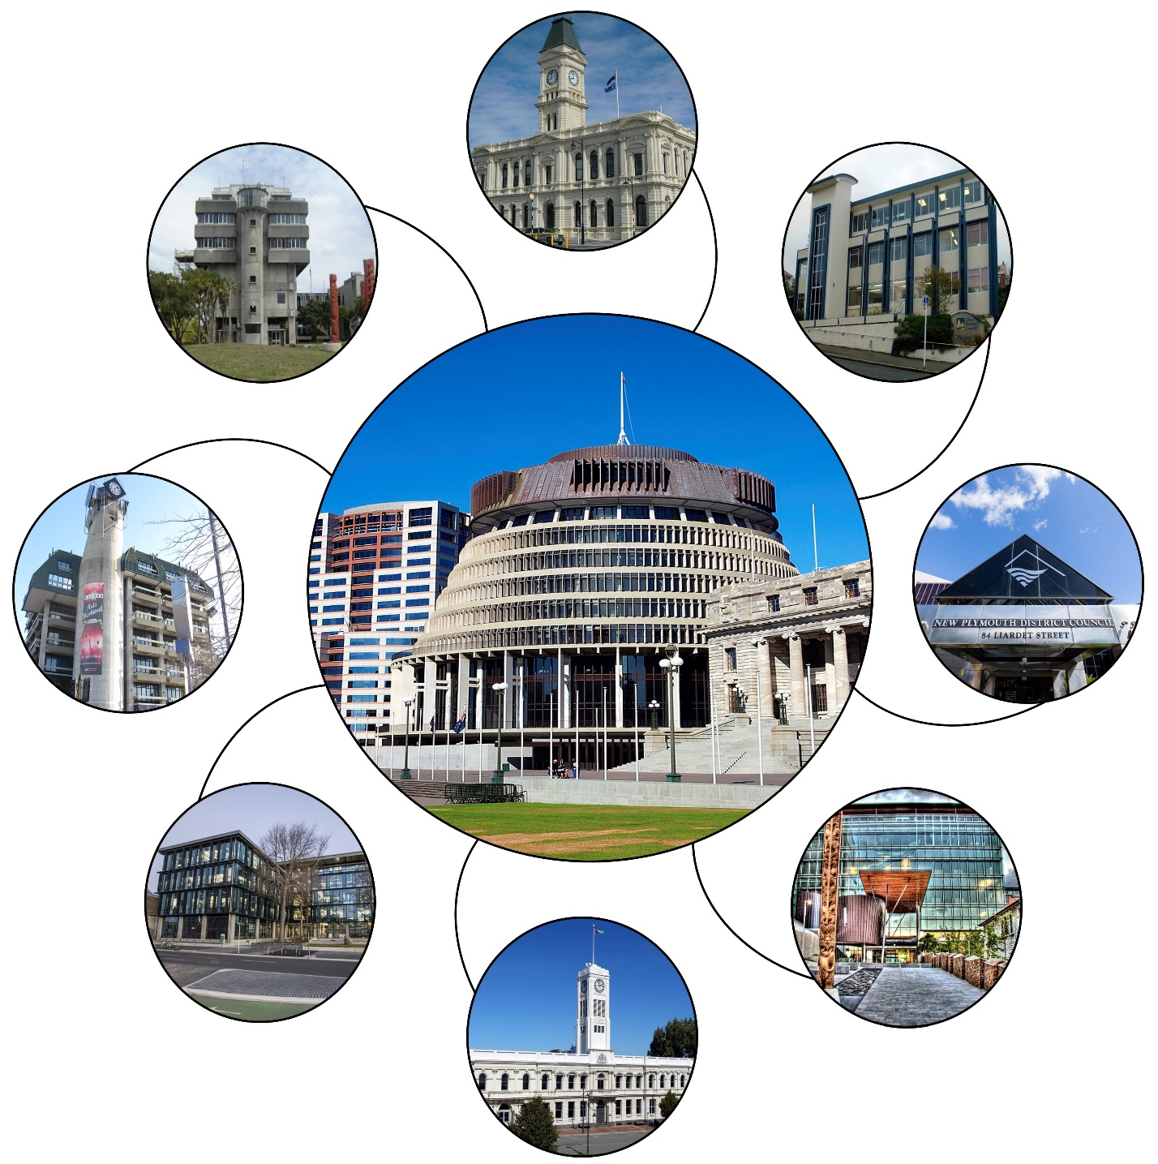

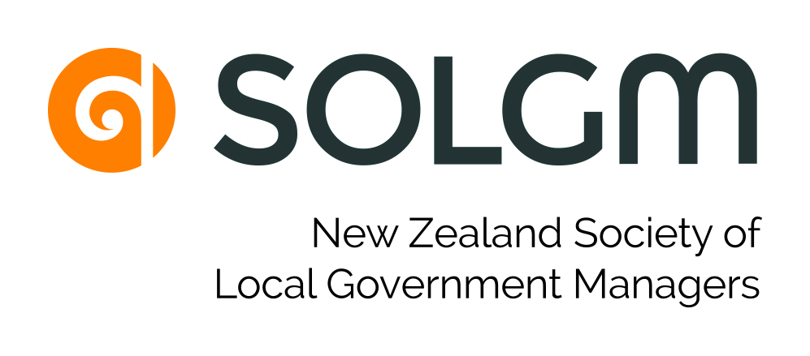
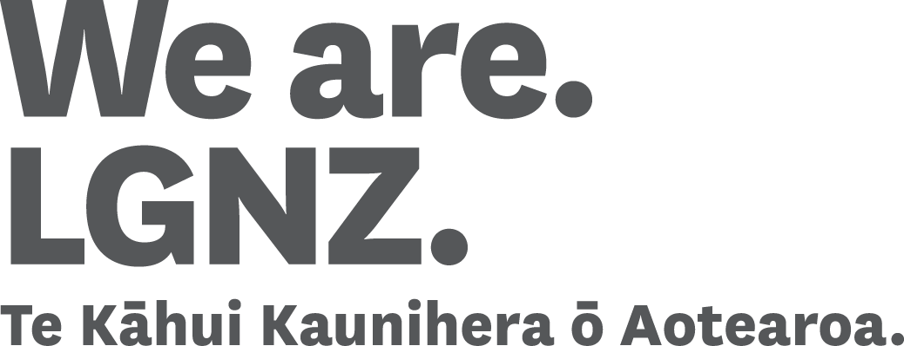

ISBN: 978-0-947520-10-6 (print)
ISBN: 978-0-947520-09-0 (online)

Citation: Department of the Prime Minister and Cabinet. 2019. Guide for central government engagement with local government. Wellington: Department of the Prime Minister and Cabinet.

Published in May 2019
by the Department of the Prime Minister and Cabinet

This document is available at www.dpmc.govt.nz

This work is licensed under the Creative Commons Attribution 4.0 International licence.
In essence, you are free to copy, distribute and adapt the work, as long as you attribute the work to the Crown and abide by the other licence terms.
To view a copy of this licence, visit https://creativecommons.org/licenses/by/4.0/.
Please note that no departmental or governmental emblem, logo or Coat of Arms may be used in any way which infringes any provision of the Flags, Emblems, and Names Protection Act 1981. Attribution to the Crown should be in written form and not by reproduction of any such emblem, logo or Coat of Arms.
Table of contents

Foreword 4
Executive summary 5
1. Introduction 13
1.1 Vision and purpose 13
1.2 What is central and local government ‘engagement’? 13
1.3 What makes engagement ‘effective’? 14
1.4 Spectrum of engagement 14
2. Principles of partnership and engagement between central and local government 16
2.1 The value of a partnership approach 16
2.2 Partnership principles 16
2.3 Engagement principles 17
3. Understanding central and local government roles, responsibilities and relationships 18
3.1 Overview 18
3.2 Power, roles and purpose of local government 18
3.3 Structure, functions and diversity of local authorities 22
3.4 Governance relationships, decision-making and accountability 29
3.5 Planning requirements 35
3.6 Planning and funding cycles 35
3.7 Pressures and challenges faced by local government 41
4. Engagement with local government: approach, methods and tools 43
4.1 Overview 43
4.2 Application of principles to the engagement approach 43
4.3 Support from central government for engagement 45
4.4 Engagement assessment – whether to engage local government 46
4.5 Engagement strategy – what type of engagement approach? 49
4.6 Value of engagement to the design and delivery of policy and services 52
4.7 Opportunities to engage with sector organisations 55
5. Conclusion 61
Appendices 63
Appendix A – Case studies 64
Appendix B – Regulatory responsibilities of local government 70
Appendix C – Engagement between central and local government on strategy 76
Appendix D1 – Engagement on policy: Commissioning and Discovery 78
Appendix D2 – Engagement on policy: Design and Delivery 80

Foreword

An effective partnership between central and local government is crucial to inform many decisions that affect New Zealanders, and to ensure they are implemented well.
Strengthening the engagement between our two levels of government is vital if we are to reflect the diversity of our regions, and work together on responses that best reflect the needs of all our communities.
This guidance recognises that one size does not fit all when it comes to engagement between local and central government. What works in one situation with one local authority as a policy issue emerges, may be different for other local authorities, or at different stages of the policy process.
Rt Hon Jacinda Ardern
Prime Minister
I expect my ministerial colleagues and their central government agencies to engage early and comprehensively with local government, unless there is a clear reason not to. This guidance is an effective reminder that collaboration and pooling resources is not just best practice, but a way for both central and local government to better achieve their goals for the wellbeing of New Zealanders.

Executive summary

Introduction and overview
Many decisions in the interests of and affecting New Zealanders require an effective partnership between central and local government.
The guidance is primarily focused on providing central government officials with context for engagement with local government. However, the guidance also sets out information about central government decision-making processes that will be useful for local government readers.
Improving engagement between our two levels of government is vital if we are going to understand the diversity of our regions, and work together to develop local responses that best reflect the needs of all our communities. The value of a partnership approach and the application of a principled approach to engagement is set out in section 2 of the guidance. Key partnership principles are respect, reciprocity, and trust.
Section 3 of the guidance highlights the differences between central and local government, and sheds light on aspects of the local government operating environment (including the significant differences within local government) that need to be better understood to ensure effective engagement. By setting out the structures and processes of both systems and their differences, this guidance will help minimise the disconnect that can occur between central government agencies and local authorities.
As well as setting the scene for engagement, section 4 of the guidance demonstrates the value that engaging with local government can bring to ongoing strategic discussions and policy development on specific policy issues. For those agencies undertaking engagement activity with local authorities, this very practical guide provides tools and resources to help engage effectively.

Engagement principles
Effective engagement can be achieved through applying the following engagement principles.

Early communication
Communicate clearly and early and provide all the information needed for local government to engage effectively with central government. Early discussions build better understanding and make subsequent debate better informed. It is important to give local government representatives a reasonable opportunity to state their views on the issues and to discuss the engagement approach. Communicating early will also ensure there is time to factor in their requirements for community consultation and the need to align with their planning and funding processes.

Genuine and meaningful engagement
Trust and goodwill can be built up over time by ensuring there is a meaningful effort to work with local government to develop policy. Relationships with local authorities can also be strengthened by starting with a genuine intention to understand the value local government brings to decision-making. This also involves making real effort to understand the environment that local government operates within.

Open and transparent
Central government needs to be aware of the open and transparent environment of local government. You should consider carefully whether local authority engagement requires confidentiality. Central government needs to be clear about what honest and robust dialogue it is willing to have in the open, and be prepared to recognise that both levels of government may need to agree to disagree in a public setting. Central government and local government should discuss what is possible and within scope, what is not, and what will happen with information gathered.

Being responsive and flexible
Being responsive and flexible means central government agencies adapting policy processes and the engagement approach where possible, to take account of several important factors. These include the constant tension between the different roles, powers and authority of each sphere of government, and the diversity of local areas, including differing pressures on local authorities and their capacity to engage.

Support from central government for engagement
Central government should understand how to access its own resources to support good engagement. Accessing good advice from the Department of Internal Affairs (DIA) and relationships and engagement staff within individual agencies, can lead to more productive and effective engagement through taking a joined-up approach to how central government engages with local authorities. Within agencies and at a system level, there are a number of resources to support engagement with local government including:
- The Central and Local Government Partnerships Team, DIA
This team was established to facilitate a collaborative and system-wide public service approach in which central and local government work effectively together for the benefit of people, communities, businesses, and the environment. A dedicated group of Partnerships Directors spend time in their regional ‘constituencies’, which are aligned to Local Government New Zealand zone groupings. This group connects with local government and gathers and provides information to agencies. Partnerships Directors have particular portfolio responsibilities through which they provide leadership for key joint initiatives. The team also operates a directory of local authority contacts at the political and officials level, which they can share with agencies undertaking engagement. For more information, see the Central/Local Government Partnerships page on the DIA website.
- Relationship and engagement staff within agencies
Many agencies, especially those who have significant involvement with local government, have their own staff dedicated to maintaining and engaging local relationships.

Criteria for engaging with local government
Not all policy proposals need to be discussed with or require the involvement or a partnership with local government. Clearly where local government is likely to have a role in the administration or implementation of any framework that may be required, the answer to the question as to whether to engage is usually relatively straightforward.
Central government officials should check with their ministers before engaging with local government and lay out their reasons for the proposed approach to engagement.
In general, central government agencies should apply the following criteria when assessing whether to engage with local government when developing policy:
- Could there be an impact on particular communities?
- Might the proposal create costs or compliance for councils?
- Might the councils have a role in implementation?
- Might the initiative involve an existing council service or responsibility?
Might the proposal involve a change to local government’s constitutional architecture?
If the answer to one or more of those questions is yes, then engagement with local government will be the expectation.
To determine who to approach and engage with in local government, two further questions then need to be asked:
- Who is affected by the policy issue (and proposals to address it)?
  - a majority of councils?
  - a specific type of local authority?
  - sub-national groupings of councils (e.g. only in Northland)?
  - single or small numbers of councils?
Is it an urgent matter?
The following diagram from section 4.4 (see page 48) shows who in local government can help provide an answer to these questions, depending whether the matter being engaged on is primarily of a policy/political or administrative/technical nature.

Figure 1. Criteria and approaches for engagement with local government

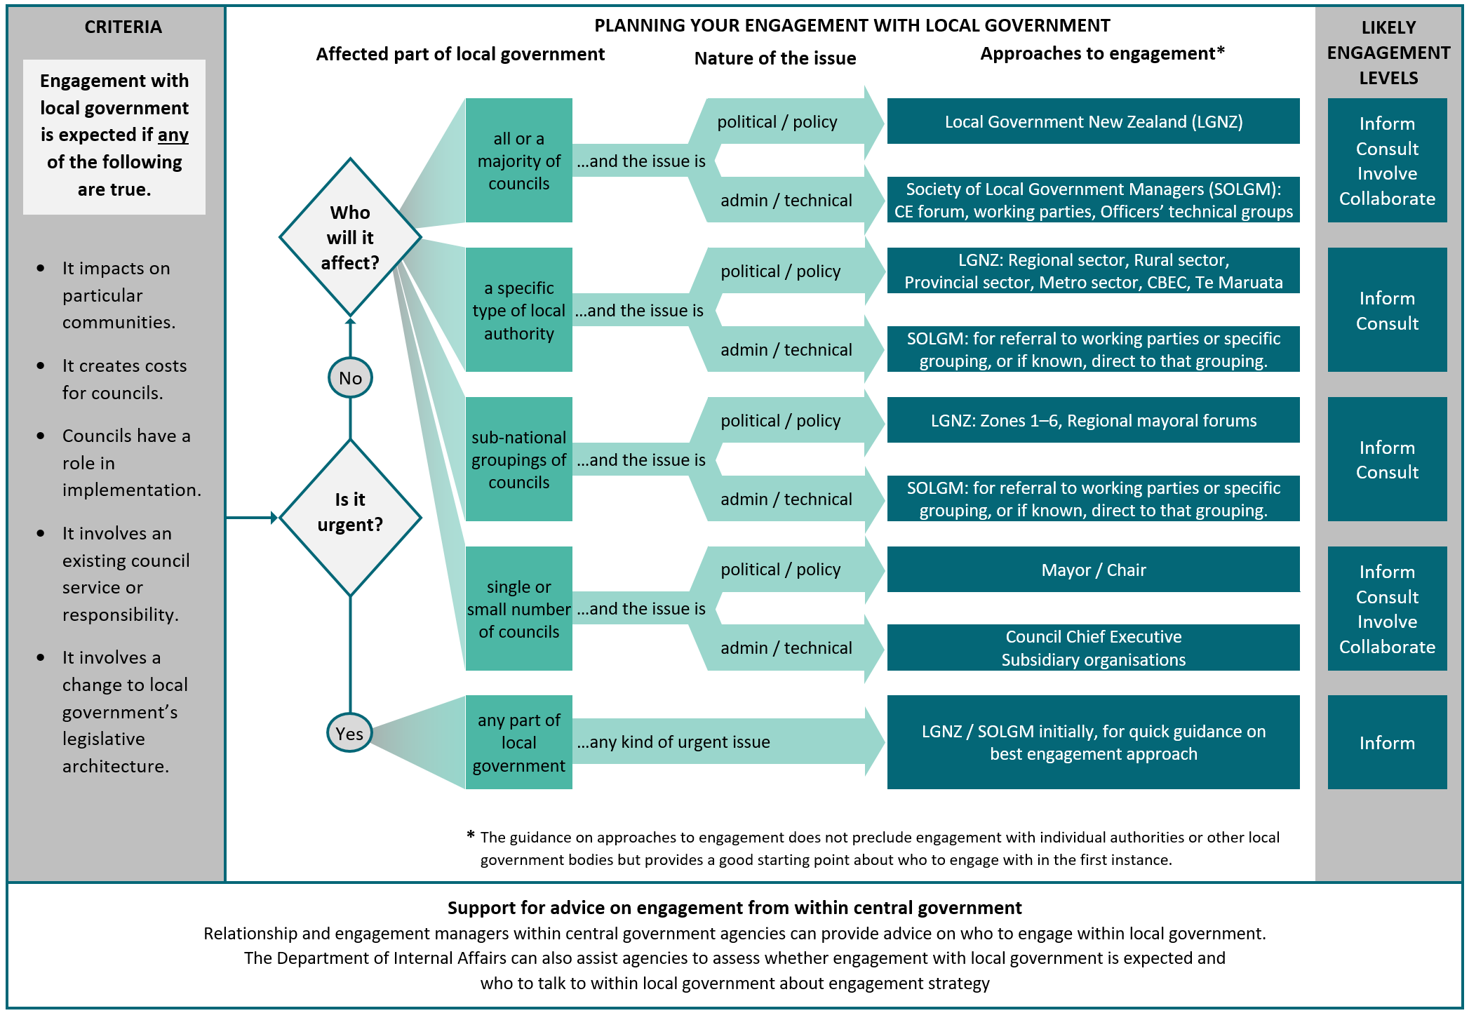

Spectrum of engagement
The spectrum of engagement featured in section 4.5 (see page 51) is a useful tool for thinking about the alternative approaches central government could adopt in engaging with local government. This is based on the spectrum of public participation developed by the International Association of Public Participation (IAP2). The IAP2 spectrum identifies five levels for engagement, ranging from inform, consult, involve, collaborate and empower. The level of influence that those engaged with have on government decisions increases as you move up this spectrum.
The table below illustrates the spectrum of engagement by central government with local government. It summarises the full table on page 51. It provides a common language as a starting point for double-checking both local and central government’s understandings about what type of engagement is taking place.
Figure 2. Spectrum of engagement by central government with local government
Increasing level of impact on decisions

 | Inform | Consult | Involve | Collaborate | Empower
Engagement goal | To provide local government with balanced and objective information to assist them in understanding a problem exists, or how central government is planning to respond to it | To obtain local government feedback on central government analysis, alternatives and decisions | To work directly with local government throughout the process to ensure their concerns and interests are consistently understood and considered | To partner with local government in each aspect of the decision, including developing alternatives and identifying the preferred solution | To place final decision-making, accountabilities and funding (or a national contribution to funding) in the hands of local government
Undertaking to local government | We will keep you informed when strategic and policy issues affecting local government first arise | We will keep you informed, listen to and acknowledge concerns and interests, and provide feedback on how local government input influenced central government decisions | We will work with you to ensure that the concerns of local government and your interests are directly reflected in the alternatives developed | We will look to you for direct input and advice in formulating solutions and will incorporate your advice and recommend-ations into the decisions to the maximum extent possible | We will work with you to help you resolve and implement the changes that you consider appropriate, to be led at a local level – we acknowledge that local government should make the decisions, as mandated

Broad strategic engagement or narrower issue-specific engagement?
In principle, central government should engage with local government in a future-focused way on broad strategic issues and priorities, or in a narrower way on specific and relatively immediate policy issues and options. Effective engagement on both these matters can add value, improving the quality of the decisions made and implemented. In the past there has been more of the latter than the former.

Strategic partnership on work programmes
Maintaining ongoing strategic discussions can help identify joint interests and objectives, where both levels of government could be working collaboratively together if they are not already. Opportunities to engage on longer-term regional and sectoral strategic issues will also ensure there are ‘no surprises’ at both levels of government.
Benefits can be achieved by engaging local government in the overall status and progress of the relevant nationally-led work programme, and ongoing monitoring and maintenance of the system (policy/regulatory and operations) – as well as on longer term stewardship and planning matters, and effective management of current policy settings.
In addition, strategic engagement with local government can have flow-on effects, adding further value in the following ways.

The value of strategic engagement
- A local government sector that understands central government’s objectives and supports them to the extent they are able to articulate and promote those objectives locally
- Local objectives and planning processes can be more aligned with joint efforts to grow the economy, or contribute to initiatives, such as ameliorating climate change
- Maintaining an ongoing engagement between central and local government can make it easier to help resolve conflict or avoid it in the first place
A diminishing risk of the councils inadvertently undermining national objectives

Partners in policy development and problem-solving
Effective engagement is a vital ingredient of policy formulation on specific and immediate policy issues. Integral to a successful policy process is early engagement on defining the problem and designing the options. As well as engaging at the political level through Local Government New Zealand on ‘headline’ policy intent, it is also important to consider opportunities to engage managers and staff of local authorities in the more detailed and technical development process.
More workable and effective outcomes from initiatives to address specific policy issues can be achieved, if the policy development process is informed by local knowledge and experience. Ongoing engagement with local authorities throughout the policy development process will ensure relevant local information and perspectives are incorporated within policy and operational settings. Where possible, collaborating with local government on policy development will also mitigate implementation risks and can ensure that unintended consequences are avoided. While collaborative policy-making is a desired approach it may not always be possible. In some cases a mixture of approaches throughout the policy process at different stages may be required.
Effective engagement on specific policy issues is best achieved by central government engaging early with local government, and continuing engagement at each stage in the policy development process. Subject to ministerial agreement, this includes the following stages and activities.

Commissioning and discovery
- Notifying local government of new proposed initiatives, emerging issues or problems affecting the sector
- Scoping a project plan for the response to the issue
- Evidence and information gathering for context-setting and problem diagnosis
- Planning the engagement approach and strategy
- Defining any problem or proposal for responding to it
Setting objectives and identifying possible desired outcomes

Design and delivery
- Further gathering of information, evidence and statistics to feed into the design of responses
- Developing and confirming possible solutions and design options, including:
  - assessing suitability for and partnering with local government on any trial, test or prototyping of response or initiative
  - assessing whether any new legislation or regulations, or any new funding or operational response will be required, or whether a response could be mandated within current regulatory frameworks
  - identifying how possible solutions could be implemented and delivered and the cost implications
  - assessing the likely impact of solutions on outcomes
  - identifying how it will be monitored and by whom
  - identifying how it will be evaluated, how it will be resourced and carried out
- Coordinating communication of any policy or operational changes at the national and local level
- Delivery and implementation of policy or operational response
Ongoing monitoring and evaluation of initiative or response

Conclusion
This guidance is intended to help central government agencies consciously reflect on and improve our relationship with local government, and deepen our understanding of what engaging effectively with local government means. It identifies the value in doing so, enabling better-informed decisions that are implemented more effectively to improve the wellbeing of New Zealanders. In areas where local government has a legitimate interest, collaborating with local government should be the norm, not the exception.
In the coming decades, with the combined pressures of urban population growth and looming environmental challenges, central government will not be able to deliver good outcomes for communities without the contribution and experience of local government. It will require a concerted effort to understand and respond to the diverse needs of each local area. There will be benefits for communities and the system of government as a whole if central and local government face future challenges together.

Introduction

Vision and purpose
This guide outlines the key elements of good practice that government agencies should follow when engaging local authorities in the development of policy and services. The shared vision is to establish ‘rules of engagement’ that may frame the relationship and assist local and central government to work well together to make better decisions for New Zealanders.
The guidance is primarily focused on providing central government officials with context for engagement with local government. However, the guidance also sets out information about central government decision-making processes that will be useful for local government readers.
Building relationships between central and local government and engaging citizens and communities at an early stage is critical to the implementation and delivery of good policy outcomes. The guide aims to make central government engagement practices with local government more timely, effective and consistent across central government.

What is central and local government ‘engagement’?
Cabinet is the central decision-making body of executive government. The principles of Cabinet decision-making, including guidance regarding consultation requirements, are set out in Chapter 5 of the Cabinet Manual. That guidance provides that a key consideration in developing workable and effective policy is assessing the need for and the timing of consultation with relevant stakeholder groups. Chapter 7 of the Cabinet Manual also states that during the process for developing bills:
7.44 “Ministers may wish to consult other organisations such as Māori groups, professionals or trade associations, non-government organisations, local government, or community groups, or to engage in a wider process of public consultation with citizens or affected parties, before policy decisions are finalised and the bill is drafted and introduced into the House.”
Local government plays two roles in the development of national-led policy: as an agent or bridge between central government and local communities; and as a pivotal partner in developing, delivering and monitoring policies and services that impact on our communities.
In this context, ‘engagement’ may involve connecting with others to share information and ideas, and to build understanding and relationships. Good engagement processes are ongoing. They help ensure there are ‘no surprises’. Central and local government engagement represents a partnership where both parties work together to ensure the wellbeing of citizens by monitoring relevant current policy trends and settings to identify emerging issues, and by discussing together who should do what to respond to those issues.

What makes engagement ‘effective’?
Effective engagement with local government involves balancing good process, inclusiveness, timeliness, and cost, while drawing on the spirit of partnership and principles of engagement. This guidance sets out some principles of effective engagement between central and local government. See section 2 – Principles of partnership and engagement between central and local government.
Good quality engagement requires a good understanding of the operating environment at both levels of government, the diverse issues faced by local authorities, and the different factors that drive decision-makers at both spheres of government. This guidance sets out the key differences and relationships between the two spheres of government and highlights the information central government agencies need to identify to engage effectively with local authorities – see section 3 – Understanding central and local government roles, responsibilities and relationships.
Finally, improvements to engagement follow if central government understand the best times to engage, the pros and cons of the different methods of engagement, and the value that local government brings to decision-making. This guidance assists central government to understand when and how to engage, including criteria for assessing whether to engage with local government. It explains the value gained from engaging early and at different stages of the policy development process. The guidance also provides practical tools, methods and resources to support effective engagement. See section 4 – Engagement with local government: approach, methods and tools.

Spectrum of engagement
Early in any engagement process, central government may decide the extent to which it wishes to involve local government in the design of policy and services. Where local government is likely to be affected, early and comprehensive engagement should be the usual practice, unless there is compelling reason not to.
Internationally there is a recognised spectrum of engagement – the International Association for Public Participation’s Spectrum of Public Participation. Different levels on the spectrum reflect different engagement goals, different roles for those involved, and different levels of impact on the decision taken by government.

This Spectrum of Public Participation has been used as a guide to develop an engagement spectrum for the central and local government engagement relationship. Figure 3 below summarises the objectives of each level of engagement on the spectrum, and the degree to which local government’s contribution will influence central government’s decisions. The table articulates the undertaking central government would typically make for each level of engagement with local government in the decision-making process. It serves as a guide for central government to more consciously decide how it should approach its engagement with local government, while recognising that the level of involvement may vary at different stages in the policy process for a given issue.
Figure 3. Spectrum of engagement by central government with local government

Increasing level of impact on decisions

 | Inform | Consult | Involve | Collaborate | Empower
Engagement goal | To provide local government with balanced and objective information to assist them in understanding a problem exists, or how central government is planning to respond to it | To obtain local government feedback on central government analysis, alternatives and decisions | To work directly with local government throughout the process to ensure their concerns and interests are consistently understood and considered | To partner with local government in each aspect of the decision, including developing alternatives and identifying the preferred solution | To place final decision-making, accountabilities and funding (or a national contribution to funding) in the hands of local government
Undertaking to local government | We will keep you informed when strategic and policy issues affecting local government first arise | We will keep you informed, listen to and acknowledge concerns and interests, and provide feedback on how local government input influenced central government decisions | We will work with you to ensure that the concerns of local government and your interests are directly reflected in the alternatives developed | We will look to you for direct input and advice in formulating solutions and will incorporate your advice and recommend-ations into the decisions to the maximum extent possible | We will work with you to help you resolve and implement the changes that you consider appropriate, to be led at a local level – we acknowledge that local government should make the decisions, as mandated

Principles of partnership and engagement between central and local government

The value of a partnership approach
At the Central and Local Government Forum in May 2018, the Prime Minister and Minister of Local Government proposed three overarching principles that should guide the partnership between central and local government – the principles of respect, reciprocity and trust. Central and local government agreed to work together under these principles to effect change in agreed areas of priority.

Partnership principles
To build a meaningful and enduring relationship with local government that is centred on these three principles, it is necessary to understand what they each mean in practice.
Respect
- Engagement between central and local government based on mutual respect and a genuine intention to strengthen relationships and work together effectively.
Reciprocity
- Central and local government providing each other with timely information on matters that have the potential to impact on their respective responsibilities. For matters of significant mutual interest, early engagement in clarifying the issues, policy options, and ways in which collaboration could occur.
Trust
- Subject to the law governing the public disclosure of information, central and local government maintaining the confidentiality of information provided in the course of working together or keeping each other informed. Central and local government being prepared to have honest and robust dialogue, recognising the right to disagree, but seeking shared understanding and cooperative resolution of any issues arising in the relationship.

Engagement principles
Translating these partnership principles of respect, trust and reciprocity into the practice of engagement is the challenge for central government agencies. Effective engagement can be achieved through applying the following engagement principles.

Early communication
Communicate clearly and early and provide all the information needed for local government to engage effectively with central government. Early discussions build better understanding and make subsequent debate better informed. It is important to give local government representatives a reasonable opportunity to state their views on the issues and to discuss the engagement approach. Communicating early will also ensure there is time to factor in their requirements for community consultation and the need to align with their planning and funding processes.

Genuine and meaningful engagement
Trust and goodwill can be built up over time by ensuring there is a meaningful effort to work with local government to develop policy. Relationships with local authorities can also be strengthened by starting with a genuine intention to understand the value local government brings to decision-making. This also involves making real effort to understand the environment that local government operates within.

Open and transparent
Central government needs to be aware of the open and transparent environment of local government. You should consider carefully whether local authority engagement requires confidentiality. Central government needs to be clear about what honest and robust dialogue it is willing to have in the open, and be prepared to recognise that both levels of government may need to agree to disagree in a public setting. Central government and local government should discuss what is possible and within scope, what is not, and what will happen with information gathered.

Being responsive and flexible
Being responsive and flexible means central government agencies adapting policy processes and the engagement approach where possible, to take account of several important factors. These include the constant tension between the different roles, powers and authority of each sphere of government, and the diversity of local areas, including differing pressures on local authorities and their capacity to engage.

Understanding central and local government roles, responsibilities and relationships

Overview
For central government to engage effectively with local government, a good understanding is required of the operating environment at the local level and how it differs from that of central government. For example, central government doesn’t have the legislative requirement to regularly formally consult with its community on planning and funding that local authorities have.
Local authorities are also very diverse, as are the pressures and challenges they face in each area. It is important to understand those factors and how they drive decision-making at the local level. These differences can affect the appropriate level of engagement between both spheres of government, and its quality.
This section outlines how local government operates. It emphasises what is important to understand about the relationship with central government, and in particular it covers:
- power, roles and purpose of local government
- structure, functions and diversity of local authorities
- governance, decision-making and accountability
- planning and funding cycles
- pressures and challenges faced by local government.

Power, roles and purpose of local government

Powers and role of local government in Local Government Act 2002
The Local Government Act 2002 (LGA02) is the key statute that establishes the roles, functions and purpose of local authorities. It also sets out the powers of councils, including the power to make local bylaws, and council planning and accountability requirements.
Local government has a broadly defined set of powers. LGA02 empowers a local authority to “carry on any activity or business, do any act or enter into any transaction” provided that it can demonstrate that the activity or transaction is consistent with the purpose of local government, any other enactment, and the general law.
Under section 11 of LGA02, an individual local authority has two major roles:
- giving effect to the purpose of local government within its local area
- performing other roles, powers, functions or duties assigned under other Acts of Parliament, essentially where local government acts as an agent of central government to administer and deliver nationally-led initiatives at the local level.

Giving effect to the purpose of local government in its local area
Parliament has recently changed the purpose of local government, which is now to:
- enable democratic local decision-making and action by, and on behalf of communities
promote the social, economic, environment and cultural wellbeing of communities in the present and for the future.

Dimensions of ‘the four wellbeings’
The sector generally uses the short hand descriptor ‘the four wellbeings’ to refer to the social, economic, environment and cultural wellbeing of the communities that local government is responsible for promoting. The local government sector generally understands each dimension of community wellbeing as including the following aspects:
- Social wellbeing – encompasses those factors that enable individuals, their families, whānau, iwi, hapū and a range of communities to set goals and achieve them – factors such as education, health, the strength of community networks, connectedness, financial and personal security, equity of opportunity, rights and freedoms.
- Economic wellbeing – encompasses factors relating to the capacity of the economy to generate employment and wealth necessary to provide many of the prerequisites for social wellbeing, such as health, financial security, and equity of opportunity.
- Environmental wellbeing – encompasses factors that relate to the capacity of the natural environment to support, in a sustainable way, the activities that constitute community life (e.g. air quality, fresh water, uncontaminated land, control of pollution).
Cultural wellbeing – encompasses the shared beliefs, values, customs, behaviours, and identities reflected through language, stories, visual and performing arts, ceremonies and heritage (i.e. the diversity of a district, with inclusiveness reflected in the cultural activities undertaken).
Democratic decision-making by local authorities to promote the wellbeing of their communities enables different places to set different priorities and ways of achieving them, if they wish. They often do. Variability and difference is a hallmark of the local government sector.

Regulatory framework for local government
As well as the LGA02, there are a number of other Acts that establish the operating environment for local government. These include:
- The Local Government (Rating) Act 2002 (LGRA) sets out the methods by which councils raise revenue through rates
- The Local Electoral Act 2001 sets out the process for council elections
- The Local Government (Auckland Council) Act 2009 sets out variations from the framework in the LGA02 that are specific to the Auckland Council
The Local Government Official Information and Meetings Act 1987.

Delegated versus devolved powers
Many specific local government activities (especially regulatory functions) are also governed by a number of other central government statutes, such as the Resource Management Act 1991 (RMA) and the Building Act 2004. There are over 150 pieces of central government legislation that relate to the activity of local government. See Appendix B for a list of many of the local government regulatory responsibilities.
The role that local government is required to play on behalf of central government varies significantly in different statutory vehicles – on a spectrum from delegation to devolution, as described in Figure 4.
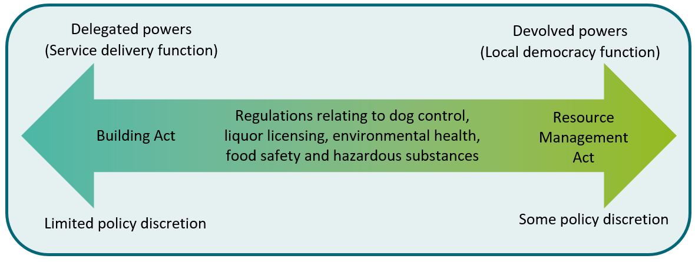
Figure 4. The spectrum of local authority powers: from delegation to devolution

Where there is a uniform nationwide service delivery objective, powers are delegated centrally (with local government acting as an agent of central government). The degree of scope for local variation under delegated powers varies, from nearly none to some, depending on the Act involved.
Central government tends to devolve regulatory powers to local government for matters where it is considered important to allow local or regional communities to decide how rules will be applied locally, or how services are delivered through local democratic decision-making. This allows considerably more variation in how the powers are exercised in each area, than in cases where powers are delegated.

Contributions to central government policy objectives
Table 1 provides examples of how local authorities are regulated to perform activities that contribute to achieving central government policy objectives.
Table 1. Examples of how local regulation contributes to national policy objectives
Central government policy area | Examples of how local regulation contributes to central policy objectives | Legislation
Export promotion  and economic growth | Land use plans impact on the use of New Zealand agricultural land (a major source of international competitive advantage) | Resource Management Act 1991
 | Zoning regulations determine the supply of land for industrial, business and commercial purposes | Resource Management Act 1991
 | Pest management strategies help to protect key export industries (and access to overseas markets) | Biosecurity Act 1993
Efficient national infrastructure | Resource consents impact on the development of network infrastructure such as telecommunication and electricity networks | Resource Management Act 1991
 | Regional land transport programmes assist in the management and development of the land transport system | Land Transport Management Act 2003
 | Bylaws relating to the management and operation of airports assist the operation of the national and international air transport system | Airport Authorities Act 1966
Natural resource management and environmental  protection | Regional policy statements and plans help to protect sensitive environment landscapes and habitats | Resource Management Act 1991
 | Regulation of territorial authorities promotion of effective and efficient waste management and minimisation within its district | Waste Minimisation Act 2008
 | Regulation of hazardous substances assists in preventing contaminants being discharged into the environment | Hazardous Substances and New Organisms Act 1996
Healthy and safe communities | Dog control regulations assist in preventing harm caused by dog attacks | Dog Control Act 1996
 | Liquor licensing regulations assist in managing anti-social behaviour associated with excessive alcohol consumption | Sale of Liquor Act 1989 and Sale and Supply of Alcohol Act 2012
 | Bylaws aimed at controlling health hazards help to improve, promote and protect public health | Health Act 1956
Protection of historical and cultural heritage | Bylaws and zoning regulations assist with the preservation of historic and culturally significant places or areas | Heritage New Zealand Pouhere Taonga Act 2014

Structure, functions and diversity of local authorities
There are three types of local authority, each with different roles specified in the LGA02. Figure 5 below outlines the types and numbers of local authorities, while Figure 6 on pages 26 and 27 describes the geographic boundaries of each local authority by type, and the location and population size they serve.
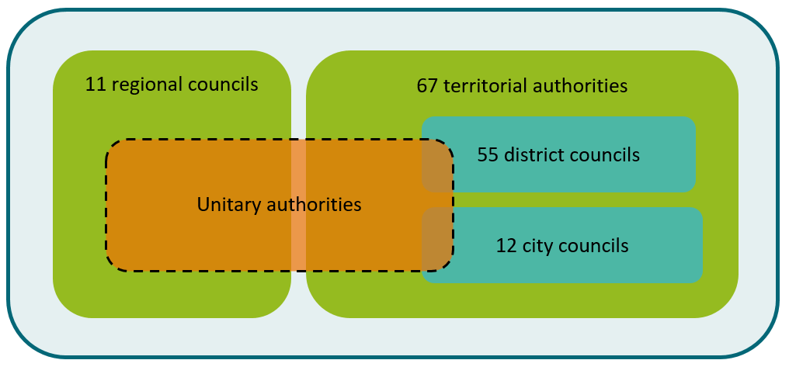
Figure 5. Types and number of local authorities

Types of local authorities
There are three types of local authorities:
- Regional councils – there are currently 11 of these. Regional councils have anywhere from three to as many as ten territorial authorities sitting within their boundaries.
- Territorial authorities – there are currently 67 of these (12 city and 55 district councils). The only legal difference between a city and a district council is that most city councils serve populations of 50,000 or more within a predominantly urban area. District councils typically have larger predominantly rural areas with lower populations. City and district councils have the same powers and responsibilities.
Unitary authorities – unitary authorities are territorial authorities that also have the powers and responsibilities of a regional council. There are currently six unitary councils: Auckland Council; Gisborne District Council; Marlborough District Council; Nelson City Council; Tasman District Council and the Chatham Islands Council.
While relationships between territorial authorities and regional councils differ in different contexts, there is no overall hierarchy – that is, a territorial authority is not legally subordinate to the regional council for the region in which its district is located, or vice versa. The two levels tend to have different regulatory roles and responsibilities. Where both undertake related functions under specific legislation, the relationship is explicitly stated (e.g. section 75 of the RMA provides that territorial authority district plans must give effect to regional policy statements and cannot be inconsistent with regional plans). Sections 15 and 16 of the LGA02 prescribe processes for cooperation between councils within a region, and for avoiding duplication where the same activity is proposed to be undertaken at both regional and territorial level.

Functions of local authorities
All local authorities have the same broad powers under the LGA02. In most cases though, individual pieces of primary legislation (such as the RMA, Building Act 2004 or the Land Transport Management Act 2003) are the vehicles for setting out the governing power structures, functions and regulatory relationships between specific parts of central and specific types of local government. In most cases regional councils operate as environmental regulators while territorial authorities own and retain assets. Unitary authorities do both.
A regional council generally has the following responsibilities:
- managing the effects of using fresh water, land, air and coastal waters
- developing regional policy statements and issuing consents for use of natural resources (except land use)
- managing rivers, mitigating soil erosion and flood control
- planning regional land transport and funding passenger transport services
- harbour navigation and safety, oil spills and other issues related to marine pollution
managing plant and animal pests (sometimes called pest management or biosecurity).
A territorial authority generally undertakes the following activities:
- the provision and funding of network infrastructure such as water supply, sewage disposal, stormwater disposal, roads and footpaths
- provision and funding of community infrastructure such as parks, museums, playgrounds, recreation centres and libraries
- funding or operating other community programmes – such as cultural and recreational events, promoting local business
- regulation such as subdivision and land use consents, building control, road control, liquor licensing, public health inspections, plant and animal control.

Other statutory bodies and structural groups with responsibilities to local government
Beyond the three types of local authority, there are a number of other bodies and structural groups with responsibilities in relation to local government. These include the Local Government Commission, Local Government New Zealand (LGNZ) and their sector and zone groups, and the New Zealand Society of Local Government Managers (SOLGM). Some of these can be of considerable potential assistance in engaging with local government. For more information about how and who to engage with in relation to each of the following groups see section 4.7 – Opportunities to engage.

Local Government Commission
The Local Government Commission is an independent body established to make decisions on the structure of local authorities and their electoral representation. The Commission determines appeals and objections against proposals by local authorities in relation to their representation arrangements. It can determine and implement proposals for boundary changes, transfers of responsibilities between local authorities, or the creation, abolition or union of local authorities.
The Commission can also consider and make recommendations on any matter relating to local government in New Zealand, either on its own initiative or at the request of the Minister of Local Government.

Local Government New Zealand
Local Government New Zealand (LGNZ) is the national voice of local government representing all 78 local authorities. The authorities are members of LGNZ by choice. The vision of LGNZ is “Local democracy powering community and national success”.

The New Zealand Society of Local Government Managers
SOLGM is an incorporated society, established in 1988 to promote excellence in management within the local government sector. Unlike LGNZ, SOLGM is an individual membership organisation (councils are not members), with approximately 700 members drawn from employees of a local authority or council controlled organisation.

LGNZ sector groups
There are four types of LGNZ sector groups: metropolitan, regional, provincial, and rural.

Metropolitan sector
This sector consists of councils with populations of 90,000 or more, or are part of the Wellington urban metropolitan area. Queenstown Lakes District and Palmerston North City are also members. The purpose of the Metropolitan sector is to enable the mayors of New Zealand’s largest cities to identify and consider the current and emerging matters they have in common.

Regional sector
This sector consists of New Zealand’s 11 regional councils and six of the largest unitary councils. The purpose of the Regional sector is to enable the chairs of regional councils to consider policy and operational matters of common interest to the regions, and to act on behalf of its members.

Provincial sector
This sector consists of territorial councils, with populations between 20,000 and 90,000 residents. The purpose of the Provincial sector is to enable representatives of provincial councils to identify and consider the current and emerging matters they have in common (most unitary councils also attend these sector meetings). There are approximately 30 councils in this sector.

Rural sector
This sector consists of territorial councils with populations under 20,000. The purpose of the Rural sector is to enable representatives of rural councils to identify and consider the current and emerging matters they have in common. There are approximately 26 councils in this sector.
See also further information about sector groups on the LGNZ website: www.lgnz.co.nz/about-lgnz/membership-representation/sector-groups

LGNZ zone groups
LGNZ facilitates regular meetings of councils at a sub-national level. These meetings are referred to as Zone meetings, reflecting the division of New Zealand into six zones. Each zone is made up of a collection of councils within a similar regional location:
Zone 1 – Northland/Auckland
Zone 2 – Waikato/Bay of Plenty
Zone 3 – Central North Island
Zone 4 – Greater Wellington
Zone 5 – Upper South Island/Canterbury
Zone 6 – Southland/Otago/West Coast
For more information about zone groups and the chairs of those groups, see the LGNZ website: www.lgnz.co.nz/about-lgnz/membership-representation/zone-groups

Diversity of local authorities
Local authorities vary considerably, in a number of different ways, even within the same type of local authority. They serve populations of very different sizes, which are all declining or growing at different rates. Their age structures differ considerably, as do the physical resources and industry structures that underpin their local economies.

Population size and growth variations
Figure 6 shows, for example, that the population sizes of territorial and unitary authorities (other than Auckland) range from a low of 650 in the Chatham Islands to a high of 388,500 in Christchurch city. For regional councils the range is from 32,600 in the West Coast region to 521,500 in the Wellington region. Auckland Council – which as a unitary authority performing the roles of both a territorial authority and regional council – serves a population of 1,695,900 and has its own legislation.
New Zealand has experienced significant population growth since the 1990s. A high proportion of that growth has occurred in urban areas. Some areas have experienced that more than others. For instance, Queenstown Lakes District has more than doubled in size.

Figure 6. Geographic boundaries and population of New Zealand local authorities
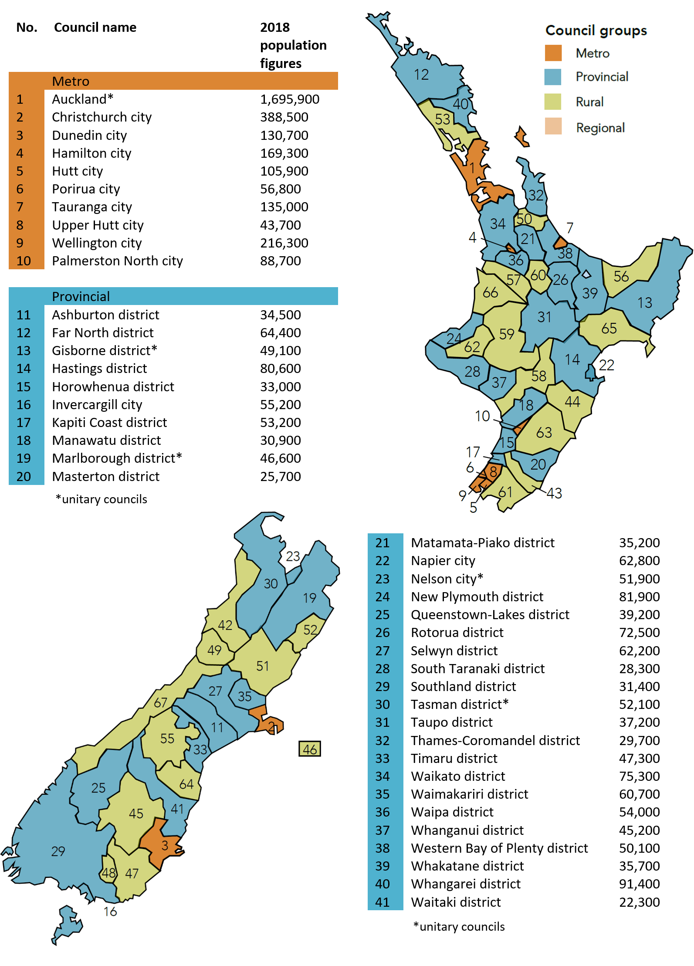
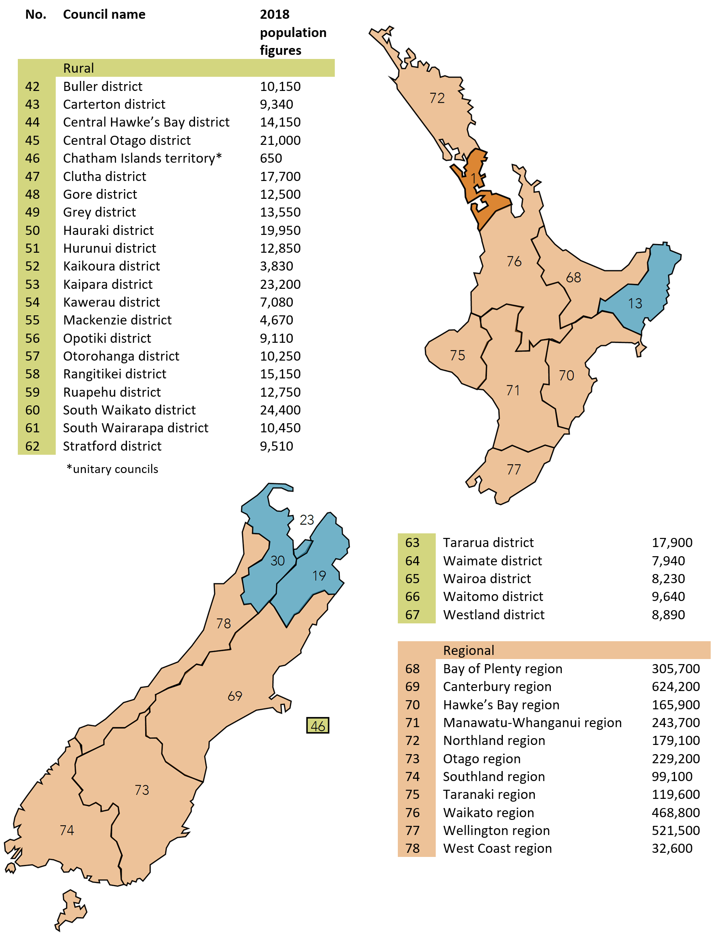

Physical resources and industry structure
Physical resources and industry structure vary across the country, which drives variations in regulatory needs and infrastructure requirements. Some areas have very specialised industries. For example, employment in the Kawerau District is heavily concentrated in manufacturing, reflecting the importance of the nearby newsprint mill to the local economy. See further discussion on the pressures facing local government in section 3.6.

Age structures
The average age of populations in cities and towns has been increasing, due to a reduction in birth rates and increasing life expectancy. Projections for median age increases vary across regions. High growth areas (such as Auckland) tend to have a younger population than slow growth areas. In towns and cities with a declining population growth rate, the younger demographic is often the first to leave. Factors driving population decline can be highly challenging, and in some cases difficult to reverse.
As demonstrated in Figure 7 below, the age structures and rates of ageing are highly diverse across the country.
Figure 7. Contrasting age demographics in Hamilton city and Thames-Coromandel
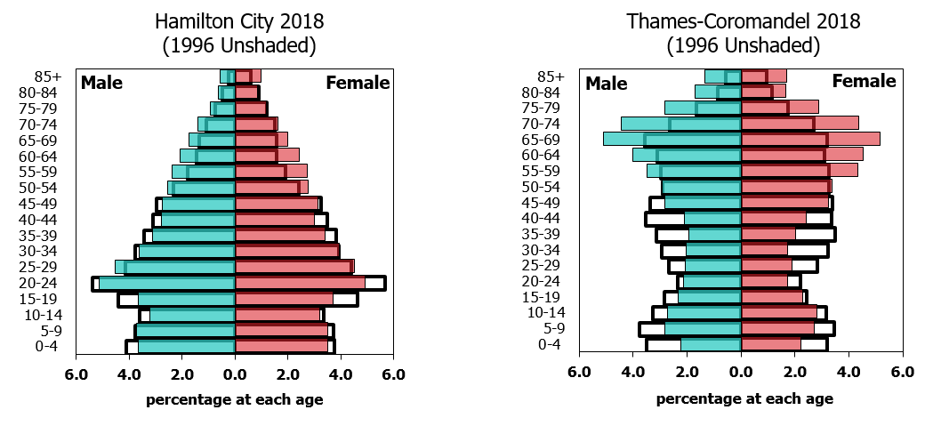

Ethnic structures
Diverse communities imply diverse needs. This poses challenges for local authorities and the way in which they engage and consult with people on the issues that affect those groups. Increasing ethnic diversity may increase the need for new ways to communicate with and involve local groups.
As figure 8 demonstrates, people of Asian origin and Pacific peoples have different age distributions. Both have ageing populations, but in general, Pacific peoples have a much higher proportion of younger age groups than those of Asian origin.
Figure 8. Total New Zealand Pacific peoples and Asian origin population by age
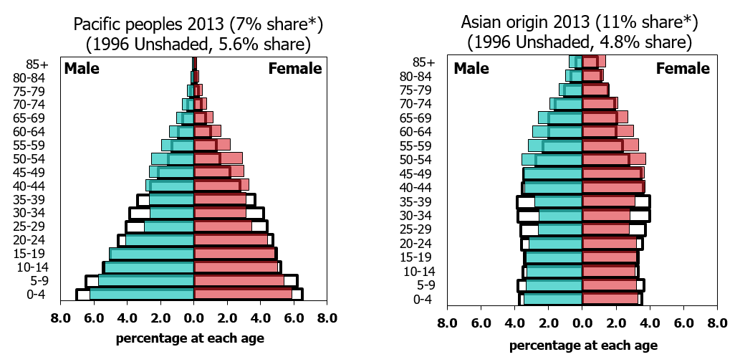

Governance relationships, decision-making and accountability

Central and local government constitutional relationship
Constitutionally, local and central government are regarded as two spheres of collective decision-making, each with revenue and collection powers to fund the implementation of its particular policies and programmes. Many local authorities see themselves as autonomous bodies, but feel that central government agencies sometimes treat local authorities as local offices or branches. This is complicated by the fact that the two spheres of government each have their own constituents, governance and accountabilities, decision-making processes, and funding cycles.
When local government is characterised as an agent of government, it can imply that local government is more generally accountable to central government, with broad requirements to implement national priorities and central government directions. Central government can give local authorities guidance and direction through mechanisms such as national policy statements under the RMA, and the Government Policy Statement on land transport. However in reality, the nature and extent of local authorities’ relationship with central government is context specific, depending on the particular regulatory framework.

Constitutional relationship with Parliament and the Courts
Parliament both formally empowers and acts as a check on central and local government. The House of Representatives and select committees scrutinise legislation, both government and local bills. Local bills affect a particular locality and are introduced by any Member of Parliament on application by local authorities. The Governance and Administration Select Committee is responsible for considering matters relating to local government. The Regulations Review Committee also reviews empowering provisions in bills.
The Controller and Auditor-General, as an Officer of Parliament, manages the audit requirements for local government. Audits of local authorities are carried out by Audit New Zealand on behalf of the Office of the Auditor General (OAG). The OAG reports to Parliament and the Governance and Administration Select Committee on the results of those audits and any other matters that arise as a result of its monitoring role in relation to local government.
The courts also act as a check on local authorities, with local authorities subject to the law and judicial review. Decisions made under various statutes by local authorities can be reviewed by the courts, and local authorities can be liable for damages in civil law.

Local government relationships with Māori
A positive, strategic relationship between local authorities and Māori, supported by central government, contributes to building strong prosperous regions and communities. Māori communities hold a broad, Treaty-based view of their relationship with local government and aspire to have an ongoing strategic relationship.
Māori have a strong interest in local authority matters and functions, some of which are reflected in the deeds of settlement and settlement legislation. While section 4 of LGA02 clearly acknowledges responsibility for the Treaty obligations lie with the Crown, and it is Crown and Māori who are the Treaty partners, in some cases Treaty settlements do confer specific obligations on identified local authorities. Obligations vary and may relate to statutory acknowledgements, natural resource arrangements, or administration of conservation land held as reserves.
Parts 2 and 6 of the Act are intended to facilitate participation of Māori in local government decision-making. Under section 14(1)(d) of LGA02 local government is charged with the responsibility to promote opportunities for Māori to contribute to its decision-making processes. On issues where the local authority is involved in administering a regulatory regime that is partly prescribed by government and partly determined by a council itself, it is important that there is clear accountability for engagement and who will be involved in helping determine issues.
Te Arawhiti – The Office for Māori Crown Relations – has produced separate guidance for central government engagement with Māori (see link below). Both central and local government agencies need to be familiar with this guidance to provide a joined up approach when both spheres of government are engaging with Māori.
Additional reading:
Guidelines for engagement with Māori – www.tearawhiti.govt.nz/assets/Maori-Crown-Relations-Roopu/6b46d994f8/Engagement-Guidelines-1-Oct-18.pdf

Local authority governance and decision-making

Elected members of local authorities
Every three years, the members of local authority governing bodies are elected by their communities. Elected council members are accountable to and funded by their own communities. The LGA02 provides that a local authority should ensure that the local governance structures, relationships and processes are effective, open and transparent and well understood by elected members, their management and communities. This includes ensuring that, so far as practicable, decision-making processes for regulatory activities are separated from those for non-regulatory or operating activities.

Mayors of territorial authorities and regional council chairs
Mayors are also elected by the community for a three-year term and cannot be removed from office by the council (whereas at the central government level the Prime Minister can be removed by the governing party’s members of Parliament electing someone else to play that role). The LGA02 defines the role of a mayor as providing leadership to the other elected members of the territorial authority, being a leader in the community, and empowering the Mayor to establish committees and appoint the deputy-mayor and committee chairs. The Mayor also chairs council meetings.
The Mayor has one vote like all other councillors, and does not have a casting vote or ability to override decisions of the other elected members.
Regional councillors elect their chair from amongst themselves and can remove them from office. The role of regional council chair is limited to chairing council meetings and acting as spokesperson for the council.

Roles of councillors and councils
As representatives and leaders of their communities, the role of councillors involves setting policies, making regulatory decisions, and reviewing council performance through the Annual Report and the performance review of the Chief Executive. There is no specific job description for councillors, but the respective roles of the elected members and management are defined in each council’s local governance statement.
Council services tend to be provided by internal departments, stand-alone business units or Council Controlled Organisations (CCO). Responsibility for the implementation of council decisions and the management of the local authority’s activities rests with the Chief Executive. Decisions about how services will operate are usually made by the Chief Executive. However, the decision to form a CCO can only be made after consultation with the community. CCOs are public companies owned by one or more local authority. Councils operating trading activities will almost always incorporate them as CCOs, which puts the activity at arm’s length from the council. Auckland Council has seven CCOs to run a wide range of activities, from transport and water systems to economic development and events.
Councils can delegate responsibilities to council committees, and also have the ability to delegate responsibilities to community and local boards and to individual members or officers of the local authority, including the Chief Executive.

Local boards
Local boards are a relatively new part of the decision-making system of local government. They can be created within any unitary authority, but at present exist only in Auckland. Local boards must be allocated responsibility for making decisions on local non-regulatory matters, and can be delegated other responsibilities by the ’parent’ council. They provide local leadership and support strong local communities, including through important local input into region-wide strategies and plans. Local boards have the power to develop bylaws that apply specifically to their local area and propose those to the local authority for adoption.

Community boards
By contrast, a community board is a board of people that represents a particular part of the local authority, legally termed a community. The role of a community board is to represent and advocate for the community’s interests to the territorial authority in whose district they are located. They can, however, be delegated extensive decision-making powers, and the extent of powers that are delegated to these boards varies considerably.

Chief Executives and council staff
Each council only directly employs one staff member, their Chief Executive, who employs the remainder of staff on behalf of the council. Chief Executives are employed on fixed term contracts limited to five years, although the term can be extended for another two years following a performance review. Typically the Chief Executive will work with a management team, but organisational structures will vary according to the size of the council and preference of the Chief Executive.
Staff numbers vary: Auckland Council employs 8,000 staff while Kaikoura District Council operates with fewer than 30 paid employees. The question of how to organise themselves and whether or not to delegate decision-making responsibilities is addressed by councils immediately following their election, and is outlined in each council’s governance statement.
The capacity for local authorities to engage with central government is heavily affected by size of each local authority and the ability of the Chief Executive and his or her staff to engage. Before approaching a particular council as part of any engagement exercise, it can be useful to seek out the relevant council’s governance statement, which can usually be found on a council’s website. Links to each council’s website can be found on the LGNZ website: www.lgnz.co.nz/nzs-local-government/new-zealands-councils
Council websites are also useful sources of information about current issues and pressures facing a council and its staff.

Central government governance and decision-making
The Prime Minister is the head of executive government and has an important role in maintaining and coordinating the government by overseeing the government’s general policy direction. The role of the Prime Minister has evolved over time. There is no statutory provision that constitutes the office or defines its role.
The Prime Minister is the chair of Cabinet – the group of ministers that constitutes the central decision-making body of New Zealand’s executive government. As well as chairing Cabinet, the Prime Minister determines portfolio allocations and ministerial rankings, taking into account practical and political considerations, and advises the Governor-General to appoint or dismiss ministers.
The operating and decision-making environments of central and local government are quite distinct. Within local authorities, council members and the Mayor have a single vote on all decisions, and then have the ability to express their personal views publicly. In contrast, there are some significant matters that sit only with the Prime Minister. For example, the Prime Minister is the final arbiter of Cabinet procedure, and only the Prime Minister can advise the Governor-General to appoint or dismiss ministers, or dissolve Parliament and call a general election. However, the Prime Minister must still work with coalition partners, adhere to decisions by Cabinet as part of the convention of collective responsibility, and is expected to bring matters to Cabinet just as other ministers should.

Accountability within central government for local government matters
The Minister for Local Government has primary responsibility for policy and legislation affecting local government, and the overall efficiency and effectiveness of the legislative framework within which local government operates. However, local authorities are not accountable to the Minister for the exercise of their powers. The Minister for Local Government is also responsible for leading the relationship between central and local government. The DIA provides policy advice to the Minister of Local Government and information about local government to ministers, other government departments, councils, and the public.

Central government intervention where significant problems
Except where provided for in legislation, the Minister is not answerable for specific instances of operational performance and cannot intervene in local authorities’ decisions. However, where there is a ‘significant problem’ in relation to a local authority, the Minister does have general powers of intervention under the LGA02. The Minister can require the local authority to provide information, appoint a Crown observer, Crown Manager, Crown Review Team or Commissioners, or call an election of a local authority. Section 256 of the LGA02 defines ‘problem’ as:
- an issue relating to the management or governance of the local authority that detracts from its ability to give effect to the purpose of local government, or
- a significant or persistent failure by a local authority to perform its statutory functions or duties, or
the consequences of a state of emergency.
‘Significant’ is defined to mean the problem will have actual or probable adverse consequences for residents and ratepayers.

Local government lines of accountability
Local government has much more complex lines of accountability than central government. When engaging with local government, it is important that central government agencies understand where the accountability balance currently lies in the regulatory and operational frameworks it is dealing with, and what factors are taken into account when establishing new lines of accountability.
Other mechanisms used by central government to give local authorities directions should also be taken into account in specific areas such as National Policy Statements under the RMA and the Government Policy Statement on land transport.

Requirements to consult
As noted earlier, councils are required to establish consultative processes during their policy-making activities, with the main principles and requirements of consultation set out in section 82 of LGA02. As well as the requirement to involve Māori in its decision-making as set out above, there are many statutory requirements embedded in various Acts for local government to consult their communities. Local government is also required to consult on planning and funding through the Long Term Plan (LTP) and the annual plans as set out in section 3.5 below.

Transparency of decisions
Local government organisations are subject to a similar official information regime as that applying to central government organisations. The Local Government Official Information and Meetings Act (LGOIMA) gives everyone the ability to request access to official information from local authorities. LGOIMA also provides for advance notification of and public access to meetings of local authorities (and the documents considered at those meetings).
The principles under which local government official information requests are dealt with essentially mirror those under the Official Information Act 1982 (OIA). Similar to the OIA, LGOIMA also protects some information from disclosure, but only to the extent that it is consistent with the public interest and the need to protect personal privacy. There is no absolute bar on release.
When providing information to local government, central government must be aware that the information supplied becomes subject to LGOIMA; and the usual rules applying to requests for that information apply. If central government supplies information to local government that it wishes to maintain confidential over a period of time, then the supplying person should:
- make it clear to the receiving person that the material presently is confidential, and
seek assurance that, in the event a request for that information is made to local government, that the relevant local government entity will first consult with the supplying party before considering the release of any document.

Planning requirements
The LGA02 establishes the processes to shape the provision of local government services, including network infrastructure, community infrastructure, regulatory functions and other services. The Act also sets out the following range of planning requirements.
- Long Term Plan – sets out planning activities and service provision over a timeframe of at least 10 years. Local authorities must prepare and adopt a financial strategy as part of their LTPs.
- Financial strategy – the strategy’s purpose is to facilitate prudent financial management and to provide transparency on the effect of funding and expenditure proposals on rates, debt and investments. It sets out the main financial issues and drivers that the local authority faces over the next 10 years and how these will be managed. This includes the local authority setting its own limits on rates and debt.
- Infrastructure strategy – sets out the local authority’s approach over 30 years to the development of new assets and the management of existing assets.
- Annual plan and reports – outline activities, revenue and expenditure for a financial year.
Activity plans – set out levels of service for each activity that a local authority undertakes along with the programmes of capital and operating expenditure necessary to achieve and maintain those levels of service.
Central government has explicitly required local government to focus on producing place-based plans. Those who live in a local or regional area are given the opportunity to think about the kind of community they want to live in, and then put in place plans and funding to help them achieve that kind of community.

Planning and funding cycles
Local government plays an essential role as a provider of services (including water, transport, flood protection and waste management) that enable our regions and cities to function and support the wellbeing of our communities. To that end, councils oversee the rating, financing and funding of large infrastructure projects and services to accommodate population growth and the overall needs of the community. Local and central government have different funding sources and a different range of mechanisms to raise funds needed to carry out these activities. They also have different planning and funding cycles.
There is a cycle to local authority planning – both in the long term and in the short term that is required by the LGA02. Its associated funding cycles differ significantly from the central government annual budget process. Figure 9 demonstrates the differences between the two spheres of government and gives a high-level indication of the respective funding and planning activity. Further information for each planning and funding cycle can be found at the following links.
For central government, see The Treasury’s Putting It Together guidance
For local government, see Council planning and consultation processes
Figure 9. Central and local government planning cycles and processes
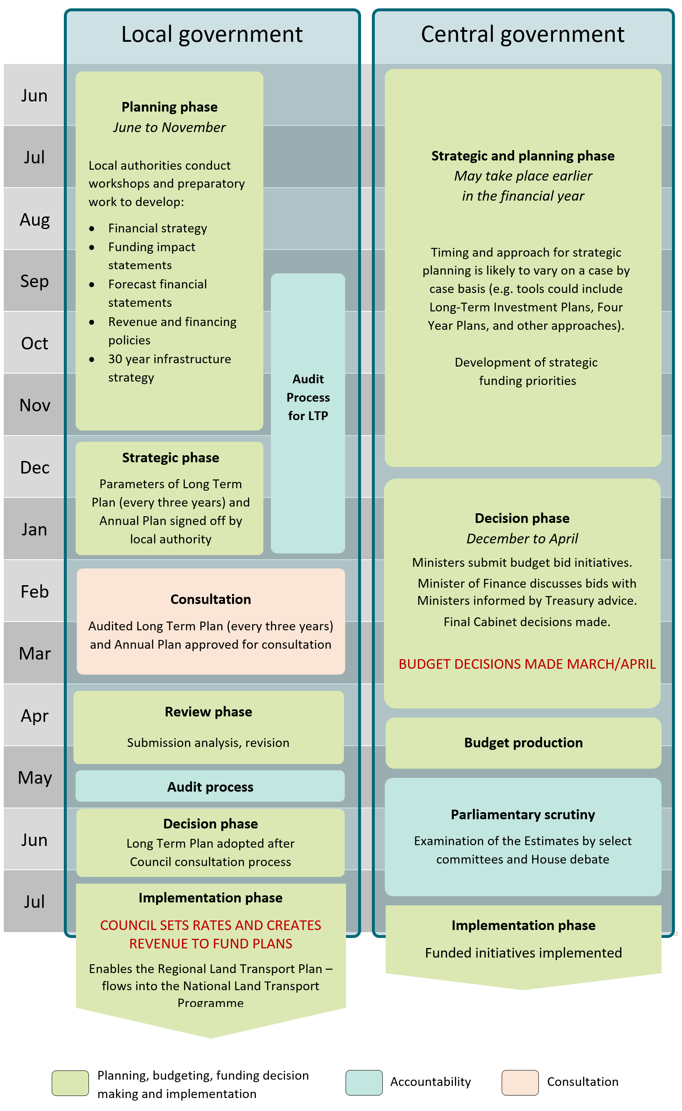

Long Term Plans
Local authorities must begin their planning process by identifying community outcomes. These are the overall objectives that the council is trying to meet with its policy and service delivery decisions to achieve community wellbeing (over and above the obligations that central government legislation places on them and that the LGA02 places on them for service delivery).
Deciding what these outcomes should be, and how the local authority’s activities and policies contribute to the achievement of these outcomes is one of the most important sets of decisions a local authority gets to make. All of this gets recorded in a document known as a Long Term Plan. Local authorities must adopt a new LTP once every three years, setting out information on:
- what the local authority will be doing and why
- what service levels will be provided
- how performance will be measured
- what assets and expenditure will be needed
how these will be funded.
This information must be provided in detail for each of the three years following the LTP’s adoption, and in outline every year for at least the subsequent seven years.
The LTP drives the annual budgeting decisions, regarding the things that the local authority will do to meet the objectives set out in the LTP.

The annual plan and its relationship to the Long Term Plan
Each year every local authority must produce an annual plan that acts as the budget for the year, and a record of the works and services the local authority will provide. This should serve as an update or refinement of the forecast in the LTP for the year ahead. Note that for the first year covered by the LTP, the LTP itself serves as the annual plan.
The main purpose of an annual plan is to set out an annual budget. The annual plan acts as the link between the LTP and the annual setting of rates. The plan also highlights differences between the LTP and the planned financials or levels of service for the year, whether an amendment to the LTP is also being made or not. It is an ‘exceptions based’ document – the annual plan must point to the LTP contents except where there is an exception because the local activity is not referenced in the LTP.
An annual plan must be prepared each year, but does not necessarily have to be consulted on locally. If an annual plan does not include significant or material differences from the content of the LTP for the year, the local authority will not need to consult.
However, circumstances can change dramatically in a short period of time, and the local authority may wish to amend its LTP at the same time as it adopts the annual plan. In these circumstances, consultation on the annual plan is usually carried out in conjunction with consultation on the amendment.

Planning and financial phases and processes

Strategic phase
In most cases, local authority staff will start working with elected members on the strategic phase of planning and financial processes soon after local elections are over. Initial conversations are held about the overall ‘state of the community’, and the direction that elected members want the community and the council to take. This can be informed by some type of environmental scanning process.
The length and nature of this direction-setting phase will vary from council to council, from one three-year cycle to the next, and with varying degrees of leadership by the council leader, the council as a whole, and professional staff. During this phase, the local authority determines the key issues for inclusion in the next plan. It may engage with the community to get feedback to inform this, or to help determine the practicable options for resolving a particular issue. This engagement, if any, marks the end of the strategic phases of the LTP.

From strategic direction into reality – and implications for central government
The next phases of the local government planning process involve translating the strategic direction into reality. Staff are sent away to do the detailed service planning, including any last reviews of service levels and the associated asset/activity management planning. A first cut of the financial forecasts and the overall funding implications of the LTP will be developed. Any proposals to start or stop activities will be developed here.
This is the best place for central government agencies to put their new policy ideas and initiatives in the mix – especially where those require funding or resources from local authorities. The best time to get new initiatives into an LTP is 12 to 15 months before the adoption of an LTP (i.e. March to July 2020 for the LTPs that get adopted in June 2021). No local authority or elected member will thank your minister and your agency for notification that their council is expected to fund or resource a new idea in the run-up to the statutory engagement (or after).
Ideally, local authorities will have a working draft of the LTP at some point between seven and ten months from adoption of an LTP. This becomes the basis for the council to debate and make trade-offs between different proposals, and between the overall bundle of levels of service and the financial implications.

Statutory engagement on the Long Term Plan
When the council is happy with the working set of financials and levels of service, the council heads out to engage on the plan. Most local authorities undertake statutory LTP engagement at some point between mid-February and the end of March prior to the statutory due date for adoption. Local authorities will prepare a consultation document – a document that covers the key issues in the proposed plan.
During the statutory engagement, local authorities will be receiving feedback from the community in writing and in person. The feedback that comes through engagement is an input into the decision-making and not a substitute for it. The obligation is on local authorities to consider any feedback with an open mind.

Prospective audit of Long Term Plan
The accountability regime for local authorities is unusual in that there is a prospective audit of the LTP. The council’s appointed auditor will provide an opinion on the quality of the underpinning information and assumptions used to produce the plan, and whether the plan meets the statutory purpose.

Long Term Plan amendments
It is important for central government to be aware that if a proposed policy initiative involves a local authority starting or stopping an activity, significantly changing the standards for an activity, or has financial implications, then it may require an amendment to a LTP. While a LTP is a statement of strategic intentions, it is not set in stone. The plan can be changed through a mechanism known as a LTP amendment.
Amendments require consultation with the community especially where they involve a significant change to a level of service or a transfer of a strategic asset to or from the local authority. Local authorities can – and often do – consult concurrently on LTP amendments alongside the consultation on an annual plan, or other consultations that are running.
If any policy initiative has major financial implications then the local government consultation requirements on LTPs and amendments means that the best time to be telling the sector is a year before you expect it to take effect.

What funding sources are available to local government?
Local government in New Zealand raises the overwhelming majority of funding from local sources. In the year to June 2018, around one dollar in eight came from central government, while almost three-fifths came from local taxes (rates). The picture varies considerably from local authority to local authority. For example, many regional councils have interests in port companies and their flow of investment income is considerably higher than the national average.
Councils can access a variety of sources of revenue to fund infrastructure and other services. These can pay for both operating costs and the costs of any debt attached to infrastructure assets. Total revenue across all local councils in 2017 was about $11.6 billion. This does not include $5.6 billion in revenue generated by valuations changes and other non-operating income. Figure 10 below sets out the main funding tools available to local government.

Figure 10. Main funding tools available to local authorities
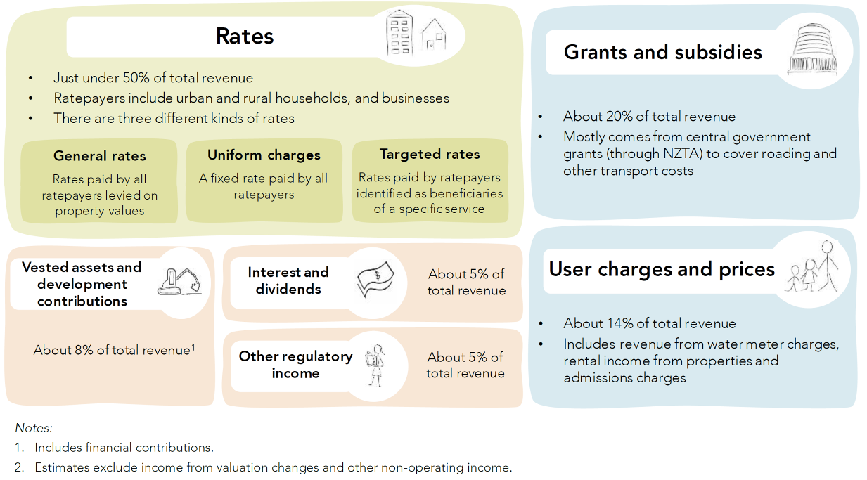

What are rates?
A rate is a tax that every local authority in New Zealand sets and assesses to fund their activities. Rates are a tax on an individual’s holding of land, and developments on that land. Rates are council’s major revenue source. Many assume that increasing property values translate to an increase in rates but it is council expenditures that drive the level of rates.
Local government collects rates under the authority of the Local Government (Rating) Act 2002 (the Rating Act). Local authorities can only set the types of rates that Parliament has provided for in the Rating Act. The Rating Act sets out:
- what property is liable for rates, and to what extent
- the types of rates that local authorities can collect
- the process for setting and collecting rates
- the information local authorities must have in order to collect rates
processes for dealing with situations where rates are not paid.
There are three types of rating tools:
- general rates – where the local authority decides that all or part of the cost of a particular activity should be met by the community as a whole
- uniform rates – where a fixed uniform charge is set per rating unit
targeted rates – where the local authority decides that all of part of the cost of a particular service or group of services should be funded by its own rate, or that a particular group of ratepayers should pay the rate.
Local authorities can use any of these tools. Because rates are a tax, a local authority cannot act without lawful authority and due process, or act unreasonably or arbitrarily, when setting rates.

Allocation of financial responsibility
In general, funding sources should be aligned with whether central or local government is responsible for implementing and administering the initiative or regulation. This can be a challenge when local government is implementing a service as an agent for central government.
It is important to make sure the responsibility for funding an initiative (who and how) is discussed at an early stage when central government is developing a policy that will be implemented with support from local government.

Understanding how funding arrangements may affect local government’s approach on engagement
The independence of funding is one of the main reasons that the local government sector operates with a high degree of autonomy. Regardless, funding arrangements will be one of the main practical concerns that the sector will raise as you engage with it about your initiative.
Making decisions about how activities are funded is a key policy decision for local authorities. The process for making funding policy is set out in the LGA02, with the kit of rating tools set out in the Rating Act. The funding policy process includes a set of mandatory factors to consider, and an obligation to document the results in a document known as a revenue and financing policy. If your minister or agency has a particular view on the way a local authority should fund a particular activity or policy then you may need to regulate to achieve that objective.
Additional reading:
- The New Zealand Productivity Commission Report: Towards Better Local Regulation, May 2013

Pressures and challenges faced by local government
It is important to understand the constraints and challenges faced by local authorities and be mindful of them. There are many systemic and cultural challenges at both levels of government that can limit effective engagement and have implications for the approach to engagement.
Local government faces a range of challenges as a result of requirements placed on it by central government and by changing circumstances. These include a range of pressures creating cost and price escalation, statutory requirements to consult, and risks of consultation fatigue.
It is important to understand the requirements, pressures and challenges faced by local authorities representing a given region. The DIA, LGNZ or SOLGM can help identify considerations for local government and how to navigate them during engagement.

Climate change and impacts on infrastructure
Local communities face an increasing burden as a result of natural disasters, weather events, and the effects of climate change on our coastal regions. Assets are at risk from sea level rise, and the impacts are most significant for water infrastructure and roads. There is a mismatch between the resources available to local authorities and the scale of their adaptation challenges. Many local areas with ageing populations will struggle to raise the capital necessary for future-proofing their infrastructure.

Cost and funding pressures
The Productivity Commission recently identified a number of pressures faced by local government that can impact on costs. Some of the factors include population growth and decline, ageing population and changes in household composition that are occurring across local communities. An ageing population has implications for the affordability of local services as the elderly are more likely to be on fixed incomes. Age related pressures can also have an effect on the demand for certain services. An increase in the number of tourists has also been identified as a source of funding pressure for some local authorities. Another source of funding pressure for some local authorities is the cost of implementing Treaty of Waitangi settlements.

Regulatory compliance, operational and service delivery impacts
Most regulations made or administered by local authorities are in response to primary legislation initiated by central government. Over time, central government has collectively imposed a wide range of complex responsibilities on all the different parts of local government.
It is important to note that the constant adjustment of regulatory requirements driven at a national level by central government and from local demand for higher levels of service can have a complex cumulative effect, imposing a challenging burden of change and requests to engage on local government. When central government raises quality standards, such as standards for water quality systems, and tightens performance measures, it may have cumulative funding impacts that local authorities struggle to absorb.

Capacity and capability of local government to engage with central government, and the impact of consultation fatigue
It is also important to consider the capacity and capability of local government to be able to have the time and resources to engage with central government. In particular the six to nine months before the adoption of a long-term plan (e.g. September 2020 to June 2021 and every three years thereafter) is likely to involve much of the senior management and policy capabilities in the small to medium-sized local authorities. Other staff experience workload peaks at other times (e.g. finance staff will be preparing annual reports between July and September, while building staff are at peak capacity in the spring and summer). It is not always possible to avoid these times, but when you need to engage, be aware of these pressures. In addition, when you need to involve local government in the development of policy, central government agencies should make a genuine effort to identify whether there are other parts of central government that are engaging with local authorities at the same time and on similar issues.

Engagement with local government: approach, methods and tools

Overview
This section sets out when and how to engage, including criteria for assessing whether to engage with local government. It explains the value gained from engaging early and at different stages of the policy development process. The guidance also provides practical tools, methods, and resources to support effective engagement.

Application of principles to the engagement approach
The requirement for central government to consult with local government is broad in nature, so the scope of engagement approaches and the application of the engagement principles (set out in section 2.3) can vary considerably across central government.
The engagement principles can be applied to both ongoing strategic discussions and discrete policy matters. Examples of what applying them to engagement in those circumstances could look like are set out below.

Early communication
This principle means communicating clearly and early, and providing all the information needed for local government to engage effectively with central government. Where possible, this could involve:
- engaging with local government to assess whether a policy initiative meets the criteria for engaging with local government
- giving local government representatives a reasonable opportunity to state their views on nationally-led issues and participate in high-level strategic discussions so the expectations and understanding of work programme objectives are understood at both levels of government, and better aligned within planning processes
ensuring local government is engaged at an early stage in policy development so its representatives can be involved throughout policy design and development, from accurate diagnosis of the problem to delivery of the response, if appropriate.

Genuine and meaningful engagement
Applying this principle involves building up trust and good will over time by ensuring there is genuine effort to involve local government, and an intention to understand the value and reasons why central government should engage with local government. This could involve:
- building relationships between local and central government on an ongoing basis outside of engaging on policy issues

- keeping local authorities informed, and where appropriate, involving local government in discussions about strategic direction or possible initiatives that may affect the community they represent and impact on their funding or monitoring requirements
making an effort to understand the operating environment at the local level and the relationships, requirements and constraints facing local government authorities that might affect their capacity at any time to engage with central government.

Openness and transparency
When considering the approach to engagement at the start, central government should consider applying the principles of openness and transparency to its engagement with local government. Central government needs to think about the dialogue it is willing to have in the open, and be prepared to recognise that both spheres of government may need to agree to disagree in a public setting. It is important to be aware of the following before, during, and after engagement:
- understanding the operating environment and governance structures of local government and its requirements to engage with communities on planning and changes to policy settings
- acknowledging how the nature of decision-making environments between both spheres of government differs, especially the transparency and accountability reporting requirements for local authorities
- being open to a discussion about gaps in the system or burdens of compliance on local authorities and their communities and how they could be addressed
- being prepared to ask and answer the difficult questions, to ensure decisions do not affect the integrity of the system, or cut across other policy settings
providing clear feedback on how local government’s contribution to the dialogue has, or has not, altered policy proposals.

Being responsive and flexible
Being responsive and flexible means adapting policy processes and the engagement approach where possible, to factor in the constant tension between the different roles, powers and authority of each sphere of government, the diversity of local regions and the pressures and capacity of local government to engage. When engaging with local government it will be important to:
- understand the constitutional and ongoing relationship between central and local government, and how to maintain the right balance of what is best kept in the national versus local interest, especially when the appropriate balance of that interest may vary from region to region
- understand the purpose, role, structure, planning and funding cycles of local government and related organisations and how the local operating environment differs from central government
- understand the current trends and issues affecting relevant local communities, including the nature of the current pressures and regulatory requirements impacting local government, particularly in the region and sector that is affected
- identify any disconnect between reality, and expectations that could affect local government’s capacity to comply or meet its obligations under any new initiative
- take into account the diversity of regions, to better inform policy design and delivery and be prepared to adapt policies and engagement approaches that acknowledge the diversity of need across the regions
- partner with local authorities to collect relevant data and information to better enable strategic monitoring of the system in relation to community wellbeing outcomes
work with local government to monitor and evaluate new initiatives and ensure that they are appropriately targeted and resourced.

Support from central government for engagement
Central government should understand how to access its own resources to support good engagement. Accessing good advice from the DIA and relationships and engagement staff within individual agencies, can lead to more productive and effective engagement through taking a joined-up approach to how central government engages with local authorities. Within agencies and at a system level, there are a number of resources to support engaging with local government, including:
- The Central and Local Government Partnerships Team, DIA
This team was established to facilitate a collaborative and system-wide public service approach in which central and local government work effectively together for the benefit of people, communities, businesses, and the environment. A dedicated group of Partnerships Directors spend time in their regional ‘constituencies’ which are aligned to LGNZ zone groupings. This group connects with local government and gathers and provides information to agencies. Partnership Directors have particular portfolio responsibilities through which they provide leadership for key joint initiatives. The team also operates a directory of local authority contacts at the political and officials level which they can share with agencies undertaking engagement. For more information, see the Central/Local Government Partnerships page on the DIA website.
- Relationship and engagement staff within agencies
Many agencies – especially those who have significant involvement with local government – have their own staff dedicated to maintaining and engaging the local relationship.

Engagement assessment – whether to engage local government

Strategic partnership on work programmes
Maintaining ongoing strategic discussions can help identify joint interests and objectives, where both levels of government could be working collaboratively together if they are not already. Opportunities to engage on longer-term regional and sectoral strategic issues will also ensure there are ‘no surprises’ at both levels of government.
Benefits can be achieved by engaging local government the overall status and progress of the relevant nationally-led work programme, and ongoing monitoring and maintenance of the system (policy/regulatory and operations) as well as on longer term stewardship and planning matters, and effective management of current policy settings.

The value of strategic engagement
- A local government sector that understands central government’s objectives and supports them to the extent they are able to articulate and promote those objectives locally
- Local objectives and planning processes can be more aligned with joint efforts to grow the economy, or contribute to initiatives, such as ameliorating climate change
- Maintaining an ongoing engagement between central and local government can make it easier to help resolve conflict or avoid it in the first place
A diminishing risk of the councils inadvertently undermining national objectives

See Appendix C – Engagement between
central and local government on strategy

Criteria for engaging with local government on specific issues
Not all policy proposals need to be discussed with or require the involvement of a partnership with local government. Clearly where local government is likely to have a role in the administration or implementation of any framework that may be required, the answer to the question of whether to engage is usually relatively straightforward.
Central government officials should check with their ministers before engaging with local government, and lay out their reasons for the proposed approach to engagement.
In general, central government agencies should apply the following criteria when assessing whether to engage with local government when developing policy:
- Could there be an impact on particular communities?
- Might the proposal create costs or compliance for councils?
- Might the councils have a role in implementation?
- Might the initiative involve an existing council service or responsibility?
Might the proposal involve a change to local government’s constitutional architecture?
If the answer to one or more of those questions is yes, then engagement with local government will be advisable.
To determine who to approach and engage with in local government, two further questions then need to be asked:
- Who is affected by the policy issue (and proposals to address it)?
  - a majority of councils?
  - a specific type of local authority?
  - sub-national groupings of councils (e.g. only in Northland)?
  - single or small numbers of councils?
Is it an urgent matter?
Figure 11 on the next page shows who in local government can help provide an answer to these questions, depending whether the matter being engaged on is primarily of a policy/political or administrative/technical nature.
Figure 11. Criteria and approaches for engagement with local government

Applying the criteria to the question of whether to engage
The DIA can assist central government agencies in deciding whether to propose engagement with local government and how to apply the criteria referenced above. If your minister is comfortable with you proceeding, LGNZ and SOLGM will be able to help you refine your approach.
When considering whether there is an impact on individual communities it is advisable to prepare for engagement by reviewing the four wellbeings, as set out in section 3.2.2.
If any regulatory or operational changes being proposed are likely to increase compliance for local government, or could involve local authorities in being delegated new responsibilities to administer new services, then central government should carry out engagement with local government. This would especially apply to any change that will result in any economic impact for local communities involving the application of any fee, tax, levies, credits or other market-based instruments. Central government agencies should seek advice about whether to engage if proposals would involve maintaining, restoring or preserving any portion of land for which local government is responsible.
Proposals with implications for local authority financial and planning processes are an example of changes to local government constitutional architecture that may require agencies to engage. Making any changes that will have cost implications or will require changes to local authority budgets, or the LTP, should be discussed with the particular local authorities it will affect.
If any changes or proposals would mean councils would be involved in providing outreach to a local community or would be likely to be required to develop a communication plan or be approached to respond to requests, then central government should also consider informing or consulting with local government.
A final example of whether to engage with local authorities would be when a proposal involves central government requiring local government to measure, monitor and evaluate the policy impacts, or would involve the use of local government data or information.

Engagement strategy – what type of engagement approach?
Once it is clear that local government should be engaged on a particular issue, it is important to consider what type and level of engagement is required. If conducting a one-off engagement on a particular matter, it will be important to choose an approach on the engagement spectrum that reflects the significance of the issue, while being realistic about resources and time available to engage. It is also important to ensure there is support for the engagement approach from ministers or leadership teams within your agency.
During the policy development process and throughout your engagement approach, it is important to understand the political context both at the central and local level. Successful outcomes are most likely when there is strong support from ministers for the engagement approach. Also be aware during your engagement, that within a local authority, there may not always be alignment between the views of the political arm and the council officers. In such circumstances it is important to understand how any lack of alignment might have implications for the policy development process. If appropriate, modify your engagement strategy accordingly.

Spectrum of engagement
The engagement spectrum featured in section 1.4 is a useful tool for thinking about the alternative approaches central government could adopt in engaging with local government. The International Association of Public Participation (IAP2) identifies five levels for engagement, ranging from inform, consult, involve, collaborate and empower. The level of influence that those engaged with have on government decisions increases as you move up the spectrum.
Figure 12 summarises how the engagement goal, the undertaking to local government, and the engagement opportunities vary at different points on the IAP2 engagement spectrum. It provides a common language as a starting point for double-checking both local and central government’s understandings about what type of engagement is taking place.

Figure 12. Spectrum of engagement by central government with local government, with engagement opportunities and examples of methods
Increasing level of impact on decisions

 | Inform | Consult | Involve | Collaborate | Empower
Engagement Goal | To provide local government with balanced and objective information to assist them in understanding a problem exists, or how central government is planning to respond to it | To obtain local government feedback on central government analysis, alternatives and decisions | To work directly with local government throughout the process to ensure their concerns and interests are consistently understood and considered | To partner with local government in each aspect of the decision, including developing alternatives and identifying the preferred solution | To place final decision-making, accountabilities and funding (or a national contribution to funding) in the hands of local government
Undertaking to local government | We will keep you informed when strategic and policy issues affecting local government first arise | We will keep you informed, listen to and acknowledge concerns and interests, and provide feedback on how local government input influenced central government decisions | We will work with you to ensure that the concerns of local government and your interests are directly reflected in the alternatives developed | We will look to you for direct input and advice in formulating solutions and will incorporate your advice and recommend-ations into the decisions to the maximum extent possible | We will work with you to help you resolve and implement the changes that you consider appropriate, to be led at a local level – we acknowledge that local government should make the decisions, as mandated
Engagement opportunities | - Central/local government fora  - LGNZ and SOLGM  - Zone meetings | - Directly with local authorities  - LGNZ and SOLGM  - Sector meetings  - Zone meetings  - Local Boards | - Directly with local authorities  - Local Boards  - Zone meetings  - LGNZ and SOLGM | - Directly with local authorities  - Local Boards  - Zone meetings  - LGNZ and SOLGM | - Directly with local authorities  - Local Boards  - Zone meetings  - LGNZ and SOLGM
Examples of methods | - Fact sheets  - Websites  - Hotlines  - Info kiosks  - Newsletters  - Updates on social media  - Press releases  - Conferences | - Exposure to draft bills  - Focus groups  - Stakeholder surveys  - Public meetings  - Webinars | - Advisory committees or workshops  - Public meetings  - Focus groups | - Collaborative process co-design or co-production workshops  - Secondments | - Delegated legislation and empowering provisions that devolve power to the local authority to carry out activities

Value of engagement to the design and delivery of policy and services
In principle, central government could engage with local government in a future-focused way on broad strategic issues and priorities, or in a narrower way on specific and relatively immediate policy issues and options. Both can add value, improving the quality of the decisions made and implemented, though in the past there has been more of the latter than the former.

Partners in policy development and problem-solving
Effective engagement is a vital ingredient of policy formulation on specific and immediate policy issues. Early engagement on defining the problem and designing the options is integral to a successful policy process. As well as engaging at the political level through LGNZ on ‘headline’ policy intent, it is also important to consider opportunities to engage managers and staff of local authorities in the more detailed and technical development process.
More workable and effective outcomes from initiatives to address specific policy issues can be achieved, if the policy development process is informed by local knowledge and experience. Ongoing engagement with local authorities throughout the policy development process will ensure relevant local information and perspectives are incorporated within policy and operational settings.
Effective engagement on specific policy issues is best achieved by central government engaging early with local government and continuing engagement at each stage in the policy development process. Subject to ministerial agreement, this includes the following stages and activities.

Commissioning and discovery
- Notifying local government of new proposed initiatives, emerging issues or problems affecting the sector
- Scoping a project plan for the response to the issue
- Evidence and information gathering for context-setting and problem diagnosis
- Planning the engagement approach and strategy
- Defining any problem or proposal for responding to it
Setting objectives and identifying possible desired outcomes

See Appendix D1 – Engagement between
central and local government on policy: Commissioning and Discovery

Design and delivery

- Further gathering of information, evidence and statistics to feed into the design of responses
- Developing and confirming possible solutions and design options, including:
  - assessing suitability for and partnering with local government on any trial, test or prototyping of response or initiative
  - assessing whether any new legislation or regulations, or any new funding or operational response will be required, or whether a response could be mandated within current regulatory frameworks
  - identifying how possible solutions could be implemented and delivered and the cost implications
  - assessing the likely impact of solutions on outcomes
  - identifying how it will be monitored and by whom
  - identifying how it will be evaluated, how it will be resourced and carried out
- Coordinating communication of any policy or operational changes at the national and local level
- Delivery and implementation of policy or operational response
Ongoing monitoring and evaluation of initiative or response

See Appendix D2 – Engagement between
central and local government on policy: Design and Delivery

Selecting appropriate levels of engagement for certain policy activities
Where possible, collaboration with local government on policy development will mitigate implementation risks and can ensure that untended consequences are avoided. While collaborative policy making is a desired approach, it may not always be possible. In some cases a mix of approaches to the level of engagement selected throughout the policy process at different stages may be required.
The descriptions below show levels of engagement that could be adopted at certain stages, and reference three case studies within the appendices. The case studies demonstrate a variety of approaches on the spectrum of engagement from ‘consult’ to ‘involve’ and ‘collaborate’. Agencies take into account factors of time and resource when proposing a level of engagement approach. Case Study 1 and Case Study 2 demonstrate successful collaborative approaches undertaken within short project timeframes.

At an early stage – timely notification of new initiatives
Inform local authorities as early as possible of new work programme initiatives where an early assessment based on criteria indicates central government should engage.

Engagement to define the problem and set objectives
Involve or collaborate with local authorities in defining the problem and its context by working with them to:
- gather information and contextual background information that incorporates local information and knowledge, a current assessment of related compliance issues and costs for local government, and experience of the problem at a local level
- clarify the problem definition and outcomes that are being sought, incorporating views of relevant local stakeholders
- identify the national interest and the local outcomes and interests
identify initial high-level policy objectives that are likely to meet the interests of central and local government, while achieving the intended outcomes for the community – see Case Study 2: Responsible Camping.
Consult with local authorities about central government’s proposed policy objectives and potential policy responses through discussion papers – see Case Study 3: Food Bill.

Engagement on possible solutions and options
Collaborate with local government to ensure that:
- alternative options and possible solutions identified are realistic, feasible, practical and can be implemented at both spheres of government
- the preferred option will achieve agreed objectives and maintain the integrity of the policy intent
- any proposals appropriately balance and allocate responsibilities and accountabilities and lines of authority between central and local authorities, and those allocations and responsibilities are clearly expressed
it is clear how any initiative will be evaluated and monitored, and how that will be conducted and resourced at the local level if necessary – see Case Study 1: TAG review on emergency response.

Engagement during decisions and delivery
Inform local government about the timing and process for obtaining Cabinet’s agreement to any funding proposal at central government level.
Collaborate with local government to ensure the authorisation process at the local level relating to planning and funding cycles aligns with central government expectations on timings for implementation and delivery of any services relating to the policy response.
Collaborate to understand the political ramifications at both levels of government and be clear on communications relating to the policy objectives and agreed approach.
See Appendix D1 and Appendix D2 for a summary of engagement on policy development with links to resources and opportunities to engage.

Opportunities to engage with sector organisations
As well as linking with the representative groups at the national level (such as LGNZ or SOLGM) there are many opportunities for central government to attend local government fora. The following section details the variety of local government groups and organisations that can assist central government. Where relevant, it provides information about how often these groups meet and how they could support any engagement process.

Local Government New Zealand
LGNZ provides policy and advocacy services, business support and advice and training for its members (especially, but not exclusively to the elected councillors of councils who are LGNZ members).
LGNZ is governed by a National Council of 15 elected members drawn from amongst its member local authorities – most of whom are mayors, or chairs of council.

LGNZ is the organisation to contact if you:
- need assistance identifying whether local government needs to be involved in strategic discussions or policy development and problem-solving
- seek a general view from local government about an issue that affects a number of local authorities
- need support for capability building within your agency
- would like an idea about what local government mayors and chief executives think about a particular initiative.

The Society of Local Government Managers
SOLGM is an incorporated society, established in 1988 to promote excellence in management within the local government sector. Unlike LGNZ, SOLGM is an individual membership organisation (councils are not members), with approximately 700 members drawn from employees of a local authority or council controlled organisation. SOLGM’s vision is “professional local government management, leading staff and enabling communities to shape their future”.
In pursuit of this vision, SOLGM undertakes three types of core business:
- Capability building – SOLGM identifies and disseminates good practice guidance throughout the local government sector and advisors to local government, such as lawyers and auditors. SOLGM also runs the annual Local Government Excellence Awards. SOLGM markets the local government sector as a career option to graduates and other prospective recruits in key occupational groups, such as civil engineering, and building inspection.

- Building the sector’s base of skills and knowledge – SOLGM provides local government staff with opportunities to develop their base of occupational knowledge and related skills by organising training and other professional development opportunities.
Advocacy and thought leadership – SOLGM identifies issues that affect the sector and provides the sector and national policy-makers with advice on the practical, technical and implementation issues, as opposed to governance and political issues.

SOLGM is the organisation to contact if you:
- want advice on how to make a policy initiative work on a practical level, such as the likely ‘fish hooks’ in a piece of legislation
- want advice on how to implement a particular policy or piece of legislation
- want to know what local government managers think about a particular initiative.

Institute of Public Works Engineering Australasia
The Institute of Public Works Engineering Australasia (IPWEA) is the membership organisation for those who manage, maintain and operate public infrastructure in New Zealand. Public infrastructure includes roads and bridges, water supplies, sewerage schemes, stormwater systems, river control schemes, land drainage schemes, airports and harbour facilities. IPWEA focuses on asset management and engineering for public infrastructure.
IPWEA is also the owner of the National Asset Management Steering Group (NAMS) – a non-profit industry organisation established to promote asset management through the development of best practice guidelines and training. The NAMS Group provides a hub through which industry professionals can both gain and distribute information on the latest developments in asset management.
IPWEA is the organisation to contact if you have a policy initiative that requires advice on the technical aspects of infrastructure delivery and asset management.

Local government fora
LGNZ and SOLGM support a number of local government fora that offer a range of opportunities available to central government when seeking to engage with local authorities.

LGNZ Sector groups
Sector meetings provide opportunities to present and seek feedback on proposed regulations or legislation, inform councils about new policies that may be under consideration and get feedback on the roll-out of existing programmes that impact on local government and communities. As membership consists largely of political leaders, presentations are generally made by ministers or senior officials.
See also page 24 for information about the membership and purpose of sector groups.

Metropolitan sector
This sector meets quarterly and participation consists of mayors (or delegate), accompanied by their chief executive (or delegate). On average about 20 or so members would attend each meeting.
Agendas are set in advance by LGNZ. Requests to meet with the Metropolitan sector should be made through LGNZ.

Regional sector
The Regional sector meets four times a year, with attendees being the chairs of regional councils (or their delegates) and regional councils chief executives (or delegates). Meetings would normally consist of 20 to 25 members.
Agendas are set in advance by LGNZ. Requests to meet with the Metropolitan sector should be made through LGNZ.

Provincial sector
The Provincial sector meets three times a year (meetings are held jointly with the Rural sector) with attendees being mayors, chief executives and senior councillors. The number attending is usually between 90 and 100.
Agendas are set in advance by LGNZ. Requests to present to the Provincial sector should be made through LGNZ.

Rural sector
The Rural sector meets three times a year (meetings are held jointly with the Provincial sector) with attendees being mayors, chief executives and senior councillors. The number of attendees range between 90 and 100.
Agendas are set in advance by LGNZ. Requests to present to the Rural sector should be made through LGNZ.

LGNZ Zone meetings
LGNZ facilitates regular meetings of councils at a sub-national level. These meetings are referred to as Zone meetings, reflecting the division of New Zealand into six zones. Zone meetings are held at various locations and at multiple times during the year. They usually last for a day, although some zones will have a two day gathering once a year.
Participation varies significantly between zones, but membership is wider than occurs at a sector level, with participation from councillors and community boards, as well as mayors, regional chairs, chief executives, and senior managers. It is common for government officials to speak to Zone meetings.
Zone meetings provide a more informal setting than sector meetings and can be used to:
- promote a government policy or programme
- get feedback on proposed policies or programmes
raise awareness about the local or regional implications of a new policy or programme.
Each Zone has a chairperson and secretary. LGNZ can provide advice on how best to approach the zones. Agendas for Zone meetings are set in advance and contact details for each can be found at: www.lgnz.co.nz/about-lgnz/membership-representation/zone-groups

Other local government fora

Te Maruata (a LGNZ network)
Te Maruata is a network in which all Māori elected local authority members are entitled to participate. Two Hui are held annually. The role of Te Maruata involves:
- promoting increased representation of Māori as elected members of local government
- enhancing Māori participation in local government processes
- providing support for councils in building strong relationships with iwi, hapū and Māori groups
- providing Māori input on development of future policies or legislation relating to local government
fostering and supporting a network of Māori elected members and staff of local government for the purpose of sharing information, challenges and aspirations relevant to kaupapa Māori.
Te Roopu Whakahaere acts on behalf of the Te Maruata network between hui and meets four times a year. Government agencies could meet with Te Maruata or Te Roopu Whakahaere to obtain the perspective of Māori local government elected members on issues that have potential implications for iwi and the Māori community.

Community Boards Executive Committee (a LGNZ network)
The Community Boards Executive Committee (CBEC) represents the 108 community boards in New Zealand. It is an advisory committee to LGNZ’s National Council.
The committee's role is to advocate in favour of community boards, advise the National Council of LGNZ, and promote best practice amongst community boards. CBEC meets four times a year in Wellington. As well as these meetings, each Zone representative runs regular fora in their zones to update community board members and focus on topical issues. CBEC organises a biannual conference for community board members.

Young Elected Members’ Committee (a LGNZ network)
The Young Elected Members’ Committee (YEM) represents elected members between the ages of 18 and 40. It provides advice to the LGNZ National Council on any matter that the National Council or the Committee deems relevant.
This could include, but is not limited to:
- enhancing youth participation in local government processes
- building strong relationships between councils, young people and youth organisations
- practical matters likely to have specific implications for younger elected members, such as remuneration and professional development
matters of LGNZ policy, and central government policy and legislation, on which young elected members share a view.
YEM also coordinates opportunities for young elected members to network and exchange ideas, peer mentor and access practical support, and access appropriate professional development. The committee meets four times a year.

SOLGM Working Parties
SOLGM maintains a network of six working parties in specialised topic areas. The working parties support SOLGM’s Chief Executive by providing her with robust, quality advice in their specialist area or areas of expertise. This includes:
- responsibility for leading the development of any SOLGM contribution to any policy, legislative or regulatory reviews in their areas of expertise
- identifying ideas of importance to the sector and ensuring these are shared with the sector
- identifying and sharing leading practice in the sector
- developing and delivering (where applicable) part of the SOLGM learning and development programme
assisting with the delivery of SOLGM’s other services (e.g. the Performance Excellence Programme).
SOLGM working parties are an excellent means of obtaining advice on the technical or practical barriers to implementing a particular policy, or advice on how to make a policy initiative work to best effect.
The five working parties are:
- the Business Performance Working Party – promotes high standards of financial management, performance measurement and management, asset management, and the use of these disciplines as drivers of business improvement
- the Democracy and Governance Support Working Party – assists the local government sector to achieve high standards in the conduct of democracy services and governance support activity; assists the local government sector to achieve high standards in the planning, management and conduct of elections and polls under the Local Electoral Act 2001; works in conjunction with other agencies to enhance public understanding of the role of local democracy within New Zealand’s system of governance, and public participation in local democracy
- the Planning and Accountability Working Party – promotes high standards of integrated planning and policy development, and the associated accountability and reporting arrangements. Among other things this includes planning and reporting under the LGA02, district planning, spatial/integrated strategic planning, and the planning requirements of other legislation.
- the Sector Policy and Outlook Working Party – supports achievement of SOLGM’s vision by identifying policy issues and trends with the potential to impact on local authorities and communities now and in the medium to long-term future, and advising the sector on these issues and trends. For example, if you wanted a managerial view on a climate change adaptation policy this would be the place to come

the Workforce Working – identifies the local government sector’s present and future workforce needs, and developing guidance and solutions so that chief executives can meet those needs, at reasonable cost. This working party would be the place to come for advice on matters affecting the sector’s obligations as an employer, or on matters relating to the sector’s existing or likely future skill needs.
With a little lead time (usually a week), SOLGM can arrange to either meet with these bodies remotely, or to obtain input in writing. The working parties have a long history of being able to work quickly, constructively and confidentially with central government agencies.
The point to note is the more technical and detailed the feedback you require, the more time you will need to allow. For example, approaching SOLGM at 5pm on a Friday with a draft Bill for comment by Monday is unlikely to allow enough time for feedback.

SOLGM Learning and Development Events
SOLGM runs a stable of annual leading practice events. These provide identified occupational groups with the opportunity to discuss common issues of concern to their profession or occupation. These are good opportunities to network with a wide group of people with common interests.
These might provide a good opportunity for those who are evaluating the strengths and weaknesses of an existing policy or practice. The discussions are open, so this is not the place to engage if the intent is that the subject matter remain confidential. The further out you let SOLGM know that you would like time at these events the more likely it is that they can accommodate your request – though if they cannot get you onto the programme, they can usually find an alternative.

Conclusion

This guidance is intended to help central government agencies consciously reflect on and improve our relationship with local government, and deepen our understanding of what engaging effectively with local government means. It identifies the value in doing so, enabling better-informed decisions that are implemented more effectively to improve the wellbeing of New Zealanders. In areas where local government has a legitimate interest, collaborating with local government should be the norm, not the exception.
In the coming decades, with the combined pressures of urban population growth and looming environmental challenges, central government will not be able to deliver good outcomes for communities without the contribution and experience of local government. It will require a concerted effort to understand and respond to the diverse needs of each local area. There will be benefits for communities and the system of government as a whole if central and local government face future challenges together.

Appendices

A – Case studies
B – Regulatory responsibilities of local government
C – Engagement between central and local government on strategy
D1 – Engagement between central and local government on policy: Commissioning and Discovery
D2 – Engagement between central and local government on policy: Design and Delivery

Appendix A – Case studies

Case study 1

Ministerial TAG review

Better Responses to Natural Disaster and Other Emergencies

Background

A series of recent hazard events and emergencies in New Zealand resulted in a widespread reflection on whether the current operational and legislative settings for responding to natural disasters and other emergencies are fit for purpose. Many lessons from the Canterbury earthquakes of 2010 and 2011 were already embedded in the system, but there had been no significant review of the organisational structures, roles and decision-making powers within which responses were orchestrated. In 2017, the Minister of Civil Defence and
Emergency Management ordered a review to ensure New Zealand’s emergency response capabilities and framework are world-leading and well placed to meet future challenges.
In June 2017, a Technical Advisory Group was established to carry out the review. This case study gives a summary of how that group engaged and collaborated with a wide range of stakeholders, including local government, to recommend changes to functions, structures and culture at the national level.

Engagement process and approach

The terms of reference defined the problem and scope, provided high-level guidance on the consultation and engagement process, and set out the key deliverables. The Minister gave a timeframe for the review of three months from the date of agreement to the terms of reference.
Over 80 submissions were received and the TAG review team travelled to meet with stakeholders. Where necessary, the Minister attended those face-to-face meetings. A cross-party group was kept informed. A four stage process was undertaken, to ‘socialise, develop, test and decide’, with 42 final recommendations made as a result of the review.
The review team updated the Minister and Department of Internal Affairs Partnerships Team with a mix of informal verbal briefings and written briefings. A memorandum was sent to Local Government New Zealand (LGNZ) to forward to the National Council and to their Chief Executives Forum. The memo outlined the background and process for developing a response, the process for engagement, and a request for sector experts with a description of the skills needed to address each area in the review.
The review team asked LGNZ to nominate sector experts to help develop the policy and proposed to LGNZ that a reference group of chief executives and mayors be formed to test thinking and further develop ideas.
When they contacted the reference group and LGNZ, the review team was open and transparent about the fact that they had begun testing initial ideas at a very high level with key stakeholders. The team shared its early thinking and early discussions it had been having with some experts, but asked for their help in testing and further developing the thinking.
The review team had a limited budget, so stakeholder meetings with the Minister were scheduled alongside other appointments, where possible. The reference group met once a month between March and June, and a flexible process to engagement was developed. For example, rather than taking minutes, an overarching story detailing likely emergency responses in particular circumstances was tested with the reference group.

Lessons learned

With short timeframes and a wide group of stakeholders, it was important to be flexible – sometimes sector experts were called into working group meetings, while at other times a quick phone call was made to discuss a technical aspect of local government.
Expectations needed to be clear upfront. The review team made it explicit with stakeholders that they might not be able to share everything and that some things might need to be kept in confidence.
It was important for central government to listen well and be open to feedback from anyone. The review team did not filter the candidates that were put forward by LGNZ.
At each point the review team demonstrated respect and trust. Local government was also happy to collaborate, and provided experts in local impacts as well as much needed local perspectives, insights and input. Skills in systems thinking were used and local government was open to discuss new options and different ways of doing things.
This case study shows how central and local government can work constructively and innovatively together to support and contribute
to the policy development process. On reflection, the review team noted that ongoing engagement is needed to ensure the recommendations of the review are implemented as intended, and result
in systems well-placed to respond in an emergency.

Written information for this case study provided by the Department of the Prime Minister and Cabinet, along with an interview with a senior government official on the Technical Advisory Group review team.
Case study 2

Responsible camping

Background

Councils are under increasing pressure to manage issues associated with freedom camping in their local areas. Central government established a Responsible Camping Working Group in April 2018 to provide the Minister of Tourism with an evaluation of the role of responsible camping in New Zealand’s tourism industry. The government made a broad request for recommendations for better management of the camping system, and also asked for practical actions to support councils to manage freedom camping in their regions during the 2018/19 peak summer season.
The working group recommended a review of regulatory settings to improve the system for managing camping in public places and a series of actions to support regulatory change. As the review of policy settings and regulatory change
can take time, the working group also recommended practical actions, including that councils receive funding to manage the pressures created by freedom camping. The Tourism Infrastructure Fund (TIF) was established by central government in partnership with local government to administer a $100 million fund for the development of visitor-related public infrastructure. It was recommended that an amount from the fund be set aside to meet the costs of the local proposals.
The government accepted the various recommendations and set aside $8 million from the TIF to fund several councils that were able to submit proposals for related projects. In most cases, the proposals were accepted with money allocated from the ring-fenced amount.

Engagement process and approach

A group of ministers led the project, including the Minister for Tourism and the Minister of Finance with support from Ministry of Business, Innovation and Employment, the Department of Conservation and the Department of Internal Affairs.
Ministers established the working group as a partnership between central and local government and the tourism industry. There were 10 representatives on the group: three from central government, three from the tourism industry and four from local government. It was set up in April 2018 and tasked with reporting by 31 July 2018. It met three times during this period. In May, the working group wrote to all mayors inviting them to identify solutions to address responsible camping issues. The working group was starting from
scratch with no real idea of the nature and extent
of the issues in local areas, or a view about how to solve them. It sought to identify the problems and whether it was real.
Mayors were asked to take a regional and cross-agency approach where appropriate. 37 councils responded with proposed suggestions for change including a range of temporary infrastructure (toilets, showers, waste facilities), landscaping, signage, education, and monitoring initiatives.
31 councils were keen to access funding to progress local initiatives ahead of the 2018/19 peak season. The working group recommended funding to be used for infrastructure investment initiatives, education and information provision, monitoring and enforcement initiatives. The total cost identified was $15 million. To focus the funding requests, the working group identified some locations that were ‘hot spots’, where the issues of responsible camping were so significant they had the potential to have a national impact on the reputation of camping in New Zealand.

Engagement process and approach (continued)

The working group prioritised the responses identified in the hotspot areas, with an approximate cost of $5 million. It identified a further $3 million that would help progress projects proposed by remaining councils. A total of $8 million was provided to local authorities who had self-identified solutions. The process empowered them to implement change for their local area.
The engagement process assisted the working group to identify the key problems with the existing system for managing camping in public places. It was also able to identify areas for legislative review and implementation actions.
The working group continues to operate to oversee reforms.

Lessons learned

This case study highlights the benefits of starting with a broad set of objectives and a clear ministerial mandate for a genuine and meaningful approach to engaging with local government and the tourism industry. While ministers maintained decision rights in the end, central government took a collaborative engagement approach whereby it worked with stakeholders in local government and the industry, and empowered them to develop solutions rather than driving what options were put forward. The strong ministerial support for the working group was facilitated by a core group of agencies which helped to create a joined-up central government approach to the engagement.
To apply an open and transparent approach before undertaking engagement, central government identified at the outset that freedom camping as an issue was in the national interest. Central government was able to acknowledge that it should help fund local initiatives from the TIF. This partnership approach meant that local government and the industry knew that there was central government support to implement initiatives. Central government was prepared to think outside the square about how it could facilitate change by properly listening to the industry and local government.
This engagement approach led to a strong collaborative effort. The industry and local government worked together with central government in the development of a response from the beginning. This approach meant the working group accessed local government and private sector expertise to enable innovative and industry-led problem-solving to occur. Several non-regulatory responses were also identified, that were simple and practical in nature and which had an immediate impact (such as introducing ‘camping ambassadors’ to help campers find facilities).
The working group maintained a consensus and took a responsible and considered approach to funding, establishing criteria and a mechanism for prioritising funds from the TIF. The project benefitted from having a social license to act on freedom camping, implications and impacts at a local level as well as a issues for tourism and New Zealand’s brand that were in the national interest.
Ongoing engagement between central and local government and the industry is a key part of maintaining momentum and ensuring that the recommendations are implemented as intended.

Written information for this case study was provided by the Ministry of Business, Innovation and Employment and Local Government New Zealand, along with interviews with senior government officials who participated in and supported the working group.
Case study 3

Food bill

Background

The Domestic Food review was a long-term project that began in March 2003 and recommended changes for greater consistency in the delivery of safe food in New Zealand. The review was informed by a consultation process with the release of a large number of discussion papers and meetings with stakeholders on those papers, that led to a series of recommendations. Officials submitted ideas for a new regulatory approach to ministers.
Following Cabinet approval for the development of a new Food Bill (the Bill) in 2006, a small working group, the Territorial Authority Steering Group (TASG), was established in 2007. This was jointly convened by the New Zealand Food Safety Authority (NZFSA) and LGNZ. The purpose of the TASG was to work with the NZFSA to implement decisions of the Domestic Food Review.

Engagement process and approach

Representation on the TASG was arranged by LGNZ, who sought to include a mix of rural and urban territorial authorities of varying sizes. TASG members assisted with the implementation of decisions in their areas or regions. The members also fed the views of their colleagues back into the TASG process. TASG input was considered essential by the Ministry for Primary Industries, as territorial authorities have a co-regulatory role in implementing the Bill, so the policy and drafting needed to be practical and workable. Summaries of each TASG meeting were made available to all territorial authorities via the territorial authorities’ secure webpage on the NZFSA website. The webpage was a repository for all information about the Bill and territorial authority involvement, including upcoming training, implementation matters and guidance material.
In 2008, the Ministry for Primary Industries established a specific local government liaison team to oversee ongoing engagement with territorial authorities around the implementation of the Food Bill. The team attended territorial authority cluster meetings, provided advice on implementation matters, worked with territorial
authorities on any concerns or issues they had, and collected information to assist with the future implementation of the Bill after its enactment.
It provided direct support to territorial authorities through coaching and delivering seminars to food business operators, including promoting the use of ‘champions’ to promote the Bill.
Additionally, in 2008 NZFSA introduced the Voluntary Implementation Programme (VIP). The purpose of the VIP was to trial aspects of the proposed regime for the food service sector, with the intention of incorporating lessons learnt when the Food Act was implemented. Territorial authorities were identified as critical to the success of the VIP.
A number of workshops were held by NZFSA across New Zealand as part of the VIP. These workshops were to prepare territorial authorities for the shift from a model of ‘inspection’ to ‘verification’, and included training workshops to upskill Environmental Health Officers on their future role as Food Act Officers and verifiers of template Food Control Plans.

Lessons learned

A contestable Territorial Authority Initiative Fund was established in 2008 to provide funding to territorial authorities for initiatives that contributed to the objectives of the VIP. Two rounds of funding were held, with a total pool of $500,000. Fourteen territorial authorities received funding to undertake a range of activities, from specific workshops for business operators with English as a second language, to encouraging the use of territorial authority cluster models to work collaboratively in the food safety area.
The TASG provided significant input into the development and drafting of the Bill. This was made possible by the Minister for Food Safety, who agreed that the draft of the Bill could be shared with the TASG before it was introduced to the House. This allowed for discussion on the workability of the Bill, and allowed the roles and duties of territorial authorities as co-regulators in the food safety area to be clearly established.
The extensive engagement process took time. It is important to ensure the right balance between scope, scale, and timing of engagement.

Information for this case study provided by the Ministry for Primary Industries, confirmed by LGNZ, referenced as part of the Productivity Commission Report Towards Better Local Regulation 2015.

Appendix B – Regulatory responsibilities of local government

Primary legislation
Legislation and agency | Regulatory responsibilities of local government
Airport Authorities Act 1966  Ministry of Transport | The Act empowers local authorities to act as airport authorities, for the purpose of establishing, maintaining, operating or managing an airport. Local authorities and airport authorities are authorised to make bylaws for a range of purposes relating to the management and operation of airports.
Biosecurity Act 1993  Ministry for Primary Industries | The Biosecurity Act 1993 allows regional councils to control pests by developing pest management strategies (sections 71 to 83). These set out the objectives of the strategy, the pests to be managed or eradicated and the methods of management.
Building Act 2004  Ministry of Business, Innovation, and Employment | Territorial authorities are Building Consent Authorities. They issue building consents and undertake building inspections under the Building Act 2004, but have no role in setting building standards and cannot set higher or lower building standards than the Building Code.  Regional Councils are Building Consent Authorities for dams, which usually require resource as well as building consent.
Burial and Cremation Act 1964  Ministry of Health | Requires local authorities to establish, maintain and regulate cemeteries (where sufficient provision is not otherwise made), and grants local authorities power to carry out those responsibilities.
Climate Change Response Act 2002  Ministry for the Environment | Local authorities are subject to the Kyoto Protocol.
Conservation Act 1987  Department of Conservation | Section 35 stipulates that, “A local authority may make contributions out of its general fund or account for the management, improvement, or maintenance of any conservation area even if the area is outside its district.”
Dog Control Act 1996 and Impounding Act 1955  Department of Internal Affairs | The Dog Control Act 1996 makes councils responsible for the control of dogs and makes the registration of dogs mandatory each year. Councils must adopt dog control policies, maintain the dog registration system and enforce this Act.  The Impounding Act 1955 requires every local authority to provide and maintain a public pound (two or more local authorities may jointly provide and maintain a public pound).
Electoral Act 1993  Ministry of Justice | Enables electoral officers of local authorities to obtain from the Electoral Commission certain specified information required for any election, by-election or poll required by, or under, any Act.
Fencing of Swimming Pool Act 1987  Ministry of Business, Innovation, and Employment | Territorial authorities must take ‘reasonable steps’ to ensure compliance with the Act’s fencing requirements within their district.
Food Act 2014  Ministry for Primary Industries | The responsible Minister can set standards other than the 1974 regulations. Territorial authorities must maintain a register of food premises in their district. Territorial authorities may inspect premises and vehicles for compliance.
Forest and Rural Fires Act 1977  Department of Internal Affair and Department of Conservation | Territorial authorities are sometimes a ‘Fire Authority’ for part of their jurisdiction. As a Fire Authority, territorial authorities must promote and carry out fire control measures, can make bylaws to do so (which could include fire bans), give warnings about fire risks and must comply with the standards of the National Rural Fire Authority in doing so.
Freedom Camping Act 2011  Department of Internal Affairs and Department of Conservation | Under this Act, freedom camping is considered to be a permitted activity everywhere in a local authority (or Department of Conservation) area (section 10), except at those sites where it is specifically prohibited or restricted (section 11). Bylaws must not absolutely prohibit freedom camping (section 12). Bylaws need to designate the places where freedom camping is not allowed, or where it is restricted in some way (for example, for a limited duration, or only in self-contained vehicles).
Gambling Act 2003  Department of Internal Affairs | Territorial authorities are required to develop class 4 (section 101) and Totalisator Agency Board (TAB) venue policies that must specify whether gambling machines are allowed and, if so, where they may be located. The policies may also specify any restrictions on the number of machines that can operate in a class 4 venue. Territorial authorities must decide consent applications on the basis of the policies they develop.
Government Roading Powers Act 1989  Ministry of Transport | Ministers of the Crown and the New Zealand Transport Agency (NZTA) are vested with various powers to execute, manage and consent work on roads, motorways and highways under their control. The Act also confers local authority bylaw-making powers on the NZTA (e.g. regarding state highways). It enables the Minister of Transport to vest management of an access way or service lane in a territorial authority and the NZTA to delegate its powers and duties in respect of state highways to territorial authorities.
Hazardous Substances and New Organisms Act 1996 (HSNO)  Administered by the Environmental Protection Agency for Ministry for the Environment | Section 97 instructs territorial authorities to enforce the HSNO Act in or on any premises in the district of the territorial authority. Regional councils play an enforcement role under the HSNO Act where this role overlaps with their functions under the RMA (they are responsible for controlling hazardous substances, under their functions relating to managing the discharge of contaminants into the environment). The HSNO Act does not prevent stricter standards from being introduced by a territorial authority or regional council under the RMA.
Health Act 1956  Ministry of Health | This Act makes it the duty of every local authority to improve, promote and protect public health within its district. Local authorities are empowered and directed to appoint staff, inspect their districts, take steps to abate nuisances or health hazards, make bylaws and enforce regulations made under this Act (subject to the direction of the Director-General of Health). An amendment made to the Act by the Health (Drinking Water) Amendment Act 2007 imposed an obligation on water suppliers and water carriers (including local authorities) to monitor drinking water and take all practical steps to comply with standards. It also requires local authorities to report on drinking water quality within its district as required by the Director-General or Medical Officer of Health.
Heritage New Zealand Pouhere Taonga Act 2014 | The purpose of this Act is to promote the identification, protection, preservation, and conservation of the historical and cultural heritage of New Zealand. Heritage New Zealand Pouhere Taonga may make recommendations to the local authorities that have jurisdiction in the area where the historic area is located, as to the appropriate measures that those local authorities should take to assist in the conservation and protection of the historic area.
Housing Accords and Special  Housing Areas Act 2013 | The purpose of this Act is to enhance housing affordability by facilitating an increase in land and housing supply in certain regions or districts. The Act allows central government and local authorities to enter into accords. The Act also allows for the establishment of special housing areas where special procedures apply to resource consenting and subdivision.
Land Drainage Act 1908  Ministry for the Environment | The Act confers on local authorities the same powers with respect to cleaning, repairing or other maintenance as were had by elected drainage (and river) boards. Local authorities may order the removal of obstructions to waterways and dams, and may also be compelled to do so by individuals.
Land Transport Act 1998  Ministry of Transport | Road controlling authorities (which include territorial authorities) have the power to make bylaws about almost any road-related matter.
Land Transport Management Act 2003  Ministry of Transport | The Act manages the process of developing and maintaining land transport systems to achieve “an affordable, integrated, safe, responsive, and sustainable land transport system” (section (3)(1)). This largely affects regional councils and unitary authorities, who must ensure the production, by a regional transport committee, of a regional land transport programme. The Act directs where funds are disbursed through Regional Land Transport Strategies. It also confers various powers on regional councils: standard setting for commercial public transport services; regulation of commercial public transport services; requirements for public transport services to be provided under contract by the council.
Litter Act 1979  Department of Internal Affairs | Territorial authorities are listed as ‘Public Authorities’ under the Litter Act 1979 and, as such, are responsible for the regulation of litter (defined as including “any refuse, rubbish, animal remains, glass, metal, garbage, debris, dirt, filth, rubble, ballast, stones, earth, or waste matter, or any other thing of a like nature”). Litter Control Officers can request the removal of litter and issue infringement notices and fines.
Local Government (Auckland Council) Act 2009  Department of Internal Affairs | The Act establishes the Auckland Council as a unitary authority for Auckland, conferring appropriate powers on the council.
Local Government Act 1974  Department of Internal Affairs | Residual regulatory powers – sewerage and stormwater, waste management. Continues to confer bylaw-making powers in various statutory areas.
Local Government Act 2002  Department of Internal Affairs | This Act establishes and empowers local authorities, confers local authorities with a power of general competence, empowers local authorities to make bylaws, and prescribes how local authorities exercise their regulatory functions.
Local Government Official Information and Meetings Act 1987  Department of Internal Affairs | Regulates the public availability of official information held by local authorities.
Maritime Transport Act 1994  Ministry of Transport | Local authorities are required to provide navigational aids inside the ports they operate. Regional councils are required to have and update regional oil spill plans and to notify the director of the Maritime Safety Authority regarding hazardous substances on ships, or substances being discharged from ships in their waters. The Act also confers bylaw-making powers and powers of investigation and enforcement (prosecution) for acts endangering safety.
Prostitution Reform Act 2003  Ministries of Justice and Health and the Department of Labour | Local authorities are empowered to regulate the location and advertising of brothels through bylaws.
Psychoactive Substances Act 2013 | The purpose of this Act is to regulate the availability of psychoactive substances in New Zealand to protect the health of, and minimise harm to, individuals who use psychoactive substances. Local authorities may develop a locally approved products policy that regulates the sale of these products within their district
Public Works Act 1981  Ministry of Transport  Ministry for Primary Industries | This Act regulates the execution of public works, including by local government. The Act grants local authorities powers necessary to carry out public works, including (but not limited to) acquiring necessary land, managing compensation processes, conducting surveying and managing road traffic.
Reserves Act 1977  Department of Conservation | Section 65 gives the administering body of any recreation reserve the power to pass bylaws to control public access and movement. This includes regional councils. Councils may also be responsible for administering local purpose reserves.
Resource Management Act 1991  Ministry for the Environment | The Resource Management Act confers significant powers and functions on local authorities concerning the regulation of activities relating to natural and physical resources. Local authorities are required to prepare and implement plans and policy statements, and to process and adjudicate resource consent applications.
Sale of Liquor Act 1989 and Sale and Supply of Alcohol Act 2012  Ministry of Justice | The 1989 Act makes all territorial authorities District Licensing Agencies. Their role is to consider applications for the various kinds of liquor licences and for managers’ certificates. Territorial authorities appoint inspectors to monitor compliance with liquor licences. The 2012 Act will replace the 1989 Act from 18 December 2013. The 2012 Act aims to give local communities more input into licensing decisions. It will empower territorial authorities to develop local alcohol policies about the sale and supply of alcohol, in consultation with their communities.
Soil Conservation and Rivers Control Act 1941  Ministry for the Environment | Some residual enabling clauses for local authorities and catchment, drainage and river boards to perform certain functions (for instance, purchasing plant and machinery) for soil conservation and river control purposes.
Takutai Moana Act 2011  Department of Conservation | If a customary marine title planning document is lodged with the local authority that has statutory responsibilities in the district or region where that title is located, the local authority must take the planning document into account when making any decision under the LGA02 with respect to the customary marine title area.
Transport Act 1962  Ministry of Transport | This Act allows territorial authorities to make bylaws about road use, and lists the offences enforceable by parking wardens.
Waikato-Tainui River Settlement Act 2010  Co-administration arrangement | The Act gives effect to the settlement of raupatu claims (2009) and establishes co-management arrangements of the Waikato River by the Waikato Regional Council and Tainui.
Walking Access Act 2008  Ministry of Agriculture and Forestry | The Act enables controlling authorities (which can include local authorities, as appointed by the New Zealand Walking Access Commission) to enact bylaws to maintain walkways within their jurisdiction, and regulate their use.
Waste Minimisation Act 2008  Ministry for the Environment | The Act requires territorial authorities to adopt a waste management and minimisation plan to promote effective and efficient waste management and minimisation within their district.
Wildlife Act 1953  Department of Conservation | The Minister can coordinate the policies and activities of local authorities that relate to the Act.

Appendix C – Engagement between central and local government on strategy

Policy activity | Description of engagement activity | Value/purpose of engagement at this stage with local government?
Strategic work programme and context  High level strategic discussions on current policy settings and work programmes  Strategic direction on agreed topics of concern for local and central government | Partnering on monitoring of the current state and longer term strategy and stewardship  Considering whether broad strategic objectives are being met by current regulatory settings – including whether current allocation of decision rights are fit for purpose  Reflection on the likely implications of major economic, social, environment, environmental and cultural changes  Considering possible future states and preparedness and capability for change  Aligning central government strategic work programme priorities with local government planning and financial cycles | Incorporating local perspectives into high level discussions of risks and opportunities helps ensure local needs and the national interests are both being considered and met  Ensure government at a central and local level are more aware of the impact of possible future events, and risks faced by both are appropriately mitigated where possible  Identifying emerging issues early can potentially avoid greater problems later  Strategic alignment avoids duplication of effort and facilitates co-ordination of central and local approaches  Helps ensure any upcoming and known strategic projects and initiatives are appropriately resourced  Helps ensure that constitutional arrangements and structures of local government are fit for purpose

How should we engage – approach in relation to engagement spectrum | Opportunities to engage with local government | Supporting resources
Collaborate with local government in monitoring and evaluation of recent initiatives  Involve local government in strategic discussions | Directly with each local authority when consulting on Long Term Plans  Central and Local government forum meetings  Local Government New Zealand and Society of Local Government Managers  Department of Internal Affairs Partnerships Team, particularly on initiatives that are part of their agreed set of priorities  Directly with each local authority involved in the monitoring and evaluation of recent initiatives | The Department of Internal Affairs Central/Local Government Partnerships page  Policy Project skills and development pathways tool  - Strategic thinking  State Services Commission guidance on Free and Frank Advice and Policy Stewardship  The Treasury's guidance on Government expectations for good regulatory practice  The Treasury's guidance on Regulatory stewardship

Appendix D1 – Engagement between central and local government on policy: Commissioning and Discovery
Policy activity | Description of engagement activity | Value/purpose of engagement at this stage with local government?
Commissioning and discovery  Before you start designing a solution to any policy problem, undertake a commissioning conversation with local government and explore possible approaches to initial engagement  Work with local government to define the problem and gather information and evidence for developing a response | Engagement assessment | To confirm application of the criteria for assessment of whether local government should be involved and if so who?  To test your understanding of the nature of any likely impacts on or implications for local government  To better understand whether it is a local issue that affects one or a number of regions, and whether it is an issue with broader effect that is likely to need a nationally-led response
 | Planning the engagement approach and strategy | To decide the key central government agency sponsors (one agency, or cross agency, at what level) and specific appropriate local government stakeholders  To obtain appropriate assistance in developing any engagement strategy  To enable local government to better understand the ministerial authorising environment and the expectations of and directions from leadership
 | Problem definition  Defining the scope, size and nature of the policy problem  Better understanding the reasons to intervene, at which level of government  Objective setting  Identifying possible policy objectives and outcomes | To better understand how your initiative or proposal relates to any central and local government governance models, who holds the decision rights at both levels of government, and the responsibilities and scope of authority already existing within current legislative and regulatory settings  To gather place-based and national evidence and perspectives that inform understanding of the issue – enabling a shared view of the impacts of the problem (on who, where, the degree of impact and what the causes are)  To consider whether the possible objectives and outcomes accord with the needs, wants and requirements of the local communities affected by the issue, and to get early buy-in to the desire for change  To determine whether the response to the issue (whether regulatory standard, policy/operational/service delivery or other) should be developed, determined and led centrally or locally, or predominantly in partnership
 | Evidence and information gathering  Evidence gathering to better understand the problem or issue  Any information, data or statistics that could help feed into the design process | To consider perspectives at a local level through place-based assessments and ensure a shared view of the impacts of the problem (who is impacted, how much and why), and to test the reasons to intervene

How should we engage – approach in relation to engagement spectrum | Opportunities to engage with local government | Supporting resources
Involve local government in the decision to work out whether the matter concerns local government | Local Government New Zealand and Society of Local Government Managers  Partnerships Team at Department of Internal Affairs  Relationships managers within relevant agencies | Cabinet Manual and CabGuide  Section 4.4 – Engagement Assessment
Collaborate with local government to work out who to engage with at a local level and the degree of initial involvement | Local Government New Zealand and Society of Local Government Managers  Partnerships Team at Department of Internal Affairs and relationships manager within your agency  Relevant and affected local authorities | Section 4.7 – Opportunities to engage  The Department of Internal Affairs Central/Local Government Partnerships page  LGNZ website with links to council websites
Inform or involve, but if possible, collaborate with local government on gathering information and defining the scope and nature of the policy problem and defining objectives and possible outcomes | Local Government New Zealand and Society of Local Government Managers  Partnerships Team at Department of Internal Affairs and relationships manager within your agency  Local government zone and forum meetings  Relevant and affected local authorities directly | The Policy Project's Start Right tool for commissioning a policy project  The Treasury's guidance on Government expectations for good regulatory practice  The Treasury's guidance on Impact Analysis Requirements for Regulatory Proposals  Cabinet Manual and CabGuide – Impact Analysis and regulatory impact assessments  Cabinet Office circular on Impact Analysis requirements
Inform or involve, but if possible, collaborate with local government on gathering appropriate evidence to support understanding the problem | Local Government New Zealand and Society of Local Government Managers  Relevant and affected local authorities directly  Local government zone and forum meetings | The Treasury's guidance on Impact Analysis Requirements for Regulatory Proposals  Cabinet Manual and CabGuide – Impact Analysis and regulatory impact assessments

Appendix D2 – Engagement between central and local government on policy: Design and Delivery
Policy activity | Description of engagement activity | Value/purpose of engagement at this stage with local government?
Design and delivery  Working with local government to develop responses that meet the diverse needs of local communities and the country as a whole | Design response to problem or issue  Designing possible responses including:  - prototyping of possible solutions, trials or testing taking an iterative approach  - immediate mandated operational or service delivery changes  - development of longer term operational responses and regulatory options  Ensuring any options are:  - developed with monitoring or evaluation requirements built in, with clear lines of accountability for who will pay for and carry out any monitoring activity  - set within stewardship responsibilities  - have detailed and realistic implementation and delivery requirements  - supported by community insights, evidence, data research or relevant experts  - informed by impact and risk assessments and mitigation of those and robust cost/benefit analysis | To identify a range of options with realistic approaches to implementation that can be tested locally, and if necessary monitored and evaluated with support from local government  Where centrally-led policy development requires local government information or resources, to ensure that expectations of the allocation of resources required for collection of data and monitoring processes are clear and realistic  To gather information, evidence, and statistics that could help feed into the design of responses  To confirm where the future balance of any regulatory authority should lie between local and central government (i.e. should any regulation be implemented and administered, centrally or locally, in whole or part)  To ensure any new requirements for decision-making, administration and fiscal responsibility do not conflict with other existing requirements on local government  To ensure implementation of any new initiatives can be considered within local funding and governance consultation rounds – to ensure any costs to be carried by local government are covered within local budgets where necessary, and impacts and trade-offs at the local level are understood
 | Selection of the final preferred solution  - Decision-making on final options and approach  - Finalisation of wording of recommendations to ministers and Cabinet  - Providing advice on timing of Cabinet approvals to those that need to know | To ensure that local impacts, as a result of any final decision, are considered by Cabinet, especially where that decision will impact on local planning and financial processes  To give local government time to coordinate with central government on any publicity, so messaging is aligned where that is agreed, and where appropriate, queries are well managed at the local level
 | Implementation and delivery of services, communication of initiatives and monitoring of outcomes  - Ensuring plans for implementation are ready and operations and services are aligned  - Ensuring plans are in place at a local and central level for publicity and communications regarding how and when the decision will be implemented  - Systems are in place to meet any monitoring and evaluation requirements | To ensure plans for operations and services are aligned at the central and local level and ready for implementation date to ensure the initiative is supported well and smoothly rolled out  To ensure early stage monitoring of any changes to policies or operational responses is ready to be carried out, and where appropriate feeds into the overall strategic and stewardship discussions between central and local government

How should we engage – approach in relation to engagement spectrum | Opportunities to engage with local government | Supporting resources
Inform or involve but if possible collaborate with local government on defining the scope and nature of any response, identify any evaluation and monitoring required, and who will respond, and clarify funding and reporting requirements | Local Government New Zealand and Society of Local Government Managers  Relevant and affected local authorities directly  Local government zone and forum meetings | Legislation Advisory Design Committee Guidelines on the Process and Content of legislation  The Treasury's guidance on Government expectations for good regulatory practice  The Treasury's guidance on Impact Analysis Requirements for Regulatory Proposals  Cabinet Manual and CabGuide – Impact Analysis and regulatory impact assessments  Cabinet Office circular on Impact Analysis requirements
Inform or involve local government in finalising the description to ministers of the final approach or solution that is being recommended | Local Government New Zealand and Society of Local Government Managers  Affected local authorities | Cabinet Manual and CabGuide – Impact Analysis and regulatory Impact assessments
Collaborate early to ensure when local government approval is also required, timings on decisions are aligned  Inform local government of the timings relating to any final decision that needs to be taken where local government needs to take steps following the announcement or could face questions at a local level | Local Government New Zealand and Society of Local Government Managers  Affected local authorities | Cabinet Manual and CabGuide – Impact Analysis and regulatory impact assessments

The International Association for Public Participation. Core Values, Ethics, Spectrum – The 3 Pillars of Public Participation. URL: https://www.iap2.org/page/pillars, accessed 11 June 2019.
Cabinet Office Cabinet Manual 2017 at [5.22].
Cabinet Office Cabinet Manual 2017 at [7.44].
Letter from Hon Nanaia Mahuta to Ministers dated 29 May 2018, outlining the principles agreed at the Central and Local Government Forum.
Local Government Act 2002, section 12.
Local Government Act 2002, section 10(1).
Department of Internal Affairs (2003) The Know How Guide to Decision-making under the Local Government Act 2002, page 25.
The New Zealand Productivity Commission (2013) Towards Better Local Regulation, page 42.
The New Zealand Productivity Commission (2013) Towards Better Local Regulation, page 18.
The New Zealand Productivity Commission (2013) Towards Better Local Regulation, page 28.
New Zealand Productivity Commission (2018) Local government funding and financing: Issues Paper, page 10.
Presentation by Dr Natalie Jackson, Natalie Jackson Demographics Limited, The Implications of Our Ageing Population, 13 April 2019, slide 8.
Presentation by Dr Natalie Jackson, Natalie Jackson Demographics Limited, The Implications of Our Ageing Population, 13 April 2019, slide 30.
Local Futures Research Project, 2006. Pp 13–14, as cited in: New Zealand Productivity Commission (2018) Local government funding and financing: Issues Paper, page 6.
New Zealand Productivity Commission (2018) Local government funding and financing: Issues Paper.
Subject to the limitations in Schedule 7, Local Government Act 2002, in particular relating to making bylaws.
Cabinet Office Cabinet Manual 2017 at [2.2].
New Zealand Productivity Commission (2018) Local government funding and financing: Issues Paper, page 19.
New Zealand Productivity Commission (2018) Local government funding and financing: Issues Paper, page 15.
New Zealand Productivity Commission (2018) Local government funding and financing: Issues Paper, page 15.
New Zealand Productivity Commission (2018) Local government funding and financing: Issues Paper, chapter 5.
New Zealand Productivity Commission (2018) Local government funding and financing: Issues Paper, chapter 5.
The International Association of Public Participation. What is the spectrum of public participation? (14 February 2017). < https://sustainingcommunity.wordpress.com/2017/02/14/spectrum-of-public-participation/>, accessed 11 June 2019.

