Amendments to the Rules of Casino Table Games - Division 2 - Blackjack

Pursuant to section 367 of the Gambling Act 2003 the following amendments to Division 2 of the Rules of Casino Table Games (Blackjack) were prescribed on 19 August 2014.

These amendments take effect from the day after notification in the New Zealand Gazette.

Division 2 – Blackjack

- Throughout the text of the rules, all terms that are defined under section ‘1.0 Interpretation’ will be amended to be capitalised.

- Throughout the text of the rules, the term “Perfect Pair” and “Any Pair” have been substituted for “Perfect Pairs” and “Any Pairs” respectively.

- Within the list of contents:

- The letter “s” is inserted at the end of the heading “Section 15B Perfect Pair Wager”

- The following headings are inserted to appear after the existing heading “Section 15C Any Pair Wagers”:

"Section 15D House Money Wagers
Section 15E Let it Ride Wagers
Section 15F Lucky Match Wagers”

- the following headings are inserted to appear after the heading “Section 19 Blackjack +”:

“Section 20 Free Bet Blackjack
Section 20A Push 22 Wagers”

- The following headings are inserted to appear after the existing heading “Appendix 5 Blackjack Table Layout with Any Pair Wager Option”:

“Appendix 6 Blackjack Table Layout with House Money Wager Option
Appendix 7 Blackjack Table Layout with Let it Ride Wager Option
Appendix 8 Blackjack Table Layout with Lucky Match Wager Option
Appendix 9 Blackjack Table Layout for Free Bet Blackjack”

- Within section “1.0 Interpretation”, the following interpretations are inserted alphabetically:

““Coloured Match” means two red cards of different suits with the same Face Value, or two black cards of different suits with the same Face Value;
“Free Bet Lammer” is a plastic lammer used for the purposes of signifying that a player has doubled or split without placing an additional wager in accordance with section 20 of these rules;
“House Money Wager” means an optional, additional wager which may be made by a player in accordance with section 15D;
“Let it Ride Wager” means an optional, additional wager which may be made by a player in accordance with section 15E;
“Lucky Match” means two cards of the same suit each with the same Face Value;
“Lucky Triple Match” means three cards of the same suit each with the same Face Value;
“Lucky Match Wager” means an optional, additional wager which may be made by a player in accordance with section 15D;
“Mixed Match” means one red card and one black card each with the same Face Value;
“Push 22 Wager” means an optional, additional wager which may be made by a player, in accordance with section 20A of these rules;”

- Rule 3.2(c) is deleted and replaced with the following:

“(c) be marked in a manner substantially similar to that shown in appendices 1, 2, 3, 4, 5, 6, 7, 8, or 9 (with up to 9 Boxes).”

- Rule 3.6 is inserted as follows:

“3.6 At the option of the casino operator, a game results display, being an electronic device for recording and displaying the most recent results at the table.
The electronic equipment shall be of a type approved by the Secretary, contain components necessary for the performance of their respective functions, and comply with the applicable provisions of Division IV of the Rules of Casino Keno and Gaming Machines, as amended from time to time, approved for use in the casino and set out in the Supplement dated Tuesday, 1 November 1994 to the New Zealand Gazette of Thursday 27 October 1994, or any provisions approved in substitution for those provisions.”

- Rule 6.6 is inserted as follows:

“6.6 Notwithstanding rules 6.1 to 6.4, and subject to the approval of the Secretary for Internal Affairs, cards that have been pre-checked and pre-shuffled by the card manufacturer before being sealed, may be introduced on a table without having to undergo any further chemmy shuffle or riffle shuffle process.”

- Rule 15B.1A is deleted and replaced with the following:

“15B.1A Where the casino operator chooses to offer players the opportunity to place Perfect Pair Wagers at a table, it shall not offer players the opportunity to place either Any Pair Wagers or Lucky Match Wagers in accordance with section 15C or section 15D respectively at that same table.”

- Rule 15B.2 is deleted and replaced with the following:

“15B.2 Where the option is offered and the game is played at a table with a layout cloth marked in a manner similar to that shown in appendix 4, any player may elect to place a Perfect Pair Wager(s) at the time of placement of his/her initial wager as provided in rule 5.1. The Perfect Pair Wager(s) shall be placed in the designated area of the layout, as shown in appendix 4, which corresponds to a Box in which an initial wager was placed and does not have to correspond to the player’s initial wager. A maximum of 3 Perfect Pair Wagers may be accepted per Box with preference being first given to players wagering on the Box to which the Perfect Pair Wager relates.”

- Rule 15C.2 is deleted and replaced with the following:

“15C.2 Where the casino operator chooses to offer players the opportunity to place Any Pair Wagers at a table, it shall not offer players the opportunity to place either Perfect Pair Wagers or Lucky Match Wagers in accordance with section 15B or section 15D respectively at that same table.”

- Rule 15C.3 is deleted and replaced with the following:

“15C.3 Where the option is offered and the game is played at a table with a layout cloth marked in a manner similar to that shown in appendix 5, any player may elect to place an Any Pair Wager(s) at the time of placement of his/her initial wager as provided in rule 5.1. The Any Pair Wager(s) shall be placed in the designated area of the layout, as shown in appendix 5, which corresponds to a Box in which an initial wager was placed and does not have to correspond to the player’s initial wager. A maximum of 3 Any Pair Wagers may be accepted per Box with preference being first given to players wagering on the Box to which the Any Pair Wager relates.”

- Section 15D is inserted after section 15C as follows:

“15D House Money Wagers

15D.1 The casino operator may, at is discretion, offer the players the opportunity to place House Money Wagers in accordance with this section.

15D.2 Where the option is offered and the game is played at a table with a layout cloth marked in a manner similar to that shown in appendix 6, any player may elect to place a House Money Wager at the time of placement of his/her initial wager as provided in rule 5.1. The House Money Wager shall be placed in the designated area of the layout as shown in appendix 6, that corresponds to the Box in which the initial wager was placed.

15D.4 The amount of a House Money Wager shall be displayed on the sign at the table indicating the wager limits applying at the table.

15D.5 Subject to these rules, a House Money Wager shall:

- Win paying 9 to 1 if the player’s first two cards are Ace-King suited

- Win paying 4 to 1 if the player’s first two cards are of the same suit in sequence (An Ace shall count both high and low to determine if it is in sequence to the player’s other card).

- Win paying 3 to 1 if the player’s first two cards are a pair.

- Win paying 1 to 1 if the player’s first two cards are in sequence (An Ace can count both high and low to determine if it is in sequence to the player’s other card).

- Otherwise lose.

15D.6 In the event that a House Money Wager has resulted in a payout, the player shall be offered one of two options:

- The player may decide to keep the payout, in which case the House Money Wager and payout (refer section 15D.5) shall be passed to the player and will take no further part in play.

- The player may decide to keep the House Money Wager and payout (or part thereof) in action, in which case the House Money Wager and payout (or part thereof) will be stacked together and left on the House Money betting spot. By selecting this option the player is committing the House Money Wager and proceeds (or part thereof) to his original Blackjack wager. The combined total of any remaining House Money Wagers and the player’s original wager shall not exceed the maximum allowable limit as per section 14.2.

15D.7 When a player is doubling down, their additional wager under rule 11.2a may not be more than the amount of his/her original wager, plus any wagers and payouts still remaining on the House Money Betting area.

15D.8 When a player is splitting, their additional wager under rule 12.2 must be equal to their original wager, plus any wagers and payouts still remaining on the House Money betting area.

15D.9 For the purpose of calculating the maximum Insurance Wager that a player can make for the hand, any House Money Wagers and payouts shall not be included in the player’s original bet.

15D.10 At the completion of the hand when determining that the player has a winning wager under rule 5.1, any House Money Wagers and payouts still remaining in the House Money Betting area shall be paid at odds of 1 to 1 with the exception of Blackjack, which (subject to rule 10.3) shall be paid at the odds inscribed on the table layout. At the completion of the hand when determining that the player has a losing wager under rule 5.1, any House Money Wagers and payouts still remaining in the House Money Betting area shall lose. At the completion of the hand when determining that the player has a standoff under rule 5.1, any House Money Wagers and payouts still remaining in the House Money betting area shall be considered to be a standoff.

15D.11 When the dealer achieves a Blackjack, all House Money Wagers and payouts still in play shall constitute stand offs.

15D.12 House Money may not be played in conjunction with any other Blackjack side bet, with the exception of Perfect Pair or Any Pair.”

- Section 15E is inserted after section 15D as follows:

“15E Let it Ride Wagers

15E.1 The casino operator may, at is discretion, offer the players the opportunity to place Let it Ride Wagers in accordance with this section.

15E.2 Where the option is offered and the game is played at a table with a layout cloth marked in a manner similar to that shown in appendix 7, any player may elect to place a Let it Ride Wager at the time of placement of his/her initial wager as provided in rule 5.1. The Let it Ride Wager shall be placed in the designated area of the layout as shown in appendix 7, that corresponds to the Box in which the initial wager was placed.

15E.3 The amount of a Let it Ride Wager shall be displayed on the sign at the table indicating the wager limits applying at the table.

15E.4 Subject to these rules, a Let it Ride Wager shall:

- Win paying 2 to 1 if the player’s first two cards are of the same suit in sequence (An Ace shall count both high and low to determine if it is in sequence to the player’s other card);

- Win paying 1 to 1 if the player’s first two cards are suited, or are in sequence (An Ace can count both high and low to determine if it is in sequence to the player’s other card);

- Otherwise lose.

15E.5 In the event that a Let it Ride Wager has resulted in a payout, the player shall be offered one of two options:

- The player may decide to keep the payout, in which case the Let it Ride Wager and payout (refer section 15E.5) shall be passed to the player and will take no further part in play.

- The player may decide to keep the Let it Ride Wager and payout (or part thereof) in action, in which case the Let it Ride Wager and payout (or part thereof) will be stacked together and left on the Let it Ride betting spot. When selecting this option the player is committing the Let it Ride Wager and proceeds (or part thereof) to his blackjack wager. 15D.12. The combined total of any remaining Let It Ride Blackjack wagers and the player’s original wager shall not exceed the maximum allowable limit as per section 14.2.

15E.6 When a player is doubling down, their additional wager under rule 11.2(a) may not be more than the amount of his/her original wager, plus any wagers and payouts still remaining on the Let it Ride betting area.

15E.7 When a player is splitting, their additional wager under rule 12.2 must be equal to their original wager, plus any wagers and payouts still remaining on the Let it Ride betting area.

15E.8 For the purpose of calculating the maximum Insurance Wager that a player can make for the hand, any Let it Ride Wagers and payouts shall not be included in the player’s original bet.

15E.9 At the completion of the hand when determining that the player has a winning wager under rule 5.1, any Let it Ride Wagers and payouts still remaining in the Let it Ride betting area shall be paid at odds of 1 to 1 with the exception of Blackjack, which (subject to rule 10.3) shall be paid at the odds inscribed on the table layout. At the completion of the hand when determining that the player has a losing wager under rule 5.1, any Let it Ride Wagers and payouts still remaining in the Let it Ride betting area shall lose. At the completion of the hand when determining that the player has a standoff under rule 5.1, any Let it Ride Wagers and payouts still remaining in the Let it Ride betting area shall be considered to be a standoff.

15E.10 When the dealer achieves a Blackjack, all Let it Ride Wagers and payouts still in play shall constitute stand offs.

15E.11 Let It Ride Blackjack may not be played in conjunction with any other Blackjack side bet, with the exception of Perfect Pair or Any Pair.”

- Section 15F is inserted after section 15E as follows:

“15F Lucky Match Wagers

15F.1 The casino operator may, at its discretion, offer the players the opportunity to place Lucky Match Wagers in accordance with this section.

15F.2 Where the casino operator chooses to offer players the opportunity to place Lucky Match Wagers at a table, it shall not offer players the opportunity to place either Perfect Pair Wagers or Any Pair Wagers in accordance with section 15B or section 15C respectively at that same table.

15F.3 Where the Lucky Match option is offered and the game displayed at a table with a layout cloth marked in a manner that clearly denotes the wagering option, any player may elect to place a Lucky Match Wager at the time of placement of his/her initial wager as provided in rule 5.1. The Lucky Match Wager shall be placed in the designated area of the layout that corresponds to a Box in which an initial wager was placed and does not have to correspond to the player’s initial wager. A maximum of 3 Lucky Match Wagers may be accepted per Box with preference being first given to players wagering on the Box to which the Lucky Match Wager relates.

15F.4 The Lucky Match Wager shall be placed before any cards in the Round of play are dealt.

15F.5 The amount of a Lucky Match Wager shall be that displayed on the sign at the table indicating the wager limits applying at the table.

15F.6 A Lucky Match Wager shall win if the first two cards dealt to the player have the same Face Value or if the first three cards dealt to the player are of the same suit with the same Face Value and lose if the first two cards do not have the same Face Value.

15F.7 Where a player places a Lucky Match Wager in a Round and achieves both a Lucky Match and Lucky Triple Match in that Round, that player shall be paid a winning wage in respect of the Lucky Triple Match only.

15F.8 At the completion of the Initial Deal, the dealer shall collect the losing Lucky Match Wagers and leave all winning Lucky Match Wagers in situ until a result has been rendered with respect to the wager, subject to rule 15F.10.

15F.9 Winning Lucky Match Wagers shall be paid in accordance with one of the following pay scale options:

Pay Scale One Pay Scale Two
Mixed Match 5 to 1 5 to 1
Coloured Match 10 to 1 10 to 1
Lucky Match 25 to 1 20 to 1
Lucky Triple Match 100 to 1 500 to 1

15F.10 Notwithstanding rule 15F.6, 15F.7 and 15F.8, if the first 2 cards dealt to a Box constitute a Lucky Match and the player elects to split the Pair, the Lucky Match Wager shall be paid immediately in accordance with the Lucky Match payout odds displayed at the table, and the Lucky Match Wager shall be deemed complete irrespective of the value and suit of the third card.

15F.11 The casino operator shall display which pay scale under rule 15F.9 is in operation.”

- Rules 16.14 and 16.15 are inserted as follows:

“16.14 In the event that the player has made a decision on his/her hand with respect to section 8.3 prior to the decision in 15D.6, then the House Money Wager will be paid at the odds in section 15D.5 and passed to the player and the House Money Wager and payout will take no further part in play.

16.15 In the event that the player has made a decision on his/her hand with respect to section 8.3 prior to the decision in 15E.6, then the Let it Ride Wager will be paid at the odds in section 15E.5 and passed to the player and the Let it Ride Wager and payout will take no further part in play.”

- Section 20 is inserted after section 19 as follows:

“20 Free Bet Blackjack

20.1 Where Free Bet Blackjack is adopted the approved rules of Blackjack will apply and where Blackjack Style A is also adopted, the approved rules of Blackjack Style A will also apply except where those rules are inconsistent with the rules of Free Bet Blackjack in which case the rules of Free Bet Blackjack will prevail.

20.2 Free Bet Blackjack shall be played at a table with a layout marked in a manner similar to that shown in appendix 9 equipped with Free Bet Lammers.

20.3 The player may double down for free with a first two-card total of 9, 10 or 11. If the player indicates they wish to exercise this option, then the dealer shall place a Free Bet Lammer to the right of the player’s original bet to replace the additional wager the player would usually place when doubling. This shall represent a double down wager made to the maximum allowable amount as per section 11.2(a).

20.4 The player may split for free when his initial cards are a pair of A’s,2’s,3’s,4’s,5’s,6’s,7’s,8’s, or 9’s. If the player indicates they wish to exercise this option, then the dealer shall place a Free Bet Lammer to replace the additional wager the player would usually wager when splitting. No more than 3 hands per box shall be formed in any round as a result of splitting. Aces may only be split once.

20.5 The player may still split and double under other circumstances that would normally apply under the rules of Blackjack.

20.6 Additional cards shall be drawn to the dealer’s hand until a hard total of 17, 18, 19, 20 or 21, or a soft total of 18, 19, 20, or 21 are achieved, at which point no additional cards will be drawn.

20.7 With the exception of Blackjack, if the dealer’s hand total equals 22, then all remaining player hands are considered to be standoffs.

20.8 For the purpose of paying out winning wagers, a Free Bet Lammer shall be considered to be of equal value to the player’s original bet. At the completion of the round the dealer will collect all Free Bet Lammers regardless of whether the hand won, lost, or was a standoff.”

- Section 20A is inserted after section 20 as follows:

“20A Push 22 Wagers

20A.1 The casino operator may, at its discretion, offer the players the opportunity to place Push 22 Wagers in accordance with this section.

20A.2 Where the option is offered and the game is played at a table with a layout cloth marked in a manner similar to that shown in appendix 8, any player may elect to place a Push 22 Wager at the time of placement of his/her initial wager as provided in rule 5.1. The Push 22 Wager shall be placed in the designated area of the layout, as shown in appendix 8, that corresponds to the box in which the initial wager was placed.

20A.3 The amount of a Push 22 Wager shall be that displayed on the sign at the table indicating the wager limits applying at the table.

20A.4 If a player has placed a Push 22 Wager then this bet will win if the Dealer’s hand equals a total of 22, otherwise this bet will lose.

20A.5 At the completion of the hand, the dealer shall pay the winning and collect the losing Push 22 Wagers in accordance with approved procedures.

20A.6 Winning Push 22 Wagers shall be paid in accordance with either Pay Scale One or Pay Scale Two as follows:

Hand | Pay scale 1 | Pay scale 2
Dealer Same Suit 22 | 50 to 1 | 50 to 1
Dealer Same Colour 22 | 20 to 1 | 20 to 1
Dealer Other 22 | 8 to 1 | 7 to 1
Dealer Bust Not 22 | Lose | Lose

20A.7 The casino operator shall display which pay scale under rule 20A.6 is in operation.”

- Appendices 6, 7, 8 and 9 are inserted after Appendix 5 as follows:
“Appendix 6
Blackjack Table Layout with House Money Wager Option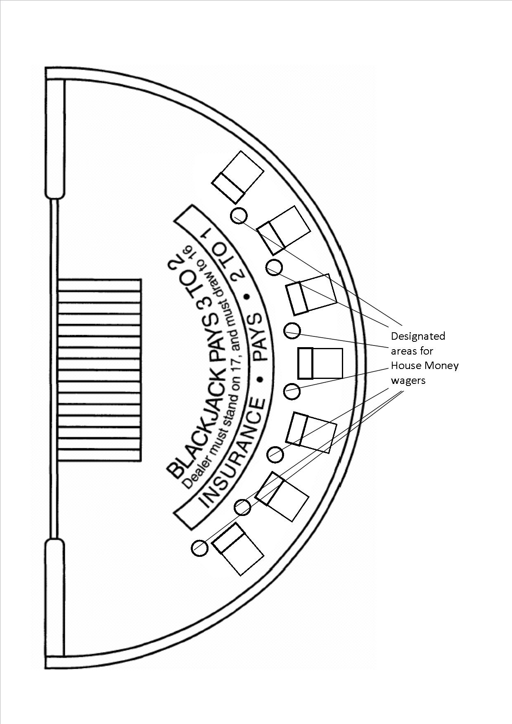

Appendix 7
Blackjack Table Layout with Let it Ride Wager Option

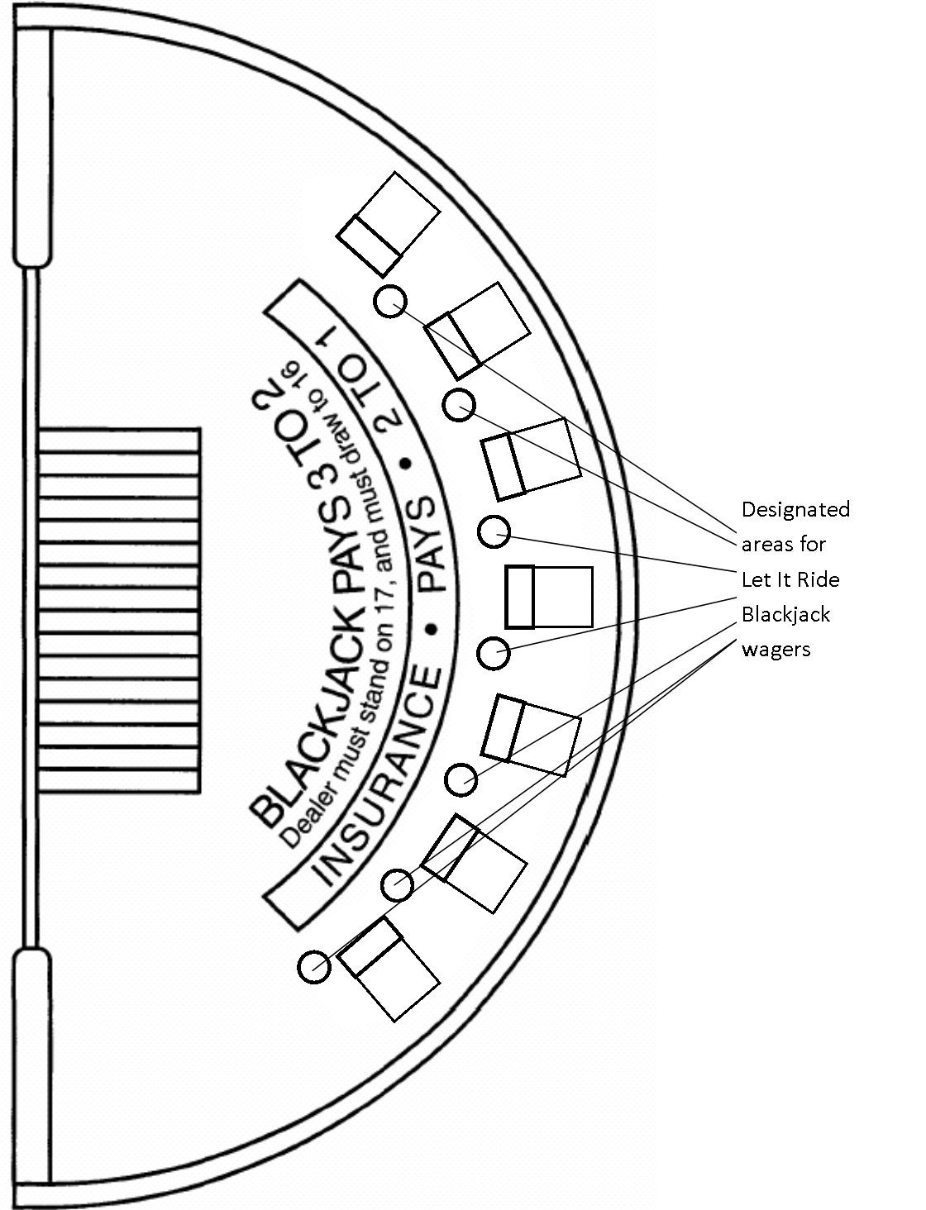

Appendix 8
Blackjack Table Layout with Lucky Match Wager Option

Appendix 9
Table Layout for Free Bet Blackjack

