Regulatory impact statement
Births, Deaths, Marriages, and Relationships Registration Amendment Bill:
1 BDM access provisions
1A Publication of index information: search function for non-historical information
1B Online access to historical register information
2 Law Commission review of burial and cremation law: preliminary notice of death
Agency disclosure statement
This regulatory impact statement (RIS) has been prepared by the Department of Internal Affairs.
It provides an analysis of options for (a) improving public access to registered information about births, deaths, marriages, civil unions, and name changes (BDM information) held by the Department of Internal Affairs (the Department), and (b) improving the timeliness and accuracy of reported cause of death information.
This RIS assumes solutions to the issues identified need to align with the Government’s Better Public Services objectives, including Result 10 (BPS Result 10) which the Department is responsible for: New Zealanders can complete their transactions with government easily in a digital environment.

1 BDM access provisions
The Department recently reviewed the access provisions in the Births, Deaths, Marriages, and Relationships Registration Act 1995 (BDMRRA 1995) on behalf of the Minister of Internal Affairs. The Minister’s October 2016 report to Parliament proposed a number of discrete amendments to improve public access to BDM information through digital and online channels, including Proposals 1A and 1B. A RIS is not required for the review’s other recommendations or those arising from the Department’s internal, operational review of the BDMRRA 1995.
The mandate for the review, which did not extend to a first-principles review of the BDMRRA 1995, is the key constraint. The analysis is limited to options that can be accommodated within the existing principles governing the access provisions, which in turn reflect the public register provisions in the Privacy Act 1993. A fundamental change to the regulation of third party access to BDM information (eg, through a consent-based information exchange, or opening up access to confidential information) is outside scope.
As noted above, this RIS assumes government and public expectations that New Zealanders should be able to transact with government easily in a digital environment will continue to be a key focus for modernising BDM services, including access to BDM information. This assumption is reflected in the analysis of the options, which draws heavily on evidence derived from a review of the ScotlandsPeople website (see Appendix A).
Scotland is a pioneer in the provision of large-scale online access to historical records. It has very similar BDM access rules to New Zealand, including the time limits used to define historical records. ScotlandsPeople has operated a successful commercial model for online access to BDM information, without any reported privacy breaches, since the late 1990s.

2 Law Commission review of burial and cremation law
No particular constraints have been identified. The options analysis compares the status quo to a system for preliminary notification of death to a system similar to that already operating for preliminary notification of births (70 per cent of which are notified electronically) (Law Commission Recommendation R.7).

Cameron Sherley
Acting General Manager
 | / |  | /

Contents
Executive summary 4
Background 5
1 BDM access provisions 5
2 Law Commission review of burial and cremation law 5
Objectives 5
Criteria 6
Status quo and problem definition—BDM access provisions 7
Options and impact analysis—BDM access provisions 9
Conclusions and recommendations—BDM access provisions 13
Status quo and problem definition—Law Commission review of burial and cremation law: preliminary notice of death 13
Options and impact analysis—Law Commission review of burial and cremation law: preliminary notice of death 14
Conclusion and recommendation—Law Commission review of burial and cremation law: preliminary notice of death 16
Consultation 16
Conclusions and recommendations 16
1 BDM access provisions 16
2 Law Commission review of burial and cremation law: preliminary notice of death 17
Implementation plan 17
Monitoring, evaluation, and review 17
Appendix A: ScotlandsPeople Website overview 18

Executive summary

1 BDM access review
- The access provisions in the Births, Deaths, Marriages, and Relationships Registration Act 1995 (BDMRRA 1995) regulate access to registered information about births, deaths, marriages, civil unions, and name changes (BDM information) held by the Department of Internal Affairs (the Department). The rules aim to balance the public interest in access for legitimate purposes with the protection of at-risk individuals and individuals’ privacy interests.
- A statutory review of the access provisions (2015–16) confirmed the basic principles underpinning the BDM access regime remain sound, but submitters expressed a clear preference for digital and online access over paper-based access via certificates and printouts (the status quo). However, current legislative settings limit the Department’s ability to develop end-to-end BDM services, including facilitating public access to BDM information through digital and online channels.
- The Minister of Internal Affairs’ October 2016 report on the review [EGI 16-Min-0258] included a number of recommendations to facilitate development of an online, pay-for view, BDM access regime similar to that operating in Scotland. This RIS considers two of those recommendations (a limited search function for non-historical information; and providing online access to historical register images, as an alternative to the purchase of a certificate or printout.
- The recommended options reflect the result of extensive public and agency consultation.
The Department considers they strike the right balance between individual rights and the public interest at a time people expect to be able to interact with government in a digital environment. The proposals have broad public and agency support, including the support of the Privacy Commissioner.
- The RIS is limited to amendments to the BDMRRA 1995. Operational implementation
(eg, designing new BDM services and access channels) is a separate issue that will be considered as part of the Department’s multi-year work programme: Transforming the System of Service Delivery (TSSD).

2 Law Commission review of burial and cremation law
- Complete, accurate, and verifiable BDM information is important for a wide range of government and public interest purposes. This RIS considers a discrete amendment to the BDMRRA 1995 that responds to an issue raised in the Law Commission’s report to improve the timeliness and accuracy of cause of death information. The preferred option can be progressed independently of the other work underway, including the Ministry of Health-led consideration of a replacement for the Burial and Cremation Act 1964.

Background

1 BDM access provisions
- The BDMRRA 1995 consolidated the legislation for the civil registration of life events, previously found in a number of Acts of Parliament. It established the framework for the centralisation of the registration process, and computerisation and digitisation of paper records created before 1998.
- The BDMRRA 1995 affirmed the existing status of BDM registers as public registers. There were few restrictions on access, no distinction between historical and non-historical records, and no formal record was kept of who accessed whose records. There were no restrictions on either the purpose for or the way in which BDM information could be used.
- The BDMRR Amendment Act 2008 was in part a response to growing public concern that individuals’ privacy interests were being or could be negatively impacted by unrestricted access to BDM information at a time of rapid technological change. Key changes relevant to this RIS were new rules distinguishing historical and non-historical records (essentially information about living individuals), including when and where historical and non-historical information could be published, in what form, and by whom.
- As part of changes, which came into force in 2009, Parliament asked the Minister of Internal Affairs to review the operation of the access provisions after five years (BDM access review). There was a requirement to consult with interested parties, including the Privacy Commissioner and the Chief Archivist. The review found the basic principles underpinning the BDM access regime were sound. However, submitters expressed a clear preference for digital and online access over paper-based access via certificates and printouts.
- The Minister’s report on the review was presented to the House of Representatives on
20 October 2016 [EGI 16-Min-0258]. This RIS (Proposals 1A and 1B) addresses two of the recommendations in that report.

2 Law Commission review of burial and cremation law
- The Law Commission released its report—Death, Burial and Cremation: A new law for contemporary New Zealand on 27 October 2015. The Government response presented to the House of Representatives on 20 April 2016 noted the Ministry of Health was undertaking further policy work on Commission recommendations to streamline and clarify the process for death determination, certification, and notification.
- This RIS considers a discrete amendment to the BDMRRA 1995 that responds to an issue raised in the Law Commission’s report (Proposal 2), which can be progressed independently of the other work underway, including the Ministry of Health-led consideration of a replacement for the Burial and Cremation Act 1964.

Objectives
- The key objectives of the BDMRRA 1995 are to (a) establish a system of civil registration of life events (births, adoptions, name changes, sexual assignment and reassignment, marriages, civil unions, and deaths) (BDM information) for matters important to government, and (b) regulate third party access to BDM information for authorised purposes, including the provision and effect of certificates that provide an official record of registered BDM information.
- These objectives incorporate a number of elements, which are outlined below as the criteria against which the options will be assessed.

Criteria
- The criteria are interrelated and conflicts can arise, which requires a careful balancing exercise. For example, there is an inherent tension between personal privacy interests and maintaining freedom of information and the right of public access to BDM registers. Both are important. This has particular implications for Proposals 1A and 1B where the options involve balancing private rights and the public interest. Similarly, rules intended to improve the timeliness and accuracy of registered information (like Proposal 2) could have the opposite effect if they are difficult to comply with.
- The options analysis identifies which criteria are relevant to each proposal.
Criteria | Description and link to objectives | Relevant to …
BDM information is complete, accurate, and verifiable  (see BDMRRA 1995, s 1A) | As the official record of New Zealand life events, members of the public, and private and public sector agencies rely on BDM information for a wide range of purposes including family and public-benefit research, establishing entitlements (eg, to citizenship, income support, public health services, or superannuation), and updating records. Information that is incomplete or out-of-date undermines public trust and confidence, can increase costs, and can delay access to services. Government decision-making can also be compromised if BDM information does not form an accurate demographic record. | All Proposals
The risk of misuse of BDM information is minimised | Individuals provide a large amount of personal information when they register a life event. That information has the potential to be used for inappropriate and potentially criminal purposes, including identity theft and the targeting of at-risk individuals. The government has a duty of care to protect individual rights and interests. | All Proposals
The public’s right to access to BDM information is maintained | BDM registers have been public registers since the registration of life events began in 1847. The Registrar-General must ensure that right can be exercised in practice as well as theory. That includes responding to changing public and government expectations about how BDM services, including access to BDM information, are delivered. | Proposals 1A and 1B
The Registrar-General can recover the private benefit element of the costs of providing BDM services | While BDM registers are public registers, the Department is obliged to charge fees that maximise cost recovery outcomes in line with Treasury’s Guidelines for Setting Charges in the Public Sector 2002. Fees for access to BDM information support the first three criteria—they help fund the ongoing maintenance and upgrading of essential systems and technology. | Proposals 1A and 1B
The compliance burden on individuals and agencies is minimised | Systems and processes should make it easy for individuals and industry professionals (including District Health Boards, medical and nursing staff, and funeral directors) to create and update BDM records. Specific requirements, including when, where, how, and by whom life events should be notified need to balance the benefits (including timely notification, completeness, and accuracy) with the administrative burden and the costs of compliance. | Proposal 2
- The proposal for a new preliminary notice of death, to be completed electronically by the health professional responsible for the Certificate of Cause of Death (CCD), responds to a recommendation in the Law Commission’s report on its review of burial and cremation law, released on 27 October 2015.

Status quo and problem definition—BDM access provisions

1A: Publication of index information: search function for non-historical BDM information

1B: Online access to historical register information
- The 2008 Amendment Act authorised the Registrar-General to make historical BDM information available to be searched online. Currently, the historical search function is free but the BDMRRA 1995 allows a fee to be charged. However, the Act made it unlawful to publish non-historical information on the Internet in a form that could identify an individual. That prohibition extends to the BDM register indexes (see s 78I). It reflected concern online access to non-historical indexes would enable computer-based manipulation and cross-matching of core identity information. This could facilitate identity fraud, as well as publicising personal information (some of which could be sensitive) about a large number of living individuals.
- The 2008 Amendment Act did not change the long-standing “named person” rule, which requires an access request to be in respect of a specific individual rather than, for example, a class of person, or information categorised by date or place. The “named person” rule applies to historical and non-historical BDM information. BDM staff can search historical and non-historical records (charges apply) to help identify a record for a “named person”.
- Access to a “named person’s” registered BDM information is provided via a certificate or printout. For historical records, the certificate or printout can be ordered and paid for online (and printouts can be delivered by email). Someone with a verified RealMe ID can order and pay for a certificate or printout for a non-historical “named person” record online. Certificates and printouts can be ordered by telephone or by completing a form. There is no refund if the certificate or printout is ordered for the “wrong” record.
- The 2008 Amendment Act included a provision (s 89A) that enables most transactions to be completed electronically. Section 89A has enabled the Department to make considerable progress in delivering online, customer-focused, access to BDM services. For example, parents have been able register their child’s birth online since 23 March 2015; over 90 percent of births are now registered online.
- SmartStart, a Result 10 integrated service with the Department as lead agency, working with the Ministry of Social Development, Inland Revenue and Ministry of Health, was launched on 6 December 2016. SmartStart is a “one-stop shop” where a parent can register their child’s birth, get her an IRD number, adjust their MSD benefits, update their Working for Families application, and create a personalised timeline and checklist of things to do.

Problem definition
- The flexibility s 89A provides does not extend to the BDM access provisions. Section 78H authorises the current, limited, historical information search function. Consequently, the Department is unable to respond to changing customer expectations about how and when they want to access BDM information, including the format in which access is provided. For example, although most historical records are stored as image files, the rules on publishing BDM information means the images cannot be made available through digital and online channels as an alternative to purchasing a certificate or printout.
- The current focus on certificates and printouts as the primary means of access to registered BDM information creates other difficulties. There is an inherent tension between the need to optimise the income from fees charged to cover the cost of providing BDM services, and meeting customers’ needs. For historical information, that tension has driven a business model that, of necessity, prioritises the sale of certificates and printouts over an expanded search facility that could provide access to a wider range of information.
- It would be possible to expand the historical search function (and introduce a search fee) without amending the BDMRRA 1995. However, an expanded search function would not address the underlying problem posed by an outmoded paper records-based business model, which is becoming increasingly difficult to sustain in a modern digital environment.
- The prohibition on the publication online of identifying non-historical information is another obstacle to the establishment of an end-to-end service that includes the ability to access BDM information through digital and online channels.
- Currently, members of the public, including family historians and genealogists, may need to pay to access multiple “named person” records (via a certificate or printout) to identify the “right” record. While this can also happen when someone with incomplete information is trying to identify a particular historical record, different considerations arise. In particular, the privacy interests of living individuals are much less likely to be affected.
- For non-historical records, the ability to conduct a basic “elimination” search (along the lines of the current, limited, historical records search facility), but not one that would reveal a complete record, would reduce the need for people to access records that are not relevant to their interests, even though that access is lawful. However, current legislative settings preclude development of such a privacy-enhancing search facility.

Options and impact analysis—BDM access provisions

1A: Publication of index information: search function for non-historical BDM information
- Three options for regulating publication of non-historical BDM information have been identified:
Option | Description
- Status quo | Non-historical index information must not be published online in a form that could be used to identify an individual; in practice no non-historical BDM information is published in any medium, other than in an anonymised format.
- Limited search function (recommended option) | Will enable the Registrar-General (but no-one else) to publish a limited sub-set of non-historical BDM information to enable bona-fide family historians and genealogists to conduct “elimination” searches; access to individual “named person’s” records would remain via a certificate or printout (status quo).
- Full online access | All registered non-historical BDM information would be available to search; individual BDM records would be able to reconstructed by progressively refining search terms; official copies of individual “named person’s” records would be accessible online.
- The following table outlines the Department’s assessment of these options against the objectives and related criteria.

Criteria |  |  | Options: Publication of index information – search function for non-historical BDM information
 |  |  | 1. Status quo |  |  | 2. Limited search function  (recommended option) |  | 3. Full online access
BDM information is complete and accurate |  |  | Unlikely to impact reporting of life events; however, could prompt users to access BDM information from unofficial online sources. |  |  | Unlikely to impact reporting of life events. |  | X  Likely reduction in public trust; negative impact on compliance could undermine accuracy of BDM information over time.
The risk of misuse of BDM information is minimised |  |  | Prioritises privacy interests over public access; possible unintended consequences, ie, driving increase in unnecessary (if legal) access to additional records. |  |  | Will not support “fishing expedition” searches; will help users identify (but not reconstruct) a “named person” record; reduces the need to access irrelevant records, which would be privacy-enhancing. |  | X  High risk of misuse (eg, data mining and data aggregation), including potentially criminal purposes, which could be difficult to mitigate; inconsistent with international standards.
The public’s right to access to BDM information is maintained |  |  | Researchers may have to search available hard copy records (eg, pre-1998 indexes) to help identify a named person record; cost can be a barrier if several records need to be accessed to find the “right” record and/or if BDM staff search fees are involved; does not address public and government expectations about access to digital services. |  |  | Balances individual rights (eg, privacy) and the public interest; recognises people expect to be able to interact with government in a digital environment. |  | Potentially high fees for online access could act as a de facto barrier; likely to disadvantage legitimate researchers; increase in access could be rendered theoretical by systems and process to minimise/eliminate risks; likely substantial increase in administrative costs; negatives likely to outweigh positives.
The Registrar-General can recover the private benefit element of the costs of providing BDM services |  |  | May not immediately impact cost recovery; however, a solely paper records-based business model is not sustainable long-term. Cabinet is to consider a separate proposal to increase fees to address memorandum account deficits [EGI-16-Min-0255]. |  |  | Individual “named person” records would be accessed via a certificate or printout (like ScotlandsPeople); likely to be cost-neutral (fewer “wrong” records accessed, but easier to access the “right” record). |  | New fee for online access would need to be set at a high level to discourage misuse; could discourage legitimate access requests across the board.
The compliance burden on individuals and agencies is minimised |  |  | —NA— |  |  | —NA— |  | —NA—
Key: | Meets: | Partially meets: |  | Does not meet: X | Not applicable: NA

1B Online access to historical register information
- Five options for regulating publication of historical register information have been identified:
Option | Description
- Status quo | Historical BDM information (other than that available through the current, limited search function) can only be accessed by purchasing a certificate or printout.
- Amended status quo | Expand the existing online search function to include all the information specified in s 78H(3), but introduce a search fee to offset possible loss of income from the sale of certificates and printouts.
- Allow online access to historic register images (recommended option) | Allow historical register images to be viewed online, as an alternative to the purchase of a certificate or printout, subject to the user having a verified RealMe ID (or approved equivalent) that can be asserted online. This would require an exception to the “named person” rule for historical births and deaths register images that commonly have multiple entries per register page. It would also require an exception to the rules that require certain BDM information to be kept confidential (eg, a notation indicating a child has been adopted), and historic notations such as “illegitimate” which are deemed expunged (s 86). Certificates or printouts would continue to exclude confidential information.
4a. Recreate the historic register image database | Rescan and crop register pages using modern technology to (a) ensure individual records can be made available for view, and (b) records that contain information the BDMRRA 1995 requires to be kept confidential are excluded from public access.
4b. Create a new historic records database | Rekey all historic register information to create a new historic records database. This would, over time, reduce manual processing and facilitate end-to-end online services.
- Options 4a and 4b have not been considered further. The expense involved would be prohibitive, and could not be justified by the number of requests for access to historical BDM records. There are more than 11 million records in the Department’s LifeData database; 80 per cent pre-date 1998. Approximately 32 per cent of records are currently classed as historical. However, records will continue to be added to the “historical” category as they age. Consequently, recreating the historic register image database (option 4a) or creating a new database (option 4b) would require conversion of all pre-1998 paper-based registers.
- The following table outlines the Department’s assessment of the remaining three options against the objectives and related criteria.
Criteria |  |  | Options: Online access to historical register information
 |  |  | 1. Status quo |  |  | 2. Amended status quo |  | 3. Allow online access to historic register images (recommended option)
BDM information is complete and accurate |  |  | —NA— |  |  | —NA— |  | —NA—
The risk of misuse of BDM information is minimised |  |  | Limited search facility precludes possibility of reconstructing individual records. |  |  | Risk of misuse of historical information (eg, identity fraud) is very low; expanding search terms unlikely to increase that risk. |  | Risk of misuse of historical information (eg, identity fraud) is very low—providing online access to historic births and deaths register images is highly unlikely to increase that risk.
The public’s right to access to BDM information is maintained |  |  | X  Business needs (product sales) trump public access rights; not customer-focused. |  |  | Reflects existing legislative mandate. |  | Original register images contain information and provide invaluable clues for researchers that may not be duplicated in an official certificate or printout; meets public and government expectations about being able to complete transactions in a digital environment.
The Registrar-General can recover the private benefit element of the costs of providing BDM services |  |  | X  Entrenches a paper records-based business model; the percentage of historical records product sales to total sales has reduced from 17.28% (2009/10) to 9.89% (2015/16); product sales are static overall, which has led to a reduction in income in real terms. Cabinet is to consider a separate proposal to increase fees to address memorandum account deficits [EGI-16-Min-0255]. |  |  | Expanded search function could further reduce sales of certificates and printouts–may not be offset by a search fee; providing non-searchable access to historic indexes (eg, static images) not linked to current and proposed BDM services would incur costs without benefitting users. |  | Will provide a new source of income; will help position BDM Online as a preferred alternative to services offered by commercial providers such as Ancestry.com; easier access to historical BDM information, in a format researchers prefer, likely to increase uptake (sales) over and above sales of certificates and printouts
The compliance burden on individuals and agencies is minimised |  |  | —NA— |  |  | —NA— |  | —NA—
Key: | Meets: | Partially meets: |  | Does not meet: X | Not applicable: NA

Conclusions and recommendations—BDM access provisions

1A Publication of index information: search function for non-historical BDM information

1B Online access to historic register information
- The status quo is not sustainable for either issue. Static product sales (certificates and printouts) have led to a reduction in income in real terms. An initial increase in orders for historical records associated with the introduction of the online search function has not been sustained (but it is a pointer to what could be achieved with an updated pay-for-view model).
- The Department is currently seeking Cabinet approval to increase fees for the first time in
15 years [EGI-16-Min-0255], but this is a short-term solution. It does not address the underlying problem. An alternative to the current business model is required.
- For Proposal 1A—Publication of non-historical index information, Option 2 (limited search function) is the only practical option. The status quo is not sustainable beyond the short term. Option 3 (full online access) is high risk. It could have unintended consequences if the risk factors discourage accurate reporting of life events. Option 3 meets some of the criteria in part, but the negatives are likely to outweigh the positives.
- The status quo meets only one of the criteria for Proposal 1B—Online access to historical register information; it entrenches an outmoded paper-records based business model.
Option 2 offers a partial solution, but is likely to meet public resistance. It has the potential to increase costs for members of the public without delivering a proportionate benefit. Option 2 could undermine the Department’s ability to recover costs if it further reduces sales of certificates and printouts.
- Option 3 (online access to historic register images) satisfies all relevant criteria. The ability to view information about individuals other than the “named person” on the same register page is highly unlikely to increase the already low risk of misuse. The potential risk to privacy interests is mitigated by the fact very few living individuals are likely to be impacted, and then only indirectly. Option 3 strikes the right balance between individual rights and the public interest at a time people expect to be able to interact with government in a digital environment.

Status quo and problem definition—Law Commission review of burial and cremation law: preliminary notice of death
- The person “who disposes of a body” must notify the death within three days of the body’s disposal (cremation, burial, etc). Ninety-two per cent of “disposals” are notified electronically by funeral directors through BDM online. A small number of “disposals” (fewer than 3,000 annually) are notified manually via a handwritten form, including some where people do not use a funeral director.
- A body cannot be “disposed of” without a Certificate of Cause of Death (CCD) or coroner’s authorisation. The CCD is a handwritten form provided by the Ministry of Health. The person responsible for the “disposal” uses information from the CCD to enter the cause of death on the notification sent to the Registrar-General. That person must send the completed CCD or coroner’s authorisation to the Ministry of Health.

Problem definition
- There are two aspects to the problem. First, the existing law conflates responsibility to notify a death with responsibility to notify disposal of a body. It may be unclear whether the obligation to notify the death (disposal) lies with the person making the decision about what is to happen (eg, family member), the person arranging the disposal (eg, funeral director), or the person carrying out the disposal (eg, crematorium operator). Notification of a death for registration can be delayed or overlooked completely, especially if a funeral director is not involved.
- Second, cause of death information is health information, which should be notified by a health professional, not a funeral director or other individual. Because the CCD remains a handwritten form, transcription errors by the person notifying the “disposal” of the body can lead to inaccuracies.
- The Law Commission noted both aspects of the problem were exacerbated by the fact the Registrar-General has only one source of death information. In contrast, the parents and the hospital or medical facility each have an obligation to notify a birth, which provides a useful cross-check. The Commission recommended introducing a new statutory system for notifying death that aligns with the births notification process.

Options and impact analysis—Law Commission review of burial and cremation law: preliminary notice of death
- Three options for addressing the Law Commission’s recommendation have been identified:
Option | Description
- Status quo | Existing law conflates responsibility` to notify a death with responsibility to notify disposal of a body; the person “disposing” of a body transcribes cause of death information from the CCD/coroner’s authorisation, and sends the CCD/authorisation to the Ministry of Health.
- Amended status quo | Amend the Burial and Cremation Act 1964 to require the person disposing of the body to send the completed CCD/coroner’s authorisation to the Department, which the Department would forward to the Ministry of Health. This option would return the law to its pre-2008 Amendment Act state.
- Introduce a provision, equivalent to s 5A of the BDMRRA 1995, for a preliminary notice of death (recommended option) | Implement Law Commission Recommendation 7: Amend the BDMRRA 1995—the health professional or coroner who determines the cause of death has a duty to provide preliminary notice of the death (and cause of death) to the Registrar-General. The new provision would be subject to  s 47, which authorises the Registrar-General to specify the manner in which notice should be given, including approved electronic means. This option will not affect operation of the Burial and Cremation Act 1964.
- The amended status quo has not been considered further. It would increase the Department’s administration costs without addressing any aspect of the problem. It would also be inconsistent with the “digital by choice, and digital by default” focus of BPS Result 10.
- The following table outlines the Department’s assessment of the remaining two options against the objectives and related criteria:
Criteria |  |  | 1. Status quo |  |  | 2. Introduce a provision, equivalent to s 5A of the BDMRRA 1995, for a preliminary notice of death (recommended option)
BDM information is complete and accurate |  |  | X  Accuracy of cause of death information is compromised by reliance on transcribing handwritten information; single source of information about when a death occurred and cause of death. |  |  | Registrar-General would receive information from two sources; would facilitate immediate follow-up if the death is not formally notified in a timely way. Direct access to information created by a health professional would help the Registrar-General identify discrepancies in information provided when a death is formally notified.
The risk of misuse of BDM information is minimised |  |  | Paper-based records are less susceptible to some forms of abuse, eg, large-scale manipulation or data-mining. However, that information needs to be recreated in a digital format by someone at some stage of the process. |  |  | Records that are created digitally and transferred through secure online systems (like 70% of preliminary birth notifications) reduces the need for individuals to access private and/or sensitive information (death records also contain information that can identify living individuals).
The public’s right to access to BDM information is maintained |  |  | —NA— |  |  | —NA—
The Registrar-General can recover the private benefit element of the costs of providing BDM services |  |  | —NA— |  |  | —NA—
The compliance burden on individuals and agencies is minimised |  |  | In the short-to-medium term, medical professionals could continue to use existing systems and processes. Paper-based systems are not sustainable in the long term. |  |  | Preliminary notice of death could be generated automatically from an online CCD. Digital processes for recording and transferring information, would streamline administration and reduce compliance costs. An online CCD would also benefit funeral directors who could receive information electronically.
Key: | Meets: | Partially meets: |  | Does not meet: X | Not applicable: NA

Conclusion and recommendation—Law Commission review of burial and cremation law: preliminary notice of death
- The option to introduce a provision, equivalent to s 5A of the BDMRRA 1995, for a preliminary notice of death, to be completed electronically by the health professional responsible for determining the cause of death, is clearly superior to the status quo across all the criteria.

Consultation
- Proposals 1A and 1B reflect the result of consultation with, and submissions received from, a wide range of individuals, and public and private sector agencies during the BDM access review. Eighty submissions were received on a Discussion Paper issued in January 2015 [EGI Min (14) 20/16], and a further 32 submissions were received on the Proposals Paper responding to those submissions [EGI-16-Min-0024]. Several submitters cited the ScotlandsPeople website as an exemplar of best practice for access to BDM information.
- The Minister’s report [EGI 16-Min-0258] noted the strong public support for the proposals to improve digital and online access to BDM information. There will be a further opportunity for public consultation during the select committee process.
- The Department met with the Privacy Commissioner’s representatives to discuss their submission before finalising the Minister’s report on the outcome of the review.
- The Law Commission consulted fully during its review of burial and cremation law.
The Government has accepted the relevant recommendation. The Department will continue to consult with the Ministry of Health on the operational implications of Proposal 2.
- The following agencies have been consulted on this RIS: Ministry of Health, Ministry of Justice, Ministry of Social Development, Statistics New Zealand, Treasury, New Zealand Police, Law Commission, and the Privacy Commissioner. The Chief Archivist, the Registrar-General of Births, Deaths and Marriages, and the Government Chief Privacy Officer have also been consulted.

Conclusions and recommendations

1 BDM access provisions

1A: Publication of index information: search function for non-historical BDM information

1B: Online access to historical register information
- The Department recommends, respectively, Option 2 (limited search function) and Option 3 (allow online access to historical register information). These two options will “book end” the proposed all-of-BDM Internet-based search, pay-for-view, and records access and ordering facility discussed in the Minister’s report on the review [EGI 16-Min-0258].
- At the point of access (the “front-end”), the intention is to align the initial, high-level, online search functions for historical information and that proposed for non-historical information. At the “back-end”, when access to a specific BDM record is sought, customers will have the option of accessing historical BDM register information through digital and online channels.

2 Law Commission review of burial and cremation law: preliminary notice of death
- The Department recommends Option 2, which will implement Recommendation 7 from the Law Commission’s review of burial and cremation law. It will improve the accuracy and timeliness of reported deaths, and cause of death information. Unlike the status quo, it aligns with BPS Result 10 and the Department’s commitment to digital transformation.

Implementation plan
- The three proposals in this RIS will be included in a BDMRR Amendment Bill. Implementation at an operational level is outside the scope of this RIS as it will involve decisions yet to be made as the Department’s TSSD Programme is rolled out. However, the Department will ensure a “privacy by design” approach informs new digital and online service channels. We will work closely with the Privacy Commissioner and the Government Chief Privacy Officer as these systems are developed.
- The Department will also ensure industry and health professionals and organisations are consulted on necessary systems and technological changes before implementing new requirements for a preliminary notice of death.

Monitoring, evaluation, and review
- The systems that enable the Department to monitor who is accessing non-historical records are already in place. For example, the Department maintains an access register than enables individuals to see if anyone has accessed their BDM information, and when (see s 75D).
- The TSSD Single Stage Business Case for Tranche 1 of the Programme is scheduled to be submitted to Cabinet in April 2017 [SEC-16-Min 0067]. We will ensure appropriate consideration is given to the requirements for operationalising the proposed all-of-BDM Internet-based search, pay-for-view, and records access and ordering facility at each stage of the TSSD process.

Appendix A
ScotlandsPeople: Website overview
User registration (to set up account and login)—
- Registration is free
- Unique email address (becomes user name) and password
- Name and other personal identifying information
- Purchase prepaid credits to access search results and historical records (and order a certificate) for historical and non-historical records).
Note: The proposed NZ pay-for-view model will require users to have a verified Real Me ID or other approved identity that can be asserted online.

User access: Key terms and conditions—
- Crown copyright applies
- Copying, publication, distribution, reproduction, etc, of website content prohibited
- Use of tools for data extraction, data mining, or automatic access, etc prohibited
- (to state the obvious) Must not introduce malicious software (eg, viruses, trojans, worms, etc)
- Personal use only (other than professional family history research as a self-employed genealogist)
- Commercial or business use specifically prohibited
- Breach of T & Cs can be an offence.

User access: What ScotlandsPeople offers—
- Free index search function across all records: limited to name and date range:

- Identifies how many records available by register/record type, which include:
  - Statutory register (births, marriages, deaths, civil partnerships; divorces; dissolutions): 1855—
  - Census returns: 1841—
  - Church registers (births, baptisms, marriages, burials): 1538—
  - Valuation rolls (lists of property owners, tenants, occupiers): 1855–1987
  - Legal records (civil, criminal, and church court records including—wills and testaments: 1513—, soldiers’ and airmen’s wills: 1857—, coats of arms: 1672—, Military Service Appeal Tribunal records: 1916–1918)
  - Image library (historical photographs, manuscripts, drawings): mediaeval to mid-20th C

Login to view results …:
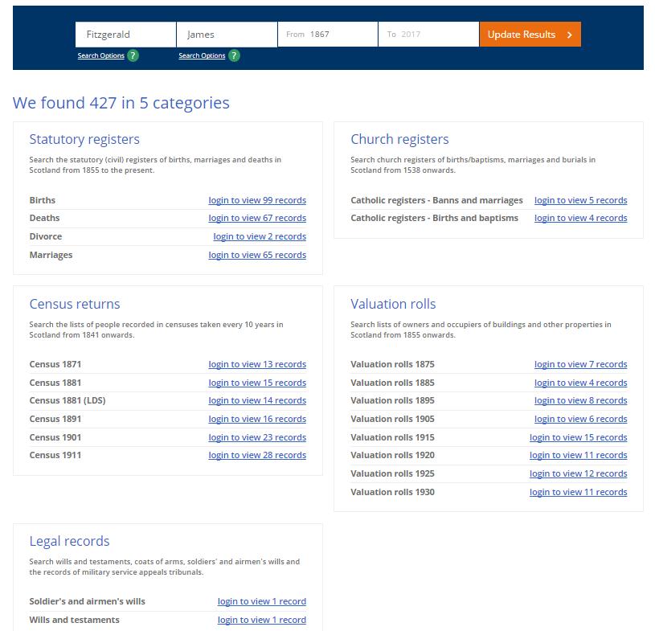
… or Login to limit search to a particular register, to conduct a place-based search, or to search records indexed by personal name – search can be based on some or all of the following:
Index information | Statutory register:  Births, Marriages,  Civil partnerships, Deaths, Divorces, Dissolutions (CPs) | Comment
Surname | All | The Register of Corrected Entries (RCE) records additional authorised post-registration information. Eg, a birth record could be amended to include of father’s name following a paternity case, or the parents’ subsequent marriage). A death record could be amended to record/correct the cause of death. RCEs were recorded separately, with a notation being made in the original register. Historical RCE images and original register images are linked, and can be viewed online.
Forename | All | Registered name changes (surname and/or forename) are recorded on subsequent birth certificates; the index search is based on the current name, not previous names.
Gender | Births, Marriages, Civil partnerships, Deaths | A person who is granted a Gender Recognition Certificate (GRC) under the Gender Recognition Act 2004 (UK) can obtain a new birth certificate showing her or his legal gender, which is issued from a confidential Gender Recognition Register. The original birth record remains available for public inspection and search. If a GRC is issued after a person marries or registers a civil partnership, they can choose to “re-register” the ceremony. If so, the original register entry will be sealed; only the new entry is available for public inspection and search.
Year range  (eg, 1865–1965) | All | Records are indexed by year of registration not event; minimum search period is one year (eg, 1965–1965).
Registration district | Births, Marriages, Civil partnerships, Deaths | Where the life event was registered.
County or city or Minor Records | Births, Marriages, Civil partnerships Deaths | Minor Records are statutory registers of births, deaths and marriages of Scots (or persons of Scottish descent) which occurred outside Scotland. They include the Foreign Register, consular and High Commissioner returns; the Marine Register and Air Register; service returns, and war registers.
Other surname | Deaths | Eg, father’s surname.
Mother’s maiden name | Deaths | Included since 1974, but being added retrospectively to older records.
Age at death | Deaths
Partner’s surname & forename | Civil partnership | Civil partnerships: 2005—
Spouse’s surname | Marriages, Divorces, Dissolutions (CPs) | Divorces: 1984—; Dissolutions (CPs): 2007—  Pre-1984 divorces were recorded in the Register of Corrected Entries.
- Search results include links to view an image or to order a certificate (certificates are posted)
- Pay to view to view historical register/record images (births 100+ years; marriages 75+ years; deaths 50+ years):

Access to non-historical records
- Individual non-historical records cannot be viewed online, but—
  - can be accessed by purchasing a certificate, which is posted, or
  - at National Records of Scotland search rooms and at local family history centres by paying a daily search fee.
Historical records: Prepaid account facility enables online access to …:
Births register
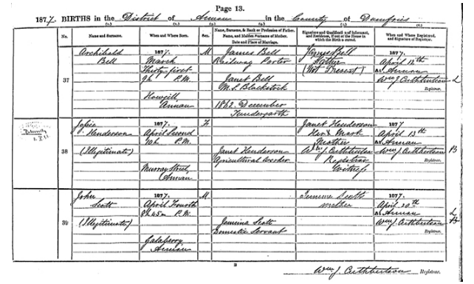
Register of Corrected Entries
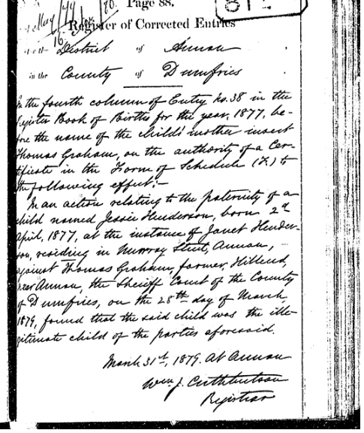
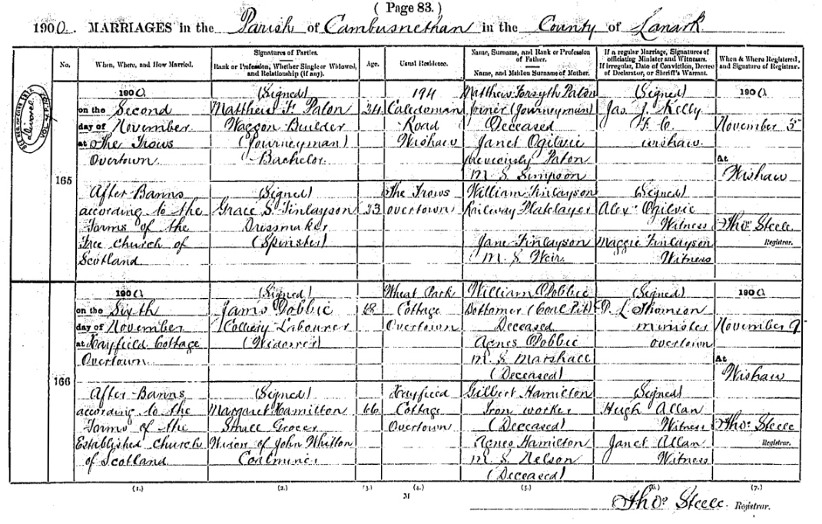
Marriage register
Register of Corrected Entries (divorce record)

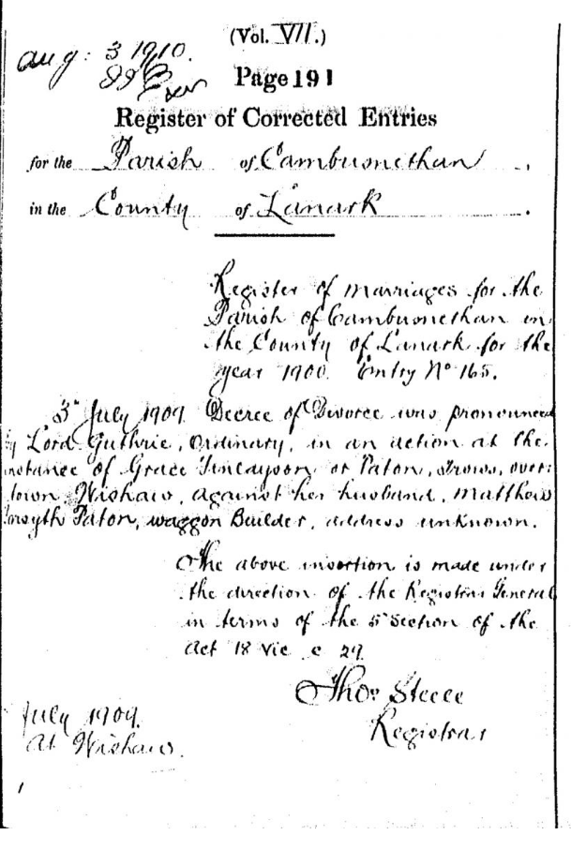
Deaths register

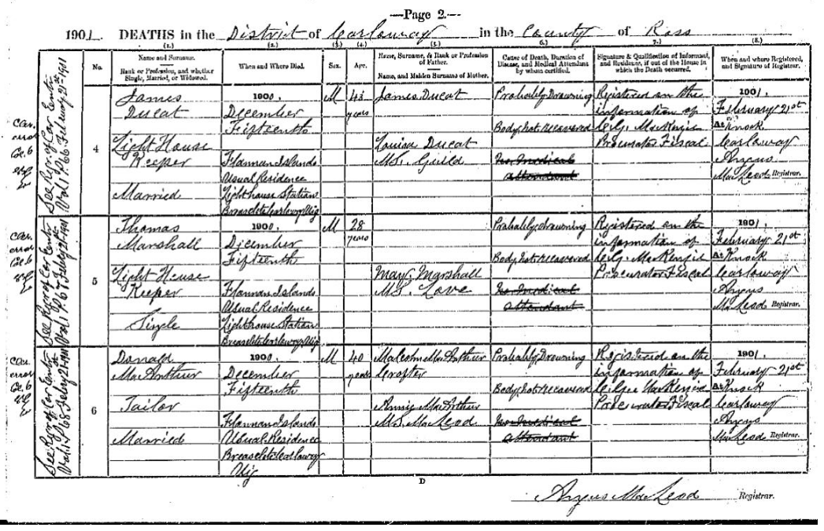

Section 78J specified the sections to be reviewed (ss 74–75G, which govern public access for approved purposes; s 78F, which enables NGOs to receive death information to update their databases, eg, purging mailing lists; and s 78H, which sets out what historical information the Registrar-General can make available for search on the Internet).
In addition to the statutory registers (births, marriages, deaths, civil partnerships, divorces, and dissolutions), ScotlandsPeople enables users to search a wide range of official records, including census returns, church registers, valuation rolls, and wills and testaments. However, consideration of extending BDM Online to include records other than those controlled by the Registrar-General is outside the scope of this RIS and the related Cabinet paper.
Law Commission Death, Burial and Cremation: A new law for contemporary New Zealand (NZLC R134, 2015).
The indexes were produced from 1848 to 1998 to help BDM staff identify individual entries in the (then) paper-based registers held in BDM offices and courts throughout the country. Members of the public also used the indexes to identify the records they wanted to access. After 1998, computerised and centralised registration of BDM life events made indexes largely redundant, and production ceased entirely in 2009.
The Department is obliged to charge fees that maximise cost recovery outcomes in line with Treasury’s Guidelines for Setting Charges in the Public Sector 2002.
The current search fields on BDM Online do not include all historical information that s 78H of the BDMRRA 1995 authorises the Registrar-General to make available.
Scotland, like New Zealand, discontinued the use of the word “illegitimate”, with retrospective effect, early in the 20th century. Option 3 reflects how Scotland handles access requests for historical records that may contain confidential information (see Appendix A).
The original digitisation process (1999–2001) involved 10+ staff over 3 years at a cost of approximately $10m.
In the first full year of the online historical search function (the 2009/10 financial year) the percentage of historical record access requests to total requests increased to 17.28% – up from 9.94% in 2008/09. However, that had reduced to 9.94% in 2014/15, and 9.89% in 2015/16.
269,830 in 2008/09 and 270,292 in 2014/15; there was a slight increase to 282,869 in 2015/16.
Burial and Cremation Act 1964, s 46AA(2).
BDMRRA 1995, s 34(1) requires a death to “be notified and registered in accordance with [Part 6]”; however, the provisions in Part 6 link notification to disposal of the body, not the fact of death.
On average, 20 deaths a year are not notified. It can take up to two years for the problem to come to light as a result of Ministry of Health cross-checks on the death information it receives from which it compiles mortality statistics (Schedule 1A of the BDMRRA 1995 refers).
BDMRRA 1995, ss 5A, 9. Seventy per cent of preliminary notices of birth are completed electronically.
The Law Commission recommended a complementary amendment to clarify it is the person making the decision about the disposal of the body who should notify the death to the Registrar-General (R8): see paras 88–89 of the EGI paper. A RIS is not required to implement this recommendation, but it will be addressed in the BDMRR Amendment Bill.
Government Response to Law Commission Report on Burials and Cremations (20 April 2016) at [23].
The proposed NZ pay-for-view model is limited to BDM information, which the Department is responsible for. It is not currently possible to link to records held by other agencies (eg, local authority cemetery records, or wills and testaments admitted to probate).
Civil partnerships date from 2005, and dissolutions date from 2007, so they will not be available as historical records until 2080 and 2082 respectively at the earliest. .

