Key findings from the 2015 Survey of AML/CFT reporting entities

Contents
Executive summary 1
Introduction 3
Information about our sector 5
Information Services 8
Sector understanding of the AML/CFT Act 12
Risk Assessment 13
AML/CFT Programme 13
Annual Report 14
Submitting Suspicious Transaction Reports 15
Subsector ratings 15
Final comments 15

Executive summary
This report summarises the key findings of the Department of Internal Affairs’ 2015 survey of its reporting entities under the Anti-Money Laundering and Countering Financing of Terrorism Act 2009 (the Act).
Information collected in the survey gives us, as a supervisor under the Act, an opportunity to gauge the level of understanding that our reporting entities have about their obligations.
We are also interested in how effective our communication with the sector is. We use survey information to inform how and when we communicate information.
This is the second year that we have conducted this survey and we received a good response rate of 35 per cent. Invitations were sent to 972 individuals and 337 responses were received. This compares to 2014 when 788 invitations were sent and 308 responses were received, giving a response rate of 39 per cent.
Survey findings – information services
Almost all of our survey respondents have referred to the Department of Internal Affairs’ (the Department) website and this number has increased compared to last year (from 87 per cent in 2014 to 91 per cent in 2015).
Overall ratings for ease of finding information and usefulness of information on our website were positive.
A number of respondents told us that information in some areas of the website is easier to find and more useful than others. Average ratings in both areas have decreased slightly compared to last year.
Requests for simplified language and an improved website search function were made and this is similar to last year’s survey. It is interesting to note that opinion about the website was divided, with other comments stating that information is easy to find and set out simply.
We plan to review the information on our website and how it is presented.
Most respondents have had additional contact with the Department (other than website or newsletters), and this number has increased (from 62 per cent in 2014 to 71 per cent in 2015).
A reduction in the numbers of roadshow and face to face interactions reflects the change in our focus from education to more active supervision. The number of interactions due to desk based programme reviews and on-site inspections has increased accordingly.
The number of survey respondents who received information from us by telephone and email has increased considerably compared to 2014.
The majority of reporting entities use other information sources to help them to understand and comply with the Act. Consultants are the most popular option.
Survey findings – sector understanding of the Act.
We repeated last year’s awareness questions and asked respondents to self-rate their understanding of four areas:
Risk assessment, Anti-Money Laundering and Countering Financing of Terrorism (AML/CFT) Programme, Annual Report, and Suspicious Transaction Reports.
The majority of respondents indicated that they have a reasonable or extremely good understanding of each of these requirements. Average ratings are very similar to last year and tell us that sector confidence has been maintained.
The increase in ratings for understanding of Annual Report requirements is evident. Respondents had now completed one report cycle and have higher confidence and ratings in this area compared to last year. Guidelines and templates were developed by the Department to support this process and comments indicate that these were generally well received.
At the lower end of the rating scales there has also been some development. Fewer respondents rated themselves as having no understanding or very little understanding in any area.
There were a number of similar themes in the comments provided this year and last year. The cost of compliance, especially for small businesses, is a concern raised by a number of respondents.
Other comments reflect initial challenges but increased confidence over time.
Overall, the Department is pleased with these results and the level of awareness the sector has with its obligations under the Act. There is room for improvement, and we will continue to support those in the sector who are trying to comply.
Thank you to everyone who spent time responding to this survey and providing us with this valuable information.

Introduction
The Department is one of three government agencies under the Act responsible for ensuring that financial businesses in New Zealand, known as reporting entities, have robust programmes in place to detect and deter money laundering and financing of terrorism. Obligations came into full force on 30 June 2013.
Other supervisors under the Act are the Reserve Bank of New Zealand and the Financial Markets Authority.
By complying with the Act, businesses help to disrupt criminal activity, and maintain the integrity of our financial institutions. This ensures that New Zealanders have confidence in our financial system and that our good international reputation is maintained.
This survey has been conducted to provide us with information about the confidence and level of understanding that our reporting entities have with their obligations under the Act, with a particular focus on four key requirements. We conducted a similar survey for the first time in 2014.
We also wanted to find out about our reporting entities’ experiences when engaging with us, and their perceptions of information available from the Department and the wider sector to support compliance.
We would like to further develop our understanding of our sector so that we can continue to refine our regulatory approach and improve services.
A Support Document accompanies this report of key findings which contains additional analysis of survey data and some comparisons to 2014 (Appendix A). A complete copy of individual survey responses is also provided. A small amount of information has been withheld to ensure the anonymity of the respondent.
Our survey approach
An email invitation was sent to all known reporting entities as of 7 May 2015. Respondents participated by clicking on the link contained in the email, which connected them to the web-based survey.
The survey was open for response for a period of two weeks with a reminder invitation email sent at the mid-point.
The survey involved participants responding to a maximum of twenty one fixed or multi-choice and rating scale questions. Up to fourteen questions required an answer and seven offered an optional, free text, opportunity for comment.
We included two demographic questions relating to subsector and location and this provides the option to consider these aspects when analysing responses. We did not ask for further details such as relative size of businesses. All responses are anonymous.
Where we provide information and analysis about subsector groups the overall total of survey responses increases. This is because a number of respondents identify with more than one business type and their responses are therefore included in more than one data set.
Invitations were sent to 972 individuals and 337 responses were received, which is a response rate of 35 per cent. This is lower than last year’s response rate of 39 per cent.
The margin of error is ±4.32 with a 95 per cent confidence level.
Survey Sample
Listed below are the business types that the Department is responsible for supervising:
- Cash Transport
- Casino
- Debt Collection
- Factor
- Financial Leasing
- Foreign Exchange
- Non-Bank and Non-Deposit Taking Lender
- Non-Bank Credit Card
- Payment Provider
- Payroll
- Remittance
- Safe Deposit
- Tax Pooling
- Trust and Company Service Provider

The survey design provides an option for respondents to also select “other” and then include a free text response to describe the business.

In 2014 four additional categories were created in order to manage response information provided in the “other” category. We revised our approach this year and allocated these responses into one of the above business types where it was reasonable to do so from the information given. Further information about our approach is provided on page 6 of this report and in the support document (Figure 1.1).

As a result of this revised approach we have avoided making lots of direct comparisons between subsector data from the 2014 and 2015 surveys in this report.

Information about our sector
The survey began by asking respondents to tell us which business sector(s) they identify with. We note that this information includes data from some reporting entities not required to submit an annual report. Therefore we refer only to survey data in this section.
Figure 1: Subsector breakdown.
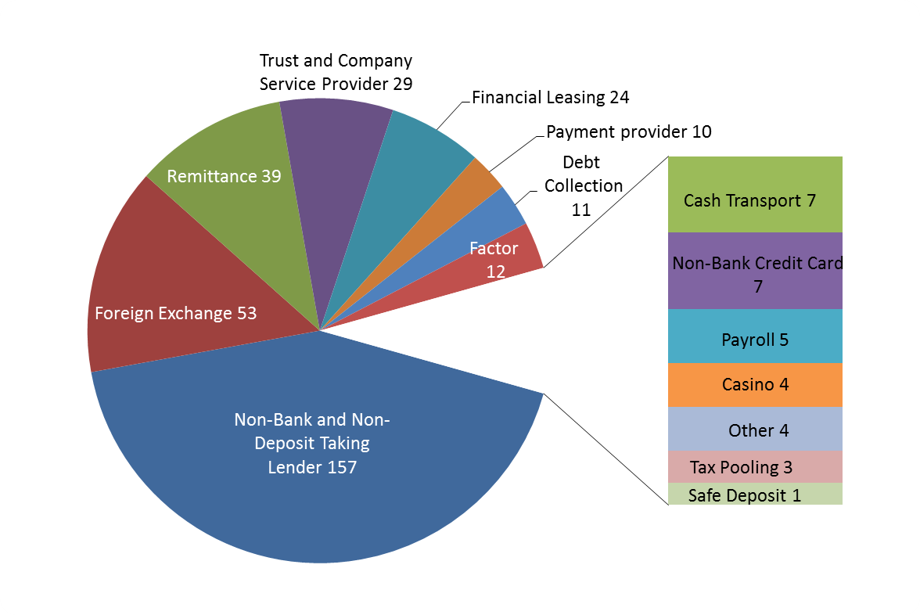

Figure 1 shows the number of selections in each subsector. Seven subsectors have fewer than ten selections. These have been grouped together and displayed to one side for ease of reference.
More than one selection was permitted and the total count is 366 selections from 337 respondents. This shows that a number of our reporting entities identify with more than one subsector. For example, nine respondents indicated that they operate both foreign exchange and remittance services.
The largest subsector the Department supervises is Non-Bank and Non-Deposit Taking Lenders.

The largest subsector by a considerable margin is Non-Bank and Non-Deposit taking Lenders. This is consistent with last year’s survey.
All fourteen business types that the Department is responsible for supervising were represented with at least one respondent.
“Other” was provided as an answer option and sixty three responses were supplied. We allocated fifty nine of these responses to one of the above subsectors using the information specified. The remaining group of four “other” represents responses that we were unable to categorise from the information given.
A table showing some examples of the responses and allocations can be found in the support document - Figure 1.1.
Most businesses we supervise are located (or have their head office) in Auckland.

Over two hundred businesses are located (or have their head office) in Auckland, and represent 60 per cent of survey respondents. This is consistent with last year’s survey result. Details are provided in the Support Document Figure 1.2 – Respondent Locations.
There are a small number of businesses based offshore that the Department is responsible for supervising, accounting for three per cent of responses.
Figure 2: Membership of a Designated Business Group (DBG).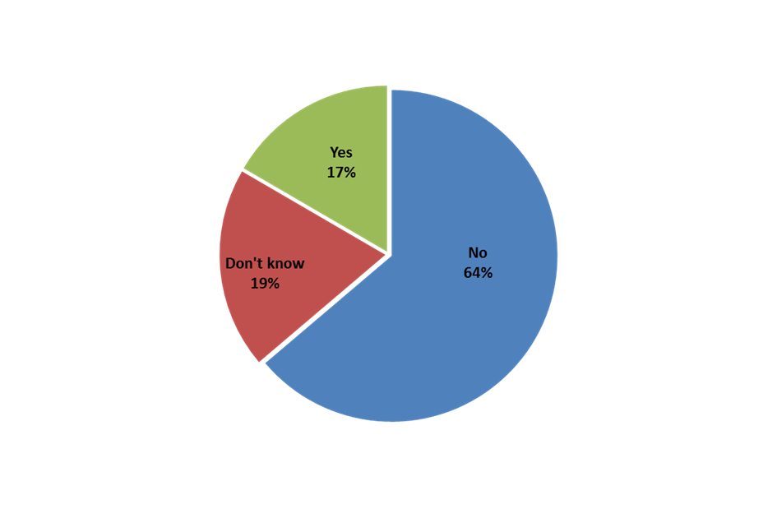Figure 2 shows that the majority of respondents do not belong to a DBG. We recognise that many of our reporting entities are small independent businesses therefore membership of a DBG may not be an option.
A slight increase of five per cent in DBG membership from 2014 to 2015 is likely to reflect take up by larger businesses realising the collective advantages of forming a DBG.

Information Services
There has been a small increase this year in the number of respondents who report referring to the Department’s website, from 87 per cent to 91 per cent. This shows the high number of our reporting entities who use our website as an information source.
Figure 3: Individual website ratings 2015.
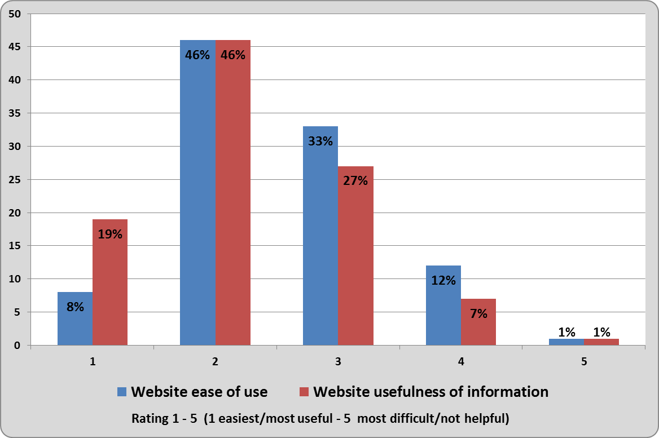
Figure 3 shows the ratings made by survey respondents for two questions asking about our website. Ratings are from 1-5, with 1 being easiest/most useful and 5 being most difficult/not helpful.
Almost all respondents have referred to our website for information. Overall ratings are positive, but there is room for improvement.

Website ease of use
Over half of the respondents rated the Department’s website as extremely easy or reasonably easy to use.
A third of respondents indicated that some information is easier to find than others.
Average individual ratings for ease of finding information show a slight reduction compared to 2014 (from 2.53 to 2.51).
There were no notable differences in website ratings across subsectors. A breakdown is provided in the support document - Figure 3.1.
Sixty seven respondents provided additional comments. Some indicated that navigating the website is easy using the search function, while others expressed the opposite viewpoint.
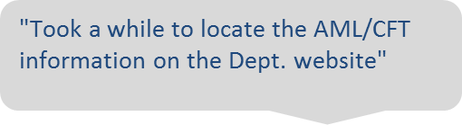
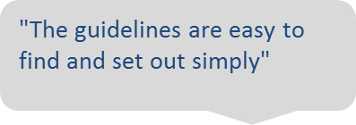
Website information
Almost two thirds of respondents rated information on the website as being extremely useful or reasonably useful.
A quarter of respondents indicated that they find some information more useful than others.
Average ratings for usefulness of information provided on our website also show a slight reduction compared to 2014 (from 2.49 to 2.25).
Forty six respondents provided additional comments. Again, opinions were split between those finding the information useful and easy to understand to those requesting simplification of the language and additional guidance material.
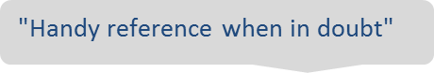
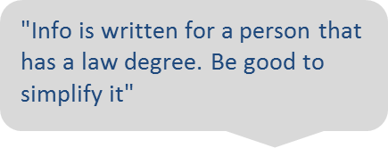
There are no significant differences in website ratings across subsectors. A breakdown is provided in the Support Document - Figure 3.1.
We recognise the importance of our website in providing information to our sector. Survey results and comments will be considered when decisions are made on any changes.

Other interaction
Seventy percent of respondents have had contact with the Department (other than the website or newsletters).
Figure 4: Types of interaction with the Department
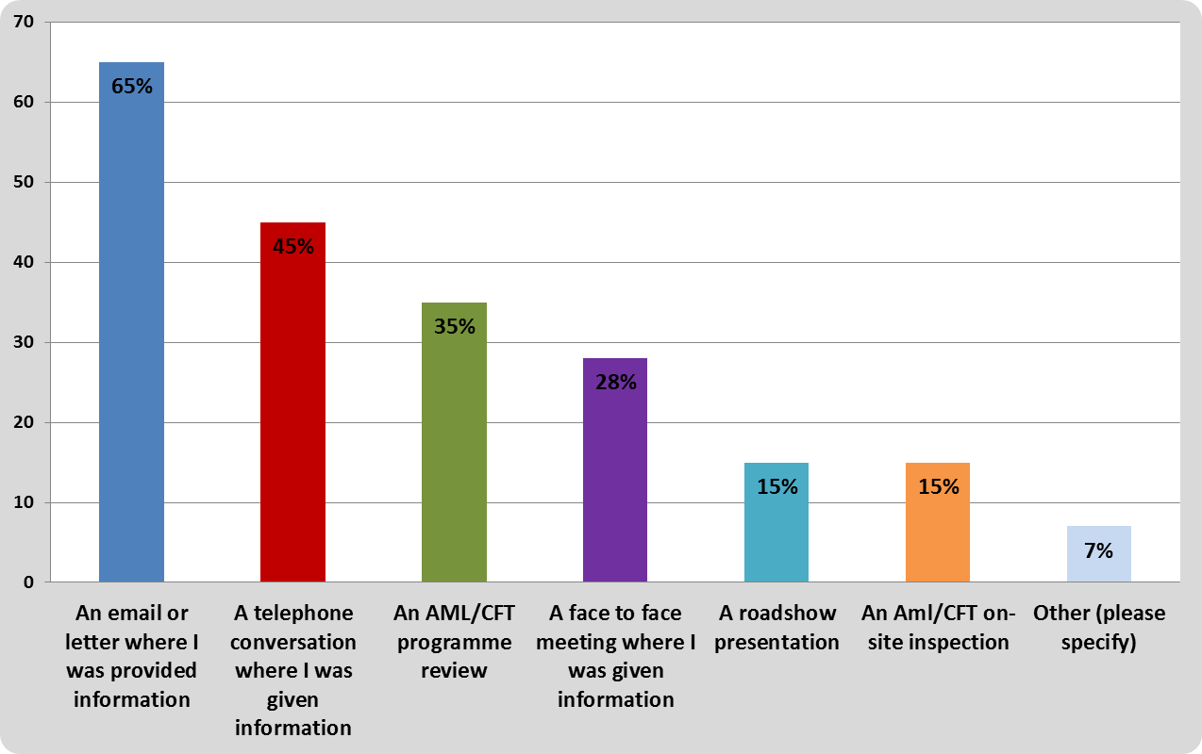
Figure 4 shows the ways survey respondents interact with the Department. A total of 482 selections were made by 231 respondents.
Interactions through programme reviews and on-site inspections have increased compared to 2014 which reflects changes in the Department’s work programme over the past twelve months.
There have been notable increases in the number of telephone and email interactions compared to 2014.
Other sources of information
Three quarters of respondents have used other sources of information to assist their understanding of compliance with the Act’s requirements.
Multiple selections indicate that our reporting entities are aware of the range of sources available and are actively using them (235 respondents made a total of 616 selections).
In our survey we provided nine specific sources to choose from, as well as an “other” option. All received at least thirty selections by survey respondents.

Figure 5: Five most popular non-Department sources of information
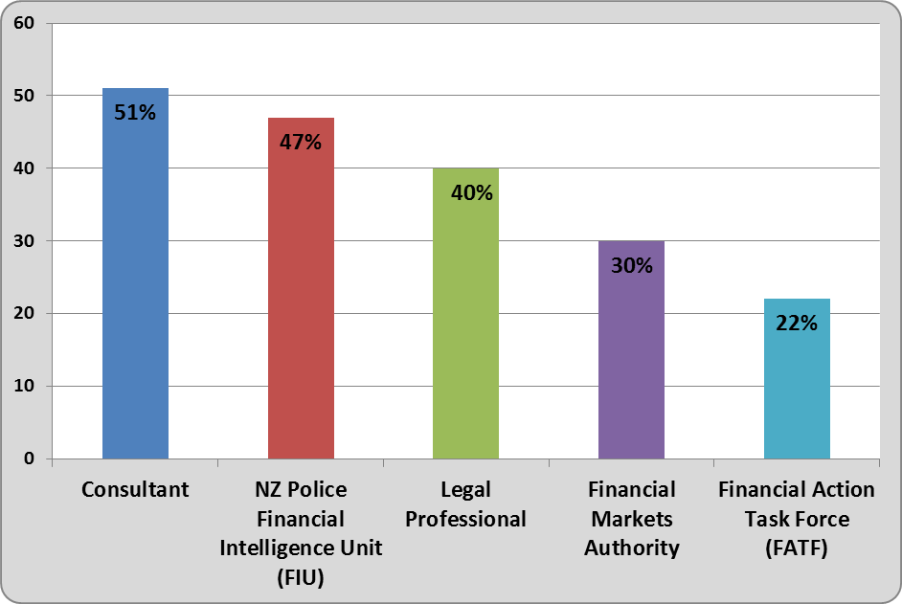
Figure 5 shows the five non-Department sources of information mostly commonly used by our survey respondents. These are the same sources that received the most selections in 2014.
Our reporting entities recognise the value of using other information sources to help them understand and comply with the Act.

Consultants remain the most popular option, although the percentage of respondents using this source has reduced slightly compared to last year’s survey (from 58 per cent to 51 per cent).
The FIU has overtaken legal professionals as the second most popular source (from 36 per cent to 47 per cent).
Australian Transaction Reports and Analysis Centre (AUSTRAC) was provided as a selection option this year and received thirty two selections (13 per cent).
In the “other” category, a number of respondents told us that auditors are also used as an additional source of information.

Sector understanding of the AML/CFT Act
As a supervisor under the Act, we want to be confident that our reporting entities understand their obligations.
Our 2014 survey focused on four areas and we repeated them this year:
- How would you rate your business’s understanding of conducting a risk assessment to assess the money laundering and terrorist financing risks your business reasonably expects to face?
- How would you rate your business’s understanding of developing and regularly reviewing the AML/CFT Programme for your business?
- How would you rate your business’s understanding of the information you need to provide in your Annual Report to the Sector Supervisor (i.e. to the Department)?
- How would you rate your business’s understanding of the requirement to submit Suspicious Transactions Reports (STRs) to the Police Financial Intelligence Unit (FIU)?

Figure 6: Comparison of individual average awareness ratings
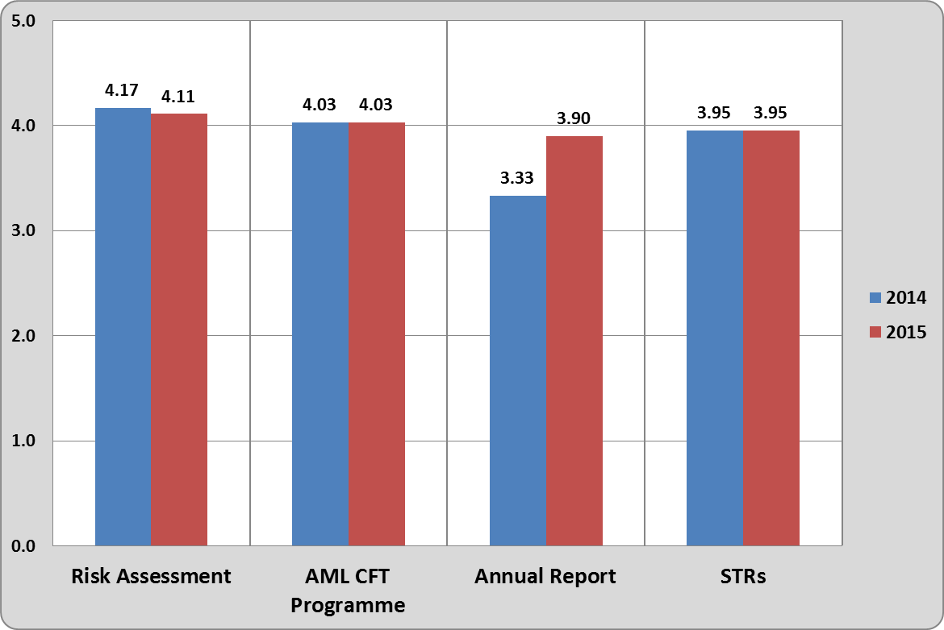
Figure 6 shows average individual ratings for 2014 and 2015 for each of the focus area questions. Subsector averages are provided in the Support Document - Figures 6.1- 6.4.

Questions use a self-rating scale from 1-5, with 1 being low and 5 being high:
- No understanding at all
- Very little understanding of the requirements
- Some understanding of the requirements
- A reasonable understanding of the requirements
- An extremely good understanding of the requirements
Each rating question was followed by the opportunity for respondents to include a comment about that area. This enabled us to collect additional, specific information.
Reporting entities have maintained or improved their understanding of four important obligations under the Act.

Risk Assessment
There has been a slight reduction in individual respondent’s confidence ratings compared to last year, from 4.17 to 4.11.
Overall there is a high degree of reported confidence from individual respondents, with 85 per cent rating their understanding as reasonable or extremely good.
Eighty comments were provided linked to the risk assessment. Some comments offer reflection on the learning process their business has been though. Others state that they are small, low risk entities. Many refer to helpful sources (both from the Department and others) that they have used to support compliance.

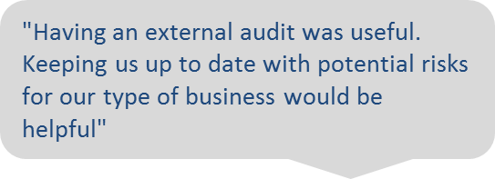

AML/CFT Programme
Self-reported understanding for individual respondents in 2014 was high and has remained constant this year at an average of 4.03.
Almost eighty percent are confident in rating their understanding as reasonable or extremely good.
Sixty two comments were provided. They reflect the range of support sources being used in this area (including Department and non-Department sources). Some respondents provided details of the challenges experienced and approach taken.

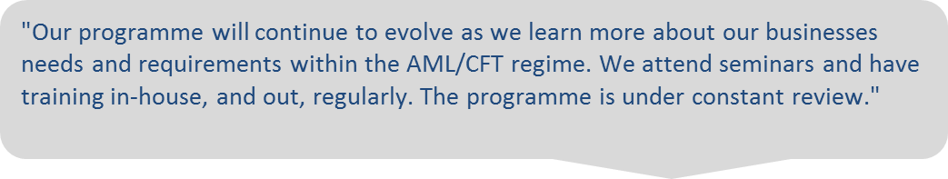

Annual Report
Self-reported understanding for individual respondents in 2014 was in the mid-range (average of 3.33) and shows an increased rating this year to an average of 3.90.
Seventy five per cent of respondents are confident in rating their understanding as reasonable or extremely good.
Respondents completing the survey in 2014 had not yet submitted an annual report and this was reflected in the lowest ratings of the four areas. A year later, one annual report submission cycle has been completed (August 2014) and this process has improved respondents’ understanding.
Some comments indicate that the Department’s templates and guidelines have been helpful in supporting businesses through the process. Others say they find it confusing and not easily applied to their business.

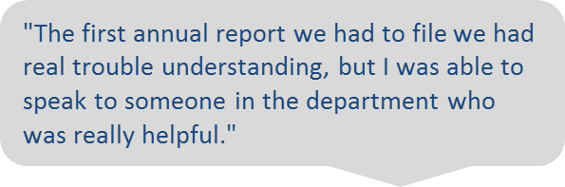
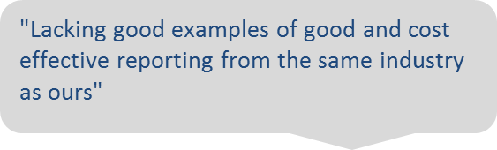

Submitting Suspicious Transaction Reports
Self-reported understanding for individuals in 2014 was relatively high and has remained constant this year at an average of 3.95.
Seventy six per cent of respondents are confident in rating their understanding as reasonable or extremely good.

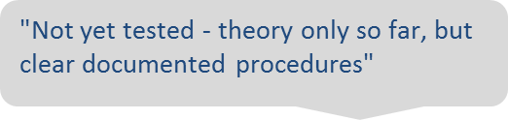

Subsector ratings
The Department’s three highest risk subsectors are Remitters, Trust and Company Service Providers, and Casinos. At the time we carried out the survey, these made up approximately 23 per cent of the known reporting entities that we supervise and are adequately represented in our survey sample (20 per cent of respondents).
Casinos remain one of the most confident subsectors in rating their understanding of conducting a risk assessment (average of 4.75).
Average ratings for risk assessments for each of the high risk subsectors have reduced slightly this year, which is consistent with the individual respondent trend in our survey.
Overall, there are no particular patterns or differences in average ratings between the sub sectors.
Payroll had the lowest average ratings across all four questions, although this is a small subsector representing less than 2 per cent of survey respondents.

Final comments
A number of comments were about the cost impact of the Act (financial and time), reflecting that it is expensive for small businesses. Some respondents stated an opinion that it shouldn’t apply to their business.
Other final comments said that using the Department and other sources has developed their understanding. For a number, that was challenging at first, but has become easier.
“Good to see the DIA supporting us whilst we come up to speed on what is required.”

For example, Debt Collection Services are exempt under regulation 22 of the Anti-Money Laundering and Countering Financing of Terrorism (Exemptions) Regulations 2011
As outlined in the AML/CFT Sector Risk Assessment Guides 2014 available on our website: http://www.dia.govt.nz/diawebsite.nsf/wpg_URL/Services-Anti-Money-Laundering-Sector-and-National-Risk-Assessments#GUI

