**Appendix A**

**DIVISION 20 - DRAGON 21**

Section 1 Interpretation

Section 2 Application

Section 3 Table Layout and Equipment

Section 4 Playing Cards

Section 5 Wagers

Section 6 Opening of Table for Gambling

Section 7 Shuffle and Cut of Cards

Section 8 Initial Deal

Section 9 Drawing Additional Cards

Section 10 Payment and Collection of Wagers

Section 11 End of Shoe

Section 11A Perfect Pairs

Section 12 Irregularities

Appendix A Dragon 21 Layout

**1 Interpretation**

In this division, unless the contrary intention appears:

**“Blackjack”** means an ace and any card having a point value of 10 dealt as the initial 2 cards to a Tiger or Dragon;

**“Coloured Pair”** means a pair comprised of either two red cards of different suits, or two black cards of different suits;

**“Continuous Shuffler”** means a type of automatic card shuffler that shuffles all or most of the cards used in the game continuously as the game is being conducted;

**“Dragon”** means the seated player (or his/her nominee who must also be seated at the game) who, when the game is conducted in accordance with Dealing Style B, receives and handles the Dragon’s hand;

**“Dragon’s box”** means that part of the layout in front of the dealer controlling the cards that is designated as the playing area for the Dragon’s Hand by the word “Dragon”

**“Dragon’s hand”** means the cards dealt to the Dragon’s Box pursuant to these rules;

**“Initial Deal”** means the dealing of the first 4 cards in a round of play, 2 each to the Dragons hand and the Tigers Hand;

**“Mixed Pair”** means a pair comprised of one red card and one black card;

**“Nominee”** means a person nominated by a player who may handle the cards and/or place wagers on behalf of that player;

**“Non-Continuous Shuffler”** means a type of automatic card shuffler that shuffles a set of 4 to 8 decks of cards used in the game as a batch before they are dealt;

**“Pair”** means two cards with the same face value;

**“Perfect Pair”** means a pair comprised of cards of the same suit;

**“Perfect Pairs Wager”** means an optional, additional wager which may be made by a player in accordance with section 11A;

**“Tiger”** means the seated player (or his/her nominee who must also be seated at the game) who, when the game is conducted in accordance with Dealing Style B, receives and handles the Tiger’s hand;

**“Tiger’s Box”** means that part of the layout in front of the dealer controlling the cards that is designated as the playing area for the Tiger’s Hand by the word “Tiger”;

**“Tiger’s hand”** means the cards dealt to the Tiger’s Box pursuant to these rules;

**“Table Differential”** means the difference between the total amount wagered on the Dragon’s hand and the total amount wagered on the Tiger’s Hand in a round of play;

**“Tie”** means that the Dragon’s hand and the Tiger’s Hand have the same point count after all cards required to be dealt to those hands pursuant to these rules have been dealt to those hands; and

**“Void Hand”** means a round of play which is conducted in accordance with the rules of Dragon21, except that no wagers are permitted.

**2.0 Application**

2.1 The rules contained in this division together with the general rules contained in division 1, shall apply to the game of Dragon21.

2.2 Notwithstanding any other rule in this division;

(a) a player may only appoint a nominee with the prior approval of the game supervisor or casino supervisor;

(b) a nominee must be announced by the game supervisor or casino supervisor prior to initiating the role:

(c) an identification marker which is clearly distinguishable by surveillance must be placed on the table in front of the person the nominee represents while the nominee is acting in that capacity;

(d) a nominee may only act on behalf of one player at any given time;

(e) subject to rules 2.3(f) and (g), the game supervisor or casino supervisor shall announce following confirmation from the player when a nominee ceases to act on the player’s behalf;

(f) the game supervisor or casino supervisor may at any time withdraw his/her approval and direct some or all players at the game to place their own wagers, in which case the players may not instruct other persons to place wagers on their behalf;

(g) the game supervisor or casino supervisor may at any time withdraw his/her approval and direct some or all players at the game to turn or handle their own cards, in which case the players may not instruct other persons to turn or handle cards on their behalf; and

(h) a casino employee, associated person or any other person who works at the casino cannot act as a nominee for another player.

**3.0 Table layout and Equipment**

3.1 Dragon21 shall be played at a table that has 7 sets of wagering areas for the players and on the opposite side a place for the dealer. Each Dragon21 table shall have a drop box attached to it.

3.2 The layout cloth covering the table shall be marked in a manner similar to that show in Appendix A.

3.3 The wagering areas shall be designated:

(a) for wagers on the Dragon’s Hand by the work “Dragon”

(b) for wagers on the Tiger’s Hand by the word “Tiger”

(c) for wagers on a Tie Bet by the work “Tie”

3.4 The following equipment shall also be used in the game:

(a) at the option or the casino operator, either:

(i) (A) one set of 4 to 8 decks of playing cards, and

(B) a card shoe, with a non-transparent sliding cover, which is capable of holding all of the cards used in the game, or

(ii) (A) 2 sets of 4 to 8 decks of playing cards each, the backs of each

set being of different colour, and

(B) a non-continuous shuffler which is capable of holding 8 decks of cards, and

(C) a card shoe, with a non-transparent sliding cover, which is capable of holding either of the sets of cards used in the game, or

(iii) unless the game is being conducted in accordance with Dealing style B as described in section 8:

1. One set of 4 to 8 decks of playing cards, and
2. A continuous shuffler which is capable of holding all of the cards used in the game; and

(b) one or (at the option of the casino operator) 2 cutting cards; and

(c) a discard rack or container capable of holding all of the cards used in the game; and

(d) 2 round indicator pucks marked “Dragon” and “Tiger” respectively, which shall be used to indicate the Dragon and Tiger respectively when the game is being conducted in accordance with Dealing Style B.

(e) at the option of the casino operator, a game results display, being an electronic device for recording and displaying the most recent winning results at the table

**4.0 Playing Cards**

4.1 The point value of the playing cards used in the game shall be as follows:

(a) a card from 2-9 inclusive shall have its face value; and

(b) a 10, jack, queen or king shall have a point value of 10; and

(c) an ace shall have a point value of 11 except where that would give a Dragon or Tiger hand a point total of more than 21, in which case it shall have a value of 1.

4.2 No player or spectator shall handle, alter or withdraw any card used in the game, except as expressly permitted by these rules, and no dealer or other person shall permit a player or spectator to do so. The dealer shall at all times deal the cards.

**5.0 Wagers**

5.1 A player (or his/her nominee) at the game may place the following wagers subject to rule 5.1a

(a) a wager on the “Dragons Hand”, which shall:

(i) (a) win if the final point count of the Dragon’s hand is higher than that of the Tiger’s hand if both hands point counts are less than 22; or

(b) win if the Dragons hand is less than the Tigers hand if both hands point counts are 22 or more; or

(c) win if the Dragons hand is 21 or less and the Tigers hand exceeds 21.

(d) win if the Dragons hand has Blackjack and the Tigers hand does not.

Winning wagers shall be paid at the odds contained in rule 5.2

(ii) constitute a standoff if the final point counts of the Dragon and Tiger hands are equal.

(iii) otherwise lose.

(b) a wager on the “Tigers Hand’, which shall:

(i) (a) win if the final point count of the Tiger’s hand is higher than that of the Dragon’s hand if both hands point counts are less than 22; or

(b) win if the Tiger’s hand is less than the Dragon’s hand if both hands point counts are 22 or more; or

(c) win if the Tiger’s hand is 21 or less and the Dragon’s hand exceeds 21.

(d) win if the Tigers hand has blackjack and the Dragon’s hand does not.

Winning wagers shall be paid at the odds contained in rule 5.1a

(ii) constitute a standoff if the final point counts of the Dragon and Tiger hands are equal, notwithstanding rules 5.1(a)(i)(d) and 5.1(b)(i)(d).

(iii) otherwise lose.

(c) a “Tie Bet”, which shall:

(i) win if the Dragons and Tigers hands are both equal unless exactly one of the two hands has blackjack. The wager shall be paid at the following odds:

Tie <21 7 to 1

Tie>21 7 to 1

Tie = 21 9 to 1

Tie Blackjack 12 to 1

(ii) otherwise lose.

5.1a Winning Dragon and Tiger bets shall be paid at the following odds:

Win with 17 Push

Win with 18,19,20,21 1 to 1

Tie Push

Win with Blackjack 3 to 2

Win with >21 5 to 1

5.2 In any round of play a player (or his/her nominee) may wager on:

(a) The Dragon’s hand; or

(b) The Dragons’ hand and Tie; or

(c) The Dragon’s hand and Tiger’s hand: or

(d) The Dragon’s hand and Tiger’s hand and Tie; or

(e) The Tiger’s hand; or

(f) The Tigers Hand and tie; or

(g) Tie

5.3 All wagers shall be made by placing chips, with the smaller denomination chips on tip, in the appropriate wager area of the baccarat layout.

5.4 Orally declared wagers shall be accepted only when accompanied by chips and if the dealer has enough time to place the wager on the layout before “No more bets” is called.

5.5 Each player shall be responsible for the correct placement of his/her wager whether or not he/she is assisted by his/her nominee and/or the dealer. Each player shall be responsible for ensuring that any instructions he/she gives to his/her nominee and/or the dealer regarding the placement of his/her wager are correctly carried out.

5.6 Subject to these rules, standing players may also participate in the game.

Standing players shall not participate in the cut of the cards or touch or handle the cards used in the game in any manner and shall not be appointed Dragon or Tiger.

5.7 The Casino operator may;

(a) permit up to three players (including their nominees) to wager on any one wagering area.

(b) direct that the total of all players’ (including their nominees’) wagers on any one wagering area shall not exceed the table maximum, or that the total of the wagers of any particular player (including his/her nominee) or players (including their nominees’) on any one wagering area shall not exceed the table maximum.

5.8 If a player (or his/her nominee), being allowed by these rules to do so, wagers on the Dragon’s Hand, or on the Tiger’s hand, or on a Tie bet, by placing a bet on more than one wagering area during a round of play:

(a) the applicable minimum wager limit applies to each bet placed by the player (or his/her nominee) on each of those wagering areas; and

(b) subject to rule 5.7(b), the applicable (table or personal) maximum wager limit applies to the total of the bets placed by the player (or his/her nominee) on that outcome.

5.9 Except as permitted by these rules, once the dealer has called “No more bets” no player (or his/her nominee) shall:

(a) make any wager; or

(b) handle, alter or withdraw any wager until a decision has been make and implemented with respect to all winning wagers in the wagering area,

And no dealer or other person shall permit a player (or his/her nominee) to do so.

5.10 No player (or his/her nominee) shall handle, alter or withdraw a losing wager.

5.11 If there is a tie, players (or their nominees) may alter their wagers on the Dragon or Tiger Hands before the start of the next round.

5.12 The casino operator may stipulate a maximum table differential. The amount of any such differential shall be displayed on the notice at the table indication the minimum and maximum wager limits.

5.13 Where the total amount wagered on the Dragon’s hand or the Tiger’s hand is such that the maximum table differential displayed on the notice is exceeded, the dealer may reduce the wagers on the hand pro rata so that the maximum table differential is not exceeded.

**6.0 Opening the table for Gambling**

6.1 Division 5, section 6 of the rules of Baccarat shall apply.

**7.0 Shuffle and cut of Cards**

7.1Division 5, section 7 of the rules of Baccarat shall apply.

**8.0 Initial Deal**

8.1Division 5, section 8 of the rules of Baccarat shall apply, where references to the “Player” and “Players Hand” shall refer to “Dragon” and “Dragons Hand” respectively, and references to “Banker” and “Bankers’ Hand” shall refer to “Tiger” and “Tigers Hand” respectively.

**9.0 Dealing of Additional Cards**

9.1 If either the Dragon’s hand or the Tiger’s hand has a blackjack, then no more cards shall be drawn.

9.2 Subject to rule 9.1, additional cards shall be drawn to the Dragon’s hand until the point total of that hand exceeds 16, then additional cards shall be drawn to the Tiger’s hand until the point total of that hand exceeds 16.

9.3 When dealing Style A and Style C any additional cards dealt to a hand shall be dealt face up to that hand.

9.4 When dealing Style B, any additional cards dealt to a hand shall be passed face down to the player (or his/her nominee) (if any) designated to receive the cards dealt to the hand. The provisions of rules 8.13 to 8.18 inclusive of the rules of Baccarat shall apply, with all necessary modifications, as if the additional cards were the 2 initial cards of the hand.

9.5 When dealing Style B, the casino operator may at their discretion deal any additional cards dealt to a hand face up.

**10.0 Payment and Collection of Wagers**

10.1 When each hand has received all the cards it is entitled to under the rules, the dealer shall announce the final point totals of each hand, indicating which hand has won the round. If both hands have equal point totals, the dealer shall announce “Tie Hand” and the point total that the hands are tied on.

10.2 After announcing the result of the round, the dealer shall collect all losing wagers and pay all winning wagers.

**11.0 End of Shoe.**

11.1The rules of Division 5 Section 11 of Baccarat shall apply.

**11A Perfect Pairs wagers**

11A.1Division 5, section 11a of the rules of Baccarat shall apply, where references to the “Player” and “Players Hand” shall refer to “Dragon” and “Dragons Hand” respectively, and references to “Banker” and “Bankers’ Hand” shall refer to “Tiger” and “Tigers Hand” respectively.

**12.0 Irregularities**

12.1Division 5, section 12 of the rules of Baccarat shall apply, where references to the “Player” and “Players Hand” shall refer to “Dragon” and “Dragons Hand” respectively, and references to “Banker” and “Bankers’ Hand” shall refer to “Tiger” and “Tigers Hand” respectively.

**Appendix A**

**Dragon21 layout**

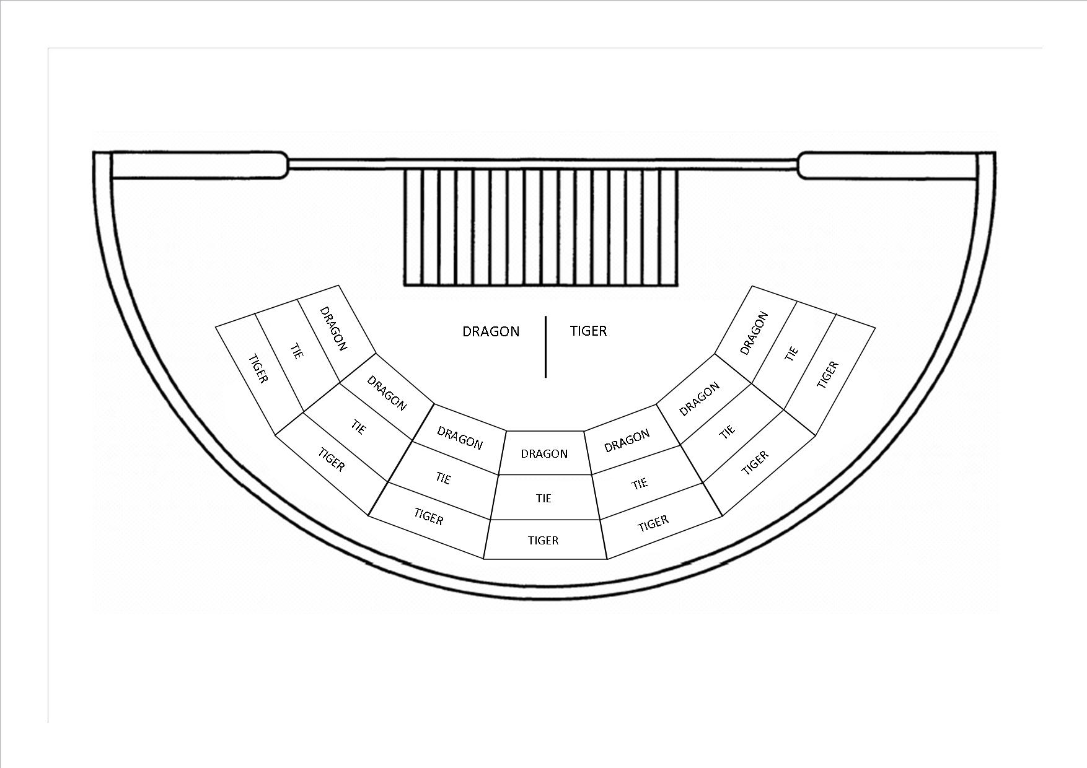

**Appendix B**

**DIVISION 21 – LUNAR POKER**

**1 Interpretation**

In this division, unless the contrary intention appears:

**“Ante Wager”** means the initial wager made by a player pursuant to subparagraph (a) of rule 5.1;

**“Super bet Wager”** means the side bet wager made by a player pursuant to subparagraph (b) of rule 5.1;

**“Bet Wager”** means an additional wager made by a player on his/her hand pursuant to subparagraph (b) of rule 5.2;

**“Fee”** means the money paid by a player, enabling the player to exercise one of two Draw options as well as the Force dealer to try to qualify option in accordance rules 8.5, 8.6 and 10.3;

**“Fold”**, in relation to a hand of cards, means to continue no longer with the hand;

**“Play”**, in relation to a hand of cards means to continue with the hand against the dealer;

**“Draw”** means the two options available to the player where they may either exchange 2-5 cards or to buy a 6th card pursuant to rules 8.5 & 8.6.

**“Poker Value”** means, in relation to a hand of cards, the ranking of that hand as determined in accordance with section 4.

**2 Application**

* 1. The rules contained in this document, shall apply to the game of Lunar Poker.

**3 Table Layout and Equipment**

* 1. Lunar Poker shall be played at a table having on one side up to 5 sets of wagering areas for the players and on the opposite side a place for the dealer. Each Lunar Poker table shall have a drop box attached to it.
  2. The layout cloth covering the table shall:

1. bear an inscription to the effect that the “Dealer only plays with ace and king or higher”; and
2. be marked in a manner substantially similar to that shown in the appendix.
   1. The wagering and fee areas shall be designated as follows:
3. for ante wagers by the word “Ante”;
4. for bet wagers by the word “Bet”;
5. for super wagers by the word “Super”;
6. for option fees by the wording “Exchange 2-5 Cards”, “Buy a 6th Card” and “Force the Dealer”
   1. The following equipment shall also be used in the game:
7. one deck of playing cards;
8. one cutting card;
9. either:

(i) a card shoe capable of holding all of the cards used in the game, or

(ii) an automatic shuffler capable of holding 2 decks of cards, from which the cards will be dealt; and

1. a discard rack capable of holding a single deck of cards.

**4 Playing Cards and Ranking of Hands**

* 1. All suits of cards shall have the same rank.
  2. Cards shall rank, from lowest to highest, as follows: 2, 3, 4, 5, 6, 7, 8, 9, 10, jack, queen, king, ace, except as provided in rule 4.3, where aces may be counted low.
  3. Hands of cards shall rank, from lowest to highest, as follows:

(a) **Odd Cards -** for example, ace, king, 6, 4, 2

(b) **1 Pair -** 2 cards of the same value, a higher pair beating a lower pair. Aces shall be high

(c) **2 Pairs -** 2 different pairs, with a pair of aces and a pair of kings being the highest ranking 2 Pair. Aces shall be high

(d) **3 of a Kind -** 3 cards of the same value. The hands take their rank from the higher ranked threesome

(e) **Straight -** 5 cards of any suit in sequence. An ace may be counted as high or low

(f) **Flush** - 5 cards of the same suit, not in sequence. The value of the highest card in the hand shall decide the ranking between 2 flushes; where the highest cards in both hands are the same value, the next card; and so on

(g) **Full House** - 3 cards of the same value and a Pair. The hands take their rank from the threesome

(h) **4 of a Kind** - 4 cards of the same value. The value of the highest 4 of a kind cards in the hand shall decide the ranking between 2 different 4 of a kind

(i) **Straight Flush**  - 5 cards of the same suit in sequence. The value of the highest card in the hand shall decide the ranking between 2 straight flushes

(j) **Royal Flush -** ace, king, queen, jack and 10 of the same suit.

* 1. Hands of the same poker hand value, but consisting of different card values, shall be ranked according to the card values prescribed in rule 4.2. For example:

1. In the case of odd cards, the respective card values of the highest card in each hand shall determine the ranking. If the highest of these cards in the hands are of the same card value, the respective values of the next highest cards shall determine the outcome, and so on;
2. Where 2 hands hold single Pairs of the same card value, the respective values of the highest of the remaining cards in each hand shall determine the outcome. If the highest of the remaining cards in the hands are of the same card value, the respective values of the next highest cards shall determine the outcome, and so on;
3. In the case of 2 hands each containing 2 Pairs, the hand holding the highest pair in terms of card value shall be ranked the higher. If the highest pair in each of the hands is of the same value, the respective card values of the second pairs shall determine the outcome. In the case of a draw, the respective card values of the fifth cards in the hands determine which hand shall be higher;
4. A Straight (or Straight Flush) that contains the highest value card beats a hand that contains the lowest value cards.
   1. A player is responsible for declaring their optimum poker hand to the dealer, as well as any instant cash payout or super hands as described in rules 5.6. and 5.9.

**5 Wagers and Fees**

* 1. Before the first card is dealt in a round each player:

1. shall make an ante wager; and
2. may elect to place a super bet wager
   1. After 5 cards have been dealt to each player and the dealer, the players may pick up their cards, evaluate their hands and either:
3. fold; or
4. play by making a bet wager of twice the amount of the ante wager on the hand; or
5. pay a draw fee to exchange 2-5 cards or buy a 6th card and then decide to fold or play
   1. All ante wagers, bet wagers and draw fees shall be made by placing chips, with the smaller denomination chips on the top, in the appropriate wager or fee area of the layout.
   2. Only one wager shall be accepted on any one wagering area.
   3. Aside from when the player has an instant cash payout hand as described in rule 5.6, ante wagers will only be paid when the dealer does not qualify. Ante and bet wagers shall be paid at the following odds:

**Ante Wagers Payout Odds**

Ante wagers 1 to 1

**Bet Wagers Payout Odds**

Ace and king 1 to 1

1 Pair 1 to 1

2 Pairs 2 to 1

3 of a Kind 3 to 1

Straight 4 to 1

Flush 5 to 1

Full House 7 to 1

4 of a Kind 20 to 1

Straight Flush 50 to 1

Royal Flush 100 to 1

* 1. If the player is dealt a Royal Flush or Straight Flush in their initial five card hand, they automatically qualify for the instant cash payout feature.

In this case and regardless of the dealer qualifying or not, the player’s ante wager will be paid out at odds selected from the below range. Theses odds will be selected and displayed at the gaming table by the Casino Operator:

**Straight Flush Royal Flush**

**“Ante” Pays** **“Ante” Pays**

200:1 600:1

300:1 600:1

200:1 800:1

300:1 800:1

200:1 1000:1

300:1 1000:1

200:1 1200:1

300:1 1200:1

400:1 1200:1

200:1 1500:1

300:1 1500:1

400:1 1500:1

500:1 1500:1

* 1. The verification and settlement of instant cash payout winning wagers will take place in clockwise order.

The Dealer will wait for all other players to make a decision on whether to play, fold or draw and announce “all decisions are locked in” prior to verifying and settling the winning super wagers. Once the dealer has made this announcement, the players cannot change their decisions.

* 1. Once the player’s ante has been paid out according to the selected and displayed odds outlined in rule 5.6, the player’s cards are collected and the round of play is then over for that player.
  2. If the player has placed a super bet wager as described in rule 5.1(b) and is dealt any of the super combinations in their initial five card hand as outlined in the pay table below, the player’s super wager will be paid out at the following described odds:

**Super Combination Super Wager Pays**

Four of a Kind 200:1

Same Coloured Straight 150:1

Full House 100:1

Flush 50:1

Straight 25:1

Three of a Kind 8:1

Ace-King-Queen 6:1

5 Same Coloured Cards 2:1

The Casino Operator may elect to adjust the odds in the SUPER Side Bet Pat Table outlined above where the combination of Three of a Kind may pay 7:1 and/or the combination of Ace-King-Queen may pay 5:1.

* 1. The settlement of winning super wagers will take place in clockwise order and prior to the dealer acting on the option selected by each player in turn.

The Dealer will wait for all other players to make a decision on whether to play, fold or draw and announce “all decisions are locked in” prior to verifying and settling the winning super wagers. Once the dealer has made this announcement, the players cannot change their decisions.

As each player’s winning super wager is verified and settled, the cards are then passed back to the player where the player then has the opportunity to fold, play or draw as described in rule 5.2.

* 1. If the player’s winning super combination is a Royal Flush or Straight Flush these hands constitute a Same Coloured Straight, either combination also qualifies for the instant cash payout feature as described in rule 5.6.

In this case, the player’s ante will be paid out at the selected instant cash payout odds in rule 5.6 and if a super bet has been placed, that bet will be paid out at the relevant super odds, according to the pay tables outlined in rule 5.9 and with either or both bets also subject to rule 5.12. The round of play will then be over for that player that has received the Royal flush or Straight flush, and their cards will be collected by the dealer.

* 1. The payout odds on bet wagers, ante wagers and super wagers shall be subject to any maximum payout limit set by the casino operator. The amount of such limit will be selected and displayed at the gaming table by the Casino Operator:
  2. Except as permitted by these rules, once the dealer has called “No more bets” no player shall:

1. make any ante wager or super wager; or
2. handle, alter or withdraw any wager until a decision has been made and implemented with respect to the wager
   1. No player shall handle, alter or withdraw a losing wager.

**6 Opening of Table for Gambling**

* 1. After receiving the designated number of decks of cards at the table (1 deck if a card shoe is used, 2 decks if an automatic shuffler is), both the dealer and the game supervisor shall sort and inspect the cards independently of each other.
  2. After the cards have been inspected they shall be spread out face up on the table for visual inspection. The cards shall be spread out in horizontal fan-shaped rows according to suit, in sequence within the suit.
  3. After the cards have been inspected visually, the cards shall be turned face down on the table, stacked and shuffled.
  4. When an automatic shuffler is used:

1. each of the decks of cards shall be turned face down on the table, chemmy shuffled, stacked and riffle shuffled separately within the deck by the dealer;
2. each of the decks shall then be loaded into the automatic shuffler and shuffled separately by it; and
3. the cutting card shall be used in accordance with approved procedures.

**7 Shuffle and Cut of Cards**

* 1. The cards shall be shuffled so that they are randomly intermixed within the deck:

1. immediately before the start of play;
2. at the end of each round;
3. at the recommencement of play following any period during which the table has been vacant; and
4. at the direction of a game supervisor or casino supervisor where there is reason to suspect that the randomness of the shuffle has been
5. compromised; and
6. if any card has been exposed prior to the cards entering the shoe; and at the direction of a game supervisor or casino supervisor, at his or her discretion.
   1. Where a card shoe is used, after the cards have been shuffled a casino employee shall cut the cards once, place them on the cutting card and then place all of the cards in the shoe for the commencement of play. No player ever cuts the cards.
   2. The dealer may at any time check and verify that the deck of cards or any of the decks, as the case may be, contains the correct number of cards, namely 52.
   3. The casino operator may, after any round of play, direct that the cards be replaced, in which event the new cards shall be checked, shuffled and cut in accordance with sections 6 and 7.

**8 Dealing the Cards**

* 1. Immediately before the start of each round of play, and after all ante wagers and super wagers (if applicable) have been made, the dealer shall:

1. Call “No more bets”; and then
2. Starting on his/her left and continuing clockwise around the table, deal the cards.
   1. All cards shall be dealt face down except for the dealer’s last card, which (subject to rule 8.4) shall be dealt face up.
   2. When a card shoe is used the cards shall be dealt as follows:
3. one card to each wagering area containing an ante wager and then 1 card to the dealer; followed by
4. a further card to each such wagering area and the dealer, and so on until every player and the dealer have 5 cards each.
   1. When an automatic shuffler is used the cards shall be dealt as follows:
5. 5 cards at a time to each wagering area containing an ante wager; followed by
6. 5 cards to the dealer.

The dealer’s bottom card shall then be turned over to face up.

* 1. If after the initial deal described in rules 8.1-8.4, a player wishes to exchange 2-5 cards; after paying the draw fee of an amount equivalent to their ante wager, the player will place their unwanted cards face down beside their options area. The dealer will then:

1. remove the draw fee from the options area as payment for the card exchange
2. spread the player’s unwanted cards for exchange to verify the amount
3. Remove and replace the player’s unwanted cards with the same amount of cards from the deck in play

The player will then add the replacement cards to their hand.

* 1. If after the initial deal described in rules 8.1-8.4, a player wishes to buy a 6th card; once the player pays the draw fee an amount equivalent to their ante wager, the dealer will then:

1. remove the draw fee from the options area as payment for buying the 6th card
2. deal the player a 6th card beside their option area

The player will then add the 6th card to their initial 5 card hand.

* 1. Any additional cards required by players electing to exercise either of the draw options as described in rules 8.5 and 8.6, will be dealt from a card shoe using the remaining cards in the deck of play after the initial deal is complete. This will be the case regardless of whether a card shoe or an automated shuffler was used to complete the initial deal as described in rules 8.1-8.4.

**9 Betting Round**

* 1. After the initial 5 cards have been dealt to each player, the players will pick up their cards and decide whether to fold, draw as described in rules 8.5 and 8.6 or play against the dealer by making a bet wager double to that of their ante wager.
  2. At the same time, players who have placed a super wager must declare any wining super combination in their hand to the dealer. If the player does not declare a winning super combination, the dealer will go ahead and collect the losing super wager. Players must also declare any instant cash payout combinations after evaluating their initial 5 cards.
  3. If a player does declare a winning super or instant cash payout combination to the dealer, they will be asked to lay their cards face down in their bet area.

The dealer will not verify and pay any winning super or instant cash payout hands until all other players have clearly made a decision to play, fold or draw according to rules 9.4, 9.5 and 9.6.

The dealer will then verify and pay the winning super combinations in clockwise order prior to that player folding, exchanging cards, buying a 6th card or placing their bet wager to play against the dealer. At this point, any instant cash payout combinations will be settled in accordance with rule 5.6.

* 1. A player who decides to fold shall place his/her cards face down on the table. The dealer shall then, in relation to each player who has folded:

1. collect the ante wager and the player’s cards;
2. individually spread out the cards, face down, and count them; and
3. place the cards in the discard rack.
   1. The remaining players in the game then have the option to play against the dealer by placing a bet wager which will be double in value to that of their ante wager, or before making that decision, the players can elect to participate in the draw option.
   2. If any of the remaining players elect to participate in the draw option, the players may to choose to exchange 2-5 cards from their hand or buy a 6th card using the next card(s) from the deck in play as described in rules 8.5 and 8.6.
   3. Once all remaining players have clearly made a decision to play or draw, and all winning super or instant cash payout combinations have been settled in accordance to rules 5.6 and 5.9, the dealer will act on each box in a clockwise order from the dealer’s left to right.
   4. The Casino Operator may allow the dealer to act on the players’ options in a clockwise order as each player makes their decision to draw or play and prior to subsequent boxes making their decisions to draw or play.
   5. Once the players participating in the draw option have received their exchanged cards or 6th card from the dealer, they will then re-evaluate their hand and decide to fold by placing their cards face down on the layout, or play against the dealer by placing a bet wager in value of double their ante wager.
   6. When the players remaining in the game have made their bet wagers, the players shall place their cards face down on the layout in their designated bet area underneath their bet wager. After announcing “no more bets”, the dealer shall then turn all the remaining cards in the dealer’s hand face up and declare the highest poker value of the hand.
   7. The casino operator may, at its discretion, direct where players place their cards on the layout.
   8. When handling the cards, players shall at all times ensure that the cards remain on or above the area of the table. The cards must not be removed from the table.
   9. Except as expressly permitted by these rules, players may not exchange cards, nor exchange, communicate, nor cause to be exchanged or communicated any information regarding their respective hands to other players.
   10. At any time while a game is in progress the casino operator may direct that:
4. there be silence while a hand is in progress;
5. Players suspected of collusion not play at the same table.

**10 Final Settlement**

* 1. If the dealer’s hand does not have a poker value of an ace and king or higher, the dealer shall announce “No hand” or “Dealer does not qualify” and then, the dealer will ask the remaining players “Does anyone want to force dealer to try to qualify”
  2. For those players who do not wish to participate in the force dealer to try to qualify option, the dealer will;

1. pay the respective ante wagers in accordance with rule 5.5; and
2. spread each hand face down to ensure there are 5 or 6 cards where applicable,
3. collect the cards of those players and place them in the discard rack.
4. all bet wagers belonging to these players shall then be returned to each respective player.
   1. For those players who do wish to participate in the force dealer to try to qualify option, their ante wagers will not be paid and each player will need to pay a fee equivalent to that of their ante wager. Each fee will be placed in the player’s respective options fee area and collected by the dealer.
   2. The dealer will then remove the card of highest value from the dealer’s hand and replace this card with the next card from the deck in play, creating a second chance for the dealer to qualify. This process can only take place once in each round of play. If the dealer still fails to qualify with Ace and King or higher, all ante and bet wagers will be considered a stand-off and returned to the players.
   3. Regardless of the force dealer to qualify option being exercised by the players or not, if the dealer’s hand subsequently has a poker value of ace and king or higher, the dealer shall, starting on their right, turn the cards of the players remaining in the game face up, and:
5. arrange each player’s hand so that the highest poker value may easily be read;
6. compare the player’s hand with that of the dealer; and
7. announce the value of the player’s hand and whether it wins or loses.
   1. A player’s hand shall:
8. win if it has a higher poker value than that of the dealer’s hand;
9. lose if it has a lower poker value than that of the dealer’s hand;
10. constitute a stand-off if it has a poker value equal to that of the dealer’s hand.
    1. If a player’s hand loses the dealer shall:
11. collect the ante and the bet wagers on the hand; and
12. collect and count the player’s cards by individually spreading out the cards, face down, and counting them; before placing the cards in the discard rack.
    1. If a player’s hand wins the dealer shall:
13. pay the bet wager on the hand in accordance with rules 5.5 and 5.12,
14. collect and count the player’s cards by individually spreading out the cards, face down, and counting them; before placing the cards in the discard rack.
15. return the ante wager to the player
    1. If a winning player’s hand contains a second poker combination where at least one card in the second combination is not included in the winning combination, the dealer shall:
16. after paying the bet wager for the winning combination, reorganise the player’s cards to display the second poker combination; and
17. pay the bet wager for second combination as per the pay table outlined in rule 5.5 and in accordance with rule 5.12
18. collect and count the player’s cards as by individually spreading out the cards, face down, and counting them; before placing the cards in the discard rack.
    1. Subject to rule 10.2, if a player’s hand constitutes a stand-off the dealer shall collect and count the player’s cards by individually spreading out the cards, face down, and counting them; before placing the cards in the discard rack.

**11 Irregularities**

* 1. If a player fails to comply with rules 9.12 and 9.13 the casino operator may declare the player’s hand void, in which event any ante, bet and jackpot wagers made by that player shall be void.
  2. Except as specified elsewhere in these rules, if an incorrect number of cards is dealt to any player or to the dealer this shall constitute a misdeal.
  3. Subject to rules 11.4 and 11.5, if an exposed card is dealt this shall not constitute a misdeal. The dealer shall turn the card over and continue dealing.
  4. If a card is exposed in error to the dealer’s hand, the card shall be left exposed as the dealer’s face up card and the dealer’s fifth card shall be dealt face down, and, where the cards are dealt from an automatic shuffler, shall not be turned over as provided in rule 8.4.
  5. If more than one card is exposed in error during the dealing of the cards this shall constitute a misdeal.
  6. If a player exposes one or more cards in his/her hand, this shall not constitute a misdeal, subject to rule 11.1.
  7. Subject to rule 11.4 and not withstanding rule 11.5, if the dealer exposes one or more cards in his/her hand in error before all of the players have made a decision in relation to their bet wagers, the players will be given the option to make a bet wager or to fold.
  8. Subject to rule 11.9, if, before all cards are dealt, it is discovered that cards have been dealt to a wagering area without an ante wager, the round of play shall be declared a misdeal.
  9. If it is discovered that a complete hand has been dealt to a wagering area without an ante wager, the cards dealt to that wagering area shall be counted and placed in the discard rack and the game shall then continue.
  10. If it is discovered that the deck in use at the table does not contain 52 cards, the round shall constitute a misdeal and be void.
  11. Subject to these rules, in the event of a misdeal all wagers affected by the misdeal, shall be void. In the event of the entire round being void the hands shall be re-dealt after the players have had an opportunity to change their ante and super wager.
  12. If a player makes a wager and is dealt a complete hand but is not present at the table to make a decision on that hand, the player shall be deemed to have folded and all wagers shall be forfeited.
  13. If the dealer collects a player’s cards before the player has decided whether to make a bet wager or to fold, the player’s hand shall be reconstructed where possible but otherwise shall be void.
  14. Notwithstanding rule 11.10, when a player has laid his/her cards down on the table subsequent to the dealing of a complete hand, and those cards have been placed on the discard pile, that player’s hand may be reconstructed providing those cards are the top five on the discard pile. The player shall otherwise be deemed to have folded pursuant to rule 9.4
  15. If a player buys a 6th card or exchanges cards and has failed to declare an instant cash payout hand prior to receiving the 6th card or the exchanged cards, provided that the player has not viewed that 6th card or the exchanged cards and no further cards have been dealt to subsequent boxes, the casino operator may elect to make payment on the instant cash payout hand. In this case, the 6th card or the exchanged cards in question will be used by the dealer as the next card(s) in play if required.

If the player has viewed their 6th card or exchanged cards, or if additional cards have been bought or exchanged in subsequent boxes, then that player no longer qualifies for the instant cash payout feature payment.

11.16 If a player buys a 6th card or exchanges cards and has failed to declare a super combination prior to receiving the 6th card or the exchanged cards, provided that the player has not viewed that 6th card or the exchanged cards and no further cards have been dealt to subsequent boxes, the casino operator may elect to make payment on the super combination.

If the player has viewed their 6th card or exchanged cards, or if additional cards have already been bought or exchanged in subsequent boxes, then that player no longer qualifies for the super combination payment.

11.17 If there are insufficient cards to complete a hand, the dealer will manually shuffle the cards from the discard rack and deal those remaining cards as required.

11.18 If any provisions are not covered by the rules, the Operations Manager (or above) decision is final.

**Appendix**

**Lunar Poker layout**

Area designated for “Super” wagers

Area designated for “Option fees”. Will state:

“Exchange 2-5 cards”

“Buy a 6th card”

“Force the Dealer”

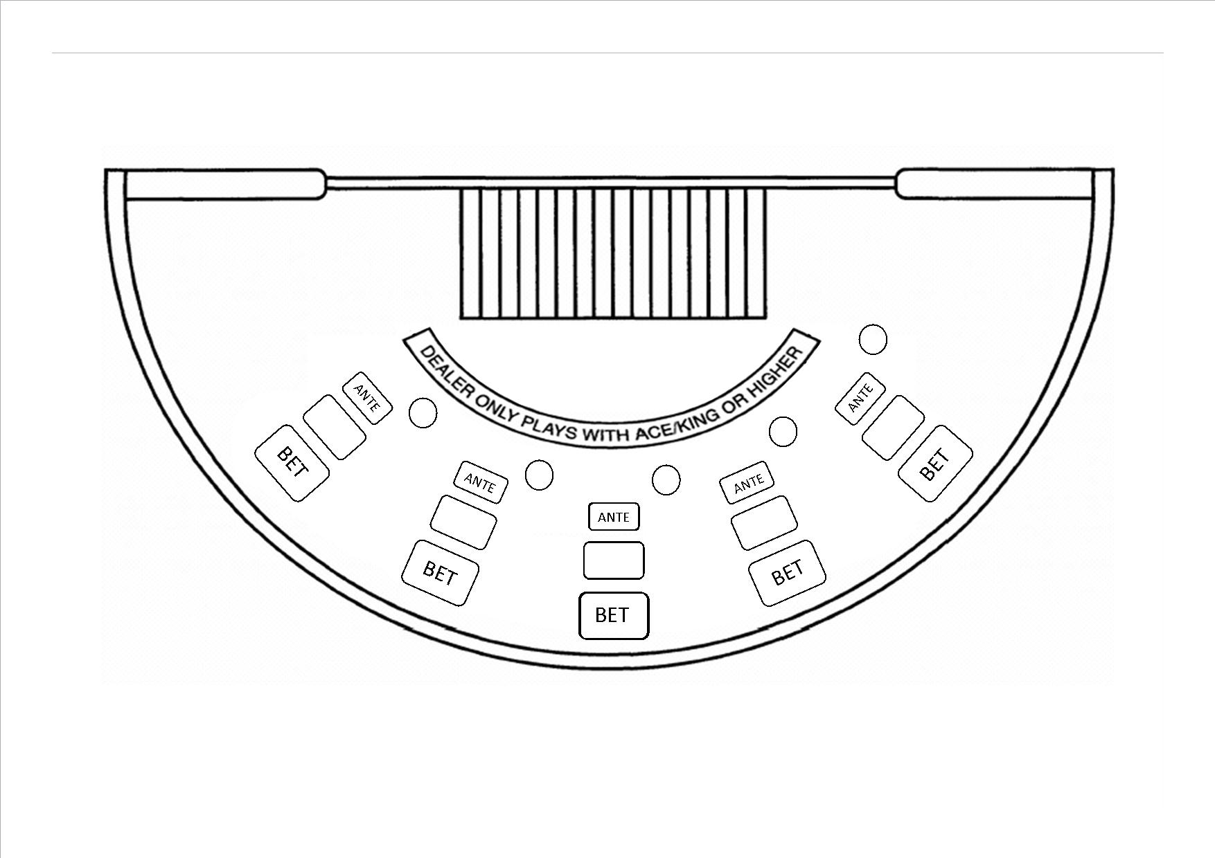

**Appendix C**

DIVISION 22 – BIG RAISE STUD POKER

Section 1 Interpretation

Section 2 Application

Section 3 Table Layout and Equipment

Section 4 Playing Cards; Ranking of Hands

Section 5 Wagers

Section 6 Opening of Table for Gambling

Section 7 Shuffle and Cut of Cards

Section 8 Dealing the Cards

Section 9 Betting Round

Section 10 Final Settlement

Section 11 Irregularities

Appendix Big Raise Stud Poker Table Layout (TBC)

**1.0 Interpretation**

1.1 In these rules, any words and expressions used that are defined in the Gambling Act 2003 have the same meaning as in that Act.

1.2 In this division, unless the contrary intention appears:

**“Ante Wager”** means the initial wager made by a player pursuant to subparagraph (a) of rule 5.1;

**“Raise Wager”** means an additional wager made by a player on his/her hand pursuant to subparagraph (b) of rule 5.2;

**“Fold”**, in relation to a hand of cards, means to continue no longer with the hand;

**“Three Card Bonus Wager”** means a wager made in relation to the Three Card Bonus; and

**“Poker Value”** means, in relation to a hand of cards, the ranking of that hand as determined in accordance with section 4;

**2.0 Application**

The rules contained in this division, together with the general rules contained in division 1, shall apply to the game of Big Raise Stud Poker.

**3.0 Table Layout and Equipment**

3.1 Big Raise stud poker shall be played at a table having on 1 side up to 7 sets of wagering areas for the players and on the opposite side an area for the placing of the community cards. Each Big Raise stud poker table shall have a drop box attached to it.

3.2 The layout cloth covering the table shall be marked in a manner substantially similar to that shown in the appendix.

3.3 The wagering areas shall be designated as follows:

(a) for ante wagers by the word “Ante”;

(b) for raise wagers by the word “Bet”; and

(c) for wagers on the Three Card Bonus wager.

3.4 The following equipment shall also be used in the game:

(a) 1 deck of playing cards;

(b) 1 cutting card;

(c) either:

(i) a card shoe capable of holding all of the cards used in the game, or

(ii) an automatic shuffler capable of holding 2 decks of cards, from which the cards will be dealt; and

(d) a discard rack capable of holding a single deck of cards.

**4.0 Playing Cards; Ranking of Hands**

4.1 All suits of cards shall have the same rank.

4.2 Cards shall rank, from lowest to highest, as follows:

2, 3, 4, 5, 6, 7, 8, 9, 10, jack, queen, king, ace,

except as provided in rule 4.3, where aces may be counted low.

4.3 Hands of cards shall rank, from lowest to highest, as follows:

(a) **Odd Cards** for example, ace, king, 6, 4, 2

(b) **1 Pair** 2 cards of the same value, a higher pair beating a lower pair. Aces shall be high

(c) **2 Pairs** 2 different pairs, with a pair of aces and a pair of kings being the highest ranking 2 Pair. Aces shall be high

(d) **3 of a Kind** 3 cards of the same value

(e) **Straight** 5 cards of any suit in sequence. An ace may be counted as high or low

(f) **Flush** 5 cards of the same suit, not in sequence. The value of the highest card in the hand shall decide the ranking between 2 flushes; where the highest cards in both hands are the same value, the next card; and so on

(g) **Full House** 3 cards of the same value and a Pair. The hands take their rank from the threesome

(h) **4 of a Kind** 4 cards of the same value

(i) **Straight Flush** 5 cards of the same suit in sequence

(j) **Royal Flush** ace, king, queen, jack and 10 of the same suit.

4.4 Hands of the same poker hand value, but consisting of different card values, shall be ranked according to the card values prescribed in rule 4.2. For example:

(a) in the case of odd cards, the respective card values of the highest card in each hand shall determine the ranking, if these are the same the values of the next highest cards, and so on;

(b) where 2 hands hold single Pairs of the same card value, the respective values of the highest of the remaining cards in each hand shall determine the outcome. If the highest of the remaining cards in the hands are of the same card value, the respective values of the next highest cards shall determine the outcome, and so on;

(c) in the case of 2 hands each containing 2 Pairs, the hand holding the highest pair in terms of card value shall be ranked the higher. If the highest pair in each of the hands is of the same value, the respective card values of the second pairs shall determine the outcome. In the case of a draw, the respective card values of the fifth cards in the hands determine which hand shall be higher;

(d) a Straight (or Straight Flush) consisting of king, queen, jack, 10 and 9 beats one consisting of jack, 10, 9, 8 and 7.

4.5 A player is responsible for declaring his/her optimum poker hand.

**5.0 Wagers**

5.1 Before the first card is dealt in a round each player:

(a) shall make an ante wager;

(b) subject to these rules may, where the casino operator offers a Three Card Bonus Wager, make such a wager; and

(c) subject to these rules may, where the casino operator allows a blind betting option, make a bet wager.

5.2 After the required number of cards have been dealt to the players and the dealer, the players may pick up their cards and either:

(a) fold; or

(b) make a raise wager of one, two, three, or four times the amount of the ante wager on the hand.

5.3 All ante wagers and raise wagers shall be made by placing chips, with the smaller denomination chips on the top, in the appropriate wager area of the layout.

5.4 Orally declared wagers shall be accepted only when accompanied by chips and if the dealer has enough time to place the wager on the layout before “No more bets” is called.

5.5 At the discretion of the casino operator, a player may place a wager on more than one betting area in accordance with rule 5.5.1 and 5.5.2.

5.5.1 A player may only place a wager on more than one betting area provided that no other player(s) is excluded from participating in the game.

5.5.2 Where a player places a wager on more than one betting area in accordance with rule 5.5, the casino operator or their delegate may direct that players will only be permitted to view one hand and that hand will be the one dealt to the betting area at which the player was seated when the cards were dealt. In this event, any additional hands must be played ‘blind’, i.e. no person, including the player who placed the wager or the dealer, will be permitted to view the cards until the hand is settled in accordance with rule 10.

5.6 Only 1 wager shall be accepted on any 1 wagering area.

5.7 Winning ante wagers and raise wagers shall, subject to rule 5.8, both be paid at the following odds:

**Ante Wagers Payout Odds**

All ante wagers 1 to 1

**Raise Wagers Payout Odds**

Pair of 6’s to 9’s standoff

Pair of 10’s or better 1 to 1

2 Pairs 2 to 1

3 of a Kind 3 to 1

Straight 4 to 1

Flush 6 to 1

Full House 8 to 1

4 of a Kind 40 to 1

Straight Flush 100 to 1

Royal Flush 500 to 1.

5.8 The payout odds on raise wagers shall be subject to any maximum payout limit set by the casino operator. The amount of such limit shall be approved by the Secretary and be displayed on a notice at the table.

5.9 Except as permitted by these rules, once the dealer has called “No more bets” no player shall:

(a) make any ante wager or Three Card bonus wager; or

(b) handle, alter or withdraw any wager until a decision has been made and implemented with respect to the wager except that where the casino operator allows a blind betting option, the raise wager may be withdrawn if the player folds.

5.10 No player shall handle, alter or withdraw a losing wager.

**6.0 Opening of Table for Gambling**

6.1 After receiving the designated number of decks of cards at the table (1 deck if a card shoe is used, 2 decks if an automatic shuffler is), both the dealer and the game supervisor shall sort and inspect the cards independently of each other.

6.2 After the cards have been inspected they shall be spread out face up on the table for visual inspection by the first player or players to arrive at the table. The cards shall be spread out in horizontal fan-shaped rows according to suit, in sequence within the suit.

6.3 After the first player has or players have had an opportunity to inspect the cards visually, the cards shall be turned face down on the table, stacked and shuffled.

6.4 When an automatic shuffler is used:

(a) each of the decks of cards shall be turned face down on the table, chemmy shuffled, stacked and riffle shuffled separately within the deck by the dealer;

(b) each of the decks shall then be loaded into the automatic shuffler and shuffled separately by it; and

(c) the cutting card shall be used in accordance with approved procedures.

**7.0 Shuffle and Cut of Cards**

7.1 The cards shall be shuffled so that they are randomly intermixed within the deck:

(a) immediately before the start of play;

(b) at the end of each round;

(c) at the recommencement of play following any period during which the table has been vacant; and

(d) at the direction of a game supervisor or casino supervisor where there is reason to suspect that the randomness of the shuffle has been compromised; and

(e) if any card has been exposed prior to the cards entering the shoe; and

(f) at the direction of a game supervisor or casino supervisor, at his or her discretion.

7.2 Where a card shoe is used, after the cards have been shuffled a casino employee shall cut the cards once, place them on the cutting card and then place all of the cards in the shoe for the commencement of play. No player ever cuts the cards.

7.3 The dealer may at any time check and verify that the deck of cards or any of the decks, as the case may be, contains the correct number of cards, namely 52.

7.4 The casino operator may, after any round of play, direct that the cards be replaced, in which event the new cards shall be checked, shuffled and cut in accordance with sections 6 and 7.

**8.0 Dealing the Cards**

8.1 Immediately before the start of each round of play and after all ante wagers and Three Card bonus wagers (if any) have been made, the dealer shall:

(a) call “No more bets”; and then

(b) starting on his/her left and continuing clockwise around the table, deal the cards.

8.2 All cards shall be dealt face down.

8.3 When a card shoe is used the cards shall be dealt as follows:

(a) 1 card to each wagering area containing an ante wager and then 1 card to the area holding the community cards; followed by

(b) a further card to each such wagering area and the dealer,

and so on until every player has 3 cards and the community card area has 2 cards.

8.4 When an automatic shuffler is used the cards shall be dealt as follows:

(a) 3 cards at a time to each wagering area containing an ante wager; followed by

(b) 3 cards to the community card area. The bottom card shall then be discarded to the discard rack.

**9.0 Betting Round**

9.1 After the cards have been dealt the players may pick up their cards and decide whether to fold or make a raise wager.

9.2 A player who decides to fold shall place his/her cards face down on the table. The dealer shall then, in relation to each player who has folded:

(a) collect the ante wager.

(b) individually spread out the cards, face down, and count them; and

(c) place the cards under the players Three Card Bonus wager, or, if no such wager has been made (or is known to be a losing wager), place the cards in the discard rack.

9.3 When the players remaining in the game have made their raise wagers, the player shall place his/her cards face down on the layout

9.3A The casino operator may, at its discretion, direct where players place their cards on the layout.

9.4 When handling the cards, players shall at all times ensure that the cards remain on or above the area of the table. The cards must not be removed from the table.

9.5 Except as expressly permitted by these rules, players may not exchange cards, nor exchange, communicate, nor cause to be exchanged or communicated any information regarding their respective hands.

9.6 At any time while a game is in progress the casino operator may direct that:

(a) only English be spoken by the players at the table;

(b) there be silence while a hand is in progress;

(c) players suspected of collusion not play at the same table.

**10.0 Final Settlement**

10.1 A players poker hand shall be determined from the hand formed using the players three cards and both community cards.

10.2 A player’s hand shall:

1. win if it has a higher poker value than a pair of 9’s;
2. be a stand off if it has a poker hand between a pair of 6’s and pair of 9’s;
3. lose otherwise.

10.3 A players Three Card Bonus wager shall win if the player’s first three cards (ranked according to Division 17 Three Card Poker, rule 4.3) are a pair or better paying:

Straight flush 40 to 1

Three of a kind 30 to 1

Straight 6 to 1

Flush 3 to 1

Pair 1 to 1

10.5 If a player’s hand loses the dealer shall collect the ante and the raise wagers on the hand, verify whether the Three Card Bonus wager wins or loses before counting the player’s cards and placing them to the discard rack.

10.6 If a player’s hand wins the dealer shall:

(a) pay the ante and the raise wagers on the hand in accordance with rules 5.7 and 5.8; and

(b) pay any winning Three Card Bonus Wagers;

(c) collect and count the player’s cards as described in rule 9.2.

**11.0 Irregularities**

11.1 If a player fails to comply with rule 9.5 the casino operator may declare the player’s hand void, in which event any ante, raise and jackpot wagers made by that player shall be void.

11.2 Except as specified elsewhere in these rules, if an incorrect number of cards is dealt to any player or to the dealer this shall constitute a misdeal.

11.3 Subject to rules 11.4 and 11.5, if an exposed card is dealt this shall not constitute a misdeal. The dealer shall turn the card over and continue dealing.

11.4 If a community card is exposed in error to the community card area, then this shall constitute a misdeal.

11.5 If more than 1 card is exposed in error during the dealing of the cards this shall constitute a misdeal.

11.6 If a player exposes 1 or more cards in his/her hand, this shall not constitute a misdeal, subject to rule 11.1.

11.7 Subject to rule 11.4 and notwithstanding rule 11.5, if the dealer exposes 1 or more cards in his/her hand in error before all of the players have made a decision in relation to their raise wagers, the players will be given the option to make a raise wager equal to his ante, or to fold.

11.8 Subject to rule 11.9, if, before all cards are dealt, it is discovered that cards have been dealt to a wagering area without an ante wager, the round of play shall be declared a misdeal.

11.9 If it is discovered that a complete hand has been dealt to a wagering area without an ante wager, the cards dealt to that wagering area shall be counted and placed in the discard rack and the game shall then continue. If a Three Card Bonus wager has been placed in such a wagering area, then that wager shall be void.

11.10 If it is discovered that the deck in use at the table does not contain 52 cards, the round shall constitute a misdeal and be void.

11.11 Subject to these rules, in the event of a misdeal all wagers affected by the misdeal, shall be void. In the event of the entire round being void the hands shall be redealt after the players have had an opportunity to change their ante and Three Card Bonus wagers.

11.12 If a player makes a wager and is dealt a complete hand but is not present at the table to make a decision on that hand, the player shall be deemed to have folded and their ante wager shall be forfeited. Any Three Card bonus wager shall remain in action.

11.13 If the dealer collects a player’s cards before the player has decided whether to make a raise wager or to fold, the player’s hand shall be reconstructed where possible but otherwise shall be void.

11.14 Notwithstanding rule 10, when a player has laid his/her cards down on the table subsequent to the dealing of a complete hand, and those cards have been placed on the discard pile, that player’s hand may be reconstructed providing those cards are the top three on the discard pile. The player shall otherwise be deemed to have folded pursuant to rule 9.2.

11.15 Where a player has placed an additional wager(s) in accordance with rule 5.5 and he/she contravenes the provisions of rule 5.5.2 by viewing a hand other than, or in addition to, the hand dealt to the area at which he/she was seated, the dealer will immediately notify the game supervisor (or above), who may:

(a) where the player has viewed one hand only, deem that particular hand to be the hand dealt to the area at which he/she was seated and continue the game; or

(b) where the player has viewed more than one hand, deem all hands viewed by the player to be void.

Appendix

Big Raise Stud Poker layout

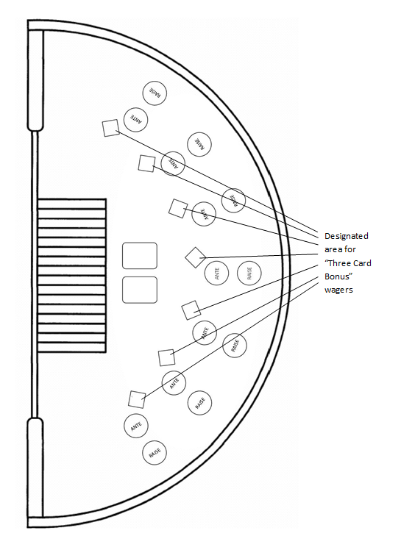

**Appendix D**

**DIVISION 9A – ELECTRONIC TAI-SAI**

Section 1 Interpretation

Section 2 Application

Section 3 Table Layout and Equipment

Section 4 Wagers

Section 5 Dealing the Game

Section 6 Settlement

Section 7 Irregularities

**1.0** **Interpretation**

1.1 In this Division, unless the contrary intention appears:

**“Game System”** means the configuration of software and game hardware

necessary to operate a tai-sai terminal;

**“Tai-Sai Terminal”** means a touch screen terminal used for the placement

and settlement of wagers in the game of electronic tai-sai.

1.2 A reference in these rules:

(a) to a bet is a reference to the contingency or outcome on which a player

may place a wager; and

(b) to a wager is to the money appropriated to such a bet in a particular

case.

**2.0 Application**

The rules contained in this Division, the general rules contained in Division 1,

and the applicable rules from Division 9 of these rules referred to in this

Division shall apply to the game of electronic tai-sai.

**3.0 Table Layout and Equipment**

3.1 Electronic tai-sai shall be played with a table with a dice tumbler which shall:

(i) be mechanically, electrically or electronically activated,

(ii) be attached to the table,

(iii) contain the dice under seal in a transparent compartment,

(iv) have over the compartment securing the dice a dome-shaped, removable, non-transparent cover which conceals the dice while the tumbler is being shaken, and

(v) be used to tumble the dice

(b) up to 30 tai-sai terminals associated with that table; and

(c) a game system comprising the hardware and software needed to

operate the tai-sai terminals, record the outcome of a spin (either

automatically or following the dealer or the game supervisor entering

the outcome manually), and communicate the outcome of each spin of

the dice tumbler.

3.2 Where players are offered the option of placing wagers on the table layout:

(a) the table shall have a drop box attached to it;

(b) the layout on the tai-sai table shall be the same type as that used

in the game of tai-sai;

(c) The table shall be fitted with electronic equipment which is:

(i) linked to an entry terminal which is attached to the top of the table and has:

(A) 6 buttons or switches numbered 1, 2, 3, 4, 5 and 6 respectively,

(B) 1 entry button, and

(C) 1 light-emitting diode, which gives visual verification of the last 3 numbered buttons or switches depressed, being the 3 numbers entered into the electronic equipment when the entry button is depressed; and

(ii) programmed so that when the 3 winning numbers corresponding to a declared result of a game are entered into the equipment by the activation of the relevant numbered buttons or switches, all the areas of the layout representing the winning combination or combinations are illuminated.

(d) Rule 3.4 of Division 9 of these rules shall apply.

3.3 The tai-sai terminal must:

(a) display the betting areas of a tai-sai layout .

(b) display the following information:

(i) the minimum and maximum permissible wagers that may be

made through the terminal,

(ii) the point at which no more wagers will be accepted for the next

Spin, which shall be at least 30 seconds from the time the result of the last spin was confirmed’

(iii) the total number of credits available to the player, shown in dollars and cents,

(iv) the number of credits wagered by the player for the current

round of play, shown in dollars and cents,

(v) the winning number for the previous round of play, and

(vi) the number of credits won by the player for the previous round

of play;

(vii) the correct time while it is being used by a player.

(c) be programmed so that:

(i) after the point of time at which no more wagers will be

accepted for the next spin, the terminal will not accept a wager

or any change or withdrawal of a wager,

(ii) if a player attempts to place through the terminal an individual

wager that is less than the minimum permissible wager for a

particular bet, the terminal will not display any chips in respect

of that wager,

(iii) if a player attempts to place an individual wager:

(A) in a multiple over the minimum which is not permitted,

or

(B) that is greater than the maximum permitted wager,

the terminal will display only so many chips or such

denomination of chips as is the next lowest permitted wager,

(iv) if, by the end of the wagering period for an individual spin, a

player has placed one or more wagers which are in aggregate

less than the permitted aggregate wager (if any), the tai-sai

terminal will not recognise those wagers for that spin, and

(v) at the settlement of wagers for a spin losing wagers will be

cleared automatically from the terminal layout, and winning

wagers will be paid by causing an appropriate number of chips

to appear or by causing an appropriate adjustment to be made to

the amount showing as standing to the credit of the player’s

chip account; and

(d) be capable of dispensing a payment voucher for the value of credits on

the terminal’s chip account; and/or

(e) be capable of having credits cancelled to allow the dealer to pay out

the full value of remaining credits on the terminal’s chip account by

tendering chips to a player.

3.4 The tai-sai terminals and game system shall be of a type approved by the

Secretary and contain components necessary for the performance of, and be

designed and programmed to perform, their respective functions in accordance

with these rules.

3.5 No person shall tilt, rock, or in any way damage or interfere with the tai-sai terminals, nor shall any person seek to gain any undue advantage from any manipulation of any gambling equipment or any part thereof.

3.6 A player shall not be entitled to a prize on a tai-sai terminal unless that prize results from the legitimate attainment of the prize on the terminal.

**4.0 Wagers**

4.1 Where players are offered the option of placing wagers on the table layout,

section 4 of Division 9 of these rules shall apply to all such wagers.

4.2 Where a tai-sai terminal is used:

(a) the wagers specified in section 4 of Division 9 of these rules may be

placed by touching the appropriate part of a tai-sai terminal’s touch

screen designated for making wagers; and

(b) the player may place wagers on any combination of bets specified on

the touch screen display.

4.3 A tai-sai terminal shall be activated by a player either:

(a) inserting an amount of cash into the tai-sai terminal’s note acceptor;

or

(b) by tendering to the dealer an amount of cash or chips.

4.4 Where a player inserts cash into a tai-sai terminal note acceptor under rule

4.3(a), the amount of cash will automatically be credited to the terminal’s chip

account in respect of that tai-sai terminal, thereby causing chips to appear on

the display of the tai-sai terminal or that amount to be shown as standing to

the credit of the terminal’s chip account.

4.5 If the dealer accepts an amount under rule 4.3(b), the dealer must:

(a) give the player control of a tai-sai terminal; and

(b) credit the tai-sai terminal chip account with the amount tendered,

thereby causing chips to appear on the display of the tai-sai terminal

or that amount to be shown as standing to the credit of the terminal’s

chip account.

4.6 The player is solely responsible for the correct placement of the chips

appearing on the tai-sai terminal layout.

4.7 Any wager placed through a tai-sai terminal may only be settled in

accordance with the appearance of the tai-sai terminal at the time a wagering

period expired.

4.8 The minimum and maximum wagers for electronic tai-sai may differ from

one terminal to another and from those applied to players wagering on the

table layout.

**5.0 Dealing the Game**

5.1 Each tai-sai terminal must incorporate a mechanism for displaying the point

at which no more wagers will be accepted and, following that point, the

tai-sai terminal must not accept a wager or change or withdrawal of a wager.

5.2 Where players are offered the option of placing wagers on the table layout,

section 6 of Division 9 of these rules shall apply.

5.3 Where wagers may only be placed through tai-sai terminals, rules 6.1 and 6.6 of Division 9 of these rules shall apply.

5.4 Following determination of the outcome of a spin:

(a) the dealer or game supervisor shall enter the outcome manually into the

game system, unless the system is programmed to record it automatically; and

(b) the game system shall:

(i) record the outcome,

(ii) display the outcome on each active tai-sai terminal, and

(iii) in respect of the wager or wagers placed on a tai-sai terminal:

(A) if an amount has been won, automatically calculate and

display the amount, and

(B) automatically calculate and display the player’s credit

balance as a result of the outcome, in accordance with these rules.

**6.0 Settlement**

6.1 Wagers shall be settled in accordance with rule 4.10 of Division 9 of

these rules.

6.2 Credits due to a player must be paid in accordance with rules 3.3(d) and (e) of

this division.

6.3 A player may redeem a payment voucher with the casino operator for an

amount equivalent to the value of the credits.

**7.0 Irregularities**

7.1 Section 7 of Division 9 of these rules shall apply to the game of electronic

tai-sai.

7.2 If the dealer reasonably forms the opinion that a disruption or similar event,

which would compromise the integrity of the game, has occurred or is

occurring, he/she shall announce a “no spin” and the spin shall be void.

7.3 Where the casino operator has reason to believe that an incorrect result has

been entered into the game system or communicated to the tai-sai terminal, it

shall cause the results to be recalculated on the basis of the actual outcome.

7.4 Where in the opinion of the casino operator an amount has been credited to a

player by a tai-sai terminal or game system:

(a) as a result of the terminal or game system malfunctioning; or

(b) after a terminal or the game system has malfunctioned and before it has

been repaired,

the casino operator may refuse to pay or credit the player with the amount.

7.5 Where the casino operator refuses to pay or credit an amount pursuant to rule 7.4, the casino operator shall:

(a) report the matter to a Gambling Inspector in accordance with

approved procedures;

(b) ensure that the tai-sai terminal or, as the case may be, the game

system involved is not operated or otherwise dealt with by any person

until the malfunction has been investigated and dealt with in

accordance with approved procedures; and

(c) refund any credit or credits wagered by the player for the round in

relation to which the payment of any prize is being refused.

**Appendix E**

This appendix contains all of the proposed amendments to the rules of Blackjack as referenced in the consultation document. Where there is a proposed amendment to an existing rule, those changes are shown highlighted and/or struck out.

**DIVISION 2 - BLACKJACK**

…

Section 15D House Money Wagers

Section 15E Let it Ride Wagers

Section 15F Lucky Match Wager

…

Section 20 Free Bet Blackjack

…

Appendix 6 Blackjack Table Layout with House Money Wager Option

Appendix 7 Blackjack Table Layout with Let it Ride Wager Option

Appendix 8 Blackjack Table Layout with Free Bet Blackjack Wager Option

Appendix 9 Blackjack Table Layout with Lucky Match Wager Option

**1.0 Interpretation**

In this division, unless the contrary intention appears:

**…**

**“Coloured Match”** means two red cards of different suits with the same Face Value, or two black cards of different suits with the same Face Value;

**…**

“**Free Bet Lammer**” is a plastic lammer used for the purposes of signifying that a player has doubled or split without placing an additional wager in accordance with section 20 of these rules.

…

“**House Money Wager**” means an optional, additional wager which may be made by a player in accordance with section 15D;

**…**

“**Let it Ride Wager**” means an optional, additional wager which may be made by a player in accordance with section 15E

…

**“Lucky Match”** means two cards of the same suit each with the same Face Value;

**“Lucky Triple Match”** means three cards of the same suit each with the same Face Value;

**“Lucky Match Wager”** means an optional, additional wager which may be made by a player in accordance with section 15D;

…

**“Mixed Match”** means one red card and one black card each with the same Face Value;

…

“**Push 22**” means an optional, additional wager which may be made by a player in accordance with section 20A of these rules.

**…**

1. **Table Layout and Equipment**

**…**

3.6 At the option of the casino operator, a game results display, being an electronic device for recording and displaying the most recent results at the table.

**5.0 Wagers**

**…**

5.4 All winning wagers made in accordance with rule 5.1 shall be paid at odds of 1 to 1 with the exception of blackjack, which (subject to rule 10.3) shall be paid at the odds inscribed in the layout. Winning Super Sevens wagers shall be paid in accordance with rules 15.4 and 15.5. Madness 21 Wagers shall be paid in accordance with rules 15A.4 and 15A.6. Winning Perfect Pair’s Wagers shall be paid in accordance with rule 15B.7. Winning Any Pair’s Wagers shall be paid in accordance with rule 15C.8. Winning Lucky Match Wagers shall be paid in accordance with rule 15D8.

**…**

5.6 Except as expressly permitted by these rules, once an optional wager (being an insurance, Super Sevens, Madness 21, Perfect Pairs, Any Pairs, Lucky Match, double down or split Pairs wager) has been made and has been confirmed by the dealer, no player shall handle, alter or withdraw such wager until a decision has been made and implemented with respect to it, and no dealer or other person shall permit any player to do so.

**6.0 Opening the Table for Gambling**

**…**

6.5 Notwithstanding rules 6.1 to 6.4, cards that have been pre-checked or pre-shuffled ~~cards~~ by the casino operator may be used provided they are secured in a designated area on completion of the pre-check or pre-shuffle, until such time as they are required. Before being cut pre-shuffled cards shall be either chemmy shuffled and/or riffle shuffled, but pre-checked cards shall be:

(a) chemmy shuffled;

(b) stacked; and

(c) riffle shuffled.

6.6 Notwithstanding rules 6.1 to 6.4, and subject to the approval of the Secretary for Internal Affairs, cards that have been pre-checked and pre-shuffled by the card manufacturer before being sealed, may be introduced on a table without having to undergo any further chemmy shuffle or riffle shuffle process.

**…**

**8.0 Dealing of Cards**

**…**

8.6 At the end of a Round the dealer shall collect all of the cards remaining on the layout in order and in such a way that the hands can readily be reconstructed in the event of a question or dispute, and place them face down in the discard rack or Continuous Shuffler where one is being utilised.

**…**

**15B Perfect Pair’s Wagers**

**…**

15B.1A Where the casino operator chooses to offer players the opportunity to place Perfect Pair’s Wagers at a table, it shall not offer players the opportunity to place either Any Pair’s Wagers or Lucky Match Wagers in accordance with section 15C or section 15D respectively at that same table.

15B.2 Where the option is offered and the game is played at a table with a layout cloth marked in a manner similar to that shown in appendix 4, any player may elect to place a Perfect Pair’s Wager at the time of placement of his/her initial wager as provided in rule 5.1. The Perfect Pair’s Wager shall be placed in the designated area of the layout, as shown in appendix 4, which corresponds to ~~the~~ a Box in which ~~the~~ an initial wager was placed and does not have to correspond to the player’s initial wager. A maximum of 3 Perfect Pair’s Wagers may be accepted per Box with preference being first given to players wagering on the Box to which the Perfect Pair’s Wager relates.

**…**

**15C** **Any Pair’s Wagers**

…

15C.2 Where the casino operator chooses to offer players the opportunity to place Any Pair’s Wagers at a table, it shall not offer players the opportunity to place either Perfect Pair’s Wagers or Lucky Match Wagers in accordance with section 15B or section 15D respectively at that same table.

15C.3 Where the option is offered and the game is played at a table with a layout cloth marked in a manner similar to that shown in appendix 5, any player may elect to place an Any Pair’s Wager at the time of placement of his/her initial wager as provided in rule 5.1. The Any Pair’s Wager shall be placed in the designated area of the layout, as shown in appendix 5, which corresponds to ~~the~~ a Box in which ~~the~~ an initial wager was placed and does not have to correspond to the player’s initial wager. A maximum of 3 Any Pair’s Wagers may be accepted per Box with preference being first given to players wagering on the Box to which the Any Pair’s Wager relates.

**15D House Money Wagers**

15D.1 The casino operator may, at is discretion, offer the players the opportunity to place House Money wagers in accordance with this section.

15D.2 Where the option is offered and the game is played at a table with a layout cloth marked in a manner similar to that shown in appendix 6, any player may elect to place a House Money Wager at the time of placement of his/her initial wager as provided in rule 5.1. The House Money Wager shall be placed in the designated area of the layout as shown in appendix 6, that corresponds to the box in which the initial wager was placed.

15D.4 The amount of a House Money Wager shall be displayed on the sign at the table indicating the wager limits applying at the table.

15D.5 Subject to these rules, a House Money Wager shall:

1. Win paying 9 to 1 if the players first two cards are Ace-King suited;
2. Win paying 4 to 1 if the player’s first two cards are of the same suit in sequence (An Ace shall count both high and low to determine if it is in sequence to the other player’s card);
3. Win paying 3 to 1 if the players first two cards are a pair;
4. Win paying 1 to 1 if the player’s first two cards are in sequence (An Ace can count both high and low to determine if it is in sequence to the other player’s card);
5. Otherwise lose.

15D.6 In the event that a House Money Wager has resulted in a payout, the player shall be offered one of two options:

1. The player may decide to keep the payout, in which case the House Money Wager and payout (refer section 15D.5) shall be passed to the player and will take no further part in play.
2. The player may decide to keep the House Money Wager and payout (or part thereof) in action, in which case the House Money Wager and payout (or part thereof) will be stacked together and left on the House Money Wager betting area. By selecting this option the player is committing the House Money Wager and proceeds (or part thereof) to his original blackjack wager. The combined total of any remaining House Money Wagers and the player’s initial wager shall not exceed any maximum allowable limit per section 14.2.

15D.7 When a player is doubling down, their additional wager under rule 11.2a may not be more than the amount of his/her original wager, plus any wagers and payouts still remaining on the House Money Wager betting area.

15D.8 When a player is splitting, their additional wager under rule 12.2 must be equal to their original wager, plus any wagers and payouts still remaining on the House Money Wager betting area.

15D.9 For the purpose of calculating the maximum insurance bet that a player can make for the hand, any House Money Wagers and payouts shall not be included in the player’s original bet.

15D.10 At the completion of the hand when determining that the player has a winning wager under rule 5.1, any House Money Wagers and payouts still remaining in the House Money Wager betting area shall be paid at odds of 1 to 1 with the exception of blackjack, which (subject to rule 10.3) shall be paid at odds of 3 to 2. At the completion of the hand when determining that the player has a losing wager under rule 5.1, any House Money Wagers and payouts still remaining in the House Money Wager betting area shall lose. At the completion of the hand when determining that the player has a standoff under rule 5.1, any House Money Wagers and payouts still remaining in the House Money Wager betting area shall be considered to be a standoff.

15D.11 When the dealer achieves a blackjack, all House Money Wagers and payouts still in play shall constitute stand offs.

15.D.12 House Money Wagers may not be made in conjunction with any other Blackjack side bet with the exception of Perfect Pairs, Any Pairs or Lucky Match Wagers.

…

**15E Let it Ride Wagers**

15E.1 The casino operator may, at is discretion, offer the players the opportunity to place Let it Ride Wagers in accordance with this section.

15E.2 Where the option is offered and the game is played at a table with a layout cloth marked in a manner similar to that shown in appendix 7, any player may elect to place a Let it Ride Wager at the time of placement of his/her initial wager as provided in rule 5.1. The Let it Ride Wager shall be placed in the designated area of the layout as shown in appendix 7, that corresponds to the box in which the initial wager was placed.

15E.3 The amount of a Let it Ride Wager shall be displayed on the sign at the table indicating the wager limits applying at the table.

15E.4 Subject to these rules, a Let it Ride Wager shall:

(a) Win paying 2 to 1 if the player’s first two cards are of the same suit in sequence (An Ace shall count both high and low to determine if it is in sequence to the other player’s card).

(b) Win paying 1 to 1 if the players first two cards are suited, or are in sequence (An Ace can count both high and low to determine if it is in sequence to the other player’s card).

(c) Otherwise lose.

15E.5 In the event that a Let it Ride Wager has resulted in a payout, the player shall be offered one of two options:

(a) The player may decide to keep the payout, in which case the Let it Ride Wager and payout (refer section 15E.5) shall be passed to the player and will take no further part in play.

(b) The player may decide to keep the Let it Ride Wager and payout (or part thereof) in action, in which case the Let it Ride Wager and payout (or part thereof) will be stacked together and left on the Let it Ride Wager betting area. When selecting this option the player is committing the Let it Ride Wager and proceeds (or part thereof) to his blackjack wager.

15E.6 When a player is doubling down, their additional wager under rule 11.2a may not be more than the amount of his/her original wager, plus any wagers and payouts still remaining on the Let it Ride Wager betting area.

15E.7 When a player is splitting, their additional wager under rule 12.2 must be equal to their original wager, plus any wagers and payouts still remaining on the Let it Ride Wager betting area.

15E.8 For the purpose of calculating the maximum insurance bet that a player can make for the hand, any Let it Ride Wagers and payouts shall not be included in the players original bet.

15E.9 At the completion of the hand when determining that the player has a winning wager under rule 5.1, any Let it Ride Wagers and payouts still remaining in the Let it Ride betting area shall be paid at odds of 1 to 1 with the exception of blackjack, which (subject to rule 10.3) shall be paid at odds of 3 to 2. At the completion of the hand when determining that the player has a losing wager under rule 5.1, any Let it Ride wagers and payouts still remaining in the Let it Ride Wager betting area shall lose. At the completion of the hand when determining that the player has a standoff under rule 5.1, any Let it Ride Wagers and payouts still remaining in the Let it Ride Wager betting area shall be considered to be a standoff.

15E.10 When the dealer achieves a blackjack, all Let it Ride Wagers and payouts still in play shall constitute stand offs.

15E.11 Let it Ride Wagers may not be made in conjunction with any other Blackjack side bet with the exception of Perfect Pairs, Any Pairs or Lucky Match Wagers.

**15F Lucky Match**

15F.1 The casino operator may, at its discretion, offer the players the opportunity to place Lucky MatchWagers in accordance with this section.

15F.2 Where the casino operator chooses to offer players the opportunity to place Lucky Match Wagers at a table, it shall not offer players the opportunity to place either Perfect Pair’s Wagers or Any Pair’s Wagers in accordance with section 15B or section 15C respectively at that same table.

15F.3 Where the Lucky MatchWageroption is offered and the game displayed at a table with a layout cloth marked in a manner similar top appendix 9, any player may elect to place a Lucky MatchWager at the time of placement of his/her initial wager as provided in rule 5.1. The Lucky Match Wager shall be placed in the designated area of the layout that corresponds to a Box in which an initial wager was placed and does not have to correspond to the player’s initial wager. A maximum of three Lucky Match Wagers may be accepted per Box with preference being first given to players wagering on the Box to which the Lucky Match Wager relates.

15F.4 The Lucky MatchWager shall be placed before any cards in the Round of play are dealt.

15F.5 The amount of a Lucky MatchWager shall be that displayed on the sign at the table indicating the wager limits applying at the table.

15F.6 A Lucky Match Wager shall win if the first two cards dealt to the player have the same Face Value or if the first three cards dealt to the player are of the same suit with the same Face Value and lose if the first two cards do not have the same Face Value.

15F.7 Where a player places a Lucky Match Wager in a Round and achieves both a Lucky Match and Lucky Triple Match in that Round, that player shall be paid a winning wager in respect of the Lucky Triple Match only.

15F.8 At the completion of the Initial Deal, the dealer shall collect the losing Lucky MatchWagers and leave all winning Lucky Match Wagers in situ until a result has been rendered with respect to the wager, subject to rule 15D.10.

15F.9 Winning Lucky MatchWagers shall be paid in accordance with one of the following pay scale options:

**Pay Scale One**

Mixed Match 5 to 1

Coloured Match 10 to 1

Lucky Match 25 to 1

Lucky triple Match 100 to 1

**Pay Scale Two**

Mixed Match 5 to 1

Coloured Match 10 to 1

Lucky Match 20 to 1

Lucky triple Match 500 to 1

15F.10 Notwithstanding rule 15D.6, 15.7 and 15.8, if the first 2 cards dealt to a Box constitute a Lucky Match and the player elects to split the Pair, the Lucky Match Wager shall be paid immediately in accordance with the Lucky Match payout odds displayed at the table, and the Lucky Match Wager shall be deemed complete irrespective of the value and suit of the third card.

15F.11The casino operator shall display which pay scale under rule 15D.8 is in operation.

**16.0 Irregularities**

…

16.14 In the event that the player has made a decision on his/her hand with respect to section 8.3 prior to the decision in 15D.6, then the House Money Wager will be paid at the odds in section 15D.5 and passed to the player and will take no further part in play.

16.15 In the event that the player has made a decision on his/her hand with respect to section 8.3 prior to the decision in 15E.6, then the Let it Ride Wager will be paid at the odds in section 15E.5 and passed to the player and will take no further part in play.

…

**20 Free Bet Blackjack**

20.1 Free Bet Blackjack shall follow the approved rules of Blackjack except where the rules are inconsistent with Section 20 in which case Section 20 will prevail.

20.2 Free Bet Blackjack shall be played at a table with a layout marked in a manner similar to that shown in appendix 8 equipped with Free Bet Lammers.

20.3 The player may double down for free with a first two-card total of 9, 10 or 11. If the player indicates they wish to exercise this option, then the dealer shall place a Free Bet Lammer to the right of the player’s original bet to replace the additional wager the player would usually place when doubling. This shall represent a double down wager made to the maximum allowable amount per section 11.2(a).

20.4 The player may split for free when his initial cards are pairs of Aces, 2s, 3s, 4s, 5s, 6s, 7s, 8s, or 9s. If the player indicates they wish to exercise this option, then the dealer shall place a Free Bet Lammer to replace the additional wager the player would usually wager when splitting. No more than 3 hands per box shall be formed in any round as a result of splitting. Aces may only be split once.

20.5 The player may still split and double under other circumstances that would normally apply under the rules of Blackjack.

20.6 Additional cards shall be drawn to the dealers hand until a hard total of 17, 18, 19, 20 or 21, or a soft total of 18, 19, 20, or 21 are achieved, at which point no additional cards will be drawn.

20.7 With the exception of Blackjack, if the dealers hand total equals 22, then all remaining player hands are considered to be standoffs.

20.8 For the purpose of paying out winning wagers, a Free Bet Lammer shall be considered to be of equal value to the player’s original bet. At the completion of the round the dealer will collect all Free Bet Lammers regardless of whether the hand won, lost or was a standoff.

20A **Push 22**

20A.1 The casino operator may, at its discretion, offer players the opportunity to place Push 22 Wagers in accordance with this section.

20A.2 Where the option is offered and the game is played at a table with a layout cloth marked in a manner similar to that shown in appendix 6, any player may elect to place a Push 22 Wager a the time of placement of his/her initial wager as provided in rule 5.1. The Push 22 Wager shall be placed in the designated area of the layout that corresponds to the box in which the initial wager was placed.

20A.3 The amount of a Push 22 Wager shall be displayed on the sign at the table indicating the wager limits applying at the table.

20A.4 If a Player has placed a Push 22 wager then this bet will win if the Dealer’s hand equals a total of 22, or otherwise lose.

20A.5 At the completion of the hand, the dealer shall pay the winning and collect the losing Push 22 wagers in accordance with approved procedures.

20A.6 Winning Push 22 wagers shall be paid in accordance with either Pay Scale One or Pay Scale Two as follows:

**Pay Scale One**

Dealer same suit 22 50 to 1

Dealer same colour 22 20 to 1

Dealer other 22 8 to 1

**Pay Scale Two**

Dealer same suit 22 50 to 1

Dealer same colour 22 20 to 1

Dealer other 22 7 to 1

20A.7 The casino operator shall display which pay scale under rule 20A.6 is in operation.

…

**Appendix 6**

**Blackjack Table Layout with House Money Wager Option**

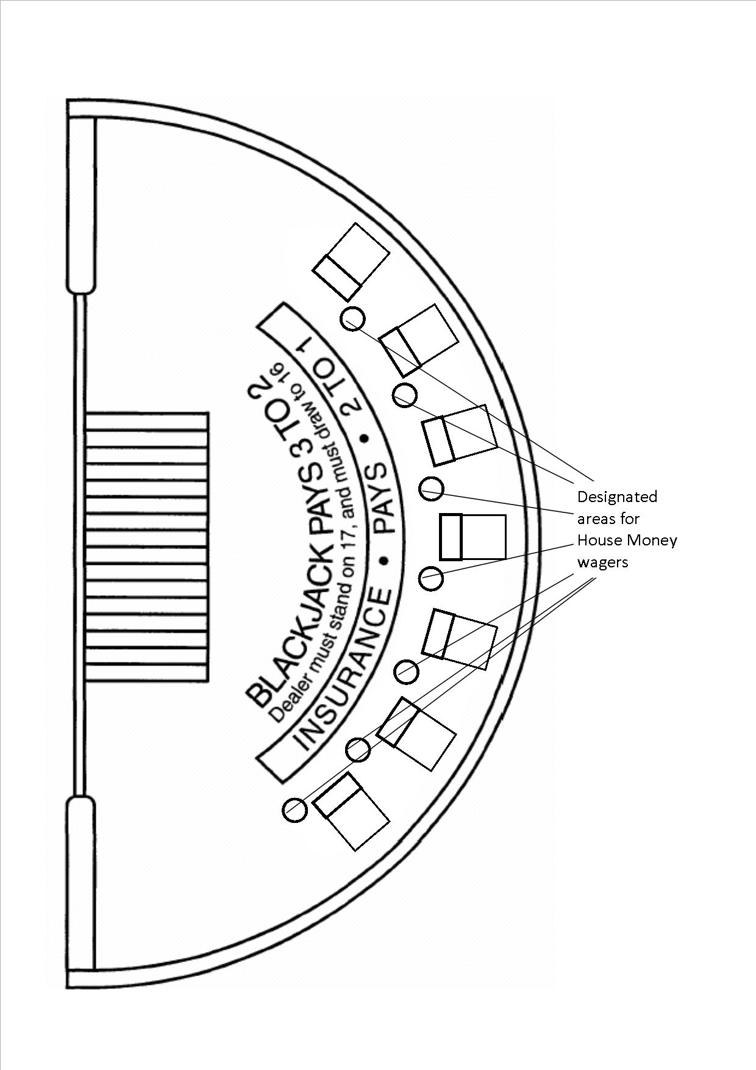

**Appendix 7**

**Blackjack Table Layout with Let it Ride Wager Option**

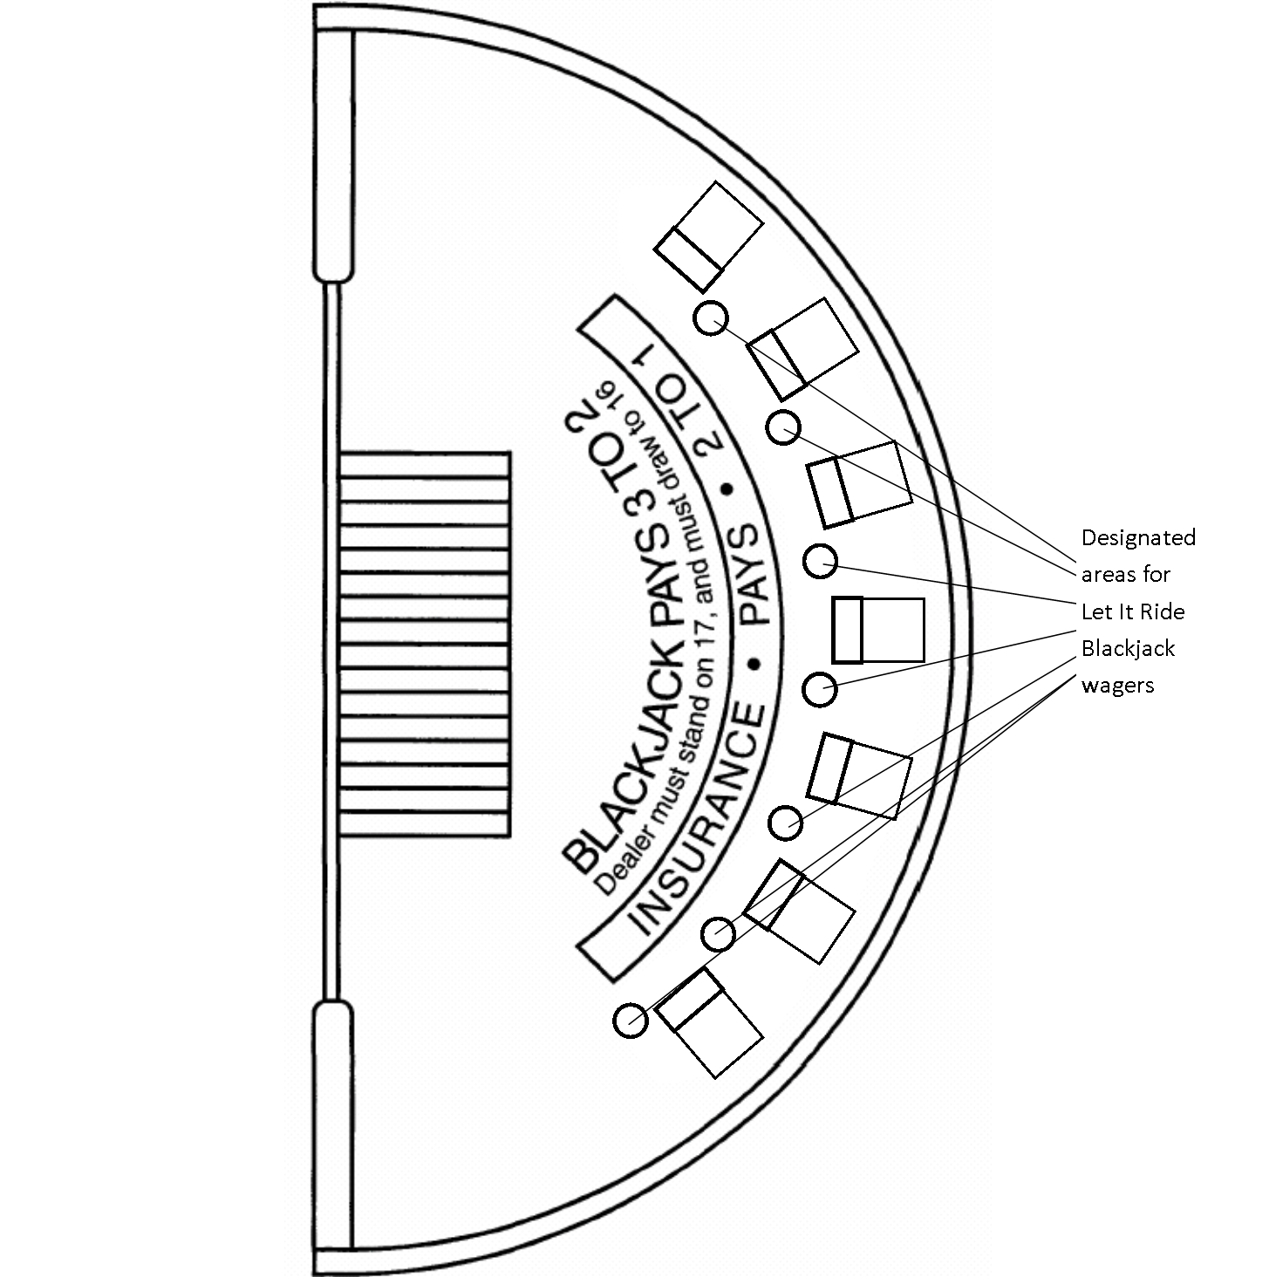

**Appendix 8**

**Table Layout for Free Bet Blackjack**

Designated area for Push 22 wagers

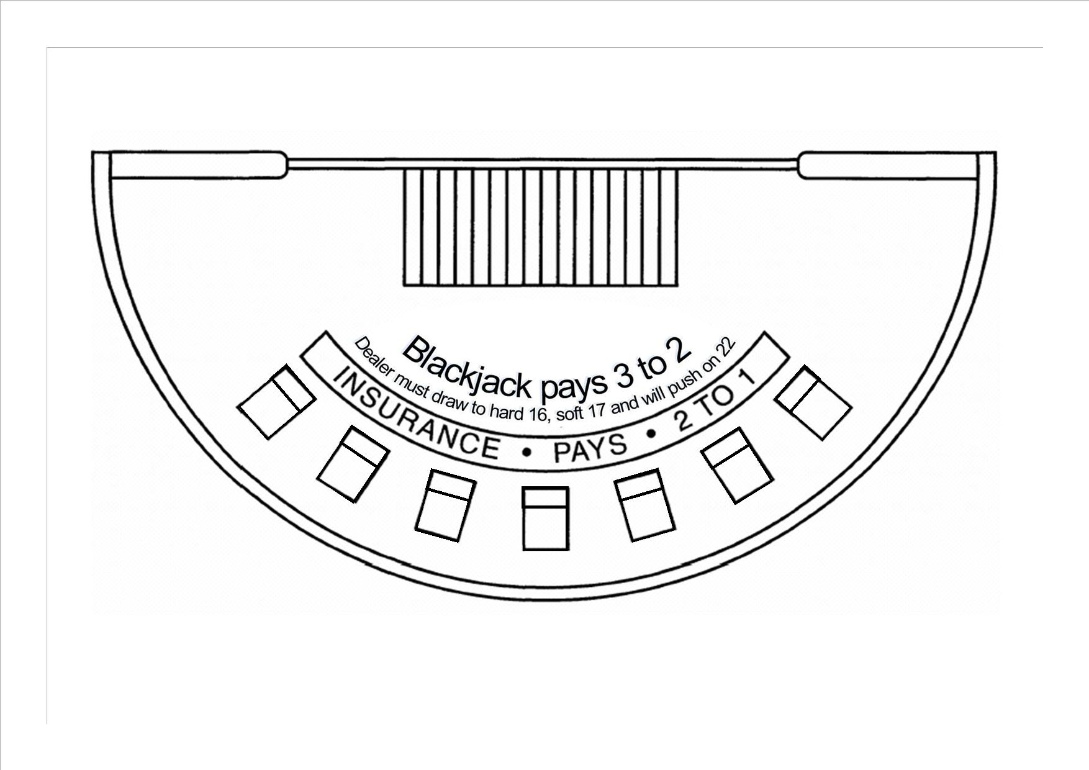

**Appendix 9**

**Blackjack Table Layout with Lucky Match Wager Option**



**Appendix F**

This appendix contains all of the proposed amendments to the rules of Baccarat as referenced in the consultation document. Where there is a proposed amendment to an existing rule, those changes are shown highlighted and/or struck out.

**DIVISION 5 – BACCARAT**

…

Section 11C Any Pair

Section 11D Lucky Match

…

Section 13 2 to 1 Baccarat

Section 14 Ante Up Baccarat

**1.0 Interpretation**

…

**“Ante”** means a flat rate participation fee of not more than 12.5% of the table minimum wager payable to the casino operator and used in a game of Ante Up Baccarat in accordance with section 14;

**“Ante Up Baccarat”** means a version of baccarat conducted in accordance with section 14;

**“Any Pair”** has the same meaning as “Pair” as defined in this section;

**“Any Pair’s Wager”** means an optional, additional wager which may be made by a player (or his/her Nominee) in accordance with section 11C;

…

**“Coloured Match”** means two red cards of different suits each with the same Face Value, or two black cards of different suits each with the same Face Value;

…

**“Face Value”** means, in respect of a card, the number of that card (namely 2, 3, 4, 5, 6, 7, 8, 9, or 10), or the type of that card (namely jack, queen, king or ace);

…

**“Lucky Match”** means two cards of the same suit each with the same Face Value;

**“Lucky Triple Match”** means three cards of the same suit each with the same Face Value;

**“Lucky Match Wager”** means an optional, additional wager which may be made by a player (or his/her Nominee) in accordance with section 11D;

**“Mixed Match”** means one red card and one black card each with the same Face Value;

…

**“Perfect Pair’s Wager”** means an optional, additional wager which may be made by a player (or his or her Nominee) in accordance with section 11A;

…

**“2 to 1 Baccarat”** means a form of baccarat where Banker Hands and Player Hands are paid odds of 2 to 1 when they win with a three card total of either eight (8) or nine (9) (i.e. not a Natural) and are paid odds of 1 to 1 for any other winning result subject to rule 13.4. Both the Player and the Banker hand lose when the result is a Tie.

…

**4.0 Playing Cards**

4.1 Subject to rule 4.1A, the point value of the playing cards used in the game shall be as follows:

(a) a card from 2 to 9 inclusive shall have its face value;

(b) a 10, jack, queen or king shall have a value of 0; and

(c) an ace shall have a value of 1.

4.1A For the purposes of rule 7.7, a 10, jack, queen and king shall a point value of 10.

**5.0 Wagers**

…

5.10 Subject to rule 5.11, winning wagers made pursuant to rule 5.1 shall be paid at the following odds:

(a) wagers on the Player’s Hand at odds of 1 to 1;

(b) wagers on the Banker’s Hand at odds of 1 to 1, less a commission of 5% on the amount won, which shall be payable to the casino operator and shall be collected from the player (or his/her Nominee) at the time the winnings are paid;

(c) Tie Bets at odds of either 8 to 1 or 9 to 1 as specified on the table layout.

…

**6.0 Opening of Table for Gambling**

…

6.5 Notwithstanding rules 6.1 to 6.4, cards that have been pre-checked or pre-shuffled by the casino operator may be used provided they are secured in a designated area on completion of the pre-check or pre-shuffle, until such time as they are required. Before being cut pre-shuffled cards shall be chemmy shuffled and/or riffle shuffled, but pre-checked cards shall be:

(a) chemmy shuffled;

(b) stacked; and

(c) riffle shuffled.

6.6 Notwithstanding rules 6.1 to 6.4, and subject to the approval of the Secretary for Internal Affairs, cards that have been pre-checked and pre-shuffled by the card manufacturer before being sealed, may be introduced on a table without having to undergo any further chemmy shuffle or riffle shuffle process.

**7.0 Shuffle and Cut of Cards**

…

7.7 The stack of cards shall then be placed in the card shoe or Continuous Shuffler for the commencement of play, following which the dealer shall either:

1. (a) remove the first card from the card shoe or shuffler face up; and

(b) draw, face down, additional cards equal in number to the point value of the first card drawn; and

(c) place the first and additional cards drawn in the discard rack or container; or

(ii) draw and discard face down the first card of the shoe before the start of the first round. A player may, upon request, view any card so drawn and discarded.

7.8 Where the game is conducted using a Continuous Shuffler, rules 7.5 and 7.6 shall not apply to cards that are being shuffled in accordance with rule 7.2, and no cutting card need be placed with the stack of cards in the shuffler.

~~7.9 For the purposes of rule 7.7, a 10, jack, queen and king shall have a face value of 10 and an ace a face value of 1.~~

…

**8.0 Initial Deal**

…

8.5 The game may, at the discretion of the casino operator and subject to these rules, be conducted in accordance with any one of the following styles of dealing: Style A, Style Band Style C. ~~Where a game is conducted using a card shoe or a non-continuous shuffler, it shall continue in the style in which it began until its completion. Where the game is conducted using a continuous shuffler, the dealing style may be changed only in accordance with approved procedures.~~

…

**11A Perfect Pairs**

…

11A.2 Where the casino operator chooses to offer players the opportunity to place Perfect Pair’s Wagers at a table, it shall not offer players the opportunity to place either Any Pair’s Wagers or Lucky Match Wagers in accordance with section 11C or section 11D respectively at that same table.

…

**11C Any Pair**

11C.1 The casino operator may, at its discretion, offer the players (or their Nominees) the opportunity to place Any Pair’s Wagers in accordance with this section.

11C.2 Where the casino operator chooses to offer players the opportunity to place Any Pair’s

Wagers at a table, it shall not offer players the opportunity to place either Perfect Pair’s Wagers or Lucky Match Wagers in accordance with section 11A or section 11D respectively at that same table.

11C.3 Where the Any Pairs option is offered and the game displayed at a table with a layout cloth marked in a manner that clearly denotes the wagering option, any player (or his/her Nominee) may elect to place an Any Pair’s Wager at the time of placement of his/her initial wager as provided in rule 5.1. The Any Pair’s Wager may be placed on the Player Hand and/or the Banker Hand and does not have to correspond to the player’s (or his/her Nominee’s) initial wager

11C.4 The Any Pair’s Wager shall be placed before any cards in the round of play are dealt.

11C.5 The amount of an Any Pair’s Wager shall be that displayed on the sign at the table indicating the wager limits applying at the table.

11C.6 An Any Pair’s Wager shall win where the wager has been placed on the Player’s Hand and the first two cards dealt to the Player’s Hand are a Pair, or where the wager has been placed on the Banker’s Hand and the first two cards dealt to the Banker’s Hand are a pair, and lose if the first two cards do not comprise a Pair.

11C.7 At the completion of the deal and after announcing the result of the round in accordance with rule 10.2, the dealer shall collect all losing wagers and pay all winning wagers.

11C.8 Winning Any Pair’s Wagers shall be paid in accordance with either Pay Scale One or Pay Scale Two as follows:

**Pay Scale One**

Any Pair 11 to 1

**Pay Scale Two**

Any Pair 10 to 1

11C.9 The casino operator shall display which pay scale under rule 11C.8 is in operation.

**11D Lucky Match**

11D.1 The casino operator may, at its discretion, offer the players (or their Nominees) the opportunity to place Lucky MatchWagers in accordance with this section.

11D.2 Where the casino operator chooses to offer players the opportunity to place Lucky Match Wagers at a table, it shall not offer players the opportunity to place either Perfect Pair’s Wagers or Any Pair’s Wagers in accordance with section 11A or section11C respectively at that same table.

11D.3 Where the Lucky Matchoption is offered and the game is played at a table with a layout cloth marked in a manner that clearly denotes the wagering option, any player (or his/her Nominee) may elect to place a Lucky MatchWager at the time of placement of his/her initial wager as provided in rule 5.1. The wager may be placed on the Player’s Hand and/or the Banker’s Hand and does not have to correspond to the player’s (or his/her Nominee’s) initial wager.

11D.4 The Lucky MatchWager shall be placed before any cards in the round of play are dealt.

11D.5 The amount of a Lucky MatchWager shall be that displayed on the sign at the table indicating the wager limits applying at the table.

11D.6 A Lucky MatchWager shall win where the wager has been placed on the Player’s Hand and the first two cards dealt to the Player’s Hand have the same Face Value or the first three cards dealt to the Player’s Hand are of the same suit with the same Face Value or where the wager has been placed on the Banker’s Hand and the first two cards dealt to the Banker’s Hand have the same Face Value or the first three cards dealt to the Banker’s Hand are of the same suit with the same Face Value and lose if the first two cards do not have the same Face Value.

11D.7 At the completion of the deal and after announcing the result of the round in accordance with rule 10.2, the dealer shall collect all losing wagers and, subject to rule 11D.9, pay all winning wagers.

11D.8 Winning Lucky MatchWagers shall be paid in accordance with one of the following pay scale options:

**Pay Scale One**

Mixed Match 5 to 1

Coloured Match 10 to 1

Lucky Match 25 to 1

Lucky triple Match 100 to 1

**Pay Scale Two**

Mixed Match 5 to 1

Coloured Match 10 to 1

Lucky Match 20 to 1

Lucky triple Match 500 to 1

11D.9 Where a player (or his/her Nominee) places a Lucky Match Wager in a round of play and achieves both a Lucky Match and Lucky Triple Match in that round, that player shall be paid a winning wage in respect of the Lucky Triple Match only.

11D.10 The casino operator shall display which pay scale under rule 11D.8 is in operation.

…

13.0 **2 to 1 Baccarat**

13.1 Where 2 to 1 Baccarat is adopted the approved rules of baccarat will apply except where those rules are inconsistent with the rules of 2 to 1 Baccarat as set out in this section in which case the rules of 2 to 1 Baccarat will prevail.

13.2 A player (or his/her Nominee) at the game may place the following wagers, subject to rule 5.2:

(a) a wager on the “Banker’s Hand”, which shall:

(i) win if the final Point Count of the Banker’s Hand is higher than that of the Player’s Hand; or

(ii) otherwise lose;

(b) a wager on the “Player’s Hand”, which shall:

(i) win if the final Point Count of the Player’s Hand is higher than that of the Banker’s Hand; or

(ii) otherwise lose;

(c) a “Tie Bet”, which shall:

(i) win if the final Point Counts of the Banker’s Hand and the Player’s Hand are equal; or

(ii) otherwise lose.

13.3 Subject to rule 13.4, winning wagers made pursuant to rule 13.2 shall be paid at the following odds:

(a) wagers on the Banker’s Hand and Player’s Hand at odds of 1 to 1 except where the Banker or Player wins with a three card Point Count of 8 or 9, in which event such wagers shall be paid at odds of 2 to 1 (e.g. $50 pays $100); and

(b) Tie Bets (as detailed in rule 13.2(c)) at odds of either 8 to 1 or 9 to 1 as specified on the table layout.

13.4 Pursuant to rule 13.2, the casino operator may elect to pay winning wagers on the Banker’s Hand at odds of 1 to 2 (e.g. $100 pays $50) where the Banker wins with a Point Count of 6.

13.5 Where the casino operator decides to offer 2 to 1 Baccarat at a table, a notice to that effect must be displayed at the table.

13.6 Where the casino operator elects to modify the payment of the winning wagers on the Banker’s Hand pursuant to rule 13.4, a sign indicating the modified odds must be displayed at the table at all times while the modification is in effect, from the beginning of the round at which it took effect.

**14.0 Ante Up Baccarat**

14.1 Where Ante Up Baccarat is adopted, the approved rules of baccarat will apply and where 2 to 1 Baccarat is also adopted, the approved rules of 2 to 1 Baccarat will also apply except where those rules are inconsistent with the rules of Ante Up Baccarat in which case the rules of Ante Up Baccarat will prevail.

14.2 The layout cloth covering the Ante Up Baccarat table shall, in addition to the inscriptions specified in rule 3.2 have areas designated for the placement of wagers and the Ante.

14.3 The amount of the Ante shall be that displayed on the sign at the table indicating the minimum and maximum wager limits for the table.

14.4 The casino operator may at its discretion waive payment of the Ante where the initial wager meets or exceeds a value prescribed by the operator and displayed on the sign referred to in rule 14.3.

14.5 Subject to rule 14.4, before the first card is dealt in a round, each player shall make a wager in accordance with rule 5.1 and place any accompanying Ante.

14.6 At the completion of the deal and after announcing the result of the round in accordance with rule 10.2, the dealer shall collect the Antes, all losing wagers and pay all winning wagers.

14.7 If it is discovered that a wager has been inadvertently accepted without a required Ante, the wager shall be void.

**Appendix G**

This appendix contains a proposed amendment to the rules of Ultimate Texas Hold’em as referenced in the consultation document. The proposed amendment to an existing rule is highlighted.

## DIVISION 16 – ULTIMATE TEXAS HOLD’EM

…

**8.0 Dealing the Cards**

…

8.4 When an automatic shuffler is used the cards shall be dealt either:

(a) 2 cards at a time to each wagering area containing an Ante Wager and Blind Wager; followed by

1. 2 cards to the Dealer; followed by
2. 5 Community Cards in the centre of the table;

Or

* 1. 5 Community Cards in the centre of the table; followed by
  2. 2 cards at a time to each wagering area containing an Ante Wager and Blind Wager; followed by
  3. 2 cards to the dealer.