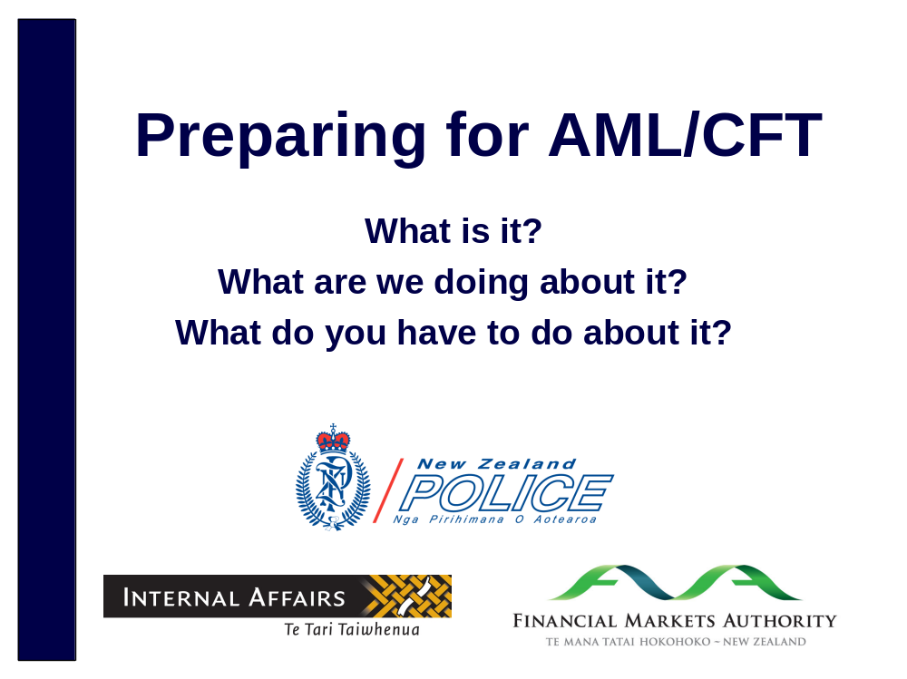
No notes

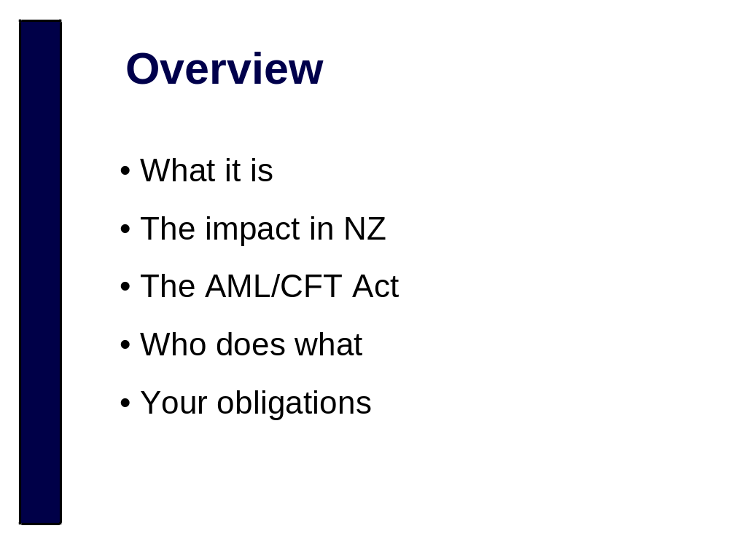
No notes


No notes


How criminals disguise the illegal origins of their money. The objective is to make the funds look like legitimate funds that were obtained through normal transactions such as selling property or gambling at a casino.

Money laundering myths:
- It’s always physical cash that smells like marijuana. In fact much money laundering these days is carried out electronically, for example using funds obtained through on-line fraud.
- It’s always related to drugs. Money laundering can be associated with any serious crime that results in financial gain.
- It’s always an overt operation designed to retain as much of the money as possible – it can just mean spending illegally gotten gains!

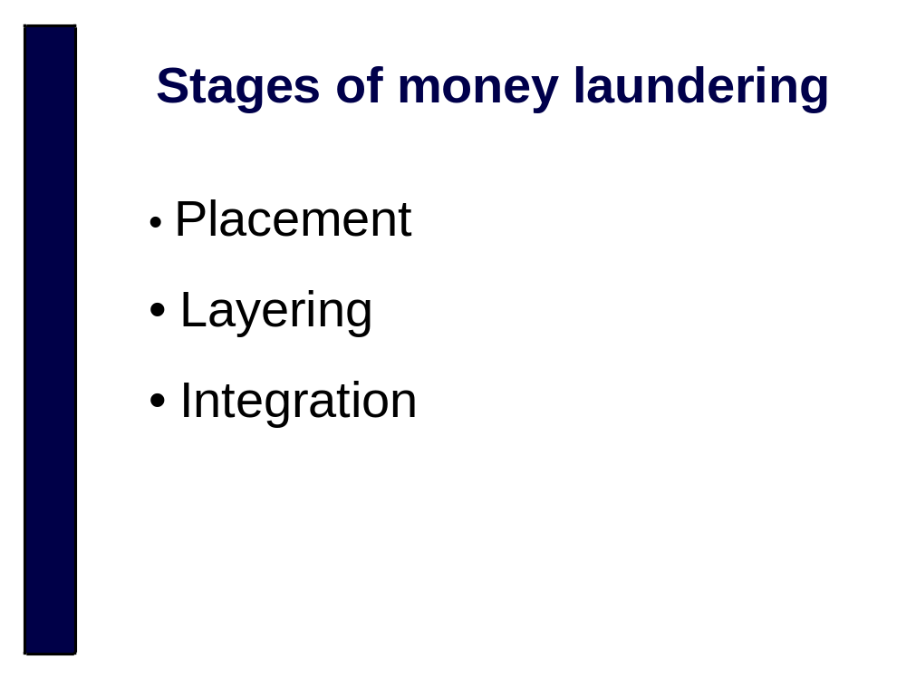
Generally ML is a three step process involving:
- Introduction of illegally obtained money in the financial system (this step is called “placement”);
- Disguising the audit trail so it is difficult to identify the original source of the funds. This is often achieved by breaking funds up and moving them around in a series of complex transactions (this step is called “layering”);
- Transferring the now apparently legitimate funds into a form which they can be used (this step is called “integration”).

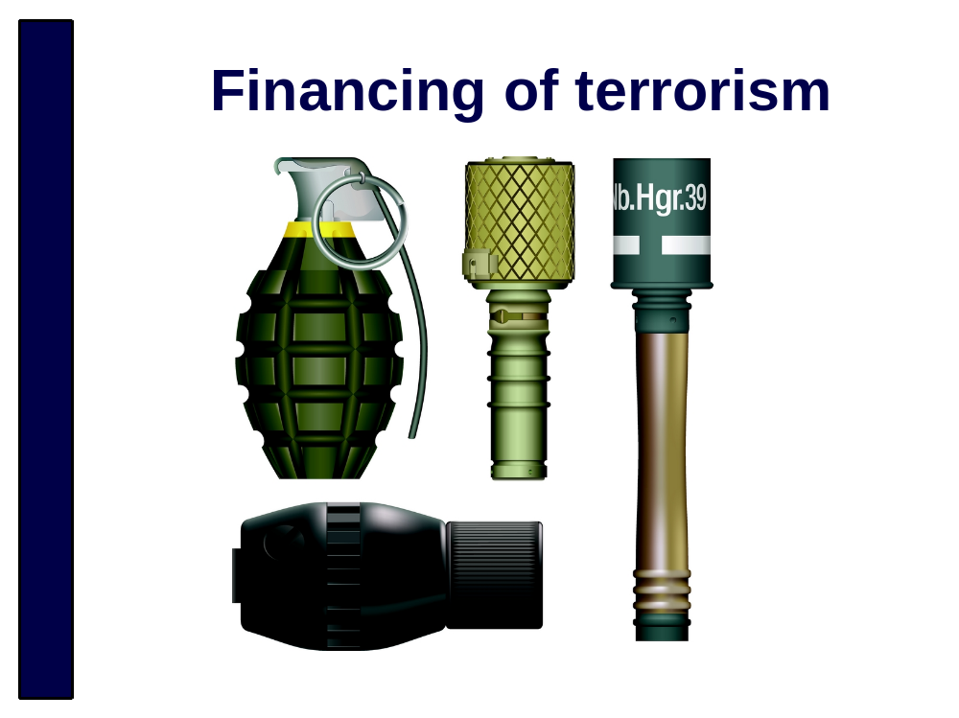
Terrorism financing is “the act of providing financial support to terrorists or terrorist organisations to enable them to carry out terrorist acts”
Financiers of terrorism use similar techniques to money launderers to avoid detection by authorities and to protect the identity of those providing and receiving the funds. The Internet and globalisation has made this easier.
It’s not just about providing direct support to terrorist acts (like buying bombs), it can just be helping terrorists to live day to day. It’s almost like a mirror image of money laundering - often Terrorism Financing is legitimate/clean funds used to finance crime/terror, Money laundering is laundering the proceeds of crime to make it legitimate/clean.

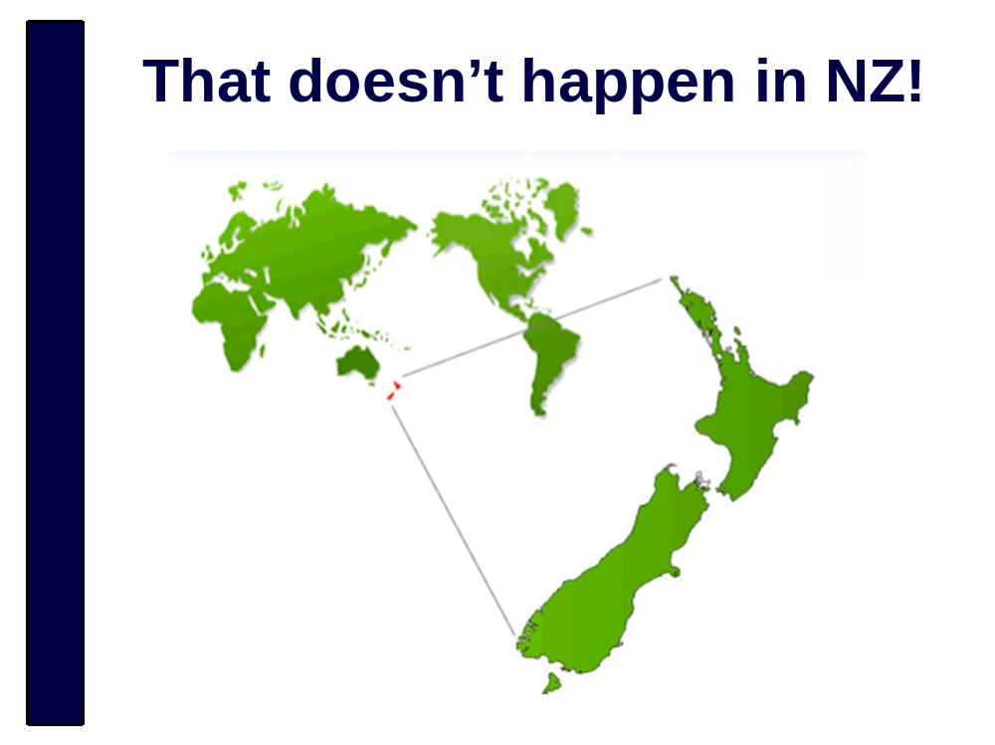
Well yes it does.
-Even NZ with its relative isolation has its own home-grown crime
-With globalisation and the internet, we are increasingly exposed to risks from international organised crime and possibly even from organisations supporting terrorism.
You can find examples of ML risks in NZ in the National Risk Assessment, available on the Ministry of Justice website.

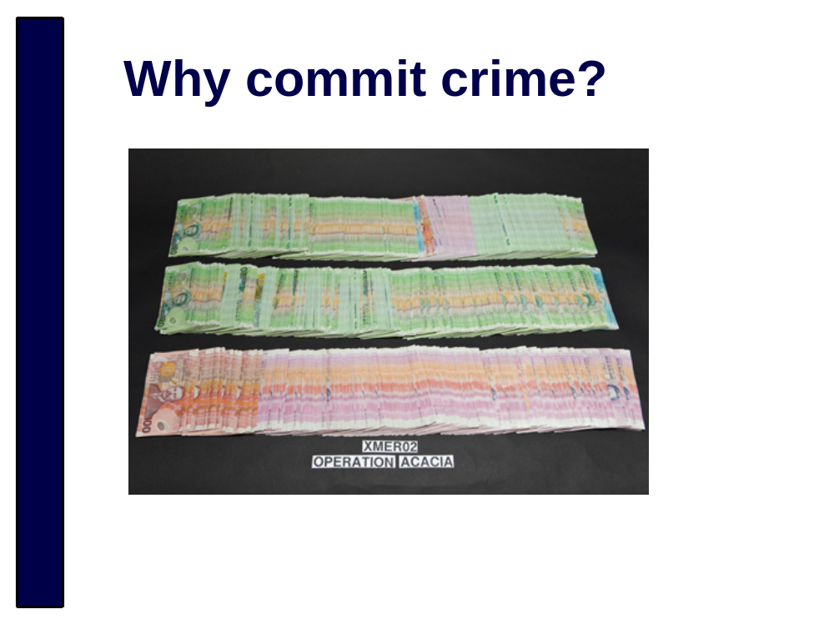
Serious crime is profit driven. Estimates put the amount of money laundering that occurs in New Zealand at 1 to 1.5 billion NZD every year.

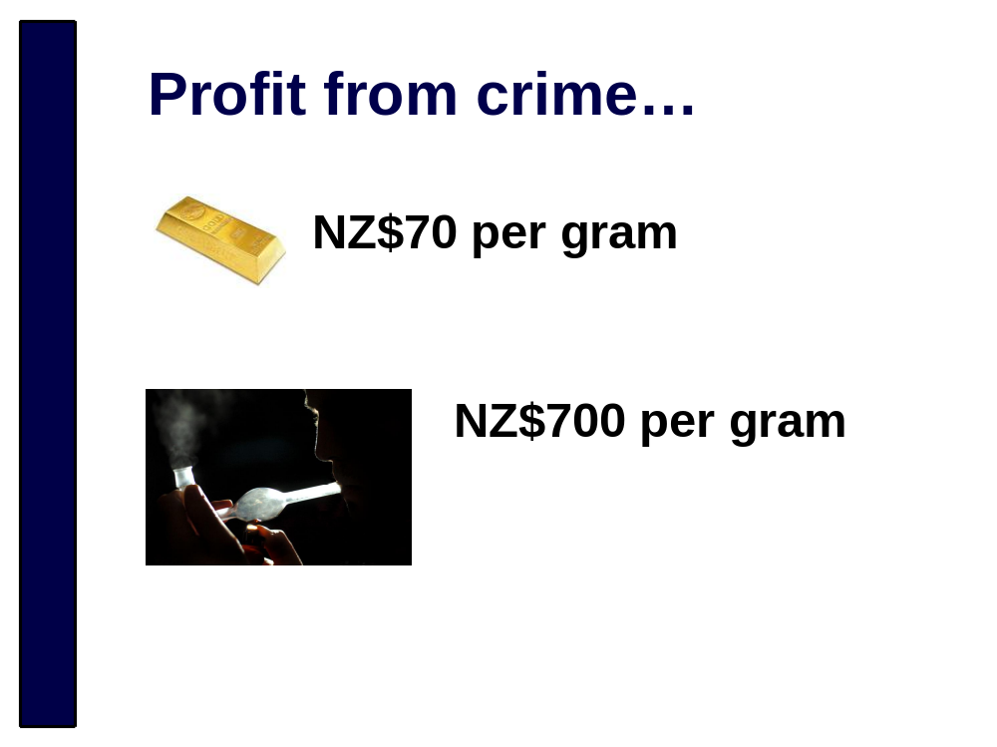
When these presentation slides were prepared, gold was priced at around NZ$70 per gram. In comparison, pure methamphetamine sells for about NZ$700 per gram.

There is a lot of money to be made in serious crime. And criminals want to be able to keep their ‘hard earned’ profits of crime. So to make it look clean, they launder it.

There a number of methods that criminals use to launder the money they make from their crimes. The next few slides illustrate some of the more common methods.

This isn’t an exhaustive list of money laundering methods. It is important to note that any type of transaction could be part of a money laundering process. So even if the next few slides don’t include the types of transactions that your business provides, we hope these examples prompt you to consider how your business model could be targeted by a money launderer.

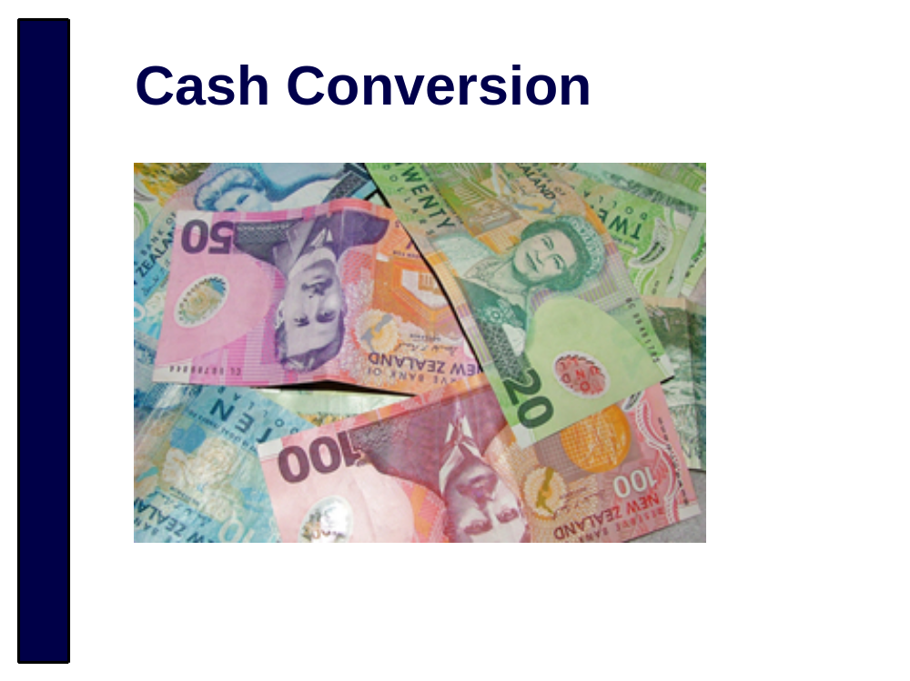
Cash conversion involves exchanging one denomination of cash notes for another. In New Zealand these transactions often involve $20 notes being exchanged for $50 or $100 notes. Cash conversion adds a layer in the money laundering process. And once converted to larger denominations, less notes are required to achieve the same value. So it makes a large amount of cash easier to store or conceal.

Foreign currency conversion can also be used to launder money. This can occur using physical cash or through electronic transactions.

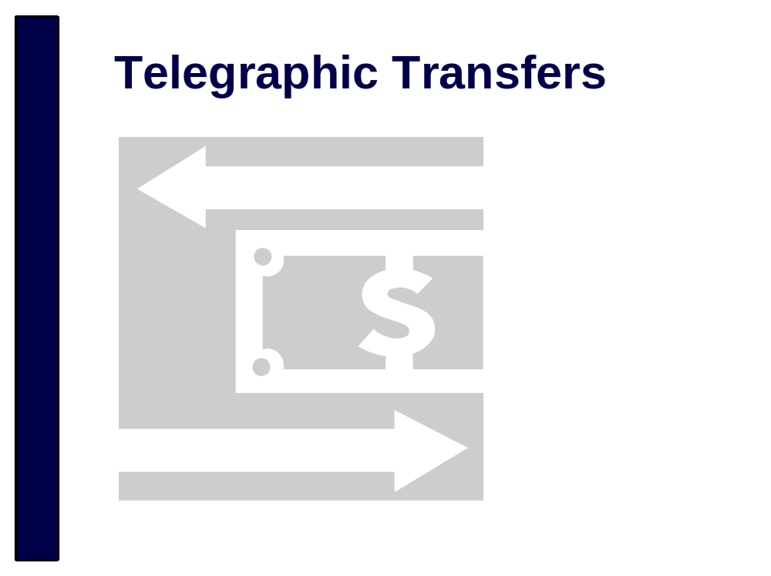
Money remittance is currently the most significant typological risk for money laundering in New Zealand. Telegraphic transfers have been identified in many money laundering investigations for both domestic and transnational crime. Money might be moved from one economy to another and back again. Or it might be sent around the world to add as many layers as possible to disguise its criminal origins.

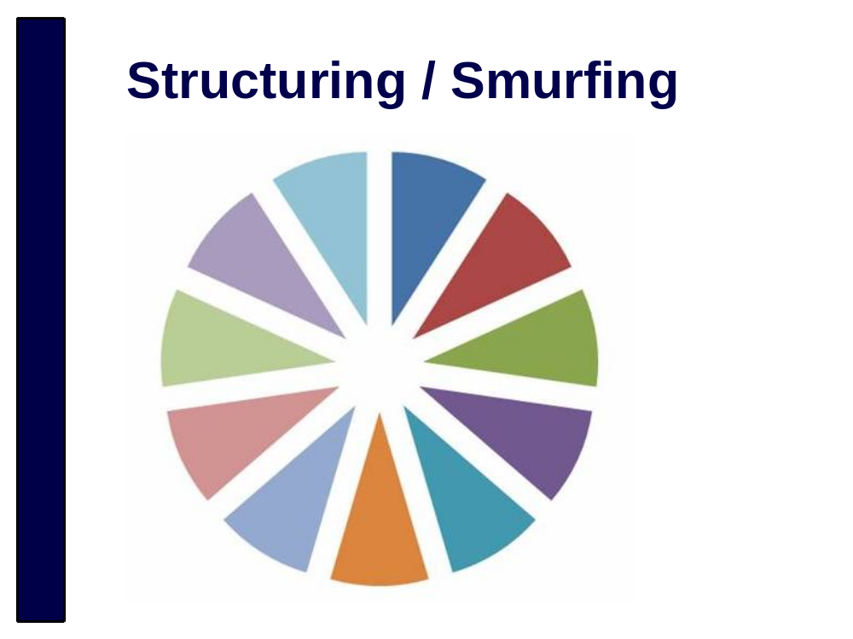
Structuring or smurfing is when one large transaction is broken into smaller transactions in order to avoid attention. This is most often done to avoid due diligence requirements associated with larger transactions. It also makes coming up with a reason for the money a little easier. The launderer can say “I sold my car for cash” 10 times instead of having to explain one single $70,000 transaction.

Structuring is when one person conducts multiple small transactions to avoid attention to a larger amount. Smurfing is when the transactions are conducted by multiple people but the funds have come from a single source.

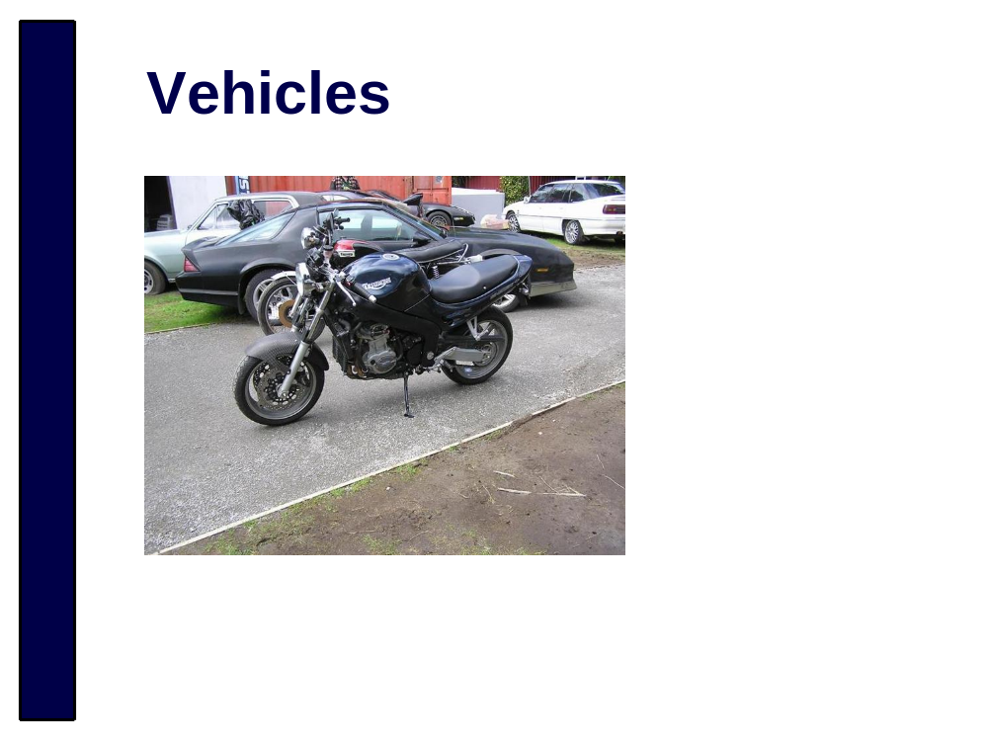
Criminal profits are often invested into cars and motorbikes. In Police investigations into criminal assets we see everything from average priced motorbikes, to high value cars.

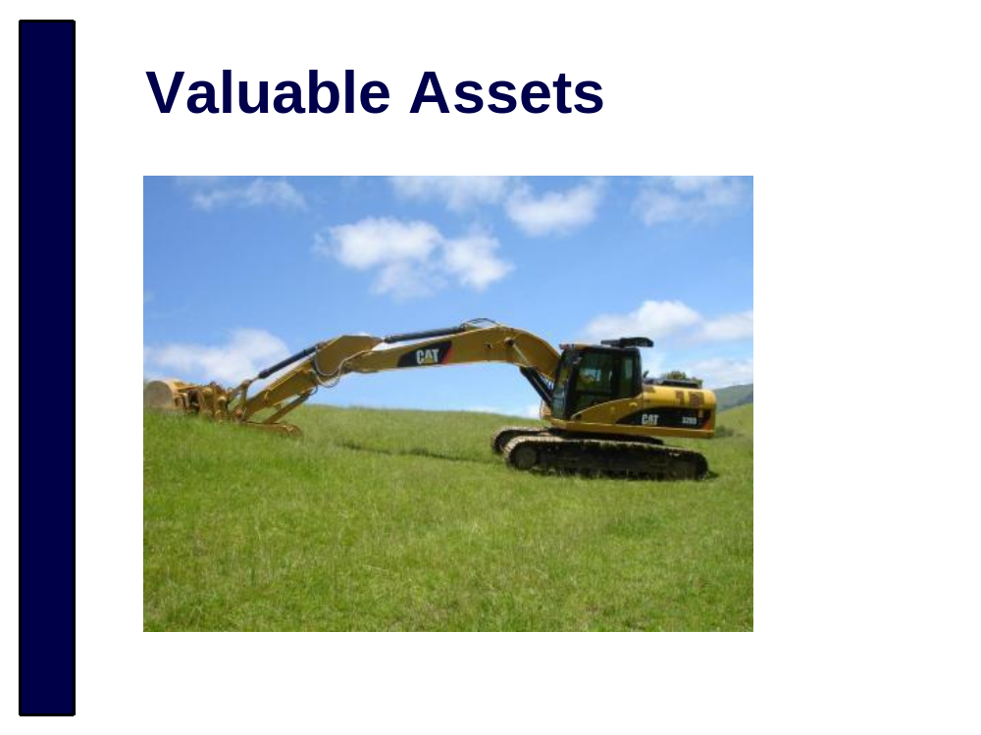
Sometimes criminals hide their profits in ways we wouldn’t expect, like purchasing farm equipment. Purchases like this can be used to integrate criminal profits into legitimate activities like farming.

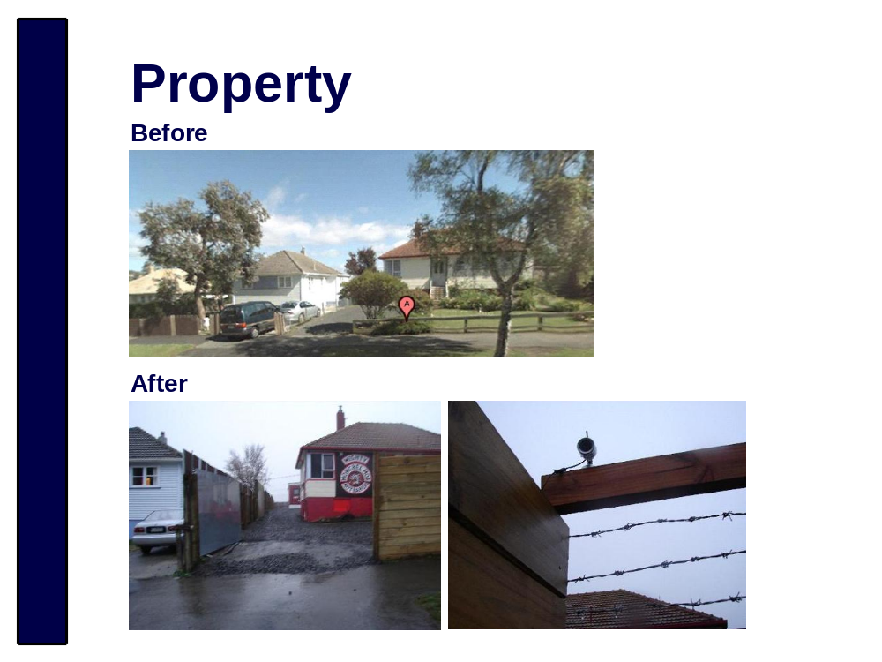
The house in the top photo was an average, suburban New Zealand home. And then the Mongrel Mob purchased the property using money gained from criminal offending.

Their presence in the neighbourhood had a significant negative impact on the community. A nearby school had a role of just over 100 students prior to the Mob purchasing this house. So many parents subsequently withdrew their children from the school that it had to be shut down.

The house was restrained by New Zealand Police and forfeit to the Crown.

This example shows that the profit criminals make from their crimes can be used in ways that have severe, negative impacts on our communities.


Money laundering through trading in shares, bonds, commodities, futures, etc. requires a bit more financial expertise than some of the simpler money laundering methods. But it can be very effective, especially if the launderer conducts multiple and complicated trading transactions.

Trading is one area where money laundering could be indicated by a client’s willingness to accept unnecessary financial losses. A money launderer will often accept a financial loss where their practical gain is money that appears ‘clean’ as a result of the transaction.

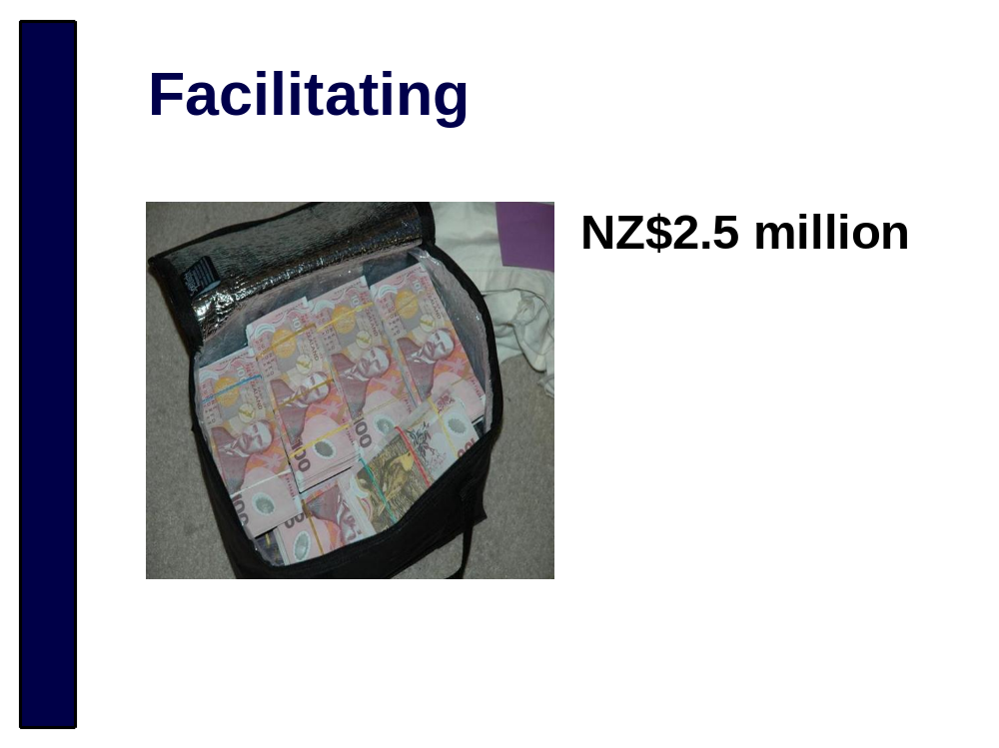
Police have seen cases where reporting entities have recklessly or knowingly facilitated money laundering. The cash in this photo was restrained during an investigation that linked a reporting entity to money laundering and drug trafficking activity.

Allowing these things to occur in your business could expose you to the risk of criminal prosecution.


No notes

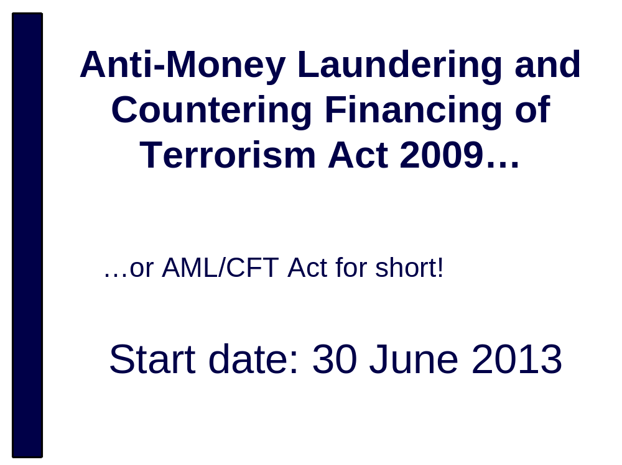
Yes, it is a mouthful. That’s why it is know as the AML\CFT Act for short
Commencement Order 2011 brings all obligations under the Act into force on 30 June 2013 – the two year countdown has begun
There won’t be an assisted compliance period like there was in Australia


Detect and deter money laundering and financing of terrorism.
The detection and deterrence of ML and FT is best achieved by you because you best know your business, the risks involved and the customers you deal with. You know what’s a normal transaction and what’s abnormal.
The public/private sectors are working together to ensure criminals do not use NZ businesses for ML or FT.


Ensure NZ is a good international citizen.
There are international standards we are expected to comply with. New Zealand is a member country of the Financial Action Task Force who evaluate our systems and policies for detecting and deterring ML/FT every 4 years or so and we need to show New Zealand is complying with that.
Our credit rating and relationships with other countries (whether they want to do business with us) can be affected if we aren’t responsible.

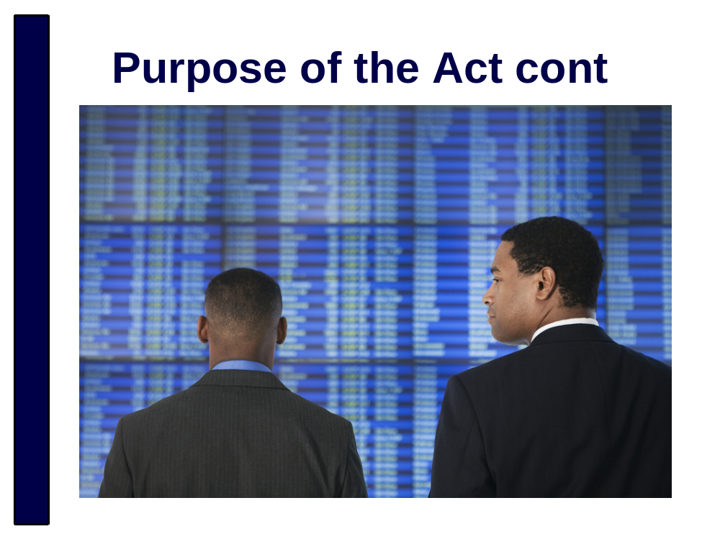
Maintain public confidence in the financial system.
New Zealanders want to know they’re investing their money with a company that isn’t laundering money for criminals

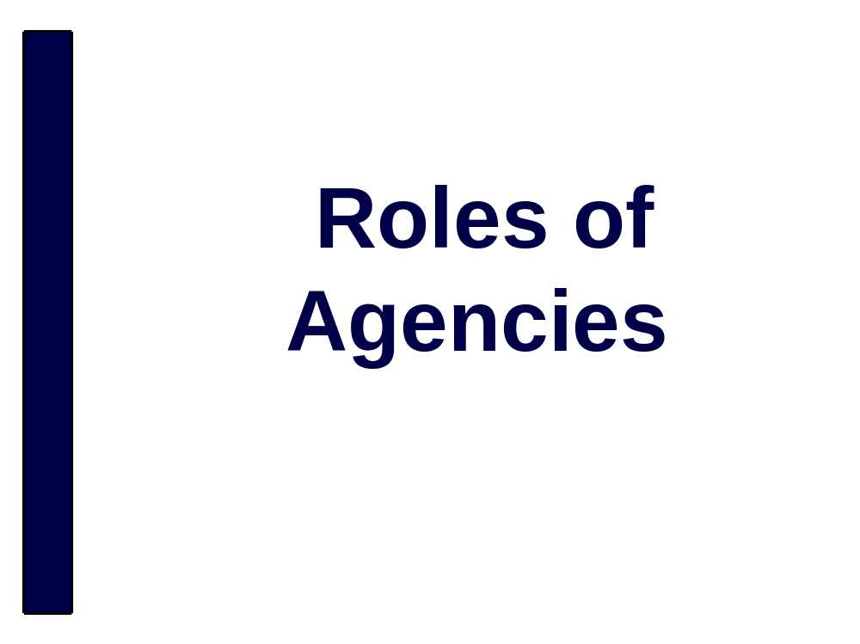
No notes

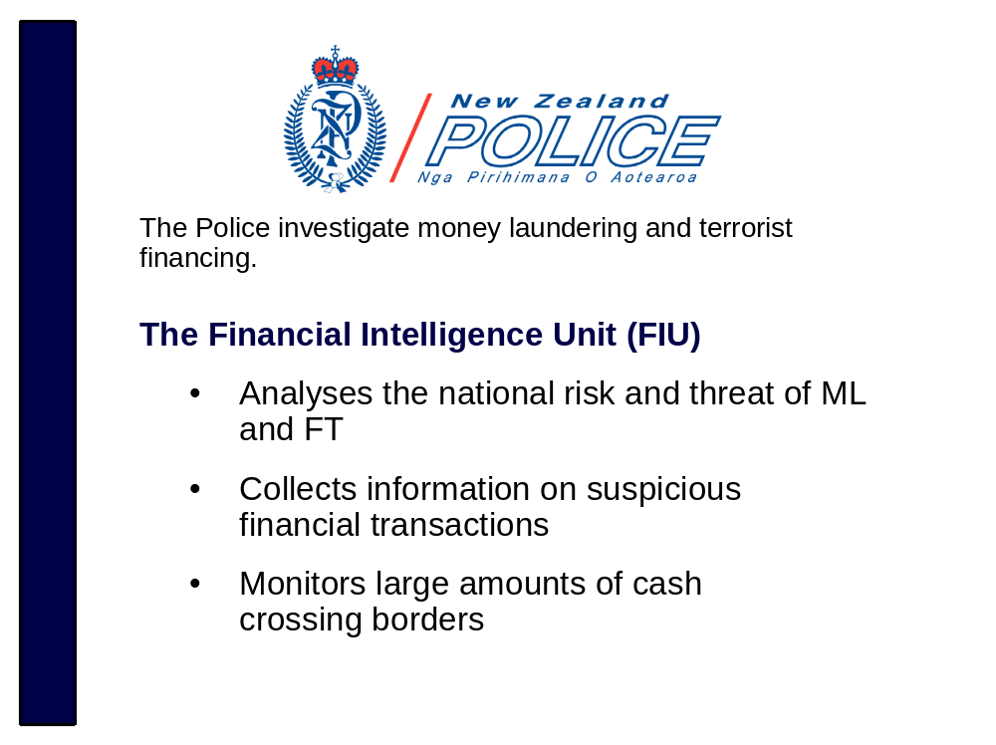
No notes

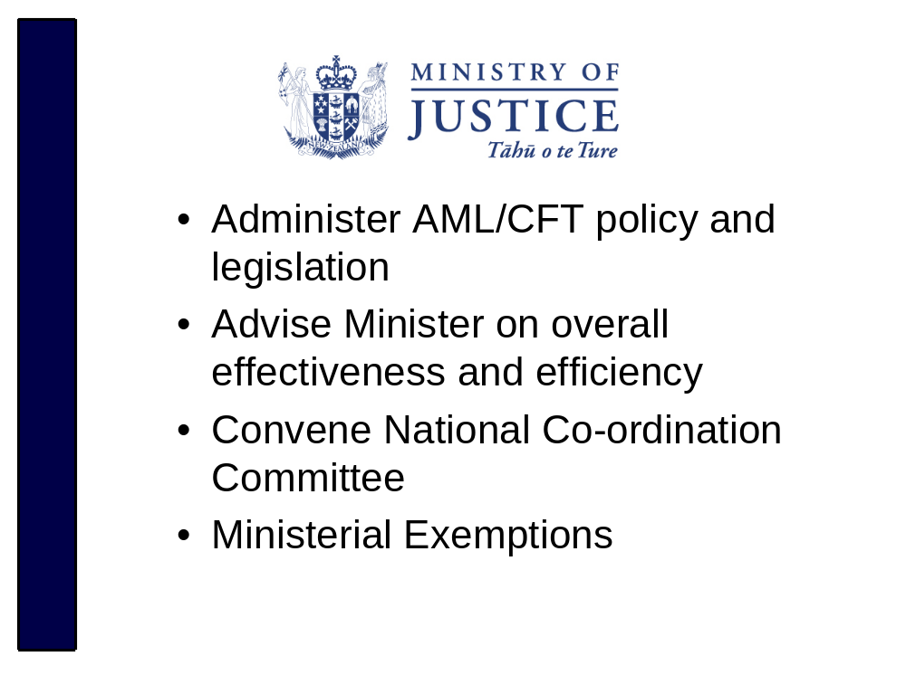Legislation includes the Act and Regulations
Advice to Minister will include any changes necessary to the AML/CFT regime to improve its effectiveness
National Co-ordination Committee
The Act established the AML/CFT co-ordination committee more commonly known as the National Co-ordination Committee (NCC).
The NCC comprises of a representative from each of:
- Ministry of Justice
- New Zealand Customs
- Every AML/CFT supervisor
- Police
- Any other persons (who must be employees of a government agency) as are invited by (the chief executive of) the Ministry of Justice
The role of the NCC is to ensure that the necessary connections between the supervisors, Police, and other agencies are made in order to ensure the consistent, effective, and efficient operation of the regime.

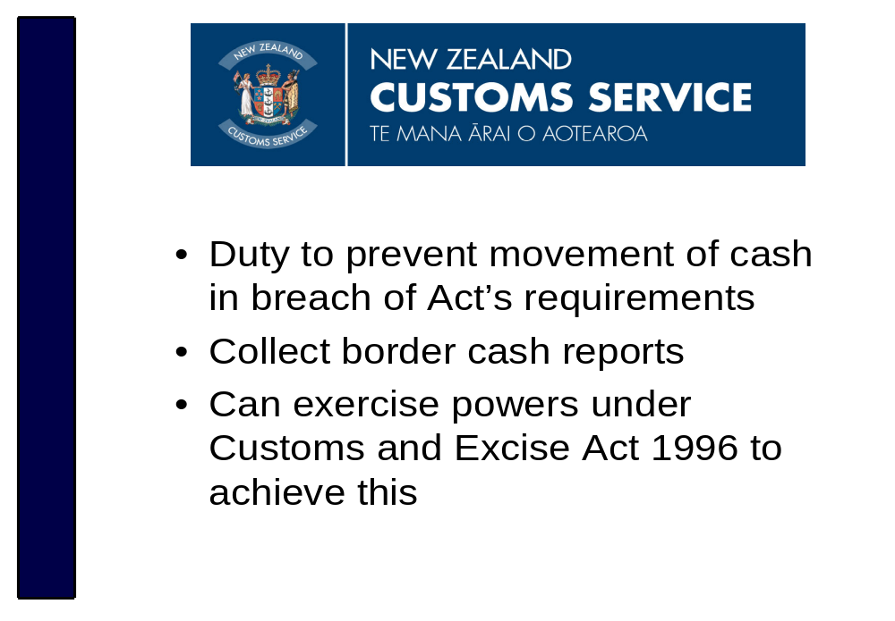People bringing cash into or out of the country valued at $10,000 or more must provide customs with a border cash report. It is an offence not to do so.
The term person includes legal persons i.e. companies
The term “cash” includes bearer negotiable instruments.
A bearer-negotiable instrument means:
- A bill of exchange
- A cheque
- A promissory note
- A bearer bond
- A traveller’s cheque
- A money order or postal order
A report is required for unaccompanied as well as accompanied cash.
Powers under Customs and Excise Act 1996 include:
- Questioning
- Detention
- Search and Seizure
- Examination of goods etc.

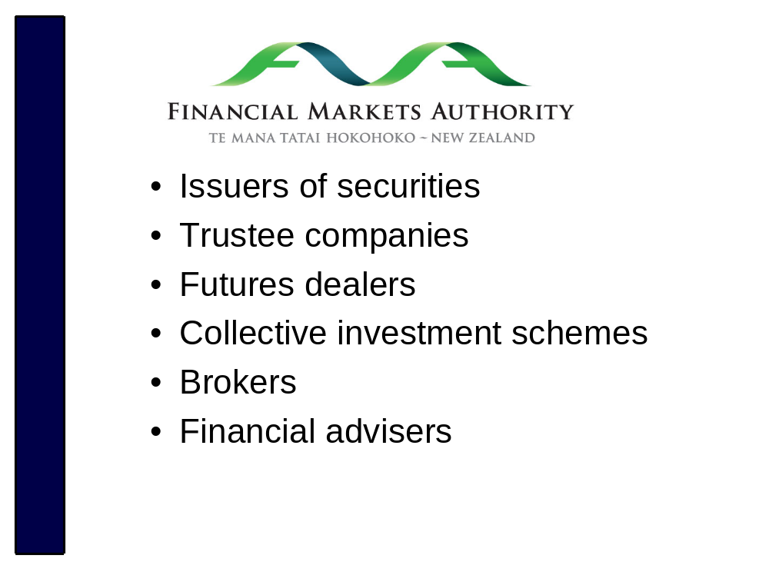
The Financial Markets Authority will monitor these entities.
This includes authorised financial advisors, AML/CFT obligations apply to the AFA’s entity rather than the individual AFA’s

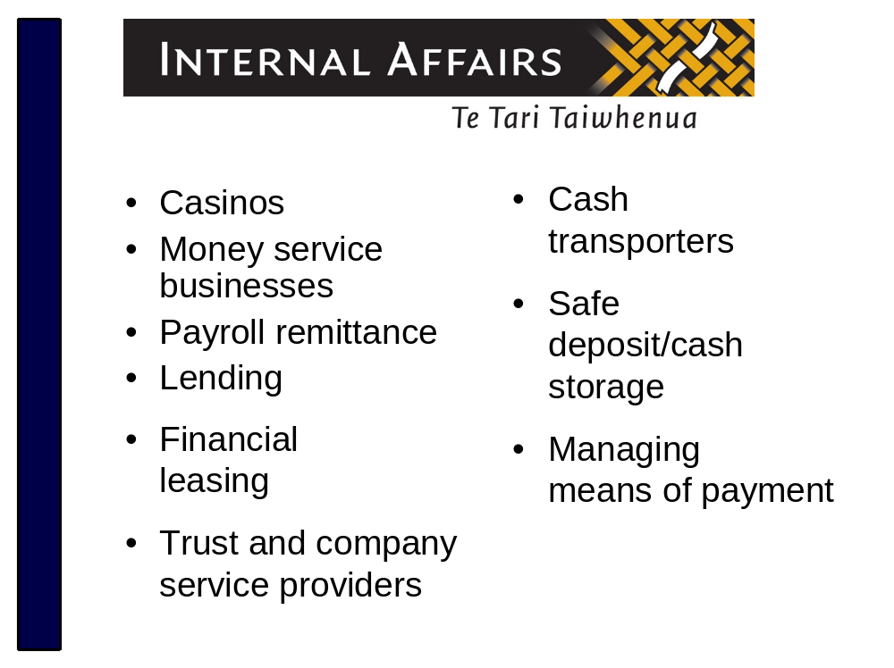
DIA will monitor these entities.
Money service business includes: currency exchange and money remittance/transfer.
Lending includes: non-bank non-deposit-taking lenders, debt collection and factoring
Managing means of payment includes: non bank credit card providers
Trust and Company Service providers are those businesses that provide 1 or more of the following activities:
- Acting as a formation agent of legal persons or arrangements
- Arranging for a person to act as a nominee director/shareholder or trustee in relation to legal persons or arrangements
- Providing a registered office, business address, or accommodation, or a correspondence, or an administrative address for a company, a partnership, or any other legal person or arrangement
This applies whether the companies established are on-shore or off-shore

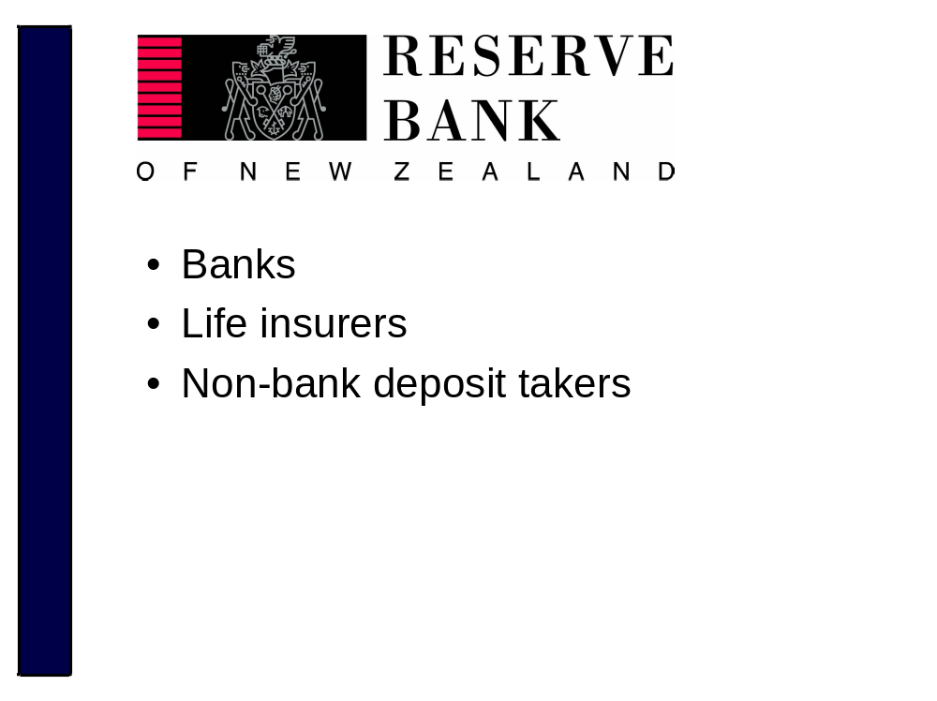
Non-bank deposit takers are finance companies, building societies and credit unions

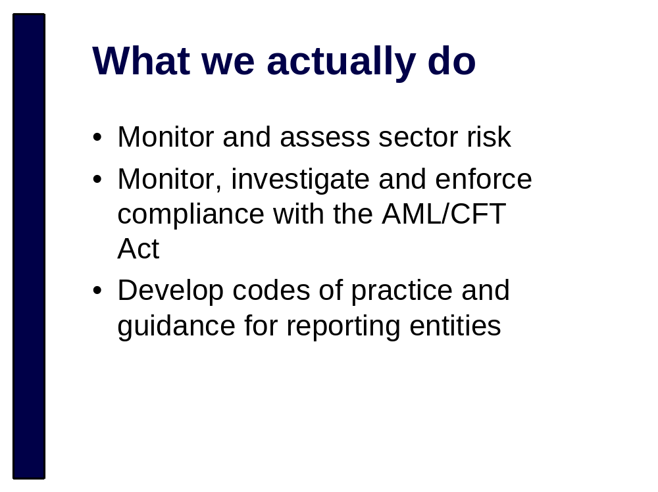
Codes of practice = safe harbour, best practice of how to approach an obligation. Will be generic or sector specific
Guidelines = non enforceable, best practice, generic or sector specific (there is scope for sectors to develop their own guidance)
We are also co-operating with domestic and international counterparts


You need to be ready to fulfill your obligations from 30 June 2013.

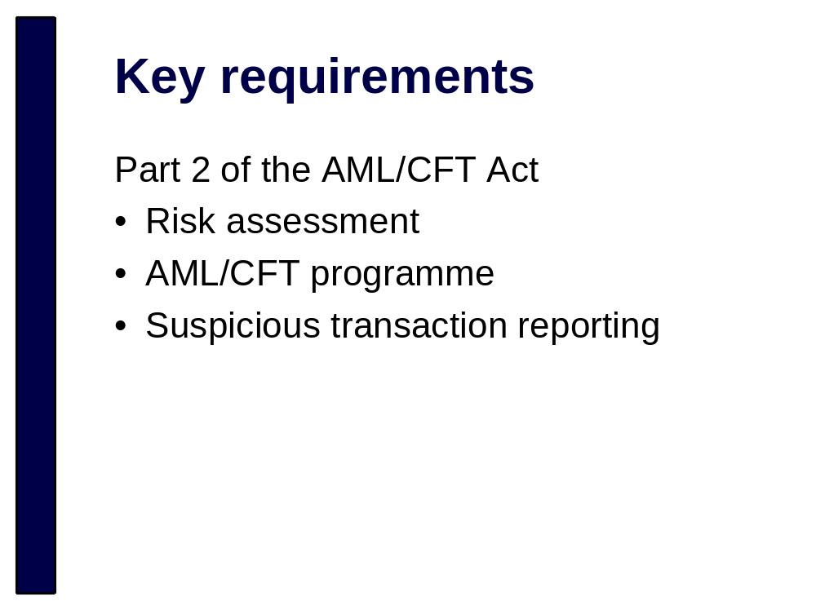
No notes

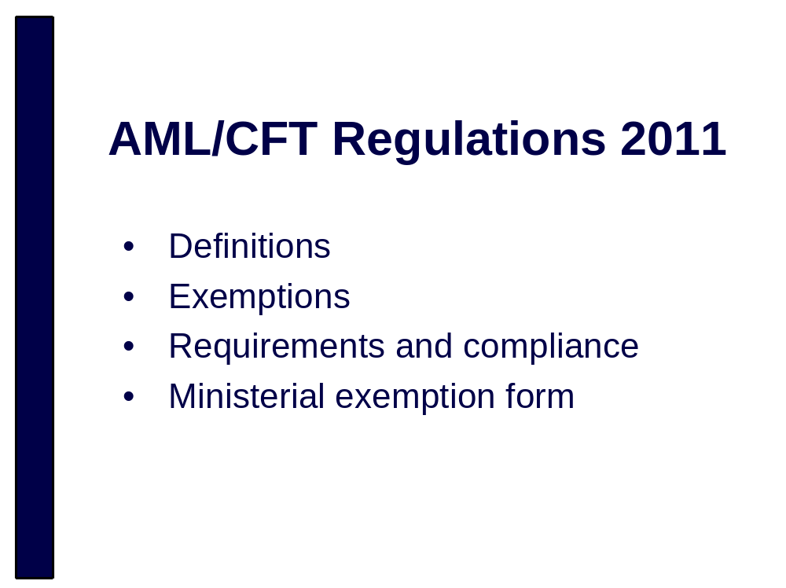
Regulations contain inclusions (eg trust and company service providers and authorised financial advisers) and exemptions from all or part of the AML/CFT obligations under the Act
You should read and understand the Regulations and how they relate to your business
The following obligations are what apply to most businesses; you should check the Regulations to see if any exemptions apply to your business
For example Debt collectors are exempt from all aspects of the regime except suspicious transaction reporting

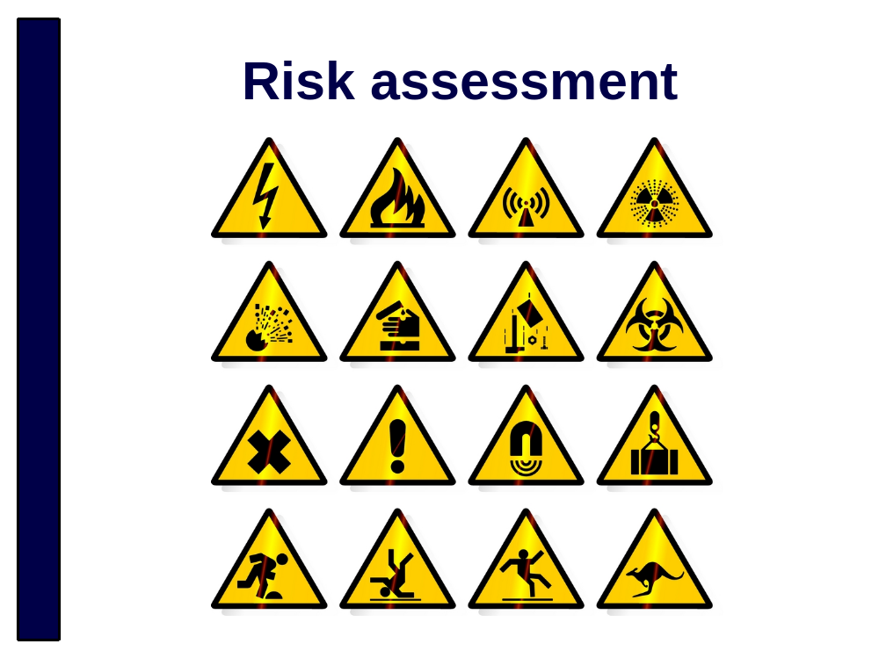
The AML/CFT Act takes a risk based approach. A National Risk Assessment (completed by Police) and Sector Risk Assessments (completed by supervisors) have been developed.
You will also be expected to develop your own risk assessment:
- You know best about your business i.e. what is and isn’t a normal customer
- You know the risks
We strongly recommend you refer to the SRA when conducting your own risk assessment.
We have released a Risk Assessment Guideline to help you with your risk assessment; this includes a list of additional resources that will assist you
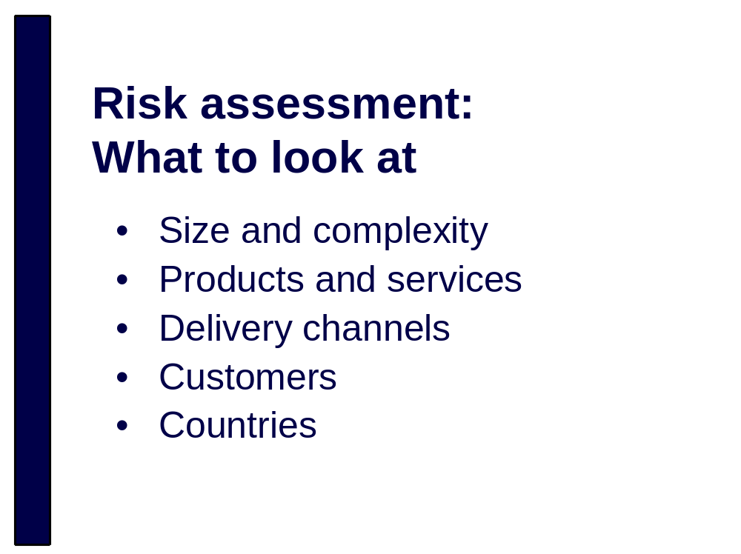
When assessing the risk your business may be susceptible to you should consider:
- Nature, size and complexity of your business
- Products and services you offer
- The way you deliver your products and services
- The types of customers you deal with
- The countries you deal with

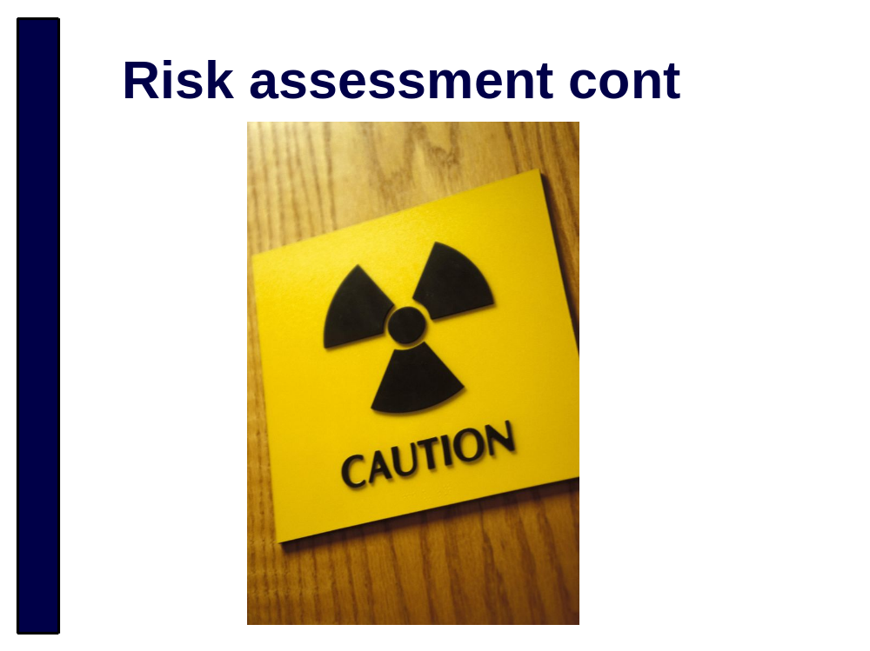
You must assess and rate the likelihood of your business being used for ML/FT
Consider each aspect you have identified using your business experience and published information
The end result will be a likelihood rating for each at-risk area of your business. You could use the following ratings
- Very unlikely
- Possible
- Likely
- Very Likely
Your risk assessment must enable you to prepare a comprehensive compliance programme, and meet your obligations especially in relation to CDD and ongoing CDD
The Risk Assessment must be in writing and describe how the business will ensure the assessment remains up to date

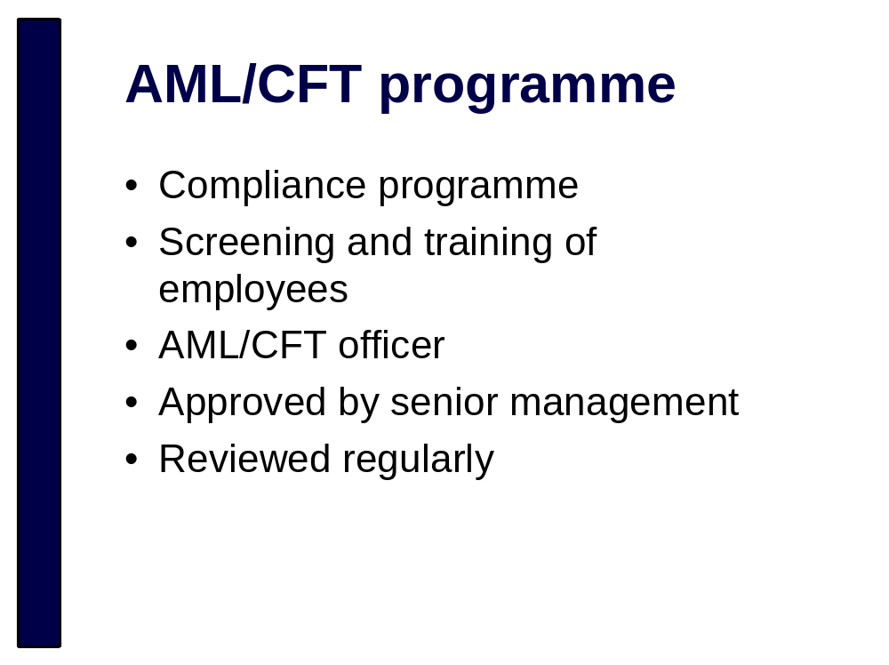
Your AML/CFT programme must include procedures, polices and controls to detect, deter, manage and mitigate ML and FT

Programme is based on your AML/CFT risk assessment and will include adequate and effective procedures, policies and controls for:
- Vetting and training staff
- CDD requirements
- Suspicious Transaction Reports
- Record Keeping
- How you will mitigate/manage risks of ML and TF
- Account Monitoring
An effective programme will protect the business against regulatory penalties or reputational damage.
We are currently developing a guideline to assist you with your AML/CFT programme that we hope to release by the end of the year

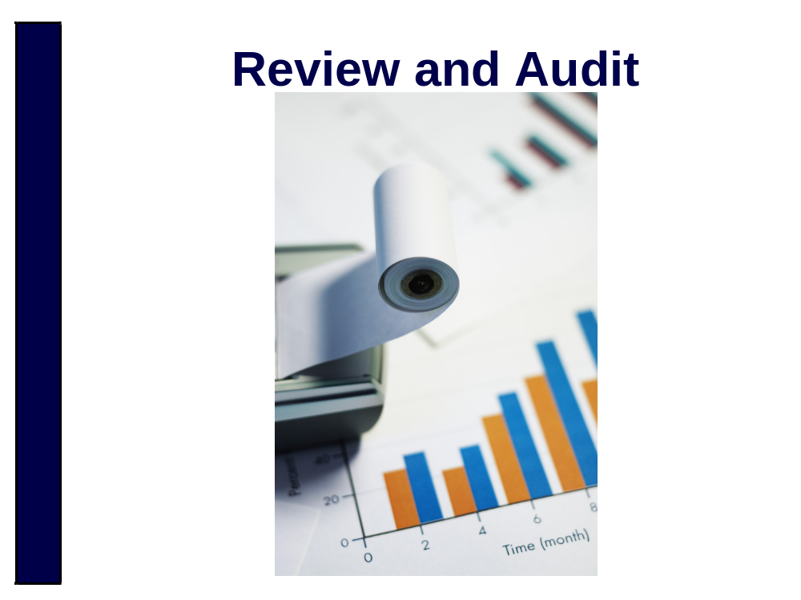
Reporting entities must review their Risk Assessment and AML/CFT programme to:
- Ensure they remain current
- Identify any deficiencies in their effectiveness
- Make any changes identified as necessary to remedy deficiencies
Must audit Risk Assessment and AML/CFT programme every 2 years (or at request of supervisor)
Audit must be carried out by an independent person, appropriately qualified
This might not be an accountant, but it does mean someone with relevant skills or experience (eg people with AML/CFT or relevant financial experience), you must be able to justify to your supervisor why the auditor is appropriately qualified.
The auditor must be independent and not involved in the reporting entities risk assessment or AML/CFT programme in any way. They may be a staff member but they must be adequately separated from the area of your business that deals with the risk assessment and AML/CFT programme.
A reporting entity may decide on an external auditor, the auditor’s business must ensure the same separation between staff who deal with the risk assessment/AML/CFT programme and the audit.

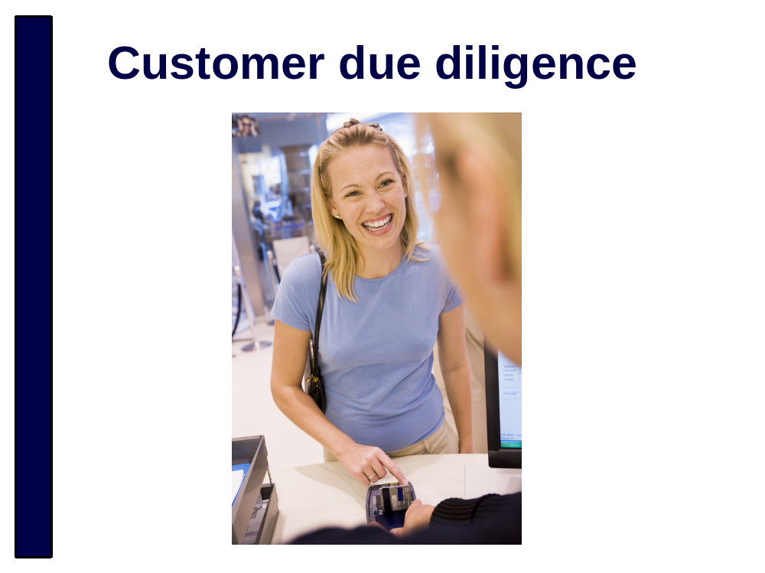
Abbreviated as CDD

Customer Due Diligence involves gathering and verifying information about a customer’s:
- Identity
- Beneficial owners
- Representatives (i.e. people acting on their behalf)

The purpose of good customer identification and verification processes is to:
- Manage identity fraud risks and the criminal use of anonymity
- Ensure greater observation of transaction behaviour of higher risk customers

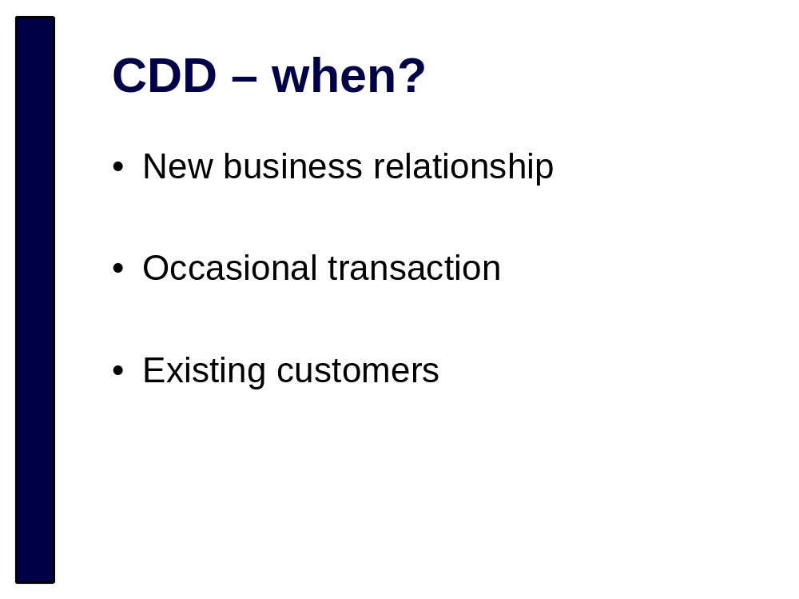
You must do CDD on:
- Customers seeking to establish a new business relationship, e.g. set up an account or take out a loan: or
- Customers conducting an occasional transaction (an occasional transaction means a cash transaction that occurs outside of a business relationship, over the applicable threshold (these are set out in the Definitions Regulations) whether carried out in a single operation or several that appear to be linked.
- Existing customers where there has been a material change in the nature or purpose of the business relationship or you consider you do not have sufficient information on them

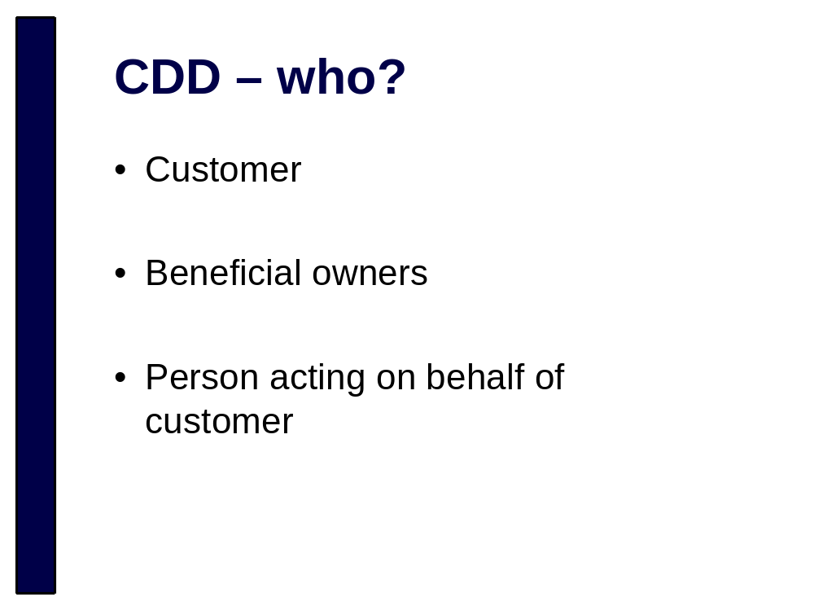
Who to do CDD on:
- A customer (new or existing)
- Any beneficial owner of a customer (individuals who have effective control of a customer or own 25% or more of a customer when the customer is a legal person –a company, trust or other organisation)
- Any person acting on behalf of a customer
- A customer conducting an occasional transaction.

You also need to do ongoing CDD by periodically reviewing your existing customer base. It’s not about annoying your regular customers it’s about preventing criminals from exploiting your business.

There are three levels of CDD that depend on the risk that each customer represents (based on your risk assessment):
- Simplified/standard and enhanced due diligence

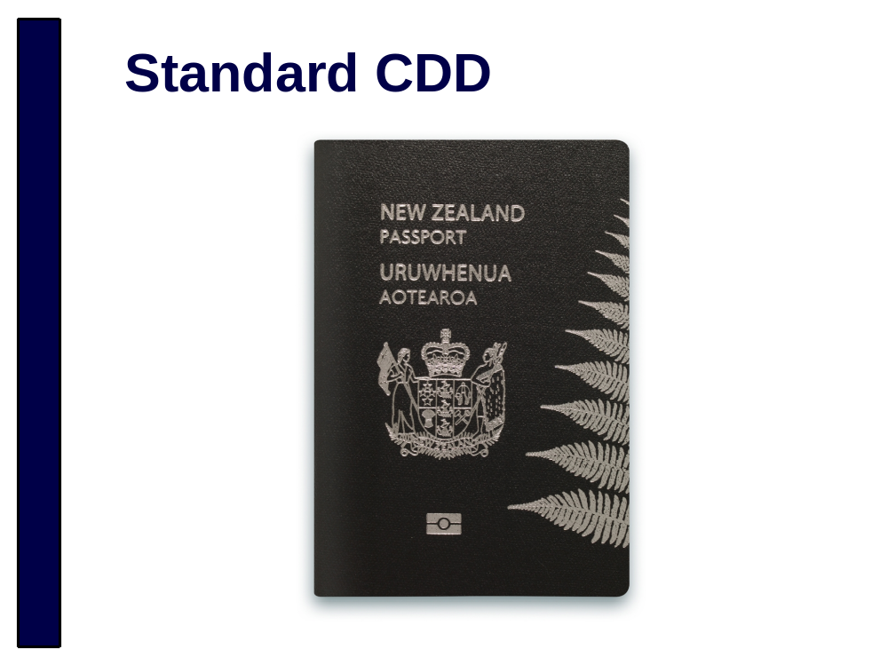
Standard CDD requires you to collect identity information including:
- The person’s full name and date of birth
- If the person is not the customer, the person’s relationship to the customer
- The person’s address or registered office
- The person’s company identifier or registration number

You must then take reasonable steps to be satisfied that the above information is correct, verify any beneficial owner's identity, and if the person is acting on behalf of a customer verify their identity and authority to act

You must also collect information on the nature and purpose of any proposed business relationship, and gather sufficient information to determine whether the customer should be subject to enhanced CDD

You must also conduct standard CDD as soon as practicable after you become aware that an existing account is anonymous (Requirements and Compliance Regulations)

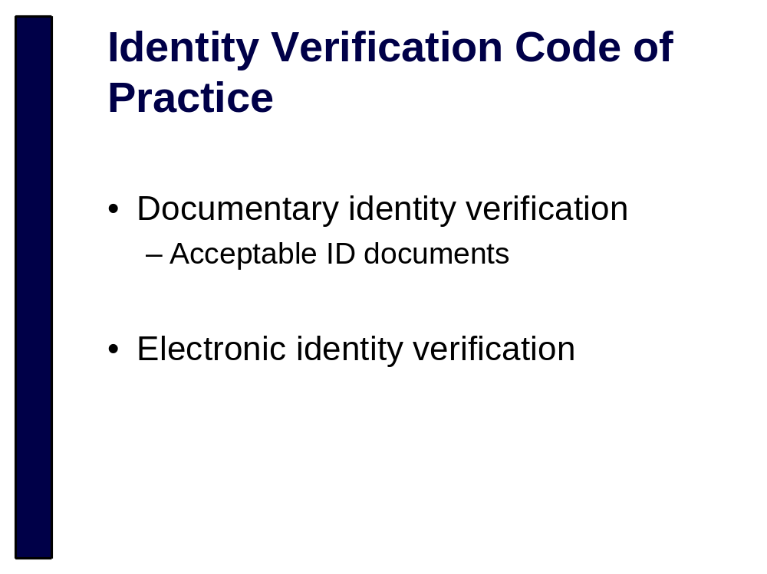
We have now released the Identity Verification Code of Practice; it is available on supervisors’ websites.

The code sets out a standard of practice to help you verify the name and date of birth of customers you have assessed as low to medium risk that are natural persons

It covers documentary and electronic identity verification including the use of certified documents
It details acceptable primary photographic and non-photographic identification, and outlines when secondary or supporting identification is required

For example, a passport on its own, or a driver licence together with an eftpos card.

Although it is not mandatory, it constitutes a safe harbour. If a reporting entity fully complies with the code it is deemed to be compliant with the relevant parts of the legislation. If a reporting entity opts not to comply, it must adopt practices that are equally effective, otherwise it risks non-compliance

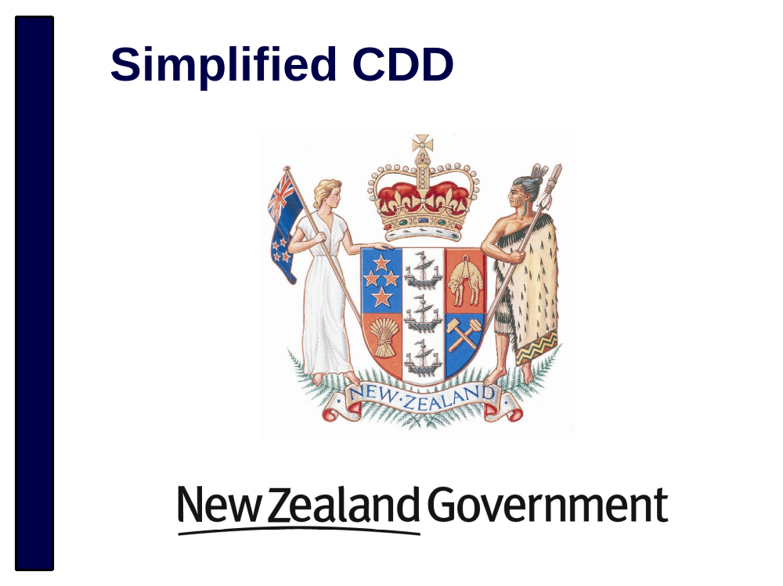
Simplified CDD can be conducted on:
- Government Departments
- Local Authorities
- New Zealand Police
- New Zealand Security Intelligence Service
- Crown entities
- Listed companies
Simplified CDD requires you to obtain identity information from the person acting on behalf of the customer:
- Full name
- Date of birth
- Their relationship to the customer
You must verify the identity of the person acting on behalf of the customer, and their authority to do so
This must be done before establishing a business relationship/conducting an occasional transaction on behalf of the customer
Obtain information on the nature and purpose of any proposed business relationship
The difference between simplified CDD and standard CDD is that you do not have to obtain or verify information on beneficial owners for simplified CDD

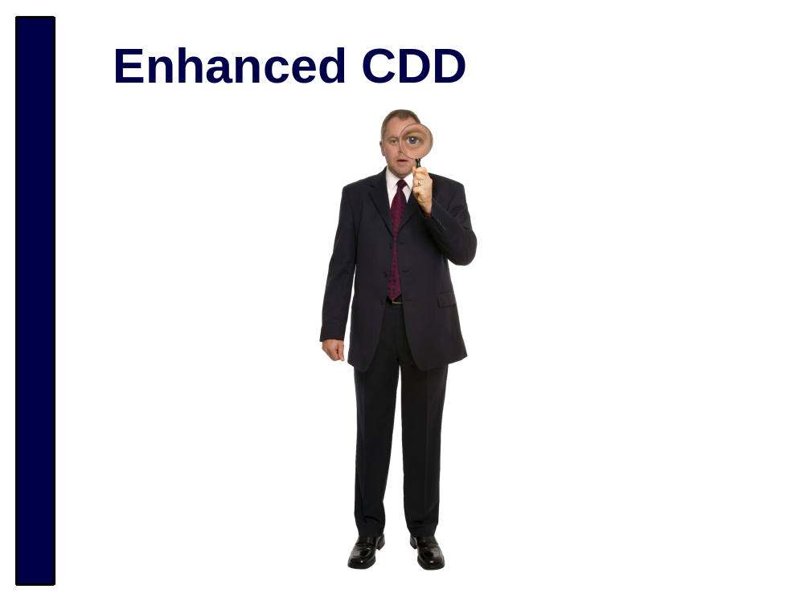
You must conduct enhanced due diligence in the following circumstances which have a higher ML/FT risk associated with them:
If you establish a business relationship/conduct an occasional transaction on behalf of a customer that is
  - A trust
  - A non-resident from a country with insufficient AML/CFT systems or measures
  - A company with nominee shareholders or shares in bearer form
  - Where new or developing technologies, or new or developing products, that might favour anonymity are involved
  - If a customer seeks to conduct a complex or unusually large transaction or unusual pattern of transactions that have no apparent or visible economic or lawful purpose
  - Where you consider that the level of risk involved requires it
Or
  - If the customer is A Politically exposed person including:
        - Head of State/country or government
        - Government Minister or equivalent
        - Supreme Court Judge or equivalent
Cont’d next page
        - Governor of a central bank or equivalent
        - Senior foreign representative, ambassador or high commissioner
        - High ranking member of armed forces
        - Board chair, CE, CFO or position with comparable influence in any State enterprise
        - Includes their immediate family
        - Includes anyone in joint ownership with a PEP, or who owns an entity on the PEPs behalf
Etc.

Enhanced CDD requires the collection and verification of the same information as standard CDD as well as:
The collection and verification (according to the level of risk involved) of information relating to the source of the funds or the wealth of the customer
Where a customer is a trust, you must obtain the name and date of birth of each beneficiary of the trust unless there are more than 10 beneficiaries, in which case you must obtain the class or type of beneficiary and if it is a charitable trust – the objects of the trust

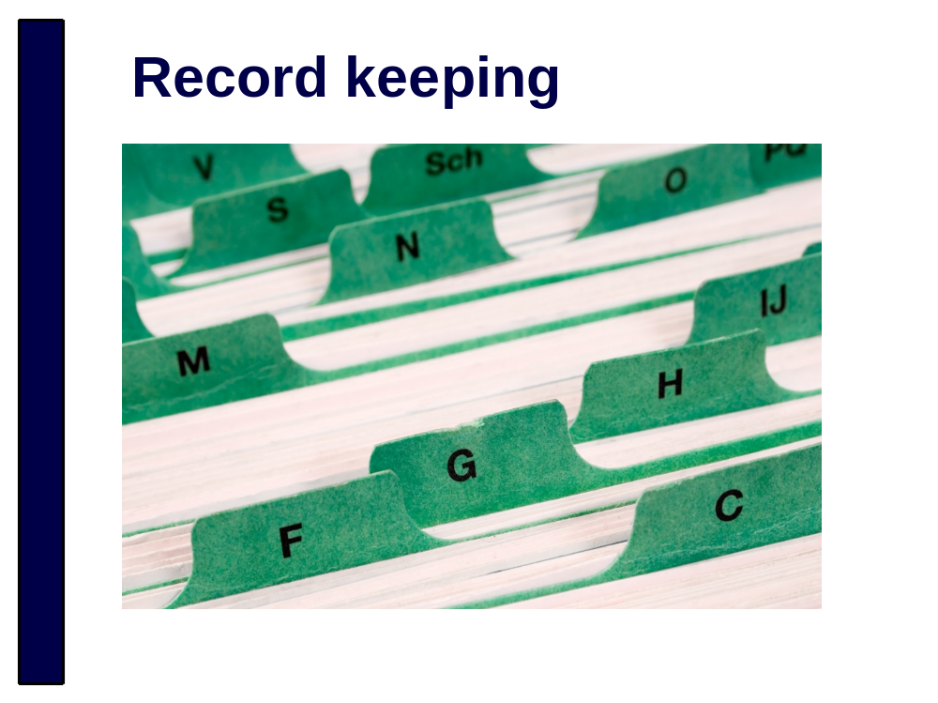
Transaction records must contain information on the:
- Nature of the transaction
- Value & currency
- Date
- Parties involved
- Accounts/facilities involved
- Name of the employee/agent who had face to face dealings with the parties involved

Other records that must be kept include:
- Identity verification records
- Records relevant to the establishment of a business relationship
- Records relating to risk assessments, AML/CFT programmes, and audits ETC.

These records must be kept for at least 5 years.

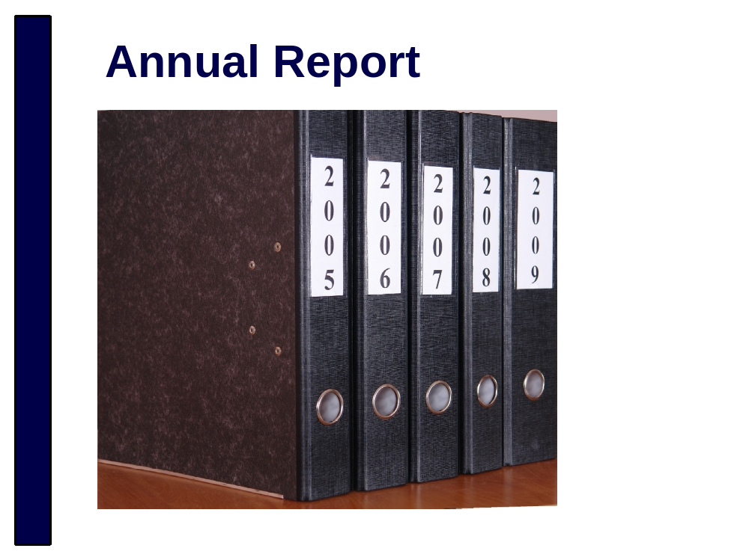
Reporting entities must prepare an annual report on the risk assessment and AML/CFT programme and provide it to their supervisor.

The Annual Report must:
- Include the information prescribed by the regulations for example:
    - The types of relevant activities you do
    - A description of your risk assessment
    - Information about record keeping procedures
    - A description of the different types of CDD applied in different circumstances etc etc
- Take into account the results and implications of their audit

There is a list of the information that must be included in annual reports in the schedule to the Requirements and Compliance Regulations
A form for the annual report will be gazetted next year

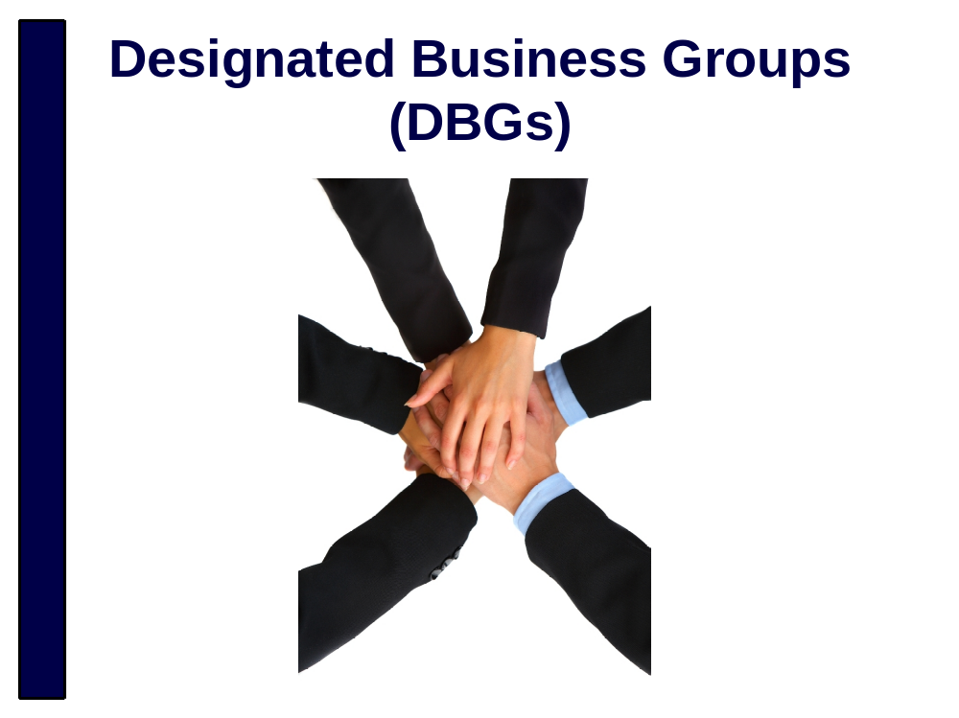
For example, entities that are related to each other (within the meaning of the Companies Act 1993) can form a Designated Business Group (DBG).

An advantage of forming a DBG is that members of the DBG may share various provisions of the same AML/CFT programme.

Provisions of the programme that can be shared include:
- Record keeping;
- Account monitoring;
- Ongoing customer due diligence;
- Annual reporting;
- Procedures, policies and controls of the above provisions
- Risk assessments can also be shared where relevant to the business

How to form a DBG is set out in the regulations and supervisors are working on providing more information on this.

Cont’d next page

Each member of the DBG will still be required to:
- Have an AML/CFT Compliance officer
- Review and audit their Risk Assessment

You should note that although aspects of the AML/CFT programme can be shared, responsibility for complying with all relevant obligations under the Act still remain with the individual reporting entity.

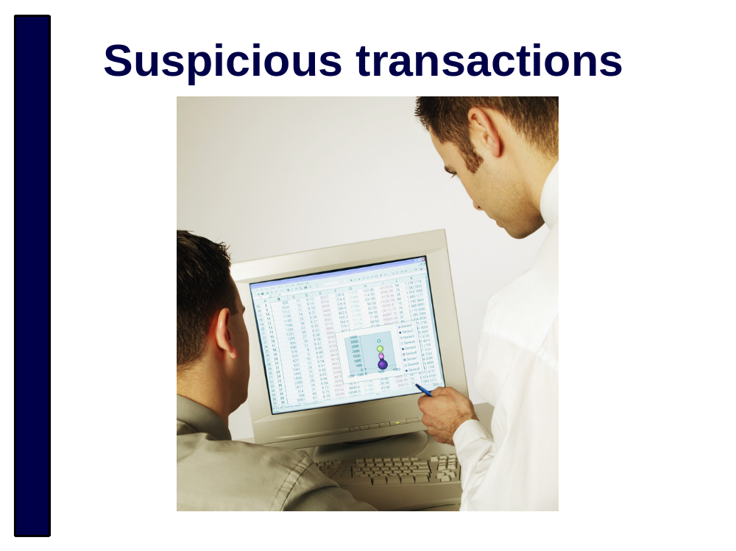
Suspicious Transaction Reports (STRs) aren’t a new concept. If you are captured under the Financial Transactions Reporting Act 1996, then you already have an obligation to report any suspicious transactions to the Commissioner of Police.

Suspicious transactions might be:
- Large amounts
- Lots of small transactions
- Transactions across borders
- Money going in and out of an account on the same day
But generally suspicion comes down to:
- Behaviour that is abnormal for that kind of account or customer
- Transactions that don’t make economic sense

However you best know what is suspicious in your business! And there is no set list of ‘suspicious’ transactions. There is no minimum transaction value on a suspicious transaction either.

A best practice guidelines document is publicly available for STRs submitted under the Financial Transactions Reporting Act 1996. Police will be issuing a new set of guidelines on submitting STRs under the AML/CFT Act prior to the ‘go live’ date.

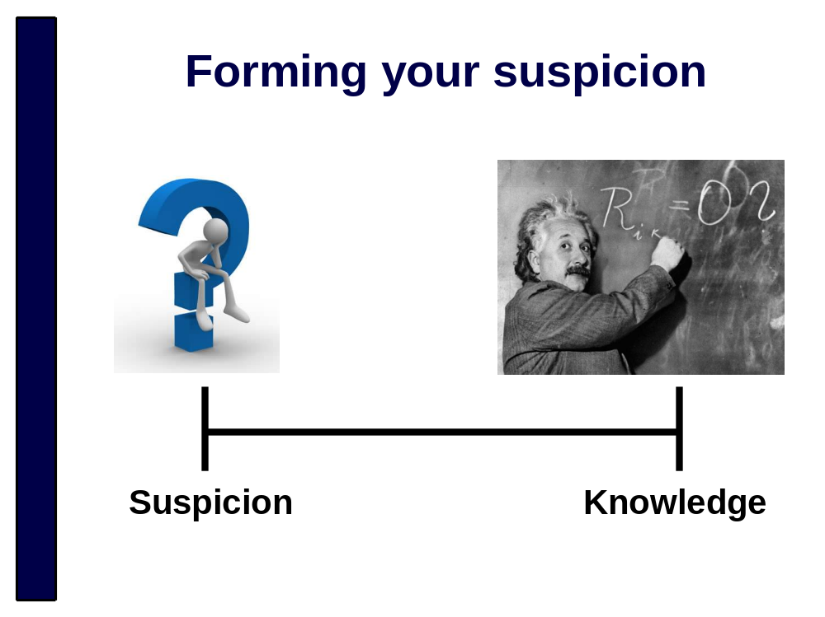
Suspicion is not the same as knowledge. You don’t have to be 100% certain that your customer is laundering money or financing terrorism before you can submit an STR. And you don’t have to know what the ‘predicate’ offence is either (e.g. drug trafficking or tax evasion).

But you shouldn’t just report every transaction you are unsure about. That is called defensive reporting and you will receive negative feedback from us if we think you are doing that. When you first identify that a transaction might be suspicious we expect you to apply some professional judgement, and possibly take the opportunity to ask your customer some additional questions. (But remember that you cannot disclose that you are considering submitting an STR.)

If you are in doubt, then call or email the Financial Intelligence Unit. We cannot make the decision for you, but we can talk you through the process.

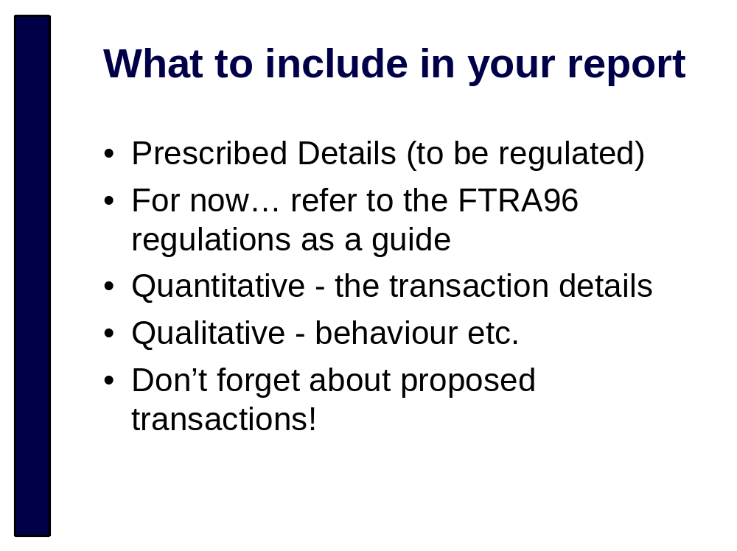
The prescribed details for a suspicious transaction report under the AML/CFT Act have not been regulated yet.

For now, you can refer to the prescribed details for an STR that were regulated through the Financial Transactions Reporting Act. They will give you an indication of what to expect.

We need the quantitative details of the transaction, the mechanics of how the transaction was conducted. Who was involved, when it happened, how much, what type of transaction etc.

But the qualitative information is just as important. Sometimes more important! How did the customer behave? Did they say anything unusual? Were they reluctant to answer your questions? If any cash was involved, what condition was it in?

Don’t forget about proposed transactions. You might choose to decline a transaction because of your suspicions, but you should still report it to us. Failing to notify us about suspicious activity, even when the transactions don’t eventuate, could result in civil or criminal sanctions against you or your business.

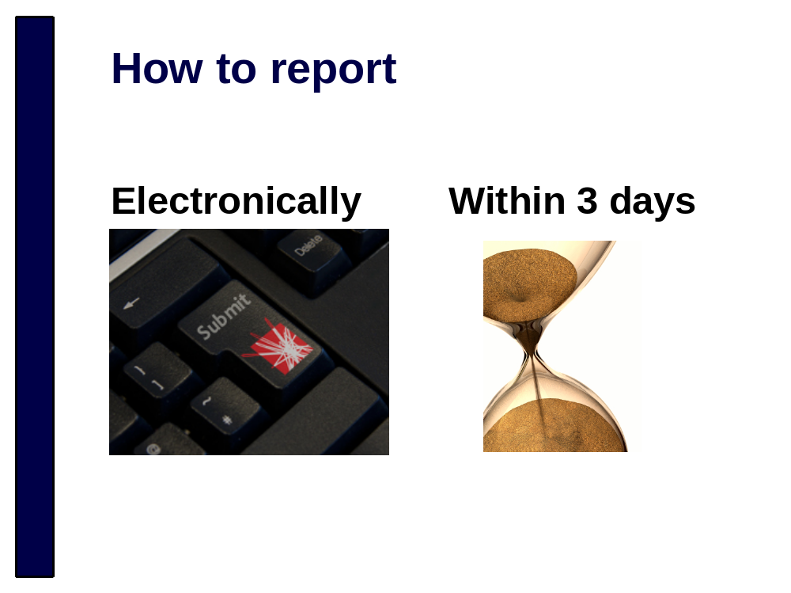
Under the AML/CFT Act you need to report any suspicious transactions to us electronically, unless we give you an exemption to provide a physical report. Where you think that we should be notified urgently you can phone us and make the report over the phone and follow that up with an electronic or physical report.

You also need to report a suspicious transaction to us within three days of forming your suspicions.

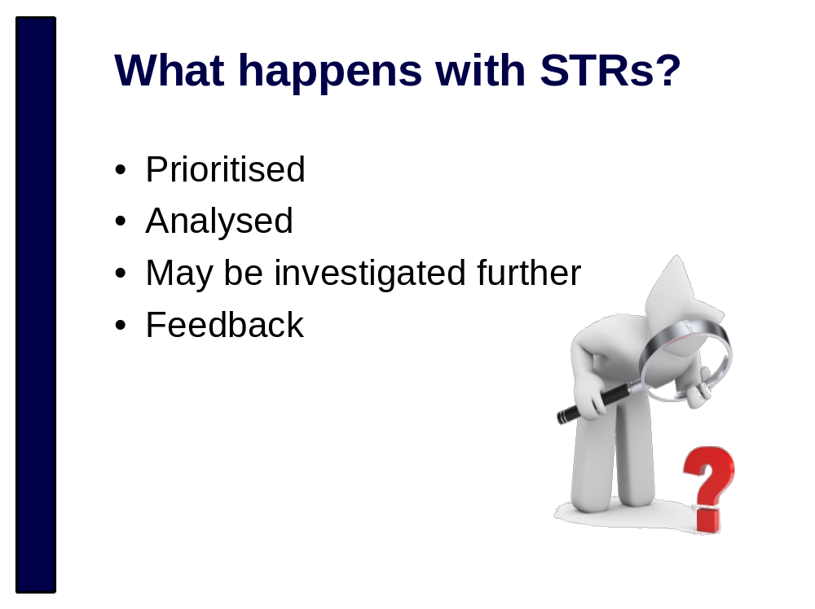
Suspicious Transaction Reports are stored in a secure database that can only be accessed by the Financial Intelligence Unit.

Every STR we receive is assessed and prioritised. If the report highlights something that we think is high risk then we will begin pro-active work on analysing the transaction(s) and determining if there are resources available to investigate further. We also provide intelligence products for ongoing law enforcement investigations in New Zealand and overseas.

The Financial Intelligence Unit does not conduct investigations. We refer the information on to other workgroups in New Zealand Police, or other investigative agencies such as the New Zealand Customs Service.

If the STR you submit assists in an investigation then we will let you know the results of the investigation. Most investigations and prosecutions can take significant time to be resolved though. So please appreciate that sometimes feedback will come months or years after you first told us about the transaction.

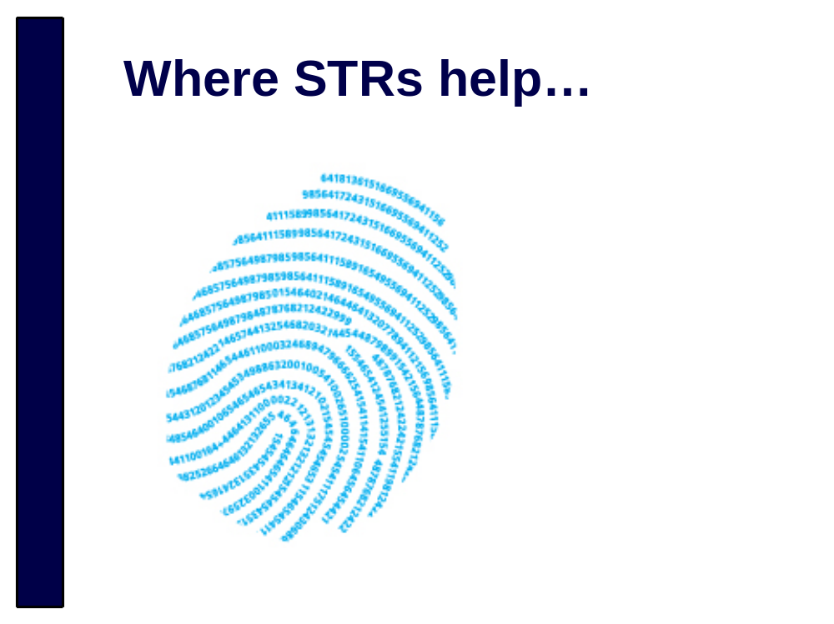
Financial intelligence is just as valuable as fingerprints, DNA and photographic evidence. It tells us a lot about a criminal’s motivations, activity and how much they are making from their crimes.

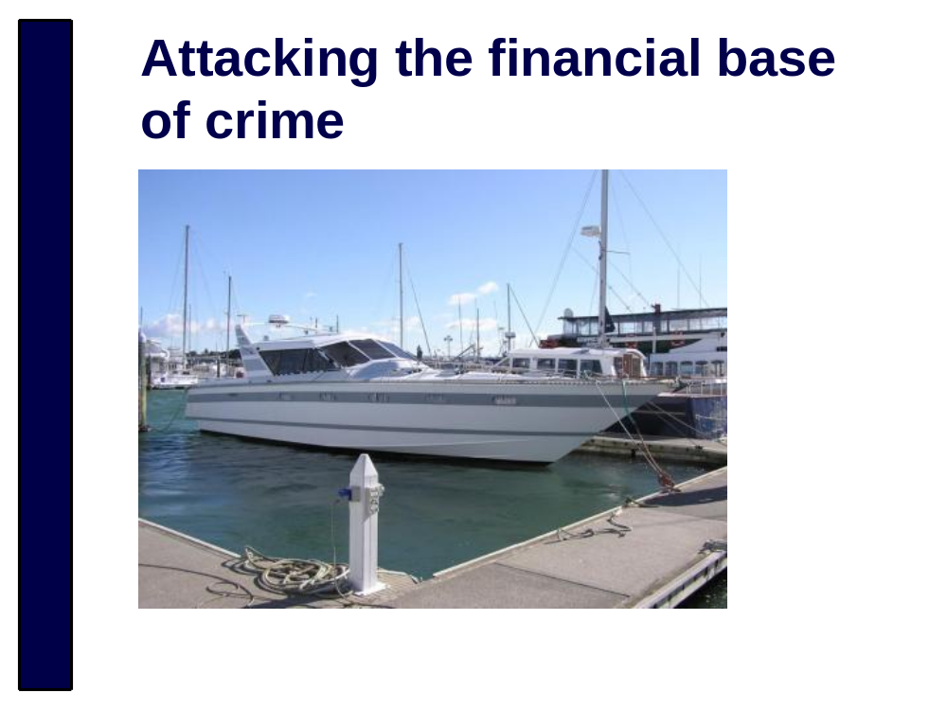
This luxury boat worth approximately 70,000 NZD was found to be purchased with the proceeds of alleged drug offending. Information from a suspicious transaction report assisted in the investigation. The most useful information in this particular suspicious transaction report was the observations about the customer’s behaviour.

This boat has been restrained and will hopefully be forfeit to the crown soon. Restraining and seeking forfeiture of assets reduces the chances that a criminal will have the resources to set up business again in the future.

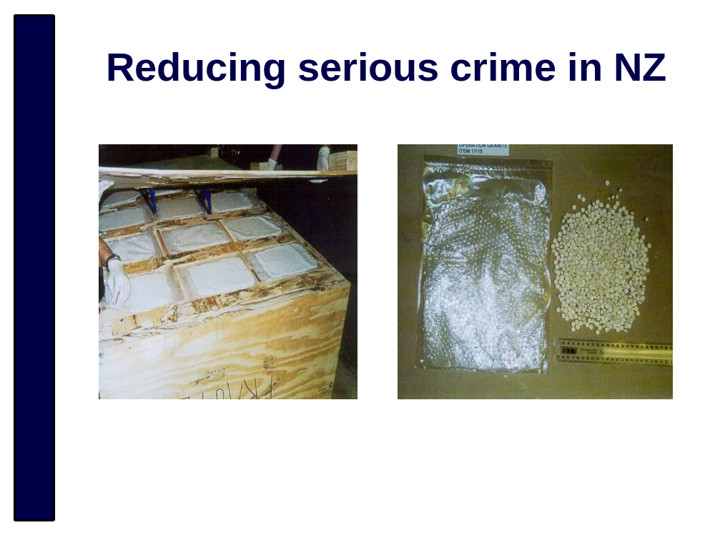
The crate on the left was located in a shipping container during a joint Police/Customs operation. It contained $1million of ecstasy intended for distribution in New Zealand. Information from suspicious transaction reports was used to identify the flow of criminal profits associated with these drugs.

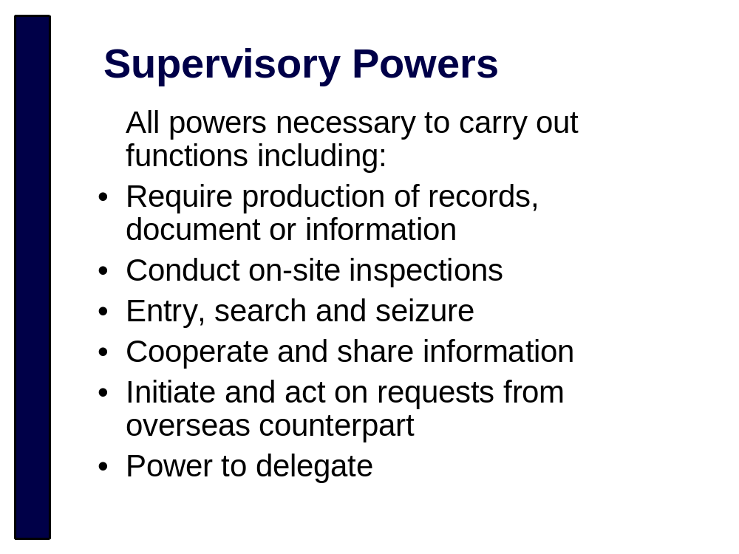
No notes

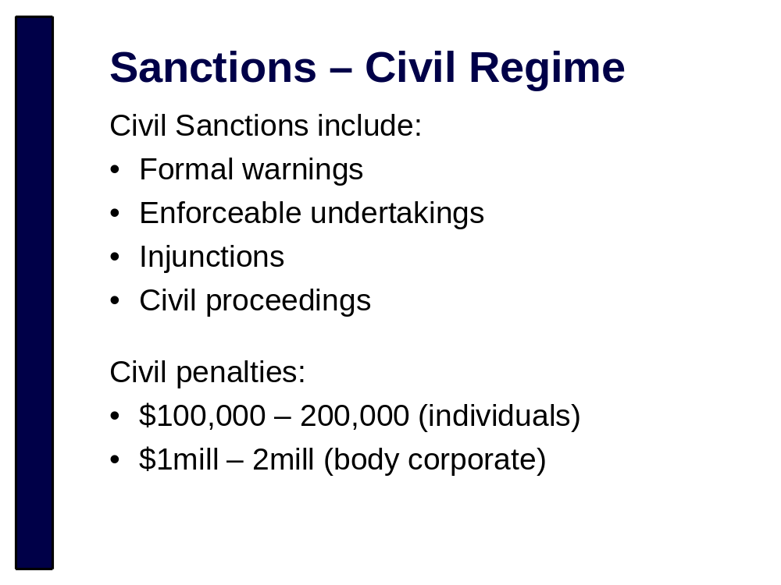
Civil liability act – occurs when a reporting entity fails to comply with any of the AML/CFT requirements

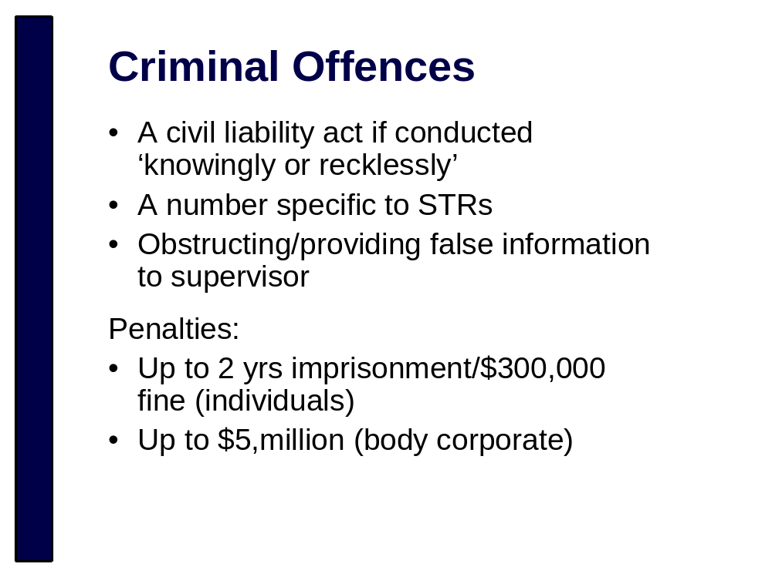
A reporting entity that engages in conduct constituting a civil liability act commits an offence if the reporting entity engages in that conduct knowingly or recklessly.

STR related offences include:
  - failure to report an STR
  - providing false/misleading information re STR
  - unlawful disclosure of STR
  - failure to retain adequate records re STR
  - obstructing investigation into STR

A person conducts an offence if they wilfully obstruct any AML/CFT supervisor in the exercise of any of their AML/CFT Act powers/functions and if they provide information to a supervisor knowing that information to be false or misleading in any material respect


2 year countdown until you must comply with AML/CFT obligations has begun!

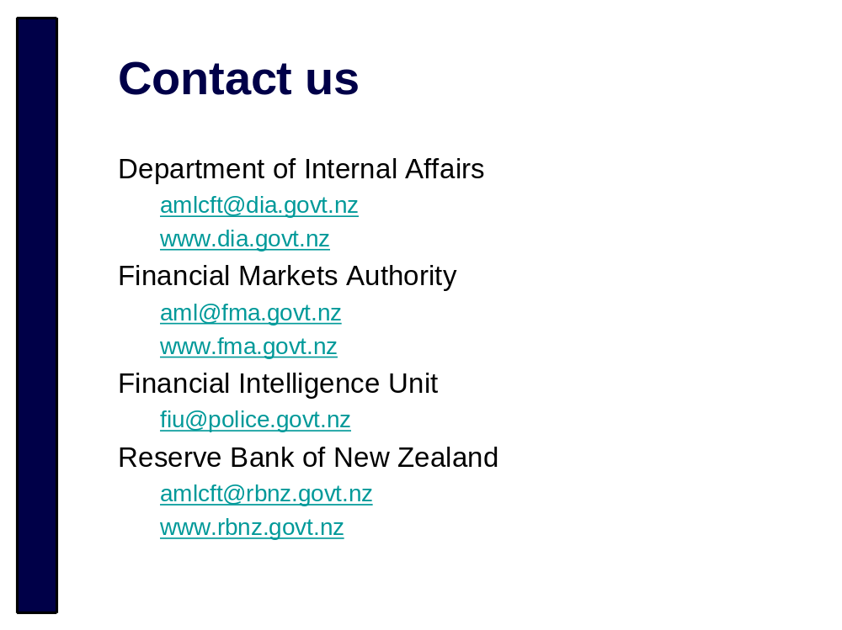
Did you receive our quarterly e-newsletter, if not contact us and let us know.



