**INFORMATION SHEET**

### Water Services Entity Establishment Boards (the Entity establishment boards)

### Background

The government is committed to significantly improve the safety, quality, resilience, accessibility, and performance of three waters services in a way that is efficient and affordable for New Zealanders.

This requires effective infrastructure delivery, underpinned by an efficient, high-performing, financially-sustainable and transparent three waters system, which is well-connected to, and integrated with local and regional planning processes and strategies.

Integral to this is ensuring delivery against Te Tiriti o Waitangi obligations, including by improving outcomes for mana whenua in relation to three waters service delivery.

At the heart of the reforms is the creation of four large-scale, publicly-owned Water Services Entities (Entities) to manage water services, currently managed by 67 councils. These four entities will be statutory entities, established by specific legislation (*Water Services Entities Bill,* currently before Select Committee).

From 1 July 2024, these four new entities will deliver drinking water, wastewater and stormwater services to people across New Zealand. Ahead of this, Cabinet has agreed that the Minister of Local Government (the Minister) will appoint four Water Services Entity establishment boards (Entity establishment boards) to prepare for the set-up of the Entities and undertake transition activities. The Entity establishment boards will be responsible to, and report to the Minister.

### Purpose of the Entity Establishment Boards

There will be four Entity establishment boards that align with the penultimate entity jurisdictions (map below) which are:

* Entity A comprising the Auckland Northland regions;
* Entity B comprising all districts from the Waikato, Bay of Plenty and Taranaki regions and the upper parts of Manawatū-Whanganui region (Ruapehu, Whanganui, and Rangitikei);
* Entity C comprising
  + the local authorities in the eastern and lower part of the North Island (Gisborne, Hawke’s Bay region, lowers parts of the Manawatū-Whanganui Region[1], and Wellington regions); and
  + the local authorities at the top of the South Island (Tasman, Nelson and Marlborough;
* Entity D comprising the districts and regions in the rest of the South Island, including those parts of the Marlborough and Tasman Districts that comprise the Ngāi Tahu takiwā[2].

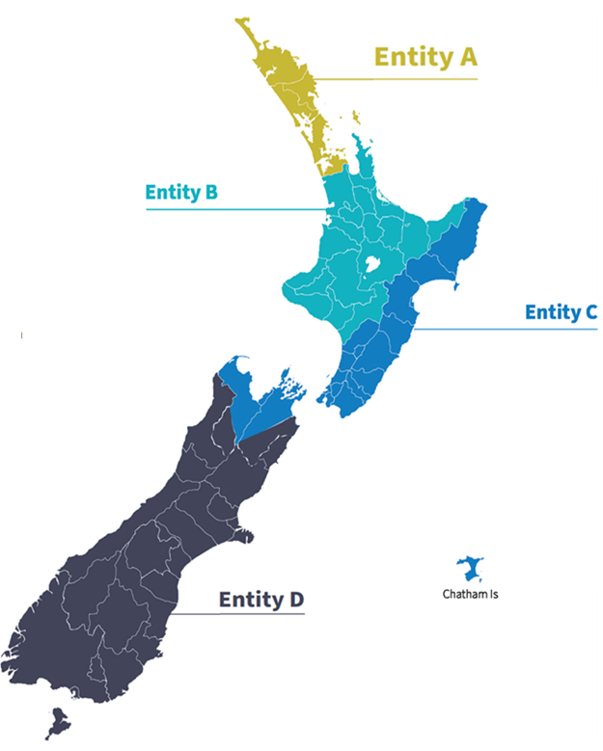

Each of the Entity establishment boards will be accountable for certain transition activities. The Entity establishment boards will provide governance oversight for their respective Water Services establishment entity (Establishment Entity).

Each Establishment Entity will be a statutory body, set up through the Water Services Entities Bill and will have express legislative provisions to equip them with the powers needed to perform their role during the transition period. Each Establishment Entity will have a Chief Executive appointed by late 2022. The Establishment Entities will not be responsible for water service delivery, rather they will undertake transition activities that are key for the ongoing accountability of operational decisions.

The four Establishment Entities will ensure decisions are made and owned by the enduring water services entities, and to embed enduring ownership and entity-specific accountability arrangements. However, the functions of the Establishment Entities will be limited by statute and essentially preparatory in nature.

The Establishment Entities will be responsible to, and report to, the Minister of Local Government (for example through a letter of expectations, and reports) with oversight from the National Transition Unit (Department of Internal Affairs).

### Membership

The four Entity establishment boards will each consist of between four and six members, appointed by the Minister. A member’s term of appointment is between two and four years, and they may be appointed to the enduring Water Services Entity Board.

### Required skills and experience

Members of the Entity establishment board will have a broad range of skills, experience, and diversity to enable the board to effectively provide governance oversight of the Establishment Entities through the transition phase, and to meet its statutory responsibility for its respective Establishment Entity’s functions. Candidates should be able to demonstrate:

* **Transition/change/establishment** – Significant senior level experience and success in large-scale sector and/or organisational reform, change and establishment, preferably at a governance level.
* **Te Tiriti o Waitangi/mātauranga Māori/tikanga Māori/te ao Māori** – Experience and deep understanding of te ao Māori and Te Tiriti o Waitangi; an understanding of the significance of wai to Māori social, environmental and economic wellbeing; and understanding of iwi dynamics and the ability to bring those perspectives to the board table.
* **Local government expertise** – In-depth understanding of the machinery of local government; ability to bring to bear the unique responsibilities and obligations local authorities operate under; ability to provide insight into how the water services entities can engage with the sector; and an understanding of the challenges and opportunities the reforms provide for local government.
* **Human resources/organisational design/workforce development** – Significant human resources expertise and experience in large complex organisations or sectors; an understanding of the impact of change and transition on the water and local government workforce; and an ability to provide guidance and expertise on organisational design and workforce development.
* **Asset and infrastructure management, development and operations** – Wide ranging experience across a range of asset and infrastructure management development, with an emphasis on water assets and infrastructure governance; and an understanding and awareness of the transformational opportunities within water and infrastructure investment and operations.
* **Te Mana o te Wai as a framework** – A deep understanding of Te Mana o te Wai as a framework, with relevant expertise in order to determine how it could be applied for the respective entity to reflect place.
* **Finance** – Experience in complex commercial arrangements, including capital structure, debt financing and pricing and charging mechanisms; experience within networked regulated industries; and an ability to identify risk and bring appropriate pragmatic advice to the board table.

### Commitment and remuneration

The Entity Establishment boards are expected to meet at least monthly, with an anticipated workload of up to 80 days per year for the chair, and up to 40 days per year for members. The proposed directors’ fees are as follows:

|  |  |  |
| --- | --- | --- |
| Member | Daily rate | Maximum number of days per year |
| Member | $ 1,298 | 40 |
| Deputy chair | $ 1,622 | 40 |
| Chair | $ 1,725 | 80 |

Reasonable travel expenses are reimbursed.

### Diversity of representation

Expressions of interest are welcomed from candidates who can offer a range of cultural and personal perspectives. This includes candidates from groups that have historically been under-represented at a governance level, such as Māori, Pasifika, recent migrants, gender diverse New Zealanders and people living with disabilities.

### How to apply

To submit your expression of interest, you need to complete the expression of interest form, provide a current curriculum vitae, and a cover letter to [threewatersboards@dia.govt.nz](mailto:threewatersboards@dia.govt.nz) by **5.00pm Friday 7 October 2022**. All appointments are subject to background checks. Any queries should be directed to the National Transition Unit, Three Waters Reform Programme Governance and Appointments team at the above email address.

More information about the Three Waters reforms can be found at [www.threewaters.govt.nz](http://www.threewaters.govt.nz).

1. This includes Horowhenua, Manawatū, Palmerston North and Tararua.
2. Boundaries have been determined based on a range of factors, scale benefits, communities of interest, and relationships with other jurisdictional boundaries, including catchments. The Entity D boundary corresponds to Ngāi Tahu takiwā.